

Fact sheet 7A—TTY—Speak and Read
In TTY Speak and Read calls you speak your side of the conversation into the handset of the TTY and read the text of the other person’s words on the TTY which have been typed by the relay officer. The other person’s spoken words will also come through on the call. The volume can be turned up or down according to your preferences.
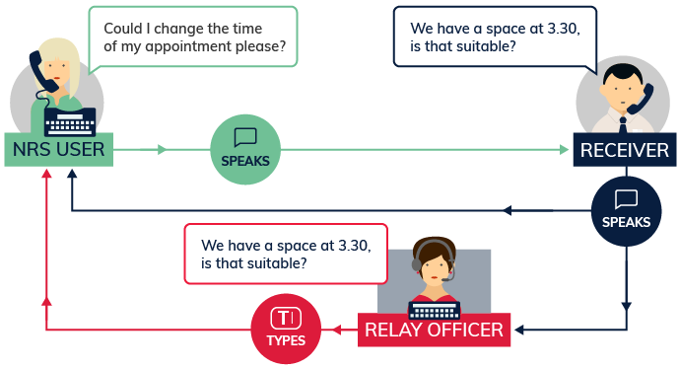

What equipment is needed?
You will need a TTY (also known as a teletypewriter or a textphone) and a landline connection.

How much will it cost?
A TTY call will cost the same as any other call to a 13/1300 phone number depending on the phone plan you have. Relay Officers will offer the option of making another call at the end of each call. On application, users can usually rent a TTY for about the same cost as an ordinary phone through the disability equipment programs offered by Telstra or Optus.

Things to remember
For a detailed step-by-step explanation about how to use this TTY option, read the TTY Speak and Read instruction sheets on the Service features webpage on Accesshub.

Helpdesk
The Helpdesk is open from 8am to 6pm, Monday to Friday (Eastern Standard Time). There are a number of ways to make contact with Helpdesk staff:
- email helpdesk@relayservice.com.au
- phone 1800 555 660
- SMS 0416 001 350
- TTY 1800 555 630
- Fax 1800 555 690.

