

Fact sheet 5—NRS captions
In NRS Captions you speak directly to the other person. You can listen to their responses or wait to read them shortly after on your screen after they have been captioned by the relay officer using voice recognition software. This NRS call option is useful if you are hard of hearing and prefer to use your own voice.
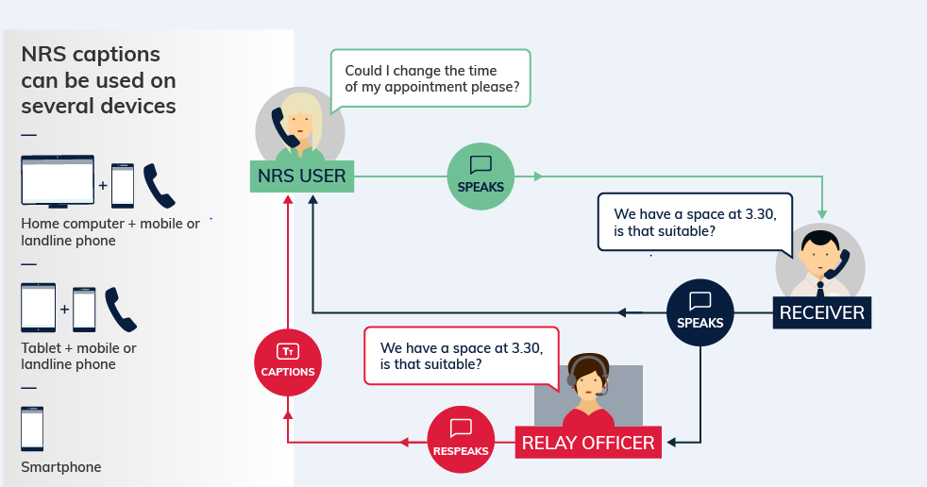

What equipment is needed?
A phone and a device with an internet connection. For example, a landline phone and a computer OR just a smartphone. Calls are made through the NRS app or the NRS Captions call page on Accesshub.

How much will it cost?
NRS Captions calls can be made without any additional cost to the user. However, broadband data costs will apply. Text based messaging uses very small amounts of data so NRS Captions is likely to be cheap to use, depending on the user’s data plan.

Things to remember
- If using a smartphone, the caller will need to use speaker mode or use a headset so that they can speak into the phone and read the captions at the same time.
- Users need to sign up on the NRS Captions call page to receive calls.
- For a detailed step-by-step explanation about how to use this option, read the NRS Captions instruction sheets on the Service features webpage of Accesshub.
The Helpdesk is open from 8am to 6pm, Monday to Friday (Eastern Standard Time). There are a number of ways to make contact with Helpdesk staff:
- Email helpdesk@relayservice.com.au
- Phone 1800 555 660
- SMS 0416 001 350
- Online contact form.

