

Fact sheet 2B—SMS Relay (Text and Listen)
In SMS Relay (Text and Listen) calls you type your side of the conversation on your mobile phone and listen to the other person speaking.
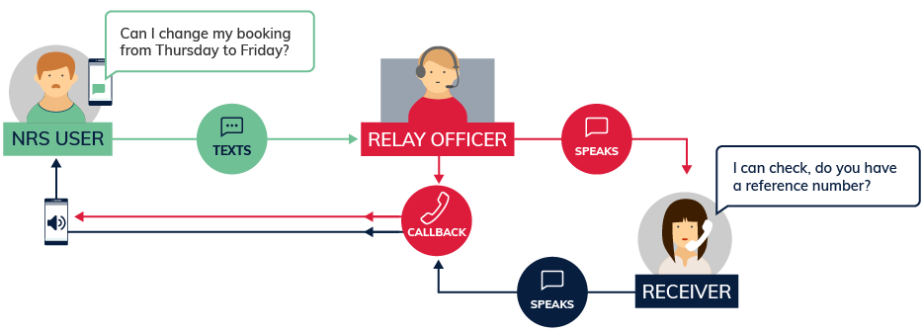

What equipment is needed?
All that is needed to use SMS Relay is a mobile phone; it doesn’t need an internet connection. You can put your phone on speaker or you will need earphones to listen to the other person.

How much will it cost?
Every SMS sent to the NRS will cost the same as any other SMS message sent by the NRS user, which depends on their mobile phone plan. There is no cost to receive the call from the relay service.

Things to remember
- For a detailed step-by-step explanation about how to use this option, read the SMS Relay (Text and Listen) instruction sheets on the Service features webpage on Accesshub.
The Helpdesk is open from 8am to 6pm, Monday to Friday (Eastern Standard Time). There are a number of ways to make contact with Helpdesk staff:
- Email helpdesk@relayservice.com.au
- Phone 1800 555 660
- SMS 0416 001 350
- Fax 1800 555 690.

