



Vehicle Standards Bulletin 1 (Revision 6) – Trailers with an aggregate trailer mass of 4.5 tonnes or less

August 2026

© Commonwealth of Australia 2026
August 2026 / INFRASTRUCTURE 2026

Ownership of intellectual property rights in this publication
Unless otherwise noted, copyright (and any other intellectual property rights, if any) in this publication is owned by the Commonwealth of Australia (referred to below as the Commonwealth).

Disclaimer
The material contained in this publication is made available on the understanding that the Commonwealth is not providing professional advice, and that users exercise their own skill and care with respect to its use, and seek independent advice if necessary.
The Commonwealth makes no representations or warranties as to the contents or accuracy of the information contained in this publication. To the extent permitted by law, the Commonwealth disclaims liability to any person or organisation in respect of anything done, or omitted to be done, in reliance upon information contained in this publication.

Use of the Coat of Arms
The Department of the Prime Minister and Cabinet sets the terms under which the Coat of Arms is used. Please refer to the Commonwealth Coat of Arms - Information and Guidelines publication available at http://www.pmc.gov.au.

Contact us
This publication is available in PDF format. All other rights are reserved, including in relation to any departmental logos or trademarks which may exist. For enquiries regarding the licence and any use of this publication, please contact:
Director – RVS Legislation, Policy and Partnerships
Vehicle Safety Policy & Partnerships Branch
Department of Infrastructure, Transport, Regional Development, Communications, Sport and the Arts
GPO Box 594
Canberra ACT 2601
Australia
Email: RVSAcomms@infrastructure.gov.au
Website: www.infrastructure.gov.au
Published February 2021
Updated May 2023 – Document reformatted to aid readability, including moving definitions to Chapter 2. Minor change to Chapter 13.1.1—trailer model is not a vehicle plate requirement.
Updated November 2023 – Guidance added for ‘Make’ to be used for concessional trailers. Additional guidance for deciding if a brake system is efficient.
Updated March 2024 – Corrected calculation under 14.2.2 Safety chain connections, amended the value equals the force in Newtons and changed ‘gross’ to ‘aggregate’.
September 2024 – Clarified the requirement for front position lamps.
July 2025 – Clarified that the mandatory vehicle plate information must match those entered on the RAV. Added a link to guidance note on what is an approved calculation for ADR 62/02.
August 2026 – Added section 13.2.5 Load carrying capacity.

Contents
Chapter 1: Introduction 6
1.1 Coloured boxes in this document 6
1.2 Scope 6
Chapter 2: Definitions 8
Chapter 3: Registration 13
3.1 Rear registration plate (number plate) 13
Chapter 4: Types of trailers covered by this bulletin 14
4.1 Trailer types 14
4.2 Examples of trailers 15
Chapter 5: Dimensions 18
5.1 Length 18
5.2 Width 19
5.3 Height 20
5.4 Running clearance 20
5.5 Ground clearance 20
Chapter 6: Lighting 21
6.1 General requirements 21
6.2 Careful 22
6.3 Alternative names for lamps 22
6.4 Essential lighting – summary 22
6.5 Rear lamps and reflectors 23
6.6 Side reflectors and lights 41
Chapter 7: Electrical wiring 48
7.1 Wiring installation 48
7.2 Plugs 48
7.3 Other electrical systems 49
Chapter 8: Braking 50
8.1 750kg GTM and under 50
8.2 Over 750 kg GTM 50
Chapter 9: Drawbars, safety chains and couplings 51
9.1 Drawbars 51
9.2 Safety chains and their mounting 51
9.3 Couplings 53
Chapter 10: Mudguards 56
10.1 Function 56
10.2 Design 56
Chapter 11: Axles and suspension 58
Chapter 12: Wheels and tyres 60
12.1 Requirements 60
12.2 Tyre placard 60
12.3 Wheels 60
Chapter 13: General requirements 61
13.1 Trailer requirements 61
13.2 Caravan-specific requirements 62
Chapter 14: Testing drawbar strength and safety chain attachment point strength 65
14.1 Drawbars 65
14.2 Test procedure 65
14.3 Analysis of results 66
14.4 Reporting of results 66

Chapter 1: Introduction
  - Coloured boxes in this document
In this document, three types of coloured breakout boxes are used.
White boxes highlight commonly asked questions
Green boxes contain expansions or clarifications of the main text.
Blue boxes contain information relating to content within VSB1 that is currently subject to review
  - Scope
This bulletin is intended to assist manufacturers of trailers with an aggregate trailer mass of 4.5 tonnes or less to understand the Australian Design Rule (ADR) requirements applying to the most common types of trailers that meet this condition.
Under the Road Vehicle Standards legislation, trailers with an aggregate trailer mass of 4.5 tonnes or less are expected to comply with the applicable ADRs. Not all trailers with an aggregate trailer mass of 4.5 tonnes or less will need to comply with the same ADRs or ADR requirements. ADR requirements are likely to change from time to time. The Department of Infrastructure, Transport, Regional Development, Communications and the Arts (the department) publishes an applicability table for trailers setting out when ADRs become applicable for each trailer category. It can be found on the department’s website.
The content of the ADRs is periodically reviewed. In the event that VSB1 becomes inconsistent with the applicable ADRs, the ADRs take precedence. To ensure that you are using the current version of VSB1, please refer to the online version of this document.
VSB 1 Revision 6 is a subset of requirements from the following ADRs:
- ADR 1/00 Reversing Lamps
- ADR 6/00 Direction Indicators
- ADR 13/00 Installation of Lighting and Light Signalling Devices on other than L-Group Vehicles
- ADR 23/03 Passenger Car Tyres
- ADR 38/05 Trailer Braking Systems
- ADR 42/05 General Safety Requirements
- ADR 43/04 Vehicle Configuration and Dimensions
- ADR 44/02 Specific Purpose Vehicles
- ADR 45/01 Lighting and Light Signalling Devices not covered by ECE Regulations
- ADR 47/00 Retro Reflectors
- ADR 48/00 Devices for Illumination of Rear Registration Plates
- ADR 49/00 Front and Rear Position (Side) Lamps, Stop Lamps, and End Outline Marker Lamps
- ADR 51/00 Filament Lamps
- ADR 61/03 Vehicle Markings
- ADR 62/02 Mechanical Connections Between Vehicles
- ADR 74/00 Side Marker Lamps
- ADR 91/00 Rear Underrun Impact Protection
- ADR 92/00 External Projections
- ADR 95/00 Installation of Tyres
- ADR 96/00 Commercial Vehicle Tyres.
Additional requirements applying to more specialised trailers and other options may be set out in the ADRs themselves. Manufacturers or importers of trailers that do not comply with VSB 1 need to consider if their trailer should be modified to comply or if alternative arrangements exist within the ADRs.
This bulletin does not cover the administrative arrangements related to obtaining approvals under the Road Vehicle Standards Act 2018 (RVSA) or for registration by a State and Territory. For further information about the RVSA approval requirements please visit the department’s website.
Examples of the types of trailers covered by this bulletin are shown in Chapter 3 of this document.
Questions
I want to build a trailer design that isn’t covered by this bulletin. Where should I seek guidance?
The ADRs contain alternative requirements to those covered in this bulletin. You should refer to the applicable ADRs, available on the department’s website. Applicable ADRs for trailers include 1,6,13, 23, 38, 42, 43, 44, 45, 47, 48, 49, 51, 61, 62, 91, 92, 95 and 96.
I am thinking of importing trailers for local sale. How should I use this document?
If the trailers are being built to your specifications, you should ensure that they are built to the requirements stated in this bulletin. If they are used trailers, or trailers being built for other markets, in addition to using this bulletin, you should consult the ADRs for alternative requirements that may better suit your circumstances. Note that most trailers not built specifically for the Australian market will not be compliant without modification (e.g. to lights and couplings).
I have heard a lot about the specialised testing that is needed when manufacturing a trailer e.g. testing of trailer couplings. I don’t have the resources to do this sort of testing, so what approach should I take?
You can buy components with component type approvals. These are components where the testing has been carried out by the component manufacturer. Component type approvals can be used as evidence of compliance with the National Road Vehicle Standards. Component type approvals apply to components such as lamps, couplings, brake systems and safety chains. Note that components approved through this process must be fitted according to the manufacturer’s instructions.
- Definitions

The Act
The Act means the Road Vehicle Standards Act 2018.

The Rules
The Rules means the Road Vehicle Standards Rules 2019.

Register of Approved Vehicles
The Register of Approved Vehicles (RAV) is an online, publicly searchable, database of vehicles approved for use on Australian roads. See also section 14 of the Act.

Australian Design Rules
The ADRs mean the Australian Design Rules.
Note: The Australian Design Rules are national road vehicle standards determined by the Australian Government under section 12 of the Act.

Component type approval
A component type approval is an approval for a road vehicle component, issued under section 177 of the Road Vehicle Standards Rules 2019.
Component type approvals may be used as evidence of compliance with the National Road Vehicle Standards (the ADRs). Component type approvals apply to components such as:
- lamps
- couplings
- brake systems
- tyres
- safety chains
- chassis, including drawbars.

Road trailer
A road trailer is:
- a vehicle without motive power designed for attachment to a road motor vehicle; or
- a piece of machinery or equipment that is equipped with wheels and designed to be towed behind a road motor vehicle.

Trailer categories
- Very light trailer (TA) - A single-axle trailer with a GTM not exceeding 750kg.
- Light trailer (TB) - A trailer with a GTM not exceeding 3,500kg, other than a trailer of category TA.
- Medium trailer (TC) - A trailer with a GTM exceeding 3,500kg but not exceeding 10,000kg.
Note: The above categories use GTM – gross trailer mass. The definition of GTM is shown below.
The medium trailer (TC) category extends up to 10,000kg GTM; most trailers in the TC category will have an aggregate trailer mass (ATM) exceeding 4,500kg. This bulletin only applies to those trailers with an ATM not exceeding 4,500kg. See below for an explanation of the terms gross trailer mass and aggregate trailer mass.

Tare mass
The definition of trailer tare mass in the following section is currently under review
Tare mass is the total mass of the trailer when not carrying any load, and with all fluid reservoirs (if fitted) filled to nominal capacity. (Fluid reservoirs do not include water tanks and waste water tanks in caravans.) Tare mass includes the mass imposed on the towing vehicle, when the combined tow vehicle and trailer are resting on a horizontal surface. Tare mass is specified:
- with the trailer ‘ready for service’, that is with all standard equipment and any options fitted
- at the time of entry onto the RAV.
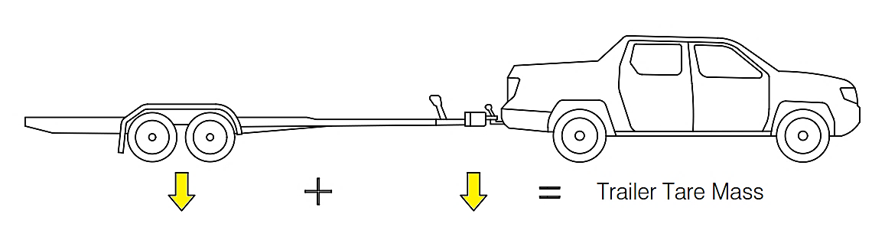
The tare mass is made up of the weight acting downwards through both the trailer’s tyres and the trailer’s coupling. With this specification, the trailer is unladen and is ready for service, with all standard equipment and optional accessories fitted.

Gross trailer mass
Gross trailer mass (GTM) is the specified mass transmitted to the ground by the tyres of the trailer when coupled to a towing vehicle and carrying the maximum load recommended by the manufacturer, approximately uniformly distributed over the load-bearing area.
The manufacturer must have shown the trailer complies with the ADRs at this mass.
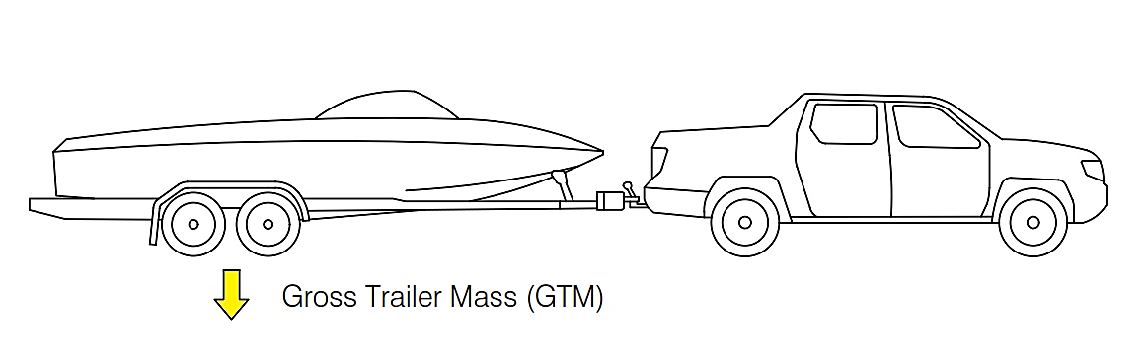
The GTM is the maximum weight (as set by the manufacturer) the trailer may apply through the trailer’s tyres. In this specification, the trailer is fully loaded.

Aggregate trailer mass
Aggregate trailer mass (ATM) is the total mass of the trailer when carrying the maximum load recommended by the manufacturer. ATM includes the mass imposed on the towing vehicle, when the combined tow vehicle and trailer are resting on a horizontal surface.
Note: The maximum load the trailer can carry is the same when determining both GTM and ATM.
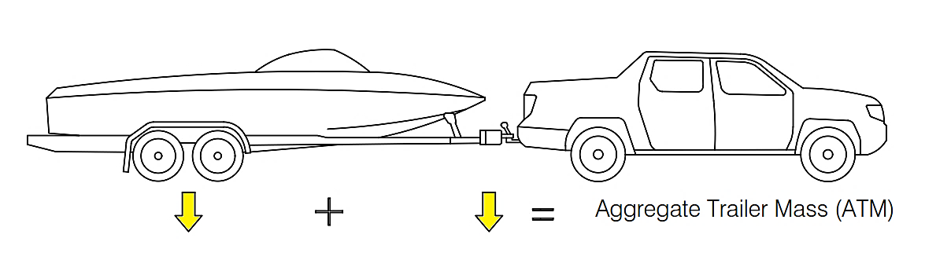
The ATM is the maximum weight acting downwards through both the trailer tyres and the trailer coupling the trailer is designed for. In this specification, the trailer is fully loaded.
Questions
I am confused about GTM and ATM. What’s the difference between them?
First, both ATM and GTM are manufacturer-specified ratings – that is, they cannot be measured on a weigh-bridge. Second, it’s important to note that both ATM and GTM apply only when the trailer is carrying the maximum load it is designed to carry, and that load is distributed evenly across the load-carrying area. (Or, in the case of a boat trailer or caravan, load is positioned as specified by the trailer manufacturer.)
ATM is the total permitted mass of the trailer and its load, including the downwards force acting on the tow vehicle. GTM is the maximum permitted mass of the fully-loaded trailer that acts only through the trailer wheels, and so doesn’t include the downwards force on the tow vehicle.
If the trailer is at maximum load and is loaded evenly (or as specified by the manufacturer), ATM minus GTM equals the tow-ball down-weight.
How are ATM and GTM determined?
ATM and GTM are manufacturer specifications. Both must be developed through engineering calculations and expertise that consider factors including:
- chassis strength
- wheel, axle and tyre ratings
- towing stability.
How does tare mass and aggregate trailer mass (ATM) determine how heavy a load can be carried on trailer?
In all trailers, ATM minus tare mass equals the maximum load the trailer can carry. For example, if a car trailer has a tare mass of 700kg and the ATM is specified at 2,000kg, the trailer can carry a car that has a mass of up to 1,300kg.
What weight ratings are manufacturers required to state?
Both the vehicle plate and the RAV list ATM, GTM and tare mass. A breach of the Act is committed if a manufacturer or importer incorrectly states any of these values.

Length (total length)
Length is the longitudinal distance between the extreme front and rear of the trailer.
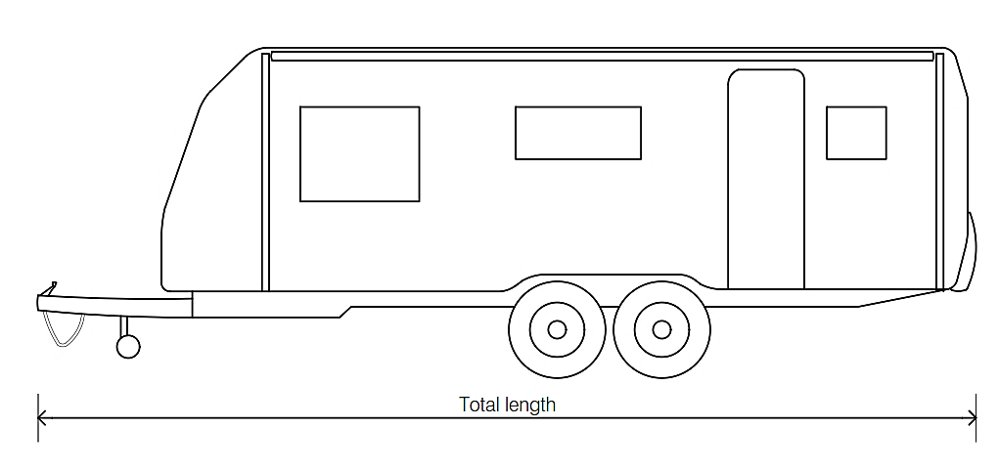
The total length of a trailer includes the length of the drawbar and coupling, and any rear protrusions such as a spare wheel or rack.

Width (overall width)
Width is the maximum distance measured across the body, including wheel guards but excluding side-mounted lamps required for compliance.
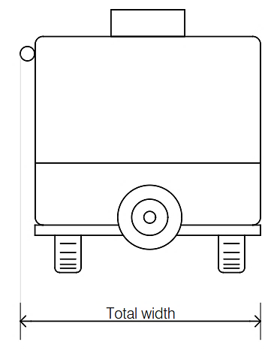
The total width of a trailer includes any protrusions such as a side-mounted awning on a caravan. However, it excludes lamps required for compliance.
Note: Overall width is the maximum width of the vehicle measured across the body. It includes wheel guards, side-mounted spare wheels, side-mounted racks and awnings. It does not include lamps required for compliance, permanently affixed load restraint devices or tyre pressure and inflation devices.

Height (total height)
Height is the maximum distance measured from the road surface to the highest point of the trailer.
The total height of a trailer includes any protrusions such as a roof-mounted air-conditioner on a caravan.
- Registration
  - Rear registration plate (number plate)
Provision must be made for mounting of a 372mm x 136mm registration plate on the rear of every trailer.
- No part of the registration plate may be more than 1,300mm from the ground.
- No part of the trailer (including production options or equipment) can be located so that it obscures any part of the registration plate.
- The plate location must be oriented so that the long edge of the plate is horizontal.
- Registration plate lights must be fitted.
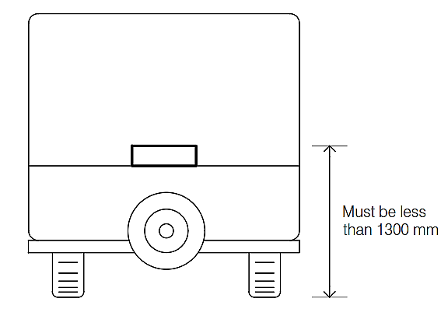
No part of the number plate may be higher than 1,300mm above the ground.
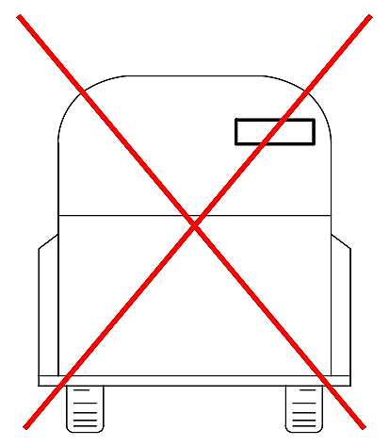
A number plate more than 1,300mm above the ground is not compliant.
Note: The registration plate must be illuminated at night. See Chapter 6.5.3.
- Types of trailers covered by this bulletin
  - Trailer types
This document covers the following trailer types.
    - Pig trailer
A pig trailer has one axle group placed near the middle of the length of the trailer’s goods-carrying surface.
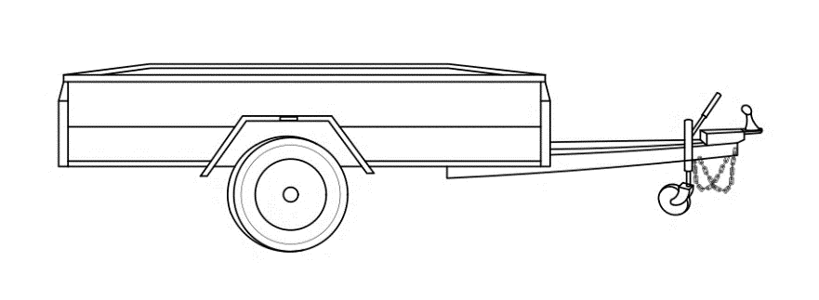
    - Dog trailer
A dog trailer has:
- two axle groups
- the front axle group steered by a connection to the tow vehicle.
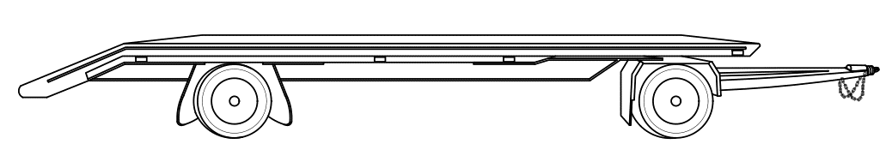
    - Semi-trailer
A semi-trailer has one axle group or a single axle placed towards the rear of the length of the trailer’s goods-carrying surface, so that a significant downwards load is placed on the tow vehicle. Some of the goods-carrying surface is positioned over the tow vehicle.

  - Examples of trailers
This document covers the following examples of trailers.
    - Caravan
A caravan is an enclosed trailer intended for use as a mobile home or living quarters when it is parked. It usually provides sleeping accommodation and facilities for the preparation of food. Note that the following are also categorised as caravans:
- mobile kitchens
- mobile offices
- workers’ amenity trailers.
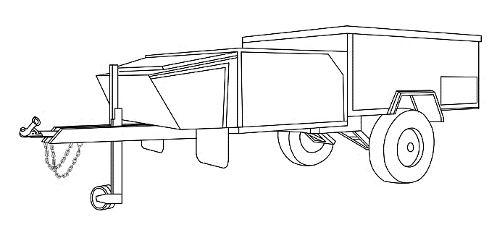
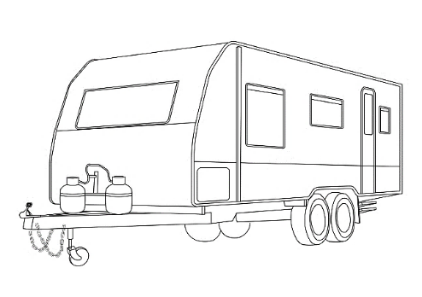
Caravan (pig trailer) Camper trailer (pig trailer)
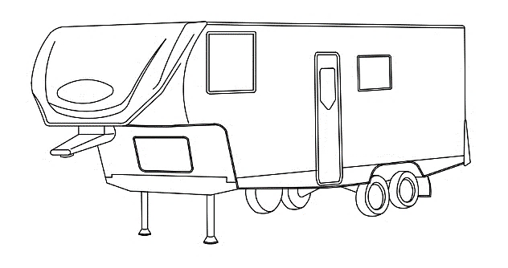
Goose-neck caravan (semi-trailer) Fifth-wheel caravan (semi-trailer)
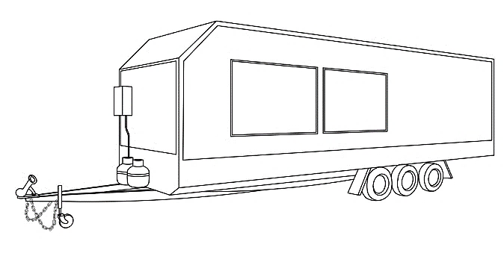
Mobile kitchen (pig trailer)
Question: For compliance purposes, are goose-neck and fifth-wheel caravans regarded as semi-trailers?
Yes, they are. This has implications – for example, in the maximum allowable dimensions (Chapter 5) and in rear under-run protection for trailers over 3,500kg GTM (Chapter 13).
    - Box trailer
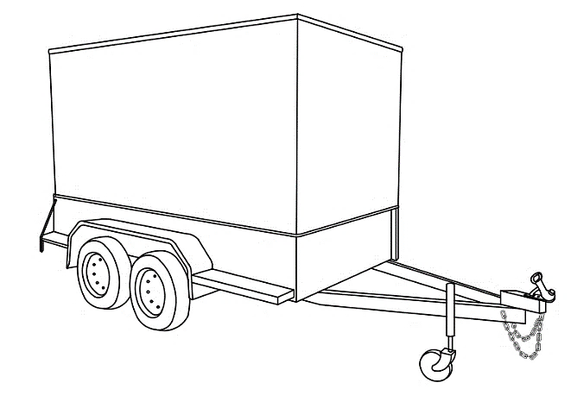
A box trailer is a general-purpose trailer that has its load space bounded by vertical sides. This category also includes box trailers fitted with a canopy, but which is not equipped as a caravan – for example, a box trailer equipped with temporary sleeping accommodation only.
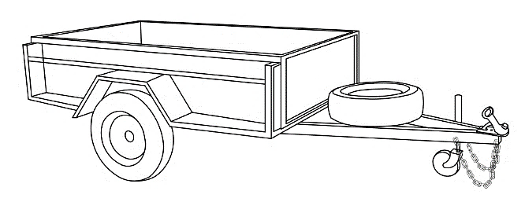

Box trailer Box trailer with canopy
    - Tray trailer
A tray trailer is a general-purpose trailer used to carry machinery.
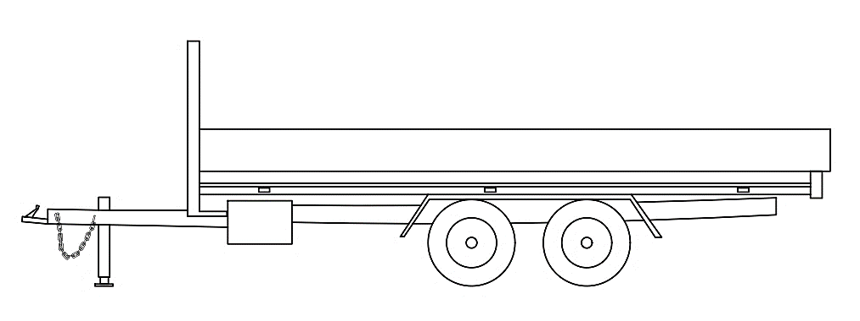
    - Boat trailer
A boat trailer is specifically designed to carry a boat. 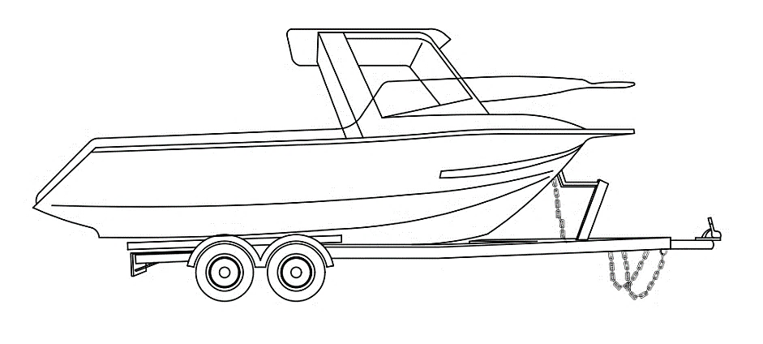

    - Car trailer
A car trailer is specifically designed to carry a car.
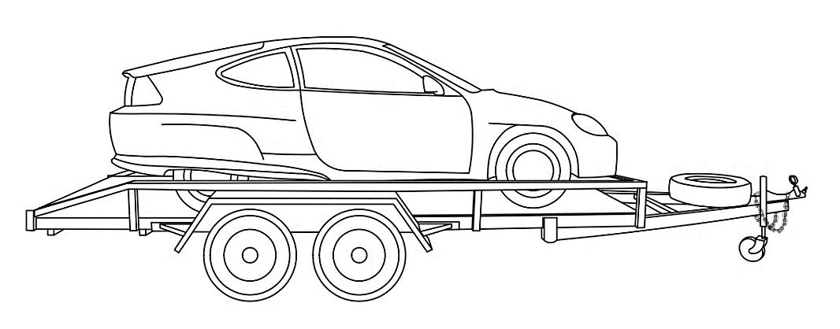
    - Horse float
A horse float is a trailer specifically designed to carry one or more horses or similar livestock.
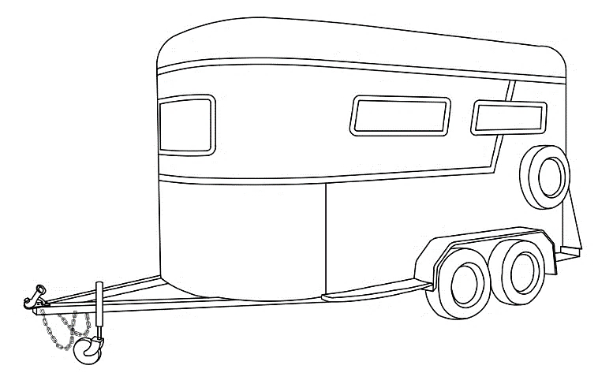
    - Specialised trailers
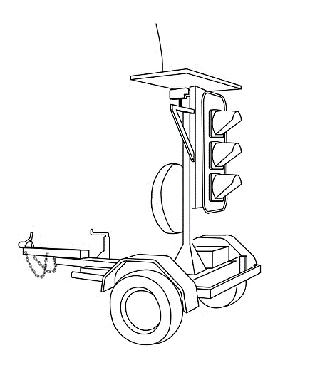
Specialised trailers do not have a load space. Instead, they have been designed to carry permanently fixed machinery or other equipment.
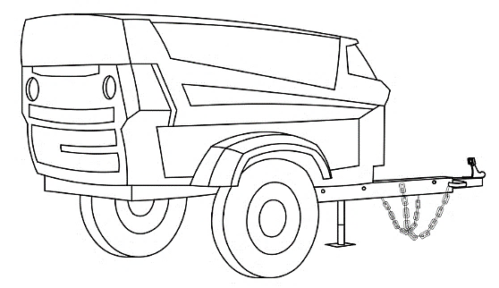
Air compressor Traffic lights
- Dimensions
  - Length
    - Pig trailers
- Maximum drawbar length – 8,500mm. except for convertor dollies which must not exceed 5000mm
- Maximum rear overhang – 3,700mm or the length of the front load space, whichever is smaller.
- Maximum length of a pig trailer – 12,200mm.

Key length dimensions of pig trailers. The maximum total length of a pig trailer is 12,200mm (12.2 metres).
Questions
What is the front load space?
This is not (yet) defined in the ADRs, but load space includes that part of the length of the trailer designated by the manufacturer for the carriage of load. The front load space on a pig trailer must not be less than the rear overhang to ensure downforce on the tow coupling.
If I put gas cylinders or storage boxes on the drawbar are they part of the front load space?
Answer: Yes, however the drawbar must not be modified from the configuration it was tested in to support load or another drawbar test must be conducted.
    - Semi-trailers
- The distance from the point of articulation to the line from which the rear overhang is measured must not exceed 9,500mm.
- Maximum rear overhang – 3,700mm or 60% of the distance between the point of articulation and the line from which the rear overhang is measured, whichever is smaller.
- The forward projection from the point of articulation must be contained within a radius of 1,900mm.
- The distance from the point of articulation to the rear of the trailer must not exceed 13,200mm.
Note: Special requirements apply for trailers to be used in road trains and b doubles or refrigerated trailers – see ADR 43/…
Key length dimensions of semi-trailers
    - Dog trailers
- Maximum drawbar length – 5,000mm.
- The distance from the point of articulation to the line from which the rear overhang is measured (wheelbase) must not exceed 9.5m.
- Maximum rear overhang – 3,700mm or 60% of the wheelbase, whichever is smaller.
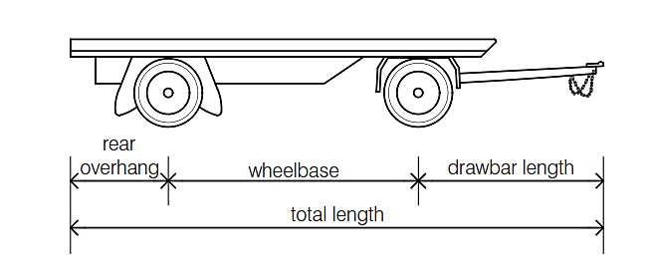
Key length dimensions of dog trailers
  - Width
- Maximum width – 2,500mm.
Note: Overall width is the maximum width of the vehicle measured across the body. It includes mudguards, side-mounted spare wheels, side-mounted racks and awnings. It does not include lamps required for compliance, permanently affixed load restraint devices or tyre pressure and inflation devices.
  - Height
- Maximum height – 4,300mm.
- Maximum height livestock trailer – 4,600mm.
  - Running clearance
All trailers must have a running clearance of 100mm or greater.
Running clearance is the distance from the surface on which an unladen vehicle is standing to the lowest point on the vehicle. This distance does not apply to parts of the vehicle that are not supported by the suspension.
  - Ground clearance
There is only a ground clearance requirement for space between two consecutive axles. The limits that apply are:
- For the midpoint between two consecutive axles, the dimension in millimetres obtained by multiplying the distance between those axles in metres by 33.33.
- For any other point, the vehicle will pass over the apex of two intersecting planes where the planes have a 1:15 gradient.
Ground clearance measurements should be made with the trailer body horizontal and under the condition of maximum loaded test mass. Ground clearance measurement excludes unsprung mass (that is, the tyres, wheels, axles and other parts of the suspension that move up and down over bumps).
In addition, the minimum ground clearance measurement does not include flexible mud flaps.
Image to be provided demonstrating ground clearance requirements
- Lighting
The content of the lighting ADRs in following section is currently under review
  - General requirements
The ADRs specify the following lighting aspects:
- number of lamps and reflectors
- location of lamps and reflectors
- colour of lamps and reflectors
- geometric visibility of lamps and reflectors
- electrical behaviour of lamps.
The requirements specified in the ADRs for the performance and installation of lamps and reflectors are based on the regulations set by the United Nations.
The ADRs provide many options for fitting lamps to trailers. VSB1 describes only a limited set of these options. Should your trailer not meet the VSB1 requirements, you should consult the ADRs for alternative options before changing the design.
Trailer manufacturers must ensure they purchase and fit compliant lamps. This may be done by:
- Using lamps and/or reflectors where the lamp manufacturer provides a copy of the UN approval related to the lamp or reflector.
- Purchasing a lamp covered by a component type approval. Component type approvals can be checked by searching the number given by the component manufacturer on the component type approval web page.
In either case, the lamps and reflectors must be:
- appropriate for the specific location and use on the trailer
- fitted according to the provided instructions
- fitted so that no part of the trailer or its equipment obstructs the lamp output or obscures the reflectors.
Lamps on a trailer must operate with the corresponding lamps on the towing vehicle. Where pairs of lamps or reflectors are fitted, they must be spaced equally on either side of the centreline of the trailer.
Questions
I am building a one-off trailer. Can I source my trailer lights and reflectors cheaply online?
You can buy the lamps and reflectors anywhere you wish, but you must be certain that the lamps and reflectors are compliant. Usually this will involve checking the component type approval of each type of lamp and reflector that you are using on the department’s web page. Using non-compliant lamps or reflectors and then entering the trailer on the RAV is a breach of the Act.
I am an importer of trailers. Do the positions of lamps on my trailers have to comply exactly with what is covered here?
The ADRs contain alternative standards that may be applicable to your trailers.
  - Careful
This document divides the requirements for trailer lamps and reflectors into three categories:
- rear lamps and reflectors
- front lamp and reflectors
- side lamps and reflectors.
Lighting is a major area where inspections often show non-compliance. Manufacturers and importers are advised to:
- work methodically through these requirements
- ensure that the lamps and reflectors are approved for use in Australia
- ensure that the lamps and reflectors are mounted according to the supplied instructions.
  - Alternative names for lamps
Terms used in describing lighting vary. Here is a summary of equivalent terms:
- lights = lamps
- tail lamps = rear position lamps
- brake lamps = stop lamps
- indicator lamps = direction lamps
- clearance lamps = end-outline marker lamps
- reflectors = retro reflectors
- marker = side-marker.
  - Essential lighting – summary
The lamps and reflectors shown in the table below must be fitted to all trailers of the stated dimensions. Additional lamps (e.g. centre high mount brake lamps and reversing lamps) may be optionally fitted. All lamps and reflectors, whether optional or not, must meet the requirements stated in the ADRs.
Trailer dimension | Required lamps and reflectors
All trailers, irrespective of size | - Rear position lamps  - Rear brake lamps  - Rear indicator lamps  - Rear reflectors  - Rear registration (number) plate lamp  - Front reflectors  - Side reflectors
Longer than 4,000mm and wider than 1,600mm, or wider than 1,800mm | - Front position lamps.
Wider than 2,100mm | - Front and rear clearance lamps  - Side-marker lamps
Longer than 6,000mm | - Side-marker lamps
Note: Alternative arrangements apply to red/amber side marker lamps. See ADR 13/00 for details.
  - Rear lamps and reflectors
    - Tail lamps, brake lamps, rear indicators and rear reflectors
      - Colour, number and location
All trailers must be fitted with two rear:
- tail lamps
- brake lamps
- indicator lamps
Item | Colour | Location
Tail lamps | Red | 350mm minimum height  1,500mm maximum height*  Maximum of 400mm from trailer edge  Minimum of 600mm apart**
Brake lamps | Red
Indicator lamps | Amber
Reflectors**** | Red | 250mm minimum height  not more than 900mm maximum height***  Maximum of 400mm from trailer edge  Minimum of 600mm apart**
* May be increased to 2,100mm if bodywork design requires this.
** May be reduced to 400mm if trailer width is less than 1,300mm.
*** May be increased to 1,500mm if bodywork design makes it impossible to keep within the 900mm limit or 1200mm limit if the reflectors are grouped with other lamps.
**** Triangular reflectors may be fitted separate to other lamps; non-triangular reflectors must be combined with other signalling lamps.
If bodywork is present, the extreme edges of the tail, brake and indicator lamps must be positioned within the blue rectangles.
If bodywork is present, the extreme edges of the reflectors must be positioned within the blue rectangles.
      - Geometric visibility
All lamps and reflectors fitted to trailers have geometric visibility requirements. These requirements state the field of view within which the lamp or reflector must be visible.
For each lamp or reflector type, geometric visibility requirements are stated for:
- horizontal visibility
- vertical visibility.
When planning the installation of lamps and reflectors, care should be taken that the geometric visibility requirements are met.
Item | Geometric visibility
 | Horizontal | Vertical
Tail lamps | 45 degrees inwards*  80 degrees outwards | 15 degrees above and below horizontal**
Brake lamps | 45 degrees inwards***  45 degrees outwards | 15 degrees above and below horizontal**
Indicator lamps | 45 degrees inwards  80 degrees outwards | 15 degrees above and below horizontal**
Reflectors (non-triangular) | 30 degrees inwards  30 degrees outwards | 10 degrees above and below horizontal
Reflectors (triangular) | 30 degrees inwards  30 degrees outwards | 15 degrees above and below horizontal****
* Where the tail lamp is mounted at a height of less than 750mm, the inward angle may be reduced to 20 degrees under the horizontal plane.
** Where a lamp is mounted at a height of less than 750mm, the downward angle may be reduced to 10 degrees.
Where the tail lamp is mounted at a height of less than 750mm, the downward angle of 15 degrees may be reduced to 5 degrees.
Where the tail lamp is mounted above 2,100mm the upward angle of 15 degrees may be reduced to 5 degrees.
Where the brake lamp is mounted below 750mm the vertical angle may be reduced to 5 degrees downwards.
*** Where the brake lamp is mounted below 750mm the horizontal angle may be reduced to 20 degrees inwards.
**** Where a triangular reflector is mounted at a height of less than 750mm, the downward angle may be reduced to 5 degrees.
Note the requirement for tail lamps and indicator lamps to be visible from an 80 degrees outwards angle.
The tail lamps and indicator lamps must be horizontally visible from 80° outward and 45° inward angles.
The brake lamps must be horizontally visible from 45°, both inwards and outwards.
Rear reflectors must be horizontally visible from 30 degrees, both inwards and outwards.
Tail, brake and indicator lamps must be vertically visible 15 degrees above and below horizontal.
Non-triangular rear reflectors must be vertically visible 10 degrees above and below horizontal.
Triangular rear reflectors must be vertically visible 15 degrees above and below horizontal.
    - Common mistakes in rear lamps and reflectors
The following diagrams show areas where mistakes are often made in:
- rear lamp and reflector locations
- geometric visibility.
Ensure that rear lamps and reflectors meet the minimum height requirement.
On a caravan, ensure that lamps and reflectors are not positioned too high or too far inwards from the edge of the vehicle.
When a boat trailer is carrying the boat for which it was designed, ensure that the lamps and reflectors are not positioned too far inwards from the edge.
Tail and indicator lamps must be horizontally visible from an outwards angle of 80 degrees. Deeply recessed lamps, without an opening on the outer side of the bodywork, may not meet this requirement.
On boat trailers ensure that all rear lights are visible from a 45 degrees inwards angle. The configuration shown here is non-compliant, as the right-hand side group of lights cannot be seen from this angle.
      - Electrical operation
Item | Electrical operation
Tail lamps | Must operate when tow vehicle’s tail lamps are illuminated.
Brake lamps | Must operate when the tow vehicle’s brake lamps are illuminated, and when the service brakes (if fitted) on the trailer are operating.
Indicator lamps | Must operate:  - when the tow vehicle’s indicators are operating  - via a single control, independent of other lamps  - at a flash rate within the range of 60 - 120 flashes per minute.  On each side of the trailer, they must also flash together.
    - Rear registration (number) plate lamp
All trailers must be fitted with a rear registration (number) plate lamp.
- At least one lamp must be fitted (although note that some registration plate lamps have been approved to be fitted only as a pair).
- The lamp must illuminate the registration plate with white light.
- No light may be directed rearwards.
    - Reversing lamps
Reversing lamps are optional on trailers. If fitted, the following applies:
- one or two lamps on trailers of less than 6,000mm length
- two lamps on trailers of over 6,000mm length
- maximum height of 1,200mm
- minimum height of 250mm
- must operate only when reversing lights are operating on the tow vehicle.
Item | Geometric visibility
 | Horizontal | Vertical
Reverse Lamps  (If one lamp fitted) | 45 degrees left and right | 15 degrees above horizontal  5 degrees below horizontal
Reverse Lamps  (If two lamps fitted) | 45 degrees outwards and 30 degrees inwards | 15 degrees above horizontal  5 degrees below horizontal.
Question: Are reversing lights required on caravans?
Reversing lights are optional on all trailers. Pin 2 in both 7-pin and 12-pin plugs is designated for reversing lights or signals.
    - Centre high mounted stop lamp
Centre high mounted stop lamps are optional on trailers. If fitted, the following mounting location applies:
- less than 150mm below the bottom edge of the rear window (e.g. on a caravan), or
- minimum height of 850mm
- the lower edge of the centre high mounted stop lamp must be located above the upper edge of the stop lamps.

    - Grouping of rear lamps
Rear lamps and reflectors may be grouped, as long as their individual requirements are still met.
The following examples are compliant.
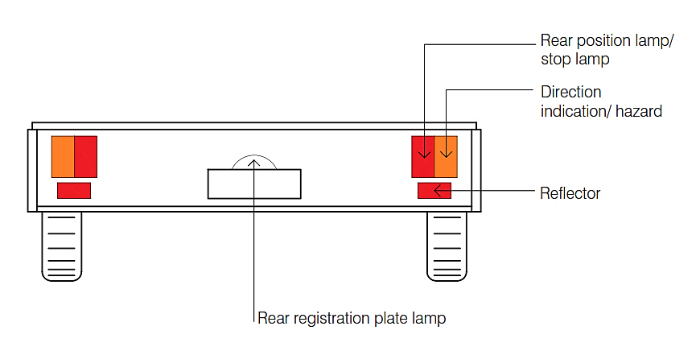
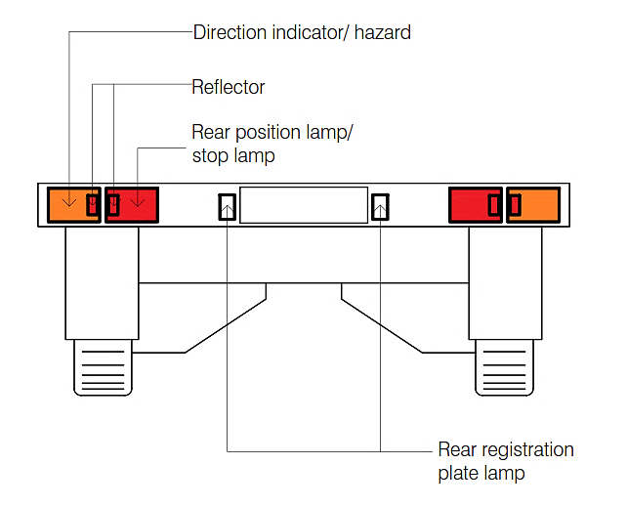
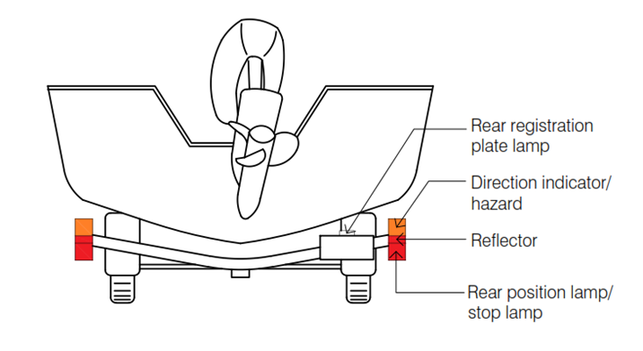
    - Rear clearance lamps – wide trailers
If the trailer is more than 2,100mm wide, two rear clearance (end-outline) lamps must be fitted. These must be:
- red
- as high as possible
- as close as possible to the edge of the trailer
- no more than 400mm from the edge of the trailer
- at least 200mm from the tail (position) lamp.
These lamps must electrically operate with the tail (position) lamps.
A trailer wider than 2,100mm requires that two red rear clearance lamps be fitted. These must be mounted as high and wide as possible, and no more than 400mm from the trailer’s edge.
Note: If a trailer has no structure at the rear on which these lamps can be mounted (for example, on a boat trailer), a combination white (or amber)/red clearance lamp may be fitted midway on each side instead.
Clearance lamps are optional on trailers that do not have permanent structure over the load carrying area.
Item | Geometric visibility
 | Horizontal | Vertical
Clearance lamps | 80 degrees outwards | 5 degrees above horizontal  20 degrees below horizontal.
Rear clearance lamps must be horizontally visible from an outwards angle of 80 degrees.
Clearance lamps must be vertically visible 5 degrees above, and 20 degrees below, horizontal.
    - Visibility requirements – tray-type trailers over 2,200mm wide
Trailers of over 2,200mm width, and that have a tray body, have special rear visibility requirements. In trailers of this type:
- the parts of the mudguards visible from behind must be coloured white or silver if the trailer is not fitted with rear marking plates.
- must have a white or silver band 75mm deep across the full width of the rear of the tray if the trailer is not fitted with conspicuity markings in accordance with ADR 13/00 Appendix A clause 6.21.
    - Rear lamps and reflectors – summary of requirements
Lamps | Colour | Location | Visibility |  | Electrical
 |  |  | Horizontal | Vertical
Tail lamps | Red | 350mm minimum height  1,500mm maximum height*  Maximum of 400mm from trailer edge  Minimum of 600mm apart** | 45 degrees inwards  80 degrees outwards | 15 degrees above and below horizontal*** | Must operate when tow vehicle’s tail lamps are illuminated
Brake lamps | Red |  | 45 degrees inwards  45 degrees outwards | 15 degrees above and below horizontal*** | Must operate when the tow vehicle’s brake lamps are illuminated, and when the service brakes (if fitted) on the trailer are operating.
Indicator lamps | Amber |  | 45 degrees inwards  80 degrees outwards | 15 degrees above and below horizontal*** | Must operate:  - when the tow vehicle’s indicators are operating  - via a single control, independent of other lamps  - at a flash rate within the range of 60-120 flashes per minute  - in phase on each side of the trailer
Centre high mounted stop lamp | Red | 850mm minimum height***** | 10 degrees inwards  10 degrees outwards | 10 degrees above horizontal  5 degrees below horizontal | Must operate when the tow vehicle’s brake lamps are illuminated, and when the service brakes (if fitted) on the trailer are operating.
Rear reflectors  (non-triangular) | Red | 250mm minimum height  900mm maximum height****  Maximum of 400mm from trailer edge  Minimum of 600mm apart** | 30 degrees inwards  30 degrees outwards | 10 degrees above and below horizontal | N/A
Rear reflectors  (triangular) | Red |  | 30 degrees inwards  30 degrees outwards | 15 degrees above and below horizontal | N/A
Rear registration (number) plate lamp | White | Must illuminate the registration plate with white light. | N/A | N/A | N/A
* May be increased to 2,100mm if bodywork design requires this
** May be reduced to 400mm if trailer width is less than 1,300mm.
*** Where a lamp is mounted at a height of less than 750mm, the downward angle may be reduced to 10.
**** May be increased to 1,500mm if bodywork design requires this.
***** Must be fitted so that the lower edge of the centre high mounted stop lamp is located above the upper edge of the brake lamps.
For trailers more than 2,100mm wide, additionally:
Lamps | Colour | Location | Visibility |  | Electrical
 |  |  | Horizontal | Vertical
Rear clearance lamps | Red | - as high as possible  - as close as possible to the edge of the trailer  - no more than 400mm from the edge of the trailer  - at least 200mm from the tail (position) lamp. | 80 degrees outwards | 5 degrees above horizontal  20 degrees below horizontal | Must operate when tow vehicle’s tail lamps are illuminated
For tray-type trailers more than 2,200mm wide, additional rear visibility requirements occur – refer to Chapter 6.5.8.
    - Front reflectors
All trailers must be fitted with front reflectors.
Item | Colour | Location
Reflectors | white | 250mm minimum height  900mm maximum height*  Maximum of 150mm from trailer edge  Minimum of 600mm apart**
* May be increased to 1,500mm if bodywork design requires this.
** May be reduced to 400mm if trailer width is less than 1,300mm.
If bodywork is present, the extreme edges of the reflectors must be positioned within the blue rectangles. Trailers narrower than 1,300mm may have the reflectors a minimum of 400mm apart.
Item | Geometric visibility
 | Horizontal | Vertical
Front reflectors | 10 degrees inwards*  30 degrees outwards | 10 degrees above and below horizontal**
* If because of the construction of the trailer, this angle cannot be met, extra reflectors must be added to achieve this angle.
** Where a reflector is mounted at a height of less than 750mm, the downward angle may be reduced to 5 degrees.
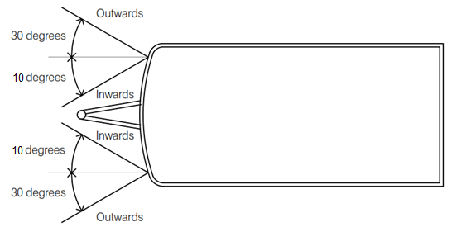
Front reflectors must each be horizontally visible 10 degrees inwards and 30 degrees outwards.
Front reflectors must each be visible 10 degrees above and below horizontal.
Caravan stone guards must be positioned so that they do not obscure front reflectors. Alternatively, the reflectors can be moved to the stone guard, or additional reflectors placed on the stone guard or on the trailer body such that the visibility requirements are met.
    - Front position lamps
Front position lamps must be fitted if the trailer is:
- more than 4,000mm long and more than 1,600mm wide, or
- more than 1,800mm wide.
However, if side marker lamps are fitted to the front of each side of the trailer in accordance with requirements in paragraph 6.6.2.2.2, these act as front position lamps and additional front position lamps are not required.
These lamps must electrically operate with the tail (position) lamps.
Item | Colour | Location
Front position lamps | white* | 250mm minimum height  1,500mm maximum height**  Maximum of 150mm from trailer edge  Minimum of 600mm apart***
* May be amber if combined with a side-marker lamp.
** May be increased to 2,100mm if bodywork design requires this or the trailer is in TA or TB vehicle category.
*** May be reduced to 400mm if trailer width is less than 1,300mm.
If bodywork is present, the extreme edges of the front position lamps must be positioned within the blue rectangles. Trailers narrower than 1,300mm may have the lamps a minimum of 400mm apart.
Item | Geometric visibility
 | Horizontal | Vertical
Front position lamps | 45 degrees inwards*,  80 degrees outwards | 15 degrees above and below horizontal**
* Where a lamp is mounted at a height of less than 750mm, the inward angle may be reduced to 5 degrees.
** Where a lamp is mounted at a height of less than 750mm, the downward angle may be reduced to 5 degrees.
The front position lamps must each be horizontally visible 80 degrees outwards and 45 degrees inwards.
The front position lamps must each be visible 15 degrees above and below horizontal.
Where lamps, designed for vertical surface mounting, would otherwise be mounted on heavily sloping surfaces, brackets (or similar means) may be needed to maintain the correct vertical orientation. Lamps must be fitted in accordance with the lamp manufacturer’s instructions. Installation instructions should be included with components covered by a component type approval.
    - Front clearance lamps – wide trailers
If the trailer is more than 2,100mm wide, two front end-outline (clearance) lamps must be fitted. These must be:
- white or amber
- as high as practically possible
- as close as possible to the edge of the trailer
- no more than 400mm from the edge of the trailer
- at least 200mm from the front position lamp.
These lamps must electrically operate with the tail (position) lamps.
Note: Front clearance lamps are optional if:
- a trailer has no structure at the front on which these lamps can be mounted (for example, a boat trailer), or
- if the maximum separation between the front position lamp and end outline marker lamp is less than, or equal to, 1,500mm.
Item | Geometric visibility
 | Horizontal | Vertical
Clearance lamps | 80 degrees outwards | 5 degrees above horizontal  20 degrees below horizontal
A trailer wider than 2,100mm requires that two white or amber front clearance lamps be fitted. These should be mounted as high and wide as possible, and no more than 400mm from the trailer’s edge.
The front clearance lamps must each be visible from 5 degrees above, and 20 degrees below, horizontal.
The front clearance lamps must each be visible from an 80 degrees outward angle.
    - Front reflectors and lamps summary
Lamps | Colour | Location | Visibility |  | Electrical
 |  |  | Horizontal | Vertical
Reflectors | white | 250mm minimum height  900mm maximum height  Maximum of 150mm from vehicle edge  Minimum of 600mm apart | 10 degrees inwards  30 degrees outwards | 10 degrees above and below horizontal | N/A
Front position lamps | white | 250mm minimum height  1,500mm maximum height  Maximum of 150mm from vehicle edge  Minimum of 600mm apart | 45 degrees inwards  80 degrees outwards | 15 degrees above horizontal  15 degrees below horizontal | Must electrically operate with the tail (position) lamps
Front clearance lamps | White or amber | as high as possible  as close as possible to the edge of the trailer  no more than 400mm from the edge of the trailer  at least 200mm from the front position lamp | 80 degrees outwards | 5 degrees above horizontal  20 degrees below horizontal | Must electrically operate with the tail (position) lamps
Note
- Reflector height may be increased to 1,500mm if bodywork design requires this.
- Reflector spacing may be reduced to 400mm if trailer width is less than 1,300mm.
- If because of the construction of the trailer, the 10 degrees inwards reflector angle cannot be met, extra reflectors must be added to achieve this angle.
- Reflectors mounted at a height of less than 750mm may have the downward angle reduced to 5°.
- Front position lamp may be amber if combined with a side-marker lamp.
- Front position lamp may be increased to 2,100mm if bodywork design requires this.
- Front position lamp spacing may be reduced to 400mm if trailer width is less than 1,300mm.
- Front position lamps located at less than 750mm height may have a 5 degrees inward and downwards angles of geometric visibility.
- Front position lamps mounted at a height of less than 750mm may have the downward angle reduced to 5 degrees.
  - Side reflectors and lights
    - Side reflectors
      - Height
Item | Colour | Height
Reflectors | Amber* | 250mm minimum height  900mm maximum height**
* The rearmost reflector can be red if it is grouped, or has part of the light emitting surface in common with, the rear position (tail) lamp, the rear end-outline (clearance) marker lamp, the stop (brake) lamp or the red rearmost side-marker lamp.
** May be increased to 1,200mm if grouped with other lights, or 1,500mm if bodywork design requires this.
      - Location
The location of the side reflectors must conform with the following:
- at least one reflector in the middle third of the trailer
- the foremost reflector not further than 3,000mm from the front
- the rearmost reflector not further than 1,000mm from the rear
- the distance between adjacent reflectors not more than 3,000mm (4,000mm if the structure, design or the operational use of the trailer makes it impossible to meet the 3000mm requirement).
The rearmost reflector must not be more than 1,000mm from the rear of the trailer. The foremost reflector should not be more than 3,000mm from the front of the trailer. At least one reflector should be placed in the middle third of the trailer. In addition, the maximum spacing between reflectors must not exceed 3,000mm, except in circumstances where the structure, design or operational use of the vehicle makes it impossible to comply with such a requirement. In this instance, the spacing of the reflectors may be increased to 4000mm.
Question: I am manufacturing a caravan and I am confused as to where side reflectors need to be located. What is a simple approach I can take that will be compliant?
            - Use masking tape to temporarily mark where the reflectors are going to be placed.
            - Ensure that the reflectors will be positioned at a height above the road of between 250mm – 900mm, and placed on a vertical surface.
            - Place one reflector as close to the rear of the bodywork as possible ensuring the reflector is not more than 1,000mm from the rear including protrusions.
            - Place one reflector as close to the front of the bodywork as possible. Ensure this reflector is not more than 3,000mm from the leading edge of the coupling.
            - Place a reflector in the middle third of the length. Ensure that the distance between reflectors is not more than 3,000mm. If it is, add more reflectors, ensuring that one is always present in the middle third.
            - Replace masking tape markings with the reflectors.
      - Geometric visibility
Item | Geometric visibility
 | Horizontal | Vertical
Side reflectors | 45 degrees to the front and rear | 10 degrees above and below horizontal*
* Where a reflector is mounted at a height of less than 750mm, the downward angle may be reduced to 5 degrees.

The side reflectors need to be horizontally visible 45 degrees front and rear of each reflector.
The side reflectors need to be vertically visible 10 degrees above and below horizontal.
    - Side marker lamps
Side-marking (marker) lamps must be fitted to all trailers more than 6,000mm long and/or 2,100mm wide.
For trailers under 3,500kg ATM, no electrical requirements exist for side marker lamps, but they are usually wired to operate with the tail lights. (For trailers over 3,500kg, refer to the ADRs.)
Two approaches can be taken:
Option number | Light colour
Option 1 | Amber to front and rear*
Option 2 | Amber to front, red to rear
* Except for the rearmost light, that can be red, refer to ADR 74/…
Note: For more details on side marker lamps, see ADR 13/00 Appendix A paragraph 6.18 for option 1 and ADR 13/00 clause 9.2. for option 2.
      - Option 1 – Amber front and rear
        - Height
Item | Colour | Height
Marker lamps | Amber front and rear | 250mm minimum height  1,500mm maximum height*
* May be increased to 2,100mm if bodywork design requires this.
        - Location
The location of the marker lamps must conform with the following:
- at least one maker lamp in the middle third of the trailer
- the foremost marker lamp not further than 3,000mm from the front
- the rearmost marker lamp not further than 1,000mm from the rear
- the distance between adjacent marker lamps not more than 3,000mm (4,000mm if required by trailer shape or operation).
The rearmost side-marker must not be more than 1,000mm from the rear of the trailer. The foremost marker should not be more than 3,000mm from the front of the trailer. At least one marker should be placed in the middle third of the trailer. In addition, the maximum spacing between markers must not exceed 3,000mm, except in circumstances where the structure, design or operational use of the vehicle makes it impossible to comply with such a requirement. In this instance, the spacing of the side-markers may be increased to 4,000mm.
Item | Geometric visibility
 | Horizontal | Vertical
Side markers | 45 degrees to the front and rear | 10 degrees above and below horizontal*
* Where a lamp is mounted at a height of less than 750mm, the downward angle may be reduced to 5 degrees.
The side marker lamps need to be horizontally visible 45 degrees front and rear of each lamp.
The side markers need to be vertically visible 10 degrees above and below horizontal.

Ensure that the position of accessories such as side-mounted awnings does not block geometric visibility of side marker lamps and side reflectors. Here the awning upright blocks the required forward 45 degrees visibility requirement.
      - Option 2 – Amber front, red rear
Required on:
- trailers wider than 2,100mm or longer than 7,500mm
- all semi-trailers, irrespective of dimensions.
        - Height
Item | Colour | Height
Marker lamps | Amber front and red rear | 600mm minimum height  1,500mm maximum height*
* May be increased to 2,100mm if bodywork design requires this.
        - Arrangement
Trailer size and type | Lamp arrangement
Trailers over 2,100mm wide | - two at rear
Semi-trailers equal to, and less than, 7,500mm long | - two at rear  - two at front
Trailers over 7,500mm long | - two at front  - two at rear  - two mid-way between front and rear lamps
Note: In the above table:
- ‘Front’ is defined as being no more than 300mm from the front of the side of the trailer.
- ‘Rear’ is defined as being no more than 300mm from the rear of the side of the trailer.
- Where trailer construction makes these locations impracticable, as close as possible to the front and rear of the trailer.
Additional pairs of side marker lamps may be used if:
- they are equally spaced between the front and rear lamps
- the distances between the centres of adjacent lamps is not more than 5,000mm.
Item | Geometric visibility
 | Horizontal
Side markers | 5 degrees
    - Side reflectors and lights summary
Lamps | Colour | Height | Visibility |  | Electrical
 |  |  | Horizontal | Vertical
Side reflectors | Amber | 250mm minimum height  900mm maximum height | 45 degrees to the front and rear | 10 degrees above and below horizontal | N/A
Marker lamps - Option 1 | Amber front and rear | 250mm minimum height  1,500mm maximum height | 45 degrees to the front and rear | 10 degrees above and below horizontal | For trailers under 3,500kg ATM, no electrical requirements exist for side marker lamps, but they are usually wired to operate with the tail lights.
Marker lamps - Option 2 | Amber front and red rear | 600mm minimum height  1,500mm maximum height | 5 degrees | N/A

Note
- Where a reflector or Option 1 side marker lamp is mounted at a height of less than 750mm, the downward angle may be reduced to 5 degrees.
- The rearmost reflector can be red if it is grouped, or has part of the light emitting surface in common with, the rear position (tail) lamp, the rear end-outline (clearance) marker lamp, the stop (brake) lamp or the red rearmost side-marker lamp.
- The maximum height of side reflectors may be increased to 1,200mm if grouped with other lights, or 1,500mm if bodywork design requires this.
- The maximum height of side marker lamps may be increased to 2,100mm if bodywork design requires this.
- Electrical wiring
In trailer electrical wiring, the ADRs and cited Australian Standards specify:
- appropriate wiring installation
- the way in which an electrical ground should be provided
- plugs
- plug wiring.
  - Wiring installation
Trailer wiring must:
- be supported at intervals of not more than 600mm along its length
- be insulated at joints
- be located so that it cannot become overheated or contact moving parts
- be protected from chafing.
The edge of all holes in metal through which the wiring passes must be rolled or bushed with a rubber grommet or similar.
An earth (ground) return wire between the trailer and its tow vehicle must be provided.
  - Plugs
Trailers that do not exceed 3,500kg ATM must use either 7 or 12-pin plugs that meet Australian Standard AS 4177.5-2004 Caravan and Light Trailer Towing Components - Part 5 Electrical Connectors.

12-pin plug 7-pin plug

Required plug wiring is shown in the table below.
Plug type |  | Circuit | Colour
7 pin | 12 pin
1 | 1 | Left-hand indicator | Yellow
2 | 2 | Reversing signal | Black
3 | 3 | Earth (ground) return | White
4 | 4 | Right-hand indicator | Green
5 | 5 | Service brakes (where fitted) | Blue
6 | 6 | Tail (stop) lamps | Red
7 | 7 | Tail lamps, clearance lamps and side-marker lamps | Brown
 | 8 | Battery supply | Orange
 | 9 | Auxiliaries | Pink
 | 10 | Earth (ground) return | White
 | 11 | Rear fog lamp | Grey
 | 12 | Auxiliaries | Violet
Front view of 7-pin and 12-pin trailer plugs
Trailers exceeding 3,500kg ATM may use the above 7 or 12-pin plugs, or may comply with alternative standards – see ADR 42/… General Safety Requirements.
Question: On trailers that don’t need electric brakes, can Pin 5 in a 7-pin plug be used for charging a fridge?
Because of interchangeability problems that may arise, it is recommended that pin 5 in 7-pin connectors be used only for service brakes. If auxiliary circuits are required, then the use of a 12-pin connector is preferable.
  - Other electrical systems
Electrical installations on a trailer that are intended for connection to an AC power system other than that of the tow vehicle must comply with Australian Standard AS/NZS 3001:2008 Electrical installations – Transportable structures and vehicles including their site supplies.
- Braking
The content of the following section is currently under review
Brake components are available with component type approvals. These components have been tested by the component manufacturer to ensure they meet the appropriate Australian Design Rules. Component type approvals can be used by a trailer manufacturer as evidence of compliance with the National Road Vehicle Standards.
Braking requirements are specified in terms of gross trailer mass (GTM) not aggregate trailer mass (ATM). See Chapter 2 for definitions of these terms.
Alternative standards
Trailers that comply with the technical requirements of UN Regulation No.13 Uniform Provisions Concerning the Approval of Vehicles of Categories M, N and O (trailers) with regard to braking, incorporating the 11 series of amendments are deemed to meet the requirements in this section.
  - 750kg GTM and under
Brakes are not required on trailers that do not exceed 750kg GTM.
  - Over 750 kg GTM
Trailers exceeding 750kg GTM must be fitted with an efficient service braking system. Except for over-run brakes, this braking system must be activated by a control signal generated by the tow vehicle.
Over-run brakes may be used on trailers with a GTM up to 2,000kg.
Up to 2,000kg GTM, brakes may be fitted to only one axle. Over 2,000kg GTM, the brakes must operate on all wheels.
Trailers over 2,000kg GTM must be fitted with an efficient emergency braking system (breakaway brakes). This system must cause the immediate application of the brakes, should the trailer become disconnected from the tow vehicle. Under these circumstances, the brakes must remain applied for at least 15 minutes.
Although the requirement for trailers is to have an efficient brake system, the following examples could be used as a guide to demonstrate ‘efficient’ braking:
- test results to UN Regulation 13, identified as an alternative standard in section 23 of ADR 38/05, or
- test results using the performance requirements applicable to trailers over 4.5 tonnes identified in sections 8, 11, 12, 13, 14 and 23 of ADR 38/05, or
- test results to the requirements determined by the manufacturer, that may be based on other international low ATM trailer braking regulations and/or on-road low ATM trailer braking regulations in Australia.
- Drawbars, safety chains and couplings
The content of the following section is currently under review
Safety chains, couplings and chassis (including the drawbar) are available with component type approvals. These components have been tested by the component manufacturer to ensure they meet the appropriate Australian Design Rules. Component type approvals can be used by a trailer manufacturer as evidence of compliance with the National Road Vehicle Standards.
  - Drawbars
Drawbars must be securely attached to a substantial structural member of the trailer. The drawbar and its attachments must withstand at least the following forces without:
- any residual deformation that would interfere or degrade the function of the assembly
- any breaks, cracks or separation of the components.
The test forces must be maintained for at least 10 seconds.
Drawbar test forces
- Longitudinal tension and compression (N) = 1.5 x 9.81 x ATM (kg).
- Transverse thrust (N) = 0.5 x 9.81 x ATM (kg).
- Vertical tension and compression for rigid drawbar trailer (N) = 0.5 x 9.81 x ATM (kg).
The strength of the drawbar may also be shown by approved calculation procedures. These calculations must consider both strength and fatigue resistance.
Note: For ‘approved calculation’ refer to What is an approved calculation for ADR 62/02. See also ADR 62/02 for an alternative dynamic test method.
Question: I want to conduct my own tests of drawbar strength. Does the department provide any guidance as to how these tests should be done?
Appropriate test procedures are described in Chapter 14 of this document.
  - Safety chains and their mounting
    - Drawbar safety chains
Safety chains or cables must be fitted to all trailers without an emergency brake system (breakaway brakes) and all trailers with rigid drawbars (regardless of if they have emergency brakes or not)
Trailers that do not exceed 2,500kg ATM
- Must use at least one safety chain.
- The chain must comply with Australian Standard AS 4177.4-2004 Caravan and light trailer towing components – Safety chains up to 3,500kg capacity, or be a safety cable with the same certified load capacity.
Trailers over 2,500kg but not exceeding 3,500kg ATM
- Must use two safety chains.
- The chains must comply with Australian Standard AS 4177.4-2004 Caravan and light trailer towing components – Safety chains up to 3,500kg capacity, or be a safety cable with the same certified load rating.
Trailers over 3,500kg ATM
- Must use two safety chains.
- The chains must be made from steel of a minimum 800 MPa breaking stress that conforms to the mechanical properties of Grade T chain as specified in Australian Standard AS 2321-2001 Short-link chain for lifting purposes.
- Each chain must have a minimum breaking load greater than the trailer ATM and use a 6mm chain size with a minimum breaking load of 5,100kg.
Question: I have used the same chain supplier for many years. I asked for the Australian Standard to be stamped on the chain and they have now done that. I have never had a problem with the chains and so I imagine that the new requirements will not change anything?
Meeting Australian Standards requires that specific strength and other criteria be met. You must have evidence that the chain manufacturer meets these standards for the chains that you are using. Without such evidence, you will be committing an offence when you add your trailers to the RAV.
    - Drawbar safety chain attachment points
Safety chains are attached to the trailer’s drawbar. The chain attachment points must be:
- attached to a substantial structural member of the trailer
- located as near as practical to the trailer coupling.
Where two safety chains are used, they must be mounted one each side of the centreline of the drawbar. Each safety chain attachment point must withstand at least the following forces without:
- any residual deformation that would interfere or degrade the function of the assembly
- any breaks, cracks or separation of the components.
The test forces must be maintained for at least 10 seconds.
Safety chain attachment point test forces:
- Longitudinal tension (N) = 9.81 x trailer ATM (kg)
- Vertical tension (N) = 0.5 x 9.81 x trailer ATM (kg).
Question: I import trailers from a country that does not need to have safety chains fitted. I fit new chains, attaching them to a 2mm thick sheet steel bracket that is bolted to the leading part of the drawbar. Is this an adequate attachment?
The safety chain attachment points must withstand the required test forces. The longitudinal test force is the equivalent of the weight of the fully loaded trailer hanging vertically, by each safety chain. The vertical tension is the equivalent of a pull upwards, on each safety chain, of half the weight of the fully loaded trailer. Before entering the trailer on the RAV, you need to have evidence that the strength of the safety chain mounting points meet these requirements.
Safety chain markings
Chain that complies with Australian Standard AS 4177.4 – 2004 Caravan and light trailer towing components – Safety chains up to 3,500kg capacity is marked in the following way:
- manufacturer or importer identification
- 4177
- a hyphen and two digits
- Markings shall be repeated at least on every fourth link.
For example, 4177-35 indicates a 3,500kg rating.
Safety chain for trailer ATMs not exceeding 3,500kg should be selected using the following table.
Chain designation (kg) | Trailer ATM (kg)
1,000 | 0-1,000
1,600 | Up to 1,600
2,500 | Up to 2,500
3,500 | Up to 3,500

Grade T chain is marked with T, 8, 80 or 800. Note: T-rated safety chains should not be welded.
  - Couplings
    - General requirements
Couplings designed for use between towing vehicles and trailers with an ATM up to 3.5 tonnes must be quick release couplings. A quick release coupling must incorporate a positive locking mechanism together with a separate means of automatically retaining this mechanism in the locked position. This locking must be readily verifiable by visual examination.
Additionally, a coupling used between a towing vehicle and a trailer with an ATM greater than 3.5 tonnes and up to 4.5 tonnes must also incorporate a positive locking mechanism together with a separate means of automatically retaining this mechanism in the locked position. This locking must be readily verifiable by visual examination.
    - 50mm ball couplings
Ball couplings used on trailers with an ATM not exceeding 3,500kg must comply with Australian Standard AS4177.3-2004 Caravan and Light Trailer Towing Components – Part 3: Coupling Body for Ball Couplings. This standard specifies the following three ratings:
Type | Rating
750 kg | Trailers with an ATM not exceeding 750kg
2,000 kg | Trailers with an ATM not exceeding 2,000kg
3,500 kg | Trailers with an ATM not exceeding 3,500kg
Couplings must be prominently and permanently marked with the following:
- manufacturer, trade mark or factory mark
- ‘50’ to indicate the 50mm tow-ball diameter for which the coupling is intended
- the rating of the coupling (i.e. 750kg, 2,000kg or 3,500kg).
Note: Vehicles designed to tow trailers with an ATM not exceeding 3,500kg must comply with AS 4177.1-2004. 50mm tow balls fitted in accordance with this standard must be able to be adjusted to a height between 350mm and 460mm, measured from the ground to the centre of the ball when the vehicle is fully loaded.
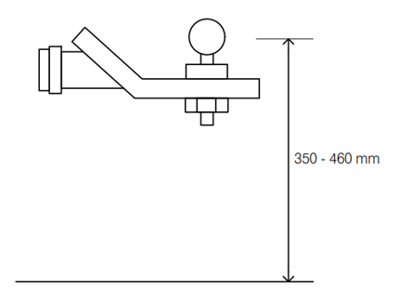
Trailers should be designed to be level within this range.
50mm ball couplings must be marked with their trailer ATM rating (750kg, 2,000kg or 3,500kg), manufacturer name or trademark, a code to indicate the serial number, batch and production date, the words ‘Do Not Weld’ if the coupling is made from non-weldable material, the words ‘Weld Only’ if the coupling body is specifically designed to be attached by welding only, and ‘50’ to indicate the ball diameter.
    - Other couplings
Refer to ADR 62/- Mechanical Connections Between Vehicles for couplings:
- not covered above
- suitable for trailers over 3,500 kg ATM
- approvable under UN regulations i.e. couplings that meet the technical requirements of UN R 55/01.
Question: I build off-road camper trailers, and 50mm ball couplings do not provide the required articulation that is needed off-road. A supplier has approached me with a suitable off-road coupling that looks appropriate for my needs. How can I ensure it is compliant?
You should ask the supplier for the coupling’s component type approval number. This shows that the coupling has been tested to meet the requirements of the ADRs.

- Mudguards
  - Function
All trailer wheels must be fitted with wheel guards (mudguards).
These must:
- protect other road users against thrown-up stones, mud, ice snow and water
- help prevent people contacting the moving wheels.
  - Design
Mudguards can be formed by any, or all, of the following:
- the trailer’s body structure
- specifically-shaped covers over the wheels
- mud-flaps
When two or more axles form an axle group, on each side of the trailer:
- separate mudguards may be fitted to each wheel, or
- a single continuous mudguard that cover the wheels may be fitted.
    - Width
Mudguards must be wide enough to fully cover:
- the full width of the widest tyre and wheel combination that may be fitted by the manufacturer as options.
Note: in the case of a dog trailer with steerable front wheels, the width requirement applies only with the wheels in the straight-ahead position.
    - Length
- Trailers with a GTM not over 3,500kg can comply with either of the two approaches shown below.
- Trailers over 3,500kg GTM must comply with the second approach.
- Trailers with more than one axle in an axle group may have individual mudguards for each wheel or may have one mudguard covering all wheels as long as the front of the guard meets the requirements in approach 2 for the front wheel and the rear of the guard meets the requirements in approach 2 for the rear wheel.
Approach #1
The mudguard must extend at least as far forwards as a position indicated by a line extending outwards from the centreline of the wheel, 30 degrees forward of vertical.
The mudguard must extend at least as far rearwards and downwards as a position indicated by a horizontal line placed 150mm above the centre of the wheel.
In Approach #1, the mudguard must extend at least as far forwards as indicated by the 30 degrees line. The mudguard must extend at least as far rearwards and downwards as indicated by the horizontal line, located 150mm above the wheel centre.
Approach #2
The mudguard must extend at least as far forwards as a position indicated by a vertical line, placed at the leading edge of the tyre. The mudguard must extend at least as far rearwards and downwards as a position indicated by a horizontal line, placed 230mm above the road.
In Approach #2, the mudguard must extend at least as far forwards as a vertical line placed at the leading edge of the tyre. The mudguard must extend at least as far rearwards and downwards as indicated by the horizontal line, 230mm above the road.
Note: The 230mm rear clearance dimension shown in the above diagram can include the use of a mud flap.
On off-road vehicles, this clearance can be increased to 300mm.
This requirement does not apply if the mud guard extends to a point that is within an area formed by the ground and a line drawn at 20 degrees upwards from the contact point of the tyre with the ground.
- Axles and suspension
Trailers may have axles at one or two locations.
If the trailer has two axle groups, the front axle group must be steered by the drawbar.
An axle group can comprise single, tandem or triaxle axles. Within an axle group:
- the two axles must not be more than 2,000mm apart
- three axles must not be more than 3,200mm apart overall.

Examples of trailer axle configurations.
All axles in a group must be interconnected by load-sharing suspension, except for the following configurations
- where the two axles in a group have their centres not more than 1,000mm apart
- where the three axles in a group have their centres not more than 2,000mm apart
- where the four (or more) axles have their centres not more than 3,200mm apart.
Where non-load sharing suspension is used in ‘close-coupled axles’, the following must apply. The individual axles, and the wheels and tyres fitted to each axle, must have a load carrying capacity at least 120% of the load on that axle with the trailer at its ATM (maximum permitted load).
Load sharing suspensions must be designed so that each axle in a group carries the same load irrespective of the relative movement of the wheels.
A diagram will be added in future to demonstrate ‘Non-load sharing suspension used with close-coupled axles must have each axle (and corresponding wheels and tyres) rated for at least 120% of the load on that axle with the trailer at the trailers ATM on a level surface’.
Load-sharing suspension must be designed so that each axle in a group carries the same load, irrespective of vertical movement of the axle.
- Wheels and tyres
  - Requirements
All tyres fitted to the trailer must be of suitable specifications for the trailer’s intended use. These specifications include:
- size
- speed rating
- load rating.
All wheels and tyres (including retreaded tyres) must comply with the appropriate ADRs.
These include ADR 23/… Passenger Car Tyres, 95/… Installation of Tyres, 96/… Commercial Vehicle Tyres and 42/… General Safety Requirements.
  - Tyre placard
Trailers with a GTM not exceeding 3,500kg must be fitted with a tyre placard that includes at least the manufacturers recommended:
- tyre size
- tyre load rating
- speed rating
- cold inflation pressure.
The tyre placard should be made of durable material and positioned where it can be easily seen.
  - Wheels
All wheels fitted to the trailer must be suitable with respect to their dimensions, speed and load performance characteristics.
- General requirements
  - Trailer requirements
    - Vehicle plate
All trailers must be fitted with a vehicle plate. The plate must be:
- durable
- permanently attached (e.g. by welding or riveting) to the trailer. Such a plate will be considered a secure vehicle marking for the purposes of ADR 61/03.
The information on the plate must be:
- embossed, indented, etched or engraved
- in English, using block letters and numerals not less than 2.5mm high.
The information on the plate must comprise:
- manufacturer’s name or the vehicle make (if submitting a concessional RAV entry application AND the trailer is home built, or you cannot identify the make of the trailer, you can enter the make of Concessional trailer on the plate and the application in ROVER.
- vehicle identification number
- aggregate trailer mass (ATM)
- gross trailer mass (GTM)
- tare mass.
The vehicle plate may also include the:
- tyre information covered in Chapter 12.2
- trailer model
- trailer build date
Note: The mandatory details on the vehicle plate must match those entered on the RAV. An offence occurs if an actual vehicle specification (for example, tare mass) does not match the details entered on the RAV.
    - Vehicle Identification Number (VIN)
All trailers must have a unique 17-character Vehicle Identification Number that meets the requirements outlined in ADR 61/03.
Note: Some state and territory registering authorities require a VIN to be stamped onto a substantial part of the trailer (i.e. drawbar) for registration purposes. It is recommended that a secondary VIN be provided in addition to the one provided on the vehicle plate.
    - Carrying passengers
Trailers of any kind must not be designed or used for carrying passengers.
    - Projections
All trailer exterior fittings must be designed, constructed and attached to the trailer in a way that reduces the risk of injury to a person.
For example:
- exterior fittings that are pointed or have sharp edges must not be used
- bumper bars should have their ends turned inwards to avoid the risk of hooking or grazing.
All trailers must be constructed so that exterior surfaces do not have pointed or sharp edges.
Trailers must also not be equipped with any interior fittings that, through being pointed or sharp, could cause injury.
    - Semi-trailer rear under-run impact protection
Semi-trailers over 3,500kg GTM must be equipped with rear under-run impact protection. This must comprise a bumper that:
- has a lower surface no more than 600mm above the ground with the trailer unladen
- has a rear surface that is no more than 600mm forward of the rear of the trailer
- is attached to the trailer’s structural members.
Note: All gooseneck and fifth-wheel caravans are classed as semi-trailers.
  - Caravan-specific requirements
    - Doors
All caravans must have only outward-opening or sliding doors.
At least one door must be located on the left-hand side or rear of the caravan. A door on the left-hand side or at the rear must also be able to function as a door, in the normal sense of the word, providing direct entry to and egress from the vehicle.
Whilst there are no specific dimensions, the intent is clearly to enable an average size person to easily enter and exit the vehicle without additional external fixtures or fittings. In addition, there must be no impediments (such as fixed objects) which interfere in any way with the easy use of doors for entry and exit.

    - Fire extinguishers
- All caravans must be fitted with at least one fire extinguisher.
- Fire extinguishers and fire blankets used in caravans must conform to Australian Standard AS 2444-1985 – Portable Fire Extinguishers and Fire Blankets – Selection and Location.
Caravan type | Minimum rating and classification of extinguishers | Minimum number of extinguishers
Single compartment | 1A:5B | 1
Multi-compartment | 1A:5B | 2
Note
1. Where cooking appliances are installed, a fire blanket is recommended.
2. For trailers intended for operation in remote areas, consideration should be given to fitting further fire protection equipment, i.e. in addition to that shown in the above table.
3. To gain access to awkward locations, consideration should be given to the provision of extinguishers equipped with hoses.
4. Smoke alarms are recommended and are required by some States and Territories.
    - Toilets, basins and sinks
- Toilets must not discharge directly onto the road.
- Toilet closets must vent directly to atmosphere.
- Tanks into which toilets discharge must contain non-inflammable and non-irritant chemicals to form an efficient deodorant and germicide.
- Basins and sinks must not drain into the toilet tank.
    - LPG Installations
Unless otherwise approved, LPG installations in caravans must comply with the requirements of the Code Governing the Installation in Caravans of Liquefied Petroleum Gas Equipment and Appliances. Also, refer to AS/NZS 5601.1:2013 – Gas installations – General installations, State, and Territory registering authorities.
Note: For AC Power System requirements, refer to Chapter 7.3
    - Load carrying capacity
The caravan should have sufficient load carrying capacity for its intended purpose and remain within the manufacturer’s specified GTM and ATM values.
Load carrying capacity should:
- include all supplied equipment, such as toilet, refrigerator, shower, gas cylinder, including the mass of all fluids and gas as full capacity. If greywater or blackwater tanks are provided, their mass may be reduced by the mass of the water stored in any freshwater tanks.
- allow for equipment that is not supplied with the vehicle but is intended to be fitted based on provided features. For example, the allowance for jerry can holders must include the mass of the jerry cans and associated fuel. The allowance for bike racks must include the mass of the bikes.
- include a personal effects allowance to cover cooking utensils, bedding, luggage and other such items. The allowance is 50 kg for each of the first 2 sleeping berths and 10 kg for each additional sleeping berth.
Note: To determine the certified gross axle load rating (GALR), the personal effects allowance should be distributed uniformly, as outlined in the definition of GTM.
The caravan’s luggage requirements are separate from, and in addition to, those of the towing vehicle. The towing vehicle’s specific luggage and load distribution requirements should also be met.
- Testing drawbar strength and safety chain attachment point strength
The content of the following section is currently under review
The following test method is considered acceptable to confirm compliance with the drawbar strength and safety chain attachment point strength requirements in ADR 62/02. All testing must be conducted by testing facilities approved under section 111 of the Rules.
  - Drawbars
The drawbar fitted to a trailer shall be tested by application of a static test load. The loads applied shall be a function of the aggregate mass of the trailer and applied to the centreline of the towing coupling fitted to the drawbar. The trailer may have either a rigid drawbar or a hinged drawbar.
    - Test equipment
The test rig shall consist of:
- a structure to be capable of accepting the trailer, or the relevant portion of a trailer to which the drawbar is attached
- fixtures to restrain the trailer on the test rig during the test without affecting the vehicle structure in the area of the drawbar attachment
- a loading device, usually a hydraulic cylinder, of sufficient capacity to apply the test loads, and with brackets to enable longitudinal, vertical and transverse loads to be applied
- fixtures to attach the loading device to the drawbar, usually a towing coupling of appropriate size
- force measurement to measure the test load applied to the drawbar may be made by either: a pressure gauge, taking account of seal friction or: a load cell with appropriate power source
- amplifiers and read out instrument: a recorder may be used to produce a permanent record of test load -v- time for the test
- time measurement; stopwatch.
Note: Care should be taken when setting up the test components that the forces are applied in line with the heads of the testing machine.
  - Test procedure
    - Drawbar
Securely attach the trailer in its road-wise position to the test rig so that application of the test loads is on the centre line of the drawbar. The body of the trailer shall be securely restrained on the test rig. Apply the test loads to the drawbar coupling as follows after taking account of instrument uncertainty:
- longitudinal tension and compression = 1.5 x aggregate trailer mass x 9.81
- transverse thrust = 0.5 x aggregate trailer mass x 9.81
- for rigid drawbars, vertical tension and compression= 0.5 x aggregate trailer mass x 9.81.
    - Safety chain connections
Apply the following loads to each attachment point:
- longitudinal tension load in Newtons = aggregate trailer mass x 9.81
- vertical loads in Newtons = 0.5 x aggregate trailer mass x 9.81.
  - Analysis of results
On completion of the tests the drawbar and its attachments to the trailer, and the safety chain attachments shall be carefully examined. The ‘Drawbar’ and safety chain attachments shall withstand forces applied at the centreline of the intended ‘Coupling’ without incurring loss of attachment or any distortion or failure which will affect the safe drawing of the towed trailer.
  - Reporting of results
The testing facility shall prepare a report describing the trailer and drawbar together with the safety chain attachments tested, the loads imposed, and the results of examination of the components after testing.

