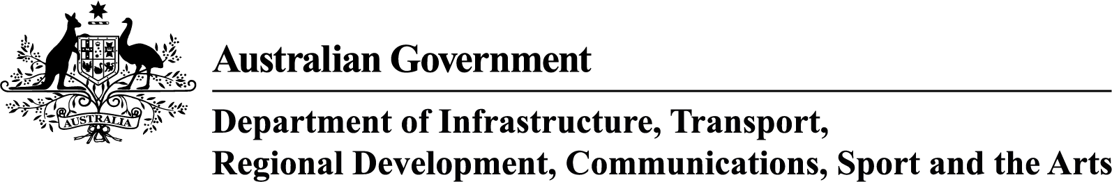

urban Precincts and Partnerships Program—Announced Projects
October 2025

uPPP Program stream | Applicant Organisation | Project Title | Project Description | Project Location | State | Commonwealth Funding Approved | Date Announced
One | Department of Energy and Public Works | Boggo Road Innovation Precinct Planning | Funding will support development of a precinct-wide plan including implementation plans and preliminary business cases. | Dutton Park | QLD | $4,949,502 | 10 October 2025
One | City of West Torrens | Creating the City Fringe West Precinct from Industrial Foundations | Funding will support precinct development and planning to activate former industrial sites and establish the ‘City Fringe West Precinct’. | Thebarton and Torrensville | SA | $1,026,545 | 23 October 2025
One | Hume City Council | Pioneering Urban Innovation: Planning a New City in Melbourne's North | Funding will support delivery of an urban design framework and master plan for a thriving transport hub and mixed-use precinct. | Kalkallo | VIC | $2,622,500 | 14 October 2025
One | City of Melbourne | Birrarung Riverfront Activation Precinct plan | Funding will support planning to revitalise the north bank of Melbourne’s Yarra River (Birrarung). | Melbourne | VIC | $4,435,839 | 14 October 2025
One | City of Canning | Canning Rail to River Precinct | Funding will support detailed planning for delivery of 10 infrastructure projects within the precinct. | Cannington and Queens Park | WA | $1,512,217 | 13 October 2025
One | Hume City Council | Broadmeadows Precinct Roadmap Strengthening Place, Community & Connection | Funding will support the development of an integrated roadmap which aims to revitalise Broadmeadows, address gaps and identify future opportunities through a place-based approach to precinct planning and delivery. | Broadmeadows | VIC | $3,332,500 | 23 January 2025
One | Maribyrnong City Council | Creative West: Transforming Footscray into a thriving cultural hub | Funding will support the revitalisation of Footscray's Metropolitan Activity Centre by establishing a cultural precinct in Melbourne's inner west. | Footscray | VIC | $5,000,000 | 23 January 2025
One | Brimbank City Council | Sunshine Energy Park Feasibility Study and Business Case | Funding will support the development of a comprehensive business case and delivery strategy to transform a closed former landfill site into a new 74-hectare "central park". | Sunshine | VIC | $500,000 | 24 January 2025
One | Ipswich City Council | Ipswich Central Hearts: Arts, Commerce and Urban Greening | Funding will support the planning and detailed design for key activities in Ipswich Central, including expanding Ipswich Art Gallery, redeveloping the Ipswich Civic Centre, streetscape refresh of Brisbane Street, connection to the cycle network, urban greening initiatives, and the addition of a new Black Box Theatre. | Ipswich | QLD | $3,837,000 | 30 January 2025
Two | Adelaide Central School of Art | The Erindale Transformation: A Multi-use arts zone in the Glenside Precinct | Funding will support the transformation of a historic building in the Erindale Precinct into a multi-use facility with artist studios, a First Nations artist residential studio, galleries, mental health arts program, education spaces, a Kaurna native edible garden, and a social enterprise cafe. | Erindale | SA | $6,954,000 | 30 January 2025
Two | Women’s & Children’s Hospital Foundation | Family Health and Wellbeing Hub in Elizabeth Vale, South Australia | Funding will support the Women's & Children's Hospital Foundation to establish a Family Health and Wellbeing Hub, equipped to provide co-located, integrated wellbeing services. | Elizabeth Vale | SA | $26,050,046 | 30 January 2025
Two | City of Armadale | Armadale Central Park | Funding will support construction of a new public space, ‘Central Park’, next to the new Armadale train station | Armadale | WA | $5,000,000 | 13 October 2025

