

Update to modernise and harmonise classification guidelines 2025




Foreword
Australia’s classification symbols, from G to X18+, are widely recognised and trusted. They help people choose what to watch, read and play. But the media environment has changed. Streaming, interactive content and global platforms now shape how Australians encounter media, and the current guidelines were not designed for this reality.
This review focuses on practical renewal, not a redesign. It keeps what people value, the familiar symbols and clear age categories, while updating the guidelines and thinking behind them. The aim is a simpler, more consistent approach across films, games and publications, supported by modern technology and clearer consumer advice.
Community and stakeholder input has highlighted priorities for change: decisions grounded in evidence and potential harm (not moral judgement); clearer signposting of sensitive content such as sexual violence, suicide and discrimination; and better accessibility through plain language, visual cues and digital tools (for example, QR codes and a searchable public database). Industry participants also called for streamlined processes, transparency in decision-making and the ability to update classifications when new information emerges.
The concepts presented here translate those priorities into testable options, including harmonised criteria across media, a “single-touch” principle across iterations of the same media to reduce unnecessary reclassification, improved consumer advice and strengthened public education. They are designed to protect without overreach, inform without censorship, and reflect Australia’s diversity.
This document invites public feedback. Your views will help refine the guidelines so the classification system remains trusted, consistent and useful in a rapidly changing digital world.

Key highlights
- Synopsis of existing literature and establishing the evidence base.
- Outcomes of community co-design workshops and interviews with industry experts.
- Concept testing from a respresentative sample of Australian adults and children.
- Upcoming public consultation process to test and refine recommendations.

Contents
Foreword 1
Executive summary 2
Method and approach 6
Evidence review activities 9

Expert insights and concept development 10
Concept testing 12
About the Social Research Centre partnership 17

Executive summary

Context
Australia’s classification system is one of the most recognised and trusted public frameworks in the world. The familiar “G to R18+” symbols are part of the national lexicon, guiding families and consumers in making informed choices about what to watch, read or play. Yet the media landscape in which the system operates has changed profoundly. Streaming platforms, interactive games and user-generated content have transformed how Australians engage with media.
Consultation across government, industry and the community has identified a timely opportunity to modernise and harmonise the classification guidelines. Classification guidelines are the rules that determine how films, games and other content are rated for different age groups. They are being updated to keep what works, modernise what doesn’t, and ensure the system remains effective, inclusive, and trusted in a digital-first environment.

Purpose of the review
Commissioned by the Department of Infrastructure, Transport, Regional Development, Communications, Sport and the Arts (the Department), this review, delivered by the Social Research Centre in partnership with Mettlesome, aims to update and harmonise Australia’s classification guidelines. It seeks to ensure that the framework continues to protect and inform in ways that align with contemporary community standards and the realities of digital media.

The case for modernisation
Across government, industry, and community sectors, stakeholders consistently described a classification system that has served Australia well but no longer reflects modern media realities. While valued for its clarity and intent, the system is hindered by fragmentation, inflexibility and outdated technology.
Industry participants highlighted legacy systems and inconsistent processes that slow classification and cause confusion, particularly where legislation overlaps, such as with the Online Safety Act 2021 (Online Safety Act). Meanwhile, community and advocacy groups called for a more inclusive, evidence-based approach that reflects contemporary values and avoids moral framing.

Shared priorities for reform
Stakeholders expressed a strong and unified desire for reform that maintains public trust while improving relevance and transparency. Core priorities include:
- Retaining the existing system of symbols and age categories (such as PG, M, R18+), with some refinement and updating the guidelines that sit behind them.
- Simplifying and harmonising classification criteria across films, games and publications.
- Providing clearer, harm-informed consumer advice that reflects modern issues such as sexual violence, discrimination and suicide.
- Streamlining processes through modern technology, including searchable databases and digital classification tools.
- Allowing post-release updates to classifications when new information or contexts emerge.
These reforms aim to deliver a system that is flexible, transparent and evidence-led, supported by modern infrastructure and accessible communication.

Responding to modern values
Community and advocacy voices emphasised the need for a system that better represents Australia’s diversity and acknowledges lived experience. They called for classification processes that are inclusive and appropriately responsive to community sensitivities – issues such as discrimination, cultural harm and mental health. Stakeholders also supported introducing multilingual consumer advice and clearer explanations for classification decisions to strengthen trust and understanding.

Structural and systemic challenges
Government and regulatory agencies identified several structural challenges, including overlapping responsibilities, limited jurisdiction over online and streaming content, and inconsistent enforcement across states and territories. There was strong support for a centralised oversight model with clearer accountability, complemented by modern digital tools, such as unified title listings, QR-code access to classification information, and options for users to personalise settings and guidance.

Proposed Reforms and Next Steps
Two key structural reforms are proposed to ensure the system’s long-term sustainability:
- A Classification Advisory Council to provide ongoing community input and ensure the guidelines evolve with changing social standards.
- Stronger regulatory oversight of growing industry self-classification and automation tools to improve efficiency while maintaining accountability.
These recommendations form the basis of the next phase, a national public consultation process.

Recommendations
Recommendations for changes to the classification guidelines include a few main headline adjustments:
- Reducing the complexity of implementing classifications in a modern age of near-unlimited media consumption.
- Supporting the use and understanding of the classification system for the general public by improving how individuals can interact with the system.
These headline adjustments are informed by twenty-two concepts that include changes to the guidelines instruments themselves as well as supporting tools, processes and platforms.
Proposed changes to the guidelines include:
- Introduction of a PG13 rating.
- An overhaul of the Themes classifiable element to include relevant categories and remove legacy inclusions.
- A re-balancing of both community concern about particular content with established evidence on potential harms, when classifying.
- A focus on reflecting the impact of real-world activities in video games when classifying (e.g. gambling in video games replicating the same psychological effect).
- Adjusting MA15+ to MA16+.
- Aligning classification of publications to match other media (G, MA16+, R18+, X18+).
Some of these proposed changes include:
- Developing icons for key content warnings to be shown on media, alongside the overall classification.
- Cleaning and unifying the Australian Classification website database to remove duplication and confusion in title listings.
- Single-touch classification for industry to classify a title once and update the classification only if content significantly changes.
- Quick links (via technology such as QR codes) on media for the public to access greater detail on the spot.
- Personalised preferences for classification on the Australian Classification website.
- An Advisory Council formed from community representatives to inform decisions.
- Expansion of the auto-classification tools.
# | Element | Description
C01 | PG13 Rating | The guidelines could be updated with a new classification rating - PG13.
C02 | Overhaul of classifiable element ‘Themes’* | Themes could be re-worked to clearly classify, identify and communicate specific community needs so that the resultant classification truly reflects the content.  Genre descriptors (e.g. science fiction, fantasy) could be removed from Themes.  Themes would act as a collection of sub-elements for classification and reflect the most requested issues. These would be: Sexual violence, suicide, discrimination and scariness.  When a classification matrix for a title is shown, the sub-matrix of Themes would also be visible.
C03 | Improved reliance on evidence over morality | Guidelines would be updated to clearly define terms and thresholds to balance both community concern for certain content with any established evidence-based research of actual harms.
C04 | Interactivity classifications focus on replication | Currently, classifications of elements in video games have a stricter benchmark when interactivity is involved. If a video game includes violence or nudity at the same level as a film, the game will be considered more extreme.  The classification guidelines could be updated to remove the harsher judgement of video games’ interactivity, except when it comes to real-world replication. E.g. violence in a video game is not the same as real world violence, but gambling in a video game for a reward or incentive is, in effect, the same as gambling in the real-world.
C05 | MA15→ MA16+ | The MA15+ classification could be updated to MA16+, reflecting the social benchmark of age sixteen, and other legislation such as the Online Safety Act that prohibits certain online environments for those under sixteen.
C06 | Publications to adopt the rest of the classification system | Publications currently have a unique classification system unlike other media - Unrestricted, Unrestricted Mature, Category 1 Restricted and Category 2 Restricted.  To simplify, publications could adopt the same classification system, but only using the relevant levels:  Unrestricted - General  Unrestricted Mature - MA16+  Category 1 Restricted - R18+  Category 2 Restricted - X18+
C07 | Clarify definitions | The current language in the guidelines is ambiguous, which can lead to broad interpretation and potential bias in classification decisions, depending on how instructions and definitions are understood.  To address this, clear and well-informed definitions and instructions should be developed alongside updated evidence, ensuring the guidelines provide objective and understandable direction for classifying content.
C08 | Reconsideration of sexual content | Currently, sexual scenes involving participants that are non-heteronormative (a man and a woman) are often automatically considered higher impact, as are depictions that include fetish or kink-related acts typically judged through a moral lens rather than an evidence-based, harm-informed framework.  Except in cases involving depictions of sexual violence or non-consensual acts, sexual content should be rated consistently, regardless of the artistic style or identities of those involved.
C09 | Classification Advisory Council | A Classification Advisory Council, composed of community voices, not professional industry stakeholders, could be created to not only aid in this process, but also provide a productive method by which industry and government can gain feedback on decisions and ideas.
C10 | Single touch Classification | Titles could be classified once, only to be updated again if the content itself changes. This would mean if a film is classified for theatres, it automatically carries the same rating for streaming, etc. This would reduce the burden for industry and improve the experience for consumers.
C11 | Permit updates to classifications | Currently, any change to a piece of media requires the entire content to be reclassified.  Instead, the database could allow for classifications to be updated. A record of the previous classification would be retained on the listing - if the classification changes.
C12 | Self-classification as default | A significant proportion of content is still classified by the Classification Board—a process that is both time-consuming and costly. There is also concern from industry - whether factual or not - that outcomes can be influenced by individual biases, depending on the composition of the Board.  Rather than relying on Board classification, self-classification could become the industry standard, supported by evidence-based tools - with Board classification only in rare circumstances.
C13 | Modernise the classification database | Updating the database so titles are nested together, potentially utilising AI/natural language to aid in search functionality to remove potential error from different spelling/grammar, and the reduction of required elements for an entry could aid in making the user experience of the database more manageable.
C14 | Expand use of automated classification tools | Expanding the use of automation and self-classification tools could support industry to meet classification obligations more efficiently. This may involve reviewing existing tools, introducing new ones and investing in improved technologies aligned with updated definitions. These tools would not only streamline the classification process but also enable industry to more effectively reach their intended audiences.
C15 | Classification website - uniform matrix | The website could be updated and refreshed to always show (if the data is available in the current guideline era) the classification matrix, ensuring consistency and usability for consumers wanting to know more about certain content.
C16 | Classification website - personalised preferences* | The classification website could allow users to create accounts and set personalised preferences for themselves or those they care for. When logged in and viewing a title, a consumer could then see how this title aligns with their chosen settings. It could also direct the consumer to important resources and information relevant to the content - e.g. how to introduce teenagers to higher rated content safely.
C17 | Classification website - unify listings | When viewing a listing on the classification website, it currently provides a list of all possible iterations or versions of one single title.  The website could be updated to provide one listing for a title, for ease of search, and then include the ratings under this for different versions or formats. This might greatly improve the usability of the website and reduce confusion for consumers.
C18 | Classification website - transparent decisions | The website could show a log of the questions, concerns and decisions raised/made by the Classification Board or Review Board for listings, especially where classifications were contentious. This communicates the consideration and effort undertaken by the classification process, so the public further understands the nuance that goes into classifications.
C19 | Classification website - addition of extra community information | The public actively seeks input and perspectives on content and classifications from other organisations and community groups. Further information and nuance are often sought to understand content appropriateness. Example resources/groups include Children & Media Australia, Common Sense Media etc.  The website could display a summarised dashboard of community input from these groups on content listings and provide additional links to their resources as well as those of other organisations, such as eSafety.
C20 | Element icons | Icons could be implemented to highlight the most important and highest rated classifiable elements (e.g. Nudity, Violence, Sex) in a given media. Specialised icons could be used to highlight areas of significant community concern when they are otherwise hidden under ‘Themes’ (e.g. sexual violence, suicide).
C21 | Quick links to classification listings | Classification titles could come with an option to quickly access the title listing on the classification website, via QR Codes (or similar technology) for easy scanning.  This would mean that some information could be displayed firsthand, while deeper detail is readily available via a smartphone scan.
C22 | Generational education campaign | Misunderstandings about classifications has led to confusion about its function and place in society and the modern media landscape.  A public campaign to remind Australians of the purpose and functionality of the classification system could be implemented. It could provide clear education and communication around its role in advice and restriction of certain content, that it is a point of reference for information so that individuals can make informed decisions for themselves and their children, and clearer understanding on what the symbols and levels mean.

Method and approach

Overview
Following the announcement made by the Hon Michelle Rowland, the then-Minister for Communications, in March 2023 of a two-stage classification reform agenda, the Department undertook a structured series of engagements with the public, industry and government stakeholders. Early priority reforms, implemented in 2024, focused on enabling greater industry self-classification, aligning legislation across sectors and addressing gambling-like content in games. Building on this foundation, the current reform work is centred on updating the classification guidelines themselves, a process underpinned by comprehensive national consultation.
To deepen understanding of public attitudes and priorities, the Department engaged independent research partners, the Social Research Centre and Mettlesome, to design a participatory consultation program. This approach included a combination of qualitative and quantitative research:
- National online engagement through SRC’s Conversations in Australia™ platform, combining survey and deliberative activities to explore community awareness, values, and expectations for classification.
- Public co-design workshops held in Brisbane and Sydney, where participants collaborated to identify system pain points and imagine the features of a “modern classification experience.”
- Targeted interviews and submissions with over 35 expert stakeholder groups, including the Classification Board and Review Board, the Office of the eSafety Commissioner, the Australian Communications and Media Authority, state and territory government representatives, industry bodies (film, streaming, gaming, publishing), researchers, and advocacy groups representing families, children, and community safety interests.
- Quantitative online survey with 1,000 adults, parents and children.
Feedback from these activities revealed a consistent desire for reform that builds on trust and familiarity rather than replacing the system outright. Participants wanted clearer, harm-informed content advice, recognition of emerging concerns such as suicide and discrimination and more transparent decision-making.
The insights gathered through this consultation were synthesised into a Concept Report, which translated stakeholder feedback into a practical reform blueprint. Key concepts tested through this process include:
- Harmonised, evidence-based classification guidelines across all media.
- Expansion of a “classify-once” principle (across different media) and post-release amendment capability.
- Enhanced accessibility through digital tools such as QR codes, content icons, and an improved classification website.
- Establishment of a Classification Advisory Council to maintain ongoing community input.
- Strengthened public education to rebuild understanding of the role and purpose of classification.
These activities build on the comprehensive two-stage reform process currently underway to bring about a fundamental modernisation of classification policy. Together, they demonstrate broad public and sectoral support for a modern, transparent and inclusive classification framework that continues to protect and inform Australians in a digital-first environment.
Process map of the project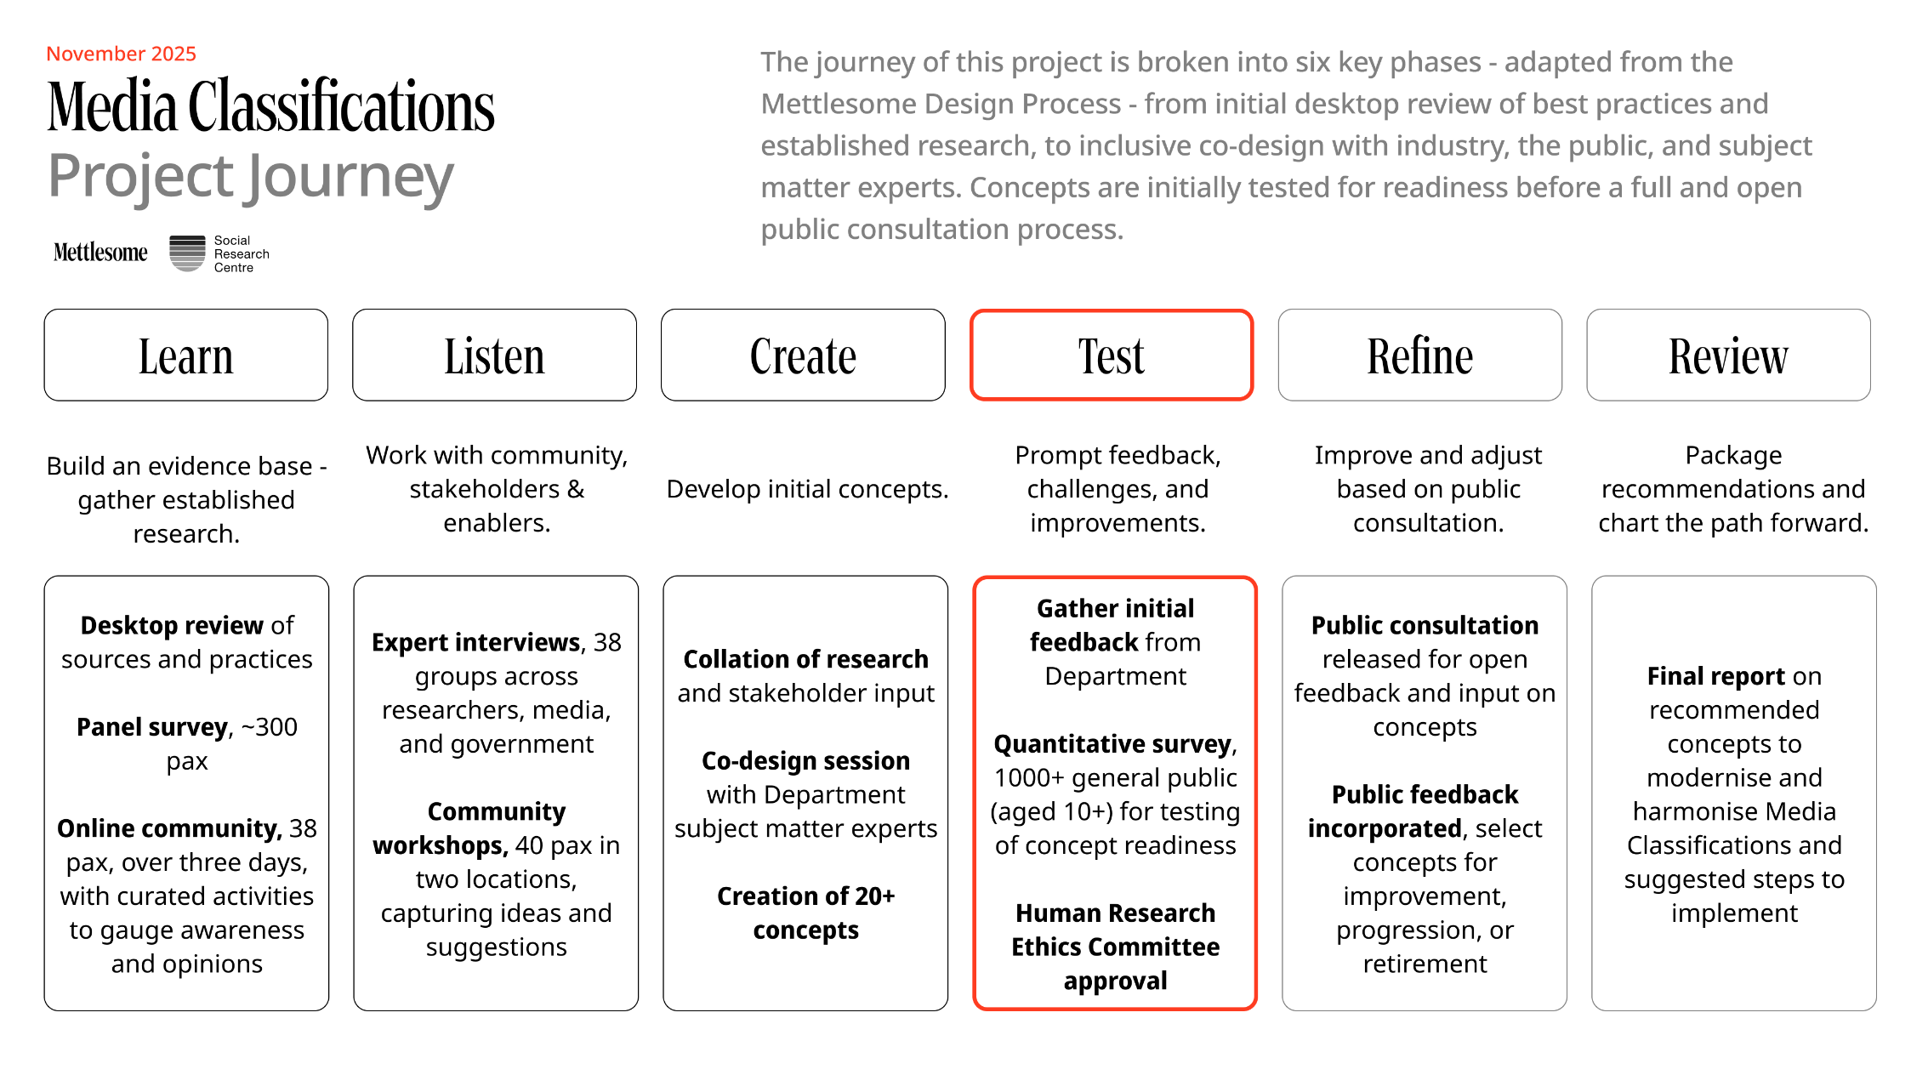

Approach in more detail
The reform of Australia’s National Classification Scheme has been guided by a structured, evidence-based research process designed to ensure the system remains relevant, transparent and responsive in today’s rapidly changing media environment. Consultation and concept development were broken into component phases of work.

Evidence review
The first component established the evidence base for reform through three linked activities: a rapid desktop review, a national panel survey and an online community study.
- The desktop review analysed Australia’s classification framework, synthesising academic literature, previous reviews and international comparators (Canada, UK, US, New Zealand) to identify gaps and opportunities for reform.
- The panel survey (n=318) measured public familiarity with classification categories, media consumption patterns and the influence of classifications on viewing choices.
- The online community (n=28) explored awareness, satisfaction and attitudes toward reform options, drawing comparisons with international models.
Findings from this phase shaped the next stages of research by clarifying key reform issues, refining the elements to explore in public consultations, and informing the development of concept-testing tools. This ensured subsequent engagement was grounded in empirical evidence and contemporary community perspectives.

Community workshops and expert insights
This component was divided into two phases with the general community and industry experts:
- Phase 1 focused on understanding community expectations and stakeholder experiences with the current classification system, identifying opportunities for greater clarity, consistency and inclusiveness. Building on these insights. This component of work involved public co-design workshops and over 35 expert interviews undertaken by Mettlesome to understand the public, industry and government’s perspectives on the classification framework, classification system and how it might evolve to better serve Australians and our modern and evolving media landscape.
- Phase 2 translated the findings into practical, draft recommendations aimed at harmonising classification standards across media types, strengthening transparency and improving accessibility for all Australians.

Community perspectives
Based on the recommendations developed from the community workshops and expert insights, a quantitative online survey with 1,000 adults, parents and children was undertaken to test people’s understanding, appeal and likelihood to use each of the concepts. This work then informed the final concepts to take to public consultation.

Public consultation
This is the current process of engagement to hear from the public on the proposed recommendations and changes.
Together, these phases form a critical step towards developing an updated, future-ready classification framework that protects and informs audiences while supporting creative and technological innovation.

Evidence review activities
The first component of this research involved a rapid desktop review, a panel survey and an online community. The core purpose and data sources used for these activities is summarised in the following table:

 | Purpose | Data sources
Rapid  desktop review | - Analyse existing structure, regulatory instruments and classifiable elements of Australia’s classification system  - Identify gaps and opportunities for reform by synthesising evidence from academic literature, prior reviews and systems of international comparators | - Academic literature and evidence from Australian and culturally comparable jurisdictions (Canada, UK, US, NZ)  - Documents pertaining to previous reviews of Australia’s system
  Panel survey | - Generate preliminary data on public familiarity and engagement with Australia’s classification symbols and categories  - Identify patterns in media consumption and classification influence on consumption patterns | - n=318 participants drawn from SRC’s Conversations in Australia™ panel
  Online community | - Develop preliminary understanding of public's awareness, satisfaction and engagement with the current classification system  - Gauge early opinions on the approaches used by international comparators (UK, Netherlands, New Zealand). | - n=28 participants drawn from SRC’s Conversations in Australia™ panel engaged in set of qualitative activities across 3 days

What we know
- The system for rating films, games and other content hasn’t had a major update since 1995.
- Different media have different rules, which causes confusion, especially online.
- Other countries use simpler, clearer systems (like colour codes, icons and specific warnings).
- People want ratings to alert them to the presence of certain types of content, including modern issues such as such as mental health, suicide, discrimination and gambling-like features in games.
- Many support letting industry rate its own content, with government oversight to ensure fairness.

How did these phases inform the rest of the research?
Given the iterative design of the project, this foundational research directly shaped the design and delivery of the subsequent public consultations and the concept-testing survey with parents and children in the following ways:
- The synthesis of academic literature, review papers and other key documents consolidated the working team’s understandings of core reform issues and opportunities and grounded decisions about the potential concepts to test in later stages of research within a working knowledge of Australia’s classification policy context.
- Findings from the desktop review, panel survey and online community fed into the public consultations led by Mettlesome, allowing for conversations to be facilitated based on preliminary understandings of the perspectives of everyday Australians.
- Sort-and-rank activities regarding the seriousness of different classifiable elements (e.g. violence, coarse language, sexual content etc) enabled a refinement of the issues to be addressed in specific classifiable elements.
- Activities in the online community allowed for the harvesting of preliminary reactions and ideas about different kinds of reform options, facilitating the development of the concept testing survey tool.

Expert insights and concept development
This component of work was broken into two phases of activity.
Phase 1 explored community and expert perspectives on the current system, identifying priorities for clarity, inclusiveness and consistency across media. Building on these insights, Phase 2 developed and tested a suite of draft recommendations to harmonise classification standards, strengthen transparency and improve accessibility for audiences and industry.
These consultation and concept development activities found strong support for keeping Australia’s existing classification symbols while modernising their application and communication. Participants called for clearer content descriptors, greater consistency across media types and more transparent decision-making. Industry and government stakeholders supported streamlined processes and improved digital tools. The concept development phase translated these insights into practical ideas, including harmonised guidelines, a classify-once framework, and enhanced accessibility through digital and visual updates, laying the groundwork for a more consistent, inclusive and future-ready classification system.

Phase 1: Community and expert insights

Purpose and scope
Phase 1 sought to understand how Australians experience and interpret the National Classification Scheme, and how the existing classification guidelines might better reflect modern media use and community standards.
The research explored public and expert perspectives on the relevance, clarity and consistency of classification information across films, computer games and publications.

Consultation activities
Two major consultation activities were conducted:
- Public workshops in Brisbane and Sydney brought together participants from diverse age groups and cultural backgrounds. Using persona-based exercises and design activities, participants examined what makes a classification system effective, trustworthy and easy to understand.
- Expert interviews with representatives from industry, government, academia and advocacy sectors provided informed commentary on how classification operates in practice and how it could evolve to meet emerging needs.

Key findings
Across community and expert engagement, participants emphasised:
- The importance of consistency and harmonisation across all forms of media.
- A desire for clearer, more intuitive symbols and descriptors, including attention to content themes such as violence, sexual violence, discrimination and mental health.
- The need for greater transparency in how decisions are made and opportunities for public education about classification.
- Support for technological innovation, such as QR codes linking to detailed classification information and systems that can evolve as media platforms change.
Experts and stakeholders broadly agreed that the current scheme is respected but no longer aligned with modern content consumption or technology, underscoring the need for a holistic refresh.

Outcome of Phase 1
Findings from Phase 1 formed the evidence base for developing proposed updates to the classification guidelines. Specifically, the results established guiding principles for the next phase, that Australia’s classification system should be modern, consistent, transparent, inclusive and adaptable to new forms of media.

Phase 2: Draft recommendations and reform concepts

Purpose and scope
Building directly on the evidence gathered in Phase 1, Phase 2 translated insights into a set of draft reform concepts and recommendations. Over the course of 10 weeks, we conducted extensive interviews and received written responses from experts, industry, government, research and community bodies across Australia's media and classification ecosystem. Conversations explored key challenges, strengths and future-facing design opportunities for the National Classification Scheme.
This phase aimed to uncover ways to modernise and harmonise classification processes, ensuring they remain effective for audiences, industry and regulators in a changing digital environment.

Research and design process
The Phase 2 work program:
- Reviewed and synthesised evidence from Phase 1 workshops, interviews and literature.
- Developed conceptual reform options across guidelines, processes, technology and communication.
- Used co-design methods and expert input to draft practical, testable recommendations.
- Integrated academic expertise from the Queensland University of Technology on digital content, gaming and online harms.

Draft recommendations
The draft recommendations are organised into four broad domains:
- Guidelines Updates: introduce clearer content descriptors, consider age-referenced categories (e.g. a PG13 equivalent), and balance a harm-informed approach with community standards.
- Process reform: streamline classification through a “classify-once” principle, strengthen quality assurance and enable timely updates.
- Technology and access: develop a modern database and tools allowing easy, unified access to classifications across media.
- Communication and education: improve public awareness through icons, plain-language descriptors and a national education campaign.
Phase 2 also highlighted opportunities to future-proof the system through ongoing monitoring, research on community standards, and exploration of artificial intelligence tools to support classification consistency.

Outcome of Phase 2
The Phase 2 Draft Recommendations form the basis for the quantitative survey to test concepts and to take to public consultation the potential future of Australia’s classification guidelines.
They propose a modernised, unified and flexible approach that balances community protection, freedom of expression and technological innovation, ensuring that the National Classification Scheme continues to serve Australians in a rapidly evolving media landscape.

Overall program vision
Australians continue to value a classification system that informs without censoring and protects without overreaching. The call is not for revolution, but evolution. This means a modern, connected and inclusive classification framework that honours its trusted heritage while embracing the realities of a diverse, digital and dynamic media landscape.
Together, the community workshops and expert interviews represent a structured process of listening, learning and designing for reform. These phases have produced a robust, evidence-based platform of insights and practical reform concepts that will guide the next stage of public consultation and policy refinement toward a modern, unified classification framework.

Concept testing
Following the expert insights and concept development, we proceeded to concept testing in September 2025. This involved an online quantitative survey conducted through the Social Research Centre’s national probability-based online panel, known as Life in Australia™. A total of 1,020 took part – including 802 adults (479 of whom were parents) and 218 children aged 8 to 17. The survey asked about their media habits, exposure to different types of content, how they feel about the current classification guides and symbols and their views on possible changes to the classification system.

Media habits and consumption behaviours
Australians have clear views on which content warnings matter most to them. Explicit warnings for depictions of sexual violence, self-harm and suicidal themes were found to be ‘extremely important’ by most adults. In contrast, warnings for scariness, smoking, alcohol, drug use and nudity were seen as less critical. Sexual content, discrimination and warnings for in-game gambling-like content were found to be moderately important.
Australian adults enjoy a mix of entertainment, with nine-in-ten watching movies or TV shows each week. Most adults also use social media, stream content online and read books or magazines. Gaming is less common amongst adults, with fewer than half playing video or online games regularly.
Children’s weekly routines are dominated by screen-based activities, with four-in-five watching movies or TV shows and a similar number streaming online. Gaming is also popular with nearly three-quarters playing video or online games. While two-thirds read or use social media in a given week, reading is more popular amongst those aged 8-12 and social media amongst those aged 13-17. When asked whether they had watched, read or played something intended for older audiences, eight-in-ten children reported that they had. Parents notice this most frequently occcurs when watching films or playing video games. However, one-fifth did recognise that their children are exposed to more mature content when reading books or graphic novels.

Recognising and using current classification guides
Most children easily recognise common classification symbols like G, PG, M, and MA15+, while fewer are familiar with R18+ or X18+. Despite this, over half of the children said that the classification symbols were only ‘sometimes helpful’.
Adults find the classification symbols most helpful when choosing what to watch with their families, with over half describing it as ‘very’ or ‘extremely’ helpful’. Around two-fifths find the system
“ Classification enables me to make a judgement on the content based on my feelings and level of tolerance for the content. It enables me to make a decision for others who may be observing with me ”

helpful when deciding what their family can play, while more than a quarter of adults feel that the classification symbols offer no help when deciding what to read.

Children are active decision-makers when it comes to their media choices, often deciding what to watch, rea, or play on their own or with some input from their parents. They show the most independence in choosing what to read, with only about a third having parental oversight. Friends were found to play a minor role in influencing what games children choose to play.
Parents echoed these patterns, saying they are most involved in decisions about what their cildren watch or play. The classification guides and symbols were reported to be used most often by parents when deciding what their children can watch or play.

Proposed concepts and updates
Within the survey, a range of potential updates to the media guidelines were presented to the adult participants, where their appeal, clarity, relevance and usability was canvassed.

Adding element icons:
Consumers often want more information than just a rating when selecting media - for themselves or dependants. This information needs to be quickly understood, uniform and easily replicated on limited space such as movie posters and game packaging.
Icons could be implemented to highlight the most important and highest rated classifiable elements (e.g. nudity, violence, sex) in a given piece of content. Specialised icons could be used to highlight areas of significant community concern when they are otherwise captured under ‘Themes’ (e.g. sexual violence, suicide).
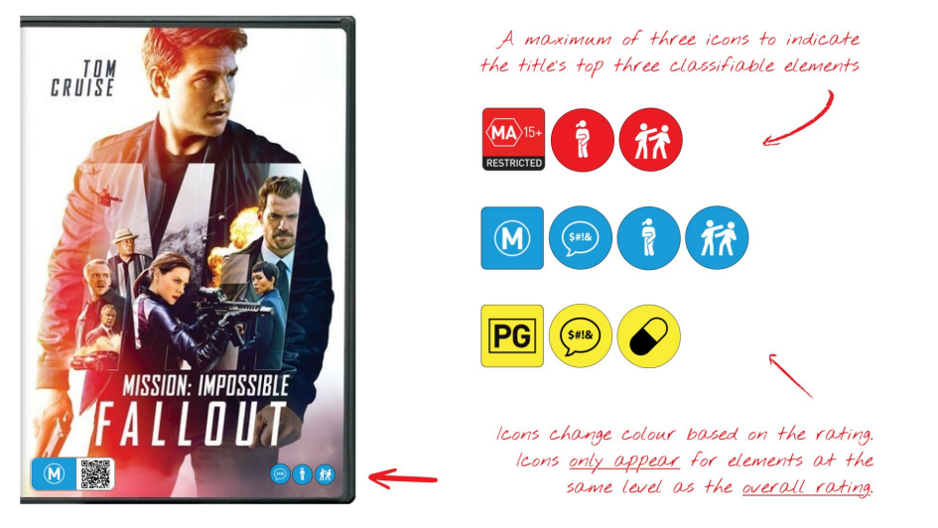

Aligning publication classifications with other media:
Certain printed publications, including some books, comics and magazines, currently use a separate classification system (Unrestricted, Unrestricted Mature, Category 1 & 2 Restricted), which can be confusing and inconsistent with the broader media classification framework.
To improve clarity and consistency, publications which require classification could adopt the standard classification levels already used for other media:
- Unrestricted → General (G)
- Unrestricted Mature → MA16+
- Category 1 Restricted → R18+
- Category 2 Restricted → X18+
This simplification would make the system easier to understand and more cohesive across media types.

Updating MA15+ to MA16+:
It is proposed to change the MA15+ rating to MA16+, aligning with:
- Social norms that recognise sixteen as a key age benchmark.
- Existing legislation, such as the minimum age for social media in the Online Safety Act, which restricts certain online content for those under sixteen.
- Aims to clarify and further delineate between PG and M (both of which have an age 15 recommendation).

Consistent rating of sexual content:
It has been suggested that the classification of some sexual content is not aligned with community standards and evidence. This might include:
- LGBTQI+ sex scenes or sexual references, and
- Fetish or kink-related acts.
A revised approach would:
- Apply consistent ratings to sexual content regardless of participant identity, artistic style or context.
- Use a harm-informed, evidence-based framework to assess impact definitions for each classification level.
- Ensure that violent or non-consensual depictions are still rated strictly based on their impact, with no exceptions for artistic merit.
This change would promote fairness, inclusivity and clarity in how sexual content is classified and seen in modern society, while continuing to ensure appropriate protection from potential harms for vulnerable groups.

Updating ‘Themes’ categorisation:
The current ‘Themes’ category acts as a broad catch-all for a wide range of content, from serious social issues (e.g. animal cruelty, mature themes) to genre elements (e.g. science fiction, fantasy). This makes classifications less clear. Proposed changes include:
- Refocusing ‘Themes’ on key community concern areas: sexual violence, suicide, discrimination (inclusive of bullying) and scariness.
- Removing genre descriptors (such as horror or fantasy) from the ‘Themes’ category.
- Displaying these specific sub-elements separately as part of a list of what the content includes, improving clarity for audiences.
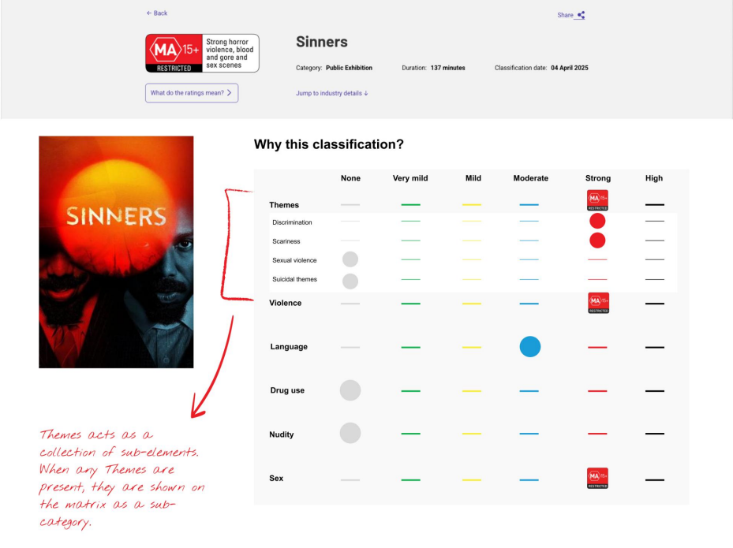

Quick links to classification listings:
The classification website currently provides information on a title and could include more detail surrounding title classification. This could include information on why a specific classification was given. However, a majority of the public are unaware of the classification website’s existence and additionally, finding the correct title amongst a list of overlapping titles is difficult.
Further detail on classifications could come with an ability to quickly access the title listing on the website, via QR codes (or similar technology) for easy access. This would mean that some key information could be displayed firsthand, while deeper detail would be readily available via a smartphone scan.

Introducing user accounts on the classification website:
Given Australia's diverse population, it’s difficult for a uniform classification system to meet everyone's needs. People have different sensitivities and expectations based on their life stage and experiences.
A proposed solution is to introduce user accounts on the classification website, allowing individuals to:
- Set personalised classification preferences for themselves or others in their care.
- Receive custom guidance when browsing titles, indicating how well content aligns with their set preferences.
- Access relevant resources, such as advice on introducing teens to more mature content.
Key features:
- No personal identifiers required — users can remain anonymous.
- This tool is advisory only, not restrictive: it informs rather than limits.
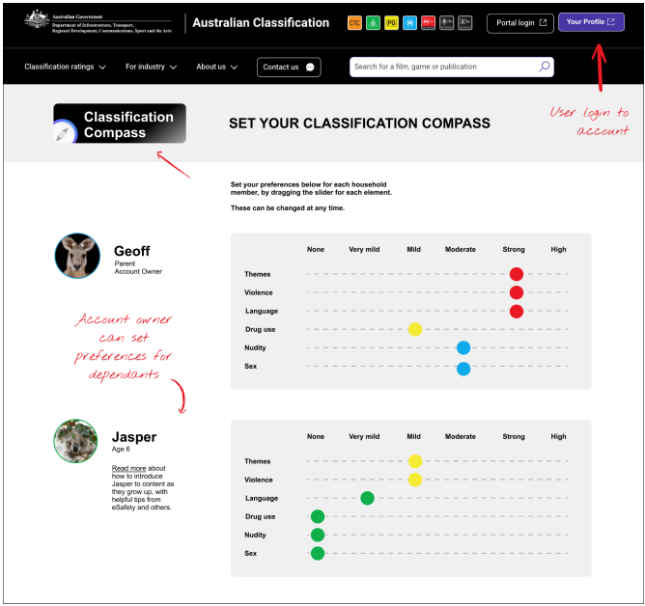

Creating a community-led Classification Advisory Council:
Although classifications are intended to reflect community standards, current processes lack a modern, direct channel for public input. Government, industry and the Classification Board are often disconnected from evolving community sentiment.
To address this, a Classification Advisory Council could be established that:
- Is comprised of community members, not industry professionals.
- Acts as a structured feedback mechanism for policy updates and classification decisions.
- Supports ongoing alignment between classification practices and community expectations.
This council would strengthen transparency, trust and responsiveness in the classification system.

New age rating:
Introducing a new age rating and symbol such as ‘PG-13’ or ‘12+’ to help consumers work out if something is appropriate for their age.

Further proposed updates:

Most adults and children agreed that showing the severity of content warnings, such as labelling something as ‘mild’ or ‘strong’, is helpful. This finding suggests that audiences would appreciate more detailed information about the intensity of content in their decision making at all classification levels.
Gambling-like content in video games, particularly through loot boxes, was a moderate concern for adults, with many saying that clear warnings are very important. Adding these warnings was suggested as a solution, however, only one-third of those aged 13-17 said that seeing a gambling warning would make them less likely to play these games.

Trust and transparency
Transparency was found to drive trust in the classification ratings, as nearly half of all adults reported that they would be ‘very’ or ‘extremely’ likely to trust the system more if given a short explanation about why something received its rating.
Young people also value this level of transparency, as almost three-quarters of children aged 13-17 said they too would like to see a short explanation for why something received its rating. While consumer advice provides short descriptions of the content, this is not always known to consumers as to how to access or find this information. Further, some consultation yielded a desire to see the actual decision process behind a rating more clearly.
Parents often engage with the classification ratings to help manage their children’s media consumption, with over half of the parent respondents checking the classification ratings ‘often’ or ‘always’ before allowing their children to watch, play or read something.
Children on their own, however, are less likely to check the classification ratings, with only a third of parents saying their children regularly look at classification ratings without prompting.
When asked who should be responsible for classifying content, almost nine-in-ten Australians prefer that an independent panel make these decisions. Around half also support the involvement of industry, while fewer think that Government should take on this role.
People who selected ‘other’ when asked who should classify content were able to explain their choices. Most respondents felt that a mixed approach would work best, such as Government collaborating with industry experts and community members.
Some respondents re-stated their preference for independent oversight or greater involvement from industry, while a few suggested specialists, such as psychologists and educators being involved in this process.

About the Social Research Centre partnership
The Social Research Centre
The Social Research Centre delivers high-quality social research that informs policy and supports positive social outcomes. We partner with government, academia, not-for-profits and mission-aligned commercial clients to provide robust, methodologically rigorous insights across key social issues, including education, health, employment and social cohesion.
We also run Life in Australia™, the country’s highest-quality probability-based online panel, which provides reliable, nationally representative data to support evidence-based decision-making across sectors. Our expertise in survey design, data collection and analysis ensures decision-makers have access to insights they can trust.

Mettlesome
Mettlesome is a Brisbane-based research, design and ideas lab dedicated to tackling complex social challenges. Rooted in a strong non-profit heritage, Mettlesome partners with government, non-government and corporate organisations to co-design and deliver innovative solutions that drive meaningful behaviour change.
With a commitment to social impact, Mettlesome chooses “the tough ones”, projects that require fresh thinking, rigorous evidence and creative collaboration. The team supports clients to understand what makes people tick, adapt to change, and realise better outcomes for communities.

