

Triple zero custodian

Triple Zero Legislative and Regulatory Review
  - Consultation Paper
May 2026

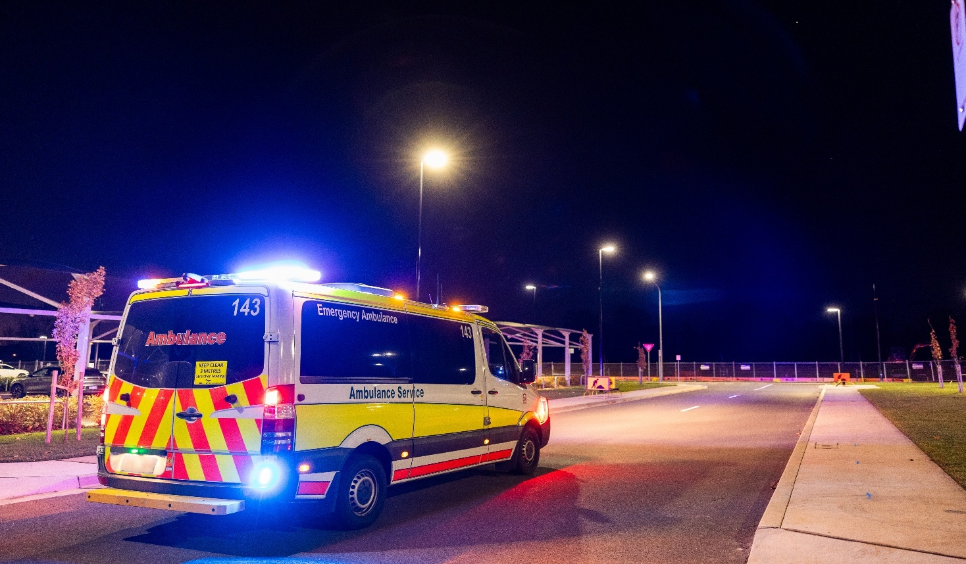

© Commonwealth of Australia 2026
Ownership of intellectual property rights in this publication
Unless otherwise noted, copyright (and any other intellectual property rights, if any) in this publication is owned by the Commonwealth of Australia (referred to below as the Commonwealth).
Disclaimer
The material contained in this publication is made available on the understanding that the Commonwealth is not providing professional advice, and that users exercise their own skill and care with respect to its use, and seek independent advice if necessary.
The Commonwealth makes no representations or warranties as to the contents or accuracy of the information contained in this publication. To the extent permitted by law, the Commonwealth disclaims liability to any person or organisation in respect of anything done, or omitted to be done, in reliance upon information contained in this publication.
Creative Commons licence

With the exception of (a) the Coat of Arms; (b) the Department of Infrastructure, Transport, Regional Development, Communications, Sport and the Arts photos and graphics; (c) content supplied by third parties; (d) content otherwise labelled; copyright in this publication is licensed under a Creative Commons BY Attribution 4.0 International Licence.
Use of the Coat of Arms
The Department of the Prime Minister and Cabinet (PM&C) sets the terms under which the Coat of Arms is used. Please refer to the guidelines at https://www.pmc.gov.au/resources/commonwealth-coat-arms-information-and-guidelines .
Contact us
This publication is available in PDF format. All other rights are reserved, including in relation to any departmental logos or trademarks which may exist. For enquiries regarding the licence and any use of this publication, please contact:
Triple Zero Custodian Division
Email: TripleZeroCustodian@infrastructure.gov.au
Website: https://www.infrastructure.gov.au/media-communications/phone/triple-zero-custodian/triple-zero-legislative-and-regulatory-review

Table of Contents
Table of Contents 3
1. About this consultation 4
1.1 Purpose of the Review 4
1.2 Triple Zero Service 4
1.3 Responding to this consultation paper 4
2. Methods of Access for Triple Zero 6
2.1 Legislative principles for access 6
2.2 The interdependency of mobile devices and networks 7
3. Industry obligations 8
3.1 Outcomes-based requirements and prescriptive requirements 8
3.2 Principles-based approach to ensuring Triple Zero calls are successfully carried 8
3.3 Reporting 9
4. The legislative framework’s impact on ESOs 10
4.1 A single national emergency call system 10
4.2 Information sharing 10
4.3 Welfare checks 10
5. Proactive regulatory oversight of Triple Zero 12
5.1 ACMA’s powers to proactively regulate access to Triple Zero 12
6. Other matters 13
7. Appendix 14
The Triple Zero Call Process 14
How Triple Zero is Delivered and Managed 14
Move from Circuit Switched Networks to All-IP Networks 15
Triple Zero Legislation and Regulation 16
8. Glossary 17
Attachment A - Review Terms of Reference 19

About this consultation
On 17 March 2026, the Hon Anika Wells MP, Minister for Communications, announced the Terms of Reference (at Attachment A) for a Triple Zero Legislative and Regulatory Review (the Review). This Review will implement recommendation 18 of the 2023 Optus Outage Review (Optus Outage Review) and will report to Government in March 2027.
The Triple Zero Custodian (Custodian) within the Department of Infrastructure, Transport, Regional Development, Communications, Sport and the Arts (department) is leading the Review.
Your submission to this consultation paper will help inform the development of an interim report in the second half of 2026 and the final report to Government. Submissions will also inform discussions between the Triple Zero Custodian and stakeholders throughout the duration of the Review. Stakeholders will have multiple opportunities to provide feedback throughout the duration of the Review process.

1.1 Purpose of the Review
The Review will provide a final report offering recommendations that identify opportunities to improve:
- Public access to Triple Zero
- Industry’s delivery of, and access to, Triple Zero
- The legislative framework’s impact on emergency services
- Government oversight of Triple Zero

1.2 Triple Zero Service
An accessible and reliable Emergency Call Service (ECS), also referred to as the Triple Zero service, depends on multiple organisations working effectively and efficiently together. As shown in the Appendix, the Commonwealth, state and territory governments and industry each have legislative and regulatory responsibilities for the efficient and effective operation of the Triple Zero service.
This Review is not intended as an exhaustive examination of the broader telecommunications regulatory settings. Identified pieces of Triple Zero legislation and regulation that fall within the scope of the Review are listed in the Appendix.

1.3 Responding to this consultation paper
You are invited to make a submission to the department in response to the matters raised in this paper.
Please include:
- Contact name
- Organisation name, if applicable
- Contact details, including telephone number, postal and email addresses
- Confirmation whether or not your submission can be made public or kept confidential.
Submissions that will be made public must meet the Digital Service Standard for accessibility. If needed, submissions may be modified before publication to meet this standard. If your submission is to be made public, please ensure you do not include any personal information you do not want to be published.
If your submission is confidential, please ensure each page of the submission is marked as confidential.
You can upload your submission on the department’s Have Your Say page. Alternatively, you can email your completed submission to TripleZeroCustodian@infrastructure.gov.au.

Submissions may also be made in hard copy to:
Department of Infrastructure, Transport, Regional Development, Communications, Sport and the Arts
Attention: Assistant Secretary, Triple Zero Custodian Operations
Triple Zero Custodian Division
GPO Box 594
CANBERRA ACT 2601
If you have any questions about responding to this paper, please contact the department via email at TripleZeroCustodian@infrastructure.gov.au.

Methods of Access for Triple Zero
Reasonable and equitable access to Triple Zero is mandated by the current legislative and regulatory framework (the framework). However, technology and user behaviour has evolved significantly since the framework was developed in the 1990s, when the majority of calls were made on landlines (fixed-lines) and mobile phones did not have the functionality they have today. Recent and evolving technologies are continuing to provide alternative ways to access Triple Zero.
This Review will consider if the current framework should be amended to regulate these new technologies and methods of accessing Triple Zero, and how best to balance innovation with ensuring a reliable and resilient ECS.

2.1 Legislative principles for access
The Telecommunications (Consumer Protection and Service Standards) Act 1999 (TCPSS Act) designates the ECS as a public interest telecommunications service, to be provided on reasonable grounds, and free of charge, to end users of fixed-line or mobile voice services. The TCPSS Act provides the basis for the Telecommunications (Emergency Call Service) Determination 2019 (ECS Determination), which outlines requirements for carriers and carriage service providers (CSPs) to enable access to Triple Zero. The current principles underpinning the Triple Zero framework, found in the TCPSS Act and ECS Determination, include but are not limited to:
- Free access for end users of fixed-line and mobile voice telephony services
- The appearance of a single national system for end users
- Meeting reasonable community delivery expectations
- High levels of access, integrity, and service reliability
- Network maintenance to support Triple Zero calls
Under the current framework, carriers and CSPs are required to deliver to a high standard on their responsibilities within the Triple Zero service. This includes prioritising emergency calls on their networks and allowing emergency calls from other networks to use their networks (to “camp-on”).
The framework also sets out that the National Relay Service (NRS) supports individuals who are deaf, hard of hearing, and/or have a speech communication difficulty, including communication with emergency services through relay officers and Auslan interpreters.
The telecommunications industry is experiencing considerable and ongoing technological development. Technologies such as vehicle emergency calls (eCall), fall detection wearables (such as smart watches), and satellite-enabled emergency messaging, can reach emergency services in ways not initially envisioned under the existing regulatory framework. These technologies provide greater access for end users of Triple Zero, however, these access methods are currently not fully considered under the legislative and regulatory framework. This may create risks to end users, and possible risks to the integrity of Triple Zero, through unintended consequences such as an increase in non-genuine calls.
Supported by the proposed Universal Outdoor Mobile Obligation (UOMO), Low Earth Orbit satellite direct-to-device services (LEOSat D2D) will increasingly provide mobile coverage in areas of Australia which are currently not serviced by terrestrial mobile infrastructure. While LEOSat D2D technologies will expand opportunities to access emergency services, it is important that the Triple Zero legislative and regulatory framework is calibrated to support these new technologies. Further, government and industry may need to test and confirm the commercial and technical arrangements for LEOSat D2D services to ensure access to Triple Zero.
Questions
- What principles should guide Triple Zero service regulation in the contemporary telecommunications environment? How should these be reflected in the legislative and regulatory framework?
- Are there any barriers in the current legislative and regulatory framework blocking access to the benefits of new delivery technologies which could be used to contact Triple Zero? If so, what aspects of the legislative and regulatory framework need to be amended to increase flexibility?
- How should the legislative and regulatory framework balance multi-modal access to Triple Zero, when compared to reliability and redundancy?
- Should the legislative and regulatory framework allow for the ACMA, and/or the Minister, to determine which class of devices or technologies should or should not be able to reach Triple Zero, in order to safeguard the integrity of access for the system?

2.2 The interdependency of mobile devices and networks
The Triple Zero framework was established in a period where fixed-line calls represented the majority of calls to Triple Zero. Today, calls from mobile devices make up over 85 per cent of all calls to Triple Zero. Mobile technology has also advanced significantly in the past 20 years with the introduction of smart phones and other smart devices. This change has been further accelerated by the transition from circuit switched networks (2G and 3G) to fully Internet Protocol (IP) mobile networks (4G and 5G).
In the era of circuit switched networks, call functions were simple and followed a relatively predictable path along the network, making it easier to identify and fix issues as they arose. In an all-IP network, calling functions follow packet switched routing, which has benefits for the efficiency of call delivery but can make the identification and rectification of issues more complex (see Appendix for more explanation).
In this new environment, the interaction of mobile device functionality and network configuration is increasingly important for Triple Zero access. Mobile devices now carry important functionality, found in software and firmware, which directly link to emergency calling. In the circuit switched and fixed-line environment, much more of this functionality existed in the network. Network operators and device manufacturers must now work together more closely to ensure the delivery of Triple Zero calls. In the all-IP network environment, software updates, spectrum changes and network reconfiguration can materially affect emergency calling outcomes. These factors may need to be treated holistically by industry and government. The current regulatory and legislative framework may require updates to address this change.
The Telecommunications (Labelling Notice for Customer Equipment and Customer Cabling) Instrument 2025 (TLN) is the key regulatory tool which governs mobile devices. The TLN states a regulatory compliance mark (RCM) may be labelled on a mobile device if, among other things, a mobile device complies with standards which ensure the device can establish emergency calls to Australian mobile networks. Industry representatives have suggested that it would be beneficial to industry and the community if a mobile device register was established. Such a register would assist network operators, industry, and end users by providing a repository of information detailing device capability and emergency calling. This could also assist network operators in identifying mobile devices to be blocked from access under Part 4 of the ECS Determination. Further, the collection and consolidation of device and network capability data in a register could provide valuable guidance for the approach to introducing new access methods to Triple Zero.
With the increasing interdependency of mobile devices and networks and the introduction of new capabilities, such as LEOSat D2D services, it is timely to consider whether the legislation and regulatory framework governing access to Triple Zero by mobiles, and other devices, remain fit for purpose.

Questions
- Should mobile device manufacturers be considered more centrally in the Triple Zero legislative and regulatory framework (such as under the ECS Determination)? What, if any, additional requirements should apply to mobile device manufacturers to ensure mobile devices can reliably contact Triple Zero on Australian networks?

Industry obligations
The principles which underpin the obligations applying to carriers, CSPs, and emergency call persons (ECPs) to provide the Triple Zero service affect the way in which the service is safeguarded now and into the future. Current obligations focus heavily on outcomes-based requirements which ensure the active provision of emergency calls. Reporting mechanisms are focused on the role and performance of the ECP.
This Review will consider whether the legislative and regulatory framework should take a more proactive approach to preventing and identifying issues. It will also consider whether new reporting requirements are needed to support ongoing monitoring of Triple Zero delivery as service provision becomes more distributed across multiple parties.

3.1 Outcomes-based requirements and prescriptive requirements
The ECS Determination sets out the rules enforcing carriers and/or CSPs to provide access to Triple Zero for end users, and to transfer calls to emergency service organisations (ESOs). The ECS Determination uses a combination of outcomes-based and prescriptive language to address various aspects of the Triple Zero service.
For example:
- Section 19 is an outcomes-based requirement; CSPs and carriers must ensure an emergency call is carried to the relevant termination point.
- Section 31 is a prescriptive requirement. This section provides specific steps carriers and CSPs must take to minimise the number of non-genuine calls received by the ECP.
Additional prescriptive requirements are also outlined in industry codes and guidelines relating to the delivery of Triple Zero. The Australian Telecommunications Alliance (ATA) develops industry codes and guidelines, with industry codes being subject to registration and enforcement by the ACMA, while guidelines are not subject to registration or enforcement.

3.2 Principles-based approach to ensuring Triple Zero calls are successfully carried
The current regulatory framework focuses on the active provision of access to Triple Zero, specifying how carriers, CSPs and ECPs must operate in carrying and handling emergency calls.
The ECS Determination has recently been amended to adopt more proactive clauses to address issues that may impact on the Triple Zero service.
- Part 4 allows for the identification and blocking of mobile devices that cannot make a Triple Zero call.
- Division 5.3 requires carriers to identify network changes that may negatively affect the delivery of Triple Zero calls and to provide management plans to the ACMA.
Changes to the ECS Determination now require proactive identification of potential risks to Triple Zero call delivery resulting from major network changes, such as future mobile generational changes and the introduction of LEOSat D2D services. The Review will consider whether these recent amendments are adequate. There is potential for further requirements to promote, protect and facilitate ongoing and robust access to Triple Zero, regardless of the technical changes being made to access or delivery networks and equipment.
Questions
- What outcomes should carriers, CSPs and ECPs be accountable for in delivering Triple Zero calls, and what minimum requirements are needed to achieve those outcomes?
- How could the framework be amended to further provide obligations to support the proactive identification and rectification of systemic issues? What mechanisms (for example, incident learnings, mandatory improvement plans, directions, audits) are most effective, and why?

3.3 Reporting
The ECS Determination outlines the requirements on the ECPs for 000, 112, and 106. Among other things, these requirements ensure minimum standards for speed, efficiency, and reliability are met by ECPs. Performance is reported to the ACMA as a regulatory obligation and to the department through contractual mechanisms.
Performance reporting requirements for ECPs only capture one part of a broader system of service providers involved in delivering Triple Zero calls. For instance, an emergency call made on a mobile device can travel from a mobile device to a carrier network, from this carrier network to the ECP carrier network, and then finally to the ECP itself, with each of these steps potentially delivered by a different provider. As such, focusing solely on the performance of the ECP may result in limited visibility of Triple Zero call delivery performance.
Under the current framework, carriers and CSPs have requirements describing an outcome, such as “CSPs must ensure that an emergency call made using the service is carried to the relevant termination point for the call”, but are not required to report performance against, or meet minimum standards required to achieve, these outcomes. On 17 April 2026, the Custodian requested the ACMA to issue ECS Directions to the three Mobile Network Operators (MNOs) requiring network performance data that focused on Triple Zero call delivery. Learnings from these directions could inform future performance obligations for carriers and CSPs.
There are currently no specific performance standards for networks which carry Triple Zero calls.
Carriers must maintain their networks, ensure lawful operation under carrier-licence conditions, and comply with broader requirements, but there are no set benchmarks for minimum standards. Ultimately, access to Triple Zero is not possible when the telecommunications networks which provide access are unavailable. In considering the utility of network performance standards it will also be important to consider the evolving capabilities of technologies providing access to Triple Zero.
Questions
- Should new and ongoing performance reporting for carriers and/or CSPs providing access to Triple Zero be introduced? If yes, what metrics should be reported and how often?
- What information is and should be shared across industry and/or ESOs to support the proactive, reliable and future-proof delivery of Triple Zero. What governance arrangements are needed to enable timely, secure and usable information sharing?

The legislative framework’s impact on ESOs
The Triple Zero service operates across policy jurisdictions in Australia’s federation. Decisions made on telecommunications policy by the Commonwealth affect the operational outcomes of emergency service organisations by states and territories and vice versa.
This section seeks views about whether Commonwealth legislative and regulatory settings support innovation in the delivery of emergency response services in state and territory jurisdictions.
The Review is also seeking comment on information ESOs need to support timely decision-making and resourcing and issues which cut across the system, such as welfare checks.

4.1 A single national emergency call system
The legislative framework seeks to provide the appearance of a single national emergency call system to end users. The Commonwealth is responsible for telecommunications policy and regulation, while state and territory governments are responsible for providing emergency services, including the provision of call handling and dispatch services. Triple Zero is provided in collaboration between jurisdictions, each with their own respective legislation governing aspects of the ecosystem.
Given this structure, the Commonwealth is largely responsible for delivering a high-quality baseline service that can be accessed by end users in all states and territories. This does not prevent ESOs introducing additional access technologies on top of this baseline service. For example, the BluLink service in New South Wales allows police to initiate video and location sharing with the end user once an emergency call is connected to the ESO, using a process which exists outside of the native Triple Zero call process. Conversely, any decisions to expand access to Triple Zero beyond calling (for example, to messaging and/or video) will also require complementary investments and technology upgrades at each ESO within each state and territory.

4.2 Information sharing
The ECS Determination outlines several requirements for information sharing with ESOs. If an ESO requests information about a call after it has been transferred, CSPs and ECPs must provide as much information as possible as soon as practicable. If an ESO requests information from a carrier about the location of an emergency call, the carrier must provide the ESO with the most precise location information available as soon as practicable.
On 21 August 2024, the then Minister for Communications, the Hon Michelle Rowland MP, directed the ACMA to amend the ECS Determination to introduce new requirements to ensure carriers and CSPs provide real-time information during outages to networks carrying Triple Zero calls. On 24 April 2025, the ACMA amended the ECS Determination to give effect to the direction, with the amendments coming into force on 1 November 2025. This requirement was introduced in response to the recommendations from the Optus Outage Review and reflects the need for clear and efficient information to be provided to ESOs during outages, enabling ESOs to make communication and operational decisions.

4.3 Welfare checks
A welfare check involves the process in which a carrier, CSP or ECP attempts to confirm the safety of an end user when a call to Triple Zero fails. If the safety of the end user cannot be confirmed, the caller’s details are provided to the relevant state police for a physical welfare check. Section 28 of the ECS Determination requires a CSP to undertake a welfare check if it is notified or becomes aware of a major outage and section 55 requires the ECP to undertake a welfare check if there is a disruption to the ECS and a caller has connected to the ECP’s system. Some carriers and CSPs also undertake welfare checks outside of these regulatory obligations in line with internal business policy.
The Custodian has undertaken consultation with MNOs and ESOs to identify opportunities to improve processes for welfare checks carried out by industry, both during and outside major outages.
Feedback highlighted a lack of consistency in processes across the industry and noted that internal business decisions by MNOs can impact ESO resourcing beyond what is set by the regulatory framework. Reform in this area will be guided by these initial consultations and a principles-based approach, aiming to balance the interests of ESOs and carriers/CSPs, while ensuring the safety of the end user remains at the centre of consideration.
Questions
- Does the objective of the single national emergency call system encourage, or hinder, the ability for state and territory organisations to innovate in their delivery of emergency calling and dispatch services?
- Is there information that carriers, CSPs, and ECPs hold which is not currently, but should be made available to ESOs through regulation to support the delivery of emergency services?

Proactive regulatory oversight of Triple Zero
The ACMA regulates communications and media services in Australia and is responsible for monitoring compliance with the ECS Determination and other legislation and regulatory instruments relevant to Triple Zero. The ACMA utilises its enforcement powers with respect to carriers, CSPs and ECPs and in relation to issues affecting the delivery of Triple Zero. Issues are investigated against regulatory obligations set out in relevant legislation and instruments.
Since October 2025, this has been complemented with the establishment of the Triple Zero Custodian which has a range of functions, including overseeing the effective functioning of Triple Zero and the proper functioning of related matters. The Custodian also has powers to compel the provision of certain information or require certain action in support of its functions.
This Review will consider whether additional powers are required to address systemic issues and promote prevention in addition to compliance. The Review will also consider the balance of the ACMA as regulator and the Custodian as an overseer to the wider Triple Zero ecosystem.

5.1 ACMA’s powers to proactively regulate access to Triple Zero
Part 27 of the Telecommunications Act 1997 (Tel Act) empowers ACMA to obtain information from carriers, CSPs and other persons if the information is relevant to the performance of any of the ACMA’s telecommunications functions or the exercise of any of the ACMA’s telecommunications powers.
Under section 12 of the Australian Communications and Media Authority Act 2005 (ACMA Act) ACMA has the power to do all things necessary or convenient to be done for or in connection with the performance of its functions, including regulating carriers, CSPs and ECPs in relation to the delivery of Triple Zero calls.
Division 2 of the ACMA Act outlines ACMA’s functions, including regulating telecommunications in accordance with the Tel Act and TCPSS Act. While the ACMA Act provides broad powers, these powers exist within a wider legislative framework which sets the limits for the exercise of ACMA’s regulatory powers.
In addition to the functions and powers of the ACMA, the Telecommunications Legislation Amendment (Triple Zero Custodian and Emergency Calling Powers) Act 2025 established the Custodian within the department with the following functions (paraphrased):
- aiding preparation for, response to or recovery from an emergency call service outages;
- improving preparedness for emergency call service outages;
- overseeing the effective functioning of the emergency call services and the proper functioning of related matters;
- any other function conferred by the TCPSS Act or by the Minister
While not a regulator, the Custodian supports delivery of the service through advocating for best-practice processes, policies and procedures. The Custodian also works with stakeholders in the Triple Zero ecosystem, including the ACMA, to anticipate and understand current and emerging opportunities and challenges that may affect the ECS.
The Review will consider if the legislative and regulatory framework enables ACMA to regulate Triple Zero in a proactive and future-focused manner. Effective regulation depends not only on the existence of obligations, but on the regulator having appropriate powers to monitor and respond to risks across the system.

Questions
- Are there any additional regulatory powers and mechanisms the ACMA requires to regulate Triple Zero, especially to support a framework which is proactive and future-focused?
- Are there barriers to the ACMA considering systemic Triple Zero issues, or linking related infringements, to ensure issues indicating broader problems are addressed appropriately? If yes, what should change?
- Do recent changes to the TCPSS Act effectively balance the role of the ACMA as a regulator with the role of the Custodian as an entity which oversees the Triple Zero ecosystem as a whole?
- Does the Triple Zero Custodian have all the powers needed to fulfil its functions under the TCPSS Act?

Other matters
Stakeholders are invited to raise any other matters, issues, opportunities or principles that should be considered.

Appendix

The Triple Zero Call Process
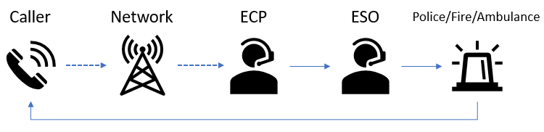

How Triple Zero is Delivered and Managed
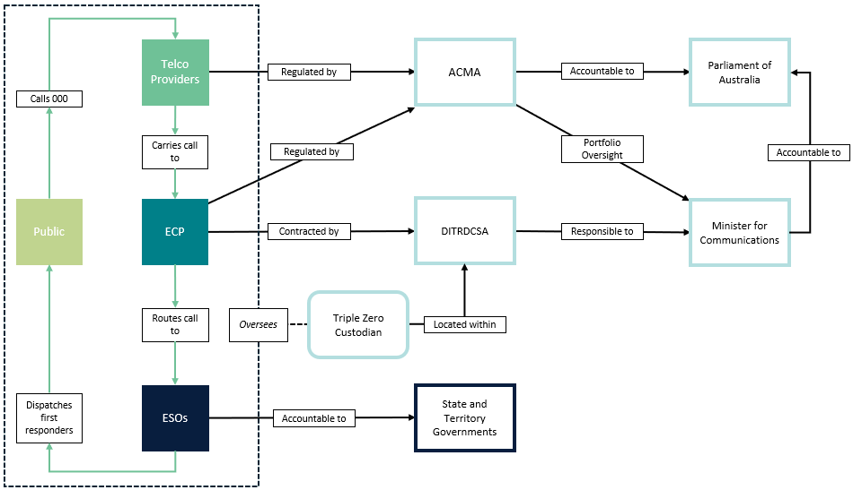

Move from Circuit Switched Networks to All-IP Networks
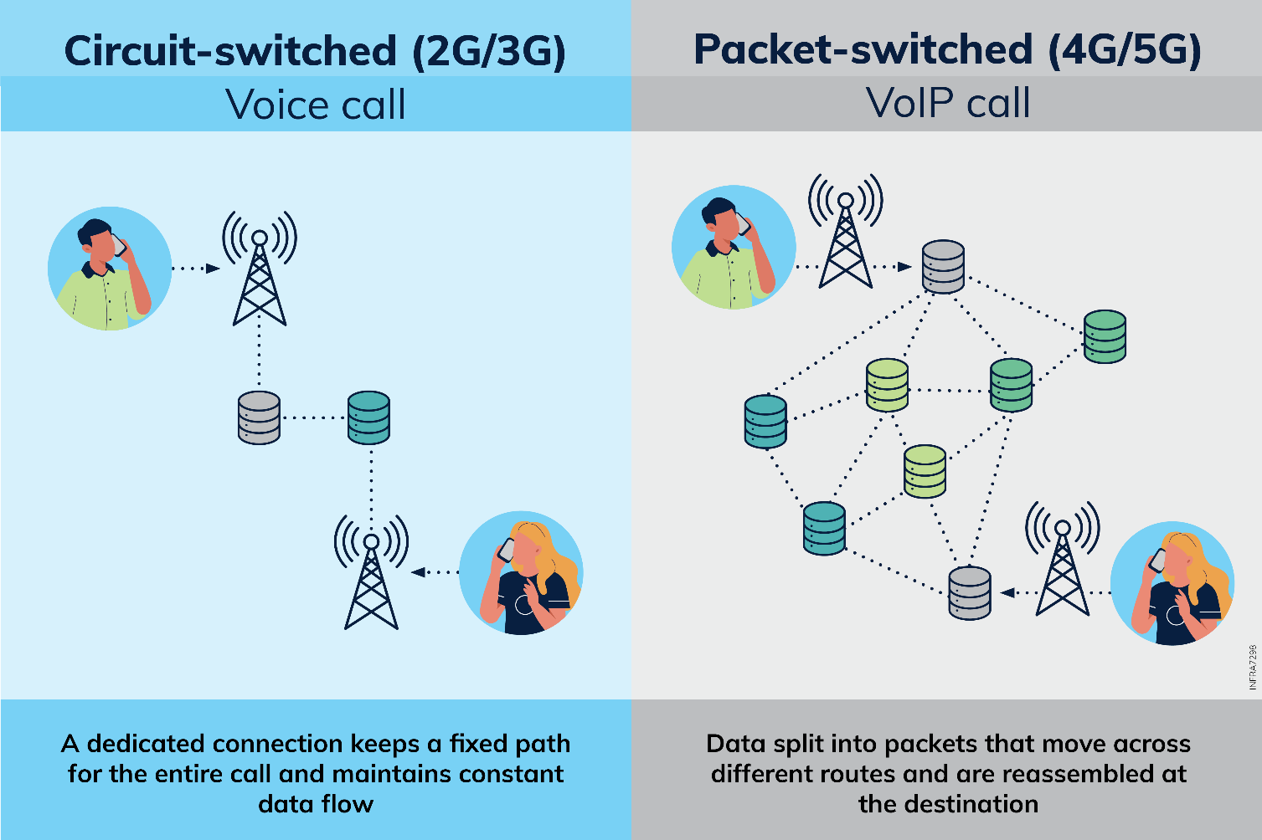

Triple Zero Legislation and Regulation
Telecommunications Act 1997
Telecommunications (Consumer Protection and Service Standards) Act 1999
Australian Communications and Media Authority Act 2005
Telecommunications (Emergency Call Persons) Determination 2019
Telecommunications (Emergency Call Service) Determination 2019
Telecommunications (Customer Communications for Outages) Industry Standard 2024
Telecommunications (Labelling Notice for Customer Equipment and Customer Cabling) Instrument 2025
Telecommunications (Mobile Equipment Air Interface) Technical Standard 2022
Industry Code C536:2020 Emergency Call Service Requirements Industry Code
Industry Code C674:2025 Emergency Calling – Network and Mobile Phone Testing

Glossary
This glossary explains key terms and acronyms used in this consultation paper.
- 000 (Triple Zero) – Australia’s main phone number for emergency services (police, fire and ambulance).
- 106 – A number for calling emergency services. This number can only be used with a teletypewriter, a type of accessible phone for people who are deaf, hard of hearing, and/or have a speech communication difficulty.
- 112 – An alternative emergency number for emergency services. This number can only be used on mobile phones.
- ACMA (Australian Communications and Media Authority) – Australia’s national regulator for communications and media services in Australia.
- Australian Telecommunications Alliance (ATA) – The ATA is the peak body of the Australian telecommunications industry.
- Carrier – A company that owns or operates telecommunications network infrastructure (such as mobile or fixed networks).
- Camp-on – When a mobile phone can make an emergency call using another network if its usual network is unavailable (for example, no signal).
- Carriage service provider (CSP) – A company that supplies phone or internet services to customers (often using a carrier’s network).
- Circuit switched – An older type of telephone network that sets up a dedicated connection for the duration of a call (commonly used in 2G and 3G mobile networks).
- ECS Direction – Under section 151A of the TCPSS Act, the ACMA is able to make ECS Directions to carriers, CSPs, ECPs requiring the provision of information or action in relation to matters affecting Triple Zero. Under Section 151L the Triple Zero Custodian is able to request the ACMA to make an ECS Direction to carriers, CSPs and ECPs.
- Emergency Call Person (ECP) – The designated organisation contracted to answer emergency calls and transfer them to the appropriate emergency service organisation. Telstra is the ECP for 000/112.
- Emergency service organisations (ESOs) – state and territory-based police, fire and ambulance organisations.
- Fixed-line/landline – A phone service that uses a physical line connected to premises (rather than a mobile network).
- Internet Protocol (IP) Network – A network that sends information as small pieces across multiple pathways, rather than as a single piece along a fixed path.
- LEOSat D2D (Low Earth Orbit satellite direct-to-device) – Services that aim to connect a standard consumer device (such as a mobile phone) directly to a satellite in low Earth orbit, to send messages and/or make calls in some circumstances.
- Mobile Network Operator (MNO) – A company that runs a mobile network and provides mobile services to customers. Typically used in reference to Telstra, Optus, and TPG Telecom (Vodafone).
- Multi-modal – Using more than one method, channel or technology to access or deliver a service.
- National Relay Service (NRS) – An Australian Government service facilitating access to phone calls through relay officers, and Auslan interpreters, for people who are deaf, hard of hearing, and/or have a speech communication difficulty.
- Non-genuine calls – Calls to emergency services that are not genuine emergencies (for example, accidental calls or misuse), which can reduce capacity for real emergencies.
- Packet switched routing – A method of sending information across a network by breaking it into smaller “packets” that may take different paths and are reassembled at the destination (common in IP networks).
- Prioritisation (of emergency calls) – Handling emergency calls ahead of other calls or traffic on a network to improve the chance they connect quickly.
- RCM (regulatory compliance mark) – A label that indicates a device meets certain Australian regulatory requirements.
- Redundancy – Having backup options (for example, alternative network routes or systems) so services can keep operating if something fails.
- Reliability – The ability of a service or system to work as intended, when needed.
- Spectrum – The range of radio frequencies used to carry wireless communications (such as mobile services).
- Relevant termination point – The technical destination where an emergency call must be delivered.
- Terrestrial network – A communications network that operates on the ground (for example, mobile towers and fixed-lines), as distinct from satellites.
- Triple Zero Custodian – The area within the Australian Government that manages and oversees the Triple Zero emergency call arrangements described in this paper.
- Universal Outdoor Mobile Obligation (UOMO) – The policy to require mobile operators to provide equitable access to baseline outdoor mobile coverage across Australia. At the time of writing this paper, the enabling legislation - Telecommunications Legislation Amendment (Universal Outdoor Mobile Obligation) Bill 2025 - is before parliament for consideration.
- Voice telephony – A form of communication where people talk to each other in real time over a telecommunications network.
- Welfare check – Steps taken to confirm someone’s safety when there are concerns they may be at risk following a failed emergency call.

Attachment A - Review Terms of Reference
Terms of Reference – Triple Zero Legislative and Regulatory Review
Background
On 8 November 2023, Optus customers, and customers of Optus network resellers, were impacted by a national whole-of-network outage. The outage interrupted critical services for consumers and businesses. It also impacted essential government and public health services as well as critical safety infrastructure.
The Australian Government commissioned a post-incident review into the outage and appointed Mr Richard Bean, former Deputy Chair of the Australian Communications and Media Authority (ACMA) to lead the review.
Mr Bean submitted the Optus Outage Review final report on 21 March 2024, with 18 recommendations to address structural issues within the broader telecommunications ecosystem, with a particular focus on Triple Zero.
Recommendation 18 recommended a review of all legislation and regulation relating to Triple Zero with a clear focus on the recommendations of the review and the outcomes of ACMA’s investigation regarding the 8 November 2023 Optus outage. The government accepted the review’s recommendation on 30 April 2024.
To date, the government responses to 17 of the recommendations have been fully implemented or are significantly progressed. Recommendation 18 is the only outstanding recommendation. Work undertaken to acquit these recommendations has included a series of regulatory changes and the establishment of the Triple Zero Custodian function within the Department of Infrastructure, Transport, Regional Development, Communications, Sport and the Arts, including legislative changes to empower this new function.
Since the finalisation of the Optus Outage Review further matters with significance to Triple Zero have arisen, including complications related to the closure of 3G mobile networks, another major outage specifically affecting the carriage of Triple Zero calls in September 2025, and evidence of certain mobile phones being unable to call Triple Zero under specific circumstances on some mobile networks.
I consider it is the appropriate time to initiate this review of all legislation and regulation relating to Triple Zero to ensure this framework is fit for purpose to support an effective, accessible and accountable emergency calling system.
It is essential all callers can rely on Triple Zero when in need of assistance. The review will seek to identify whether regulatory and legislative settings remain effective in supporting delivery of this critical service now and into the future.
Review Objectives
The review will produce a final report to the Australian Government with recommendations seeking to identify opportunities to improve:
- Public access to Triple Zero
- Industry’s delivery of, and access to, Triple Zero
- The legislative framework’s impact on emergency services
- Government oversight of Triple Zero
The review is to identify opportunities to safeguard the delivery of Triple Zero into the future.
Recommendations are also to set out a workplan to establish a modern, scalable and adaptable framework ensuring Triple Zero meets public expectations, enabling the reliable delivery of emergency assistance while also providing industry with clear requirements.

Review Scope
The review will be undertaken by the Triple Zero Custodian and constitutes an exercise of the function conferred by section 151K(1)(c) of the Telecommunications (Consumer Protection and Service Standards) Act 1999. The Triple Zero Custodian is to engage closely with ACMA, as the responsible regulator for Triple Zero, throughout the review.
The review will have regard to, but not be limited to, the following:
- Telecommunications (Consumer Protection and Service Standards) Act 1999
- Telecommunications (Emergency Call Service) Determination 2019
- Australian Communications and Media Authority Act 2005
- Telecommunications (Customer Communications for Outages) Industry Standard 2024
- Telecommunications (Labelling Notice for Customer Equipment and Customer Cabling Instrument) 2025
- Telecommunications Act 1997
- Reports of any relevant parliamentary inquiries
- and any relevant industry codes or standards which relate to Triple Zero.
The review’s focus is the effectiveness of Triple Zero and is not intended to consider broader matters covered by the instruments/documents above.
The review may have regard to state and territory government requirements in identifying opportunities for improvements to Commonwealth legislation and regulation, however recommendations for changes to state and territory legislation are not within the scope of the review.
The review will include broad consultation with stakeholders across industry, consumer representative bodies, emergency service organisations, and relevant federal, state and territory government agencies. This will include formal consultation and business as usual engagement through the Triple Zero Custodian.
Matters for Consideration
In reviewing legislation and regulation, and in undertaking stakeholder consultation, the review will consider, but is not limited to, the following issues in relation to Triple Zero:
- The effectiveness of implemented relevant Optus Outage Review recommendations
- The adequacy of ACMA’s current regulatory functions and powers
- The effectiveness and appropriateness of rules requiring that customer equipment be capable of contacting Triple Zero
- The feasibility of introducing new minimum mobile network performance standards, and other performance standards as applicable.
Final Report
The Triple Zero Custodian will provide a final report to me within 12 months of the publication of these terms of reference. The Triple Zero Custodian may provide interim reports and recommendations prior to the provision of a final report.
The final report will recommend opportunities for enhancements to the Triple Zero legislative and regulatory framework.

Overseeing the effective functioning of emergency call services and the proper functioning of the ECS matters.

