

# The economic impacts of new NBN investments on business

Decorative

##### Prepared for the Department of Infrastructure, Transport, Regional Development and Communications | July 2021

Frontier Economics Pty Ltd is a member of the Frontier Economics network, and is headquartered in Australia with a subsidiary company, Frontier Economics Pte Ltd in Singapore. Our fellow network member, Frontier Economics Ltd, is headquartered in the United Kingdom. The companies are independently owned, and legal commitments entered into by any one company do not impose any obligations on other companies in the network. All views expressed in this document are the views of Frontier Economics Pty Ltd.

#### Disclaimer

None of Frontier Economics Pty Ltd (including the directors and employees) make any representation or warranty as to the accuracy or completeness of this report. Nor shall they have any liability (whether arising from negligence or otherwise) for any representations (express or implied) or information contained in, or for any omissions from, the report or any written or oral communications transmitted in the course of the project.

Contents

Summary 7

Key points 7

Business fibre and other business broadband initiatives 7

What are the key benefits of better broadband for businesses? 8

Estimation of economic benefits 9

Direct effects on the value of output 9

Forecast firm productivity benefits 10

Expected benefits vary by location 11

The nature and scope of competition benefits 12

1. Introduction 16

Background: network upgrades and fibre initiatives 16

The research tasks 20

About this report 21

2. The economic impact of the business initiatives 22

Introduction 22

Methodology for assessing economic impacts 22

Benefits for firm productivity 35

Key results 39

Business satellite services 48

3. Competition impacts in markets for business broadband services 50

Method for identifying competition impacts 50

Two markets relevant to business broadband services 51

Wholesale network markets 53

Retail broadband service markets 53

Competition in business markets without the investment 53

Competition in business markets with the investment 56

Expected competition benefits 59

4. Case studies on business impacts 66

Introduction 66

Case studies 67

Key lessons from the case studies 72

A Literature review on the economic effects of broadband investment 74

Scope of review 74

Direct benefits 75

Assessing the evidence from literature review 80

B Further details on benefits methodology 82

Estimation of gross value added 82

Productivity benefit 83

C ANZSIC division and subdivision codes and titles 88

D References 91

Tables

**Table 1:** Average firm productivity benefits by location 12

**Table 2:** Use of broadband internet in Australian businesses 19

**Table 3:** Challenges in estimating economic benefits 23

**Table 4:** Summary of findings from the literature review 29

**Table 5:** Output or urban and rural areas 32

**Table 6:** Central impact of increases in broadband speed and output, including urban-rural 32

**Table 7:** Impacts on GDP growth by 2024 33

**Table 8:** GDP impacts 33

**Table 9:** Low, central and high estimates 34

**Table 10:** Base forecast firm productivity gain 40

**Table 11:** Proxy for locational benefits – example of 6 Business Fibre Zones 43

**Table 12:** GVA-weighted ranking of industry productivity benefits. 46

**Table 13:** Where are benefits of competitive entry likely to be highest? 59

Figures

**Figure 1**: Overview of network investments 8

**Figure 2**: Impact on Australian GDP 10

**Figure 3**: Productivity gains by industry 11

**Figure 4**: Overview of case studies 14

**Figure 5**: Quotes from case studies – ADW Johnson, Cumulus Visual Effects and Catholic Education Tasmania 15

**Figure 6**: Increase in available speeds following network investments 16

**Figure 7**: Shares of fixed line connections (AVCs) on NBN Co’s MTM network, December 2020, excludes Enterprise Ethernet 20

**Figure 8**: Relevant benefits estimated in this study 23

**Figure 9**: Overview of AlphaBeta results 25

**Figure 10**: Impact on Australian GDP 34

**Figure 11**: Sources of differences in business benefits 35

**Figure 12**: Methodology to estimate firm productivity effects 36

**Figure 13**: Methodology for estimating specific firm productivity effects 37

**Figure 14**: IT intensity (IT capital stock / Total capital stock) for Australian industry sectors, 2020 41

**Figure 15**: Forecast productivity gain by industry 42

**Figure 16**: Average productivity gain in Business Fibre Zones, by state 44

**Figure 17**: Benefits by State, Metro/Regional Business Fibre Zone location 45

**Figure 18**: Proportion of total bandwidth capacity relative to FY24 target 48

**Figure 19**: Overview of competition benefits methodology 50

**Figure 20**: Illustration of wholesale and retail markets for business grade broadband 52

**Figure 21**: Estimated shares of fibre, shares of lit buildings and share of revenues for enterprise customers 54

**Figure 22**: Availability of TC-2 services for business use 56

**Figure 23**: 15 national suppliers of Enterprise Ethernet services 58

**Figure 24**: Increased opportunities for switching 60

**Figure 25**: Telair retail services and wholesale suppliers 61

**Figure 26**: Price competition appears to be intensifying 61

**Figure 27**: Service innovation using NBN Co’s wholesale business products 63

**Figure 28**: Types of economic impact 74

**Figure 29**: Methodology for estimating specific firm productivity effects 83

Boxes

**Box 1 :** NBN Co’s Business grade services 17

**Box 2 :** Price discounts in Business Fibre Zones – from September 2020 18

**Box 3 :** Business broadband in New Zealand 26

**Box 4 :** Understanding increases in firm productivity and output 37

**Box 5 :** Case Study – Cumulus Visual Effects 67

**Box 6 :** Case study – ADW Johnson 68

**Box 7 :** Case study – Catholic Education Tasmania 69

**Box 8 :** Case study – BIG4 Easts Beach Holiday Park 70

**Box 9 :** Case study – Forico 71

**Box 10 :** Bureau of Metrology (BoM) trial of business nbn Satellite Service 72

## Summary

### Key points

|  |  |
| --- | --- |
| Network | NBN Co’s $700m Business Fibre Investment, announced in September 2020, is well underway.  The Business Fibre Investment and other network upgrades are likely to produce a range of economic benefits to business, via increases in broadband speeds, firm productivity and through increased competition. |
| Bar graph with upward trend | We estimated the **total economic benefit** to Australian businesses to be between $1.8 billion and $7.2 billion in 2024, with a midpoint estimate of **$4.5 billion**. Around a quarter, or **$1.2 billion** of the $4.5 billion estimated, will accrue in **regional** areas. |
| Gauge | The benefits to the economy derive from improvements in firm productivity – how well businesses turn inputs into outputs. We forecasted an average productivity gain from improved broadband services of **2.0 per cent** annually from 2024. |
| Magnifying glass | Productivity benefits of up to **12 per cent** are forecasted for firms in certain sectors. The main industries to benefit from the business initiatives and upgrades include professional and technical services, personal and administrative services, and wholesale and retail trade. Other sectors, including construction and health, will also be major beneficiaries due to the size and geographic spread of these sectors.  Larger benefits are forecasted in regional areas as they will benefit from the greatest wholesale pricing discounts and the greatest increase in available speeds. |
| Lightbulb | NBN Co’s entry into wholesale business broadband markets has enhanced rivalry and competition in retail markets. There are now 15 national suppliers of NBN Co’s Enterprise Ethernet services, and the business initiatives will further increase benefits in the form of lower retail prices, reduced barriers to switching and service innovation. The competitive benefits will also be particularly evident in regional areas given the larger price discounts and increase in speeds. |

### Business fibre and other business broadband initiatives

This study examines the economic and competition benefits of NBN Co’s business initiatives, first announced in September 2020.

These initiatives included three main components, as highlighted in Figure 1:

the introduction of 240 Business Fibre Zones, including 85 in regional areas, with discounted wholesale prices up to 67% in certain areas

access to Enterprise Ethernet service no upfront build cost for 90% of Australian businesses, and

other network upgrades that will provide on demand access to speeds of up to 1Gbps speeds for 75% of NBN Co’s fixed line network.

Figure 1: Overview of network investments

A graphic setting out an overview of network investments. The total nbn fixed-line premises in Australia - speeds potentially available are represented in a bar chart. Today, the fastest wholesale internet plans are accessible to 20% of total nbn fixed line premises. Following implementation of the network investment plan, this figure increases to up to 75% of total nbn fixed line premises. Below the graphic are three summaries. First summary -Investment: $4.5 billion investment, with
$3.5 billion for network upgrades
$700 million to business fibre initiatives
$300 million on co-investment fund for rural and regional communities.
Second summary - Network upgrades: Increase FTTP penetration, upgrade HFC network and FTTC network, and enhance FTTN speeds.
Third summary - Beneficiaries: Residential and business users will both benefit from network upgrades in residential premises, while businesses specifically benefit from business fibre initiatives.

Source: NBN Co

More recently, NBN Co has also enhanced its business satellite offerings, which broaden the benefits available for businesses across the whole of Australia.

### What are the key benefits of better broadband for businesses?

The business fibre initiatives and other service upgrades were expected to have two main benefits for businesses:

To enhance competition in business markets. Competition has historically been hindered by the limited availability and cost of business grade services in areas outside of business CBDs; particularly for point-to-point fibre services which offer the highest levels of service quality.

To reduce costs and enhance productivity of businesses, particularly for (i) businesses within Business Fibre Zones which were previously subject to geographically differentiated pricing and (ii) for smaller businesses which faced significant upfront costs to access business grade fibre services.

The Department therefore commissioned this study to:

review competition in business markets and the likely impact of NBN Co’s business fibre Initiative, to improve competition in these markets.

assess the economic impact of NBN Co’s business fibre initiative and other fixed line upgrades, including forecasting the likely impact in terms of cost, productivity and benefits with consideration to location, service type/industry, business size and the aggregated economic benefits.

### Estimation of economic benefits

For this research, we developed a methodology for estimating the benefits for firms of adopting the better business broadband services enabled by the Business Fibre Zones and other business upgrades.

Better broadband services can increase *firm productivity*. Higher firm productivity ultimately translates into more and higher-valued outputs, as measured in gross domestic product (GDP), and better outcomes for Australian businesses.

We applied two main methods to quantify the impacts of broadband improvements. The first is to estimate the effect of better broadband on broadband speeds and then on output directly. The second is to estimate the effect of better broadband on broadband speeds and then on firm productivity directly.

In undertaking our study, we have had regard to similar studies of broadband effects, including that prepared by AlphaBeta (2020) for NBN Co. In general, our results should be seen as complementary to that study, in that we estimate a subset of the effects estimated, but with more detail on specific industry sectors and locations.

### Direct effects on the value of output

The relationship between improvements in broadband speeds and economic growth are well-established. We used studies of these relationships to estimate impacts on GDP caused by the NBN Co business investments.

We forecasted an increase in GDP of 0.23% per year in 2024, or approximately $4.5 billion. Around one quarter ($1.2 billion) of this is expected to accrue in regional areas. The forecasted impact of $4.5 billion is a midpoint or central estimate, with a likely range of between $1.8 and $7.2 billion (Figure 2).

Figure 2: Impact on Australian GDP

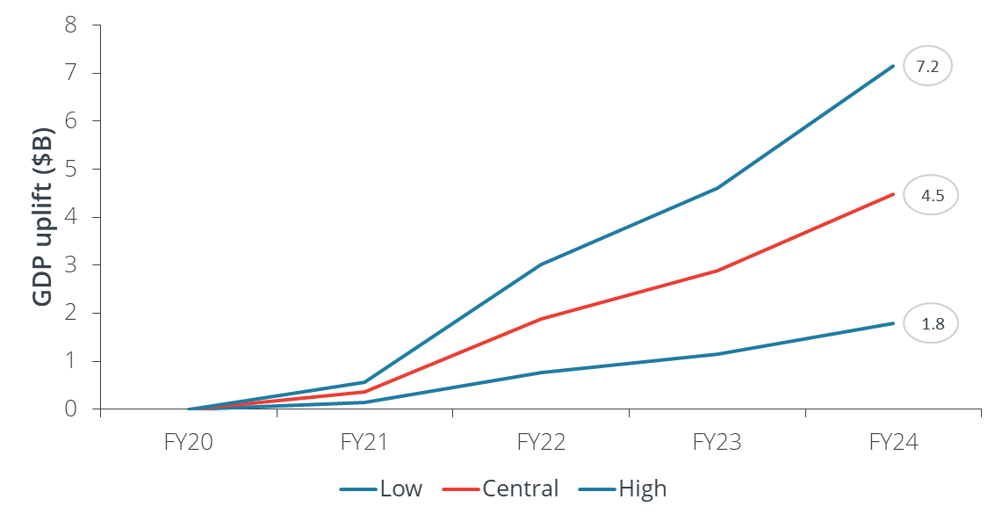

Source: Frontier Economics analysis of ABS data, Consensus Economics data and Briglauer et al (2021)

### Forecast firm productivity benefits

In addition to aggregate impacts, we estimate effects on firm productivity. Estimating firm productivity effects allows for a more detailed sectoral and locational breakdown of benefits.

Based on the estimated speed increase to 2024 for business services, we estimated that the *average* firm productivity benefit across all industries will be around 2.0% per year. The 2.0% average gain translates to significant gains for particular sectors, with professional, technical and scientific services to improve by as much as 10 percent, and other industries such as construction, and retail to experience above average impact as shown in Figure 3.

Figure 3: Productivity gains by industry

This figure plots the forecast average productivity gains by industry due to NBN Co’s business initiatives.

The average productivity gain is 2% across all industries, as high as 12.1% for Other services, and as low as 0.7% for Mining.

A full list of industries and their forecasted productivity gains are as follows:

Agriculture, forestry and fishing 2%

Mining 1%

Manufacturing 2%

Electricity, gas, water and waste services 3%

Construction 7%

Wholesale trade 6%

Retail trade 6%

Accommodation and food services 3%

Transport, postal and warehousing 2%

Information media and telecommunications 7%

Financial and insurance services 9%

Rental, hiring and real estate services 2%

Professional, scientific and technical services 10%

Administrative and support services 11%

Public administration and safety 3%

Education and training 2%

Health care and social assistance 3%

Arts and recreation services 5%

Other services 12%

All industries 2%


Source: Frontier Economics analysis

### Expected benefits vary by location

We estimated the geographic distribution of benefits as outlined in Table 1. Firms in regional areas are expected to benefit more than those in metropolitan areas, as regional areas are less well-served by business-grade broadband. For example, business productivity in regional areas was forecast to increase by an average 5.5% per annum, and in some states up to 6.4%.

We also noted that industries with a larger regional presence are likely to experience higher benefits. For example, we identified sectors such as construction and wholesale/retail trade as the most significant beneficiaries, as their output is more geographically spread across Australia than other sectors.

Table 1: Average firm productivity benefits by location

| **Location** | **Business fibre zone:  Metro / Regional** | **Metro** | **Regional** |
| --- | --- | --- | --- |
| New South Wales | 60/36 | 4.7% | 5.6% |
| Victoria | 35/11 | 4.7% | 5.1% |
| Queensland | 20/20 | 4.6% | 5.3% |
| South Australia | 17/7 | 4.3% | 5.2% |
| Western Australia | 18/5 | 4.9% | 6.4% |
| Tasmania | 0/4 | - | 5.8% |
| Australian Capital Territory | 4/0 | 4.0% |  |
| Northern Territory | 0/3 | - | 5.4% |

Source: Frontier Economics

### The nature and scope of competition benefits

A second element of the study was to examine the impact of the increase in accessibility and affordability on competition in (i) the markets in which fibre and other business services are supplied, and (ii) the market in which retail services are provided to business users.

#### Competition for business-grade services has been geographically uneven

Wholesale and retail markets for business grade services - defined as high speed, symmetric services with a higher level of service - have tended to have few competitors in Australia, except for CBD areas where multiple networks were available. Moreover, competitors experienced difficulties in supplying multi-site business customers in areas where they did not have their own infrastructure capable of supplying business grade services.

Consistent with historic industry practice, NBN Co’s charges for business services were previously based on four zones. Prices in less dense areas were substantially higher than in CBD and inner metropolitan areas. In that light, NBN Co’s upfront and ongoing price discounts for Enterprise Ethernet offerings in Business Fibre Zones have the potential to substantially improve competitive outcomes in outer metropolitan and regional areas.

The competition benefits are likely to arise from:

1. A further lowering of barriers for retail entry and expansion to supply business grade services. NBN Co only supplies wholesale services and has a mandate and incentive to increase retail competition, and the public nature of its pricing offers create transparent pricing benchmarks for retailers.
2. There are many areas in which there would only have been one or two other suppliers capable of supplying an affordable direct fibre services.

Access to NBN Co’s enterprise services “…allows us to provide the most cost-effective mix of our own fibre and third-party fibre such as NBN to deliver complex network solutions for major contracts.” Vocus spokesperson

#### Complex to quantify benefits, but strong supporting evidence

The retail markets for business grade broadband services are much more opaque than residential markets. Prices tend to be individually quoted and negotiated – particularly for larger, multi-site customers. This hinders our ability to quantify benefits. Nonetheless, we can identify changes in market structure – including 15 national suppliers of Enterprise Ethernet – and three kinds of conduct benefits resulting from more competition:

**Increased opportunities for retail switching**: 85% of Enterprise Ethernet connections are attributable to a different retail service provider (RSP) than the RSP that was providing a service previously, with more than 70% of upgrading TC-4 connections coming from a new RSP.

**Discounts in wholesale and retail prices** and increases in quality of services: There is evidence to suggest that NBN Co’s steep price discounts offered from September 2020 have (i) been passed through to end users and (ii) are being matched and in some cases bettered by other network suppliers. This produces further benefits to users, regardless of whether end users actually use an NBN Co service.

**Increase in retailers’ ability to bundle service offerings** across network platforms: a much more diverse range of firms are winning large, multi-site contracts as RSPs (and even non-RSPs) have a much-increased ability to put network services together that are multi-platform.

#### Benefits of competition for business

We also considered the kinds of businesses that were likely to be benefit most from greater competition. Major beneficiaries include firms in the following sectors:

Construction

Health Care

Mining

Retail trade

Manufacturing

Transport, postal and warehousing

Interestingly, these sectors are somewhat different from those that should experience the highest productivity gains, with both mining and transport sectors appearing. This reflects that firms in these sectors are present in many parts of Australia where they have historically only had access to higher cost services.

#### Lessons from case studies

We use case studies to provide a better understanding of how productivity, access and other benefits are practically being experienced by businesses (see Case studies with summary below). The case studies highlight the broader productivity and social benefits of the broadband initiatives for businesses, including more equity of access to digital learning opportunities and improved communication for workers in remote locations. This may contribute, for example, to increased firm and employment opportunities in regional and rural areas.

Figure 4: Overview of case studies

Overview of case studies by firm and primary benefits.
ADW Johnson, an engineering firm, had primary benefits of Remote working from multi-site offices and from home, with increased ability to work collaboratively on large engineering design files.
Catholic Education Tasmania, education services, had primary benefits of Equity of access to services across large number of sites has allowed roll out of new digital learning and administration tools using cloud services.
BIG4 Easts Beach, an accommodation provider, had primary benefits of increased customer satisfaction through expanded services offerings such as video streaming and 'working from holiday'.
Forico, in forestry management, had primary benefits of hybrid NBN solutions supporting new technology in remote sites and reduced manual processes.
Bureau of Meteorology, weather services, primary benefits are better satellite services increase use of cloud-based applications and VoIP, but also allow for social use which increases satisfaction for workers.
Cumulus Visual Effects, a visual effects firm, primary benefits were access to critical higher upload speeds that allows new ways of collaboration with customers and increase in competitiveness.



Figure 5: Quotes from case studies – ADW Johnson, Cumulus Visual Effects and Catholic Education Tasmania

Image of three quotes from case studies – ADW Johnson, Cumulus Visual Effects and Catholic Education Tasmania. 
Quote 1-“We value reliability and stability so highly because we understand that the cost of downtime can be immense. Downtime can mean a loss of productive output from staff, up to 30%, or it can mean the loss of direct revenue to the business if downtime happens at a critical moment in working with a new client”
Scott Robinson, Director at ADW Johnson
Quote 2 - “It’s really empowered us. We’ve been able to compete with some of the big kids in the big cities. The same opportunities that you would have had out of CBD Sydney. We’ve now engaged clients that we’ve never been able to get before”
Nicky Ladas, Senior IT Manager at Cumulus Visual Effects
Quote 3 - “Students at Holy Rosary [Catholic School] have the opportunity to do robotics and to learn from people in America, they have the opportunity to have coaches in Japan – the connection that they can have with people as global citizens is quite phenomenal" 
Catherine Midson, Digital Technologies Teacher at Holy Rosary Catholic School



## 1. Introduction

### Background: network upgrades and fibre initiatives

In September 2020, NBN Co announced a $4.5 billion investment in service improvements, including network upgrades. These investments were endorsed by Government[1] and included:

upgrades to deliver ultra-fast broadband to 75% of Australian businesses and households connected to NBN Co’s fixed line network.

the Business Fibre Initiative, a $700 million investment over three years to provide:

* + an estimated 90% of businesses with access to symmetrical business grade fibre at no upfront cost, and
  + CBD-equivalent wholesale Enterprise Ethernet pricing for businesses located within 240 Business Fibre Zones, with 85 located in regional Australia.
* $300 million of co-investment funding for NBN Co to partner with governments and local councils to further improve broadband services in regional Australia.

As identified in Figure 6, the investments should markedly increase the availability of higher speeds to residential and business users on the fixed-line network, with up to 75% obtaining speeds up to 1000Mbps.

Figure 6: Increase in available speeds following network investments

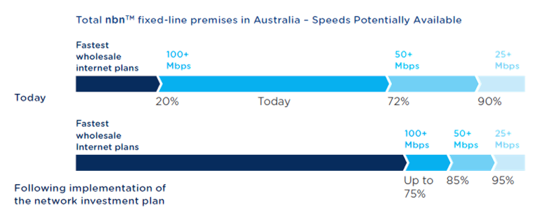

Source: NBN Co

#### Enhanced business-grade services

The business initiatives will substantially increase the availability of higher quality business grade services around Australia. The distinguishing features of business-grade services are described inthe box below.

1. **:** NBN Co’s Business grade services

NBN Co provides services to businesses using its multi-technology mix (MTM) network and supplies Enterprise Ethernet via a fibre optic network (with point-to-point fibre connections from fibre access nodes). The recently-introduced business satellite services round out NBN Co’s suite of business services.

At the time of this study, Enterprise Ethernet offers the highest grade of service, including:

wholesale speed tiers from 10/10Mbps to nearly 1/1Gbps.

opportunity to configure services to suit the specific needs of a business including aggregation of 1Gbps services at a single premise. In future, there is a clear technology path towards to faster speeds from 10Gbps and beyond.

Ability to access priority data using “Class of Service – High” (committed information rates, or CIR): all data allocated to this class of service is given priority over best efforts residential and business traffic.

a 99.95% network availability target.

NBN Co also supplies TC-2 and TC-4 services to businesses over its MTM network. TC-2 services are offered with CIR, symmetric speeds and with optional higher service levels, but cannot achieve the higher speeds of Enterprise Ethernet.

TC-4 services are available at fast speeds but on an asymmetric basis (download faster than upload) and on a ‘best efforts’ traffic priority basis (PIR), and are more subject to network congestion. This makes them less suitable for a range of business uses, such as voice calling and video conferencing which rely on high quality links. Outside of voice and video, each business and industry will have different use cases of what is a mission-critical application that will benefit from priority data. NBN Co indicates that some examples include:

Point of sale (POS) data needed by retailers and supermarkets

Data used by sensors or robotic machines in high end manufacturers

Architecture firms using data-intensive cloud-based applications in their design processes

CRM applications used by front-of-house contact centre agents

Design agencies, videographers, photographers etc regularly transferring large files

NBN Co further provides information to businesses about selecting products which best meet their needs. Business satellite services are described in further detail in section 1.

*Source: NBN Co*

#### Business fibre initiative

The Business Fibre Initiative has resulted in substantial discounts for business customers. These are summarised in Box 2.

1. **:** Price discounts in Business Fibre Zones – from September 2020[2]

From September 2020, NBN Co has substantially discounted and rationalised wholesale prices for its Enterprise Ethernet services in Business Fibre Zones. The following Figure highlights that the discounts differ both by the location of the zone and the speed of the service:

NBN Co categorises the Business Fibre Zones into different zones which effectively reflect the remoteness of the zone from CBD areas. Zone 3 was previously the most expensive zone, so the move to ‘CBD equivalent’ pricing has resulted in the largest price discounts in these areas (with all services at speeds below 250mbps receiving price discounts of more than 60%).

Services below 250mbps have received price discounts regardless of zone.

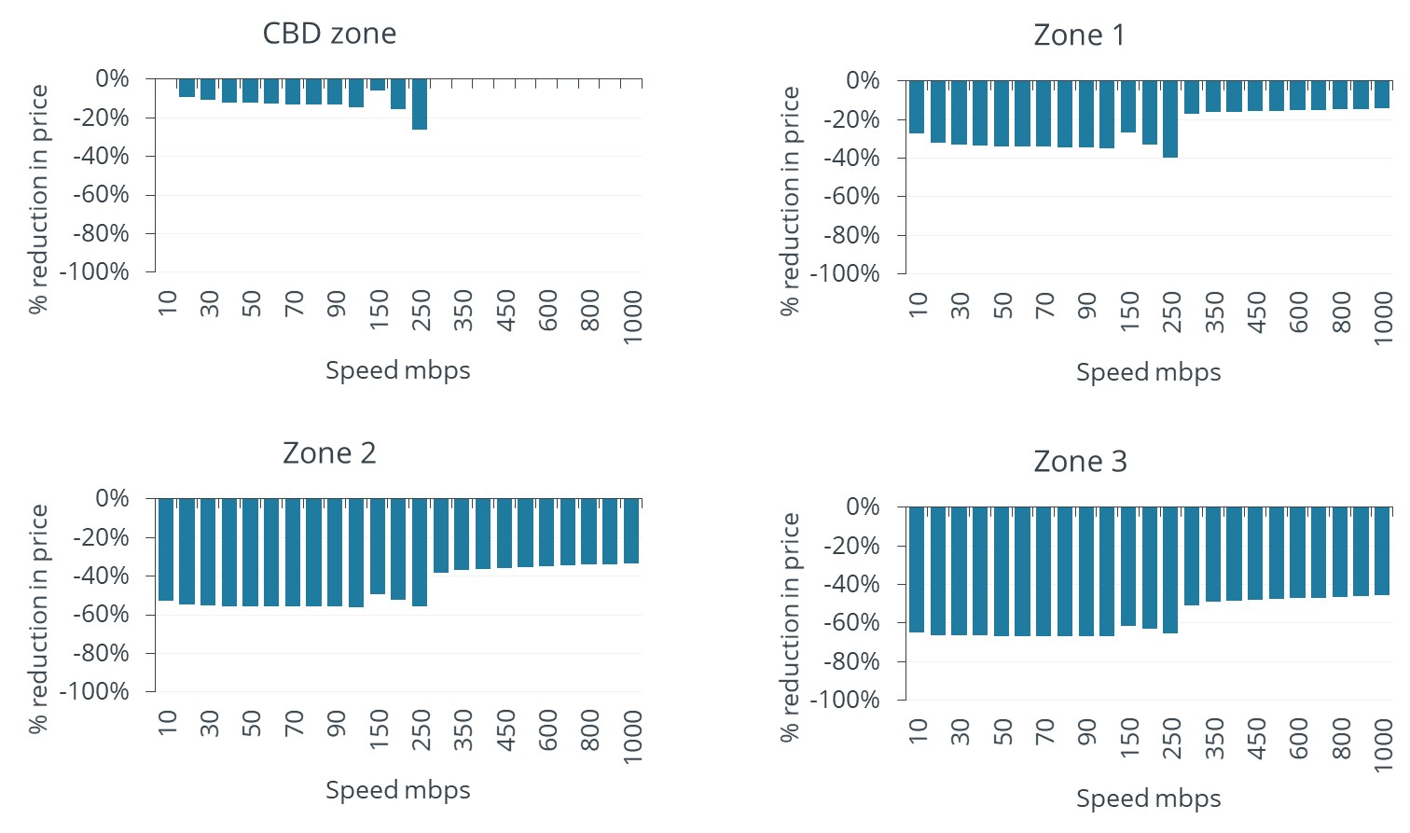

Additionally, the price discounts are different by the class of service, with the lower class of service receiving larger discounts (reflected in the figure above for CoS-L).

*Source: NBN Co*

#### Business satellite services

The Sky Muster satellite service provides high speed broadband to all Australia through 101 spot beams. In March 2021, NBN Co further announced plans to expand the number of satellite beams that provided access to its business satellite service (BSS). These services will cover 100 per cent of the Australian mainland and surrounding large islands to help retail service providers deliver business-grade services to businesses with remote operations. Along with enhanced coverage, NBN Co has also discounted its wholesale price by approximately 40 per cent for the key business services.

#### Businesses in Australia make use of broadband internet, but not necessarily business grade internet

The network upgrades and business fibre initiatives can be seen in the context of internet use by Australian businesses. Australian Bureau of Statistics (ABS) data indicates that:

19 in 20 businesses have internet access

almost all of these access the internet using a broadband service, and this has been true for a number of years (see Table 2).

Table 2: Use of broadband internet in Australian businesses

| **Category** | **Unit** | **2014-15** | **2015-16** | **2016-17** |
| --- | --- | --- | --- | --- |
| Estimated number of businesses | '000 | 776 | 799 | 831 |
| Businesses with internet access | % | **94.8** | **95.3** | **95.4** |
| Businesses with web presence | % | 48.6 | 50.1 | 51.1 |
| Businesses with social media presence | % | 34.0 | 38.2 | 40.4 |
| Businesses with internet access:  broadband as the main type of connection | % | **99.2** | **99.3** | **99.4** |

Source: ABS, Summary of IT Use and Innovation in Australian Business, 2018

The take-up of **business grade** services (described in Box 1) by Australian businesses has been slower. Data from the ACCC and NBN Co indicates that the large majority of connections on its MTM fixed line network are “best effort” TC-4 services rather than the higher-quality, business-focused TC-2 services.[3] This is highlighted in Figure 7 (and excludes Enterprise Ethernet services). The significance of this is that many services sold to business users may not be ideal to meet the current and future needs of Australian businesses - from general functions such as multi-line voice, video conferencing and cloud services to industry-specific applications that require higher quality.

Figure 7: Shares of fixed line connections (AVCs) on NBN Co’s MTM network, December 2020, excludes Enterprise Ethernet

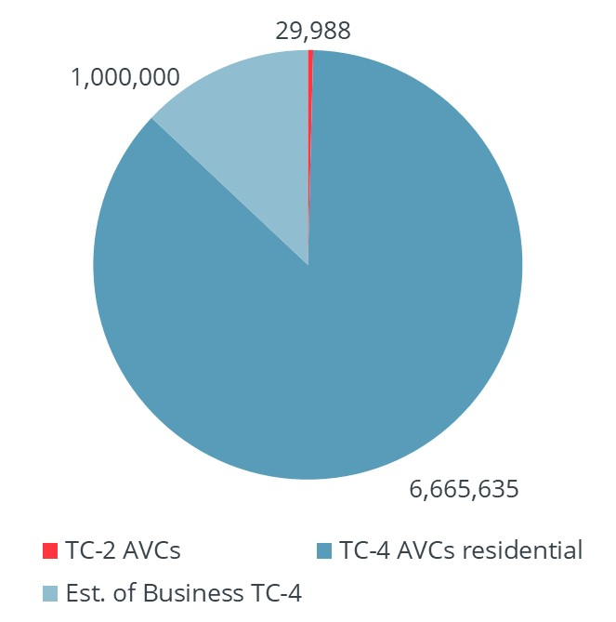

Source: ACCC and NBN estimates

In part, the services taken by business also reflects that Australian businesses are dominated by ‘microbusinesses’ with between 0-4 employees. ABS data for 2019-20 indicates that 93.0% of businesses had turnover of less than $2 million and 28.4% of businesses had turnover of less than $50,000.[4] A relatively small number of businesses usually with many employees are likely to demand very high grade (speed and quality) TC-2 or Enterprise Ethernet broadband services. This also highlights the importance of NBN Co’s TC-4 upgrades for smaller businesses, who will be able to access faster downland and upload speeds but without some of the other features of business grade offerings.

### The research tasks

Frontier Economics was engaged by the Department of Infrastructure, Transport, Regional Development and Communications to assess the likely economic and market impact of the Business Fibre Initiative on Australian business, as well as the impact of other recently announced fixed line upgrades on small businesses.

The research focuses on the impact on competition, cost and productivity to businesses at the business and aggregate level. Where possible, we have looked at impacts across industries/sectors, business type, size and geographical regions. The methodology we have developed can be used to assess the impact of policy options relating to the business market in future.

### About this report

This report is organised into the following sections:

In **section 2,** we report our findings on the estimated economic benefits of the business initiatives

In **section 3**, we consider the competition benefits associated with the business initiatives

In **section 4**, we provide some case studies on the use of business services, with a focus on business fibre services. These provide more specific examples of the kinds of benefits that are likely to be received by businesses that are difficult to quantify in the economic analysis.

In the **Annexes**, we provide further details of our literature review (A), estimation of benefits (B), industry sectors (C) and references (D).

## 2. The economic impact of the business initiatives

### Introduction

For this research, we have developed a methodology for estimating the benefits for firms of adopting the faster business broadband services enabled by the Business Fibre Zones and other business broadband upgrades.

The primary benefit of better broadband on business is through its effect on *firm productivity*. Higher firm productivity ultimately translates into more and higher-valued outputs (as measured in gross domestic product (GDP), and better outcomes for Australian businesses.

We have considered two main methods to quantify the impacts of broadband improvements. The first is to estimate the effect of better broadband on broadband speeds and then on output directly. The second is to estimate the effect of better broadband on broadband speeds and then on firm productivity directly. These methods are based on published empirical studies applied to Australian conditions.

We first set out the methodology including an overview of the relevant literature, before presenting the results. Further details on the methodology and literature are attached as Annexes A and B to the report.

**Wireless** How broadband can increase firm productivity

Broadband offers business a combination of general and industry-specific benefits. The main sources of benefit are likely to include improved communication tools, better data management and software applications, lower cost marketing, applications that reduce administration costs, online shops that reduce the need for bricks and mortar and reduce occupancy costs, cloud technologies than can reduce IT spending; and machine to machine technologies that can improve capital productivity.[5]

Some specific examples of how broadband can increase firm productivity are provided in Section 4.

### Methodology for assessing economic impacts

#### Direction

The Department selected Frontier Economics through a competitive procurement process to assess the economic impact of NBN Business Fibre Initiative and other fixed line upgrades which will benefit small and medium businesses, rather than the benefits of the NBN as a whole (Austender reference CN3760979). This includes forecasting the likely impact of the initiatives and upgrades in terms of cost, productivity and benefits with consideration to:

location (Business Fibre Zone, state, region)

service type/industry

business size

aggregated economic benefits/impact

We have sought to quantify productivity and output effects as per Figure 8, which is based on a categorisation developed by the International Telecommunications Union (ITU). Our analysis looks at benefits to business users. These extend beyond the purely direct financial benefits to firms (e.g. from lower prices) to the benefits from increased availability of higher speeds that can manifest in productivity improvements.

Figure 8: Relevant benefits estimated in this study

This figure charts the relevant benefits due to NBN Co’s business initiatives estimated in this study. NBN Co’s business initiatives can lead to
(1) Direct benefits based on increased accessibility and affordability and
(2) Deployment benefits (for example, employment, construction and spending).

The relevant benefits estimated in this study focus on direct benefits. In particular, the focus is on enterprise (productivity) effects and impacts of these productivity benefits on GDP.

Source: ITU (2012)

#### Challenges in estimating benefits

It must be recognised that there are several challenges to estimating the economic impacts of improvements in broadband performance on businesses, such as NBN Co’s investments. We have considered these challenges in developing our methodology, but we emphasise that these points should also be taken carefully into consideration when reading our results. In Table 3 we highlight the challenges in estimating benefits and how we have addressed them.

Table 3: Challenges in estimating economic benefits

| **Challenge** | **Mitigation strategy** |
| --- | --- |
| Large and complex literature on economic benefits from improvements in broadband, with less on specifics of fast, symmetric, high quality business broadband | We have conducted a wide review of literature to identify those studies most pertinent to business broadband, including those with a significant fibre focus (see Annex B) |
| Hard to predict competitive responses to business entry and pricing – which could drive further benefits | We present results in ranges to account for uncertainty, and recognise whether results are likely to be conservative |
| There are likely to be differences in sectoral / size / locational responses:  Each region has a different business mix, and each business uses ICT differently  Regions with more businesses that make use of ICT are likely to see larger benefits | We identify data that helps differentiate effects between regions based on existing regional pricing, and those based on ICT intensity or proxies |
| Business services and their uses are more complex than for residential users, which makes benefit identification more complex | We use case studies to present illustrative gains that are possible with business broadband services |
| The investments compared to the overall investment in the National Broadband Network are relatively modest, and so determining the effects of just the incremental investment is difficult to measure.  Avoiding double counting of benefits – e.g. estimating an increase in GDP captures firm productivity benefits indirectly. | These challenges can be best addressed through careful presentation of results; we use different approaches and data sources where possible, and highlight where results are additive or alternative. |

Source: Frontier Economics

#### Existing estimates of economic benefit

##### AlphaBeta’s study for NBN Co

In September 2020, AlphaBeta published an economic impact analysis of the nbn network investment plan.[6] This study was commissioned by NBNC Co, and the key results were reported in NBN Co’s corporate plan and summarised here in Figure 9.

Figure 9: Overview of AlphaBeta results

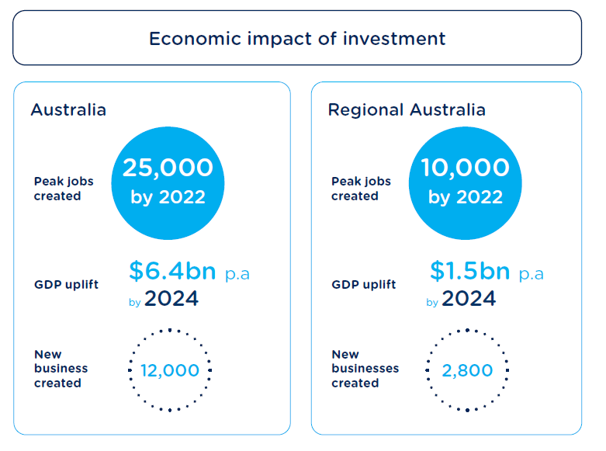

Source: NBN Corporate Plan, p. 46.

These headline findings were reached using a combination of economic analysis methodologies:

The increase in GDP was estimated using a computable general equilibrium model, with new businesses estimated based on the GDP result.

The jobs calculation is based on the direct jobs at NBN Co to deliver the investment plan with indirect jobs (i.e. those supported by the investment of NBN Co) estimated through the use of input-output tables.

Computable general equilibrium models and input-output tables are both macroeconomic models of the economy. The former is a dynamic sectoral model which can be “shocked” to reflect changes across the economy which result from a change in inputs. An input-output model is a static sectoral model of the economy which is most commonly used for “multiplier” analysis – a first principles estimate of the indirect and catalytic impacts of change in spending (input) in the economy. These approaches are regularly used in economic impact analysis and are best suited to projects or policies which have broad impacts across the economy.

AlphaBeta’s study focuses on the NBN Co investment plan. It does not specifically distinguish between impacts from business broadband and residential uses. The study does include high level consideration of the Business Fibre Zones. This includes evidence that higher internet speeds are associated with higher average revenue growth and employment for small businesses (based on data for 2015-17).

The study includes estimated productivity effects which are based on forecast changes and observed relationships between Internet speeds and GDP, and Internet penetration and GDP. These estimates use average changes in speeds/penetration across households and businesses. The estimates are converted to overall productivity changes for modelling, then allocated between industries according to:

Business use of IT (ABS data)

Share of costs attributable to ICT (ABS input output)

The degree to which industry was underserved by nbn prior to the investments.

The AlphaBeta study uses these productivity effects as inputs to a computable general equilibrium model in order to estimate the economy wide impacts.

Relating the AlphaBeta study back to this study, the overarching point is that they are complementary rather than directly comparable. Both studies identify likely benefits from high speed broadband, including business grade broadband. The AlphaBeta provides a high-level analysis of economy-wide impacts of the NBN Co investment plan, with a split into metropolitan and regional areas. In contrast, this study drills down into the specific economic impacts of NBN Co’s business product investments, including analysis of sector and location impacts. Nevertheless, there are methodological similarities such as focus on relating internet speeds and penetration to productivity outcomes, and an overall finding of material economic benefits.

##### Other studies

Another relevant recent paper is a working paper by the Australian Government on the economic impact of high speed broadband on the agriculture sector. The paper estimated that the “additional economic benefit from broadband-supported technology could be between $3.0 and $10.6 billion per year (in 2017–18 dollars) for the agricultural sector by 2029–30, which represents an additional boost to economic activity in agriculture of between 4.7 to 16.9 per cent by 2030.” The paper estimated that this equated to an economy-wide impact in the range $64-299 increase in GDP per capita.

This paper drew on evidence from previous studies which specifically looked at the economic impacts of broadband-supported technology in agriculture. The methodology for estimating the economic impacts was running a series of scenarios with different high level assumptions around impact on output, investment and timing of impacts based on two published studies.

The Australian Government paper, while related, has a slightly different purpose to this study. It focuses solely on agriculture and looks at long-term impacts, whereas this study covers all business and covers a shorter term timeframe.

A final touchpoint for this study is in relation to the deployment and take-up of business grade services in New Zealand. The largest supplier of fibre services in New Zealand, Chorus, offers business fibre services in zones that are somewhat analogous to Business Fibre Zones in Australia. The nascent experiences in New Zealand indicate that certain sectors are likely to be key beneficiaries from these services (Box 3) which provide useful context for this study.

1. **:** Business broadband in New Zealand

New Zealand has undertaken a sustained effort over the last decade to upgrade the broadband infrastructure across the country. From a business broadband perspective, the key initiative has been Chorus’ roll out of a business grade fibre product to 28 major towns and cities across New Zealand (referred to as Urban Fibre Zones). This roll out was completed in November 2019 and is sold as a product called “Hyperfibre.”

Hyperfibre offers symmetric speeds with high traffic class options and high levels of customer support including “business restore” should a customer experience a fibre outage. A 1000 Mbps symmetric product launched in 2014 followed by 2000 and 4000 Mbps products which were launched in financial year 2020. A further 8000 Mbps service has since been launched. Chorus offers access to the highest speed services at relatively modest charging increments (monthly charges) for its business 2000, 4000 and 8000 Mbps services.

The change in uptake over time of businesses with a fibre-to-the premises connection is striking. According to data from Stats NZ[7], take up for these business premises rose from 22% in 2014 to 52% in 2018 and then 64% in 2020. The sectors with highest uptake in 2020 were:

professional, scientific & technical services (84%)

information media & telecommunications (86%)

financial & insurance services (89%).

We would expect that the sectors with highest take-up rates would closely correlate with those which find business broadband most beneficial. There is good alignment of these sectors with the Australian sectors estimated to have the highest total factor productivity gains in this study (see Figure 15).

Hyperfibre would be expected to have similar benefits to other high speed business broadband products, as per the literature. Although it predates the Hyperfibre launch, one economic study of firms in New Zealand found that only firms making complementary investment get productivity gains from ultrafast broadband; this cautions against merely assuming that deployment on its own is sufficient to produce economic benefits.[8] There is other qualitative evidence (on the Hyperfibre website) of businesses with high end connectivity needs (graphics and visual effects companies) experiencing benefits from being able to quickly share large data files with remote collaborators. This is similar to the Australian example of Cumulus Visual Effects benefitting from a Gigabit Enterprise Ethernet product (see Box 5).

The New Zealand experience is instructive for Australia. New Zealand’s business broadband roll out pre-dates the major initiatives in Australia and there are similarities in scope (e.g. urban fibre zones in New Zealand and Business Fibre Zones in Australia). Take up of business services has been strong, particularly in sectors which we have also identified as beneficiaries of the investment. However, as yet there is no specific economic impact assessment for the New Zealand experience which could guide this study; older studies do however draw our attention to the complexity of the broadband - productivity benefits relationship (as we discuss further in Annex B).

#### Review of the economic literature on estimation of economic benefits from broadband deployments

There is a rich and evolving literature on the economic effects of broadband. Links between broadband investment, use and broader social benefits have been a key concern of governments for many years.

For this study, we develop estimates of effects using estimated (causal) relationships between broadband and outcomes such as GDP, firm productivity and other benefits. These estimates are supported by empirical studies; however, the studies must be carefully applied to the circumstances of NBN Co’s fibre investments.[9]

The following table highlights the key studies from our literature review (which are further discussed in Annex0). It is clear that there a few studies closely related to our study question, and no studies that specific reference Australia (although there are some studies where Australia forms one of number of countries in which effects are measured). Careful adaption of existing studies is required, including factoring in economy differences as well as the treatments considered in the studies (i.e. the ‘driver’ of the estimated change).

Table 4: Summary of findings from the literature review

| **Type of study and key findings** | **Key authors/contributions\*** |
| --- | --- |
| ***Quantifying macroeconomic impacts of broadband deployment***  There is strong evidence that broadband deployment and increases in broadband speeds contribute to economic growth (GDP), but relatively few studies on the impact on going to faster fibre services from existing broadband. Some recent estimates suggest:  (ITU 2018) a cross-country study estimates the impact of increasing broadband penetration by 10% is to add 0.8% to 1.4% to GDP (AUD $13 to $23 billion)  (Briglauer 2019) a cross-country study estimates the impact of moving from basic broadband to 100% fibre broadband would increase GDP by 0.2%-0.3% per year (AUD $3.6-$5.4 billion)  (Briglauer 2021) a within-country (regional) study estimates that an increase in average bandwidth speed by one unit (1 Mbps) induces a rise in regional GDP of 0.18%. | Briglauer et al. (2019), Briglauer et al (2021)*, ITU (2018), Soza and Analysis Group (2015), Gruber et al. (2014), Rohman and Bohlin (2012), UK Broadband Impact Study (2013) |
| ***Firm productivity impacts of broadband deployment***  A number of studies suggest broadband deployment increases firm productivity, with estimates between 7 and 10 percent improvements in firm productivity due to broadband deployment. The Canzian et al study finds an effect of 9.1% based on approximately 18 months of availability of faster broadband.  Some caveats, with other studies finding no direct impact on productivity or positive impacts are available only for ‘skilled’ workers or firms that make complementary investments to improve ICT utilisation | Positive impact: Canzian et al. (2019), Mölleryd (2015), Grimes et al. (2012), Ipsos MORI (2018)  No/conditional impact: Akerman et al. (2015), Haller and Lyons (2015), Motu Economic and Public Policy Research (2016), |
| ***Employment, job creation and wages impact of broadband deployment***  Lack of evidence that moving from fast to very fast broadband boosts employment or job creation, even where the same studies find broadband deployment increases GDP  However, some studies find a positive association between broadband penetration and employment within countries. For example evidence from the UK suggested a 0.8% positive employment impact on relevant postcodes receiving subsidised fibre deployment | Briglauer et al. (2019)*, Bai (2016), Mölleryd (2015)*, Ipsos MORI (2018) |
| ***Business creation impacts of broadband deployment***  There is mixed evidence for business creation impact of deployment, though a number of studies suggest broadband deployment increases firm productivity. Mölleryd (2015) finds 10% higher fibre penetration Increased business creation is correlated with 0.08 more company registrations per 1000 inhabitants per year. | Hasbi (2017)*, McCoy et al. (2016)*, Mölleryd (2015)*, AlphaBeta Advisors (2018) |
| ***Competition benefits of broadband deployment***  Country-level studies indicate that (1) more competition (as measured by reduced market concentration) increases fixed broadband penetration and that (2) penetration increase GDP (as above). Moving from monopoly to duopoly could increase penetration by 17%.  US cross-section (state-level) study identifies significant reduction in residential prices for markets with more providers of gigabit internet (>1Gbps), 34-37% for 1=>2 suppliers | ITU (2018), Lebourges and Liang (2018), Aimene at el. (2020), Mahoney and Rafert (2016) |
| ***Labour productivity***  Some studies focus on the relationship between broadband and labour productivity – such as output per worker. This can translate to higher GDP, given certain assumptions.  Sapere has data set that identifies labour productivity is 29% higher for firms with fibre connections (but cannot establish causality) | Sapere (2018), Hagsten (2015) |
| ***Ancillary benefits of broadband deployment***  A wide range of ancillary benefits may result from broadband deployment, including: decreased driving (due to e-commerce substituting physical trips), improvements in school performance (passing rates), as well as potential benefits of additional teleworking, reduced job-search times and additional online education participation as a result of broadband deployment | Mölleryd (2015)*, Grimes and Townsend (2018)*, AlphaBeta Advisors (2018) |
| ***Note: Asterisked (*) studies examine impacts of moving from existing (basic) broadband to fibre-based / ultrafast broadband*** |  |

#### Methodological approach

##### Existing studies may understate effects of business broadband

The relationship between improvements in broadband penetration and quality on economic growth are well-established in the numerous studies cited. These reduced-form studies examine changes in broadband penetration and speed/quality across the economy, i.e. on average across all users and locations. This includes residential as well as business use, and, commonly, not the incremental benefits of fibre or business services.

Applying tested empirical relationships that are derived from aggregate household and business data appears likely to understate potential benefits to the economy as:

1. there are relatively few business connections, but
2. businesses that use Enterprise Ethernet have more employees and use higher quality services that are more likely to benefit from better broadband.

Against this, we must also recognise that many businesses that value broadband very highly will already have access to business-grade broadband (including through location choice), although even these firms may benefit by reduced prices as a result of a more competitive market for ultrafast broadband.

##### Our approach

We adopt a methodology based on the findings of a study which examined the impact of high-speed broadband adoption on the output of 401 German counties over the period 2010 to 2015.[10],[11] The study found that an increase in average bandwidth speeds of 1 Mbps induces a rise in regional GDP of 0.18%, with smaller increases in urban counties (0.05%) than rural counties (0.23%). Accordingly, to apply a similar approach we require a forecast impact of NBN Co’s business investments on bandwidth speeds.

To determine the impact on bandwidth speeds, we used forecasts provided by NBN Co of speeds of TC-4, TC-2 and Enterprise Ethernet connections, the number of TC-2 and Enterprise Ethernet business connections, and the total number of connections.[12] We then estimated the average speed increase that was attributable to the fibre initiatives and other network upgrades; this is the key driver of the productivity benefits and increases in output.

To apply the Briglauer et al. results to Australia we first attempt to account for differences between Australia and Germany. This includes which parts of Australia would be classified as urban or rural counties.

The Briglauer study considered regions as urban if they were denoted as “Kreisfreie Stadt” in the German administrative language; these counties typically have population of at least 100,000. We accordingly consider as urban the significant urban areas within Australia with population of at least 100,000 as at 2020.[13] This yields 19 significant urban areas, the smallest being Bendigo with a population of 102,499 as at 2020.[14] We then determine the gross value added (GVA[15]) within the 19 selected urban areas, and obtain GVA estimates in 2020 as shown in Table 5.

Table 5: Output or urban and rural areas

| **Area** | **GVA ($M)** |
| --- | --- |
| Urban | $1,228,189 |
| Rural | $469,349 |
| Total | $1,697,537 |

Source: Frontier Economics analysis of ABS data

#### Key results

In applying the estimates of Briglauer et al (2021), we note that directly multiplying the coefficient by the average broadband speed change may not be appropriate: the speeds in Australia in FY2020 are considerably higher than that of German counties over the sample period.

To account for this difference, we normalise using percentages, so a 1% increase in download speeds is associated with some percentage increase in GDP.[16] The impacts differ materially when either rural or urban counties are considered, as shown in Table 6.

Table 6: Central impact of increases in broadband speed and output, including urban-rural

| **Result** | **Impact of 1 Mbps increase** | **Impact of 1% increase** |
| --- | --- | --- |
| Briglauer et al – rural counties | 0.23% | 0.058% |
| Briglauer et al – urban counties | 0.05% | 0.024% |

Source: Frontier Economics

Briglauer at al note that the lower coefficient estimates for urban regions can be explained by diminishing returns and the comparatively low speeds in rural counties.[17] We consider that the as the gap between urban and rural areas are smaller than the observed German differences[18], and that current speeds in both areas are similar to German urban speeds, we apply the smaller urban coefficient to all areas of Australia.

These still effects appear larger than those using earlier studies (e.g. Rohman and Bohlin (2012)[19]). However, this study is more recent and uses changes in speeds that are larger in Mbps than earlier studies, while considering speeds that are somewhat comparable to those adopted in the NBN.

Applying the impacts of Briglauer et al to the percentage impact of speeds attributable to NBN business investments of around 10% yields output impacts of 0.23% in both urban and rural areas.[20] These impacts can be translated into dollar terms by applying to forecast GVA of each area, yielding Table 8.[21]

Table 7: Impacts on GDP growth by 2024

| **Location** | **Estimate of GDP increment per annum, FY2024** |
| --- | --- |
| Rural areas | 0.23% |
| Urban areas | 0.23% |

Source: Frontier Economics

Table 8: GDP impacts

| **Area** | **FY20** | **FY21** | **FY22** | **FY23** | **FY24** |
| --- | --- | --- | --- | --- | --- |
| Urban | $0m | $257m | $1,365m | $2,086m | $3,238m |
| Rural | $0m | $98m | $522m | $797m | $1,237m |
| Total | $0m | $355m | $1,887m | $2,883m | $4,476m |

Source: Frontier Economics of ABS data, Consensus Economics data and Briglauer (2021)

To accommodate uncertainty in the Briglauer results, we produce bounds on the impact by using estimates one standard error below and above the central estimate. This approach yields impacts as in Table 9.

Table 9: Low, central and high estimates

| **Area** | **Low – impact of speed increase** | **Central** | **High** |
| --- | --- | --- | --- |
| Rural / Urban | 0.10% | 0.24% | 0.39% |

Source: Frontier Economics

Applying these impacts yields estimates ranging from $1.8bn to $7.2bn in FY2024, as shown in Figure 10.

Figure 10: Impact on Australian GDP

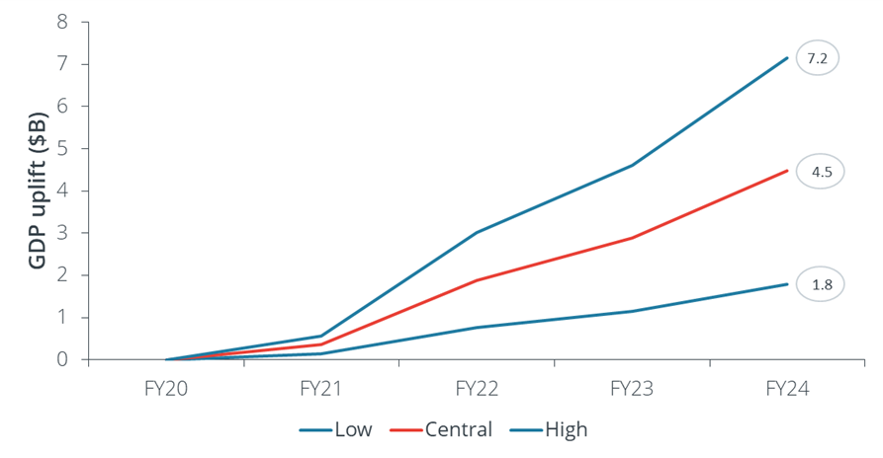

Source: Frontier Economics of ABS data, Consensus Economics data and Briglauer (2021)

There is also some uncertainty regarding the actual impact of the initiative on speed increases. In particular, the adoption of new Enterprise Ethernet services is responsible for almost all of the speed increases. It is plausible that some of the additional Enterprise Ethernet connections would have been served by other fibre suppliers. The results we report largely scale with alternative estimates; for example, if additional connections would be served in the counterfactual by other suppliers (and retaining the same speeds for Enterprise Ethernet connections) the benefits as in Table 8 would be reduced.

### Benefits for firm productivity

#### Methodological approach

A second type of approach to estimation of economic benefits is to directly examine the likely gains in firm productivity from better broadband. As identified in the literature review, there are a range of ‘micro’ empirical studies that examine causal relationships between broadband availability and adoption and changes in firm productivity, where that is commonly measured as multi-factor productivity.[22]

Although there is no specific Australian data that we can use to estimate changes in productivity from broadband use, we can apply the results of some overseas studies to Australian data. This can provide a reasonable prediction of the kinds of effects that we should see from NBN Co’s business initiatives.

Given the nature of the business initiatives, we caution that the firm-specific effects are still complex. They will depend on matters such as the extent of existing infrastructure, firm location and on specific business decisions about whether and how higher quality broadband can be used. As an example, in Figure 11: Sources of differences in business benefits we highlight that the specific benefits to a business can really only be understood in the context of its location and existing supplier of broadband services. Because this granularity of detail is not available – for example, we know a firm’s current broadband service but not its preceding service – we have to average the effects based on available data.

Figure 11: Sources of differences in business benefits

This highlights the possible upgrade paths for business within and outside business fibre zones. From (list of options) Non-NBN fibre; NBN residential service; Non-fixed line supplier to (list of options) NBN Enterprise Ethernet or Upgraded NBN MTM service (TC-4 or TC-2).

Source: Frontier Economics

Our overall approach to estimation of firm productivity benefits is summarised in Figure 12.

Figure 12: Methodology to estimate firm productivity effects

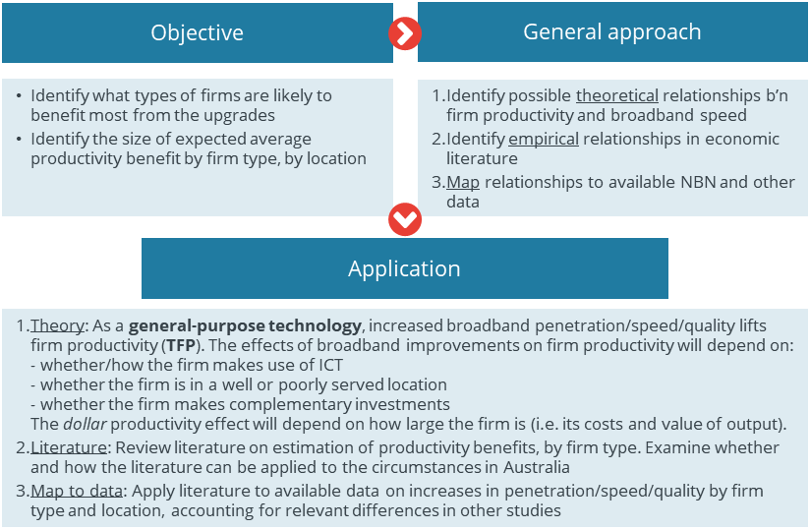

Source: Frontier Economics

Two particular matters are worth addressing from this figure (in bold):

**General purpose technologies:** Broadband internet is a general-purpose technology (Bresnahan and Trajtenberg, 1995) that is used in many different applications. Like transport and energy innovations, general purpose technologies induce positive externalities and have a more significant impact on innovation because its effects apply to many other major sectors of the economy. “Firms grow faster and are more productive in countries where Internet access is better.”[23]

Measuring productivity (TFP): An economy’s production function can be written as Y = A f(K,L), where output Y is a function of technology / productivity (A), capital (K) and Labour (L). The **change in A over time** is a measure of multi- or total-factor productivity (MFP / TFP). MFP is a central variable is studies of the impact of broadband on productivity. This can also be interpreted as an increase in output (see Box 4).

1. **:** Understanding increases in firm productivity and output

A firm’s production function can be written as Y = A*f*(K,L), where output Y is a function of technology / productivity (A), capital (K) and Labour (L). The **change in A over time** is a measure of multi- or total-factor productivity (MFP or TFP).

Using some simple growth accounting and the common Cobb-Douglas production function where $Y=AK^{α}L^{β}$, we can see that the change in A over time has a direct influence on output growth, Y. That is, taking logs and differentiating with respect to time:

$$\frac{\dot{Y}}{Y}=\frac{\dot{A}}{A}+α\frac{\dot{K}}{K}+β\frac{\dot{L}}{L}$$

Given fixed inputs (i.e. K and L), we can see that output growth $\frac{\dot{Y}}{Y}$ is determined by MFP growth $\frac{\dot{A}}{A}$. So the results can also be interpreted in this manner; a 10% increase in MFP growth increases output growth by 10%.

The forecast productivity gain may also be converted into a cost saving by using a Cobb Douglas cost function, which is the cost minimising solution to the Cobb Douglas production function. This assumes that firms maintain their output but benefit from being able to use fewer inputs to produce that output at unchanged prices. For small percentage changes in A and assuming constant returns the cost reductions will be similar to the changes in A, but of the opposite sign (i.e. a 1% increase in A will reduce costs by 1%).

*Source: Frontier Economics*

#### The methodology for estimating specific firm productivity effects

Our methodology is summarised in Figure 13. In summary, we:

Estimated an average productivity gain from the “treatment” - NBN Co’s relevant business investments and their impact on the internet speed of firms that take up its services

Broke down that impact by firm industry type and by location.

Figure 13: Methodology for estimating specific firm productivity effects

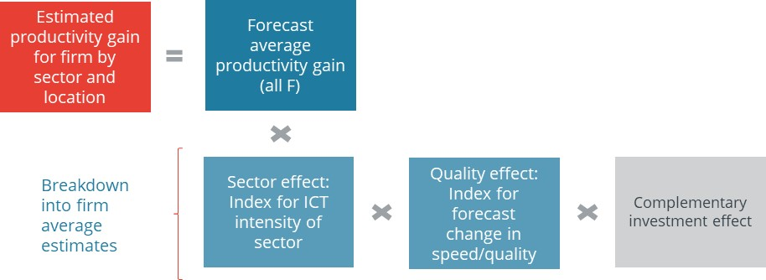

Source: Frontier Economics

We focussed our estimations on firms within Business Fibre Zones, as we have the most information on these firms. However, the average results across sectors are also relevant to those firms outside Business Fibre Zones.

#### Forecast average productivity gain

To derive a forecast for the average productivity gain, we adapted the study of Canzian et al (2019) to Australian data. This is the only available published study that provides recent data on the relationship between faster broadband and firm productivity (see Annex B for the literature review) although we must recognise that it does not specifically identify benefits of fibre broadband. This study used Italian data based on firm responses to increases in broadband speed for a period of two years after services became available. Two key results were that the firms in regions subject to the speed increases (of between 2 to 10 times[24]) experienced:

Increased revenues by 14.8% (or between 1.6% and 28.0%)[25]

Increased MFP by 9.1% (or between 3.3% and 14.9%) [26]

Over a period up until one year after increased ADSL2+ availability.

We adjusted these estimates to reflect two factors: (i) the likely speed effects of the NBN Co upgrades, and (ii) for the industry composition in Australia, which is different from Italy.[27]

#### Sectoral effect - IT intensity of a sector

To break down the forecast effects by sector, we calculated data on IT intensity by dividing net IT capital stock by the net capital stock, by industry. We then used this index (where the average industry = 100) to scale the effects by industry sector. This adjustment simply reflects that the industries likely to receive the largest benefit are those that invest relatively more capital in IT (Mollyerd, 2015).

#### Existing quality effect - area remoteness

We think there are good reasons to expect the impact of NBN Co’s investments to be significantly greater in areas that currently have access to only basic broadband. This is not simply a function of price discounts, but rather the greater quality differential expected. So, for example, in CBD areas that are already well served by fibre, the economic benefits are likely to be relatively smaller than in Ballina in regional NSW, which has does not presently have access for enterprise-grade fibre services at no upfront cost. To account for these locational effects, we constructed an index for the remoteness of the Business Fibre Zones based on NBN Co’s categorisations[28] and used these to proxy for pre-upgrade business internet quality.[29]

#### Complementary investment effects

The economic literature also tells us the importance of firms making complementary investments to get the most out of higher broadband speeds. While we consider that this effect is important, it is complex to forecast which firms are likely to undertake more of that investment and we could not find suitable data.[30] One approach may be to treat such investments as a binary variable - without such investments the forecast benefits will not materialise.[31]

### Key results

#### Overall effects

As we have highlighted above, we needed to estimate the change in average speed that is likely from the business fibre and other business initiatives. This can be used to scale the effect in the Canzian et al (2019) study, assuming that the impacts from the average speed increase are proportional.[32] Note that for this part of our study, we used the changes in speeds that are expected for *business* services over-and-above those changes that were likely to have occurred without the initiatives. That is because we wished to estimate the benefits for businesses, rather than the total speed increase across all users as for Section 2. This forecast captures expected use of all available services by businesses, including Enterprise Ethernet, TC-2 and TC-4. We weighted these forecasts by total speed available rather than simply by connections, reflecting the additional benefits obtainable from the much higher capacity direct fibre connections.

Scaling also occurred for the different composition of industry in Australia, as highlighted in Table 10.

Table 10: Base forecast firm productivity gain

| **Result** | **Average firm TFP gain** | **Average firm revenue gain** | **Notes** |
| --- | --- | --- | --- |
| Canzian et al study effect | 9.1% | 14.8% | Based on speed and other benefits derived from shifts to business ADSL+ services between 2010-2015. |
| Corrected for Australian IT intensity | 6.2% | 10.1% | Based on average IT intensity in Australia, excluding mining and agriculture which were not included in Canzian et al study |
| Corrected for forecast speed increase | **2.0%** | **3.3%** | Based on a forecast speed increase due to broadband improvements of 100% over the period to 2024, around 54% of the increase in Canzian et al study. |

Source: Frontier Economics

#### Expected productivity gains by industry type

The breakdown of the gains into sectors proceeds as described above, using ABS data.

We first calculated IT intensity of sectors, as shown in Figure 14. There are large variations between industry sectors. The services sectors have a much higher share of their capital stock in IT investment. Other sectors with relatively high intensity include construction, information media and communications, and wholesale and retail trade. Sectors with low intensity include mining, agriculture, manufacturing and transport.[33] Although these sectors have low IT intensity, it is also worth noting that some of these sectors are large and investments significant in dollar terms.

Figure 14: IT intensity (IT capital stock / Total capital stock) for Australian industry sectors, 2020

This figure charts the IT Intensity of Australian industry sectors as at 2020. IT intensity for an industry is total IT capital stock in the industry divided by the total capital stock in the industry.

Average IT intensity is 1.9% and is as high as 14.4% for Other services, and as low as 0.2% for the mining sector.

IT intensities for by sector for all sectors are:

Agriculture, forestry and fishing 1.4%
Mining 0.2%
Manufacturing 2.0%
Electricity, gas, water and waste services 3.4%
Construction 8.1%
Wholesale trade 6.9%
Retail trade 7.0%
Accommodation and food services 3.7%
Transport, postal and warehousing 1.4%
Information media and telecommunications 8.1%
Financial and insurance services 10.7%
Rental, hiring and real estate services 2.0%
Professional, scientific and technical services 11.5%
Administrative and support services 12.7%
Public administration and safety 2.7%
Education and training 2.1%
Health care and social assistance 3.6%
Arts and recreation services 5.1%
Other services 14.4%
All industries 1.9%


Source: ABS

The diversity in IT intensity also means that although the aggregate effect might not be considered large across all industries, it is reasonably high for particular sectors: note from Figure 14 that the effect for professional, scientific and technical services will be more than 5 times the average effect across industries with no further scaling.

We then considered whether these effects are likely to directly translate in different productivity effects. For example, the relationship between IT intensity and estimated productivity benefit from faster broadband may show increasing or decreasing returns, or have a fixed and variable component.[34]

We used a further scaling factor to account for relative effect between sectors - i.e. we do not use IT intensity directly to distribute the overall forecast productivity effect. We adopted a scaling factor of 0.75 in our standard case[35], as in Figure 15.

Figure 15: Forecast productivity gain by industry

This figure plots the forecast average productivity gains by industry due to NBN Co’s business initiatives.
The average productivity gain is 2% across all industries, as high as 12.1% for Other services, and as low as 0.7% for Mining.
A full list of industries and their forecasted productivity gains are as follows:
Agriculture, forestry and fishing 2%
Mining 1%
Manufacturing 2%
Electricity, gas, water and waste services 3%
Construction 7%
Wholesale trade 6%
Retail trade 6%
Accommodation and food services 3%
Transport, postal and warehousing 2%
Information media and telecommunications 7%
Financial and insurance services 9%
Rental, hiring and real estate services 2%
Professional, scientific and technical services 10%
Administrative and support services 11%
Public administration and safety 3%
Education and training 2%
Health care and social assistance 3%
Arts and recreation services 5%
Other services 12%
All industries 2%


Source: Frontier Economics

The sectors that show the largest benefits mirror those with the highest IT intensity - mostly services sectors, with construction and trade also material.

#### Expected productivity gains by location

As identified earlier, we also accounted for different starting point for business locations. CBD areas are much better served with high speed broadband infrastructure than other areas in which business congregate. Therefore, areas that are more remote relative to the CBD that have not historically had the benefit of existing high speed infrastructure and availability of multiple competing fibre networks, are likely to experience more incremental benefits than CBD businesses, all else equal. To account for this, we constructed an index for the remoteness of the Business Fibre Zones based on NBN Co’s zone categorisations and used these to proxy for pre-upgrade business internet quality. An example is shown in Figure 21; each fibre zone was assigned a score depending on how many of its compositional SA1 statistical units[36] are in each zone. Adelaide CBD received a low score as nearly all of its SA1s are in CBD zoned areas, whereas Albury would received a higher score as this Business Fibre Zone includes a number of zone 2 areas.

Table 11: Proxy for locational benefits – example of 6 Business Fibre Zones

| **Business Fibre Zone** | **CBD** | **Zone 1** | **Zone 2** | **Zone 3** | **Total** |
| --- | --- | --- | --- | --- | --- |
| Adelaide CBD | 58 | 7 | 0 | 0 | 65 |
| Albany | 0 | 0 | 44 | 0 | 44 |
| Albury / Lavington | 41 | 0 | 86 | 0 | 127 |
| Alexandria | 48 | 26 | 0 | 0 | 74 |
| Annerley | 39 | 47 | 0 | 0 | 86 |
| Applecross - Melville | 0 | 57 | 0 | 0 | 57 |

Source: Frontier Economics based on NBN Co data

Assigning a different score depending on share of various zones allowed us to produce forecast productivity effects by firm type by Business Fibre Zone.

#### Gains by industries in different states

We first present the results by averaging firm productivity effects by Business Fibre Zone location in different states (Figure 16). We can observe similar effects by State, although the differences between Tasmania at 5.8 per cent and ACT at 4.0% appear non-trivial.

We also note that the average results reported here appear higher than the overall effect across all industries of 2.0%. That is because the results are not weighted to reflect industry size; the distribution of effects indicates lesser percentage returns to industries such as mining which have a relatively high share of capital stock but low IT intensity.

Figure 16: Average productivity gain in Business Fibre Zones, by state

This figure charts the average productivity gains in the business fibre zones (BFZs) by State. due to NBN Co’s business initiatives.

The bars on the chart plot the number of BFZ in each state, while the dot/point above each bar indicates the average productivity gain.

The results are the following:

New South Wales; 96 BFZs, 5.0% average productivity gain

Victoria; 46 BFZs, 64.8% average productivity gain

Queensland 40 BFZs, 5.0% average productivity gain

South Australia 24 BFZs,  4.6% average productivity gain

Western Australia 23 BFZs, 5.2% average productivity gain

Tasmania 4 BFZs, 5.8% average productivity gain

Australian Capital Territory 4 BFZs, 4.0% average productivity gain

Northern Territory 3 BFZs, 5.4% average productivity gain


Source: Frontier Economics analysis

Further analysis indicates that the State differences are primarily caused by the location of the Business Fibre Zones. Zones in regional areas are forecast to receive greater benefits.

Figure 17: Benefits by State, Metro/Regional Business Fibre Zone location

This figure charts the average productivity gains by State, by are (metro and rural), due to NBN Co’s business initiatives.

The average productivity gain in metro areas is 4.5%, while the average productivity gain in regional areas is 5.6%.

Benefits in metro areas are highest in Western Australia (4.9%) and lowest in the Australian Capital Territory (4%). Note that there are no metro areas in Tasmania and the Northern Territory that are effected by NBN Co’s business initiatives, hence metro productivity gains in these states are not charted.

Benefits in regional areas are highest in Western Australia (6.4%) and lowest in the Victoria (5.1%). Note that there are no regional areas in the Australian Capital Territory that are effected by NBN Co’s business initiatives, hence regional productivity gains in these states are not charted.



Source: Frontier Economics analysis

#### Gains by industry in different Business Fibre Zones

As we identify above, one issue with the results presented is that they do not tell us much about the significance of a particular industry in a Business Fibre Zone. For example, a forecast that finance firms would expect an increase in productivity of 15% in a particular zone may overstate benefits and there might be very few or no firms offering those services in that zone.

To address this problem, we have estimated the GVA by industry in each Business Fibre Zone. We then use this to identify industry sectors that (i) are forecast to receive a material productivity gain and (ii) contribute materially to GVA in that fibre zone.

To summarise the results, we calculated a score that accounts for both forecast productivity gain and GVA by industry. We then constructed the following table which ranks the scores by industry and sums them across zones (Table 12).

Table 12: GVA-weighted ranking of industry productivity benefits.

This table provides the GVA-weighted ranking of industry productivity benefits due to NBN Co’s business initiatives. As noted in the text, the results indicate that industry sectors such as construction, professional services, retail and wholesale trade, and other services including finance and insurance and health care are likely to receive the greatest share of benefits in the most Business Fibre Zones. That is, there are many Business Fibre Zones in which these sectors are the biggest productivity beneficiaries.

The table capture and accounts for both: (1) forecast productivity gain by business fibre zone and (2) GVA by industry.

Each column is an industry and the rows are benefits rank from 1 to 19. For example, the first row and column represents a rank of 1 in the construction industry. The number for this table entry is 93, which indicates that in 93 business fibre zones, the construction industry received the most benefit.
 Source: Frontier Economic analysis,

The results indicate that industry sectors such as construction, professional services, retail and wholesale trade, and other services including finance and insurance and health care are likely to receive the greatest share of benefits in the most Business Fibre Zones. That is, there are many Business Fibre Zones in which these sectors are the biggest productivity beneficiaries.[37] Accounting for output in these results affects the rankings of sectors to benefit quite materially (as per the last row of the table): for example, we note that the health care and social assistance sector ranked on average 11th out of 19th industries in expected benefit, but when GVA is accounted for this increases to 5th. This is particularly relevant in light of 14 of the Business Fibre Zones in dedicated health precincts centred around a major hospital. Those sectors receiving the least benefit are sectors with either low IT intensity (e.g. Mining and Agriculture) or have a relatively low share of GVA (public administration, arts and recreation).

Some sectors show more widely varying results. This includes manufacturing, which has a higher share of GVA in some fibre zones. Information media and telecommunications appears a somewhat anomalous result, as one would expect it to be a sector that benefits significantly from better broadband. However, this result may also reflect that there are few of these kinds of firms in areas outside of well-served markets such as CBD areas - i.e. they have a relatively low share of GVA in many fibre zones because the broadband infrastructure may not support them, and so choose to locate in better served areas.

#### The timing of benefits

The availability and take-up of broadband services do not produce immediate benefits. Rather, the empirical evidence shows that benefits emerge over time (with a lag). This is due to broadband being an enabling technology – to appropriate its full benefits requires investments in physical capital (i.e. new equipment, software or processes) and human capital (i.e. training). Early Productivity Commission (2004) research on firm adoption of ICTs found that the lag in most industries was from six months to two or three years, but was up to four years in some cases in the mining industry.

The Canzian study (2019) that forms the basis for our estimates of productivity benefits explicitly considers the size of productivity impact at various points in time. So the average gain in productivity for firms in the sample was 1.4% for each 100 days of exposure, i.e. ADSL2+ deployment in the region, where the “full effect” was measured after another 12 months (512 days). The authors indicate that “…the effects of the ADSL2+ upgrade do not seem to be contemporaneous but come into effect only after one year.”[38]

The nature of deployment of fibre in Business Fibre Zones is similar to the Canzian study, in that the impact of take-up was not directly measured but averaged across firms that would have been able to access the upgraded service.

NBN Co’s data indicates that the full impact of the fibre initiatives may take some time to emerge, at least in comparison to expected take-up. For example, see Figure 18 which highlights the rapid growth in total bandwidth capacity expected to FY2024.

Figure 18: Proportion of total bandwidth capacity relative to FY24 target

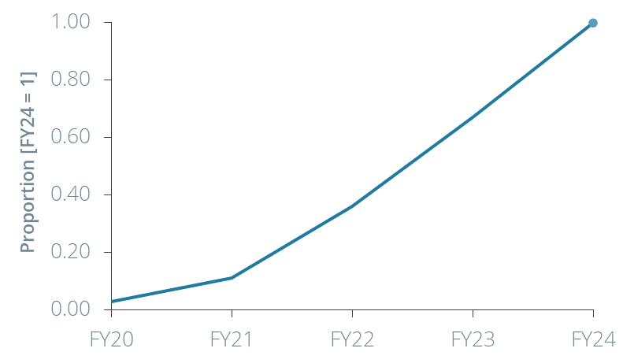

Source: Frontier Economics based on NBN projections of take up by connection types.  
Note: Total bandwidth is the product average of the number of Enterprise Ethernet, TC-2 and TC-4 connection and their respective speeds based on NBN forecasts. The chart shows the proportion of total bandwidth over time relative to that expected by FY24. For example, based on NBN data, FY21 will have approximately 11% of the total speed/coverage expected in FY24.

While the average benefit to a firm in a fibre zone might be initially lower, this could also be reflective of lower average take-up rather than smaller benefits for each firm that does take up Enterprise Ethernet. Nonetheless, the empirical studies indicate that we should be cautious in attributing the timing of benefits too soon after the availability of better services.

### Business satellite services

NBN Co is also investing in business satellite services (BSS) to deliver a higher quality of service to users in satellite areas than standard residential grade services. NBN Co announced in March 2021 that it would increase coverage from 93% to 100% of Australian mainland and surrounding large islands, and, in parallel, lower its monthly wholesale charge for the service by between 32-43% depending on the service.

As part of BSS, three levels of service are being offered:

Access Bandwidth Service Layer 3 (ABSL3) – a product aimed at business customers who require high quality bandwidth with a Committed Information Rate. Delivers wholesale speeds of up to 50Mbps download, 13 Mbps upload (50/13). The services also include ABSL3 burst – Committed Information Rate bandwidth for critical business applications with additional forward Peak Information Rate bandwidth in burst to 10, 20 or 50Mbps.

Virtual ISP (VISP) – a business product offering wholesale speeds of up to 30/13Mbps. Other features of VISP include allowing service providers to pool the data quotas of businesses with multiple premises and the service being deployed in ‘stand-by’ mode (bandwidth available on demand). The stand-by mode feature allows VISP to be used as a disaster recovery service.

Internet of Things – a business product aimed at connectivity for remote monitoring of infrastructure and devices. The bandwidth offered range from 10/10 kbps to 2/2Mbps to suit the use case. The service offers both a Committed Information Rate and Peak Information Rate for connections.

It would be reasonable to expect that BSS will provide similar types of benefit to other NBN Co business broadband products. That is to say, improved connectivity will lead to business productivity benefits where the level of benefit varies depending on factors including the sector of the business and the increment of speed/reliability improvement.

Given data limitations — especially around sector of businesses taking up BSS and their previous data solution — it is not possible to undertake a quantitative analysis of the benefits of business nbn satellite services. As previously mentioned, it would be expected that BSS contribute to business productivity benefits. However, given that the nature of the service and intended users differ from other business broadband products, the nature of the productivity benefits may also differ. For example, it may be that satellite services allow businesses to be more responsive to operational risks and issues with remote assets rather than changing the products and services that they offer customers. It may also be that satellite services provide more social benefits, as BSS allows remote workers to access video calls and streaming which was not previously possible. An example of benefits from business satellite services is provided in Box 10.

## 3. Competition impacts in markets for business broadband services

A second element of the study was to examine the impact of the increase in accessibility and affordability on competition in the (i) the markets in which fibre and other business services are supplied, and (ii) the market in which retail services are provided to business users.

### Method for identifying competition impacts

There is a relatively standard economic approach to identify the effects of changes in market conditions (e.g. a policy change) on competition. This is identified in Figure 19.

Figure 19: Overview of competition benefits methodology

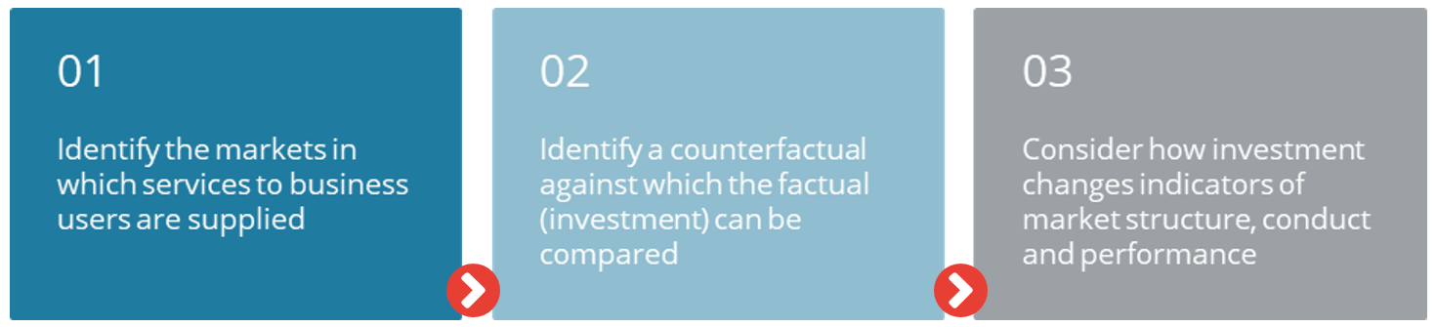

Source: Frontier Economics

The first step is the identify markets in which competition takes place. This will need to include some consideration of the product markets, geographic markets, and the different functional markets at which products are offered.

The second step considers the ‘increment’ of change in action that is being considered - here, the development of markets for business services without the investments being made. This may be the same as the ‘status quo’, but in a market with ongoing technological change, may also be a change in the speed of investments occurring.

The third step is to identify how the investments change indicators of competition. The conventional economic approach to the assessment of competition is to consider three kinds of indicators: structural indicators, behavioural indicators and performance indicators (the ‘structure conduct performance framework’).[39]

The structure-conduct-performance scheme can be used to classify various indicators of competition:

* The **structure** of a market can be examined to see whether the structure is of a kind that is likely to produce competitive conduct.
* Patterns of **conduct** can be examined directly to ascertain the extent to which firms within the market are behaving in a competitive manner.
* **Performance** measures can be examined to determine whether prices and economic returns are similar to those that we would expect to be earned in competitive markets.

The approach we describe here is in line with both conventional economic thinking and views expressed by the Australian Competition Tribunal.[40]

### Two markets relevant to business broadband services

To understand competition and competitive benefits, we need to have some insight into how firms are competing, and for what. We use market definition to assist this process.[41] It is not, however, necessary to come to a conclusive view on the market or markets in which NBN Co competes for business services.

The process of identifying markets begins with an identification of the products that are the subject of the analysis. Here, our particular interest is in the markets in which NBN Co provides its business broadband services, so it makes sense to begin with identifying the three main kinds of NBN business-related services that are relevant for this study:

Enterprise Ethernet services, a point-to-point fibre service

Ethernet services (TC-2) provided via the range of technologies available on the NBN including FTTN, FTTC, HFC and FTTP (MTM)

Residential grade (TC-4) services also provided using the MTM networks, which are not specifically business services but are used by many smaller businesses.

We also consider NBN Co’s business satellite services within the context of this study.

The assessment of substitution in demand is a key element in defining markets in competition law. The essential task in market definition is to define all the products on the demand side that buyers regard as reasonable substitutes for the product and then to identify all the sellers who supply or could potentially supply them – this is the relevant market. This exercise of market definition includes defining the geographical reach of the relevant market.[42]

We therefore need to identify substitutes for NBN Co’s services. In the following figure we identify, in a stylised way, the key structure of how markets for business grade services for high speed, high quality, and symmetric speed services.

Figure 20: Illustration of wholesale and retail markets for business grade broadband

This figure highlights the supply chain for business grade broadband services. There is a mix of supply models, with NBN a wholesale only supplier, while other suppliers offer services directly to businesses, often bundled with other services.

Source: Frontier Economics

In this Figure, we highlight that:

* NBN competes with other fibre providers (if there are any in the geographic area) to supply services to retailers.
* Other fibre providers may or may not provide wholesale services, and may be vertically-integrated.
* Retailers buy inputs from NBN and can self-supply other inputs (e.g. mobile services) to supply to businesses.

The potential substitutes for NBN Co’s services include services provided using mobile networks, satellites or fixed wireless technology.

### Wholesale network markets

Our view is that there are wholesale network markets for the supply of fibre and other fixed network services to retailers that are capable of providing business grade broadband services to end users. We consider these markets are likely to be local in scope.

We have formed this view for the following reasons:

Purchasers of wholesale network services face few good substitutes for fixed networks to supply business grade services. The main substitutes include mobile or fixed wireless networks. It is plausible that, at the margin, some retailers may seek to supply end users using other technologies but there are fundamental limitations associated with these technologies in supplying symmetric, high speed services with very high reliability. Mobile and fixed wireless networks are subject to capacity limitations relating to available spectrum (which increases costs) and subject to performance degradation from buildings and other obstacles which limits their reliability compared to a fixed connection.

There is little possibility of geographic substitution - i.e. to purchase service in other geographic areas. There are very high fixed and sunk costs associated with the supply of fixed network services. It is most commonly the case that any pressure from substitution comes from networks that are located nearby, as it is much cheaper to extend an existing network to a customer.

### Retail broadband service markets

In contrast to wholesale markets, the retail markets for business-grade broadband supply appear to be national. We have formed this view for the following reasons:

For similar reasons as for wholesale markets, end users have specific needs for business grade services that are difficult to meet using other non-fixed line networks.

Most retail suppliers of business grade services operate on a national basis, including all of the larger suppliers such as Telstra, Optus, TPG Telecom and Vocus. This is likely to be because there are economies in having a retail presence across Australia. This allows key fixed costs, such as marketing and branding, to be spread across a greater use base, as well as allowing some economies of scale in backhaul networks and related service markets. However, to the extent that retailers operate some fibre networks, these are concentrated in CBD and inner metropolitan areas.

### Competition in business markets without the investment

NBN Co introduced business-grade services into network (TC-2) progressively from 2013 and Enterprise Ethernet services in 2018. Prior to NBN Co’s entry into the business grade markets, Telstra had high shares of (retail) markets supplying fixed business grade broadband and related services, at least when examined at a national level.

Information we have gathered suggests that, at that time, Telstra had the majority fibre footprint, buildings connected with fibre (lit buildings), and more revenue - see Figure 21. This does not exactly align with our market definition, which would potentially cover a broader scope of services than that illustrated here and would also consider local wholesale markets. Nonetheless, it does demonstrate that:

Telstra was the market leader across these services

Markets were likely to be highly concentrated, noting that Herfindahl-Hirschman indexes (which are calculated using the sum of squares of market shares)[43] for any of these measures would be between 4,500 and 5,500 - which is highly concentrated.[44]

Note that it is also very likely that there is considerable or close-to-universal overlap in fibre and lit buildings, so that these shares to some degree mask that there is considerable competition in some areas and little in others.

Figure 21: Estimated shares of fibre, shares of lit buildings and share of revenues for enterprise customers

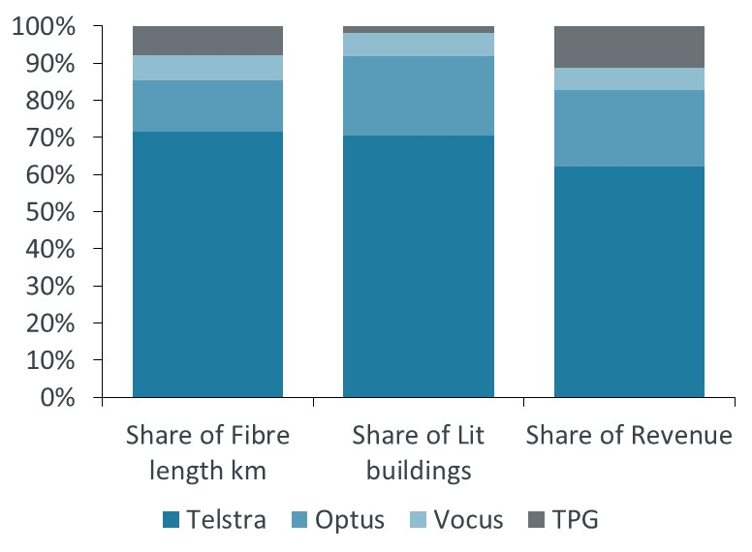

Source: Estimates based on annual reports for Telstra, TPG and Vocus, Optus estimate

#### Market structure and competition varies by location

The aggregated shares addressed above do not really convey the full competitive picture, as there are two other key elements to understanding market structure:

1. Wholesale and retail competitors focus on central areas in major metropolitan cities: CBD wholesale markets are effectively competitive, with many fibre suppliers. But in most markets outside of CBDs, Telstra was the dominant supplier of business-grade fixed services using copper and fibre networks. Other wholesale markets or market segments such as regional and rural areas are less competitive.[45]
2. Vertical integration between wholesalers and retailers limited the degree of competition in retail markets, because there was limited wholesale supply of services or supply only on unfavourable commercial terms.

These structural market features led to two important factors that limited competition in areas outside of CBD areas:

**Ubiquity matters**: It is much cheaper to extend an existing network to new customers than for competitors that have no local network. In practice this provided Telstra with a substantial competitive advantage in that its fixed network was ubiquitous, whereas competitors were limited to extending existing CBD or inner metropolitan networks, or areas close to where they had existing fibre backhaul.

**Leveraging of market power:** A competition issue has arisen from the ability (primarily by Telstra, but also applicable to other network operators) of wholesale network operators to leverage network-level market power from uncompetitive to competitive markets. Retailers without infrastructure were therefore hindered from competing with those with infrastructure, particularly as infrastructure availability in regional areas may be leveraged (e.g. via pricing discounts for bundles).

As identified above, NBN Co has increasingly competed with Telstra and other suppliers with residential-grade TC-4 and business grade TC-2 products over its MTM network. NBN Co has reported that it has over 1 million business customers, but the service attributes supplied reflect residential service levels (TC-4). For example, on services connected to FTTN, TC-2 services of only up to 20mbps symmetric were available - as per Figure 22.

Figure 22: Availability of TC-2 services for business use

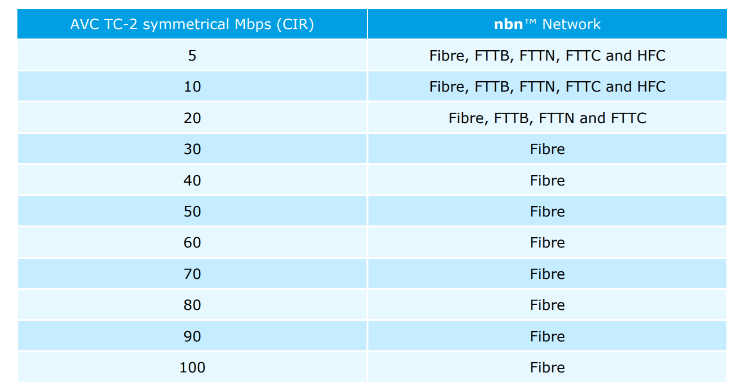

Source: NBN Co WBA

#### The counterfactual: these conditions were not likely to change in the absence of further NBN investment

In assessing the competitive effects of NBN Co’s investments in business services, we must form a judgement as to the likely changes that would have occurred without the investments. In our view, it would be reasonable to observe the following counterfactual:

Competition would remain limited for high speed, high quality fibre services for enterprise use outside of CBD and inner metro areas. The high fixed and sunk costs associated with duplicating investment would mean it is only in dense business areas close to existing networks where network extensions would occur.

Continuing limitations on MTM services outside of existing FTTP areas would limit their ability to effectively substitute for higher grade services offered by fibre networks.

### Competition in business markets with the investment

The investments by NBN Co will change competition in the wholesale markets significantly. In this section, we set out our expectations of changes to market structure, and then report what we have been able to discern from the early stages of NBN Co’s deployment of Enterprise Ethernet services.

#### Changes in wholesale market structure

Given the wholesale market structure that we have outlined in section 3, it should not be surprising to observe that the effect of NBN Co’s entry in local wholesale markets will have quite different competitive effects. This will depend on, for example, whether NBN Co’s supply is in a CBD area where it may become the 7th or 8th supplier of similar fixed line business grade services, or whether it is an outer metropolitan or regional area where there might only be one or two networks available for retail supply.

Bresnahan and Reiss (1991) provide a theoretical treatment of entry effects, identifying that:

Theoretical models of imperfect competition make diverse predictions about the competitive effects of entry. At one end is contestability. At the other is entry barrier models which argue that only actual entry increases competition. Between these two extremes lies a range of theories with varying quantitative predictions about the prevalence and consequences of entry.[46]

This suggests that what we would ideally like is a detailed empirical model of entry in broadband markets - and one that focuses specifically on business broadband. However, to our knowledge there are no studies of business broadband internet. We assume that this is because there are not many examples of competitive entry.

In Bresnahan and Reiss’ empirical element to their study of entry, they find that in certain services markets with five or fewer incumbents, almost all variation in competitive conduct occurs with the entry of the second and third firms. Although the markets that we are looking at here are somewhat different, with far larger sunk and fixed costs, there is reason to suggest we should expect declining competition benefits from further entrants. The main reason is that the existence of fixed and sunk costs deters entry, but makes competition more fierce once entry occurs. Incumbents have relatively low marginal costs of supply and so are willing to discount heavily to keep market share.[47] This suggests we should expect large benefits from entry into monopoly areas, and less in areas where entry has already motivated competition. However, there may also be benefits to competition where monopoly allows for leverage of market power into related markets that are more competitive. This might be pertinent to, for example, supply of services to enterprise customers that have a head office in a CBD (competitive) but other stores or offices in less-competitive outer-metropolitan or regional areas.

#### Changes in retail market structure

There are three important features of NBN Co’s entry into the supply of wholesale-only dedicated fibre services with national reach:

NBN Co’s ubiquitous entry[48] substantially reduces barriers to *retail* entry to supply business-grade services and related products (reduced market concentration) and the ability of existing wholesale network suppliers to leverage market power into retail and other more competitive markets (see Figure 23 which highlights national suppliers of Enterprise Ethernet shown on NBN Co’s website, noting that there may be more state-based suppliers not listed here).

NBN Co is vertically separated, with a mandate to increase retail competition, which substantially lessens concerns that NBN Co would compete with its downstream customers[49]

NBN Co’s increased price transparency provides a benchmark for retailers and end-users which can increase their ability to negotiate better deals as in residential markets.

Figure 23: 15 national suppliers of Enterprise Ethernet services

This figure highlights the 15 retailers that supply Enterprise Ethernet services on a national basis. The 15 retailers are:
Aussie Broadband, Ethan Group, Evetel, Field Solutions Group, Kinetix Networks, Launtel Pty Ltd, Macquarie Telecom, Optus, Superloop, TasmaNet, Telstra, TPG Telecom, TransGrid, Verizon and Vocus.

Source: nbnco.com.au  
Note: Other suppliers are available in specific states and territories.

In summary, highlights the range of competitive outcomes we would expect to see in local wholesale markets and the relative size of benefits.

Table 13: Where are benefits of competitive entry likely to be highest?

| **Competition** | **Benefits** |
| --- | --- |
| No existing fixed networks (satellite only) | If fixed line services become available, economic benefits may be substantial, but not necessarily from competition  If business satellite services become available, substantial economic and competition benefits are likely (as other satellite services do not presently deliver business grade service) |
| Monopoly networks | Significant benefits from increase in network competition, and also benefit from increase in retail competition as it allows competition for contracts that include the monopoly area |
| Two+ networks | Smaller benefits in areas where existing network competition (e.g. CBDs), but may be further benefits from enhancements in retail competition (e.g. to compete for national contracts) if existing networks did not wholesale services |

Source: Frontier Economics

### Expected competition benefits

Competition invariably delivers with it a range of benefits, of which the most important is potentially unforeseen innovations. This makes any forecasting of benefits subject to uncertainty. Noting this consideration, we analyse prospective benefits under three headings:

Increased opportunities for retail switching

Discounts in wholesale and retail prices and increases in quality of services

Increase in retailers’ ability to bundle service offerings across network platforms, e.g. increased ability to put network services together that are multi-platform

While there are almost certainly other benefits from increased competition, such as the ongoing pressure on networks to be efficient and innovative, these are not likely to be easy to quantify.

#### Benefits - increased opportunities for retail switching

NBN’s supply of Enterprise Ethernet services has the potential to unlock more retail competition, as it provides:

Opportunities for RSPs to switch businesses from other networks and technologies, such as existing fibre or ADSL, to Enterprise Ethernet

Opportunities for RSPs to switch businesses from residential grade TC-4 or business grade TC-2 services to Enterprise Ethernet

NBN Co’s existing analysis of its Enterprise Ethernet data highlights this increased switching being observed in new sales:

50% of the customer base is new (which includes switching from other networks)

a further 35% take services from an Enterprise Ethernet RSP that is not the same as their current TC-4 or TC-2 RSP. This suggests that RSPs are actively marketing services to existing NBN Co network customers.

Figure 24: Increased opportunities for switching

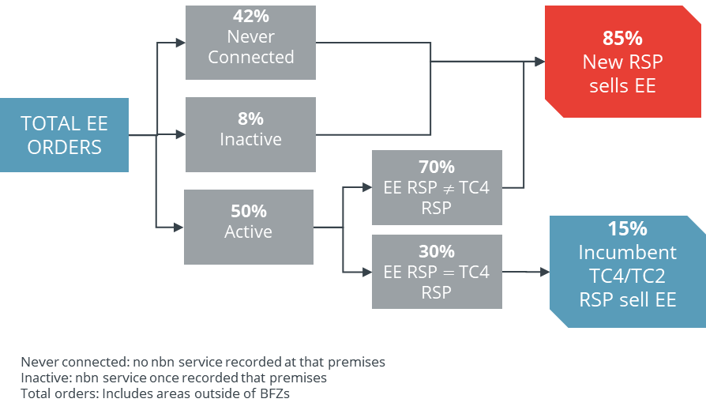

Source: NBN

#### Benefits - reductions in wholesale and retail prices

We have observed in Section 1 that NBN Co’s business fibre initiatives have included significant price discounts for Enterprise Ethernet services in Business Fibre Zones - as much as 67% for services in more remote Zone 3 areas that get the maximum benefit from ‘CBD equivalent’ pricing.

Given those price discounts and the extensive availability of NBN Co’s offer, it would not be surprising to see a competitive pricing response from other wholesalers. That said, no other wholesaler offers widely-available wholesale prices for services equivalent to Enterprise Ethernet, so we must infer changes from analysis of retail prices.

Of course, it is also challenging to analyse retail prices for business-grade services, for two main reasons:

business services are more complex and more valuable than residential services

RSPs negotiate directly with end users and may offer a range of discounts depending on the number and type of services, and contract length.

The bespoke nature of pricing means there is little publicly-available data on retail prices – unlike the residential market which markets heavily ‘headline’ prices for the most common services.

Through the course of this study, we identified an RSP, Telair, that offers business services from a range of suppliers (Figure 25) as well as its own entity, ACG.

Figure 25: Telair retail services and wholesale suppliers

This figure highlights that Telair resells from four different wholesale suppliers.

Source: Telair.com.au

We can use information on Telair’s past and current offers, in combination with NBN Co’s wholesale prices, to identify some key pricing trends - see Figure 26.

Figure 26: Price competition appears to be intensifying

This figure contains two charts.

The first chart highlights price changes for 100mbps services sold in CBD areas. NBN wholesale prices have fallen, and so have Telair retail prices for both NBN wholesale and Telstra wholesale products.

The same pattern is evident for 1Gbps services, even though there are no wholesale price discounts.

Source: Frontier Economics analysis of Telair offers

We observe that:

Telair has materially reduced its retail prices that use NBN Co’s wholesale products, with significant discounts in 100mbps and 1Gbps prices, even though CBD discounts are the smallest (when compared with Zones 1,2,3). This suggests that pass through of the lower NBN Co wholesale prices may have occurred.

Telstra appears to have responded to NBN Co’s competitive offers by lowering its wholesale prices significantly – Telair has reduced retail prices by more than 50%, to a point lower than the price offered for an equivalent NBN Co service.

Some component of this reduction is not directly driven by falls in wholesale prices – as we can observe that 1Gbps prices have also fallen even though there are no applicable wholesale discounts on NBN Co’s network for this service.

Not shown is that we found no evidence of changes in pricing of TPG- or Vocus- wholesale services over the January 2020 - May 2021 period. However, these networks are focused in CBD and Metro areas where NBN Co’s price discounts were less significant.

Unfortunately, we have little insight into retail price changes in areas where NBN Co’s price discounts have been most significant – no zone 1-3 pricing is available.

#### Benefits - innovation in service delivery

##### Multi-site competition

A major effect of NBN Co’s Enterprise Ethernet offerings has been to increase the contestability of large enterprise customers with multi-site operations. This has included entities such as Australia Post, which has many thousands of sites requiring networking, and state government health networks.

Using NBN Co’s services means that there is no need to build networks out to all sites, or to operate networks with dedicated capacity (e.g. MPLS). Instead, multi-technology solutions such as SD-WAN can be employed. SD-WAN can be used on both NBN Co and other platforms including mobile networks. In the past, only those with existing physical network infrastructure in most or all locations would have been able to compete for large contracts for multi-site operations. (In the Australia Post contract, Telstra was the incumbent).

We note that this contract was won *prior* to NBN Co’s business fibre initiatives**.** But the further discounts in Enterprise Ethernet prices in Business Fibre Zones will reduce cost to companies like Australia Post, and increase the viability of multi-site competition. Comscentre, the winning contractor for Australia Post, identified that:

By leveraging the Australian government’s $40 billion investment in the NBN and complimentary technologies such as SD-WAN, Comscentre (and other similar type service providers) are now able to compete in a market that was previous dominated by a select few.[50]

Figure 27: Service innovation using NBN Co’s wholesale business products

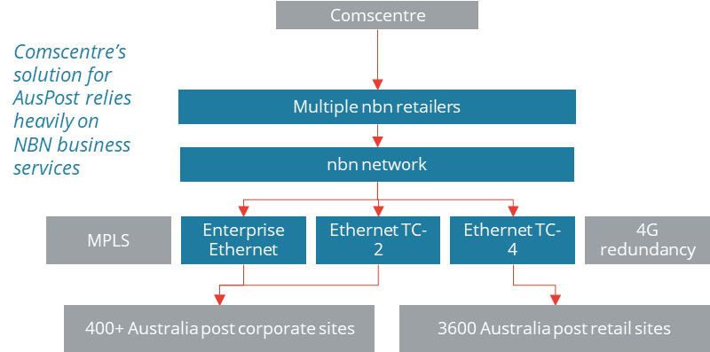

Source: [www.comscentre.com.au](http://www.comscentre.com.au) and Comscentre’s submission to the Inquiry into the business case for the NBN and the experiences of small businesses

##### Vocus’ experience

Large service provider and fibre network operator Vocus has also provided information on the benefits available from using NBN Co’s services. It states that it has combined its own services with those of NBN Co to win a number of large complex deals which needed fibre connectivity and network solutions to multiple sites across state, national and international boundaries.

This included deals with the Bureau of Meteorology (see Box 10), Northern Minerals, South Australia Health and NSW Health, for which Vocus was using both its own network and NBN enterprise services (including Enterprise Ethernet and Business Satellite Services). A Vocus spokesperson stated that access to NBN Co’s enterprise services:

…allows us to provide the most cost-effective mix of our own fibre and third-party fibre such as NBN to deliver complex network solutions for major contracts.[51]

With reference to its NSW Health deal, Vocus provides point-to-point Ethernet services for hospitals and health agencies across 80 sites, all on NBN Enterprise Ethernet, in regional New South Wales. The upgrade to a Health Wide Area Network will facilitate improvements to the quality of care NSW Health provides to people in the Wagga Wagga, Queanbeyan, Dubbo, Coffs Harbour and Lismore regions.[52]

Vocus has also identified the role of Business Satellite Services in winning more corporate customers. Vocus has stated that its capabilities in satellite access technology were a key factor in it recently winning a deal for 25 sites with a major utilities business, and that the introduction of layer three connections to private corporate networks for customers across the country has been an important addition to Vocus’ satellite solutions, as it enables greater security and resiliency, as well as unmetered data for customers.[53]

Vocus identified its Bureau of Meteorology contract as a good example of its ability to partner with NBN Co to better compete. While the Bureau was an existing Vocus customer, Vocus identified that:

the contract size increased from $7m (3 year contract) to $16m (4 year contract), with

around 115 sites will be serviced with Vocus fibre, with “renewed and increased scope” to around 200 sites

it partnered with NBN for 65 new sites (using fibre and satellite) and Telstra for remaining sites.[54]

#### Benefits in downstream retail and end-customer markets:

Benefits accruing to firms in markets downstream of RSPs will depend on use cases and the degree of competition prior to NBN’s entry:

**Use cases:** The significance of use cases is that higher speeds and quality must ultimately be able to deliver something that is of benefit to business - a way to reduce costs or to increase sales. It is apparent that there are many use cases for business for very high symmetric speeds, even if that business is not managing a large workforce. Rather, businesses in fields that make use of cloud computing, e-commerce, or extensive content sharing are likely to obtain material benefits from better availability and lower prices for business grade services.

**Competition:** Those downstream firms that were in regions that were previously in markets with single wholesale and retail providers are also likely to see the greatest benefits, as with pass through of price discounts offered by NBN Co.[55] Firms requiring high-speed symmetric business services in monopoly local (wholesale) markets will show greatest benefits: lower prices and greater availability of services from retailers. This also applies to firms that require services as part of multi-site solution across non-competitive or less competitive and competitive local markets.

We can determine a rough measure of the kinds of downstream industry sectors that are likely to benefit most from competition and existing price discounts by matching our index for remoteness for the Business Fibre Zone (discussed in section 2) with shares of GVA. We calculated the shares of GVA for industry sectors in the 30 Business Fibre Zones with the highest remoteness score: this identified that the following sectors are likely to derive particular benefits from lower prices and better availability of retail services:

Construction (11% of GVA)

Retail trade (10%)

Health Care (9%)

Manufacturing (8%)

Transport, postal and warehousing (8%).

Mining (8%)

Interestingly, these sectors are somewhat different from those that should experience the highest productivity gains, with both mining and transport sectors appearing. This reflects that these sectors are present in many parts of Australia where they can presently only access higher-cost services.

## 4. Case studies on business impacts

### Introduction

We have observed that it is challenging to quantify all the impacts of improvements to business broadband. Broadband is a general-purpose technology[56] that provides direct benefits to many different kinds of downstream services, such as:

Education

Transport/logistics

E-commerce

Manufacturing

Health

Broadband also provides benefits to many other kinds of services where it is not a central feature of the service but improves the efficiency by which certain tasks can be undertaken. This might include mining, forestry and agriculture.

The purpose of these case studies is to bridge some of the measurement gap, by providing real examples of the kinds of benefits that businesses can expect. By highlighting the kinds of businesses that will be more likely to benefit from proposed changes, and identifying whether there are likely to be many of these kinds of businesses, we can provide a further sense for the overall benefits of the network upgrades and investments.

Information to develop case studies was sought from NBN Co. The case studies in Section 3reflect this information while also seeking to identify more generalisable insights where possible.

### Case studies

1. **:** Case Study – Cumulus Visual Effects

Cumulus Visual Effects are a professional visual effects company who work across the film and television industries. The firm are based in Byron Bay, New South Wales, employing a core staff of 20 which grows for large projects.

Cumulus work virtually with collaborators around the globe. Projects regularly require transfers of files in excess of a terabyte in size. They were doing this on an ADSL connection with upload speed capped at 10Mbps. In order to transfer files to clients, Cumulus were having to schedule their upload to commence three days before the delivery date.

Cumulus now have a business nbn Enterprise Ethernet Gigabit symmetric product (1000/1000 Mbps upload and download). This means that terabyte files can be sent and received in minutes rather than days. The higher speeds have allowed Cumulus to collaborate in ways that previously weren’t possible for them, for example being able to livestream 4K footage with a client in Los Angeles.

“It’s really empowered us. We’ve been able to compete with some of the big kids in the big cities. The same opportunities that you would have had out of CBD Sydney. We’ve now engaged clients that we’ve never been able to get before.” Nicky Ladas, Senior IT Manager at Cumulus Visual Effects

From a price perspective, the Business Fibre Zone pricing lowers the wholesale pricing of a Gigabit service in Byron Bay by 41%.[57] This equates to a monthly price saving of $425, or $15,300 over a 36 month period. The extent to which the retailer passed this saving through to Cumulus is not known.

Cumulus Visual Effects is an example of a firm with high connectivity needs who have experienced a step change in their business capability as a result of nbn Enterprise Ethernet. Since the upgrade they have experienced an increase in their competitiveness compared to similar international firms.

*Source: NBN case study available at* [*https://www.nbnco.com.au/blog/business/positively-effecting-the-visual-effects-industry*](https://www.nbnco.com.au/blog/business/positively-effecting-the-visual-effects-industry)

1. **:** Case study – ADW Johnson

ADW Johnson are a multi-disciplinary engineering firm who cover civil engineering, design, town planning, surveying and project management. The business has more than 100 employees who work out of three offices in Sydney, the Central Coast and Newcastle.

ADW Johnson need to be able to collaborate across multiple locations, exchange large files, such as AutoCAD 3D design files, and participate in video conferencing. They need to be able to do this across their three offices and with staff working from home and from construction sites.

ADW Johnson now have business nbn Enterprise Ethernet (100/100 Mbps) at their Central Coast and Newcastle offices. They are now able to have 80 employees concurrently access their company server via a Virtual Private Network. The upgrade has also allowed employees to work concurrently on engineering design files on the company server.

ADW Johnson have a business nbn Enterprise Ethernet product with a “high class of service”. This relates to a wholesale Committed Information Rate which is less impacted by other internet traffic on the network. Together with a 4G backup, ADW Johnson now have a highly reliable and stable solution.

“We value reliability and stability so highly because we understand that the cost of downtime can be immense. Downtime can mean a loss of productive output from staff, up to 30%, or it can mean the loss of direct revenue to the business if downtime happens at a critical moment in working with a new client.” Scott Robinson, Director at ADW Johnson

From a cost perspective, the introduction of the Business Fibre Zone pricing has resulted in a 17% decrease in monthly wholesale charges. Assuming pass through of the saving, this would save ADW Engineering $6,120 over a 36 month contract compared to taking a 100/100 Mbps service prior to the Business Fibre Zone designation.

Business nbn Enterprise Ethernet has allowed ADW Johnson to bring the connectivity of their Central Coast and Newcastle offices to similar level to their Sydney office. More than this, it has allowed better connectivity for their staff to work remotely. Other multi-site firms with inconsistent internet products could also benefit from business nbn Enterprise Ethernet.

*Source: NBN case study available at* [*https://www.nbnco.com.au/blog/business/supporting-collaboration-in-a-multi-site-workplace*](https://www.nbnco.com.au/blog/business/supporting-collaboration-in-a-multi-site-workplace)

1. **:** Case study – Catholic Education Tasmania

Catholic Education Tasmania are a school network operating 38 schools and colleges across Tasmania. Locations range from the cities of Hobart and Launceston to small towns like Deloraine and Roseberry.

The schools in the network had a range of different internet connections with different bandwidths. Most were either on residential nbn or ADSL while there were instances where teachers were having to use their personal mobile hotspot to get online. This led to a digital divide where regional or remote schools in the network were often unable to use the same educational tools and applications as the metropolitan schools.

Catholic Education Tasmania now has business nbn Enterprise Ethernet at 26 sites in their network where they control IT management. This has allowed a roll out of digital learning tools including video conferencing replacing face-to-face for some interactions which required hours of travel for the teaching staff. It has also allowed for cloud-based systems for student information and finance, available across the 26 sites.

“Students at Holy Rosary [Catholic School] have the opportunity to do robotics and to learn from people in America, they have the opportunity to have coaches in Japan – the connection that they can have with people as global citizens is quite phenomenal.” Catherine Midson, Digital Technologies Teacher at Holy Rosary Catholic School

This example illustrates the social benefits that can be provided by business nbn Enterprise Ethernet. Greater equity of access to digital learning opportunities, while difficult to quantify, are intuitively a desirable outcome.

*Source: NBN case study available at* [*https://www.nbnco.com.au/blog/business/connecting-students-with-equal-opportunity-learning*](https://www.nbnco.com.au/blog/business/connecting-students-with-equal-opportunity-learning)

1. **:** Case study – BIG4 Easts Beach Holiday Park

The BIG4 Easts Beach Holiday Park in Kiama, NSW has over 550 sites and covers around 14 hectares. The Park employs 100 people in a town of 7,700.

The Park offers free Wi-Fi to guests and there are up to 500 guests accessing the Wi-Fi network concurrently. In addition, they have business uses for broadband to make bookings, train staff and coordinate site maintenance. The Park found that their residential nbn plan (100/40 Mbps) was insufficient for their needs. In particular, the Park was starting to get complaints from guests about their Wi-Fi which was appearing in online reviews for the Park and impacting on their rating level.

The BIG4 Easts Beach Holiday Park has moved to business nbn Enterprise Ethernet. They are now able to meet customer expectations including the ability to stream television and films on the Wi-Fi network. They have also been able to adapt to changes to work arrangements arising from covid-19 that has seen a rise in “work from holiday” where guests need access to Virtual Private Networks and video conferencing facilities.

The move to business nbn Enterprise Ethernet has also been positive from a business operations perspective. New staff are able to undertake training on-the-go using tablets anywhere in the Park. The staff are now being upskilled quicker while actually doing productive work. The Park has also introduced a cloud-based system allowing health and safety issues to be logged remotely from anywhere on the site.

“Better connectivity on site has allowed us to improve our operational technology by changing how much we could do at any given time.” Jennifer Drummond, Director at Big4 Easts Beach Holiday Park.

This case study illustrates the advantages of business nbn Enterprise Ethernet for businesses who need connectivity for both their business operations and to satisfy guests who increasingly see a good Wi-Fi connection as a given.

*Source: NBN case study available at: <https://www.nbnco.com.au/blog/business/tourisms-triple-threat-bed-breakfast-and-broadband/>*

1. **:** Case study – Forico

Forico are Tasmania’s largest private forest management company. The company manage over 170,000 hectares of land which require a high level of communication and operational logistics. Forico, has been increasing its use of digital technology in a bid to increase productivity, sustainability and safety across its remote worksites.

Forico has a data intensive business. Backing up data was taking two and a half days prior to upgrade. At times Forico’s team would instead opt to transfer data backups manually via a portable hard drive that would be physically driven to a backup storage site.

Forico has adopted a hybrid solution to meet their connectivity needs. Their communications retailer, 42-24, proposed business nbn Enterprise Ethernet for their head office in Launceston with a microwave technology introduced at their Surrey Hills chip mill. This has allowed the head office to process more data while also improving communications with their remote sites, allowing for improvements in their transport and logistics functions.

Forico installed 3D laser scanning technology at its Surrey Hills site that measures the volume of wood arriving on trucks. This has enabled a transition from deliveries being paid based on weight to being based on volume. Under the previous regime there was no incentive to dry lumber, as less water weight meant less value for a driver. This created an issue of heavier loads meaning more fuel burned and a less efficient logistics process.

“The forest management industry is undergoing change powered by digital transformation. New technology like our digital docketing system […] has the potential to make operations more efficient, sustainable and safe for our staff.” Shevaun Mackenzie, IT Manager at Forico

This case study provides an example of retailer stacking a business nbn Enterprise Ethernet solution with another technology to meet a business’ requirements.

*Source: NBN case study available at:* [*https://www.nbnco.com.au/blog/business/axing-barriers-to-digital-transformation*](https://www.nbnco.com.au/blog/business/axing-barriers-to-digital-transformation)

1. **:** Bureau of Metrology (BoM) trial of business nbn Satellite Service

The BoM have around 60 remote sites across Australia which are used to gather data about weather patterns. One example of this is their site on Willis Island – an island measuring around 450 x 150 metres which is located 450 kilometres off the coast of Cairns.

Data connectivity is essential to the Bureau’s Willis Island site. This is not just required for transferring weather data back to the mainland. Given that scientists do 6-month rotations on the island, connectivity is also needed to allow them to stay connected with friends and family.

Prior to the upgrade, the connection on the island was limited to 2 Mbps upload/download. Given the remoteness of Willis Island, business nbn Satellite Service was a good fit to improve connectivity. BoM used the site to trial the Virtual ISP (VISP) wholesale product provided by NBN Co. This product offers wholesale speed and network reliability.

The move to the business nbn Satellite Service has increased the volume of corporate activity. It has also opened up opportunities for on-site staff to have access to more social/welfare style uses such as video conferencing and entertainment.

“Our VISP product means customers can access applications and services that are important to their work. From cloud-based business applications and support for VoIP telephony services, disaster recovery, through to crew welfare including entertainment and communication services, like Skype and Netflix.” Wesam Al-sudani, Network Operations Manager at the BoM

This case study provides an example of the benefits that can be offered by business nbn Satellite Service for remote locations. This includes both productivity benefits for the business and also a broader social benefit for workers.

*Source: NBN case study available at: https://www.nbnco.com.au/blog/business/bureau-of-meteorology-trials-new-business-nbn-satellite-service-offering*

### Key lessons from the case studies

These case studies illustrate a broad range of benefits arising from increasing availability and affordability of business broadband products. These range from productivity and competitiveness economics benefits to broad social benefits.

These case studies can be linked back to the quantitative impacts. For example, the Cumulus Visual Effects case study in Box 5represents a firm that is likely to achieve among the highest economic benefits as well as significant input cost savings. This business is located in the Byron Bay Business Fibre Zone, an area which is in the highest category for wholesale price decreases (a 45% price fall for the product taken by Cumulus Visual Effects) and average speed increase given that this region was not previously well served by affordable fibre infrastructure. Based on the productivity estimates in our analysis, Cumulus Visual Effects is also estimated to receive a 12% productivity benefit.

ADW Johnson are another example of a business being at the upper end of the benefits spectrum. The Business Fibre Zone has resulted in a 17% decrease in monthly wholesale charges, and our analysis estimates productivity benefits for firms like ADW Johnson to be up to 11%.

At a higher level, these case studies appear to provide a reasonable cross-section of likely users of NBN Co’s business broadband products. They include creative, professional services, education, tourism, forestry and government uses of business broadband. They also cover a variety of business sizes, services and locations. Cumulus Visual Effects is the example with the highest usage needs, and it is unclear the extent to which it is reflective of other sectors with high usage requirements such as IT, healthcare and financial services. Given that the Business Fibre Zones include 14 specific health precincts, this is a sector where it would be especially useful to better understand the benefits. Unfortunately, it was not possible to develop case studies for these sectors at this time.

The case studies do also capture broader benefits which are not captured in the formal analysis. These encompass a broad range of benefits, including of firms maintaining competitiveness[58] and improvements to occupational health and safety. They also capture social benefits including improved equity of access to digital learning opportunities and improved communication for workers in remote locations (which may lead to improved staff satisfaction and wellbeing).

## A Literature review on the economic effects of broadband investment

We undertook a literature review on the impacts of broadband deployment to inform our analysis. This annex describes the scope of the review and our key findings.

### Scope of review

The relevant mechanisms through which broadband deployment delivery benefit at an aggregate level / to the economy, are highlighted in Figure 28. Given the focus on business enterprises, we will first focus on enterprise (productivity) effects as highlighted in the blue boxes.

Figure 28: Types of economic impact

This figure charts the relevant benefits due to NBN Co’s business initiatives estimated in this study. NBN Co’s business initiatives can lead to
(1) Direct benefits based on increased accessibility and affordability and
(2) Deployment benefits (for example, employment, construction and spending).

The relevant benefits estimated in this study focus on direct benefits. In particular, the focus is on enterprise (productivity) effects and impacts of these productivity benefits on GDP.

Source: Frontier Economics, based on ITU (2012)

Broadly speaking, the review considers three key types of studies:

1. At an aggregate level, the review focusses on GDP and GDP growth as the key macroeconomic variables likely to be affected by growth in business broadband.
2. At a firm-level, the review focusses on literature one-step removed from GDP impacts of broadband deployment, and examines research on enterprise productivity impacts
3. Finally, we consider studies on other partial indicators or variables from aggregate or firm-level studies if credible published data and studies are available. These examine the broader benefits of broadband deployment, speed or affordability of broadband on
   * Development of new businesses (perhaps indicating falling barriers to entry)
   * Employment and
   * Other notable ancillary benefits

### Direct benefits

#### Macroeconomic studies: broadband deployment and its contribution to GDP

A number of papers draw a direct empirical association between marginal improvements in broadband deployment and use and the value of production (GDP) . These studies have been conducted at a state or sub-state level and generally find positive macroeconomic effects of investment in broadband infrastructure. Most often these studies examine impacts of improved broadband *speed*, or increased *penetration* of improved broadband.

Briglauer and Guglar (2019) use data on EU27 member states over the period 2001-2015 to study the impacts of the incremental effect of end-to-end fibre-based broadband relative to basic (non-fibre) broadband. It therefore is primarily measuring **speed** or **other quality** effects. They found that a 1% increase in fibre adoption leads to an increase of 0.002%-0.005% of GDP, or, alternatively that moving from basic broadband to 100% fibre broadband would increase GDP by 0.2% to 0.5% per year - equivalent to $3.6-$9.0 billion in Australia.[59] This study appears related to the circumstances of the NBN business fibre rollout as it examines an incremental improvement to existing broadband infrastructure to new generations of broadband.[60]

Briglauer et al. (2021) explore effects of broadband deployment on regional GDP using German county-level data. They find that for each unit increase broadband speed (by 1 Mbps), there is a positive contribution to regional GDP of 0.18% on average. The further find there are ‘spill over’ effects. Namely, a unit increase in broadband speed of nearby counties also contributes to positively to regional GDP.[61] Taking both the direct impact of speed and the speed of neighbouring counties into account, a 1 Mbps increase in speed contributes to 0.31% increase in regional GDP.

Soza (2014) examine the effect of gigabit broadband[62] on GDP per capita using data from nine metropolitan statistical areas (MSAs) which have more than 50% gigabit broadband coverage in the United States. By comparing them to MSAs in the same state, they found that GDP per capita was about 1.1 per cent higher in states that have more than 50 per cent gigabit coverage. However, our view is that with a lack of controls at the level of the MSA, this is likely to overstate the causal impact of the high-speed broadband on GDP.[63]

Most other macroeconomic studies to date have analysed the investment or adoption up to basic broadband, either explicitly or implicitly as indicated by the range of speed improvement that the research examines. For example, Gruber et al. (2014) consider incremental improvements in (the speed of) broadband that utilise data on EU27 nations over 2005 to 2011 to find that having broadband speeds above 2 MB/s relative to speeds of 2 MB/s or slower positively impact GDP growth by 0.032%.[64]

In an older study, Rohman and Bohlin (2012) seek to identify a more general impact of broadband speed on GDP. They utilise data from 33 OECD countries over 2008-2010 and found that doubling the broadband speed contributes 0.3% GDP growth, controlling for a range of demographic factors and broadband penetration and price. Given their modelling suggests a linear impact of broadband speed on GDP growth, an implication is that the impact of broadband improvements is greater for countries that experienced lower economic growth in previous years (relatively). These results – that a doubling the broadband speed contributes 0.3% GDP growth – correspond with results from a subsequent study on the impact of broadband in the United Kingdom (SQW, 2013).[65] In this subsequent study, they further emphasise that evidence of the relationship between broadband speed and productivity has yet to be fully addressed in the academic literature and the impact estimate is uncertain.[66]

A few studies examine the GDP impact of broadband deployment as a result of increased **penetration**. For example, ITU (2018) link broadband penetration to GDP and found that a 1% increase in broadband subscriber penetration leads to a 0.08% increase in GDP. As an intermediate step, ITU also present indicative results on the impact of HHI[67] in the broadband market on broadband subscriber penetration. They find that 0.1 decrease in HHI in fixed line broadband market is associated with a 3.5% increase in fixed broadband subscriber penetration.[68] Koutroumpis (2009) conducts similar research based on 22 OECD countries and found a positive contribution of broadband deployment to GDP, though found that this impact increased with the level of existing fixed broadband penetration in the country. In particular, he found that 1% increase in broadband adoption contributes to 0.008% to 0.014% to GDP growth depending on existing broadband penetration. This suggests there are increasing returns to scale of broadband deployment. An update by Koutroumpis for Ofcom (2018) using more recent data confirmed these findings, including that:

the increase in broadband connections per 100 people from 3.8 (2002) to 31.3 (2016) contributed to a cumulative GDP increase of 4.34% for the countries in the sample

the effect declined as penetration increased, so that a ten-line increase from 10 to 20 lines yielded 1.40% GDP increase but 20 to 30 lines per 100 people lead to a 0.82% GDP impact.[69]

#### Firm-level studies: broadband deployment and its contribution to enterprise productivity

There is some literature focussed on firm-level productivity impacts of broadband deployment, which does not quantify the contribution of these productivity improvements on GDP. While these cannot be used directly to estimate broad or general effects, growth in productivity has been closely tied to GDP growth in the field of economics since Solow’s (1957) seminal paper on explanations for output growth. More recent literature on general purpose technologies highlights that broadband can be an “engines for growth.” It is increasing pervasive, improving over time, and leading to complementary innovation (Bresnahan and Trajtenberg 1995).

As with macroeconomic studies, older firm-level studies largely examined investment or adoption up to basic broadband, while newer studies include coverage of faster broadband. The results of these studies are mixed, with the following five studies identifying positive effects:

Canzian et al. (2019) studied the effect of broadband accessibility in rural areas on firm performance of limited companies in Italy. They found that the availability[70] of ADSL2+ contributes to a 9.1% increase in total factor productivity, accumulated over two years following ADSL2+ activation.[71]

In a more qualitative study from 2016 study prepared for the European Commission by a consortium of consultants[72] they found broadband speed is positively correlated with total factor productivity across major industrial sectors.

Mölleryd (2015) had similar findings though positing a specific causal chain to product impacts. He examined the ADSL broadband rollout in the United Kingdom over the period 1999-2004 found a positive causal relationship from ADSL enablement to ICT intensity and from ICT intensity to labour productivity in a firm.

Grimes et al. (2012) found that broadband adoption boosts productivity[73] within New Zealand firms. The study uses survey data from 2006, which compromises a representative, economy-wide sample of approximately 6,000 firms with at least six employees. The authors find an impact of between 7 to 10 percent improvement in productivity across all firms. The authors further find that productivity improvements were not dependent on the knowledge intensity of the sector and whether the firm is located in an urban or rural location. [74]

Ipsos MORI (2018) evaluated the impacts of the deployment of UK’s Superfast Broadband Programme in which the federal government provided co-funding to local bodies in England for broadband deployment.[75] The study found the co-funding led to improved firm productivity of firms in the subsidised areas (1-2 years following deployment), largely due to firms relocating to receive the subsidised broadband coverage.[76]

A further three studies found little or no positive association between broadband adoption and productivity:

In another study however, Akerman et al. (2015) did not find a general positive association between broadband adoption and productivity. In particular, they use data on Norwegian firms and finds that the adoption of broadband only boots firm productivity for skilled workers, while reducing productivity for unskilled workers.

Haller and Lyons (2015) employed Irish firm-level data and also fail to find a general positive relationship between broadband adoption and productivity. Focussing on the manufacturing industry, they found no significant impact of firms adopting faster DSL (speeds above 2 MB/s relative to speeds of 2 MB/s or slower) on firm productivity.

Similarly, in a working paper by Fabling and Grimes for Motu Economic and Public Policy Research (2016) they found a lack of impact on firm productivity due to ultrafast broadband adoption, through focusing on data from the rollout of ultra-fast broadband in New Zealand.[77] They further suggest productivity improvements may be available for firms that make complementary business capital investments to improve their ICT utilisation.[78] However, they qualify this further result by suggesting the relationship between concurrent investment, broadband adoption and productivity may not be causal.

A key lesson that emerges from the literature is that firms may only realise the potential benefits of broadband if broadband improvements are combined with sufficient changes in how the business operates.

#### Broader impacts of broadband deployment

##### Employment, job creation and wages

The aforementioned Briglauer et al. (2019) paper also explored the impacts of increased in broadband coverage on job creation, wages and employment. While it found increases in the local employment rate as a result of greater coverage, no statistically significant effect on local job creation or wages were found.

Bai (2017) also explores the effect of broadband deployment on employment, though via deployment impact on internet speed. The paper relied on US county-level data for the years from 2011 to 2014 and found a positive association between broadband speed and job creation. However, despite the positive impact of broadband speed at lower speeds, the estimates from the paper does not find a positive employment impact of going from ‘fast’ to ‘very fast’ broadband.[79]

Mölleryd (2015) found an association between fibre penetration and employment using municipal level data from Sweden from 2010-2012, finding that 10% higher fibre penetration is correlated with 1.1% higher employment.[80] Singer et al. (2015) also conduct a municipal level study and explore the deployment of FTTP[81] broadband in Canada. They found that 100% deployment at the municipal level leads to an increase in employment of around 2.9% for that municipality.

##### Development of new businesses

In a conference paper, Hasbi (2017) uses French municipal-level data for non-farm sectors over 9 years (2006-2014), a period over which high-speed broadband was deployed in France[82] He found that municipalities where high-speed broadband is deployed have 3.2% higher business creation of sole proprietorships than municipalities where high-speed broadband is not deployed. In a similar study, McCoy et al. (2016) find that the availability of fibre-based infrastructure has a positive impact on business creation but only in areas where high-education human capital is available using data from locations which are at or above the 75th percentile of employment density in Ireland.[83] The Mölleryd (2015) study found that an increase of broadband fibre penetration of 10% led to business creation by one additional company per 12000 inhabitants per year, equivalent to around 2100 additional businesses a year based on current Australia’s population.

AlphaBeta Australia (2020) also found positive associations between broadband deployment on job creation, especially for metropolitan areas.

##### Other impacts

A number of studies have examined ancillary benefits of broadband deployment.

The aforementioned Mölleryd (2015) study also examined data from Sweden, finding a positive association between the deployment of fibre networks and decreased driving. The idea proposed in the paper was that physical transport may be substituted by high-speed broadband to some extent e.g. the possibility for certain goods and services to be ordered and obtained online in place of a physical trip to a brick and mortar store. Overall, it found that a 10% increase in fibre penetration is correlated with lower drive distances of 135km/yr/inhabitant on average. Grimes and Townsend (2018) examine the impact of fibre broadband rollout in New Zealand and find that its adoption by primary schools increases passing rates in standardised assessment by approximately one percentage point.

AlphaBeta Australia (2020) posit a number of ancillary benefits of improved broadband related to the labour market. This research is at an aggregate level i.e. does not specifically relevant to business broadband, though suggests improved broadband in general leads to:

**Teleworking benefits**:[84] Additional people able to work from home, which are estimated to lead to additional total working hours based on survey data

**Job search benefits**: Additional people undertaking online education which they would not have otherwise undertaken. They then use ABS data on hours worked and earnings to determine the impact of holding a qualification on earnings and find a positive relationship

**Online education benefits**: Additional people engaging in online job search, which is expected to lead to reduced time spent searching for work-based job-search literature[85]

### Assessing the evidence from literature review

How we will use the relevant literature will depend on the type of literature assessed:

1. Macroeconomic studies that look at the impact of deployment on GDP and GDP growth

These studies identify impacts of deployment at the municipal to national level of improved broadband (typically proxied via improvements in speed). However, the impacts quantified in these studies will have to be applied carefully to NBN Co’s initiatives. These studies are at a relatively high level of aggregation, for instance, looking at the impact of broadband deployment on GDP due to its aggregate affect in a state, municipality, or other bounded area. In general, this means that these studies do not necessarily look specifically at deployment of broadband for business. Additionally, many of the studies look at adoption of early broadband technologies, while we are interested mostly in the adoption of fibre or later broadband technologies in general, where macroeconomic effects may be different. The study and results of Briglauer and Guglar (2019) and Briglauer et al (2021) are likely to be the most relevant for this study.

1. Firm-level studies that look at the impact of broadband deployment on firm productivity

These studies are potentially more useful as they identify and test for causal relationships between broadband deployment and firm outcomes. These studies present a mixed picture on effects and can be quite region and time-specific, but can be used to develop upper and lower bound impacts for firms in different industry sectors or locations. The studies of Canzian (2019) and Grimes et al (2012) appear most relevant to this study, although the Grimes et al study is now dated.

## B Further details on benefits methodology

### Estimation of gross value added

#### Gross value added in each industry by statistical areas

We use GVA to weight estimates in particular locations. We estimate GVA in each Statistical Area Level 2 (SA2) as the relevant unit and align these with Business Fibre Zones. SA2s are medium-sized general purpose areas built up from whole SA1s, with a population range of 3,000 to 25,000 persons and an average population of about 10,000 persons.[86]

To estimate GVA by SA2 and by industry/Business Fibre Zone (BFZ), we first estimate GVA for each industry for each SA2.

To derive GVA by industry/region we first used ABS data on turnover by industry by SA2 area.[87] However, this data presents turnover rather than GVA, and presents turnover as counts of businesses within turnover size ranges. To convert to GVA, we supplement with alternative sources of data.

We take ABS data on industry turnover (income) in 2020[88] and gross value added in FY2020.[89] This allows us to construct a ratio between turnover and GVA for each industry, as well as the total GVA for each industry. However, turnover information was not available for Division K: Financial and Insurance Services; we used the Rental, Hiring and Real Estate Services industry as a comparator for the ratio between turnover and GVA.

For each industry, we take the total number of businesses in each of the turnover size bins, and reconcile with the total GVA. Rather than taking the midpoint of each turnover bin as the average turnover for businesses in that bin, we instead fit a log-normal distribution of business turnover to the data.[90] This allows us to estimate the average turnover of firms within each bin. While this method provides an estimate of average turnover (by industry) of firms in the highest “$10M or more” bin, we prefer to use the turnover that equates the observed total GVA to that obtained when summing across turnover bins the number of firms with each bin multiplied by the average turnover of firms in the bin, divided by the turnover to GVA ratio. This yields for each bin/industry, the average GVA of firms in that bin, such that the total GVA reconciles with that in the raw data. This then allows us to derive the GVA of each industry/SA2 area.

#### Gross value added in each Business Fibre Zone

To derive the GVA of each industry in each BFZ, we first find for each BFZ the SA2 areas which are at least partially covered by the BFZ.[91] We then consider two approaches:

* Allocate the GVA within each SA2 to the BFZ on the basis of the share the SA2 area that is within the BFZ
* Allocate all of the GVA within each SA2 to the BFZ if the BFZ covers at least part of the SA2.

The first is likely biased downwards, as firms would typically not be uniformly distributed over an SA2; rather they would be located towards the city area, i.e. the BFZ. The second is of course biased upwards, as there are likely some firms located outside the BFZ if the SA2 is only partially covered by the BFZ. As a consequence, we take the average of the two approaches to derive the GVA, by industry, for each BFZ.

We take ABS data on GVA by industry in 2020.[92]

### Productivity benefit

Our methodology for estimating productivity gains by industry sector and by location is summarised in Figure 13. In summary, we:

Estimate an average productivity gain from the “treatment” - NBN Co’s relevant business investments and their impact on the internet speed of firms that take up its services

Decompose that impact by firm industry type and by location.

Figure 29: Methodology for estimating specific firm productivity effects



Source: Frontier Economics

We focus our estimations on firms within Business Fibre Zones, as we have the most information on these firms. However, the average results across sectors are also relevant to those firms outside Business Fibre Zones to the extent that speed increases (caused by increased availability).

The following methodology was applied in calculating productivity benefits resultant from the rollout of the business fibre initiative:

1. **Utilise average productivity benefit from credible study**

Based on a review of literature on the productivity benefits attributable from broadband deployment, we identified the credible and relevant studies. The most relevant study was identified as the study on productivity benefits by Canzian et al. (2019), as described in Appendix 0. The study was based on the performance of limited companies in the Province of Trento (Italy). While we are aware of other studies, as described in Annex A, these other studies are limited due to their age or relevance of findings.

From this study, we obtained an average productivity benefit experienced from improved broadband deployment on business speeds.

1. **Adjust productivity benefit for Australian circumstances.**

Two adjustments were made to the productivity estimate measured in the study to account for relevant differences between the area of the study and Australia.

1. **Based on average difference in IT intensity between Australia relative to Trento**

Our literature review found that the overall productivity impact of broadband deployment is related to the ICT intensity of the region on which broadband is deployed. As such, we adjust the productivity benefit measured in the study to account for differences in IT intensity between the region of the study and Australia.

To calculate these intensities, we utilised national accounts data from Australian Bureau of Statistics on net capital stock and net IT capital stock by industry. IT intensity was calculated by dividing the sum of IT capital stock by the sum of net IT capital stock across industries $i$. This can be expressed algebraically as follows:

$$IT intensity=\frac{∑Net IT capital stock_{i}}{∑Net capital stock_{i}}$$

For Australia, this was simply the sum of IT capital stock across all industry divided by the sum of net capital stock across all industries, excluding mining and agriculture.[93] Canzian et al. (2019) did not include mining and agricultural firms, so these industries were left out in calculating the IT intensity in Trento.[94] The relative IT intensity of Australia can then be expressed algebraically as follows:

$$IT intensity_{relative}=\frac{IT intensity_{Australia}}{IT intensity_{Trento}}$$

At the end of this step, we obtain a obtain an average productivity benefit as if the study was conducted on Australian firms subject to the same change in broadband speeds.

1. **Based on difference in speed increase experienced in Australia relative to Trento**

A key mechanism through which the broadband deployment delivers benefits is via the improved speeds. To account for this, we have adjusted the productivity impact to account for differences in the speed increase experienced in Trento relative to that experienced in Australia.

The relative speed increase experienced in Australia can be expressed algebraically as follows:

$$\%∆Speed_{relative}=\frac{\%∆Speed_{Australia}}{\%∆Speed_{Trento}}$$

At the end of this step, we are able to obtain an average productivity benefit appliable to Australia ( $PB_{Australia})$ based on adjusting the benefit from the study ($PB_{study})$. We can express the average Australian firm productivity benefit algebraically as follows:

$$PB_{Australia}=PB_{Trento}*IT intensity_{relative}*\%∆Speed_{relative}$$

1. **Calculate industry-specific productivity benefits.**
2. **Calculate industry-specific relative IT intensities**

The relative IT intensity for industry $i$ is given by the IT intensity of the industry divided by the IT intensity of All Industries. This can be expressed algebraically as follows:

$$Relative IT intensity_{i}=\frac{IT intesity_{i}}{IT intensity_{All industries}}$$

1. **Adjust for the non-linear relationship between IT intensity and productivity**

We adjust the relative IT intensity to account for the non-linear relationship between IT intensity and productivity. We may expect, for example, the relationship between IT intensity and estimated productivity benefit from faster broadband shows increasing or decreasing returns, or have a fixed and variable component.[95] To account for this, use a further scaling factor which adjusts for the relative effect between sectors - i.e. we do not use IT intensity directly to decompose the overall forecast productivity effect. We adopt a scaling factor of 0.75 in our standard case.

What this does is reduce the impact of IT intensity for industries that have a higher relative IT intensity and lower the impact of IT intensity for industries with higher relative IT intensity. We can express the adjusted intensity algebraically as follows:

$$IT intensity_{i(adjusted)}=100*[Relative IT intensity_{i}*Scaling factor+\left(1-Scaling factor\right)]$$

1. **Apply average productivity effect to industry-specific IT intensities**

We then apply the adjusted IT intensity for each industry to the average Australian productivity benefits as follows:

$$PB_{i}=PB_{Australia}*IT intensity_{i(adjusted)}$$

1. **Calculate Business Fibre Zone-specific productivity benefits.**

Once we have obtained productivity benefits by Australian industry, we calculate productivity benefits by Business Fibre Zone. We do this be adjusting the productivity benefit by industry for the ‘starting point’ of each Business Fibre Zone and then account for the materiality of benefit by weighting benefits by the share of GVA of the Business Fibre Zone.

1. **Adjust for the ‘starting point’ for each Business Fibre Zone**

We would expect there to be locational effects to the productivity impact of broadband deployment. For example, CBD areas that are already well served by fibre, the economic benefits are likely to be relatively smaller than in Ballina in regional NSW, which does not presently have access for enterprise-grade fibre services at no upfront cost.

Ideally, we would use granular information on broadband access, speed and the gains in each Business Fibre Zone with respect to these variables in order to account for these locational effects. Given limited data, we construct an index for the remoteness of the Business Fibre Zones based on NBN Co’s zone categorisations[96] (NBN zones) and use these to proxy for pre-upgrade business internet quality.

NBN Co’s data contains a complete list of SA1 statistical units with each Business Fibre Zone, and so we are able to calculate the proportion of SA1 statistical units in each NBN zone, for each Business Fibre Zone. By weighting these proportions by the remoteness of each NBN zone, we construct a remoteness index.

If we denote a Business Fibre Zone by $j$, an NBN zone by $l$, the count of SA1 statistical units by $SA1$, and remoteness score by $RScore$, then the remoteness score can be expressed algebraically as follows:

$$Rscore_{j}=\frac{∑SA1_{l1}+2*∑SA1_{l2}+3*∑SA1_{l3}+4*∑SA1_{l4}}{∑SA1_{j}}$$

$$where \left\{l1,l2,l3,l4\right\} ϵ \{CBD, Zone 1, Zone 2, Zone 3\}$$

Given our weighting procedure, our remoteness score assigns a value of:

* + - * 4 to Business Fibre Zones where all of its SA1 statistical units reside in NBN zone, Zone 3
      * 1 to Business Fibre Zones where all of its SA1 statistical units reside in NBN zone, CBD
      * Between 1 and 4 for all other Business Fibre Zones

We further adjust the remoteness score scale to account for relative differences Business Fibre Zones. We rescale the remoteness score to lie between 75 and 150 in our standard case. We use a standard approach to making this linear adjustment. If we denote the new upper and lower bound values of the remoteness score by $UB$ and $LB$, respectively, we can express the adjusted remoteness score algebraically as follows:

$$Remoteness score_{j(adjusted)}=\left(UB-LB\right)*\frac{Rscore_{j}-\min\left(Rscore\right)}{\max\left(Rscore\right)-\min\left(Rscore\right)}+LB$$

Where $\min\left(Rscore\right)$ and $\max\left(Rscore\right)$ are the minimum and maximum of the unadjusted remoteness score (i.e. 1 and 4 respectively)

Finally, we use the remoteness score to obtain a % productivity impact by Business Fibre Zone and industry. We can express this productivity benefit algebraically as follows:

$$PB_{ij}=PB_{i}*Rscore_{j(adjusted)}$$

1. **(Adjust for complementary investment)**

We note here that our literature review revealed that the extent to which business make complementary investments along with take up of broadband, is a potentially important factor in realising the benefits of broadband deployment. We investigated potential data sources to help capture this in our productivity calculation but were unable to find an appropriately granular source of data to capture the extent of complementary investment. To the extent that a measure of this could be defined in future, it would enhance the accuracy of forecasts.

1. **Weight Business Fibre Zone-specific productivity benefits by share of GVA**

The productivity benefits $PB_{j}$ calculated up until this step express benefits in % terms and therefore do not tell us much about the significance of a particular industry in a Business Fibre Zone. For example, a forecast that finance firms that would expect an increase in productivity of 15% in a particular zone may overstate benefits and there might be very few or no firms offering those services in that zone.

To understand the materiality of productivity benefits more deeply, as a final step we estimate the gross value added (GVA) by industry in each Business Fibre Zone. We then use this to identify industry sectors that (i) are forecast to receive a material productivity gain and (ii) contribute materially to GVA in that fibre zone.

We can express the GVA-share-weighted productivity benefits for a Business Fibre Zone as follows:

$$PB_{ij(weighted)}=PB_{j}*\frac{GVA_{ij}}{GVA_{j}}$$

## C ANZSIC division and subdivision codes and titles

| **CODE** | **DIVISION AND SUBDIVISION TITLE** |
| --- | --- |
| A | AGRICULTURE, FORESTRY AND FISHING |
| 1 | Agriculture |
| 2 | Aquaculture |
| 3 | Forestry and Logging |
| 4 | Fishing, Hunting and Trapping |
| 5 | Agriculture, Forestry and Fishing Support Services |
| B | MINING |
| 6 | Coal Mining |
| 7 | Oil and Gas Extraction |
| 8 | Metal Ore Mining |
| 9 | Non-Metallic Mineral Mining and Quarrying |
| 10 | Exploration and Other Mining Support Services |
| C | MANUFACTURING |
| 11 | Food Product Manufacturing |
| 12 | Beverage and Tobacco Product Manufacturing |
| 13 | Textile, Leather, Clothing and Footwear Manufacturing |
| 14 | Wood Product Manufacturing |
| 15 | Pulp, Paper and Converted Paper Product Manufacturing |
| 16 | Printing (including the Reproduction of Recorded Media) |
| 17 | Petroleum and Coal Product Manufacturing |
| 18 | Basic Chemical and Chemical Product Manufacturing |
| 19 | Polymer Product and Rubber Product Manufacturing |
| 20 | Non-Metallic Mineral Product Manufacturing |
| 21 | Primary Metal and Metal Product Manufacturing |
| 22 | Fabricated Metal Product Manufacturing |
| 23 | Transport Equipment Manufacturing |
| 24 | Machinery and Equipment Manufacturing |
| 25 | Furniture and Other Manufacturing |
| D | ELECTRICITY, GAS, WATER AND WASTE SERVICES |
| 26 | Electricity Supply |
| 27 | Gas Supply |
| 28 | Water Supply, Sewerage and Drainage Services |
| 29 | Waste Collection, Treatment and Disposal Services |
| E | CONSTRUCTION |
| 30 | Building Construction |
| 31 | Heavy and Civil Engineering Construction |
| 32 | Construction Services |
| F | WHOLESALE TRADE |
| 33 | Basic Material Wholesaling |
| 34 | Machinery and Equipment Wholesaling |
| 35 | Motor Vehicle and Motor Vehicle Parts Wholesaling |
| 36 | Grocery, Liquor and Tobacco Product Wholesaling |
| 37 | Other Goods Wholesaling |
| 38 | Commission-Based Wholesaling |
| G | RETAIL TRADE |
| 39 | Motor Vehicle and Motor Vehicle Parts Retailing |
| 40 | Fuel Retailing |
| 41 | Food Retailing |
| 42 | Other Store-Based Retailing |
| 43 | Not applicable |
| H | ACCOMMODATION AND FOOD SERVICES |
| 44 | Accommodation |
| 45 | Food and Beverage Services |
| I | TRANSPORT POSTAL AND WAREHOUSING |
| 46 | Road Transport |
| 47 | Rail Transport |
| 48 | Water Transport |
| 49 | Air and Space Transport |
| 50 | Other Transport |
| 51 | Postal and Courier Pick-up and Delivery Services |
| 52 | Transport Support Services |
| 53 | Warehousing and Storage Services |
| J | INFORMATION MEDIA AND TELECOMMUNICATIONS |
| 54 | Publishing (except Internet and Music Publishing) |
| 55 | Motion Picture and Sound Recording Activities |
| 56 | Broadcasting (except Internet) |
| 57 | Internet Publishing and Broadcasting |
| 58 | Telecommunications Services |
| 59 | Not applicable |
| 60 | Library and Other Information Services |
| K | FINANCIAL AND INSURANCE SERVICES |
| 62 | Finance |
| 63 | Insurance and Superannuation Funds |
| 64 | Auxiliary Finance and Insurance Services |
| L | RENTAL, HIRING AND REAL ESTATE SERVICES |
| 66 | Rental and Hiring Services (except Real Estate) |
| 67 | Property Operators and Real Estate Services |
| M | PROFESSIONAL, SCIENTIFIC AND TECHNICAL SERVICES |
| 69 | Not applicable |
| 70 | Computer System Design and Related Services |
| N | ADMINISTRATIVE AND SUPPORT SERVICES |
| 72 | Administrative Services |
| 73 | Building Cleaning, Pest Control and Other Support Services |
| O | PUBLIC ADMINISTRATION AND SAFETY |
| 75 | Public Administration |
| 76 | Defence |
| 77 | Public Order, Safety and Regulatory Services |
| P | EDUCATION AND TRAINING |
| 80 | Preschool and School Education |
| 81 | Tertiary Education |
| 82 | Adult, Community and Other Education |
| Q | HEALTH CARE AND SOCIAL ASSISTANCE |
| 84 | Hospitals |
| 85 | Medical and Other Health Care Services |
| 86 | Residential Care Services |
| 87 | Social Assistance Services |
| R | ARTS AND RECREATION SERVICES |
| 89 | Heritage Activities |
| 90 | Creative and Performing Arts Activities |
| 91 | Sport and Recreation Activities |
| 92 | Gambling Activities |
| S | OTHER SERVICES |
| 94 | Repair and Maintenance |
| 95 | Personal and Other Services |
| 96 | Private Households Employing Staff and Undifferentiated Goods- and Service-Producing Activities of Households for Own Use |

## D References

Akerman, A. Gaarder, I., Mogstad, M. (2015). The skill complementarity of broadband internet. *The Quarterly Journal of Economics*, 130(4), pp. 1781-1824.

AlphaBeta Australia (2020). *Economic Impact Analysis*, NBN Network Investment Plan.

Australian Competition and Consumer Commission (2020). Communications Market Report 2019-20, available at: <https://www.accc.gov.au/system/files/20-47RPT_Communications_Market_Report_FA.pdf>

Australian Competition and Consumer Commission (2020). Preliminary view on LTRCM capital expenditure and operating expenditure for 2019-20, available at: <https://www.accc.gov.au/system/files/LTRCM%202019-20%20-%20ACCC%20preliminary%20view%20note.pdf>

Bai, Y. (2017). The faster, the better? The impact of internet speed on employment, *Information Economics and Policy*, 40(C), pp. 21-25.

Brake and Atkinson (2019), *A policymaker’s guide to broadband competition*, available at: <https://itif.org/publications/2019/09/03/policymakers-guide-broadband-competition>

Bresnahan & Trajtenberg (1995), “General purpose technologies ‘Engines of growth’?” *Journal of Econometrics*, Volume 65, Issue 1, January, Pages 83-108 .

Bresnahan and Reiss, *The Journal of Political Economy*, Vol. 99, No. 5. (Oct., 1991), pp. 977-1009.

Briglauer et al. (2021) A retrospective study on the regional benefits and spillover effects of high-speed broadband networks: Evidence from German counties, *International Journal of Industrial Organization*, 74,102677 .

Briglauer, W.; Gugler, K. (2019). Go for Gigabit First Evidence on Economic Beneﬁts of High-speed Broadband Technologies in Europe, *Journal of Common Market Studies*, 57(5), pp. 1071–1090.

Canzian, G., Poy, S., & Schüller, S. (2019). Broadband upgrade and firm performance in rural areas: Quasi-experimental evidence, *Regional Science and Urban Economics*, 77, pp 87-103.

Centre on Regulation in Europe (2017). Demand-Side Policies to Accelerate the Transition to Ultrafast Broadband.

Clarke, Qiang and Xu, *The Internet as a General-Purpose Technology: Firm-Level Evidence from around the World*, World Bank Policy Research Working Paper 7192

Department of Infrastructure, Transport, Regional Development and Communications (2021). *Working paper—Economic impact of ubiquitous high speed broadband: agriculture sector.*

Fabling, Richard and Grimes, Arthur, Picking up Speed: Does Ultrafast Broadband Increase Firm Productivity? (November 2016). Motu Working Paper No. 16-22.

Godlovitch, I., Gorp, N. V., Hausemer, P., Vassileva, I., Womersley, R., Batura O. (2016). Support for the preparation of the impact assessment accompanying the review of the regulatory framework for e-communications, Final Report.

Grimes, A., Ren, C., Stevens, P. (2012). The need for speed: impacts of internet connectivity on firm productivity,*Journal of Productivity Analysis*. 37(2), pp. 187-201 .

Gruber, H.; Hätönen, J.; Koutroumpis, P. (2014). Broadband access in the EU: An assessment of future economic benefits, *Telecommunications Policy*, 38(11), pp 1046-1058.

Haller, S. A., Lyons, S. (2015). Broadband adoption and firm productivity: Evidence from Irish manufacturing firms, *Telecommunications Policy*, 39, pp.1-13.

Hasbi, M. (2017). Impact of Very High-Speed Broadband on Local Economic Growth: Empirical Evidence, 14th ITS Asia-Pacific Regional Conference, Kyoto.

Ipsos MORI (2018). Evaluation of the Economic Impact and Public Value of the Superfast Broadband Programme, Final report.

ITU. (2018). The economic contribution of broadband, digitization and ICT regulation.

Koutroumpis, P. (2009). The economic impact of broadband on growth: A simultaneous approach, *Telecommunications Policy*, 33(9), pp. 471-485.

Koutroumpis, P. (2018) (for Ofcom), The Economic Impact of Broadband: Evidence from OECD Countries, retrieved from <https://www.ofcom.org.uk/__data/assets/pdf_file/0025/113299/economic-broadband-oecd-countries.pdf>.

McCoy, D; Lyons, S; Morgenroth, E; Palcic, D; Allen, L. (2016). The impact of broadband and other infrastructure on the location of new business establishments, 27th European Regional Conference of the International Telecommunications Society.

Rohman, I. K.; Bohlin, E. (2012). Does Broadband Speed Really Matter for Driving Economic Growth? Investigating OECD Countries.

Solow, M (1956). A Contribution to the Theory of Economic Growth, *The Quarterly Journal of Economics*, 70(1), pp. 65-94.

Sosa, D. (2014). Early Evidence Suggests Gigabit Broadband Drives GDP.

SQW. (2013). UK Broadband Impact Study Impact Report.

Y. Kim and P. Orazen (2016). “Broadband Internet and New Firm Location Decisions in Rural Areas”, in *American Journal of Agricultural Economics,* Vol. 99, Issue 1, Jan 2017.

Frontier Economics

Brisbane | Melbourne | Singapore | Sydney

Frontier Economics Pty Ltd   
395 Collins Street Melbourne Victoria 3000

Tel: +61 3 9620 4488   
<https://www.frontier-economics.com.au>

ACN: 087 553 124 ABN: 13 087 553 124

1. <https://minister.infrastructure.gov.au/fletcher/media-release/45-billion-nbn-investment-bring-ultra-fast-broadband-millions-families-and-businesses-and-create-25000-jobs>
2. Pricing was current during the period of the analysis, March to June 2021.
3. NBN Co estimates that it serves more than a million businesses with TC-4 services. As per Senate Committee (Environment and Communications Legislation) Estimates, Thursday, 27 May 2021, p. 27.
4. <https://www.abs.gov.au/statistics/economy/business-indicators/counts-australian-businesses-including-entries-and-exits/latest-release>
5. Deloitte Access Economics, *Benefits of high speed broadband for Australian Households*, Prepared for the Department of Communications, 2013, p. 10.
6. AlphaBeta, *Economic impact analysis: nbn network investment plan*, September 2020.
7. Based on Stats NZ business operations survey data.
8. Fabling and Grimes (2016).
9. The limitations are of two kinds: (i) endogeneity between broadband and the economic variables of interest and (ii) transposing the study to Australian circumstances. Endogeneity arises when the flow of the causal relationship is unclear: does an increase in broadband penetration increase GDP, or does higher GDP increase take-up of broadband. The second issue arises as there are few studies that use Australian data - for the effects to be similar, the studies will either have to reflect to or be adjusted to reflect the Australian market - e.g. for the industry structure.
10. Briglauer et al, 2021.
11. Although we recognise that cross-country studies have certain advantages over intra-country studies, our view is that this study best addresses moves towards faster broadband (>25mbps) than available cross country studies.
12. The total number of connections was sourced from the NBN Corporate Plan 2021, Table 2.
13. Results are not sensitive to the population cutoff.
14. ABS, Population estimates by selected Non-ABS Structures, 2010 to 2020.
15. Gross Value Added (GVA) is the value of gross output minus intermediate consumption. GVA estimates enable analysis of industry contributions to the economy. See <https://www.abs.gov.au/articles/output-indicator-method-national-accounts>.
16. The average download speed in the study was 29.64 Mbps, or 25.19 if restricted to rural counties.
17. Briglauer (2021), p. 12.
18. The ACCC’s March 2021 NBN wholesale market indicators report indicates no significant differences in CVC per connection (either for TC-4 connections or all connections) between regional and metro POIs; the metro regions did have slightly higher CVC per connection on average, however.
19. Rohman and Bohlin find that a doubling of speeds increases GDP by 0.3%, so that a 10% speed increase would increase GDP by 0.03%. This study is based on results from 33 OECD countries over 2008-2010; the sample mean is 8.3 mbps, hence 16.6 mbps for a 100% increase.
20. We assume that urban and rural areas both receive the same uplift in speeds because of the initiative. While it is possible that the speed increase is biased towards one area, we have not been provided with data to investigate the split.
21. Forecasts of GVA for FY2021 through FY2024 apply the April 2021 Consensus Economics forecasts of Australian GDP to 2020 GVA.
22. Total- or Multi-factor productivity is a measure of the efficiency at which business convert inputs into outputs.
23. Clarke, Qiang and Xu, *The Internet as a General-Purpose Technology: Firm-Level Evidence from around the World*, World Bank Policy Research Working Paper 7192, p. 5.
24. The authors state that the majority of upgrades were from ADSL (7mbps) to ADSL2+ (20mbps) - a 2.8 times or 188% increase while some services were initially supplied at 1.2mbps. Canzian et al (2019), p. 90.
25. The range is calculated based on standard errors from Canzian et al (2019). We use +- two standard errors of the point estimate to obtain the range, meaning that we expect the true increase to lie within this range with 95% confidence.
26. Ibid.
27. The Canzian et al. study uses data from Trentino, a province in the North of Italy, and it excludes agricultural and mining companies. As per Table 10 we adjust the results to reflect the significance of these two sectors in Australia, noting that both agriculture and mining are relatively small users of IT compared to other sectors.
28. Provided by NBN Co.
29. We recognise that this proxy is imperfect, and it would improve our estimates if we could use a more direct proxy for existing quality of service, but is the best available at this time. It is also possible that the treatment effects in more remote areas are not higher than in other areas, as the kinds of businesses located in these areas may simply choose lower quality broadband services even when higher quality services are available. Preliminary analysis of NBN Co’s data indicates that the relative take-up of Enterprise Ethernet is higher in areas with higher remoteness scores.
30. The ABS has recorded evidence, for example, that larger firms are more likely to undertake training and other activities likely to enhance the adoption of IT by employees. See ABS 81290DO002_201516 Business Use of Information Technology, 2015-16, Table 18 Implemented management practices for the use of ICT and/or the internet, by employment size–2015-16. However, we cannot identify quantitatively how important these effects are likely to be in different locations in Australia.
31. However, we do not have sufficient evidence to judge whether such effects were important in the Canzian et al study, so those estimates are likely to account for the ‘average’ complementary investments made by firms.
32. It may be argued that the effects of higher speeds are increasing in speed, as higher speeds facilitates new applications that have a significant impact on productivity. However, it is also conceivable that the positive effect will decrease as speeds increase (diminishing returns).
33. We exclude investment in dwellings.
34. For example, all firms may receive a baseline fixed benefit, and then a further benefit depending on their ICT intensity.
35. In other words, this reduces the productivity difference between sectors - equivalent to assuming there is some fixed benefit to all firms.
36. SA1s have a population of between 200 and 800 people with an average population size of approximately 400 people. There are 57,523 spatial SA1 regions covering the whole of Australia without gaps or overlaps. See <https://www.abs.gov.au/ausstats/abs@.nsf/Lookup/by%20Subject/1270.0.55.001~July%202016~Main%20Features~Statistical%20Area%20Level%201%20(SA1)~10013>.
37. For example, construction is the biggest beneficiary for 93 Business Fibre Zones.
38. Canzian et al (2019), p. 95.
39. This classification reflects the structure-conduct-performance framework that has been the basis of industrial economics for many years. Although economists may differ as to the precise formulation of this schema (and its *predictive* properties), the idea is that the structure of a market (in particular, the patterns of firms within the market and the condition of entry) is a key influence on patterns of conduct within the market; and the patterns of conduct within the market will result in the performance of the market – the efficiency with which the market allocates resources in both dynamic and static dimensions.
40. *Application by Chime Communications Pty Ltd* (No 2) [2009] ACompT 2 (27 May 2009). The Tribunal accepted the validity of the structure-conduct-performance schema to review the competitiveness of a market (at 48):  
      
    “In the Tribunal’s view a market is sufficiently competitive if the market experiences at least a reasonable degree of rivalry between firms each of which suffers some constraint in their use of market power from competitors (actual and potential) and from customers. The criteria for such competition are structural (a sufficient number of sellers, few inhibitions on entry and expansion), conduct-based (e.g. no collusion between firms, no exclusionary or predatory tactics) and performance-based (e.g. firms should be efficient, prices should reflect costs and be responsive to changing market forces)”
41. The High Court has stated that “Identifying a market and defining its dimensions is "a focusing process", requiring selection of "what emerges as the clearest picture of the relevant competitive process in the light of commercial reality and the purposes of the law”.” *ACCC v Flight Centre [2016] HCA49* at [69].
42. This approach draws on the best known Australian case on market definition, in which the Trade Practices Tribunal stated that: “A market is the area of close competition between firms or ... the field of rivalry between them. ... Within the bounds of a market there is substitution—substitution between one product and another, and between one source of supply and another, in response to changing prices. ... In determining the outer boundaries of the market we ask a quite simple but fundamental question: if the firm were to ‘give less and charge more’ would there be, to put the matter colloquially, much of a reaction.” *Queensland Cooperative Milling Association Ltd/Defiance Holdings Ltd, re proposed merger with Barnes Milling Ltd* (1976) ATPR 40-012
43. The HHI is a measure of market concentration that uses the square of market shares, which accounts for asymmetry in market shares between firms.
44. Although the ACCC does not categorise markets into concentration categories, it notes that in merger considerations, The ACCC will generally be less likely to identify horizontal competition concerns when the post-merger HHI is less than 2000, or greater than 2000 with a change in HHI less than 100.
45. Although there has been little direct analysis of competition in these markets, we observe that the NBN Implementation Study (2010) suggested that infrastructure-based competition in areas outside of CBDs and business parks is limited (p. 65.) and that “the market is complex, pricing is opaque, and the nature of intensity of competition vary significantly by location. In some areas, wholesale access is available on multiple fibre networks, while some locations are served by a single vertically-integrated provider”. While there have been some changes since this time (including TPG Telecom’s deployment of FTTB networks) these deployments are quite limited in coverage.
46. Bresnahan and Reiss, *The Journal of Political Economy*, Vol. 99, No. 5. (Oct., 1991), pp. 977-1009.
47. This is highlighted in studies of broadband competition, including by authors such Brake and Atkinson (2019).
48. Particularly when one also considers the reach of NBN Co’s business satellite services, as discussed in Section 0.
49. Although it does not eliminate concerns that NBN Co would wish to compete with network providers in the upstream local markets in ways that may extend its market power.
50. Comscentre’s submission to the Inquiry into the business case for the NBN and the experiences of small businesses, Submission 23, p. 2.
51. <https://itwire.com/telecoms-and-nbn/vocus-claims-it-has-become-top-provider-of-nbn-enterprise-ethernet-services.html>
52. Ibid.
53. <https://www.vocus.com.au/news/vocus-develops-leading-expertise-in-business-nbn-satellite-service>
54. <https://vocusgroup.com.au/media/1467/1h20-asx-release-media-release-investor-presentation.pdf>
55. Unfortunately, there is no information on the existing degree of network competition at a detailed level (e.g. by Business Fibre Zone) and so no way of specifically identifying which regions will benefit most from competition.
56. “GPT's are characterized by pervasiveness, inherent potential for technical improvements, and ‘innovational complementarities’, giving rise to increasing returns-to-scale.” Bresnahan & Trajtenberg, “General purpose technologies ‘Engines of growth’?” *Journal of Econometrics*, Volume 65, Issue 1, January 1995, Pages 83-108
57. Assuming a “medium class of service”.
58. This may not be a benefit at a whole of economy level (depending on the extent the benefit leads to a corresponding disbenefit for another Australian firm) but will be valuable to the beneficiary business.
59. The incremental effect of adopting hybrid broadband over basic broadband was found to be slightly lower (0.002%-0.003% increase in GDP). Ranges for GDP impact reflect results across different methodologies adopted in the paper. Equivalent Australian GDP impact is based on 2019 World Bank data and an exchange rate of $1USD to $1.29 AUD.
60. By ‘newer’ here we mean hybrid and end-to-end fibre broadband.
61. Nearby was defined as the 5 closest counties.
62. i.e. an internet connection that offers a speed of 1 gigabit per second or more.
63. To the extent MSA’s are fundamentally different in a way that impacts their GDP per capita (e.g. if they have different business regulations). Furthermore, despite being cited in other similar studies it appears this paper has not been peer-reviewed or published in a journal.
64. This is an annualised impact.
65. Research done SQW Consulting in collaboration with Cambridge Econometrics and Dr Pantelis Koutroumpis.
66. UK Broadband Impact Study, November 2013, pp. 14-15.
67. HHI or the ‘Herfindahl-Hirschman Index’ is a way to measure the degree of concentration in an industry and often used as a proxy for the level of competition in the industry. A higher HHI indicates high concentration, while a lower HHI indicates lower concentration. For example, if there were a single provider of fixed line broadband services in Australia, the HHI index for the Australian fixed line broadband services would be equal to 1. Should new players start to provide broadband services and capture market share, the HHI would decrease.
68. The model for HHI’s impact on penetration is an intermediate model that is ultimately used to identify the effect of penetration on GDP. As such, ITU warns that the results of this intermediate models should not be considered general conclusions.
69. <https://www.ofcom.org.uk/__data/assets/pdf_file/0025/113299/economic-broadband-oecd-countries.pdf>
70. The empirical approach estimates the effects of ADSL2+ availability (compared with existing ADSL or no broadband) on limited companies’ performance in the Province of Trento (Italy) in the short-term, i.e. up until one year after ADSL2+ activation. The effects are therefore averaged across firms that did and did not take up the speed upgrade, as the authors have no information on broadband adoption by the firms in their sample.
71. Total-factor productivity (TFP) represents the efficiency of the economy in converting inputs into outputs, and is usually measured as the ratio of aggregate output (e.g., GDP) to aggregate inputs.
72. Consultants were from WIK-Consult, Ecorys, VVA consulting, LS Telecom, and freelance legal expert and policy consultant Olga Batura.
73. Labour productivity is measured by using value added per worker.
74. Urban areas are local authorities which have a population density of at least 200 people per km2 and rural otherwise. Knowledge intensity of a firm was defined as high intensity if at least 25% of its employees who are "managers, professionals, associate professionals or technicians", with all other firms are treated as low knowledge intensity firms.
75. The programme was largely delivered through FTTC technology, facilitating download speed of at least 30 megabits per second. Businesses located in rollout zones were typically “smaller, less productive, and more concentrated in the manufacturing sector than those firms located on postcodes outside of the programme area”.
76. Firm turnover was proxied by turnover by employee.
77. Download speeds of up to 100Mbps (megabits per second), and in some areas up to 1000Mbps.
78. Complementary investment here means activities the firm reported as being conducted to “get more benefit from (their) ICT”. These activities include changed staff levels or skills mix, trained employees, introduced new work practices (e.g. teamworking), restructures the organisation, implemented new business strategies or management techniques, physically relocated any business activities, invested in capital other than ICT, performed research and development, redesigned processes for producing or distributing goods and services, shifted production towards goods and services that use ICT more intensively.
79. In fact, a negative relationship is implied. Fast vs. very fast compares speeds of 100 Mb/s – 1 Gb/s (fast) to speeds of over 1 Gb/s (very fast). The unintuitive negative employment impact of going form fast to very fast broadband is not explored in the paper to any great extent and may imply model misspecification. For example, it may be that less efficient businesses opt-into upgrading their broadband from fast to very fast and the model is picking up this effect rather than the isolated impact of improved broadband speed on employment.
80. A 1.7% contribution to employment was found for ‘highly urbanised’ municipalities.
81. Residential deployment
82. High speed services delivered through Fibre to the Home (FttH) or Fibre to the Last Amplifier (FttLA),
83. Locations were either single Electoral Divisions or aggregations of contiguous Electoral Divisions which are at or above the 75 percentile of employment density.
84. Teleworking benefits account for over $2.2 billion of the $6.4 billion of the GDP impact of improved broadband in the AlphaBeta Advisors research.
85. Kuhn & Mansour (2011) "Is Internet Job Search Still Ineffective?", IZA Discussion Paper No. 5955.
86. ABS, 1270.0.55.001 - Australian Statistical Geography Standard (ASGS): Volume 1 - Main Structure and Greater Capital City Statistical Areas, July 2016
87. ABS, 8165.0 Counts of Australian Businesses, including Entries and Exits, June 2016 to June 2020.
88. ABS, 81550DO001_201920 Australian Industry, 2019-20.
89. ABS, 5204.0 Australian System of National Accounts Table 5. Gross Value Added (GVA) by Industry.
90. To do this we use the Generalised Method of Moments approach to best match the fraction of businesses in each bin.
91. For this we use ASGS provided SA2 shapefiles, and data provided by NBN containing the geographic boundaries of each BFZ.
92. ABS, 5204.0 Australian System of National Accounts Table 5. Gross Value Added (GVA) by Industry.
93. This is to account for the fact that the study in Trento did not cover firms in the mining of agricultural sector.
94. Note given that we are utilise Italian national accounts data, we implicitly assume that ICT intensities for the same industries across Australia and Trento are similar.
95. For example, all firms may receive a baseline fixed benefit, and then a further benefit depending on their ICT intensity.
96. Provided by NBN Co. There are 4 zones, from least to most remote, these are CBD, Zone 1, Zone 2 and Zone 3. All SA1 statistical units within a Business Fibre Zone is mapped to one of these zones.