

The Broadcasting Service Exclusion Determination Consultation Paper
August 2022

© Commonwealth of Australia 2022

Ownership of intellectual property rights in this publication
Unless otherwise noted, copyright (and any other intellectual property rights, if any) in this publication is owned by the Commonwealth of Australia (referred to below as the Commonwealth).

Disclaimer
The material contained in this publication is made available on the understanding that the Commonwealth is not providing professional advice, and that users exercise their own skill and care with respect to its use, and seek independent advice if necessary.
The Commonwealth makes no representations or warranties as to the contents or accuracy of the information contained in this publication. To the extent permitted by law, the Commonwealth disclaims liability to any person or organisation in respect of anything done, or omitted to be done, in reliance upon information contained in this publication.

Creative Commons licence
With the exception of (a) the Coat of Arms; and (b) the Department of Infrastructure, Transport, Regional Development, Communications and the Arts photos and graphics, copyright in this publication is licensed under a Creative Commons Attribution 4.0 Australia Licence.
Creative Commons Attribution 4.0 Australia Licence is a standard form licence agreement that allows you to copy, communicate and adapt this publication provided that you attribute the work to the Commonwealth and abide by the other licence terms.
Further information on the licence terms is available from https://creativecommons.org/licenses/by/4.0/.
This publication should be attributed in the following way: © Commonwealth of Australia 2022.

Use of the Coat of Arms
The Department of the Prime Minister and Cabinet sets the terms under which the Coat of Arms is used. Please refer to the Commonwealth Coat of Arms — Information and Guidelines publication available at www.pmc.gov.au.

Contact us
This publication is available in hard copy or PDF format. All other rights are reserved, including in relation to any departmental logos or trademarks which may exist. For enquiries regarding the licence and any use of this publication, please contact:
Director—Publishing and Communications
Communication Branch
Department of Infrastructure, Transport, Regional Development, Communications and the Arts
GPO Box 594
Canberra ACT 2601
Australia
Email: publishing@communications.gov.au
Websites: www.infrastructure.gov.au | www.communications.gov.au | www.arts.gov.au.

Table of contents
Minister’s foreword 4
The objectives of media policy remain sound but the mechanisms to support them are not fit-for-purpose 4
Views are sought on remaking the current Determination 4
This forms part of a broader commitment to systemic regulatory reform 5
Next steps 6
Make your views known 7
Making a submission 7
Publication of submissions and confidentiality 7
Reason for this consultation 8
Technology has changed how we consume media content 8
The Broadcasting Service Exclusion Determination 10
Proposal: remake the Determination for a time-limited period 13
Form of proposed new instrument 13
Duration of proposed new instrument 13
Alternatives to remaking the Determination 14
Next steps for this consultation 15

List of figures and tables
Figure 1—Change in online media consumption over the past decade (2010–2020) 8
Figure 2—Viewing behaviours in the past 7 days, 2017–2021 9
Figure 4—Change in online media consumption since the Determination (2000–2020) 11
Figure 5—Potential industry impacts following expire of Determination 14

Minister’s foreword
Rapid technological change has enhanced the range of media content available to Australian citizens and consumers who have embraced online and Internet Protocol-enabled media services over recent years. However, Australia’s regulatory frameworks have not kept pace with these changes and there are inconsistencies in regulatory outcomes for industry and consumers, particularly with respect to safeguards and protections. This consultation paper initiates a program of work to modernise media regulation. The overall goal of this program is to establish a regulatory framework that provides for consistent regulation of audiovisual and audio services that make available content like television and radio, and supports the achievement of key policy objectives with the flexibility to accommodate new and emerging technologies.

The objectives of media policy remain sound but the mechanisms to support them are not fit-for-purpose
The objectives of media policy are enshrined in the Broadcasting Services Act 1992 (BSA) and include (among others):
- the provision of Australian content;
- the availability of a diverse range of services;
- the provision of news and local content; and
- protecting minors from harms and upholding community standards.
These explicit objectives are underpinned by an implicit aim of ensuring all Australians have access to media services and content.
These established objectives of media policy remain fit-for-purpose in a contemporary media environment, but the mechanisms used to support and achieve them are increasingly dated and ineffective. In particular, there are gaps in our regulatory framework for live-streamed and on-demand services, which is the focus of this consultation paper.
These regulatory gaps may create unintended consequences for industry, inconsistent outcomes for consumers, and may increase the risk of community harms. A number of reviews have highlighted these risks and identified the need to harmonise media regulations to provide better outcomes for consumers and industry, including the Australian Competition and Consumer Commission’s 2019 Digital Platforms Inquiry.

Views are sought on remaking the current Determination
The Broadcasting Services (“Broadcasting Service” Definition—Exclusion) Determination 2019, and its precursor instrument known as the ‘Alston Determination’ (Determination under paragraph (c) of the Definition of ‘Broadcasting Service’ (No. 1 of 2000)), have operated to exclude certain types of online media services from regulation.
Specifically, the current Determination and its predecessor have had the effect of excluding online television simulcasts, online radio stations, and live-streaming on social media and other digital platforms from the definition of ‘broadcasting service’ in the BSA. This means that internet services of this type have not been subject to broadcasting regulation.
The current Determination is set to expire on 18 September 2022. This consultation paper outlines a proposal to remake the instrument for a time-limited period and seeks views on the length of time that it should be remade for. This paper also canvasses the implications of allowing the current Determination to expire and invites comment on these possible impacts and disruptions.

This forms part of a broader commitment to systemic regulatory reform
A decision to remake the current Determination would not be undertaken in isolation, as this would do little to resolve the underlying imbalances in our current regulatory framework. These are significant issues that need to be addressed as part of a program of systemic regulatory reform and modernisation.
Australian audiences expect that media content they access is subject to basic safeguards that reflect contemporary community standards, and that service operators have processes and systems in place to reduce the potential for harms (particularly to vulnerable groups such as children) and enable concerns and complaints to be addressed. These audience expectations were highlighted in a recent position paper released by the Australian Communications and Media Authority: What audiences want—Audience expectations for content safeguards.
Australian audiences also expect that services providing audio and audio-visual content via the internet—which entertain and inform in much the same way that television and radio services have traditionally done—are subject to consistent rules and obligations. This is relevant given that streaming and on-demand media content is increasingly indistinguishable from ‘traditional’ television and radio content, from a citizen and consumer perspective.
Industry should expect that our regulatory structures facilitate open and fair competition for audiences, and enable Australian businesses to operate on a level playing field. Our regulatory obligations should be the minimum necessary to achieve clearly defined policy outcomes and shouldn’t unduly burden one sector of any industry. This is imperative in contemporary media markets, where Australian businesses are competing for domestic audiences and against global firms.
The Australian Government is committed to a program of work to modernise media regulations and fulfil the legitimate expectations of consumers and industry for consistency, transparency and equity in our regulatory environment. Our goal for this reform program is clear and unambiguous—to consistently regulate services that make available ‘like’ content and support the achievement of key policy objectives with the flexibility to accommodate new and emerging services and technologies.
This work will be sequenced and progressive and the proposed remaking of the current Determination would be an interim step in advancing this agenda. Regulatory gaps and inconsistencies are manifest at multiple points in Australia’s current regulatory system and well documented. As such, the Government’s reform agenda will involve a number of parallel work streams. It will incorporate and progress the Government’s election commitments that relate to media regulation, including:
- legislating a prominence regime to ensure Australian TV services can easily be found on connected TV platforms; and
- reviewing the anti-siphoning scheme and giving working families the chance to watch, for free, events of national and cultural significance.
It will also consider areas well acknowledged as in need of attention, such as the provision of Australian content, the National Classification Scheme, and advertising restrictions.
There will be multiple opportunities for interested stakeholders and individuals to contribute to these processes. This reflects the Government’s commitment to an open and transparent reform program and acknowledges the importance of ensuring that all groups have the opportunity to shape the reform agenda.

Next steps
- The Government will consider the views provided through this consultation on the proposed remaking of the current Determination. A decision will be made on whether to make a new instrument before the current Determination expires on 18 September 2022 to provide clarity for all stakeholders.
- The Government will progress work to implement its election commitments in relation to Australian media as a priority. This will include the commitments made to implement a framework for prominence and review the anti-siphoning scheme.
- The Government will engage further with industry in the coming months on a broader reform agenda, and the principles, priorities and process that could guide and shape this work.

Make your views known
The Department of Infrastructure, Transport, Regional Development, Communications and the Arts (the department) is seeking feedback from interested parties on the proposed remaking of the Broadcasting Services (“Broadcasting Service” Definition—Exclusion) Determination 2019 (the Determination). Submissions received by the department as part of this consultation will inform government’s considerations of whether to remake the Determination and in what terms. The proposed remaking of the Determination is intended to initiate a program of work to modernise the regulation of media services in Australia.

Making a submission
The department is welcoming written submissions on the matters outlined in this paper. Submissions should be received by 5:00 PM Australian Eastern Standard Time, Thursday, 8 September 2022.
Written submissions can be lodged by:
Website: https://www.infrastructure.gov.au/have-your-say/
Post: Media Reform—Online Safety, Media and Platforms Division
Department of Infrastructure, Transport, Regional Development, Communications and the Arts, GPO Box 2154 CANBERRA ACT 2601
Submissions should include the respondent’s name, organisation (if applicable) and contact details. Submissions with no verifiable contact details will not be considered.
Questions about the submission process can be directed to Media.Reform@communications.gov.au.

Publication of submissions and confidentiality
All submissions will be made publicly available by the department unless a respondent specifically requests that a submission, or a part of a submission, be kept confidential and acceptable reasons are provided.
The department reserves the right not to publish any submission, or part of a submission, which in its view contains potentially offensive or defamatory material, or for confidentiality reasons.
The department is subject to the Freedom of Information Act 1982 and submissions may be required to be disclosed by the department in response to requests made under that Act.

Reason for this consultation
This consultation paper seeks feedback on a proposal to remake the Broadcasting Services (“Broadcasting Service” Definition—Exclusion) Determination 2019 (the Determination) for a time-limited period before it expires on 18 September 2022. The Determination is a key part of the current regulatory framework for media services in Australia and works to exclude services that make available live-streamed online content from the definition of ‘broadcasting service’ under subsection 6(1) of the Broadcasting Services Act 1992 (BSA).
This consultation also initiates a program of work to modernise the regulation of services that make available live-streamed and on-demand (point-to-point) content and forms part of the government’s broader commitment to reform the regulation of media services in Australia.

Technology has changed how we consume media content
Over the past decade there has been a significant shift towards online media consumption in Australia, mirroring trends evident in many overseas markets. Figure 1 highlights how the appetite of Australians for online audio and audio-visual media has grown in step with increasing consumption of internet data.
Figure 1—Change in online media consumption over the past decade (2010–2020)
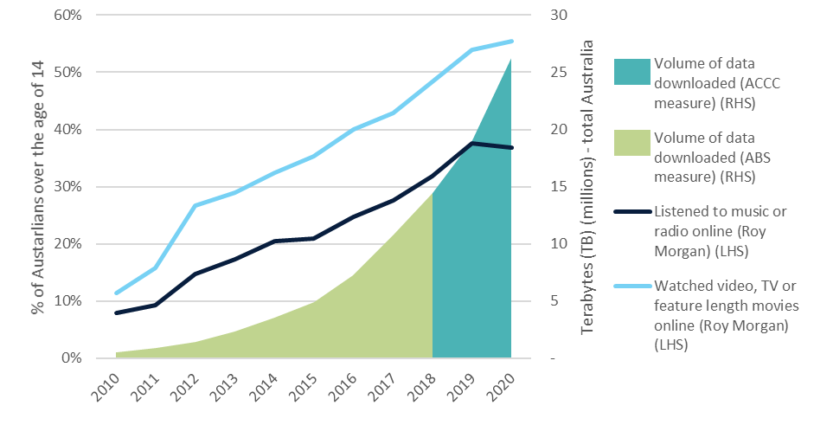
Source: Roy Morgan Single Source, Australians aged 14+, 2010–2020 (financial years); Australian Bureau of Statistics (ABS), Internet Activity, Australia 2010–2018; Australian Competition and Consumer Commission (ACCC), Internet Activity Report, 2018–2020. Quarterly data has been imputed based on biannual reports. Note that Internet volume data is indicative only and there are limitations in comparing the ABS and ACCC data, as outlined in the first Internet Activity Report (December 2018).
Rapid technological change has enhanced the range of media content available to consumers and enabled media businesses to develop new services and new ways of distributing content to consumers. Subscription video-on-demand (SVOD) services, such as Netflix, Disney and Amazon Prime Video, have enjoyed rapid consumer take-up over recent years. Between 2019 and 2021, the number of Australian subscribers to SVOD services jumped from 12.3 million to 19.1 million.
The growth of new services has not been limited to audio-visual content. Podcast and music streaming services, such as Spotify and Apple music, have grown significantly in popularity.
- In 2021, 67 per cent of Australian adults listened to at least one music streaming service in the previous seven days, up from 37 per cent in 2017.
- Australian adults who listened to music online spent an average of 9.1 hours a week streaming online music services.
The growth of online media consumption has occurred in parallel with the gradual erosion of traditional audiences for broadcasting services. This has been most evident for television.
- Between 2017 and 2021, the number of Australians that watched free-to-air television in the past seven days declined from 75 per cent to 50 per cent.
- Average prime time audiences for metropolitan free-to-air television declined by more than a third over the decade to 2021.
These changes in the consumption of television-like media content are depicted in Figure 2, which highlights the growth in online formats and the decline in traditional viewing.
Figure 2—Viewing behaviours in the past 7 days, 2017–2021
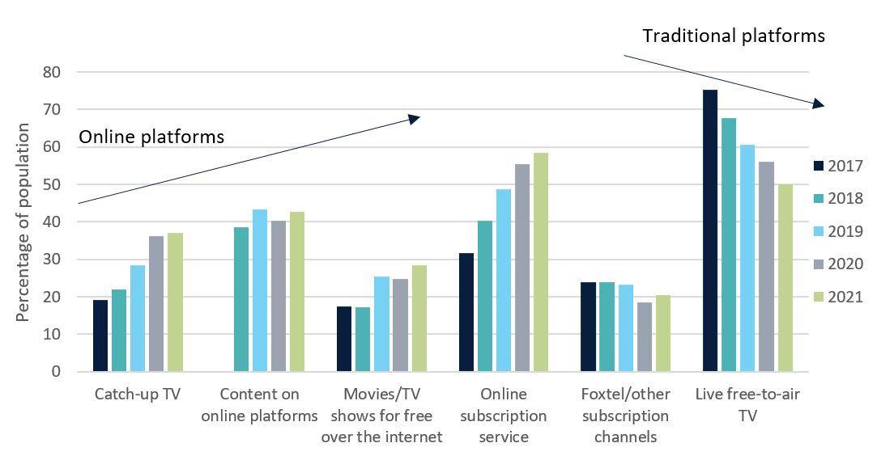
Source: ACMA interactive report Communications and media in Australia: How we watch and listen to content, 2022.

The Broadcasting Service Exclusion Determination
While the market is changing, the regulatory arrangements governing broadcasting and online services have remained largely unchanged. This is particularly the case at the fundamental level of what constitutes a broadcasting service and in turn, which services are subject to regulation as broadcasting services. The Determination is a key instrument in this regard.
The Determination was made by the Hon Paul Fletcher MP, then Minister for Communications, Cyber Safety and the Arts. The Determination was registered on 17 September 2019 and is scheduled to expire on 18 September 2022. The Determination operates to exempt any service that “makes available television programs or radio programs using the internet” from the definition of ‘broadcasting service’ under the BSA.
In conjunction with the other limbs of the definition of ‘broadcasting service’ under subsection 6(1) of the BSA, this has the effect of excluding online television simulcasts, online radio stations, and live-streaming on social media platforms and other digital platforms, from regulation as broadcasting services. This regulatory arrangement is described in Figure 3.
A service that makes programs available on demand on a point-to-point basis is separately excluded from the definition of ‘broadcasting service’ under paragraph 6(1)(b) of the BSA, and not the Determination.
Figure 3: Broadcasting services as defined in the BSA and the Determination
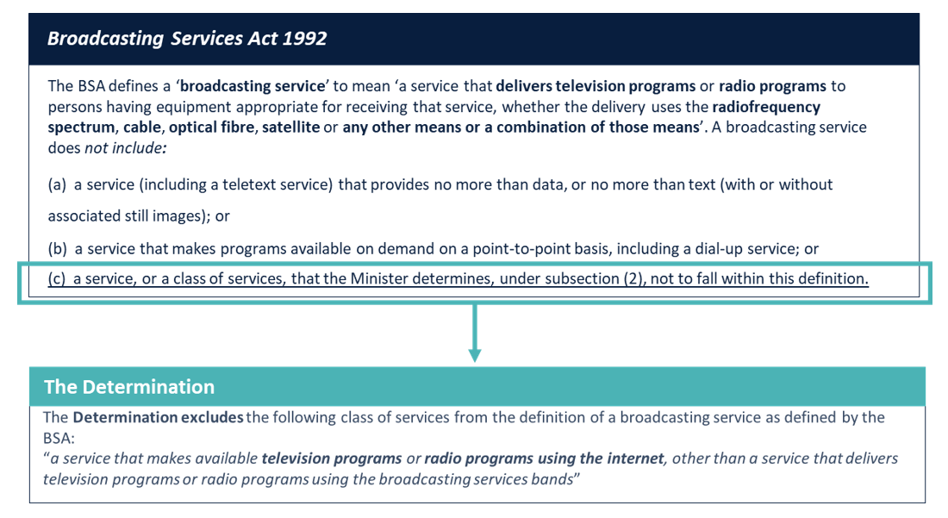
The precursor to the Determination was the Determination under paragraph (c) of the Definition of ‘Broadcasting Service’ (No. 1 of 2000), made in 2000 by the then Minister for Communications, IT, and the Arts, Senator the Hon Richard Alston AO. Known as the ‘Alston Determination’, the instrument was made to ensure that a service that makes available television or radio programs using the Internet does not fall within the definition of a broadcasting service. This threat was nascent at the time and pre-dated the growth of online services, as depicted in Figure 4.
Figure 4—Change in online media consumption since the Determination (2000–2020)
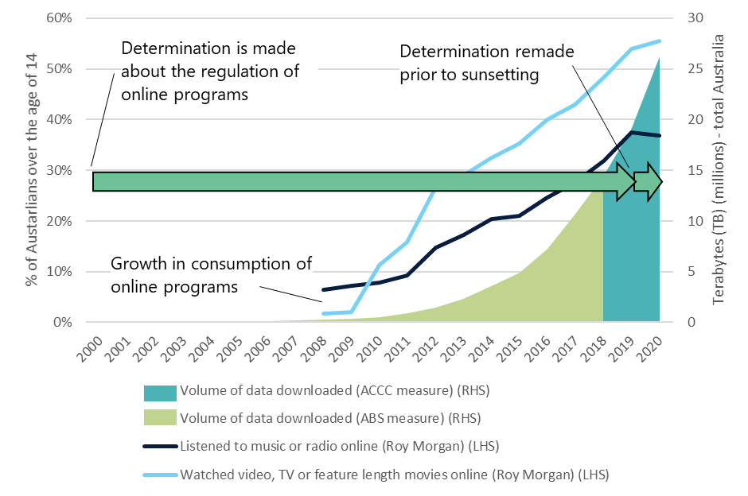
Source: Roy Morgan Single Source, Australians aged 14+, 2008–2020 (financial years); Australian Bureau of Statistics (ABS), Internet Activity, Australia 2000–2018; Australian Competition and Consumer Commission (ACCC), Internet Activity Report, 2018–2020. Quarterly data has been imputed based on biannual reports. Note that Internet volume data is indicative only and there are limitations in comparing the ABS and ACCC data, as outlined in the first Internet Activity Report (December 2018).
The regulatory delineation between broadcast and streaming services is increasingly artificial in a contemporary media environment and no longer reflects the way in which live-streaming and broadcasting services are distributed and consumed.
Audiences are increasingly able to access streaming and broadcasting services on the same device: a connected television; a smart phone; or an internet-enabled car radio, among others. Mobile phones are now the primary medium Australian adults use to access the internet, with email, web browsing and watching videos being the most popular activities performed online. This wasn’t the case in the past where the device was integrally linked to the distribution method and (in turn) the content available on the device: television content on a television set; audio content on a radio; and internet services on a desktop or laptop computer.
The consumer offering on a streaming service is also comparable with television and radio in terms of technical quality (screen resolution or audio quality) and content (the genres and diversity of content available). With increasing broadband take-up and the rollout of 4G and 5G mobile networks, there is little to distinguish an audio or audio-visual offering over the internet from similar content broadcast via radiofrequency spectrum.
The previous distinctions between online and broadcast content are also breaking down at a consumer level. Consumers increasingly hold consistent expectations for audio-visual content regardless of whether it is technically a broadcast service or an online service. ACMA affirmed this in its recent position paper, What audiences want—Audience expectations for content safeguards. The paper draws on findings from ACMA’s regulatory compliance activities, including observations about consumer complaints, findings in recent investigations, and research into consumer habits and market trends. Australians expect that consumer safeguards should apply consistently to professional content, where that content is ostensibly serving the same purpose and providers exert similar levels of control and influence over the programming of content—regardless of platform.
While the differential regulatory treatment of broadcasting and live-streaming services is increasingly out-of-date, this delineation remains embedded in commercial and regulatory arrangements.
- Contracts between entities for the supply of media content, including the rights to broadcast sporting events and program supply agreements, commonly differentiate between live-streaming and broadcasting rights.
- The Copyright Act 1968 (the Copyright Act) relies upon the definition of ‘broadcasting service’ from the BSA to define a ‘broadcast’, including for (among other matters) the statutory licence framework governing remuneration for the broadcast of sound recordings (including the so-called ‘1 per cent cap’ for radio broadcasters). The Copyright Act also recognises copyright in television and sound broadcasts, as distinct from any underlying copyright material comprised in a broadcast. The Copyright Act also provides for various exceptions and limitations to copyright infringement both for persons engaged in making broadcasts and persons using broadcasts, including under statutory licences such as the education statutory licence.
- Australia’s obligations under international treaties, multilateral and bilateral trade agreements with respect to audio-visual services and broadcasting, reflects the current delineation between services. This includes obligations under Article 14bis(1) of the Berne Convention; Article 8 of the World Intellectual Property Organisation Copyright Treaty; and the Rome Convention for the Protection of Performers, Producers of Phonograms and Broadcasting Organisations.
- The BSA itself relies upon the definition of a ‘broadcasting service’ in setting out the rights and obligations that apply to services under various categories of broadcasting services. These include obligations relating to captioning, control and ownership, Australian content, local programming, restrictions on sports rights acquisition, advertising restrictions, codes of practice and consumer complaints pathways. Under the Telecommunications Act 1997, key regulatory rules contain specific exclusions for broadcasting services to be supplied to the public. Under the Online Safety Act 2021, the definition of ‘electronic services’ does not include a broadcasting service (or a datacasting service), which are separately regulated under the BSA.
- The classification of content broadcast on television is currently regulated under co-regulatory industry codes, separate from the classification of content such as film, DVD, and video-on-demand (as well as computer games and certain publications) under the Classification (Publications, Films and Computer Games) Act 1995 (Classification Act). Section 92 of the Classification Act specifically excludes the Act from applying to “broadcasting services to which the Broadcasting Services Act 1992 applies”.

Proposal: remake the Determination for a time-limited period
The Determination expires on 18 September 2022 and it is proposed that it be remade in the form of a new instrument made under subsection 6(2) of the BSA.

Form of proposed new instrument
It is proposed that the terms of the new Determination would be identical to those of the current Determination—that a service that makes available television or radio programs using the internet, other than a service that delivers television programs or radio programs using the broadcasting service bands, will not fall within the definition of a ‘broadcasting service’. In conjunction with the broader definition of ‘broadcasting service’ under subsection 6(1) of the BSA, this would maintain the current exclusion of live-streaming services from the definition of a broadcasting service under the BSA.
Remaking the instrument in this form would be intended to provide certainty and stability for industry while broader regulatory reforms are developed and progressed. These reforms would seek to address the regulation of live-streaming services (which are immediately affected by the Determination in both its current and proposed form), along with the regulation of on-demand, point-to-point services that are currently excluded from the definition under paragraph 6(1)(b) of the definition of ‘broadcasting service’ in the BSA. Subject to the specifics of each service, the latter category of on-demand services is likely to include SVOD services such as Netflix, Disney+, and Amazon Prime.

Duration of proposed new instrument
It is proposed that the new Determination be subject to self-repeal after a period of 3 to 5 years (i.e. be remade for a period of 3 to 5 years), or for a longer period if affected stakeholders believe this may be warranted. If the instrument is not subject to earlier self-repeal, it would automatically repeal (sunset) after a period of 10 years in accordance with subsection 50(1) of the Legislation Act 2003. The proposed duration of the instrument recognises that long-term regulatory reform will be a multi-year exercise that will need to be approached carefully to ensure that new regulatory arrangements support the achievement of media policy outcomes and can accommodate technology and market changes.
It will also be important that reforms to the definition of ‘broadcasting service’, and any additional regulation of live-streaming and on-demand services, are developed in close consultation with all affected stakeholders. Any such reforms will need to be implemented progressively to avoid unintended consequences, given the extent to which the definition of ‘broadcasting service’ is embedded in the commercial and regulatory landscape for media services in Australia.
Questions:
- Should government make an instrument under subsection 6(2) of the BSA in effectively the same terms as the Broadcasting Services (“Broadcasting Service” Definition—Exclusion) Determination 2019, which excludes services that provide live-streamed content online from being considered a ‘broadcasting service’?
- If the instrument is made, in an effort to provide certainty and stability to industry while broader regulatory reforms are developed and progressed, should it be remade for a duration of 3 years, 5 years, or alternative period of time?
- If the instrument is made for a duration of 3 to 5 years, what would be the regulatory and financial impact on your business?

Alternatives to remaking the Determination
The alternatives to remaking the Determination are also being considered through this consultation process. These include the option of allowing the existing Determination to expire, and implementing legislative changes ahead of the expiry of the Determination on 18 September 2022.
Allowing the current Determination to expire would give rise to significant legal, regulatory and commercial uncertainty for entities operating in the online live-streaming environment (Figure 5).
Figure 5—Potential industry impacts following expire of Determination
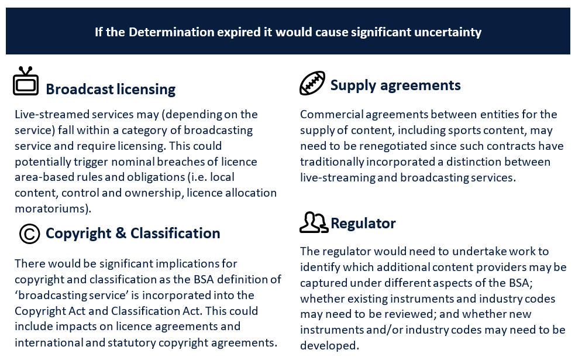
Legislative amendments to the definition of ‘broadcasting service’ under section 6 of the BSA are another option. However, given the recent election of the Albanese Government, there is unlikely to be sufficient time to develop a new model for the definition of ‘broadcasting service’, draft the requisite legislation and supporting documents, undertake consultation, introduce an amending bill and secure Parliamentary passage before the current instrument expires on 18 September 2022.
Questions:
- If the Determination expires on 18 September 2022, with no interim solution in place, how would this impact your business or area of industry? What regulatory and financial costs do you estimate your business would incur in this scenario?
- What are your views on the alternatives to remaking the Determination?

Next steps for this consultation
Submissions to this consultation paper will close at 5:00 PM (Australian Eastern Standard Time) on Thursday, 8 September 2022. The government will consider the views provided through this consultation on the proposed remaking of the current Determination. A decision will be made on whether to make a new instrument and, if so, the duration of such an instrument, before the current Determination expires on 18 September 2022.
Following a decision on the Determination, the government intends to engage further with stakeholders and consumers on a broader reform agenda, and the principles, priorities and process that could guide and shape this work.

The Determination is available on the Federal Register of Legislation at: Broadcasting Services (“Broadcasting Service” Definition — Exclusion) Determination 2019.
For example, the United Kingdom’s White Paper—Up next - the government’s vision for the broadcasting sector and Canada’s proposed Online Streaming Act 2022 (also known as Bill C-11).
This aggregate trend is also reflected on a per-household basis: volume of data downloaded per fixed broadband connection increased from around 45 GB per month in December 2013, to almost 350 GB per month in December 2020 according to analysis by the Bureau of Communications, Arts and Regional Research.
Deloitte (2021) Media Consumer Survey 2021.
Telsyte (2021) Subscription entertainment lifts in lockdown.
ACMA (2021) Trends in viewing and listening behaviour.
ACMA (2021) Trends in viewing and listening behaviour.
ACMA (2022) Communications and media in Australia: How we watch and listen to content.
ACMA (2022) Communications and media in Australia: How we watch and listen to content.
OzTAM 5 City Metro I Consolidated 7 I Average Audience I 1800–2400 I Weeks 1–52 | 2011–2021 | excludes Community TV. Data copyright @ OzTAM 2022.
ACMA (2020) Trends in online behaviour and technology use consumer survey.
The core audience expectations outlined in the ACMA’s position paper, What audiences want—Audience expectations for content safeguards (2022) include accuracy and impartiality, disclosure of commercial arrangements, treatment of distressing high-impact content, emergency information, classification and content guidance, advertising restrictions, treatment of highly offensive and discriminatory material, fair portrayal and privacy.

