

The 2025 Television & Media Survey – Summary Report
  - Prepared for the Department of Infrastructure, Transport, Regional Development, Communications and the Arts
May 2026


Table of Contents
Table of Contents 2
Executive Summary 7
Foreword 7
Methodology 7
Key trends in 2025 8
About the Survey 10
Key Results 11
General Media Behaviours (Adults) 11
Online subscription streaming services 13
Profiles of free-to-air TV viewing - 2024 and 2025 14
Social media and online platforms 15
News: consumption + sources 17
News: trust + AI 20
Antennas 23
Accessibility + inclusion 26
Emergency information 27
Australian content 28
Audio content 30
Codes + classifications 30
Sports content 32
Video gaming: Interactions + microtransactions 33
Children + media: Parental controls 35
Children and media: Age-inappropriate content (Children 0-17) 37
First Nations summary 38
First Nations summary – Caveat 38
First Nations summary 39
General screen content 39
Children’s content age 0-17 39
Televisions 39
News, current affairs and emergency information 39
Sports consumption 39
Audio 39
General screen content habits 40
Chapter Summary – General Screen Content Habits 40
Platforms used to watch screen content in past 7 days 40
Comparison of aggregate vs detailed platforms used to watch screen content in P7D 42
Broadcast channels watched in past 7 days 43
Streaming services/YouTube watched in past 7 days 46
FAST services watched in past 7 days 48
Watched video content on social media in past 7 days 49
Hours per week spent watching content on various platforms (%) 51
Frequency of watching screen content on various devices (%) 56
Social media services currently have an account with + used 58
Frequency of accessing social media services (%) 62
Search engines, app stores + online market places used P6M 67
Messaging, chat, + dating services used P6M 69
Online subscription streaming service account sign-up factors (%) 71
Online subscription streaming service account retention factors (%) 76
Watched screen content outside of home in the past 12 months 79
Reference to classification ratings (%) 81
General screen content habits: Children aged 0 —17 83
Chapter summary: General screen content habits — Children aged 0-17 83
Platforms used to watch screen content in past 7 days (children aged 0–7) 84
Platforms used to watch screen content in past 7 days (children aged 8–17) 85
Platforms children used to watch screen content in past 7 days (reported by parents) 88
Types of content children like watching most (children aged 0–7) 90
Types of content children like watching most (Children aged 8–10) 92
Types of content children like watching most (Children aged 11–15) 94
Types of content children like watching most (Children aged 16–17) 96
Types of content children watch 98
Types of content most important to be available to children 100
Hours per week spent watching content on various platforms (children aged 8–17) 102
Hours per week spent watching content on various platforms (children aged 0–7) 106
Hours spent by children watching screen content by platform 108
Children’s device usage for online content consumption: personal vs. household devices 113
Reasons for children’s device arrangement 115
Parents’ perception of children’s personal internet use on their own devices 118
Parents’ perception of children’s personal internet use outside of home 119
Use of services with parental controls enabled 120
Level of satisfaction with parental control 121
Reasons for not using parental control 123
Appropriateness of content recommended by streaming services for children 124
Australian content 125
Chapter summary: Australian content 125
Types of Australian content watched on subscription streaming services in past 7 days 125
Discovery of Australian content on subscription streaming services 128
Platforms used to watch Australian screen content (children aged 0-7) 129
Platforms used to watch Australian screen content (children aged 8–17) 130
Accessibility features 133
Chapter summary: Accessibility features 133
Use of accessibility features to watch screen content 133
Extent of reliance on accessibility features for TV content 136
Reasons for using accessibility features 137
Confidence in using Smart TV 139
Video games 141
Chapter summary: Video games 141
Video gaming participation in the past 7 days 142
Hours spent playing video games per week by devices 144
Frequency of interacting with others while playing video games 145
Played video games in past 7 days (children aged 0-17) 147
Frequency of interacting with others while playing video games (children aged 0-17) 149
Videogame Microtransactions made by children 150
Types of microtransactions made by children in past 12 months 152
Location of children at the time of the most recent microtransaction in a video game 153
TV: access, devices + free-to-air 154
Chapter summary: TV 154
How respondents access free-to-air TV 155
How respondents access free-to-air TV most often 156
Frequency of watching free-to-air TV on various devices (%) 158
Number of TVs in respondents’ houses 161
Number of TVs connected to the internet 162
Number of TVs connected to an external aerial, antenna, or broadcast signal 164
Access to an external free-to-air television aerial, antenna, or broadcast signal 165
External free-to-air television antenna access by dwelling age + type 167
TV connection to a free-to-air television aerial, antenna, or broadcast signal 170
Free-to-air television: profiling heavy watchers (35+ hours in past 7 days) 171
Frequency of watching free-to-air television via traditional connections or internet 172
Free-to-air television viewing: Personas 174
TV smart accessories used in the past 12 months 175
Purchase of a new TV in past 12 months 177
Audio content 179
Chapter summary: Audio content 179
Audio listened to in the past 7 days 179
Devices used to listen to audio content (%) 181
Hours spent per week listening to music of any type 182
Hours spent per week listening to Australian music 183
News + emergency information content 185
Chapter summary: News + emergency information content 185
Frequency of consuming news + current affairs content 186
Sources of news 188
Sources of news by category 190
Sources of news in past 7 days 192
Most important source of news 194
Level of trust in news 196
Impact on trust in news articles written using Generative AI 197
Paid news subscriptions 199
Extent of incidental news consumption 201
Source of incidental news 203
Frequency of different ways of coming across news via social media 204
Sources used for emergency information 206
Reasons for using TV or radio for information in the most recent emergency 207
Preferred source of emergency information 209
Sports content 211
Chapter summary: Sports content 211
Sports content consumed in the past 7 days 212
Whether non-consumers of sport in past 7 days consume sports in a normal year 213
How respondents consumed sports content 214
Whether sports content consumed was men’s, women’s, or both 217
Types of sports content consumed 218
Impact of various factors on amount of sports content consumption 220
Broadcast codes 222
Chapter summary: Broadcast codes 222
Awareness of the types of Codes of Practice 223
Sources of awareness for each Codes of Practice 224
Advertising + inappropriate content: Children aged 0–17 227
Chapter summary: Advertising (Children aged 0-17) 227
Platforms children saw advertisements on in the past 7 days (children aged 0–17) 227
Where children saw advertising in past 7 days 230
Watched age-inappropriate content (children aged 0–17) 232
Platforms used to watch age-inappropriate content (children aged 0–17) 234
Nature of the age-inappropriate content (children aged 0–17) 237
Where they watched age-inappropriate content (children aged 0–17) 238
Who they were with when watching age-inappropriate content (children aged 0–17) 240
Appendix 241

List of Tables
Table 1 Who were they with 37
Table 2 Reasons why content was inappropriate 38
Table 3 Comparison of aggregate vs detailed platforms used to watch screen content in P7D 43
Table 4 Frequency of watching screen content on various devices (%) 57
Table 5 Frequency of watching free-to-air TV on various devices (%) 159
Table 6 Devices used to listen to audio content (%) 181
Table 7 Frequency of watching free-to-air TV on various devices (%) 225
Table 8 List of abbreviations + terms 241
Table 9 List of definitions of terms 242
Table 10 Condensed code frames in report 242
Table 11 Sample profile 245
Table 12 Summary of historic field dates 247

Executive Summary

Foreword
Welcome to the 2025 edition of the Television and Media survey.
The Television and Media Survey is an annual survey that continues to provide a comprehensive view of how Australians engage with screen and audio content, offering valuable insights for policy, industry, and the broader community.
The 2025 release is particularly timely, reflecting a year of significant developments in the media landscape. Notable events include the announcement of Seven West Media’s merger with SCA, Paramount’s agreement to acquire Warner Bros. Discovery in the U.S., and the entry of HBO Max into the Australian market in March 2025. Milestones in Australian television also marked the year: 2025 celebrated 70 years of continuous TV broadcasting, The Project aired its final episode, the NRL Grand Final became the highest-rated broadcast of the year, and Amazon Prime Video’s revival of Neighbours concluded after more than 40 years on Australian screens. Understanding children’s media behaviour, especially their online activity, is increasingly important as their digital engagement grows, and the December 2025 social media minimum age for those under 16 begins to reshape the online environment.
This year’s report builds on a strong foundation of past iterations of the survey, showing how media habits have evolved alongside changes in the broader media landscape. The 2025 survey highlights several key trends shaping the way Australians access and experience media. Online subscription services remain the most widely used platform for screen content, while free video streaming continues to play a significant role. Social media and messaging platforms are deeply embedded in daily life, with Facebook, YouTube, and Instagram leading usage, and messaging services reaching many Australians. Traditional television retains its importance, with stable access to free-to-air TV and a growing reliance on on-demand apps.
Notably, news consumption is increasingly digital, especially being driven by news on social media in 2025. Trust in news remains a complex and evolving issue, with distrust towards news produced fully or partially by AI becoming particularly pronounced in 2025. Together, the growing reliance on social media for news and scepticism toward AI-generated content reinforce the trends observed in the 2025 Australian Digital News Report¹.
Accessibility and inclusion have seen marked improvements, with more Australians using features such as subtitles and closed captions, and those with disabilities reporting higher reliance on these tools. The survey also shows that half of respondents watched Australian content on streaming services in the past week, and that sports, audio, and gaming remain central to the media experience for many households.
As we look ahead, the findings underscore the importance of adaptability and responsiveness in media policy and practice. The Department’s ongoing commitment to understanding the needs and expectations of all Australians ensures that our media environment remains vibrant, inclusive, and relevant.
We trust this report will inform and inspire thoughtful discussion and effective action in the year ahead for the Australian media landscape.

Methodology

Overview
    - n = 4,396 adult respondents
    - n = 809 children aged 0–17 (children aged 0–7 interviewed via parents/legal guardians/carers)
    - Field dates: 15 September – 13 October 2025
    - Sample: Australian general population aged 18+, parents/legal guardians/carers of children aged 0–17, children aged 0–17, people living in regional Australia, and Aboriginal and/or Torres Strait Islander people
    - Note that children aged 0–7 were asked via parents/legal guardians/carers, while those aged 8–17 were asked survey questions directly

Research methodology
- Quantitative online survey conducted via the Social Research Centre’s national probability-based online panel, known as Life in Australia™
- Boost of people living in regional Australia, Aboriginal and/or Torres Strait Islander people, parents/legal guardians/carers of children aged 0–17, and children aged 0–17 via the ORU non-probability panel
- Blended and weighted to increase accuracy and representativeness (refer to Appendix in this report, and Technical Report for further information on weighting)
For further information on methodology, please refer the ‘Appendix: Methodology Summary’ in this report.

Key trends in 2025
General screen habits: In 2025 Australians continue to choose online subscription services for screen content (65% have used in the past 7 days), while free video streaming and hybrid viewing also remain strong. Watching content outside the home is common, with 43% reporting out-of-home viewing in the past year.
Online subscription streaming services: Netflix remains the dominant streaming platform (57% watched in the past 7 days), with content preferences and value for money driving both sign-up and retention of accounts.
Social media and online platforms: Facebook, YouTube, and Instagram are the most widely used social media platforms, with 91% of Australians holding at least one social media account. Messaging and chat services are used by 70%, while online marketplaces and app stores are also highly used.
News: sources, trust and AI: Online sources lead for how Australians access news (NET 86% generally access online), with social media leading as a new source for the first time. Trust is polarised with 45% expressing trust in the news they consume (conversely, 45% distrust news). Trust in news produced by or with the assistance of AI is low. This also declined significantly since 2023, with 73% (NET B2B) for negative trust in news where AI has assisted in generating it.
TV: Free-to-air access and antennas, profiles: Access to free-to-air TV (commercial free-to-air, and public free-to-air) are stable in 2025, stabilising the decline seen in previous years. 69% of households having an external antenna, though accessing TV via on-demand apps has increased to 61% (NET access type for free-to-air TV). Viewing profiles for TV are shifting, with growth in both broadcast-only and no free-to-air viewing, and a decline in hybrid viewing in 2025.
Accessibility and inclusion: Use of accessibility features for screen content has increased to 67%, driven by subtitles and closed captions, though reliance on dubbing has also increased. Those with disabilities or sensory impairments are significantly more likely to use and rely on these features.
Emergency information: One in five Australians (20%) experienced an emergency in the past year (an increase since 2024), with online sources the most frequently used and preferred for emergency information. Radio and television remain important, valued for accessibility and live coverage respectively.
Australian content: Half of respondents (49%) watched Australian content on streaming services in the past week, with drama, news, and comedy being the most viewed genres. Discovery is most often through home screens of devices/TVs, ongoing series, recommendations, and trending lists.
Audio content: Online music streaming is the primary mode of audio consumption, averaging 10.8 hours per week, though radio remains common (6.2 hours). Streaming and radio are both used for listening to Australian music.
Codes and classifications: Three in five (62% NET) Australians refer to classification ratings when deciding if content is appropriate for children, with advertising being the main source of awareness for broadcast codes.
Sports content: Nearly half (48%) watched sports content in the past week, with free-to-air TV being the most popular platform for sports viewing.
Video gaming: Video gaming participation among adults is at 38%, consistent with 2024, with mobile phones the most common device. Parental restrictions for gaming are most prevalent for younger children, and gaming generally increases as children get older.
Children: Parental controls, Age-inappropriate content: Parental controls are most commonly enabled on streaming and video platforms for younger children, with satisfaction highest for controls on online subscription services. Exposure to age-inappropriate content increases with age, most often occurring at home and often with family members present.
*Fieldwork dates differ between years for the survey. Please see the Notes section for fieldwork dates for each survey conducted between 2020 and 2024 and major sporting events in 2023 and 2024.

Note
- 2025 survey fieldwork: 15 September – 13 October 2025
- 2024 survey fieldwork: 28 October – 21 November 2024
- 2023 survey fieldwork: 25 September – 16 October 2023
- 2022 survey fieldwork: 12 September – 5 October 2022
- 2021 survey fieldwork: 13 September – 27 September 2021
- 2020 survey fieldwork: 14 September – 28 September 2020
2025 Field (15 September to 13 October 2025)
- AFL Grand Final, 27 September 2025
- NRL Grand Final, 5 October 2025
- Bathurst 1000 (Supercars Championship), 9–12 October 2025
- Spring Racing Carnival early events (e.g., Turnbull Stakes), late September–early October 2025
2024 Field (28 October to 21 November 2024)
- Melbourne Cup, 5 November 2024
- Australia co-hosted the 2024 Rugby League Pacific Championship, October-November 2024
- Championship series of Major League Baseball, October 25 to November 2, 2024
- The Bathurst 1000, 10-13 October 2024 (outside of the 2024 survey fieldwork period)
- NRL & NRLW Grand Finals, 6 October, 2024 (outside of the 2024 survey fieldwork period)
- Australia Cup Final, 29 September, 2024 (outside of the 2024 survey fieldwork period)
- AFL Grand Final, 28 September, 2024 (outside of the 2024 survey fieldwork period)
2023 Field (25 September – 16 October 2023)
- Australia Cup Final, 7 October 2023
- The Bathurst 1000, 5-8 October 2023
- NRL & NRLW Grand Finals, 1 October 2023
- AFL Grand Final, 30 September 2023
- Australia hosted the FIFA Women’s World Cup one month before field began for the 2023 survey.

About the Survey
The Television and Media Survey 2025 collects information on screen and media content viewing practices, habits, and expectations of Australian adults and children. The Television and Media Survey 2025 combines questions from research previously commissioned by the Department through the Media Content Consumption Survey (MCCS) since 2020 and the Television Consumer Survey (TVCS) in 2022. The Television and Media Survey 2025 maintains a core set of questions from these previous studies and adds in new material and areas of enquiry to address the changing media environment.
The Survey focuses on
- General screen content habits
- Screen viewing behaviour and content
- Audio content
- Television access, devices and free-to-air
- News and emergency information content
- Sports content
- Advertising and content attitudes
- Parental perspective on children’s content
- Children's content (from the perspective of children)
What is new in the 2025 Survey?
- General screen content habits
  - Detailed platform/service usage P7D (introduced to capture more detailed viewing behaviours across specific services, providing a more accurate reflection of how consumers access screen content in practice and to validate aggregate platform-level results at C1)
  - Social media accounts, P6M usage, frequency of access
  - Online platform usage P6M across search engines, app stores, online marketplaces, messaging/chat services and online dating services
- Screen viewing behaviour and content
  - Accessibility features
  - Confidence in using smart TVs
  - Australian content on subscription streaming services
  - Factors influencing signing up/retaining accounts on online subscription streaming services
  - Screen content viewing outside of home P12M
  - Classification rating
- Audio content
  - Hours spent per week listening to music/ Australian music across platforms
- Television access, devices and free-to-air
  - Age of old TV replaced
  - External antenna connection
- News and emergency information content
  - Frequency of encountering news on social media across passive and active ways
  - Perceived most important source of news
  - Trust in news
  - Perception towards news created partially/fully by AI
  - Source of passive news consumption
  - Reasons for using TV/radio for information in the most recent emergency
- Advertising and content attitudes
  - Source of awareness of Codes of Practice
- Parental perspective on children’s content
  - Interactions with others in video games
  - Microtransactions in video games: types, location of child
  - Parental controls: services enabled, reasons for not use, extent of satisfaction
  - Appropriateness of recommended content on streaming services
- Children's content (from the perspective of children)
  - Inappropriate content: where, who, how ,what
  - Children and gaming: interactions with others, limits on types of games accessed.

Key Results

General Media Behaviours (Adults)
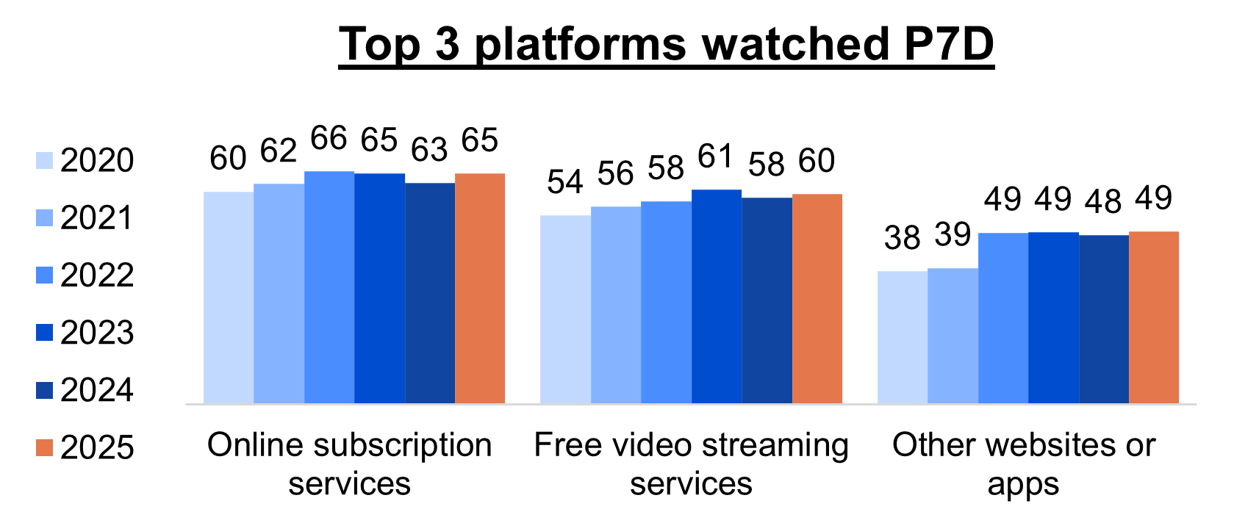
Online subscription services consistently remain the most widely used platform, followed by free video streaming services and other websites or apps.
Bar chart showing the percentage of the top 3 platforms people used to watch screen content in the past 7 days from 2020 to 2025.
For Online subscription services: 60% in 2020, 62% in 2021, 66% in 2022, 65% in 2023, 63% in 2024, and 65% in 2025.
For Free video streaming services: 54% in 2020, 56% in 2021, 58% in 2022, 61% in 2023, 58% in 2024, and 60% in 2025.
For Other websites or apps: 38% in 2020, 39% in 2021, 49% in 2022, 49% in 2023, 48% in 2024, and 49% in 2025.
TV remains the dominant device for watching screen content, though mobile phones are also used.
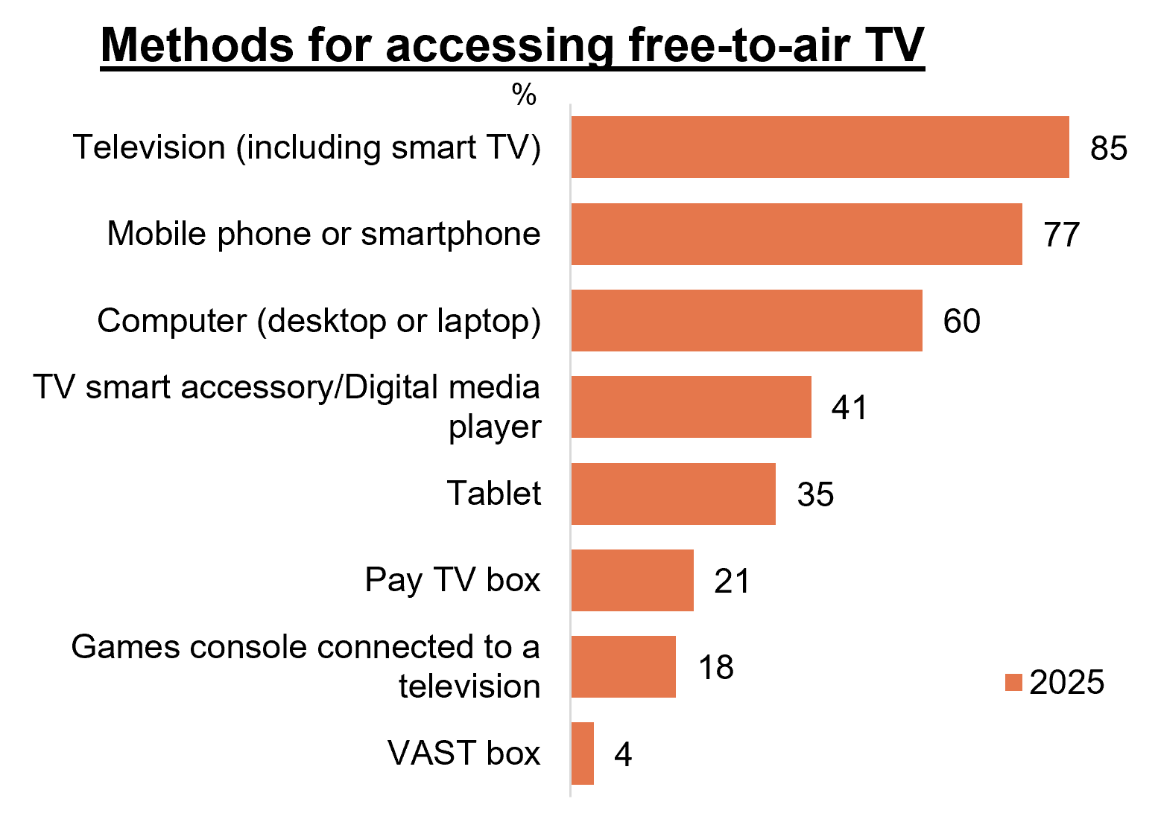
Bar chart showing the percentage of the types of method that people used to access free-to-air TV in 2025, on an average week.
Television (including smart TV): 85%
Mobile phone or smartphone: 77%
Computer (desktop or laptop): 60%
TV smart accessory / digital device: 41%
Tablet: 35%
Pay TV box: 21%
Games console connected to TV: 18%
VAST box: 4%
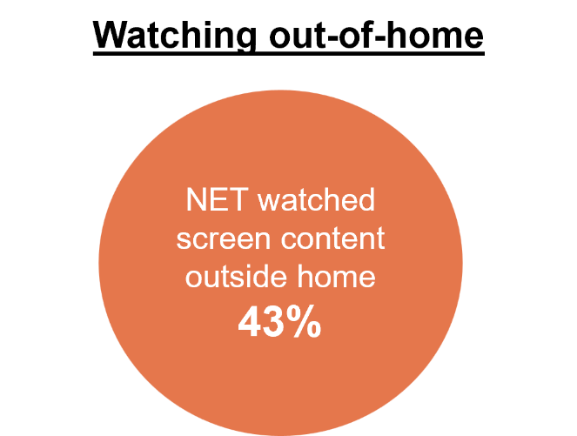
43% of respondents reported that they have ever watched screen content outside of home in the past 12 months.

Online subscription streaming services
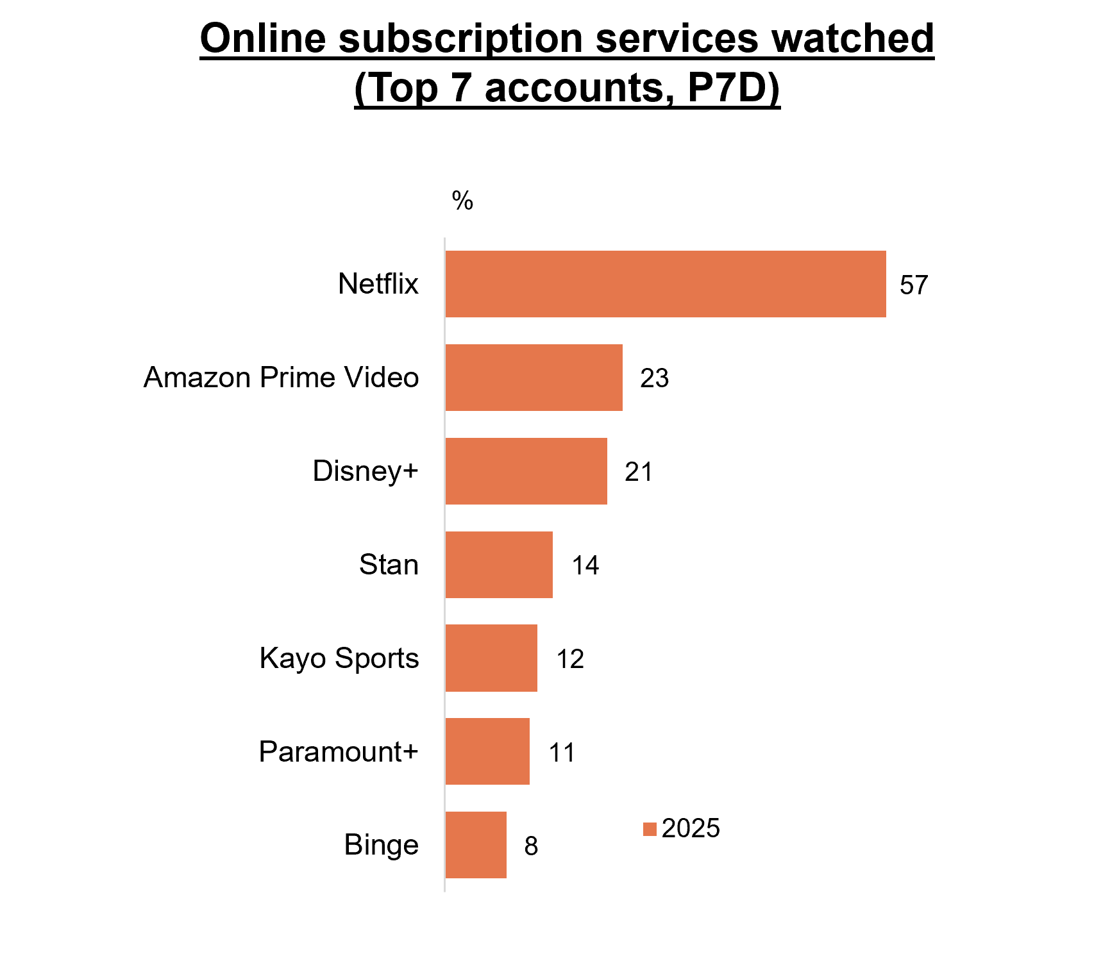
Netflix dominates in online subscription services watched in 2025, with a clear lead over other services such as Amazon Prime Video and Disney+.
Caveat – change in question structure in 2025 asking by individual platform
Bar chart showing which online subscription streaming services people watched in the past 7 days in 2025, and the percentage of people who watched each one.
Netflix: 57%
Amazon Prime Video: 23%
Disney Plus: 21%
Stan: 14%
Kayo Sports: 12%
Paramount Plus: 11%
Binge: 8%
Content-related factors are the strongest drivers of both account sign-up and retention, particularly having the types of content liked or specific shows, movies, or events. Price also played an important role, with good value contributing to both initial subscription decisions and ongoing retention.
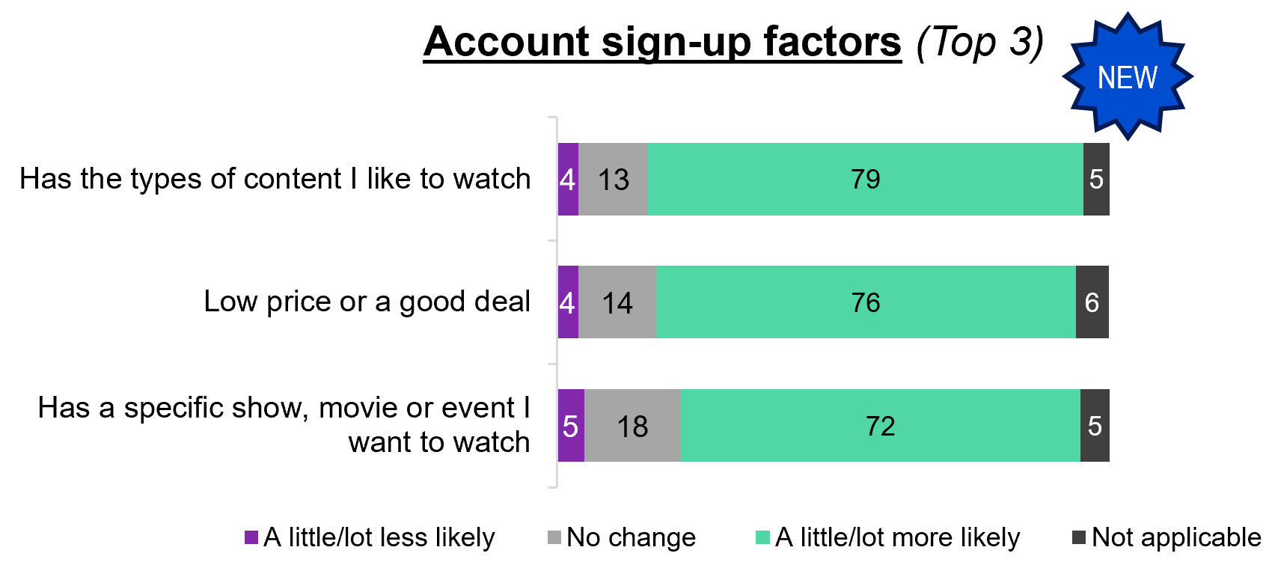
Stacked horizontal bar chart showing the top 3 reasons that people say different factors influence their likelihood of signing up for an online streaming service.
Has the types of content I like to watch: 4% A little/a lot less likely, 13% no change, 79% A little/lot more likely, and 5% Not applicable.
Low price or a good deal: 4% A little/a lot less likely, 14% no change, 76% A little/lot more likely, and 6% Not applicable.
Has a specific show, movie or event I want to watch: 5% A little/a lot less likely, 18% no change, 72% A little/lot more likely, and 5% Not applicable.
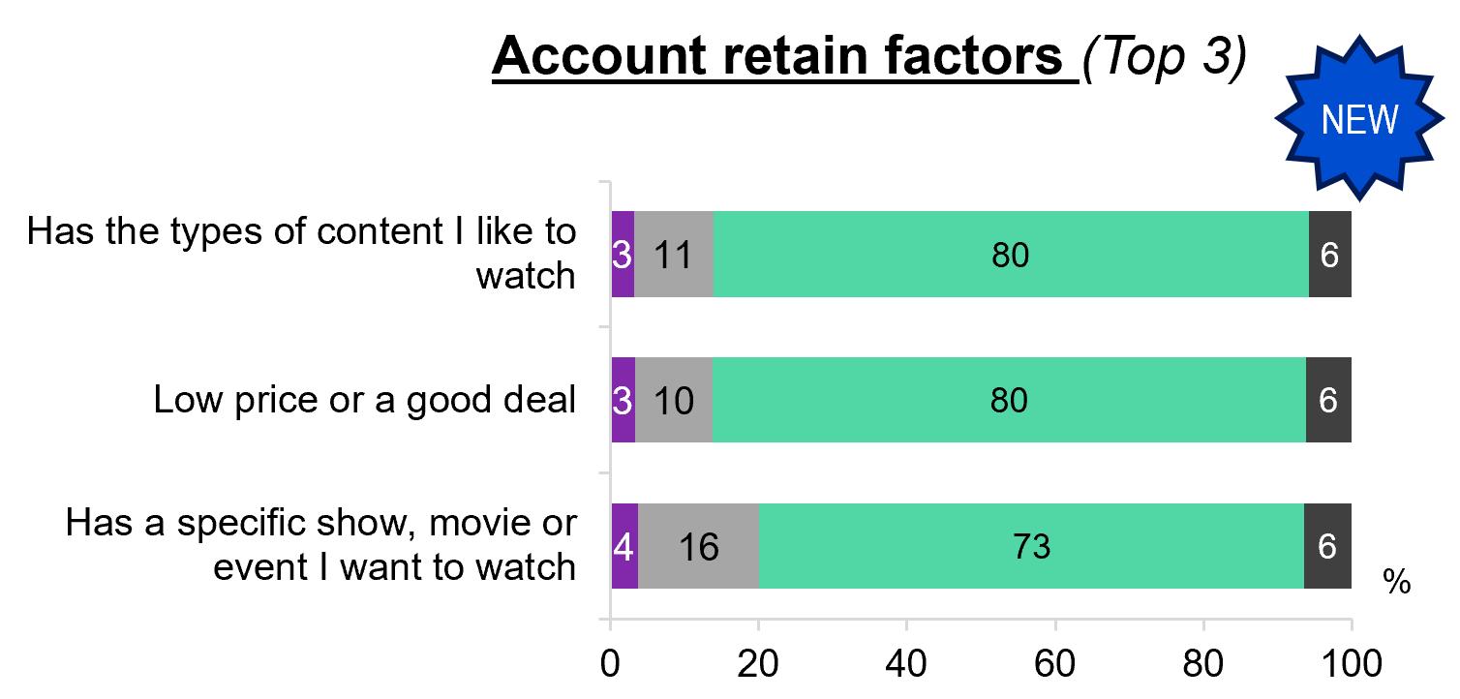
Stacked horizontal bar chart showing the top 3 reasons that people say different factors influence their likelihood of retaining an account on an online streaming service.
Has the types of content I like to watch: 3% A little/a lot less likely, 11% no change, 80% A little/lot more likely, and 6% Not applicable.
Low price or a good deal: 3% A little/a lot less likely, 10% no change, 80% A little/lot more likely, and 6% Not applicable.
Has a specific show, movie or event I want to watch: 4% A little/a lot less likely, 16% no change, 73% A little/lot more likely, and 6% Not applicable.

Profiles of free-to-air TV viewing - 2024 and 2025
Free-to-air TV usage shifted away from hybrid viewing in 2025, with growth in both broadcast-only and no free-to-air viewing. Increases in broadcast-only viewing were driven mainly by men, English-only speakers and those aged 35–44 with higher education, living in a separate house and with access to an external antenna. Growth in no free-to-air TV viewing was spread across several age groups and household types, while the decline in hybrid viewing was concentrated among older Australians and households with access to traditional broadcast infrastructure.
Hybrid free-to-air TV (53% in 2025 vs 58% in 2024)
Decrease driven by ages 65+ (49%), those without children (49%) or with dependent children (58%) in HH, with a TAFE/Trade Certificate/Diploma (53%), and households with access to external antenna (57%), English-only speakers (53%), and those living in a separate house (54%) or semi-detached, row or terrace house or townhouse (50%).
Broadcast only (20% in 2025 vs 17% in 2024)
Increase driven by men (23%), ages 35–44 (12%), those without children (26%) or with dependent children (16%) in HH, those with a Postgraduate Degree/Graduate Diploma/Graduate Certificate (16%), non-Aboriginal or Torres Strait Islanders (21%), and households with access to external antenna (25% vs 21%), English-only speakers (22%) and those living in a separate house (22%).
Online only (12% in 2025 vs 13% in 2024)
No significant change in profile to note in 2025.
No free-to-air TV (16% in 2025 vs 11% in 2024)
Increase driven by ages 18–24 (35%), 35–44 (16%), 65–74 (6%), those without children in HH (14%), with education up to Year 12 (18%), a TAFE/Trade Certificate/ Diploma (13%) or a Bachelor degree (20%), non-Aboriginal or Torres Strait Islanders (16%).

Social media and online platforms
Facebook, YouTube and Instagram are the most common social media platforms that respondents currently have accounts with, and are also among the most widely used platforms in the past six months. Search engines and app stores are used by the large majority, led by Google and Apple App Store, while online marketplaces, particularly Facebook Marketplace, are also commonly used. Messaging services are widely used, driven mainly by Facebook Messenger and WhatsApp, whereas online dating services remained relatively niche.
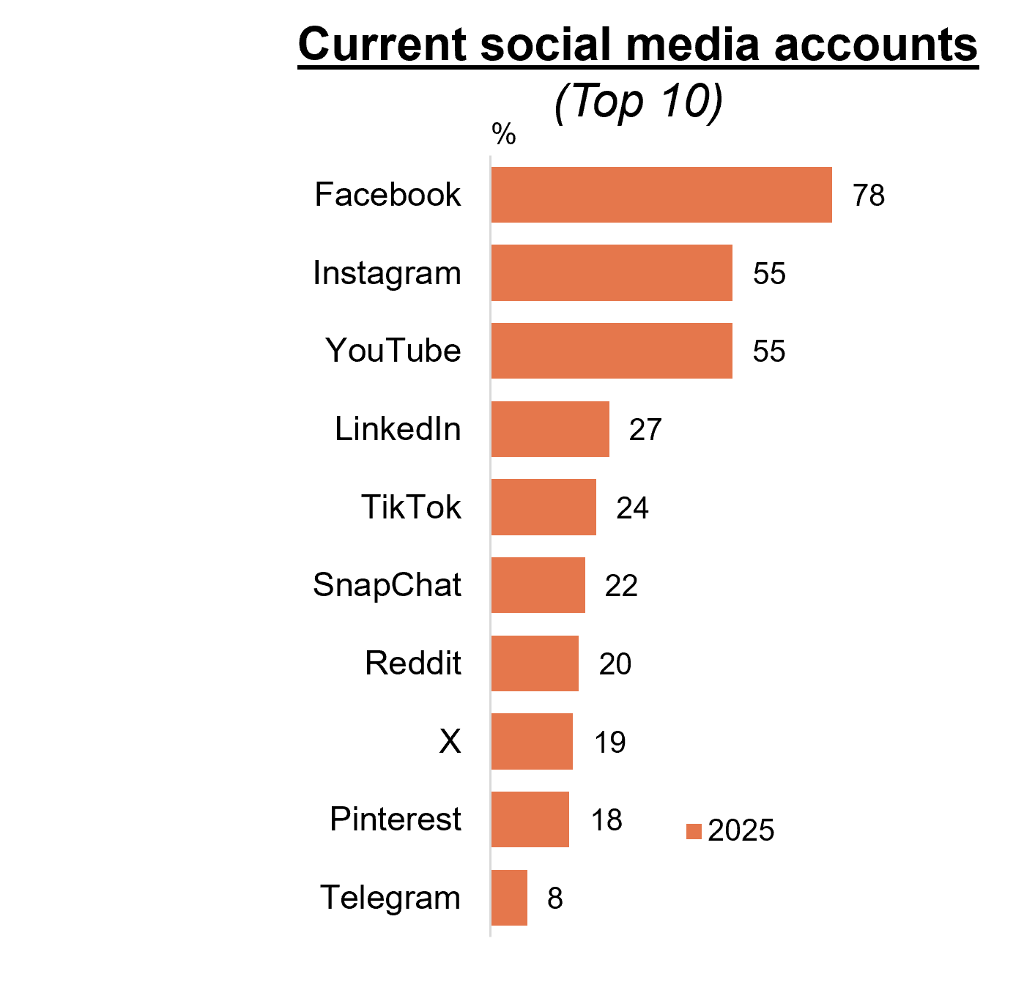
A bar chart showing the top 10 social media platforms that people currently have an account with in 2025.
Facebook: 78%
Instagram: 55%
YouTube: 55%.
LinkedIn: 27%
TikTok: 24%
Snapchat: 22%
Reddit: 20%
X: 19%
Pinterest: 18%
Telegram: 8%
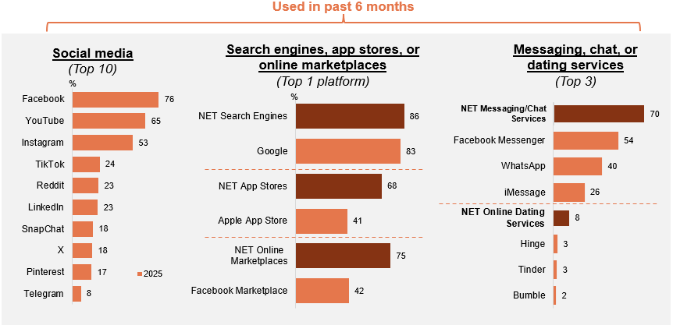
A bar chart showing the top 10 social media platform used in the past 6 months in 2025.
Facebook: 76%
YouTube: 65%
Instagram: 53%
TikTok: 24%
Reddit: 23%
LinkedIn: 23%
Snapchat: 18%
X: 18%
Pinterest: 17%
Telegram: 8%

A comparison bar chart showing the top 1 platform of search engines, app stores, or online marketplace used in the past 6 months in 2025.
NET Search Engines: 86%
Google: 83%
NET App Stores: 68%
Apple App Stores: 41%
NET Online Market Places: 75%
Facebook Marketplace: 42%

A bar chart showing the top 3 messaging, chat, or dating services platform used in the past 6 months in 2025.
NET Messaging/Chat Services: 70%
Facebook Messenger: 54%
WhatsApp: 40%
iMessage: 26%
Net Online Dating Services: 8%
Hinge: 3%
Tinder: 3%
Bumble: 2%

News: consumption + sources
P7D News consumption is stable in 2025, consistent with levels in 2024.
Online sources remain the most common way to access news, with a significant increase in 2025, this is driven by social media moving to become the top source of news in 2025.
NET news consumption in the past 7 days in 2025: 96.11%
NET news consumption in the past 7 days in 2024: 96.95%
NET news consumption in the past 7 days in 2023: 99.11%
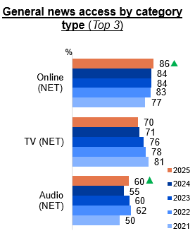
Bar chart showing the top 3 categories (NET) of how people generally access news and/or current affairs from 2021 to 2025. Each platform is represented with horizontal bars for each year. Key insights:
Online NET: 86% in 2025, 84% in 2024, 84% in 2023, 83% in 2022, and 77% in 2021.
TV NET: 70% in 2025, 71% in 2024, 76% in 2023, 78% in 2022, and 81% in 2021.
Audio NET: 60% in 2025, 55% in 2024, 60% in 2023, 62% in 2022, and 50% in 2021.

Callout
In 2025, Online NET (86% vs 84% in 2024) and Audio NET (60% in 2025 vs 55% in 2024) increased significantly compared to 2024. NET news consumption in the past 7 days decreased significantly in 2024 (96.95% vs 99.11% in 2023).
Television continues to play a strong role and stabilised since 2024, particularly as the most important source of news through publicly owned and commercial free-to-air TV and radio.
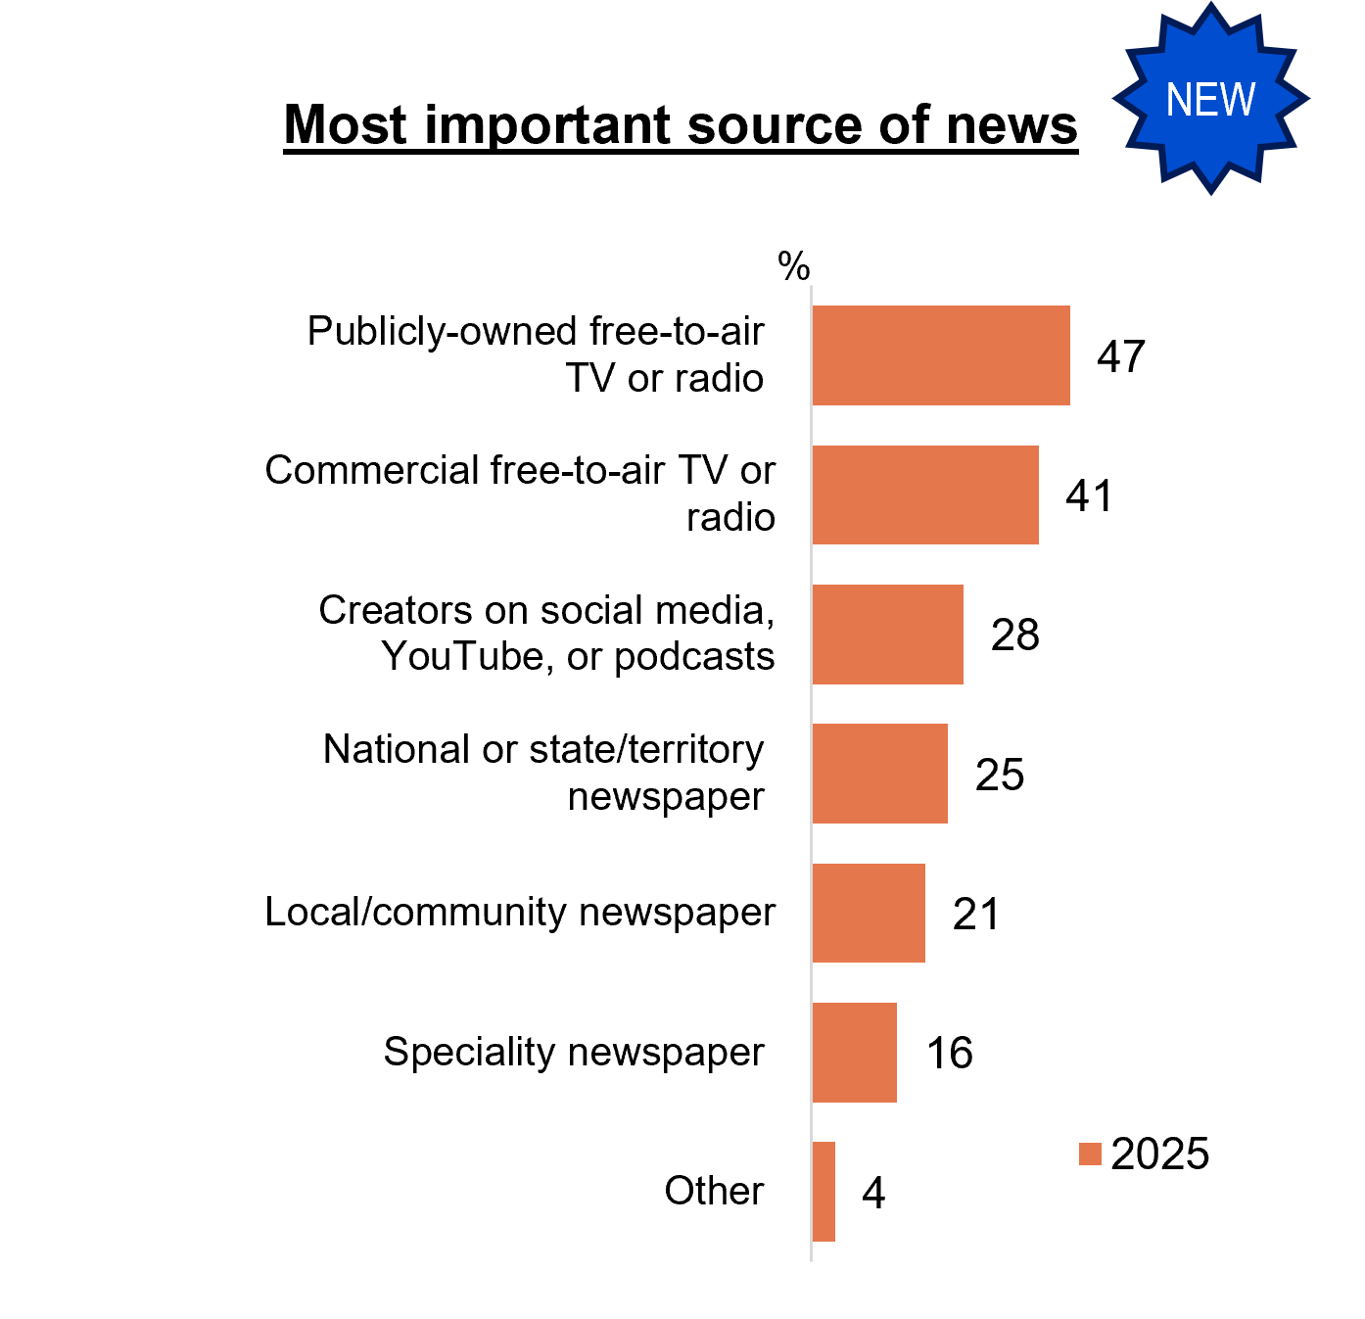
A bar chart showing the most important sources of news in 2025.
Publicly-owned free-to-air TV or radio: 47%
Commercial free-to-air TV or radio: 41%
Creators on social media, YouTube, or podcasts: 28%
National or state/territory newspaper: 25%
Local/community newspaper: 21%
Speciality newspaper: 16%
Other: 4%
Social media is a source for encountering news especially through headlines and links appearing in feeds, with direct sharing and tagging also contributing.
Source of news via social media (NET ever):
- Read an article while scrolling/browsing: 98%
- Click on a link that appears in your feed: 91%
- Went to the social media page of a news outlet: 66%
- Sent to me in a direct message on social media: 63%
- Someone tagged me in it: 57%
Passive exposure to news is common, driven primarily by social media feeds, followed by word of mouth and television at home.

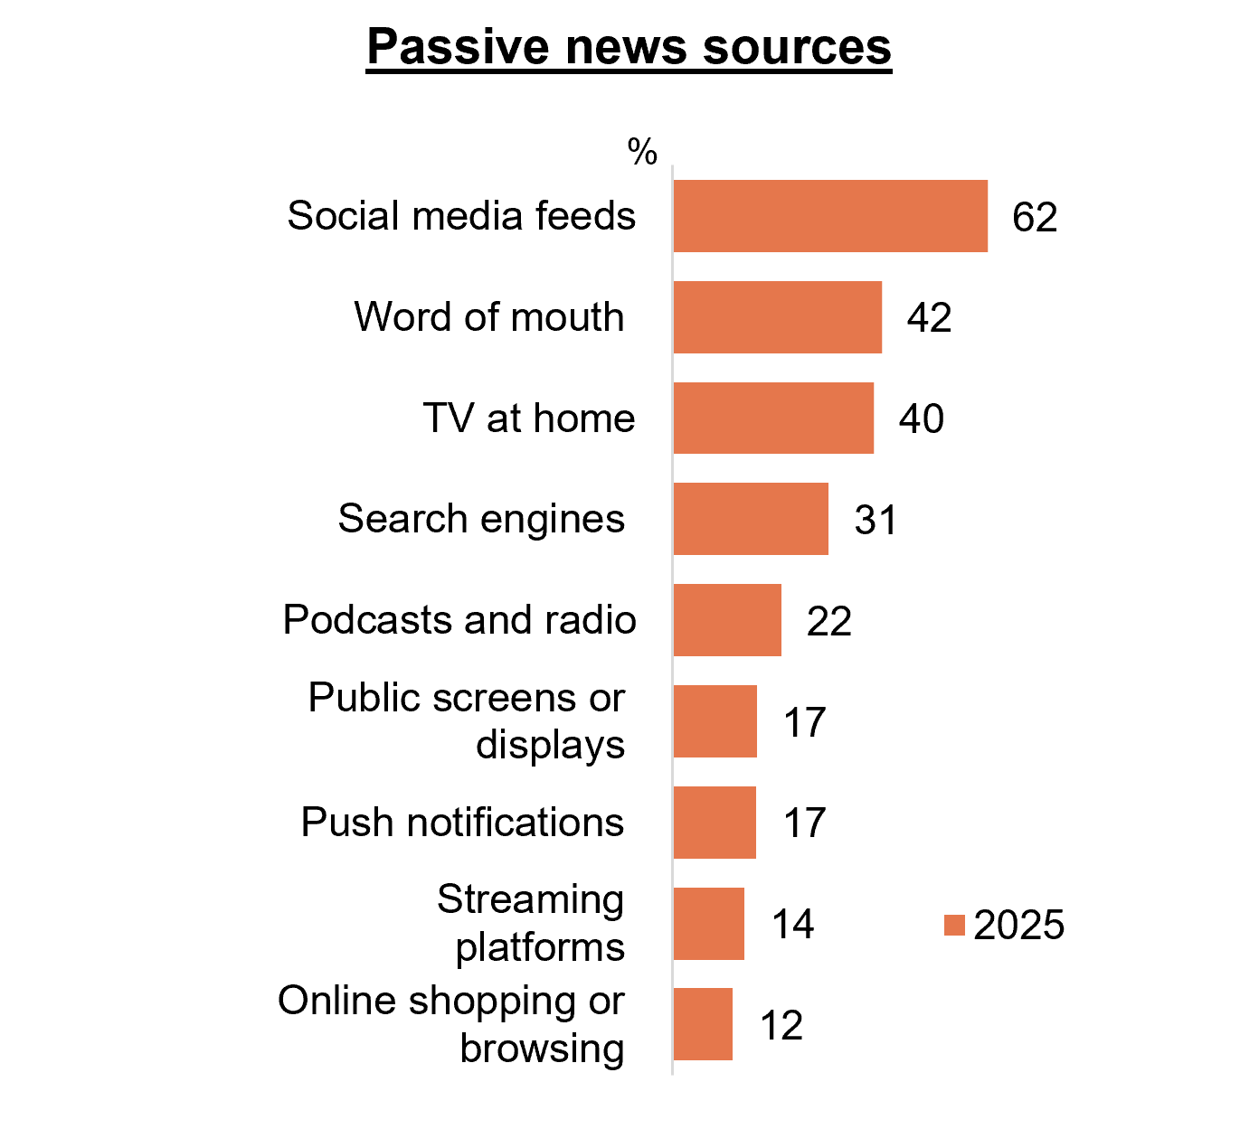
A bar chart showing how people usually come across news when they are not actively trying to access new content in 2025.
Social media feeds: 62%
Word of mouth: 42%
TV at home: 40%
Search engines: 31%
Podcasts and radio: 22%
Public screens or displays: 17%
Push notifications: 17%
Streaming platforms: 14%
Online shopping or browsing: 12%

News: trust + AI
Overall trust in news consumed is polarised in 2025, with around half expressing trust and the rest neutral or distrustful.
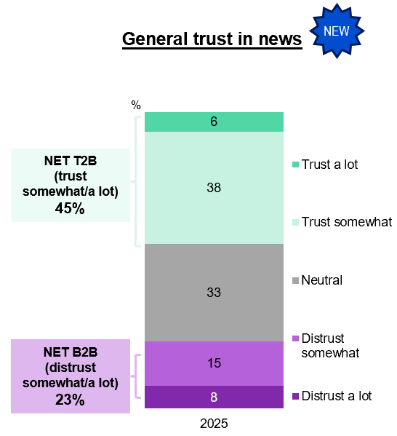
A 100% stacked vertical bar chart showing the extent to which people trust the news they come across in 2025.
NET B2B (distrust somewhat/a lot): 23%
Distrust a lot: 8%
Distrust somewhat: 15%
Neutral: 33%
Trust somewhat: 38%
Trust a lot: 6%
NET T2B (trust somewhat/a lot): 45%
News produced fully by AI shows very low positive sentiment, with most respondents reporting distrust, while AI-assisted news was viewed more favourably but still elicited more distrust than trust. Compared with 2023, perceptions of both fully AI-generated and AI-assisted news became more negative, indicating growing scepticism toward the use of AI in news production over time.

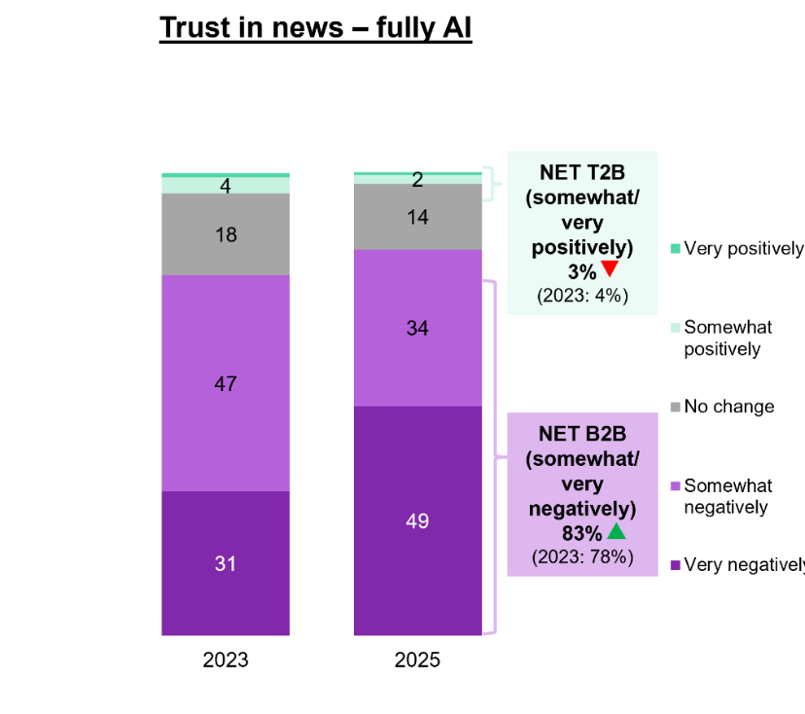
Two 100% stacked vertical bar chart showing the impact on trust in news content if it has been created fully by Generative AI in 2023 and 2025.
NET B2B (somewhat/very negatively): 83% in 2025 vs 78% in 2023
Very negative: 49% in 2025, and 31% in 2023
Somewhat negatively: 34% in 2025, and 47% in 2023
No change: 14% in 2025, and 18% in 2023
Somewhat positively: 2% in 2025, and 4% in 2023
Very positively: 1% in 2025, and 1% in 2023
NET T2B (somewhat/very positively): 3% in 2025 vs 4% in 2023.

Callout
NET B2B (somewhat/very negatively) (83% vs 78% in 2023) increased significantly, whereas NET T2B (somewhat/very positively) (3% vs 4% in 2023) decreased significantly in 2025.⁴
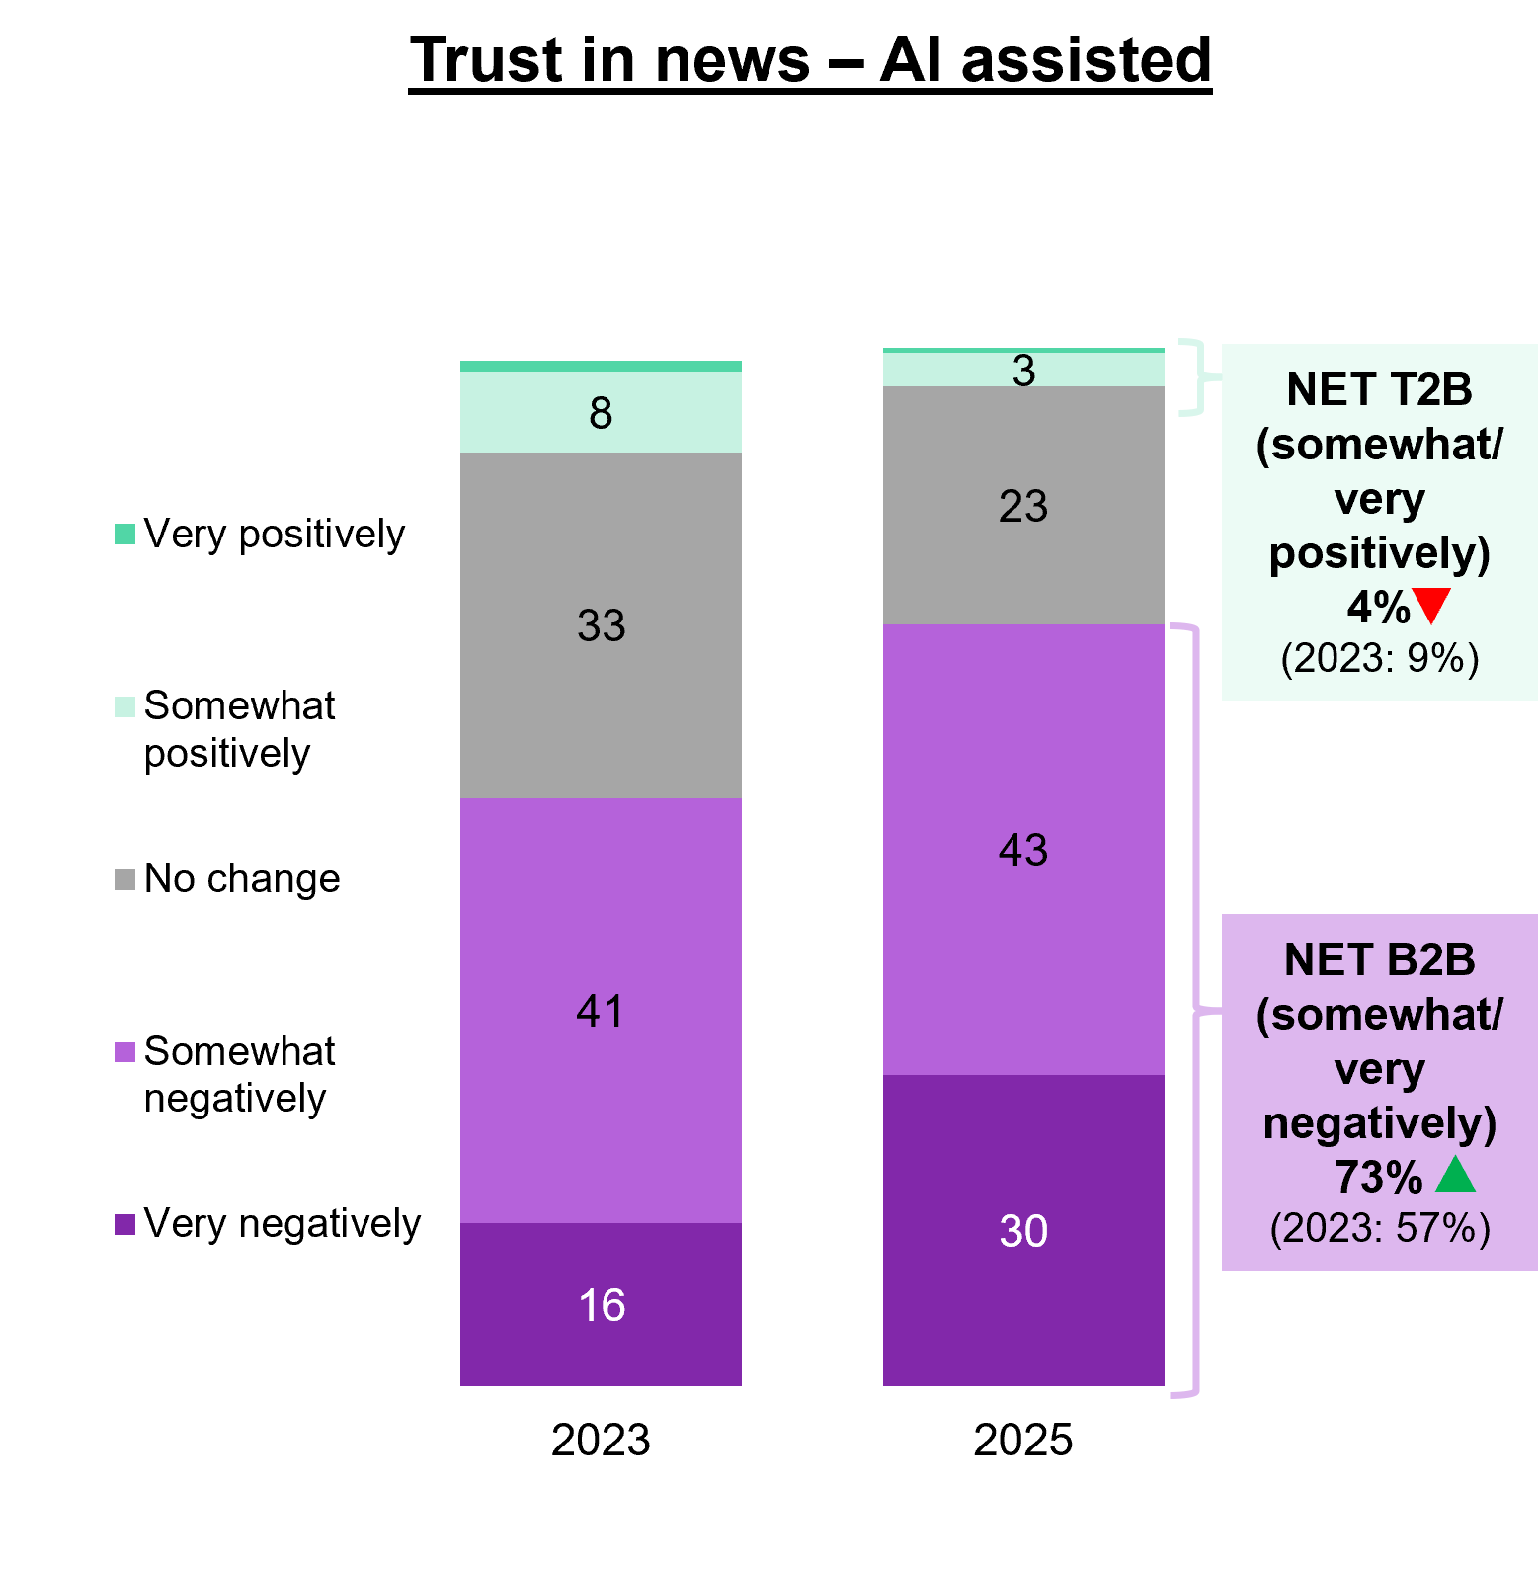
Two 100% stacked vertical bar chart showing the impact on trust in news content if it has been created with the assistance of Generative AI in 2023 and 2025.
NET B2B (somewhat/very negatively): 73% in 2025 vs 57% in 2023
Very negative: 30% in 2025, and 16% in 2023
Somewhat negatively: 43% in 2025, and 41% in 2023
No change: 23% in 2025, and 33% in 2023
Somewhat positively: 3% in 2025, and 8% in 2023
Very positively: 0% in 2025, and 1% in 2023
NET T2B (somewhat/very positively): 4% in 2025 vs 9% in 2023

Callout
NET B2B (somewhat/very negatively) (73% vs 57% in 2023) increase significantly, whereas NET T2B (somewhat/very positively) (4% vs 9% in 2023) decreased significantly in 2025.

Antennas
Three-quarters (76%) of households report having access to an external free-to-air television aerial, antenna, or broadcasting signal in 2025.
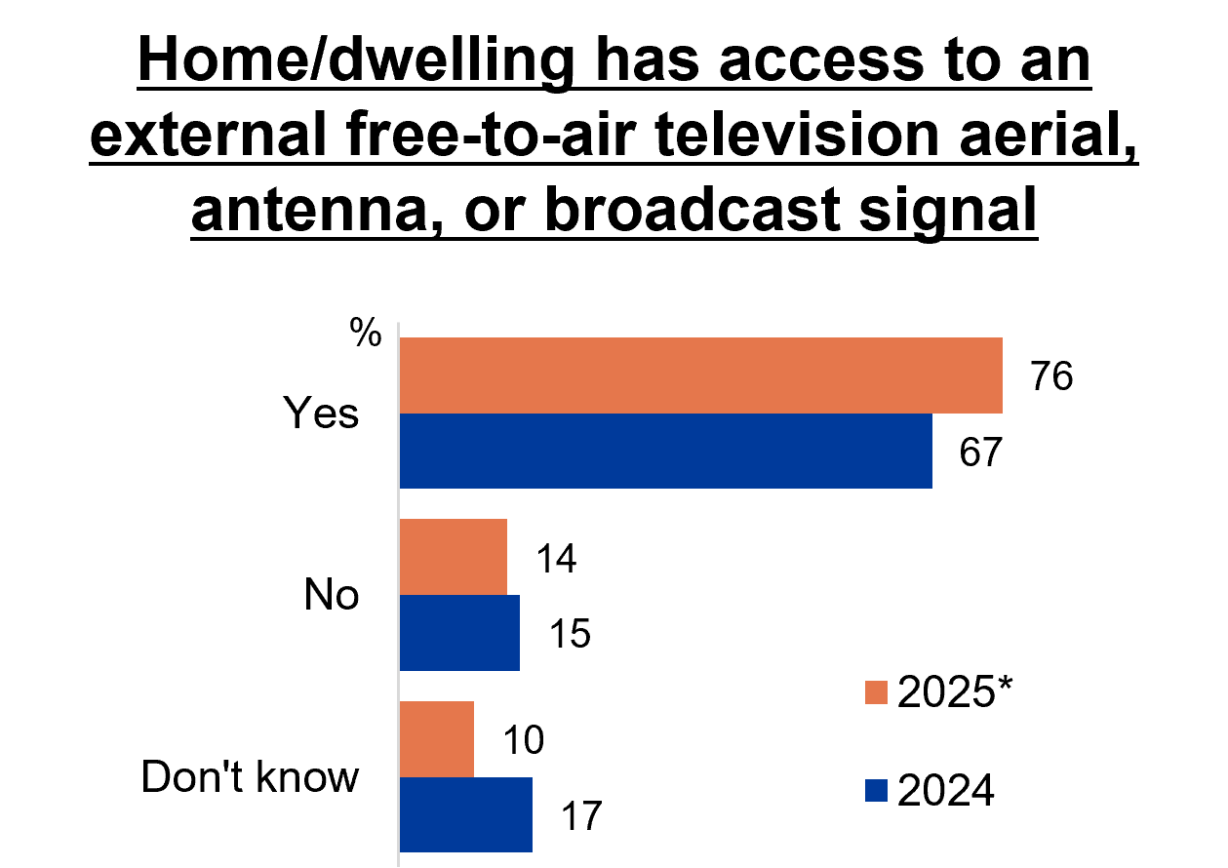
Source: ANTEN1. Does your home/dwelling have access to an external free-to-air television aerial, antenna, or broadcast signal?
Base: TVCS, MCCS. All respondents. 2025: n=4,396. 2024: n=4,490.
Notes: Refused response not shown: <0.5% in 2024 and 2025. DK and Ref options were displayed upfront with other response options.
A horizontal bar chart showing the percentage of people answering whether their home/dwelling has access to an external free-to-air TV aerial, antenna, or broadcast signal in 2024-2025.
Yes: 76% in 2025, and 67% in 2024
No: 14% in 2025, and 15% in 2024
Don’t know: 10% in 2025, and 17% in 2024

Note
Due to differences in question framing and design in 2024 and 2025, comparisons across years should be treated with caution, and no significance testing was conducted.
In 2025, a verification prompt was introduced for respondents who initially indicated they did not have access to an external antenna or were unsure, but had earlier reported watching free-to-air TV. These respondents were reminded that live broadcast TV requires an antenna and that their household likely has access to one. Following this prompt, 34% confirmed they have an external antenna, bringing the overall estimate of antenna access to 76%. 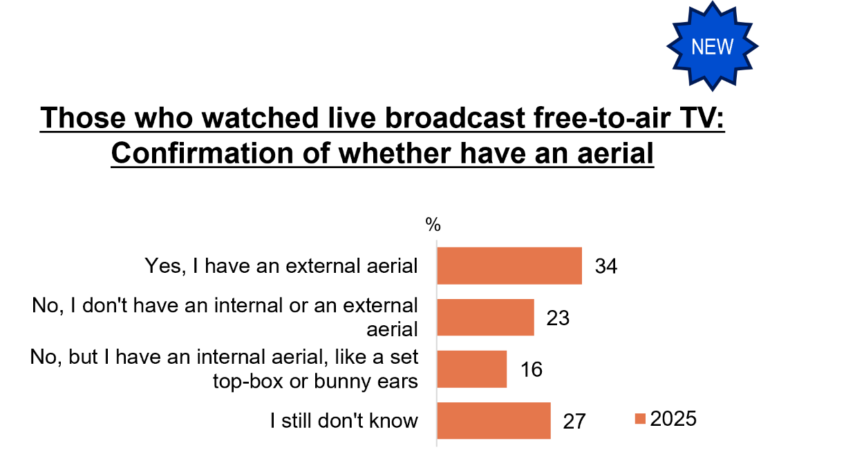
Source: ANTEN1aa. Earlier you said you watched live broadcast free-to-air TV content which requires an aerial. If you watched this content at home, it’s likely you have an aerial. Based on this information, do you think you have an external aerial?
Base: TVCS, MCCS. Respondents who did not know or said they did not have access to an external aerial but still watched free-to-air TV. 2025: n=845.
A horizontal bar chart showing the percentage of people who confirmed whether they have an aerial in 2025 after the prompt.
Yes, I have an external aerial: 34%
No, I don’t have an internal or external aerial: 23%
No, but I have an internal aerial, like a set of top-box or bunny ears: 16%
I still don’t know: 27%
Others reported using an internal aerial (16%) or accessing free-to-air TV through alternative sources such as a smart TV.
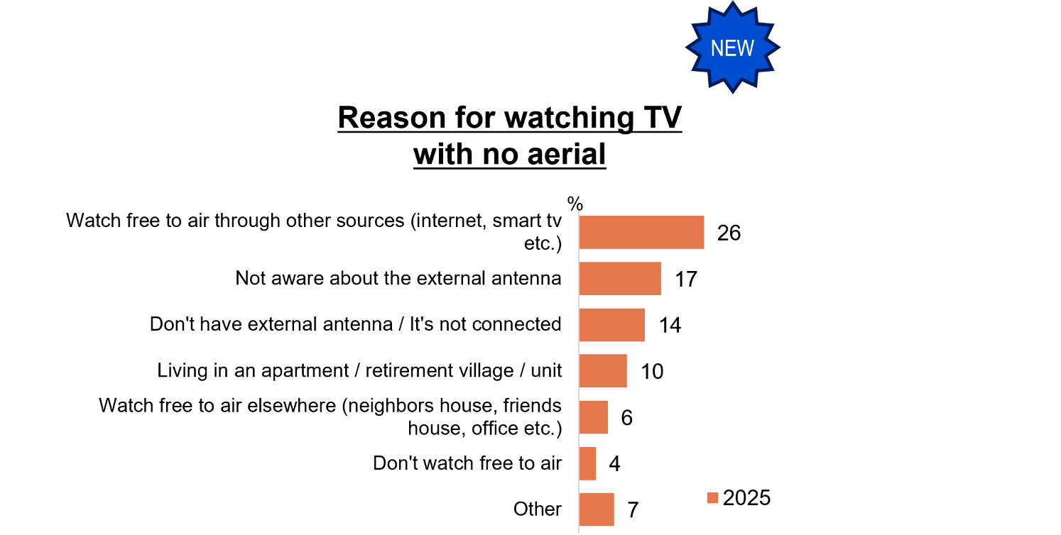
Source: ANTEN1b. You mentioned you don’t know if your home/dwelling has an external antenna or that you have watched broadcast free-to-air TV but your home/dwelling does not have an aerial. Can you please give more detail on why this is the case?
Base: TVCS, MCCS. Respondents who said they don’t have an internal/external aerial or still don’t know.
Notes: Refused response not shown. 2025: DK=20%, Ref=10%.
A horizontal bar chart showing the percentage of people who mentioned that they did not know whether their home/dwelling has an external antenna or that they have watched broadcast free-to-air TV but their home/dwelling does not have an aerial. The chart shows the reasons provided for watching TV with no aerial in 2025.
Watch free to air through other sources (internet, smart tv etc.): 26%
Not aware about the external antenna: 17%
Don’t have external antenna/ It’s not connected: 14%
Living in an apartment / retirement village/ unit: 10%
Watch free to air elsewhere (neighbors house, friends house, office etc.): 6%
Don’t watch free to air TV: 4%
Other: 7%

Accessibility + inclusion
In 2025, 67% have ever used an accessibility feature to watch screen content, with use driven mainly by subtitles (61%) and closed captions (25%). Among users of each accessibility feature, reliance on dubbing to understand TV content increased this year, while reliance on closed captions decreased. Higher reliance indicate a greater need for these features to access TV content.
In 2025
- 8% of people reported to be deaf or hard of hearing.
- 4% of people reported to be blind or have low or reduced vision.
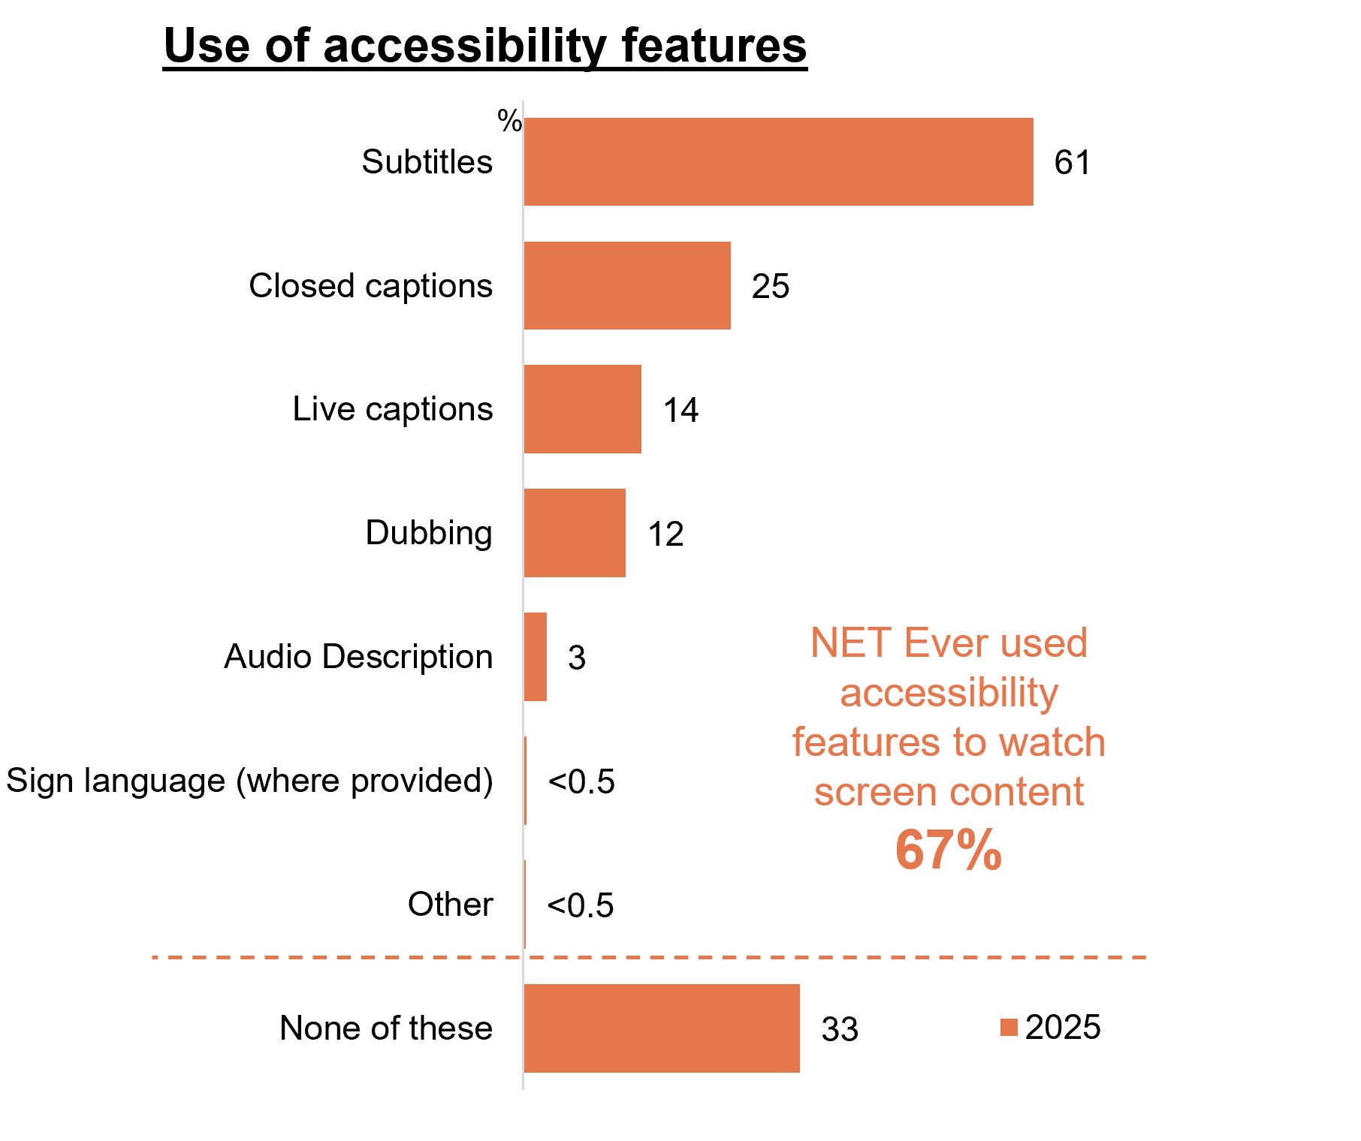
A horizontal bar chart showing the percentage of people who have used any of the following accessibility features to watch screen content in 2025.
Subtitles: 61%
Closed captions: 25%
Live captions: 14%
Dubbing: 12%
Audio Description: 3%
Sign language (where provided): less than 0.5%
Other: less than 0.5%
None of these: 33%
NET Ever used accessibility features to watch screen content: 67%

Reliance on accessibility features (T2B rely fully/partially):
Closed captions reliance decreased (31% in 2025, versus 57% in 2023). However, reliance was significantly higher for those with disability, or who were deaf or blind.
Dubbing reliance significantly increased (53% in 2025, versus 34% in 2023).

Emergency information
Online sources were the most frequently used and preferred source of emergency information, while radio and television also played an important role.
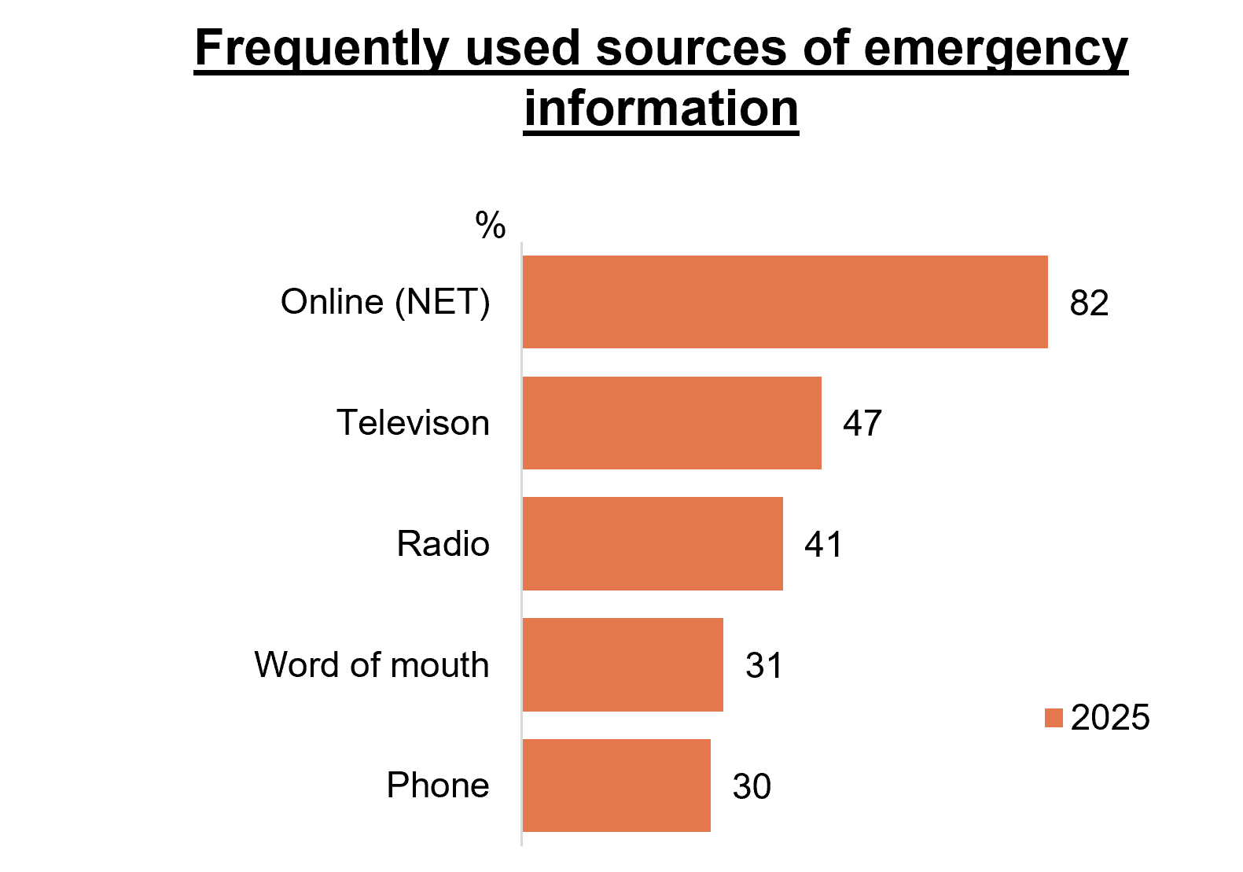
A horizontal bar chart showing the percentage of different sources of emergency information used in 2025.
Online (NET): 82%
Television: 47%
Radio: 41%
Word of mouth: 31%
Phone: 30%
Definition of ‘emergency’ in the survey was: “a natural disaster or extreme weather event”.
‘Emergency information’ refers to information about emergency situations.

Note
EMERG2 and EMERG3 were asked as unprompted open-text questions in 2024 and as closed-frame questions in 2025. Therefore, results are not comparable across years, and 2024 results are not shown.
Television was primarily valued for live and up-to-date coverage, whereas radio was favoured for its accessibility and availability during emergency situations.

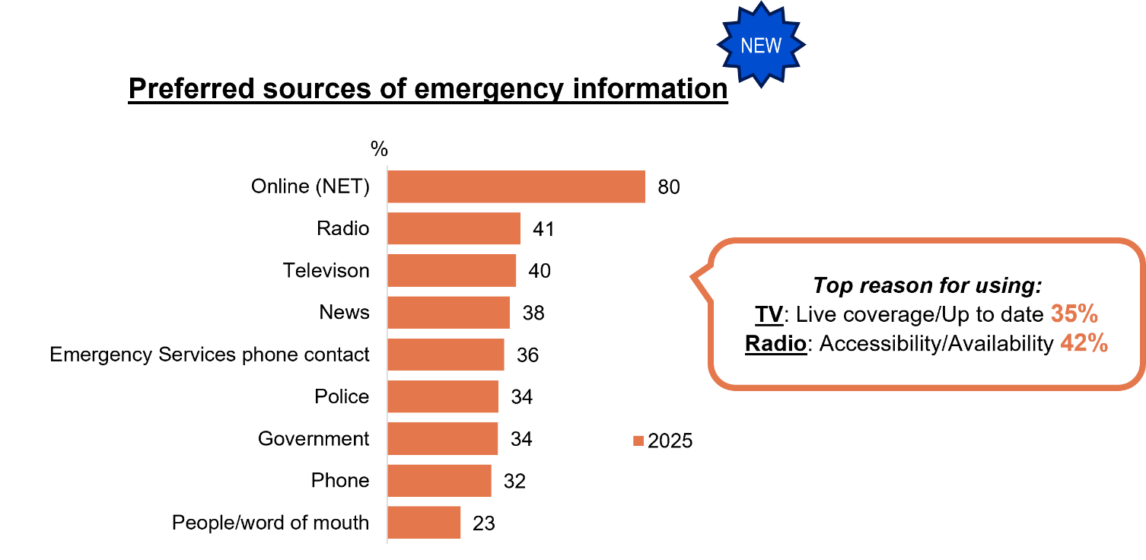
A horizontal bar chart showing the preferred sources of emergency information in 2025.
Online (NET): 80%
Radio: 41%
Television: 40%
News: 38%
Emergency Services phone contact: 36%
Police: 34%
Government: 34%
Phone: 32%
People/word of mouth: 23%

Top reasons for using:
TV: Live coverage/Up to Date: 35%
Radio: Accessibility/Availability: 42%

Australian content
Around half of respondents watched Australian content on subscription streaming services in the past 7 days (49%), with drama, news and current affairs, comedy and documentary the most commonly viewed genres.
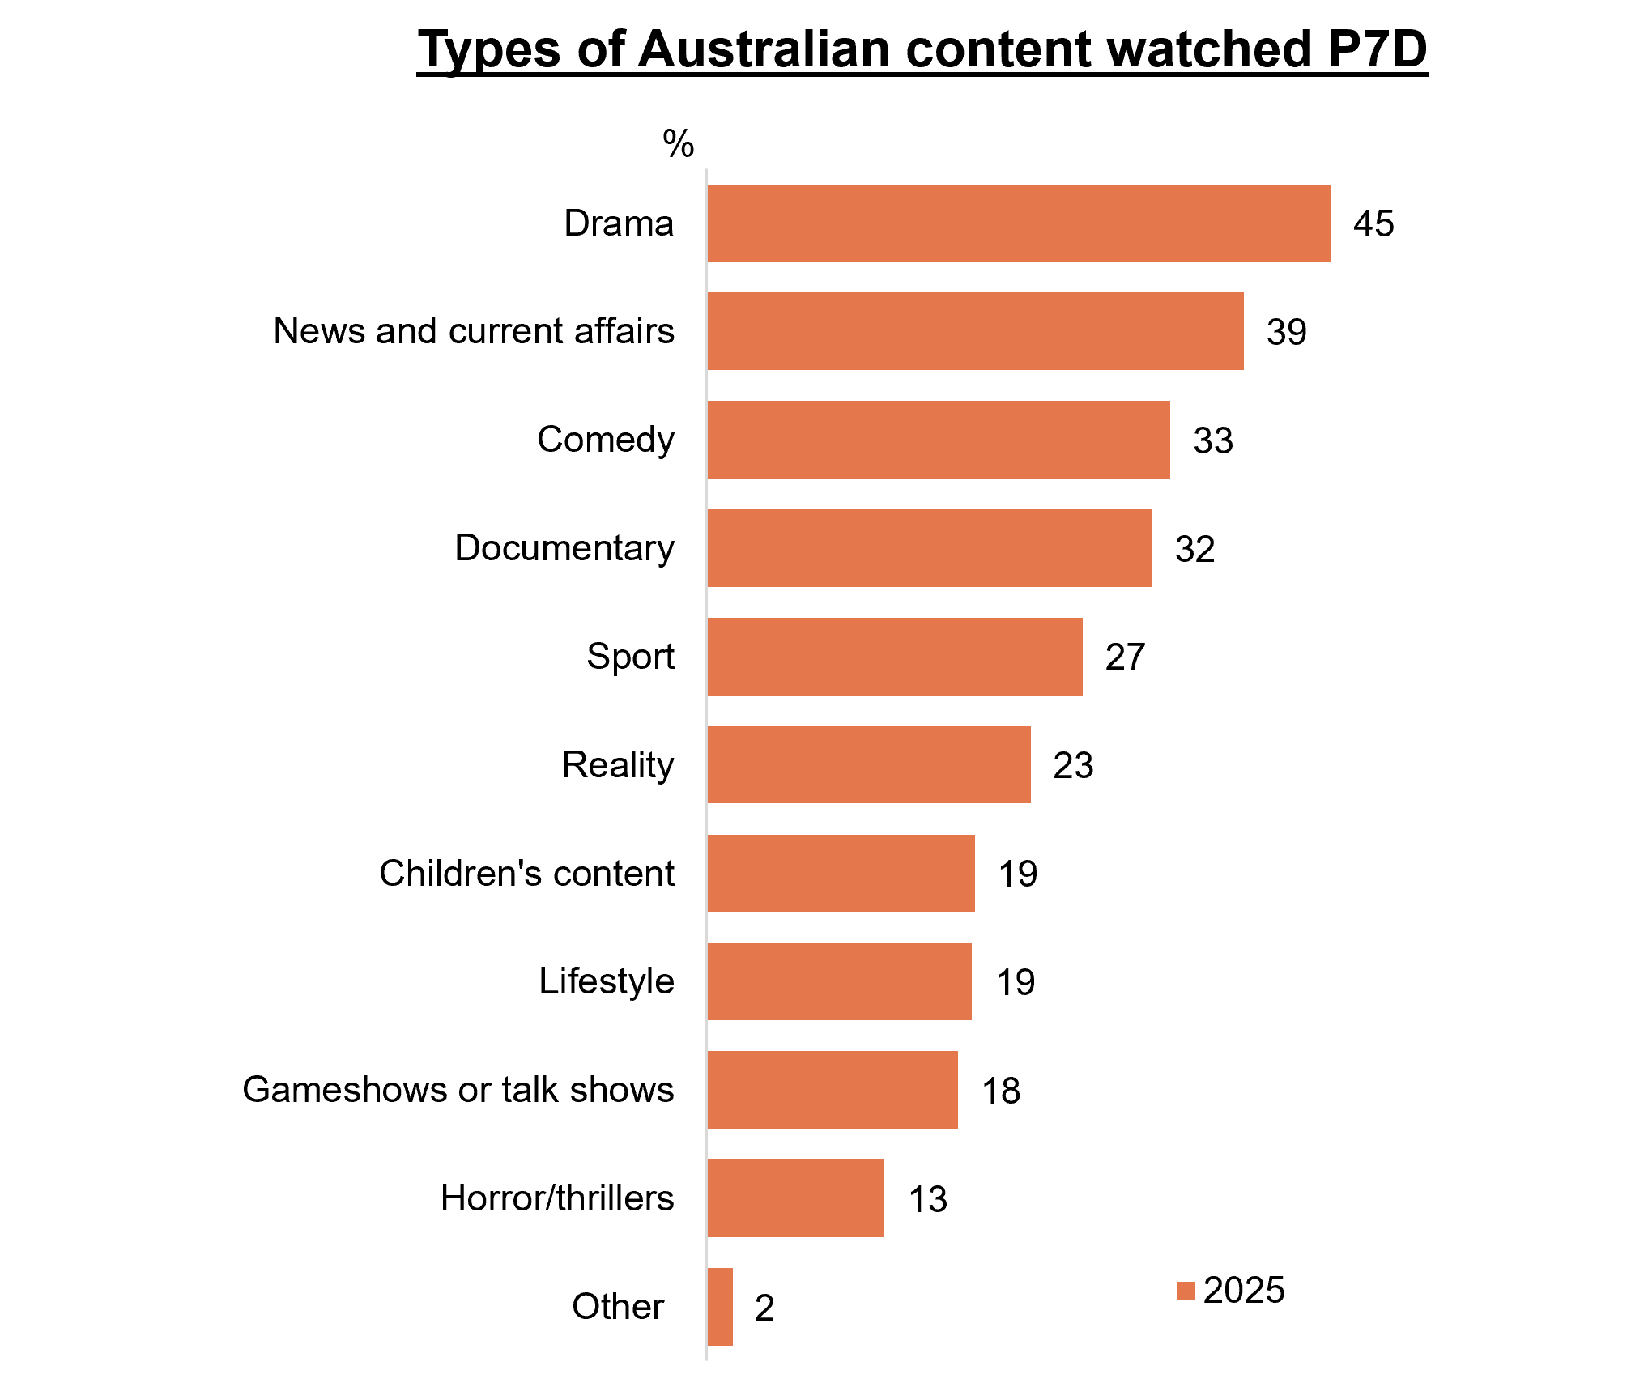
A horizontal bar chart showing the percentage of types of Australian content watched in the past 7 days in 2025.
Drama: 45%
News and current affairs: 39%
Comedy: 33%
Documentary: 32%
Sport: 27%
Reality: 23%
Children’s content: 19%
Lifestyle: 19%
Gameshows or talks show: 18%
Horror/thrillers: 13%
Other: 2%

Australian content is most often discovered via the home screen or by continuing series already being watched. Recommendations and trending lists also play a role in audiences discovering Australian content.
How Australian content was discovered (Top 4):
- I saw it on the home screen: 23%
- I was continuing watching a series I’d already been watching: 20%
- I was recommended/appeared on screen based on a show I had just finished watching: 16%
- I saw it on trending lists (e.g. Top 10): 15%

Audio content
Online music streaming services are the primary driver of audio listening, accounting for the greatest share of time spent. Australian music is consumed across both streaming and radio, with streaming used slightly more often, while radio continued to play an important role in listening.
Hours per week listening to any types of music in 2025:
- Online music streaming services: 10.8 average hours per week
- Radio (NET): 6.2% average hours per week

Hours per week listening to Australian music in 2025:
- Online music streaming services: 3.0 average hours per week
- Radio (NET): 2.5 average hours per week

Codes + classifications
Three in five (62% NET in 2025) report that they most commonly refer to a classification rating when deciding whether a film or movie is appropriate for a child or adolescent.
Frequency of referencing classification ratings in 2025:
- Film or movie for a child or adolescent: 62%
- To watch a film or movie: 61%
- Computer game for a child or adolescent: 47%
- To play a computer game: 34%
Advertising (on a service related to the code in question) was the main source of awareness across all Codes of Practice, followed by media commentary about the codes. However, a sizeable proportion did not know the source of awareness.
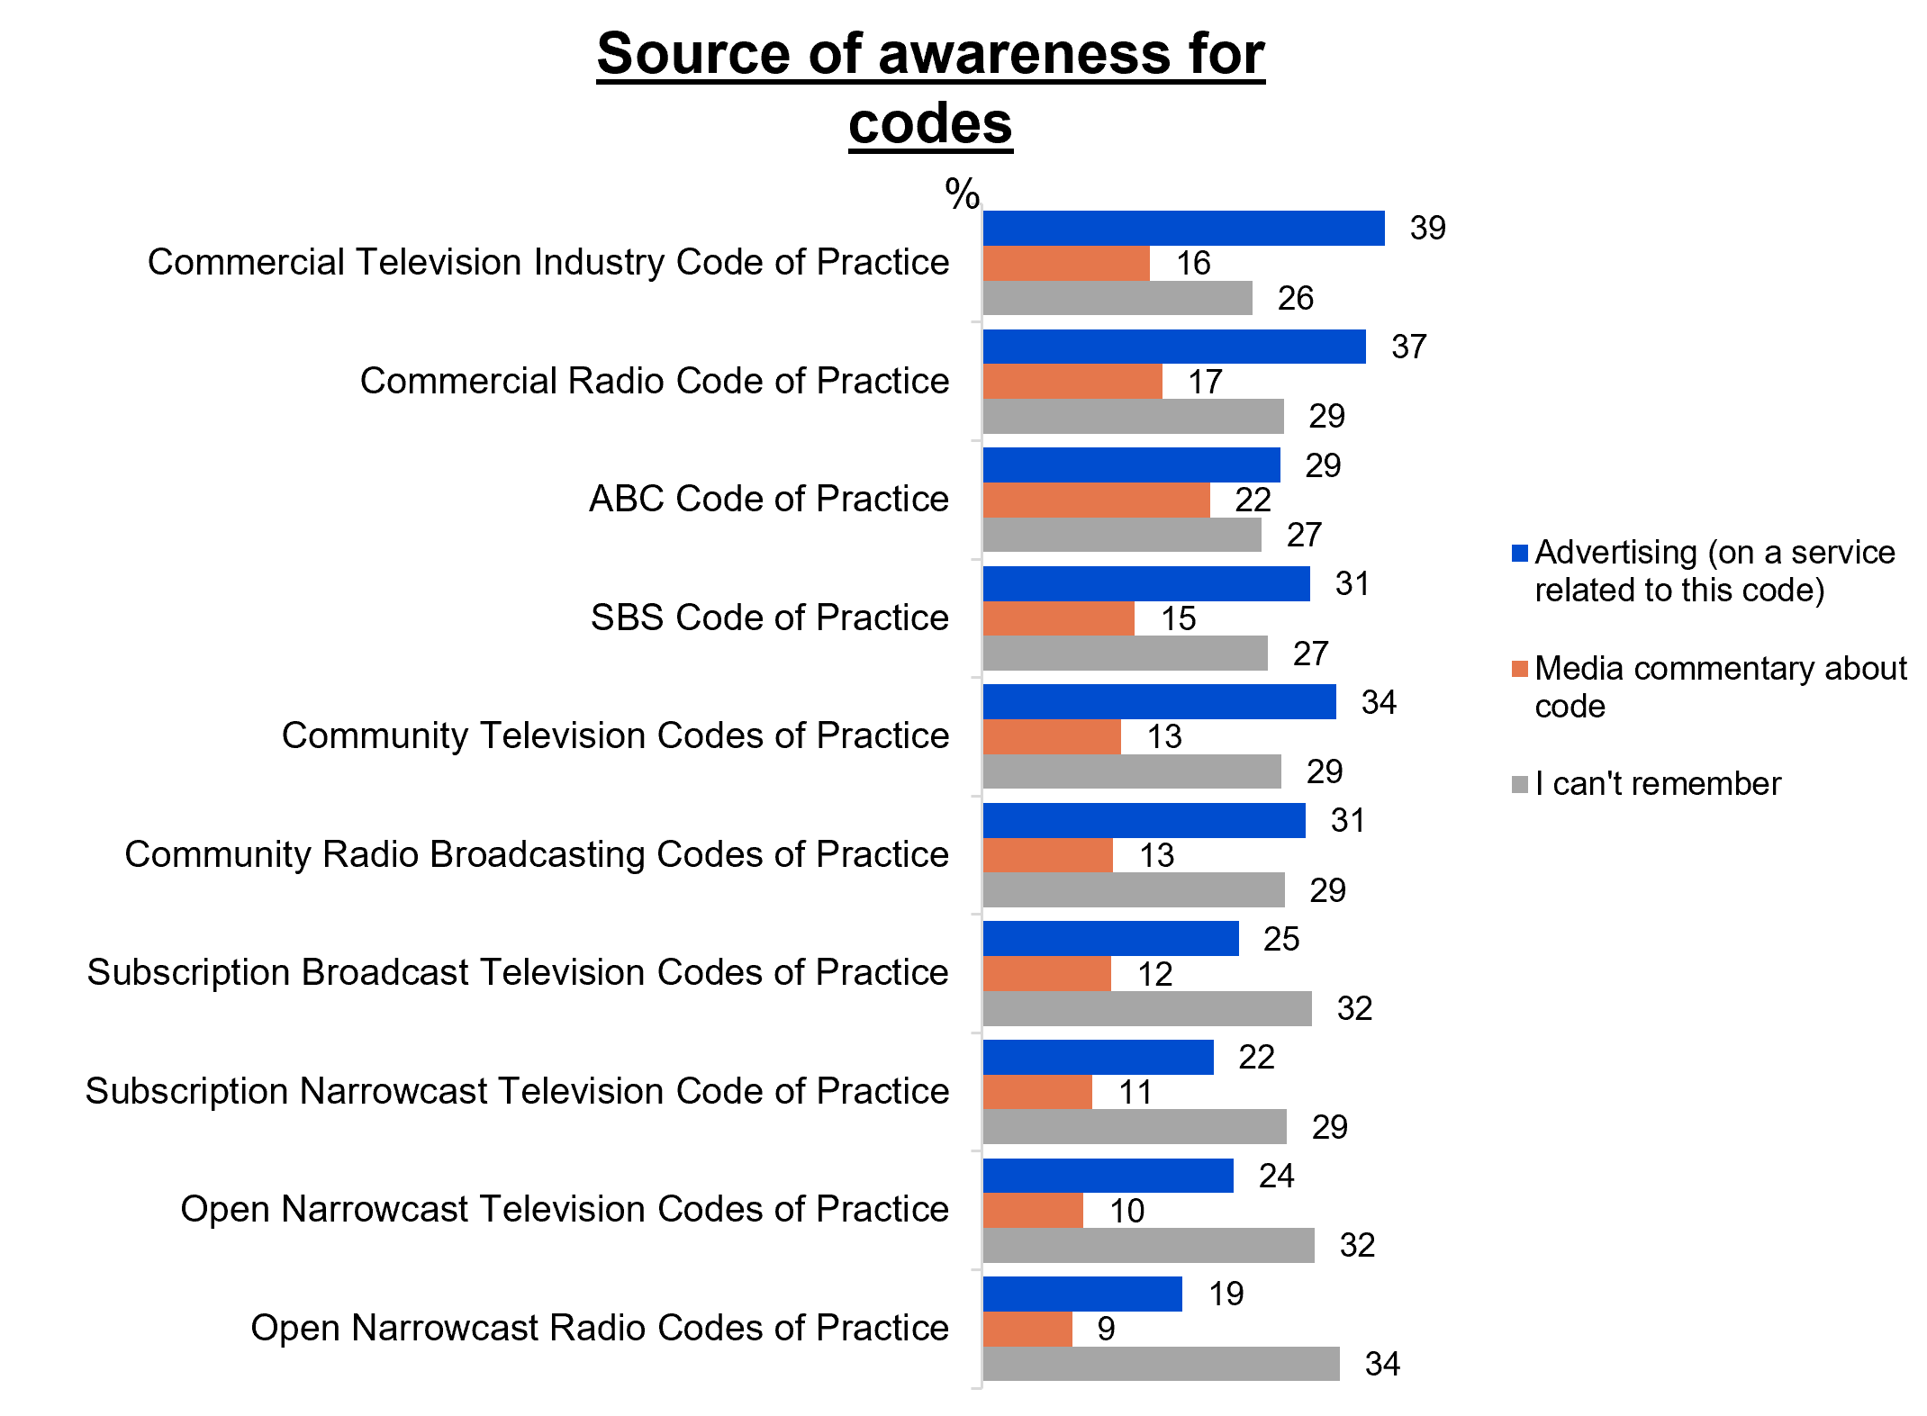
A bar chart showing the percentage of sources of awareness of codes in 2025.
Commercial Television Industry Code of Practice:
Advertising (on a service related to this code): 39%
Media commentary about code: 16%
I can’t remember: 26%

Commercial Radio Code of Practice:
Advertising (on a service related to this code): 37%
Media commentary about code: 17%
I can’t remember: 29%

ABC Code of Practice:
Advertising (on a service related to this code): 29%
Media commentary about code: 22%
I can’t remember: 27%

SBS Code of Practice:
Advertising (on a service related to this code): 31%
Media commentary about code: 15%
I can’t remember: 27%

Community Television Codes of Practice:
Advertising (on a service related to this code): 34%
Media commentary about code: 13%
I can’t remember: 29%

Community Radio Broadcasting Codes of Practice:
Advertising (on a service related to this code): 31%
Media commentary about code: 13%
I can’t remember: 29%

Subscription Broadcast Television Codes of Practice:
Advertising (on a service related to this code): 25%
Media commentary about code: 12%
I can’t remember: 32%

Subscription Narrowcast Television Code of Practice:
Advertising (on a service related to this code): 22%
Media commentary about code: 11%
I can’t remember: 29%

Open Narrowcast Television Codes of Practice:
Advertising (on a service related to this code): 24%
Media commentary about code: 10%
I can’t remember: 32%

Open Narrowcast Radio Codes of Practice:
Advertising (on a service related to this code): 19%
Media commentary about code: 9%
I can’t remember: 34%

Sports content
Sports continues to be a popular screen content choice for Australians, with nearly half (48%) saying they watched sport content in the past 7 days.
The most popular platform for viewing sports content is free-to-air TV (69%).
Types of sport watched include Olympic Games events, Commonwealth Games events, Australian rules football, Rugby League, and the Australian Open tennis tournament.
Top motivators for watching more sports content include free access, live coverage, high quality, and availability of Australian content.
48% of people have reported to consume sports content of some sort in the past 7 days. This shows significant increase in 2025 (48% vs 29% in 2024).
Platforms for watching sports
- 69% of people have watched sports content on free-to-air TV (commercial or public) in the past 7 days, while 54% watched sports content online
Top 5 sports typically watched in 2025:
- Olympic Games events: 78%
- Commonwealth Games events: 65%
- Australian rules football: 61%
- Rugby League: 54%
- Australian Open tennis tournament: 53%

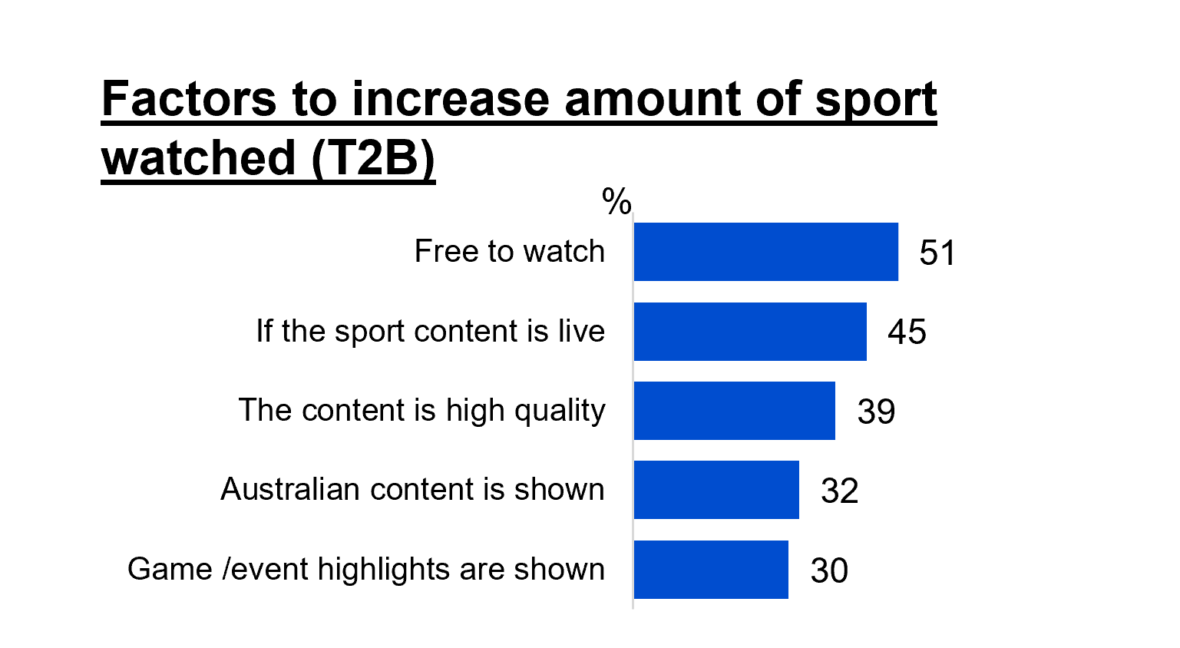
A horizontal bar graph showing factors that would increase the number of sports watched in 2025. The percentages shown are the top 2 boxes (watch a little bit more/a lot more).
Free to watch: 51%
If the sport content is live: 45%
The content quality is high quality: 39%
Australian content is shown: 32%
Game /events highlights are shown: 30%

Video gaming: Interactions + microtransactions
A slight decrease of video games played in the past 7 days is observed with 38% in 2025, with children aged 8–17 being the most frequent population. Messaging or voice chat via team chat or private messages dominate the ways children interact with others while gaming. Children aged 8–10 reported to have the most restrictions placed on gaming and 20% of children in 2025 have made some form of microtransactions purchases, with the top type being in-game currency and top location being at home.
Adults
- The percentage of adults who have played video games in the past 7 days: 38% in 2025 vs 39% in 2024
- 50% of adults in 2025 have interacted in some way when gaming (NET Ever for any interaction)
Children
- Children who have played video games in the past 7 days (2025): 35% (0–7), 76% (8–10), 75% (11–15), and 61% (16–17).
- Limits or restrictions over the types of video games that child plays or has access to: 76% (0–7), 86% (8–10), 59% (11–15), and 23% (16–17).
Microtransactions
- Top type: In-game currency (63%)
- Top location: At home (87%)

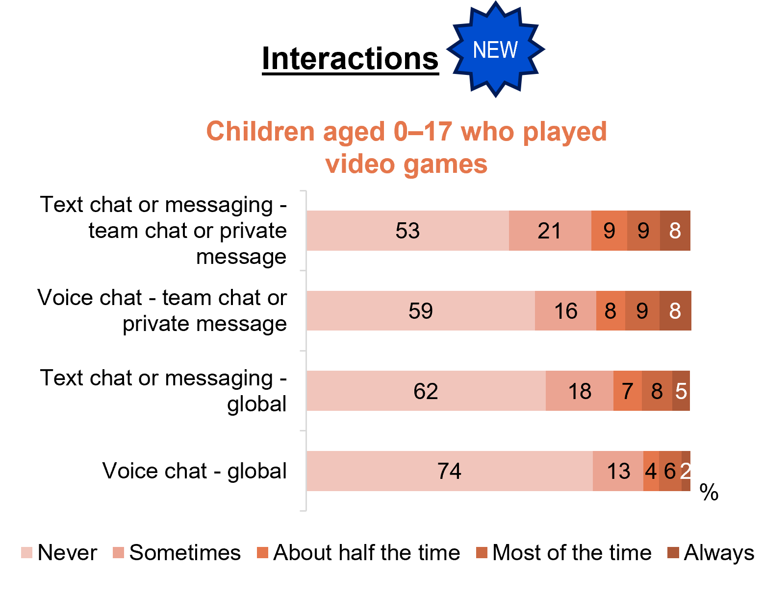
A horizonal bar chart showing how frequently children interact with others while playing video or computer games, across different interaction types, in 2025.
Text chat of messaging – team chat or private message:
Never: 53%
Sometimes: 21%
About half the time: 9%
Most of the time: 9%
Always: 8%

Voice chat – team chat or private message:
Never: 59%
Sometimes: 16%
About half the time: 8%
Most of the time: 9%
Always: 8%

Text chat of messaging – global:
Never: 62%
Sometimes: 18%
About half the time: 7%
Most of the time: 8%
Always: 5%

Voice chat – global:
Never: 74%
Sometimes: 13%
About half the time: 4%
Most of the time: 6%
Always: 2%

Children + media: Parental controls
57% of parents use parental control on services with 51% stating that they are somewhat or very satisfied with the protection controls regarding sex/nudity/sexually suggestive content, followed by depictions of self-harm (50%). There are various factors driving the decision to not use parental controls, with the most common being trust in children (38%), having direct supervision (24%) and unfamiliarity in the setup (12%). When asked regarding the appropriateness of content that is recommend to children, 21% felt it was appropriate, followed by 36% of somewhat appropriate.
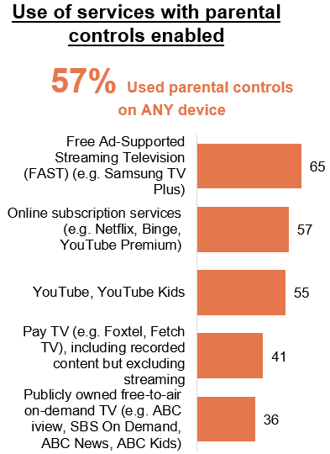
A horizontal bar chart showing the percentage of parents who have used parental controls on the services listed in 2025.
Used parental controls on any device: 57%
Free Ad-Supported Streaming Television (FAST) (e.g. Samsung TV Plus): 65%
Online subscription services (e.g. Netflix, Binge, YouTube Premium): 57%
YouTube, YouTube Kids: 55%
Pay PT (e.g. Foxtel, Fetch TV), including recorded content but excluding streaming: 41%
Publicly owned free-to-air on-demand TV (e.g. ABC iview, SBS On Demand, ABC News, ABC Kids): 36%
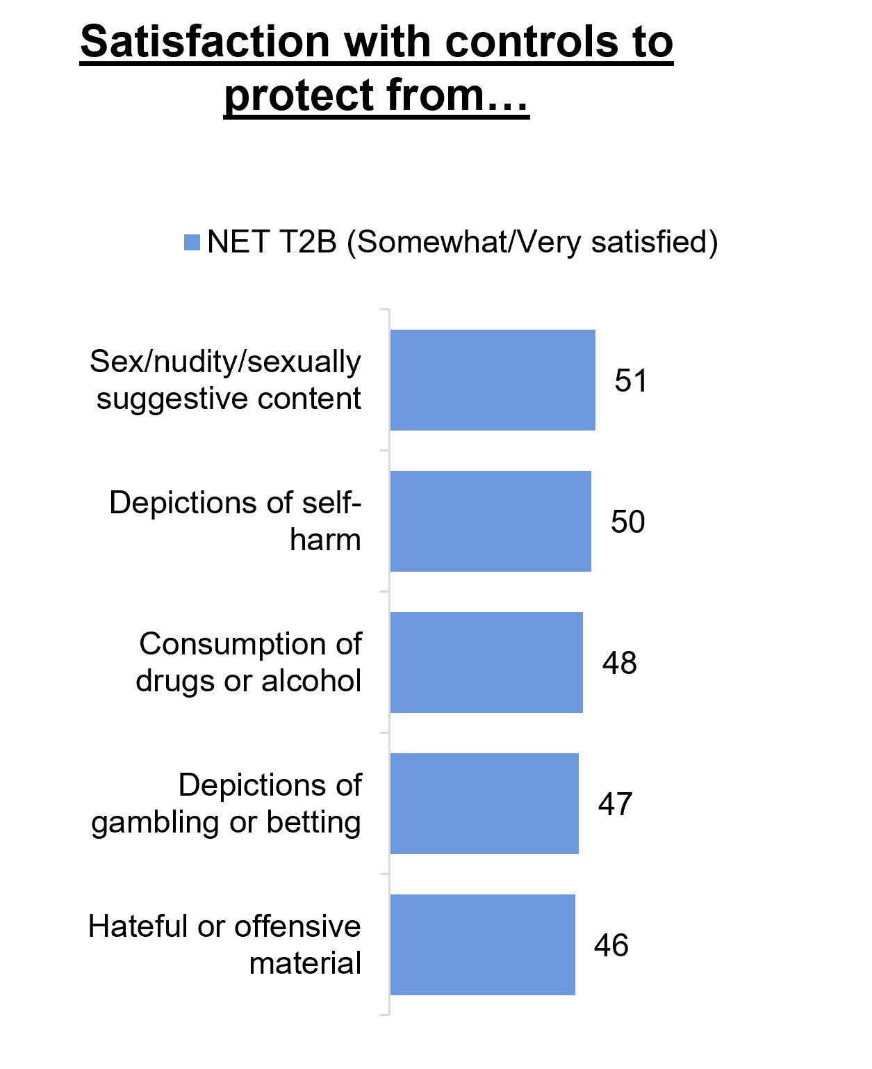
A horizontal bar chart showing parents’ satisfaction with the controls designed to protect children from various risks in 2025. The percentages are NET T2B (Somewhat/Very satisfied).
Sex/nudity/sexuality suggestive content: 51%
Depictions of self-harm: 50%
Consumption of drugs or alcohol: 48%
Depictions of gambling or betting: 47%
Hateful or offensive material: 46%

Reasons for not using parental controls in 2025:
No Need/Trust my child: 38%
Direct supervision: 24%
Unfamiliar how to set up/Hard to navigate: 12%
Children are old enough/mature: 12%
Children are too young/not old enough: 6%
Other: 11%
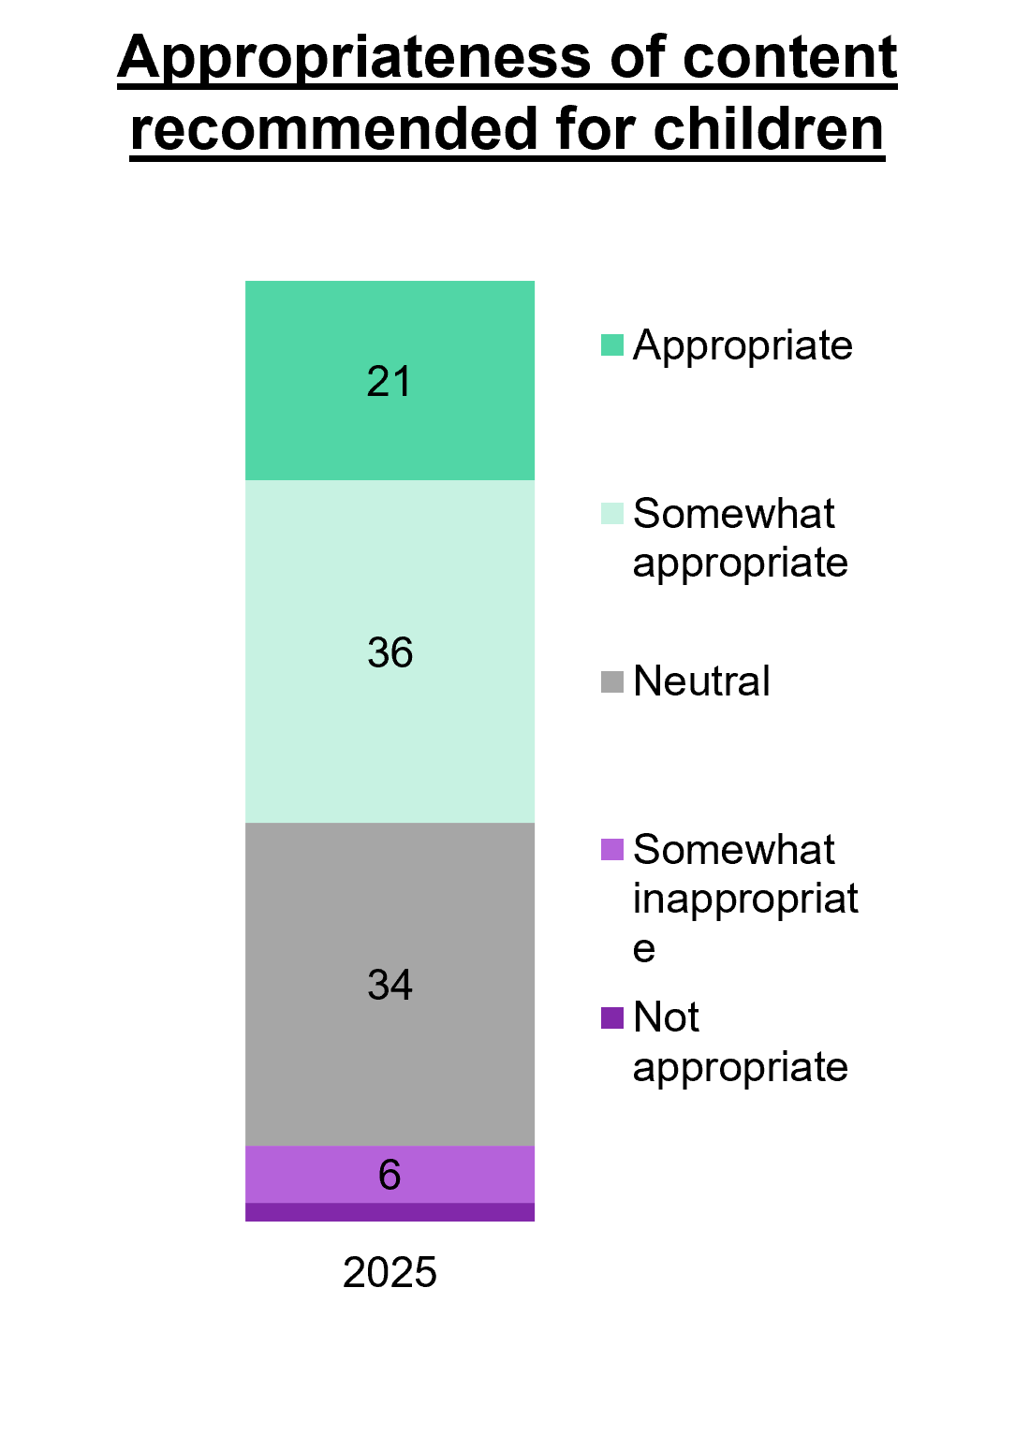
A 100% stacked bar chart showing the level of appropriateness of content that is recommended for children on streaming services in 2025.
Not appropriate: 2%
Somewhat inappropriate: 6%
Neutral: 34%
Somewhat appropriate: 36%
Appropriate: 21%

Children and media: Age-inappropriate content (Children 0-17)
At home is the most common location where children aged 0–17 saw age-inappropriate content, with younger children (0–7) accompanied by family members (86%), children aged 8–10 and 11–15 both were with parents or other older family members (75% and 53% respectively) and older children (aged 16–17) were by themselves (43%). Intentional searches for age-inappropriate content become more common as children get older, with percentage rising in each age group (22%, 35%, 48% and 50% respectively). Reasons why content is considered inappropriate differ by age group, with factors such as not child-friendly, violent content and general age rating all playing a role.
Among children who watched age-inappropriate content:
- At home: 64% (0–7), 91% (8–10), 88% (11–15), and 65% (16–17).
- Yes, intentional: 22% (0–7), 36% (8–10), 48% (11–15), and 50% (16–17).

Table 1 Who were they with
Age | Who with | Percentages
0-7 | Family members | 86%
8-10 | Parents or other older family members | 75%
11-15 | Parents or other older family members | 53%
16-17 | By myself | 43%

Table 2 Reasons why content was inappropriate
Age | Why Inappropriate | Percentages
0-7 | Inappropriate / not child friendly | 26%
8-10 | Violent | 48%
11-15 | Violent | 58%
16-17 | General age rating | 28%

First Nations summary

First Nations summary – Caveat
For the 2025 Television and Media survey, the department and the Social Research Centre (SRC) collaborated on ways to strengthen the First Nations Australian sample in the survey series. This was also reflected in the 2024 approach. First Nations respondents had been captured in previous Television and Media survey research since 2020.
For the sample, the department and the SRC designed a sample boost for First Nations respondents, which was run through the ORU non-probability online panel. This was intended to ensure that First Nations responses were better reflected in the survey finding. The presence of a sample boost has also given enhanced confidence in the First Nations specific findings in this report, and as such, a summary of First Nations respondent results has been included as a chapter in the report.
The department and the SRC acknowledge the importance of research with First Nations communities, particularly research designed and ran in collaboration with communities, and the value of the NHMRC's 2018 Ethical Conduct in research with Aboriginal and Torres Strait Islander Peoples and communities: Guidelines for researchers and stakeholders. The First Nations sample boost was part of the sample structure included in materials reviewed by the Human Research Ethics Committee that approved this study.
As an online-only survey, it is also worth acknowledging there are potential limitations around the First Nations sample, which may have over or under-indexed with particular First Nations respondents. Base sizes lower than n=70 have not been reported on or shown below. Splits for metropolitan and regional location of respondents are also not shown due to these low base sizes.

First Nations summary

General screen content
First Nations respondents were more likely than non-First Nations respondents to watch any streaming services (88% vs 74) (base n=156) in P7D, especially through YouTube/YouTube Premium (87% vs 74%) (base n=173).
First Nations respondents were also more likely than non-First Nations respondents to watch video content on social in P7D (88% vs 77%) (base n=173).
NET Use mobile phone/smart phone once per day to watch screen content was higher amongst First Nations respondents (68% vs 49%) (base n=172), those who currently have a social media account (97% vs 91%) (base n=173) and accessed their social media once an hour or more (40% vs 21%) (base n=173).
This cohort of respondents were also more likely to use chat/messaging services (80% vs 70%) (base n=173), and to have watched screen content outside of their home in the past 12 months (62% vs 42%) (base n=162).
First Nation respondents were also more likely than non-First Nations respondents to have watched FAST services in the P7D (23% vs 13%) (base n=173).

Children’s content age 0-17
Several differences emerged in children’s screen content. First Nations parents were more likely to report that any Australian content is considered as important and must be made available to children (98% vs 41% of non-First Nations parents) (base n=90).

Televisions
First Nations respondents were more likely than non-First Nations respondents to have a higher average number of working TVs connected to the internet (2.0 vs 1.6) (base n=167) and more likely to not have any TVs that are connected to an external aerial, antenna, or broadcast signal (30% vs 21%) (base n=167).

News, current affairs and emergency information
First Nations respondents in the sample were more likely than non-First Nations respondents to use social media as their current platform to access news/current affairs (69% vs 53%) and more likely to have accessed social media for news in the P7D (81% vs 65%) (base n=162).
First Nations respondents than non-First Nations respondents were more likely to have consumed news passively or all of the time (36% vs 16%) (base n=173), with social media feeds being the most frequently source for incidental news (75% vs 62%) (base n=159). First Nations respondents are more likely to have come across news content through social media page of a news outlet (81% vs 65%) (base n=125).

Sports consumption
First Nations respondents were more likely to consume sports content online than non-First Nation respondents (68% vs 53%).

Audio
First Nations respondents were more likely than non-First Nations respondents to have listened to online audio in the P7D (78% vs 64%) (base n=173) and the average hours spent per week listening to online music streaming services were higher (4.7 vs 2.9) (base n=100).
NET Ever used accessibility features to watch screen content was higher for First nations respondents (80% vs 66% of non-First Nation respondents).

General screen content habits

Chapter Summary – General Screen Content Habits
Use of online services continues to dominate in 2025 but shows a slight decline seen over the prior three years reversing. Sports specific website or app platforms saw a significant increase in 2025.
- The most common platform used to watch screen content is online subscription services (65%), followed by free video streaming services (60%), while other websites or apps and commercial free-to-air TV are both 49%. Viewing of sports specific websites or apps has significantly increased, rebounding to just above 2023 levels (18%).
Netflix was the most viewed streaming service in 2025 however YouTube was more widely viewed overall. Minimal engagement was observed for FAST services.
- Netflix (57%) remains the most common online subscription streaming service that households used in the past 7 days in 2025, followed by Amazon Prime Video (23%), Disney+ (21%), and Stan (14%). Content that is liked and low price/good deal were the most common factors for online subscription service sign-up and retention.
- Broadcast viewing is strongest among older Australians, with Channel 7 (41%) being the most popular, followed by Channel 9 (40%) and ABC TV (30%).
TVs and mobile phones / smartphones are the most commonly used devices for viewing screen content, with most having watched video content on social media in the past 7 days in 2025.
- TV has the highest device usage for watching screen content (85% NET use), but mobile phones (77% NET use) are used more intensively within a single day.
- 78% of respondents have watched video content on social media in the past 7 days, with Facebook (60%) and Instagram (45%) being the most popular platform. Frequency of accessing social media platforms such as Facebook and Instagram also dominate with 76% and 65% respectively reporting having used within the last 6 months. Over two in five of respondents have watched screen content outside of their house in the past 12 months.
Messaging and chat services are widely used and driven by major mainstream apps. Search engines, app stores, and online marketplaces are all commonly used in 2025.
- Messaging skews to younger age groups and heavier social-media users, and dating messaging services is more concentrated among 18–34s (17%), men (10%) and LGBTQIA+ audiences (24%).
- Google is the most commonly used search engine (83% used in P6M), distantly followed by Bing at 9%. A majority have also used an app store (68%) and an online marketplace (75%) in the past six months.
Women and those with children are more inclined to refer to classification ratings in deciding on appropriateness of content.
- Three in five (62% NET) of respondents report that they most commonly refer to a classification rating when deciding whether a film or movie is appropriate for a child or adolescent. Within this cohort, respondents are more likely to be ages 35–54, women (69% vs 57%), and have with children aged 8–10 (95% vs 91%).
Text explaining statistical testing at the 95% confidence level compared to the prior year. A green upward arrow indicates a result that is reliably higher, while a red downward arrow indicates a result that is reliably lower. Differences shown are unlikely to be due to chance

Platforms used to watch screen content in past 7 days
Online subscription services continue to be the most common platform to watch screen content at 65%, followed by free video streaming services (60%). Other websites or apps and commercial free-to-air TV are both 49%. Viewing of sports specific websites or apps has significantly increased, rebounding to just above 2023 levels (18%).
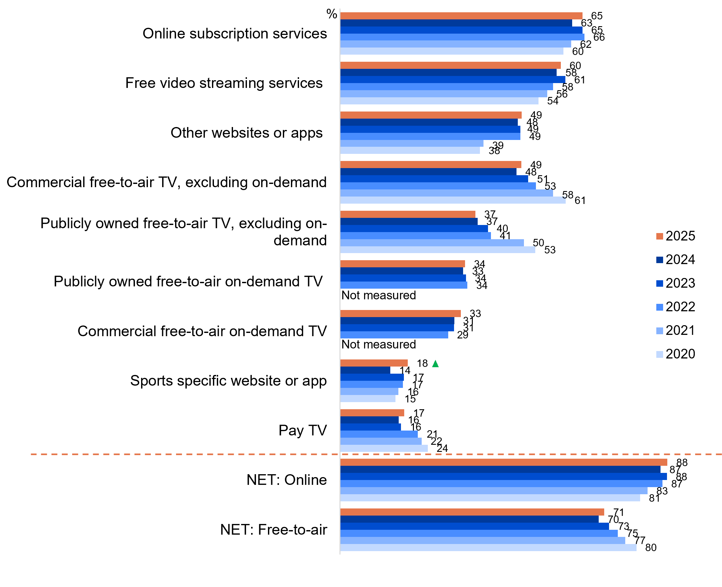
Source: C1. Which of the following did you watch in the past 7 days at home or elsewhere on any device?
Base: TVCS & MCCS, All respondents. 2025: n=4,396. 2024: n=4,490. 2023: n=4,892. 2022: n=5,017. 2021: n=4,135. 2020: n=4,096
Notes: Don’t know/refused responses not shown: all <0.5% between 2020 and 2025. Responses for codes not shown on chart if <5% in 2025 (Pay-per-view services=2%, None of the above=1%).
Bar chart showing platforms used to watch screen content in past 7 days from 2020 to 2025. Each platform is represented with horizontal bars for each year. Key insights:
Online subscription services: 65% in 2025, 63% in 2024, 65% in 2023, 66% in 2022, 62% in 2021, and 60% in 2020
Free video streaming services: 60% in 2025, 58% in 2024, 61% in 2023, 58% in 2022, 56% in 2021, and 54% in 2020
Other websites or apps: 49% in 2025, 48% in 2024, 49% in 2023, 49% in 2022, 39% in 2021, and 38% in 2020
Commercial free-to-air TV, excluding on-demand: 49% in 2025, 48% in 2024, 51% in 2023, 53% in 2022, 58% in 2021, and 61% in 2020
Publicly owned free-to-air TV, excluding on-demand: 37% in 2025, 37% in 2024, 40% in 2023, 41% in 2022, 50% in 2021, and 53% in 2020
Publicly owned free-to-air on-demand TV: 34% in 2025, 33% in 2024, 34% in 2023, 34% in 2022, not asked in 2021, and not asked in 2020
Commercial free-to-air on-demand TV: 33% in 2025, 31% in 2024, 31% in 2023, 29% in 2022, not asked in 2021, and not asked in 2020
Sports specific website or app: 18% in 2025, 14% in 2024, 17% in 2023, 17% in 2022, 16% in 2021, and 15% in 2020
Pay TV: 17% in 2025, 16% in 2024, 16% in 2023, 21% in 2022, 22% in 2021, and 24% in 2020
NET: Online: 88% in 2025, 87% in 2024, 88% in 2023, 87% in 2022, 83% in 2021, and 81% in 2020
NET: Free-to-air: 71% in 2025, 70% in 2024, 73% in 2023, 75% in 2022, 77% in 2021, and 80% in 2020

Subgroup
Sports specific website or app was higher for:
- Men (24% vs 13% of women)
- English-only speakers (20% vs 14% of those who speak a language other than English)
- Those who watched sports in P7D (35% vs 2% of those who did not)
- Those with fixed home internet (19% vs 11% of those without)
NET FTA TV Broadcast was higher for:
- Men (62% vs 57% of women)
- Ages 75+ (90% vs 55% of ages 18–74)
- Those living outside a capital city (67% vs 50% of those living in a capital city)
- Those without children in HH (67%), empty nesters (58%), those with dependent children (50% vs 41% of non-related adults living in a share house)
- Those not in the labour force (68% vs 52% of those employed and 47% of those unemployed)
Screen consumption by device:
- NET SVODs were more likely to be consumed using games console connected to a TV (83%), TV smart accessory (81%), and mobile phone (75%)
- Free video streaming services were more likely to be consumed using games console connected to a TV (75%), computer (71%), and mobile phone (68%)
- NET FTA TV were more likely to be consumed using Pay TV box (82%), TV (79%), TV smart accessory (75%), and Tablet (73%)
- NET Pay-TV were more likely to be consumed using Pay TV box (65%)

Callout
Sports specific website or app increased significantly in 2025 (18% vs 14% in 2024).
Online subscription services are still the most common place to view screen content in Australia in 2025, with the slight decline seen over the prior three years reversing.

Comparison of aggregate vs detailed platforms used to watch screen content in P7D
Detailed platform questions were included in 2025 to capture more granular viewing behaviours across specific services and better reflect how consumers access screen content in practice. Platform usage estimates derived from these detailed service-level questions (C1a-e) are generally higher than those reported at the aggregate platform level (C1), particularly for free-to-air TV, online subscription services, free video streaming services, and other websites or apps. This reflects the use of aided recall in the detailed questions, where prompting with specific services increases reported usage compared with the more conceptual, self-classification approach used in C1.
Detailed platform NETs were constructed by aggregating relevant services to mirror the conceptual groupings in C1; however, these measures reflect different ways of reporting viewing behaviour and are therefore not directly comparable on a like-for-like basis. The demographic profiles across the aggregate and detailed measures are largely consistent, indicating that both approaches identify the same core audience groups, and that differences in reported usage primarily reflect higher levels of aided recall in the detailed questions rather than substantive differences in consumer profiles.
Table 3 Comparison of aggregate vs detailed platforms used to watch screen content in P7D
Platform | Aggregate platforms (C1) | Detailed platform NETs (C1a–e)
NET free-to-air TV | 58% | 67%
Commercial free-to-air TV | 49% | 59%
Publicly owned free-to-air TV | 37% | 43%
NET free-to-air on-demand TV | 48% | 47%
Publicly owned free-to-air on-demand TV | 34% | 28%
Commercial free-to-air on-demand TV | 33% | 32%
Online subscription services | 65% | 71%
Free video streaming services | 60% | 71%
Other websites or apps | 49% | 78%
Sports specific website or app | 18% | 18%
Pay TV | 17% | 15%

Subgroup
NET free-to-air TV (detailed C1a) was higher for ages 55+ (87%), residing outside a capital city (73%), homeowners (73%), with a TAFE/Trade Certificate/Diploma (71%), English-only speakers (71%), pensioner or self-funded retiree (89%), HH with access to an external FTA antenna (77%).
NET free-to-air TV (aggregate C1) was higher for men (62%), ages 55+ (82%), residing outside a capital city (67%), homeowners (65%), with a TAFE/Trade Certificate/Diploma (63%), non-Aboriginal or Torres Strait Islanders (59%), English-only speakers (64%), pensioner or self-funded retiree (82%), HH with access to an external FTA antenna (69%).

Broadcast channels watched in past 7 days
Overall, 78% watched at least one broadcast channel in the past 7 days, underscoring the continued relevance of free-to-air TV despite the rise of on-demand viewing. Channel 7 and Channel 9 are the most-viewed broadcast channels at 41% and 40% respectively, followed by ABC TV (30%) and Channel 10 (28%). The most popular streaming or app service for a channel was ABC iView (23%), followed by 7Plus (19%) and 9Now (18%).
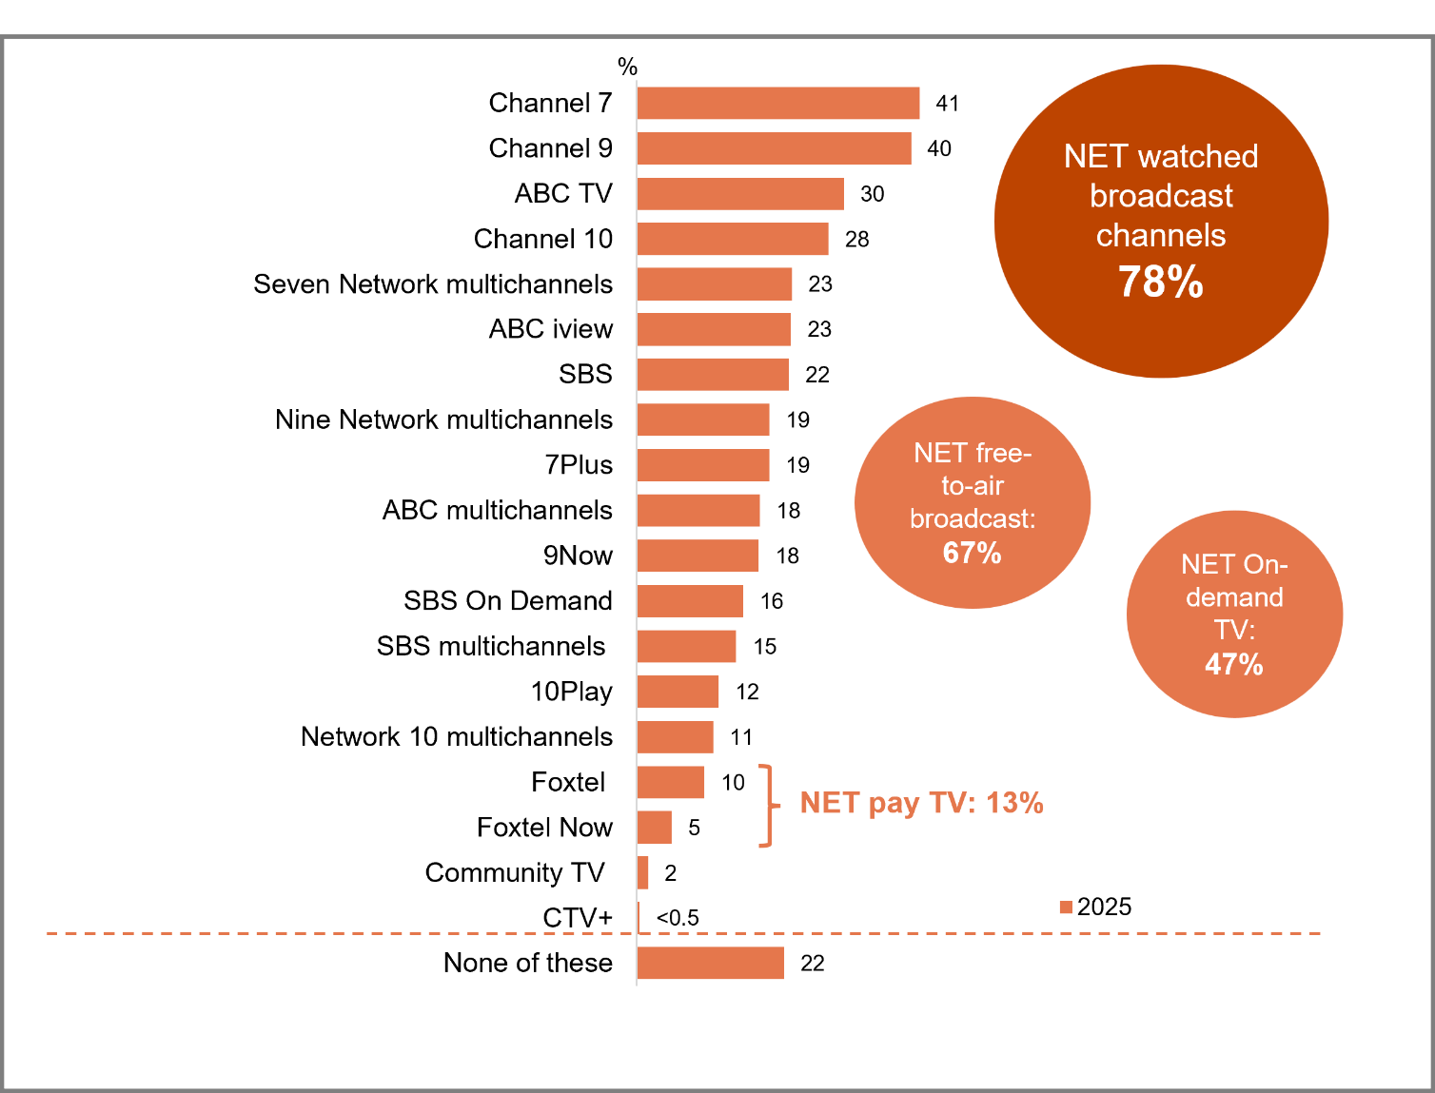
Source: C1a. Which of the following broadcast channels did you watch in the past 7 days at home or elsewhere on any device?
Base: TVCS & MCCS, All respondents. 2025: n=4,396.
Notes: Don’t know/refused responses not shown: 0% for DK and Ref in 2025.
Bar chart showing the percentage of people who watched each specific broadcast channel or service in the past 7 days in 2025.
Channel 7: 41%
Channel 9: 40%
ABC TV: 30%
Channel 10: 28%
Seven Network multichannels: 23%
ABC iview: 23%
SBS: 22%
Nine Network multichannels: 19%
7plus: 19%
ABC multichannels: 18%
9Now: 18%
SBS On Demand: 16%
SBS multichannels: 15%
10Play: 12%
Network 10 multichannels: 11%
Foxtel: 10%
Foxtel Now: 5%
Community TV: 2%
CTV+: less than 0.5%
None of these: 22%
NET pay TV (Foxtel and Foxtel Now): 13%
NET watched broadcast channels: 78%
NET free-to-air broadcast: 67%
NET On-demand TV: 47%

Subgroup
NET Watched any broadcast channels was higher for:
- Ages 55+ (94% vs 70% of ages 18–54)
- Those with a TAFE qualification/Trade Certificate/Diploma (84% vs 79% of those with education up to Year 12, 77% of those with a Postgraduate degree/Graduate Diploma, and 69% of those with a Bachelor degree)
- Those living outside a capital city (85% vs 72% of those living in a capital city)
- Those without children in HH (83%), empty nesters (81%), those with dependent children (78% vs 55% of non-related adults living in a share house)
- Those not in the labour force (84% vs 75% of those employed and 71% of those unemployed)
- Homeowners (84% vs 65% of renters or those occupied rent free)
- Those who watched sports in P7D (91% vs 66% of those who did not)
- Those who watched exclusively offline content in P7D (98% vs 48% of those who watched exclusively online content)
- Households with access to an external FTA TV antenna (NET) (87% vs 52% of households without)
- English-only speakers (83% vs 64% of those who speak a language other than English)

Note
NET free-to-air broadcast includes:
- Channel 7, Seven Network multichannels, (e.g. 7mate, 7two, 7Bravo, 7flix, TVSM, Racing.com), Channel 9, Nine Network multichannels, (e.g. 9Gem, 9Go!, 9Life, 9Rush, Extra, Gold, Imparja, Ch-54), Channel 10, Network 10 multichannels, (e.g. 10 Peach Comedy, 10 Bold Drama, Nickelodeon, You.tv, Gecko, Sky News Regional), ABC TV + ABC multichannels , (e.g. ABC Family, ABC Kids, ABC Entertains, ABC NEWS), SBS, SBS multichannels , (e.g. SBS Viceland, SBS World Movies, SBS Food, NITV HD, SBS WorldWatch), Community TV (e.g. Channel 31, Channel 44)
NET on-demand TV includes:
- 10Play, 7Plus, 9Now, ABC iview, SBS On Demand, CTV+ (live and on-demand Community TV content from Channel 31 and Channel 44)
Broadcast viewing is strongest among older Australians, those living outside a capital city, and homeowners. Viewing content from traditional providers via broadcast is still more common than viewing through their respective on-demand services.

Streaming services/YouTube watched in past 7 days
Netflix is the most viewed streaming service by a large margin, with more than twice as many viewing it in the past seven days compared to the next most viewed service (57% vs 23% for Amazon Prime). YouTube, however, was more widely viewed overall, with 75% having watched either YouTube or YouTube Premium.
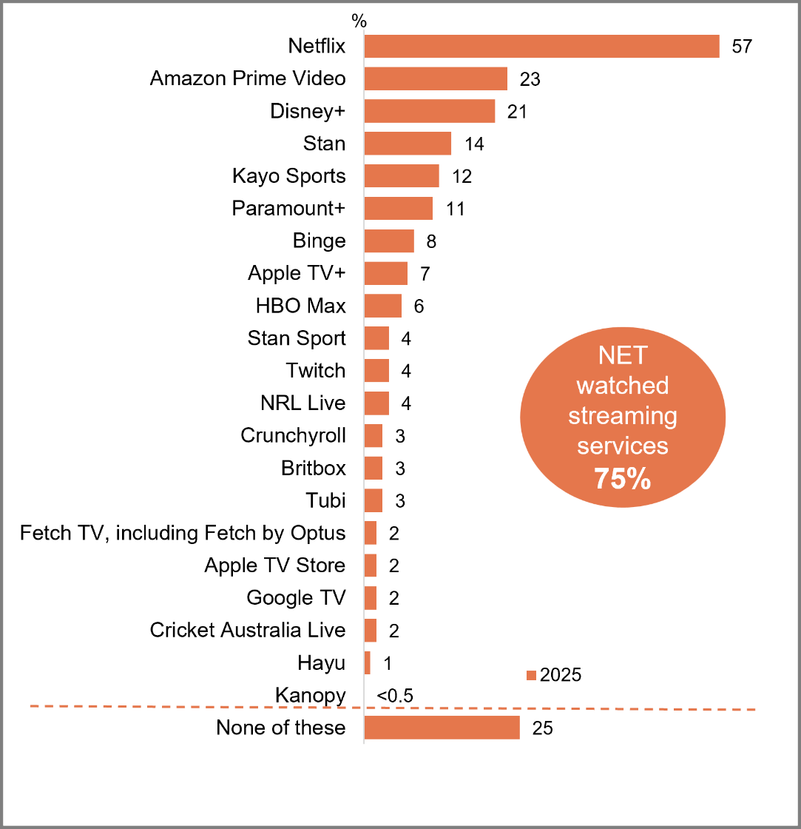
Source: C1b. Which of the following streaming services did you watch in the past 7 days at home or elsewhere, on any device?
Base: TVCS & MCCS, All respondents. 2025: n=4,396.
Notes: Don’t know/refused responses not shown: <0.5% for DK and Ref in 2025.
A bar chart showing the percentage of streaming services that people used to watch in the past 7 days or elsewhere, on any device in 2025.
Netflix: 57%
Amazon Prime Video: 23%
Disney plus: 21%
Stan: 14%
Kayo Sports: 12%
Paramount plus: 11%
Binge: 8%
Apple TV plus: 7%
HBO Max: 6%
Stan Sport: 4%
Twitch: 4%
NRL Live: 4%
Crunchyroll: 3%
BritBox: 3%
Tubi: 3%
Fetch TV, including Fetch by Optus: 2%
Apple TV Store: 2%
Google TV: 2%
Cricket Australia Live: 2%
Hayu: 1%
Kanopy: less than 0.5%
None of these: 25%
NET watched streaming services: 75%
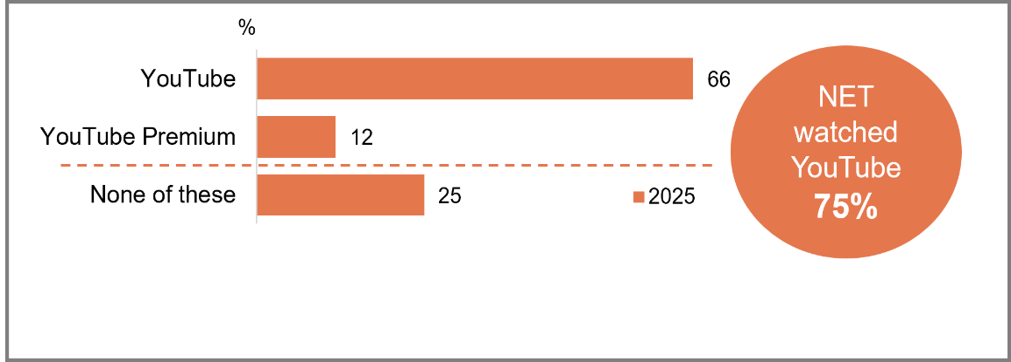
Source: C1c. Which of the following YouTube services did you watch in the past 7 days at home or elsewhere, on any device?
Base: TVCS & MCCS, All respondents. 2025: n=4,396.
Notes: Don’t know/refused responses not shown: 0% for DK and Ref in 2025.
A bar chart showing the percentage of people who have watched YouTube in the past 7 days at home or elsewhere, on any device in 2025.
YouTube: 66%
YouTube Premium: 12%
None of these: 25%
NET watched YouTube: 75%

Subgroup
NET Watched any streaming services was higher for:
- Ages 25–44 (87% vs 79% of ages 18–24, 67% of ages 45+)
- Those living in a capital city (80% vs 70% of those living outside a capital city)
- Those with dependent children in HH (84% vs 76% of empty nesters and 69% of those without children)
- Those employed (82% vs 67% of those unemployed and 66% of those not in the labour force)
- Aboriginal and/or Torres Strait Islanders (88% vs 74% of non-Aboriginal or Torres Strait Islanders)
- Those with an annual HH income of $104,000 or more (83% vs 72% of those with income <$104,000)
NET Watched YouTube/Youtube Premium was higher for:
- Men (80% vs 69% of women)
- Ages 18–44 (86% vs 64% of ages 45+)
- Those living in a capital city (82% vs 66% of those living outside a capital city)
- Non-related adults living in a share house (86%), those with dependent children in HH (79%), empty nesters (79% vs 68% of those without children)
- Renters (83% vs 71% of homeowners)
Aboriginal and/or Torres Strait Islanders (87% vs 74% of non-Aboriginal or Torres Strait Islanders)
There is an inverse U-shaped relationship with viewing streaming services – more of the middle age groups viewed at least one in the past seven days compared with those in younger and older cohorts.

FAST services watched in past 7 days
Few respondents have watched any FAST services in the past 7 days (13%), with the most popular being Samsung TV Plus (6%).
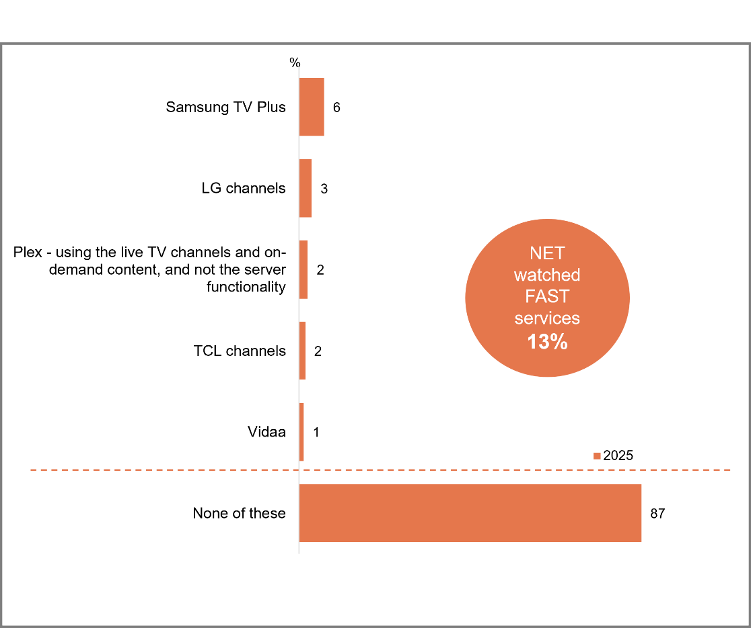
Source: C1d. Which of the following FAST services (Free Ad-supported Streaming Television) did you use to watch screen content in the past 7 days at home or elsewhere, on any device?
Base: TVCS & MCCS, All respondents. 2025: n=4,396.
Notes: Don’t know/refused responses not shown: 0% for DK and Ref in 2025.
A bar chart showing the percentage of people who have used the following FAST services (Free Ad-supported Streaming Television) to watch screen content in the past 7 days at home or elsewhere, on any device in 2025.
Samsung TV Plus: 6%
LG channels: 3%
Plex – using the live TV channels and on-demand content, and not the server functionality: 2%
TCL channels: 2%
Vidaa: 1%
None of these: 87%
NET watched FAST services: 13%

Subgroup
NET Watched FAST services was higher for:
- Ages 35–44 (20%)
- Those living in a capital city (15% vs 11% of those living outside a capital city)
- Those with dependent children in HH (20% vs 10% of those without children and 7% of adults living in a share house)
- Those with a TAFE qualification/Trade Certificate/Diploma (16%), a Bachelor degree (15%) or a Postgraduate degree/Graduate Diploma (12% vs 8% of those with education up to Year 12)
- Aboriginal and/or Torres Strait Islanders (23% vs 13% of non-Aboriginal or Torres Strait Islanders)
- Those who speak a language other than English (17% vs 12% of English-only speakers)

Further reading
As a new question in 2025, the survey asked about the use of Free ad-supported Streaming Television (FAST). RMIT suggest growing availability², though ACMA suggests limited uptake more broadly.³
FAST services have relatively low usage over the past 7 days.

Watched video content on social media in past 7 days
Most have watched video content on social media in the past seven days (78%). Facebook is the most popular social media platform to watch video content (60%), followed by Instagram (45%) and TikTok (22%). Younger viewers aged 18-24 are more likely to have viewed video content on social media compared with those 25+ (95% vs 75% respectively), as were women compared to men (80% vs 75% respectively).
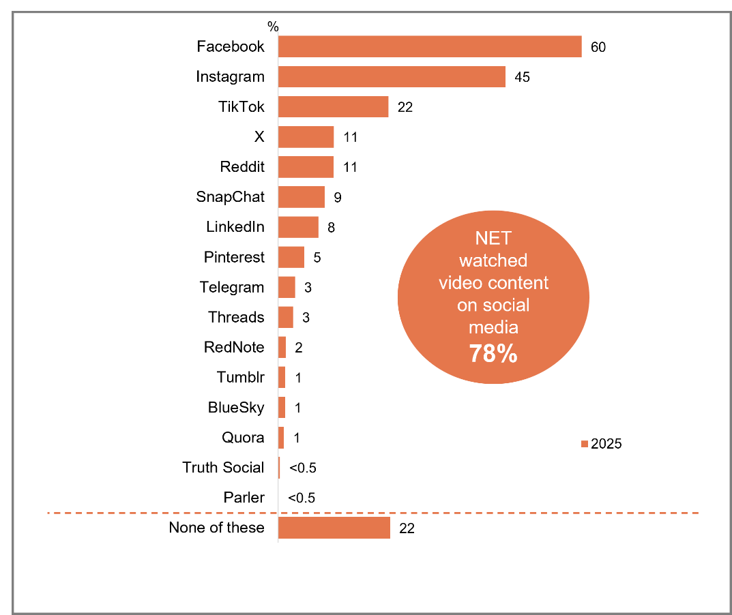
Source: C1e. Which of the following social media services and websites did you watch video screen content on in the past 7 days, at home or elsewhere on any device?
Base: TVCS & MCCS, All respondents. 2025: n=4,396.
Notes: Don’t know/refused responses not shown: 0% for DK and Ref in 2025.
A bar chart showing the percentage of individual social media platforms and websites used to watch video screen content in the past 7 days, at home or elsewhere on any device in 2025.
Facebook: 60%
Instagram: 45%
TikTok: 22%
X: 11%
Reddit: 11%
Snapchat: 9%
LinkedIn: 8%
Pinterest: 5%
Telegram: 3%
Threads: 3%
RedNote: 2%
Tumblr: 1%
BlueSky: 1%
Quora: 1%
Truth Social: less than 0.5%
Parler: less than 0.5%
None of these: 22%
NET watched video content on social media: 78%

Subgroup
NET Watched video content on social media was higher for:
- Women (80% vs 75% of men)
- Ages 18–24 (95% vs 75% of ages 25+)
- Those living in a capital city (83% vs 72% of those living outside a capital city)
- Non-related adults living in a share house (92% vs 85% of those with dependent children in HH, 82% of empty nesters and 69% of those without children)
- Those with a Bachelor degree (83%)
- Aboriginal and/or Torres Strait Islanders (88% vs 77% of non-Aboriginal or Torres Strait Islanders)
- Those who watched exclusively online content in P7D (84% vs 44% of those who watched exclusively offline content)
- Those who view posts, images, and videos on social media sites once a day or more (91% vs 56% of those who did it less than once a day)
- Those who comment or post images to social media sites once a day or more (90% vs 75% of those who did it less than once a day)
- Those who speak a language other than English (87% vs 75% of English-only speakers)
Most people have watched video content on social media recently, with Facebook and Instagram being the most popular platforms. Women, those 18-24, and those living in a capital city are all more likely to have viewed content recently.

Hours per week spent watching content on various platforms (%)
The average number of hours spent watching content per week is 8.3 hours for online subscription services, 6.8 hours for free video streaming services, and 8.0 hours for commercial free-to-air TV excluding on-demand.
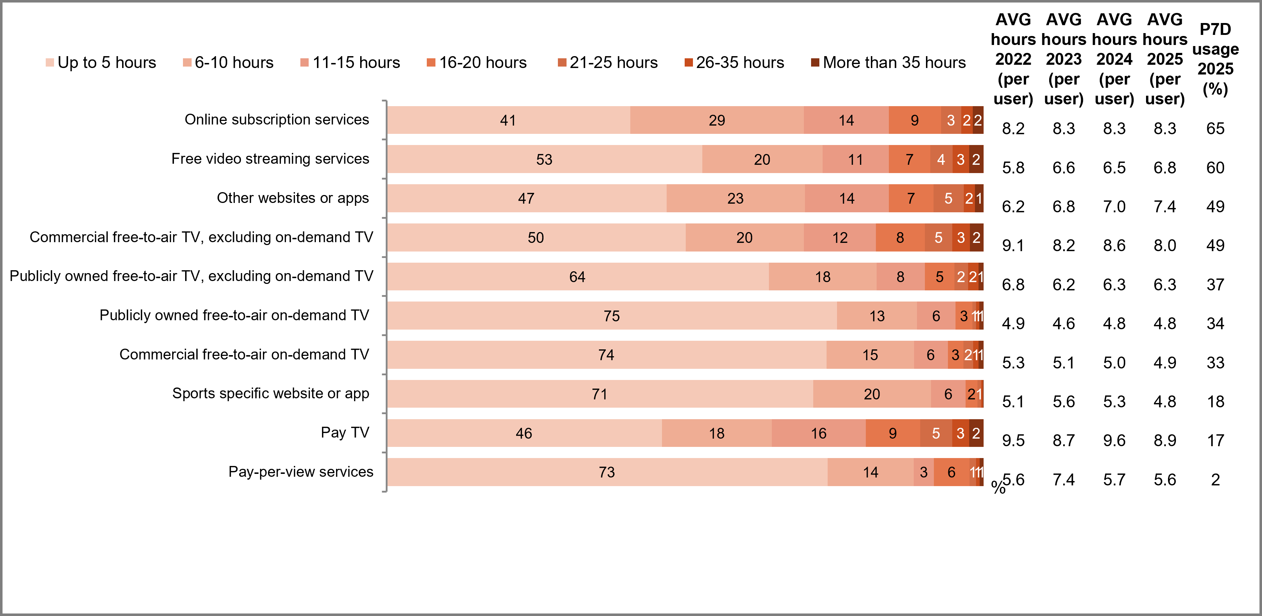
Source: C1. Which of the following did you watch in the past 7 days at home or elsewhere on any device?
Base: TVCS & MCCS, All respondents. 2025: n=4,396. 2024: n=4,490. 2023: n=4,892. 2022: n=5,017.
Source: C2. On average, how many hours per week do you spend watching each of the following?
Base: TVCS & MCCS, Respondents who watched screen content in past 7 days. 2025: n= from 120 to 2,956.
Notes: Don’t know/refused responses not shown, % very per statement. Labels for responses less than 1% not shown on chart.
A bar chart comparing the types of content watched at home or elsewhere on any device over the past 7 days, in 2025.
Online subscription services:
Up to 5 hours: 41%
6-10 hours: 29%
11-25 hours: 14%
16-20 hours: 9%
21-25 hours: 3%
26-25 hours: 2%
More than 35 hours: 2%
Average hours 2022 (per user): 8.2
Average hours 2023 (per user): 8.3
Average hours 2024 (per user): 8.3
Average hours 2025 (per user): 8.3
Past 7 days usage 2025: 65%

Free video streaming services:
Up to 5 hours: 53%
6-10 hours: 20%
11-25 hours: 11%
16-20 hours: 7%
21-25 hours: 4%
26-25 hours: 3%
More than 35 hours: 2%
Average hours 2022 (per user): 5.8
Average hours 2023 (per user): 6.6
Average hours 2024 (per user): 6.5
Average hours 2025 (per user): 6.8
Past 7 days usage 2025: 60%

Other websites or apps:
Up to 5 hours: 47%
6-10 hours: 23%
11-25 hours: 14%
16-20 hours: 7%
21-25 hours: 5%
26-25 hours: 2%
More than 35 hours: 1%
Average hours 2022 (per user): 6.2
Average hours 2023 (per user): 6.8
Average hours 2024 (per user): 7.0
Average hours 2025 (per user): 7.4
Past 7 days usage 2025: 49%

Commercial free-to-air, excluding on-demand TV:
Up to 5 hours: 50%
6-10 hours: 20%
11-25 hours: 12%
16-20 hours: 8%
21-25 hours: 5%
26-25 hours: 3%
More than 35 hours: 2%
Average hours 2022 (per user): 9.1
Average hours 2023 (per user): 8.2
Average hours 2024 (per user): 8.6
Average hours 2025 (per user): 8.0
Past 7 days usage 2025: 49%

Publicly owned free-to-air, excluding on-demand TV:
Up to 5 hours: 64%
6-10 hours: 18%
11-25 hours: 8%
16-20 hours: 5%
21-25 hours: 2%
26-25 hours: 2%
More than 35 hours: 1%
Average hours 2022 (per user): 6.8
Average hours 2023 (per user): 6.2
Average hours 2024 (per user): 6.3
Average hours 2025 (per user): 6.3
Past 7 days usage 2025: 37%

Publicly owned free-to-air on-demand TV:
Up to 5 hours: 75%
6-10 hours: 13%
11-25 hours: 6%
16-20 hours: 3%
21-25 hours: 1%
26-25 hours: 1%
More than 35 hours: 1%
Average hours 2022 (per user): 4.9
Average hours 2023 (per user): 4.6
Average hours 2024 (per user): 4.8
Average hours 2025 (per user): 4.8
Past 7 days usage 2025: 34%

Commercial owned free-to-air on-demand TV:
Up to 5 hours: 74%
6-10 hours: 15%
11-25 hours: 6%
16-20 hours: 3%
21-25 hours: 2%
26-25 hours: 1%
More than 35 hours: 1%
Average hours 2022 (per user): 5.3
Average hours 2023 (per user): 5.1
Average hours 2024 (per user): 5.0
Average hours 2025 (per user): 4.9
Past 7 days usage 2025: 33%

Sports specific website or app:
Up to 5 hours: 71%
6-10 hours: 20%
11-25 hours: 6%
16-20 hours: 2%
21-25 hours: 1%
26-25 hours: 0%
More than 35 hours: 0%
Average hours 2022 (per user): 5.1
Average hours 2023 (per user): 5.6
Average hours 2024 (per user): 5.3
Average hours 2025 (per user): 4.8
Past 7 days usage 2025: 18%

Pay TV:
Up to 5 hours: 46%
6-10 hours: 18%
11-25 hours: 16%
16-20 hours: 9%
21-25 hours: 5%
26-25 hours: 3%
More than 35 hours: 2%
Average hours 2022 (per user): 9.5
Average hours 2023 (per user): 8.7
Average hours 2024 (per user): 9.6
Average hours 2025 (per user): 8.9
Past 7 days usage 2025: 17%

Pay-per-view services:
Up to 5 hours: 73%
6-10 hours: 14%
11-25 hours: 3%
16-20 hours: 6%
21-25 hours: 1%
26-25 hours: 1%
More than 35 hours: 1%
Average hours 2022 (per user): 5.6
Average hours 2023 (per user): 7.4
Average hours 2024 (per user): 5.7
Average hours 2025 (per user): 5.6
Past 7 days usage 2025: 2%

Subgroup
Those who watched more than 35 hours across ANY platform were more likely than those who watched fewer hours to:
- live outside a capital city (59%)
- from the most disadvantaged SEIFA quintiles (29%)
- have no children in household (59%)
- rent (37%)
- have an education up to Year 12 (46%)
- not be in the labour force (49%) or be unemployed (15%)
- receive Government pensions, benefits or allowances (63%)
- Aboriginal and/or Torres Strait Islanders (14%)
- have an annual household income of less than $41,600 (43%)
Pay TV and online subscription services recorded the highest average weekly viewing hours of all platform types in 2025.

Frequency of watching screen content on various devices (%)
Television remains the dominant screen content device with 85% of respondents reporting its use, followed by mobile phones (77%) and computers (60%). While TV leads in overall usage, mobile phones are used most intensely, with 25% of users watching content more than five times daily, compared to just 9% for TV and 8% for computers.

Table 4 Frequency of watching screen content on various devices (%)
Device | NET  Use Device | More often than 5 times a day | 3-5 times a day | Once or twice a day | More often than 5 times a week | 3-5 times a week | Once or twice a week | Never | 2022: NET use once per day + | 2023: NET use once per day + | 2024: NET use once per day + | 2025: NET use once per day +
Television (including smart TV) | 85 | 9 | 10 | 30 | 12 | 13 | 11 | 15 | 47 | 48 | 50 | 49
Mobile phone or smartphone | 77 | 25 | 14 | 12 | 6 | 8 | 13 | 23 | 44 | 46 | 46 | 50
Computer (desktop or laptop) | 60 | 8 | 7 | 10 | 5 | 10 | 20 | 40 | 25 | 27 | 25 | 25
TV smart accessory/Digital media player | 41 | 3 | 4 | 10 | 5 | 7 | 13 | 58 | 16 | 17 | 16 | 16
Tablet | 35 | 3 | 3 | 7 | 3 | 6 | 13 | 64 | 13 | 13 | 14 | 13
Pay TV box | 21 | 2 | 2 | 5 | 3 | 3 | 5 | 79 | 10 | 10 | 10 | 9
Games console connected to a television | 18 | 1 | 1 | 2 | 2 | 3 | 9 | 82 | 4 | 5 | 4 | 5
VAST box | 4 | 0 | 1 | 1 | 0 | 1 | 1 | 96 | 2 | 3 | 2 | 2
Source: C4. On average per week, how often do you use the following devices to watch screen content?
Base: TVCS & MCCS, Respondents who watched screen content in past 7 days. 2025: n=4,342. 2024: n=4,412. 2023: n=4,825. 2022: n=4,929.
Notes: Don’t know/refused responses not shown, % vary per statement. ‘NET use once per day +’ includes ‘Once or twice a day’, ‘3-5 times a day’, and ‘More often than 5 times a day’.

Subgroup
NET Use mobile phone/smart phone once per day + to watch screen content was higher for:
- Ages 18–24 (84% vs 44% of ages 25+)
- Those living in a capital city (60% vs 40% of those living outside a capital city)
- Aboriginal and/or Torres Strait Islanders (68% vs 49% of non-Aboriginal or Torres Strait Islanders)
- Those with a Bachelor degree (63% vs 53% of those with a Postgraduate degree/Graduate Diploma, 48% of those with education up to Year 12 and 44% of those with TAFE qualification/Trade Certificate/Diploma)
- Those who speak a language other than English (69% vs 45% of English-only speakers)
- Those who watched other websites or apps (66%), free video streaming services (61%), SVOD in P7D (55% vs 45% of those who watched Pay TV, 44% of FTA BVOD, 40% of FTA Broadcast)
TV was the mostly widely used device to watch screen content, but mobile phones were used more intensively within a single day.

Social media services currently have an account with + used
Social media use is very common, with 91% having at least one account and 93% using an account in the last six months. Facebook is the most common social media service to have an account with (78%) and is frequently used by 76%. This is followed by Instagram (55% have account, 53% used P6M) and YouTube (55% have account, 65% used P6M).
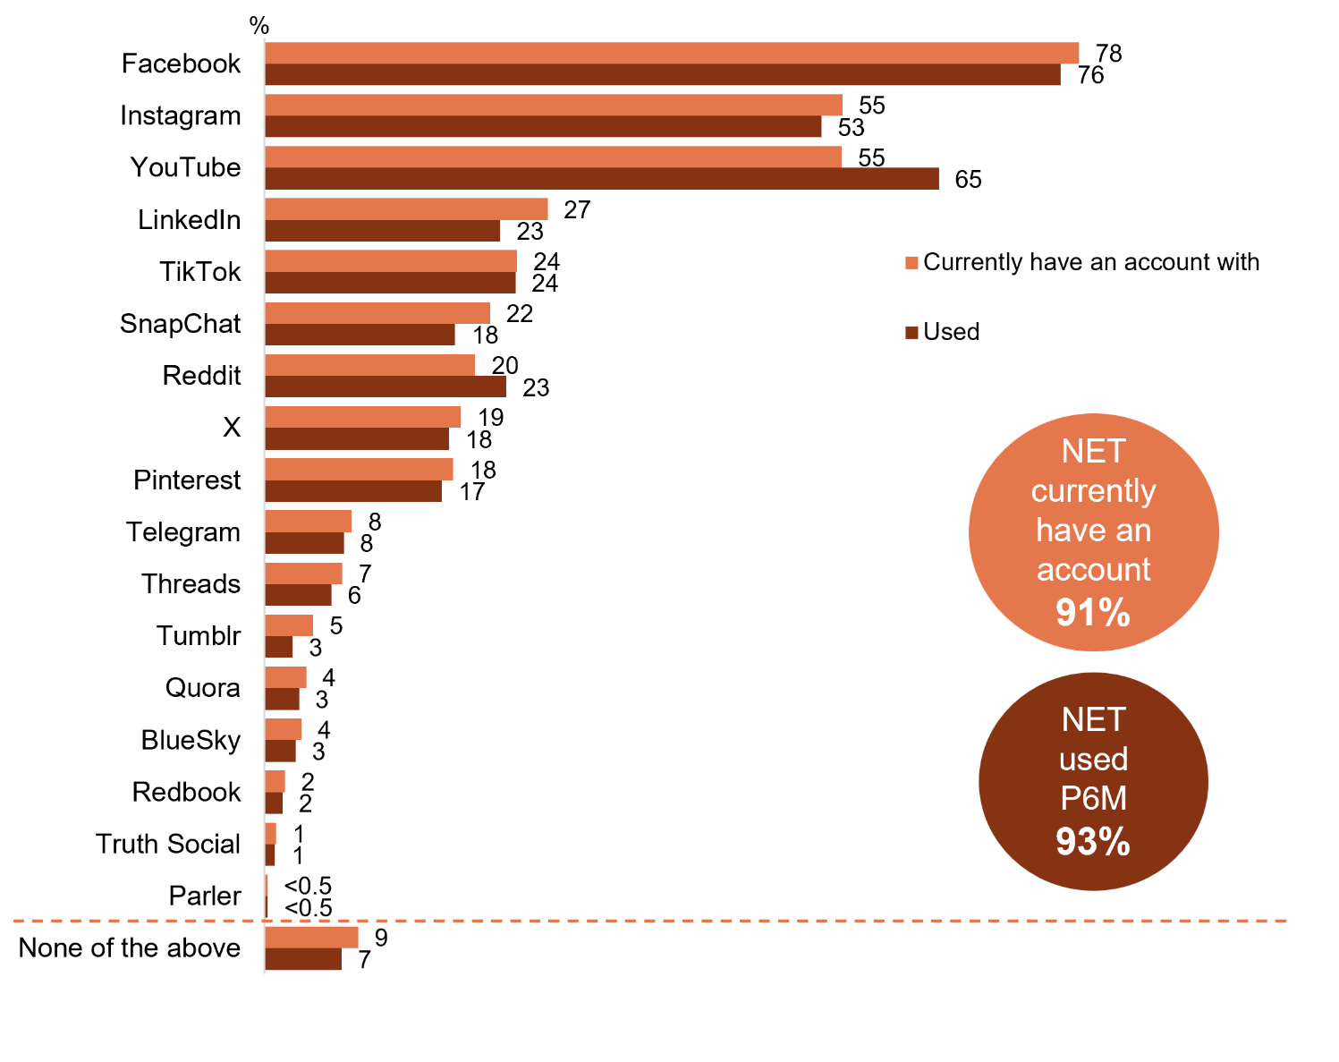
Source: SOCIAL1. Which of the following social media services do you currently have an account with? SOCIAL2 - Which of the following social media services have you used, for any purpose, in the last six months?
Base: TVCS & MCCS, All respondents. 2025: n=4,396.
Notes: Don’t know/refused responses not shown: both <0.5% for DK and Ref in 2025.
A comparison horizontal bar chart showing the percentage of people who currently hold a social media account and who have used each service in the past six months in 2025.
Facebook:
Currently have an account with: 78%
Used in the past 6 months: 76%

Instagram:
Currently have an account with: 55%
Used in the past 6 months: 53%

YouTube:
Currently have an account with: 55%
Used in the past 6 months: 65%

LinkedIn:
Currently have an account with: 27%
Used in the past 6 months: 23%

TikTok:
Currently have an account with: 24%
Used in the past 6 months: 24%

Snapchat:
Currently have an account with: 22%
Used in the past 6 months: 18%

Reddit:
Currently have an account with: 20%
Used in the past 6 months: 23%

X:
Currently have an account with: 19%
Used in the past 6 months: 18%

Pinterest:
Currently have an account with: 18%
Used in the past 6 months: 17%

Telegram:
Currently have an account with: 8%
Used in the past 6 months: 8%

Threads:
Currently have an account with: 7%
Used in the past 6 months: 6%

Tumblr:
Currently have an account with: 5%
Used in the past 6 months: 3%

Quora:
Currently have an account with: 4%
Used in the past 6 months: 3%

BlueSky:
Currently have an account with: 4%
Used in the past 6 months: 3%

Redbook:
Currently have an account with: 2%
Used in the past 6 months: 2%

Truth Social:
Currently have an account with: 1%
Used in the past 6 months: 1%

Parler:
Currently have an account with: less than 0.5%
Used in the past 6 months: less than 0.5%

None of the above:
Currently have an account with: 9%
Used in the past 6 months: 7%

NET currently have an account: 91%
NET used in past 6 months: 93%

Subgroup
NET Currently have a social media account was higher for:
- Women (93% vs 88% of men)
- Ages 18–54 (96% vs 82% of ages 55+)
- Those living in a capital city (94% vs 88% of those living outside a capital city)
- Aboriginal and/or Torres Strait Islanders (97% vs 91% of non-Aboriginal or Torres Strait Islanders)
- Those who speak a language other than English (95% vs 90% of English-only speakers)
- Those who watched other websites or apps (99%), free video streaming services (96%), SVOD in P7D (94% vs 92% of those who watched FTA BVOD, 89% of FTA Broadcast and 88% of Pay TV)
- Those who view posts, images, and videos on social media sites once a day or more (99% vs 78% of those who did it less than once a day)
- Those who comment or post images to social media sites once a day or more (99% vs 89% of those who did it less than once a day)
Almost all currently have a social media account, and most had used them in the past six months.

Frequency of accessing social media services (%)
While Facebook, YouTube, and Instagram remain the most widely used platforms over the past six months, they were accessed less frequently (25% access Facebook once an hour or more, 26% for YouTube, and 32% for Instagram). In contrast, TikTok and Snapchat stand out for intensity of engagement, with 44% and 43% of social media users respectively checking in at least hourly. This suggests that although reach is highest for the big platforms, newer social apps drive more habitual, high-frequency usage.
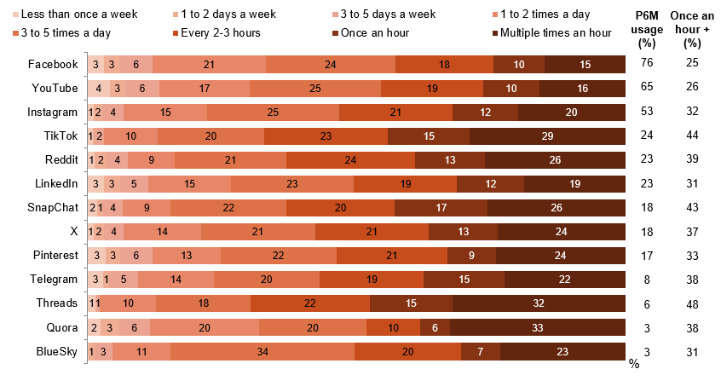
Source: SOCIAL3. How frequently do you access social media services you use? SOCIAL2. Which of the following social media services have you used, for any purpose, in the last six months?
Base: TVCS & MCCS, Used social media services P6M. 2025: n=4,017.
Notes: Don’t know/refused responses not shown, % very per statement (all <0.5%). Labels for responses less than 1% not shown on chart. ‘Less than once a week’ includes ‘Every few weeks’, ‘Once a month’, ‘Less than once a month’, and ‘Never’. Platforms with n<100 not charted: Tumblr (n=70), Redbook (n=43), Truth Social (n=34), Parler (n=12).
A 100% stacked bar chart showing the frequency of accessing social media services among those who have used any social media service in the past six months in 2025.
Facebook:
Less than once a week: 3%
1 to 2 days a week: 3%
3 to 5 days a week: 6%
1 to 2 times a day: 21%
3 to 5 times a day: 24%
Every 2-3 hours: 18%
Once an hour: 10%
Multiple times an hour: 15%
Past 6 months usage (in percentage): 76%
Once an hour plus (in percentage): 25%

YouTube:
Less than once a week: 4%
1 to 2 days a week: 3%
3 to 5 days a week: 6%
1 to 2 times a day: 17%
3 to 5 times a day: 25%
Every 2-3 hours: 19%
Once an hour: 10%
Multiple times an hour: 16%
Past 6 months usage (in percentage): 65%
Once an hour plus (in percentage): 26%

Instagram:
Less than once a week: 1%
1 to 2 days a week: 2%
3 to 5 days a week: 4%
1 to 2 times a day: 15%
3 to 5 times a day: 25%
Every 2-3 hours: 21%
Once an hour: 12%
Multiple times an hour: 20%
Past 6 months usage (in percentage): 53%
Once an hour plus (in percentage): 32%

TikTok:
Less than once a week: 1%
1 to 2 days a week: 0%
3 to 5 days a week: 2%
1 to 2 times a day: 10%
3 to 5 times a day: 20%
Every 2-3 hours: 23%
Once an hour: 15%
Multiple times an hour: 29%
Past 6 months usage (in percentage): 24%
Once an hour plus (in percentage): 44%

Reddit:
Less than once a week: 1%
1 to 2 days a week: 2%
3 to 5 days a week: 4%
1 to 2 times a day: 9%
3 to 5 times a day: 21%
Every 2-3 hours: 24%
Once an hour: 13%
Multiple times an hour: 26%
Past 6 months usage (in percentage): 23%
Once an hour plus (in percentage): 39%

LinkedIn:
Less than once a week: 3%
1 to 2 days a week: 3%
3 to 5 days a week: 5%
1 to 2 times a day: 15%
3 to 5 times a day: 23%
Every 2-3 hours: 19%
Once an hour: 12%
Multiple times an hour: 19%
Past 6 months usage (in percentage): 23%
Once an hour plus (in percentage): 31%

SnapChat:
Less than once a week: 2%
1 to 2 days a week: 1%
3 to 5 days a week: 4%
1 to 2 times a day: 9%
3 to 5 times a day: 22%
Every 2-3 hours: 20%
Once an hour: 17%
Multiple times an hour: 26%
Past 6 months usage (in percentage): 18%
Once an hour plus (in percentage): 43%

X:
Less than once a week: 1%
1 to 2 days a week: 2%
3 to 5 days a week: 4%
1 to 2 times a day: 14%
3 to 5 times a day: 21%
Every 2-3 hours: 21%
Once an hour: 13%
Multiple times an hour: 24%
Past 6 months usage (in percentage): 18%
Once an hour plus (in percentage): 37%

Pinterest:
Less than once a week: 3%
1 to 2 days a week: 3%
3 to 5 days a week: 6%
1 to 2 times a day: 13%
3 to 5 times a day: 22%
Every 2-3 hours: 21%
Once an hour: 9%
Multiple times an hour: 24%
Past 6 months usage (in percentage): 17%
Once an hour+ (in percentage): 33%

Telegram:
Less than once a week: 3%
1 to 2 days a week: 1%
3 to 5 days a week: 5%
1 to 2 times a day: 14%
3 to 5 times a day: 20%
Every 2-3 hours: 19%
Once an hour: 15%
Multiple times an hour: 22%
Past 6 months usage (in percentage): 8%
Once an hour plus (in percentage): 38%

Threads:
Less than once a week: 1%
1 to 2 days a week: 0%
3 to 5 days a week: 1%
1 to 2 times a day: 10%
3 to 5 times a day: 18%
Every 2-3 hours: 22%
Once an hour: 15%
Multiple times an hour: 32%
Past 6 months usage (in percentage): 6%
Once an hour plus (in percentage): 48%

Quora:
Less than once a week: 2%
1 to 2 days a week: 3%
3 to 5 days a week: 6%
1 to 2 times a day: 20%
3 to 5 times a day: 20%
Every 2-3 hours: 10%
Once an hour: 6%
Multiple times an hour: 33%
Past 6 months usage (in percentage): 3%
Once an hour plus (in percentage): 38%

BlueSky:
Less than once a week: 0%
1 to 2 days a week: 1%
3 to 5 days a week: 3%
1 to 2 times a day: 11%
3 to 5 times a day: 34%
Every 2-3 hours: 20%
Once an hour: 7%
Multiple times an hour: 23%
Past 6 months usage (in percentage): 3%
Once an hour+ (in percentage): 31%

Subgroup
NET Accessed social media once an hour or more was higher for:
- Ages 18–24 (51% vs 17% of ages 25+)
- Those living in a capital city (28% vs 16% of those living outside a capital city)
- Those with a Bachelor degree (31% vs 23% of those with education up to Year 12, 21% of those with a Postgraduate degree/Graduate Diploma and 17% with a TAFE qualification/Trade Certificate/Diploma)
- Aboriginal and/or Torres Strait Islanders (40% vs 21% of non-Aboriginal or Torres Strait Islanders)
- Those who speak a language other than English (31% vs 19% of English-only speakers)
- Those who watched other websites or apps (30%), free video streaming services (27%) or SVOD in P7D (25% vs 18% of those who watched FTA BVOD, 17% of pay TV and 15% of FTA Broadcast)
The biggest platforms lead on overall reach, but the most frequent “always-on” use is concentrated among users of a smaller set of services (notably Threads and Snapchat). More frequent access is strongest among younger and capital-city audiences.

Search engines, app stores + online market places used P6M
Google is the most commonly used search engine (83% used in P6M), followed distantly by Bing at 9%. A strong majority have used an app store (68%) or an online marketplace (75%) in the past six months. The most commonly used marketplaces were Facebook Marketplace and eBay, both 42%. Marketplace viewing was less common among those aged 55+.
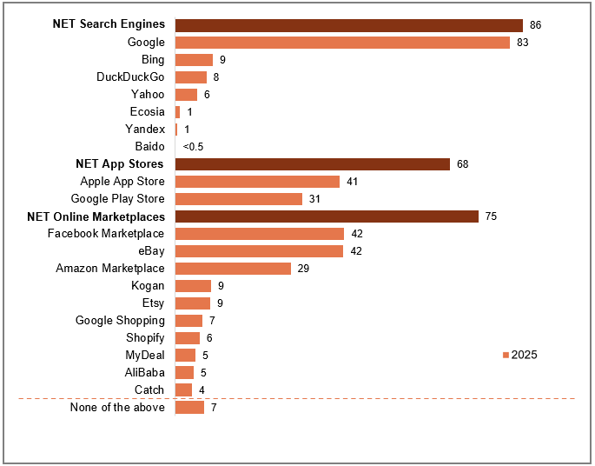
Source: SOCIAL4. Which of the following search engines, app stores, or online marketplaces have you used, for any purpose, in the last six months?
Base: TVCS & MCCS, All respondents. 2025: n=4,396.
Notes: Don’t know/refused responses not shown: both <0.5% for DK and Ref in 2025.
A horizontal bar chart showing use of search engines, app stores, and online marketplaces in the past six months in 2025.
NET Search Engines: 86%
Google: 83%
Bing: 9%
DuckDuckGo: 8%
Yahoo: 6%
Ecosia: 1%
Yandex: 1%
Baido: 0%
NET App Stores: 68%
Apple App Store: 41%
Google Play Store: 31%
NET Online Marketplaces: 75%
Facebook Marketplace: 42%
eBay: 42%
Amazon Marketplace: 29%
Kogan: 9%
Etsy: 9%
Google Shopping: 7%
Shopify: 6%
MyDeal: 5%
AliBaba: 5%
Catch: 4%
None of the above: 7%

Subgroup
NET Used search engines was higher for:
- Men (88% vs 84% of women)
- Ages 18–44 (89% vs 80% of ages 65+)
- Those who look for information over the internet once a day or more (89% vs 71% of those who did it less than once a day)

NET Used Online Marketplaces was higher for:
- Ages 18–54 (78% vs 69% of ages 55+)
- Those who speak a language other than English (79% vs 73% of English-only speakers)
- Those who look for information over the internet once a day or more (78% vs 59% of those who did it less than once a day)
- Those who post to blogs/forums/interest groups once a day or more (83% vs 74% of those who did it less than once a day)
Search engines, app stores, and online marketplaces were all commonly used in 2025. While app stores and online marketplaces had multiple commonly used options, search engine use is dominated by one provider: Google.

Messaging, chat, + dating services used P6M
Messaging services are widely used (70% using at least one) with Facebook Messenger (54%) and WhatsApp (40%) being the most popular. Online dating services are used by a much smaller proportion (8%), led by Hinge (3%) and Tinder (3%). Messaging/chat use is higher among those 18–34 (84% vs 64%), women (73% vs 67%), capital city residents (76% vs 64%), and those accessing social media at least hourly (80% vs 67%). Online dating use was higher among 18–34s (17% vs 5%), men (10% vs 6%), and LGBTQIA+ (24% vs 6%).
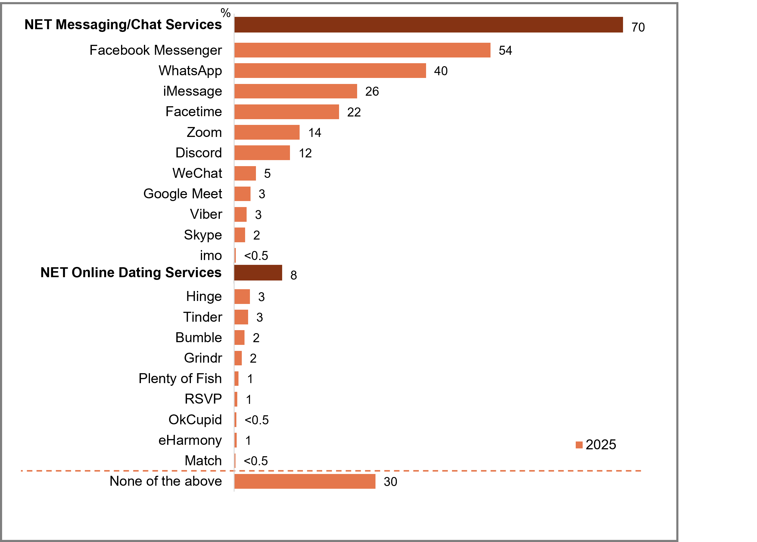
Source: SOCIAL6. Which of these messaging, chat, or dating services have you used, for any purpose, in the last six months?
Base: TVCS & MCCS, All respondents. 2025: n=4,396.
Notes: Don’t know/refused responses not shown: both <0.5% for DK and Ref in 2025.
A horizontal bar chart showing usage of the following messaging, chat, or dating services in the last six months in 2025.
NET Messaging/Chat Services: 70%
Facebook Messenger: 54%
WhatsApp: 40%
iMessage: 26%
Facetime: 22%
Zoom: 14%
Discord: 12%
WeChat: 5%
Google Meet: 3%
Viber: 3%
Skype: 2%
Imo: less than 0.5%
NET Online Dating Services: 8%
Hinge: 3%
Tinder: 3%
Bumble: 2%
Grindr: 2%
Plenty of Fish: 1%
RSVP: 1%
OkCupid: less than 0.5%
eHarmony: 1%
Match: less than 0.5%
None of the above: 30%

Subgroup
NET Used messaging/chat services was higher for:
- Women (73% vs 67% of men)
- Ages 18–34 (84% vs 64% of ages 35+)
- Those living in a capital city (76% vs 64% of those living outside a capital city)
- Those with a Bachelor degree (79%) or a Postgraduate degree/Graduate Diploma (78% vs 68% of those with education up to Year 12 and 64% of those with a TAFE qualification/Trade Certificate/Diploma)
- Aboriginal and/or Torres Strait Islanders (80% vs 70% of non-Aboriginal or Torres Strait Islanders)
- Those who speak a language other than English (78% vs 68% of English-only speakers)
- Those who accessed social media at least once an hour or more often (80% vs 67% of those who accessed less frequently)

NET Used online dating services was higher for:
- Men (10% vs 6% of women)
- Ages 18–34 (17% vs 5% of ages 35+)
- Those living in a capital city (11% vs 6% of those living outside a capital city)
- LGBTQIA+ (24% vs 6% of heterosexual/straight)
- Those who speak a language other than English (11% vs 8% of English-only speakers)
Messaging and chat services were widely used and driven by the major mainstream apps, whereas online dating was a niche behaviour. Messaging skews to younger, heavier social-media users, while dating is more concentrated among younger adults, men and LGBTQIA+ audiences.

Online subscription streaming service account sign-up factors (%)
The most common factors to subscribe on an online streaming services are that it has content that is liked (79% NET), followed by low price or a good deal (76% NET) and has specific shows, movies or events (72% NET). Respondents who subscribe for low price or a good deal are more likely to be younger, have children and a higher annual income. Those who value an Australian content library are likely to have watched Australian content on subscription streaming services in the past seven days.
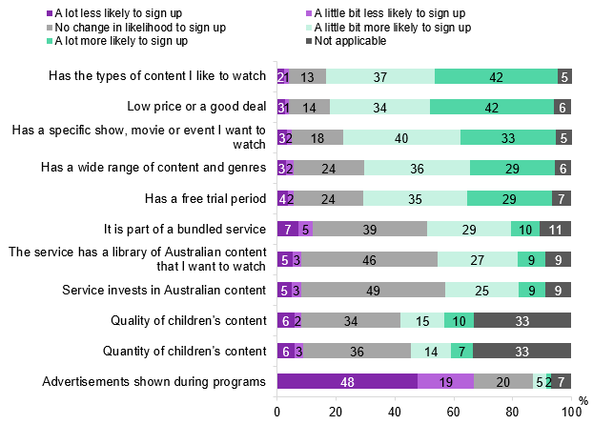
Source: C28b. Based on the following factors, how likely or unlikely are you to sign up to an account on an online subscription streaming service?
Base: MCCS. All respondents. 2025: n=3,396.
Notes: Don’t know/refused responses not shown, % very per statement (all <0.5%).
A 100% stacked bar chart showing the percentage of people who are likely or unlikely to sign up for an account with an online subscription streaming service, based on the following factors, in 2025.
Has the types of content I like to watch:
A lot less likely to sign up: 2%
A little bit less likely to sign up: 1%
No change in likelihood to sign up: 13%
A little bit more likely to sign up: 37%
A lot more likely to sign up: 42%
Not Applicable: 5%
NET T2B (A lot or a little bit more likely to sign up): 79%

Low price or a good deal:
A lot less likely to sign up: 3%
A little bit less likely to sign up: 1%
No change in likelihood to sign up: 14%
A little bit more likely to sign up: 34%
A lot more likely to sign up: 42%
Not Applicable: 6%
NET T2B (A lot or a little bit more likely to sign up): 76%

Has a specific show, movie or event I want to watch:
A lot less likely to sign up: 3%
A little bit less likely to sign up: 2%
No change in likelihood to sign up: 18%
A little bit more likely to sign up: 40%
A lot more likely to sign up: 33%
Not Applicable: 5%
NET T2B (A lot or a little bit more likely to sign up): 72%

Has a wide range of content and genres:
A lot less likely to sign up: 3%
A little bit less likely to sign up: 2%
No change in likelihood to sign up: 24%
A little bit more likely to sign up: 36%
A lot more likely to sign up: 29%
Not Applicable: 6%
NET T2B (A lot or a little bit more likely to sign up): 65%

Has a free trial period:
A lot less likely to sign up: 4%
A little bit less likely to sign up: 2%
No change in likelihood to sign up: 24%
A little bit more likely to sign up: 36%
A lot more likely to sign up: 29%
Not Applicable: 7%
NET T2B (A lot or a little bit more likely to sign up): 64%

It is part of a bundled service:
A lot less likely to sign up: 7%
A little bit less likely to sign up: 5%
No change in likelihood to sign up: 39%
A little bit more likely to sign up: 29%
A lot more likely to sign up: 10%
Not Applicable: 11%
NET T2B (A lot or a little bit more likely to sign up): 38%

The service has a library of Australian content that I want to watch:
A lot less likely to sign up: 5%
A little bit less likely to sign up: 3%
No change in likelihood to sign up: 46%
A little bit more likely to sign up: 27%
A lot more likely to sign up: 9%
Not Applicable: 9%
NET T2B (A lot or a little bit more likely to sign up): 37%

Service invests in Australian content:
A lot less likely to sign up: 5%
A little bit less likely to sign up: 3%
No change in likelihood to sign up: 49%
A little bit more likely to sign up: 25%
A lot more likely to sign up: 9%
Not Applicable: 9%
NET T2B (A lot or a little bit more likely to sign up): 34%

Quality of children’s content:
A lot less likely to sign up: 6%
A little bit less likely to sign up: 2%
No change in likelihood to sign up: 34%
A little bit more likely to sign up: 15%
A lot more likely to sign up: 10%
Not Applicable: 33%
NET T2B (A lot or a little bit more likely to sign up): 25%

Quantity of children’s content:
A lot less likely to sign up: 6%
A little bit less likely to sign up: 3%
No change in likelihood to sign up: 36%
A little bit more likely to sign up: 14%
A lot more likely to sign up: 7%
Not Applicable: 33%
NET T2B (A lot or a little bit more likely to sign up): 21%

Advertisements shown during programs:
A lot less likely to sign up: 48%
A little bit less likely to sign up: 19%
No change in likelihood to sign up: 20%
A little bit more likely to sign up: 5%
A lot more likely to sign up: 2%
Not Applicable: 7%
NET T2B (A lot or a little bit more likely to sign up): 6%

Subgroup
Low price or a good deal, NET T2B was higher for:
- Ages 18–54 (82% vs 58% of ages 55+)
- Those with dependent children in HH (80% vs 69% of those without children)
- Those with an annual HH income of $104,000 or more (84% vs 71% of those with income <$104,000)

The service has a library of Australian content that I want to watch, NET T2B was higher for:
- Those who watched Australian content on subscription streaming services in P7D (49% vs 31% of those who did not)
- Aboriginal and/or Torres Strait Islanders (47% vs 36% of non-Aboriginal or Torres Strait Islanders)

Advertisements shown during programs, NET B2B was higher for:
- Ages 18–34 (79% vs 59% of ages 35+)
- Empty nesters (74% vs 62% of those with dependent children in HH)
- Those with an annual HH income of $104,000 or more (73% vs 63% of those with income <$104,000)
- Those who watched other websites or apps (73%), SVOD (71%) or free video streaming services in P7D (71% vs 64% of those who watched FTA BVOD, 63% of FTA Broadcast, and 60% of pay TV)
Respondents are more likely to subscribe to online streaming services for content that they like followed by low price.

Online subscription streaming service account retention factors (%)
80% NET respondents report the most common factors for retention of online subscription accounts are having content they like to watch and low price. This is followed by specific content they like (73% NET) and a wide range of content and genres (68%). Respondents that value low price or a good deal are more likely to be younger, empty nesters and those with higher income. Those who value services with Australian content are more likely to have watched Australian content via subscription streaming services in the past seven days.
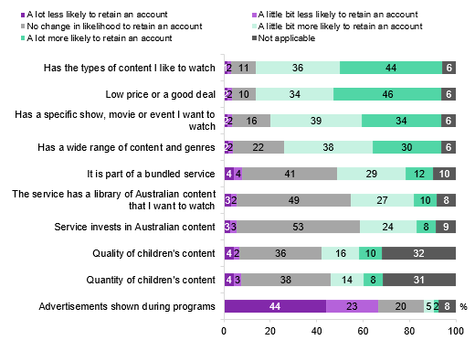
Source: C28c. What factors are likely to increase or decrease whether or not you retain an account on an online subscription streaming service?
Base: MCCS. All respondents. 2025: n=3,396.
Notes: Don’t know/refused responses not shown, % very per statement (all <0.5%).
A 100% stacked bar chart showing the percentage of people who are likely to increase or decrease whether or not they will retain an account on a subscription streaming service, in 2025.
Has the types of content I like to watch:
A lot less likely to retain an account: 1%
A little bit less likely to retain an account: 2%
No change in likelihood to retain an account: 11%
A little bit more likely to retain an account: 36
A lot more likely to retain an account: 44%
Not applicable: 6%
NET (A lot or a little bit more likely to retain): 80%

Low price or a good deal:
A lot less likely to retain an account: 2%
A little bit less likely to retain an account: 2%
No change in likelihood to retain an account: 10%
A little bit more likely to retain an account: 34%
A lot more likely to retain an account: 46%
Not applicable: 6%
NET (A lot or a little bit more likely to retain): 80%

Has a specific show, movie or event I want to watch:
A lot less likely to retain an account: 2%
A little bit less likely to retain an account: 2%
No change in likelihood to retain an account: 16%
A little bit more likely to retain an account: 39%
A lot more likely to retain an account: 34%
Not applicable: 6%
NET (A lot or a little bit more likely to retain): 73%

Has a wide range of content and genres:
A lot less likely to retain an account: 2%
A little bit less likely to retain an account: 2%
No change in likelihood to retain an account: 22%
A little bit more likely to retain an account: 38%
A lot more likely to retain an account: 30%
Not applicable: 6%
NET (A lot or a little bit more likely to retain): 68%

It is part of a bundled service:
A lot less likely to retain an account: 4%
A little bit less likely to retain an account: 4%
No change in likelihood to retain an account: 41%
A little bit more likely to retain an account: 29%
A lot more likely to retain an account: 12%
Not applicable: 10%
NET (A lot or a little bit more likely to retain): 41%

The service has a library of Australian content that I want to watch:
A lot less likely to retain an account: 3%
A little bit less likely to retain an account: 2%
No change in likelihood to retain an account: 49%
A little bit more likely to retain an account: 27%
A lot more likely to retain an account: 10%
Not applicable: 32%
NET (A lot or a little bit more likely to retain): 37%

Service invests in Australian content:
A lot less likely to retain an account: 3%
A little bit less likely to retain an account: 3%
No change in likelihood to retain an account: 53%
A little bit more likely to retain an account: 24%
A lot more likely to retain an account: 8%
Not applicable: 9%
NET (A lot or a little bit more likely to retain): 33%

Quality of children's content:
A lot less likely to retain an account: 4%
A little bit less likely to retain an account: 2%
No change in likelihood to retain an account: 36%
A little bit more likely to retain an account: 16%
A lot more likely to retain an account: 10%
Not applicable: 32%
NET (A lot or a little bit more likely to retain): 26%

Quantity of children's content:
A lot less likely to retain an account: 4%
A little bit less likely to retain an account: 3%
No change in likelihood to retain an account: 38%
A little bit more likely to retain an account: 14%
A lot more likely to retain an account: 8%
Not applicable: 31%
NET (A lot or a little bit more likely to retain): 23%

Advertisements shown during programs:
A lot less likely to retain an account: 44%
A little bit less likely to retain an account: 23%
No change in likelihood to retain an account: 20%
A little bit more likely to retain an account: 5%
A lot more likely to retain an account: 2%
Not applicable: 8%
NET (A lot or a little bit more likely to retain): 6%

Subgroup
Low price or a good deal, NET T2B was higher for:
- Ages 18–54 (85% vs 65% of ages 55+)
- Empty nesters (87%) or those with dependent children in HH (82% vs 75% of those without children)
- Those with an annual HH income of $104,000 or more (88% vs 76% of those with income <$104,000)

The service has a library of Australian content that I want to watch, NET T2B was higher for:
- Those who watched Australian content on subscription streaming services in P7D (50% vs 30% of those who did not)

Advertisements shown during programs, NET B2B was higher for:
- Ages 18–34 (77% vs 60% of ages 35+)
- Those with an annual HH income of $104,000 or more (74% vs 61% of those with income <$104,000)
- Those who watched other websites or apps (72%), SVOD (72%) or free video streaming services in P7D (71% vs 65% of those who watched FTA BVOD, 63% of FTA Broadcast, and 63% of pay TV)
Four in five respondents report that the most common factor for online subscription retainment were having content they like to watch and low price or a good deal.

Watched screen content outside of home in the past 12 months
Over two in five (43% NET) of respondents have watched screen content outside of their house in the past 12 months. With just over a quarter (27%) reporting that this was done via someone else's house watching subscription TV or online streaming services, followed by watching free-to-air TV at someone’s house (17%). Respondents that have watched screen content outside of their home were more likely to be aged 18–24 (61% vs 39%), urban dwellers (46% vs 38%), have watched sports in the past seven days (52% vs 36%) and live in a share house (58% vs 41%). More than half (57%) of respondents report they did not watch screen content outside of their home.
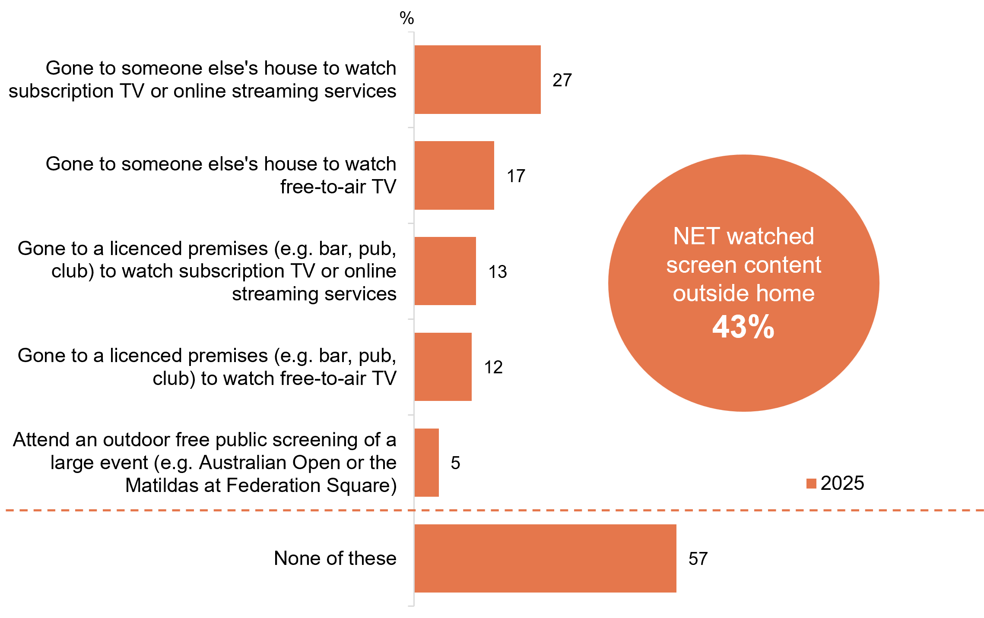
Source: C31. Have you watched screen content outside your home in any of the following locations in the past 12 months?
Base: MCCS, All respondents. 2025: n=3,396.
Notes: Don’t know/refused responses not shown: 0% for both in 2025.
A horizontal bar chart showing the percentage of people who have watched screen content outside of their home in any of the following locations in the past 12 months, in 2025.
Gone to someone else's house to watch subscription TV or online streaming services: 27%
Gone to someone else's house to watch free-to-air TV: 17%
Gone to a licenced premises (e.g. bar, pub, club) to watch subscription TV or online streaming services: 13%
Gone to a licenced premises (e.g. bar, pub, club) to watch free-to-air TV: 12%
Attend an outdoor free public screening of a large event (e.g. Australian Open or the Matildas at Federation Square): 5%
None of these: 57%
NET watched screen content outside home: 43%

Subgroup
NET Watched screen content outside of home was higher for:
- Ages 18–24 (61% vs 39% of ages 25+)
- Those living in a capital city (46% vs 38% of those living outside a capital city)
- Non-related adults living in a share house (58% vs 41% of those without children in HH and 40% of those with dependent children)
- Aboriginal and/or Torres Strait Islanders (62% vs 42% of non-Aboriginal or Torres Strait Islanders)
- Those who watched sports in P7D (52% vs 36% of those who did not)

Over two in five respondents watched screen content outside of their house in the past 12 months, while just over half did not watch screen content outside of their home.

Reference to classification ratings (%)
Three in 5 (62% NET) of respondents report that they most commonly refer to a classification rating when deciding whether a film or movie is appropriate for a child or adolescent.
Within this cohort, respondents are more likely to be ages 35–54, women (69% vs 57%), living in capital cities (65% vs 55%) and have children aged 8–10 (95% vs 91%). Other common reasons to reference classification ratings are when deciding whether to watch a movie or film (61% NET), whether a computer game is appropriate for children or adolescents (47% NET) and whether to play a computer game (34% NET).
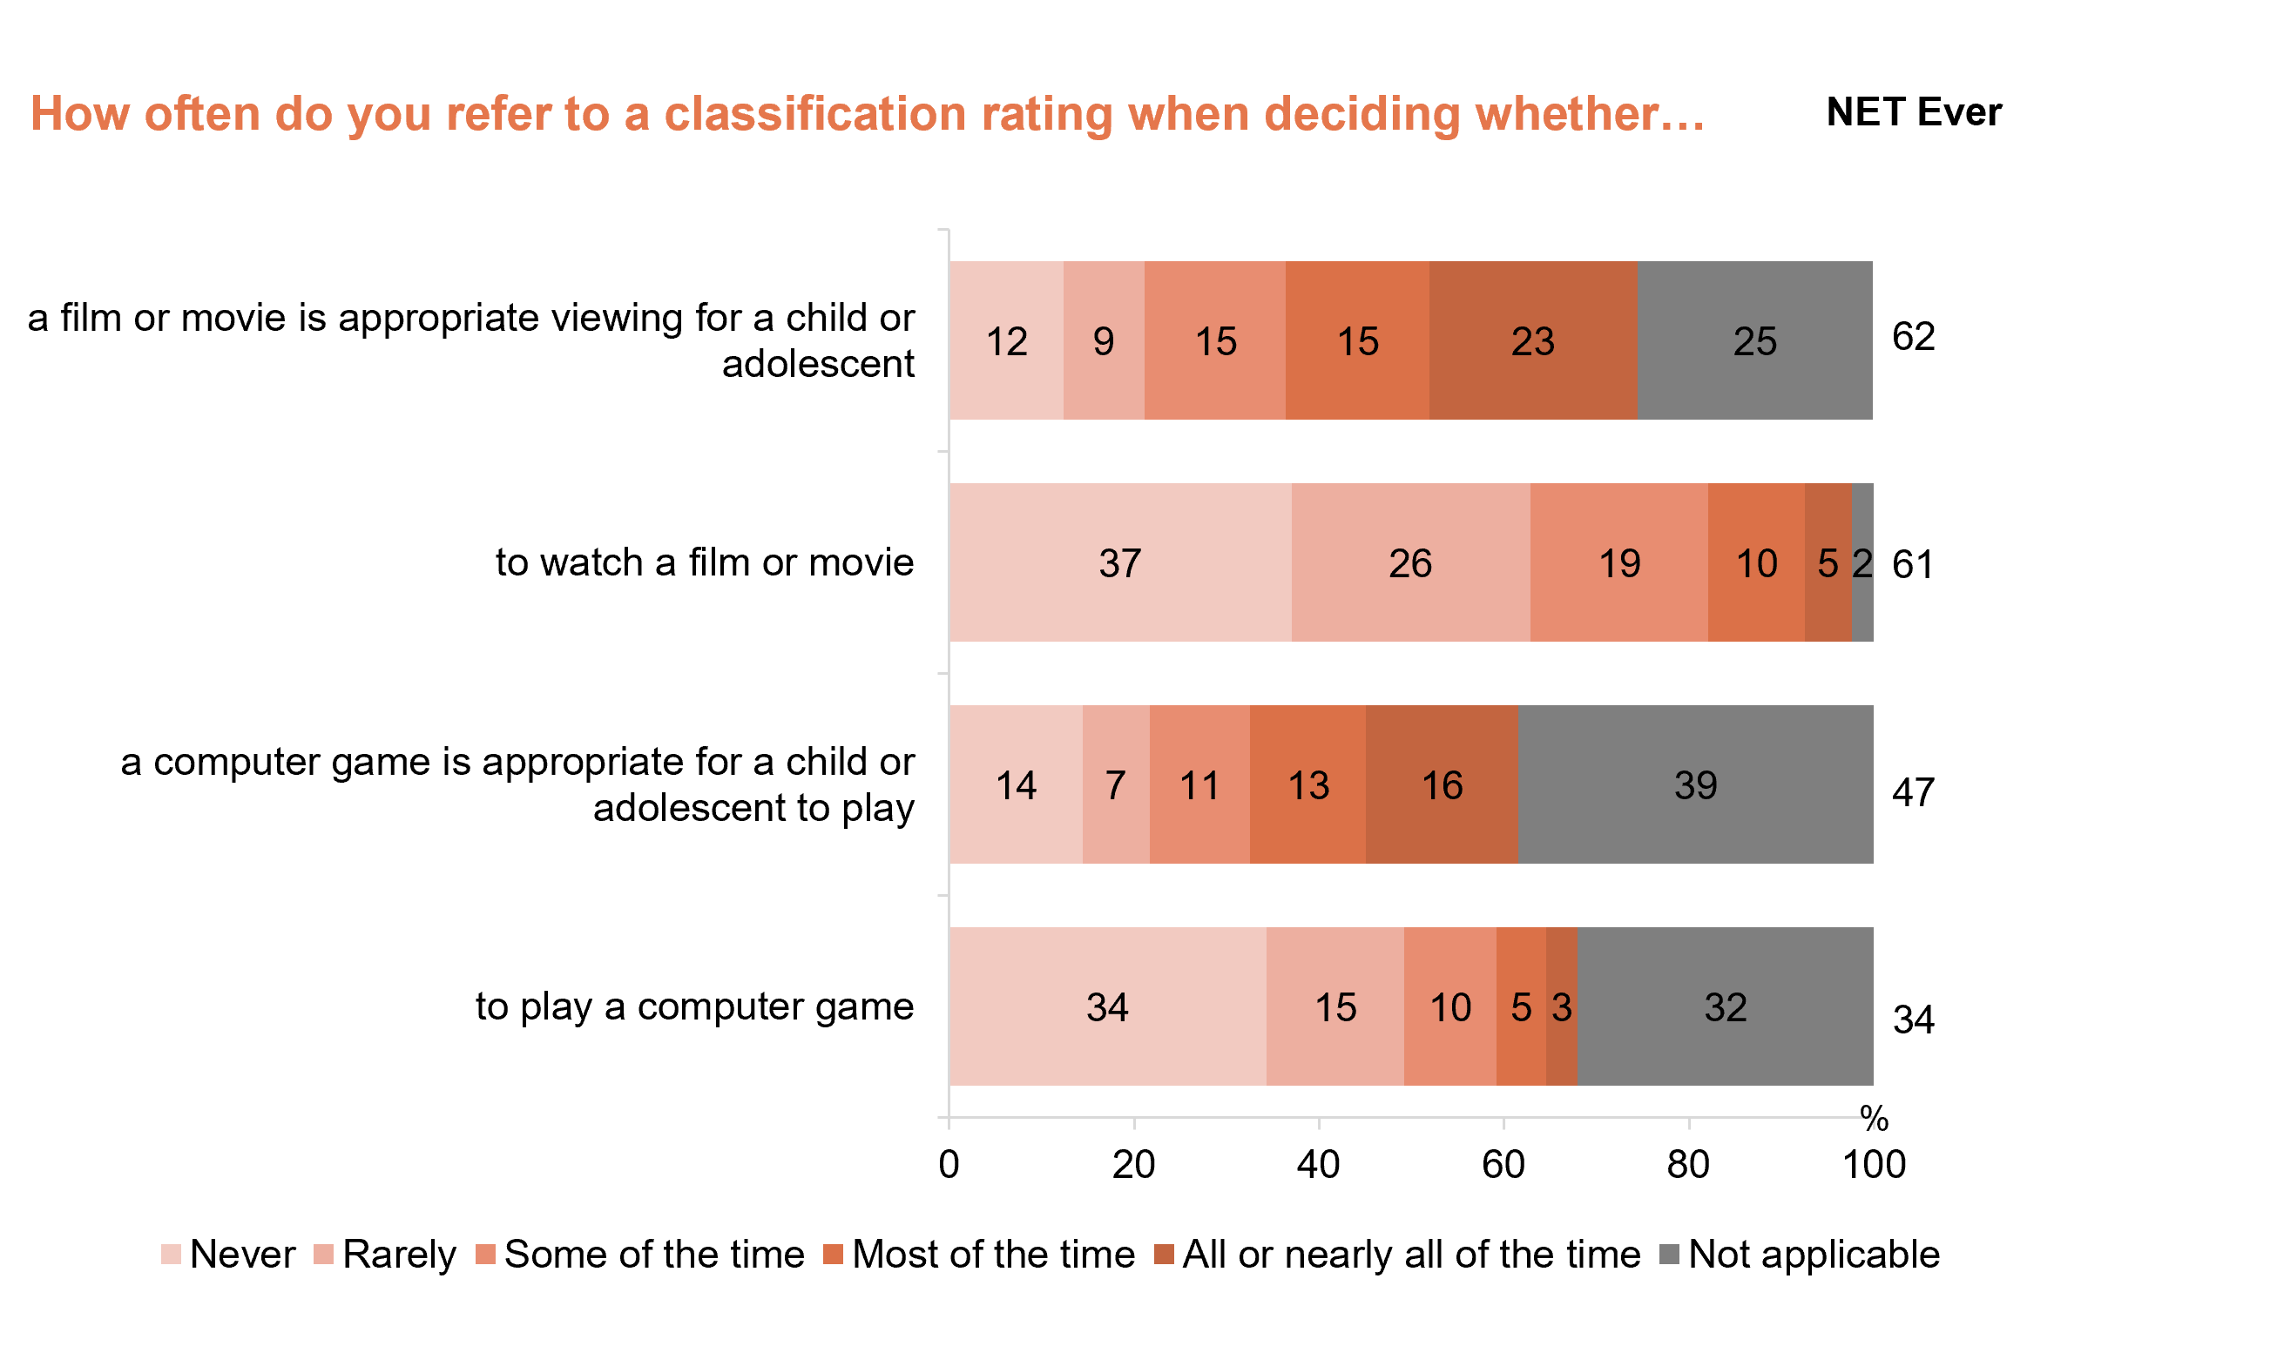
Source: C33. How often do you refer to a classification rating when…?
Base: MCCS. All respondents. 2025: n=3,396.
Notes: Don’t know/refused responses not shown, % very per statement (all <0.5%).
A horizontal bar chart showing how often people refer to a classification rating when deciding whether to watch a film/movie or play a computer game in 2025.
A film or movie is appropriate viewing for a child or adolescent:
Never: 12%
Rarely: 9%
Some of the time: 15%
Most of the time: 15%
All or nearly all of the time: 23%
Not applicable: 25%
NET Ever: 62%

To watch a film or movie:
Never: 37%
Rarely: 26%
Some of the time: 19%
Most of the time: 10%
All or nearly all of the time: 5%
Not applicable: 2%
NET Ever: 61%

A computer game is appropriate for a child or adolescent to play:
Never: 14%
Rarely: 7%
Some of the time: 11%
Most of the time: 13%
All or nearly all of the time: 16%
Not applicable: 39%
NET Ever: 47%

To play a computer game:
Never: 34%
Rarely: 15%
Some of the time: 10%
Most of the time: 5%
All or nearly all of the time: 3%
Not applicable: 32%
NET Ever: 34%

Subgroup
Deciding whether a film/movie is appropriate viewing for a child/adolescent (NET Ever) was higher for:
- Women (69% vs 57% of men)
- Ages 35–54 (78% vs 59% of those ages 18–34 and 42% of those ages 55+)
- Those living in a capital city (65% vs 55% of those living outside
a capital city)
- Those with dependent children in HH (86% vs 55% of empty nesters, 53% of non-related adults living in a share house and 41% of those without children)
- Those whose child is aged 8–10 (95% vs 91% of those aged 11–15, 88% of those aged 0–7 or 83% of those aged 16-17)
Women and respondents with younger children are reported to be more likely to refer to classification ratings when deciding a film/movie’s appropriateness for viewing for child/adolescent.

General screen content habits: Children aged 0 —17

Chapter summary: General screen content habits — Children aged 0-17
Consumption of online subscription services and YouTube/YouTube Kids are the highest among children aged 0 –17.
- Online subscription services were the most used platform by children aged 8–17 (8–10, 73%. 11–15, 67%. 16–17, 61%). This is followed by YouTube, YouTube kids, where it was most watched by younger children aged 0-7 (62%). This trend is consistent with the most common responses from children.
- Social media website/apps recorded the highest average weekly viewing hours among older children aged 8-17 (9.9 hours), whereas YouTube, YouTube Kids had the highest weekly viewing hours for children aged 0-7 (6.6 hours).
Sports, user-generated content and children’s comedy saw a rise in popularity among older children aged 11-17, whilst animation remains the preferred genre among younger children aged 0–10, though educational programs are regarded the most important to be made available to children 0–7.
- According to parents/legal guardians/carers, children’s animation or cartoons are the most common type of content that children like watching most, for both Australian and international content, especially for younger children.
- Children’s educational programs (both Australian, 61% and international, 59%) are regarded as the most important to be made available to children by parents/legal guardians/carers.
- For children aged 8–17, user-generated content saw a slight decrease in popularity. While older children aged 16–17 saw an equal increase in interest of both national and international news and current affairs (26%).
Access to personal devices for online content consumption is high among older children aged 16–17.
- Older children are more likely to have their own devices, while younger children typically rely on household devices or have no personal device.
- The primary reasons for access to personal devices included age, independence, and communication needs for older children. For younger children, the arrangements are driven by parental control and promoting a cohesive household environment.
Personal internet use outside the home and on personal devices is high among children.
- Parents/legal guardians/carers perception of their child’s personal internet use outside of home shows that younger children aged 0-7(38%) and 8–10(37%) were less likely to use internet outside of home compared to older children (17% of ages 11–15 and 7% of ages 16–17).
- Older children aged 16–17 (83% vs 67% of ages 11–15, 59% of ages 8–10 and 52% of ages 0–7) are more likely to use internet on their own devices the majority or all of the time. They are also more likely to use their own device (73% vs 39% whose children mostly used a household device).
Younger children (aged 0-10) are more likely to have parental controls enabled, with the most commonly platform being Free ad-supported streaming television (FAST), online subscription services and YouTube, YouTube Kids.
- 51% of parents/legal guardians/carers are somewhat/very satisfied with the parental controls for content involving sex/nudity/sexually suggestive content, followed closely behind for depictions of self-harm (50%) and consumption of drugs and alcohol (48%). Parents/legal guardians/carers who have enabled parental controls are more likely to agree the recommended content from streaming services are appropriate/somewhat appropriate for children (57%).

Platforms used to watch screen content in past 7 days (children aged 0–7)
Parents/legal guardians/carers reported that children aged 0–7 gravitated more toward YouTube, YouTube Kids (62%), showing a significant increase in 2025. This was followed by online subscription services (59%). Of the 62% of children aged 0-7 using YouTube, YouTube Kids, they are more inclined to watch age-inappropriate content (71%) and have watched online content in the past seven days (67%).
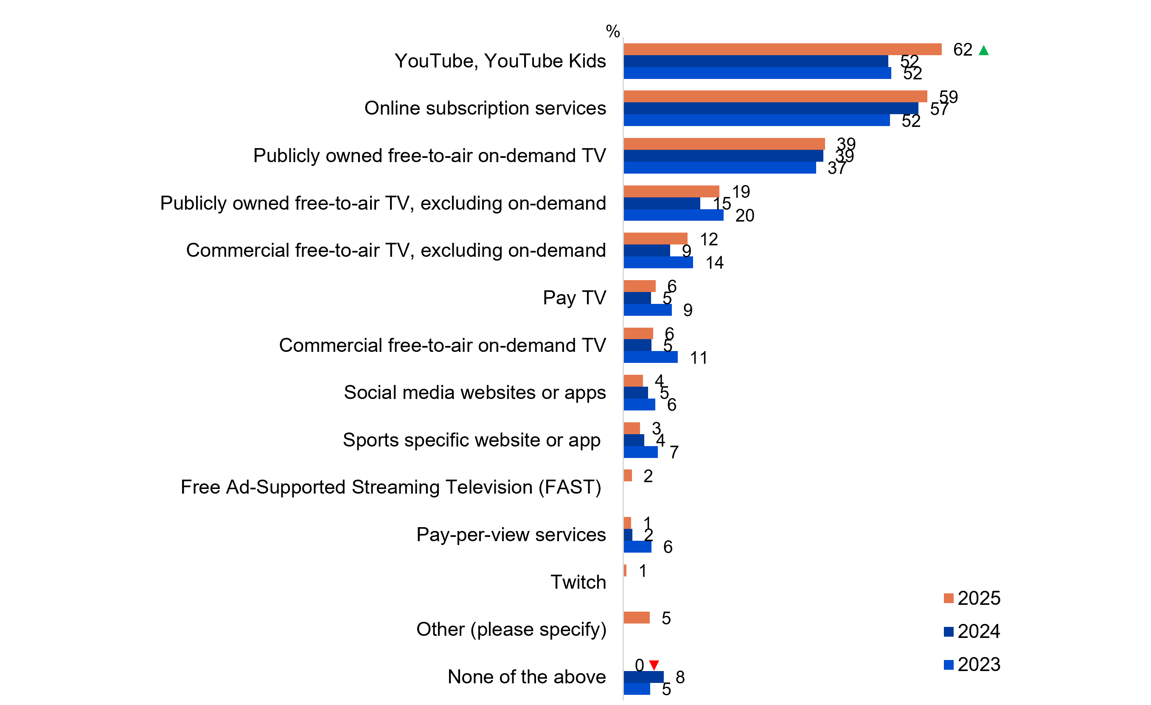
Source: F1. In the past 7 days, which of the following did your child watch at home or elsewhere on any device?
Base: MCCS, All parents/legal guardians/carers answering on behalf of 0-7 year old child. 2025: n=304. 2024: n=336. 2023: n=359.
Notes: Don’t know/refused responses not shown: <0.5% for DK and Ref between 2023 and 2025. Full code labels not shown on chart due to ease of reading. Missing bar means item not asked that year.
A horizontal bar chart showing the percentage of children who watched screen content on the following platforms at home or elsewhere, on any device, in the past seven days across 2023–2025.
YouTube, YouTube Kids: 62% in 2025, 52 in 2024, and 52% in 2023
Online subscription services: 59% in 2025, 57% in 2024, and 53% in 2023
Publicly owned free-to-air on-demand TV: 39% in 2025, 39% in 2024, and 37% in 2023
Publicly owned free-to-air TV, excluding on-demand: 19% in 2025, 15% in 2024, and 20% in 2023
Commercial free-to-air TV, excluding on-demand: 12% in 2025, 9% in 2024, and 15% in 2023
Pay TV: 6% in 2025, 5% in 2024, and 9% in 2023
Commercial free-to-air on-demand TV: 6% in 2025, 5% in 2024, and 11% in 2024
Social media websites or apps: 4% in 2025, 5% in 2024, and 6% in 2023
Sports specific website or app: 3% in 2025, 4% in 2024, and 7% in 2023
Free Ad-Supported Streaming Television (FAST): 2% in 2025, not asked in 2024, not asked in 2023
Pay-per-view services: 1% in 2025, 2% in 2024, and 6% in 2023
Twitch: 1% in 2025, not asked in 2024, not asked in 2023
Other (please specify): 5% in 2025, not asked in 2024, not asked in 2023
None of the above: 0% in 2025, 8% in 2024, and 5% in 2023

Subgroup
YouTube, YouTube Kids was higher for children who:
- Watched age-inappropriate content (71% vs 54% of those who did not)
- Watched online content in P7D (67% vs 63% of those who watched offline content)

Callout
In 2025, YouTube, YouTube Kids increased significantly (62% vs 52% in 2024), whereas none of the above
decreased significantly (0% vs 8% in 2024).
YouTube, YouTube Kids and online subscription services were the platforms most watched by children aged 0-7, reported by parents/legal guardians/carers, followed by publicly owned free-to-air on-demand TV.

Platforms used to watch screen content in past 7 days (children aged 8–17)
Online subscription services dominated youth viewing across all age groups in 2025 at 73% of children aged 8–10 (a significant increase), 67% of those 11–15 years, and 61% of 16–17-year-olds. This is followed by YouTube, YouTube Kids for children aged 8–17 (8–10: 72%, 11–15: 72% and 16–17: 58%). Social media websites/apps are higher for children aged 16–17 (56%), a significant increase for children aged 11–15 (50%). Publicly owned free-to-air on-demand TV was higher access for children aged 8–10 (28%) however a significant increase was seen for children aged 16–17 (14%).
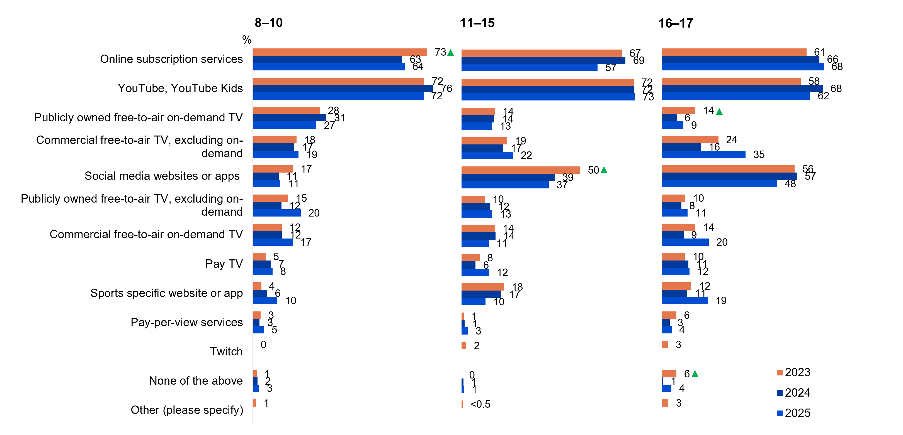
Source: KB1, KC1, KD1. In the past 7 days, what kinds of things did you watch at home or elsewhere on any device?
Base: MCCS, All children aged 8-17. 2025: 8-10 (n=179), 11-15 (n=196), 16-17 (n=130). 2024: 8-10 (n=199), 11-15 (n=199), 16-17 (n=141). 2023: 8-10 (n=197), 11-15 (n=191), 16-17 (n=137).
Notes: Don’t know/refused responses not shown: 0% for DK and Ref for all ages between 2023 and 2025. Full code labels not shown on chart due to ease of reading. Missing bar means item not asked that year.
Bar charts showing platforms used to watch screen content at home or elsewhere on any device by children in different age groups (8-10, 11-15, 16-17) for the years 2023 to 2025.
Age group 8-10:
Online subscription services: 73% in 2025, 63% in 2024, and 64% in 2023
YouTube, YouTube Kids: 72% in 2025, 76% in 2024, and 72% in 2023
Publicly owned free-to-air on-demand TV: 28% in 2025, 31% in 2024, and 27% in 2023
Commercial free-to-air TV, excluding on-demand: 18% in 2025, 17% in 2024, and 19% in 2023
Social media websites or apps: 17% in 2025, 11% in 2024, and 11% in 2023
Publicly owned free-to-air TV, excluding on-demand: 15% in 2025, 12% in 2024, and 20% in 2023
Commercial free-to-air on-demand TV: 12% in 2025, 12% in 2024, and 17% in 2023
Pay TV: 5% in 2025, 7% in 2024, and 8% in 2023
Sports specific website or app: 4% in 2025, 6% in 2024, and 10% in 2023
Pay-per-view services: 3% in 2025, 3% in 2024, and 5% in 2023
Twitch: 0% in 2025, not asked in 2024, not asked in 2023
None of the above: 1% in 2025, 2% in 2024, and 3% in 2023
Other (please specify): 1% in 2025, not asked in 2024, not asked in 2023

Age group 11-15:
Online subscription services: 67% in 2025, 68% in 2024, and 57% in 2023
YouTube, YouTube Kids: 72% in 2025, 72% in 2024, and 73% in 2023
Publicly owned free-to-air on-demand TV: 14% in 2025, 14% in 2024, and 13% in 2023
Commercial free-to-air TV, excluding on-demand: 19% in 2025, 17% in 2024, and 22% in 2023
Social media websites or apps: 50% in 2025, 39% in 2024, and 37% in 2023
Publicly owned free-to-air TV, excluding on-demand: 10% in 2025, 12% in 2024, and 13% in 2023
Commercial free-to-air on-demand TV: 14% in 2025, 14% in 2024, and 11% in 2023
Pay TV: 8% in 2025, 6% in 2024, and 12% in 2023
Sports specific website or app: 18% in 2025, 17% in 2024, and 10% in 2023
Pay-per-view services: 1% in 2025, 1% in 2024, and 3% in 2023
Twitch: 2% in 2025, not asked in 2024, not asked in 2023
None of the above: 0% in 2025, 1% in 2024, and 1% in 2023
Other (please specify): 0% in 2025, not asked in 2024, not asked in 2023

Age group 16-17:
Online subscription services: 61% in 2025, 66% in 2024, and 68% in 2023
YouTube, YouTube Kids: 58% in 2025, 68% in 2024, and 62% in 2023
Publicly owned free-to-air on-demand TV: 14% in 2025, 6% in 2024, and 9% in 2023
Commercial free-to-air TV, excluding on-demand: 24% in 2025, 16% in 2024, and 35% in 2023
Social media websites or apps: 56% in 2025, 57% in 2024, and 48% in 2023
Publicly owned free-to-air TV, excluding on-demand: 10% in 2025, 8% in 2024, and 11% in 2023
Commercial free-to-air on-demand TV: 14% in 2025, 9% in 2024, and 20% in 2023
Pay TV: 10% in 2025, 11% in 2024, and 12% in 202
Sports specific website or app: 12% in 2025, 11% in 2024, and 19% in 2023
Pay-per-view services: 6% in 2025, 3% in 2024, and 4% in 2023
Twitch: 3% in 2025, not asked in 2024, not asked in 2023
None of the above: 6% in 2025, 1% in 2024, and 4% in 2023
Other (please specify): 3% in 2025, not asked in 2024, not asked in 2023

Subgroup
YouTube, YouTube Kids was higher for:
- Ages 8–10 (72%) and 11–15 (72% vs 58% of ages 16–17)
Social Media websites or apps was higher for:
- Ages 16–17 (56%) or 11–15 (50% vs 17% of ages 8-10)
Publicly owned free-to-air on-demand TV was higher for:
- Ages 8–10 (28% vs 14% of ages 11–15 and 14% of ages 16–17)
Sports specific websites or apps was higher for:
- Ages 11–15 (18%) and 16–17 (12% vs 4% of ages 8-10)

Callout
Ages 8–10
- Online subscription services (73% vs 63% in 2024) increased significantly in 2025
Ages 11–15
- Social media websites or apps (50% vs 39% in 2024) increased significantly in 2025
Ages 15–16
- Publicly owned free-to-air on-demand TV (14% vs 6% in 2024) and none of the above (6% vs 1% in 2024) increased significantly in 2025
Consumption of online subscription services and YouTube/YouTube Kids were the highest among children aged 8-17.

Platforms children used to watch screen content in past 7 days (reported by parents)
Screen content consumption patterns reported by parents showed an increase in usage of YouTube, YouTube Kids (68%) in the past 7 days. Parents’ perceptions of the platforms their children use to watch screen content generally align with children's own responses but slightly underestimated the use of YouTube, YouTube Kids among children aged 8–10 (78%) and 11–15 (70%). Twitch and ‘other’ option were new additions in 2025, contributing to 1% and 3% respectively. This trend is consistent with the most common responses from children.
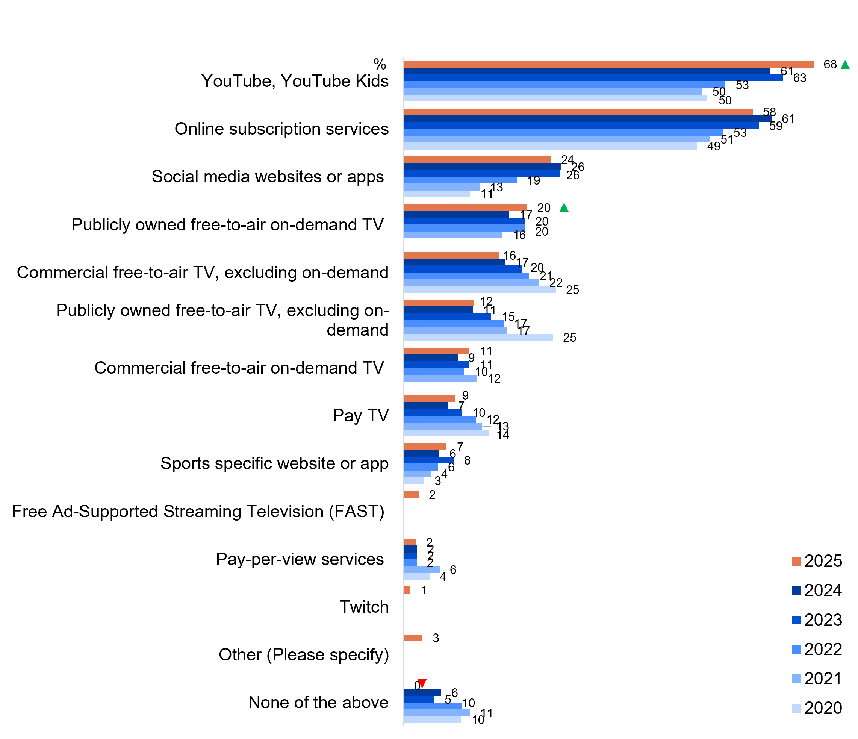
Source: F1. In the past 7 days, which of the following did your child watch at home or elsewhere on any device?
Base: MCCS, All respondents who are parents/legal guardians/carers of a child aged 17 years or under. 2024 n=2,054. 2023 n=2,409. MCCS, All respondents who are parents/legal guardians/carers of a child aged 15 years or under: 2022: n=1,618. 2021: n=1,603. 2020: n=1,571.
Notes: Don’t know/refused responses not shown: <0.5% for DK and Ref between 2020 and 2025. Full code labels not shown on chart due to ease of reading. Missing bar means item not asked that year.
A bar chart showing the platforms that children used to watch screen content in the past 7 days from 2020 to 2025, reported by parents/legal guardians/carers.
YouTube, YouTube Kids: 68% in 2025, 61% in 2024, 63% in 2023, 53% in 2022, 50% in 2021, and 50% in 2020
Online subscription services: 58% in 2025, 61% in 2024, 59% in 2023, 53% in 2022, 51% in 2021, and 49% in 2020
Social media websites or apps: 24% in 2025, 26% in 2024, 26% in 2023, 19% in 2022, 13% in 2021, and 11% in 2020
Publicly owned free-to-air on-demand TV: 20% in 2025, 17% in 2024, 20% in 2023, 20% in 2022, 16% in 2021, and not asked in 2020
Commercial free-to-air TV, excluding on-demand: 16% in 2025, 17% in 2024, 20% in 2023, 21% in 2022, 22% in 2021, and 25% in 2020
Publicly owned free-to-air TV, excluding on-demand: 12% in 2025, 11% in 2024, 15% in 2023, 17% in 2022, 17% in 2021, and 25% in 2020
Commercial free-to-air on-demand TV: 11% 2025, 9% 2024, 11% in 2023, 10% in 2022, 12% in 2021, and not asked in 2020
Pay TV: 9% in 2025, 7% in 2024, 10% in 2023, 12% in 2022, 13% in 2021, and 14% in 2020
Sports specific website or app: 7% 2025, 6% in 2024, 8% in 2023, 6% in 2022, 4% in 2021, and 3% in 2020
Free Ad-Supported Streaming Television (FAST): 2% in 2025, not asked in 2024, not asked in 2023, not asked in 2022, not asked in 2021, and not asked in 2020
Pay-per-view services: 2% in 2025, 2% in 2024, 2% in 2023, 2% in 2022, 6% in 2021, and 4% in 2020
Twitch: 1% in 2025, not asked in 2024, not asked in 2023, not asked in 2022, not asked in 2021, and not asked in 2020
Other (Please specify): 3% in 2025, not asked in 2024, not asked in 2023, not asked in 2022, not asked in 2021, and not asked in 2020
None of the above: 0% in 2025, 6% in 2024, 5% in 2023, 10% in 2022, 11% in 2021, and 10% in 2020

Subgroup
YouTube, YouTube Kids was higher for:
- Ages 8–10 (78%) and 11–15 (70% vs 63% of ages 0–7 and 60% of ages 16–17)
- Those who speak a language other than English (76% vs 64% of English-only speakers)
- Those whose children watched online content in P7D (72% vs 63% of those who watched offline content)
Publicly owned free-to-air on-demand TV was higher for:
- Ages 0–7 (33% vs 24% of ages 8–10, 10% of ages 11–15 and 7% of ages 16–17)
- Those whose children watched publicly owned free-to-air TV (75% vs 22% of those who watched commercial free-to-air TV)

Callout
- YouTube, YouTube Kids (68% vs 61% in 2024) and publicly owned free-to-air on-demand TV (20% vs 17% in 2024) increased significantly, whereas none of the above (0% vs 6% in 2024) decreased significantly in 2025.
YouTube, YouTube Kids and online subscription services were the most commonly used platforms for children to watch screen content in 2025, as reported by parents/legal guardians/carers.

Types of content children like watching most (children aged 0–7)
Animated content leads in young children's content preferences, with Australian cartoons (71%) on par with international content (70%), and educational content maintaining preference (46% Australian, 47% international). There were no significant increases or decreases across both Australian and International content, noting overall stability in 2025. Out of the 71% of children that enjoy Australian cartoons, they were more likely to have watched publicly owned free-to-air TV (85% vs 67%) and 70% of the children who watch international cartoons were more likely to have watched publicly owned free-to-air TV (81% vs 69%) and age-inappropriate content (76% vs 65%).
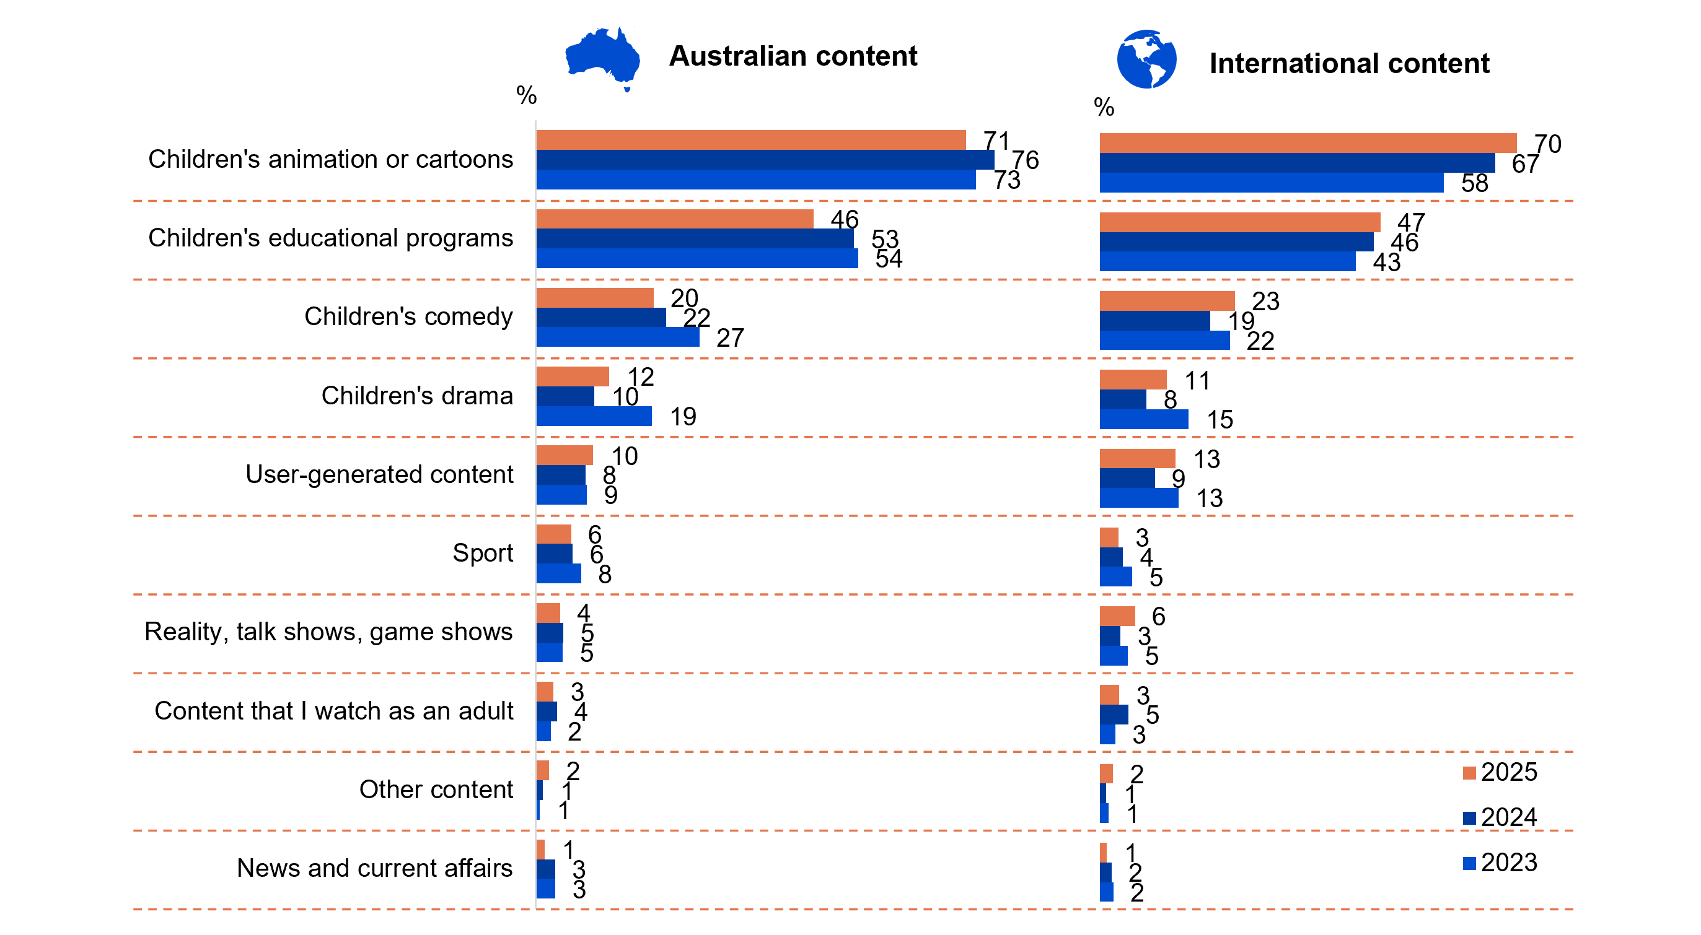
Source: KA3. Which types of content does your child like watching most?
Base: MCCS, All parents/legal guardians/carers answering on behalf of their 0-7 year old child. 2025: n=304. 2024: n=336. 2023: n=359.
Notes: Don’t know/refused responses not shown: 2025 DK=2%, Ref<0.5%. 2024 DK=1%, Ref<0.5%. 2023 DK=1%, Ref=0%.
Car charts showing the types of Australian and international content children aged 0–7 like watching most from 2023 to 2025.
For Australian content:
Children's animation or cartoons: 71% in 2025, 76% in 2024, and 73% in 2023
Children's educational programs: 46% in 2025, 53% in 2024, and 54% in 2023
Children's comedy: 20% in 2025, 22% in 2024, and 27% in 2023
Children's drama: 12% in 2025, 10% in 2024, and 19% in 2023
User-generated content: 10% in 2025, 8% in 2024, and 9% in 2023
Sport: 6% in 2025, 6% in 2024, and 8% in 2023
Reality, talk shows, game shows: 4% in 2025, 5% in 2024, and 5% in 2023
Content that I watch as an adult: 3% in 2025, 4% in 2024, and 2% in 2023
Other content: 2% in 2025, 1% in 2024, and 1% in 2023
News and current affairs: 1% in 2025, 3% in 2024, and 3% in 2023

For International content:
Children's animation or cartoons: 70% in 2025, 67% in 2024, and 58% in 2023
Children's educational programs: 47% in 2025, 46% in 2024, and 43% in 2023
Children's comedy: 23% in 2025, 19% in 2024, and 22% in 2023
Children's drama: 11% in 2025, 8% in 2024, and 15% in 2023
User-generated content: 13% in 2025, 9% in 2024, and 13% in 2023
Sport: 3% in 2025, 4% in 2024, and 5% in 2023
Reality, talk shows, game shows: 6% in 2025, 3% in 2024, and 5% in 2023
Content that I watch as an adult: 3% in 2025, 5% in 2024, and 3% in 2023
Other content: 2% in 2025, 1% in 2024, and 1% in 2023
News and current affairs: 1% in 2025, 1% in 2024, and 2% in 2023

Subgroup
Australian children’s animation or cartoons was higher for children who:
- Watched publicly owned free-to-air TV (85% vs 67% of those who watched commercial free-to-air TV)
International children’s animation or cartoons was higher for children who:
- Watched publicly owned free-to-air TV (81% vs 69% of those who watched commercial free-to-air TV)
- Watched age-inappropriate content (76% vs 65% of those who did not)
Parents/legal guardians/carers reported that Australian and international animation or cartoons and Australian or international education content were the leading types of content consumed by children aged 0-7 in 2025.

Types of content children like watching most (Children aged 8–10)
Animation remained the preferred genre among children aged 8–10, with international cartoons (57%) slightly leading Australian animations (51%). Children’s comedy ranked next in popularity with a significant increase in Australian content (42%). User-generated content was ranked relatively high in 2024, however experienced a significant decline in popularity in international content (27%) in 2025. Content that adults watch in households significantly decreased both for Australian and International content (3% and 2% respectively). Australian animation or cartoons were more likely to be preferred by girls and children who have watched FTA BVOD, FTA broadcast or SVOD in the past seven days.

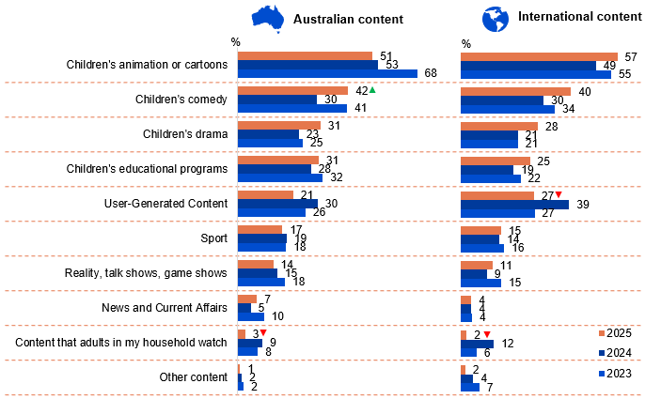
Source: KB3. Which types of content do you like watching most?
Base: MCCS, Children aged 8-10 who have watched screen content in past 7 days. 2025: n=176. 2024: n=196. 2023: n=192.
Notes: Don’t know/refused responses not shown: <0.5% for DK and Ref between 2023 and 2025.
Bar charts showing the types of Australian and international content children aged 8–10 like watching most from 2023 to 2025.
For Australian content:
Children's animation or cartoons: 51% in 2025, 53% in 2024, and 68% in 2023
Children's comedy: 42% in 2025, 30% in 2024, and 41% in 2023
Children's drama: 31% in 2025, 23% in 2024, and 25% in 2023
Children's educational programs: 31% in 2025, 28% in 2024, and 32% in 2023
User-Generated Content: 21% in 2025, 30% in 2024, and 26% in 2023
Sport: 17% in 2025, 19% in 2024, and 18% in 2023
Reality, talk shows, game shows: 14% in 2025, 15% in 2024, and 18% in 2023
News and Current Affairs: 7% in 2025, 5% in 2024, and 10% in 2023
Content that adults in my household watch: 3% in 2025, 9% in 2024, and 8% in 2023
Other content: 1% in 2025, 2% in 2024, and 2% in 2023

For International content:
Children's animation or cartoons: 57% in 2025, 49% in 2024, and 55% in 2023
Children's comedy: 40% in 2025, 30% in 2024, and 34% in 2023
Children's drama: 28% in 2025, 21% in 2024, and 21% in 2023
Children's educational programs: 25% in 2025, 19% in 2024, and 22% in 2023
User-Generated Content: 27% in 2025, 39% in 2024, and 27% in 2023
Sport: 15% in 2025, 14% in 2024, and 16% in 2023
Reality, talk shows, game shows: 11% in 2025, 9% in 2024, and 15% in 2023
News and Current Affairs: 4% in 2025, 4% in 2024, and 4% in 2023
Content that adults in my household watch: 2% in 2025, 12% in 2024, and 6% in 2023
Other content: 2% in 2025, 4% in 2024, and 7% in 2023

Subgroup
Australian animation or cartoons was higher for:
- Girls (64% vs 43% of boys)
- Those whose children watched FTA BVOD (69%), FTA Broadcast (67%) or SVOD in P7D (58% vs 51% of those who watched YouTube, YouTube Kids and 41% of those who watched social media websites or apps)
Types of content watched by platform:
- Children’s comedy was more likely to be watched on online subscription services (58%)
- User-generated content was more likely to be watched on YouTube, YouTube Kids (41%)

Callout
Australian content:
- Children’s comedy (42% vs 30% in 2024) increased significantly, whereas content that adults in my household watch (3% vs 9% in 2024) decreased significantly in 2025
International content:
- Both User-Generated Content (27% vs 39% in 2024) and content that adults in my household watch (2% vs 12% in 2024) decreased significantly in 2025

Further reading:
These findings should, however, be considered alongside RMIT research indicating that children aged 7-9 often struggle to distinguish Australian content from international programming.⁴
Children aged 8-10 enjoyed watching Australian or international animation or cartoons the most, followed by children’s comedy and children’s drama.

Types of content children like watching most (Children aged 11–15)
Sports content led viewing preferences among children aged 11–15, with Australian content (34%), outpacing International (24%), and Australian showing a significant increase in 2025. User-Generated content attracted significantly lower preference in 2025 (29% Australian, 31% international). Significant increases were seen for international children’s comedy (30%) and children’s drama (24%), whilst reality, talk shows, game has a significant increase for Australian content (21%). Boys prefer both Australian and international sport content (51% vs 17%).
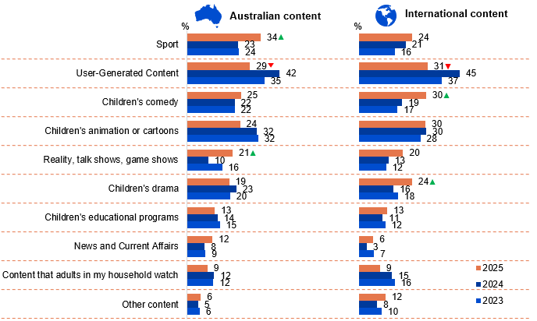
Source: KC3. Which types of content do you like watching most?
Base: MCCS, Children aged 11-15 who have watched screen content in past 7 days. 2025: n=196. 2024: n=197. 2023: n=189.
Notes: Don’t know/refused responses not shown: <0.5% for DK and Ref between 2023 and 2025.
Bar charts showing the types of Australian and international content children aged 11–15 like watching most from 2023 to 2025.
For Australian content:
Sport: 34% in 2025, 23% in 2024, and 24% in 2023
User-Generated Content: 29% in 2025, 42% in 2024, and 35% in 2023
Children's comedy: 25% in 2025, 22% in 2024, and 22% in 2023
Children's animation or cartoons: 24% in 2025, 32% in 2024, and 32% in 2023
Reality, talk shows, game shows: 21% in 2025, 10% in 2024, and 16% in 2023
Children's drama: 19% in 2025, 23% in 2024, and 20% in 2023
Children's educational programs: 13% in 2025, 14% in 2024, and 15% in 2023
News and Current Affairs: 12% in 2025, 8% in 2024, and 9% in 2023
Content that adults in my household watch: 9% in 2025, 12% in 2024, and 12% in 2023
Other content: 6% in 2025, 5% in 2024, and 6% in 2023

For International content:
Sport: 24% in 2025, 21% in 2024, and 16% in 2023
User-Generated Content: 31% in 2025, 45% in 2024, and 37% in 2023
Children's comedy: 30% in 2025, 19% in 2024, and 17% in 2023
Children's animation or cartoons: 30% in 2025, 30% in 2024, and 28% in 2023
Reality, talk shows, game shows: 20% in 2025, 13% in 2024, and 12% in 2023
Children's drama: 24% in 2025, 16% in 2024, and 18% in 2023
Children's educational programs: 13% in 2025, 11% in 2024, and 12% in 2023
News and Current Affairs: 6% in 2025, 3% in 2024, and 7% in 2023
Content that adults in my household watch: 9% in 2025, 15% in 2024, and 16% in 2023
Other content: 12% in 2025, 8% in 2024, and 10% in 2023

Subgroup
Australian or international Sport was higher for:
- Boys (51% vs 17% of girls)
Types of content watched by platform:
- User-Generated Content was more likely to be watched on YouTube, YouTube Kids (44%)
- Sport content was more likely to be watched on sports specific website or app (95%)
- News and current affairs was more likely to be watched on FTA Broadcast (31%) or BVOD (26%)

Callout
Australian content:
- Both sport (34% vs 23% in 2024) and reality, talk shows, game shows (21% vs 10% in 2024) increased significantly, whereas user-generated content (29% vs 42% in 2024) decreased significantly in 2025
International content:
- User-Generated Content (31% vs 45% in 2024) decreased significantly, whereas both children’s comedy (30% vs 19% in 2024) and children’s drama (24% vs 16% in 2024) increased significantly in 2025
Children aged 11-15 enjoyed watching sports more followed by user-generated content and children’s comedy.

Types of content children like watching most (Children aged 16–17)
Ages 16–17 displayed similar engagement levels with international and Australian sport content (26% and 30% respectively), followed by user-generated content with a significant decrease in Australian content (28%). News and current affairs which showed a significant increase for both Australian and International content (26%). Both international user-generated content and sport were more preferred by boys (51% and 37% respectively).

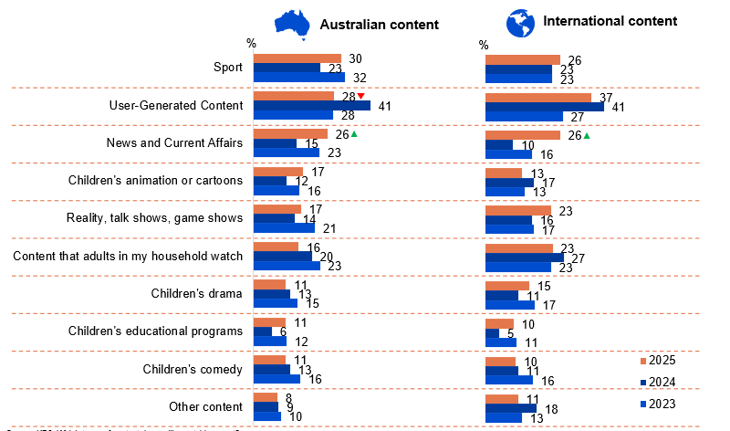
Source: KD3. Which types of content do you like watching most?
Base: MCCS, Children aged 16-17 who have watched screen content in past 7 days. 2025: n=124. 2024: n=140. 2023: n=132.
Notes: Don’t know/refused responses not shown: 2025: DK=1%, Ref=0%. 2024: DK=2%, Ref=0%. 2023: DK=0%, Ref=0%.
Bar charts showing the types of Australian and international content children aged 16–17 like watching most from 2023 to 2025.
For Australian content:
Sport: 30% in 2025, 23% in 2024, and 32% in 2023
User-Generated Content: 28% in 2025, 41% in 2024, and 28% in 2023
News and Current Affairs: 26% in 2025, 15% in 2024, and 23% in 2023
Children's animation or cartoons: 17% in 2025, 12% in 2024, and 16% in 2023
Reality, talk shows, game shows: 17% in 2025, 14% in 2024, and 21% in 2023
Content that adults in my household watch: 16% in 2025, 20% in 2024, 23% in 2023
Children's drama: 11% in 2025, 13% in 2024, and 15% in 2023
Children's educational programs: 11% in 2025, 6% in 2024, and 12% in 2023
Children's comedy: 11% in 2025, 13% in 2024, and 16% in 2023
Other content: 8% in 2025, 9% in 2024, and 10% in 2023

For International content:
Sport: 36% in 2025, 23% in 2024, and 23% in 2023
User-Generated Content: 37% in 2025, 41% in 2024, and 27% in 2023
News and Current Affairs: 26% in 2025, 10% in 2024, and 16% in 2023
Children's animation or cartoons: 13% in 2025, 17% in 2024, and 13% in 2023
Reality, talk shows, game shows: 23% in 2025, 16% in 2024, and 17% in 2023
Content that adults in my household watch: 23% in 2025, 27% in 2024, and 23% in 2023
Children's drama: 15% in 2025, 11% in 2024, and 17% in 2023
Children's educational programs: 10% in 2025, 5% in 2024, and 11% in 2023
Children's comedy: 10% in 2025, 11% in 2024, and 16% in 2023
Other content: 11% in 2025, 18% in 2024, and 13% in 2023

Subgroup
International user-generated content was higher for:
- Boys (51% vs 22% of girls)
International sport was higher for children who:
- Boys (37% vs 15% of girls)
Types of content watched by platform:
- Sport content was more likely to be watched on commercial FTA TV (65%)
- News and Current Affairs was more likely to be watched on commercial FTA TV (62%)

Callout
Australian content:
- User-Generated Content (28% vs 41% in 2024) decreased significantly, whereas news and current affairs (26% vs 15% in 2024) increased significantly in 2025
International content:
- News and Current Affairs (26% vs 10% in 2024) increased significantly in 2025
Children aged 16-17 enjoyed watching sport, followed by user-generated content and news and current affairs.

Types of content children watch
Parents/legal guardians/carers were asked what types of screen content their child watches most. Usage is highest for animated content (Australian 44%, international 49%), followed by Australian educational programs (28%) and children’s comedy (international 23%, Australian 22%) – findings that largely aligned with children's own responses. Significant declines were observed for Australian children's animation (44%), user-generated content (international 19%, Australia 15%) and reality talk/game shows (Australian 9%). However, significant increases were observed for international content in children’s animation, educational programs, children’s comedy and news and current affairs (49%, 28%, 23% and 4% respectively) in 2025.
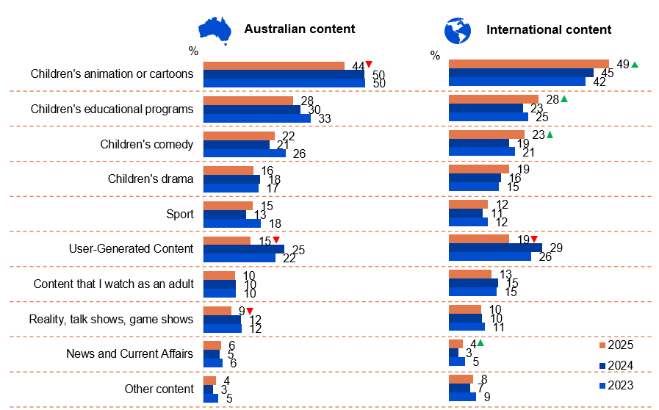
Source: NEWF4b. Which types of content does your child watch most?
Base: MCCS, Respondents whose child watched screen content in past 7 days. 2025: n=2,037. 2024: n=1,924. 2023: n=2,285.
Notes: Don’t know/refused responses not shown: 2025 <0.5% for DK and Ref. 2024 DK=1%, Ref<0.5%. 2023 <0.5% for DK and Ref.
Bar charts showing the types of Australian and international content children like watching most from 2023 to 2025.
For Australian content:
Children's animation or cartoons: 44% in 2025, 50% in 2024, and 50% in 2023
Children's educational programs: 28% in 2025, 30% in 2024, and 33% in 2023
Children's comedy: 22% in 2025, 21% in 2024, and 26% in 2023
Children's drama: 16% in 2025, 18% in 2024, and 17% in 2023
Sport: 15% in 2025, 13% in 2024, and 18% in 2023
User-Generated Content: 15% in 2025, 25% in 2024, and 22% in 2023
Content that I watch as an adult: 10% in 2025, 10% in 2024, and 10% in 2023
Reality, talk shows, game shows: 9% in 2025, 12% in 2024, and 12% in 2023
News and Current Affairs: 6% in 2025, 5% in 2024, and 6% in 2023
Other content: 4% in 2025, 3% in 2024, and 5% in 2023

For International content:
Children's animation or cartoons: 49% in 2025, 45% in 2024, 42% in 2023
Children's educational programs: 28% in 2025, 23% in 2024, and 25% in 2023
Children's comedy: 23% in 2025, 19% in 2024, and 21% in 2023
Children's drama: 19% in 2025, 16% in 2024, and 15% in 2023
Sport: 12% in 2025, 11% in 2024, and 12% in 2023
User-Generated Content: 19% in 2025, 29% in 2024, and 26% in 2023
Content that I watch as an adult: 13% in 2025, 15% in 2024, and 15% in 2023
Reality, talk shows, game shows: 10% in 2025, 10% in 2024, and 11% in 2023
News and Current Affairs: 4% in 2025, 3% in 2024, and 5% in 2023
Other content: 8% in 2025, 7% in 2024, and 9% in 2023

Subgroup
Australian or international children’s animation or cartoons was higher for:
- Ages 0–7 (85% vs 71% of ages 8–10, 42% of ages 11–15 and 20% of ages 16–17)
- Those whose child watched publicly owned free-to-air TV (live or on-demand) (77%), online subscription services (66%) or YouTube, YouTube Kids (63%) in P7D
Australian or international user-generated content was higher for:
- Ages 16–17 (31%), 11–15 (30%) and 8–10 (26% vs 9% of ages 0–7)
- Those whose child watched social media websites or apps (35%) and YouTube, YouTube Kids (27%) in P7D
Australian or international sport was higher for:
- Ages 16–17 (33%), 11–15 (27% vs 18% of ages 8–10 and 8% of ages 0–7)
- Those whose child watched sports specific website or app (75%), commercial FTA TV (live or on-demand) (36%) and social media website or app (26%) in P7D

Callout
Australian content:
- Children’s animation or cartoon (44% vs 50% in 2024), user-generated content (15% vs 25% in 2024), and reality, talk shows, game shows (9% vs 12% in 2024) decreased significantly in 2025
International content:
- Children’s animation or cartoon (49% vs 45% in 2024), children’s educational programs (28% vs 23% in 2024), children’s comedy (23% vs 19% in 2024) and news and current affairs (4% vs 3% in 2024) increased significantly in 2025
- User-Generated Content (19% vs 29% in 2024) decreased significantly in 2025
Children’s animation or cartoons remained the primary type of content watched by children, reported by parents/legal guardians/carers. This is consistent with the responses of younger children.

Types of content most important to be available to children
Despite children's preference for animated content, parents/legal guardians/carers prioritise educational programming as most important for their children's viewing, with Australian content (61%) rated slightly ahead of international offerings (59%), however Australian content significantly decreased in 2025.
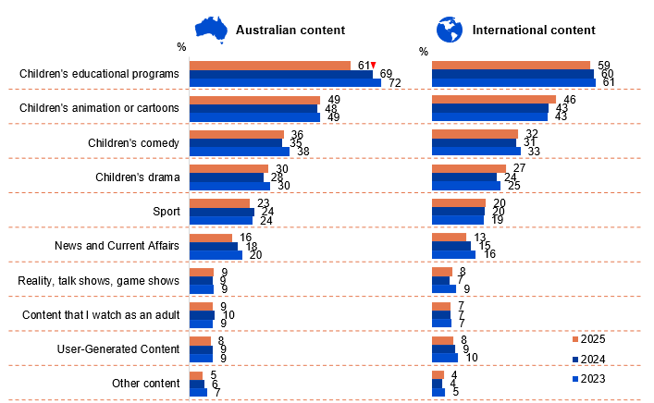
Source: NEWF5b. Which types of content are most important to be made available to children?
Base: MCCS, Respondents who are parents/legal guardians/carers of a child aged 17 or under. 2024: n=2,097. 2024: n=2,054. 2023: n=2,409.
Notes: Don’t know/refused responses not shown: 2025 DK=1%, Ref<0.5%. 2024 DK=1%, Ref=1%. 2023 DK=1%, Ref=1%.
Bar charts showing the types of content most important to be made available to children from 2023 to 2025.
For Australian content:
Children's educational programs: 61% in 2025, 69% in 2024, and 72% in 2023
Children's animation or cartoons: 49% in2025, 48% in 2024, and 49% in 2023
Children's comedy: 36% in 2025, 35% in 2024, and 38% in 2023
Children's drama: 30% in 2025, 28% in 2024, and 30% in 2023
Sport: 23% in 2025, 24% in 2024, and 24% in 2023
News and Current Affairs: 16% in 2025, 18% in 2024, and 20% in 2023
Reality, talk shows, game shows: 9% in 2025, 9% in 2024, and 9% in 2023
Content that I watch as an adult: 9% in 2025, 10% in 2024, and 9% in 2023
User-Generated Content: 8% in 2025, 9% in 2024, and 9% in 2023
Other content: 5% in 2025, 6% in 2024, and 7% in 2023

For International content:
Children's educational programs: 59% in 2025, 60% in 2024, and 61% in 2023
Children's animation or cartoons: 46% in 2025, 43% in 2024, and 43% in 2023
Children's comedy: 32% in 2025, 31% in 2024, and 33% in 2023
Children's drama: 27% in 2025, 24% in 2024, 25% in 2023
Sport: 20% in 2025, 20% in 2024, and 19% in 2023
News and Current Affairs: 13% in 2025, 15% in 2024, and 16% in 2023
Reality, talk shows, game shows: 8% in 2025, 7% in 2024, and 9% in 2023
Content that I watch as an adult: 7% in 2025, 7% in 2024, and 7% in 2023
User-Generated Content: 8% in 2025, 9% in 2024, and 10% in 2023
Other content: 4% in 2025, 4% in 2024, and 5% in 2023

Subgroup
Australian or international children’s educational programs was higher for:
- Ages 0–7 (78% vs 71% of ages 8–10, 62% of ages 11–15 and 58% of ages 16–17)
Australian or international children’s animation or cartoons was higher for:
- Ages 0–7 (66%) or 8–10 (66% vs 48% of ages 11–15 and 40% of ages 16–17)
ANY Australian content was higher for:
- Aboriginal and/or Torres Strait Islanders (98% vs 91% of non-Aboriginal or Torres Strait Islanders)

Callout
Australian content
- Children’s educational programs (61% vs 69% in 2024) decreased significantly in 2025
Parents/legal guardians/carers regarded educational programs to be the most important type of content to be available to children.

Hours per week spent watching content on various platforms (children aged 8–17)
Among children aged 8–17, weekly screen time was highest on social media websites/apps (9.9 hours), followed by YouTube, YouTube Kids (7.4 hours) and Pay TV (6.7 hours) – consistent with trends observed in 2024. In contrast to the hours spent on these platforms, YouTube, YouTube Kids and online subscription services had the highest reported usage by children in the past seven days (69% and 68% respectively). A sizeable proportion of hours spent on each of these platforms were predominately up to 5 hours.
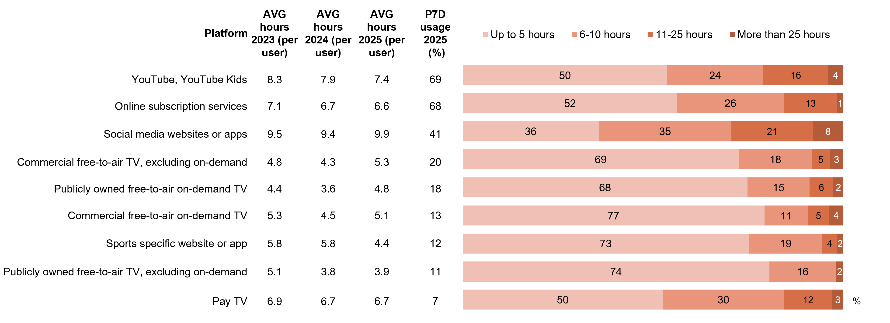
Source: KB1, KC1, KD1. In the past 7 days, what kinds of things did you watch at home or elsewhere on any device?
Base: MCCS, All children aged 8-17. 2025: 8-10 (n=179), 11-15 (n=196), 16-17 (n=130). 2024: 8-10 (n=199), 11-15 (n=199), 16-17 (n=141). 2023: 8-10 (n=197), 11-15 (n=191), 16-17 (n=137).
Source: KB2, KC2, KD2. On average, how many hours per week do you watch each of the following?
Base: MCCS, Children aged 8-17 who watched screen content in the past 7 days. Total (n= from 39 to 347). Reported at total level due to small base sizes in individual age groups.
Notes: Don’t know/refused responses not shown: % vary per statement. Results for ‘Google Play (or pay-per-view services)’ (n=16), ‘Twitch’ (n=8) and ‘Other (please specify)’ (n=6) not shown due to small base sizes. Full code labels not shown on chart due to ease of reading.
A bar chart showing how many hours per week children aged 8–17 spent watching content across various platforms in 2025, compared with 2023–2025 weekly viewing averages.
YouTube, YouTube Kids:
Average hours 2023 (per user): 8.3
Average hours 2024 (per user): 7.9
Average hours 2025 (per user): 7.4
Past 7 day usage (in percentage): 69%
Up to 5 hours: 50%
6-10 hours: 24%
11-25 hours: 16%
More than 25 hours: 4%

Online subscription services:
Average hours 2023 (per user): 7.1
Average hours 2024 (per user): 6.7
Average hours 2025 (per user): 6.6
Past 7 day usage (in percentage): 68%
Up to 5 hours: 52%
6-10 hours: 26%
11-25 hours: 13%
More than 25 hours: 1%

Social media websites or apps:
Average hours 2023 (per user): 9.5
Average hours 2024 (per user): 9.4
Average hours 2025 (per user): 9.9
Past 7 day usage (in percentage): 41%
Up to 5 hours: 36%
6-10 hours: 35%
11-25 hours: 21%
More than 25 hours: 8%

Commercial free-to-air TV, excluding on-demand:
Average hours 2023 (per user): 4.8%
Average hours 2024 (per user): 4.3%
Average hours 2025 (per user): 5.3%
Past 7 day usage (in percentage): 20%
Up to 5 hours: 69%
6-10 hours: 18%
11-25 hours: 5%
More than 25 hours: 3%

Publicly owned free-to-air on-demand TV:
Average hours 2023 (per user): 4.4
Average hours 2024 (per user): 3.6
Average hours 2025 (per user): 4.8
Past 7 day usage (in percentage): 18%
Up to 5 hours: 68%
6-10 hours: 15%
11-25 hours: 6%
More than 25 hours: 2%

Commercial free-to-air on-demand TV:
Average hours 2023 (per user): 5.3
Average hours 2024 (per user): 4.5
Average hours 2025 (per user): 5.1
Past 7 day usage (in percentage): 13%
Up to 5 hours: 77%
6-10 hours: 11%
11-25 hours: 5%
More than 25 hours: 4%

Sports specific website or app:
Average hours 2023 (per user): 5.8
Average hours 2024 (per user): 5.8
Average hours 2025 (per user): 4.4
Past 7 day usage (in percentage): 12%
Up to 5 hours: 73%
6-10 hours: 19%
11-25 hours: 4%
More than 25 hours: 2%

Publicly owned free-to-air TV, excluding on-demand:
Average hours 2023 (per user): 5.1
Average hours 2024 (per user): 3.8
Average hours 2025 (per user): 3.9
Past 7 day usage (in percentage): 11%
Up to 5 hours: 74%
6-10 hours: 16%
11-25 hours: 0%
More than 25 hours: 2%

Pay TV:
Average hours 2023 (per user): 6.9
Average hours 2024 (per user): 6.7
Average hours 2025 (per user): 6.7
Past 7 day usage (in percentage): 7%
Up to 5 hours: 50%
6-10 hours: 30%
11-25 hours: 12%
More than 25 hours: 3%
Contrastingly to the hours spent on these platforms, YouTube, YouTube Kids and online subscription services had the highest reported usage by children in the past seven days (69% and 68% respectively).

Hours per week spent watching content on various platforms (children aged 0–7)
Young children (aged 0–7) averaged similar weekly viewing hours in 2025 compared to 2024, with YouTube, YouTube Kids (6.6 hours) and online subscription services (5.3 hours) being the main forms of platforms accessed.
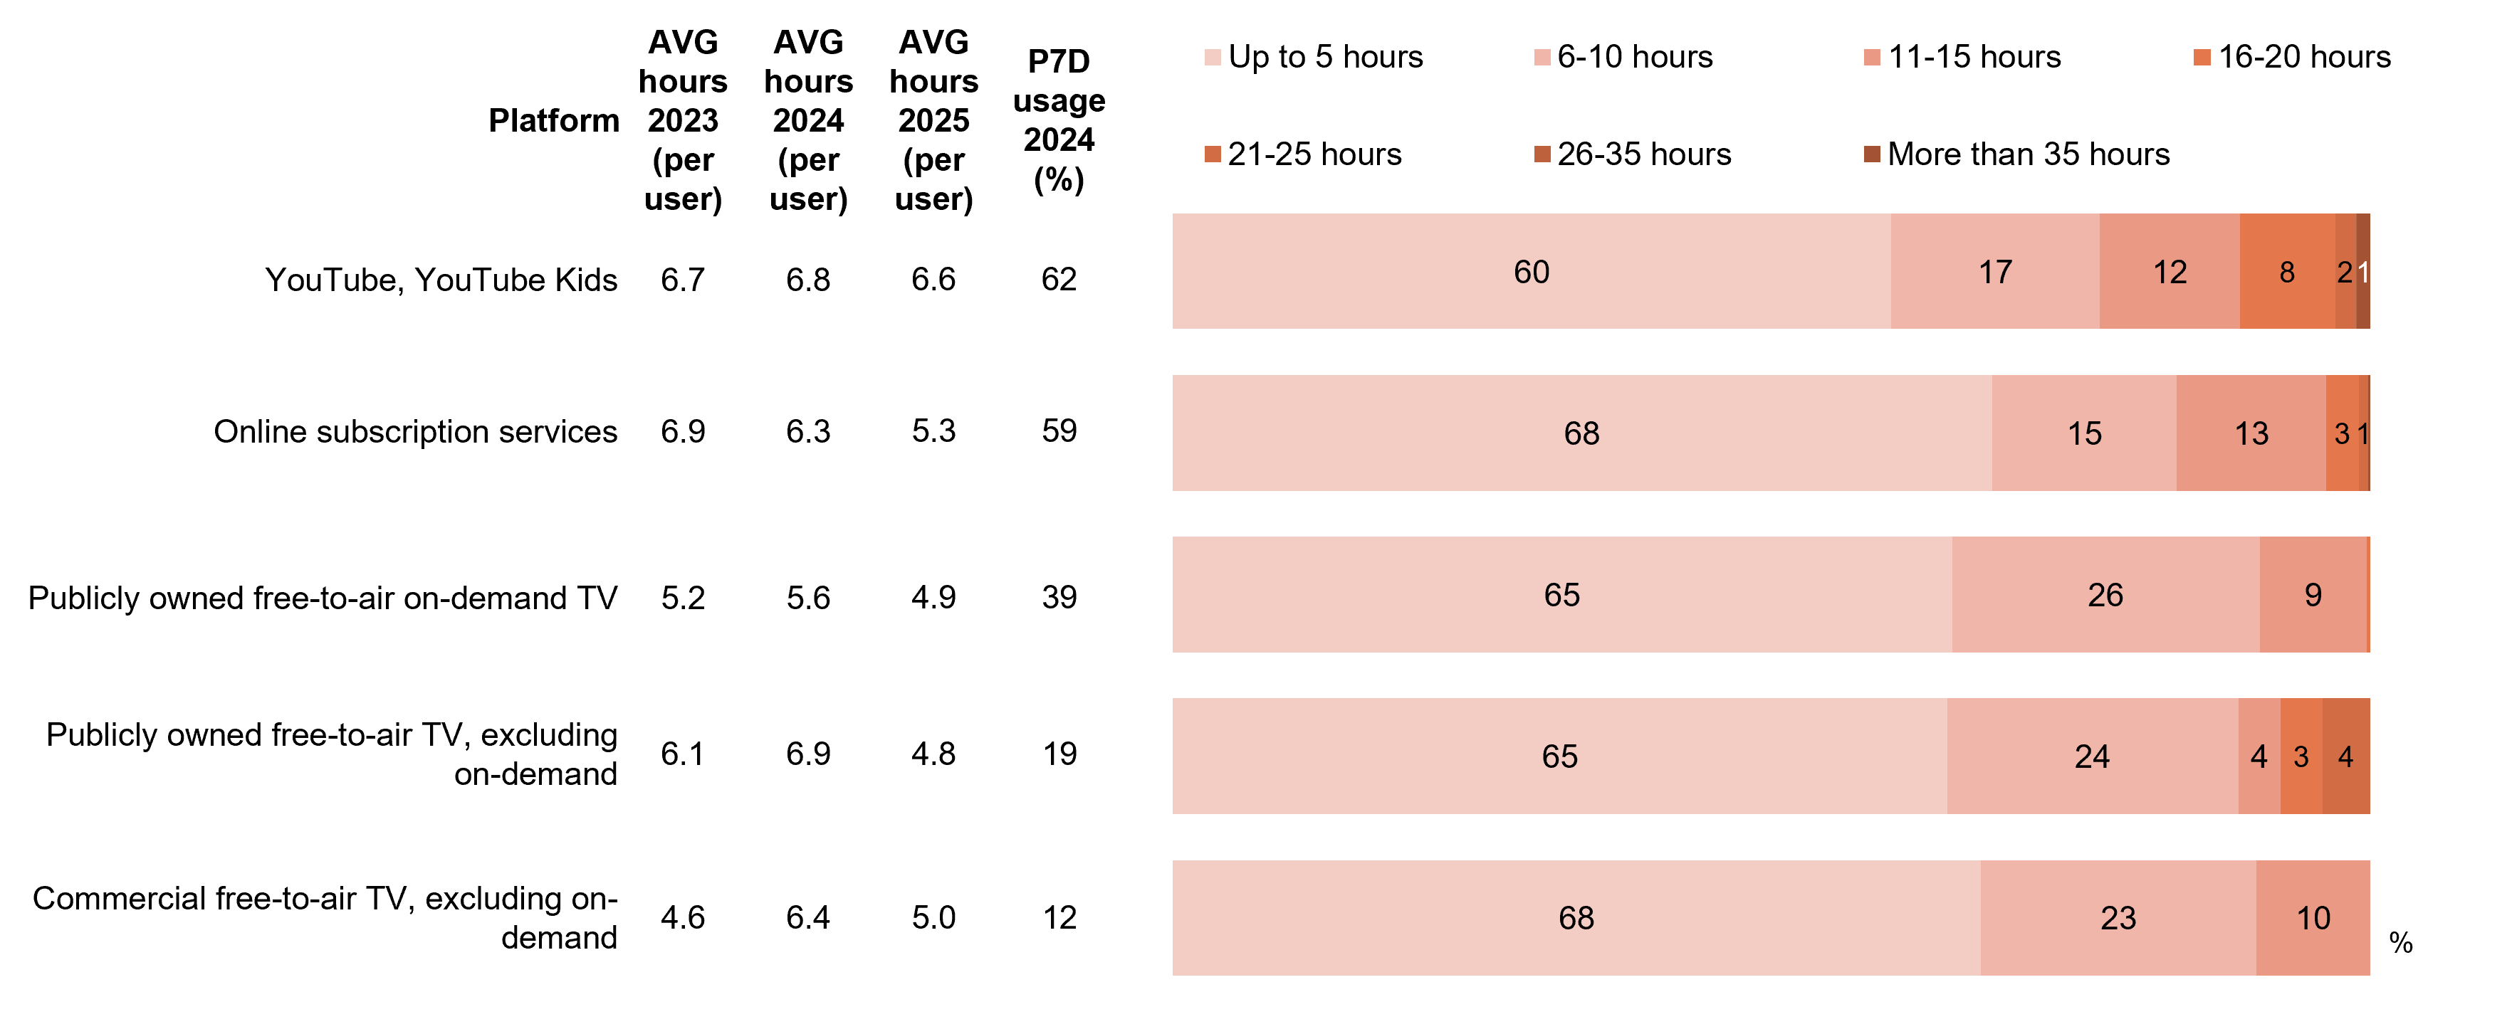
Source: F1. In the past 7 days, which of the following did your child watch at home or elsewhere on any device?
Base: MCCS, All parents/legal guardians/carers answering on behalf of 0-7 year old child. 2025: n=304. 2024: n=336. 2023: n=359.
Source: F2. On average, how many hours per week does your child spend watching each of the following?
Base: MCCS, Parents/legal guardians/carers whose 0-7 year old child watched screen content in the past 7 days (n= from 38 to 189).
Notes: Don’t know/refused responses not shown: % vary per statement. Labels for responses <1% not shown. Responses for Pay TV (n=19), Commercial free-to-air on-demand TV (n=18), Social media websites or apps (n=12), Sports specific website or app (n=10), Pay-per-view services (n=5), Free Ad-Supported Streaming Television (FAST) (n=5), and Twitch (n=2) not shown due to small base sizes. Full code labels not shown on chart due to ease of reading.
A bar chart showing how many hours per week children aged 0–7 spent watching content across various platforms in 2025, compared with 2023–2025 weekly viewing averages.
YouTube, YouTube Kids:
Average hours 2023 (per user): 6.7
Average hours 2024 (per user): 6.8
Average hours 2025 (per user): 6.6
Past 7 day usage (in percentage): 62%
Up to 5 hours: 60%
6-10 hours: 17%
11-15 hours: 12%
16-20 hours: 8%
21-25 hours: 2%
26-35 hours: 0%
More than 35 hours: 1%

Online subscription services:
Average hours 2023 (per user): 6.9
Average hours 2024 (per user): 6.3
Average hours 2025 (per user): 5.3
Past 7 day usage (in percentage): 59%
Up to 5 hours: 68%
6-10 hours: 15%
11-15 hours: 13%
16-20 hours: 3%
21-25 hours: 1%
26-35 hours: 0%
More than 35 hours: 0%

Publicly owned free-to-air on-demand TV:
Average hours 2023 (per user): 5.2
Average hours 2024 (per user): 5.6
Average hours 2025 (per user): 4.9
Past 7 day usage (in percentage): 39%
Up to 5 hours: 65%
6-10 hours: 26%
11-15 hours: 9%
16-20 hours: 0%
21-25 hours: 0%
26-35 hours: 0%
More than 35 hours: 0%

Publicly owned free-to-air TV, excluding on-demand:
Average hours 2023 (per user): 6.1
Average hours 2024 (per user): 6.9
Average hours 2025 (per user): 4.8
Past 7 day usage (in percentage): 19%
Up to 5 hours: 65%
6-10 hours: 24%
11-15 hours: 4%
16-20 hours: 3%
21-25 hours: 4%
26-35 hours: 0%
More than 35 hours: 0%

Commercial free-to-air TV, excluding on-demand:
Average hours 2023 (per user): 4.6
Average hours 2024 (per user): 6.4
Average hours 2025 (per user): 5.0
Past 7 day usage (in percentage): 12%
Up to 5 hours: 68%
6-10 hours: 23%
11-15 hours: 10%
16-20 hours: 0%
21-25 hours: 0%
26-35 hours: 0%
More than 35 hours: 0%
YouTube, YouTube Kids had the highest average weekly viewing hours for children aged 0-7 in 2025.

Hours spent by children watching screen content by platform
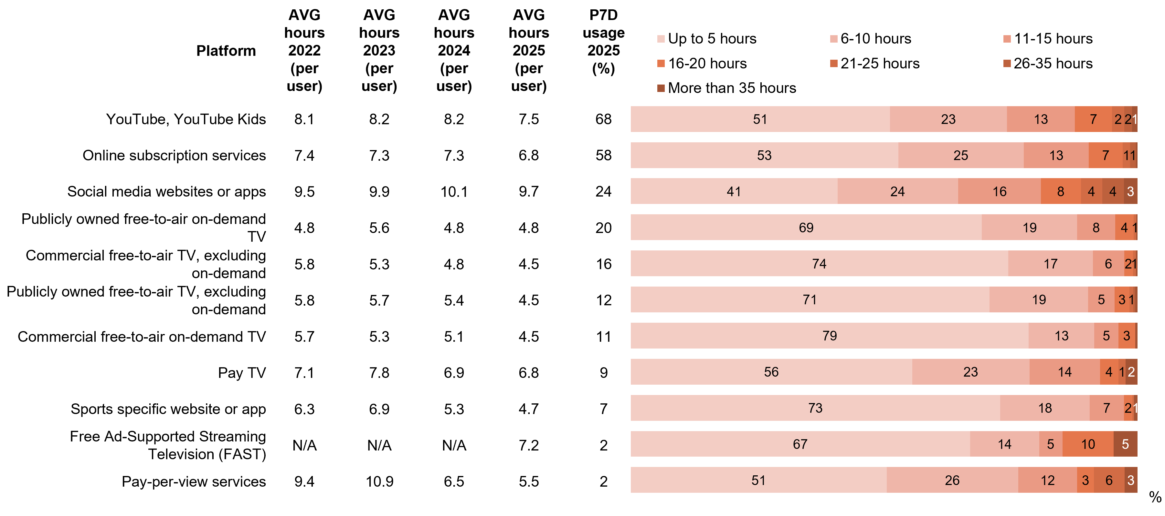
Parents/legal guardians/carers were asked to indicate how much time their child spends watching various platforms per week. In 2025 children spend the most weekly screen time (9.7 hours) on social media websites or apps, aligning with viewing patterns reported directly by 8–17-year-olds. YouTube, YouTube Kids followed (AVG 7.5 hours), aligning with viewing patters reported by parents/legal guardian/carers of 0–7-year-olds.
Source: F1. In the past 7 days, which of the following did your child watch at home or elsewhere on any device?
Base: MCCS, All parents/legal guardians/carers 2025: n=2,097. 2024: n=2,054. 2023: n=2,409.
Source: F2. On average, how many hours per week does your child spend watching each of the following?
Base: MCCS, Respondents whose child watched screen content in the past 7 days. 2024: n= from 37 to 1,397. 2024: n= from 36 to 1,297. 2023: n= from 95 to 1,411. 2022: n= from 48 to 885.
Notes: Don’t know/refused responses not shown, % vary per statement. Labels for responses <1% are not shown on chart. Responses for Twitch (n=28) not shown due to small base sizes. Full code labels not shown on chart due to ease of reading.
A bar chart showing the hours and percentages spent by children watching screen content by platform in 2025, compared with 2022–2025 averages.
YouTube, YouTube Kids:
Average hours 2022 (per user): 8.1
Average hours 2023 (per user): 8.2
Average hours 2024 (per user): 8.2
Average hours 2025 (per user): 7.5
Past 7 day usage 2025 (%): 68%
Up to 5 hours: 51%
6-10 hours: 23%
11-15 hours: 13%
16-20 hours: 7%
21-25 hours: 2%
26-35 hours: 2%
More than 35 hours: 1%

Online subscription services:
Average hours 2022 (per user): 7.4
Average hours 2023 (per user): 7.3
Average hours 2024 (per user): 7.3
Average hours 2025 (per user): 6.8
Past 7 day usage 2025 (%): 58%
Up to 5 hours: 53%
6-10 hours: 25%
11-15 hours: 13%
16-20 hours: 7%
21-25 hours: 1%
26-35 hours: 1%
More than 35 hours: 0%

Social media websites or apps:
Average hours 2022 (per user): 9.5
Average hours 2023 (per user): 9.9
Average hours 2024 (per user): 10.1
Average hours 2025 (per user): 9.7
Past 7 day usage 2025 (%): 24%
Up to 5 hours: 41%
6-10 hours: 24%
11-15 hours: 16%
16-20 hours: 8%
21-25 hours: 4%
26-35 hours: 4%
More than 35 hours: 3%

Publicly owned free-to-air on-demand TV:
Average hours 2022 (per user): 4.8
Average hours 2023 (per user): 5.6
Average hours 2024 (per user): 4.8
Average hours 2025 (per user): 4.8
Past 7 day usage 2025 (%): 20%
Up to 5 hours: 69%
6-10 hours: 19%
11-15 hours: 8%
16-20 hours: 4%
21-25 hours: 1%
26-35 hours: 0%
More than 35 hours: 0%

Commercial free-to-air TV, excluding on-demand:
Average hours 2022 (per user): 5.8
Average hours 2023 (per user): 5.3
Average hours 2024 (per user): 4.8
Average hours 2025 (per user): 4.5
Past 7 day usage 2025 (%): 16%
Up to 5 hours: 74%
6-10 hours: 17%
11-15 hours: 6%
16-20 hours: 2%
21-25 hours: 1%
26-35 hours: 0%
More than 35 hours: 0%

Publicly owned free-to-air TV, excluding on-demand:
Average hours 2022 (per user): 5.8
Average hours 2023 (per user): 5.7
Average hours 2024 (per user): 5.4
Average hours 2025 (per user): 4.5
Past 7 day usage 2025 (%): 12%
Up to 5 hours: 71%
6-10 hours: 19%
11-15 hours: 5%
16-20 hours: 3%
21-25 hours: 1%
26-35 hours: 0%
More than 35 hours: 0%

Commercial free-to-air on-demand TV:
Average hours 2022 (per user): 5.7
Average hours 2023 (per user): 5.3
Average hours 2024 (per user): 5.1
Average hours 2025 (per user): 4.5
Past 7 day usage 2025 (%): 11%
Up to 5 hours: 79%
6-10 hours: 13%
11-15 hours: 5%
16-20 hours: 3%
21-25 hours: 0%
26-35 hours: 0%
More than 35 hours: 0%

Pay TV:
Average hours 2022 (per user): 7.1
Average hours 2023 (per user): 7.8
Average hours 2024 (per user): 6.9
Average hours 2025 (per user): 6.8
Past 7 day usage 2025 (%): 9%
Up to 5 hours: 56%
6-10 hours: 23%
11-15 hours: 14%
16-20 hours: 4%
21-25 hours: 1%
26-35 hours: 0%
More than 35 hours: 2%

Sports specific website or app:
Average hours 2022 (per user): 6.3
Average hours 2023 (per user): 6.9
Average hours 2024 (per user): 5.3
Average hours 2025 (per user): 4.7
Past 7 day usage 2025 (%): 7%
Up to 5 hours: 73%
6-10 hours: 18%
11-15 hours: 7%
16-20 hours: 2%
21-25 hours: 0%
26-35 hours: 0%
More than 35 hours: 1%

Free Ad-Supported Streaming Television (FAST):
Average hours 2022 (per user): Not asked
Average hours 2023 (per user): Not asked
Average hours 2024 (per user): Not asked
Average hours 2025 (per user): 7.2
Past 7 day usage 2025 (%): 2%
Up to 5 hours: 67%
6-10 hours: 14%
11-15 hours: 5%
16-20 hours: 10%
21-25 hours: 0%
26-35 hours: 0%
More than 35 hours: 5%

Pay-per-view services:
Average hours 2022 (per user): 9.4
Average hours 2023 (per user): 10.9
Average hours 2024 (per user): 6.5
Average hours 2025 (per user): 5.5
Past 7 day usage 2025 (%): 2%
Up to 5 hours: 51%
6-10 hours: 26%
11-15 hours: 12%
16-20 hours: 3%
21-25 hours: 6%
26-35 hours: 0%
More than 35 hours: 3%
The average number of hours that children spend watching content trended downwards across several platforms in 2025. Social media websites or app had the highest average weekly viewing hours among children, reported by parents/legal guardians/carers, consistent with responses from older children.

Children’s device usage for online content consumption: personal vs. household devices
Parents/legal guardians/carers were asked if their child had their own device for online content consumption, reporting a NET Yes of 70%. Device access patterns varied by age but maintain consistency in 2025 with 55% reporting their child has their own device, 17% share household devices, and 30% have no device access. Personal device ownership peaked among teens (16–17), while younger children (aged 8–10) typically relied on shared devices and children aged 0–7 were reported more likely to not have access to devices.
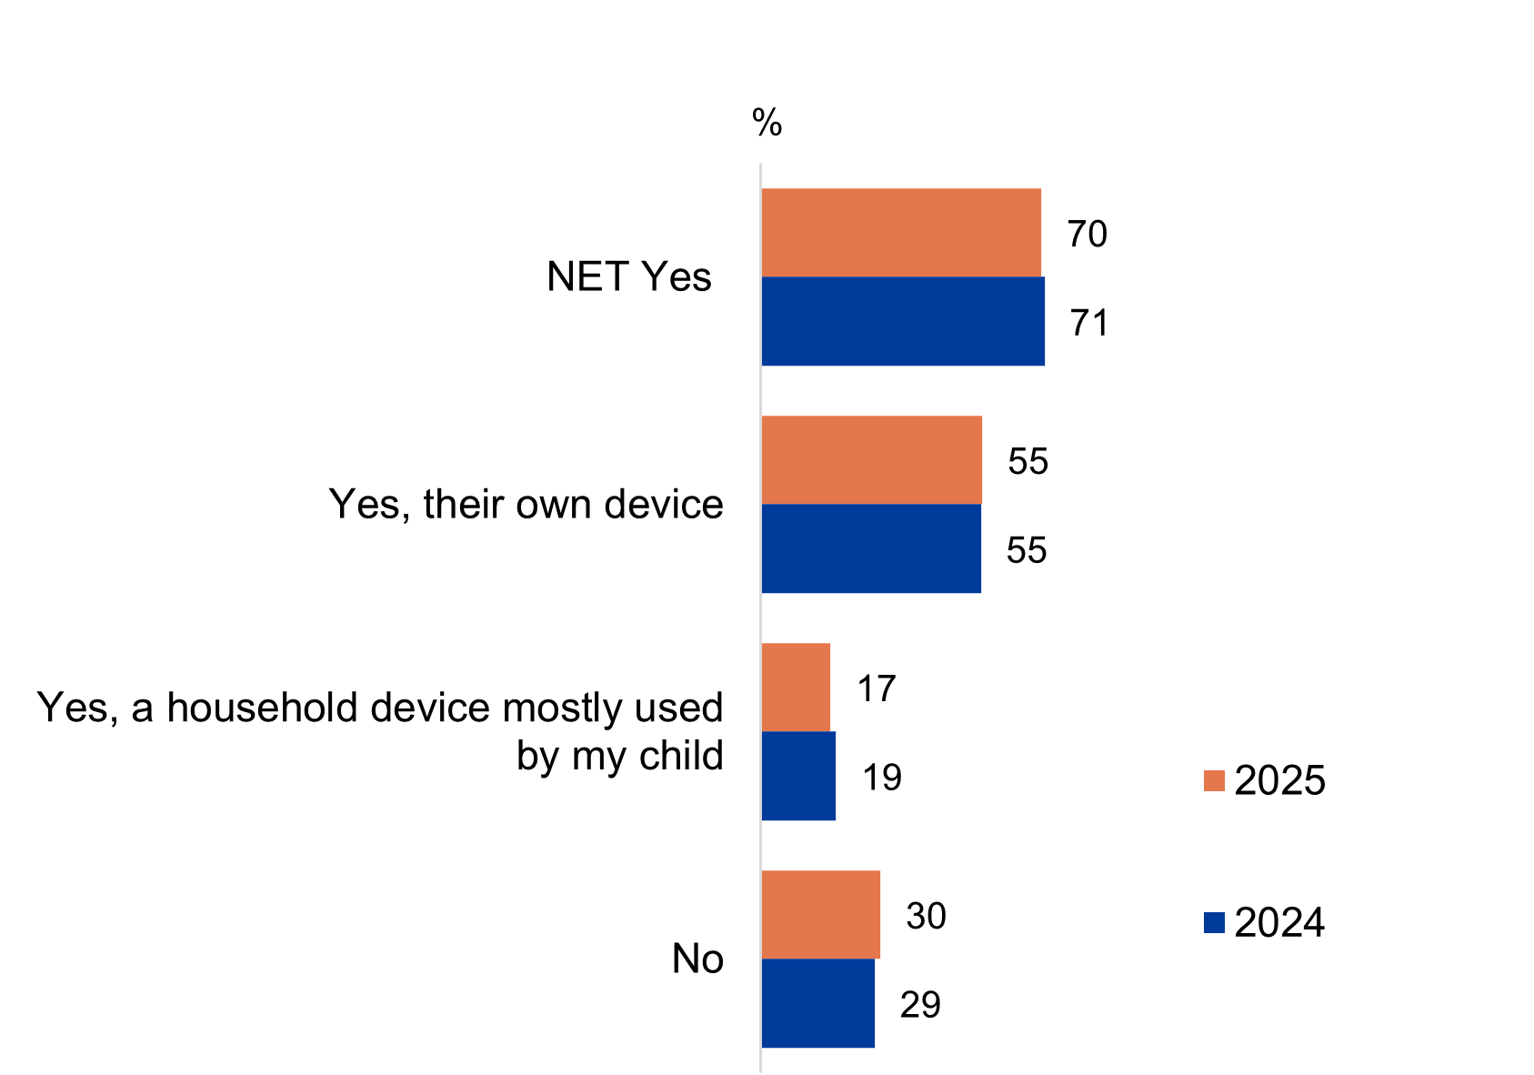
Source: PARF7. Does your child have their own device for online content consumption, or a household device that is mostly used by your child?
Base: MCCS, Respondents who are parents/legal guardians/carers of a child aged 17 or under. 2025: Total n=2,097. 0-7 (n=585), 8-10 (n=513), 11-15 (n=507), 16-17 (n=449). 2024: Total n=2,054.
Notes: Don’t know/refused responses not shown. 2025 0% for DK and Ref. 2024 DK=1%, Ref<0.5%. ‘NET Yes’ includes ‘Yes, their own device’ and ‘Yes, a household device mostly used by my child’.
A horizontal bar chart comparing the proportion of children using their own personal device or a shared household device for online content consumption in 2024 and 2025.
NET Yes: 70% in 2025 and 71% in 2024
Yes, their own device: 55% in 2025 and 55% in 2024
Yes, a household device mostly used by my child: 17% in 2025 and 19% in 2024
No: 30% in 2025 and 29% in 2024

Subgroup
Yes, their own device was higher for:
- Ages 16–17 (88% vs 79% of ages 11–15, 54% of ages 8–10 and 23% of ages 0–7)
- Those living outside a capital city (61% vs 54% of those living in a capital city)
- Those with education up to Year 12 (67%) or a TAFE qualification/Trade Certificate/Diploma (61% vs 46% of those with a Bachelor degree and 45% of those with a Postgraduate degree/Graduate Diploma)
- English-only speakers (59% vs 49% of those who speak a language other than English)
Yes, a household device mostly used by my child was higher for:
- Ages 8–10 (24% vs 14% of ages 11–15 and 10% of ages 16–17)
- Those who speak a language other than English (22% vs 15% of English-only speakers)
No was higher for:
- Ages 0–7 (61% vs 25% of ages 8–10, 11% of ages 11–15 and 4% of ages 16–17)
- Those with a Postgraduate degree/Graduate Diploma (39%) or a Bachelor degree (36% vs 21% of those with education up to Year 12 and 25% of those with a TAFE qualification/Trade Certificate/Diploma)
- Non-Aboriginal and/or Torres Strait Islanders (31% vs 18% of Aboriginal or Torres Strait Islanders)
Just over two thirds of parents/legal guardians/carers reported that their child either had their own device or relied on a household device for online content consumption.

Reasons for children’s device arrangement
Parents/legal guardians/carers whose child had their own device or primarily used a household device were asked the reasons for this arrangement, with the reason for access levels generally varying by age. Teens received devices primarily because they were old enough and for communication needs, while younger children's access focused on creating a cohesive household environment within a controlled environment (parental controls). For children who owned devices saw a decrease in educational and communication purposes. While for shared household devices saw decreases in entertainment and creating cohesive household environment, where increase in safety/security and convenience were observed.
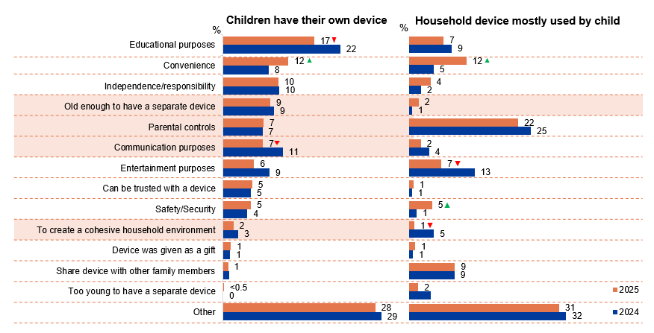
Source: PARF8. You answered [OPTION SELECTED AT PARF7] – what are the reasons you have this arrangement in place?
Base: MCCS, All parents/legal guardians/carers whose child has their own device or a household device they mostly used for online content consumption. Children have their own device: 2025 n=1,201. 2024: n=1,133. Household device mostly used by child: 2025 n=361. 2024: n=358. Notes: Don’t know/refused responses not shown. 2025 DK=2%, Ref=4%. 2024 DK=2%, Ref=7% at total level.
Bar charts comparing reasons children have their own device and reasons household device is mostly used by child for years 2024 and 2025.
Children have their own device:
Educational purposes: 17% in 2025, and 22% in 2024
Convenience: 12% in 2025, and 8% in 2024
Independence/responsibility: 10% in 2025, and 10% in 2024
Old enough to have a separate device: 9% in 2025, and 9% in 2024
Parental controls: 7% in 2025, and 7% in 2024
Communication purposes: 7% in 2025, and 11% in 2024
Entertainment purposes: 6% in 2025, and 9% in 2024
Can be trusted with a device: 5% in 2025, and 5% in 2024
Safety/Security: 5% in 2025, and 4% in 2024
To create a cohesive household environment: 2% in 2025, and 3% in 2024
Device was given as a gift: 1% in 2025, and 1% in 2024
Share device with other family members: 1% in 2025, and 1% in 2024
Too young to have a separate device: less than 0.5% in 2025, and 0% in 2024
Other: 28% in 2025, and 29% in 2024

Household device mostly used by child:
Educational purposes: 7% in 2025, and 9% in 2024
Convenience: 12% in 2025, and 5% in 2024
Independence/responsibility: 4% in 2025, and 2% in 2024
Old enough to have a separate device: 2% in 2025, and 1% in 2024
Parental controls: 22% in 2025, and 25% in 2024
Communication purposes: 2% in 2025, and 4% in 2024
Entertainment purposes: 7% in 2025, and 13% in 2024
Can be trusted with a device: 1% in 2025, and 1% in 2024
Safety/Security: 5% in 2025, and 1% in 2024
To create a cohesive household environment: 1% in 2025, and 5% in 2024
Device was given as a gift: 1% in 2025, and 1% in 2024
Share device with other family members: 9% in 2025, and 9% in 2024
Too young to have a separate device: 2% in 2025, and 4% in 2024
Other: 31% in 2025, and 32% in 2024

Subgroup
Children who have their own device:
- Old enough to have a separate device was higher for children aged 16–17 (19% vs 5% of ages 0–15)
- Parental controls was higher for children aged 0–10 (12% vs 5% of ages 11–17)
- Communication purposes was higher for children aged 11–17 (11% vs 1% of ages 0–10)
- To create a cohesive household environment was higher for children aged 0–10 (4% vs 0% of ages 11–17)
Household device mostly used by a child
- Old enough to have a separate device was higher for children aged 11–17 (6% vs 0% of ages 0–10)

Callout
‘Other’ examples:
- “Preferred to have their own device“
- “Old device passed down to children”
- “Travel”
- “Want my child to have internet and phone access”
- “Child has disability/autism and use it for therapy and assistance purposes”
Children have their own device:
- Educational purposes (17% vs 22% in 2024) and communication purposes (7% vs 11% in 2024) decreased significantly, whereas convenience (12% vs 8% in 2024) increased significantly in 2025
Household device mostly used by children:
- Convenience (12% vs 5% in 2024) and safety and security (5% vs 1% in 2024) increased significantly, whereas, entertainment purposes (7% vs 13% in 2024) and to create a cohesive household environment (1% vs 5% in 2024) decreased significantly in 2025

Note
Educational purposes was higher for:
- Children aged 8-10 (27%), 11-15 (22% vs 9% of those aged 0-7, 15% of those aged 16-17)
- Those employed full time or part time (19%), self-employed (26%), students (36% vs 6% of those employed casually, 4% of non-worker)
- Non-Aboriginal and/or Torres Strait Islander respondents (19% vs 5% of Aboriginal and/or Torres Strait Islander respondents)
- Those born in a mainly non-English speaking country (25% vs 16% of those born in a mainly English speaking country)
Parental controls was higher for:
- Children aged 0-7 (19%), 8-10 (16% vs 9% of those aged 11-15, 6% of those aged 16-17).
Entertainment purposes was higher for:
- Children aged 0-7 (17%), 8-10 (11% vs 5% of those aged 16-17).
Communication purposes was higher for:
- Children aged 16-17 (15%), 11-15 (14% vs 3% of those aged 0-7, 4% of those aged 8-10).
- Those with a TAFE, Trade Certificate, Diploma (13% vs 4% of those with education up to Year 12).
Independence / responsibility was higher for:
- Children aged 16-17 (14% vs 5% of those aged 0-7, 7% of those aged 8-10, 7% of those aged 11-15).
- Those born in a mainly English speaking country (10% vs 6% of those born in a mainly non-English speaking country).
Old enough to have a separate device was higher for:
- Children aged 16-17 (19% vs 7% of those aged 11-15, 2% of those aged 8-10, 0% of those aged 0-7).
- Those with education up to Year 12 (9%), a TAFE, Trade Certificate, Diploma (9% vs 6% of those with a Bachelor degree, 3% of those with a Postgraduate Degree).
- Those born in a mainly English speaking country (9% vs 3% of those born in a mainly non-English speaking country).
Safety / security was higher for:
- Children aged 11-15 (8% vs 1% of those aged 0-7, 2% of those aged 8-10).
To create a cohesive household environment was higher for:
- Children aged 0-7 (6%), 8-10 (6% vs 2% of those aged 11-15, 1% of those aged 16-17).
Parents/legal guardians/carers reported that the primary reasons for providing their child with a personal or household device for online content consumption were for educational purposes, followed by convenience, independence, being old enough, parental control and communication purposes.

Parents’ perception of children’s personal internet use on their own devices
Parents/legal guardians/carers were asked the extent to which their child accessed internet for personal use on their own devices. Two thirds (65%) used personal devices the majority or all of the time to access the internet, with rates climbing as age increased (52% for youngest children 0–7, 59% for ages 8–10, 67% for ages 11–15, and 83% for teens 16–17). Children who watched social websites or apps in the past seven days (79%) and are English-only speakers (70%) are more likely to use internet on their own devices.
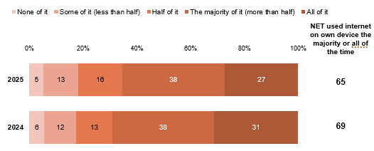
Source: PARF9. How much of your child’s personal use of the internet occurs on their own device?
Base: MCCS, All parents/legal guardians/carers whose child has their own device or a household device they mostly used for online content consumption. 2025: n=1,493. 2024: n=1,435.
Notes: Don’t know/refused responses not shown: <0.5% for DK and Ref in 2024 and 2025.
Bar charts comparing parents’ views on how much of their children’s personal internet use was on their own devices in 2024 and 2025.
None of it: 5% in 2025, and 6% in 2024
Some of it (less than half): 13% in 2025, and 12% in 2024
Half of it: 16% in 2025, and 13% in 2024
The majority of it (more than half): 38% in 2025, and 38% in 2024
All of it: 27% in 2025, and 31% in 2024
NET used internet on own device the majority or all of the time: 65% in 2025, and 69% in 2024

Subgroup
NET used internet on own devices the majority or all of the time was higher for:
- Ages 16–17 (82% vs 67% of ages 11–15, 59% of ages 8–10 and 52% of ages 0–7)
- Those whose child watched social media websites or apps in P7D (79%)
- English-only speakers (70% vs 56% of those who speak a language other than English)
- Those whose children had their own device (73% vs 39% whose children mostly used a household device)
Parents/legal guardians/carers report that older children were more likely than younger children to have used internet on their own device the majority or all of the time.

Parents’ perception of children’s personal internet use outside of home
Parents/legal guardians/carers were asked the extent to which their child accessed the internet for personal use outside their home. Personal internet use outside the home averaged 14% across all age groups. The NET used internet outside of home for none of the time were higher among young children aged 0–7 (38%) and aged 8–10 (37%) compared to those aged 11-15 (17%) and 16–17 (7%). Children who use a shared household device were less likely to personally use the internet outside of home (36%).
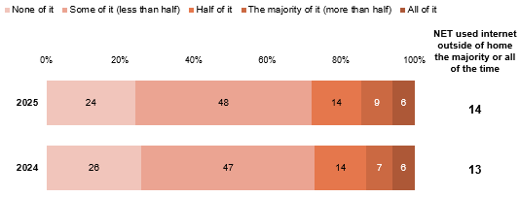
Source: PARF10. How much of your child's personal use of the internet occurs outside your home/dwelling?
Base: MCCS, All parents/legal guardians/carers whose child has their own device or a household device they mostly used for online content consumption. 2025: n=1,493. 2024: n=1,435.
Notes: Don’t know/refused responses not shown: 2025: DK<0.5%, Ref=0%. 2024: DK=1%, Ref<0.5%.
Bar charts comparing parents’ perception of on how much of their children’s personal internet use was outside of home in 2024 and 2025.
None of it: 24% in 2025, and 26% in 2024
Some of it (less than half): 48% in 2025, and 47% in 2024
Half of it: 14% in 2025, and 14% in 2024
The majority of it (more than half): 9% in 2025, and 7% in 2024
All of it: 6% in 2025, and 6% in 2024
NET used internet outside of home majority or all of the time: 14% in 2025, and 13% in 2024

Subgroup
NET used internet outside of home none of the time was higher for:
- Ages 0–7 (38%) or 8–10 (37% vs 17% of ages 11–15 and 7% of ages 16–17)
- Those whose children mostly used a household device (36% vs 21% whose children had their own device)
Parents/legal guardians/carers perception of their child’s personal internet use outside of home report that younger children aged 0-7 and 8–10 were less likely to use internet outside of home.

Use of services with parental controls enabled
Parents/legal guardians/carers were asked whether they use parental control across the listed services. Free ad-supported streaming television (FAST) (65%), online subscription services (57%) and YouTube, YouTube Kids (55%) were the most common platforms with parental controls enabled. The enablement of parental controls on any service used were higher for those with younger children aged 8–10 (73%), 0–7 (66%) compared to those with teenagers aged 11–15 and 16–17 (51% and 21% respectively). Children who mostly use a household device (71%) were more likely to have parental controls enabled.
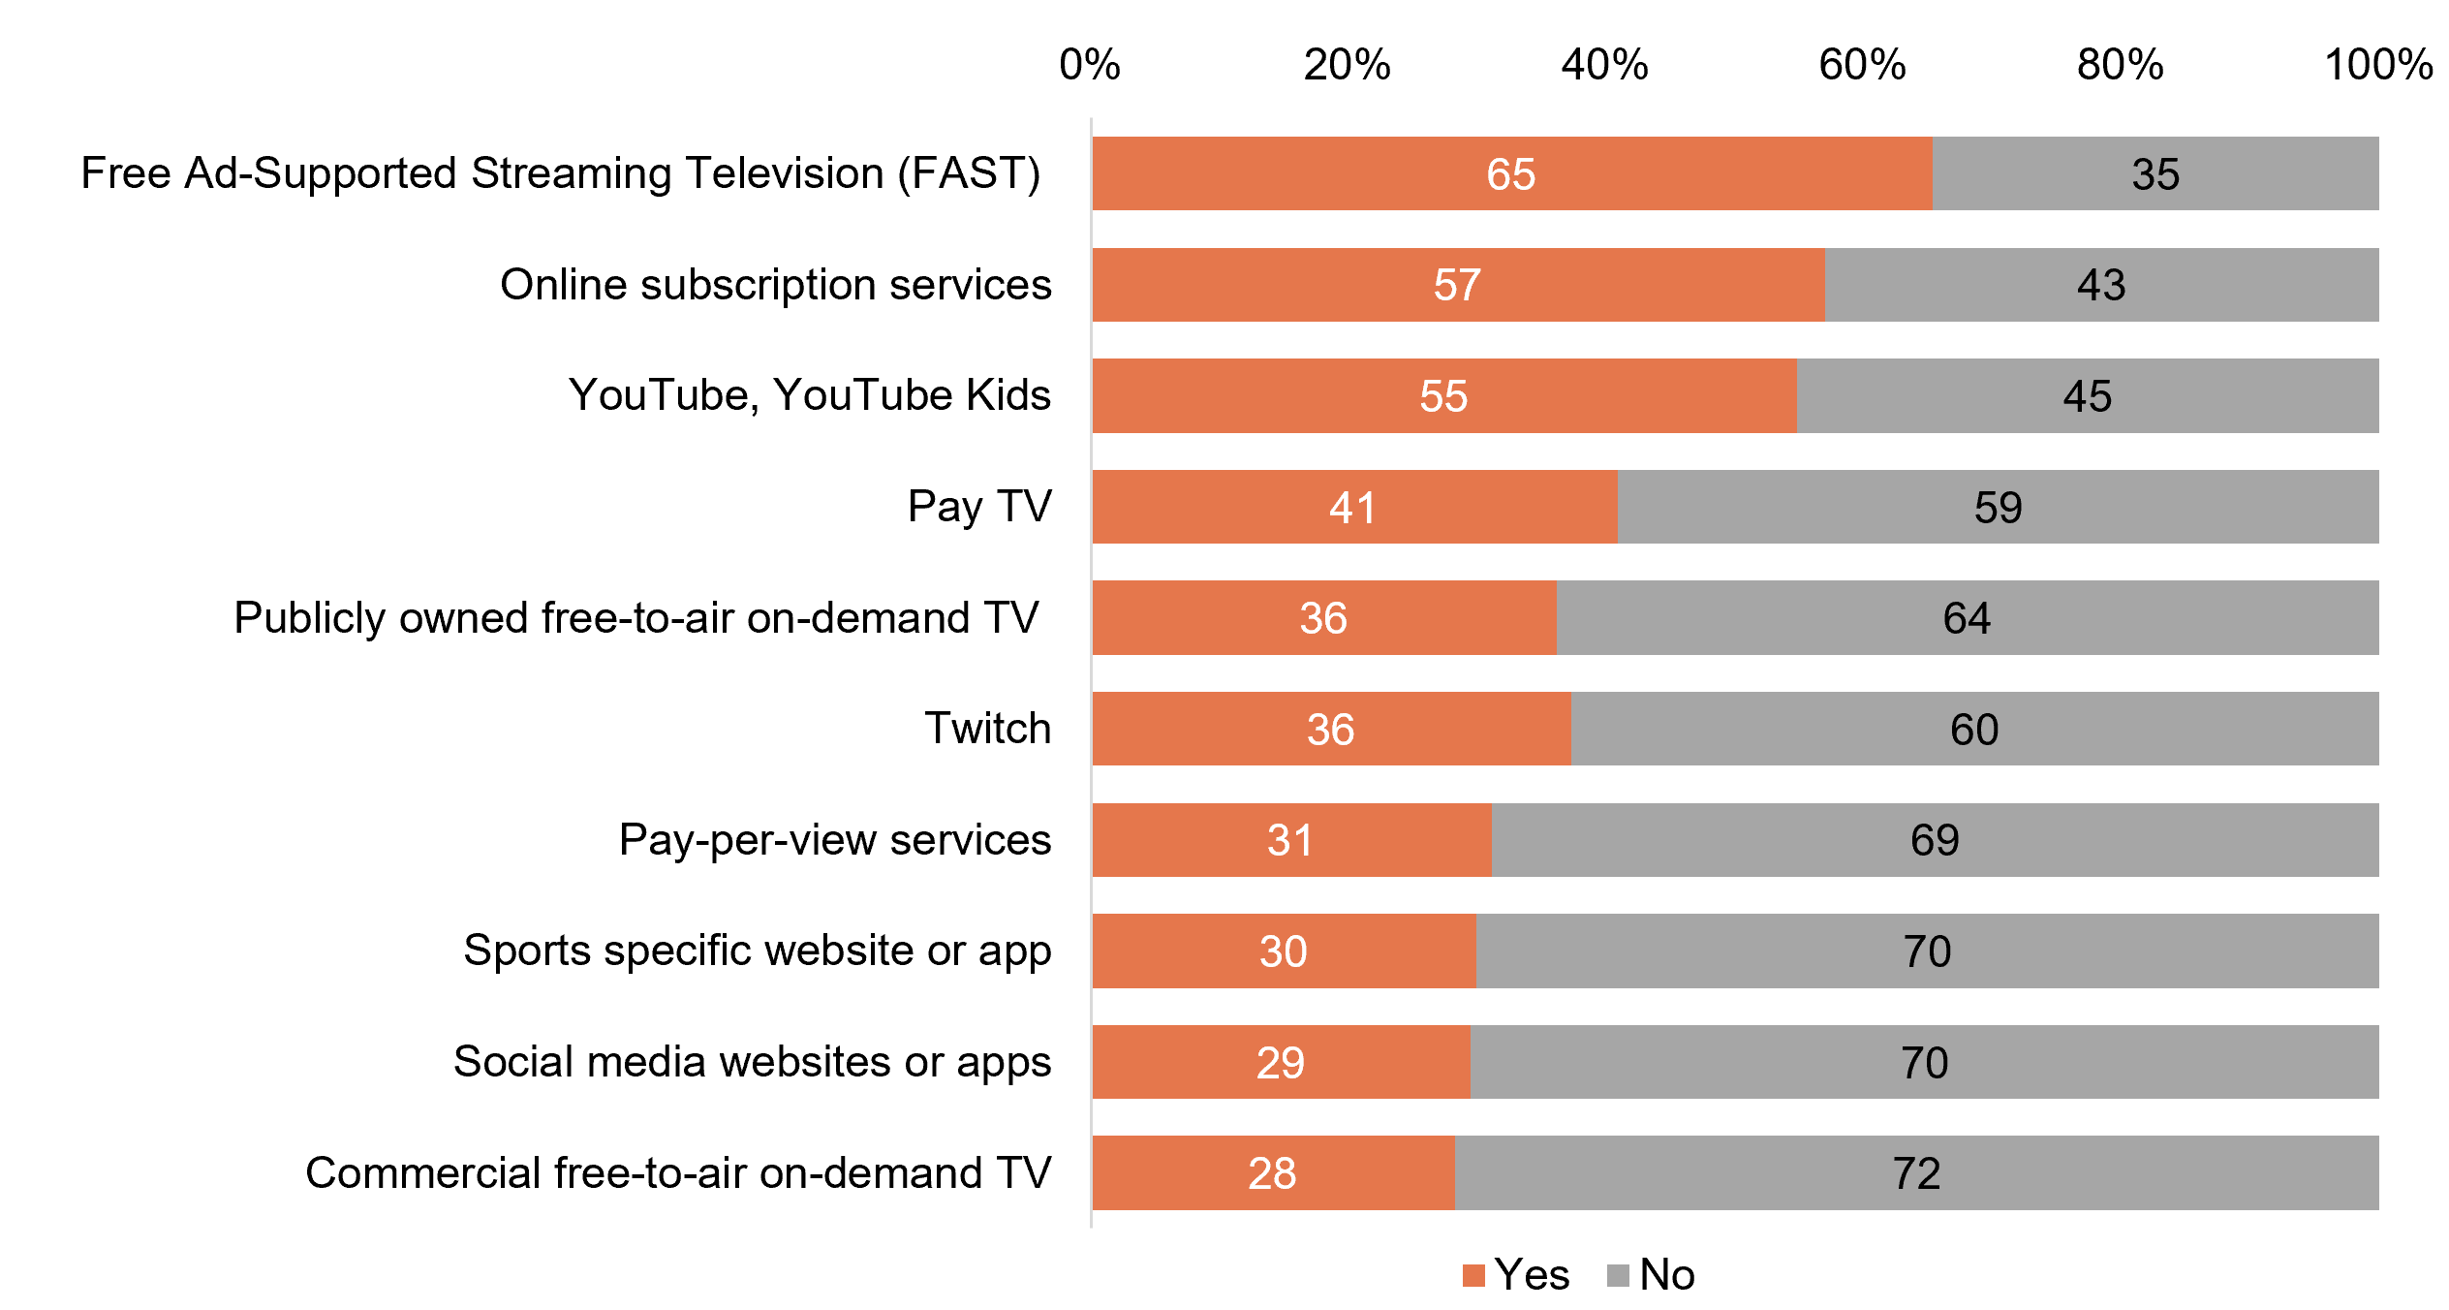
Source: F1a. Do you use parental controls on any of these services?
Base: MCCS, All parents/legal guardians/carers whose child watched any screen content on non-free-to-air platforms in the 7 days before the survey. 2025: n= from 28 to 1,397.
Notes: Don’t know/refused responses not shown, % vary per statement.
Horizontal stacked bar chart showing the percentage of parents who used parental controls across different services in 2025.
Free Ad-Supported Streaming Television: 65% for Yes and 35% for No
Online subscription services: 57% for Yes and 43% for No
YouTube/YouTube Kids: 55% for Yes and 45% for No
Pay TV: 41% for Yes and 59% for No
Publicly owned free-to-air on-demand TV: 36% for Yes and 64% for No
Twitch: 36% for Yes and 60% for No
Pay-per-view services: 31% for Yes and 69% for No
Sports-specific websites or apps: 30% for Yes and 70% for No
Social media websites or apps: 29% for Yes and 70% for No
Commercial free-to-air on-demand TV: 28% for Yes and 72% for No

Subgroup
NET used parental controls on ANY service was higher for:
- Ages 8–10 (73%) or 0–7 (66% vs 51% of ages 11–15, 21% of ages 16–17)
- Those whose children mostly used a household device (71% vs 55% of those whose children had their own device and 54% of those whose children did not have access to any device for online content consumption)
- Those living in a capital city (58% vs 51% of those living outside a capital city)
- Those who speak a language other than English (62% vs 54% of English-only speakers)
Younger children (aged 0-10) were more likely to have parental controls enabled, with the most commonly platform being Free ad-supported streaming television (FAST), online subscription services and YouTube, YouTube Kids.

Level of satisfaction with parental control
Parents/legal guardians/carers were asked about their satisfaction of parental controls enabled on platforms used against certain risks/harmful content towards their child. Overall, half (51% NET somewhat/very satisfied) had higher satisfaction for parental controls towards content of sex/nudity/sexually suggestive content (51%), followed closely behind were depictions of self-harm (50%) and consumption of drugs and alcohol (48%).
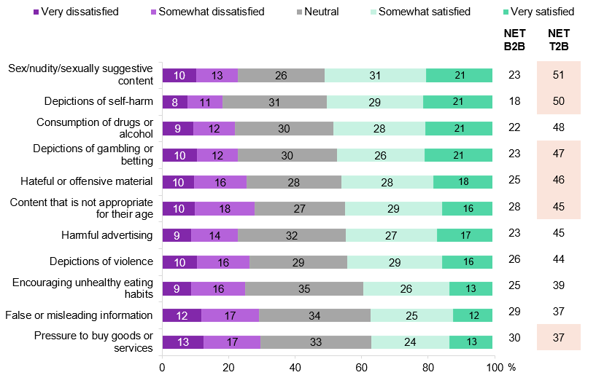
Source: F1c. How satisfied or dissatisfied are you that the parental controls on [Platform selected at F1a] protect your child from…?
Base: MCCS, All parents/legal guardians/carers who used parental controls on any non-free-to-air platforms their children used to watch screen content. 2025: n= from 28 to 1,397.
Notes: Don’t know/refused responses not shown, % vary per statement. ‘NET B2B’ includes ‘Very dissatisfied’ and ‘Somewhat dissatisfied’. ‘NET T2B’ includes ‘Very satisfied’ and ‘Somewhat satisfied’.
Horizontal stacked bar chart showing parents’ satisfaction with parental controls by content type in 2025.
Sex/nudity/sexually suggestive content: 10% very dissatisfied, 13% somewhat dissatisfied, 26% neutral, 31% somewhat satisfied, 21% very satisfied (NET B2B 23%, NET T2B 51%)
Depictions of self-harm: 8% very dissatisfied, 11% somewhat dissatisfied, 31% neutral, 29% somewhat satisfied, 21% very satisfied (NET B2B 18%, NET T2B 50%)
Consumption of drugs or alcohol: 9% very dissatisfied, 12% somewhat dissatisfied, 30% neutral, 28% somewhat satisfied, 21% very satisfied (NET B2B 22%, NET T2B 48%)
Depictions of gambling or betting: 10% very dissatisfied, 12% somewhat dissatisfied, 30% neutral, 26% somewhat satisfied, 21% very satisfied (NET B2B 23%, NET T2B 47%)
Hateful or offensive material: 10% very dissatisfied, 16% somewhat dissatisfied, 28% neutral, 28% somewhat satisfied, 18% very satisfied (NET B2B 25%, NET T2B 46%)
Content that is not appropriate for age: 10% very dissatisfied, 18% somewhat dissatisfied, 27% neutral, 29% somewhat satisfied, 16% very satisfied (NET B2B 28%, NET T2B 45%)
Harmful advertising: 9% very dissatisfied, 14% somewhat dissatisfied, 32% neutral, 27% somewhat satisfied, 17% very satisfied (NET B2B 23%, NET T2B 45%)
Depictions of violence: 10% very dissatisfied, 16% somewhat dissatisfied, 29% neutral, 29% somewhat satisfied, 16% very satisfied (NET B2B 26%, NET T2B 44%)
Encouraging unhealthy eating habits: 9% very dissatisfied, 16% somewhat dissatisfied, 35% neutral, 26% somewhat satisfied, 13% very satisfied (NET B2B 25%, NET T2B 39%)
False or misleading information: 12% very dissatisfied, 17% somewhat dissatisfied, 34% neutral, 25% somewhat satisfied, 12% very satisfied (NET B2B 29%, NET T2B 37%)
Pressure to buy goods or services: 13% very dissatisfied, 17% somewhat dissatisfied, 33% neutral, 24% somewhat satisfied, 13% very satisfied (NET B2B 30%, NET T2B 37%)

Subgroup
NET satisfaction (T2B) was higher for parental controls enabled on:
- Sex/nudity/sexually suggestive content: YouTube, YouTube Kids (51% vs 38% of social media websites or apps)
- Depictions of self-harm: Online subscription services (53%) and YouTube, YouTube Kids (50% vs 39% of social media websites or apps)
- Depictions of gambling or betting: Online subscription services (49%) and YouTube, YouTube Kids (47% vs 36% of social media websites or apps)
- Hateful or offensive material: YouTube, YouTube Kids (44% vs 32% of social media websites or apps)
- Content that is not appropriate for age: Online subscription services (48%) and YouTube, YouTube Kids (43% vs 35% of social media websites or apps)
- Pressure to buy goods or services: Online subscription services (37%) and YouTube, YouTube Kids (36% vs 28% of social media websites or apps)
Overall, the NET satisfaction for parental controls are more prevalent in online subscription services against different risk/harmful content, following by YouTube, YouTube Kids.

Reasons for not using parental control
The key reason for parents/legal guardians/carers to not use parental control were that they trust their child (38%) which was higher for teenagers aged 11–15 (47%) or 16–17 (47%). A quarter (24%) directly supervise the usage of services, which is notably higher for younger children aged 0–7 (40%) and 8–10 (31%). Unfamiliarity, difficulty to set up, and consideration of the children’s ages were reported at similar levels (12%). One in ten (11%) reported other reasons why parental controls are not enabled, such as noting that children can bypass the parental controls and/or can watch content someplace else.
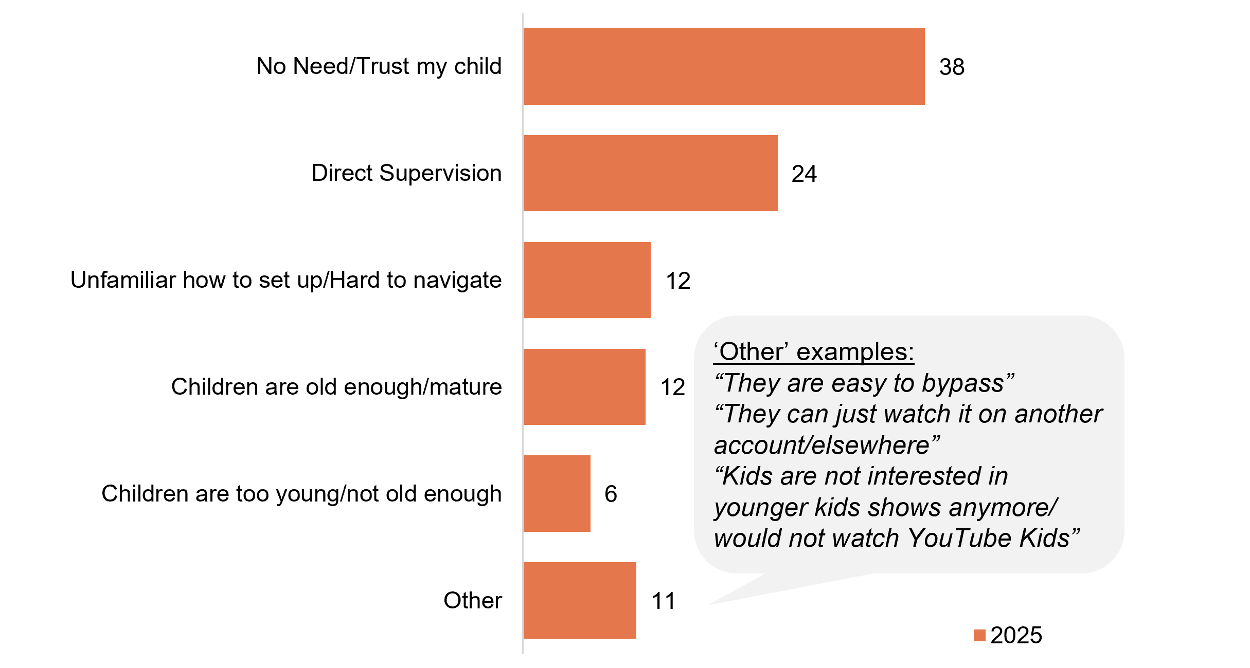
Source: F1bb. What are the reasons you don't use parental controls on this service?
Base: MCCS, All parents/legal guardians/carers who did not use parental controls on any non-free-to-air platforms their children used to watch screen content. 2025: n=1,264.
Notes: Don’t know/refused responses not shown: 2025 DK=3%, Ref=5%.
Horizontal bar chart showing reasons parents did not use parental controls in 2025.
No need / trust my child: 38%
Direct supervision: 24%
Unfamiliar how to set up or hard to navigate: 12%
Children are old enough or mature: 12%
Children are too young / not old enough: 6%
Other reasons: 11%, including examples such as “parental controls being easy to bypass, children watching content on other accounts or elsewhere, and children no longer being interested in younger-age services like YouTube Kids.”

Subgroup
No need/trust my child was higher for:
- Ages 11–15 (47%) or 16–17 (47% vs 30% of ages 8–10, 26% of ages 0–7)
Direct supervision was higher for:
- Ages 0–7 (40%) or 8–10 (31% vs 18% of ages 11–15, 7% of ages 16–17)
Unfamiliar how to set up/Hard to navigate was higher for:
- Women (15% vs 6% of men)
- Ages 8–10 (17%), 0–7 (13%) or 11–15 (13% vs 4% of ages 16–17)
Children are old enough/mature was higher for:
- Ages 16–17 (31% vs 10% of ages 11–15, 6% of ages 8–10 and 1% of ages 0–7)
Children are too young/not old enough was higher for:
- Ages 0–7 (25% vs 0% of ages 8–17)
Two in five of parents/legal guardians/carers report the most common reason why they do not use parental control is due to not thinking it is necessary and/or they trust their child.

Appropriateness of content recommended by streaming services for children
Parents/legal guardians/carers were asked about the level of appropriateness of the content that is recommended by steaming services for their children. Just over a half (57% NET) believed the recommended content was somewhat appropriate/appropriate. A sizeable proportion believe the content was somewhat appropriate for children (36%) and a third were neutral towards the recommended content (34%). Overall, the NET of somewhat appropriate/appropriate was higher for those who have enabled parental controls on subscription services (61% vs 52%).
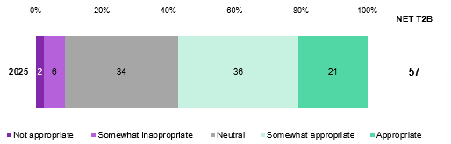
Source: F11. How appropriate or inappropriate is the content recommended by this feature for your child?
Base: MCCS, All parents/legal guardians/carers whose child watched streaming services. 2025: n=1,258.
Notes: Don’t know/refused responses not shown: <0.5% for both in 2025.
Horizontal stacked bar chart showing parents’ views on the appropriateness of content recommended by streaming services for children in 2025.
Not appropriate: 2%
Somewhat inappropriate: 6%
Neutral: 34%
Somewhat appropriate: 36%
Appropriate: 21%
NET T2B (somewhat appropriate or appropriate): 57%

Subgroup
NET T2B (Somewhat appropriate/appropriate) was higher for:
- Those who enabled parental controls on online subscription services (61% vs 52% of those who did not)
Parents/legal guardians/carers who have enabled parental controls are more likely to agree the recommended content from streaming services are appropriate/somewhat appropriate for children.

Australian content
For the purposes of this survey, ‘Australian content’ means shows or movies that are made or produced by Australians. They may also have a primarily Australian cast, and may often, but not always, be set in Australia.

Chapter summary: Australian content
Viewing patterns of Australian content varies across different categories with women more likely to have watched drama and reality shows while men are more inclined to watch news and current affairs and sport.
- Half (49%) of respondents have watched Australian content via subscription streaming services in the past seven days, with the most commonly watched Australian content being drama (45%), news and current affairs (39%) followed by comedy (33%).
Respondents most commonly discover Australian content on streaming services through the home screen, continuing a series, recommendations at the end of a show, and trending lists, with notable differences by gender and platform.
- Overall, respondents are finding Australian content through a variety of methods on their streaming platforms. The most common ways respondents discover Australian content on subscription streaming services are by seeing it on the home screen (23%) and continuing to watch a series (20%), followed by recommendations at the end of a show (16%, higher for women) and trending lists (15%, especially among recent Amazon Prime Video viewers).
Younger children (aged 8–17) more commonly use YouTube, YouTube Kids, whilst children aged 11-17 are more inclined to use online subscription services and social media website or apps for Australian screen content.
- YouTube and YouTube Kids are the leading platforms for Australian content viewing among children aged 8–10, while for ages 11–15, YouTube, YouTube Kids, and online subscription services are equally popular. In 2025, teenagers (especially those aged 16–17) are increasingly using online subscription services, social media, and commercial free-to-air on-demand TV to access Australian content.
- A similar proportion of children aged 0–7 watched Australian screen content on publicly owned free-to-air on-demand TV (51%) and YouTube or YouTube Kids (50%). Engagement with traditional commercial TV (excluding on-demand) increased to 11%, while on-demand commercial TV, sports apps, pay-per-view, and social media websites or apps all showed minimal use (1–4%).

Types of Australian content watched on subscription streaming services in past 7 days
Half (49%) of respondents have watched Australian content via subscription streaming services in the past seven days. The most commonly watched Australian content is drama (45%), news and current affairs (39%) followed by comedy (33%). Viewing patterns vary across different categories of Australian content with women more likely to have watched drama (50%), reality shows (27%) and children’s content (23%) whilst men are more likely to watch news and current affairs (45%) and sport (34%).
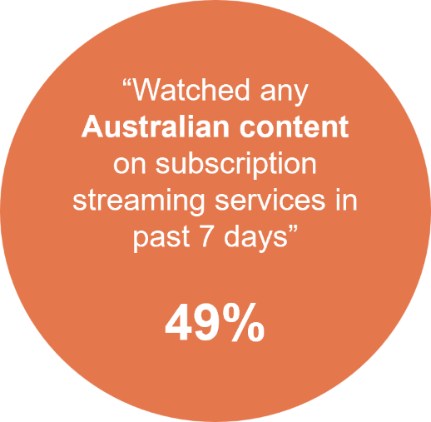
Source: C27. Have you watched any Australian content on subscription streaming services in the past 7 days?
Base: MCCS, Watched subscription streaming services in the 7 days before the survey. 2025: n=2,428.
Notes: No/Don’t know/refused responses not shown: No = 61%, <0.5% for DK and Ref.

Subgroup
Yes was higher for:
- Women (54% vs 45% of men)
- Ages 25+ (54% vs 34% of ages 18–24)
- Aboriginal and/or Torres Strait Islanders (71% vs 48% of non-Aboriginal or Torres Strait Islanders)
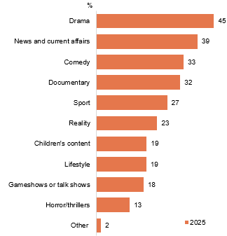
Source: C28. What types of Australian content have you watched on subscription streaming services in the past 7 days?
Base: MCCS, Watched any Australian content on subscription streaming services in the 7 days before the survey. 2025: n=1,226.
Notes: Don’t know/refused responses not shown: 2025 DK=1%, Ref=0%.
Horizontal bar chart showing the types of Australian content watched on subscription streaming services in the past seven days in 2025.
Drama: 45%
News and current affairs: 39%
Comedy: 33%
Documentary: 32%
Sport: 27%
Reality: 23%
Children’s content: 19%
Lifestyle: 19%
Gameshows or talk shows: 18%
Horror/thrillers: 13%
Other: 2%

Subgroup
Drama was higher for:
- Women (50% vs 39% of men)
- Ages 65+ (66% vs 41% of ages 18–54)
News and current affairs was higher for:
- Watched Paramount+ (51%) in P7D
- Men (45% vs 34% of women)
Sport was higher for:
- Watched Cricket Australia Live (86%), NRL Live (68%), Stan Sport (66%), and Kayo Sports (60%) in P7D
- Men (34% vs 22% of women)
- Non-Aboriginal and/or Torres Strait Islanders (28% vs 16% of Aboriginal or Torres Strait Islanders)
Reality was higher for:
- Women (27% vs 19% of men)
- Aboriginal and/or Torres Strait Islanders (35% vs 22% of Non-Aboriginal or Torres Strait Islanders)
Children’s content was higher for:
- Watched Disney+ (27%) in P7D
- Women (23% vs 15% of men)
- Those with dependent children in HH (34% vs 6% of those without children and 5% of empty nesters)
Half of respondents report that they have watched Australian content via subscription streaming services in the past seven days.

Discovery of Australian content on subscription streaming services
The most common methods to discover Australian content on subscription streaming services were from seeing it on the home screen of a streaming service (23%) and by continuing to watch a series (20%). This was followed by having the recommended content appear at the end of a show (16%) which was higher for women (19% vs 12% of men) and seeing it on a trending list (15%) which occurred more often for respondents who have watched Amazon Prime Video in the past seven days (2%).
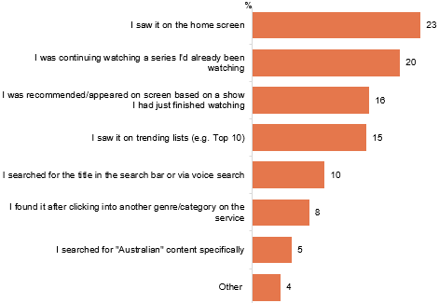
Source: C28a. Thinking of the most recent Australian content you watched on subscription streaming services, how did you come across or search for the Australian content?
Base: MCCS, Watched any Australian content on subscription streaming services in the 7 days before the survey. 2025: n=1,226.
Notes: Don’t know/refused responses not shown: <0.5% for both in 2025.
Horizontal bar chart showing how respondents discovered Australian content on subscription streaming services in the past seven days, in 2025.
I saw it on the home screen: 23%
I was continuing watching a series I’d already been watching: 20%
I was recommended or appeared on screen based on a show I had just finished watching: 16%
I saw it on trending lists (e.g. Top 10): 15%
I searched for the title in the search bar or via voice search: 10%
I found it after clicking into another genre/category on the service: 8%
I searched for ‘Australian’ content specifically: 5%
Other: 4%.

Subgroup
I was recommended or appeared on screen based on a show I had just finished watching was higher for:
- women (19% vs 12% of men)
I saw it on trending lists (e.g. Top 10) was higher for:
- those watched Amazon Prime Video in P7D (22%)
Seeing content on a home screen and continuing to watch a series are the most common ways to discover Australian content on streaming services.

Platforms used to watch Australian screen content (children aged 0-7)
A similar proportion of children aged 0-7 watch Australian screen content on publicly owned free-to-air on-demand TV (51%) and YouTube / YouTube Kids (50%), followed by online subscription services (42%). Traditional formats recorded a significant increase for commercial TV excluding on-demand services with 11%, while on-demand services (4%), sports apps (3%) and pay-per-view (1%) showed minimal viewing. Social media websites or apps also showed a minimal engagement at 3%.
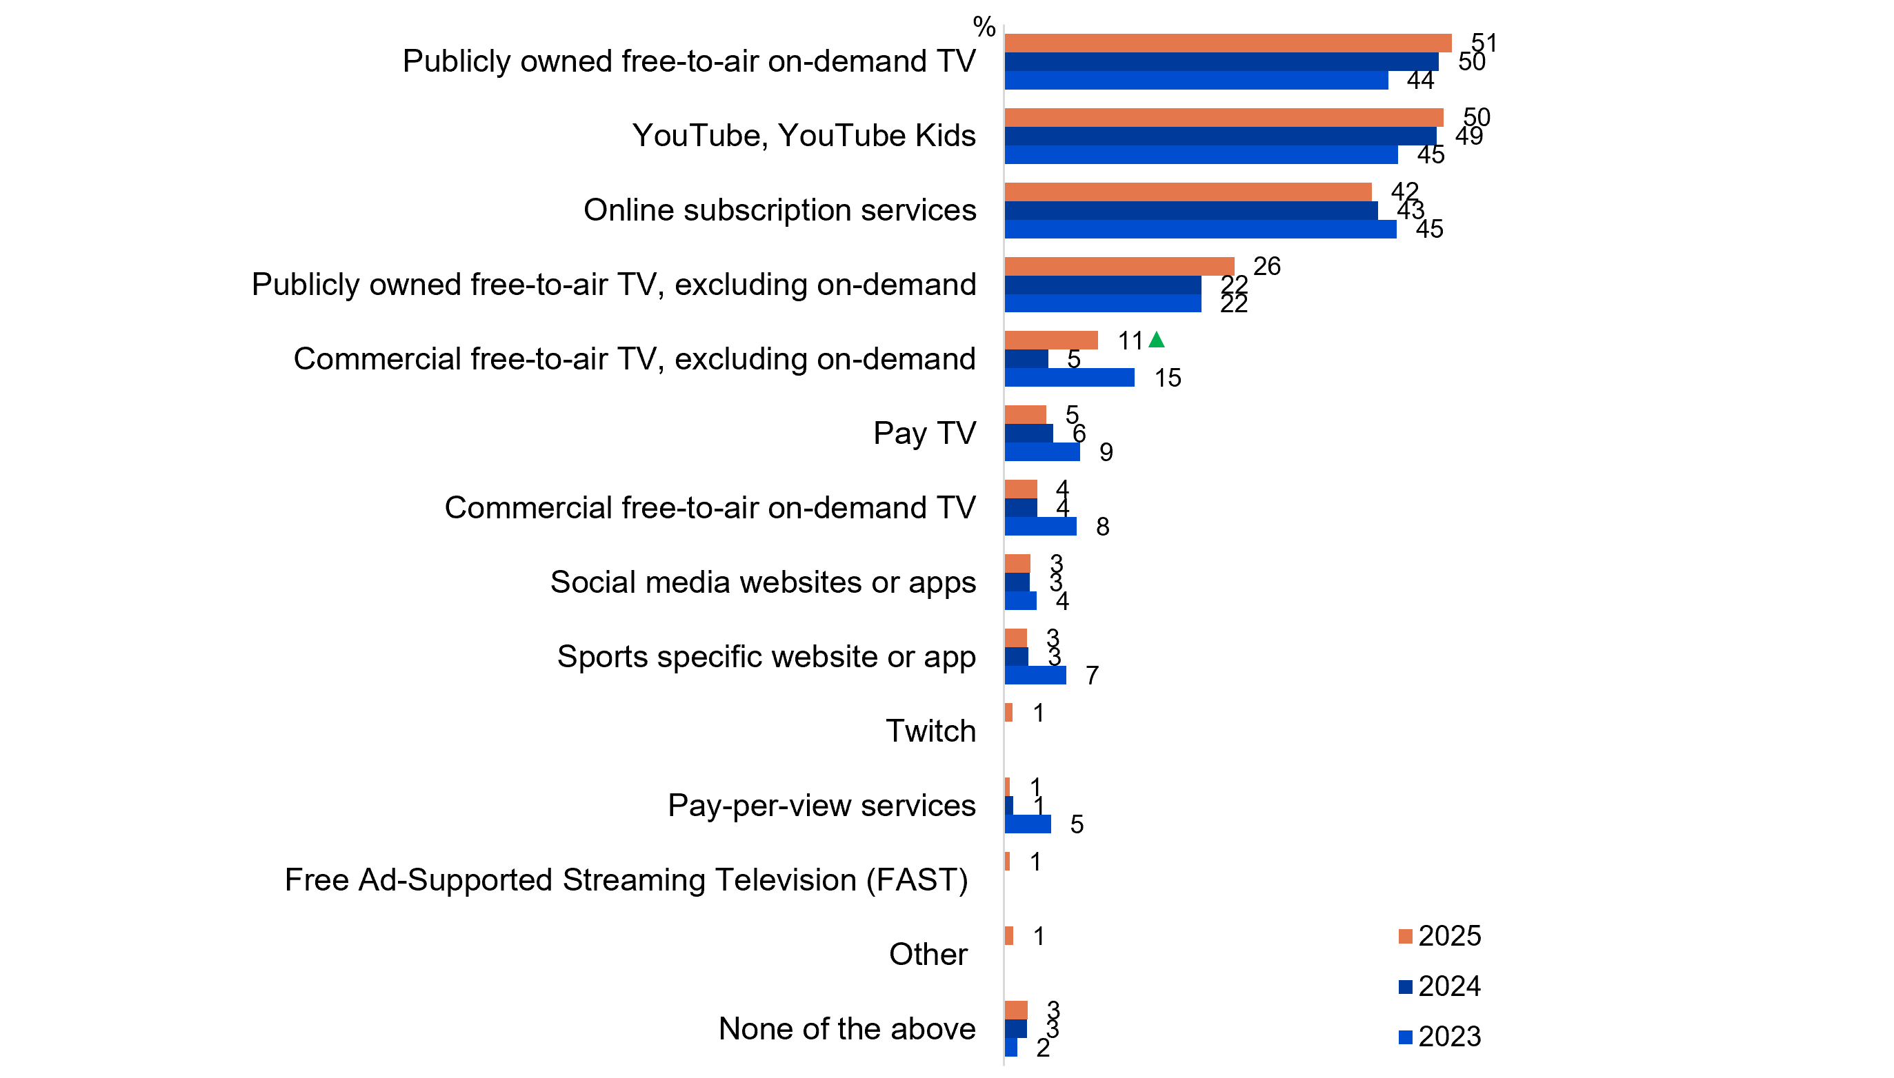
Source: KA4. Now thinking only about Australian children’s programs, which does your child usually watch these on?
Base: MCCS, Parents/legal guardians/carers whose 0-7 year old child watches Australian content. 2025: n=274. 2024: n=313. 2023: n=351.
Notes: Don’t know/refused responses not shown: 0% for both between 2023 and 2025. Full code labels not shown on chart due to ease of reading. Missing bar means item not asked that year.
Horizontal bar chart comparing the platforms used to watch Australian screen content by children aged 0–7 in the past seven days, across 2023, 2024 and 2025
Publicly owned free-to-air on-demand TV: 51% in 2025, 50% in 2024, and 44% in 2023
YouTube / YouTube Kids: 50% in 2025, 49% in 2024, and 45% in 2023
Online subscription services: 42% in 2025, 43% in 2024, and 45% in 2023
Publicly owned free-to-air TV (excluding on-demand): 26% in 2025, 22% in 2024, and 22% in 2023
Commercial free-to-air TV (excluding on-demand): 11% in 2025, 5% in 2024, and 15% in 2023
Pay TV: 5% in 2025, 6% in 2024, and 9% in 2023
Commercial free-to-air on-demand TV: 4% in 2025, 4% in 2024, and 8% in 2023
Social media websites or apps: 3% in 2025, 3% in 2024, and 4% in 2023
Sports-specific website or app: 3% in 2025, 3% in 2024, and 7% in 2023
Twitch: 1% in 2025, not asked in 2024, and not asked in 2023
Pay-per-view services: 1% in 2025, 1% in 2024, and 5% in 2023
Free Ad-Supported Streaming Television (FAST): 1% in 2025, not asked in 2024, and not asked in 2023
Other: 1% in 2025, not asked in 2024, and not asked in 2023
None of the above: 3% in 2025, 3% in 2024, and 2% in 2023

Callout
Commercial free-to-air TV (excluding on-demand) (11% vs 5% in 2024) increased significantly in 2025.
Parents/legal guardians/carers reported that children aged 0-7 primarily watched Australian content on Publicly owned free-to-air on-demand TV, as well as through YouTube, YouTube Kids and online subscription services.

Platforms used to watch Australian screen content (children aged 8–17)
YouTube and YouTube Kids largely led Australian content viewing for children aged 8–10 (49%). Whilst YouTube, YouTube Kids and online subscription services equally lead the Australian viewing content for children aged 11–15 (44%). Comparatively to 2024, children aged 16–17 use platforms such as online subscription services (40%) and social website and apps (36%) more commonly in 2025. Social media websites or apps accessed to watch Australian screen content have significantly increased in 2025 for teenagers, especially 11–15 (25%) and 16–17 (36%) year olds. Older children, 16–17 years olds, report an increase access of commercial free-to-air on demand TV (12%).
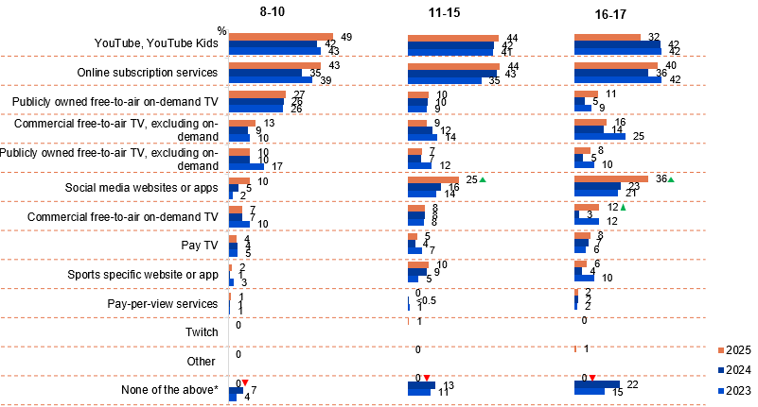
Source: KB4, KC4, KD4. Now thinking only about Australian children’s programs, which do you usually watch these on?
Base: MCCS, Children who watch Australian content. 2025: 8-10 (n=150), 11-15 (n=168), 16-17 (n=108). 2024: 8-10 (n=180), 11-15 (n=187), 16-17 (n=124). 2023: 8-10 (n=185), 11-15 (n=174), 16-17 (n=120).
Notes: Don’t know/refused responses not shown: 2025: 8-10 DK=4%. 11-15 DK=2. 16-17 DK=1%. 2024: 8-10 DK=0%. 11-15 DK=0. 16-17 DK=1%. 2023: 8-10 DK=0%. 11-15 DK=0. 16-17 DK=1%. 0% for Ref between 2023 and 2025. Full code labels not shown on chart due to ease of reading. Missing bar means item not asked that year.
Horizontal bar charts showing platforms used to watch screen content in the past seven days by children aged 8–10, 11–15, and 16–17, comparing 2023, 2024 and 2025.
Age group 8–10:
YouTube / YouTube Kids: 49% in 2025, 42% in 2024, and 43% in 2023
Online subscription services: 43% in 2025, 35% in 2024, and 39% in 2023
Publicly owned free-to-air on-demand TV: 27% in 2025, 26% in 2024, and 26% in 2023
Commercial free-to-air TV (excluding on-demand): 13% in 2025, 9% in 2024, and 10% in 2023
Publicly owned free-to-air TV (excluding on-demand): 10% in 2025, 10% in 2024, and 17% in 2023
Social media websites or apps: 10% in 2025, 5% in 2024, and 2% in 2023
Commercial free-to-air on-demand TV: 7% in 2025, 7% in 2024, and 10% in 2023
Pay TV: 4% in 2025, 4% in 2024, and 5% in 2023
Sports-specific website or app: 2% in 2025, 1% in 2024, and 3% in 2023
Pay-per-view services: 1% in 2025, 1% in 2024, and 1% in 2023
Twitch: 0% in 2025, not asked in 2024, and not asked in 2023
Other: 0% in 2025, not asked in 2024, and not asked in 2023
None of the above: 0% in 2025, 7% in 2024, and 4% in 2023

Age group 11–15:
YouTube / YouTube Kids: 44% in 2025, 42% in 2024, and 41% in 2023
Online subscription services: 44% in 2025, 43% in 2024, and 35% in 2023
Publicly owned free-to-air on-demand TV: 10% in 2025, 10% in 2024, and 9% in 2023
Commercial free-to-air TV (excluding on-demand): 9% in 2025, 12% in 2024, and 14% in 2023
Publicly owned free-to-air TV (excluding on-demand): 7% in 2025, 7% in 2024, and 12% in 2023
Social media websites or apps: 25% in 2025, 16% in 2024, and 14% in 2023
Commercial free-to-air on-demand TV: 8% in 2025, 8% in 2024, and 8% in 2023
Pay TV: 5% in 2025, 4% in 2024, and 7% in 2023
Sports-specific website or app: 10% in 2025, 9% in 2024, and 5% in 2023
Pay-per-view services: 0% in 2025, 0% in 2024, and 1% in 2023
Twitch: 1% in 2025, not asked in 2024, and not asked in 2023
Other: 0% in 2025, not asked in 2024, and not asked in 2023
None of the above: 0% in 2025, 13% in 2024, and 11% in 2023

Age group 16–17:
YouTube / YouTube Kids: 32% in 2025, 42% in 2024, and 42% in 2023
Online subscription services: 40% in 2025, 36% in 2024, and 42% in 2023
Publicly owned free-to-air on-demand TV: 11% in 2025, 5% in 2024, and 9% in 2023
Commercial free-to-air TV (excluding on-demand): 16% in 2025, 14% in 2024, and 25% in 2023
Publicly owned free-to-air TV (excluding on-demand): 8% in 2025, 5% in 2024, and 10% in 2023
Social media websites or apps: 36% in 2025, 23% in 2024, and 21% in 2023
Commercial free-to-air on-demand TV: 12% in 2025, 3% in 2024, and 12% in 2023
Pay TV: 8% in 2025, 7% in 2024, and 6% in 2023
Sports-specific website or app: 6% in 2025, 4% in 2024, and 10% in 2023
Pay-per-view services: 2% in 2025, 2% in 2024, and 2% in 2023
Twitch: 0% in 2025, not asked in 2024, and not asked in 2023
Other: 1% in 2025, not asked in 2024, and not asked in 2023
None of the above: 0% in 2025, 22% in 2024, and 15% in 2023

Subgroup
- YouTube / YouTube Kids was higher amongst children aged 8–10 (49% vs 32% of ages 16–17)
- Publicly owned free-to-air on-demand TV was higher amongst children aged 8–10 (27% vs 11% of ages 16–17 and 10% of ages 11–15)
- Social media websites or apps was higher amongst children aged 16–17 (36% vs 25% of ages 11–15 and 10% of ages 8–10)
Callout
Children aged 11–15:
- None of the above (0% vs 7% in 2024) decreased significantly in 2025
Children aged 11–15:
- Social media websites or apps (25% vs 16% in 2024) increased significantly, whereas none of the above (0% vs 13% in 2024) decreased significantly in 2025
Children aged 16–17:
- Social media websites or apps (36% vs 23% in 2024) and commercial free-to-air on-demand TV (12% vs 3% in 2024) increased significantly, whereas none of the above (0% vs 22% in 2024) decreased significantly in 2025
Note
The decrease in ‘None of the above’ responses this year may be due to the new ‘Other (please specify)’ option introduced in 2025, with many verbatim responses entered there being back-coded to platforms in the existing frame.
Younger children more commonly use YouTube, YouTube Kids, whilst children aged 11-17 are slightly more inclined to use online subscription services and social media website or apps for Australian screen content.

Accessibility features

Chapter summary: Accessibility features
Respondents who use accessibility features to watch screen content are more likely to be aged 18–54, with subtitles and closed captions being more frequently used (an increase in 2025).
- The NET ever used accessibility features to watch screen content increased to 67% in 2025 from 63% in 2023. Usage of accessibility features were higher among those who are deaf or hard of hearing, blind or have reduced vision, people with disabilities, and those living in capital cities, aged 18–54, speaking a language other than English.
Half of respondents in 2025 rely mostly on dubbing for accessibility and rely less on closed captions.
- Reliance on dubbing to understand TV content rose to 52% in 2025, while use of audio description and subtitles remained steady at 40%. Reliance on closed captions declined, with older respondents and those with disabilities, deafness, or vision impairment more likely to use subtitles and closed captions, and many respondents viewing accessibility features as a valuable addition.
A general trend of confidence is observed in respondents using smart TVs.
- Overall, respondents are confident in navigating their smart TV to perform certain tasks.
- Most respondents feel very or somewhat confident in searching for content (80%), switching between platforms (77%), and connecting their Smart TV to the internet (72%), with confidence levels highest among those aged 25+, living in capital cities, and those who watch TV via internet or hybrid methods.

Use of accessibility features to watch screen content
8% of respondents report they are deaf or hard of hearing and 4% report they are blind or have reduced vision. Two thirds (67% NET) report using accessibility features with the most common features used being subtitles (61%) and closed captions (25%). Comparisons of accessibility feature usage between 2023 and 2025 should be treated with caution, as observed differences may reflect changes in media habits or device usage. Those report to have used accessibility features are higher amongst those living in capital city, aged 18–54, and speak a language other than English.
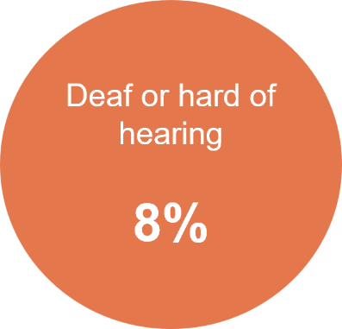
Source: HEAR_Q03. Are you deaf or hard of hearing?
Base: TVCS & MCCS, All respondents. 2025: n=4,396.
Notes: No/Don’t know/refused responses not shown: No=90%, Ref<0.5%, DK=1%

Subgroup
Deaf or hard of hearing was higher for:
- Men (10% vs 6% of women)
- Ages 55+ (18% vs 3% of ages 18–54)
- Those living outside a capital city (11% vs 5% of those living in a capital city)
- Those who are blind or have low/reduced vision (20% vs 8% of those who did not)
- Those with a disability (20% vs 6% of those without)
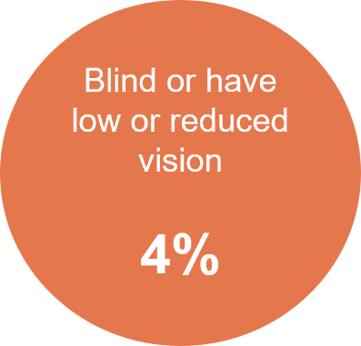
Source: VISION_Q03. Are you blind or do you have low or reduced vision?
Base: TVCS & MCCS, All respondents. 2025: n=4,396.
Notes: No/Don’t know/refused responses not shown: No=95%, Ref<0.5%, DK=1%

Subgroup
Blind or have low or reduced vision was higher for:
- Those who are deaf or hard of hearing (10% vs 3% of those who are not)
- Those with a disability (10% vs 3% of those without)
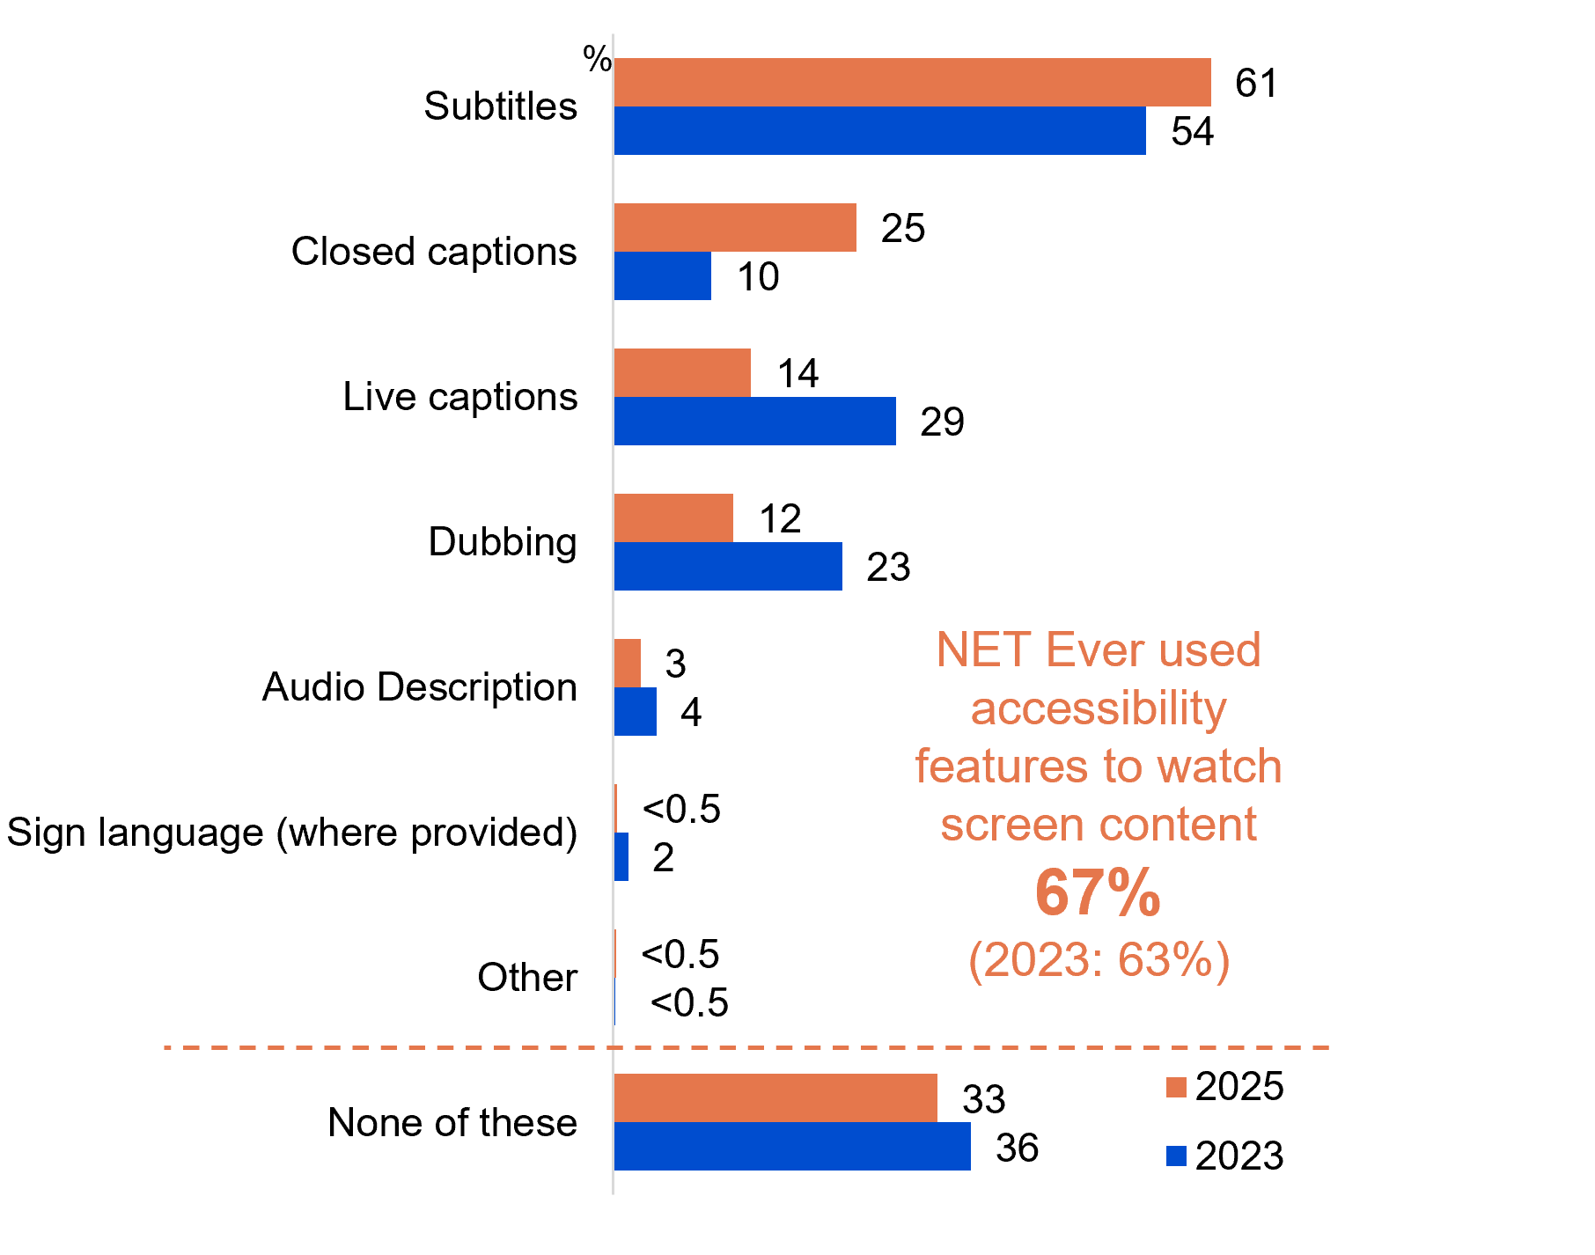
Source: C20A. Have you ever used any of the following accessibility features to watch screen content?
Base: TVCS & MCCS, Used any accessibility features to watch screen content. 2025: n=4,324. 2023: n=4,790.
Notes: Don’t know/refused responses not shown: <0.5% for both in 2023 and 2025. Significant testing was not conducted between the 2023 and 2025 results, as any observed differences may reflect changes in media habits or device usage rather than accessibility feature usage.
Horizontal bar chart showing accessibility features used to watch screen content, comparing 2025 and 2023
Subtitles: 61% in 2025 and 54% in 2023
Closed captions: 25% in 2025 and 10% in 2023
Live captions: 14% in 2025 and 29% in 2023
Dubbing: 12% in 2025 and 23% in 2023
Audio description: 3% in 2025 and 4% in 2023
Sign language (where provided): less than 0.5% in 2025 and 2% in 2023
Other: less than 0.5% in both 2025 and 2023
None of these: 33% in 2025 and 36% in 2023
NET ever used accessibility features to watch screen content: 67% in 2025, compared with 63% in 2023

Subgroup
NET Ever used accessibility features to watch screen content was higher for:
- Ages 18–54 (76% vs 51% of ages 54+)
- Those living in a capital city (76% vs 57% of those living outside a capital city)
- Aboriginal and/or Torres Strait Islanders (80% vs 66% of Non-Aboriginal or Torres Strait Islanders)
- Those who speak a language other than English (80% vs 63% of English-only speakers)
- Those with a Bachelor degree (78%) or a Postgraduate degree/Graduate Diploma (74% vs 62% of those with education up to Year 12 and 62% of those with a TAFE qualification/Trade Certificate/Diploma)
Two thirds of respondents report using accessibility features to watch screen content, with subtitles and closed captions being most commonly used.

Extent of reliance on accessibility features for TV content
Half (52% NET) of respondents rely on dubbing fully or partially to understand TV content, with a significant increase in 2025. This is followed by audio description and subtilties (40% NET), however a decrease is observed over the reliance on closed captions (31% NET). Older respondents, those with disabilities and those who are deaf, blind, hard of hearing or have low/reduced vision are more likely to use subtitles and closed captions. A sizeable proportion of respondents have responded that accessibility features are a nice feature to have.
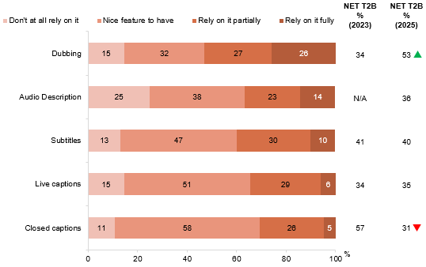
Source: C20B. For each of the following accessibility features you have used, to what extent do you rely on it to understand the TV content you are watching?
Base: TVCS & MCCS, All respondents. 2025: n= from 124 to 2,604. 2023: n= from 418 to 2,424.
Notes: Don’t know/refused responses not shown, % vary per statement. ‘NET T2B’ includes ‘Rely on it partially’ and ‘Relied on it fully’. Responses for Sign language (n=25) and Other (n=12) not shown due to small base sizes.
Horizontal stacked bar chart showing the extent to which people rely on accessibility features to understand TV content in 2025, with comparison to NET T2B results between 2023 and 2025.
Dubbing: 15% do not rely on it at all, 32% say it is a nice feature to have, 27% rely on it partially, and 26% rely on it fully (NET T2B 53% in 2025 and 34% in 2023)
Audio description: 25% do not rely on it at all, 38% say it is a nice feature to have, 23% rely on it partially, and 14% rely on it fully (NET T2B 36% in 2025, not asked in 2023)
Subtitles: 13% do not rely on it at all, 47% say it is a nice feature to have, 30% rely on it partially, and 10% rely on it fully (NET T2B 40% in 2025, and 41% in 2023)
Live captions: 15% do not rely on it at all, 51% say it is a nice feature to have, 29% rely on it partially, and 6% rely on it fully (NET T2B 35% in 2025, and 34% in 2023)
Closed captions: 11% do not rely on it at all, 58% say it is a nice feature to have, 26% rely on it partially, and 5% rely on it fully (NET T2B 31% in 2025, and 57% in 2023)

Subgroup
NET T2B (2025) for Subtitles was higher for:
- Ages 55+ (51% vs 36% of ages 18–54)
- Those with a disability (57% vs 38% of those without)
- Those who are deaf or hard of hearing (65% vs 38% of those who are not)
- Those who are blind or have low/reduced vision (56% vs 39% of those who did not)
NET T2B (2025) for closed captions was higher for:
- Ages 75+ (56% vs 28% of ages 18–54)
- Those with a disability (56% vs 26% of those without)
- Those who are deaf or hard of hearing (69% vs 26% of those who are not)
- Those who are blind or have low/reduced vision (55% vs 29% of those who did not)

Callout
NET T2B (2025) for dubbing (53% vs 34% in 2023) increased significantly higher, whereas NET T2B (2025) for closed captions (31% vs 57% in 2023) decreased significantly in 2025.
Half of the respondents report that dubbing as an accessibility feature is more frequently relied on, with a reported decrease on reliance in closed captions.

Reasons for using accessibility features
Easy comprehension was the most common reason for using live captions (60%), closed captions (64%) and audio description (47%). This is followed by environmental factors for both live and closed captions (57% and 55% respectively), whereas audio descriptions are mostly used for multitasking reasons (41%).
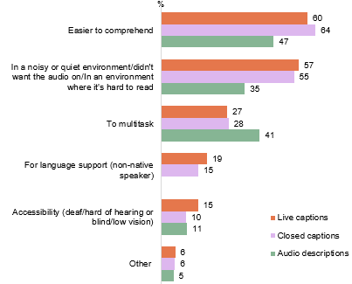
Source: C35. Why do you use live captions? C36. Why do you use closed captions? C37. Why do you use audio descriptions?
Base: TVCS & MCCS, Used live captions, closed captions or audio descriptions. 2025: Used live captions (n=573), Used closed captions (n=987), Used audio descriptions (n=124).
Notes: Don’t know/refused responses not shown: all <1% in 2025. Missing bar means item not asked.
Horizontal bar chart showing reasons for using accessibility features, by feature type, in 2025.
Easier to comprehend: 60% for live captions, 64% for closed captions, and 47% for audio descriptions
In a noisy or quiet environment / didn’t want audio on / in an environment where it’s hard to read: 57% for live captions, 55% for closed captions, and 35% for audio descriptions
To multitask: 27% for live captions, 28% for closed captions, and 41% for audio descriptions
For language support (non-native speaker): 19% for live captions, 15% for closed captions and not asked for audio descriptions
Accessibility (deaf or hard of hearing, or blind or low vision): 15% for live captions, 10% for closed captions, and 11% for audio descriptions
Other: 6% for live captions, 6% for closed captions, and 5% for audio descriptions

Subgroup
Easier to comprehend
- Live captions was higher for ages 18–24 (74% vs 55% of ages 25+)
- Closed captions was higher for ages 18–24 (80% vs 57% of ages 25+)
Accessibility (deaf or hard of hearing, or blind or low vision)
- Live captions was higher for ages 55+ (38% vs 9% of ages 18–44), those with a disability (31% vs 12% of those without), those who are deaf or hard of hearing (79% vs 5% of those who are not) and those who are blind or have low/reduced vision (42% vs 13% of those who did not)
- Closed captions was higher for ages 55+ (29% vs 6% of ages 18–44), those with a disability (19% vs 9% of those without), those who are deaf or hard of hearing (74% vs 4% of those who are not) and those who are blind or have low/reduced vision (32% vs 9% of those who did not
Easy comprehension were reported to be the most common reason which respondents use audio description, live and closed captions.

Confidence in using Smart TV
Respondents are very/somewhat confident in searching for particular content or programs (80%), followed by switching between platforms (77%) and connecting the TV to the internet (72%). Overall, a sizeable proportion of respondents report that they feel very/somewhat confident in performing the listed tasks on their Smart TV which is consistently higher amongst those aged 25+, those living in capital city and have watched TV either via the internet or hybrid of traditional and online.
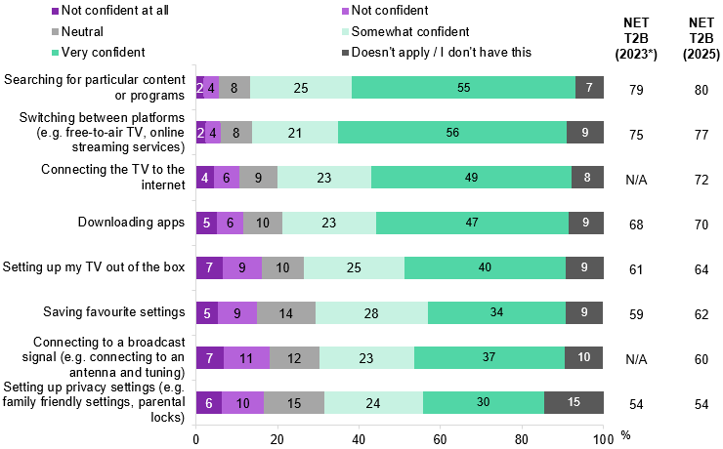
Source: C26_1. To what extent are you confident or not confident in doing each of the following on a Smart TV?
Base: 2025: TVCS & MCCS, All respondents: n=4,396. 2023: MCCS, All respondents: n=3,730.
Notes: Don’t know/refused responses not shown, % vary per statement. ‘NET T2B’ includes ‘Somewhat confident’ and ‘Very confident’. N/A means item not asked that year. *Significant testing was not conducted between 2023 and 2025 results due to differences in sample composition.
Horizontal stacked bar chart showing the level of confidence in using smart TVs to perform different tasks, with NET T2B (somewhat or very confident) comparisons between 2023 and 2025.
Searching for particular content or programs:
2% not confident at all, 4% not confident, 8% neutral, 25% somewhat confident, 55% very confident, and 7% does not apply or do not have this.
NET T2B: 80% in 2025 and 79% in 2023.
Switching between platforms (for example, free-to-air TV and online streaming services):
2% not confident at all, 4% not confident, 8% neutral, 21% somewhat confident, 56% very confident, and 9% does not apply or do not have this.
NET T2B: 77% in 2025 and 75% in 2023.
Connecting the TV to the internet:
4% not confident at all, 6% not confident, 9% neutral, 23% somewhat confident, 49% very confident, and 8% does not apply or do not have this.
NET T2B: 72% in 2025 and not available for 2023.
Downloading apps:
5% not confident at all, 6% not confident, 10% neutral, 23% somewhat confident, 47% very confident, and 9% does not apply or do not have this.
NET T2B: 70% in 2025 and 68% in 2023.
Setting up my TV out of the box:
7% not confident at all, 9% not confident, 10% neutral, 25% somewhat confident, 40% very confident, and 9% does not apply or do not have this.
NET T2B: 64% in 2025 and 61% in 2023.
Saving favourite settings:
5% not confident at all, 9% not confident, 14% neutral, 28% somewhat confident, 34% very confident, and 9% does not apply or do not have this.
NET T2B: 62% in 2025 and 59% in 2023.
Connecting to a broadcast signal (for example, connecting to an antenna and tuning):
7% not confident at all, 11% not confident, 12% neutral, 23% somewhat confident, 37% very confident, and 10% does not apply or do not have this.
NET T2B: 60% in 2025 and not available for 2023.
Setting privacy settings (for example, family-friendly settings and parental locks):
6% not confident at all, 10% not confident, 15% neutral, 24% somewhat confident, 30% very confident, and 15% does not apply or do not have this.
NET T2B: 54% in 2025 and 54% in 2023.

Subgroup
Searching for particular content or programs was higher for:
- Ages 25–34 (90%)
Switching between platforms (for example, free-to-air TV and online streaming services) was higher for:
- Ages 25–34 (87%)
- Those living in a capital city (79% vs 75% of those living outside a capital city)
- Watched TV via the internet only (84%) or via a hybrid of traditional and online connection (83% vs 67% of those watched TV via traditional connection only and 66% of those who did not watch TV)
Setting up my TV out of the box was higher for:
- Ages 25–64 (70% vs 59% of ages 18–24 and 52% of ages 65+)
Connecting to a broadcast signal (for example, connecting to an antenna and tuning) was higher for:
- Ages 25–64 (65% vs 55% of ages 65+ and 47% of ages 18–24 )
- Watched TV via a hybrid of traditional and online connection (67%) or via traditional connection only (59% vs 50% of those watched TV via the internet only and 46% who did not watch TV)
Overall, respondents are confident in navigating their smart TV to perform certain tasks.

Video games

Chapter summary: Video games
Younger Australians and men were more likely play video games in the past 7 days, with mobile phones the most commonly used device for gaming in 2025.
- Younger respondents aged 18–54 were more likely to use mobile phone (62% vs 53%), followed by computer (41% vs 33%) to play video games, whereas older respondents aged 55+ were more likely to use tablets (31% vs 14%) for gaming.
- Gender plays a factor in the devices used for gaming, women are more likely to use mobile phone for gaming (68%) whilst men are more likely to use a computer (27%) and PlayStation (29%).
Computers and Xbox have the highest average weekly playing hours of all devices in 2025.
- Computers lead weekly gaming hours varied at 9.3 hours which was slightly lowered compared to 2024. This is followed by Xbox at 7.4 hours and PlayStation and tablet usage equally at 6.9 hours. 4% of respondents used other handheld or portable consoles citing a significant increase in 2025.
Text chat or messaging with a team or via private message was the most common form of interaction while gaming.
- Text chat or messaging with a team or via private message was the most common form of interaction, with around four in ten (42%) players reporting having ever done so. Interacting with others while gaming was more common among men, those aged 18–44, and heavy gamers who played more than 20 hours per week across any device. Interactions were most likely to occur on other handheld or portable consoles, followed by computers and PlayStation.
Children aged 8–10 reportedly played the most games in the past seven days and have the most parental restrictions placed on their video games. Whilst children aged 16–17 interact with others more frequently when playing video games across various formats.
- Children aged 8–10 (76%) were reported by parents/legal guardians/carers to have played video games in the past seven days, while 65% of children aged 0–7 report to not have played in the past seven days. The accessibility to play video games can be seen correlating to the parental restrictions that are placed on video games, as 77% parents/legal guardians/carers of older children (aged 16–17) report not placing restrictions but those aged 8–10 who were reported as the cohort with the greatest number of parental restrictions placed (86%).
- Teenagers, aged 16–17 were the most frequently active across voice chat – global (52%), team chat or private message (70%), text chat – global (65%) and team chat via text/messaging (73%). For voice chat in global context - global, boys are more likely to be part of the cohort (28% vs 19% of girls).
Children aged 8-15 were more likely to have made microtransaction purchases in a video game with permission, while older teenagers paid with their own funds. The most common form of video game purchase is in-game currency and actioned most frequently at home.
- 64% of microtransactions purchases done so in videogames were parent-authorised by children aged 8–10 (75%) and 11–15 (72%). While teens (11–17) showed higher overall purchase rates, 13% were paid by children aged 16–17 (27%) with their own funds, 8% has ongoing permission and one in six (15%) have made unauthorised transactions.
- 63% of videogame purchases in the past 12 months were for in-game currency with the most frequency location of purchases being at home.
- Purchases completed at home were reportedly higher for older children aged 16–17 (95%) and aged 11–15 (89%).

Video gaming participation in the past 7 days
Video gaming participation spans 38% of respondents in the past seven days, with a notable gender gap showing higher participation among men (41%) than women (34%). Age emerges as a factor also, with participation declining steadily from 60% among 18–24 year-olds to just 29% for those 35+. Mobile phones lead as the preferred gaming platform. Gaming device usage also varies by gender, with men more likely to use a computer (47% vs 25%) and PlayStation (23% vs 17%), while women are more likely to use a mobile phone (68% vs 51%). Other handheld or portable consoles usage have significantly risen in 2025 with 4%.
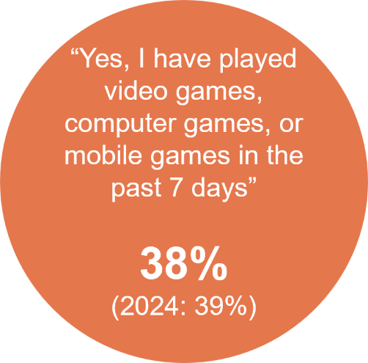
Source: VIDEO1. Have you played any video games, computer games, or mobile games in the past 7 days, at home or elsewhere?
Base: TVCS & MCCS, All respondents. 2025: n=4,396.
2024: n=4,490.
Notes: No/Don’t know/refused responses not shown: 2025 No = 62%, 0% for DK and Ref. 2024 No = 61%, <0.5% for DK and Ref.
Circular highlight graphic showing that 38% of respondents said they have played video games, computer games, or mobile games in the past seven days, compared with 39% in 2024.

Subgroup
Played video games in P7D was higher for:
- Men (41% vs 34% of women)
- Ages 18–34 (60% vs 29% of ages 35+)
- Those living in a capital city (45% vs 31% of those living outside a capital city)
- 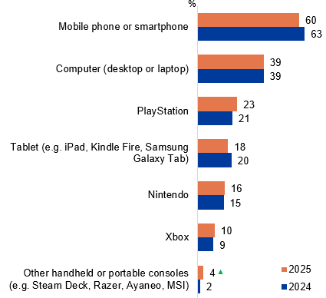
Source: VIDEO2. Which of the following did you use to play video games or computer games in the past 7 days, at home or elsewhere?
Base: TVCS & MCCS, Respondents who played video games in past 7 days. 2024: n=1,506. 2024: n=1,629.
Notes: Don’t know/refused responses not shown: <0.5% for both in 2024 and 2025.
Horizontal bar chart showing devices used to play video games in the past seven days, comparing 2025 and 2024.
Mobile phone or smartphone: 60% in 2025 and 63% in 2024
Computer (desktop or laptop): 39% in 2025 and 39% in 2024
PlayStation: 23% in 2025 and 21% in 2024
Tablet (for example, iPad, Kindle Fire, Samsung Galaxy Tab): 18% in 2025 and 20% in 2024
Nintendo: 16% in 2025 and 15% in 2024
Xbox: 10% in 2025 and 9% in 2024
Other handheld or portable consoles (for example, Steam Deck, Razer, Ayaneo, MSI): 4% in 2025 and 2% in 2024

Subgroup
Mobile phone or smartphone was higher for:
- Women (68% vs 51% of men)
Computer (desktop or laptop) was higher for:
- Men (47% vs 25% of women)
- Ages 18–34 (52% vs 26% of ages 35–74)
- Those living in a capital city (42% vs 34% of those living outside a capital city)
PlayStation was higher for:
- Men (29% vs 17% of women)
- Ages 25–44 (33% vs 22% of ages 18–24 and 13% of ages 45+)
Younger respondents aged 18-54 were more likely to use mobile phone (62% vs 53%), Computer (41% vs 33%), PlayStation (28% vs 7%), Nintendo (20% vs 1%), and Xbox (12% vs 5%) to play video games, whereas older respondents aged 55+ were more likely to use Tablets (31% vs 14%) for gaming.

Callout
Other handheld or portable consoles (for example, Steam Deck, Razer, Ayaneo, MSI) (4% vs 2% in 2024) increased significantly in 2025.
Younger Australians and men were more likely to report playing video games in the past 7 days in 2025.
Mobile phones were the most commonly used device for gaming.

Hours spent playing video games per week by devices
Weekly gaming hours varied by platform, with computer leading at 9.3 hours slightly lower in previous year, followed by Xbox at 7.4 hours and PlayStation and tablet usage equally at 6.9 hours. 4% of respondents used other handheld or portable consoles citing a significant increase in 2025, the average weekly gaming time among users (6.8 hours) yet similar to that of PlayStation and Tablet users (6.9 hours).
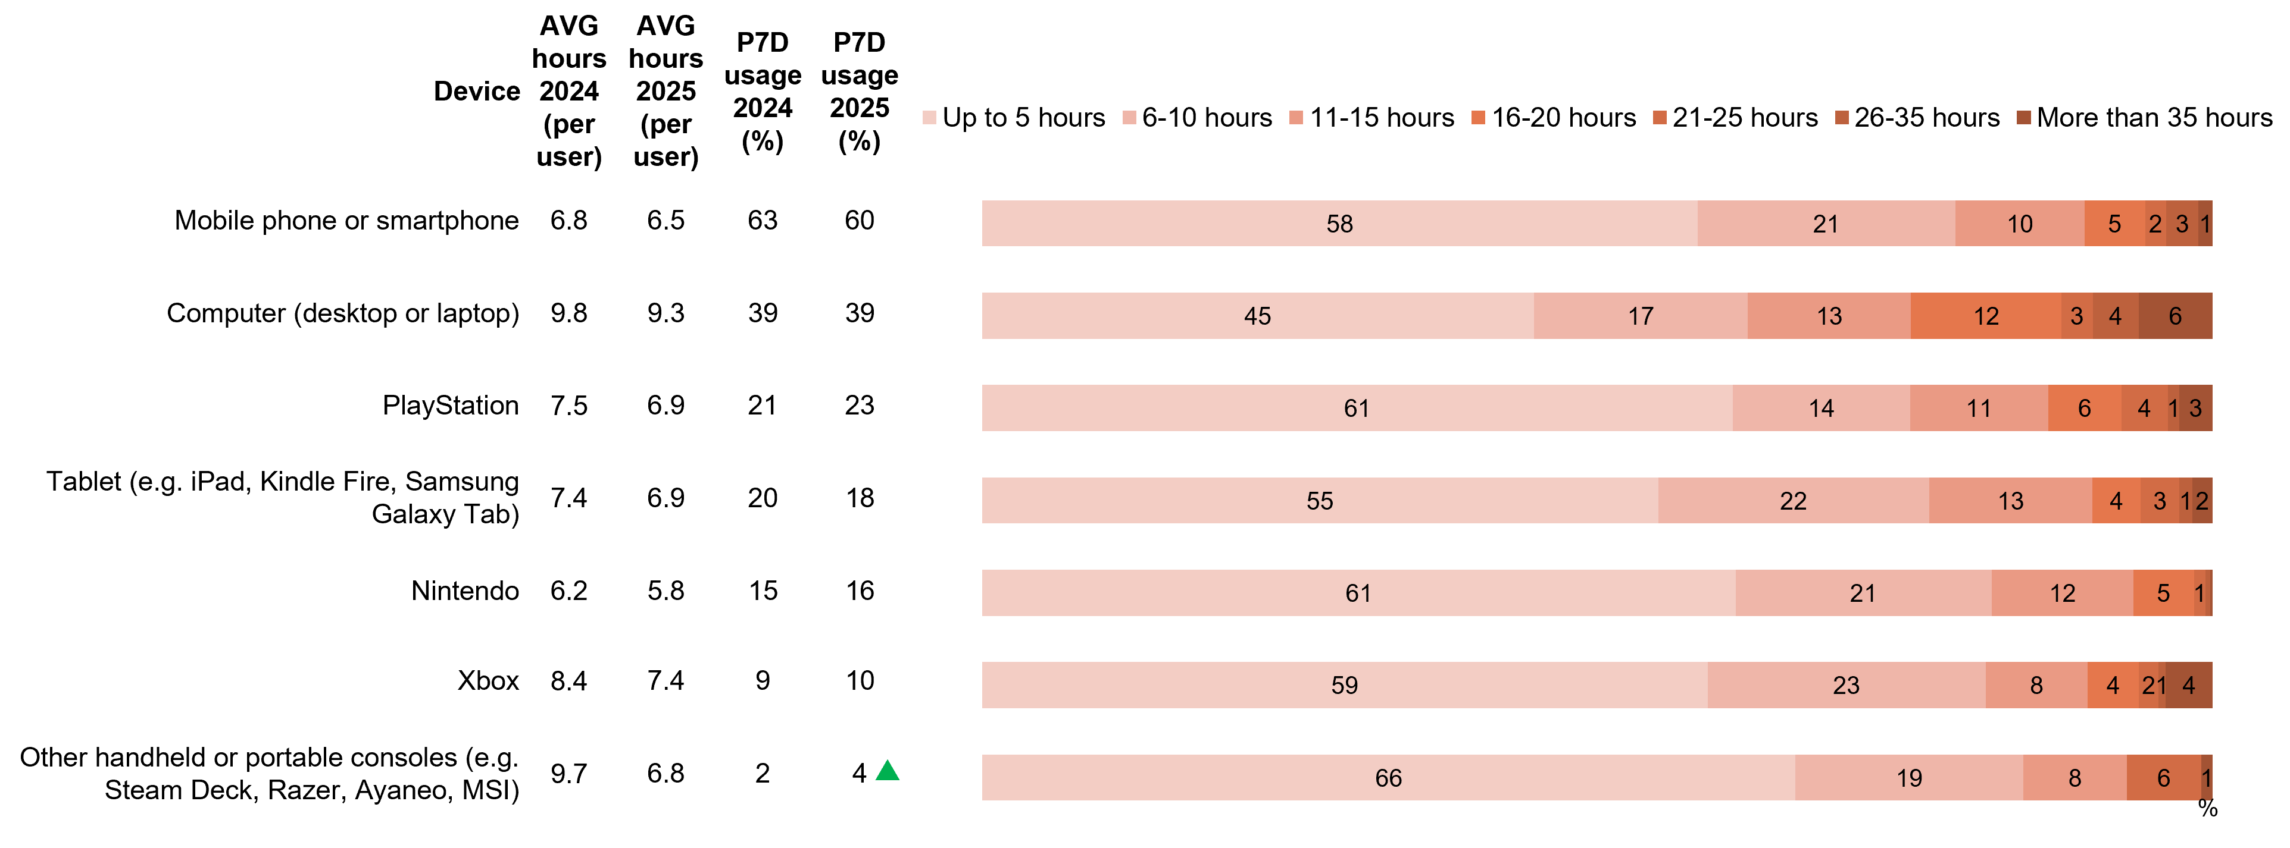
Source: VIDEO3. On average, how many hours per week do you spend playing video games with each of the following devices?
Base: TVCS & MCCS, Respondents who played video games in past 7 days. 2025: n= from 43 to 875. 2024: n= from 31 to 994.
Notes: Don’t know/refused responses not shown, % vary per statement.
Stacked horizontal bar chart showing hours spent playing video games per week by device, comparing 2024 and 2025.
Mobile phone or smartphone:
Average hours per user were 6.8 in 2024 and 6.5 in 2025. Past seven-day usage was 63% in 2024 and 60% in 2025.
Time spent gaming in 2025: 58% up to 5 hours, 21% 6–10 hours, 10% 11–15 hours, 5% 16–20 hours, 2% 21–25 hours, 3% 26–35 hours, and 1% more than 35 hours.
Computer (desktop or laptop):
Average hours per user were 9.8 in 2024 and 9.3 in 2025. Past seven-day usage was 39% in both years.
Time spent gaming in 2025: 45% up to 5 hours, 17% 6–10 hours, 13% 11–15 hours, 12% 16–20 hours, 3% 21–25 hours, 4% 26–35 hours, and 6% more than 35 hours.
PlayStation:
Average hours per user were 7.5 in 2024 and 6.9 in 2025. Past seven-day usage was 21% in 2024 and 23% in 2025.
Time spent gaming in 2025: 61% up to 5 hours, 14% 6–10 hours, 11% 11–15 hours, 6% 16–20 hours, 4% 21–25 hours, 1% 26–35 hours, and 3% more than 35 hours.
Tablet (for example, iPad, Kindle Fire, Samsung Galaxy Tab):
Average hours per user were 7.4 in 2024 and 6.9 in 2025. Past seven-day usage was 20% in 2024 and 18% in 2025.
Time spent gaming in 2025: 55% up to 5 hours, 22% 6–10 hours, 13% 11–15 hours, 4% 16–20 hours, 3% 21–25 hours, 1% 26–35 hours, and 2% more than 35 hours.
Nintendo:
Average hours per user were 6.2 in 2024 and 5.8 in 2025. Past seven-day usage was 15% in 2024 and 16% in 2025.
Time spent gaming in 2025: 61% up to 5 hours, 21% 6–10 hours, 12% 11–15 hours, 5% 16–20 hours, 1% 21–25 hours, 0% 26–35 hours, and 0% more than 35 hours.
Xbox:
Average hours per user were 8.4 in 2024 and 7.4 in 2025. Past seven-day usage was 9% in 2024 and 10% in 2025.
Time spent gaming in 2025: 59% up to 5 hours, 23% 6–10 hours, 8% 11–15 hours, 4% 16–20 hours, 2% 21–25 hours, 1% 26–35 hours, and 4% more than 35 hours.
Other handheld or portable consoles (for example, Steam Deck, Razer, Ayaneo, MSI):
Average hours per user were 9.7 in 2024 and 6.8 in 2025. Past seven-day usage was 2% in 2024 and 4% in 2025.
Time spent gaming in 2025: 66% up to 5 hours, 19% 6–10 hours, 8% 11–15 hours, 0% 16–20 hours, 6% 21–25 hours, 0% 26–35 hours, and 1% more than 35 hours.

Callout
Other handheld or portable consoles (for example, Steam Deck, Razer, Ayaneo, MSI) (4% vs 2% in 2024) increased significantly in 2025 in the past 7 day usage.
Computer and Xbox recorded the highest average weekly playing hours of all devices used for gaming in 2025.

Frequency of interacting with others while playing video games
In general, interactions with teams via chat or private messages were slightly more common than global interactions, across both text and voice chat. Text chat or messaging with a team or via private message was the most common form of interaction, with around four in ten (42%) players reporting having ever done so. Interacting with others while gaming was more common among men, those aged 18–44, and heavy gamers who played more than 20 hours per week across any device. Interactions were most likely to occur on other handheld or portable consoles, followed by computers and PlayStation.
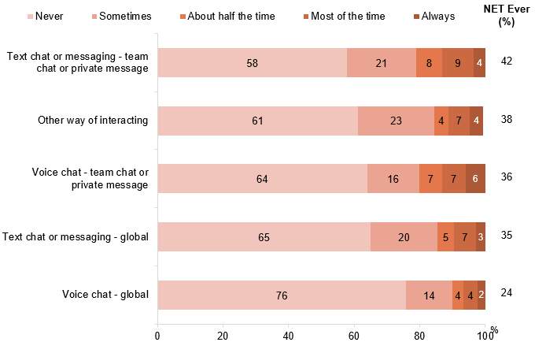
Source: VIDEO4. How often do you interact with anyone else while playing video games or computer games via each of the following?
Base: TVCS & MCCS, Respondents who played video games in past 7 days. 2025: n= 1,506.
Notes: Don’t know/refused responses not shown, % vary per statement.
Horizontal stacked bar chart showing how often people interact with others while playing video games, by type of interaction, with NET ever percentages in 2025.
Text chat or messaging – team chat or private message: 58% never, 21% sometimes, 8% about half the time, 9% most of the time, and 4% always. NET ever interacted is 42%
Other way of interacting: 61% never, 23% sometimes, 4% about half the time, 7% most of the time, and 4% always. NET ever interacted is 38%
Voice chat – team chat or private message: 64% never, 16% sometimes, 7% about half the time, 7% most of the time, and 6% always. NET ever interacted is 36%
Text chat or messaging – global: 65% never, 20% sometimes, 5% about half the time, 7% most of the time, and 3% always. NET ever interacted is 35%
Voice chat – global: 76% never, 14% sometimes, 4% about half the time, 4% most of the time, and 2% always. NET ever interacted is 24%

Subgroup
Text chat or messaging – team chat or private message was higher for:
- Men (48% vs 32% of women)
- Ages 18–44 (54% vs 19% of ages 45+)
- Played video games using other handheld/portable consoles (86%), computer (56%) and PlayStation (55%) in P7D
Voice chat – team chat or private message was higher for:
- Men (44% vs 24% of women)
- Ages 18–44 (48% vs 13% of ages 45+)
- Played video games using other handheld/portable consoles (75%), computer (52%) and PlayStation (51%) in P7D
Text chat or messaging – global was higher for:
- Men (42% vs 25% of women)
- Ages 18–44 (45% vs 16% of ages 45+)
- Played video games using other handheld/portable consoles (67%), computer (48%) and PlayStation (48%) in P7D
Voice chat – global was higher for:
- Men (31% vs 15% of women)
- Ages 18–44 (33% vs 7% of ages 45+)
- Played video games using other handheld/portable consoles (50%), PlayStation (38%) and computer (34%) in P7D
Text chat or messaging with a team or via private message was the most common form of interaction while gaming.

Played video games in past 7 days (children aged 0-17)
Children aged 8–10 (76%), 11–15 (75%) and 16–17 (61%) are more likely to have played video games in the past seven days. While two thirds (65%) of children aged 0–7 have not played in the past seven days. Playing video games relates to the parental restrictions that are placed on video games, with three quarters (77%) parents/legal guardians/carers of older children (aged 16–17) report not placing restrictions. However, whilst children aged 8–10 report to be the most commonly cohort to play video games, they were also reported as the cohort with the greatest number of parental restrictions placed (86%), followed by children aged 0–7 (76% vs 59% of ages 11–15).
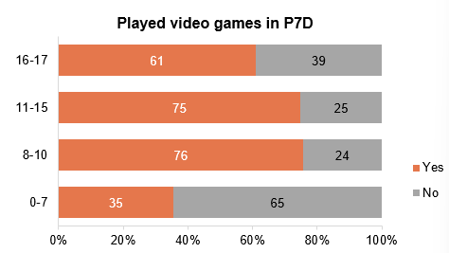
Source: KAVIDEO1. Has your child played any video games, computer games, or mobile games in the past 7 days, at home or elsewhere? KBVIDEO1, KCVIDEO1, KDVIDEO1. Have you played any video games, computer games, or mobile games in the past 7 days, at home or elsewhere?
Base: MCCS, All children aged 8-17. 2025: 8-10 (n=179), 11-15 (n=196), 16-17 (n=130). All parents/legal guardians/carers answering on behalf of their 0-7 year old child (2025: n=304).
Notes: Don’t know/refused responses not shown: 0% for all age groups in 2025.
Horizontal stacked bar chart showing whether children played video games in the past seven days, by age group, in 2025.
Ages 16–17: 61% played video games in the past seven days and 39% did not
Ages 11–15: 75% played video games in the past seven days and 25% did not
Ages 8–10: 76% played video games in the past seven days and 24% did not
Ages 0–7: 35% played video games in the past seven days and 65% did not

Subgroup
Played video games in P7D was higher among children ages 8–10 (76%) or 11–15 (75% vs 61% of ages 16–17 and 35% of ages 0–7).
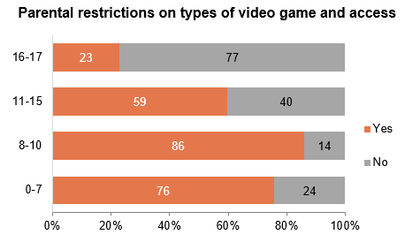
Source: KAVIDEO6. Do you place any limits or restrictions over the types of video games your child plays or has access to?
KBVIDEO6, KCVIDEO6, KDVIDEO6. Do your parents limit the types of video games you play or can access?
Base: MCCS, All children aged 8-17. 2025: 8-10 (n=179), 11-15 (n=196), 16-17 (n=130). All parents/legal guardians/carers answering on behalf of their 0-7 year old child (2025: n=304).
Notes: Don’t know/refused responses not shown: <0.5% for all age groups in 2025.
Horizontal stacked bar chart showing whether parents place restrictions on the types of video games children can play or their access to video games, by age group, in 2025.
Ages 16–17: 23% of parents reported having restrictions in place, while 77% reported no restrictions
Ages 11–15: 59% of parents reported having restrictions in place, while 40% reported no restrictions
Ages 8–10: 86% of parents reported having restrictions in place, while 14% reported no restrictions
Ages 0–7: 76% of parents reported having restrictions in place, while 24% reported no restrictions

Subgroup
Parental restrictions on the types of video games children play or access was higher among children ages 8–10 (86%) or 0–7 (76% vs 59% of ages 11–15 and 23% of ages 16–17).
Children aged 8–10 were reported by parents/legal guardians/carers to be the cohort to have played the most amount of games in the past seven days and with the most parental restrictions placed on their video games.

Frequency of interacting with others while playing video games (children aged 0-17)
Parents/legal guardians/carers were asked about the frequency of their child interacting with others while playing video games. A sizeable proportion said never, however, NET Ever (sometimes, about half the time, most of the time, always) was higher for teenagers, those aged 16–17 across global voice chat (52%), team chat or private message (70%), global text chat (65%) and team chat via text/messaging (73%). For global voice chat, boys are more likely to be part of the cohort (28% vs 19% of girls).
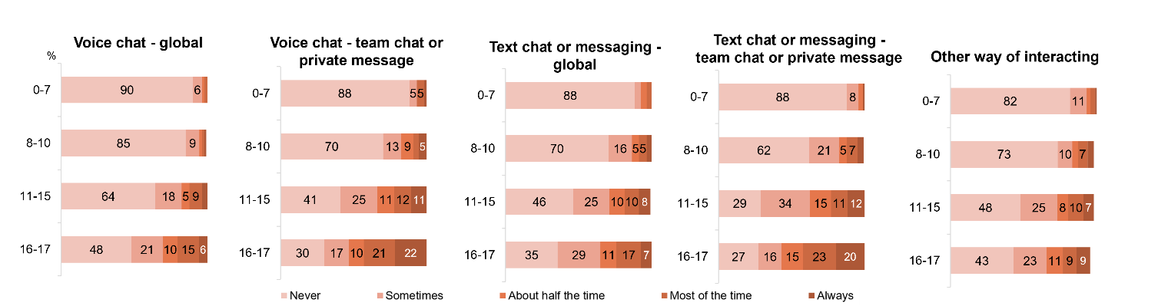
Source: KAVIDEO4. How often does your child interact with anyone else while playing video games or computer games via each of the following? KBVIDEO4, KCVIDEO4, KDVIDEO4. How often do you interact with anyone else while playing video games or computer games via each of the following?
Base: MCCS, All children aged 8-17. 2025: 8-10 (n=179), 11-15 (n=196), 16-17 (n=130). All parents/legal guardians/carers answering on behalf of their 0-7 year old child (2025: n=304).
Notes: Don’t know/refused responses not shown, % vary per statement. Responses for codes not shown on chart if <5% in 2025
Four individual horizontal bar charts showing the frequency (as reported by parents and the child) of interacting with anyone else while playing video games or computers via each interaction form in 2025 for children aged 0-17.
Voice chat – global:
- Ages 0–7: 90% never, 6% sometimes, 2% about half the time, 2% most of the time, 0% always
- Ages 8–10: 85% never, 9% sometimes, 2% about half the time, 1% most of the time, 2% always
- Ages 11–15: 64% never, 18% sometimes, 5% about half the time, 9% most of the time, 4% always
- Ages 16–17: 48% never, 21% sometimes, 10% about half the time, 15% most of the time, 6% always
Voice chat – team chat or private message:
- Ages 0–7: 88% never, 5% sometimes, 0% about half the time, 5% most of the time, 2% always
- Ages 8–10: 70% never, 13% sometimes, 9% about half the time, 3% most of the time, 5% always
- Ages 11–15: 41% never, 25% sometimes, 11% about half the time, 12% most of the time, 11% always
- Ages 16–17: 30% never, 17% sometimes, 10% about half the time, 21% most of the time, 22% always
Text chat or messaging – global:
- Ages 0–7: 88% never, 4% sometimes, 4% about half the time, 3% most of the time, 0% always
- Ages 8–10: 70% never, 16% sometimes, 5% about half the time, 5% most of the time, 3% always
- Ages 11–15: 46% never, 25% sometimes, 10% about half the time, 10% most of the time, 8% always
- Ages 16–17: 35% never, 29% sometimes, 11% about half the time, 17% most of the time, 7% always
Text chat or messaging – team chat or private message:
- Ages 0–7: 88% never, 8% sometimes, 3% about half the time, 0% most of the time, 1% always
- Ages 8–10: 62% never, 21% sometimes, 5% about half the time, 7% most of the time, 4% always
- Ages 11–15: 29% never, 34% sometimes, 15% about half the time, 11% most of the time, 12% always
- Ages 16–17: 27% never, 16% sometimes, 15% about half the time, 23% most of the time, 20% always
Other way of interacting:
- Ages 0–7: 82% never, 11% sometimes, 2% about half the time, 3% most of the time, 1% always
- Ages 8–10: 73% never, 10% sometimes, 4% about half the time, 7% most of the time, 4% always
- Ages 11–15: 48% never, 25% sometimes, 8% about half the time, 10% most of the time, 7% always
- Ages 16–17: 43% never, 23% sometimes, 11% about half the time, 9% most of the time, 9% always

Subgroup
NET Ever was higher for:
Voice chat – global:
- Ages 16–17 (52%) or 11–15 (36% vs 12% of ages 0–10)
- Boys (28% vs 19% of girls)
Voice chat – team chat or private message:
- Ages 16–17 (70%) or 11–15 (59% vs 20% of ages 0–10)
Text chat or messaging – global:
- Ages 16–17 (65%) or 11–15 (53% vs 20% of sages 0–10)
Text chat or messaging – team chat or private message:
- Ages 16–17 (73%) or 11–15 (71% vs 24% of ages 0–10)
Parents/legal guardians/carers report that children aged 16–17 are more active in interacting with others while playing video games across different formats.

Videogame Microtransactions made by children
Parents/legal guardians/carers were asked if their child had made any in-game purchases in a video game, and if the purchases were authorised. In-game purchasing behavior varied by age, with 20% of all children making purchases, of which 64% were parent-authorised by children aged 8–10 (75%) and 11–15 (72%). While teens (11–17) showed higher overall purchase rates, 13% were paid by children aged 16–17 (27%) with their own funds, 8% has ongoing permission and one in six (15%) have made unauthorised transactions.
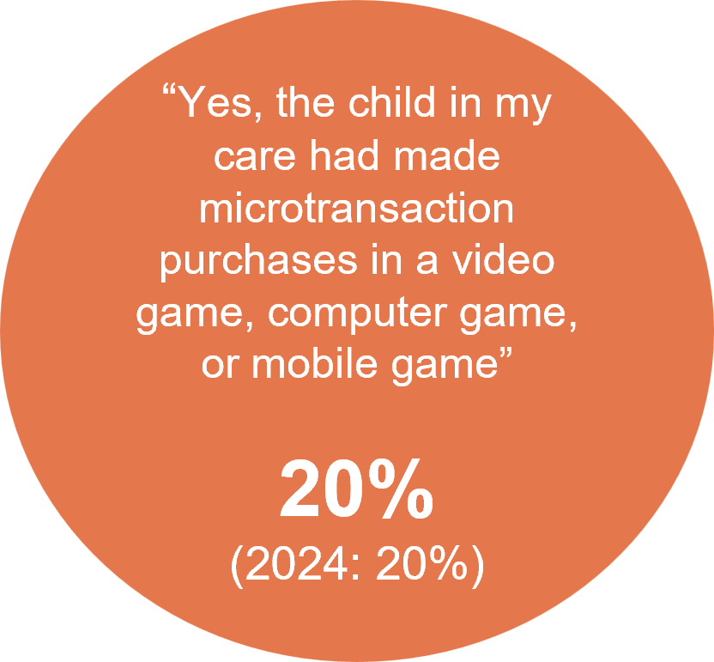
Source: PARF11. In the past 12 months, has a child in your care made any microtransaction purchases in a video game, computer game, or mobile game?
Base: MCCS, Respondents who are parents/legal guardians/carers of a child aged 17 or under. 2025: n=2,097.
2024: n=2,054.
Notes: No/Don’t know/refused responses not shown. DK and Ref options were displayed upfront with other response options. 2025 No=80%, <0.5% for both. 2024 No=73%, DK=7%, Ref=1%.
A circular graphic showing that 20% of parents or carers report that a child in their care made a microtransaction purchase in a video, computer, or mobile game. The result is unchanged from 2024, which also recorded 20%.

Subgroup
Made any microtransaction purchase in a video game was higher for:
- Ages 16–17 (29%), 11–15 (29%) and 8–10 (23% vs 7% of ages 0–7)
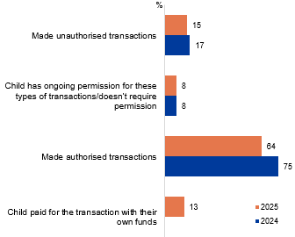
Source: PARF12. Were any of the microtransaction purchases by the child in your care made without permission of the person paying for the transaction?
Base: MCCS, All parents/legal guardians/carers whose child had made any microtransaction purchases in a video game. 2025: n=419. 2024: n=426.
Notes: Don’t know/refused responses not shown: 0% for both in 2024 and 2025. Significant testing was not conducted between 2023 and 2025 results due to changes in code frame. Missing bar means item not asked that year.
A horizontal bar chart comparing how children made microtransaction purchases in 2025 and 2024.
Made unauthorised transactions: 15% in 2025 and 17% in 2024
Child has ongoing permission for these types of transactions/doesn’t require permission: 8% in 2025 and 8% in 2024
Made authorised transactions: 64% in 2025 and 75% in 2024
Child paid for the transaction with their own funds: 13% in 2025, not asked in 2024

Subgroup
Made authorised transactions was higher for:
- Ages 8–10 (75%) and 11–15 (72% vs 50% of ages 16–17 and 46% of ages 0–7)
Child paid for the transaction with their own funds was higher for:
- Ages 16–17 (27% vs 8% of ages 0–15)
One in five parents/legal guardians/carers reported that their child had made microtransaction purchases in a video game, and the majority reported that such purchases were made with permission.

Types of microtransactions made by children in past 12 months
In-game currency (63%) the most common purchase made by children in video games in the past twelve months, with this purchase more frequently made at home (67%) compared to outside of home (49%). This is followed by in-game cosmetic items (36%) and battle passes (27%).
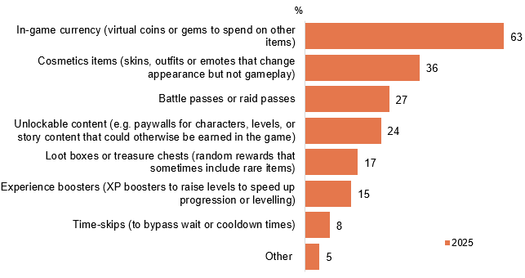
Source: PARF13. What types of microtransactions were made by the child in the past 12 months?
Base: MCCS. All parents/legal guardians/carers whose child had made any microtransaction purchases in a video game. 2025: n=419.
Notes: Don’t know/refused responses not shown: 2025 DK=1%, Ref=0%.
Horizontal bar chart showing types of microtransactions made by children in 2025.
In-game currency (virtual coins or gems to spend on other items): 63%
Cosmetics items (skins, outfits or emotes that change appearance but not gameplay): 36%
Battle passes or raid passes: 27%
Unlockable content (e.g. paywalls for characters, levels, or story content that could otherwise be earned in the game): 24%
Loot boxes or treasure chests (random rewards that sometimes include rare items): 17%
Experience boosters (XP boosters to raise levels to speed up progression or levelling): 15%
Time-skips (to bypass wait or cooldown times): 8%
Other: 5%

Subgroup
In-game currency (virtual coins or gems) was higher for:
- Made the most recent microtransaction in a video game at home (67% vs 49% outside of home)
Over three in five microtransaction purchases were made for in-game currency as reported by parents/legal guardians/carers.

Location of children at the time of the most recent microtransaction in a video game
Parents/legal guardians/carers report that the most common place that their child’s most recent video game transaction was at home (87%). Purchases completed at home were higher for older children aged 16–17 (95%), 11–15 (89%) and 8–10 (87% vs 65% of ages 0–7) and done so with their funds (97% vs 78% of children who made the transaction without permission). Other locations such as before/after school care, friends/relative house, schools, public space showed similar frequencies while someplace else ranked the lowest.
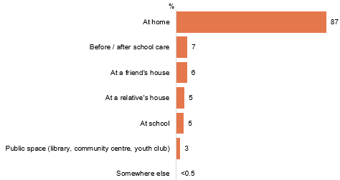
Source: PARF14. Where was the child when they made their most recent microtransactions in a video game?
Base: MCCS. All parents/legal guardians/carers whose child had made any microtransaction purchases in a video game. 2025: n=419.
Notes: Don’t know/refused responses not shown: 0% for both in 2025.
Horizontal bar chart showing where children were when they made their most recent microtransaction in a video game in 2025.
At home: 87%
Before or after school care: 7%
At a friend’s house: 6%
At a relative’s house: 5%
At school: 5%
Public spaces (library, community centre, youth club): 3%
Somewhere else: less than 0.5%

Subgroup
At home was higher for:
- Ages 16–17 (95%), 11–15 (89%) and 8–10 (87% vs 65% of ages 0–7)
- Children paid for the most recent transaction with their own funds (97% vs 78% of children who made the transaction without permission)
Nine in ten of parents/legal guardians/carers report that the most common place that their child have made their recent video game purchase was at home.

TV: access, devices + free-to-air

Chapter summary: TV
Access to TV via traditional means of broadcast signal or antennas was consistent with 2024, whilst on-demand app usages sees a significant increase in 2025.
- Broadcast signal or antenna (56%) remained the most common method for accessing free-to-air TV, while on-demand TV apps (NET) sees a significant increase (61%).
- Just under a half of respondents (47%) use traditional broadcast signal or antenna in 2025 and television sets dominated free-to-air viewing at 73%, although use of mobile phones to access free-to-air content increased to 32%.
Numbers of TVs in Australian households has increased slightly in 2025.
- The average number of TVs in a household increased slightly in 2025 (2.0%).
- Respondents most commonly have either one (36%) or two (33%) TVs in their house, with the proportion of households having five TV increased in 2025 (3%).
TV-internet connectivity remained consistent in 2025.
- Most commonly one TV was connected to the internet (42%) showing a slight decline in 2025, although some respondents said three were connected to the internet (26%, a slight increase), while 11% said no TVs were connected to the internet.
TV connection to a free-to-air television aerial, antenna, or broadcast signal remains consistent in 2025.
- Around two-thirds (69%) of households had access to a free-to-air broadcast signal. Those who have access to an external aerial were more likely to have watched TV via a traditional connection only (86%) or both online and traditional (75%).
- TV connection via an external aerial was most common via a co-axial cable or a similar cable (89%), a significant increase in 2025.
- 53% of respondents who live in a separate house that is older than 25+ years have access to free-to-air television via an aerial.
- Those who watched 35+ hours of free-to-air television in the past 7 days were more likely to be 65+ years of age and living in rural areas.
- Traditional connections such as broadcast signal, aerial, antenna, or pay-TV set-top box (73% NET rarely, sometimes, often, very often), and those with an internet-connected television, an internet-enabled device, or a broadcaster’s video-on-demand service (64% NET) were used by most to watch free-to-air TV content. However, both ways of consumption saw a decline in 2025.
Smart TV accessories were used by half of respondents, with usage driven by demographic factors.
- Half (50% NET) of respondents reported to have TV smart accessories, which is higher amongst those with an annual income of $104,000 or more (58%).
- The most commonly used accessories is Google Chromecast (29%), followed by Apple TV (12%), although half (50%) reported not using any of the listed accessories in 2025 which remains consistent with 2024.
- Those who use Google Chromecast were more likely to be aged 25–44, living in the capital, renters and with children.
- One seventh (14%) of respondents reported purchasing new TVs in 2025 over a 12-month period. 29% of respondents reported replacing their TV between the age of six and ten.

How respondents access free-to-air TV
Access to free-to-air TV via traditional broadcast signal remained stable in 2025 at 56%, with usage higher among men, those who live in rural areas, with no fixed internet and households with access to an external antenna. Use of on-demand apps increased further in 2025 (61% NET), with usage higher among women, urban dwellers, those who speak another language, and households without access to an external antenna or fixed home internet. VAST Box viewership remained niche.
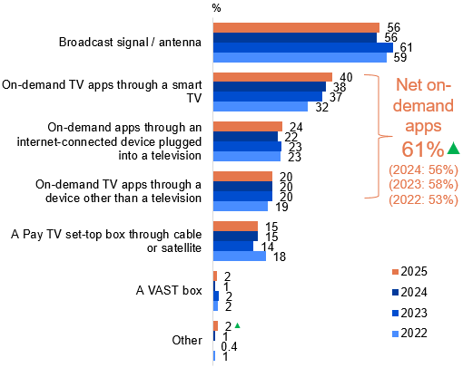
Source: NEWC2b.How do you access free-to-air television?
Base: TVCS, MCCS. Respondents who watched free-to-air TV in the 7 days before the survey. 2025: n=2,677. 2024: n=2,702. 2023: n=2,439. 2022: n=2,935.
Notes: Don’t know/refused responses not shown: All <0.5% except for DK=1 in 2022.
Horizontal bar chart showing how people accessed free-to-air TV, comparing 2022, 2023, 2024 and 2025.
Broadcast signal / antenna: 56% in 2025, 56% in 2024, 61% in 2023 and 59% in 2022
On-demand TV apps through a smart TV: 40% in 2025, 38% in 2024, 37% in 2023 and 32% in 2022
On-demand apps through an internet-connected device plugged into a television: 24% in 2025, 22% in 2024, 23% in 2023 and 23% in 2022
On-demand TV apps through a device other than a television: 20% in 2025, 20% in 2024, 20% in 2023 and 19% in 2022
Pay TV set top box through cable or satellite: 15% in 2025, 15% in 2024, 14% in 2023 and 18% in 2022
A VAST box: 2% in 2025, 1% in 2024, 2% in 2023 and 2% in 202
Other: 2% in 2025, 1% in 2024, 0.4% in 2023 and 1% in 2022
Net on-demand apps (On-demand TV apps through a smart TV, On-demand apps through an internet-connected device plugged into a television, On-demand TV apps through a device other than a television): 61% in 2025, 56% in 2024, 58% in 2023 and 53% in 2022

Subgroup
Broadcast signal / antenna was higher for:
- Men (63% vs 48% of women)
- Those living outside a capital city (61% vs 51% of those living in a capital city)
- English-only speakers (58% vs 48% of those who speak a language other than English)
- Households with access to an external FTA TV antenna (NET) (61% vs 25% of households without)
- Those without fixed home internet (68% vs 56% of those with fixed home internet)
Net on-demand apps (On-demand TV apps through a smart TV, On-demand apps through an internet-connected device plugged into a television, On-demand TV apps through a device other than a television) was higher for:
- Women (64% vs 58% of men)
- Those living in a capital city (69% vs 54% of those living outside a capital city)
- Those who speak a language other than English (71% vs 59% of English-only speakers)
- Households without access to an external FTA TV antenna (NET) (74% vs 59 of households with access)
- Those without fixed home internet (62% vs 40% of those with fixed home internet)

Callout
Other (2% vs 1% in 2024) increased significantly in 2025 and NET on-demand apps (61% vs 56% in 2024) increased significantly both in 2025.
Access to free-to-air TV was more common via on-demand apps, with a further increase in popularity in 2025.

How respondents access free-to-air TV most often
Of those who have watched free-to-air TV in the 7 days prior to the survey, a traditional broadcast signal or antenna remained the preferred access method (47%), followed by smart TV apps (24%), while other ways of access increased to 2% in 2025. Similar to findings of how respondents access free-to-air TV, men are more likely to use broadcast signal/antenna as well as those who live in rural areas, those without fixed home internet, and households with access to an external FTA TV antenna.
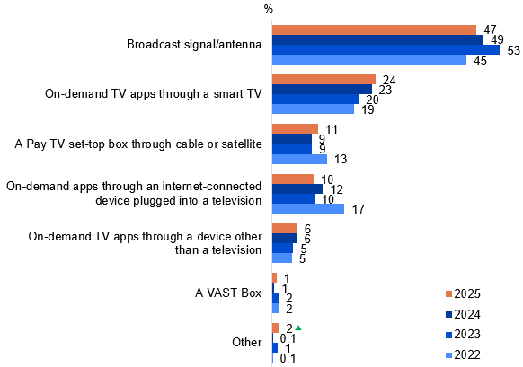
Source: NEWC2c. How do you access free-to-air television most often?
Base: TVCS, MCCS. Respondents who watched free-to-air television in the 7 days before the survey and accessed free-to-air television via more than one ways. 2024: n=2,677. 2024: n=2,677. 2023: n=2,439. 2022: n=1,048.
Notes: Don’t know/refused responses not shown: <0.5% for both between 2022 and 2025.
Horizontal bar chart showing the percentage of people using different methods to access free-to-air TV from 2022 to 2025.
Broadcast signal / antenna: 47% in 2025, 49% in 2024, 53% in 2023 and 45% in 2022
On-demand TV apps through a smart TV: 24% in 2025, 23% in 2024, 20% in 2023 and 19% in 2022
A Pay TV set-top box through cable or satellite: 11% in 2025, 9% in 2024, 9% in 2023 and 13% in 2022
On-demand apps through an internet-connected device plugged into a television: 10% in 2025, 12% in 2024, 10% in 2023 and 17% in 2022
On-demand TV apps through a device other than a television: 6% in 2025, 6% in 2024, 5% in 2023 and 5% in 2022
A VAST box: 1% in 2025, 1% in 2024, 2% in 2023 and 2% in 2022
Other: 2% in 2025, 0.1% in 2024, 1% in 2023 and 0.1% in 2022

Subgroup
Broadcast signal / antenna was higher for:
- Men (52% vs 41% of women)
- Those living outside a capital city (52% vs 42% of those living in a capital city)
- Households with access to an external FTA TV antenna (NET) (51% vs 18% of households without)
- Those without fixed home internet (62% vs 46% of those with fixed home internet)

Callout
Other (2% vs 0.1% in 2024) increased significantly in 2025.
Broadcast signal or antenna remained the most common way to access free-to-air TV in 2026.

Frequency of watching free-to-air TV on various devices (%)
Television sets dominated free-to-air viewing, with 73% of viewers (NET use) accessing content through traditional TV screens in an average week. Use of mobile phone increased to 32% (NET use) with a decrease observed in VAST box with 2% (NET use).

Table 5 Frequency of watching free-to-air TV on various devices (%)
Device | Never | Once or twice a week | 3-5 times a week | More often than 5 times a week | Once or twice a day | 3-5 times a day | More often than 5 times a day | 2022 NET use | 2023 NET use | 2024 NET Use | 2025 NET Use
Television (including smart TV) | 11 | 14 | 10 | 11 | 23 | 8 | 7 | 74 | 74 | 71 | 73
Mobile phone or smartphone | 43 | 11 | 4 | 3 | 4 | 4 | 7 | 30 | 30 | 27 | 32
Computer (desktop or laptop) | 35 | 12 | 3 | 2 | 4 | 2 | 1 | 26 | 25 | 24 | 25
TV smart accessory/Digital media player | 14 | 8 | 5 | 4 | 5 | 2 | 2 | 27 | 28 | 24 | 26
Tablet | 17 | 7 | 3 | 2 | 2 | 1 | 1 | 19 | 16 | 17 | 17
Pay TV box | 5 | 3 | 2 | 3 | 4 | 2 | 1 | 18 | 15 | 16 | 15
Games console connected to a television | 9 | 4 | 1 | 1 | 1 | 0.4 | 0.4 | 8 | 7 | 7 | 8
VAST box | 1 | 0.5 | 0.2 | 0.4 | 0.4 | 0.1 | 0.1 | 3 | 5 | 3 | 2
Source: NEW10. On average per week, how often do you use the following devices to watch free-to-air television (live or on-demand)?
Base: TVCS, Results have been rebased to all TVCS survey respondents. 2025: n=3,716. 2024: n=3,890. 2023: n=3,861. 2022: n=4,016.
Notes: Don’t know/refused responses not shown, % vary per statement. Rows do not sum to 100%: due to rebasing to total respondents n/a figures are not shown in table. Note that this question reflects use of devices to watch free-to-air TV specifically, and has a different base to C4, which asks about use of devices to watch screen content more generally and was asked of all respondents who watched screen content in the past 7 days.

Table showing frequency of device use for watching screen content in 2025 and NET device use from 2022 to 2025.
Television (including smart TV): 11% never, 14% once or twice a week, 10% 3–5 times a week, 11% more often than 5 times a week, 23% once or twice a day, 8% 3–5 times a day and 7% more often than 5 times a day. 2022 NET use: 74%, 2023 NET use: 74%, 2024 NET use: 71% and 2025 NET use: 73%.
Mobile phone or smartphone: 43% never, 11% once or twice a week, 4% 3–5 times a week, 3% more often than 5 times a week, 4% once or twice a day, 4% 3–5 times a day and 7% more often than 5 times a day. 2022 NET use: 30%, 2023 NET use: 30%, 2024 NET use: 27% and 2025 NET use: 32%.
Computer (desktop or laptop): 35% never, 12% once or twice a week, 3% 3–5 times a week, 2% more often than 5 times a week, 4% once or twice a day, 2% 3–5 times a day and 1% more often than 5 times a day. 2022 NET use: 26%, 2023 NET use: 25%, 2024 NET use: 24% and 2025 NET use: 25%.
TV smart accessory / digital media player: 14% never, 8% once or twice a week, 5% 3–5 times a week, 4% more often than 5 times a week, 5% once or twice a day, 2% 3–5 times a day and 2% more often than 5 times a day. 2022 NET use: 27%, 2023 NET use: 28%, 2024 NET use: 24% and 2025 NET use: 26%.
Tablet: 17% never, 7% once or twice a week, 3% 3–5 times a week, 2% more often than 5 times a week, 2% once or twice a day, 1% 3–5 times a day and 1% more often than 5 times a day. 2022 NET use: 19%, 2023 NET use: 16%, 2024 NET use: 17% and 2025 NET use: 17%.
Pay TV box: 5% never, 3% once or twice a week, 2% 3–5 times a week, 3% more often than 5 times a week, 4% once or twice a day, 2% 3–5 times a day and 1% more often than 5 times a day. 2022 NET use: 18%, 2023 NET use: 15%, 2024 NET use: 16% and 2025 NET use: 15%.
Games console connected to a television: 9% never, 4% once or twice a week, 1% 3–5 times a week, 1% more often than 5 times a week, 1% once or twice a day, 0.4% 3–5 times a day and 0.4% more often than 5 times a day. 2022 NET use: 8%, 2023 NET use: 7%, 2024 NET use: 7% and 2025 NET use: 8%.
VAST box: 1% never, 0.5% once or twice a week, 0.2% 3–5 times a week, 0.4% more often than 5 times a week, 0.4% once or twice a day, 0.1% 3–5 times a day and 0.1% more often than 5 times a day. 2022 NET use: 3%, 2023 NET use: 5%, 2024 NET use: 3% and 2025 NET use: 2%.

Subgroups
Television (NET Use) was higher for:
- Ages 55+ (85% vs 65% of ages 18–54)
- Those living outside a capital city (79% vs 66% of those living in a capital city)
- Homeowners (78% vs 61% of renters and 59% of those occupied rent free)
- English-only speakers (76% vs 62% of those who speak a language other than English)

Callout
- Use of mobile phone or smartphone to watch free-to-air TV increased significantly in 2025 (32% vs 27% in 2024)
- Use of VAST box to watch free-to-air TV decreased significantly in 2025 (2% vs 3% in 2024)
Free-to-air remained the most watched via TV in 2025, consistent with prior years. This is consistent with respondents who are aged 55+ and homeowners.

Number of TVs in respondents’ houses
Most households maintained one (36%) or two TVs (33%), with just 3% reporting no television in their house. The average number of working TVs in households has increased from 1.9 in 2024 to 2.0 in 2025. Those who report no TVs in their household remain consistent and are more likely to be younger, renters and living in metropolitan areas. The average number of working TVs in households was higher for older respondents (aged 45–64), homeowners, English-only speakers and those with a higher annual income.
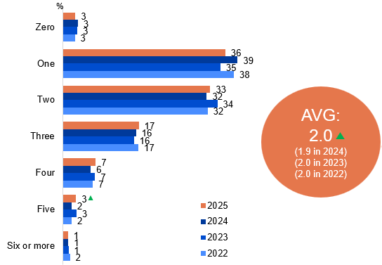
Source: NEW17a. How many working TVs are currently in your house?
Base: TVCS. All respondents. 2025: n=3,716. 2024: n=3,890. 2023: n=3,861. 2022: n=4,016.
Notes: Don’t know/refused responses not shown: <0.5% for both between 2022 and 2025.
Horizontal bar chart showing the number of televisions in households, by percentage, from 2022 to 2025.
Zero TVs: 3% in 2025, 3% in 2024, 3% in 2023 and 3% in 2022
One TV: 36% in 2025, 39% in 2024, 35% in 2023 and 38% in 2022
Two TVs: 33% in 2025, 32% in 2024, 34% in 2023 and 32% in 2022
Three TVs: 17% in 2025, 16% in 2024, 16% in 2023 and 17% in 2022
Four TVs: 7% in 2025, 6% in 2024, 7% in 2023 and 7% in 2022
Five TVs: 3% in 2025, 2% in 2024, 3% in 2023 and 2% in 2022
Six or more TVs: 1% in 2025, 1% in 2024, 1% in 2023 and 2% in 202
Average number of TVs per household: 2.0 in 2025, 1.9 in 2024, 2.0 in 2023 and 2.0 in 2022

Subgroup
Zero was higher for:
- Ages 18–24 (9% vs 2% of ages 25+)
- Those living in a capital city (4% vs 2% of those living outside a capital city)
- Renters (7% vs 1% of homeowners)
Average number of working TVs in household was higher for:
- Ages 45–64 (2.4 vs 2.3 of ages 65+ and 1.9 of ages 18–44)
- Homeowners (2.2 vs 1.7 of renters and 1.6 of those occupied rent free)
- English-only speakers (2.1 vs 1.7 of those who speak a language other than English)
- Households with access to an external FTA TV antenna (NET) (2.2 vs 1.6 of households without)
- Those with an annual HH income of $104,000 or more (2.2 vs 1.9 of those with income <$104,000)

Callout
- Having five TVs (3% vs 2% in 2024) in the household increased significantly 2025.
- The average number of working TVs in a household (2.0 vs 1.9 in 2024) increased significantly in 2025.
The average number of TVs in households has increased slightly in 2025.

Number of TVs connected to the internet
Among respondents with at least one TV in their house, two in five (42%) had one internet-connected set, showing a decrease in 2025, while just over a quarter (27%) connected two TVs, and 11% maintained offline-only television viewing. Those with three TVs that are internet-connected has increased in 2025 to 12%, whilst the average number of working TVs connected to the internet remains stable at 1.6%. This average was higher for respondents aged 35–64, urban dwellers, and those with children.
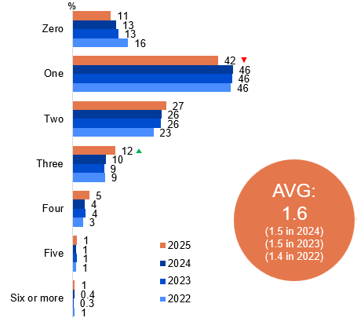
Source: NEW17b. Of the working TVs currently in your house, how many are connected to the internet (e.g. a smart TV or through a smart TV accessory such as a Google Chromecast)?
Base: TVCS, Respondents who have at least one TV in their house. 2025: n=3,635. 2024: n=3,795. 2023: n=3,757. 2022: n=3,910
Notes: Don’t know/refused responses not shown: <0.5% for both between 2022 and 2025.
Horizontal bar chart showing the number of working televisions in households that are connected to the internet (e.g. a smart TV or through a smart TV accessory such as a Google Chromecast), by percentage, for 2022 to 2025.
Zero: 11% in 2025, 13% in 2024, 13% in 2023 and 16% in 2022
One: 42% in 2025, 46% in 2024, 46% in 2023 and 46% in 2022
Two: 27% in 2025, 26% in 2024, 26% in 2023 and 23% in 2022
Three: 12% in 2025, 10% in 2024, 9% in 2023 and 9% in 2022
Four: 5% in 2025, 4% in 2024, 4% in 2023 and 3% in 2022
Five: 1% in 2025, 1% in 2024, 1% in 2023 and 1% in 2022
Six or more: 1% in 2025, 0.4% in 2024, 0.3% in 2023 and 1% in 2022
Average: 1.6 in 2025, 1.5 in 2024, 1.5 in 2023 and 1.4 in 2022

Subgroup
Zero TVs was higher for:
- Ages 75+ (28% vs 9% of ages 18–74)
- Those living outside a capital city (15% vs 7% of those living in a capital city)
- Those with an annual HH income <$41,600 (19% vs 8% of those with income of $41,600 or more)
- Those who watched FTA Broadcast in P7D (13%)
- Those without fixed home internet (33% vs 9% of those with fixed home internet)
Average number of working TVs connected to the internet was higher for:
- Ages 35–64 (1.9 vs 1.6 of ages 18–34 and 1.3 of ages 65+)
- Those living in a capital city (1.7 vs 1.6 of those living outside a capital city)
- Those with dependent children in HH (2.0) or empty nesters (2.0 vs 1.6 of non-related adults living in a share house and 1.4 of those without children)
- Homeowners (1.7 vs 1.5 of renters)
- Aboriginal and/or Torres Strait Islanders (2.0 vs 1.6 of Non-Aboriginal or Torres Strait Islanders)
- Those with an annual HH income of $156,000 or more (2.0 vs 1.6 of those with income <$156,000)
- English-only speakers (1.7 vs 1.4 of those who speak a language other than English)
- Those with fixed home internet (1.7 vs 0.9 of those without)
- Watched TV via a hybrid of traditional and online connection (1.8) or via the internet only (1.7 vs 1.4 of those watched TV via traditional connection only or did not watch TV)

Callout
One TV connected to the internet (42% vs 46% in 2024) decreased significantly, whereas three TVs connected to the internet (12% vs 10% in 2024) increased significantly in 2025.
The average number of TVs in households connected to the internet remain stable in 2025.

Number of TVs connected to an external aerial, antenna, or broadcast signal
Among respondents with at least one TV in their household, the most common setup was having one TV connected to an external free-to-air television aerial, antenna, or broadcast signal (42%). Households with on TVs connected to an external antenna are more likely to be younger (aged 18–44), urban dwellers, watch TV via the internet only or not watch TV at all, and renting.
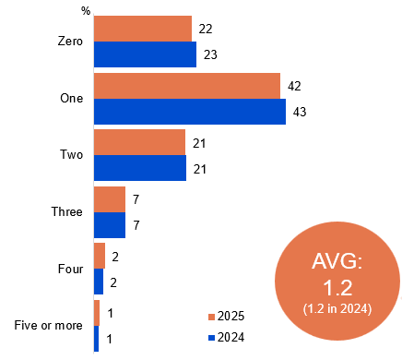
Source: NEW17bb. Of the working TVs in your house, how many are connected to an external free-to-air television aerial, antenna, or broadcast signal?
Base: TVCS, Respondents who have at least one TV in their house. 2025: n=3,635. 2024: n=3,795.
Notes: Don’t know/refused responses not shown: 2025 DK=4%, Ref<0.5%. 2024 DK=2%, Ref<0.5%.
Horizontal bar chart showing the number of working televisions in households connected to an external antenna in 2025 and 2024.
Zero: 22% in 2025 and 23% in 2024
One: 42% in 2025 and 43% in 2024
Two: 21% in 2025 and 21% in 2024
Three: 7% in 2025 and 7% in 2024
Four: 2% in 2025 and 2% in 2024
Five or more: 1% in 2025 and 1% in 2024
Average: 1.2 in 2025 and 1.2 in 2024

Subgroup
Zero TVs connected of working TVs connected to an external antenna was higher for:
- Ages 18–44 (33% vs 12% of ages 45+)
- Those living in a capital city (27% vs 16% of those living outside a capital city)
- Renters (35% vs 17% of homeowners)
- Aboriginal and/or Torres Strait Islanders (30% vs 21% of Non-Aboriginal or Torres Strait Islanders)
- Those who speak a language other than English (31% vs 19% of English-only speakers)
- Those who watched online content in P7D (22% vs 12% of those who watched offline content)
- Households without access to an external FTA TV antenna (NET) (67% vs 10% of households with access)
- Watched TV via the internet only (57%) or did not watch TV (48% vs 13% watched TV via a hybrid of traditional and online connection and 6% via traditional connection only
Average number of working TVs connected to an external antenna was higher for:
- Men (1.3 vs 1.1 of women)
- Ages 45+ (1.6 vs 0.8 of ages 18–44)
- Those living outside a capital city (1.3 vs 1.1 of those living in a capital city)
- Homeowners (1.4 vs 0.9 of those occupied rent free and 0.7 of renters)
- English-only speakers (1.3 vs 0.9 of those who speak a language other than English)
- Those who watched exclusively offline content in P7D (1.4 vs 0.8 of those who watched exclusively online content)
- Households with access to an external FTA TV antenna (NET) (1.5 vs 0.3 of households without)
Among households with at least one working TV, most have only one TV connected to an external free-to-air aerial or antenna.

Access to an external free-to-air television aerial, antenna, or broadcast signal
Approximately two-thirds (69%) of households have access to an external free-to-air television aerial, antenna, or broadcasting signal, a similar level to 2024 (67%). Those who initially reported
not having access to an external antenna or were unsure, but had indicated earlier in the survey that they watch free-to-air TV, were prompted that live broadcast TV requires an antenna and that their household likely has access to one. Following this prompt, one-third (34%) confirmed they have an external antenna, bringing total antenna access to 76%. Some also mentioned they do have a set top box of bunny ears (16%). However, a portion watch free-to-air TV through other sources (such as a smart TV). Those who have access to an external aerial were more likely to have watched TV via a traditional connection only (86%) or both online and traditional (75%).
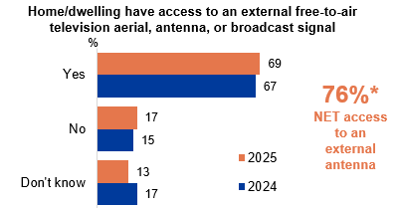
Source: ANTEN1. Does your home/dwelling have access to an external free-to-air television aerial, antenna, or broadcast signal? Base: TVCS, MCCS. All respondents. 2025: n=4,396. 2024: n=4,490.
Notes: Refused response not shown: <0.5% in 2024 and 2025. DK and Ref options were displayed upfront with other response options. *NET access = ANTEN1 (Yes) or ANTEN1aa (Yes)
Horizontal bar chart showing whether homes/dwellings have access to an external free-to-air television aerial, antenna, or broadcast signal, comparing 2025 and 2024.
Yes: 69% in 2025 and 67% in 2024
No: 17% in 2025 and 15% in 2024
Don’t know: 13% in 2025 and 17% in 2024
NET access to an external antenna: 76%*

Subgroup
Of those who said Yes, it was higher for:
- Men (73% vs 66% of women)
- Ages 55+ (86% vs 60% of ages 18–54)
- Those living outside a capital city (77% vs 62% of those living in a capital city)
- Homeowners (77% vs 50% of renters or those occupied rent free)
- Non-Aboriginal and/or Torres Strait Islanders (70% vs 58% of Aboriginal or Torres Strait Islanders)
- English-only speakers (74% vs 55% of those who speak a language other than English)
- Watched TV via traditional connection only (86%) or via a hybrid of traditional and online connection (75% vs 50% of those watched TV via online connection only and 43% of those who did not watch TV)
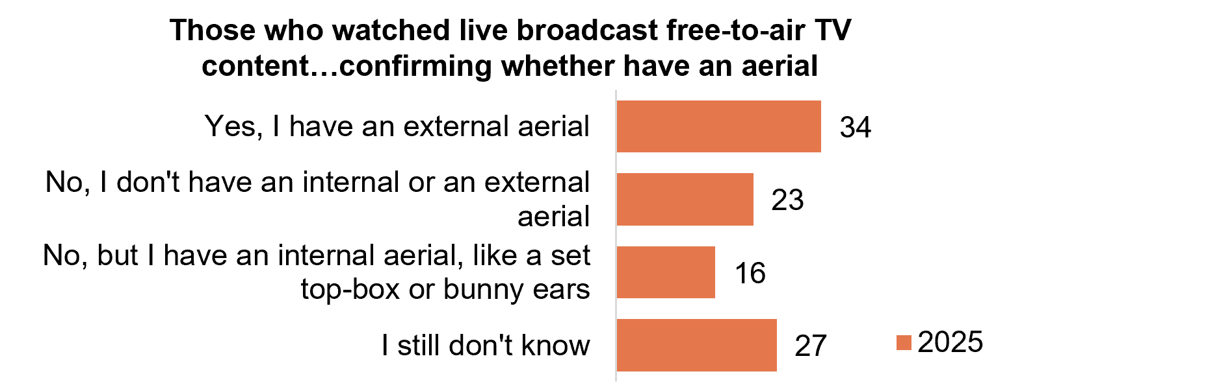
Source: ANTEN1aa. Earlier you said you watched live broadcast free-to-air TV content which requires an aerial. If you watched this content at home, it’s likely you have an aerial. Based on this information, do you think you have an external aerial?
Base: TVCS, MCCS. Respondents who did not know or said they did not have access to an external aerial but still watched free-to-air TV. 2025: n=845.
Horizontal bar chart showing confirmation of aerial access among people who watched live broadcast free-to-air TV in 2025.
Yes, have an external aerial: 34%
No, I don’t have an internal or external aerial: 23%
No, but I have an internal aerial (e.g. set-top box or bunny ears): 16%
I still don’t know: 27%
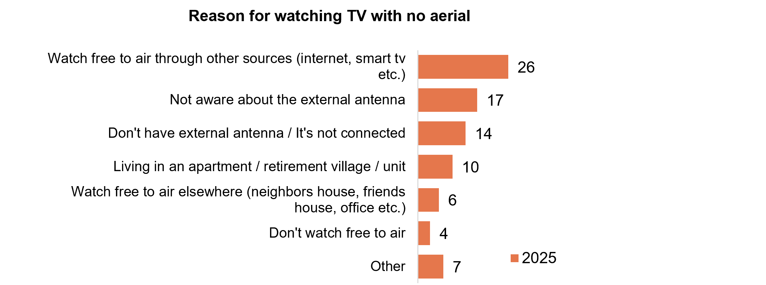
Source: ANTEN1b. You mentioned you don’t know if your home/dwelling has an external antenna or that you have watched broadcast free-to-air TV but your home/dwelling does not have an aerial. Can you please give more detail on why this is the case?
Base: TVCS, MCCS. Respondents who said they don’t have an internal/external aerial or still don’t know. Notes: Refused response not shown. 2025: DK=20%, Ref=10%.
Horizontal bar chart showing reasons for watching TV without an external aerial in 2025.
Watch free-to-air through other sources (e.g. internet, smart TV): 26%
Not aware of the external antenna: 17%
Do not have an external antenna / it is not connected: 14%
Living in an apartment, retirement village or unit: 10%
Watch free-to-air elsewhere (e.g. neighbour’s, friend’s or office): 6%
Do not watch free-to-air TV: 4%
Other: 7%
Approximately two-thirds of households had access to a free-to-air broadcast signal, while households with no aerial report they watch free-to-air through other sources.

External free-to-air television antenna access by dwelling age + type
Just over a half (53%) of respondents who live in a separate house that is older than 25+ years have access via an external free-to-air television aerial, which is significantly higher than those living in other dwelling types. However, there is a decline for separate houses against other dwellings in access to television via an external aerial in dwellings aged 20–24 (11%), 5–9 (8%) and under 2 years (2%). For those who live in a separate house, three in four (77%) report having access to external aerial, a significant increase. Whilst those living in a flat/apartment or other dwelling types (e.g. caravan, cabin, improvised home, tent etc) were less likely to access free-to-air TV via an external aerial (1% and 2% respectively).
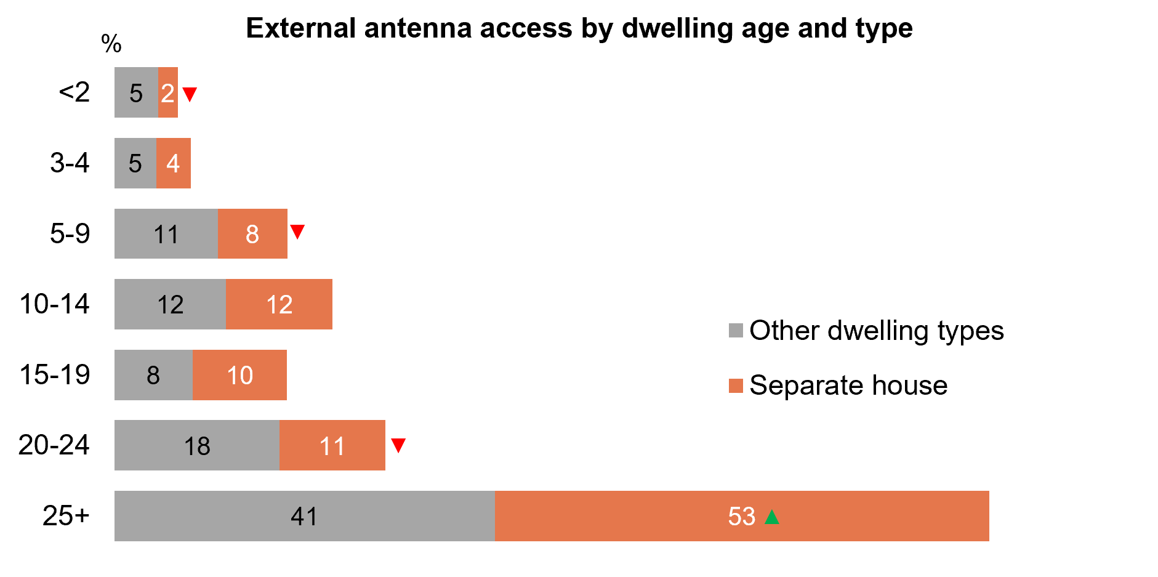
Source: Z8. What type of home/dwelling do you live in? Z5. How old is your home?
Base: Home/dwelling have access to an external free-to-air television aerial. 2025: n=3,192. Notes: Don’t know/refused responses not shown. All <0.5% in 2025.
A horizontal bar chart showing the percentages of external antenna access by dwelling age and type in 2025.
Dwellings less than 2 years old: 5% of other dwelling types have external antenna access and 2% of separate houses
Dwellings aged 3–4 years: 5% of other dwelling types have external antenna access and 4% of separate houses
Dwellings aged 5–9 years: 11% of other dwelling types have external antenna access and 8% of separate houses
Dwellings aged 10–14 years: 12% of other dwelling types have external antenna access and 12% of separate houses
Dwellings aged 15–19 years: 8% of other dwelling types have external antenna access and 10% of separate houses
Dwellings aged 20–24 years: 18% of other dwelling types have external antenna access and 11% of separate houses
Dwellings aged 25 years or older: 41% of other dwelling types have external antenna access and 53% of separate houses

Subgroup
External free-to-air antenna access was higher for:
- Those live in a separate house (75% vs 61% of those living in a semi-detached, row or terrace house, 55% of those living in a flat or apartment and 48% of those living in a caravan, cabin, improvised home or house attached to a shop)
- Residence aged more than 25 years old (77% vs 69% of those whose residence aged 15 to 24 years old and 60% of those whose residence aged less than 14 years old)
- Those who owned a dwelling outright (82% vs 73% of those owned with a mortgage, 50% of renters or occupied rent free)

Callout
The percentage of external antenna access was significantly lower:
- For dwellings less than 2 years old for a separate house compared to other dwelling types (2% vs 5%)
- For dwellings aged 5–9 years for a separate house compared to other dwelling types (8% vs 11%)
- For dwellings aged 20–24 years for a separate house compared to other dwelling types (11% vs 18%
The percentage of external antenna access was significantly higher:
- For dwellings aged 25 years or older for a separate house compared to other dwelling types (53% vs 41%)
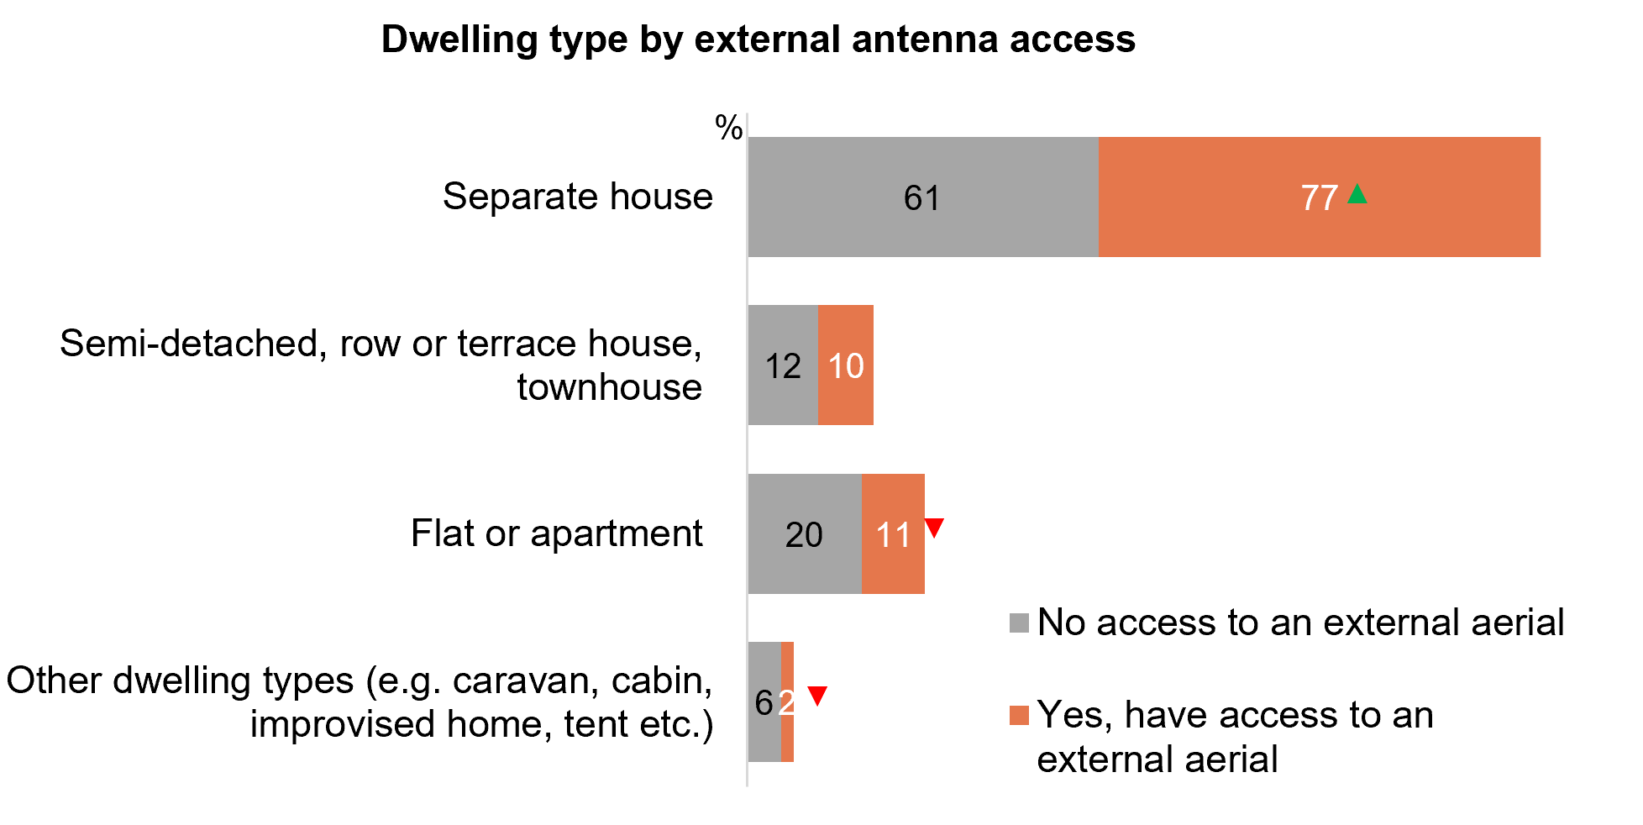
Source: Z8. What type of home/dwelling do you live in? ANTEN1. Does your home/dwelling have access to an external free-to-air television aerial, antenna, or broadcast signal?
Base: TVCS, MCCS. All respondents. 2025: n=4,396.
Notes: Don’t know/refused responses not shown. <0.5% for both in 2025.
Horizontal bar chart showing dwelling type by external antenna access in 2025.
Separate house
- No access to an external aerial: 61%
- Yes, have access to an external aerial: 77%
Semi-detached, row or terrace house, townhouse
- No access to an external aerial: 12%
- Yes, have access to an external aerial: 10%
Flat or apartment
- No access to an external aerial: 20%
- Yes, have access to an external aerial: 11%
Other dwelling types (e.g. caravan, cabin, improvised home, tent)
- No access to an external aerial: 6%
- Yes, have access to an external aerial: 2%

Callout
The percentage of external antenna access was significantly higher:
- For separate house (77% have access to an external aerial vs 61% with no access)
The percentage of external antenna access was significantly lower:
- For flat or apartment (11% have access to an external aerial vs 20% with no access)
- For other dwelling types (e.g. caravan, cabin, improvised home, tent (2% have access to an external aerial vs 6% with no access)

Note
‘Other dwelling types’ includes: Semi-detached, row or terrace house, townhouse etc. with one storey, Semi-detached, row or terrace house, townhouse etc. with two or more storeys, Flat or apartment in a one or two storey block, Flat or apartment in a three storey block, Flat or apartment in a four to eight storey block, Flat or apartment in a nine or more storey block, Flat or apartment attached to a house, Caravan, Cabin, houseboat, Improvised home, tent, sleepers out, House or flat attached to a shop, office, etc., Other (please specify)
‘Semi-detached, row or terrace house, townhouse’ includes: Semi-detached, row or terrace house, townhouse etc. with one storey (5%), Semi-detached, row or terrace house, townhouse etc. with two or more storeys (4%).
‘Flat or apartment’ includes: Flat or apartment in a one or two storey block (5%), Flat or apartment in a three storey block (2%), Flat or apartment in a four to eight storey block (2%), Flat or apartment in a nine or more storey block (2%), Flat or apartment attached to a house (0.3%).
‘Other dwelling types’ includes: Caravan (0.2%), Cabin, houseboat (0.2%), Improvised home, tent, sleepers out (0%), House or flat attached to a shop, office, etc. (1%), Other (please specify) (1%)
In general, those in older, separate houses have access to an external free-to-air television aerial, than those in newer or other housing types.

TV connection to a free-to-air television aerial, antenna, or broadcast signal
Of those with a TV connected to a free-to-air television aerial, a co-axial cable or a similar cable was most often used for the connection (89%), a significant increase in 2025. A smaller percentage connected through a device, such as a set-top box (14%), or via an indoor antenna (4%), whilst other forms of connection also saw an increase (2%). Connection via a coaxial or similar cable is more likely to be reported by men, households with access to an external free-to-air TV antenna, those living in newer houses, and those who have watched free-to-air TV via broadcast signal or on-demand TV apps.
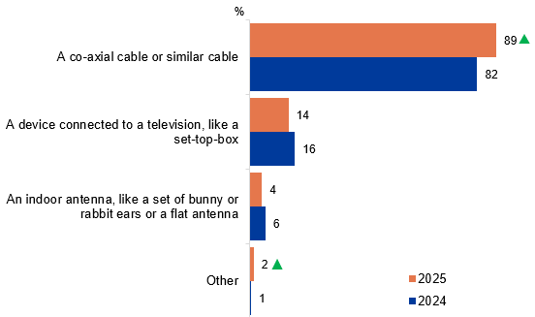
Source: ANTEN6. You said your television was connected to a free-to-air television antenna, aerial, or broadcast signal. Is this via…
Base: TVCS, MCCS. Respondents who have any TV connected to an external aerial. 2025: n=2,834. 2024: n=3,019.
Notes: Don’t know/refused responses not shown: <0.5% for both in 2025. 2024 DK=2%, Ref<0.5.
A bar chart showing the methods by which televisions are connected to a free-to-air television antenna, aerial, or broadcast signal in 2025 and 2024.
A co-axial cable or similar cable: 89% in 2025 and 82% in 2024
A device connected to a television (e.g. set-top box): 14% in 2025 and 16% in 2024
An indoor antenna (e.g. bunny ears or flat antenna): 4% in 2025 and 6% in 2024
Other: 2% in 2025 and 1% in 2024

Subgroup
A co-axial cable or similar cable was higher for:
- Men (92% vs 87% of women)
- Households with access to an external FTA TV antenna (NET) (91% vs 66% of households without)
- Residence aged less than 2 years old (98% vs 88% of residence aged more than 19 years old)
- Those accessed FTA TV via broadcast signal (91%) or on-demand TV apps (90% vs 77% of those accessed via a Pay TV set-top box and 62% via a VAST box)

Callout
A co-axial cable or similar cable (89% vs 82% in 2024) and other (2% vs 1% in 2024) increased significantly in 2025.
Most respondents with a TV connected to an external aerial used a co-axial or similar cable, while fewer used a set-top box or indoor antenna.

Free-to-air television: profiling heavy watchers (35+ hours in past 7 days)
Watched 35+ hours of free-to-air television in past 7 days:
- Older age groups: aged 65+ years old (51%)
- Those living outside a capital city (72%)
- Household structure of single or couple, no children (67%)
- Education of up to year 12 (45%)*
- Employment status or not in labour force (69%)
- Receive Government pensions, benefits or allowances (82%)
- Household income of $0-$41,599 (57%)
- Watched free-to-air Broadcast in P7D (91%)
Source: C2. On average, how many hours per week do you spend watching each of the following?
Base: TVCS & MCCS, Free-to-air (codes 1,2,4 or 5 is 35+ hours) (n=60).
*Caution, small base (n=23).

Note
Free-to-air incudes any of:
Commercial free-to-air TV (e.g. Seven, Nine, 10, WIN, Imparja, NBN Television), including recorded content but excluding on-demand TV
Publicly owned free-to-air TV (i.e. ABC, SBS), including recorded content but excluding on-demand TV
Commercial free-to-air on-demand TV (e.g. (e.g. 9Now, 10 Play, 7plus)
Publicly owned free-to-air on-demand TV (e.g. ABC iview, SBS On Demand, ABC News, ABC Kids)

Frequency of watching free-to-air television via traditional connections or internet
While traditional connections were more commonly used to watch free-to-air television than the internet, usage of both decreased in 2025. Use of traditional connections is higher among older viewers, those living in regional areas, and households with access to an external antenna, whereas younger viewers, females, urban dwellers, and households with fixed internet show higher rates of online access.
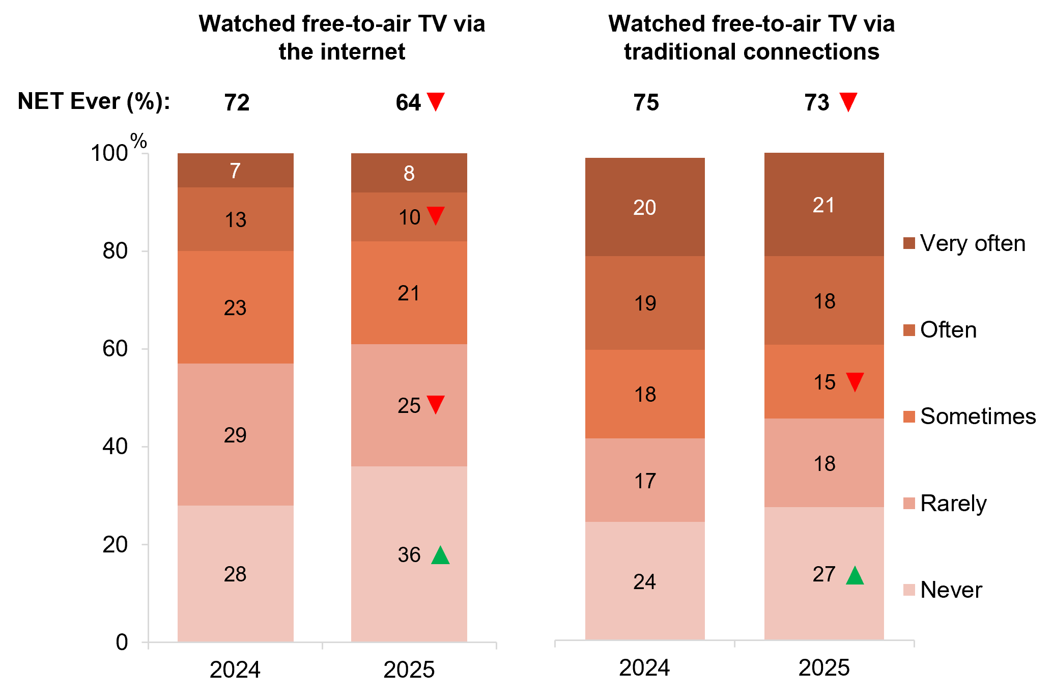
Source: ANTEN10. In general, how often do you watch free-to-air television content using the internet, such as through an internet-connected television or an internet-enabled device, or through a broadcaster-video-on-demand (BVOD) service? ANTEN11. In general, how often do you watch free-to-air television content using traditional connections, such as a broadcast signal, aerial, antenna, or pay-TV set-top box?
Base: TVCS, MCCS, All respondents. 2025 n=4,396. 2024 n=4,490.
Notes: Don’t know/refused responses not shown. <0.5% for both in 2024 and 2025. NET Ever includes ‘Rarely’, ‘Sometimes’, ‘Often’, and ‘Very often’.
Four bar charts comparing the frequency of watching free-to-air television content using the internet versus traditional connections in 2024 and 2025.
Watched free-to-air TV via the internet
- Never: 36% in 2025 and 28% in 2024
- Rarely: 25% in 2025 and 29% in 2024
- Sometimes: 21% in 2025 and 23% in 2024
- Often: 10% in 2025 and 13% in 2024
- Very often: 8% in 2025 and 7% in 2024
- NET Ever: 64% in 2025 and 72% in 2024

Watched free-to-air TV via traditional connections
- Never: 27% in 2025 and 24% in 2024
- Rarely: 18% in 2025 and 17% in 2024
- Sometimes: 15% in 2025 and 18% in 2024
- Often: 18% in 2025 and 19% in 2024
- Very often: 21% in 2025 and 20% in 2024
- NET Ever: 73% in 2025 and 75% in 2024

Subgroup
NET Ever watched free-to-air TV via the internet was higher for:
- Women (67% vs 62% of men)
- Ages 25–54 (71% vs 60% of ages 55+ and 55% of ages18–24)
- Those living in a capital city (67% vs 61% of those living outside a capital city)
- Those with dependent children in HH (71% vs 59% of those without children or non-related adults living in a share house)
- Those watched FTA BVOD in P7D (76%)
- Those with fixed home internet (66% vs 48% of those without)
- Those accessed FTA TV via on-demand TV apps (81% vs 76% of those accessed via a Pay TV set-top box, 62% via broadcast signal and 62% via a VAST box)
NET Ever watched free-to-air TV via traditional connections was higher for:
- Ages 45+ (83% vs 61% of ages 18–44)
- Those living outside a capital city (77% vs 68% of those living in a capital city)
- Those without children (75%) or with dependent children in HH (73% vs 62% of non-related adults living in a share house)
- Homeowners (77% vs 61% of renters)
- Non-Aboriginal and/or Torres Strait Islanders (73% vs 61% of Aboriginal or Torres Strait Islanders)
- English-only speakers (75% vs 64% of those who speak a language other than English)
- Households with access to an external FTA TV antenna (NET) (81% vs 44% of households without)
- Those watched FTA Broadcast in P7D (89%)
- Those accessed FTA TV via broadcast signal (96%) or a Pay TV set-top box (95% vs 86% of those accessed via on-demand TV apps and 75% via a VAST box)

Callout
Watched free-to-air TV via the internet increased significantly in 2025 for:
- Those who never watched free-to-air TV via the internet (36% vs 28% in 2024)
Watched free-to-air TV via the internet decreased significantly in 2025 for:
- Those who rarely watched free-to-air TV via the internet (25% vs 29% in 2024)
- Those who often watched free-to-air TV via the internet (10% vs 13% in 2024)
- Those who ever (NET) watched free-to-air TV via the internet (64% vs 72% in 2024)
Watched free-to-air TV via traditional connections increased significantly in 2025 for:
- Those who never watched free-to-air TV via traditional connections (27% vs 24% in 2024)

Watched free-to-air TV via traditional connections decreased significantly in 2025 for:
- Those who sometimes watched free-to-air TV via traditional connections (15% vs 18% in 2024)
- Those who ever (NET) watched free-to-air TV via traditional connections (73% vs 75% in 2024)
Use of traditional and online connections to watch free-to-air TV both declined in 2025.

Free-to-air television viewing: Personas
Highlights: Respondents’ free-to-air television viewing patterns were categorised into four personas, with hybrid free-to-air TV being the most common (53%), followed by broadcast-only (20%) and online-only (13%), and one in ten (16%) who did not watch any free-to-air TV. Those who consumed hybrid FTA TV have significantly decreased in 2025 and were more likely to be aged 35-74, have fixed home internet, own a newly purchased TV, have children and watch sports. Those who exclusively watched FTA TV via broadcast saw a significant increase and were typically older men, live in regional areas, homeowners, do not have children, and lack access to fixed home internet. Those who consumed only FTA TV online remain stable and were more likely to be younger (aged 25-44), live in metro areas, do not watch sports, watch content exclusively online, and do not have access to an external FTA aerial. Those who did not consume FTA TV saw a significant increase in 2025 were more likely to be younger (aged 18-44), live in metro areas, renters, lack access to an external FTA TV aerial, and fixed home internet.
Hybrid free-to-air TV (53% in 2025 vs 58% in 2024)
- Ages 35–74 (56%)
- Have dependent children in HH (58%)
- Watched sports in P7D (58%)
- Watched Pay-TV (67%), FTA BVOD (62%), FTA Broadcast (61%) and SVOD (56%) in P7D
- Had fixed home internet (54%)
- Had access to an external FTA TV antenna (NET) (57%)
- Primary working TV was connected to an FTA TV antenna (61%) or had a built-in ability to connect to an FTA TV antenna (56%)
Broadcast only (20% in 2025 vs 17% in 2024)
- Men (23%)
- Ages 45+ (29%)
- Those living outside a capital city (26%)
- Those without children in HH (26%)
- Homeowners (23%)
- Watched sports in P7D (24%)
- English-only speakers (22%)
- Watched FTA Broadcast in P7D (28%)
- Did not have access to fixed home internet (31%)
- Had access to an external FTA TV antenna (25%)
- Primary working TV was connected to an FTA TV antenna (26%) or had a built-in ability to connect to an FTA TV antenna (23%)
Online only (12% in 2025 vs 13% in 2024)
- Ages 25–44 (16%)
- Those living in a capital city (13%)
- Did not watch sports in P7D (14%)
- Watched free video streaming services (14%), other websites or apps (14%), FTA BVOD (14%) or SVOD in P7D (13%)
- Watched exclusively online content in P7D (18%)
- Did not have access to an external FTA TV antenna (NET) (21%)
- Primary working TV was not connected to an FTA TV antenna (37%) or did not have a built-in ability to connect to an FTA TV antenna (17%)
No free-to-air TV (16% in 2025 vs 11% in 2024)
- Ages 18–44 (24%)
- Those living in a capital city (18%)
- Non-related adults living in a share house (29%)
- Renters (25%)
- Did not watch sports in P7D (23%)
- Watched other websites of apps (18%), free video streaming services (17%) or SVOD in P7D (15%)
- Watched exclusively online content in P7D (33%)
- Did not have access to fixed home internet (21%)
- Did not have access to an external FTA TV antenna (31%)
- Primary working TV was not connected to an FTA TV antenna (33%) or did not have a built-in ability to connect to an FTA TV antenna (22%)
Source: ANTEN10. In general, how often do you watch free-to-air television content using the internet, such as through an internet-connected television or an internet-enabled device, or through a broadcaster-video-on-demand (BVOD) service? ANTEN11. In general, how often do you watch free-to-air television content using traditional connections, such as a broadcast signal, aerial, antenna, or pay-TV set-top box?
Base: TVCS, MCCS, All respondents. 2025 n=4,396. 2024 n=4,490.
Notes: Don’t know/refused responses not shown: <0.5% for both for ANTEN10 and ANTEN11 in 2024 and 2025. NET Ever includes ‘Rarely’, ‘Sometimes’, ‘Often’, and ‘Very often’.
Further reading
Research in the United Kingdom (UK) through both the UK Department of Culture, Media and Sport and through the UK’s media regulator, Ofcom, has similarly examined the characteristics of different population groups by their access to Free-to-air (FTA) television (TV).^{5,6}

Callout
Hybrid free-to-air TV (53% vs 58% in 2024) decreased significantly, whereas broadcast only (20% vs 17% in 2024) and no free-to-air TV (16% vs 11% in 2024) increased significantly in 2025.

TV smart accessories used in the past 12 months
TV smart accessory usage remained stable, with 50% of households having no usage, while Google Chromecast led among respondents at 20%. A significant decrease was observed for Telstra TV (3%) and an increase for other smart accessories (2%). Of the 20% who adopted Google Chromecast, the respondents are more likely to be ages 25–44, urban dwellers who are renters, have children in their households, watched SVOD in past seven days, and those who watched TV via a hybrid between traditional and online connection.
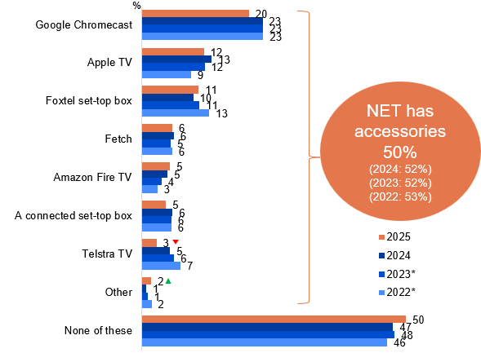
Source: NEW12_12mth. Which, if any, of the following TV smart accessories have you used in your house in the past 12 months?
Base: TVCS, All respondents. 2025: n=3,716. 2024: n=3,890. 2023: n=3,861. 2022: n=4016.
Notes: Don’t know/refused responses not shown: <0.5% for both between 2022 and 2025. Code change in 2023 for ‘Apple TV’ (previously ‘Apple TV box’ in 2022). *Reference period updated from 6 months to 12 months in 2024, comparisons with previous years should be made with caution.
A bar chart showing the usage of various TV smart accessories in households over the past 12 months for the years 2025, 2024, 2023, and 2022.
Google Chromecast: 20% in 2025, 23% in 2024, 23% in 2023, and 23% in 2022
Apple TV: 12% in 2025, 13% in 2023, 12% in 2024, and 9% in 2022
Foxtel set-top box: 11% in 2025, 10% in 2024, 11% in 2023, and 13% in 2022
Fetch: 6% in 2025, 6% in 2024, 5% in 2023, and 6% in 2022
Amazon Fire TV: 5% in 2025, 5% in 2024, 4% in 2023, and 3% in 2022
A connected set-top box: 5% in 2025, 6% in 2024, 6% in 2023, and 6% in 2022
Telstra TV: 3% in 2025, 5% in 2024, 6% in 2023, and 7% in 2022
Other: 2% in 2025, 1% in 2024, 1% in 2023, and 2% in 2022
None of these: 50% in 2025, 47% in 2024, 48% in 2023, and 46% in 2022
Usage of any TV smart accessories (NET has accessories): 50% in 2025 (vs 52% in 2024, 52% in 2023, 53% in 2022)

Subgroup
Google Chromecast was higher for:
- Ages 25–44 (30% vs 20% of ages 18–24 and 15% of ages 45+)
- Those living in a capital city (23% vs 18% of those living outside a capital city)
- Those with dependent children in HH (24% vs 18% of those without children)
- Renters (35% vs 17% of homeowners)
- Those watched SVOD in P7D (24% vs 23% of those watched FTA BVOD, 23% of free video streaming services, 22% of other websites or apps, 21% of Pay-TV and 20% of FTA Broadcast)
- Watched TV via a hybrid of traditional and online connection (23% vs 17% of those who did not watch TV and 15% watched TV via traditional connection only)
Usage of any TV smart accessories (NET has accessories) was higher for:
- Those with an annual HH income of $104,000 or more (58%)
- Watched Pay-TV in P7D (86%)

Callout
Telstra TV (3% vs 5% in 2024) decreased significantly, whereas other types of TV smart accessories was (2% vs 1% in 2024) increased significantly in 2025.
Overall usage of TV smart accessories over 12 months in 2025 remained consistent with results from 2024 over a 6-month period, with slight observations of decrease in Telstra TV.

Purchase of a new TV in past 12 months
New TV purchases (14%) showed particular demographic patterns, with higher rates among men, homeowners, those who watched screen content using a television, and those who had watched sports in the past seven days. The most common TV age for replacement reported by respondents is 6–10 years (29%) followed closely by more than 10 years (24%) and 3-5 years (22%). One in ten (10%) were reported to have replaced their TV for less than a year old and for respondents who did not have an existing TV, whilst a small group (5%) replaced their TV within 1–2 years since purchasing their last TV.
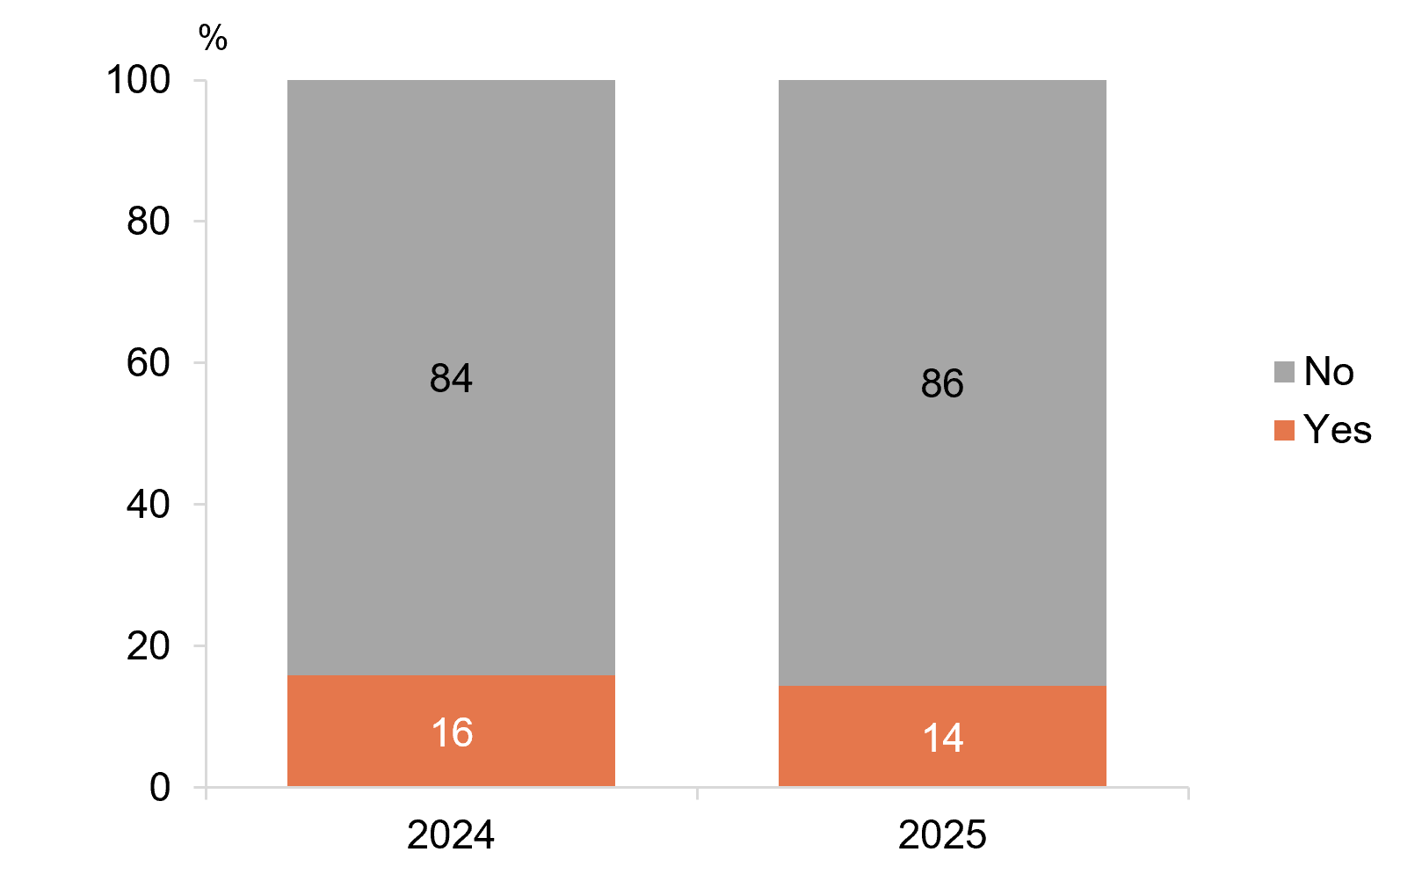
Source: NEW16_12mth. Did you buy a new TV in the past 12 months?
Base: TVCS, All respondents. 2025: n=3,716. 2024: n=3,890.
Notes: Don’t know/refused responses not shown: <0.5% for both between 2022 and 2025.
A bar chart showing the percentage of people who bought a new TV in the past 12 months in 2024 and 2025.
Yes: 14% in 2025 and 16% in 2024
No: 86% in 2025 and 84% in 2024

Subgroup
Purchased a new TV in P12M was higher for:
- Men (16% vs 12% of women)
- Homeowners (17% vs 9% renters)
- Those who watched sports in P7D (16% vs 12% of those who did not)
- Those who watched screen content using a television (16% vs 4% of those who did not)
- English-only speakers (16% vs 10% of those who speak a language other than English)
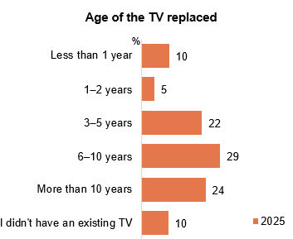
Source: TVDISP1. When you most recently bought a new TV, how old was the TV it replaced?
Base: TVCS. Respondents who bought a new TV in the 12 months before the survey. 2025: n=582.
Notes: Don’t know/refused responses not shown: <0.5% for both in 2025.
A bar chart showing the percentage of the age of the TV that was replaced at the time when the new TV was bought in 2025.
Less than 1 year: 10%
1–2 years: 5%
3–5 years: 22%
6–10 years: 29%
More than 10 years: 24%
I didn’t have an existing TV: 10%
One seventh of respondents reported purchasing new TVs in 2025 over a 12-month period.
29% of respondents reported replacing their TV between the age of six and ten.

Audio content

Chapter summary: Audio content
Audio content consumption has decreased across various channels in 2024.
- Online music streaming services became the most commonly listened audio content (51%) followed closely by FM radio (49%) in 2025.
- Digital radio (DAB) saw a decrease in usage of audio content, whilst FM radio, podcasts, AM radio, radio via the internet or an app (excluding podcasts), and not having listened to any audio remains steady, while online music streaming services increased in 2025.
Smartphones were mainly used to listen to online audio, while traditional radio was listened to in the car.
- Respondents most commonly listen to FM radio (85%) and AM radio (80%) in the car, while smartphones were more commonly used to listen to podcasts (84%) and online music streaming services (80%).
- Online music streaming services are the most commonly used audio service in the 7 days, with respondents spending an average of 1–5 hours listening to audio content across different sources.
- Respondents most frequently use online music streaming services to listen to Australian music (3.0 NET AVG), with the majority spending between 1–10 hours per week across various platforms.

Audio listened to in the past 7 days
Online music streaming services (51%) are the most common source of audio consumption over the past 7 days in 2025, despite experiencing a decline in 2024. This was followed by FM radio (49%), podcasts (23%), AM radio (16%), and radio via the internet or app (12%). However, a decline is observed for DAB (9%). Overall, there is a significant increase of audio consumption of NET online formats (65% NET online) compared to NET AM/FM radio (54%).
Those who listened to AM/FM radio were more likely to watch offline content, whereas those who listened to online audio content tend to watch online screen content.
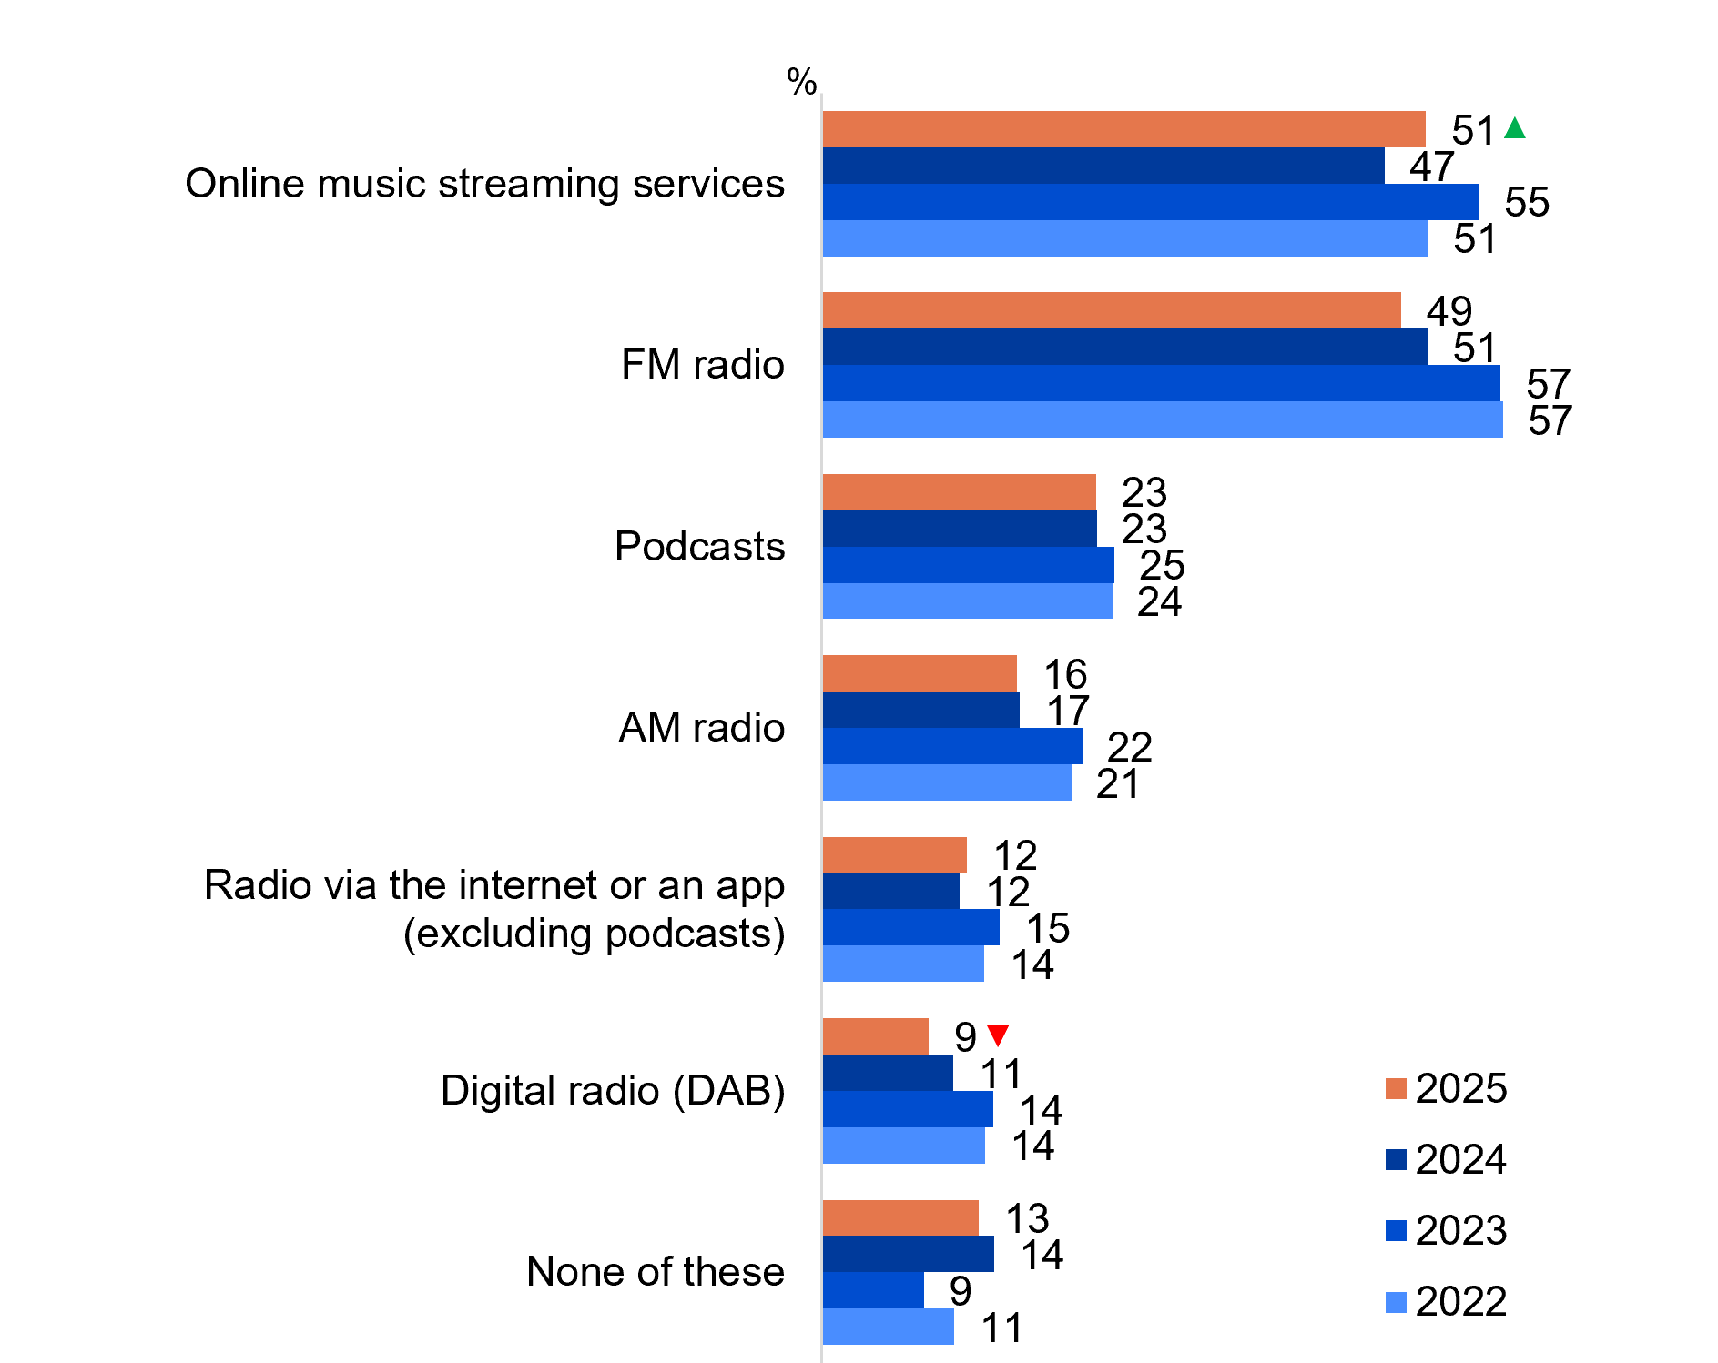
Source: NEW28. Which, if any, of the following have you listened to in the past 7 days? This includes all listening at home, in a car, or somewhere else on any device.
Base: TVCS, MCCS. All respondents. 2025: n=4,396. 2024: n=4,490. 2023: n=3,730. 2022: n=4002.
Notes: Don’t know/refused responses not shown: <0.5% for both between 2022 and 2025.
A bar chart showing the percentages of the types of audio that people listened to in the past 7 days in 2022 to 2025.
Online music streaming services: 51% in 2025, 47% in 2024, 55% in 2023, and 51% in 2022
FM radio: 49% in 2025, 51% in 2024, 57% in 2023, and 57% in 2022
Podcasts: 23% in 2025, 23% in 2024, 25% in 2023, and 24% in 2022
AM radio: 16% in 2025, 17% in 2024, 22% in 2023, and 21% in 2022
Radio via the internet or an app (excluding podcasts): 12% in 2025, 12% in 2024, 15% in 2023, and 14% in 2022
Digital radio (DAB): 9% in 2025, 11% in 2024, 14% in 2023, and 14% in 2022
None of these: 13% in 2025, 14% in 2024, 9% in 2023, and 11% in 2022
NET AM/FM radio: 54% in 2025 (57% in 2024, 64% in 2023 and 64% in 2022)
NET Online*: 65% in 2025 (61% in 2024, 71% in 2023 and 67% in 2022)

Subgroup
NET AM/FM radio: 54% in 2025 (57% in 2024, 64% in 2023 and 64% in 2022)
- Ages 55+ (71% vs 45% of ages 18–54)
- Those living outside a capital city (61% vs 48% of those living in a capital city)
- English-only speakers (57% vs 45% of those who speak a language other than English)
- Those watched Pay-TV (69%), FTA Broadcast (67%) or FTA BVOD in P7D (65% vs 54% of those watched SVOD, 52% of other websites or apps and 50% of free video streaming services)
- Those watched exclusively offline content in P7D (67% vs 37% of those watched exclusively online content)
NET Online*: 65% in 2025 (61% in 2024, 71% in 2023 and 67% in 2022)
- Ages 18–44 (79% vs 52% of ages 45+)
- Those living in a capital city (72% vs 57% of those living outside a capital city)
- Aboriginal and/or Torres Strait Islanders (78% vs 64% of Non-Aboriginal or Torres Strait Islanders)
- Those with an annual HH income of $78,000 or more (74% vs 55% of those with income <$78,000)
- Those who speak a language other than English(70% vs 63% of English-only speakers)
- Those watched other websites or apps (74%), free video streaming services (73%) or SVOD (73% vs 67% of those watched FTA BVOD, 66% of Pay-TV and 60% of FTA Broadcast)
- Those watched exclusively online content in P7D (73% vs 24% of those watched exclusively offline content)
‘NET Online’ includes ‘online music streaming services’, ‘podcasts’, ‘radio via the internet or app’, and ‘digital radio’.

Callout
Digital radio (DAB) (9% vs 11% in 2024) decreased significantly, whereas online music streaming services (51% vs 47%) increased significantly in 2025.
NET Online increased significantly in 2025 (65% vs 61% in 2024).
Audio content consumption has increased via online streaming services whilst a decrease in DAB usage was observed.

Devices used to listen to audio content (%)
Device usage preferences remain consistent: car radios are most often used when listing to FM (85%) and AM (80%) radio, while smartphones are the preferred choice for podcasts (84%) and music streaming (80%). The use of smartphones to listen to audio content are more popular for younger ages, with those aged 18–34 being more inclined to listen to music streaming via smartphone (94% NET vs 72% NET of ages 35+), whilst ages 18–64 (24% NET vs 14% NET of ages 65+) listen to radio.
Table 6 Devices used to listen to audio content (%)
Audio content | Base  (n) | Car audio system  (%) | Smartphone  (%) | Dedicated radio  (%) | Smart Speaker  (%) | Computer/  Tablet/Laptop  (%) | Other  (%)
FM radio | 1,579 | 85 | 13 | 24 | 6 | 6 | 2
Online music streaming services | 1,343 | 36 | 80 | 1 | 22 | 28 | 3
Podcasts | 709 | 25 | 84 | 2 | 8 | 17 | 3
AM radio | 574 | 80 | 18 | 31 | 7 | 7 | 3
Radio via the internet or an app (excluding podcasts) | 410 | 25 | 58 | 8 | 24 | 27 | 8
Digital radio (DAB) | 342 | 68 | 13 | 32 | 10 | 6 | 3
Source: NEWG29. In general, what do you use to listen to [‘insert NEW28 Response of codes 1-6’]
Base: TVCS, MCCS, Respondents who listened to audio content in the 7 days before the survey. 2025 n= from 342 to 1,579.
Notes: Don’t know/refused responses not shown, % vary per statement.
Devices used to listen to radio*:
- Car audio system NET: 63% (vs 79% in 2024, 84% in 2023)
- Smart speaker NET: 7% (vs 10% in 2024, 9% in 2023)
*NETs only include AM radio, FM radio, Digital radio (DAB), and Radio via the internet or an app

Subgroup
NET Listened to radio* using smartphone was higher for:
- Ages 18–64 (24% vs 14% of ages 65+)
- Those living in a capital city (84% vs 78% of those living outside a capital city)
- Those used a mobile phone to watch screen content (26% vs 11% of those who did not)

NET Listened to online music streaming services using smartphone was higher for:
- Ages 18–34 (94% vs 72% of ages 35+)
- Those used a mobile phone to watch screen content (84% vs 57% of those who did not)
FM and AM radio were most commonly listened to in the car, while smartphones were used primarily for podcasts and online music streaming.

Hours spent per week listening to music of any type
Online music streaming services are the most commonly used audio service in the 7 days before the survey. An average of 10.8 hours are spent per week on online music streaming services in the past 7 days, followed by radio via the internet or an app (AVG 7.0 hours), FM radio (AVG 6.3 hours), DAB (AVG 5.3 hours) and AM radio (AVG 5.2 hours). Respondents are predominantly spending an average of 1–5 hours listening to audio content across different sources.
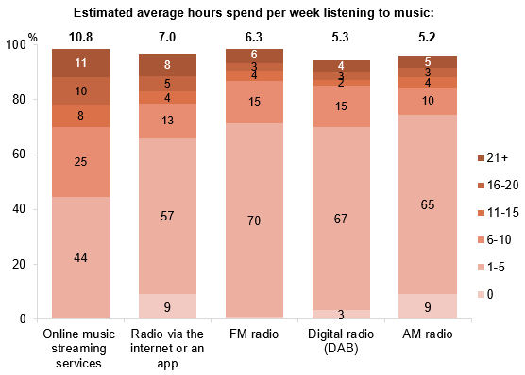
Source: AUDIO2. On average, how many hours per week do you spend listening to music of any type on each of the following?
Base: TVCS, MCCS. Respondents who listened to audio content other than podcasts in the 7 days before the survey. 2025 n= from 523 to 2,322.
Notes: Columns do not sum to 100%: Don’t know/refused responses not shown, % vary per statement. Responses not shown on chart if <3%
Stacked bar chart showing the estimated hours spent per week listening to music by platform in 2025.
Online music streaming services: 0% listen for 0 hours, 44% for 1–5 hours, 25% for 6–10 hours, 8% for 11–15 hours, 10% for 16–20 hours, and 11% for 21 or more hours per week. Estimated average hours spend per week listening to music: 10.8.
Radio via the internet or an app: 9% listen for 0 hours, 57% for 1–5 hours, 13% for 6–10 hours, 4% for 11–15 hours, 5% for 16–20 hours, and 8% for 21 or more hours per week. Estimated average hours spend per week listening to music: 7.0.
FM radio: 1% listen for 0 hours, 70% listen for 1–5 hours, 15% for 6–10 hours, 4% for 11–15 hours, 3% for 16–20 hours, and 6% for 21 or more hours per week. Estimated average hours spend per week listening to music: 6.3.
Digital radio (DAB): 3% listen for 0 hours, 67% for 1–5 hours, 15% for 6–10 hours, 2% for 11–15 hours, 3% for 16–20 hours, and 4% for 21 or more hours per week. Estimated average hours spend per week listening to music: 5.3.
AM radio: 9% listen for 0 hours, 65% for 1–5 hours, 10% for 6–10 hours, 4% for 11–15 hours, 3% for 16–20 hours, and 5% for 21 or more hours per week. Estimated average hours spend per week listening to music: 5.2.
NET radio: 6.2 hours per week

Subgroup
Average hours spent per week listening to online music streaming services was higher for:
- Ages 18–44 (12.3 vs 8.0 of ages 45+)
- Those living in a capital city (11.9 vs 9.3 of those living outside a capital city)
Average hours spent per week listening to Radio (NET) was higher for:
- Ages 45+ (7.0 vs 4.8 of ages 18–44)
- Those living outside a capital city (6.8 vs 5.4 of those living in a capital city)
- Pensioner (8.2)
- Non-Aboriginal and/or Torres Strait Islanders (6.2 vs 4.2 of Aboriginal or Torres Strait Islanders)
- English-only speakers (6.4 vs 5.3 of those who speak a language other than English)
- Those watched exclusively offline content in P7D (8.9 vs 5.1 of those watched exclusively online content)
Online music streaming services is the most commonly used audio service in the 7 days before the survey. Respondents are also predominantly spending an average of 1–5 hours listening to audio content across different sources.

Hours spent per week listening to Australian music
Respondents are more commonly using online music streaming services to listen to Australian music with an average of 3.0 hours spent. This is closely followed by FM radio (AVG 2.7 hours), radio via the internet or app (excluding podcasts) (AVG 2.4 hours), AM radio (AVG 1.8 hours) and DAB (AVG 1.7 hours). Respondents are predominantly spending an average of 6–10 hours listening to Australian music followed by 1–5 hours across different sources.
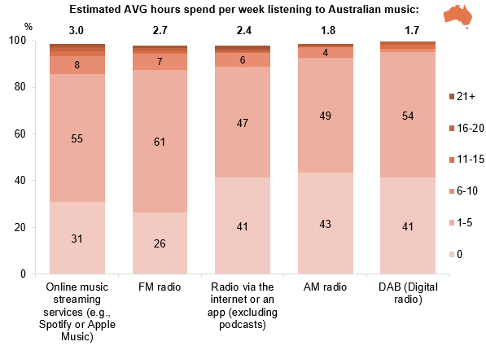
Source: AUDIO3. On average, how many hours per week do you spend listening to Australian music on each of the following?
Base: TVCS, MCCS. Respondents who listened to any music. 2025 n= from 485 to 2,275.
Notes: Columns do not sum to 100%: Don’t know/refused responses not shown, % vary per statement. Responses not shown on chart if <3%
Stacked bar chart showing the estimated hours spent per week listening to Australian music by platform in 2025.
Online music streaming services (e.g. Spotify or Apple Music): 31% listen for 0 hours, 55% for 1–5 hours, 8% for 6–10 hours, 2% for 11–15 hours, 2% for 16–20 hours, and 1% for 21 or more hours per week. Estimated average hours spend per week listening to Australian music: 3.0.
FM radio: 26% listen for 0 hours, 61% for 1–5 hours, 7% for 6–10 hours, 1% for 11–15 hours, 1% for 16–20 hours, and 1% for 21 or more hours per week. Estimated average hours spend per week listening to Australian music: 2.7.
Radio via the internet or an app (excluding podcasts): 41% listen for 0 hours, 47% for 1–5 hours, 6% for 6–10 hours, 0% for 11–15 hours, 1% for 16–20 hours, and 2% for 21 or more hours per week. Estimated average hours spend per week listening to Australian music: 2.4.
AM radio: 43% listen for 0 hours, 49% for 1–5 hours, 4% for 6–10 hours, 0% for 11–15 hours, 1% for 16–20 hours, and 1% for 21 or more hours per week. Estimated average hours spend per week listening to Australian music: 1.8.
DAB (digital radio): 41% listen for 0 hours, 54% for 1–5 hours, 2% for 6–10 hours, 2% for 11–15 hours, 1% for 16–20 hours, and 0% for 21 or more hours per week. Estimated average hours spend per week listening to Australian music: 1.7.
NET radio: 2.5 hours per week.

Subgroup
Average hours spent per week listening to online music streaming services was higher for:
- Aboriginal and/or Torres Strait Islanders (4.7 vs 2.9 of Non-Aboriginal or Torres Strait Islanders)
- Those watched Australian content on subscription streaming services in P7D (3.6 vs 2.3 of those who did not)
Average hours spent per week listening to Radio (NET) was higher for:
- Ages 45+ (2.8 vs 2.1 of ages 18–44)
- Those living outside a capital city (3.0 vs 1.9 of those living in a capital city)
- Those watched exclusively offline content in P7D (4.8 vs 2.2 of those watched exclusively online content)
- Those watched Australian content on subscription streaming services in P7D (2.2 vs 1.7 of those who did not)
Respondents most frequently reported using online music streaming services to listen to Australian music, with the majority spending between 1–10 hours per week across various platforms.

News + emergency information content

Chapter summary: News + emergency information content
News consumption increased in general in 2025, with State or territory and international news being the most consumed news type while Australian national news saw a decline.
- Consumption of international and state or territory news all increased in 2025, at 55% and 51% NET respectively (NET at least 3 times per week), whilst Australian national news sees a decline (46% NET). Local news remains consistent with 39% in 2025.
Online platforms remain the most common source for news consumption, with audio and newsletter both showing increases in 2025.
- When considering sources of news by access category, online led news consumption (86% NET), followed by TV (70% NET). Audio and newspaper both saw increase in platform news consumption in 2025 with 60% NET and 32% NET respectively.
- Social media (54%) overtook commercial free-to-air TV (50%) as the most common source of news in 2025. This was followed by domestic / Australian news websites or apps and radio (48%) Increases in sources of news were seen for social media (54%), radio (48%) and local print newspaper (16%).
- Accessing news from all forms of sources showed a general decrease in the past seven days. Social media was the only source that saw an increase of usage in the past seven days with 67%.
Publicly-owned free-to-air TV or radio and commercial free-to-air TV or radio are the most important news sources.
- Just under half (47%) of respondents report publicly-owned free-to-air TV or radio as the most important, followed by commercial free-to-air TV or radio (41%) and creators on social media, YouTube or podcasts (28%).
- The proportion of those with a paid news subscription remained consistent with levels in 2024 (11%), with an increase in most subscribers limiting themselves to a single service (75%).
- 45% of respondents say that they trust (NET trust somewhat/a lot) in the news that they consume.
Generative AI impacts on the level of trust respondents have on the news they consume.
- If news content were fully created or assisted by Generative AI, trust in the news content will be significantly impacted both somewhat negatively and very negatively (83% and 73% respectively).
Passive news consumption is driven by youth and females.
- An increase of 26% respondents reported that the majority or all of the news they consumed came from activities where they were not primarily trying to engage with (NET majority or all of the time). Passive news consumption was driven by those who are younger or female.
- Social media (62%) is the most common platform where respondents are indirectly consuming news content, followed by word of mouth / shared by family and friends (42%) and through TV (40%). Reading an article headline while scrolling/browsing (98%) is most common form of encountering news on social media (NET ever).
Emergency information sources results show that radio and Government weather / emergency websites and apps are vital.
- 20% of respondents reported to have experienced an emergency in the past 12 months and consider government weather/emergency websites or apps (60%), followed by television (47%) as key emergency information sources. Radio was primarily used during the most recent emergency due to its accessibility and availability (42%), whereas television was mainly used for its live and up-to-date coverage (35%).
- Important factors to consider when seeking emergency information varied by experiences of emergencies. Those who had experienced an emergency valued accessibility (58%), timeliness (57%), and official sources (54%), while those who had not prioritised official sources (62%) the most. Government weather/emergency services website or apps were the preferred source of emergency information, for both cohorts who have and have not experienced an emergency in the past 12 months (68% and 59% respectively).

Frequency of consuming news + current affairs content
2025 saw both an increase and decrease of news consumption among frequent consumers (those who read, watch, or listen to news at least 3-5 times per week). Over half (55% NET) of the respondents consumed international news and state of territory news (51% NET). While Australian national news reported significant decrease (46% NET), the consumption of local news remains stable at 39% NET.
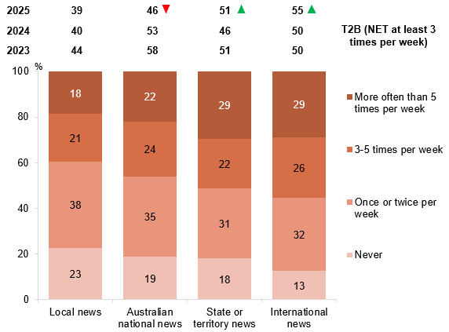
Source: D1. On average per week, how often do you read, watch, or listen to any of the following types of news and current affairs? This includes TV, radio, newspapers, and online.
Base: MCCS, All respondents. 2025 n=3,396. 2024 n=3,773. 2023 n=3,730.
Notes: Don’t know/refused responses not shown, % vary per statement. Note that in 2022 and prior ‘Local news’ and ‘State or territory news’ were combined as one code, ‘Local, state or territory news’. In 2023, this was separated out to two codes.
Bar chart showing the frequency per week that people read, watch, or listen to various types of news and current affairs, including TV, radio, newspapers, and online. The categories are International news, Australian national news, State or territory news, and Local news in 2025. The T2B (NET at least 3 times per week) is compared between 2025 to 2023.
Local news:
- Never: 23%
- Once or twice per week: 38%
- 3–5 times per week: 21%
- More often than 5 times per week: 18%
- T2B (NET at least 3 times per week): 39% in 2025, 40% in 2024, 44% in 2023
Australian national news:
- Never: 19%
- Once or twice per week: 35%
- 3–5 times per week: 24%
- More often than 5 times per week: 22%
- T2B (NET at least 3 times per week): 46% in 2025, 53% in 2024, 58% in 2023
State or territory news:
- Never: 18%
- Once or twice per week: 31%
- 3–5 times per week: 22%
- More often than 5 times per week: 29%
- T2B (NET at least 3 times per week): 51% in 2025, 46% in 2024, 51% in 2023
International news:
- Never: 13%
- Once or twice per week: 32%
- 3–5 times per week: 26%
- More often than 5 times per week: 29%
- T2B (NET at least 3 times per week): 55% in 2025, 50% in 2024, 50% in 2023

Subgroup
T2B International news was higher for:
- Men (63% vs 48% of women)
- Ages 55+ (79% vs 48% of ages 18–54)
- Non-Aboriginal and/or Torres Strait Islanders (57% vs 35% of Aboriginal or Torres Strait Islanders)
T2B Australian national news was higher for:
- Men (50% vs 42% of women)
- Ages 45+ (62% vs 35% of ages 18–44)
- Non-Aboriginal and/or Torres Strait Islanders (47% vs 27% of Aboriginal or Torres Strait Islanders)
T2B State or territory news was higher for:
- Men (61% vs 41% of women)
- Ages 55+ (71% vs 45% of ages 18–54)
- Those with a Postgraduate degree/Graduate Diploma (65% vs 51% of those with a Bachelor degree, 50% of those with education up to Year 12 and 47% of those with a TAFE qualification/Trade Certificate/Diploma)
- Non-Aboriginal and/or Torres Strait Islanders (53% vs 25% of Aboriginal or Torres Strait Islanders)

Callout
Australian national news:
- T2B (NET at least 3 times per week) (46% vs 53% in 2024) decreased significantly in 2025.
State or territory news:
- T2B (NET at least 3 times per week) (51% vs 46% in 2024) increased significantly in 2025.
International news:
- T2B (NET at least 3 times per week) (55% vs 50% in 2024) increased significantly in 2025.
International news was the most frequently consumed type of news, followed by state or territory news.

Sources of news
Social media (54%) overtook commercial free-to-air TV (50%) as the most common source of news in 2025, followed by domestic/Australian news website/app (48%), and radio (48%). Social media, radio, and local print newspaper have increased as sources of news in 2025.
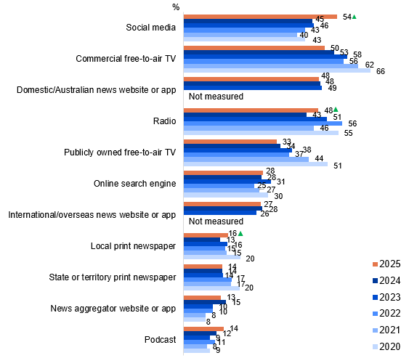
Source: D2. In general, how do you currently access most of your news and/ or current affairs?
Base: MCCS, Respondents who consume news content. 2025: n=3,156. 2024: n=3,488. 2023: n=3,454. 2022: n=3,807. 2021: n=3,981. 2020: n=3,942.
Notes: Don’t know/refused responses not shown: <0.5% for both between 2020 and 2025. Responses for codes not shown on chart if <10% in 2025. Note that ‘News website or app’ was used prior to 2023, however, was split into ‘Domestic / Australian news website or app’ and ‘International / overseas news website or app’ since 2023. Codes with ‘Not measured’ for previous years were introduced from 2023.
A bar chart showing the percentage of how people access most of their news/or current affairs comparing the years from 2020 to 2025.
Social media: 54% in 2025, 45% in 2024, 46% in 2023, 43% in 2022, 40% in 2021, and 43% in 2020
Commercial free-to-air TV: 50% in 2025, 53% in 2024, 58% in 2023, 56% in 2022, 62% in 2021, and 66% in 2020
Domestic/Australian news website or app: 48% in 2025, 48% in 2024, 49% in 2023, not measured in 2022, not measured in 2021, and not measured in 2020
Radio: 48% in 2025, 43% in 2024, 51% in 2023, 56% in 2022, 46% in 2021, and 55% in 2020
Publicly owned free-to-air TV: 33% in 2025, 34% in 2024, 38% in 2023, 37% in 2022, 44% in 2021, and 51% in 2020
Online search engine: 28% in 2025, 28% in 2024, 31% in 2023, 25% in 2022, 27% in 2021, and 30% in 2020
International/overseas news website or app: 27% in 2025, 28% in 2024, 26% in 2023, not measured in 2022, not measured in 2021, and not measured in 2020
Local print newspaper: 16% in 2025, 13% in 2024, 16% in 2023, 15% in 2022, 15% in 2021, and 20% in 2020
State or territory print newspaper: 14% in 2025, 14% in 2024, 14% in 2023, 17% in 2022, 17% in 2021, and 20% in 2020
News aggregator website or app: 13% in 2025, 15% in 2024, 10% in 2023, 10% in 2022, 8% in 2021, and 8% in 2020
Podcast: 14% in 2025, 12% in 2024, 9% in 2023, 11% in 2022, 8% in 2021, and 9% in 2020

Subgroup
Social media was higher for:
- Women (58% vs 49% of men)
- Ages 18–24 (81%), 25–34 (68%), 35–44 (55%) and 45–54 (48% vs 27% ages 55+)
- Aboriginal and/or Torres Strait Islanders (69% vs 53% of Non-Aboriginal or Torres Strait Islanders)
- Those who speak a language other than English (64% vs 50% of English-only speakers)
- Those who view posts, images, and videos on social media sites once a day or more (67% vs 26% of those who did it less than once a day)
- Those who comment or post images to social media sites once a day or more (66% vs 51% of those who did it less than once a day)
- Those who accessed social media once an hour or more often (78% vs 46% of those who accessed it less often)

Callout
Social media (54% vs 45% in 2024), radio (48% vs 43% in 2024), and local print newspaper (16% vs 13% in 2024) increased significantly in 2025.

Further reading
The growing reliance on social media for news aligns with findings from the 2025 Australian Digital News Report by the News and Media Research Centre at the University of Canberra.¹
Social media, commercial free-to-air TV, domestic / Australian news websites or apps, and radio remained the dominant channels for accessing news or current affairs.

Sources of news by category
Online platforms led news consumption (86%), followed by television (70%), audio sources (60%) and newspapers (32%). Online, audio and newspapers all show a significant increase in 2025.
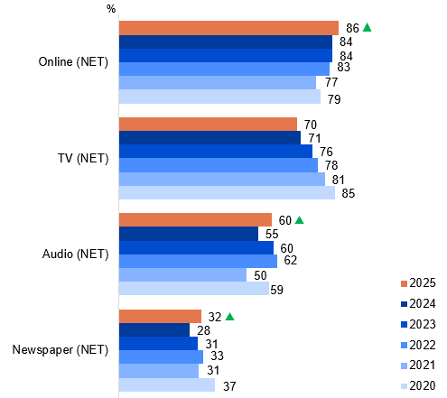
Source: D2. In general, how do you currently access most of your news and/ or current affairs?
Base: MCCS, Respondents who consume news content. 2025: n=3,156. 2024: n=3,488. 2023: n=3,454. 2022: n=3,807. 2021: n=3,981. 2020: n=3,942.
Note: The chart shows figures for 2020/2021 rebased to use the same base as 2022 for consistency (only those who consumed news). Note that ‘News website or app’ was used prior to 2023, however, was split into ‘Domestic / Australian news website or app’ and ‘international / overseas news website or app’ since 2023.
A bar chart showing the percentage of how people access most of their news/or current affairs comparing the years from 2020 to 2025. The chart has four categories of Online (NET), TV (NET), audio (NET) and newspaper (NET).
Online (NET): 86% in 2025, 84% in 2024, 84% in 2023, 83% in 2022, 77% in 2021, and 79% in 2020
TV (NET): 70% in 2025, 71% in 2024, 76% in 2023, 78% in 2022, 81% in 2021, and 85% in 2020
Audio (NET): 60% in 2025, 55% in 2024, 60% in 2023, 62% in 2022, 50% in 2021, and 59% in 2020
Newspaper (NET): 32% in 2025, 28% in 2024, 31% in 2023, 33% in 2022, 31% in 2021, and 37% in 2020

Subgroup
Those who access Online (NET) was higher for:
- Ages 18–54 (91% vs 71% of ages 55+)
- Those living in a capital city (88% vs 83% of those living outside a capital city)
- Those who speak a language other than English (93% vs 83% of English-only speakers)
- Those who look for information over the internet once a day or more (90% vs 65% of those who did it less than once a day)
- Those watched exclusively online content in P7D (95% vs 50% of those watched exclusively offline content)

Callout
Online NET (86% vs 84% in 2024), audio NET (60% vs 55% in 2025), and newspaper NET (32% vs 28% in 2024) increased significantly in 2025.

Note
‘NET: TV’ includes:
- ‘Commercial free-to-air TV, including catch-up TV’, ‘Publicly owned free-to-air TV, inc. catch-up TV’, and ‘Pay TV, inc. streaming’.
‘NET: Online’ includes:
- ‘Domestic / Australian news website or app’ (since 2023), ‘International / overseas news website or app’ (since 2023), ‘News website or app’ (2020-2022), ‘Social media’, ‘Online search engine’, ‘News aggregator website or app’, and ‘Other website or app’.
‘NET: Audio’ includes:
- ‘Radio’, ‘Podcast’, and ‘Online radio station’ (2023 only)
‘NET: Newspaper’ includes:
- ‘National print newspaper’, ‘State print newspaper’, and ‘Local print newspaper’.
While online sources of news remained the most popular, audio and newspaper sources of news continued to trend upwards in 2025.

Sources of news in past 7 days
In the past 7 days, online sources led news consumption (87% NET), with a significant increase in for social media (67%) driving digital engagement. However, news consumption via news aggregator websites or apps (24%) and other websites or apps (3%) have a significant decrease.
Traditional platforms showed an overall decline in news consumption with varying weekly access levels: commercial free-to-air TV (47%), radio (47%), and local print newspaper (15%). Traditional platforms have a significant decrease for weekly access: television (61% NET), audio (59% NET), and newspapers (26% NET).
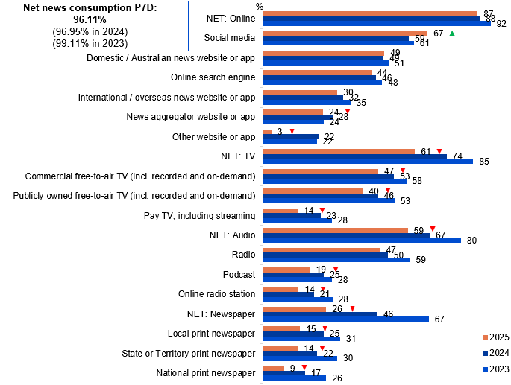
Source: D17. In the past 7 days, did you access news from any of the following sources?
Base: MCCS, All respondents. 2025: n=3,396. 2024: n=3,773. 2023: n=3,730.
Notes: No/Don’t know/refused responses not shown, % vary per statement. The methodology for D17 was a grid question with a forced yes/no choice for each option and an extended code frame for print newspaper.
Bar chart showing the percentage of Australians’ news consumption by platform in the past 7 days across 2023 to 2025.
NET: Online: 87% in 2025, 88% in 2024, and 92% in 2023
Social media: 67% in 2025, 59% in 2024, and 61% in 2023
Domestic / Australian news website or app: 49% in 2025, 49% in 2024, and 51% in 2023
Online search engine: 44% in 2025, 46% in 2024, and 48% in 2023
International / overseas news website or app: 30% in 2025, 32% in 2024, and 35% in 2023
News aggregator website or app: 24% in 2025, 28% in 2024, and 24% in 2023
Other website or app: 3% in 2025, 22% in 2024, and 22% in 2023
NET: TV: 61% in 2025, 74% in 2024, and 85% in 2023
Commercial free-to-air TV (including recorded and on-demand): 47% in 2025, 53% in 2024, and 58% in 2023
Publicly owned free-to-air TV (including recorded and on-demand): 40% in 2025, 46% in 2024, and 53% in 2023
Pay TV, including streaming: 14% in 2025, 23% in 2024, and 28% in 2023
NET: Audio: 59% in 2025, 67% in 2024, and 80% in 2023
Radio: 47% in 2025, 50% in 2024, and 59% in 2023
Podcast: 19% in 2025, 25% in 2024, and 28% in 2023
Online radio station: 14% in 2025, 21% in 2024, and 28% in 2023
NET: Newspaper: 26% in 2025, 46% in 2024, and 67% in 2023
Local print newspaper: 15% in 2025, 25% in 2024, and 31% in 2023
State or territory print newspaper: 14% in 2025, 22% in 2024, and 30% in 2023
National print newspaper: 9% in 2025, 17% in 2024, and 26% in 2023
NET news consumption past 7 days: 96.11% in 2025, 96.95% in 2024, and 99.11% in 2023

Subgroup
Social media was higher for:
- Women (71% vs 61% of men)
- Ages 18–54 (74% vs 42% of ages 55+)
- Those living in a capital city (68% vs 62% of those living outside a capital city)
- Aboriginal and/or Torres Strait Islanders (81% vs 65% of Non-Aboriginal or Torres Strait Islanders)
- Those who speak a language other than English (77% vs 62% of English-only speakers)
- Those who accessed social media once an hour or more often (88%
vs 59% of those who accessed it less often)

Callout
Social media (67% vs 59% in 2024) increased significantly in 2025.
News aggregator website or app (24% vs 28% in 2024), other website or app (3% vs 22% in 2024), NET TV (61% vs 74% in 2024), commercial free-to-air TV (including recorded and on-demand) (47% vs 53% in 2024), publicly owned free-to-air TV (including recorded and on-demand) (40% vs 46% in 2024), pay TV (including streaming) (14% vs 23% in 2024), NET Audio (59% vs 67% in 2024), podcast (19% vs 25% in 2024) , online radio station (14% vs 25% in 2024), NET Newspaper (26% vs 46% in 2024), local print newspaper (15% vs 25% in 2024), state or territory print newspaper (14% vs 22% in 2024), and national print newspaper (9% vs 17% in 2024) decreased significantly in 2025.
News access has declined across all categories in 2025. Social media was the most used news source in the past 7 days.

Most important source of news
When asked about what source of news is the most important, just under half (47%) report publicly-owned free-to-air TV or radio as the most important, followed by commercial free-to-air TV or radio (41%) and creators on social media, YouTube or podcasts (28%). Specialty newspapers (16%) and local/community newspapers (21%) were the least important news source accessed.
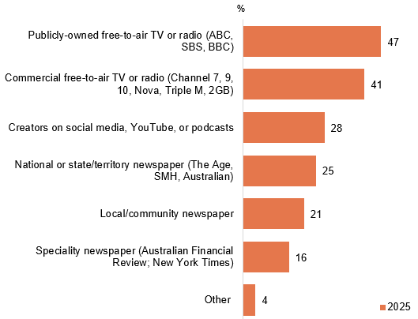
Source: D19. Which source of news is most important to you?
Base: MCCS. Respondents who consume news content. 2025: n=3,156.
Notes: Don’t know/refused responses not shown: 2025 DK=1%, Ref<0.5%.
A bar chart showing which news sources Australians see as the most important in 2025.
Publicly-owned free-to-air TV or radio (ABC, SBS, BBC): 47%
Commercial free-to-air TV or radio (Channel 7, 9, 10, Nova, Triple M, 2GB): 41%
Creators on social media, YouTube, or podcasts: 28%
National or state/territory newspaper (The Age, SMH, Australian): 25%
Local/community newspaper: 21%
Speciality newspaper (Australian Financial Review, New York Times): 16%
Other: 4%

Subgroup
NET free-to-air TV or radio (Publicly-owned free-to-air TV or radio and Commercial free-to-air TV or radio) was higher for:
- Ages 65+ (90% vs 66% of ages 18–64)
- Non-Aboriginal and/or Torres Strait Islanders (71% vs 54% of Aboriginal or Torres Strait Islanders)
- English-only speakers (73% vs 62% of those who speak a language other than English)
- Those watched exclusively offline content in P7D (89% vs 51% of those watched exclusively online content)
- Those listened to any radio in P7D (79% vs 56% of those who did not)
- Those who consumed local news (72%), Australian national news (73%), international news (71%)
- Those who generally consumed news via free-to-air or on-demand TV (31%), audio sources (76%) or print newspaper (74%)

Creators on social media, YouTube, or podcasts was higher for:
- Ages 18–34 (39% vs 21% of ages 35+)
- Those who consumed state or territory news (29% vs 21% of those who did not)
- Those who consumed news via online sources in general (31%)
Those who paid for a news subscription were more likely than those who did not to consider national or state/territory newspaper (54%), local/community newspaper (31%) or speciality newspaper (27%) as their most important source of news.
Publicly-owned free-to-air TV or radio and commercial free-to-air TV or radio were reported to be the most importance news sources.

Level of trust in news
45% of respondents reported they trust a lot or trust somewhat in the news they consume, while 23% said they distrust a lot or distrust somewhat. However, a third (33%) of respondents were neutral for trust in the news they consume. Trust in news was higher among older people, those with higher levels of education, those not from an Aboriginal and/or Torres Strait Islander background, those in higher socio-economic areas, and those who consumed any news in the past seven days.
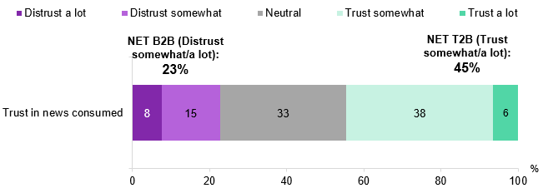
Source: D28. In general, how much or how little do you trust the news you come across?
Base: TVCS & MCCS, All respondents. 2025: n=4,396.
Notes: Don’t know/refused responses not shown: 0% for DK and Ref in 2025.
Bar chart showing people’s level of trust in news they consumed in 2025.
Trust in news consumed: 8% distrust a lot, 15% distrust somewhat, 33% neutral, 38% trust somewhat and 6% trust a lot
NET B2B (Distrust somewhat/a lot): 23%
NET T2B (Trust somewhat/a lot): 45%

Subgroup
NET Trust in news consumed (T2B) was higher for:
- Ages 65–74 (53% vs 40% of ages 18–44)
- Those with a Postgraduate degree/Graduate Diploma (52% vs 45% of those with a Bachelor degree, 43% of those with a TAFE qualification/Trade Certificate/Diploma and 42% of those with education up to Year 12 )
- Non-Aboriginal and/or Torres Strait Islanders (45% vs 31% of Aboriginal or Torres Strait Islanders)
- English-only speakers (47% vs 38% of those who speak a language other than English)
- Those from the least disadvantaged SEIFA quintile (53% vs 42% of those from the more disadvantaged SEIFA quintiles 1–3)
- Those who consumed any news in P7D (45% vs 17% of those who did not)
- Those who generally consumed news via publicly-owned FTA TV (55%) and domestic/Australian news website or app (53%)
- Those considered national or state/territory newspaper (56%) or publicly-owned FTA TV or radio (55%) as their most important source of news
Over two in five respondents say that they trust in the news that they consume with a sizeable proportion of respondents remain neutral.

Impact on trust in news articles written using Generative AI
Trust in news content being fully created by or with the assistance of Generative AI was impacted somewhat negatively or very negatively with 83% and 73% respectively, a significant increase since 2023. A small proportion (3%) of respondents reported that their trust would somewhat positively/very positivity be impacted towards news content if it had been fully created by Generative AI. While 4% of respondents reported their trust would somewhat positively/very positivity be impacted if the news content was created with the assistance of Generative AI, a significant decrease compared to 2023.

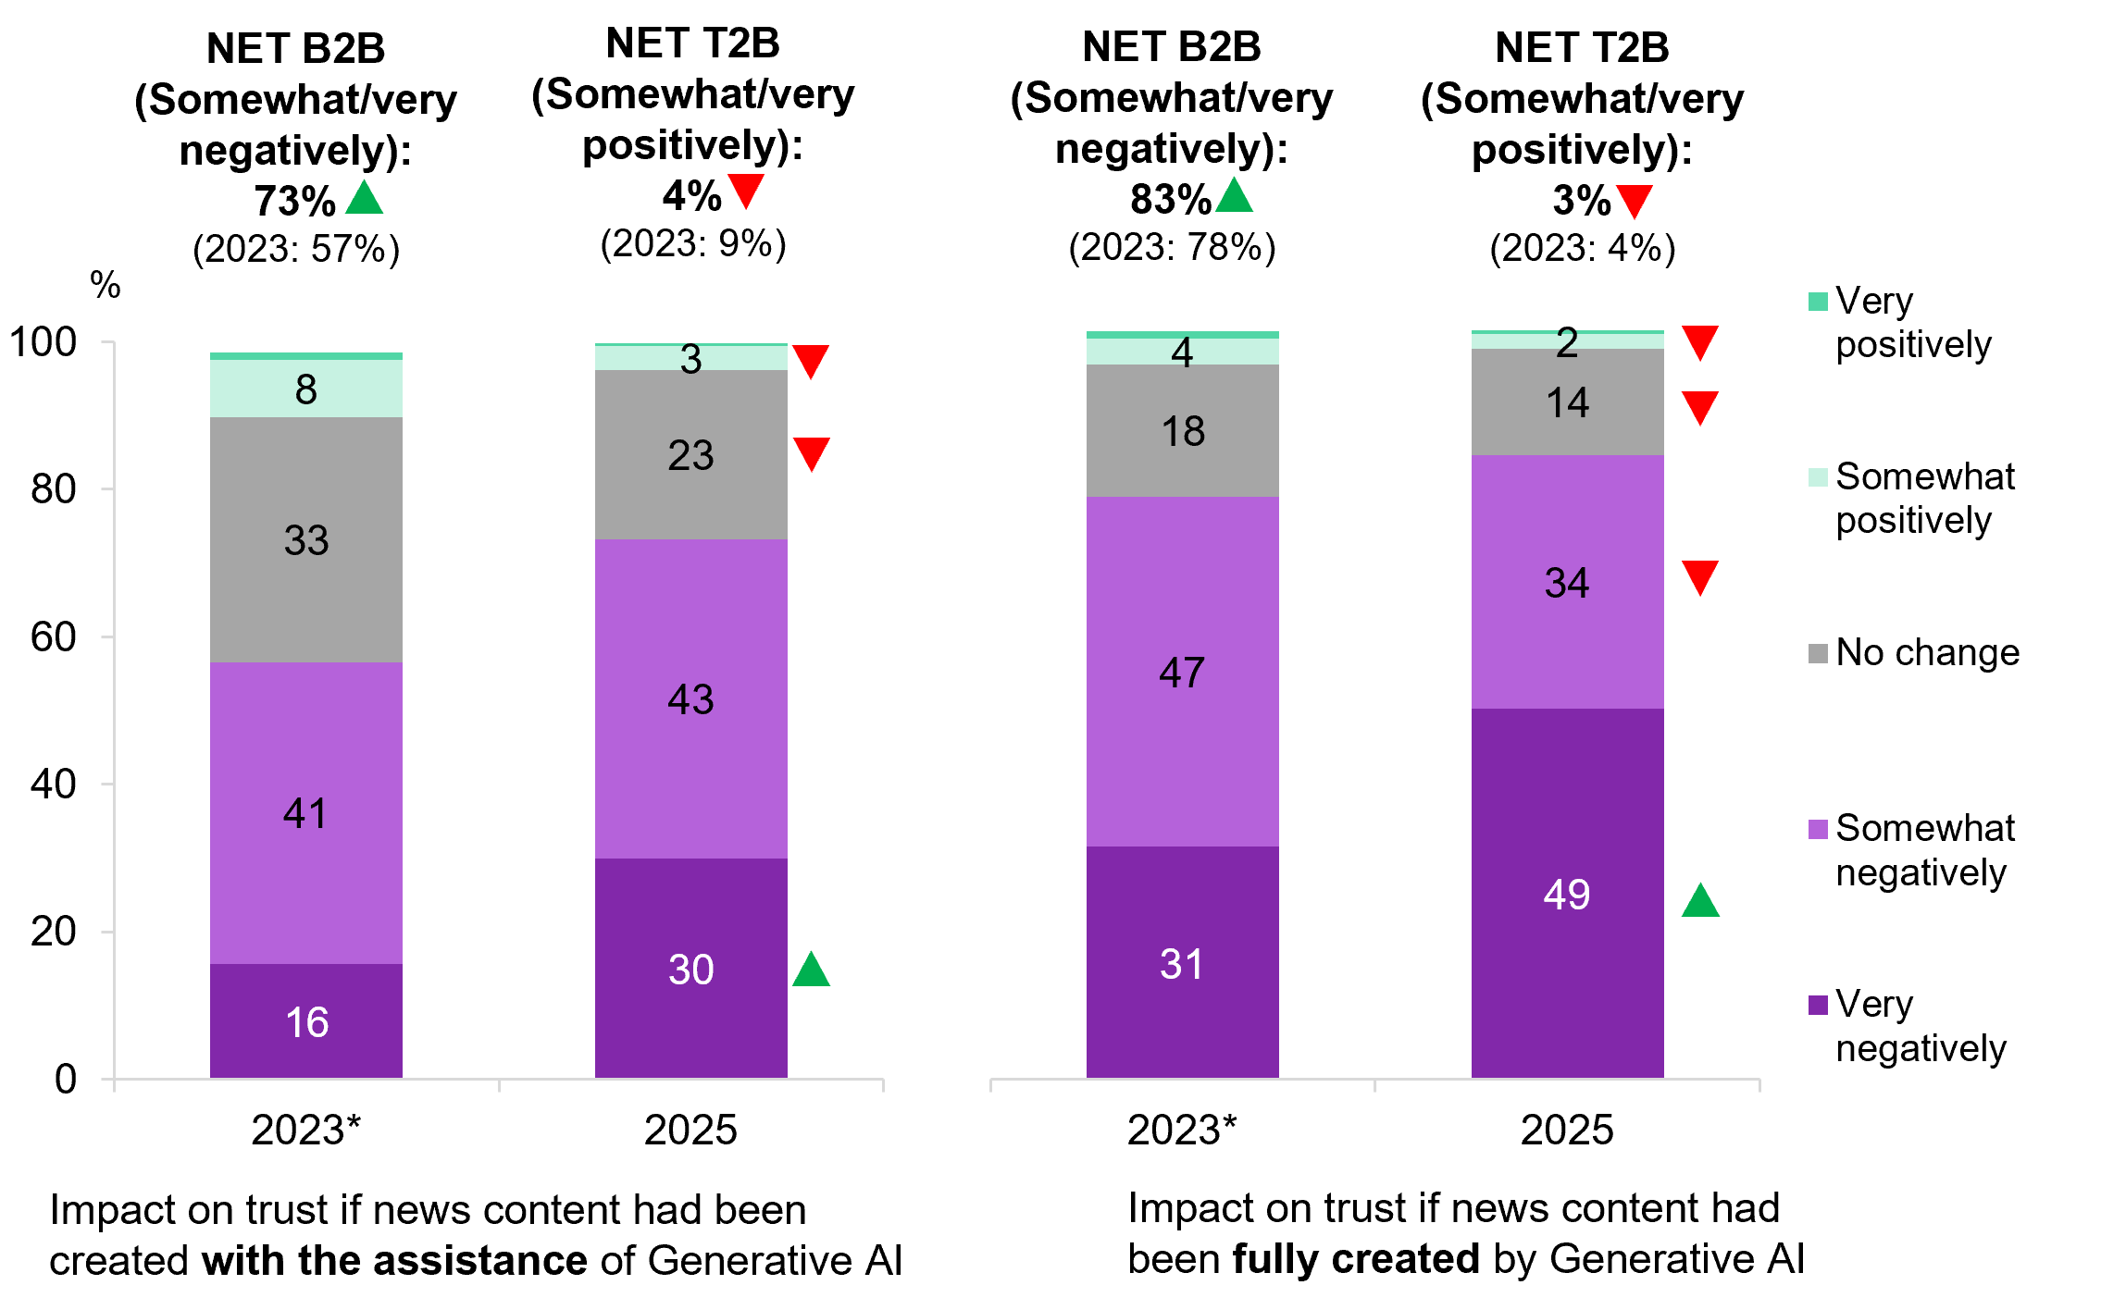
Source: D24A. If you were aware that news content had been created in full by Generative AI, how would this impact your trust in that content? D24B. If you were aware that news content had been created with the assistance of Generative AI, how would this impact your trust in that content?
Base: TVCS & MCCS, All respondents. 2025: n=4,396. *Respondents who are aware of Generative AI. 2023: n=3,264.
Notes: Don’t know/refused responses not shown: <0.5% for Ref and between 0% and 1% for DK in 2023 and 2025. Responses not shown on chart if <2%
Two stacked bar charts comparing responses across 2023 and 2025 on how people think their trust in news would change if the content were fully created by generative AI or with the assistance of Generative AI.
Impact on trust if news content had been created with the assistance of Generative AI:
- Very negatively: 30% in 2025 and 16% in 2023
- Somewhat negatively: 43% in 2025 and 41% in 2023
- No change: 23% in 2025 and 33% in 2023
- Somewhat positively: 3% in 2025 and 8% in 2023
- Very positively: 0% in 2025 and 1% in 2023
- NET B2B (somewhat/very negatively): 73% in 2025 and 57% in 2023
- NET T2B (somewhat/very positively): 4% in 2025 and 9% in 2023
Impact on trust if news content had been fully created by Generative AI
- Very negatively: 49% in 2025 and 31% in 2023
- Somewhat negatively: 34% in 2025 and 47% in 2023
- No change: 14% in 2025 and 18% in 2023
- Somewhat positively: 2% in 2025 and 4% in 2023
- Very positively: 1% in 2025 and 1% in 2023
- NET B2B (somewhat/very negatively): 83% in 2025 and 78% in 2023
- NET T2B (somewhat/very positively): 3% in 2025 and 4% in 2023

Subgroup
NET Very negatively + Somewhat negatively for news fully created by Generative AI was higher for:
- Ages 55+ (87% vs 80% of ages 25–54)
- Those living outside a capital city (85% vs 82% of those living in a capital city)
- Non-Aboriginal and/or Torres Strait Islanders (84% vs 76% of Aboriginal or Torres Strait Islanders)
- English-only speakers (85% vs 78% of those who speak a language other than English)
- Those who consumed any news in P7D (84% vs 67% of those who did not)
- Those who look for information over the internet once a day or more (85% vs 75% of those who did it less than once a day)

Callout
Impact on trust if news content had been created with the assistance of Generative AI:
- Very negatively (30% vs 16% in 2023) and NET B2B (somewhat/very negatively) (73% vs 57% in 2023) increased significantly, whereas somewhat positively (3% vs 8% in 2023), no change (23% vs 33% in 2023), and NET T2B (somewhat/very positively) (4% vs 9%% in 2023) decreased significantly in 2025.
Impact on trust if news content had been fully created by Generative AI
- Very negatively (49% vs 31% in 2023) and NET B2B (somewhat/very negatively) (83% vs 78% in 2023) increased significantly, whereas somewhat negatively (34% vs 47% in 2023), no change (14% vs 18% in 2023), somewhat positively (2% vs 4% in 2023), and NET T2B (somewhat/very positively) (3% vs 4% in 2023) decreased significantly in 2025.

Further reading
The 2025 Australian Digital News project, conducted by the News and Media Research Centre at the University of Canberra, examined public perceptions of AI-produced news, the use of AI chatbots for news, and levels of interest and comfort in AI-personalised news.¹
Respondents report that if news content were fully created or assisted by Generative AI, their trust in the news content will be significantly impacted negatively.

Paid news subscriptions
Paid news subscriptions remained stable since 2024, with 11% of respondents maintaining subscriptions (vs 11% in 2024, 12% in 2023, and 13% in 2022), and most subscribers (72%) limiting themselves to a single service, a significant increase. However, the average number of news subscriptions respondents are personally paying for has decreased to 1.3 in 2025.
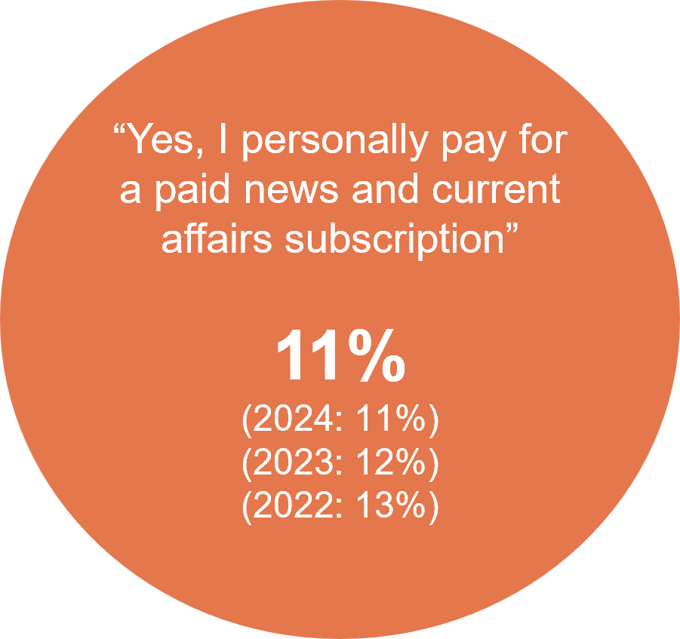
Source: D5. Do you currently personally pay for a paid news and current affairs subscription? This includes print or digital subscriptions to news and magazine publications.
Base: MCCS, All respondents. 2025: n=3,396. 2024: n=3,773. 2023: n=3,730. 2022: n=4,002.
Notes: No/Don’t know/refused responses not shown: <0.5% for DK and Ref between 2022 and 2025. No: 2025=89%, 2024=88%, 2023=88%, 2022=88%).

Subgroup
Those paying for a news subscription were more likely to be men (13%), aged 65+ (21%), with a Postgraduate degree/Graduate Diploma (20%), English-speakers (13%), pensioner or self-funded retiree (20%), those consumed any news in P7D (11%) or consumed news more often than 5 times per week (19%).
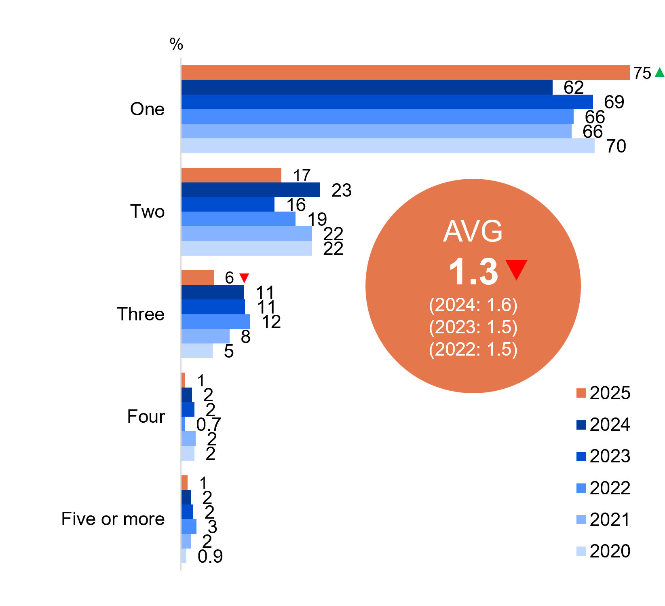
Source: D6. How many news subscriptions are you currently personally paying for?
Base: MCCS, Respondents who pay for a paid news and current affairs subscription. 2025: n=513. 2024: n=598. 2023: n=655. 2022: n=721. 2021: n=746. 2020: n=750.
Notes: Don’t know/refused responses not shown: <0.5% for both between 2020 and 2025.
Horizontal bar chart showing the number of news subscriptions people are currently personally paying for by number category from 2020 to 2025.
One: 75% in 2025, 62% in 2024, 69% in 2023, 66% in 2022, 66% in 2021, and 70% in 2020
Two: 17% in 2025, 23% in 2024, 16% in 2023, 19% in 2022, 22% in 2021, and 22% in 2020
Three: 6% in 2025, 11% in 2024, 11% in 2023, 12% in 2022, 8% in 2021, and 5% in 2020
Four: 1% in 2025, 2% in 2024, 2% in 2023, 0.7% in 2022, 2% in 2021, and 2% in 2020
Five or more: 1% in 2025, 2% in 2024, 2% in 2023, 3% in 2022, 2% in 2021, and 0.9% in 2020
Average of 1.3 in 2025, down from 1.6 in 2024, 1.5 in 2023, and 1.5 in 2022

Subgroup
Average number of paid news subscriptions was higher for:
- Those with a Postgraduate degree/Graduate Diploma (1.5)
- Those considered speciality newspaper as their most important source of news (1.5)

Callout
One news subscriptions that people are currently personally paying for increased significantly in 2025 (75% vs 62% in 2024)
Three news subscriptions that people are currently personally paying for decreased significantly in 2025 (6% vs 11% in 2024)
The average number of paid news subscription decreased significantly in 2025 (1.3% vs 1.6% in 2024)
The proportion of those with a paid news subscription remained consistent with levels in 2024, with an increase in most subscribers limiting themselves to a single service.

Extent of incidental news consumption
One quarter (26%) reported that the majority or all of the news they consumed came from activities where they were not primarily trying to engage with news, a significant increase compared to 2024. Passive news consumers, who consumed most or all of their news passively, were more likely to be younger, women, those who accessed social media once an hour or more often and have accessed news on social media in the past 7 days.
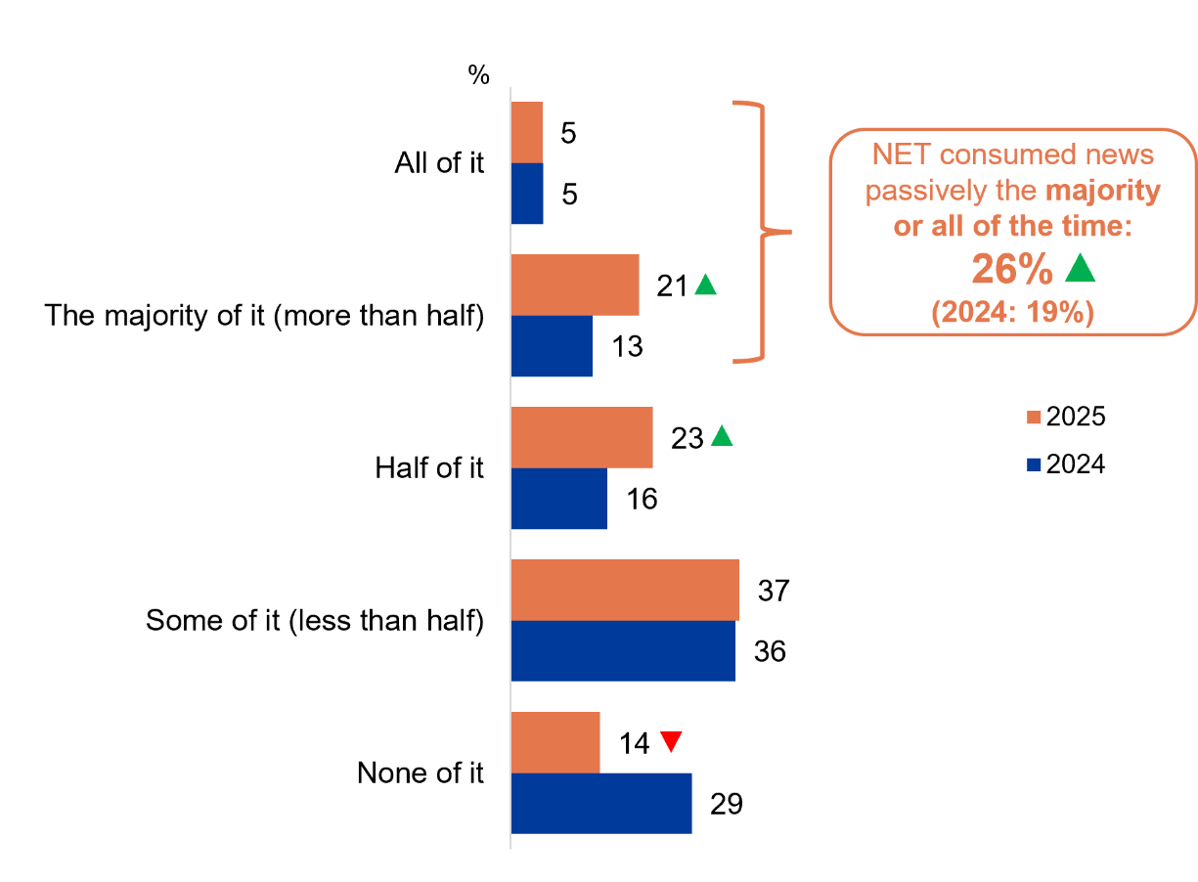
Source: NCONSUM1. How much of your news consumption comes from activities where you are not primarily trying to engage with news content?
Base: TVCS, MCCS. All respondents. 2025: n=4,396. 2024: n=4,490.
Notes: Don’t know/refused responses not shown: <0.5% for both in 2025. 2024 DK=1%, Ref<0.5%.
Horizontal bar chart showing how much news is consumed passively, comparing 2025 and 2024.
All of it: 5% in 2025 and 5% in 2024
The majority of it (more than half): 21% in 2025 and 13% in 2024
Half of it: 23% in 2025 and 16% in 2024
Some of it (less than half): 37% in 2025 and 36% in 2024
None of it: 14% in 2025 and 29% in 2024
NET consumed news passively the majority or all of the time: 26% in 2025, and 19% in 2024

Subgroup
NET consumed news passively the majority or all of the time:
- Women (29% vs 22% of men)
- Ages 18–44 (36% vs 16% of ages 45+)
- Aboriginal and/or Torres Strait Islanders (36% vs 25% of Non-Aboriginal or Torres Strait Islanders)
- Those viewing posts, images, and videos on social media sites once a day or more (30% vs 18% of those viewing less than once a day)
- Those who accessed news on social media in P7D (34% vs 19% of those who did not)
- Those who accessed social media once an hour or more often (40% vs 22% of those who accessed it less often)
- Those currently have an account on TikTok (38%), Snapchat (37%), Reddit (36%), Pinterest (35%), Instagram (31%), Facebook (28%) and YouTube (29%)

Callout
How much news is consumed passively increased significantly in 2025 for:
- The majority of it (more than half) (21% vs 13% in 2024)
- Half of it (23% vs 16% in 2024)
- NET the majority or all of the time (26% vs 19% in 2024)
How much news is consumed passively decreased significantly in 2025 for:
- None of it (14% vs 29% in 2024)
Passive news consumption has increased in 2025, particularly among women, younger respondents, and heavy users of social media for news and other general content.

Source of incidental news
Social media feeds (62%) were the most common way respondents reported passively encountering news content when they were not actively seeking it. Other common passive exposure sources include word of mouth (42%), TV (40%) or online search engines (31%).
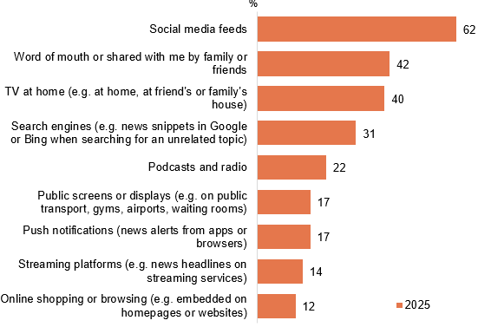
Source: NCONSUM3. Where do you usually come across news when you are not actively trying to access news content?
Base: TVCS, MCCS. Respondents who consumed any news incidentally. 2025: n=3,629.
Notes: Don’t know/refused responses not shown: <0.5% for both in 2025.
Horizontal bar chart showing how people usually come across news when they are not actively trying to access it in 2025.
Social media feeds: 62%
Word of mouth or shared with me by family or friends: 42%
TV at home (e.g. at home, at friend’s or family’s house): 40%
Search engines (e.g. news snippets in Google or Bing when searching for an unrelated topic): 31%
Podcasts and radio: 22%
Public screens or displays (e.g. on public transport, gyms, airports, waiting rooms): 17%
Push notifications (news alerts from apps or browsers): 17%
Streaming platforms (e.g. news headlines on streaming services): 14%
Online shopping or browsing (e.g. embedded on homepages or websites): 12%

Subgroup
Social media feeds was higher for:
- Women (67% vs 57% of men)
- Ages 18–54 (71% vs 44% of ages 55+)
- Aboriginal and/or Torres Strait Islanders (75% vs 62% of Non-Aboriginal or Torres Strait Islanders)
- Those who consumed the majority of news passively (73% vs 59% of those who consumed half or some of the news passively)
- Those who accessed social media once an hour or more often (77% vs 58% of those who accessed it less often)
- Those came across news on social media via reading an article headline while scrolling (87%) or clicking on a link appeared in their feeds (89%) more than once a day
Search engines (e.g. news snippets in Google or Bing when searching for an unrelated topic) was higher for:
- Those used Bing (47%), Yahoo (44%) or Google (33%) in P6M
Podcasts and radio was higher for:
- Those listened to any audio content in P7D (24% vs 3% of those who did not)
Push notifications (news alerts from apps or browsers) was higher for:
- Those paid for news subscription (33% vs 16% of those who did not)
Social media is the most common platform where respondents are indirectly consuming news content, followed by word of mouth / shared by family and friends and TV.

Frequency of different ways of coming across news via social media
Nearly all (98% NET) of respondents report ever coming across news content from reading an article headline while scrolling/browsing, while over half encounter at least once a day. This is followed by 91% (NET) of respondents who click on links that appeared in their feed. Encountering news on social media via direct messaging or tagging was relatively less frequent, with 63% and 58% respectively ever coming across news in this way. Directly seeking out news on social media via news outlet pages was also reported by 66% of respondents, though this was less frequent compared with other methods.
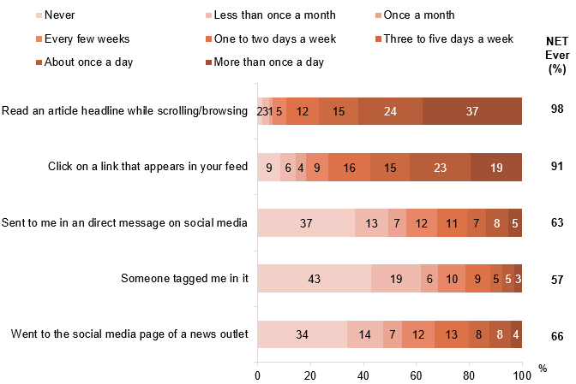
Source: D17a. How frequently do you come across news on social media via the following ways?
Base: MCCS, Respondents who accessed news via social media in the 7 days before the survey. 2025: n=2,075.
Notes: Don’t know/refused responses not shown, % vary per statement, all <0.5% in 2025.
Horizontal stacked bar chart showing how people come across news via social media in 2025, by frequency.
Read an article headline while scrolling or browsing: 2% never, 3% less than once a month, 1% once a month, 5% every few weeks, 12% one to two days a week, 15% three to five days a week, 24% about once a day, and 37% more than once a day. NET Ever: 98%.
Click on a link that appears in your feed: 9% never, 6% less than once a month, 4% once a month, 9% every few weeks, 16% one to two days a week, 15% three to five days a week, 23% about once a day, and 19% more than once a day. NET Ever: 91%.
Sent to me in a direct message on social media: 37% never, 13% less than once a month, 7% once a month, 12% every few weeks, 11% one to two days a week, 7% three to five days a week, 8% about once a day, and 5% more than once a day. NET Ever: 63%.
Someone tagged me in it: 43% never, 19% less than once a month, 6% once a month, 10% every few weeks, 9% one to two days a week, 5% three to five days a week, 5% about once a day, and 3% more than once a day. NET Ever: 57%.
Went to the social media page of a news outlet: 34% never, 14% less than once a month, 7% once a month, 12% every few weeks, 13% one to two days a week, 8% three to five days a week, 8% about once a day, and 4% more than once a day. NET Ever: 66%.

Subgroup
NET Ever (Went to the social media page of a news outlet) was higher for:
- Aboriginal and/or Torres Strait Islanders (81% vs 65% of Non-Aboriginal or Torres Strait Islanders)
- Those who accessed social media once an hour or more often (73% vs 63% of those who accessed it less often)
Reading an article headline while scrolling/browsing were reported to be the most common forms of encountering news on social media.

Sources used for emergency information
One in 5 (20% vs 11% in 2024) respondents reported experiencing an emergency situation, such as a natural disaster or extreme weather event, in the past 12 months. The increase in reported emergencies in 2025 may be attributed to floods and cyclones in Queensland and New South Wales during 12 months leading up to the September/October 2025 survey. In 2025, when prompted with a list of sources, government weather/emergency websites or apps were the most commonly accessed source of information during their most recent emergency. Radio (41%) was also widely used, particularly among older respondents and those living in regional areas. It is important to note that the choice of information sources can vary depending on the type of emergency, so findings should be interpreted in the context of major events that occurred during the period.
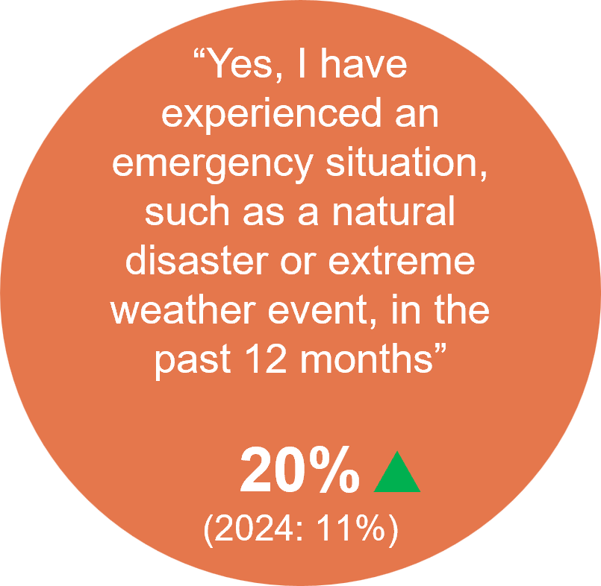
Source: EMERG1. Have you experienced an emergency situation, such as a natural disaster or extreme weather event, in the past 12 months?
Base: TVCS, All respondents. 2025: n=3,716. 2024: n=3,890.
Notes: No/Don’t know/refused responses not shown: <0.5% for DK and Ref. No: 2025=80%, 2024=89%.
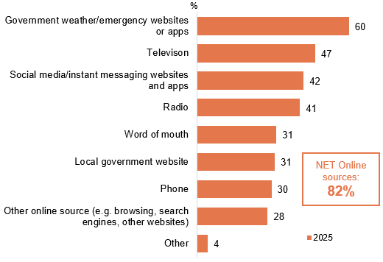
Source: EMERG2. What services, platforms, or sources did you use to find out information about the most recent emergency situation you experienced?
Base: TVCS, Respondents who have encountered an emergency situation. 2025: n=813.
Notes: Don’t know/refused responses not shown: 0% for both in 2025. ‘NET Online’ includes ‘government weather/emergency websites or apps’, ‘social media/instant messaging websites or apps’, ‘other online source’ and ‘local government website’.
*EMERG2 was asked as an unprompted open-text question in 2024 and as a closed-frame question in 2025. As a result, the results are not comparable across years, and 2024 data are not shown.
Horizontal bar chart showing sources of emergency information used in 2025.
Government weather or emergency websites or apps: 60% in 2025
Television: 47% in 2025
Social media or instant messaging websites and apps: 42% in 2025
Radio: 41% in 2025
Word of mouth: 31% in 2025
Local government website: 31% in 2025
Phone: 30% in 2025
Other online sources (e.g. browsing, search engines, other websites): 28% in 2025
Other sources: 4% in 2025
NET online sources: 82% in 2025

Subgroup
Using Radio as a source for emergency information was higher for:
- Ages 55+ (57% vs 28% of ages 18–54)
- Those living outside a capital city (47% vs 30% of those living in a capital city)
- Those listened to AM/FM/DAB radio or radio via the internet/app in P7D (56% vs 12% of those who did not)
NET online sources was higher for:
- Those looking for information over the internet once a day or more (84% vs 70% of those did it less than once a day)
- Those viewing posts, images, and videos on social media sites once a day or more (87% vs 73% of those did it less than once a day)
20% of respondents reported to have experienced an emergency situation in the past 12 months. Government weather/emergency websites or apps, television, social media/instant messaging websites and apps and radio were the key emergency information sources.

Reasons for using TV or radio for information in the most recent emergency
Accessibility/availability (42%) is the most commonly reported reason for using radio for information during the most recent emergency, equally followed by local coverage (18%) and current/up to date (18%). In comparison, TV was primarily used for its live and up to date coverage (35%), followed by accessibility/availability (25%) and emergency-specific content and updates (16%).
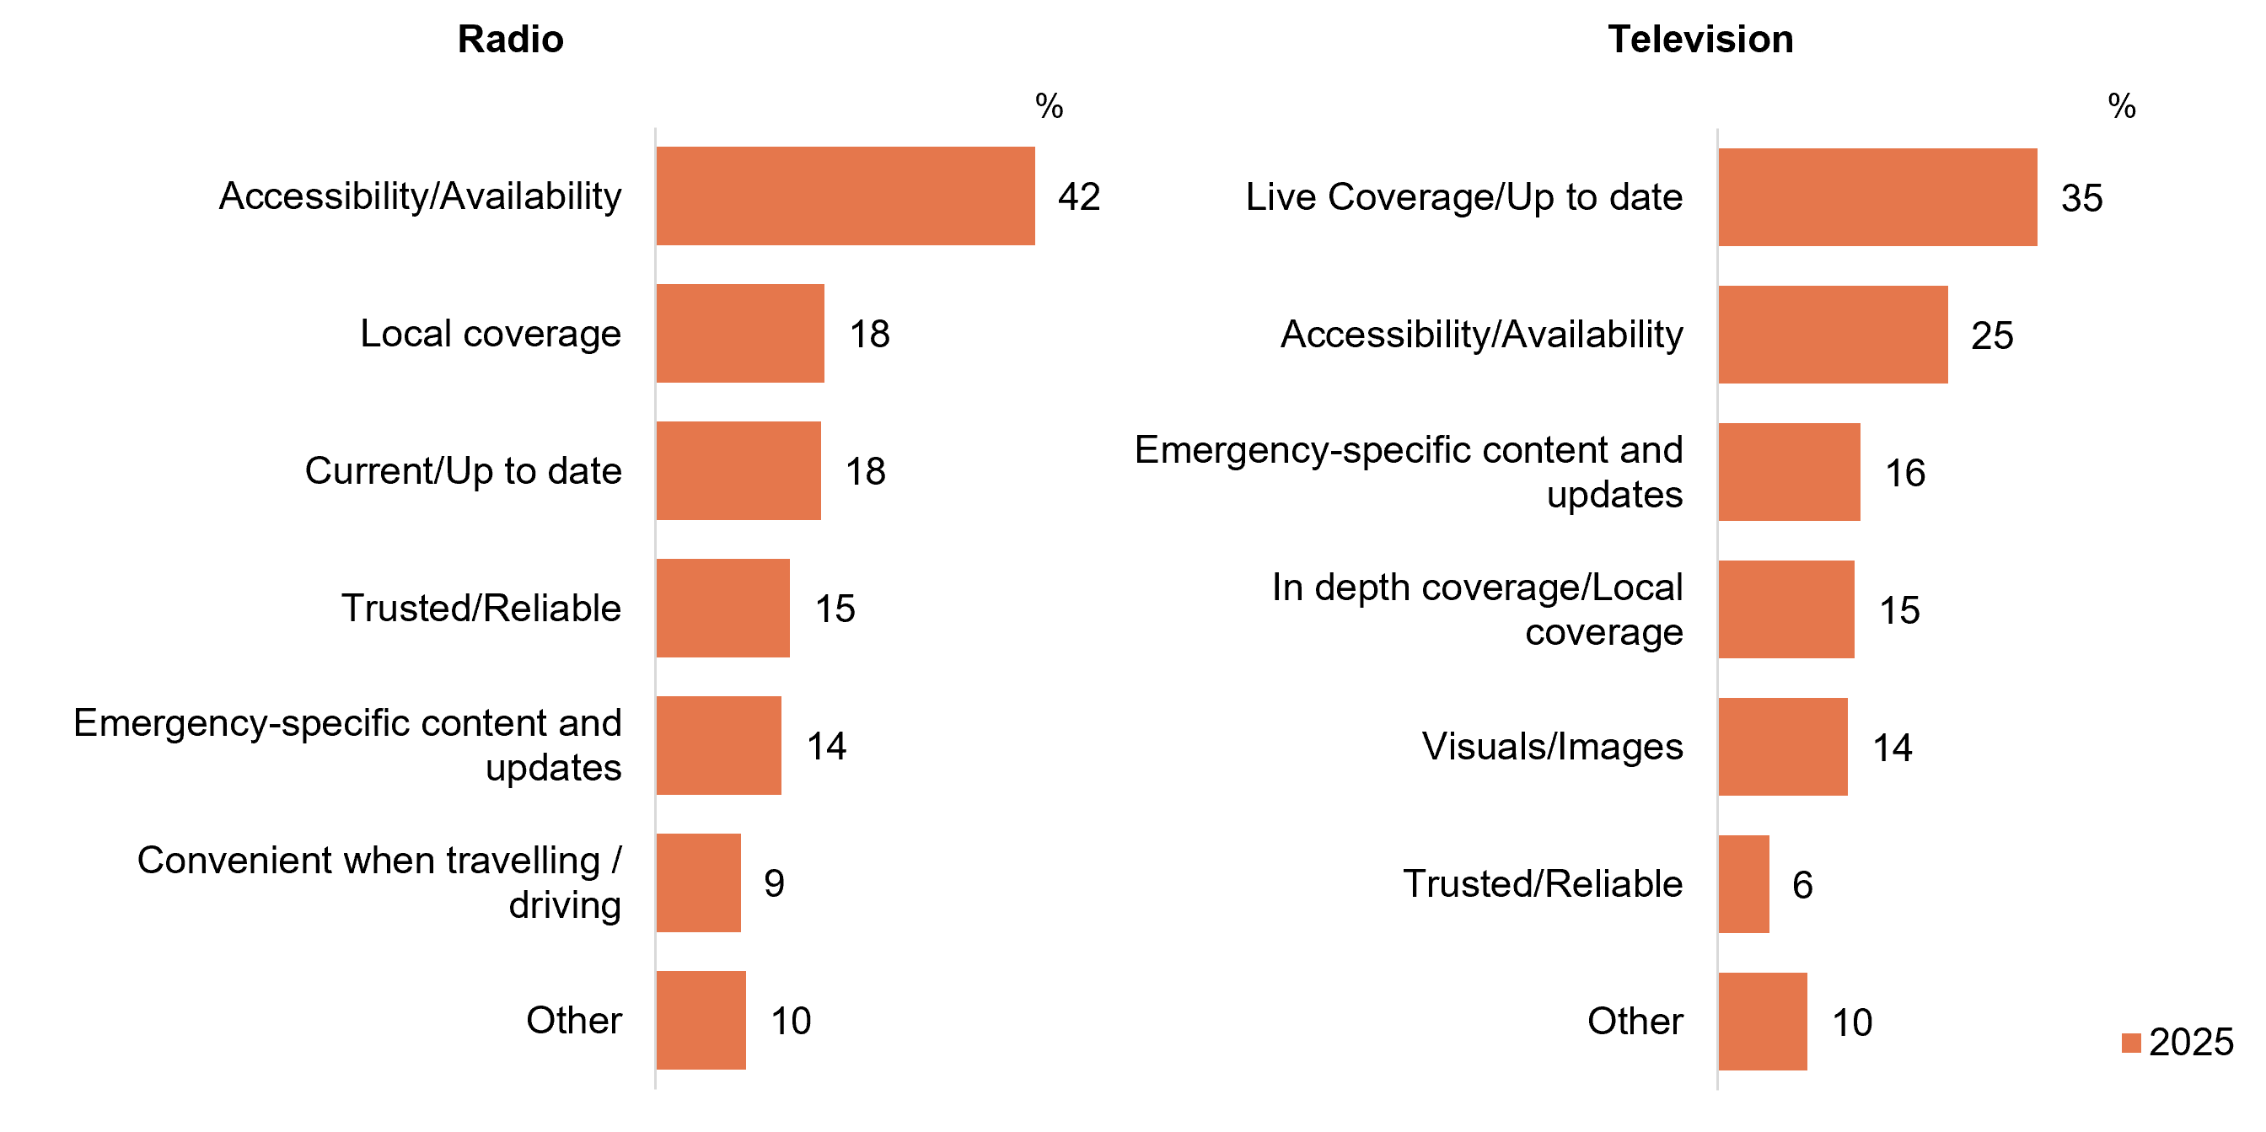
Source: EMERG2a. Why did you use radio for information in the most recent emergency?
Base: TVCS, Respondents who used radio in the most recent emergency situation. 2025: n=362.
Notes: Don’t know/refused responses not shown: 2025 DK=1%, Ref=3%.
Source: EMERG2b. Why did you use television for information in the most recent emergency?
Base: TVCS, Respondents who used TV in the most recent emergency situation. 2025: n=395.
Notes: Don’t know/refused responses not shown: 2025 DK=1%, Ref=2%.
Two horizontal bar charts compare reasons for using radio and television for emergency information in 2025.
Radio:
- Accessibility or availability: 42%
- Local coverage: 18%
- Current or up to date: 18%
- Trusted or reliable: 15%
- Emergency-specific content and updates: 14%
- Convenient when travelling or driving: 9%
- Other: 10%
Television:
- Live coverage or up to date: 35%
- Accessibility or availability: 25%
- Emergency-specific content and updates: 16%
- In-depth coverage or local coverage: 15%
- Visuals or images: 14%
- Trusted or reliable: 6%
- Other: 10%
Radio was primarily used during the most recent emergency due to its accessibility and availability, whereas television was mainly used for its live and up-to-date coverage.

Preferred source of emergency information
Government weather/emergency services website or apps were the leading source of emergency information, regardless of whether respondents had previously experienced an emergency,
though preference was higher among those who had experienced an emergency in the past 12 months. Among respondents who had not experienced an emergency, emergency information
was more commonly preferred via other online sources (39%), emergency services phone contact (37%), police (35%), and phone calls (33%).
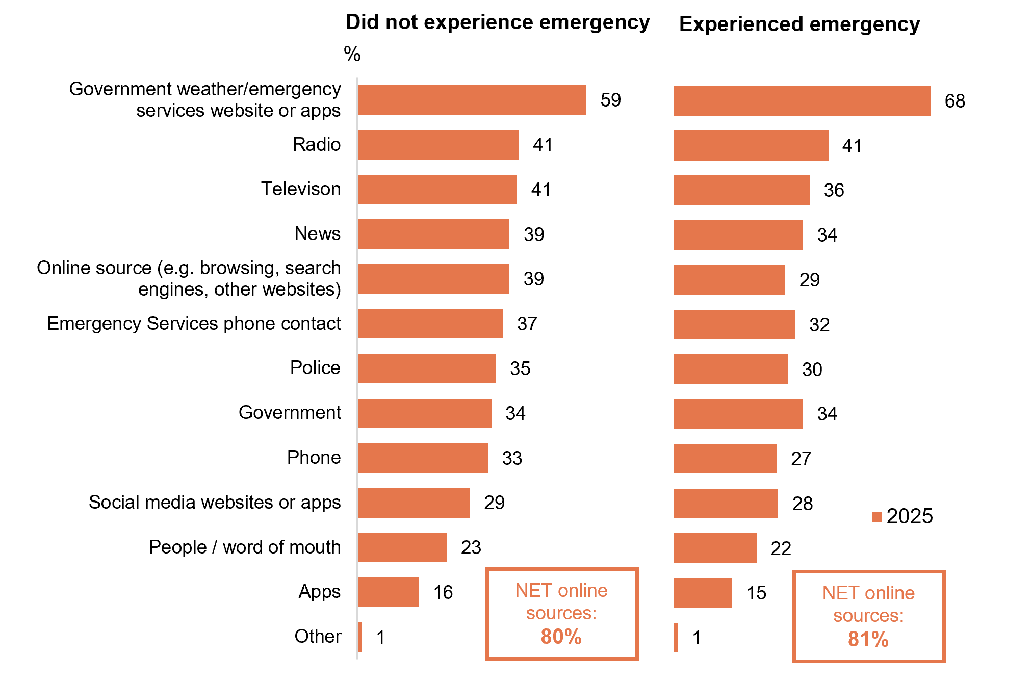
Source: EMERG3. If you were seeking information in an emergency, where would you prefer to get your information?
Base: TVCS, All respondents. 2025: n=3,716. 2024: n=3,890.
Notes: Don’t know/refused responses not shown: <0.5% for both in 2025. 2024 DK = 5%, Ref = 3 . ‘NET online sources’ includes ‘Online source (e.g. browsing, search engines, other websites)’, ‘Government emergency services website/apps’, ‘social media websites or apps’, ‘Apps’.
*EMERG3 was asked as an unprompted open-text question in 2024 and as a closed-frame question in 2025. As a result, the results are not comparable across years, and 2024 data are not shown.
Two bar charts showing the preferred sources of emergency information among people who experienced an emergency and whose who did not experience an emergency in 2025.
Preferred source of emergency information among those who did not experience an emergency:
- Government weather/emergency services website or apps: 59%
- Radio: 41%
- Television: 41%
- News: 39%
- Online source (e.g. browsing, search engines, other websites): 39%
- Emergency Services phone contact: 37%
- Police: 35%
- Government: 34%
- Phone: 33%
- Social media websites or apps: 29%
- People / word of mouth: 23%
- Apps: 16%
- Other: 1%
- NET online sources: 80%
Preferred source of emergency information among those who experienced an emergency:
- Government weather/emergency services website or apps: 68%
- Radio: 41%
- Television: 36%
- News: 34%
- Online source (e.g. browsing, search engines, other websites): 29%
- Emergency Services phone contact: 32%
- Police: 30%
- Government: 34%
- Phone: 27%
- Social media websites or apps: 28%
- People / word of mouth: 22%
- Apps: 15%
- Other: 1%
- NET online sources: 81%

Subgroup
NET online sources was higher for:
- Ages 18–64 (83% vs 69% of ages 65+)
- Those living in a capital city (83% vs 77% of those living outside a capital city)
- Those looking for information over the internet once a day or more (83% vs 65% of those did it less than once a day)
Radio was higher for:
- Men (44% vs 39% of women)
- Ages 55+ (56% vs 32% of ages 18–54)
- Those living outside a capital city (47% vs 35% of those living in a capital city)
- English-only speakers (44% vs 31% of those who speak a language other than English)
Context: General usage of sources (past 7 days):
‘NET AM radio / FM radio’ usage in P7D (NEW28) was higher for older ages aged 55+ (71%).
‘Other websites or apps’ content watched P7D (C1) was higher for younger ages aged 18-34 (66%).
‘NET TV’ in P7D (C1) was higher for older ages aged 45+ (88%)
Government weather/emergency services website or apps were the preferred source of emergency information, particularly among those who experienced an emergency in the past 12 months.

Sports content

Chapter summary: Sports content
Sports viewership increased in 2025.
- Half of the respondents (48%) reported that they consumed sports content in the past seven days, while 51% did not watch any sports content.
- The proportion of respondents with no sports consumption in the past seven days (51%) decreased significantly in 2025. Non-recent sport viewers reported their consumption of sport is significantly lower (total NET 40%).
- Live sports remained the most commonly consumed type of sports content (40%), although viewership in other sports-related programs (5%) shows a significant decline.
- Consumption of men’s sports increased (62%), while respondents reported watching both men’s and women’s sports (36%) and only women’s sports (2%) decreased.
- The most commonly consumed sport types overall (NET men’s, women’s, and both) continued to be the Olympic Games events (78%), Commonwealth Games events (65%), and Australian Rules Football (61%). The most commonly consumed women’s sports were netball (13%) and Australian soccer/football (2%), while the most commonly consumed men’s sports were Australian Rules Football (41%) and international test cricket matches (33%).
Increase shift toward content via free-to-air TV sports consumption.
- The consumption of sports content via free-to-air TV (net 69%) saw a significant increase in 2025, largely driven by the increased viewership on commercial free-to-air TV (48%).
- Consumption of sports content via online methods shows no change compared to 2024 (54% NET online).
Free to watch remains consistent as a reason for sports consumption, however, content quality sees an increase of importance, whilst a decline is observed for lesser known/specialised sports content.
- The most commonly cited feature of sports content is its availability on free-to-air broadcast TV (51% NET watch a lot/little bit more). An increase of 39% is observed for the quality of sport content (e.g. quality of the transmission or stream), however lesser known or specialised sport content saw a decrease of 14% in 2025.
- Alcohol, junk food and gambling advertising remain as factors that negatively (NET decrease watching a lot/little bit) impacted viewership (30% NET, 31% NET 44% NET respectively).

Note
Note on fieldwork dates: The 2025 fieldwork dates differ from 2024, but have returned to historical timeframe.
2025 survey fieldwork: 15 September – 13 October 2025
2024 survey fieldwork: 28 October – 21 November 2024
2023 survey fieldwork: 25 September – 16 October 2023
2022 survey fieldwork: 12 September – 5 October 2022
2021 survey fieldwork: 13 September – 27 September 2021
2020 survey fieldwork: 14 September – 28 September 2020
2025 Field (15 September to 13 October 2025)
- AFL Grand Final, 27 September 2025
- NRL Grand Final, 5 October 2025
- Bathurst 1000 (Supercars Championship), 9–12 October 2025
- Spring Racing Carnival early events (e.g., Turnbull Stakes), late September–early October 2025
2024 Field (28 October to 21 November 2024)
- Melbourne Cup, 5 November 2024
- Australia co-hosted the 2024 Rugby League Pacific Championship, October-November 2024
- Championship series of Major League Baseball, October 25 to November 2, 2024
- The Bathurst 1000, 10-13 October 2024 (outside of the 2024 survey fieldwork period)
- NRL & NRLW Grand Finals, 6 October, 2024 (outside of the 2024 survey fieldwork period)
- Australia Cup Final, 29 September, 2024 (outside of the 2024 survey fieldwork period)
- AFL Grand Final, 28 September, 2024 (outside of the 2024 survey fieldwork period)
2023 Field (25 September – 16 October 2023)
- Australia Cup Final, 7 October 2023
- The Bathurst 1000, 5-8 October 2023
- NRL & NRLW Grand Finals, 1 October 2023
- AFL Grand Final, 30 September 2023
- Australia hosted the FIFA Women’s World Cup one month before field began for the 2023 survey.

Sports content consumed in the past 7 days
About half (48%) consumed any sports content in the 7 days prior to the survey. Live sports (40%) remains the most commonly consumed type of sports programming and saw a further increase in 2025.
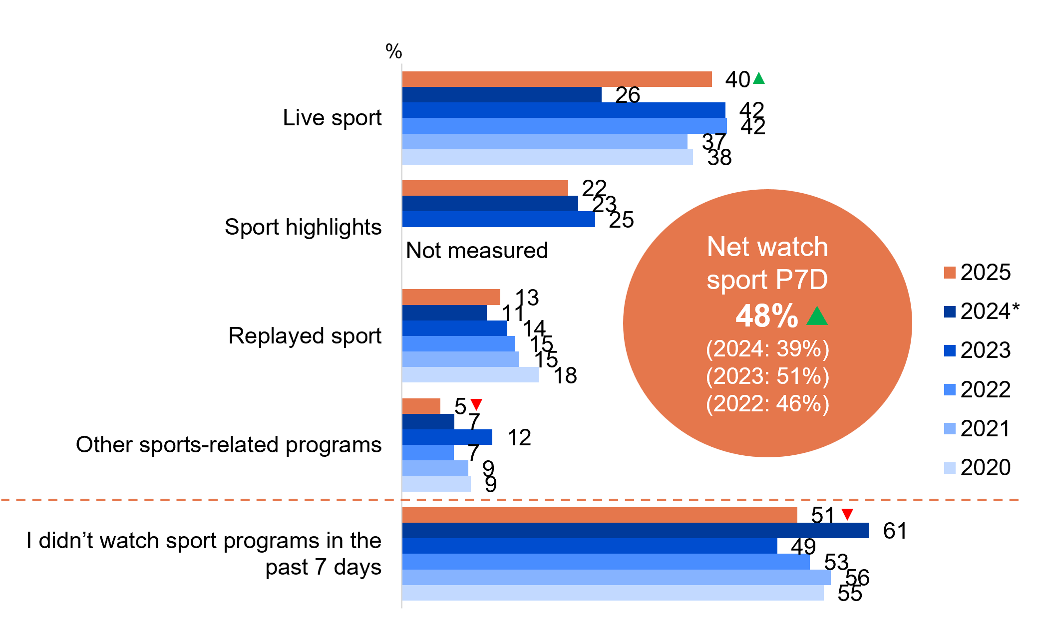
Source: E1. In the past 7 days, did you watch or listen to…?
Base: TVCS, All respondents. 2025: n=3,716. 2024: n=3,890. 2023: n=3,861. 2022: n=4,016. 2021: n=4,135. 2020: n=4,096.
Notes: Don’t know/refused responses not shown: <0.5% for both between 2022 and 2025.
*The 2024 survey fieldwork was conducted from late October through November, whereas in most other years it occurred between mid-September and early October.
A bar chart showing the types of sports content that people watched in the past 7 days from 2020 to 2025.
Live sport: 40% in 2025, 26% in 2024, 42% in 2023, 42% in 2022, 37% in 2021, and 38% in 2020
Sport highlights: 22% in 2025, 23% in 2024, 25% in 2023, not measured in 2022, not measured in 2021, and not measured in 2020
Replayed sport: 13% in 2025, 11% in 2024, 14% in 2023, 15% in 2022, 15% in 2021, and 18% in 2020
Other sports-related programs: 5% in 2025, 7% in 2024, 12% in 2023, 7% in 2022, 9% in 2021, and 9% in 2020
I didn’t watch sport programs in the past 7 days: 51% in 2025, 61% in 2024, 49% in 2023, 53% in 2022, 56% in 2021, and 55% in 2020
NET watch sports P7D: 48% in 2025, 39% in 2024, 51% in 2023, and 46% in 2022

Subgroup
NET watch sports P7D was higher for:
- Men (61% vs 36% of women)
- Ages 55+ (60% vs 41% of ages 18–54)
- English-only speakers (51% vs 39% of those who speak a language other than English)

Callout
Consumption of other sports-related program decreased significantly in 2025 (5% vs 7% in 2024).
NET watch sports P7D (48% vs 39% in 2024) and consumption of live sport (40% vs 26% in 2024) both increased significantly in 2025.
Live sport remained the most commonly consumed in the 7 days prior to the survey, with a further increase in 2025.

Whether non-consumers of sport in past 7 days consume sports in a normal year
When non-recent sports viewers were asked about their typical annual consumption of sport, 6% indicated that they watch or listen to sports during a normal year, with 11% engaging specifically during major sporting events, while 23% focus on specific seasons and 60% who do not watch or listen to sports through-out the year. Overall, 2025 shows a decrease of non-recent sport viewers of their annual consumption of sport with the total NET (40%) being significantly lower. The number of viewers who report not viewing or listening to sport content increased significantly.
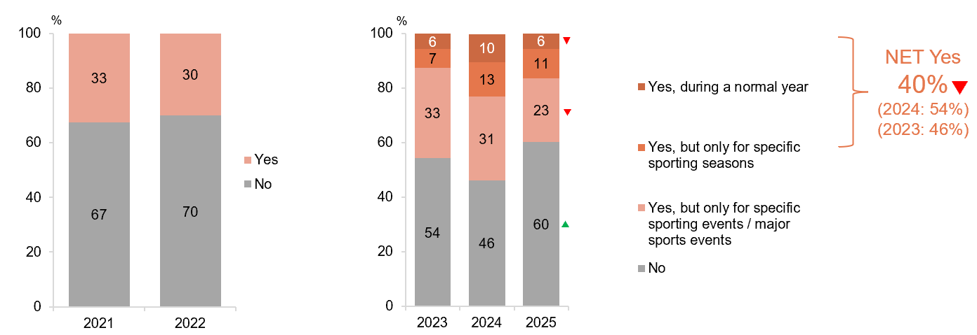
Source: E5. Do you watch or listen to sports at all during a normal year?
Base: TVCS, Respondents who have not consumed sports content in the past 7 days. 2025: n=1,796. 2024: n=2,329. 2023: n=1,838. 2022: n=2,060. 2021: n=2,211
Notes: Don’t know/refused responses not shown: <0.5% between 2021 and 2025. Question updated in 2023 to split out ‘Yes’ into three options as shown on the 2023 chart. Therefore results between 2023 and prior years are not directly comparable and are included for reference only.
The two separate bar charts showing the proportion of non-consumers of sports in the past 7 days consume sports in a normal year across 2021 to 2025. The bar charts are grouped by 2021-2022 and 2023 to 2025.
Yes: 30% in 2022 and 33% in 2021
No: 70% in 2022 and 67% in 2021
Yes, during a normal year: 6% in 2023, 10% in 2024, and 6% in 2025
Yes, but only for specific sporting seasons: 7% in 2023, 13% in 2024, and 11% in 2025
Yes, but only for specific sporting events / major sports events: 33% in 2023, 31% in 2024, and 23% in 2025.
No: 54% in 2023, 46% in 2024, and 60% in 2025
NET Yes (Yes, during a normal year / Yes, but only for specific sporting seasons): 40% in 2025, 54% in 2024, and 46% in 2023

Callout
There was a significant decrease of non-consumers of sports who said Yes, during a normal year in 2025 (6% vs 10% in 2024).

There was a significant decrease of non-consumers of sports who said Yes, but only for specific sporting events / major sports events in 2025 (23% vs 31% in 2024).

There was a significant increase of non-consumers of sports who said no in 2025 (60% vs 46% in 2024).

NET Yes, significantly decreased (40% vs 54% in 2024) in 2025.
Of those who hadn’t consumed sports content in the past 7 days, two in five did watch or listen to sport in a normal year, mostly for specific or major sporting events. There is a significant increase of those who did not consume sports content in the past 7 days.

How respondents consumed sports content
Commercial free-to-air TV, excluding on-demand, remained the most commonly accessed source of sports content (48%), showing a significant increase. Around three in ten (31%) used a sports specific website or app, while a slightly smaller proportion watched sports on commercial free-to-air on-demand TV (21%) or free video streaming services (19%).
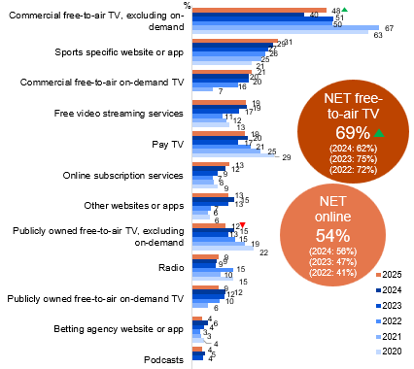
Source: E2. How did you watch or listen to sports related programs in the past 7 days?
Base: TVCS, Respondents who consumed sports content in the past 7 days. 2025: n=1,920. 2024: n=1,561. 2023: n=2,023. 2022: n=1,956. 2021: n=1,924. 2020: n=1,903.
Notes: Other/Don’t know/refused responses not shown: <0.5% for both between 2020 and 2025. Responses <4% in 2025 not shown on chart.
Bar chart showing the platforms people used to watch screen content in the past seven days, comparing usage across platforms from 2020 to 2025.
Commercial free-to-air TV, excluding on-demand: 48% in 2025, 40% in 2024, 51% in 2023, 50% in 2022, 67% in 2021, and 63% in 2020
Sports specific website or app: 31% in 2025, 29% in 2024, 27% in 2023, 26% in 2022, 25% in 2021, and 21% in 2020
Commercial free-to-air on-demand TV: 21% in 2025, 20% in 2024, 20% in 2023, 16% in 2022, 7% in 2021, and 0% in 2020
Free video streaming services: 19% in 2025, 19% in 2024, 17% in 2023, 11% in 2022, 12% in 2021, and 13% in 2020
Pay TV: 19% in 2025, 20% in 2024, 17% in 2023, 21% in 2022, 25% in 2021, and 29% in 2020
Online subscription services: 13% in 2025, 12% in 2024, 9% in 2023, 7% in 2022, 8% in 2021, and 9% in 2020
Other websites or apps: 13% in 2025, 15% in 2024, 13% in 2023, 7% in 2022, 6% in 2021, and 6% in 2020
Publicly owned free-to-air TV, excluding on-demand: 12% in 2025, 15% in 2024, 13% in 2023, 15% in 2022, 19% in 2021, and 22% in 2020
Radio: 9% in 2025, 9% in 2024, 9% in 2023, 15% in 2022, 10% in 2021, and 15% in 2020
Publicly owned free-to-air on-demand TV: 9% in 2025, 12% in 2024, 12% in 2023, 10% in 2022, 6% in 2021, and 0% in 2020
Betting agency website or app: 4% in 2025, 6% in 2024, 4% in 2023, 3% in 2022, 3% in 2021, and 4% in 2020
Podcasts: 4% in 2025, 5% in 2024, 4% in 2023, not asked in 2022, not asked in 2021, and not asked in 2020
NET free-to-air TV: 69% in 2025, 62% in 2024, 75% in 2023, and 72% in 2022
NET online: 54% in 2025, 56% in 2024, 47% in 2023, and 41% in 2022

Callout
NET free-to-air TV has increased as sources of sports content in 2025, driven by the increased use of commercial free-to-air TV.
NET free-to-air TV (69% vs 62% in 2024) and commercial free-to-air TV (excluding on-demand) (48% vs 40% in 2024) increased significantly, whereas publicly owned free-to-air TV, excluding on-demand (12% vs 15% in 2024) decreased significantly in 2025.

Subgroup
NET free-to-air TV was higher for:
- Ages 45+ (82% vs 48% of ages 18–44)
- Those living outside a capital city (76% vs 60% of those living in a capital city)
- Non-Aboriginal and/or Torres Strait Islanders (70% vs 50% of Aboriginal or Torres Strait Islanders)
- English-only speakers (74% vs 46% of those who speak a language other than English)
- Those watched FTA TV Broadcast in P7D (81%)
- Those watched screen content on TV (72% vs 36% of those who did not)
NET online was higher for:
- Men (58% vs 46% of women)
- Ages 18–44 (77% vs 40% of ages 45+)
- Those living in a capital city (66% vs 43% of those living outside a capital city)
- Aboriginal and/or Torres Strait Islanders (68% vs 53% of Non-Aboriginal or Torres Strait Islanders)

Note
Net free-to-air includes ‘Commercial free-to-air TV, excluding on-demand’, ‘Commercial free-to-air on-demand TV’, ‘Publicly owned free-to-air TV, excluding on-demand’, and ‘Publicly owned free-to-air on-demand TV’.
Net online includes ‘Sports specific website or app’, ‘Free video streaming services’, ‘Online subscription services’, ‘Betting agency website or app’, ‘Pay-per-view services’, and ‘Other websites or apps’.
Sports content consumption via free-to-air TV increased significantly in 2025.

Whether sports content consumed was men’s, women’s, or both
Consumption of men’s sports (62%) in the past 7 days increased in 2025, with a decline of respondents consuming both men’s and women’s sport (36%) or women’s sport (2%).
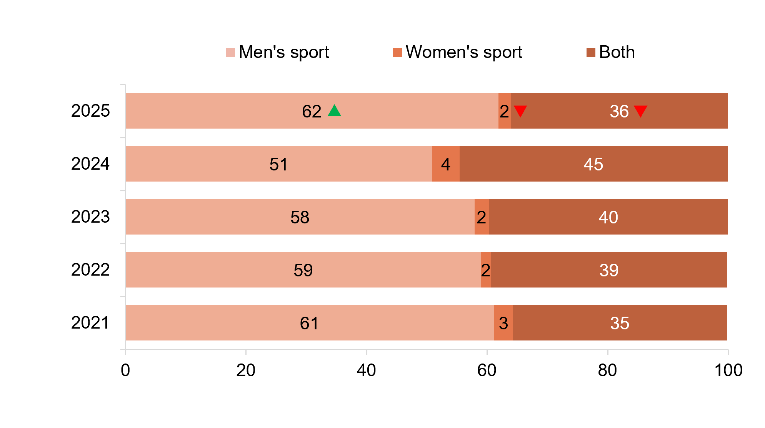
Source: E3. Were the sports programs you watched or listened to focused on:
Base: TVCS, Respondents who consumed sports content in the past 7 days. 2025: n=1,920. 2024: n=1,561. 2023: n=2,023. 2022: n=1,956. 2021 n=1,924.
Notes: Don’t know/refused responses not shown: <0.5% for both between 2021 and 2025.
Bar chart showing the percentage distribution of sports programs watched or listened to, categorised by the focus on men's sport, women's sport, or both for the years 2021 to 2025.
2025: Men's sport - 62%, Women's sport - 2%, Both - 36%
2024: Men's sport - 51%, Women's sport - 4%, Both - 45%
2023: Men's sport - 58%, Women's sport - 2%, Both - 40%
2022: Men's sport - 59%, Women's sport - 2%, Both - 39%
2021: Men's sport - 61%, Women's sport - 3%, Both - 35%

Subgroup
Men’s sport was higher for:
- Ages 18–54 (68% vs 55% of ages 55+)
- Those living in a capital city (65% vs 59% of those living outside a capital city)
Both was higher for:
- Ages 65+ (46% vs 27% of ages 18–44)
- Those living outside a capital city (40% vs 32% of those living in a capital city)

Callout
In 2025, the consumption of men's sports (62% vs 51% in 2024) increased significantly, while the consumption of women's sports (2% vs 4% in 2024) and mixed-gender sports (36% vs 45% in 2023) decreased significantly in 2025.
Consumption of men’s sport significantly increased in 2025, while both men’s and women’s sport and women’s only sport decreased in 2025.

Types of sports content consumed
Major sporting events dominate overall viewership, led by the Olympics (78%) and Commonwealth Games (65%) during years they are held, and Australian Rules Football (61%). Gender-specific viewing showed distinct patterns: women's sports were led by netball (13%) and soccer (2%), while men's sports saw highest engagement with Australian Rules Football (41%) and international test cricket (33%). However, there is a general significant decrease of the viewership online or on TV across sporting events. 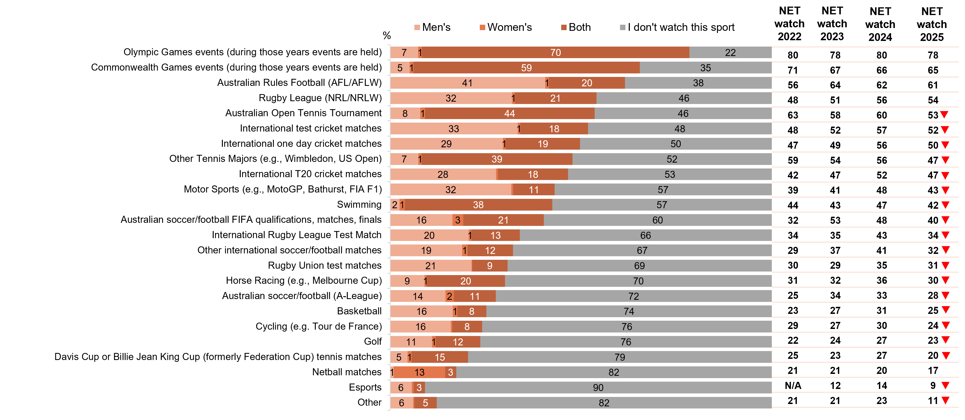
Source: E4. Which of the following sports events do you typically watch online or on TV during a normal year?
Base: TVCS, Respondents who consume sports content. 2025: n=2,036. 2024: n=1,816. 2023: n=2,126. 2022: n=2,629.
Notes: Don’t know/refused responses not shown, % vary per statement. Labels not shown for responses <1%.
Bar chart showing the percentage distribution of sports events people typically watch online or on TV during a normal year, categorised by men's, women's, both, and those who don't watch the sport in 2025. The chart also includes net watch percentages for 2022, 2023, 2024 and 2025.
Olympic Games events (during those years events are held):
Men's - 7%, Women's - 1%, Both - 70%, I don't watch this sport - 22%, Net watch 2022 - 80%, Net watch 2023 - 78%, Net watch 2024 - 80%, Net watch 2025 – 78%
Commonwealth Games events (during those years events are held):
Men's - 5%, Women's - 1%, Both - 59%, I don't watch this sport - 35%, Net watch 2022 – 71%, Net watch 2023 – 67%, Net watch 2024 -66%, Net watch 2025 – 65%
Australian Rules Football (AFL/AFLW):
Men's - 41%, Women's - 1%, Both - 20%, I don't watch this sport - 38%, Net watch 2022 – 56%, Net watch 2023 – 64%, Net watch 2024 – 62%, Net watch 2025 – 61%
Rugby League (NRL/NRLW):
Men's - 32%, Women's - 1%, Both - 21%, I don't watch this sport - 46%, Net watch 2022 – 48%, Net watch 2023 – 51%, Net watch 2024 – 56%, Net watch 2025 – 54%
Australian Open Tennis Tournament:
Men's - 8%, Women's - 1%, Both - 44%, I don't watch this sport - 46%, Net watch 2022 – 63%, Net watch 2023 – 58%, Net watch 2024 – 60%, Net watch 2025 – 53%
International test cricket matches:
Men's - 33%, Women's - 1%, Both - 18%, I don't watch this sport - 48%, Net watch 2022 – 48%, Net watch 2023 – 52%, Net watch 2024 – 57%, Net watch 2025 – 52%
International one day cricket matches:
Men's - 29%, Women's - 1%, Both - 19%, I don't watch this sport - 50%, Net watch 2022 – 47%, Net watch 2023 – 49%, Net watch 2024 – 56%, Net watch 2025 – 50%
Other Tennis Majors (e.g., Wimbledon, US Open):
Men's - 7%, Women's - 1%, Both - 39%, I don't watch this sport - 52%, Net watch 2022 – 59%, Net watch 2023 – 54%, Net watch 2024 – 56%, Net watch 2025 – 47%
International T20 cricket matches:
Men's - 28%, Women's - 0%, Both - 18%, I don't watch this sport - 53%, Net watch 2022 – 42%, Net watch 2023 – 47%, Net watch 2024 – 52%, Net watch 2025 – 47%
Motor Sports (e.g., MotoGP, Bathurst, FIA F1):
Men's - 32%, Women's - 0%, Both - 11%, I don't watch this sport - 57%, Net watch 2022 – 39%, Net watch 2023 – 41%, Net watch 2024 – 48%, Net watch 2025 – 43%
Swimming:
Men's - 2%, Women's - 1%, Both - 38%, I don't watch this sport - 57%, Net watch 2022 – 44%, Net watch 2023 – 43%, Net watch 2024 – 47%, Net watch 2025 – 42%
Australian soccer/football FIFA qualifications, matches, finals:
Men's - 16%, Women's - 3%, Both - 21%, I don't watch this sport - 60%, Net watch 2022 – 32%, Net watch 2023 – 53%, Net watch 2024 – 48%, Net watch 2025 – 40%
International Rugby League Test Matches:
Men's - 20%, Women's - 1%, Both - 13%, I don't watch this sport - 66%, Net watch 2022 – 34%, Net watch 2023 – 35%, Net watch 2024 – 43%, Net watch 2025 – 34%
Other international soccer/football matches:
Men's - 19%, Women's - 1%, Both - 12%, I don't watch this sport - 67%, Net watch 2022 – 29%, Net watch 2023 – 37%, Net watch 2024 – 41%, Net watch 2025 – 32%
Rugby Union test matches:
Men's - 21%, Women's - 0%, Both - 9%, I don't watch this sport - 69%, Net watch 2022 – 30%, Net watch 2023 – 29%, Net watch 2024 – 35%, Net watch 2025 – 31%
Horse Racing (e.g., Melbourne Cup):
Men's - 9%, Women's - 1%, Both - 20%, I don't watch this sport - 70%, Net watch 2022 – 31%, Net watch 2023 – 32%, Net watch 2024 – 36%, Net watch 2025 – 30%
Australian soccer/football (A-League):
Men's - 14%, Women's - 2%, Both - 11%, I don't watch this sport - 72%, Net watch 2022 – 25%, Net watch 2023 – 34%, Net watch 2024 – 33%, Net watch 2025 – 28%
Basketball:
Men's - 16%, Women's - 1%, Both - 8%, I don't watch this sport - 74%, Net watch 2022 – 23%, Net watch 2023 – 27%, Net watch 2024 – 31%, Net watch 2025 – 25%
Cycling (e.g., Tour de France):
Men's - 16%, Women's - 0%, Both - 8%, I don't watch this sport - 76%, Net watch 2022 – 29%, Net watch 2023 – 27%, Net watch 2024 – 30%, Net watch 2025 – 24%
Golf:
Men's - 11%, Women's - 1%, Both - 12%, I don't watch this sport - 76%, Net watch 2022 – 22%, Net watch 2023 – 24%, Net watch 2024 – 27%, Net watch 2025 – 23%
Davis Cup or Billie Jean King Cup (formerly Federation Cup) tennis matches:
Men's - 5%, Women's - 1%, Both - 15%, I don't watch this sport - 79%, Net watch 2022 – 25%, Net watch 2023 – 23%, Net watch 2024 – 27%, Net watch 2025 – 20%
Netball matches:
Men's - 1%, Women's - 13%, Both - 3%, I don't watch this sport - 82%, Net watch 2022 – 21%, Net watch 2023 – 21%, Net watch 2024 – 20%, Net watch 2025 – 17%
Esports:
Men's - 6%, Women's - 0%, Both - 3%, I don't watch this sport - 90%, Net watch 2022 – not asked , Net watch 2023 – 12%, Net watch 2024 – 14%, Net watch 2025 – 9%
Other:
Men's - 6%, Women's - 0%, Both - 5%, I don't watch this sport - 82%, Net watch 2022 – 21%, Net watch 2023 – 21%, Net watch 2024 – 23%, Net watch 2025 – 11%

Callout
Consumption of Australian open tennis tournament (53% vs 60% in 2024), international test cricket matches (52% vs 57% in 2024), international one day cricket matches (50% vs 56% in 2024), Other Tennis Majors (47% vs 56% in 2024), international T20 cricket matches (47% vs 52% in 2024), motor sports (43% vs 48% in 2024), swimming (42% vs 47% in 2024), Australian soccer/football FIFA qualifications (40% vs 48% in 2024), international Rugby League test matches (34% vs 43% in 2024), other international soccer/football matches (32% vs 41%in 2024), Rugby Union test matches (31% vs 35% in 2024), horse racing (30% vs 36% in 2024), Australian soccer/football (A-League) (28% vs 33% in 2024) , basketball (25% vs 31% in 2024), cycling (24% vs 30% in 2024), golf (23% vs 27% in 2024), Davis Cup or Billie Jean King Cup (formerly Federation Cup) tennis matches (20% vs 27% in 2024), esports (9% vs 14% in 2024), and other sports or events (11% vs 23% in 2024) all decreased significantly in 2025 (NET watch).
A variety of sports were watched in 2025, however shows a general decrease of viewership of certain sports online or on TV.

Impact of various factors on amount of sports content consumption
The likelihood to increase sports content watched on a screen (net watch a little bit more and watch a lot more) was most influenced by cost and quality: free access would increase sports consumption for 51% of viewers, if the sports content is live (45%), and high quality (39%). Conversely, gambling advertising emerged as the strongest deterrent, with 44% reporting it would reduce their viewing (net decrease watching a little bit and decrease watching a lot), followed by if junk food advertising is shown (42%).
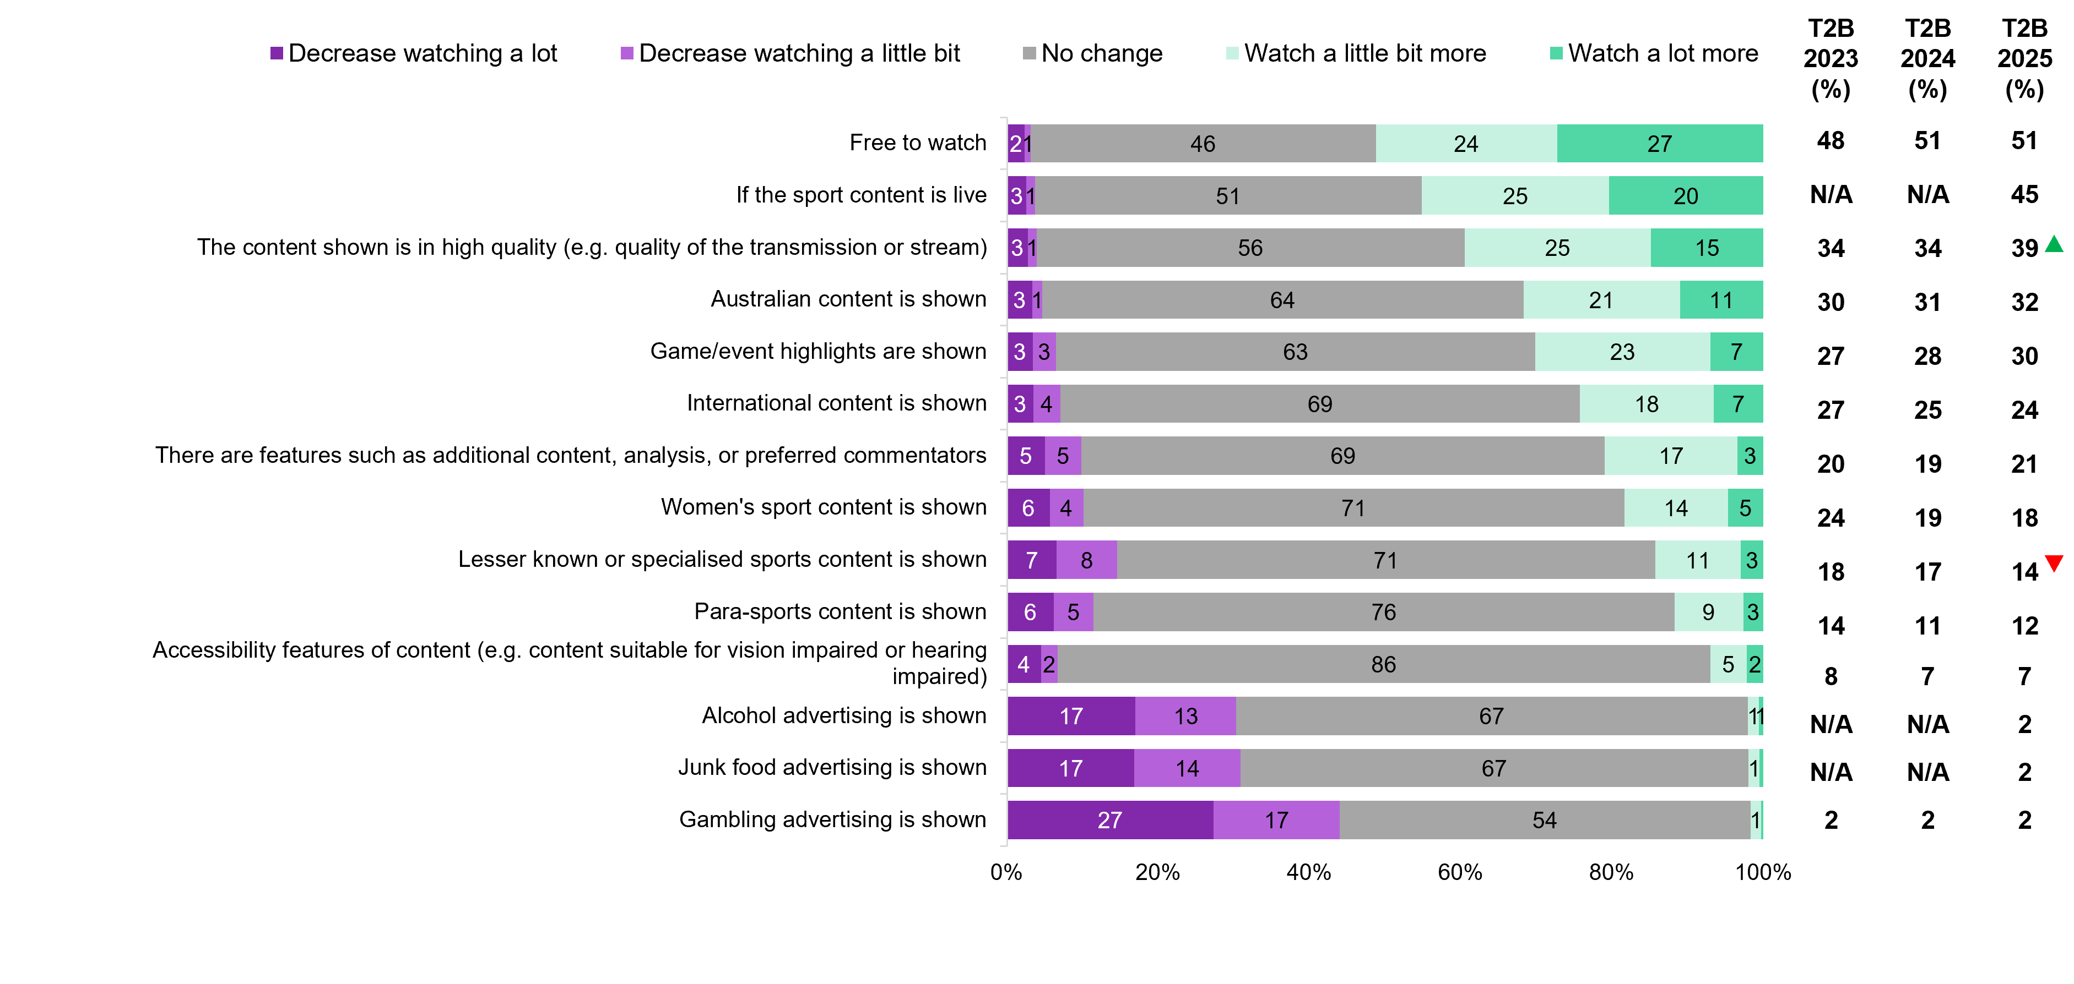
Source: E8. What factors are likely to increase or decrease how much sports content you would watch on a screen?
Base: TVCS, All respondents. 2025: n=3,716. 2024: n=3,890. 2023: n=3,861.
Notes: Don’t know/refused responses not shown, % vary per statement. Labels for responses <1% not shown. ‘T2B’ includes ‘Watched a little bit more’ and ‘Watched a lot more’. ‘N/A’ means item not asked that year.
Bar chart showing factors likely to increase or decrease how much sports content people would watch on a screen in 2025, with T2B percentages for 2023 to 2025.
Free to watch: Decrease watching a lot - 2%, Decrease watching a little bit - 1%, No change - 46%, Watch a little bit more - 24%, Watch a lot more - 27%, T2B 2023 - 48%, T2B 2024 - 51%, T2B 2025 - 51%
If the sport content is live: Decrease watching a lot - 3%, Decrease watching a little bit - 1%, No change - 51%, Watch a little bit more - 25%, Watch a lot more - 20%, T2B 2023 – not asked, T2B 2024 - not asked, T2B 2025 - 45%
The content shown is in high quality (e.g. quality of the transmission or stream): Decrease watching a lot - 3%, Decrease watching a little bit - 1%, No change - 56%, Watch a little bit more - 25%, Watch a lot more - 15%, T2B 2023 - 34%, T2B 2024 - 34%, T2B 2025 - 39%
Australian content is shown: Decrease watching a lot - 3%, Decrease watching a little bit - 1%, No change - 64%, Watch a little bit more - 21%, Watch a lot more - 11%, T2B 2023 - 30%, T2B 2024 - 31%, T2B 2025 - 32%
Game/event highlights are shown: Decrease watching a lot - 3%, Decrease watching a little bit - 3%, No change - 63%, Watch a little bit more - 23%, Watch a lot more - 7%, T2B 2023 - 27%, T2B 2024 - 28%, T2B 2025 - 30%
International content is shown: Decrease watching a lot - 3%, Decrease watching a little bit - 4%, No change - 69%, Watch a little bit more - 18%, Watch a lot more - 7%, T2B 2023 - 27%, T2B 2024 - 25%, T2B 2025 – 24%
There are features such as additional content, analysis, or preferred commentators: Decrease watching a lot - 5%, Decrease watching a little bit - 5%, No change - 69%, Watch a little bit more - 17%, Watch a lot more - 3%, T2B 2023 - 20%, T2B 2024 - 19%, T2B 2025 – 21%
Women’s sport content is shown: Decrease watching a lot - 6%, Decrease watching a little bit - 4%, No change - 71%, Watch a little bit more - 14%, Watch a lot more - 5%, T2B 2023 - 24%, T2B 2024 - 19%, T2B 2025 – 18%
Lesser known or specialised sports content is shown: Decrease watching a lot - 7%, Decrease watching a little bit - 8%, No change - 71%, Watch a little bit more - 11%, Watch a lot more - 3%, T2B 2023 - 18%, T2B 2024 - 17%, T2B 2025 – 14%
Para-sports content is shown: Decrease watching a lot - 6%, Decrease watching a little bit - 5%, No change - 76%, Watch a little bit more - 9%, Watch a lot more - 3%, T2B 2023 - 14%, T2B 2024 - 11%, T2B 2025 – 12%
Accessibility features of content (e.g. content suitable for vision impaired or hearing impaired): Decrease watching a lot - 4%, Decrease watching a little bit - 2%, No change - 86%, Watch a little bit more - 5%, Watch a lot more - 2%, T2B 2023 - 8%, T2B 2024 - 7%, T2B 2025 – 7%
Alcohol advertising is shown: Decrease watching a lot - 17%, Decrease watching a little bit - 13%, No change - 67%, Watch a little bit more - 1%, Watch a lot more - 1%, T2B 2023 - not asked, T2B 2024 - not asked, T2B 2025 – 2%
Junk food advertising is shown: Decrease watching a lot - 17%, Decrease watching a little bit - 14%, No change - 67%, Watch a little bit more - 1%, Watch a lot more - 0%, T2B 2023 - not asked, T2B 2024 - not asked, T2B 2025 – 2%
Gambling advertising is shown: Decrease watching a lot - 27%, Decrease watching a little bit - 17%, No change - 54%, Watch a little bit more - 1%, Watch a lot more - 0%, T2B 2023 - 2%, T2B 2024 - 2%, T2B 2025 – 2%

Callout
In 2025, the content shown is in high quality (e.g. quality of the transmission or stream) (39% vs 34% in 2024) (NET watch a little bit more or a lot more) increased significantly, whereas lesser known or specialised sports content is shown (14% vs 17% in 2024) decreased significantly.
Sports viewership was likely boosted by being ‘free to watch’, while the presence of gambling advertising remain as the deterrent for the reduced the amount of sports content watched.

Broadcast codes

Chapter summary: Broadcast codes
Respondents who are men, aged 45+, living in rural areas, watched offline content in the past 7 days are more likely to be aware of any of the Codes of Practice.
- Awareness of Commercial Television Industry (46%) and Commercial Radio Code of Practice (42%) were the most commonly recognised Codes.
- Awareness of any Codes was higher amongst men (66%), those who are aged 45+ (74%), live in rural locations (68%) and watched offline content exclusively in the past seven days (65%).
- Overall decline in awareness is observed in 2025, most frequently for Commercial Television Industry Codes of Practice (46%), Community Television Codes of Practice (26%), Subscription Narrowcast Television Code of Practice (6%), Open Narrowcast Television Codes of Practice (5%) and Open Narrowcast Radio Codes of Practice (4%).
Advertising played a vital role in bringing awareness towards Code/s of Practice.
- Respondents report advertising to be the main source of awareness for Code/s of Practices, followed by media commentary about Codes. A sizeable proportion cannot identify the source of awareness however, even for Codes of Practice with higher levels of awareness.

Awareness of the types of Codes of Practice
Industry-developed codes of practice ensure broadcasting content is in line with community expectations. Industry groups have developed codes of practice in consultation with the ACMA.
The ACMA monitors these codes and deals with unresolved complaints from viewers and listeners. (The ABC and SBS have different code arrangements).
Just under half (46%) of all respondents recognised the Commercial Television Industry Code of Practice, highlighting a significant decrease and just over two in five (42%) recognising the Commercial Radio Code of Practice. There is also a significant decrease of recognition in Community Television Codes of Practice (26%), Subscription Narrowcast Television Codes of Practice (6%), Open Narrowcast Television Codes of Practice (5%) and Open Narrowcast Radio Codes of Practice (4%).
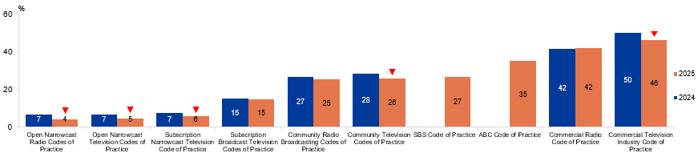
Source: BROAD3. Before today, had you heard of the following types of Codes of Practice?
Base: TVCS, MCCS, All respondents. 2025: n=4,396. 2024: n=4,490.
Notes: Don’t know/refused responses not shown, % vary per statement, all <0.5% in 2024 and 2025. Missing column means item not asked that year.
This grouped (clustered) column bar chart is showing awareness (or recognition) of different broadcasting Codes of Practice, comparing 2024 vs 2025 for each code listed.
Open Narrowcast Radio Codes of Practice: 7% in 2024, and 4% in 2025
Open Narrowcast Television Codes of Practice: 7% in 2024, and 5% in 2025
Subscription Narrowcast Television Code of Practice: 7% in 2024, and 6% in 2025
Subscription Broadcast Television Codes of Practice: 15% in 2024, and 15% in 2025
Community Radio Broadcasting Codes of Practice: 27% in 2024, and 25% in 2025
Community Television Codes of Practice: 28% in 2024, and 26% in 2025
SBS Code of Practice: not asked in 2024, and 27% in 2025
ABC Code of Practice: not asked in 2024, and 35% in 2025
Commercial Radio Code of Practice: 42% in 2024, and 42% in 2025
Commercial Television Industry Code of Practice: 50% in 2024, and 46% in 2025

Subgroup
Commercial Television Industry Code of Practice was higher for:
- Those watched offline content in P7D (56% vs 46% of those watched online content)
- Those watched screen content on TV (49% vs 31% of those who did not)

Callout
In 2025, open Narrowcast Radio Codes of Practice (4% vs 7% in 2024), open Narrowcast Television Codes of Practice (5% vs 7% in 2024), subscription Narrowcast Television Code of Practice (6% vs 7% in 2024), community Television Codes of Practice (26% vs 28% in 2024), and commercial Television Industry Code of Practice (46% vs 50% in 2024) all decreased significantly.
Those aware of ANY Codes of Practice were more likely to be men (66%), aged 45+ (74%), living outside a capital city (68%), with a TAFE/Trade Certificate/Diploma (68%), English-speakers (67%), watched offline content exclusively in P7D (65%), used a TV to watch screen content (64%) or listened to AM/FM/DAB radio or radio via the internet or app (71%) in P7D.

Note
The codes were registered in:
- 2017 for the Commercial radio code of practice
- 2015 for the Commercial television industry code of practice
- 2013 for the Subscription broadcast television codes of practice
- 2013 for the Subscription narrowcast radio codes of practice
- 2013 for the Subscription narrowcast television codes of practice
- 2011 for the Community television codes of practice
- 2009 for the Open narrowcast television codes of practice
- 2008 for the Community radio broadcastings codes of practice
The ACMA has registered a new Community radio broadcasting codes of practice (2025) which will commence from 1 July 2025.
Awareness of commercial television and radio Codes of Practice was higher among respondents, with recognition more common among men and older Australians.

Sources of awareness for each Codes of Practice
Advertising (on a service related to the code) was the main source of awareness across all Codes of Practice, followed by media commentary about the codes. However, a sizeable proportion cannot identify the source of awareness, even for Codes of Practice with higher levels of awareness.

Table 7 Frequency of watching free-to-air TV on various devices (%)
 | Advertising (on a service related to this code) | Media commentary about code | Free TV Australia' website | Word of mouth | Broadcaster or network websites | Advertising (on a service NOT related to this code) | The ACMA website | Government website | On an electronic program guide (EPG) | Launch of code | Other | I can't remember | NET  Aware (%)
Commercial Television Industry Code of Practice | 39 | 16 | 8 | 7 | 6 | 3 | 3 | 3 | 1 | 1 | 2 | 26 | 46
Commercial Radio Code of Practice | 37 | 17 | 4 | 7 | 6 | 2 | 3 | 2 | 1 | 1 | 3 | 29 | 42
ABC Code of Practice | 29 | 22 | 7 | 7 | 9 | 3 | 3 | 4 | 1 | 1 | 3 | 27 | 35
SBS Code of Practice | 31 | 15 | 7 | 6 | 8 | 4 | 2 | 4 | 1 | 2 | 4 | 27 | 27
Community Television Codes of Practice | 34 | 13 | 8 | 8 | 6 | 4 | 4 | 3 | 2 | 3 | 3 | 29 | 26
Community Radio Broadcasting Codes of Practice | 31 | 13 | 5 | 9 | 7 | 2 | 3 | 3 | 2 | 2 | 4 | 29 | 25
Subscription Broadcast Television Codes of Practice | 25 | 12 | 7 | 10 | 6 | 4 | 5 | 6 | 2 | 2 | 4 | 32 | 15
Subscription Narrowcast Television Code of Practice | 22 | 11 | 9 | 8 | 3 | 10 | 12 | 4 | 5 | 5 | 5 | 29 | 6
Open Narrowcast Television Codes of Practice | 24 | 10 | 10 | 10 | 6 | 7 | 5 | 6 | 6 | 6 | 7 | 32 | 5
Open Narrowcast Radio Codes of Practice | 19 | 9 | 8 | 8 | 7 | 8 | 7 | 7 | 4 | 5 | 6 | 34 | 4
Source: BROAD5. How did you become aware of each of the codes?
Base: TVCS, MCCS, Respondents who were aware of each type of Codes of Practice. 2025: n= from 191 to 2,248.
Notes: Don’t know/refused responses not shown, % vary per statement, DK between 2% and 6%, Ref all <0.5% in 2025.

Advertising were reported to be the main source of awareness towards Code/s of Practices, followed by media commentary about codes. A sizeable proportion cannot pinpoint the source of awareness, even for Codes of Practice with higher levels of awareness.

Advertising + inappropriate content: Children aged 0–17

Chapter summary: Advertising (Children aged 0-17)
Children were increasingly being exposed to advertisements on free streaming services and social media.
- Free video streaming services (e.g. YouTube, YouTube Kids, Twitch, Tubi) were most commonly reported by children aged 8–10 (54%) and 11–15 (52%) for the location advertisements were seen in the past 7 days. Social media websites (e.g. Facebook, TikTok, Instagram) were the most common platforms on which advertisements were seen for older children aged 16-17 (59%). Parents who answered on behalf of their children aged 0-7 reported that the platforms where advertising was most seen or heard by children in this age group were free video streaming services (e.g. YouTube ,YouTube Kids, Twitch, Tubi) (38%) followed by outdoor advertising such as posters or billboards (33%), and in-store advertising (33%).
Age-inappropriate content exposure increased with age, varying by platform.
- Children aged 0-17 shows a general trending increase of exposure to age-inappropriate content aimed at an older audience. Half (50%) of children aged 16–17 reported exposure of age-inappropriate content through intentional means, and for children aged 11–15 this was 48%. Children aged 8–10 (36%) and 0-7 (22%), were less likely to actively seek out age-inappropriate content, and tended to be indirectly exposed.
- Online subscription services and YouTube/YouTube kids were the most common platforms children used to access age-inappropriate content across all age segments. Children aged 8–10 (38%) and 11–15 (24%), there was a significant decrease for YouTube/YouTube Kids compared to previous years. For children aged 11–15 (0%), there is a significant decrease in publicly owned free-to-air TV, excluding on-demand for inappropriate content.
- The main reasons for the content being age-inappropriate are that it is too violent for children aged 8–10 (48%) and 11–15 (58%). For parents who answered behalf of their child aged 0–7 (26%), the most common reason is ‘inappropriate/not child friendly’ and children aged 16–17 (28%) was due to the general rating.
Children watch age-inappropriate content in various locations and often with people they know.
- The most common locations that children watch age-inappropriate content were at home, consistent across all ages.
- For children aged 8–10 (75%) and 11–15 (53%), they mainly watch age-inappropriate content with parents or other older family members and for children aged 0–7 (86%) it was with family members, and children aged 16–17 (43%) watched the content by themselves.

Platforms children saw advertisements on in the past 7 days (children aged 0–17)
Free video streaming services (e.g. YouTube, YouTube Kids, Twitch, Tubi) was most commonly reported by children aged 8–10 (54%) and 11–15 (52%) for the location advertisements were seen in the past 7 days. Social media websites (e.g. Facebook, TikTok, Instagram) were the most common platform on which advertisements were seen for children aged 16-17 (59%). Parents who answered on behalf of their children aged 0-7 reported that the platforms where advertising was most commonly seen or heard by children were free video streaming services (e.g. YouTube, YouTube Kids, Twitch, Tubi) (38%) followed by outdoor advertising such as posters or billboards (33%), and in-store advertising (33%).

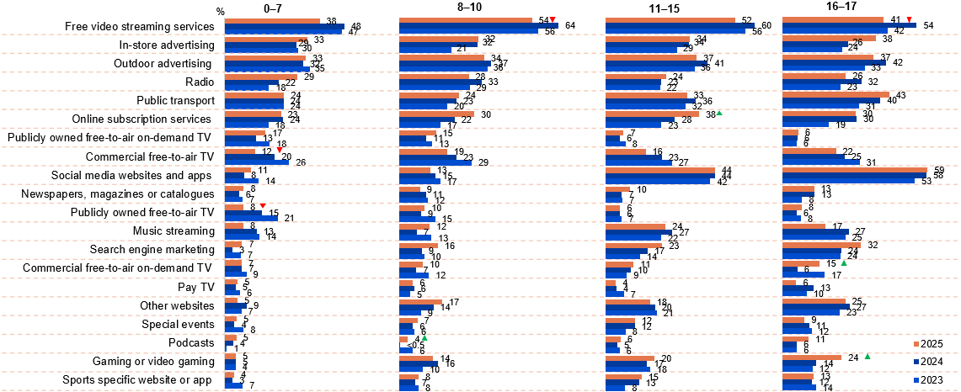
Source: F6. Where has your child seen or heard advertising in the past 7 days? KB5, KC5, KD5. Of the following, where have you seen or heard advertising in the past 7 days?
Base: MCCS, All children aged 8-17. 2025: 8-10 (n=179), 11-15 (n=196), 16-17 (n=130). 2024: 8-10 (n=199), 11-15 (n=199), 16-17 (n=141). 2023: 8-10 (n=197), 11-15 (n=191), 16-17 (n=137). All parents/legal guardians/carers answering on behalf of their 0-7 year old child (2025: n=304. 2024: n=336. 2023: n=359).
Notes: Don’t know/refused responses not shown: 2025: 0-7 DK=5%, Ref =0%. 8-10 DK=1%, Ref=0%. 11-15 DK=1%, Ref=0%. 16-17 DK=1%, Ref = 0%. 2024: 0-7 DK=7%, Ref =2%. 8-10 DK=2%, Ref=1%. 11-15 DK=2%, Ref=0%. 16-17 DK=1%, Ref = 0%. 2023: 0-7 DK = 5%, Ref=1%. 8-10 DK=5%, Ref=0%. 11-15 DK=1%, Ref=0%. 16-17 DK=1%, Ref=1%. Responses <3% across all age groups not shown on chart.
Bar chart showing the percentage of children who saw advertisements on various platforms in different age groups (0-7, 8-10, 11-15, 16-17) for the years 2023, 2024 and 2025.
Age group 0-7:
- Free video streaming services: 38% in 2025, 48% in 2024, and 47% in 2023
- In-store advertising: 33% in 2025, 29% in 2024, and 30% in 2023
- Outdoor advertising: 33% in 2025, 32% in 2024, and 35% in 2023
- Radio: 29% in 2025, 22% in 2024, and 18% in 2023
- Public transport: 24% in 2025, 24% in 2024, and 24% in 2023
- Online subscription services: 23% in 2025, 24% in 2024, and 18% in 2023
- Publicly owned free-to-air on-demand TV: 17% in 2025, 13% in 2024, and 18% in 2023
- Commercial free-to-air TV: 12% in 2025, 20% in 2024, and 26% in 2023
- Social media websites and apps: 11% in 2025, 8% in 2024, and 14% in 2023
- Newspapers, magazines or catalogues: 8% in 2025, 6% in 2024, and 7% in 2023
- Publicly owned free-to-air TV: 8% in 2025, 15% in 2024, and 21% in 2023
- Music streaming: 8% in 2025, 13% in 2024, and 14% in 2023
- Search engine marketing: 7% in 2025, 3% in 2024, and 7% in 2023
- Commercial free-to-air on-demand TV: 7% in 2025, 7% in 2024, and 9% in 2023
- Pay TV: 5% in 2025, 5% in 2024, and 6% in 2023
- Other websites: 5% in 2025, 9% in 2024, and 7% in 2023
- Special events: 5% in 2025, 4% in 2024, and 8% in 2023
- Podcasts: 5% in 2025, 4% in 2024, and 1% in 2023
- Gaming or video gaming: 5% in 2025, 5% in 2024, and 4% in 2023
- Sports-specific website or app: 4% in 2025, 3% in 2024, and 7% in 2023
Age group 8-10:
- Free video streaming services: 54% in 2025, 64% in 2024, and 56% in 2023
- In-store advertising: 32% in 2025, 32% in 2024, and 21% in 2023
- Outdoor advertising: 34% in 2025, 37% in 2024, and 36% in 2023
- Radio: 28% in 2025, 33% in 2024, and 29% in 2023
- Public transport: 24% in 2025, 23% in 2024, 20% in 2023
- Online subscription services: 30% in 2025, 22% in 2024, 17% in 2023
- Publicly owned free-to-air on-demand TV: 15% in 2025, 11% in 2024, 13% in 2023
- Commercial free-to-air TV: 19% in 2025, 23% in 2024, 29% in 2023
- Social media websites and apps: 13% in 2025, 15% in 2024, 17% in 2023
- Newspapers, magazines or catalogues: 9% in 2025, 11% in 2024, 12% in 2023
- Publicly owned free-to-air TV: 10% in 2025, 9% in 2024, 15% in 2023
- Music streaming: 12% in 2025, 7% in 2024, 13% in 2023
- Search engine marketing: 16% in 2025, 9% in 2024, 10% in 2023
- Commercial free-to-air on-demand TV: 10% in 2025, 7% in 2024, 12% in 2023
- Pay TV: 6% in 2025, 6% in 2024, 5% in 2023
- Other websites: 17% in 2025, 14% in 2024, 9% in 2023
- Special events: 7% in 2025, 6% in 2024, 6% in 2023
- Podcasts: 4% in 2025, 0% in 2024, 6% in 2023
- Gaming or video gaming: 14% in 2025, 16% in 2024, 10% in 2023
- Sports specific website or app: 8% in 2025, 7% in 2024, 8% in 2023
Age group 11-15:
- Free video streaming services: 52% in 2025, 60% in 2024, 56% in 2023
- In-store advertising: 34% in 2025, 34% in 2024, 29% in 2023
- Outdoor advertising: 37% in 2025, 41% in 2024, 36% in 2023
- Radio: 24% in 2025, 23% in 2024, 22% in 2023
- Public transport: 33% in 2025, 36% in 2024, 32% in 2023
- Online subscription services: 38% in 2025, 28% in 2024, 23% in 2023
- Publicly owned free-to-air on-demand TV: 7% in 2025, 6% in 2024, 8% in 2023
- Commercial free-to-air TV: 16% in 2025, 23% in 2024, 27% in 2023
- Social Media websites: 44% in 2025, 44% in 2024, 42% in 2023
- Newspapers, magazines or catalogues: 10% in 2025, 7% in 2024, 7% in 2023
- Publicly owned free-to-air TV: 6% in 2025, 6% in 2024, 7% in 2023
- Music streaming: 24% in 2025, 27% in 2024, 22% in 2023
- Search engine marketing: 23% in 2025, 17% in 2024, 14% in 2023
- Commercial free-to-air on-demand TV: 11% in 2025, 10% in 2024, 9% in 2023
- Pay TV: 4% in 2025, 4% in 2024, 7% in 2023
- Other websites: 18% in 2025, 20% in 2024, 21% in 2023
- Special events: 12% in 2025, 12% in 2024, 8% in 2023
- Podcasts: 6% in 2025, 5% in 2024, 6% in 2023
- Gaming or video gaming: 20% in 2025, 17% in 2024, 18% in 2023
- Sports specific website or app: 15% in 2025, 13% in 2024, 8% in 2023
Age group 16-17:
- Free video streaming services: 41% in 2025, 54% in 2024, 42% in 2023
- In-store advertising: 38% in 2025, 26% in 2024, 24% in 2023
- Outdoor advertising: 37% in 2025, 42% in 2024, 33% in 2023
- Radio: 26% in 2025, 32% in 2024, 23% in 2023
- Public transport: 43% in 2025, 40% in 2024, 31% in 2023
- Online subscription services: 30% in 2025, 30% in 2024, 19% in 2023
- Publicly owned free-to-air on-demand TV: 6% in 2025, 6% in 2024, 6% in 2023
- Commercial free-to-air TV: 22% in 2025, 25% in 2024, 31% in 2023
- Social Media websites: 59% in 2025, 58% in 2024, 53% in 2023
- Newspapers, magazines or catalogues: 13% in 2025, 13% in 2024, 8% in 2023
- Publicly owned free-to-air TV: 8% in 2025, 6% in 2024, 8% in 2023
- Music streaming: 17% in 2025, 27% in 2024, 25% in 2023
- Search engine marketing: 32% in 2025, 24% in 2024, 24% in 2023
- Commercial free-to-air on-demand TV: 15% in 2025, 6% in 2024, 17% in 2023
- Pay TV: 6% in 2025, 13% in 2024, 10% in 2023
- Other websites: 25% in 2025, 27% in 2024, 23% in 2023
- Special events: 9% in 2025, 11% in 2024, 12% in 2023
- Podcasts: 11% in 2025, 6% in 2024, 6% in 2023
- Gaming or video gaming: 24% in 2025, 14% in 2024, 12% in 2023
- Sports specific website or app: 13% in 2025, 12% in 2024, 14% in 2023

Callout
For children aged 0-7, commercial free-to-air (12% vs 20% in 2024), and publicly owned free-to-air TV (8% vs 15% in 2024) decreased significantly in 2025.
For children aged 8-10, free video streaming services (54% vs 64% in 2024) decreased significantly, whereas podcasts (4% vs 0.5% in 2025) increased significantly in 2025.
For children aged 11-15, online subscription services (38% vs 28% in 2024) increased significantly in 2025.
For children aged 16-17, free streaming services (41% vs 54% in 2024) decreased significantly, whereas commercial free-to-air on-demand TV (15% vs 6% in 2024) and gaming or video gaming (24% vs 14% in 2024) increased significantly in 2025.
Children aged 8-17 most commonly reported being exposed to advertising via free video streaming services. Exposure to advertisements on social media websites was higher among older children. Parents/legal guardians/carers reported that children aged 0-7 most commonly saw or heard advertising on free video streaming services.

Where children saw advertising in past 7 days
The survey asked about children’s exposure to advertising. The most common places that children had seen advertising were free video streaming services (43%), in-store advertising (37%), and outdoor advertising (36%). Free video streaming services (43%), Commercial free-to-air TV (excluding on-demand TV) (18%) and search engine marketing (14%), all show significant decreases. Whereas in-store advertising (37%) and outdoor advertising (36%) show significant increases compared to the previous year. It is observed that there is a significant increase of NET Out-of-home advertisement at 50%.
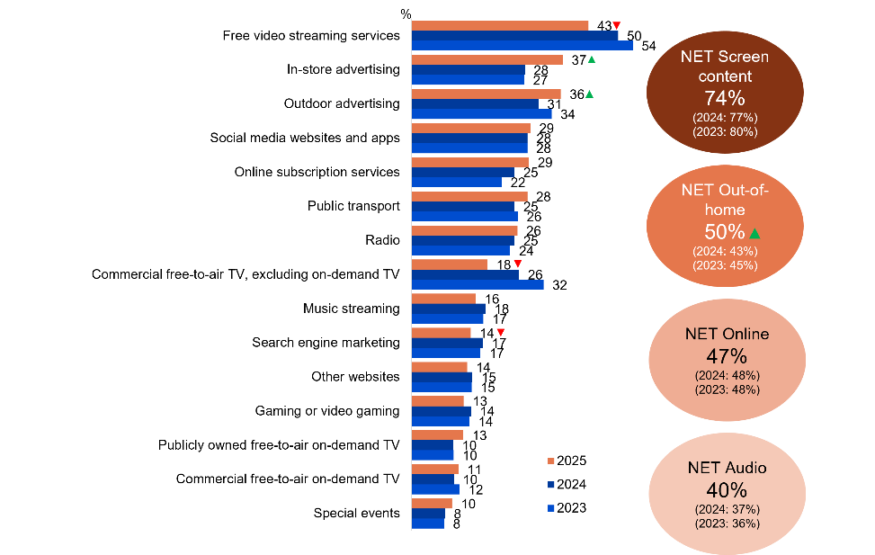
Source: F6. Where has your child seen or heard advertising in the past 7 days?
Base: MCCS, Respondents who are parents/legal guardians/carers of a child aged 17 or under. 2025: n=2,097. 2024: n=2,054. 2023: n=2,409.
Notes: Don’t know/refused responses not shown: 2025 DK=2%, Ref<0.5%. 2024 DK=3%, Ref=2%. 2023 DK=4%, Ref=1%. Responses <10% not shown on chart.
Bar chart showing where children have seen or heard advertising in the past 7 days for the years 2023, 2024, and 2025.
Free video streaming services: 43% in 2025, 50% in 2024, and 54% in 2023
In-store advertising: 37% in 2025, 28% in 2024, and 27% in 2023
Outdoor advertising: 36% in 2025, 31% in 2024, and 34% in 2023
Social media websites and apps: 29% in 2025, 28% in 2024, and 28% in 2023
Online subscription services: 29% in 2025, 25% in 2024, and 22% in 2023
Public transport: 28% in 2025, 25% in 2024, and 26% in 2023
Radio: 26% in 2025, 25% in 2024, and 24% in 2023
Commercial free-to-air TV (excluding on-demand TV): 18% in 2025, 26% in 2024, and 32% in 2023
Music streaming: 16% in 2025, 18% in 2024, and 17% in 2023
Search engine marketing: 14% in 2025, 17% in 2024, and 17% in 2023
Other websites: 14% in 2025, 15% in 2024, and 15% in 2023
Gaming or video gaming: 13% in 2025, 14% in 2024, and 14% in 2023
Publicly owned free-to-air on-demand TV: 13% in 2025, 10% in 2024, and 10% in 2023
Commercial free-to-air on-demand TV: 11% in 2025, 10% in 2024, and 12% in 2023
Special events: 10% in 2025, 8% in 2024, and 8% in 2023
NET screen content: 74% in 2025, 77% in 2024, and 80% in 2023
NET out-of-home: 50% in 2025, 43% in 2024, and 45% in 2023
NET online: 47% in 2025, 48% in 2024, and 48% in 2023
NET audio: 40% in 2025, 37% in 2024, and 36% in 2023

Subgroup
Free video streaming services was higher for:
- Those whose child is aged 8–17 (46% vs 37% of those whose child is aged 0–7)
- Those whose children watched YouTube, YouTube Kids in P7D (56%)

Callout
Free video streaming services (43% vs 50% in 2024), commercial free-to-air, excluding on-demand TV (18% vs 26% in 2024), and search engine marketing (14% vs 17% in 2024) decreased significantly, whereas in-store advertising (37% vs 28% in 2024), outdoor advertising (36% vs 31% in 2024), and NET out-of-home (50% vs 43% in 2024) increased significantly in 2025.

Note
NET SCREEN CONTENT:
- Commercial free-to-air TV (e.g. Seven, Nine, 10, WIN, Imparja, NBN Television), including recorded content but excluding on-demand TV + Publicly owned free-to-air TV (i.e. SBS), including recorded content but excluding on-demand TV + Pay TV (e.g. Foxtel, Fetch TV), including recorded content but excluding streaming + Commercial free-to-air on-demand TV (e.g. 9Now, 10 Play, 7plus) + Publicly owned free-to-air on-demand TV (e.g. ABC iview, SBS On Demand, ABC News, ABC Kids) + Free video streaming services (e.g. YouTube, YouTube Kids, Twitch, Tubi) + Online subscription services (e.g. Netflix, Amazon Prime Video, Binge, YouTube Premium, Disney+) + Pay-per-view services (e.g. Google Play)
NET OUT-OF-HOME:
- Public transport (e.g. at train / bus / tram stops, or on vehicles) + Outdoor advertising (e.g. posters, billboards) + Special events (e.g. sports, concerts, ticketed events)
NET ONLINE:
- Sports specific website or app (e.g. NRL Live, Cricket Australia Live, Kayo Sports, Stan Sport) + Social Media websites and apps (e.g. ads displayed on social media websites) + Other websites (e.g. ads displayed on websites) + Search engine marketing (e.g. ads displayed with search engine results) + Gaming or video gaming (e.g. Steam, Discord)

Watched age-inappropriate content (children aged 0–17)
The survey asked about children’s exposure to any TV shows or content shown online that were meant for someone older. 2025 data shows an increase trend of children across all age segments being exposed to TV shows or online content that was meant for an older audience. Overall, children aged 11–15 and 16–17 (72% for both, respectively), had the highest increase compared to previous years. A follow-up question was asked about whether the child actively seeks out age-inappropriate content. The results indicate that among children aged 16–17, half (50%) were exposed intentionally. Ages 11–15 (48%) also followed similar trend, while children aged 8–10 (36%) and 0-7 (22%), were less likely to actively seek for age-inappropriate content, and more inclined to be accidentally exposed.
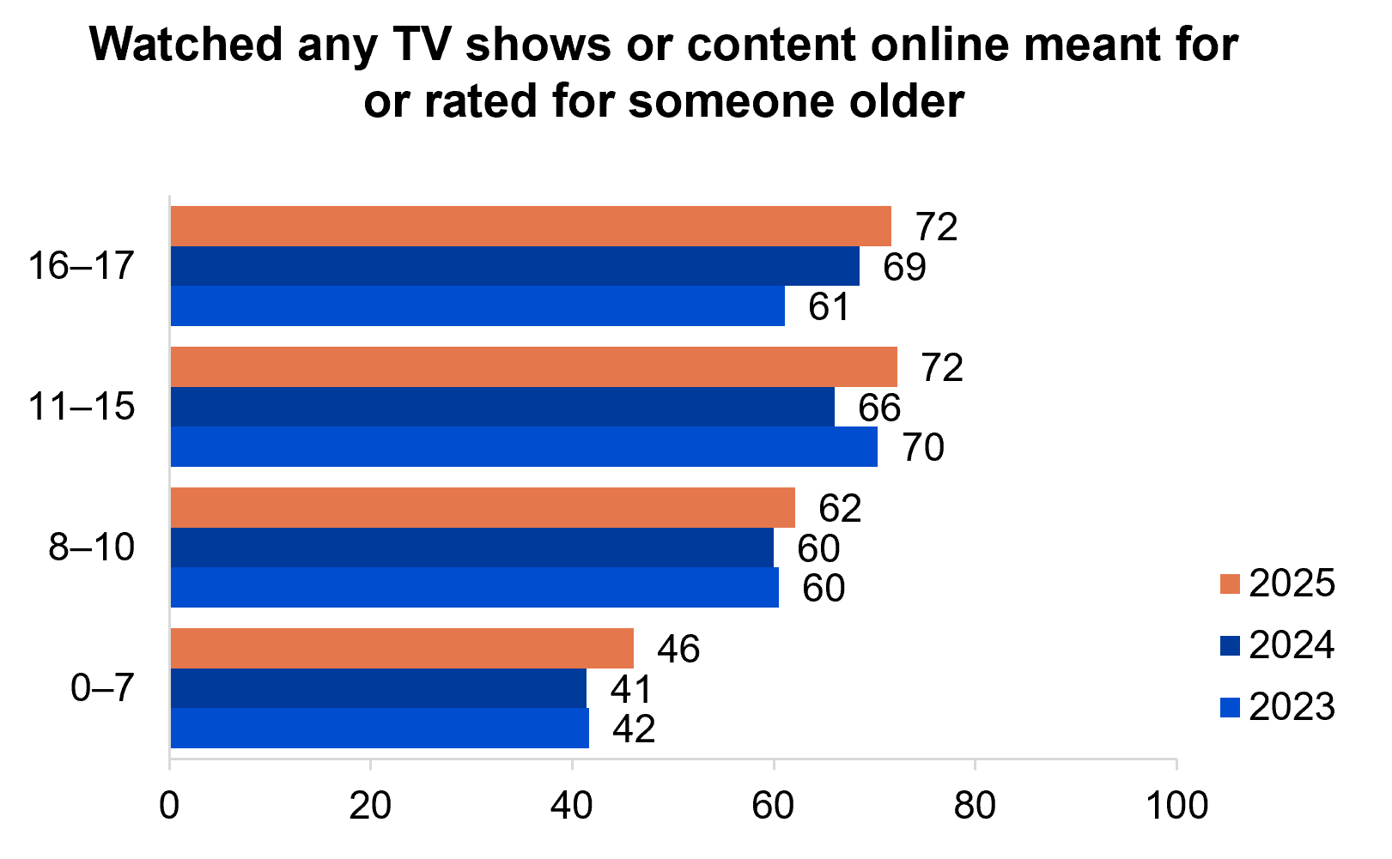
Source: KA8. Has your child ever watched any content (e.g. TV shows, movies, videos, online content, etc.) that was meant for or rated for someone older than they are? KB8, KC8, KD8. Have you ever watched any content (e.g. TV shows, movies, videos, online content, etc.) that was meant for or rated for someone older than you were?
Base: MCCS, All children aged 8-17. 2025: 8-10 (n=179), 11-15 (n=196), 16-17 (n=130). 2024: 8-10 (n=199), 11-15 (n=199), 16-17 (n=141). 2023: 8-10 (n=197), 11-15 (n=191), 16-17 (n=137). All parents/legal guardians/carers answering on behalf of their 0-7 year old child (2025: n=304. 2024: n=336. 2023: n=359).
Notes: Don’t know/refused responses not shown: <0.5% for Ref. DK= between 0 and 1%.
Bar chart showing the percentage of children ages 0-7, 8-10, 11-15 and 16-17 having watched any TV shows or content online meant for or rated for someone older in 2023, 2024, and 2025.
Age 0–7: 46% in 2025, 41% in 2024, and 42% in 2023
Age 8–10: 62% in 2025, 60% in 2024, and 60% in 2023
Age 11–15: 72% in 2025, 66% in 2024, and 70% in 2023
Age 16–17: 72% in 2025, 69% in 2024, and 61% in 2023

Subgroup
Watched any age-inappropriate TV shows or content online was higher for children ages 16–17 (72%), 11–15 (72%) and 8–10 (62% vs 46% of ages 0–7).
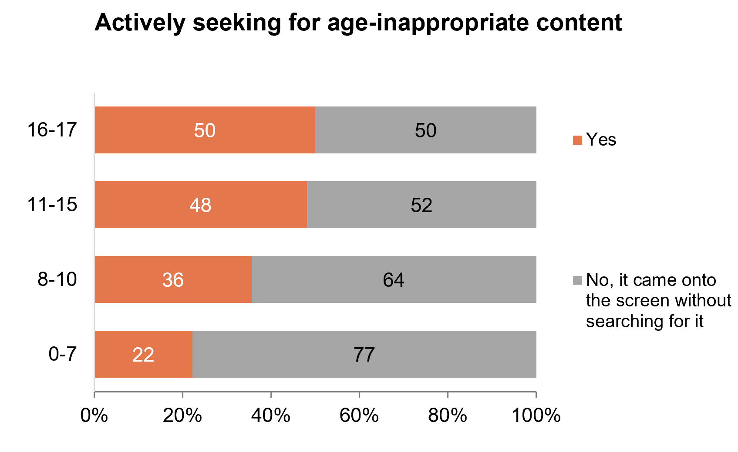
Source: KA9e. Were they trying to find this content? KB9e, KC9e, KD9e. Were you trying to find this content?
Base: MCCS, All children aged 8-17. 2025: 8-10 (n=179), 11-15 (n=196), 16-17 (n=130). All parents/legal guardians/carers answering on behalf of their 0-7 year old child (2025: n=304).
Notes: Don’t know/refused responses not shown: All 0% except for 8-10 DK=1.
Bar chart showing the percentage of whether children ages 0-7, 8-10, 11-15 and 16-17 are actively seeking for age-inappropriate content in 2025.
Age 0–7: yes: 22% and no, it came onto the screen without searching for it: 77%
Age 8–10: yes: 36%, and no, it came onto the screen without searching for it: 64%
Age 11–15: yes: 48%, and no, it came onto the screen without searching for it: 52%
Age 16–17: yes: 50%, and no, it came onto the screen without searching for it: 50%

Subgroup
Actively seeking for age-inappropriate content was higher among children ages 16–17 (50%), 11–15 (48%) and 8–10 (36% vs 22% of ages 0–7).
Increase of children being exposed to content that were not appropriate for their age across all age cohorts. Children aged 16–17 equally seek out age-inappropriate content through active and indirect methods. Children aged 11–15 were reported to be more inclined to actively seek for age-inappropriate content, whereas younger children were more susceptible to incidental exposure.

Platforms used to watch age-inappropriate content (children aged 0–17)
Online subscription services and YouTube/YouTube kids were the most common platforms used to access age-inappropriate content across all age segments in 2025. For children aged 8–10 (38%) and 11–15 (24%), shows a significant decrease of the platform YouTube/YouTube Kids being accessed compared to previous years. For children aged 11–15 (0%), there is a significant decrease in using the publicly owned free-to-air TV, excluding on-demand.
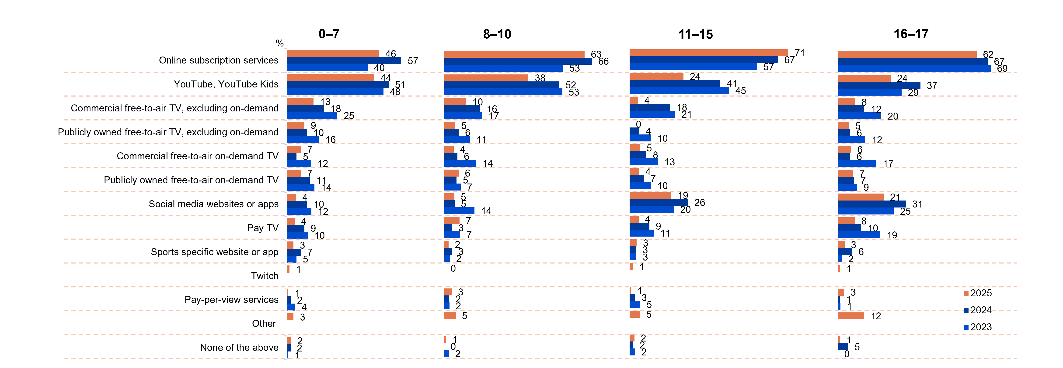
Source: KA9. And on what service or platform did they watch this content that was meant for someone older than them? KB9, KC9, KD9. And on what service or platform did you watch this content that was meant for someone older than you?
Base: MCCS, Children aged 8-17 who have ever watched content meant for someone older than them. 2024: 8-10 (n=110), 11-15 (n=142), 16-17 (n=93). 2024: 8-10 (n=118), 11-15 (n=128), 16-17 (n=92). 2023: 8-10 (n=119), 11-15 (n=135), 16-17 (n=86). All parents/legal guardians/carers answering on behalf of their 0-7 year old child. 2025: n=140. 2024: n=135. 2023: n=150.
Notes: Don’t know/refused responses not shown: All 0% except for 16-17 DK=1% in 2024. Missing bar means item not asked that year.
Bar chart showing the percentage of people who saw content that was meant for someone older than them on various platforms in different age groups (0-7, 8-10, 11-15, 16-17) for the years 2023, 2024 and 2025.
Age group 0-7:
- Online subscription services: 40% in 2023, 57% in 2024, and 46% in 2025
- YouTube, YouTube Kids: 48% in 2023, 51% in 2024, and 44% in 2025
- Commercial free-to-air TV, excluding on-demand: 25% in 2023, 18% in 2024, and 13% in 2025
- Publicly owned free-to-air TV, excluding on-demand: 16% in 2023, 10% in 2024, and 9% in 2025
- Commercial free-to-air on-demand TV: 12% in 2023, 5% in 2024, and 7% in 2025
- Publicly owned free-to-air on-demand TV: 14% in 2023, 11% in 2024, and 7% in 2025
- Social media websites or apps: 12% in 2023, 10% in 2024, and 4% in 2025
- Pay TV: 10% in 2023, 9% in 2024, and 4% in 2025
- Sports specific website or app: 5% in 2023, 7% in 2024, and 3% in 2025
- Twitch: not asked in 2023, not asked in 2024, and 1% in 2025
- Pay-per-view services: 4% in 2023, 2% in 2024, and 1% in 2025
- Other: not asked in 2023, not asked in 2024, and 3% in 2025
- None of the above: 1% in 2023, 2% in 2024, and 2% in 2025
Age group 8-10:
- Online subscription services: 53% in 2023, 66% in 2024, and 63% in 2025
- YouTube, YouTube Kids: 53% in 2023, 52% in 2024, and 38% in 2025
- Commercial free-to-air TV, excluding on-demand: 17% in 2023, 16% in 2024, and 10% in 2025
- Publicly owned free-to-air TV, excluding on-demand: 11% in 2023, 6% in 2024, and 5% in 2025
- Commercial free-to-air on-demand TV: 14% in 2023, 6% in 2024, and 4% in 2025
- Publicly owned free-to-air on-demand TV: 7% in 2023, 5% in 2024, and 6% in 2025
- Social media websites or apps: 14% in 2023, 5% in 2024, and 5% in 2025
- Pay TV: 7% in 2023, 3% in 2024, and 7% in 2025
- Sports-specific website or app: 2% in 2023, 3% in 2024, and 2% in 2025
- Twitch: not asked in 2023, not asked in 2024, and 0% in 2025
- Pay-per-view services: 2% in 2023, 2% in 2024, and 3% in 2025
- Other: not asked in 2023, not asked in 2024, and 5% in 2025
- None of the above: 2% in 2023, 0% in 2024, and 1% in 2025
Age group 11-15:
- Online subscription services: 57% in 2023, 67% in 2024, and 71% in 2025
- YouTube, YouTube Kids: 45% in 2023, 41% in 2024, and 24% in 2025
- Commercial free-to-air TV, excluding on-demand: 21% in 2023, 18% in 2024, and 4% in 2025
- Publicly owned free-to-air TV, excluding on-demand: 10% in 2023, 4% in 2024, and 0% in 2025
- Commercial free-to-air on-demand TV: 13% in 2023, 8% in 2024, and 5% in 2025
- Publicly owned free-to-air on-demand TV: 10% in 2023, 7% in 2024, and 4% in 2025
- Social media websites or apps: 20% in 2023, 26% in 2024, and 19% in 2025
- Pay TV: 11% in 2023, 9% in 2024, and 4% in 2025
- Sports specific website or app: 3% in 2023, 3% in 2024, and 3% in 2025
- Twitch: not asked in 2023, not asked in 2024, and 1% in 2025
- Pay-per-view services: 5% in 2023, 3% in 2024, and 1% in 2025
- Other: not asked in 2023, not asked in 2024, and 5% in 2025
- None of the above: 2% in 2023, 2% in 2024, and 2% in 2025
Age group 16-17:
- Online subscription services: 69% in 2023, 67% in 2024, and 62% in 2025
- YouTube, YouTube Kids: 29% in 2023, 37% in 2024, and 24% in 2025
- Commercial free-to-air TV, excluding on-demand: 20% in 2023, 12% in 2024, and 8% in 2025
- Publicly owned free-to-air TV, excluding on-demand: 12% in 2023, 6% in 2024, and 5% in 2025
- Commercial free-to-air on-demand TV: 17% in 2023, 6% in 2024, and 6% in 2025
- Publicly owned free-to-air on-demand TV: 9% in 2023, 7% in 2024, and 7% in 2025
- Social media websites or apps: 25% in 2023, 31% in 2024, and 21% in 2025
- Pay TV: 19% in 2023, 10% in 2024, and 8% in 2025
- Sports specific website or app: 2% in 2023, 6% in 2024, and 3% in 2025
- Twitch: not asked in 2023, not asked in 2024, and 1% in 2025
- Pay-per-view services: 1% in 2023, 1% in 2024, and 3% in 2025
- Other: not asked in 2023, not asked in 2024, and 12% in 2025
- None of the above: 0% in 2023, 5% in 2024, and 1% in 2025

Callout
Age group 8-10
- YouTube, YouTube Kids (38% vs 52% in 2024) decreased significantly in 2025
Age group 11-15
- YouTube, YouTube Kids (24% vs 41% in 2024), Commercial free-to-air, excluding on demand (4% vs 18% in 2024) and publicly owned free-to-air on demand TV (0% vs 4% in 2024) all decreased significantly in 2025
Online subscription services and YouTube/YouTube Kids remain the top platforms used to access age-inappropriate content. For children aged 11-15, publicly owned free-to-air TV, excluding on-demand were not reportedly used to access age-inappropriate content.

Nature of the age-inappropriate content (children aged 0–17)
The reasons why the children consider content they saw were appropriate varies across age segments. For both children aged 8–10 (48%) and 11–15 (58%), the top reasons were that ‘it was violent content’ followed by ‘there was drug or alcohol use’ (14% and 31% respectively). For parents answering on behalf of their child aged 0–7 (26%), the most common reason is cited to be ‘inappropriate/not child friendly’ and for children aged 16–17 it was due to the rating in general (28%).
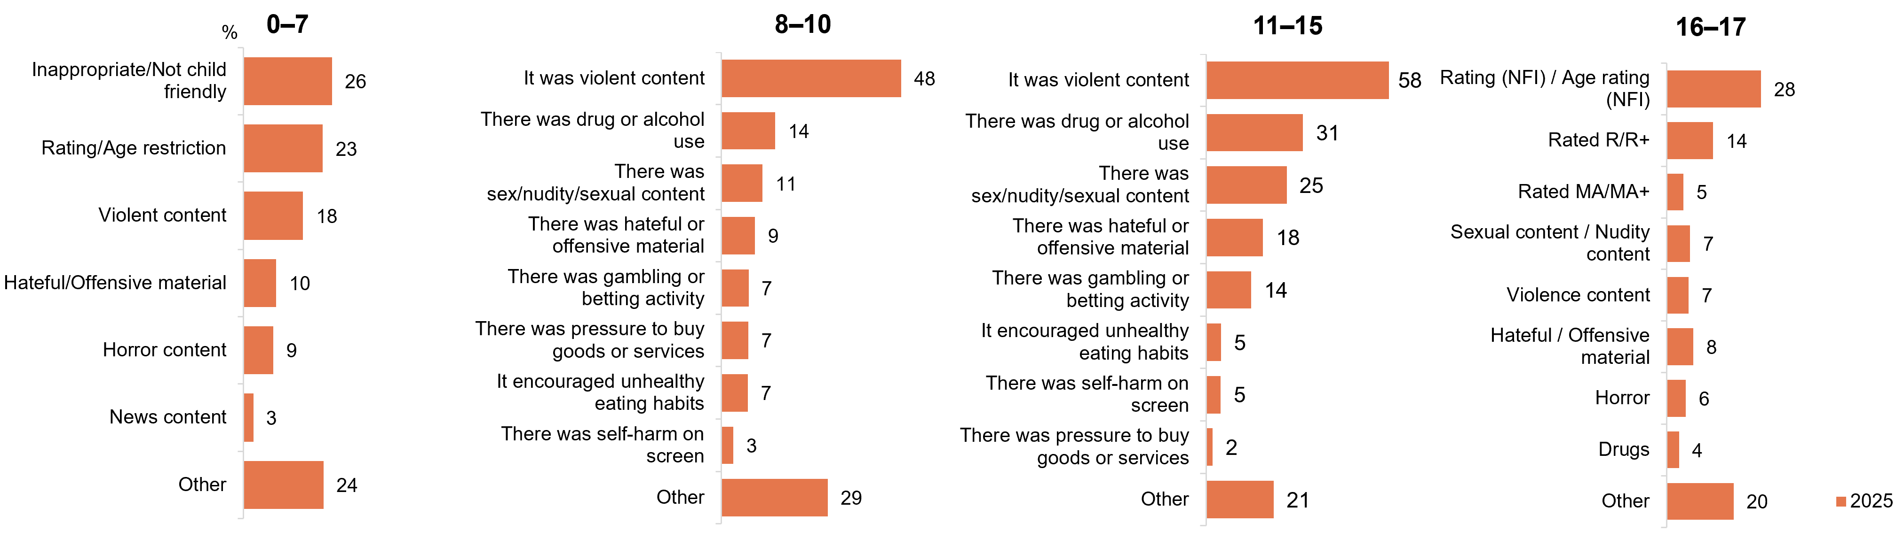
Source: KA9d. What was it about the content that made you think it was meant for someone older? KB9d, KC9d, KD9d. What was it about the content that made you think it was meant for someone older?
Base: MCCS, All children aged 8-17. 2025: 8-10 (n=110), 11-15 (n=142), 16-17 (n=93). All parents/legal guardians/carers answering on behalf of their 0-7 year old child (2025: n=140).
Notes: Don’t know/refused responses not shown: 2025: 0-7 DK=1% Ref=4%. 8-10 DK=2%, Ref=0%. 11-15 0% for both. 16-17 DK=4%, Ref=9%.
KA9d (0-7) and KD9d (16-17) were asked as open-text questions, whereas KB9d (8-10) and KC9d (11-15) were asked as closed-frame questions in 2025.
Bar charts showing the reasons to which respondents think/believe that the nature of what their child/what they saw was meant for someone older in 2025 in different age groups (0-7, 8-10, 11-15, 16-17).
Age group 0-7:
- Inappropriate/Not child friendly: 26%
- Rating/Age restriction: 23%
- Violent content: 18%
- Hateful/Offensive material: 10%
- Horror content: 9%
- News content: 3%
- Other: 24%
Age group 8-10:
- It was violent content: 48%
- There was drug or alcohol use: 14%
- There was sex/nudity/sexual content: 11%
- There was hateful or offensive material: 9%
- There was gambling or betting activity: 7%
- There was pressure to buy goods or services: 7%
- It encouraged unhealthy eating habits: 7%
- There was self-harm on screen: 3%
- Other: 29%
Age group 11-15:
- It was violent content: 58%
- There was drug or alcohol use: 31%
- There was sex/nudity/sexual content: 25%
- There was hateful or offensive material: 18%
- There was gambling or betting activity: 14%
- It encouraged unhealthy eating habits: 5%
- There was self-harm on screen: 5%
- There was pressure to buy goods or services: 2%
- Other: 21%
Age group 16-17:
- Rating (NFI)/Age rating (NFI): 28%
- Rated R/R+: 14%
- Rated MA/MA+: 5%
- Sexual content/Nudity content: 7%
- Violence content: 7%
- Hateful/Offensive material: 8%
- Horror: 6%
- Drugs: 4%
- Other: 20%
Children aged 8–15 identified similar reasons for considering what content they have watched is viewed age-inappropriate, with violent content cited most frequently as the primary concern.

Where they watched age-inappropriate content (children aged 0–17)
Children were asked about the location of where they watched age-inappropriate content. The most common places were predominately at home across all age segments (64%, 91%, 88% and 65%) respectively. Children aged 8–10 and 11–15 showed a similar trend of the location they watched aged-inappropriate content, with at a friends’ house (10% and 16%), followed by at a relative’s house (8% and 9%) and at school (4% and 5%). For children aged 16–17, the second most common location is at a friend’s house with 12%. For children aged 0–7, the second most common location is ‘At relative’s house’ (6%) followed by ‘friend’s house’ (5%). ‘Other’ locations were mostly reported by parents/legal guardians/carers of children 0–7 (19%) and 16–17 (10%).
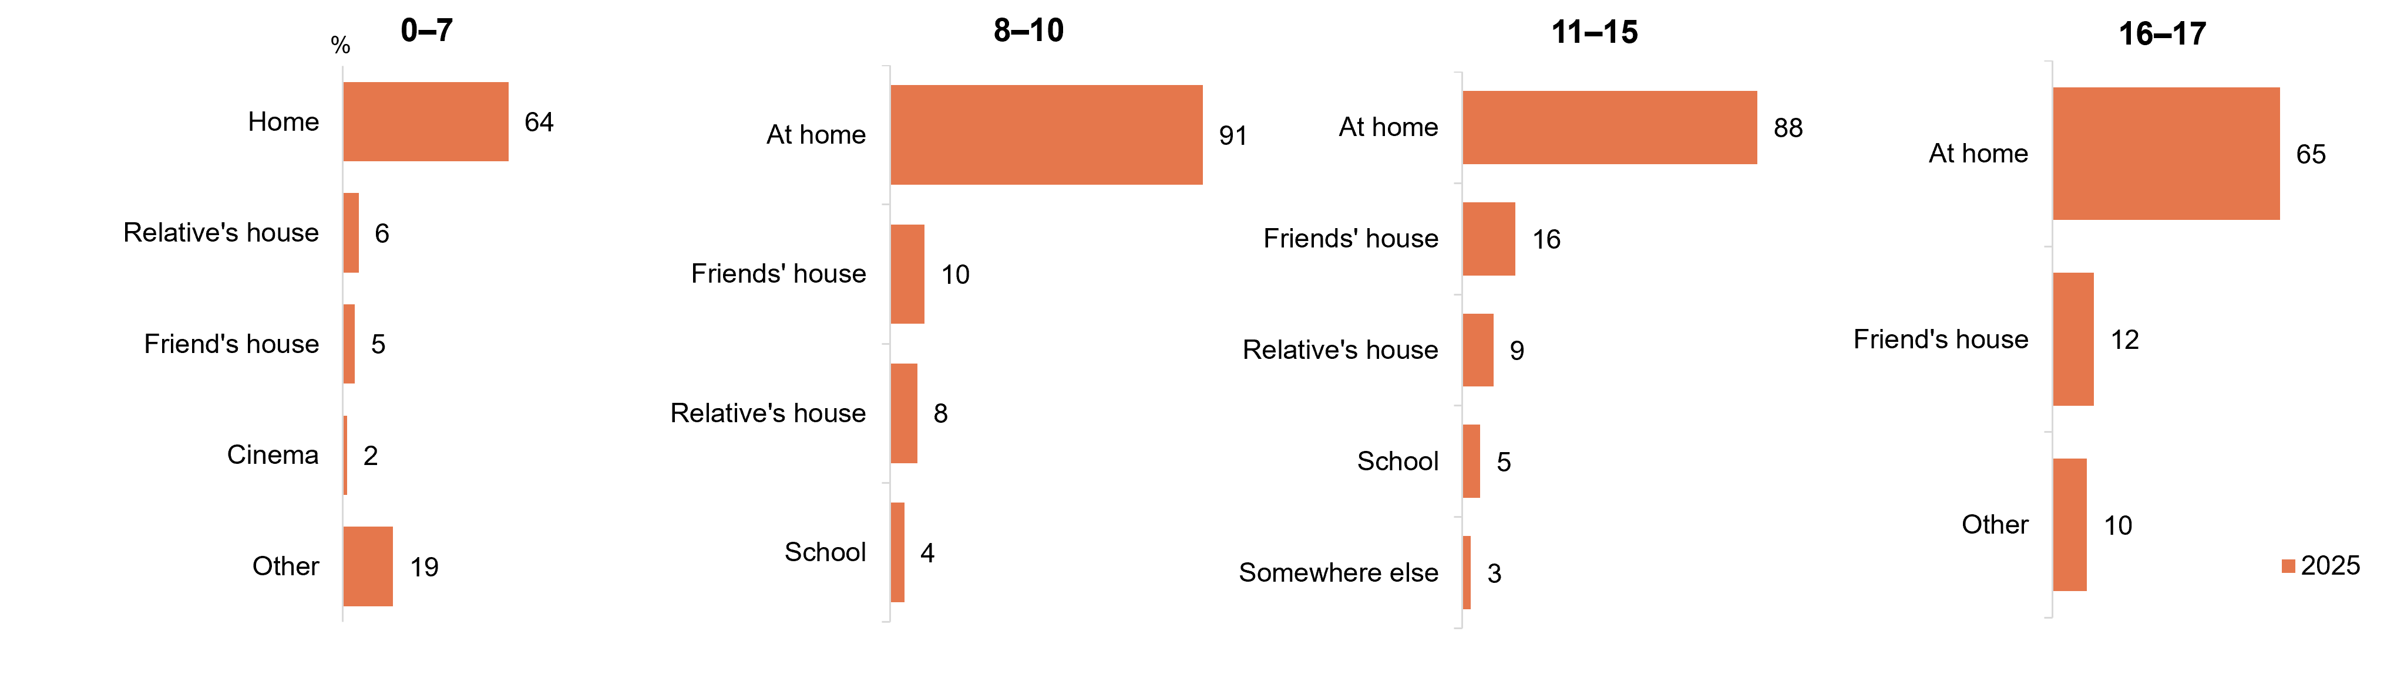
Source: KA9a. Where were they when they watched this content that was meant for someone older than them? KB9a, KC9a, KD9a. Where were you when you watched this content that was meant for someone older than you?
Base: MCCS, All children aged 8-17. 2025: 8-10 (n=110), 11-15 (n=142), 16-17 (n=93). All parents/legal guardians/carers answering on behalf of their 0-7 year old child (2025: n=140).
Notes: Don’t know/refused responses not shown: 2025: 0-7 DK=1%, Ref=3%. 8-10 0% for both. 11-15 DK=1%, Ref=0%. 16-17 DK=3%, Ref=11%.
KA9a (0-7) and KD9a (16-17) were asked as open-text questions, whereas KB9a (8-10) and KC9a (11-15) were asked as closed-frame questions in 2025.
Bar charts showing the location in which children watched content that was meant for someone older than them in 2025 in different age groups (0-7, 8-10, 11-15, 16-17).
Age group 0-7:
- Home: 64%
- Relative’s house: 6%
- Friend’s house: 5%
- Cinema: 2%
- Other: 19%
Age group 8-10:
- At home: 91%
- Friend’s house: 10%
- Relative’s house: 8%
- School: 4%
Age group 11-15:
- At home: 88%
- Friend’s house: 16%
- Relative’s house: 9%
- School: 5%
- Somewhere else: 3%
Age group 16-17:
- At home: 65%
- Friend’s house: 12%
- Other: 10%
Across all ages, it was reported that ‘home’ is the most common location where children are reported to have watched age-inappropriate content. This is followed by other people’s houses, such as friends of relatives.

Who they were with when watching age-inappropriate content (children aged 0–17)
For children aged 8–10 (75%) and 11–15 (53%), they were with parents or other older family members when watching age-inappropriate content. For children aged 0–7, majority (86%) were with family members and many children aged 16–17 (43%) watched the content by themselves. For both children aged 0–7 (5%) and 11–15 (26%), they report watching age-inappropriate content by themselves, or with family members. Children aged 8–10, one in 5 (21%) noted to have watched content with their sibling and children aged 16–17 reported they were with a friend (19%).
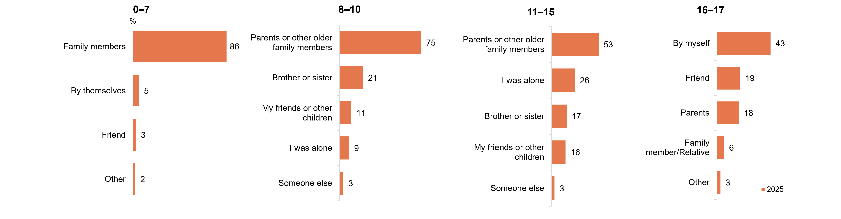
Source: KA9b. Who were they with when they watched this content that was meant for someone older than them? KB9b, KC9b, KD9b. Who were you with when you watched this content that was meant for someone older than you?
Base: MCCS, All children aged 8-17. 2025: 8-10 (n=110), 11-15 (n=142), 16-17 (n=93). All parents/legal guardians/carers answering on behalf of their 0-7 year old child (2025: n=140).
Notes: Don’t know/refused responses not shown: 2025: 0-7 DK=1%, Ref=3%. 8-10 0% for both. 11-15 0% for both. 16-17 DK=5%, Ref=7%.
KA9b (0-7) and KD9b (16-17) were asked as open-text questions, whereas KB9b (8-10) and KC9b (11-15) were asked as closed-frame questions in 2025.
Bar charts showing who the children were with when they watched content that was meant for someone older than them in 2025 in different age groups (0-7, 8-10, 11-15, 16-17).
Age group 0-7:
- Family members: 86%
- By themselves: 5%
- Friend: 2%
- Other: 2%
Age group 8-10:
- Parents or other older family members: 75%
- Brother or sister: 21%
- My friends or other children: 11%
- I was alone: 9%
- Someone else: 3%
Age group 11-15:
- Parents or other older family members: 53%
- I was alone: 26%
- Brother or sister: 17%
- My friends or other children: 16%
- Someone else: 3%
Age group 16-17:
- By myself: 43%
- Friend: 19%
- Parents: 18%
- Family member/Relative: 6%
- Other: 3%
Parents or other family members were highlighted to be the main cohort who watches age-inappropriate content for children 0–15. Whereas older children, predominately watches the content by themselves.

Appendix
  - Overview + methodology
Table 8 List of abbreviations + terms
Abbreviation | Full description
AI | Artificial intelligence
T2B | Top Two Box score – sum of the results for the top two options in a response frame with a scale (e.g. ‘Strongly agree’ and ‘Agree’)
B2B | Bottom Two Box score – sum of the results for the bottom two options in a response frame with a scale (e.g. ‘Disagree’ and ‘Strongly disagree’)
HH | Household
TVCS | Television Consumer Survey
MCCS | Media Content Consumption Survey
FTA | Free-to-air
BVOD | Broadcast Video On Demand – Net of ‘Commercial free-to-air on-demand TV (e.g. 9Now, 10 play, 7plus)’ and ‘Publicly owned free-to-air on-demand TV (e.g. ABC iview, SBS On Demand, ABC News, ABC Kids)’
SVOD | Subscription Video On Demand – Net of ‘Online subscription services (e.g. Netflix, Binge, YouTube Premium)’ and ‘Sports specific website or app (e.g. NRL Live, Cricket Australia Live, Kayo Sports, Stan Sport)’
NFI | No further information – term used in coding open ended responses when a general response was given by a respondent
ORU | Online Research Unit non-probability panel – in the MCCS the panel was parents/legal guardians/carers of children aged 17 years old and under, in the TVCS the panel was adults living in regional Australia. Both MCCS and TVCS were asked of the First Nations panel boost.
P7D / P6M / P12M | Past 7 days / Past 6 months / Past 12 months before the survey
SEIFA Quintile | Socio-Economic Indexes for Areas (where Quintile 1 is most disadvantaged, and Quintile 5 is least disadvantaged)
Table 9 List of definitions of terms
Term | Definition
Children | Children aged 0–17 years, except where a more specific age range is given
the Department | The Department of Infrastructure, Transport, Regional Development, Communications, Sport and the Arts
NET / Net | Sum of results for two or more categories
Parents | Respondents who are parents/legal guardians/carers of a child/children aged 17 years and under
Respondents | People who responded to the quantitative survey
Screen content | Content watched on a screen, including things like television shows or programs, movies, documentaries and sports
the Survey | The Television and Media Survey 2024
Note: Where age is referenced throughout the report, this should be taken as a reference to respondents in those age ranges (e.g. Ages 18–24 refers to respondents aged between 18 and 24 years).
Condensed code frames in report
- Some code frames in charts and tables throughout the report have been condensed from the original codes shown in the survey in the interest of space and ease of reading. The original codes and the condensed codes are shown below.
Table 10 Condensed code frames in report
Original (adult) | Original (children) | Condensed (adults + children)
Commercial free-to-air TV (e.g. Seven, Nine, 10, WIN, Imparja, NBN Television), including recorded content but excluding on-demand TV | Channels Seven, Nine, or 10 (sometimes called WIN, Imparja, NBN Television) (Commercial free-to-air TV) | Commercial free-to-air TV, excluding on-demand
Publicly owned free-to-air TV (i.e. ABC, SBS), including recorded content but excluding on-demand TV | ABC or SBS (Publicly owned free-to-air TV) | Publicly owned free-to-air TV, excluding on-demand
Pay TV (e.g. Foxtel, Fetch TV), including recorded content but excluding streaming | Foxtel, Fetch TV (Pay TV) | Pay TV
Commercial free-to-air on-demand TV (e.g. 9Now, 10 Play, 7plus) | 9Now, 10 Play, or 7plus (Commercial free-to-air on-demand TV) | Commercial free-to-air on-demand TV
Publicly owned free-to-air on-demand TV (e.g. ABC iview, SBS On Demand, ABC News, ABC Kids) | ABC iview, SBS On Demand, ABC News, or ABC Kids (Publicly owned free-to-air on-demand TV) | Publicly owned free-to-air on-demand TV
Free video streaming services (e.g. YouTube, Twitch, Tubi) | YouTube, YouTube Kids | Free video streaming services
Online subscription services (e.g. Netflix, Binge, YouTube Premium) | Netflix, Amazon Prime Video, Binge, Stan or Disney+ (Online subscription services) | Online subscription services
Pay-per-view services (e.g. Google Play) | Google Play (or pay-per-view services) | Pay-per-view services
Sports specific website or app (e.g. NRL Live, Cricket Australia Live, Kayo Sports, Stan Sport) | Sports specific website or app (e.g. NRL Live, Cricket Australia Live, Kayo Sports, Stan Sport) | Sports specific website or app
Other websites or apps (e.g. Facebook, TikTok, Instagram) | Social media websites or apps (e.g. Facebook, TikTok, Instagram) | Other websites or apps
Reading this report
- Where agreement scales (e.g. do you agree…?) have been used in the questionnaire, top two boxes (i.e. strongly agree and agree) and bottom two boxes (i.e. strongly disagree and disagree) have generally been combined for analysis with reporting on netted agreement scales. These are indicated by ‘T2B’ (top two box), or ‘B2B’ (bottom 2 box) scores.
- In reading quantitative findings based on the probability-based sample, reference is made to those who completed the survey throughout the report as ‘respondents’, ‘Australians’ or ‘adults’ as appropriate to the context in which the data are being discussed.
Rounding of numbers
- Percentages are rounded to 0 decimal places, unless the percentage is under 0.5%, which are rounded to 1 decimal place. As rounding has been used in producing data tables and nets in analysis, some scales may not sum to exactly 100%.
Chart labelling
- For readability on certain charts, labels for values smaller than a certain percentage (specified on chart) have been suppressed due to space and readability.
- NETs used in the report
- T2B – Top Two Box scores
- B2B – Bottom Teo Box Scores
- Nets for online and free-to-air television services are used throughout the report with the specific contents of each NET footnoted on each slide. ‘Online NET’ does not necessarily refer to all online sources, but is context specific per question. For example, content watched in past seven days at C1:
  - ‘NET: Online’ (C1) includes: ‘Online subscription services’, ‘Free video streaming services’, ‘Other websites or apps’, and ‘Sports specific website or app’.
  - ‘NET: Free-to-air’ television (C1) includes: ‘Commercial free-to-air TV’, ‘Publicly owned free-to-air TV’, ‘Commercial free-to-air on-demand TV’, Publicly owned free-to-air on-demand TV’, and ‘Free-to-air catch-up TV’ and equivalent from prior years.
Significance testing + confidence intervals
- Data were analysed using Q Research Software (Q), including significance testing. Statistical testing was undertaken to establish whether the responses from one subgroup were reliably or consistently different (not due to chance) to other subgroups.
- Where differences across subgroups are mentioned in the report commentary (for example, ‘higher than’, or ‘lower than’), unless otherwise noted, it implies that a difference at a 95% confidence level has been established. This means that when a difference is described as ‘different’ one can be 95% confident that the difference is real and not due to random sampling variation.
- For brevity and ease of reading, statistical testing has been noted in this report for the following subgroups, and generally on the leading figure per chart.
Group
- Gender
- Age
- Regional / Metro (Capital city vs Rest of State)
- Household type

Groups where appropriate
- Education
- Employment
- Disability status
- Speaking a language other than English
- Aboriginal and/or Torres Strait Islander status
- Online habits
- Frequency of accessing social media
- Content watched in the past 7 days
- Device usage
- Fixed home internet ownership
- Household access to an external free-to-air TV antenna
- Sport watchers
- SEIFA quintiles
- Household income
- Type of dwelling
- Played video games in the past 7 days
- Experienced emergency in the past 12 months
- Age of child
- Content watched past 7 days by child
- Further subgroup differences are noted in the Banner data table set, provided to the Department.
- Statistical testing at the 95% confidence level was conducted to compare results with the previous year in which the questions were fielded (e.g., 2025 vs. 2024 for most questions, and 2025 vs. 2023 for questions last asked in 2023).
  - A green upward arrow indicates the result is reliably or consistently higher.
  - A red downward arrow indicates a reliably lower result than other subgroups, and that the observed difference is unlikely due to chance.
Sample profile
- In 2025, the survey continued to run as one instrument with a total of 4,396 respondents.
- Boosts were also conducted for parents/legal guardians/carers, children aged 0–17 (MCCS), those in regional Australia (TVCS) and Aboriginal and/or Torres Strait Islander people. Questions specific to media and television were asked of these boost streams. This page shows the unweighted profile of the final sample (i.e. those who completed the survey) for respondents in the survey across a range of key demographic characteristics.
Table 11 Sample profile
Profile | Total (n) | Total (%) | MCCS (n) | MCCS (%) | TVCS (n) | TVCS (%)
Total (adults) | 4,396 | 100% | 3,396 | 100% | 3,716 | 100%
Male | 2,238 | 51% | 1,659 | 49% | 1,895 | 51%
Female | 2,130 | 48% | 1,711 | 50% | 1,793 | 48%
Non-binary / gender fluid / different identity | 25 | 1% | 24 | 1% | 25 | 1%
18–24 years old | 288 | 7% | 283 | 8% | 286 | 8%
25–34 years old | 451 | 10% | 419 | 12% | 383 | 10%
35–44 years old | 1,056 | 24% | 992 | 29% | 791 | 21%
45–54 years old | 913 | 21% | 821 | 24% | 654 | 18%
55–64 years old | 555 | 13% | 291 | 9% | 479 | 13%
65–74 years old | 739 | 17% | 400 | 12% | 729 | 20%
75+ years old | 394 | 9% | 190 | 6% | 394 | 11%
Capital city | 2,411 | 55% | 2,404 | 71% | 1,854 | 50%
Rest of state | 1,980 | 45% | 992 | 29% | 1,857 | 50%
Single or couple (no children) | 1,596 | 36% | 854 | 25% | 1,596 | 43%
Parents/legal guardians/carers (with dependent children) | 2,255 | 51% | 2,165 | 64% | 1,590 | 43%
Parents/legal guardians/carers (with non-dependent children) | 350 | 8% | 226 | 7% | 335 | 9%
Adults living in a share house | 136 | 3% | 102 | 3% | 136 | 4%
Other household type | 55 | 1% | 47 | 1% | 55 | 1%
Total (children) | 809 | 100% | 809 | 100% | 615 | 100%
0–7 years old | 304 | 38% | 304 | 38% | 242 | 39%
8–10 years old | 179 | 22% | 179 | 22% | 136 | 22%
11–15 years old | 196 | 24% | 196 | 24% | 154 | 25%
16–17 years old | 130 | 16% | 130 | 16% | 83 | 13%

Methodology summary
- For the 2025 Television and Media survey, the Social Research Centre’s probability based online panel – Life in Australia™ was used as the primary data collection vehicle for the probability-based sample estimates. The Social Research Centre established Life in Australia™ – Australia’s first and only national probability-based online panel – in December 2016. Cohorts included adults, parents/legal guardians/carers, children, Aboriginal and/or Torres Strait Islanders, and those in regional Australia.
- An opt-in online panel, Online Research Unit (ORU), was used to source a non-probability sample boost of parents/legal guardians/carers of children aged 0 to 17, children aged 0–17, Aboriginal and / or Torres Strait Islanders and regional Australians.
- Data from the Life in Australia™ and ORU panels were then blended and weighted using statistical techniques to minimise the bias associated with non-probability samples.
- More details on the survey methodology can be found in the Technical Report which will be delivered to the Department (named ‘Attachment 2 - 3314 Television and Media Survey 2025 Technical Report’)
Survey design
- The instrument and questions for the Television and Media Survey 2025 were developed off the basis of the 2024 Television and Media Survey. Approximately one third of the questions in 2025 were new or revised since 2024. This new content was designed to reflect the changing media environment, new technologies, and areas of contemporary policy significance.
Ethics approval + considerations
- All aspects of this research were undertaken in accordance with the National Health and Medical Research Council’s (NHMRC) National Statement on Ethical Conduct in Human Research (the National Statement), ISO 20252:2019 Market, Opinion and Social Research Standard, The Research Society Code of Professional Behaviour, the Australian Privacy Principles and the Privacy (Market and Social Research) Code 2021.
- The Social Research Centre is accredited under the ISO 20252:2019 scheme (certification number MSR 20015, first issued by SAI Global, on 11 December 2007 and recertified on 30 October 2025 by ISO Audit Solutions to 2028).
- Human research ethics review and approval was provided by Bellberry Limited (approval number 2025-07-1099, 20 August 2025).
Coding
- Code frames were developed for a selection of new open-ended questions in 2025. Draft code frames and coding rules were provided to the Department for comment and approval before finalising the coding frames and applying the codes to the survey data file.
- Approved code frames extensions and back-coding rules developed for previous iterations of the study were used, as appropriate, for ‘other specified’ questions to ensure overall consistency of approach to coding over time.
Weighting
Weights for 18+ respondents
- The Television and Media Content Consumption Survey consisted of two components that were combined for weighting purposes:
  - A random (probability) sample of adults from Life in Australia™.
  - A convenience (non-probability) sample to support extended reporting and analysis.
- The usual approach to weighting random (probability) samples is a two-step process that aims to reduce biases caused by non-coverage and non-response and to align weighted sample estimates with external data about the target population (Kalton and Flores-Cervantes, 2003). First, base weights are calculated to account for each respondent’s initial chance of selection and for the survey’s response rate. Next, the base weights are adjusted to align respondents with the population on key socio-demographic characteristics. Refer to Särndal et al. (1992) for detailed information about model-assisted survey sampling and estimation, and to Valliant et al. (2018) for a contemporary treatment of weighting and estimation for sample surveys.
- The convenience (non-probability) sample used a non-random mechanism to recruit participants to the survey, which means that the design-based approach just described does not apply. Refer to Elliott and Valliant (2017) for a discussion and further references about the challenges of making inferences from non-random samples. There are several methods for weighting such samples and making estimates from them, however (refer to Valliant, 2020). One of these methods, used here, is “quasi-randomisation” which requires a reference sample chosen at random from the target population. The reference sample is used to estimate pseudo-selection probabilities for the convenience sample, to adjust for selection bias. For this survey, the reference sample were the probability cases from Life in Australia™.
- The combined sample then had base weights for the two groups – a probability-based one for Life in Australia™ cases and an estimated one for convenience cases. To derive the adjusted weights, consideration was given to aligning the base weights with the population in terms of characteristics that:
  - are most different between the probability and convenience samples
  - are most associated with the survey’s key questionnaire items
  - are most different between the combined sample and the population, and
  - were used in previous iterations of the survey.
- With these factors in mind, the set of characteristics used to adjust the weights can be provided on request.
- The method used to adjust the base weights was regression calibration (Deville et al., 1993), implemented in R (R Core Team, 2023) using the survey package (Lumley, 2020). For more information on weighting of sample surveys, refer to Valliant et al. (2018).
Weights for child respondents
- A second weight for respondents who completed the child section of the questionnaire was also calculated. This weight reflects the child in the context of the population of Australian 0–17-year-old children. Like the non-probability sample, the design-based approach to weighting does not apply to child respondents, as there is a non-random mechanism of recruitment. Unlike the adult weighting, there is no probability-based reference sample with which the quasi-randomisation approach can be applied. Instead, a super-population approach is taken, in which all respondents are assigned the same base weight of 1, and regression calibration is used to adjust base weights. More information on the super-population approach can be found in Elliott and Valliant (2017).
The set of characteristics used to adjust the child weights can be provided on request.
Summary of historic field dates
Table 12 Summary of historic field dates
Year | Survey | Dates
2025 | Television and Media Survey | 15 September – 13 October 2025
2024 | Television and Media Survey | 28 October 2024 – 21 November 2024
2023 | Television and Media Survey | 25 September 2023 – 16 October 2023
2022 | Media Content Consumption Survey and Television Consumer Survey | 12 September 2022 – 5 October 2022
2021 | Media Content Consumption Survey | 13 September 2021 – 27 September 2021
2020 | Media Content Consumption Survey | 14 September 2020 – 28 September 2020

  - References
- Park, S., Fisher, C., McGuinness, K., Lee, J., Fujita, M., Haw, A., McCallum, K. & Nardi, G. (2025). Digital News Report: Australia 2025. Canberra: News and Media Research Centre, University of Canberra. https://apo.org.au/sites/default/files/resource-files/2025-06/apo-nid330740_0.pdf
- Scarlata, A., Dharmawardhana, A. (2024). Is a 24-hour Home and Away channel the answer to subscription fatigue? The Conversation. https://theconversation.com/is-a-24-hour-home-and-away-channel-the-answer-to-subscription-fatigue-226738.
- Australian Communications and Media Authority. (2024). Communications and media in Australia: Trends and developments in telecommunications 2023–24. https://www.acma.gov.au/publications/2024-12/report/communications-and-media-australia-trends-and-developments-telecommunications-2023-24.
- Balanzategui, J., Baker, D., & Clift, G. (2024). What is ‘children’s television’ in the streaming era?: Assessing content discoverability through Australian children’s streaming platform fluencies. Convergence, 30(4), 1529-1554. https://doi.org/10.1177/13548565241264002 https://journals.sagepub.com/doi/10.1177/13548565241264002
- Ofcom. (2024). Future of TV Distribution, early market report to government. https://www.ofcom.org.uk/siteassets/resources/documents/consultations/category-1-10-weeks/269636-call-for-evidence-future-of-tv-distribution/future-of-tv-distribution-report-to-government.pdf?v=344045
- Vernon, J., Johnson, C., Evans, J., Collier, R., Ellis, R., Sumanasena, A., Mills, G., Kumar, A., Jacks, T., Moullier, B., Taylor, A. (2024). Future of TV distribution. The University of Exeter with the University of Leeds. https://assets.publishing.service.gov.uk/media/672cafe262831268b0b1a2f4/Future_of_TV_Distribution_FINAL__7_Nov_2024_-accessible.pdf

