

# The 2024 Television & Media Survey—summary report

Prepared for the Department of Infrastructure, Transport, Regional Development, Communications and the Arts

**May 2025**

Report details

Report prepared for:

The Department of Infrastructure, Transport, Regional Development, Communications and the Arts

Report prepared by:

The Social Research Centre  
Level 5, 350 Queen Street  
MELBOURNE VIC. 3000

Tel: (613) 9236 8500  
Fax: (613) 9602 5422  
srcentre.com.au

Version: 3.0



Table of contents

List of tables 6

Overview and methodology 7

Condensed code frames in report 8

Methodology 9

About the Survey 10

Reading this report 11

Rounding of numbers 11

Chart labelling 11

NETs used in the report 11

Significance testing and confidence intervals 11

Sample profile 12

Executive summary 14

Summary – Adults’ General Screen Content Habits 14

Summary – Children’s General Screen Content Habits 15

Summary – Children’s device and internet usage 18

Summary – TV: Access and Devices content 20

Summary – News 21

Summary – Emergency information 22

Summary – Sports Content 24

Summary – Advertising and Content Attitudes 25

First Nations 27

First Nations summary – Caveat 27

First Nations summary 27

General Screen content habits 29

Chapter Summary – General Screen Content Habits 29

Platforms used to watch screen content in past 7 days 30

Number of online subscription streaming services households pay for 32

Online subscription streaming services households have access to 34

Ease of accessing Australian content on streaming services 36

Hours per week spent watching content on various platforms 38

Frequency of watching screen content on various devices 42

Video gaming participation in the past 7 days 43

Hours spent playing video games per week by devices 45

General screen content habits: Children aged 0-17 47

Chapter Summary – General Screen Content Habits: Children aged 0-17 47

Platforms used to watch screen content in past 7 days (children aged 8-17) 48

Platforms used to watch screen content in past 7 days (children aged 0-7) 50

Platforms children used to watch screen content in past 7 days (reported by parents) 51

Types of content children like watching most (Children aged 8-10) 53

Types of content children like watching most (Children aged 11-15) 55

Types of content children like watching most (Children aged 16-17) 56

Types of content children like watching most (children aged 0-7) 58

Types of content children watch 60

Types of content most important to be available to children 62

Watching content meant for someone older (children aged 8-17) 64

Watching content meant for someone older (children aged 0-7) 67

Platforms used to watch Australian screen content (children aged 8-17) 69

Platforms used to watch Australian screen content (children aged 0-7) 71

Hours per week spent watching content on various platforms (children aged 8-17) 72

Hours per week spent watching content on various platforms (children aged 0-7) 76

Hours spent by children watching screen content by platform 78

Children’s device usage for online content consumption: personal vs. household devices 83

Reasons for children’s device arrangement 84

Personal internet use outside of home (children aged 0-17) 90

Parents’ perception of children’s personal internet use outside of home 91

Personal internet use on their own device (children aged 0-17) 94

Parents’ perception of children’s personal internet use on their own devices 96

Personal internet use on a device not theirs (children aged 0-7 and 11-17) 98

Videogame Microtransactions made by children 100

TV: access, devices, and free-to-air 103

Chapter Summary – TV 103

How respondents access free-to-air TV 103

How respondents access free-to-air TV most often 105

Frequency of watching free-to-air TV on various devices 106

Number of TVs in respondents’ houses 108

Number of TVs connected to the internet 109

Number of TVs connected to an external aerial, antenna, or broadcast signal 111

Access to an external free-to-air television aerial, antenna, or broadcast signal 112

TV connection to a free-to-air television aerial, antenna, or broadcast signal 114

Free-to-air television: profiling heavy watchers (35+ hours in past 7 days) 115

Frequency of watching free-to-air television via traditional connections or internet 116

Free-to-air television viewing: Personas 118

TV smart accessories used in the past 12 months 119

Purchase of a new TV in past 12 months 121

VAST Box ownership 122

Audio content 126

Chapter Summary – Audio Content 126

Audio listened to in the past 7 days 126

Devices used to listen to audio content 128

News & Emergency Information content 129

Chapter Summary – News & Emergency Information Content 129

Frequency of consuming news and current affairs content 129

Sources of news 132

Sources of news by category 133

Sources of news in past 7 days 135

Main sources of local, national, and international news 137

Paid news subscriptions 138

Importance of local news content 140

Extent of incidental news consumption 142

Attitudes and behaviours around news consumption 143

Sources used for emergency information 147

Preferred source of emergency information 148

Important factors for those who have experienced an emergency 150

Sports content 153

Chapter Summary – Sports Content 153

Sports content consumed in the past 7 days 155

How respondents consumed sports content 158

Importance of various features of sports content 160

Whether sports content consumed was men’s, women’s, or both 161

Types of sports content consumed 162

Impact of various factors on amount of sports content consumption 164

Advertising and Content Attitudes 167

Chapter Summary – Advertising 167

Platforms that respondents saw advertisements on in the past 7 days 168

Appropriateness of advertisements 170

Reasons for disagreeing that advertisements were appropriate 171

Platforms respondents want restrictions on permitted advertising 174

Most important reason for restricting permitted advertisements 177

Confidence in distinguishing advertising from other content 179

Awareness of Ad Standards 180

Actions taken to complain about inappropriate advertising in past 12 months 182

Reasons for complaints about inappropriate advertising content in past 12 months 183

Service or platforms complained about inappropriate advertising in the past 12 months 185

Concern about inappropriate content in past 12 months by platform 187

Reasons for concerns about inappropriate content by platform 189

Awareness of the types of Codes of Practice 193

Familiarity with the Codes of Practice 195

Advertising and Content Attitudes: Children aged 0-17 197

Chapter Summary – Advertising (Children aged 0-17) 197

Platforms children saw advertisements on in the past 7 days (children aged 0-17) 197

Where children saw advertising in past 7 days 201

Platforms children saw advertisements on in past 7 days 202

Appropriateness of advertisements child saw 204

Reasons for disagreeing that advertisements child saw were appropriate 206

Advertisements for gambling or betting in past 7 days (children aged 8-17) 208

Advertisements for gambling or betting in past 7 days (children aged 0-7) 212

Appendix 215

Methodology Summary 215

Survey design 215

Questionnaire 215

Ethics Approval and Considerations 215

Coding… 215

Weighting 216

Summary of historic field dates 217

References 217

## List of tables

Table 1 List of abbreviations and terms 7

Table 2 Definitions of terms 7

Table 3 Condensed code frames 8

Table 4 Subgroups for analyses 11

Table 5 Sample profile 12

Table 6 Frequency of watching screen content on various devices (%) 43

Table 7 Frequency of watching free-to-air TV on various devices (%) 107

Table 8 Devices used to listen to audio content (%) 128

Table 9 Main sources of local, national, and international news (%) 137

Table 10 Importance of various features of sports content (%) 160

Table 11 Reasons for disagreeing that advertisements were appropriate (%) 172

Table 12 Most important reason for restricting permitted advertisements (%) 177

Table 13 Reasons for concerns about inappropriate content by platform (%) 190

Table 14 Summary of historic field dates 217

## Overview and methodology

Table List of abbreviations and terms

|  |  |
| --- | --- |
| **Abbreviation** | **Full description** |
| B2B | Bottom Two Box score – sum of the results for the bottom two options in a response frame with a scale (e.g. ‘Disagree’ and ‘Strongly disagree’) |
| HH | Household |
| MCCS | Media Content Consumption Survey |
| NFI | No further information – term used in coding open ended responses when a general response was given by a respondent |
| ORU | Online Research Unit non-probability panel – in the MCCS the panel was parents/legal guardians/carers of children aged 17 years old and under, in the TVCS the panel was adults living in regional Australia |
| P7D | Past 7 days |
| SEIFA Quintile | Socio-Economic Indexes for Areas (where Quintile 1 is most disadvantaged, and Quintile 5 is least disadvantaged) |
| T2B | Top Two Box score – sum of the results for the top two options in a response frame with a scale (e.g. ‘Strongly agree’ and ‘Agree’) |
| TVCS | Television Consumer Survey |

Table Definitions of terms

|  |  |
| --- | --- |
| **Term** | **Definition** |
| Children | Children aged 0-17 years, except where a more specific age range is given |
| the Department | The Department of Infrastructure, Transport, Regional Development, Communications and the Arts |
| Net | Sum of results for two or more categories |
| Parents | Respondents who are parents/legal guardians/carers of a child/children aged 17 years and under |
| Respondents | People who responded to the quantitative survey |
| Screen content | Content watched on a screen, including things like television shows or programs, movies, documentaries and sports |
| the Survey | The Television and Media Survey 2024 |

## Condensed code frames in report

Some code frames in charts and tables throughout the report have been condensed from the original codes shown in the survey in the interest of space and ease of reading. The original codes and the condensed codes are shown below.

Table Condensed code frames

|  |  |  |
| --- | --- | --- |
| Original (adult) | Original (children) | Condensed (adults and children) |
| Commercial free-to-air TV (e.g. Seven, Nine, 10, WIN, Imparja, NBN Television), including recorded content but excluding on-demand TV | Channels Seven, Nine, or 10 (sometimes called WIN, Imparja, NBN Television) (Commercial free-to-air TV) | Commercial free-to-air TV, excluding on-demand |
| Publicly owned free-to-air TV (i.e. ABC, SBS), including recorded content but excluding on-demand TV | ABC or SBS channels (Publicly owned free-to-air TV) | Publicly owned free-to-air TV, excluding on-demand |
| Pay TV (e.g. Foxtel, Fetch TV), including recorded content but excluding streaming | Foxtel, Fetch TV (Pay TV) | Pay TV |
| Commercial free-to-air on-demand TV (e.g. 9Now, 10 Play, 7plus) | 9Now, 10 Play, or 7plus (Commercial free-to-air on-demand TV) | Commercial free-to-air on-demand TV |
| Publicly owned free-to-air on-demand TV (e.g. ABC iview, SBS On Demand, ABC News, ABC Kids) | ABC iview, SBS On Demand, ABC News, or ABC Kids (Publicly owned free-to-air on-demand TV) | Publicly owned free-to-air on-demand TV |
| Free video streaming services (e.g. YouTube, Twitch, Tubi) | YouTube, YouTube Kids, Twitch, or Tubi (Free video streaming services) | Free video streaming services |
| Online subscription services (e.g. Netflix, Binge, YouTube Premium) | Netflix, Amazon Prime Video, Binge, YouTube Premium or Disney+ (Online subscription services) | Online subscription services |
| Pay-per-view services (e.g. Google Play) | Google Play (or pay-per-view services) | Pay-per-view services |
| Sports specific website or app (e.g. AFL Live, NRL Live, Cricket Australia Live, Kayo Sports, Stan Sport) | Sports specific website or app (e.g. AFL Live, NRL Live, Cricket Australia Live, Kayo Sports, Stan Sport) | Sports specific website or app |
| Other websites or apps (e.g. Facebook, TikTok, Instagram) | Other websites or apps (e.g. Facebook, TikTok, Instagram) | Other websites or apps |

## Methodology

#### Overview

* n = 4,490 adult respondents
* n= 875 children aged 0-17 (children aged 0-7 interviewed via parents/legal guardians/carers)
* Field dates: 28 October – 21 November 2024
* Sample: Australian general population aged 18+, parents/legal guardians/carers of children aged 0-17, children aged 0-17, people living in regional Australia, and Aboriginal and / or Torres Strait Islander people
* Note that children aged 0-7 were asked via parents/legal guardians/carers, while those aged 8-17 were asked survey questions directly

#### Research methodology

* Quantitative online survey conducted via the Social Research Centre’s national probability-based online panel, known as Life in Australia™
* Boost of people living in regional Australia, Aboriginal and / or Torres Strait Islander people, parents/legal guardians/carers of children aged 0-17, and children aged 0-17 via the ORU non-probability panel
* Blended and weighted to increase accuracy and representativeness (refer to Appendix in this report, and Technical Report for further information on weighting)

For further information on methodology, please refer the ‘Appendix: Methodology Summary’ in this report.

## About the Survey

The Television and Media Survey 2024 collects information on the screen and media content viewing practices, habits, and expectations of Australian adults and children.

The Television and Media Survey 2024 combines questions from research previously commissioned by the Department through the Media Content Consumption Survey (MCCS) since 2020 and the Television Consumer Survey (TVCS) in 2022. The Television and Media Survey 2024 maintains a core set of questions from these previous studies and adds in new material and areas of enquiry to address the changing media environment.

The survey focuses on Australians’ behaviours in relation to screen, media and TV content consumption, specifically:

* General screen content habits
* Screen viewing behaviour and content
* Audio content
* Television access, devices and free-to-air
* News and emergency information content
* Sports content
* Advertising and content attitudes
* Parental perspective on children’s content
* Children's content (from the perspective of children)

## Reading this report

Where agreement scales (e.g. do you agree…?) have been used in the questionnaire, top two boxes (i.e. strongly agree and agree) and bottom two boxes (i.e. strongly disagree and disagree) have generally been combined for analysis with reporting on netted agreement scales. These are indicated by ‘T2B’ (top two box), or ‘B2B’ (bottom 2 box) scores.

In reading quantitative findings based on the probability-based sample, reference is made to those who completed the survey throughout the report as ‘respondents’, ‘Australians’ or ‘adults’ as appropriate to the context in which the data are being discussed.

### Rounding of numbers

Percentages are rounded to 0 decimal places, unless the percentage is under 0.5%, which are rounded to 1 decimal place. As rounding has been used in producing data tables and nets in analysis, some scales may not sum to exactly 100%.

### Chart labelling

For readability on certain charts, labels for values smaller than a certain percentage (specified on chart) have been suppressed due to space and readability.

### NETs used in the report

T2B – Top Two Box scores

B2B – Bottom Teo Box Scores

Nets for online and free-to-air television services are used throughout the report with the specific contents of each NET footnoted on each slide. ‘Online NET’ does not necessarily refer to all online sources, but is context specific per question. For example, content watched in past seven days at C1:

* ‘NET: Online’ (C1) includes: ‘Online subscription services’, ‘Free video streaming services’, ‘Other websites or apps’, and ‘Sports specific website or app’.
* ‘NET: Free-to-air’ television (C1) includes: ‘Commercial free-to-air TV’, ‘Publicly owned free-to-air TV’, ‘Commercial free-to-air on-demand TV’, Publicly owned free-to-air on-demand TV’, and ‘Free-to-air catch-up TV’ and equivalent from prior years.

### Significance testing and confidence intervals

Data was analysed using Q Research Software (Q), including significance testing. Statistical testing was undertaken to establish whether the responses from one subgroup were reliably or consistently different (not due to chance) to other subgroups.

Where differences across subgroups are mentioned in the report commentary (for example, ‘higher than’, or ‘lower than’), unless otherwise noted, it implies that a difference at a 95% confidence level has been established. This means that when a difference is described as ‘different’ one can be 95% confident that the difference is real and not due to random sampling variation.

For brevity and ease of reading, statistical testing has been noted in this report for the following subgroups, and generally on the leading figure per chart.

Table Subgroups for analyses

|  |
| --- |
| Group |
| Gender |
| Age |
| Regional / Metro (Capital city vs Rest of State) |
| Household type |
| Groups where appropriate |
| Education |
| Employment |
| Disability status |
| Neurodiversity |
| Country of birth |
| Internet behaviours |
| Content watched past 7 days |
| Device usage |
| Household access to online subscription steaming services |
| Sport watchers |
| SEIFA quintiles |
| Household income |
| Level of spend on subscription services |
| Australian content perceptions |
| Generative AI usage / trust in AI news articles |
| Age of child |
| Content watched past 7 days by child |

Further subgroup differences are noted in the Banner data table set, provided to the Department.

Statistical testing at a 95% confidence level was conducted to compare 2024 and 2023 data points. A green upward arrow indicates the result is reliably or consistently higher, while a red downward arrow indicates a reliably lower result than other subgroups, and that the observed difference is unlikely due to chance. Green up arrow to indicate a significantly higher result. Red arrow to indicate a significantly lower result.

### Sample profile

Full methodological details can be found in the Appendix at the end of the report. In 2024, the survey was run as one instrument with a total of 4,490 respondents.

Boosts were also conducted for parents/legal guardians/carers, children aged 0-17 (MCCS), those in regional Australia (TVCS) and Aboriginal and / or Torres Strait Islander people. Questions specific to media and television were asked of these boost streams. This page shows the unweighted profile of the final sample (i.e. those who completed the survey) for respondents in the survey across a range of key demographic characteristics. Data about a range of different gender identities were collected, but due to low base sizes, it is not displayed in this report due to identification issues and data reliability concerns.

Table Sample profile

|  |  |  |  |  |  |  |
| --- | --- | --- | --- | --- | --- | --- |
| Profile | Total (n) | Total (%) | MCCS (n) | MCCS (%) | TVCS (n) | TVCS (%) |
| **Total (adults)** | 4,490 | 100% | 3,773 | 84% | 3,890 | 87% |
| **Male** | 2,203 | 49% | 1,844 | 49% | 1,869 | 48% |
| **Female** | 2,269 | 51% | 1,912 | 51% | 2,003 | 51% |
| **Non-binary / gender fluid / different identity** | 16 | 0.4% | 16 | 0.4% | 16 | 0.4% |
| **18-24 years old** | 281 | 6% | 278 | 7% | 279 | 7% |
| **25-34 years old** | 440 | 10% | 418 | 11% | 387 | 10% |
| **35-44 years old** | 1,091 | 24% | 1,042 | 28% | 819 | 21% |
| **45-54 years old** | 965 | 21% | 867 | 23% | 750 | 19% |
| **55-64 years old** | 555 | 12% | 388 | 10% | 509 | 13% |
| **65-74 years old** | 741 | 17% | 513 | 14% | 732 | 19% |
| **75+ years old** | 415 | 9% | 265 | 7% | 412 | 11% |
| **Capital city** | 2,796 | 62% | 2,796 | 74% | 2,277 | 59% |
| **Rest of state** | 1,684 | 38% | 969 | 26% | 1,604 | 41% |
| **Single or couple (no children)** | 1,653 | 37% | 1,135 | 30% | 1,653 | 42% |
| **Parents/legal guardians/carers (with dependent children)** | 2,292 | 51% | 2,192 | 58% | 1,703 | 44% |
| **Parents/legal guardians/carers (with non-dependent children)** | 305 | 7% | 236 | 6% | 294 | 8% |
| **Adults living in a share house** | 113 | 3% | 120 | 3% | 133 | 3% |
| **Other household type** | 102 | 2% | 85 | 2% | 102 | 3% |
| **Total (children)** | 875 | 100% | 875 | 100% | 558 | 100% |
| **0-7 years old** | 336 | 38% | 336 | 38% | 250 | 45% |
| **8-10 years old** | 199 | 23% | 199 | 23% | 122 | 22% |
| **11-15 years old** | 199 | 23% | 199 | 23% | 126 | 23% |
| **16-17 years old** | 141 | 16% | 141 | 16% | 60 | 11% |

## Executive summary

### Summary – Adults’ General Screen Content Habits

**Online subscription services** remained dominant but began to decline after several years of growth, while commercial free-to-air services was consistently lower in 2024 among all adults

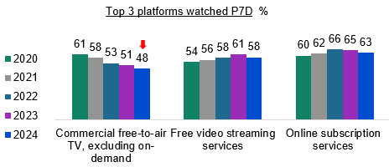

Bar chart showing the percentage of people who watched the top 3 types of video platforms in the past 7 days from 2020 to 2024.

For Commercial free-to-air TV, excluding on-demand: 61% in 2020, 58% in 2021, 53% in 2022, 51% in 2023, and 48% in 2024.

For Free video streaming services: 54% in 2020, 56% in 2021, 58% in 2022, 61% in 2023, and 58% in 2024.

For Online subscription services: 60% in 2020, 62% in 2021, 66% in 2022, 65% in 2023, and 63% in 2024.

Some **online subscription streaming services** are experiencing a consistent **decline** this year in adult viewership

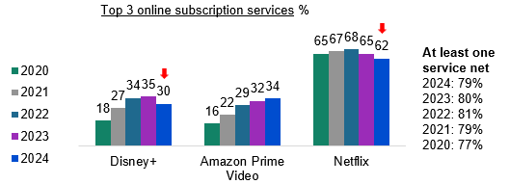

Bar chart showing the top 3 online subscription services households had access to in the past 7 days from 2020 to 2024.

For Disney+: 18% in 2020, 27% in 2021, 34% in 2022, 35% in 2023, and 30% in 2024.

For Amazon Prime Video: 16% in 2020, 22% in 2021, 29% in 2022, 32% in 2023, and 34% in 2024.

For Netflix: 65% in 2020, 67% in 2021, 68% in 2022, 65% in 2023, and 62% in 2024.

At least one service net: 2024: 79%, 2023: 80%, 2022: 81%, 2021: 79%, 2020: 77%.

TVs and mobile phones / smartphones were the most commonly used **devices** for viewing screen content

TV:

* 87% net use
* 50% once per day or more

Mobile or smartphone:

* 74% net use
* 46% once per day or more

Engagement with video games was driven by gaming on mobile phones

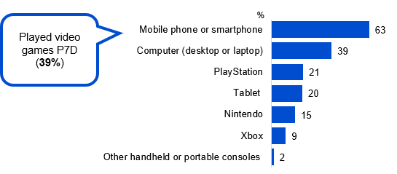

Bar chart showing the percentage of people who used various devices to play video games or computer games in the past 7 days, either at home or elsewhere, in 2024.

Played videogames P7D: 39%

Mobile phone or smartphone: 63%

Computer (desktop or laptop): 39%

PlayStation: 21%

Tablet: 20%

Nintendo: 15%

Xbox: 9%

Other handheld or portable consoles: 2%

### Summary – Children’s General Screen Content Habits

Despite parents ranking user-generated content as low priority for their children, its consumption among young viewers increased in 2024. This trend coincided with concerning exposure to gambling advertisements and age-inappropriate material.

Consumption of (Australian and International) **user-generated content** has increased**,** with especially high watch rates for children aged 11-17

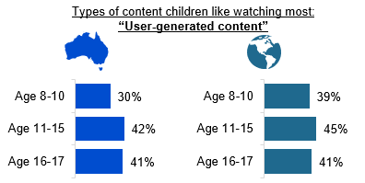

Bar chart showing the types of user-generated content children liked watching most, divided into Australian and International categories.

For Australian user-generated content:

Age 16-17: 41%

Age 11-15: 42%

Age 8-10: 30%

For International user-generated content:

Age 16-17: 41%

Age 11-15: 45%

Age 8-10: 39%

User-generated content was **low on parents’ list of importance to be made available to children,** potentially due to concerns about appropriateness

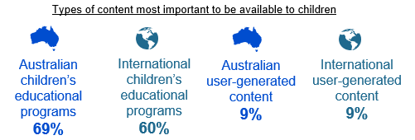

Types of content most important to be available to children:

Australian children's educational programs: 69%

International children's educational programs: 60%

Australian user-generated content 9%

International user-generated content 9%

Children aged 0-17 are being **exposed to gambling advertising.** Children aged 8-17 also report exposure to **age-inappropriate material**

* **32%** of children aged 0-17 saw a gambling ad in the last week
* **6 in 10** or more children aged 8-17 have watched age-inappropriate content

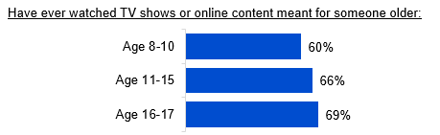

Bar chart showing the percentage of different age groups who have watched TV shows or online content meant for someone older in 2024.

Age 16-17: 69%

Age 11-15: 66%

Age 8-10: 60%

The trend for watching **free video streaming services** and **online subscription services** is well established and continues

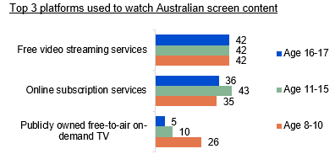

Bar chart showing the top 3 video platforms used to watch Australian screen content in the past 7 days, by children of different age groups.

For Publicly owned free-to-air on-demand TV:

Age 8-10: 26%

Age 11-15: 10%

Age 16-17: 5%

For Online subscription services:

Age 8-10: 35%

Age 11-15: 43%

Age 16-17: 36%

For Free video streaming services:

Age 8-10: 42%

Age 11-15: 42%

Age 16-17: 42%

### **Summary – Children’s device and internet usage**

Access to digital devices was widespread among children, with usage split between personal devices (primarily for education) and shared family devices. Internet usage patterns showed a clear age-related progression, with both personal device ownership and out-of-home access increasing as children got older.

Older children were more likely to **own personal devices**, while younger children tended to use shared household devices for consuming online content

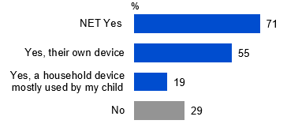

Bar chart showing the percentage of children who have their own device for online content consumption or use a household device that is mostly used by them in 2024.

NET Yes (had own device or a household device mostly used by the child): 71%

Yes, their own device: 55%

Yes, a household device mostly used by my child: 19%

No: 29%

Children most commonly had their own device for **educational purposes**. However, shared household devices allow for **parental control**

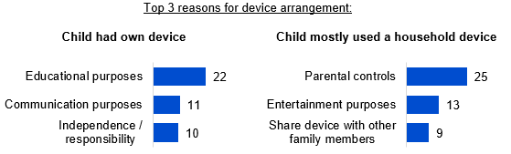

Bar chart showing the top 3 reasons for children's device arrangement.

For children who have their own device:

Educational purposes: 22%

Communication purposes: 11%

Independence / responsibility: 10%

For children who mostly use a household device:

Parental controls: 25%

Entertainment purposes: 13%

Share device with other family members: 9%

Personal **internet use outside of home** on own devices **increased with age**

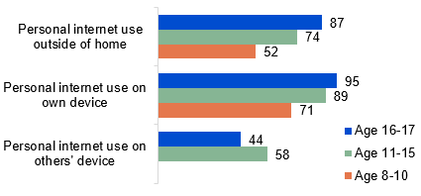

Bar chart showing children's personal internet use outside of home by age groups in 2024.

For personal internet use on others' device:

Age 8-10: 58%

Age 11-15: 44%

For personal internet use on own device:

Age 8-10: 71%

Age 11-15: 89%

Age 16-17: 95%

For personal internet use outside of home:

Age 8-10: 52%

Age 11-15: 74%

Age 16-17: 87%

Children were making **microtransaction purchases in video games**, but most were made with permission

* **20%** of children had made microtransaction purchases in a video game, computer game, or mobile game
* **Four-in-five** of the purchases were made either with permission or didn’t require permission

### Summary – TV: Access and Devices content

**Broadcast signal** and **on-demand apps** remained the most common methods for **accessing free-to-air TV**, though broadcast decreased

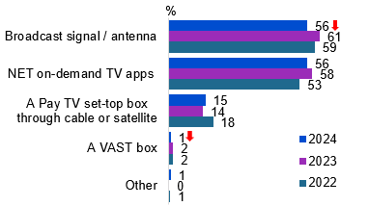

Bar chart showing the methods of accessing free-to-air television for the years 2024, 2023, and 2022.

Broadcast signal / antenna: 56% in 2024, 61% in 2023, 59% in 2022.

NET on-demand TV apps: 56% in 2024, 58% in 2023, 53% in 2022.

A Pay TV set-top box through cable or satellite: 15% in 2024, 14% in 2023, 18% in 2022.

A VAST box: 1% in 2024, 2% in 2023, 2% in 2022.

Other: 1% in 2024, 0% in 2023, 1% in 2022.

Most households have a **television connected to the internet**.

* Respondents most commonly reported having either one (39%) or two (32%) working TVs in their house.
* Most had at least one TV connected to the internet (87%).
* Three-quarters (74%) had at least one TV connected to an external free-to-air television aerial, antenna, or broadcast signal

Connection to free-to-air television via an **external antenna** is common

* 67% had access to an external free-to-air TV aerial, antenna or broadcast signal.
* 77% had a primary working TV with a built-in ability to connect to a free-to-air TV broadcast signal.
* 87% had a primary working TV connected to an external free-to-air TV antenna, most commonly via a co-axial cable or a similar cable (82%).

**VAST Box ownership** in households in general is just under 3%

* 72% rated the VAST Box as working most of the time or all of the time

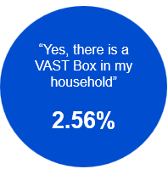

2.56% of respondents said ‘Yes there is a VAST box in my household

### Summary – News

Australian news consumption declined across all platforms in 2024, with television and audio sources experiencing the sharpest drops. Commercial free-to-air TV remained the dominant medium for both state / territory and national news coverage.

**Commercial free-to-air TV** was a common main source of news

* State or Territory news (26%)
* Australian national news (27%)
* Local news (25%)
* International news (20%)

**Australian national news** was the most consumed news content type, (though closely followed by international news consumption)

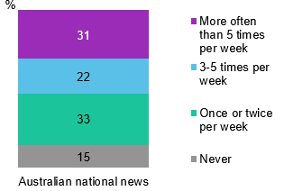

Bar chart showing the frequency of reading, watching, or listening to Australian national news and current affairs per week, including TV, radio, newspapers, and online.

Never: 15%

Once or twice per week: 33%

3-5 times per week: 22%

More often than 5 times per week: 31%

Consuming **news via online sources** plateaued, while news consumption through TV and audio declined

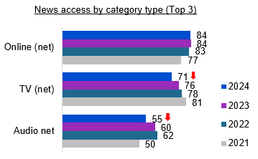

Bar chart showing news access by category type (Top 3) for the years 2024, 2023, 2022, and 2021.

Online (net): 84% in 2024, 84% in 2023, 83% in 2022, 77% in 2021.

TV (net): 71% in 2024, 76% in 2023, 78% in 2022, 81% in 2021.

Audio (net): 55% in 2024, 60% in 2023, 62% in 2022, 50% in 2021.

**34%** consumed news **incidentally** (net at least half of the time)

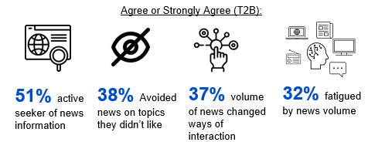

Agree or strongly agree (T2B):

active seeker of news information: 51%

avoided news on topics they didn't like: 38%

volume of news changed ways of interaction: 37%

fatigued by news volume: 32%

### Summary – Emergency information

During emergencies, respondents primarily relied on and preferred online sources over traditional media, with radio ranking as the second most important channel. When seeking emergency information, three key factors drove source selection: credibility, accessibility, and timeliness.

One-in-ten (11%) respondents reported having experienced an **emergency situation** in the past 12 months

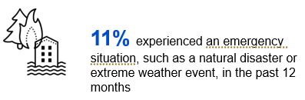

**Online** was the **most often used source** for emergency information, while radio was typically used by those not living in capital cities

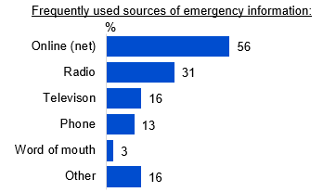

Bar chart showing the frequently used sources of emergency information in 2024.

Online (net): 56%

Radio: 31%

Television: 16%

Phone: 13%

Word of mouth: 3%

Other: 16%

**Online** was the **preferred source** of emergency information, followed by **radio**

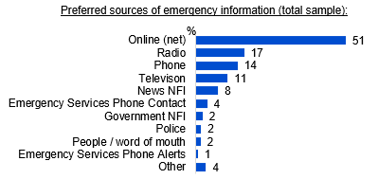

Bar chart showing the preferred sources of emergency information in 2024 by total sample.

Online (net): 51%

Radio: 17%

Phone: 14%

Television: 11%

News NFI: 8%

Emergency Services Phone Contact: 4%

Government NFI: 2%

Police: 2%

People / word of mouth: 2%

Emergency Services Phone Alerts: 1%

Other: 4%

**Official sources, accessibility of news content during an emergency, and timeliness of** information were key factors in seeking information during an emergency

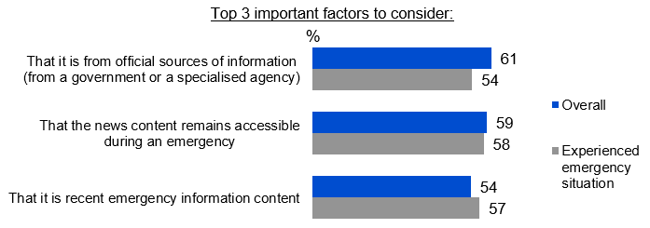

Bar chart showing the top 3 important factors to consider when seeking information during an emergency, comparing overall responses to those who have experienced an emergency situation.

That it is from official sources of information (from a government or a specialised agency): 61% overall, 54% experienced emergency situation.

That the news content remains accessible during an emergency: 59% overall, 58% experienced emergency situation.

That it is recent emergency information content: 54% overall, 57% experienced emergency situation.

### Summary – Sports Content

Sports continued to be a popular screen content choice for Australians, with importance placed on free access

Types of **sport** **watched include** Olympic Games events, Commonwealth Games events, Australian rules football, Australian Open tennis tournament, and International test cricket

* 39% consumed sports content of some sort in the past 7 days

Top 5 sports respondents typically watch:

* Olympic Games events (80%)
* Commonwealth Games events (66%)
* Australian rules football (62%)
* Australian Open tennis tournament (60%)
* International test cricket matches (57%)

**Free-to-air TV** is the most common platform for watching sports content

* 62% watched sports content on free-to-air TV (commercial or public) in past 7 days, while 56% watched sports content online

Motivators for watching sports content include **free access, high quality, and availability of Australian content**

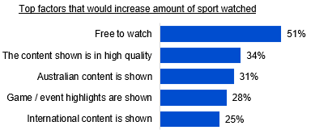

Bar chart showing the top factors that would increase amount of sport content watched in 2024.

Free to watch: 51%

The content shown is in high quality: 34%

Australian content is shown: 31%

Game / event highlights are shown: 28%

International content is shown: 25%

**Gambling ads are a de-motivator** for watching sports content

* 44% said gambling advertising being shown would reduce the amount of sports content they watched

### Summary – Advertising and Content Attitudes

Advertisements are increasingly seen across online subscription platforms in 2024. There was strong support for restrictions on permitted advertising, mainly to protect children from age-inappropriate content and limit material related gambling, tobacco and alcohol.

Advertisements were increasingly seen on **online subscription services**

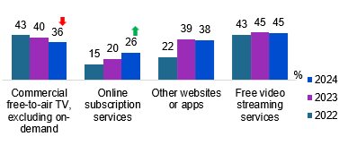

Bar chart showing the platforms where advertisements were seen in the past 7 days for the years 2024, 2023, and 2022.

Free video streaming services: 45% in 2024, 45% in 2023, 43% in 2022.

Other websites or apps: 38% in 2024, 39% in 2023, 22% in 2022.

Online subscription services: 26% in 2024, 20% in 2023, 15% in 2022.

Commercial free-to-air TV, excluding on-demand: 36% in 2024, 40% in 2023, 43% in 2022.

The overall net level of those who **want restrictions on advertisements remained stable**

* **80%** want restrictions applied on permitted advertising (net across platforms) (2023: 80% net; 2022: 80% net)

**Protecting children from harmful or age-inappropriate content** was the top reason for restrictions on permitted advertising

* Protecting children from exposure to harmful or inappropriate content (38%)
* Limiting content that may encourage bad habits, such as gambling, tobacco, or alcohol use (37%)
* Limiting the influence of advertising on consumer behaviour (18%)

**Almost 1 in 2 were aware of Ad Standards** as an avenue for lodging complaints. Inappropriate advertising was commonly seen on **social media**

* **46%** were aware of Ad Standards being an avenue for lodging advertising complaints
* **39%** were concerned about inappropriate content
* **24%** made a complaint about inappropriate advertising content

## First Nations

### First Nations summary – Caveat

For the 2024 Television and Media survey, the department and the Social Research Centre (SRC) collaborated on ways to strengthen the First Nations Australian sample in the survey series. First Nations respondents had been captured in previous Television and Media survey research since 2020.

For the 2024 sample, the department and the SRC designed a sample boost for First Nations respondents, which was run through the ORU non-probability online panel. This was intended to ensure that First Nations responses were better reflected in the survey finding. The presence of a sample boost has also given enhanced confidence in the First Nations specific findings in this report, and as such, a summary of First Nations respondent results has been included as a chapter in the report.

The department and the SRC acknowledge the importance of research with First Nations communities, particularly research designed and ran in collaboration with communities, and the value of the NHMRC's 2018 Ethical Conduct in research with Aboriginal and Torres Strait Islander Peoples and communities: Guidelines for researchers and stakeholders. The First Nations sample boost was part of the sample structure included in materials reviewed by the Human Research Ethics Committee that approved this study.

As an online-only survey, it is also worth acknowledging there are potential limitations around the First Nations sample, which may have over or under-indexed with particular First Nations respondents. Base sizes lower than n=70 have not been reported on or shown below. Splits for metropolitan and regional location of respondents are also not shown due to these low base sizes.

### First Nations summary

#### General screen content

First Nations respondents were more likely than non-First Nations respondents to watch online content (96.5% versus 91.1%) and commercial BVODs (42% versus 30%) (base n=174) in P7D but less likely to have an internet-connected TV (not statistically significant at 81% versus 87%) (base n=158).

#### Children’s content age 0-17

Several differences emerged in children’s screen content. First Nations parents were more likely to report that their children watched Australian children’s animation or cartoons the most (68% vs 49% of non-First Nations parents) (base n=81).

There was also lower consumption of free video streaming services, First Nations parents were less likely to report that their children watched free video streaming services (36% vs 63% of non-First Nations parents) (base n=91).

In terms of the importance of content being made available, First Nations parents were less likely than non-First Nations parents to think Australian (49% vs 70%) or international (38% vs 61%) children’s educational programs and Australian (15% vs 25%) or international (7% vs 21%) sports were important to be made available to children (base n=91).

#### Televisions

First Nations respondents were more likely than non-First Nations respondents to have purchased a new TV in the past 12 months (27% compared to 15%) (base n=161)

First Nations respondents were less likely to have a primary TV with built in ability to connect to free-to-air television arial, antenna, or broadcast signal (63% vs 77% of non-First Nations respondents) (base n=119)

First Nations respondents were more likely than non-First Nations respondents to have a VAST Box in the household (10% compared to 2%)(base n=174)

#### News, current affairs and emergency information

First Nations respondents in the sample were significantly more likely than non-First Nations respondents to have experienced an emergency situation, such as a natural disaster or extreme weather event, in the past 12 months (27% compared to 10%) (base n=161).

Fewer First Nations respondents than non-First Nations respondents rated emergency information from official sources as important. 61% of non-First Nations respondents selected this response, compared to 49% of First Nations respondents (Base n=161). Rather, news content remaining accessible during an emergency was most important factor for First Nations respondents when choosing content at 51%.

First Nations respondents consumed lower levels of international news and current affairs (net consumption:68% compared to 82% of non-First Nations respondents) (base n=166).

#### Sports consumption

Sports consumption differed for First Nation’s respondents, especially in regard to women’s sport, with higher levels of consumption of women’s sport in the past 7 days (First Nations respondents: 13% vs 4% of Non-First Nations respondents) (base n=76).

#### Advertising content

First Nations respondents were more likely than non-First Nations respondents to have taken action to complain about content they'd seen in the past 12 months that they'd found inappropriate (32% compared to 23%) (base n=166).

## General Screen content habits

### Chapter Summary – General Screen Content Habits

Use of online services continues to dominate in 2024 but shows a slight trending decline. Commercial free-to-air TV, excluding on-demand and sports specific website or app, consistently decreased in 2024.

* The most common platform used to watch screen content was online subscription services (63%), followed by free video streaming services (58%), and commercial free-to-air TV, excluding on-demand TV (48%).

Netflix and other online subscription streaming services experienced a decline in 2024.

* Netflix (62%) remained the most common online subscription streaming service that households have access to in 2024, followed by Amazon Prime Video (34%), Disney+ (30%), and Stan (20%).
* Several online subscription streaming services consistently decreased in 2024 (Netflix, Disney+, Stan, Binge, and Kayo Sports), while Paramount+ and YouTube Premium consistently increased this year.

TVs and mobile phones / smartphones were the most commonly used devices for viewing screen content

* TV had the highest device usage for watching screen content (87% net use), and frequency (50% net use once per day or more), followed by mobile phones (74% net use, 46% net use once per day or more).

Video game participation was driven by younger Australians and men, both more likely to report playing video games in the past 7 days in 2024.

* Two-in-five (39%) respondents had played video games, computer games or mobile games in the past 7 days at home or elsewhere.
* Mobile phones (63%) were the most commonly used device for gaming, followed by computers (39%). Computers and other handheld or portable consoles recorded the highest average weekly playing hours of all devices.

### Platforms used to watch screen content in past 7 days

Despite leveling back to 2021 figures, online subscription services maintained their lead as the platform used to watch screen content at 63%, followed by free video streaming services (58%) and traditional commercial free-to-air TV (48%).

#### 

Source: C1. Which of the following did you watch in the past 7 days at home or elsewhere on any device?

Base: TVCS & MCCS, All respondents. 2024: n=4,490. 2023: n=4,892. 2022: n=5,017. 2021: n=4,135. 2020: n=4,096

Notes: Don’t know/refused responses not shown: 2024 DK =0.1%, Ref = 0.0%. 2023 DK = 0%, Ref = 0%. 2022 DK = 0.0%, Ref = 0.0%. 2021 DK = 0.0%, Ref = 0.0%. 2020 DK = 0.0%, Ref = 0.0%. Responses for codes not shown on chart if <5% in 2024.

Bar chart showing platforms used to watch screen content in past 7 days from 2020 to 2024. Each platform is represented with horizontal bars for each year. Key insights:

Online subscription services: 63% in 2024, 65% in 2023, 66% in 2022, 62% in 2021, and 60% in 2020.

Free video streaming services: 58% in 2024, 61% in 2023, 58% in 2022, 56% in 2021, and 54% in 2020.

Commercial free-to-air TV, excluding on-demand: 48% in 2024, 51% in 2023, 53% in 2022, 58% in 2021, and 61% in 2020.

Other websites or apps: 48% in 2024, 49% in 2023, 49% in 2022, 39% in 2021, and 38% in 2020.

Publicly owned free-to-air TV, excluding on-demand: 37% in 2024, 40% in 2023, 41% in 2022, 50% in 2021, and 53% in 2020.

Publicly owned free-to-air on-demand TV: 33% in 2024, 34% in 2023, 34% in 2022, 0% in 2021, and 0% in 2020.

Commercial free-to-air on-demand TV: 31% in 2024, 31% in 2023, 29% in 2022, 0% in 2021, and 0% in 2020.

Pay TV: 16% in 2024, 16% in 2023, 21% in 2022, 22% in 2021, and 24% in 2020.

Sports specific website or app: 14% in 2024, 17% in 2023, 17% in 2022, 16% in 2021, and 15% in 2020.

NET: Online: 87% in 2024, 88% in 2023, 87% in 2022, 83% in 2021, and 81% in 2020.

NET: Free-to-air: 70% in 2024, 73% in 2023, 75% in 2022, 77% in 2021, and 80% in 2020.

#### Subgroups

Online subscription services was higher for:

* Women (65% vs 60% of men)
* Ages 18-24 (73%), 25-34 (76%), 35-44 (66%), and 45-54 (69% vs 59% of ages 55-64, 47% of ages 65-74, and 33% of ages 75+)
* Those with dependent children in the household (74%), those with non-dependent children only (68% vs 56% of those with no children)
* Adults living in a share house (69% vs 56% of those with no children)
* Those born in a mainly English speaking country (65% vs 55% of those born in a mainly non-English speaking country)

Platforms commonly used by those living in a capital city are:

* Free video streaming services (64% vs 50%)
* Other websites or apps (50% vs 45%)
* Platforms commonly used by those living outside a capital city are:
* FTA BVOD (51% vs 45%)
* FTA Broadcast (66% vs 51%)

Screen consumption by devices:

* NET SVODs were more likely to be consumed using TV smart accessory (81%), game console connected to a TV (78%), and mobile phone (73%)
* Free video streaming services were more likely to be consumed using computer (72%), mobile phone (69%), tablet (67%)
* NET FTA TV were more likely to be consumed using Pay TV box (79%), TV (76%), TV smart accessory (73%)
* NET Pay-TV were more likely to be consumed using Pay TV box (65%)

#### Note for ‘net’ inclusions

‘NET: Online’ includes:

* ‘Online subscription services’, ‘Free video streaming services’, ‘Other websites or apps’, and ‘Sports specific website or app’.

‘NET: Free-to-air’ includes:

* ‘Commercial free-to-air TV’, ‘Publicly owned free-to-air TV’, ‘Commercial free-to-air on-demand TV’, Publicly owned free-to-air on-demand TV’, and ‘Free-to-air catch-up TV’ and equivalent from prior years.

‘FTA BVOD’ includes:

* ‘Commercial free-to-air on-demand TV (e.g. 9Now, 10 Play, 7plus)’ and ‘Publicly owned free-to-air on-demand TV (e.g. ABC iview, SBS On Demand, ABC News, ABC Kids)’

‘FTA Broadcast’ includes:

* ‘Commercial free-to-air TV (e.g. Seven, Nine, 10, WIN, Imparja, NBN Television), including recorded content but excluding on-demand TV’ and ‘Publicly owned free-to-air TV (i.e. ABC, SBS), including recorded content but excluding on-demand TV’

#### **Further reading**

The survey did not explicitly ask participants about the use of Free ad-supported Streaming Television (FAST). RMIT suggest growing availability1, though ACMA suggests limited uptake more broadly.2

Online subscription services remained the leading platform for watching screen content in Australia in 2024, though the decline seen in 2023 continued. Commercial free-to-air TV excluding on-demand and sports specific website or app significantly decreased compared to 2023.

### Number of online subscription streaming services households pay for

Among households with streaming access, subscription patterns were relatively evenly distributed, with 24% each maintaining one or two services, while 18% paid for three subscriptions and 23% had 4 or more. Consumption of online subscription services and sports-specific websites or apps increases with the number of video streaming subscriptions a household pays for.

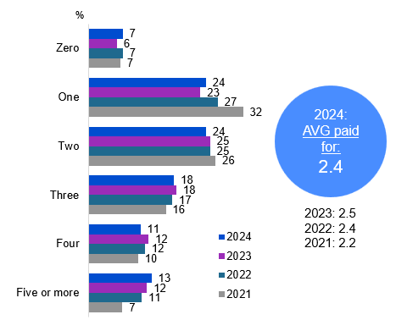

Source: C10. How many video streaming subscriptions does your household currently pay for? This excludes on-demand TV and pay-per-view.

Base: MCCS, Respondents who have access to one or more online subscription streaming services. 2024: n=3,192. 2023: n=3,194. 2022: n=3,122. 2021: n=3,296.

Notes: Don’t know/refused responses not shown: 2024 DK = 2%. Ref = 1%. 2023 DK = 2%, Ref = 1%. 2022 DK = 1%, Ref = 0.1%. 2021 DK = 2%, Ref = 0.3%. (Individual results for five and over not shown on chart).

A bar chart showing the number of video streaming subscriptions households currently pay for from 2021 to 2024, among respondents who have access to one or more online subscription streaming services.

Zero: 7% in 2024, 6% in 2023, 7% in 2022, and 7% in 2021.

One: 24% in 2024, 23% in 2023, 27% in 2022, and 32% in 2021.

Two: 24% in 2024, 25% in 2023, 25% in 2022, and 26% in 2021.

Three: 18% in 2024, 18% in 2023, 17% in 2022, and 16% in 2021.

Four: 11% in 2024, 12% in 2023, 12% in 2022, and 10% in 2021.

Five or more: 13% in 2024, 12% in 2023, 11% in 2022, and 7% in 2021.

Average number of online subscription streaming services households paid for: 2024: 2.4, 2021: 2.2, 2022: 2.4, 2023: 2.5

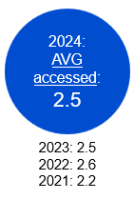

Source: C8. Which of the following online subscription streaming services or sports-specific services does your household currently have access to?

Base: 2024: n=4,490. 2023: n=4,892, MCCS respondents 2022: n=4,002.

Average number of online subscription streaming services or sports-specific services households accessed: 2024: 2.5, 2021: 2.2, 2022: 2.6, 2023: 2.5

#### Subgroups

Zero subscriptions was higher for:

* Those receiving Government pensions, benefits or allowances (10% vs 6% of non-recipients)
* Those looking for work (18%) and retired (13%) vs 6% of those employed full time or part time, 1% students, and 4% of non-workers

Household paying for 3 or more subscriptions were more likely to be:

* Ages 18-64 (91% vs 84% of households paying for 1 to 2 subscriptions, 79% of households did not pay for any subscription)
* Those with dependent children in the household (37% vs 25% of households did not pay for any subscription)
* Aboriginal and / or Torres Strait Islander respondents (9% vs 4% of households paying for 1 to 2 subscriptions)
* Those who watched SVOD in P7D (94% vs 78% of household paying for 1 to 2 subscriptions, 56% of households did not pay for any subscriptions)
* Thos who watched Pay TV in P7D (22% vs 16% of households paying for 1 to 2 subscriptions)
* Those who watched other websites or apps (e.g., Facebook, Tik Tok, Instagram) in P7D (60% vs 51% of households paying for 1 to 2 subscriptions)
* Those with fixed home internet ownership (96% vs 91% of households paying for 1 to 2 subscriptions)

#### Callout

* Those who think online subscription services have enough Australian content, pay for 2.5 services on average.

#### Notes

* Note wording for 2020 for C10 (2020 not shown on chart): How many video streaming subscription services does your household currently have access to? This excludes catch-up TV and pay-per-view.
* C8 AVG: Avg of all codes, excluding non, DK, REF.
* C10 AVG: Avg with no value assigned to REF/DK.
* 2024: For those who don’t have access to any online subscription services (C8), 38% thought online subscription services have enough Australian content, 50% said no, 12% said DK. For those who did not pay for any online subscription services (C10), 48% said yes, 46% said no, 6% said DK.

In 2024, the average number of online subscription steaming services *paid for* by households in 2024 reduced back to levels seen in 2022 (though the average number accessed remained stable).

### Online subscription streaming services households have access to

Netflix (62%) remained the most common online subscription streaming service that households had access to in 2024, followed by Amazon Prime Video (34%), Disney+ (30%), (with the decline in Disney+ being driven by households *without* children), and Stan (20%).

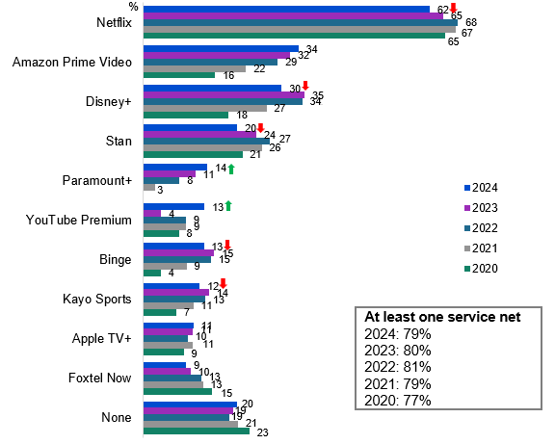

Source: C8. Which of the following online subscription streaming services or sports-specific services does your household currently have access to? This excludes on-demand TV and pay-per-view.

Base: TVCS & MCCS, All respondents. 2024: n=4,490. 2023: n=4,892. 2022: n=5017. 2021 MCCS: n=4135. 2020 MCCS: n=4096.

Notes: Don’t know/refused responses not shown: 2024 DK = 0.3%, Ref = 0.1%. 2023 DK = 0.2%, Ref = 0.0%. 2022 DK = 0.0%, REF = 0.0%. Responses not shown on chart if <5% in 2024. 2022-2024 NETs shows TVCS & MCCS result, 2021 and 2020 NETs show MCCS result. ‘Kayo’ was changed to ‘Kayo Sports’ in the 2023 survey.

A bar chart showing the online subscription streaming services households had access to from 2020 to 2024.

Households with access to at least one service (net) was 79% in 2024, 80% in 2023, 81% in 2022, 79% in 2021, and 77% in 2020.

Netflix: 62% in 2024, 65% in 2023, 68% in 2022, 67% in 2021, and 65% in 2020.

Amazon Prime Video: 34% in 2024, 32% in 2023, 29% in 2022, 22% in 2021, and 16% in 2020.

Disney+: 30% in 2024, 35% in 2023, 34% in 2022, 27% in 2021, and 18% in 2020.

Stan: 20% in 2024, 24% in 2023, 27% in 2022, 26% in 2021, and 21% in 2020.

Paramount+: 14% in 2024, 11% in 2023, 8% in 2022, 3% in 2021, and not available in 2020.

YouTube Premium: 13% in 2024, 4% in 2023, 9% in 2022, 9% in 2021, and 8% in 2020.

Binge: 13% in 2024, 15% in 2023, 15% in 2022, 9% in 2021, and 4% in 2020.

Kayo Sports: 12% in 2024, 14% in 2023, 13% in 2022, 11% in 2021, and 7% in 2020.

Apple TV+: 11% in 2024, 11% in 2023, 10% in 2022, 11% in 2021, and 9% in 2020.

Foxtel Now: 9% in 2024, 10% in 2023, 13% in 2022, 13% in 2021, and 15% in 2020.

None: 20% in 2024, 19% in 2023, 19% in 2022, 21% in 2021, and 23% in 2020.

#### Subgroups

YouTube Premium was higher for:

* Men (16% vs 10% women)
* 18-24 (22%), 25-34 (22%), 35-44 (17% vs 8% of ages 45-54, 9% of ages 55-64, 7% of ages 65-74 and 2% of ages 75+)
* Those living in a capital city (15% vs 10% of those living outside a capital city)
* Those with a Bachelor degree (17%) and those with a Postgraduate Degree, Graduate Diploma, Graduate Certificate (18% vs 11% of those with education up to Year 12, 11% of those with TAFE, Trade Certificate, Diploma)

Netflix was higher for:

* 18-24 (76%), 25-34 (74%), 35-44 (64%), and 45-54 (66% vs 53% of ages 55-64, 47% of ages 65-74 and 41% of ages 75+)
* Those living in a capital city (64% vs 58% of those living outside a capital city)
* Those with dependent children in the household (75%), those with non-dependent children only (74%), and adults living in a share house (70%) vs 53% of those with no children)
* Those employed full time or part time (70%), employed casually (65%), students (67% vs 46% of those who are retired)
* Those born in a mainly-English speaking country (35% vs 29% of those born in a mainly non-English speaking country)

Disney+ decreased in 2024 compared to 2023 for:

* Ages 25-34 (42% vs 53%), 35-44 (36% vs 45%), 65-74 (11% vs 18%), 75+ (5% vs 11%)\
* Those without dependent children in household (20% vs 26%)

#### Callout

* Access to Paramount+ (14% vs 11% in 2023) and YouTube Premium (13% vs 4% in 2023) have increased in 2024, while Netflix (62% vs 65% in 2023), Disney+ (30% vs 35% in 2023), Stan (20% vs 24% in 2023), Binge (13% vs 15% in 2023), and Kayo Sports (12% vs 14% in 2023) have all decreased.
* The highest overlap occurs in these providers: Netflix, Amazon, Disney+, Stan, Binge, Paramount.

Netflix declined in 2024, but continues to be the dominant online subscription streaming service in Australian households. Other online subscription streaming services also declined: Disney+, Stan, Binge, and Kayo Sports. Paramount+ and YouTube Premium significantly increased this year.

### Ease of accessing Australian content on streaming services

Just over half of all respondents (54%) believed that online subscription streaming services had enough Australian content. Three-in-ten (29%) thought that Australian content was easy to find on streaming services (net very easy and easy), while 16% thought it was difficult (net very difficult and difficult), and 18% didn’t look for Australian content at all.

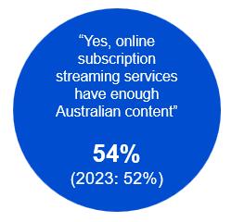

Source: C11. In your opinion, do online subscription streaming services (excluding on-demand TV services) have enough Australian content?

Base: MCCS, All respondents. 2024: n=3,773. 2023: n=3,730.

Notes: No/Don’t know/refused responses not shown: 2024 No = 42%, DK = 4%, Ref = 0.0%. 2023 No = 44%, DK = 4%, Ref = 0.2%

A blue circular graphic showing that 54% of respondents believe online subscription streaming services have sufficient Australian content, with a comparison to the previous year's percentage, which was 52% in 2023.

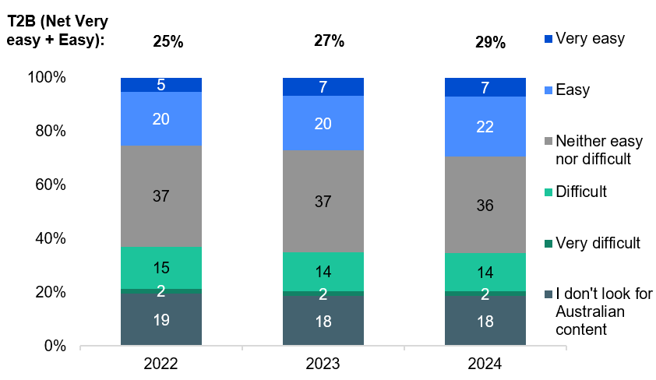

Source: C18. To what extent is Australian content easy or difficult to find on streaming services?

Base: MCCS, All respondents. 2024: n=3,773. 2023: n=3,730. 2022: n=4,002.

Notes: Don’t know/refused responses not shown: 2023 DK = 2%, Ref = 0.0%. 2022 DK = 2%, Ref = 0.2%

A stacked bar chart showing the ease or difficulty of finding Australian content on streaming services from 2022 to 2024.

2024:

I don't look for Australian content: 18%

Very difficult: 2%

Difficult: 14%

Neither easy nor difficult: 36%

Easy: 22%

Very easy: 7%

NET T2B (Top Two Box: Easy + Very Easy): 29%

2023:

I don't look for Australian content: 18%

Very difficult: 2%

Difficult: 14%

Neither easy nor difficult: 37%

Easy: 20%

Very easy: 7%

NET T2B (Top Two Box: Easy + Very Easy): 27%

2022:

I don't look for Australian content: 19%

Very difficult: 2%

Difficult: 15%

Neither easy nor difficult: 37%

Easy: 20%

Very easy: 5%

NET T2B (Top Two Box: Easy + Very Easy): 25%

#### Subgroups

NET Very easy + Easy was higher for:

* Those had access to any online subscription streaming services (32% vs 14% of those who did not have access)
* Those agreed that online subscription streaming services have enough Australian content (44% vs 11% of those who did not agree)
* Ages 18-24 (30%), 25-34 (33%), 35-44 (33%), 45-54 (30%), and 55-64 (31% vs 18% of ages 65-74 and 17% of ages 75+)
* Those with dependent children (35% vs 26% of those with no children)
* Those born in a mainly-English speaking country (30% vs 24% of those born in a mainly non-English speaking country)

Yes was higher for:

* Those had access to any online subscription streaming services (57% vs 38% of those who did not have access)
* Those paid for any online video subscription streaming services (59% vs 48% of those who did not pay for any)

#### Further reading

In discovering new streaming content, QUT shows the importance of browsing (especially for younger audiences), recommendations from family and friends, and relevant advertising.3

Approximately half of Australians agreed that online subscription streaming services had enough Australian content in 2024, however a lower proportion indicated that this content was easy to find, consistent with 2023.

### Hours per week spent watching content on various platforms

The average number of hours spent watching content per week was 8.3 hours for online subscription services, 6.5 hours for free video streaming services, and 8.6 hours for commercial free-to-air TV excluding on-demand.

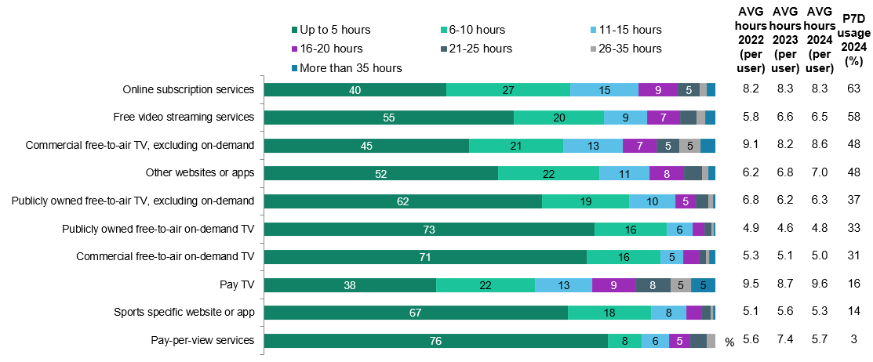

Source: C1. Which of the following did you watch in the past 7 days at home or elsewhere on any device?

Base: TVCS & MCCS, All respondents. 2024: n=4,490. 2023: n=4,892. 2022: n=5,017.

Source: C2. On average, how many hours per week do you spend watching each of the following?

Base: TVCS & MCCS, Respondents who watched screen content in past 7 days. 2024: n= from 129 to 2,909.

Notes: Don’t know/refused responses not shown, % very per statement. Labels for responses less than 5% not shown on chart

A bar chart showing the average hours per week spent watching various types of screen content among those who watched in the past 7 days.

Online subscription services:

Up to 5 hours: 40% in 2024

6-10 hours: 27% in 2024

11-15 hours: 15% in 2024

16-20 hours: 9% in 2024

21-25 hours: 5% in 2024

26-35 hours: 2% in 2024

More than 35 hours: 2% in 2024

Average hours per user: 8.2 in 2022, 8.3 in 2023, 8.3 in 2024

Past 7 days usage: 63% in 2024

Free video streaming services:

Up to 5 hours: 55% in 2024

6-10 hours: 20% in 2024

11-15 hours: 9% in 2024

16-20 hours: 7% in 2024

21-25 hours: 4% in 2024

26-35 hours: 2% in 2024

More than 35 hours: 2% in 2024

Average hours per user: 5.8 in 2022, 6.6 in 2023, 6.5 in 2024

Past 7 days usage: 58% in 2024

Commercial free-to-air TV, excluding on-demand:

Up to 5 hours: 45% in 2024

6-10 hours: 21% in 2024

11-15 hours: 13% in 2024

16-20 hours: 7% in 2024

21-25 hours: 5% in 2024

26-35 hours: 5% in 2024

More than 35 hours: 3% in 2024

Average hours per user: 9.1 in 2022, 8.2 in 2023, 8.6 in 2024

Past 7 days usage: 48% in 2024

Other websites or apps:

Up to 5 hours: 52% in 2024

6-10 hours: 22% in 2024

11-15 hours: 11% in 2024

16-20 hours: 8% in 2024

21-25 hours: 4% in 2024

26-35 hours: 2% in 2024

More than 35 hours: 2% in 2024

Average hours per user: 6.2 in 2022, 6.8 in 2023, 7 in 2024

Past 7 days usage: 48% in 2024

Publicly owned free-to-air TV, excluding on-demand:

Up to 5 hours: 62% in 2024

6-10 hours: 19% in 2024

11-15 hours: 10% in 2024

16-20 hours: 5% in 2024

21-25 hours: 3% in 2024

26-35 hours: 1% in 2024

More than 35 hours: 1% in 2024

Average hours per user: 6.8 in 2022, 6.2 in 2023, 6.3 in 2024

Past 7 days usage: 37% in 2024

Publicly owned free-to-air on-demand TV:

Up to 5 hours: 73% in 2024

6-10 hours: 16% in 2024

11-15 hours: 6% in 2024

16-20 hours: 3% in 2024

21-25 hours: 1% in 2024

26-35 hours: 1% in 2024

More than 35 hours: 0% in 2024

Average hours per user: 4.9 in 2022, 4.6 in 2023, 4.8 in 2024

Past 7 days usage: 33% in 2024

Commercial free-to-air on-demand TV:

Up to 5 hours: 71% in 2024

6-10 hours: 16% in 2024

11-15 hours: 5% in 2024

16-20 hours: 3% in 2024

21-25 hours: 1% in 2024

26-35 hours: 1% in 2024

More than 35 hours: 1% in 2024

Average hours per user: 5.3 in 2022, 5.1 in 2023, 5 in 2024

Past 7 days usage: 31% in 2024

Pay TV:

Up to 5 hours: 38% in 2024

6-10 hours: 22% in 2024

11-15 hours: 13% in 2024

16-20 hours: 9% in 2024

21-25 hours: 8% in 2024

26-35 hours: 5% in 2024

More than 35 hours: 5% in 2024

Average hours per user: 9.5 in 2022, 8.7 in 2023, 9.6 in 2024

Past 7 days usage: 16% in 2024

Sports specific website or app:

Up to 5 hours: 67% in 2024

6-10 hours: 18% in 2024

11-15 hours: 8% in 2024

16-20 hours: 3% in 2024

21-25 hours: 2% in 2024

26-35 hours: 1% in 2024

More than 35 hours: 0% in 2024

Average hours per user: 5.1 in 2022, 5.6 in 2023, 5.3 in 2024

Past 7 days usage: 14% in 2024

Pay-per-view services:

Up to 5 hours: 76% in 2024

6-10 hours: 8% in 2024

11-15 hours: 6% in 2024

16-20 hours: 5% in 2024

21-25 hours: 4% in 2024

26-35 hours: 2% in 2024

More than 35 hours: 0% in 2024

Average hours per user: 5.6 in 2022, 7.4 in 2023, 5.7 in 2024

Past 7 days usage: 3% in 2024

#### Callout

* Those with more than 35 hours watchingacross ANY platform were more likely to be male (61%), with an education up to Year 12 (38%), retired (28%) or non-worker (13%), received Government pensions, benefits or allowances (51%).

Pay TV and commercial free-to-air TV recorded the highest average weekly viewing hours of all platform types in 2024.

### Frequency of watching screen content on various devices

Television remains the dominant screen content device with 87% of respondents reporting its use, followed by mobile phones (74%) and computers (61%). While TV leads in overall adoption, mobile phones show the highest intensity of use with 22% of users watching content more than five times daily, compared to just 9% for TV and 8% for computers.

Table Frequency of watching screen content on various devices (%)

|  |  |  |  |  |  |  |  |  |  |  |  |
| --- | --- | --- | --- | --- | --- | --- | --- | --- | --- | --- | --- |
| Device | Net  Use Device | More often than 5 times a day | 3-5 times a day | Once or twice a day | More often than 5 times a week | 3-5 times a week | Once or twice a week | Never | 2022: NET use once per day + | 2023: NET use once per day + | 2024: NET use once per day + |
| **Television** | 87 | 9 | 11 | 29 | 14 | 11 | 12 | 13 | 47 | 48 | 50 |
| **Mobile phone or smartphone** | 74 | 22 | 13 | 10 | 6 | 9 | 13 | 26 | 44 | 46 | 46 |
| **Computer (desktop or laptop)** | 61 | 8 | 8 | 9 | 5 | 9 | 21 | 39 | 25 | 27 | 25 |
| **TV smart accessory / Digital media player** | 40 | 4 | 4 | 9 | 5 | 7 | 11 | 60 | 16 | 17 | 16 |
| **Tablet** | 36 | 3 | 4 | 8 | 3 | 6 | 13 | 64 | 13 | 13 | 14 |
| **Pay TV box** | 21 | 3 | 3 | 5 | 3 | 4 | 4 | 78 | 10 | 10 | 10 |
| **Games console connected to a television** | 17 | 1 | 1 | 2 | 2 | 3 | 8 | 83 | 4 | 5 | 4 |
| **VAST Box** | 5 | 0 | 1 | 1 | 1 | 1 | 1 | 94 | 2 | 3 | 2 |

Source: C4. On average per week, how often do you use the following devices to watch screen content?

Base: TVCS & MCCS, Respondents who watched screen content in past 7 days. 2024: n=4,412. 2023: n=4,825. 2022: n=4,929.

Notes: Don’t know/refused responses not shown, % vary per statement. ‘NET use once per day +’ includes ‘Once or twice a day’, ‘3-5 times a day’, and ‘More often than 5 times a day’.

#### Subgroup

Mobile phone or smart phone (net use) was higher for:

* Men (76% vs 72% of women)
* Ages 18-24 (98% vs 92% of ages 25-34, 87% of ages 35-44, 72% of ages 45-54, 60% of ages 55-64, 50% of ages 65-74, 42% of ages 75+)
* Those living in a capital city (80% vs 66% of those living outside a capital city)
* Those with a Bachelor Degree (84%), a Postgraduate Degree (84% vs 64% of those with an education up to Year 12, 71% of those with a TAFE, Trade Certificate, Diploma)
* Those born in a mainly non-English speaking country (89% vs 71% of those born in a mainly English speaking country)
* Those watching other websites or apps (89%), free video streaming services (86%), SVOD in P7D (80% vs 64% of those watching FTA Broadcast, 71% of those watching FTA BVOD, 69% of those watching Pay TV in P7D)

TV had the highest device usage and frequency for watching screen content, followed by mobile phones. Mobile, however, is the device of choice for multiple daily uses.

### Video gaming participation in the past 7 days

Video gaming participation spans 39% of respondents in the past 7 days, with a notable gender gap showing higher participation among men (41%) than women (36%). Age emerges as a factor also, with participation declining steadily from 65% among 18-24 year-olds to just 20% for those 75+. Mobile phones lead as the preferred gaming platform. Gaming device usage also varies by gender, with men more likely to use a computer (50% vs 25%), PlayStation (27% vs 13%), and Xbox (12% vs 6%), while women are more likely to use a mobile phone (69% vs 57%).

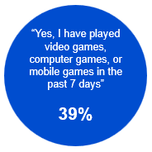

Source: VIDEO1. Have you played any video games, computer games, or mobile games in the past 7 days, at home or elsewhere?

Base: TVCS & MCCS, All respondents. 2024: n=4,490.

Notes: No/Don’t know/refused responses not shown: No = 61%, DK = 0.2%, Ref = 0.1%

A blue circular graphic showing that 39% of respondents had played video games, computer games, or mobile games in the past 7 days, at home or elsewhere.

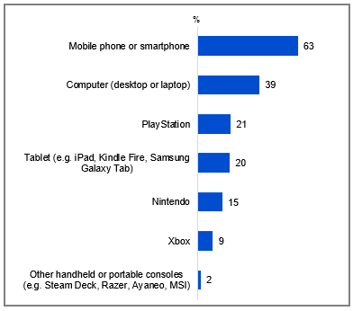

Source: VIDEO2. Which of the following did you use to play video games or computer games in the past 7 days, at home or elsewhere?

Base: TVCS & MCCS, Respondents who played video games in past 7 days. 2024: n=1,629.

Notes: Don’t know/refused responses not shown: 2024: DK = 0.0%, Ref = 0.1%.

A bar chart showing the percentage of respondents who used various devices to play video games or computer games in the past 7 days, at home or elsewhere, in 2024.

Mobile phone or smartphone: 63%

Computer (desktop or laptop): 39%

PlayStation: 21%

Tablet (e.g. iPad, Kindle Fire, Samsung Galaxy Tab): 20%

Nintendo: 15%

Xbox: 9%

Other handheld or portable consoles (e.g. Steam Deck, Razer, Ayaneo, MSI): 2%

#### Subgroups

Mobile phone or smartphone was higher for:

* Women (69% vs 57% of men)
* Ages 18-24 (65%), 25-34 (66%), 35-44 (62%), and 45-54 (71% vs 39% of ages 75+)
* Those living in a capital city (66% vs 58% of those living outside a capital city)
* Those with dependent children in the household (69%) and adults living in a share house (75%) vs 56% of those with no children)
* Those employed full time or part time (66%) and students (74% vs 48% of those retired)
* Those born in a mainly non-English speaking country (70% vs 61% of those born in a mainly English speaking country)

#### Callout

* Younger respondents aged 18-54 were more likely to use mobile phone (66% vs 54%), PlayStation (25% vs 5%), Nintendo (19% vs 2%), and Xbox (11% vs 4%) to play video games, whereas older respondents aged 55+ were more likely to use Tablets (30% vs 17%) for gaming.

Younger Australians and men were more likely to report playing video games in the past 7 days in 2024, with mobile phones being the most commonly used device for gaming.

### Hours spent playing video games per week by devices

Weekly gaming hours varied by platform, with computers leading at 9.8 hours, followed by PlayStation at 7.5 hours and mobile phones at 6.8 hours. While only 2% of participants used other handheld or portable consoles, the average weekly gaming time among users (9.7 hours) was similar to that of computer users (9.8 hours).

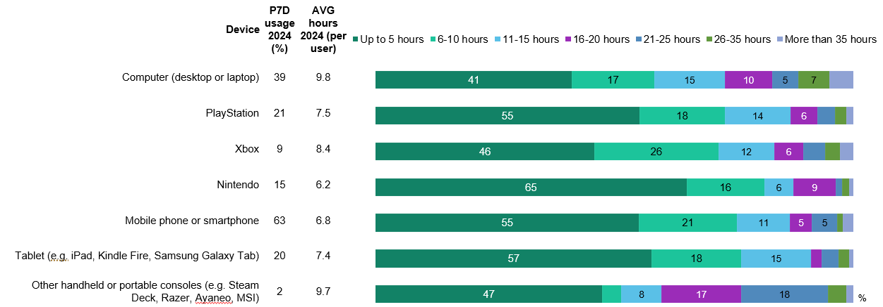

Source: VIDEO3. On average, how many hours per week do you spend playing video games with each of the following devices?

Base: TVCS & MCCS, Respondents who played video games in past 7 days. 2024: n= from 31 to 994.

Notes: Don’t know/refused responses not shown, % vary per statement. Labels for responses <5% not shown on chart.

A bar chart showing the average hours per week spent playing video games using various devices in 2024.

For computers (desktop or laptop), 41% of respondents play up to 5 hours, 17% play 6-10 hours, 15% play 11-15 hours, 10% play 16-20 hours, 5% play 21-25 hours, 7% play 26-35 hours, and 5% play more than 35 hours. The past 7-day usage is 39%, with an average of 10 hours per user.

For PlayStation, 55% of respondents play up to 5 hours, 18% play 6-10 hours, 14% play 11-15 hours, 6% play 16-20 hours, 4% play 21-25 hours, 2% play 26-35 hours, and 1% play more than 35 hours. The past 7-day usage is 21%, with an average of 8 hours per user.

For Xbox, 46% of respondents play up to 5 hours, 26% play 6-10 hours, 12% play 11-15 hours, 6% play 16-20 hours, 4% play 21-25 hours, 3% play 26-35 hours, and 3% play more than 35 hours. The past 7-day usage is 9%, with an average of 8 hours per user.

For Nintendo, 65% of respondents play up to 5 hours, 16% play 6-10 hours, 6% play 11-15 hours, 9% play 16-20 hours, 1% play 21-25 hours, 2% play 26-35 hours, and 1% play more than 35 hours. The past 7-day usage is 15%, with an average of 6 hours per user.

For mobile phones or smartphones, 55% of respondents play up to 5 hours, 21% play 6-10 hours, 11% play 11-15 hours, 5% play 16-20 hours, 5% play 21-25 hours, 1% play 26-35 hours, and 2% play more than 35 hours. The past 7-day usage is 63%, with an average of 7 hours per user.

For tablets (e.g., iPad, Kindle Fire, Samsung Galaxy Tab), 57% of respondents play up to 5 hours, 18% play 6-10 hours, 15% play 11-15 hours, 2% play 16-20 hours, 4% play 21-25 hours, 2% play 26-35 hours, and 1% play more than 35 hours. The past 7-day usage is 20%, with an average of 7 hours per user.

For other handheld or portable consoles (e.g., Steam Deck, Razer, Ayaneo, MSI), 47% of respondents play up to 5 hours, 4% play 6-10 hours, 8% play 11-15 hours, 17% play 16-20 hours, 18% play 21-25 hours, 4% play 26-35 hours, and 1% play more than 35 hours. The past 7-day usage is 2%, with an average of 10 hours per user.

#### Callout

* More than 35 gaming hours across ANY device were more likely to be young (3% of those aged 18-24 or 25-34), live in a capital city (2%), have schooling up to year 12 (3%), looking for work (4%), students (4%), non-worker (4%), or employed casually (3%).

#### Note

Base: N=50 “More than 35 hours across ANY device” at VIDEO3

Computer and other handheld or portable consoles recorded the highest average weekly playing hours of all devices in 2024.

## General screen content habits: Children aged 0-17

### Chapter Summary – General Screen Content Habits: Children aged 0-17

Children were watching free video streaming services and online subscription services at high levels.

* Free video streaming service was the most used platform by children aged 8-17 (8-10, 76%. 11-15, 72%. 16-17, 68%), whereas online subscription services was the most watched by younger children aged 0-7 (57%).
* Parents/legal guardians/carers most commonly reported that their child had watched screen content on free video streaming services (61%) and online subscription services (61%) in the past 7 days. This trend is consistent with the most common responses from children, although the rates were slightly higher among children.
* Other websites or apps recorded the highest average weekly viewing hours among older children aged 8-17 (9.4 hours), whereas publicly owned free-to-air TV had the highest weekly viewing hours for children aged 0-7 (6.9 hours).

User-generated content saw a rise in popularity among older children (and age 8-10 for international content). Children’s animation and cartoons remained popular among younger children, though educational programs were regarded the most important to be made available to children.

* According to parents/legal guardians/carers, children’s animation or cartoons was the most commonly reported type of content that children like watching most, for both Australian (50%) and international (45%) content, especially for younger children.
* Children’s educational programs (both Australian, 69% and international, 60%) were regarded the most important to be made available to children by parents/legal guardians/carers.
* For children aged 8-10, international user-generated content increased in popularity. Both Australian and international user-generated content have increased among older children.

Exposure of children to content that was not age appropriate.

* Results indicate that children have watched TV shows or online content that was meant for an older audience, and exposure to age-inappropriate content was higher among older children aged 8-17 than younger children (‘ever watched’: 0-7, 41%. 8-10, 60%. 11-15, 66%. 16-17, 69%)
* Age-inappropriate content was primarily accessed via online subscription services for all age groups, and also on free video streaming services.

Access to personal devices for online content consumption was high among children.

* Older children were more likely to have their own devices, while younger children typically relied on household devices or had no personal device.
* The primary reasons for access to personal devices included age, independence, and communication needs for older children. For younger children, the arrangements were driven by educational purposes, parental control, entertainment, safety, and promoting a cohesive household environment.

Personal internet use outside the home and on personal devices was high among children.

* Internet use outside the home the majority or all of the time increased with age (16-17, 13%. 11-15, 12%. 8-10, 11%. 0-7, 7%), aligning with parental perceptions, although a slightly lower proportion of children reported this behaviour.
* Similarly, personal internet use on their own devices the majority or all of the time also rose with age (16-17, 73%. 11-15, 72%. 8-10, 45%. 0-7, 19%), consistent with parents' views, though parents reported slightly higher proportions compared to children.

### Platforms used to watch screen content in past 7 days (children aged 8-17)

Free video streaming dominated youth viewing across all age groups in 2024, reaching 76% of children aged 8-10, 72% of those 11-15 years, and 68% of 16-17-year-olds. While online subscription services gained popularity among children aged 11-15 (69%), traditional TV formats saw declining engagement with public broadcasting dropping among 8-10-year-olds (12%) and both commercial free-to-air and on-demand TV decreasing among those aged 16-17 (16% and 9% respectively). Viewing of other websites or apps (e.g., Facebook, TikTok, Instagram) slightly increased among older age groups 11–15 and 16–17 (39% and 57%, respectively), though the change was not significant.

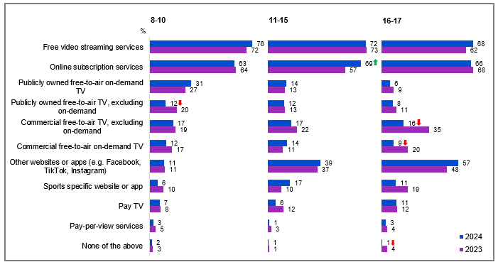

Source: KB1, KC1, KD1. In the past 7 days, what kinds of things did you watch at home or elsewhere on any device?

Base: MCCS, All children aged 8-17. 2024: 8-10 (n=199), 11-15 (n=199), 16-17 (n=141). 2023: 8-10 (n=197), 11-15 (n=191), 16-17 (n=137).

Notes: Don’t know/refused responses not shown: 2024 and 2023 DK = 0% for all ages, Ref = 0% for all ages. Full code labels not shown on chart due to ease of reading.

A bar chart showing the types of content watched by different age groups (8-10 years old, 11-15 years old, and 16-17 years old) at home or elsewhere on any device in the past seven days, comparing data from 2023 and 2024.

For the 8-10 years old group:

Free video streaming services: 72% in 2023, 76% in 2024

Online subscription services: 64% in 2023, 63% in 2024

Publicly owned free-to-air on-demand TV: 27% in 2023, 31% in 2024

Publicly owned free-to-air TV, excluding on-demand: 20% in 2023, 12% in 2024

Commercial free-to-air TV, excluding on-demand: 19% in 2023, 17% in 2024

Commercial free-to-air on-demand TV: 17% in 2023, 12% in 2024

Other websites or apps: 11% in 2023, 11% in 2024

Sports specific website or app: 10% in 2023, 6% in 2024

Pay TV: 8% in 2023, 7% in 2024

Pay-per-view services: 5% in 2023, 3% in 2024

None of the above: 3% in 2023, 2% in 2024

For the 11-15 years old group:

Free video streaming services: 73% in 2023, 72% in 2024

Online subscription services: 57% in 2023, 69% in 2024

Publicly owned free-to-air on-demand TV: 13% in 2023, 14% in 2024

Publicly owned free-to-air TV, excluding on-demand: 13% in 2023, 12% in 2024

Commercial free-to-air TV, excluding on-demand: 22% in 2023, 17% in 2024

Commercial free-to-air on-demand TV: 11% in 2023, 14% in 2024

Other websites or apps: 37% in 2023, 39% in 2024

Sports specific website or app: 10% in 2023, 17% in 2024

Pay TV: 12% in 2023, 6% in 2024

Pay-per-view services: 3% in 2023, 1% in 2024

None of the above: 1% in 2023, 1% in 2024

For the 16-17 years old group:

Free video streaming services: 62% in 2023, 68% in 2024

Online subscription services: 68% in 2023, 66% in 2024

Publicly owned free-to-air on-demand TV: 9% in 2023, 6% in 2024

Publicly owned free-to-air TV, excluding on-demand: 11% in 2023, 8% in 2024

Commercial free-to-air TV, excluding on-demand: 35% in 2023, 16% in 2024

Commercial free-to-air on-demand TV: 20% in 2023, 9% in 2024

Other websites or apps: 48% in 2023, 57% in 2024

Sports specific website or app: 19% in 2023, 11% in 2024

Pay TV: 12% in 2023, 11% in 2024

Pay-per-view services: 4% in 2023, 3% in 2024

None of the above: 4% in 2023, 1% in 2024

#### Subgroup

Publicly owned free-to-air on-demand TV was higher for:

* Ages 8-10 (31% vs 14% of ages 11-15, and 6% of ages 16-17)

Other websites or apps was higher for:

* Ages 16-17 (57% vs 39% of ages 11-15, and 11% of ages 8-10)

Sports specific website or app was higher for:

* Ages 11-15 (17% vs 11% of ages 16-17, and 6% of ages 8-10)

#### Callout

* In the past 7 days, the consumption of publicly owned free-to-air TV, excluding on-demand (12% vs 20% in 2023), decreased significantly in 2024 for those aged 8-10 years old.
* The consumption of online subscription services (69% vs 57% in 2023) increased significantly in 2024 among children aged 11-15.
* Additionally, the consumption of commercial free-to-air TV, excluding on-demand (16% vs 35% in 2023), and commercial free-to-air on-demand TV (9% vs 20% in 2023) both declined significantly for those aged 16-17 in 2024.

Consumption of free video streaming services and online subscription services remained the highest among children aged 8-17.

### Platforms used to watch screen content in past 7 days (children aged 0-7)

Parents/legal guardians/carers reported that children aged 0-7 gravitated toward online subscription services (57%) and free video streaming platforms (52%), with declines in both commercial free-to-air on-demand TV (5%) and pay-per-view services (2%).

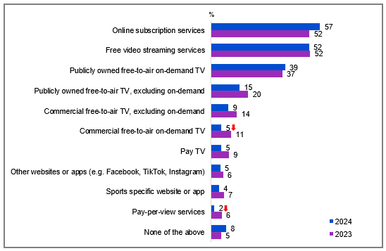

Source: F1. In the past 7 days, which of the following did your child watch at home or elsewhere on any device?

Base: MCCS, All parents/legal guardians/carers answering on behalf of 0-7 year old child. 2024: n=336. 2023: n=359.

Notes: Don’t know/refused responses not shown: 2024 DK = 0%, Ref = 0.2%. 2023 DK = 0%, Ref = 0%.

Full code labels not shown on chart due to ease of reading.

A bar chart comparing the percentages of children aged 0-7 who watched various types of screen content in 2023 and 2024, reported by parents/legal guardians/carers.

Online subscription services: 52% in 2023, 57% in 2024

Free video streaming services: 52% in both 2023 and 2024

Publicly owned free-to-air on-demand TV: 37% in 2023, 39% in 2024

Publicly owned free-to-air TV, excluding on-demand: 20% in 2023, 15% in 2024

Commercial free-to-air TV, excluding on-demand: 14% in 2023, 9% in 2024

Commercial free-to-air on-demand TV: 11% in 2023, 5% in 2024

Pay TV: 9% in 2023, 5% in 2024

Other websites or apps (e.g., Facebook, TikTok, Instagram): 6% in 2023, 5% in 2024

Sports specific website or app: 7% in 2023, 4% in 2024

Pay-per-view services: 6% in 2023, 2% in 2024

None of the above: 5% in 2023, 8% in 2024

#### Callout

* Among children aged 0-7, consumption of commercial free-to-air on-demand TV (5% vs 11% in 2023) and pay-per-view services (2% vs 6% in 2023) in the past 7 days both declined significantly in 2024.

Online subscription services were the platforms most watched by children aged 0-7, reported by parents/legal guardians/carers, followed by free video streaming services.

### Platforms children used to watch screen content in past 7 days (reported by parents)

Screen content consumption patterns reported by parents showed equal usage (61%) in the past 7 days for online subscription and free video streaming services. Parents’ perceptions of the platforms their children use to watch screen content generally align with children's own responses, but slightly underestimated the use of free video streaming services among children aged 8-17.

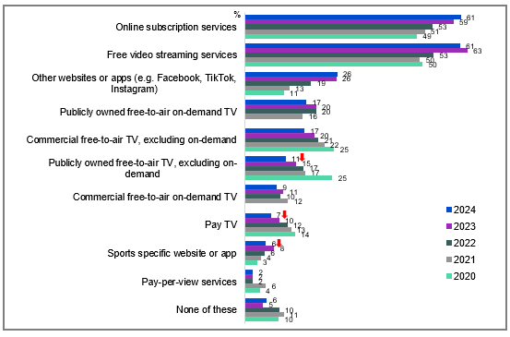

Source: F1. In the past 7 days, which of the following did your child watch at home or elsewhere on any device?

Base: MCCS, All respondents who are parents/legal guardians/carers of a child aged 17 years or under. 2024 n=2,054. 2023 n=2,409. MCCS, All respondents who are parents/legal guardians/carers of a child aged 15 years or under: 2022: n=1,618. 2021: n=1,603. 2020: n=1,571.

Notes: Don’t know/refused responses not shown: 2024 DK = 0.2%, Ref = 0.1%. 2023 DK = 0%, Ref = 0.1%. 2022 DK = 0.2%, Ref = 0.0%. 2021 DK = 0.1%, Ref = 0.0%. 2020 DK = 0.0%, Ref = 0.0%. Full code labels not shown on chart due to ease of reading.

A bar chart showing the types of content children aged 0-7 watched at home or elsewhere on any device over the past seven days between 2020 and 2024, reported by parents/legal guardians/carers.

Online subscription services: 61% in 2024, 59% in 2023, 53% in 2022, 51% in 2021, and 49% in 2020.

Free video streaming services: 61% in 2024, 63% in 2023, 53% in 2022, 50% in 2021, and 50% in 2020.

Other websites or apps (e.g., Facebook, TikTok, Instagram): 26% in 2024, 26% in 2023, 19% in 2022, 13% in 2021, and 11% in 2020.

Publicly owned free-to-air on-demand TV: 17% in 2024, 20% in 2023, 20% in 2022, 16% in 2021, and 0% in 2020.

Commercial free-to-air TV, excluding on-demand: 17% in 2024, 20% in 2023, 21% in 2022, 22% in 2021, and 25% in 2020.

Publicly owned free-to-air TV, excluding on-demand: 11% in 2024, 15% in 2023, 17% in 2022, 17% in 2021, and 25% in 2020.

Commercial free-to-air on-demand TV: 9% in 2024, 11% in 2023, 10% in 2022, 12% in 2021, and 0% in 2020.

Pay TV: 7% in 2024, 10% in 2023, 12% in 2022, 13% in 2021, and 14% in 2020.

Sports specific website or app: 6% in 2024, 8% in 2023, 6% in 2022, 4% in 2021, and 3% in 2020.

Pay-per-view services: 2% in 2024, 2% in 2023, 2% in 2022, 6% in 2021, and 4% in 2020.

None of these: 6% in 2024, 5% in 2023, 10% in 2022, 11% in 2021, and 10% in 2020.

#### Subgroup

Free video streaming services was higher for:

* Ages 35-44 (63%), 45-54 (66%), 55-64 (71% vs 48% of ages 25-34)
* Non-Aboriginal or Torres Strait Islander respondents (63% vs 36% of Aboriginal and / or Torres Strait Islander respondents)
* Those whose child is aged 8-10 (67%) or 11-15 (67% vs 53% of those whose child is aged 0-7)

Online subscription services was higher for:

* Those living outside a capital city (72% vs 58% of those living in a capital city)
* Those with a TAFE qualification / Trade Certificate / Diploma (69% vs 53% of those with a Bachelor degree or a Postgraduate Degree)
* Those born in a mainly English-speaking country (67% vs 47% of those born in a mainly non-English speaking country)
* Those whose child is aged 8-10 (65%), 16-17 (71% vs 54% of those whose child is aged 0-7)

#### Callout

* Parents/legal guardians/carers reporting children watching screen content on publicly owned free-to-air TV (11% vs 15% in 2023), pay TV (7% vs 10% in 2023), and sports-specific website or app (6% vs 8% in 2023) has decreased in 2024.

Online subscription services and free video streaming services remained the most commonly used platforms for children to watch screen content in 2024, as reported by parents/legal guardians/carers.

### Types of content children like watching most (Children aged 8-10)

Animation remained the preferred genre among children aged 8-10, with Australian cartoons (53%) slightly leading international animations (49%), despite a notable year-on-year decline in Australian content preference. User-generated content ranked next in popularity, with international content (39%) outpacing Australian content (30%).

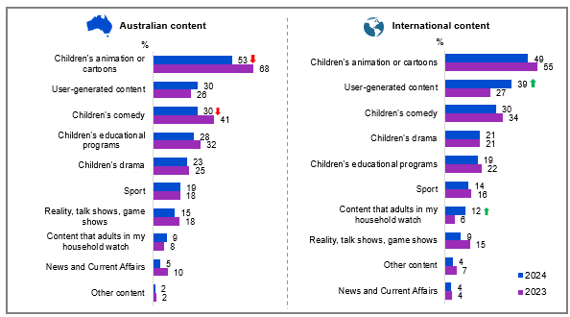

Source: KB3. Which types of content do you like watching most?

Base: MCCS, Children aged 8-10 who have watched screen content in past 7 days. 2024: n=196. 2023: n=192.

Notes: Don’t know/refused responses not shown: 2024: DK = 0%, Ref = 0%. 2023: DK = 0%, Ref = 0%.

A bar chart showing the types of Australian and international content children aged 8-10 like watching most.

For Australian content:

Children's animation or cartoons: 68% in 2023, 53% in 2024

User-generated content: 26% in 2023, 30% in 2024

Children's comedy: 41% in 2023, 30% in 2024

Children's educational programs: 32% in 2023, 28% in 2024

Children's drama: 25% in 2023, 23% in 2024

Sport: 18% in 2023, 19% in 2024

Reality, talk shows, game shows: 18% in 2023, 15% in 2024

Content that adults in my household watch: 8% in 2023, 9% in 2024

News and Current Affairs: 10% in 2023, 5% in 2024

Other content: 2% in both 2023 and 2024

For international content:

Children's animation or cartoons: 55% in 2023, 49% in 2024

User-generated content: 27% in 2023, 39% in 2024

Children's comedy: 34% in 2023, 30% in 2024

Children's drama: 21% in both 2023 and 2024

Children's educational programs: 22% in 2023, 19% in 2024

Sport: 16% in 2023, 14% in 2024

Content that adults in my household watch: 6% in 2023, 12% in 2024

Reality, talk shows, game shows: 15% in 2023, 9% in 2024

Other content: 7% in 2023, 4% in 2024

News and Current Affairs: 4% in both 2023 and 2024

#### Subgroup

Australian children’s animation or cartoons was higher for children who:

* watched publicly owned free-to-air TV or publicly owned free-to-air on-demand TV in P7D (66% vs 52% of those who watched commercial free-to-air TV or commercial free-to-air on-demand TV)

International user-generated content was higher for children who:

* watched content on other websites or apps (e.g. Facebook, TikTok, Instagram) (68%), free video streaming services (YouTube, YouTube Kids, Twitch, or Tubi) in P7D (48% vs 28% of those who watched commercial free-to-air TV, 26% of those who watched publicly owned free-to-air on-demand TV in P7D)

#### Further reading

These findings should, however, be considered alongside [recent RMIT research](https://journals.sagepub.com/doi/10.1177/13548565241264002) indicating that children aged 7-9 often struggle to distinguish Australian content from international programming.4

#### Callout

* In 2024, the popularity of Australian children's animation or cartoons (53% vs 68% in 2023) and children's comedy (30% vs 41% in 2023) decreased significantly among children aged 8-10.
* Meanwhile, the popularity of international user-generated content (39% vs 27% in 2023) and content that adults in the household watch (12% vs 6% in 2023) increased significantly among this age group in 2024.

Children aged 8-10 enjoyed watching Australian or international animation or cartoons the most, followed by user-generated content and children’s comedy.

### Types of content children like watching most (Children aged 11-15)

User-generated content led viewing preferences among those aged 11-15, with international (45%) and Australian (42%) content nearly equal in popularity. Animated content attracted lower but consistent engagement (32% Australian, 30% international).

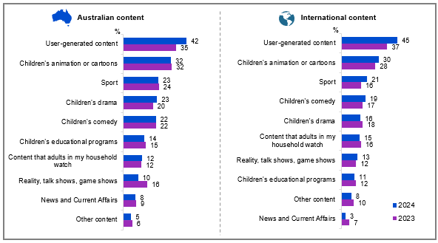

Source: KC3. Which types of content do you like watching most?

Base: MCCS, Children aged 11-15 who have watched screen content in past 7 days. 2024: n=197. 2023: n=189.

Notes: Don’t know/refused responses not shown: 2024: DK = 0.4%, Ref = 0%. 2023: DK = 0.4%, Ref = 0%.

A bar chart showing the types of Australian and international content children aged 11-15 like watching most.

For Australian content:

Children's animation or cartoons: 32% in both 2023 and 2024

User-generated content: 35% in 2023, 42% in 2024

Children's comedy: 22% in both 2023 and 2024

Children's educational programs: 15% in 2023, 14% in 2024

Children's drama: 20% in 2023, 23% in 2024

Sport: 24% in 2023, 23% in 2024

Reality, talk shows, game shows: 16% in 2023, 10% in 2024

Content that adults in my household watch: 12% in both 2023 and 2024

News and Current Affairs: 9% in 2023, 8% in 2024

Other content: 6% in 2023, 5% in 2024

For international content:

Children's animation or cartoons: 28% in 2023, 30% in 2024

User-generated content: 37% in 2023, 45% in 2024

Children's comedy: 17% in 2023, 19% in 2024

Children's drama: 18% in 2023, 16% in 2024

Children's educational programs: 12% in 2023, 11% in 2024

Sport: 16% in 2023, 21% in 2024

Content that adults in my household watch: 16% in 2023, 15% in 2024

Reality, talk shows, game shows: 12% in 2023, 13% in 2024

Other content: 10% in 2023, 8% in 2024

News and Current Affairs: 7% in 2023, 3% in 2024

#### Subgroup

International user-generated content was higher for children who:

* watched content on other websites or apps (e.g. Facebook, TikTok, Instagram) (64%), free video streaming services (YouTube, YouTube Kids, Twitch, or Tubi) in P7D (57% vs 35% of those who watched commercial free-to-air TV, 28% of those who watched publicly owned free-to-air TV, 23% of those who watched publicly owned free-to-air on-demand TV, 34% of those who watched sports specific website or app in P7D)

Children aged 11-15 enjoyed watching user-generated content the most, followed by children’s animation or cartoons.

### Types of content children like watching most (Children aged 16-17)

The 16-17 age group displayed identical engagement levels with international and Australian user-generated content (41% each), followed by international adult programming (27%) and sports content (23% for both domestic and international). Australian sports content was preferred by children who watched commercial TV, as most sports broadcasts air on these channels.

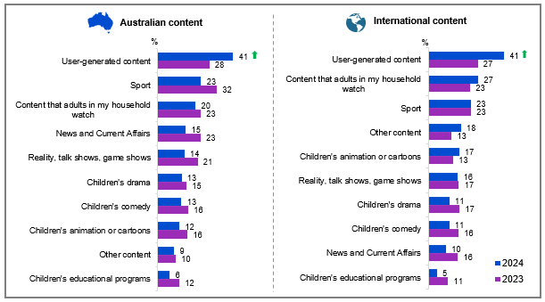

Source: KD3. Which types of content do you like watching most?

Base: MCCS, Children aged 16-17 who have watched screen content in past 7 days. 2024: n=140. 2023: n=132.

Notes: Don’t know/refused responses not shown: 2024: DK = 2%, Ref = 0%. 2023: DK = 0%, Ref = 0%.

A bar chart showing the types of Australian and international content children aged 16-17 like watching most.

For Australian content:

Children's animation or cartoons: 16% in 2023, 12% in 2024

User-generated content: 28% in 2023, 41% in 2024

Children's comedy: 16% in 2023, 13% in 2024

Children's educational programs: 12% in 2023, 6% in 2024

Children's drama: 15% in 2023, 13% in 2024

Sport: 32% in 2023, 23% in 2024

Reality, talk shows, game shows: 21% in 2023, 14% in 2024

Content that adults in my household watch: 23% in 2023, 20% in 2024

News and Current Affairs: 23% in 2023, 15% in 2024

Other content: 10% in 2023, 9% in 2024

For international content:

Children's animation or cartoons: 13% in 2023, 17% in 2024

User-generated content: 27% in 2023, 41% in 2024

Children's comedy: 16% in 2023, 11% in 2024

Children's drama: 17% in 2023, 11% in 2024

Children's educational programs: 11% in 2023, 5% in 2024

Sport: 23% in both 2023 and 2024

Content that adults in my household watch: 23% in 2023, 27% in 2024

Reality, talk shows, game shows: 17% in 2023, 16% in 2024

Other content: 13% in 2023, 18% in 2024

News and Current Affairs: 16% in 2023, 10% in 2024

#### Subgroup

Australian user-generated content was higher for children who:

* Used internet on a device not theirs none of the time (49% vs 30% of those who had ever used internet on a device not theirs)

Australian sportwas higher for children who:

* watched commercial free-to-air TV or commercial free-to-air on-demand TV in P7D (43% vs 22% of those who watched publicly owned free-to-air TV or publicly owned free-to-air on-demand TV)

#### Callout

* In 2024, the popularity of Australian (41% vs 28% in 2023) and international (41% vs 27% in 2023) user-generated content both increased significantly among children aged 16-17.

Children aged 16-17 enjoyed watching user-generated content the most, followed by sports content and content watched by adults in the household.

### Types of content children like watching most (children aged 0-7)

Parental reports showed animated content leading young children's preferences, with Australian cartoons (76%) outperforming international offerings (67%), and educational content maintaining appeal (53% Australian, 46% international).

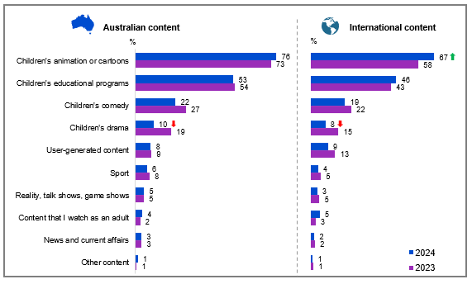

Source: KA3. Which types of content does your child like watching most?

Base: MCCS, All parents/legal guardians/carers answering on behalf of their 0-7 year old child. 2024: n=336. 2023: n=359.

Notes: Don’t know/refused responses not shown: 2024 DK = 1%, Ref = 0.2%. 2023 DK = 1%, Ref = 0%.

A bar chart showing the types of Australian and international content children aged 0-7 like watching most between 2023 and 2024, reported by parents/legal guardians/carers.

For Australian content:

Children's animation or cartoons: 73% in 2023, 76% in 2024

Children's educational programs: 54% in 2023, 53% in 2024

Children's comedy: 27% in 2023, 22% in 2024

Children's drama: 19% in 2023, 10% in 2024

User-generated content: 9% in 2023, 8% in 2024

Sport: 8% in 2023, 6% in 2024

Reality, talk shows, game shows: 5% in both 2023 and 2024

Content that I watch as an adult: 2% in 2023, 4% in 2024

News and current affairs: 3% in both 2023 and 2024

Other content: 1% in both 2023 and 2024

For international content:

Children's animation or cartoons: 58% in 2023, 67% in 2024

Children's educational programs: 43% in 2023, 46% in 2024

Children's comedy: 22% in 2023, 19% in 2024

Children's drama: 15% in 2023, 8% in 2024

User-generated content: 13% in 2023, 9% in 2024

Sport: 5% in 2023, 4% in 2024

Reality, talk shows, game shows: 5% in 2023, 3% in 2024

Content that I watch as an adult: 3% in 2023, 5% in 2024

News and current affairs: 2% in both 2023 and 2024

Other content: 1% in both 2023 and 2024

#### Subgroup

Australian children’s animation or cartoons was higher for:

* Those who did not use internet outside of home (81% vs 67% of those who used internet outside of home)

International children’s animation or cartoons was higher for:

* Those who did not use internet outside of home (72% vs 55% of those who used internet outside of home)

Australian children’s educational programs was higher for:

* Those who watched publicly owned free-to-air TV or publicly owned free-to-air on-demand in P7D (63% vs 47% of those who watched commercial free-to-air TV or commercial free-to-air on-demand)

International children’s educational programs was higher for:

* Those who watched publicly owned free-to-air TV or publicly owned free-to-air on-demand in P7D (54% vs 44% of those who watched commercial free-to-air TV or commercial free-to-air on-demand)

#### Callout

* While international animation (67% vs 58% in 2023) gained popularity in 2024, children's drama declined across Australian (10% vs 19% in 2023) and international (8% vs 15% in 2023) content.

Parents/legal guardians/carers reported that Australian and international animation or cartoons and Australian or international education content were the leading types of content consumed by children aged 0-7 in 2024.

### Types of content children watch

Parents/legal guardians/carers were also asked what types of screen content their child watches most. Highest reported usage was for animated content (Australian 50%, international 45%), followed by Australian educational programs (30%) and user-generated content (international 29%, Australian 25%) – findings that largely aligned with children's own responses.

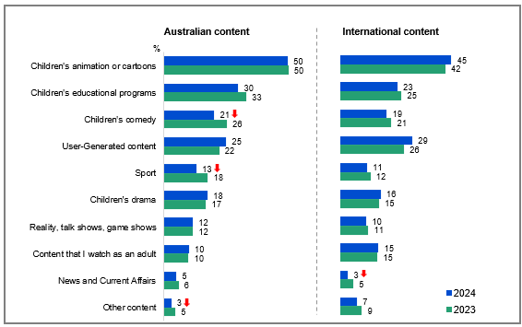

Source: NEWF4b. Which types of content does your child watch most?

Base: MCCS, Respondents whose child watched screen content in past 7 days. 2024: n=1,924. 2023: n=2,285.

Notes: Don’t know/refused responses not shown: 2024 DK = 0.7%, Ref = 0%. 2023 DK = 0.4%, Ref = 0.2%.

A bar chart comparing the types of Australian and international content parents perceive their children watch most, comparing between 2023 and 2024.

For Australian content:

Children's animation or cartoons: 50% in both 2023 and 2024

Children's educational programs: 33% in 2023, 30% in 2024

Children's comedy: 26% in 2023, 21% in 2024

User-Generated content: 22% in 2023, 25% in 2024

Sport: 18% in 2023, 13% in 2024

Children's drama: 17% in 2023, 18% in 2024

Reality, talk shows, game shows: 12% in both 2023 and 2024

Content that I watch as an adult: 10% in both 2023 and 2024

News and Current Affairs: 6% in 2023, 5% in 2024

Other content: 5% in 2023, 3% in 2024

For International content:

Children's animation or cartoons: 42% in 2023, 45% in 2024

Children's educational programs: 25% in 2023, 23% in 2024

Children's comedy: 21% in 2023, 19% in 2024

User-Generated content: 26% in 2023, 29% in 2024

Sport: 12% in 2023, 11% in 2024

Children's drama: 15% in 2023, 16% in 2024

Reality, talk shows, game shows: 11% in 2023, 10% in 2024

Content that I watch as an adult: 15% in both 2023 and 2024

News and Current Affairs: 5% in 2023, 3% in 2024

Other content: 9% in 2023, 7% in 2024

#### Subgroup

Australian children’s animation or cartoons was higher for:

* Those whose child is aged 0-7 (78%), 8-10 (64%), or 11-15 (34% vs 12% of those whose child is aged 16-17)
* Aboriginal and / or Torres Strait Islander respondents (68% vs 49% of non-Aboriginal or Torres Strait Islander respondents)
* Those whose child watched publicly owned free-to-air TV (live or on-demand) in P7D (73% vs 51% of those whose child watched commercial free-to-air TV (live or on-demand))

International children’s animation or cartoons was higher for:

* Those whose child is aged 0-7 (68%), 8-10 (54%), or 11-15 (34% vs 12% of those whose child is aged 16-17).
* Those born in a mainly non-English speaking country (51% vs 43% of those born in a mainly English speaking country)
* Those whose child watched publicly owned free-to-air TV (live or on-demand) in P7D (61% vs 39% of those whose child watched commercial free-to-air TV (live or on-demand))

#### Callout

* Children’s consumption of Australian children’s comedy (21% vs 26% in 2023), sport (13% vs 18% in 2023), other content (3% vs 5% in 2023), and international news and current affairs (3% vs 5% in 2023) all decreased significantly in 2024.

Children’s animation or cartoons remained the primary type of content watched by children, reported by parents/legal guardians/carers. This is consistent with the responses of younger children.

### Types of content most important to be available to children

Despite children's preference for animated content, parents/legal guardians/carers prioritised educational programming as most important for their children's viewing, with Australian content (69%) rated slightly ahead of international offerings (60%) – maintaining similar levels to 2023.

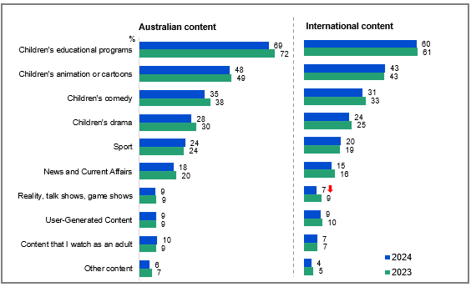

Source: NEWF5b. Which types of content are most important to be made available to children?

Base: MCCS, Respondents who are parents/legal guardians/carers of a child aged 17 or under. 2024: n=2,054. 2023: n=2,409.

Notes: Don’t know/refused responses not shown: 2024 DK = 1%, Ref = 1%. 2023 DK = 1%, Ref = 1%.

A bar chart comparing the types of Australian and international content parents perceive as most important to be made available to children, comparing between 2023 and 2024.

For Australian content:

Children's educational programs: 72% in 2023, 69% in 2024

Children's animation or cartoons: 49% in 2023, 48% in 2024

Children's comedy: 38% in 2023, 35% in 2024

Children's drama: 30% in 2023, 28% in 2024

Sport: 24% in both 2023 and 2024

News and Current Affairs: 20% in 2023, 18% in 2024

Reality, talk shows, game shows: 9% in both 2023 and 2024

User-Generated Content: 9% in both 2023 and 2024

Content that I watch as an adult: 9% in 2023, 10% in 2024

Other content: 7% in 2023, 6% in 2024

For International content:

Children's educational programs: 61% in 2023, 60% in 2024

Children's animation or cartoons: 43% in both 2023 and 2024

Children's comedy: 33% in 2023, 31% in 2024

Children's drama: 25% in 2023, 24% in 2024

Sport: 19% in 2023, 20% in 2024

News and Current Affairs: 16% in 2023, 15% in 2024

Reality, talk shows, game shows: 9% in 2023, 7% in 2024

User-Generated Content: 10% in 2023, 9% in 2024

Content that I watch as an adult: 7% in both 2023 and 2024

Other content: 5% in 2023, 4% in 2024

#### Subgroups

Australian children’s educational programs was higher for:

* Those whose child is aged 0-7 (75%) or 8-10 (78% vs 61% of those whose child is aged 11-15 and 57% of those whose child is aged 16-17)
* Non-Aboriginal or Torres Strait Islander respondents (70% vs 49% of Aboriginal and / or Torres Strait Islander respondents)

International children’s educational programs was higher for:

* Those whose child is aged 0-7 (68%), 8-10 (67%), or 11-15 (51% vs 49% of those whose child Is aged 16-17)
* Those whose child watched publicly owned free-to-air TV (live or on-demand) in P7D (63% vs 59% of those whose child watched commercial free-to-air TV (live or on-demand))
* Non-Aboriginal or Torres Strait Islander respondents (61% vs 38% of Aboriginal and / or Torres Strait Islander respondents)

#### Callout

* Parents' perceived importance of making reality shows, talk shows, and game shows (7% vs 9% in 2023) available to children decreased significantly in 2024.

Parents/legal guardians/carers regarded educational programs to be the most important type of content to be available to children.

### Watching content meant for someone older (children aged 8-17)

Children were then asked whether they had ever watched screen content meant for an older audience, and if so where they had seen this content. More than three in five children aged 8-10 (60%), 11-15 (66%), and 16-17 (69%) reported watching TV shows or online content that was meant for an older audience. Among all age groups, children who had seen content meant for someone older most often reported seeing this content on online subscription services (8-10, 66%; 11-15, 67%; 16-17, 67%).

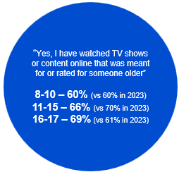

Source: KB8, KC8, KD8. Have you ever watched any TV shows or content online that was meant for or rated for someone older than you were?

Base: MCCS, All children aged 8-17. 2024: 8-10 (n=199), 11-15 (n=199), 16-17 (n=141). 2023: 8-10 (n=197), 11-15 (n=191), 16-17 (n=137).

Notes: No/Don’t know/refused responses not shown: 2024: 8-10 No = 39%, DK = 1%, Ref = 0%. 11-15 No = 34%, DK = 0%, Ref = 0%. 16-17 No = 30%, DK = 1%, Ref = 0%. 2023: 8-10 No = 39%, DK = 0.5%, Ref = 0%. 11-15 No = 29%, DK = 1%, Ref = 0%. 16-17 No = 38%, DK = 1%, Ref = 0%.

A blue circular graphic showing the proportions of children aged 8-17 who have watched TV shows or content online that was meant for or rated for someone older.

8-10 year-olds: 60% in 2024 (vs 60% in 2023)

11-15 year-olds: 66% in 2024 (vs 70% in 2023)

16-17 year-olds: 69% in 2024 (vs 61% in 2023)

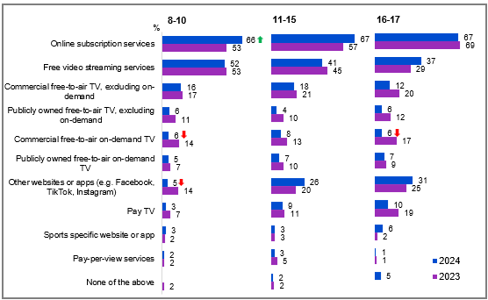

Source: KB9, KC9, KD9. And where did you see this show or content that was meant for someone older than you?

Base: MCCS, Children aged 8-17 who have ever watched content meant for someone older than them. 2024: 8-10 (n=118), 11-15 (n=128), 16-17 (n=92) 2023: 8-10 (n=119), 11-15 (n=135), 16-17 (n=86).

Notes: Don’t know/refused responses not shown: 2024 DK = 1% for 16-17, 0% for 8-10 and 11-15, Ref = 0% for al ages. 2023 DK = 0% for all ages, Ref = 0% for all ages.  
Full code labels not shown on chart due to ease of reading.

A bar chart comparing the platforms on which age-inappropriate content was seen by children aged 8-17, comparing between 2023 and 2024.

For ages 8-10:

Online subscription services: 53% in 2023, 66% in 2024

Free video streaming services: 53% in 2023, 52% in 2024

Commercial free-to-air TV, excluding on-demand: 17% in 2023, 16% in 2024

Publicly owned free-to-air TV, excluding on-demand: 11% in 2023, 6% in 2024

Commercial free-to-air on-demand TV: 14% in 2023, 6% in 2024

Publicly owned free-to-air on-demand TV: 7% in 2023, 5% in 2024

Other websites or apps (e.g., Facebook, TikTok, Instagram): 14% in 2023, 5% in 2024

Pay TV: 7% in 2023, 3% in 2024

Sports specific website or app: 2% in 2023, 3% in 2024

Pay-per-view services: 2% in both 2023 and 2024

None of the above: 2% in 2023, 0% in 2024

For ages 11-15:

Online subscription services: 57% in 2023, 67% in 2024

Free video streaming services: 45% in 2023, 41% in 2024

Commercial free-to-air TV, excluding on-demand: 21% in 2023, 18% in 2024

Publicly owned free-to-air TV, excluding on-demand: 10% in 2023, 4% in 2024

Commercial free-to-air on-demand TV: 13% in 2023, 8% in 2024

Publicly owned free-to-air on-demand TV: 10% in 2023, 7% in 2024

Other websites or apps (e.g., Facebook, TikTok, Instagram): 20% in 2023, 26% in 2024

Pay TV: 11% in 2023, 9% in 2024

Sports specific website or app: 3% in both 2023 and 2024

Pay-per-view services: 5% in 2023, 3% in 2024

None of the above: 2% in both 2023 and 2024

For ages 16-17:

Online subscription services: 69% in 2023, 67% in 2024

Free video streaming services: 29% in 2023, 37% in 2024

Commercial free-to-air TV, excluding on-demand: 20% in 2023, 12% in 2024

Publicly owned free-to-air TV, excluding on-demand: 12% in 2023, 6% in 2024

Commercial free-to-air on-demand TV: 17% in 2023, 6% in 2024

Publicly owned free-to-air on-demand TV: 9% in both 2023 and 2024

Other websites or apps (e.g., Facebook, TikTok, Instagram): 25% in 2023, 31% in 2024

Pay TV: 19% in 2023, 10% in 2024

Sports specific website or app: 2% in 2023, 6% in 2024

Pay-per-view services: 1% in both 2023 and 2024

None of the above: 0% in 2023, 5% in 2024

#### Subgroups

Other websites of apps was higher for:

* Ages 16-17 (31%) and ages 11-15 (26% vs 5% of ages 8-10)

#### Callout

* Among children aged 8-10, TV shows or content meant for older audiences were increasingly seen on online subscription services (66% vs 53% in 2023), while their presence on commercial free-to-air TV (6% vs 14% in 2023) or other websites or apps (5% vs 14% in 2023) decreased in 2024.
* For those aged 16-17, age-inappropriate content was less commonly seen on commercial free-to-air TV (6% vs 17% in 2023) in 2024.

More than three in five children aged 8-17 reported having watched age-inappropriate content, in particular via online subscription services (e.g. Netflix, Amazon Prime Video, Binge, etc.).

### Watching content meant for someone older (children aged 0-7)

Just over two-fifths (41%) of children aged 0-7 had watched TV shows or online content that was meant for an older audience. This content was most commonly accessed via online subscription services (57%), an increase from 2023, followed by free video streaming services (51%).

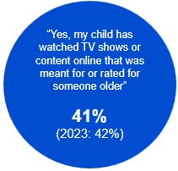

Source: KA8. Has your child ever watched any TV shows or content online that was meant for or rated for someone older than they are?

Base: MCCS, All parents/legal guardians/carers answering on behalf of their 0-7 year old child. 2024: n=336. 2023: n=359.

Notes: No/Don’t know/refused responses not shown: 2024: No = 57%, DK = 1%, Ref = 0%. 2023: No = 58%, DK = 0.3%, Ref = 0%.

A blue circular graphic showing the proportion of parents who reported that their child had watched TV shows or online content online intended for someone older: 41% in 2024 (vs 42% in 2023)

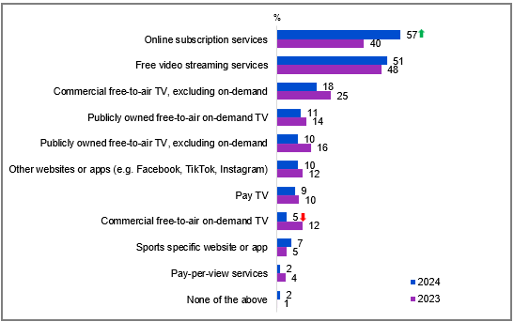

Source: KA9. And where did they see this show or content that was meant for someone older than them?

Base: MCCS, Parents/legal guardians/carers whose 0-7 year old child has ever watched content meant for someone older than them. 2024: n=135. 2023: n=150.

Notes: Don’t know/refused responses not shown: 2024 and 2023 DK = 0%, Ref = 0%. Full code labels not shown on chart due to ease of reading.

A bar chart comparing the platforms on which age-inappropriate content was seen by children aged 0-7, as reported by parents/legal guardians/carers, between 2023 and 2024.

Online subscription services: 57% in 2024, 40% in 2023

Free video streaming services: 51% in 2024, 48% in 2023

Commercial free-to-air TV, excluding on-demand: 18% in 2024, 25% in 2023

Publicly owned free-to-air on-demand TV: 11% in 2024, 14% in 2023

Publicly owned free-to-air TV, excluding on-demand: 10% in 2024, 16% in 2023

Other websites or apps (e.g., Facebook, TikTok, Instagram): 10% in 2024, 12% in 2023

Pay TV: 9% in 2024, 10% in 2023

Commercial free-to-air on-demand TV: 5% in 2024, 12% in 2023

Sports specific website or app: 7% in 2024, 5% in 2023

Pay-per-view services: 2% in 2024, 4% in 2023

None of the above: 2% in 2024, 1% in 2023

#### Callout

* For children aged 0-7, age-inappropriate content was less commonly seen on commercial free-to-air on-demand TV in 2024 (5% vs 12% in 2023) and more commonly seen on online subscription services (57% vs 40% in 2023).

Parents/legal guardians/carers reported that children aged 0-7 were also being exposed to age-inappropriate content, especially via free online subscription services and free video streaming services.

### Platforms used to watch Australian screen content (children aged 8-17)

Free video streaming largely led Australian content viewing across all youth age groups (42% for ages 8-17), while subscription services showed varying engagement (35% for ages 8-10, 43% for 11-15, and 36% for 16-17). Younger children (8-10) regularly accessed public broadcast on-demand services (26%), while older youth increasingly turned to alternative websites and apps (16% for ages 11-15, 23% for 16-17).

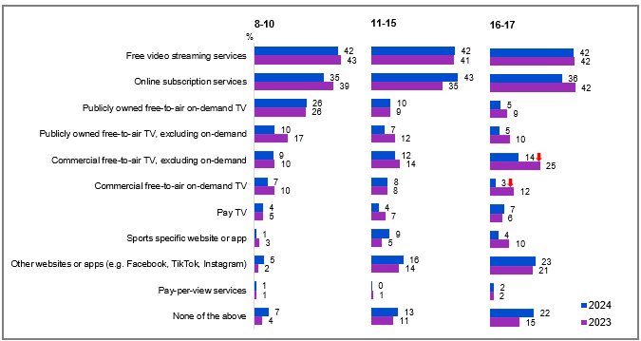

Source: KB4, KC4, KD4. Now thinking only about Australian children’s programs, which do you usually watch these on?

Base: MCCS, Children who watch Australian content. 2024: 8-10 (n=180), 11-15 (n=187), 16-17 (n=124). 2023: 8-10 (n=185), 11-15 (n=174), 16-17 (n=120).

Notes: Don’t know/refused responses not shown: 2024 and 2023: 8-10 DK = 0%, Ref = 0%, 11-15 DK = 0%, Ref = 0%, 16-17 DK = 1%, Ref = 0%. Full code labels not shown on chart due to ease of reading.

A bar chart comparing the platforms on which Australian children’s programs are usually watched by children from different age groups, between 2023 and 2024.

For ages 8-10:

Free video streaming services: 43% in 2023, 42% in 2024

Online subscription services: 39% in 2023, 35% in 2024

Publicly owned free-to-air on-demand TV: 26% in both 2023 and 2024

Publicly owned free-to-air TV, excluding on-demand: 17% in 2023, 10% in 2024

Commercial free-to-air TV, excluding on-demand: 10% in 2023, 9% in 2024

Commercial free-to-air on-demand TV: 10% in 2023, 7% in 2024

Pay TV: 5% in 2023, 4% in 2024

Sports specific website or app: 3% in 2023, 1% in 2024

Other websites or apps (e.g., Facebook, TikTok, Instagram): 2% in 2023, 5% in 2024

Pay-per-view services: 1% in both 2023 and 2024

None of the above: 4% in 2023, 7% in 2024

For ages 11-15:

Free video streaming services: 41% in 2023, 42% in 2024

Online subscription services: 35% in 2023, 43% in 2024

Publicly owned free-to-air on-demand TV: 9% in 2023, 10% in 2024

Publicly owned free-to-air TV, excluding on-demand: 12% in 2023, 7% in 2024

Commercial free-to-air TV, excluding on-demand: 14% in 2023, 12% in 2024

Commercial free-to-air on-demand TV: 8% in both 2023 and 2024

Pay TV: 7% in 2023, 4% in 2024

Sports specific website or app: 5% in 2023, 9% in 2024

Other websites or apps (e.g., Facebook, TikTok, Instagram): 14% in 2023, 16% in 2024

Pay-per-view services: 1% in 2023, 0% in 2024

None of the above: 11% in 2023, 13% in 2024

For ages 16-17:

Free video streaming services: 42% in both 2023 and 2024

Online subscription services: 42% in 2023, 36% in 2024

Publicly owned free-to-air on-demand TV: 9% in 2023, 5% in 2024

Publicly owned free-to-air TV, excluding on-demand: 10% in 2023, 5% in 2024

Commercial free-to-air TV, excluding on-demand: 25% in 2023, 14% in 2024

Commercial free-to-air on-demand TV: 12% in 2023, 3% in 2024

Pay TV: 6% in 2023, 7% in 2024

Sports specific website or app: 10% in 2023, 4% in 2024

Other websites or apps (e.g., Facebook, TikTok, Instagram): 21% in 2023, 23% in 2024

Pay-per-view services: 2% in both 2023 and 2024

None of the above: 15% in 2023, 22% in 2024

#### Subgroups

Publicly owned free-to-air on-demand TV was higher for:

* Ages 8-10 (26% vs 10% of ages 11-15 and 5% of ages 16-17)

Sports specific website or app was higher for:

* Ages 11-15 (9% vs 1% of ages 8-10)

Other websites or apps was higher for:

* Ages 16-17 (23%) and ages 11-15 (16% vs 5% of ages 8-10)

#### Callout

* In 2024, the use of commercial free-to-air TV (14% vs 25% in 2023) and commercial free-to-air on-demand TV (3% vs 12% in 2023) to watch Australian screen content decreased significantly among children aged 16-17.

The platforms most commonly used by children aged 8-17 to watch Australian screen content were free video streaming services and online subscription services, consistent with results from 2023.

### Platforms used to watch Australian screen content (children aged 0-7)

A similar proportion of children aged 0-7 watched Australian screen content on publicly owned free-to-air on-demand TV (50%) and free video streaming services (49%), with online subscription services close behind (43%). Traditional formats recorded declines in 2024, with commercial TV and its on-demand services dropping to 5% and 4% respectively, while sports apps (3%) and pay-per-view (1%) showed minimal engagement.

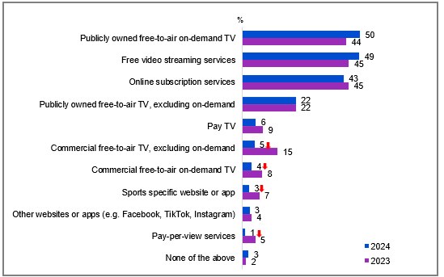

Source: KA4. Now thinking only about Australian children’s programs, which does your child usually watch these on?

Base: MCCS, Parents/legal guardians/carers whose 0-7 year old child watches Australian content. 2024: n=313. 2023: n=351.

Notes: Don’t know/refused responses not shown: 2024 and 2023 DK = 0%, Ref = 0%. Full code labels not shown on chart due to ease of reading.

A bar chart comparing the platforms on which children usually watched children's programs, reported by parents/legal guardians/carers between 2023 and 2024.

Publicly owned free-to-air on-demand TV: 50% in 2024, 44% in 2023

Free video streaming services: 49% in 2024, 45% in 2023

Online subscription services: 43% in 2024, 45% in 2023

Publicly owned free-to-air TV, excluding on-demand: 22% in both 2023 and 2024

Pay TV: 6% in 2024, 9% in 2023

Commercial free-to-air TV, excluding on-demand: 5% in 2024, 15% in 2023

Commercial free-to-air on-demand TV: 4% in 2024, 8% in 2023

Sports specific website or app: 3% in 2024, 7% in 2023

Other websites or apps (e.g., Facebook, TikTok, Instagram): 3% in 2024, 4% in 2023

Pay-per-view services: 1% in 2024, 5% in 2023

None of the above: 3% in 2024, 2% in 2023

#### Callout

* The use of commercial free-to-air TV (5% vs 15% in 2023), commercial free-to-air on-demand TV (4% vs 8% in 2023), sports specific website or app (3% vs 7% in 2023), and pay-per-view services (1% vs 5% in 2023) to watch Australian screen content all declined significantly in 2024 among children aged 0-7.

Parents/legal guardians/carers reported that children aged 0-7 primarily watched Australian content on Publicly owned free-to-air on-demand TV, as well as through free video streaming services and online subscription services, similar to older children.

### Hours per week spent watching content on various platforms (children aged 8-17)

Among children aged 8-17, weekly screen time was highest on ‘other’ websites or apps (9.4 hours), followed by free video streaming services (7.9 hours), while online subscription services and Pay TV averaged 6.7 hours – consistent with trends observed in 2023. These platforms also had the highest reported usage by children in the past 7 days, except for Pay TV.

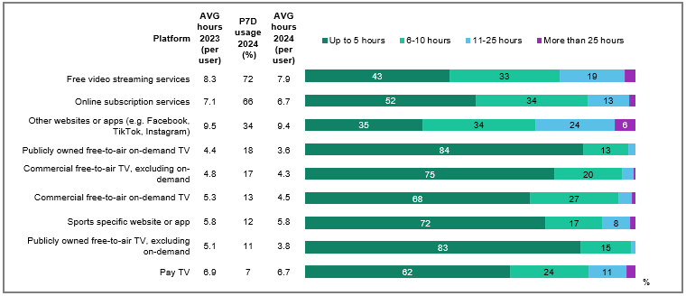

Source: KB1, KC1, KD1. In the past 7 days, what kinds of things did you watch at home or elsewhere on any device?

Base: MCCS, All children aged 8-17. 2024: 8-10 (n=199), 11-15 (n=199), 16-17 (n=141). 2023: 8-10 (n=197), 11-15 (n=191), 16-17 (n=137).

Source: KB2, KC2, KD2. On average, how many hours per week do you watch each of the following?

Base: MCCS, Children aged 8-17 who watched screen content in the past 7 days. Total (n= from 15 to 388). Reported at total level due to small base sizes in individual age groups.

Notes: Don’t know/refused responses not shown: % vary per statement. Labels for responses <5% not shown. Results for ‘Google Play (or pay-per-view services)’ not shown due to small base size (n=15). Full code labels not shown on chart due to ease of reading.

A bar chart comparing the types of content watched by children aged 8-17 at home or elsewhere on any device over the past 7 days, between 2023 and 2024.

Free video streaming services:

Up to 5 hours: 43%

6-10 hours: 33%

11-25 hours: 19%

More than 25 hours: 3%

Average hours 2023 (per user): 8.3

Past 7 days usage 2024: 72%

Average hours 2024 (per user): 7.9

Online subscription services:

Up to 5 hours: 52%

6-10 hours: 34%

11-25 hours: 13%

More than 25 hours: 2%

Average hours 2023 (per user): 7.1

Past 7 days usage 2024: 66%

Average hours 2024 (per user): 6.7

Other websites or apps (e.g., Facebook, TikTok, Instagram):

Up to 5 hours: 35%

6-10 hours: 34%

11-25 hours: 24%

More than 25 hours: 6%

Average hours 2023 (per user): 9.5

Past 7 days usage 2024: 34%

Average hours 2024 (per user): 9.4

Publicly owned free-to-air on-demand TV:

Up to 5 hours: 84%

6-10 hours: 13%

11-25 hours: 2%

More than 25 hours: 0%

Average hours 2023 (per user): 4.4

Past 7 days usage 2024: 18%

Average hours 2024 (per user): 3.6

Commercial free-to-air TV, excluding on-demand:

Up to 5 hours: 75%

6-10 hours: 20%

11-25 hours: 3%

More than 25 hours: 1%

Average hours 2023 (per user): 4.8

Past 7 days usage 2024: 17%

Average hours 2024 (per user): 4.3

Commercial free-to-air on-demand TV:

Up to 5 hours: 68%

6-10 hours: 27%

11-25 hours: 4%

More than 25 hours: 1%

Average hours 2023 (per user): 5.3

Past 7 days usage 2024: 13%

Average hours 2024 (per user): 4.5

Sports specific website or app:

Up to 5 hours: 72%

6-10 hours: 17%

11-25 hours: 8%

More than 25 hours: 2%

Average hours 2023 (per user): 5.8

Past 7 days usage 2024: 12%

Average hours 2024 (per user): 5.8

Publicly owned free-to-air TV, excluding on-demand:

Up to 5 hours: 83%

6-10 hours: 15%

11-25 hours: 1%

More than 25 hours: 0%

Average hours 2023 (per user): 5.1

Past 7 days usage 2024: 11%

Average hours 2024 (per user): 3.8

Pay TV:

Up to 5 hours: 62%

6-10 hours: 24%

11-25 hours: 11%

More than 25 hours: 3%

Average hours 2023 (per user): 6.9

Past 7 days usage 2024: 7%

Average hours 2024 (per user): 6.7

Other website or apps (e.g. Facebook, TikTok and Instagram) recorded the highest average weekly viewing hours by children aged 8-17 that used them.

### Hours per week spent watching content on various platforms (children aged 0-7)

Young children (aged 0-7) averaged nearly identical weekly viewing hours on public broadcast TV (6.9 hours) and free streaming services (6.8 hours).

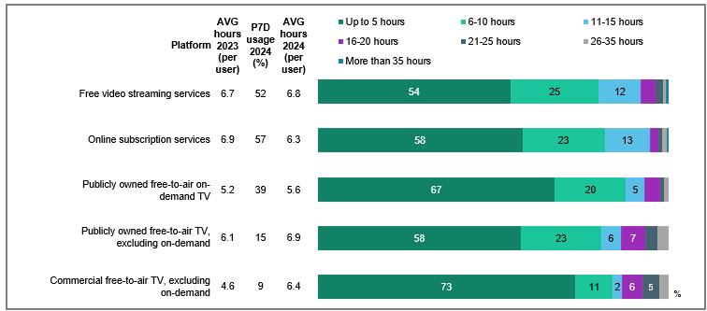

Source: F1. In the past 7 days, which of the following did your child watch at home or elsewhere on any device?

Base: MCCS, All parents/legal guardians/carers answering on behalf of 0-7 year old child. 2024: n=336. 2023: n=359.

Source: F2. On average, how many hours per week does your child spend watching each of the following?

Base: MCCS, Parents/legal guardians/carers whose 0-7 year old child watched screen content in the past 7 days (n= from 6 to 186).

Notes: Don’t know/refused responses not shown: % vary per statement. Labels for responses <5% not shown. Responses for Commercial free-to-air on-demand TV (n=20), Pay TV (n=18), Pay-per-view services (n=6), Sports specific website or app (n=14), and Other websites or apps (n=15) not shown due to small base sizes. Full code labels not shown on chart due to ease of reading.

A bar chart comparing the number of hours parents perceived their children spent watching content on various platforms at home or elsewhere over the past 7 days, between 2023 and 2024.

Free video streaming services:

Up to 5 hours: 54%

6-10 hours: 25%

11-15 hours: 12%

16-20 hours: 4%

21-25 hours: 2%

26-35 hours: 1%

More than 35 hours: 1%

Average hours 2023 (per user): 6.7

Past 7 days usage 2024: 52%

Average hours 2024 (per user): 6.8

Online subscription services:

Up to 5 hours: 58%

6-10 hours: 23%

11-15 hours: 13%

16-20 hours: 3%

21-25 hours: 1%

26-35 hours: 1%

More than 35 hours: 1%

Average hours 2023 (per user): 6.9

Past 7 days usage 2024: 57%

Average hours 2024 (per user): 6.3

Publicly owned free-to-air on-demand TV:

Up to 5 hours: 67%

6-10 hours: 20%

11-15 hours: 5%

16-20 hours: 4%

21-25 hours: 1%

26-35 hours: 1%

More than 35 hours: 0%

Average hours 2023 (per user): 5.2

Past 7 days usage 2024: 39%

Average hours 2024 (per user): 5.6

Publicly owned free-to-air TV, excluding on-demand:

Up to 5 hours: 58%

6-10 hours: 23%

11-15 hours: 6%

16-20 hours: 7%

21-25 hours: 4%

26-35 hours: 3%

More than 35 hours: 0%

Average hours 2023 (per user): 6.1

Past 7 days usage 2024: 15%

Average hours 2024 (per user): 6.9

Commercial free-to-air TV, excluding on-demand:

Up to 5 hours: 73%

6-10 hours: 11%

11-15 hours: 2%

16-20 hours: 6%

21-25 hours: 5%

26-35 hours: 2%

More than 35 hours: 0%

Average hours 2023 (per user): 4.6

Past 7 days usage 2024: 9%

Average hours 2024 (per user): 6.4

Publicly owned free-to-air TV had the highest average weekly viewing hours for children aged 0-7 in 2024.

### Hours spent by children watching screen content by platform

Parents/legal guardians/carers were also asked to indicate how much time their child spends watching various platforms per week. Parental reports in 2024 showed children spent most weekly screen time (10.1 hours) on ‘other’ websites and apps, aligning with viewing patterns reported directly by 8-17-year-olds.

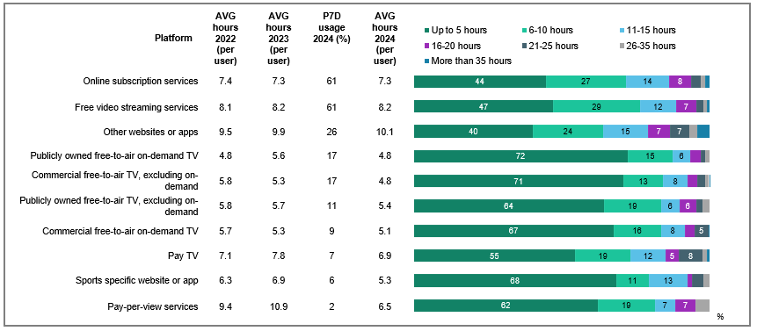

Source: F1. In the past 7 days, which of the following did your child watch at home or elsewhere on any device?

Base: MCCS, All parents/legal guardians/carers 2024: n=2,054. 2023: n=2,409.

Source: F2. On average, how many hours per week does your child spend watching each of the following?

Base: MCCS, Respondents whose child watched screen content in the past 7 days. 2024: n= from 36 to 1,297. 2023: n= from 95 to 1,411. 2022: n= from 48 to 885.

Notes: Don’t know/refused responses not shown, % vary per statement. Labels for responses <5% are not shown on chart. Full code labels not shown on chart due to ease of reading.

A bar chart comparing the hours children aged 8-17 spent watching screen content at home or elsewhere

over the past 7 days, between 2023 and 2024.

Free video streaming services:

Up to 5 hours: 44%

6-10 hours: 27%

11-15 hours: 14%

16-20 hours: 8%

21-25 hours: 3%

26-35 hours: 2%

More than 35 hours: 2%

Average hours 2022 (per user): 7.4

Average hours 2023 (per user): 7.3

Past 7 day usage 2024: 61%

Average hours 2024 (per user): 7.3

Online subscription services:

Up to 5 hours: 47%

6-10 hours: 29%

11-15 hours: 12%

16-20 hours: 7%

21-25 hours: 2%

26-35 hours: 1%

More than 35 hours: 1%

Average hours 2022 (per user): 8.1

Average hours 2023 (per user): 8.2

Past 7 day usage 2024: 61%

Average hours 2024 (per user): 8.2

Other websites or apps:

Up to 5 hours: 40%

6-10 hours: 24%

11-15 hours: 15%

16-20 hours: 7%

21-25 hours: 7%

26-35 hours: 3%

More than 35 hours: 4%

Average hours 2022 (per user): 9.5

Average hours 2023 (per user): 9.9

Past 7 day usage 2024: 26%

Average hours 2024 (per user): 10.1

Publicly owned free-to-air on-demand TV:

Up to 5 hours: 72%

6-10 hours: 15%

11-15 hours: 6%

16-20 hours: 3%

21-25 hours: 1%

26-35 hours: 1.6%

More than 35 hours: 0%

Average hours 2022 (per user): 4.8

Average hours 2023 (per user): 5.6

Past 7 day usage 2024: 17%

Average hours 2024 (per user): 4.8

Commercial free-to-air TV, excluding on-demand:

Up to 5 hours: 71%

6-10 hours: 13%

11-15 hours: 8%

16-20 hours: 3%

21-25 hours: 3%

26-35 hours: 1%

More than 35 hours: 0.3%

Average hours 2022 (per user): 5.8

Average hours 2023 (per user): 5.3

Past 7 day usage 2024: 17%

Average hours 2024 (per user): 4.8

Publicly owned free-to-air TV, excluding on-demand:

Up to 5 hours: 64%

6-10 hours: 19%

11-15 hours: 6%

16-20 hours: 6%

21-25 hours: 2%

26-35 hours: 2.4%

More than 35 hours: 0%

Average hours 2022 (per user): 5.8

Average hours 2023 (per user): 5.7

Past 7 day usage 2024: 11%

Average hours 2024 (per user): 5.4

Commercial free-to-air on-demand TV:

Up to 5 hours: 67%

6-10 hours: 16%

11-15 hours: 8%

16-20 hours: 3%

21-25 hours: 5%

26-35 hours: 0%

More than 35 hours: 0.5%

Average hours 2022 (per user): 5.7

Average hours 2023 (per user): 5.3

Past 7 day usage 2024: 9%

Average hours 2024 (per user): 5.1

Pay TV:

Up to 5 hours: 55%

6-10 hours: 19%

11-15 hours: 12%

16-20 hours: 5%

21-25 hours: 8%

26-35 hours: 1.4%

More than 35 hours: 1%

Average hours 2022 (per user): 7.1

Average hours 2023 (per user): 7.8

Past 7 day usage 2024: 7%

Average hours 2024 (per user): 6.9

Sports specific website or app:

Up to 5 hours: 68%

6-10 hours: 11%

11-15 hours: 13%

16-20 hours: 1%

21-25 hours: 4%

26-35 hours: 2.1%

More than 35 hours: 0%

Average hours 2022 (per user): 6.3

Average hours 2023 (per user): 6.9

Past 7 day usage 2024: 6%

Average hours 2024 (per user): 5.3

Pay-per-view services:

Up to 5 hours: 62%

6-10 hours: 19%

11-15 hours: 7%

16-20 hours: 7%

21-25 hours: 0%

26-35 hours: 5%

More than 35 hours: 0%

Average hours 2022 (per user): 9.4

Average hours 2023 (per user): 10.9

Past 7 day usage 2024: 2%

Average hours 2024 (per user): 6.5

The average number of hours that children spent watching content decreased across several platforms in 2024. Other websites or apps had the highest average weekly viewing hours among children, reported by parents/legal guardians/carers, consistent with responses from older children.

### Children’s device usage for online content consumption: personal vs. household devices

Parents/legal guardians/carers were asked if their child had their own device for online content consumption. Device access patterns varied by age, with 55% reporting their child has their own device, 19% share household devices, and 29% have no device access. Personal device ownership peaked among teens (16-17), while younger children typically relied on shared devices or had no dedicated access.

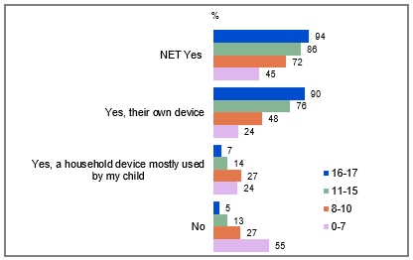

Source: PARF7. Does your child have their own device for online content consumption, or a household device that is mostly used by your child?

Base: MCCS, Respondents who are parents/legal guardians/carers of a child aged 17 or under. 2024: Total n=2,054. 8-10 (n=199), 11-15 (n=199), 16-17 (n=141).

Notes: Don’t know/refused responses not shown. 2024 DK = 1%, Ref = 0.2%. ‘NET Yes’ includes ‘Yes, their own device’ and ‘Yes, a household device mostly used by my child’.

A bar chart comparing children's device arrangements among children aged 0-7, 8-10, 11-15, and 16-17, reported by parents/legal guardians/carers.

NET Yes (having own device or a household device mostly used by child):

16-17: 94%

11-15: 86%

8-10: 72%

0-7: 45%

Yes, their own device:

16-17: 90%

11-15: 76%

8-10: 48%

0-7: 24%

Yes, a household device mostly used by my child:

16-17: 7%

11-15: 14%

8-10: 27%

0-7: 24%

No (no personal device or access to a household device)

16-17: 5%

11-15: 13%

8-10: 27%

0-7: 55%

#### Subgroups

NET Yes was higher for:

* Those whose child is aged 16-17 (94% vs 45% of those whose child is aged 0-7, 72% of those whose child is aged 8-10, 86% of those whose child is aged 11-15).
* Ages 55-64 (96% vs 80% of those ages 18-24, 53% of those ages 25-34, 64% of those ages 35-44, 87% of those ages 45-54, 81% of those ages 65-74, 73% of those ages 75+)**Parents/le**
* Those with education up to Year 12 (75%), a TAFE qualification / Trade Certificate / Diploma (78% vs 60% of those with a Bachelor degree)

Yes, their own device was higher for:

* Those whose child is aged 16-17 (90% vs 24% of those whose child is aged 0-7, 48% of those whose child is aged 8-10, 76% of those whose child is aged 11-15).
* Those living outside a capital city (64% vs 52% of those living in a capital city)

Yes, a household device mostly used by my child was higher for:

* Those whose child is aged 0-7 (24%), 8-10 (27% vs 14% of those whose child is aged 11-15, 7% of those whose child is aged 16-17)
* Those living in a capital city (20% vs 13% of those living outside a capital city)

Nowas higher for:

* Those whose child is aged 0-7 (55%), 8-10 (27% vs 13% of those whose child is aged 11-15, 5% of those whose child is aged 16-17).
* Ages 25-34 (47% vs 18% of those ages 18-24, 35% of those ages 35-44, 12% of those ages 45-54, 4% of those ages 55-64, 19% of those ages 65-74)
* Those with a Bachelor degree (39%), a Postgraduate degree (34% vs 21% of those with a TAFE qualification / Trade Certificate / Diploma)

Approximately three-quarters of parents/legal guardians/carers reported that their child either had their own device or relied on a household device for online content consumption.

### Reasons for children’s device arrangement

Parents/legal guardians/carers whose child had their own device or primarily used a household device were asked the reasons for this arrangement with the rationale for access levels generally varying by age. Teens received devices primarily to support their independence and communication needs, while younger children's access focused on educational benefits and controlled entertainment, along with creating a cohesive household and safety. Education, parental controls, entertainment, and communication were common factors across all ages.

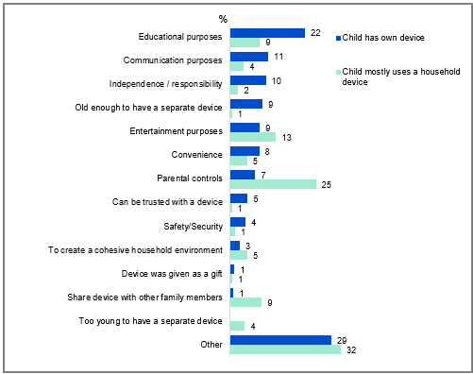

A bar chart comparing the reasons for children having their own device versus mostly using a household device.

Child has own device:

Educational purposes: 22%

Communication purposes: 11%

Independence / responsibility: 10%

Old enough to have a separate device: 9%

Entertainment purposes: 9%

Convenience: 8%

Parental controls: 7%

Can be trusted with a device: 5%

Safety/Security: 4%

To create a cohesive household environment: 3%

Device was given as a gift: 1%

Share device with other family members: 1%

Too young to have a separate device: 0%

Other: 29%

Child mostly uses a household device:

Educational purposes: 9%

Communication purposes: 4%

Independence / responsibility: 2%

Old enough to have a separate device: 1%

Entertainment purposes: 13%

Convenience: 5%

Parental controls: 25%

Can be trusted with a device: 1%

Safety/Security: 1%

To create a cohesive household environment: 5%

Device was given as a gift: 1%

Share device with other family members: 9%

Too young to have a separate device: 4%

Other: 32%

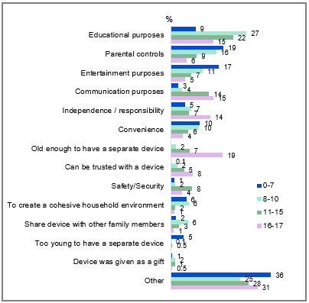

Source: PARF8. You answered [INSERT OPTION SELECTED AT PARF7] – what are the reasons you have this arrangement in place?

Base: MCCS, All parents/legal guardians/carers whose child has their own device a household device they mostly used for online content consumption. 2024: n=1,435. 0-7: n=227. 8-10: n=347. 11-15: n=435. 16-17: n=426.

Notes: Don’t know/refused responses not shown. 2024 DK=2%, Ref=7%.

A bar chart comparing the reasons for children's device arrangement, by age categories (0-7, 8-10, 11-15, 16-17).

For ages 0-7:

Educational purposes: 9%

Parental controls: 19%

Entertainment purposes: 17%

Communication purposes: 3%

Independence / responsibility: 5%

Convenience: 10%

Old enough to have a separate device: 0%

Can be trusted with a device: 0.1%

Safety/Security: 1%

To create a cohesive household environment: 6%

Share device with other family members: 2%

Too young to have a separate device: 5%

Device was given as a gift: 1%

Other: 36%

For ages 8-10:

Educational purposes: 27%

Parental controls: 16%

Entertainment purposes: 11%

Communication purposes: 4%

Independence / responsibility: 7%

Convenience: 10%

Old enough to have a separate device: 2%

Can be trusted with a device: 2%

Safety/Security: 2%

To create a cohesive household environment: 6%

Share device with other family members: 6%

Too young to have a separate device: 0.1%

Device was given as a gift: 2%

Other: 25%

For ages 11-15:

Educational purposes: 22%

Parental controls: 9%

Entertainment purposes: 7%

Communication purposes: 14%

Independence / responsibility: 7%

Convenience: 6%

Old enough to have a separate device: 7%

Can be trusted with a device: 5%

Safety/Security: 8%

To create a cohesive household environment: 2%

Share device with other family members: 3%

Too young to have a separate device: 0.5%

Device was given as a gift: 1%

Other: 28%

For ages 16-17:

Educational purposes: 15%

Parental controls: 6%

Entertainment purposes: 5%

Communication purposes: 15%

Independence / responsibility: 14%

Convenience: 4%

Old enough to have a separate device: 19%

Can be trusted with a device: 8%

Safety/Security: 4%

To create a cohesive household environment: 1%

Share device with other family members: 1%

Too young to have a separate device: 0%

Device was given as a gift: 0.5%

Other: 31%

#### ‘Other’ examples:

* “It’s an old spare iPad”
* “Peer pressure and ease”
* “They make their own content”

#### Subgroups

Educational purposes was higher for:

* Children aged 8-10 (27%), 11-15 (22% vs 9% of those aged 0-7, 15% of those aged 16-17)
* Those employed full time or part time (19%), self-employed (26%), students (36% vs 6% of those employed casually, 4% of non-worker)
* Non-Aboriginal and/or Torres Strait Islander respondents (19% vs 5% of Aboriginal and/or Torres Strait Islander respondents)
* Those born in a mainly non-English speaking country (25% vs 16% of those born in a mainly English speaking country)

Parental controls was higher for:

* Children aged 0-7 (19%), 8-10 (16% vs 9% of those aged 11-15, 6% of those aged 16-17).

Entertainment purposes was higher for:

* Children aged 0-7 (17%), 8-10 (11% vs 5% of those aged 16-17).

Communication purposes was higher for:

* Children aged 16-17 (15%), 11-15 (14% vs 3% of those aged 0-7, 4% of those aged 8-10).
* Those with a TAFE, Trade Certificate, Diploma (13% vs 4% of those with education up to Year 12)

Independence / responsibility was higher for:

* Children aged 16-17 (14% vs 5% of those aged 0-7, 7% of those aged 8-10, 7% of those aged 11-15).
* Those born in a mainly English speaking country (10% vs 6% of those born in a mainly non-English speaking country)

Old enough to have a separate device was higher for:

* Children aged 16-17 (19% vs 7% of those aged 11-15, 2% of those aged 8-10, 0% of those aged 0-7).
* Those with education up to Year 12 (9%), a TAFE, Trade Certificate, Diploma (9% vs 6% of those with a Bachelor Degree, 3% of those with a Postgraduate Degree)
* Those born in a mainly English speaking country (9% vs 3% of those born in a mainly non-English speaking country)

Safety / security was higher for:

* Children aged 11-15 (8% vs 1% of those aged 0-7, 2% of those aged 8-10).

To create a cohesive household environment was higher for:

* Children aged 0-7 (6%), 8-10 (6% vs 2% of those aged 11-15, 1% of those aged 16-17).

Parents/legal guardians/carers reported that the primary reasons for providing their child with a personal or household device for online content consumption were education, followed by parental controls, entertainment and communication purposes.

### Personal internet use outside of home (children aged 0-17)

Children aged 8-17 were directly asked about their personal internet usage (excluding school or work-related activities) outside of their home, whereas parents/ legal guardians/ carers were asked to respond on behalf of children aged 0-7. While older children reported higher rates of independent internet use outside the home the majority or all of the time, age-related differences were minimal among those who used internet outside of home regularly. However, younger children were significantly more likely to have never used the internet outside of home compared to older children.

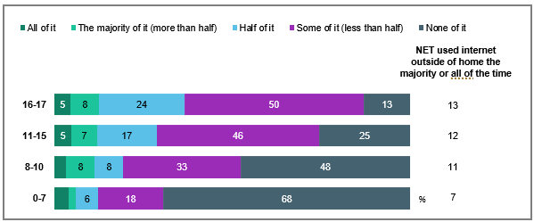

Source: KB18, KC18, KD18. How much of your internet use happens when you are not at home? (Not for school activities). KA19. How much of your child’s personal internet use, not for school or work occurs on a device that is theirs?

Base: MCCS, All children aged 0-17. 0-7 (n=336), 8-10 (n=199), 11-15 (n=199), 16-17 (n=141).

Notes: Don’t know/refused responses not shown. 0-7: DK=1%, Ref=0%. 8-10: DK and Ref=0%. 11-15: DK=0%, Ref=0.4%. 16-17: DK and Ref=0%. Labels for responses <5% are not shown on chart. ‘NET used internet outside of home the majority or all of the time’ includes ‘All of it’, ‘The majority of it (more than half)’.

A bar chart comparing the amount of children's personal internet use that happened outside of home (excluding school activities) among different age groups: 0-7, 8-10, 11-15, and 16-17.

For ages 0-7:

All of it: 4%

The majority of it (more than half): 2%

Half of it: 6%

Some of it (less than half): 18%

None of it: 68%

NET used internet outside of home the majority or all of the time: 7%

For ages 8-10:

All of it: 3%

The majority of it (more than half): 8%

Half of it: 8%

Some of it (less than half): 33%

None of it: 48%

NET used internet outside of home the majority or all of the time: 11%

For ages 11-15:

All of it: 5%

The majority of it (more than half): 7%

Half of it: 17%

Some of it (less than half): 46%

None of it: 25%

NET used internet outside of home the majority or all of the time: 12%

For ages 16-17:

All of it: 5%

The majority of it (more than half): 8%

Half of it: 24%

Some of it (less than half): 50%

None of it: 13%

NET used internet outside of home the majority or all of the time: 13%

#### Subgroups

None of it was higher for:

* Children aged 8-10 (48% vs 25% of those aged 11-15, 13% of those aged 16-17).

NET used internet outside of home at least some of the time was higher for:

* Children had own device for online content consumption (72% vs 52% of children who mostly used a household device, 29% of children had no device)

#### Callout

* For children who use the internet outside of home all or most of the time, the types of content they like watching the most were Australian children’s educational programs, and the platform most used to watch Australian and other screen content was ‘YouTube, YouTube Kids, Twitch or Tubi (Free video streaming services)’.

Older children were more likely to use the internet for personal reasons outside of the home compared to younger children in 2024 (although not at significant levels)

### Parents’ perception of children’s personal internet use outside of home

Parents/legal guardians/carers were also asked the extent to which their child accessed the internet for personal use outside their home. Personal internet use outside the home averaged 13% across all age groups, with higher rates among teens (11-17: 16%) and young children (0-7: 13%) compared to those aged 8-10 (6%). Notably, parental estimates typically exceeded children's self-reported usage, except for the 8-10 age group.

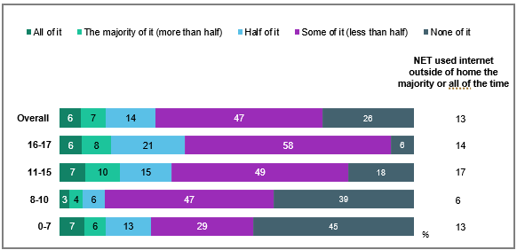

Source: PARF10. How much of your child's personal use of the internet occurs outside your home/dwelling?

Base: MCCS, All parents/legal guardians/carers whose child has their own device a household device they mostly used for online content consumption. 2024: n=1,435.

Notes: Don’t know/refused responses not shown: Overall: DK=1%, Ref=0.1%. 0-7: DK=0%, Ref=1%. 8-10: DK=2%, Ref=0%. 11-15: DK=1%, Ref=0%. 16-17: DK=0.3%, Ref=0%. ‘NET used internet outside of home the majority or all of the time’ includes ‘All of it’, ‘The majority of it (more than half)’.

A bar chart comparing the amount of personal internet use that occurred outside the home/dwelling among different age groups: 0-7, 8-10, 11-15, and 16-17.

For ages 0-7:

All of it: 7%

The majority of it (more than half): 6%

Half of it: 13%

Some of it (less than half): 29%

None of it: 45%

NET used internet outside of home the majority or all of the time: 13%

For ages 8-10:

All of it: 3%

The majority of it (more than half): 4%

Half of it: 6%

Some of it (less than half): 47%

None of it: 39%

NET used internet outside of home the majority or all of the time: 6%

For ages 11-15:

All of it: 7%

The majority of it (more than half): 10%

Half of it: 15%

Some of it (less than half): 49%

None of it: 18%

NET used internet outside of home the majority or all of the time: 17%

For ages 16-17:

All of it: 6%

The majority of it (more than half): 8%

Half of it: 21%

Some of it (less than half): 58%

None of it: 6%

NET used internet outside of home the majority or all of the time: 14%

Overall:

All of it: 6%

The majority of it (more than half): 7%

Half of it: 14%

Some of it (less than half): 47%

None of it: 26%

NET used internet outside of home the majority or all of the time: 13%

#### Subgroups

NET used internet outside of home the majority or all of the time was higher for:

* Children aged 11-15 (17%), 16-17 (14%), 0-7 (13% vs 6% of those aged 8-10).

None of it was higher for:

* Children aged 0-7 (45%), 8-10 (39% vs 18% of those aged 11-15, 6% of those aged 16-17).

NET ever used internet outside of home (all of it, the majority or it, half of it, or some of it):

* Overall: 74%
* 16-17: 93%
* 11-15: 81%
* 8-10: 59%
* 0-7: 54%

NET ever used internet outside of home was higher for children aged 16-17 (93%) and 11-15 (81%).

Parents/legal guardians/carers reported that older children aged 11-17 and younger children aged 0-7 were more likely to use internet outside of home the majority or all of the time.

### Personal internet use on their own device (children aged 0-17)

Children aged 8-17 were directly asked about their personal internet usage (excluding school or work-related activities) on own device, whereas parents/ legal guardians/ carers were asked to respond on behalf of children aged 0-7. Internet access, using their own device the majority or all of the time, showed a clear age progression among children aged 11-17 compared to younger children.

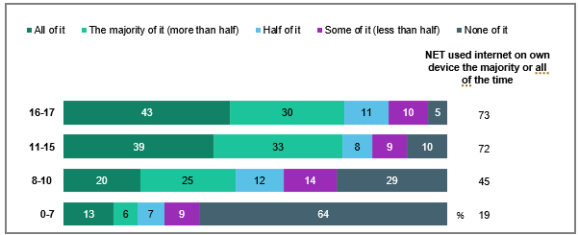

Source: KA19. How much of your child’s personal internet use, not for school or work occurs on a device that is theirs? KB19, KC19, KD19. How much of your internet use happens on a device that is yours? (Not for school)

Base: MCCS, All children aged 0-17. 0-7 (n=336). 8-10 (n=199), 11-15 (n=199), 16-17 (n=141).

Notes: Don’t know/refused responses not shown. 0-7: DK=0.4%, Ref=0.4%. 8-10: DK=0.5%, Ref=0%. 11-15: DK=0%, Ref=0.4%. 16-17: DK and Ref=0%. NET used internet outside of home the majority or all of the time’ includes ‘All of it’, ‘The majority of it (more than half)’.

A bar chart comparing the amount of personal internet use, not for school or work, that occurred on a device owned by the child, categorised by age groups: 0-7, 8-10, 11-15, and 16-17.

For ages 0-7:

All of it: 13%

The majority of it (more than half): 6%

Half of it: 7%

Some of it (less than half): 9%

None of it: 64%

NET used internet on own device the majority or all of the time: 19%

For ages 8-10:

All of it: 20%

The majority of it (more than half): 25%

Half of it: 12%

Some of it (less than half): 14%

None of it: 29%

NET used internet on own device the majority or all of the time: 45%

For ages 11-15:

All of it: 39%

The majority of it (more than half): 33%

Half of it: 8%

Some of it (less than half): 9%

None of it: 10%

NET used internet on own device the majority or all of the time: 72%

For ages 16-17:

All of it: 43%

The majority of it (more than half): 30%

Half of it: 11%

Some of it (less than half): 10%

None of it: 5%

NET used internet on own device the majority or all of the time: 73%

#### Subgroups

NET used internet on own devices the majority or all of the time was higher for:

* Children aged 16-17 (73%), and 11-15 (72% vs 45% of those aged 8-10, 19% of those aged 0-7).
* Children who used internet outside of home the majority or all of the time (72% vs 42% of those who used internet outside of home half of the time, some of the time or none of the time)
* Children who watched other websites or apps in P7D (76% vs 47% of those who watched FTA Broadcast, 35% of those who watched FTA BVOD, 50% of those who watched pay-TV, 48% of those who watched SVOD in P7D)

None of it was higher for:

* Children aged 8-10 (29% vs 10% of those aged 11-15, 5% of those aged 16-17).

NET ever used internet on own device (all of it, the majority or it, half of it, or some of it):

* 16-17: 95%
* 11-15: 89%
* 8-10: 71%
* 0-7: 35%

NET ever used internet on own device was higher for children aged 16-17 (95%) and 11-15 (89%).

#### Note

* **FTA BVOD** includes ‘Commercial free-to-air on-demand TV (e.g. 9Now, 10 Play, 7plus)’ and ‘Publicly owned free-to-air on-demand TV (e.g. ABC iview, SBS On Demand, ABC News, ABC Kids)’
* **FTA Broadcast** includes ‘Commercial free-to-air TV (e.g. Seven, Nine, 10, WIN, Imparja, NBN Television), including recorded content but excluding on-demand TV’ and ‘Publicly owned free-to-air TV (i.e. ABC, SBS), including recorded content but excluding on-demand TV’
* **SVOD** includes ‘Online subscription services (e.g. Netflix, Binge, YouTube Premium)’ and ‘Sports specific website or app (e.g. AFL Live, NRL Live, Cricket Australia Live, Kayo Sports, Stan Sport)’
* **Pay-TV** includes ‘Pay-per-view services (e.g. Google Play)’ and ‘Pay TV (e.g. Foxtel, Fetch TV), including recorded content but excluding streaming’

Older children were more likely to have accessed the internet for personal use on their own device compared to younger children.

### Parents’ perception of children’s personal internet use on their own devices

Parents/legal guardians/carers were also asked the extent to which their child accessed internet for personal use on their own devices. Seven in ten children (69%) used personal devices the majority or all of the time to access the internet, with rates climbing by age group (53% for youngest children, 59% for ages 8-10, 76% for ages 11-15, and 82% for teens 16-17). Though following similar patterns, children's self-reported usage was marginally lower than parental estimates.

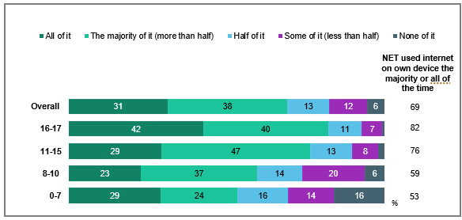

Source: PARF9. How much of your child’s personal use of the internet occurs on their own device?

Base: MCCS, All parents/legal guardians/carers whose child has their own device a household device they mostly used for online content consumption. 2024: n=1,435.

Notes: Don’t know/refused responses not shown: Overall: DK=0.2%, Ref=0.2%. 0-7: DK=0%, Ref=1%. 8-10: DK=0%, Ref=1%. 11-15: DK=0.3%, Ref=0%. 16-17: DK=0.3%, Ref=0%. Labels for responses <5% are not shown on chart. ‘NET used internet on own device at least some of the time’ includes ‘All of it’, ‘The majority of it (more than half)’, ‘Half of it’, and ‘Some of it (less than half)’.

A bar chart comparing the amount of personal internet use that occurred on a child's own device, reported by parents/legal guardians/carers whose child has their own device a household device they mostly used for online content consumption, categorised by age groups: 0-7, 8-10, 11-15, and 16-17.

For ages 0-7:

All of it: 29%

The majority of it (more than half): 24%

Half of it: 16%

Some of it (less than half): 14%

None of it: 16%

NET used internet on own device the majority or all of the time: 53%

For ages 8-10:

All of it: 23%

The majority of it (more than half): 37%

Half of it: 14%

Some of it (less than half): 20%

None of it: 6%

NET used internet on own device the majority or all of the time: 59%

For ages 11-15:

All of it: 29%

The majority of it (more than half): 47%

Half of it: 13%

Some of it (less than half): 8%

None of it: 2%

NET used internet on own device the majority or all of the time: 76%

For ages 16-17:

All of it: 42%

The majority of it (more than half): 40%

Half of it: 11%

Some of it (less than half): 7%

None of it: 1%

NET used internet on own device the majority or all of the time: 82%

Overall:

All of it: 31%

The majority of it (more than half): 38%

Half of it: 13%

Some of it (less than half): 12%

None of it: 6%

NET used internet on own device the majority or all of the time: 69%

#### Subgroups

NET used internet on own devices the majority or all of the time was higher for:

* Children aged 16-17 (82%), 11-15 (76% vs 59% of those aged 8-10, 53% of those aged 0-7).

None of it was higher for:

* Children aged 0-7 (16% vs 6% of those aged 8-10, 2% of those aged 11-15, 1% of those aged 16-17).

Parents/legal guardians/carers reported older children were more likely than younger children to have used internet on their own device the majority or all of the time.

### Personal internet use on a device not theirs (children aged 0-7 and 11-17)

Children aged 11-17 were directly asked to what extent their personal internet use (excluding school or work-related activities) happened on a device not theirs, whereas parents/ legal guardians/ carers answered on behalf of their child aged 0-7. Younger children were consistently more likely than older children to have used someone else’s device to access the internet the majority or all of the time.

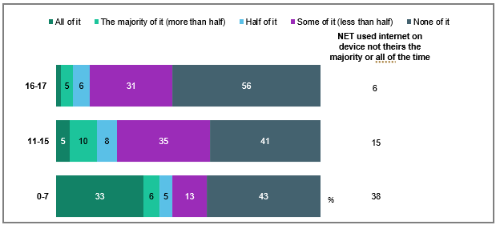

Source: : KA20. How much of your child’s internet use occurs on a device that is not theirs? (Not for school). KC20, KD20. How much of your internet use happens on a device that is not yours? (Not for school or work)

Base: MCCS, All children aged 0-7 and 11-17. 0-7 (n=336), 11-15 (n=199), 16-17 (n=141).

Notes: Don’t know/refused responses not shown: 0-7: DK=1%, Ref=0%. 11-15: DK=1%, Ref=0%. 16-17: DK and Ref =0%. Children aged 8-10 were not asked of this question. Labels for responses <5% are not shown on chart. ‘NET used internet on device not theirs the majority or all of the time’ includes ‘All of it’, ‘The majority of it (more than half)’.

A bar chart comparing the amount of personal internet use that occurred on a device not owned by the child, categorised by age groups: 0-7, 11-15, and 16-17.

For ages 0-7:

All of it: 33%

The majority of it (more than half): 6%

Half of it: 5%

Some of it (less than half): 13%

None of it: 43%

NET used internet on device not theirs the majority or all of the time: 38%

For ages 11-15:

All of it: 5%

The majority of it (more than half): 10%

Half of it: 8%

Some of it (less than half): 35%

None of it: 41%

NET used internet on device not theirs the majority or all of the time: 15%

For ages 16-17:

All of it: 2%

The majority of it (more than half): 5%

Half of it: 6%

Some of it (less than half): 31%

None of it: 56%

NET used internet on device not theirs the majority or all of the time: 6%

#### Subgroups

NET used internet on device not theirs the majority or all of the time was higher for:

* Children aged 0-7 (38% vs 15% of those aged 11-15, 6% of those aged 16-17).
* Children who watched FTA BVOD (38%), FTA Broadcast (30%), Pay-TV (25%), free video streaming services (24%), SVOD in P7D (27% vs 7% of those who watched other websites of apps in P7D)

None of it was higher for:

* Children aged 16-17 (56% vs 41% of those aged 11-15).

#### Note

* **FTA BVOD** includes ‘Commercial free-to-air on-demand TV (e.g. 9Now, 10 Play, 7plus)’ and ‘Publicly owned free-to-air on-demand TV (e.g. ABC iview, SBS On Demand, ABC News, ABC Kids)’
* **FTA Broadcast** includes ‘Commercial free-to-air TV (e.g. Seven, Nine, 10, WIN, Imparja, NBN Television), including recorded content but excluding on-demand TV’ and ‘Publicly owned free-to-air TV (i.e. ABC, SBS), including recorded content but excluding on-demand TV’
* **SVOD** includes ‘Online subscription services (e.g. Netflix, Binge, YouTube Premium)’ and ‘Sports specific website or app (e.g. AFL Live, NRL Live, Cricket Australia Live, Kayo Sports, Stan Sport)’
* **Pay-TV** includes ‘Pay-per-view services (e.g. Google Play)’ and ‘Pay TV (e.g. Foxtel, Fetch TV), including recorded content but excluding streaming’

Younger children were more likely than older children to have used others’ devices to access the internet for personal use outside of work or school.

### Videogame Microtransactions made by children

Parents/legal guardians/carers were asked if their child had made any in-game purchases in a video game, and if the purchases were authorised. In-game purchasing behavior varied by age, with 20% of all children making purchases, of which 75% were parent-authorised. While teens (11-17) showed higher overall purchase rates, unauthorised transactions were more common among young children (0-7).

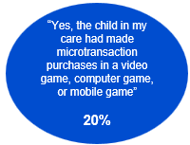

Source: PARF11. In the past 12 months, has a child in your care made any microtransaction purchases in a video game, computer game, or mobile game?

Base: MCCS, Respondents who are parents/legal guardians/carers of a child aged 17 or under. 2024: n=2,054.

Notes: No/Don’t know/refused responses not shown. DK and Ref options were displayed upfront with other response options. 2024 No = 73%, DK = 7%, Ref = 1%.

20% of parents/legal guardians/carers reported that the child in their care had made microtransaction purchases in a video game, computer game, or mobile game in the past 12 months.

#### Subgroups

Made any microtransaction purchase in a video game was higher for:

* Children aged 11-15 (30%), 16-17 (30% vs 5% of those aged 0-7, 21% of those aged 8-10).

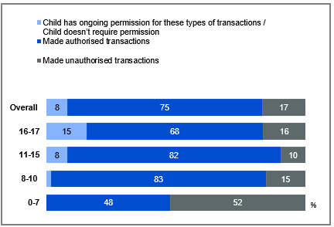

Source: PARF12. Were any of the microtransaction purchases by the child in your care made without permission of the person paying for the transaction?

Base: MCCS, All parents/legal guardians/carers whose child had made any microtransaction purchases in a video game. 2024: n=426. 0-7: n=31. 8-10: n=98. 11-15: n=163. 16-17: n=134.

Notes: Don’t know/refused responses not shown. Labels for responses <5% are not shown on chart. 2024 DK = 0% for all ages, Ref = 0% for al ages.

A bar chart comparing the types of microtransaction purchases made by children, grouped by the nature of the transactions:

Made unauthorised transactions:

Ages 0-7: 52%

Ages 8-10: 15%

Ages 11-15: 10%

Ages 16-17: 16%

Overall: 17%

Child has ongoing permission for these types of transactions / Child doesn’t require permission:

Ages 0-7: 0%

Ages 8-10: 2%

Ages 11-15: 8%

Ages 16-17: 15%

Overall: 8%

Made authorised transactions:

Ages 0-7: 48%

Ages 8-10: 83%

Ages 11-15: 82%

Ages 16-17: 68%

Overall: 75%

#### Subgroups

Made unauthorised transactions was higher for:

* Children aged 0-7 (52% vs 15% of those aged 8-10, 10% of those aged 11-15, 16% of those aged 16-17).
* Children ever used internet outside of home (19% vs 7% of those who never used internet outside of home)

Made authorised transactions was higher for:

* Children aged 8-10 (83%), 11-15 (82% vs 48% of those aged 0-7, 68% of those aged 16-17).

Ongoing permission/ doesn’t require permission was higher for:

* Children aged 16-17 (15% vs 2% of those aged 8-10).

One-in-five parents/legal guardians/carers reported that their child had made microtransaction purchases in a video game, and the majority reported that such purchases were made with permission.

## TV: access, devices, and free-to-air

### Chapter Summary – TV

Access to TV via traditional means of broadcast signal or antennas was consistent with 2023.

* Broadcast signal or antenna (56%) remained the most common method for accessing free-to-air TV, although on-demand TV apps (net) were also common (56%).
* Nearly half (49%) of respondents reported usage of traditional broadcast signal or antenna in 2024.

Numbers of TVs in Australian households has decreased slightly in 2024.

* Respondents most commonly reported having either one (39%) or two (%%) TVs in their house, with the proportion of households having one TV increased in 2024.
* The average number of TVs in a household declined slightly in 2024 (1.9).

TV-internet connectivity remained consistent

* Most commonly one TV was connected to the internet (46%), although some respondents said two were connected to the internet (26%), while 13% said none were connected to the internet.

TV connection to a free-to-air television aerial, antenna, or broadcast signal was high

* Around two-thirds (67%) of households had access to a free-to-air broadcast signal, with most connections through primary TVs (87%).
* TV connection to an external aerial was commonly reported via a co-axial cable or a similar cable (82%).
* Over three quarters (77%) of households’ primary working TVs had built-in capabilities to connect to a free-to-air broadcast signal without the need for an external aerial.
* Traditional connections such as broadcast signal, aerial, antenna, or pay-TV set-top box (75% net rarely, sometimes, often, very often), and internet connections via an internet-connected television, an internet-enabled device, or a broadcaster’s video-on-demand service (72% net) were both used by most to watch free-to-air TV content.

VAST Box ownership driven by demographic factors

* 2.56% of households owned a VAST Box, with the majority of these owning just one (69%).
* VAST Box ownership was driven by those on lower incomes, younger ages, and those with children.
* Respondents with a VAST Box in their household reported various installation timelines.
* VAST Box performance was rated highly among respondents with at least one in their household, with 91% of those owning up to two reporting it functions at least some of the time.

### How respondents access free-to-air TV

Traditional broadcast antenna and on-demand TV apps were equally common (both 56%) means for accessing free-to-air TV, though antenna usage declined in 2024. VAST Box viewership remained niche and also declined in 2024.

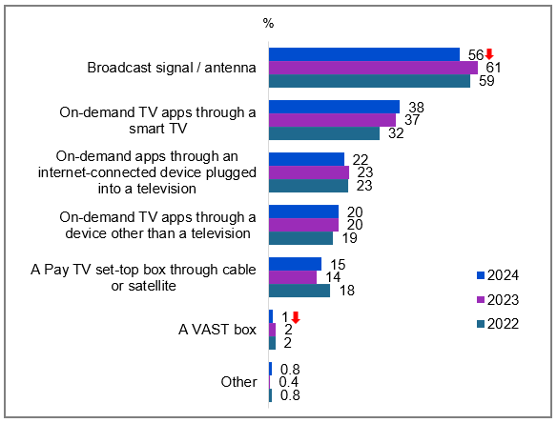

Source: NEWC2b.How do you access free-to-air television?

Base: TVCS, MCCS. Respondents who watched free-to-air TV in the past 7 days. 2024: n=2,702. 2023: n=2,439. 2022: n=2,935.

Notes: Don’t know/refused responses not shown: 2024 DK = 0.4%, Ref = 0.1%. 2023 DK = 0.3%, Ref = 0.1%. 2022 DK = 0.8%, Ref = 0.0%

A bar chart showing how people accessed free-to-air TV among those who watched free-to-air TV in the past 7 days, between 2022 and 2024.

Broadcast signal / antenna: 56% in 2024, 61% in 2023, 59% in 2022.

On-demand TV apps through a smart TV: 38% in 2024, 37% in 2023, 32% in 2022.

On-demand apps through an internet-connected device plugged into a television: 22% in 2024, 23% in 2023, 23% in 2022.

On-demand TV apps through a device other than a television: 20% in 2024, 20% in 2023, 19% in 2022.

A Pay TV set-top box through cable or satellite: 15% in 2024, 14% in 2023, 18% in 2022.

A VAST box: 1% in 2024, 2% in 2023, 2% in 2022.

Other: 0.8% in 2024, 0.4% in 2023, 0.8% in 2022.

#### Subgroups

Broadcast signal / antenna was higher for:

* Men (63% vs 48% of women)
* Ages 65-74 (62% vs 49% of ages 45-54)
* Those living outside a capital city (62% vs 50% of those living in a capital city)
* Those without children (58% vs 45% of those with dependent children in household)
* Those without fixed home internet (73% vs 53% of those with fixed home internet)

NET on-demand apps was higher for:

* Women (59% vs 53% of men)
* Ages 45-54 (64% vs 51% of ages 55-64, 50% of ages 65-74, 50% of ages 75+)
* Those living in a capital city (61% vs 51% of those living outside a capital city)
* Those with dependent children in the household (68% vs 53% of those without children)
* Those without a disability (58% vs 49% of those with a disability)
* Those with fixed home internet (59% vs 37% of those without fixed home internet)

#### Callout

* Free-to-air TV access via NET on-demand apps was 56% in 2024, 58% in 2023, and 53% in 2022.
* Accessing free-to-air TV via broadcast signal or antenna (56% vs 61% in 2023), or a VAST box (1% vs 2% in 2023) both decreased significantly in 2024.

The traditional method of accessing TV through a broadcast signal or antenna remained the most common, consistent with prior years.

### How respondents access free-to-air TV most often

Of those who have watched free-to-air TV in the past 7 days, a traditional broadcast signal or antenna remained the preferred access method (49%), followed by smart TV apps (23%), while VAST Box usage dropped to just 1% in 2024.

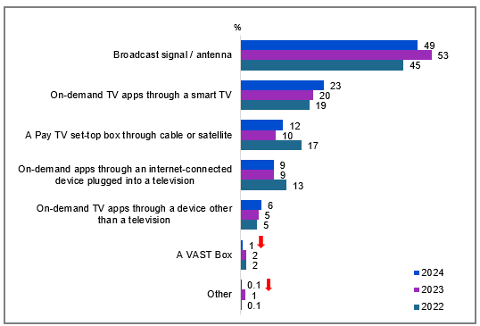

Source: NEWC2c. How do you access free-to-air television most often?

Base: TVCS, MCCS. Respondents who watched free-to-air television in the past 7 days and accessed free-to-air television via more than one ways. 2024: n=2,677. 2023: n=2,439. 2022: n=1,048.

Notes: Don’t know/refused responses not shown: 2024 DK = 0.5%, Ref = 0.1%. 2023 DK = 0.3%, Ref = 0%. 2022 DK = 0.2%, Ref = 0%

A bar chart showing how people access free-to-air television most often, grouped by the method of access for the years 2022, 2023, and 2024.

Broadcast signal / antenna: 49% in 2024, 53% in 2023, 45% in 2022.

On-demand TV apps through a smart TV: 23% in 2024, 20% in 2023, 19% in 2022.

A Pay TV set-top box through cable or satellite: 12% in 2024, 10% in 2023, 17% in 2022.

On-demand apps through an internet-connected device plugged into a television: 9% in 2024, 9% in 2023, 13% in 2022.

On-demand TV apps through a device other than a television: 6% in 2024, 5% in 2023, 5% in 2022.

A VAST Box: 1% in 2024, 2% in 2023, 2% in 2022.

Other: 0.1% in 2024, 1% in 2023, 0.1% in 2022.

#### Subgroups

Broadcast signal / antenna was higher for:

* Men (55% vs 43% of women)
* Those living outside a capital city (56% vs 43% of those living in a capital city)
* Those without children in the household (52% vs 37% of those with dependent children)
* Those without fixed home internet (73% vs 46% of those with fixed home internet)

#### Callout

* Regular access to free-to-air TV via a VAST Box (1% vs 2% in 2023) or other methods (0.1% vs 1% in 2023) decreased significantly in 2024.

Broadcast signal or antenna remained the most common way to access free-to-air TV in 2024.

### Frequency of watching free-to-air TV on various devices

Television sets dominated free-to-air viewing, with 71% of viewers (net use) accessing content through traditional TV screens in an average week.

Table Frequency of watching free-to-air TV on various devices (%)

|  |  |  |  |  |  |  |  |  |  |  |
| --- | --- | --- | --- | --- | --- | --- | --- | --- | --- | --- |
| Device | NET Use | More often than 5 times a day | 3-5 times a day | Once or twice a day | More often than 5 times a week | 3-5 times a week | Once or twice a week | Never | 2022 NET use | 2023 NET use |
| **Television (including smart TV)** | 71 | 6 | 7 | 18 | 14 | 11 | 14 | 14 | 74 | 74 |
| **Mobile phone or smartphone** | 27 | 4 | 2 | 2 | 3 | 4 | 11 | 45 | 30 | 30 |
| **TV smart accessory / Digital media player** | 24 | 2 | 2 | 3 | 4 | 5 | 9 | 14 | 27 | 28 |
| **Computer (desktop or laptop)** | 24 | 2 | 2 | 2 | 2 | 4 | 12 | 36 | 26 | 25 |
| **Tablet** | 17 | 1 | 1 | 2 | 2 | 3 | 8 | 18 | 19 | 16 |
| **Pay TV box** | 16 | 2 | 2 | 3 | 3 | 3 | 4 | 5 | 18 | 15 |
| **Games console connected to a television** | 7 | 0.0 | 0.2 | 1 | 1 | 1 | 3 | 9 | 8 | 7 |
| **A VAST box** | 3 | 0.1 | 0.3 | 0.3 | 1 | 1 | 1 | 1 | 3 | 5 |

Source: NEW10. On average per week, how often do you use the following devices to watch free-to-air television (live or on-demand)?

Base: TVCS, Results have been rebased to a proportion of all TVCS survey respondents. 2024: n=3,890. 2023: n=3,861. 2022: n=4,016.

Notes: Don’t know/refused responses not shown, % vary per statement. Rows do not sum to 100%: due to rebasing to total respondents n/a figures are not shown in table. Note that this question reflects use of devices to watch free-to-air TV specifically, and has a different base to C4, which asks about use of devices to watch screen content more generally and was asked of all respondents who watched screen content in the past 7 days.

#### Subgroups

Television (net use) was higher for:

* Women (74% vs 69% of men)
* Ages 55-64 (83%), 65-74 (85%) and 75+ (86% vs 42% of ages 18-24, 62% of ages 25-34, 72% of ages 35-44, and 73% of ages 45-54)
* Those living outside a capital city (76% vs 67% of those living in a capital city)
* Those owned outright (81%), occupied rent free (85%), owned with a mortgage (73% vs 57% of those rented)
* Those with education up to Year 12 (75%) or a TAFE qualification / Trade Certificate / Diploma (77% vs 64% of those with a Bachelor degree, 62% of those with a Postgraduate degree)

Free-to-air remained the most watched via TV in 2024, consistent with prior years.

### Number of TVs in respondents’ houses

Most households maintained one (39%) or two TVs (32%), with just 3% reporting no television in their house. Although the average number of working TVs in households decreased slightly from 2.0 in 2023 to 1.9 in 2024, single-TV households increased.

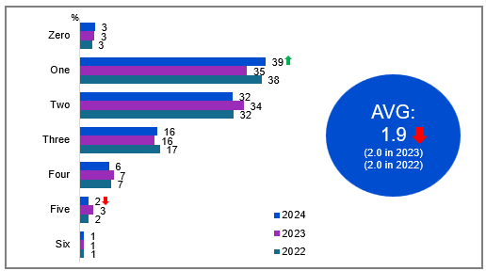

Source: NEW17a. How many working TVs are currently in your house?

Base: TVCS. All respondents. 2024: n=3,890. 2023: n=3,861. 2022: n=4,016.

Notes: Don’t know/refused responses not shown. 2024 DK = 0.2%. Ref = 0.1%. 2023 DK = 0.0%. Ref = 0.3%. 2022 DK = 0.2%, Ref = 0.1% (Seven and above not shown on chart).

A bar chart showing the percentage of households with a certain number of working TVs, grouped by the number of TVs for the years 2022, 2023, and 2024.

Zero: 3% in 2024, 3% in 2023, 3% in 2022.

One: 39% in 2024, 35% in 2023, 38% in 2022.

Two: 32% in 2024, 34% in 2023, 32% in 2022.

Three: 16% in 2024, 16% in 2023, 17% in 2022.

Four: 6% in 2024, 7% in 2023, 7% in 2022.

Five: 2% in 2024, 3% in 2023, 2% in 2022.

Six: 1% in 2024, 1% in 2023, 1% in 2022.

A blue circular graphic showing the average number of working TVs in households: 1.9 in 2024 (vs 2.0 in 2023, 2.0 in 2022)

#### Subgroups

**One** was higher for:

* Ages 25-34 (46% vs 33% of ages 45-54, 32% of ages 75+)
* Those without children in the household (44% vs 33% of those with dependent children, 28% of those with non-dependent children only)
* Those with a Bachelor degree (50%) or Postgraduate degree (48% vs 35% of those with education up to Year 12 and 32% of those with a TAFE qualification / Trade Certificate / Diploma)
* Those born in a mainly non-English speaking country (51% vs 36% of those born in a mainly English speaking country)
* Those without fixed home internet (50% vs 37% of those with fixed home internet)

#### Note

NEW17a – AVG: To set REF and DK to no value in avg, to not be included.

#### Callout

* In 2024, there was a significant increase in households having one working TV (39% vs 35% in 2023) and a decline in households with five working TVs (2% vs 3% in 2023).
* The average number of working TVs in households also declined significantly from 2.0 in 2023 to 1.9 in 2024.

The average number of TVs in households has decreased slightly in 2024.

### Number of TVs connected to the internet

Among respondents with at least one TV in their house, nearly half (46%) had one internet-connected set, while a quarter (26%) connected two TVs, and 13% maintained offline-only television viewing.

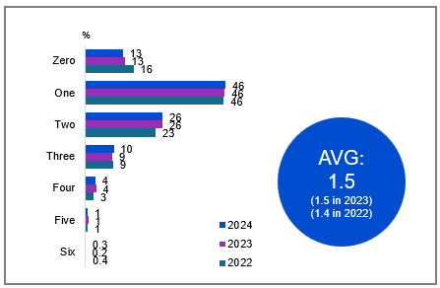

Source: NEW17b. Of the working TVs currently in your house, how many are connected to the internet (e.g. a smart TV or through a smart TV accessory such as a Google Chromecast)?

Base: TVCS, Respondents who have at least one TV in their house. 2024: n=3,795. 2023: n=3,757. 2022: n=3,910

Notes: Don’t know/refused responses not shown: 2024 DK = 0.4%, Ref = 0.3%. 2023 DK = 0.2%, Ref = 0.4%. 2022. DK = 0.5%, Ref = 0.1%. (Seven and above not shown on chart).

A bar chart showing the percentage of working TVs connected to the internet in households, grouped by the number of TVs for the years 2022, 2023, and 2024.

Zero: 13% in 2024, 13% in 2023, 16% in 2022.

One: 46% in 2024, 46% in 2023, 46% in 2022.

Two: 26% in 2024, 26% in 2023, 23% in 2022.

Three: 10% in 2024, 9% in 2023, 9% in 2022.

Four: 4% in 2024, 4% in 2023, 3% in 2022.

Five: 1% in 2024, 1% in 2023, 1% in 2022.

Six: 0.3% in 2024, 0.2% in 2023, 0.4% in 2022.

A blue circular graphic showing the average number of working TVs connected to the internet in households: 1.5 in 2024 (vs 1.5 in 2023, 1.4 in 2022)

#### Subgroups

Zero was higher for:

* Ages 75+ (27%), 65-74 (20%), and 55-64 (21% vs 4% of ages 18-24, 5% of ages 25-34, 7% of ages 35-44, and 11% of ages 45-54)
* Those living outside a capital city (16% vs 10% of those living in a capital city)
* Those without children in the household (16%), non-dependent children only (11%), other household (13%), non-related adults (9% vs 4% of those with dependent children)
* Those with education up to Year 12 (15%), a TAFE qualification / Trade Certificate / Diploma (13%), a Postgraduate degree (14% vs 8% of those with a Bachelor Degree)
* Those receiving government pensions, benefits or allowances (20% vs 9% of those did not)
* Those with a HH income of <$41,599 (22%), $41,600-$77,999 (14% vs 7% of those with a HH income of $104,000-$155,999 and 5% of those with a HH income of $156,000 or more)
* Those without fixed home internet (44% vs 9% of those with fixed home internet)

One was lower for:

* Ages 18-24 (57%), 25-34 (55% vs 36% of ages 45-54, 39% of ages 55-64)
* Those living in a capital city (49% vs 44% of those living outside a capital city)
* Those without children in the household (50% vs 40% of those with dependent children, 32% of those with non-dependent children only)
* Those with a Bachelor Degree (55%), a Postgraduate degree (52% vs 41% of those with a TAFE qualification / Trade Certificate / Diploma)
* Non-Aboriginal or Torres Strait Islander respondents (47% vs 33% of Aboriginal and / or Torres Strait Islander respondents)
* Those born in a mainly non-English speaking country (57% vs 44% of those born in a mainly English speaking country)

The average number of TVs in households connected to the internet remained unchanged in 2024.

### Number of TVs connected to an external aerial, antenna, or broadcast signal

Among respondents with at least one TV in their household, the most common setup was having one TV connected to an external free-to-air television aerial, antenna, or broadcast signal (43%). Additionally, 21% reported having two TVs connected to an external aerial, while 23% indicated that none were connected.

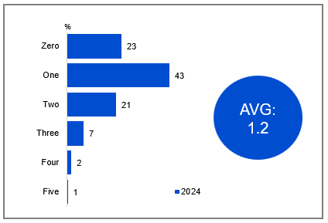

Source: NEW17bb. Of the working TVs in your house, how many are connected to an external free-to-air television aerial, antenna, or broadcast signal?

Base: TVCS, Respondents who have at least one TV in their house. 2024: n=3,795.

Notes: Don’t know/refused responses not shown: 2024 DK = 2%, Ref = 0.2%. (Six and above not shown on chart).

A bar chart showing the percentage of working TVs in households connected to an external free-to-air television aerial, antenna, or broadcast signal for the year 2024.

Zero: 23%

One: 43%

Two: 21%

Three: 7%

Four: 2%

Five: 1%

A blue circular graphic showing there was an average of 1.2 working TVs in households connected to an external free-to-air television aerial, antenna, or broadcast signal for the year 2024.

#### Subgroups

Zero was higher for:

* Ages 18-24 (33%), 25-34 (35%), and 35-44 (30% vs 21% of ages 45-54, 16% of ages 55-64, 12% of ages 65-74, and 9% of ages 75+)
* Those living in a capital city (27% vs 18% of those living outside a capital city)
* Non-related adults sharing house (34%), those with dependent children in the household (29% vs 20% of those with non-dependent children only and 20% of those without children)
* Those with a Bachelor Degree (27%), a Postgraduate degree (31% vs 20% of those with education up to Year 12 and 20% of those with a TAFE qualification / Trade Certificate / Diploma)
* Those born in a mainly non-English speaking country (31% vs 21% of those born in a mainly English speaking country)

One was higher for:

* Women (45% vs 41% of men)
* Those born in a mainly non-English speaking country (49% vs 42% of those born in a mainly English speaking country)
* Those with fixed home internet (52% vs 42% of those without fixed home internet)
* Those with a disability (51% vs 42% of those without a disability)

Among households with at least one working TV, the most common setup was a single TV connected to an external free-to-air aerial or antenna.

### Access to an external free-to-air television aerial, antenna, or broadcast signal

Approximately two-thirds (67%) of households had access to an external free-to-air television aerial, antenna, or broadcasting signal. Among those with at least one working TV connected to an external aerial, 87% were connected through their primary working TV, and 77% indicated that their primary working TV had a built-in ability to connect to a free-to-air broadcast signal without the need for an external aerial. Those who did not have access to an external aerial or answered ‘don’t know’ were less likely to have watched commercial or publicly owned FTA TV traditionally or publicly owned FTA on-demand TV in P7D.

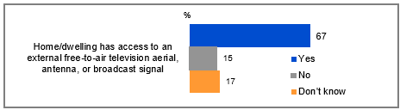

Source: ANTEN1. Does your home/dwelling have access to an external free-to-air television aerial, antenna, or broadcast signal? Base: TVCS, MCCS. All respondents. 2024: n=4,490. Notes: Refused response not shown. DK and Ref options were displayed upfront with other response options. 2024 Ref = 0.3%.

A bar chart showing the percentage of homes/dwellings with access to an external free-to-air television aerial, antenna, or broadcast signal: Yes: 67%, No: 15%, Don't know: 17%.

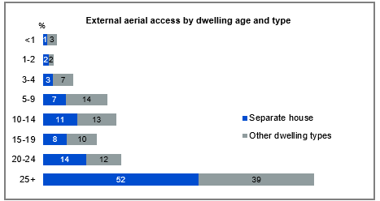

Source: Z8. What type of home/dwelling do you live in? Z5. How old is your home? Base: Home/dwelling have access to an external free-to-air television aerial. 2024: n=3,181. Notes: Don’t know/refused responses not shown. Z5: DK = 1%, Ref = 0.1%. Z8: DK = 0%, Ref = 0.3%.  
*small base size for <1 year and separate house (n=29).

A bar chart showing household external aerial access by dwelling age and type.

Less than 1 year: Separate house - 1%, Other dwelling types - 3%

1-2 years: Separate house - 2%, Other dwelling types - 2%

3-4 years: Separate house - 3%, Other dwelling types - 7%

5-9 years: Separate house - 7%, Other dwelling types - 14%

10-14 years: Separate house - 11%, Other dwelling types - 13%

15-19 years: Separate house - 8%, Other dwelling types - 10%

20-24 years: Separate house - 14%, Other dwelling types - 12%

25+ years: Separate house - 52%, Other dwelling types - 39%

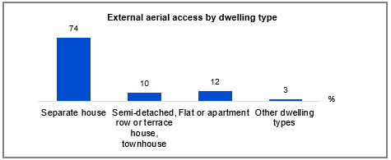

Source: Z8. What type of home/dwelling do you live in? Base: Home/dwelling have access to an external free-to-air television aerial. 2024: n=3,181. Notes: Don’t know/refused responses not shown. 2024 DK = 0%, Ref = 0.3%.

A bar chart showing the percentage distribution of different dwelling types with external aerial access.

Separate house: 74%

Semi-detached, row or terrace house, townhouse: 10%

Flat or apartment: 12%

Other dwelling types: 3%

#### Subgroups

Access to an external free-to-air television aerial was higher for:

* Men (73% vs 61% of women)
* Ages 35-44 (64%), 45-54 (72%), 55-64 (81%), 65-74 (84%), 75+ (78% vs 45% of ages 18-24, 53% of ages 25-34)
* Those living outside of a capital city (75% vs 62% of those living in a capital city)
* Those who owned a dwelling outright (80% vs 67% of those owned with a mortgage, 54% rented)
* Residence aged less than 1 year old (74%), more than 25 years old (75%), 3 to 4 years old (66%), 10-14 years old (65%), 15-19 years old (63%), 20-24 years old (68% vs 40% of those whose residence aged between 1 to 2 years old)
* Those did not access any online subscription streaming services (74% vs 66% of those accessed any online video subscription streaming services)

#### Note

External aerial access by dwelling age and type:

* **‘Other dwelling types’** includes: Semi-detached, row or terrace house, townhouse etc. with one storey, Semi-detached, row or terrace house, townhouse etc. with two or more storeys, Flat or apartment in a one or two storey block, Flat or apartment in a three storey block, Flat or apartment in a four to eight storey block, Flat or apartment in a nine or more storey block, Flat or apartment attached to a house, Caravan, Cabin, houseboat, Improvised home, tent, sleepers out, House or flat attached to a shop, office, etc., Other (please specify)

External aerial access by dwelling type:

* **‘Semi-detached, row or terrace house, townhouse’** includes: Semi-detached, row or terrace house, townhouse etc. with one storey (5%), Semi-detached, row or terrace house, townhouse etc. with two or more storeys (6%).
* **‘Flat or apartment’** includes: Flat or apartment in a one or two storey block (5%), Flat or apartment in a three storey block (2%), Flat or apartment in a four to eight storey block (2%), Flat or apartment in a nine or more storey block (2%), Flat or apartment attached to a house (1%).
* **‘Other dwelling types’** includes: Caravan (1%), Cabin, houseboat (0.1%), Improvised home, tent, sleepers out (0.1%), House or flat attached to a shop, office, etc. (1%), Other (please specify) (1%)

Around two-thirds of households had access to a free-to-air broadcast signal, with most connections through primary TVs, many of which had built-in capabilities.

### TV connection to a free-to-air television aerial, antenna, or broadcast signal

Of respondents with a TV connected to an external aerial, a co-axial cable or a similar cable was most often used for the connection (82%). A smaller percentage connected through a device, such as a set-top box (16%), or via an indoor antenna (6%).

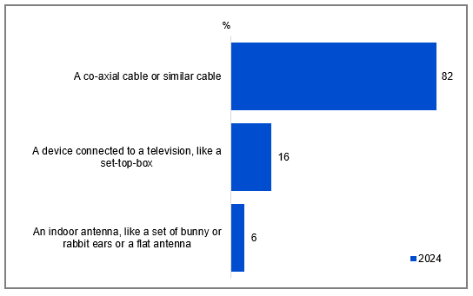

Source: ANTEN6. You said your television was connected to a free-to-air television antenna, aerial, or broadcast signal. Is this via…

Base: TVCS, MCCS. Respondents who have any TV connected to an external aerial. 2024: n=3,019.

Notes: Other/Don’t know/refused responses not shown: 2024 Other = 1% DK = 2%, Ref = 0.1%.

A bar chart showing the methods by which televisions are connected to a free-to-air television antenna, aerial, or broadcast signal in 2024.

A co-axial cable or similar cable: 82%

A device connected to a television, like a set-top-box: 16%

An indoor antenna, like a set of bunny or rabbit ears or a flat antenna: 6%

#### Subgroups

Connection via a co-axial cable or similar cable was higher for:

* Those with dependent children in the household (88% vs 81% of those without children)

Connection via a device connected to a television, like a set-top-box was higher for:

* Ages 45-54 (19%), 55-64 (21%), 65-74 (19%), 75+ (23% vs 5% of ages 25-34)
* Those with non-dependent children in the household (25%), those without children (18% vs 11% of those with dependent children)
* Those who owned a dwelling outright (21% vs 13% of those owned with a mortgage, 13% rented)

Most respondents with a TV connected to an external aerial used a co-axial or similar cable, while fewer used a set-top box or indoor antenna.

### Free-to-air television: profiling heavy watchers (35+ hours in past 7 days)

#### Subgroup

* Older age groups: aged 55-75+ years old (76%)
* Household structure of single or couple, no children (81%)
* Education of up to year 12 (43%)*
* Receive Government pensions, benefits or allowances (69%)
* Household income of $0-$41,599 (51%)
* Television as the device used to watch (95%)
* Do *not* have streaming services in household (39%)

Source: C2. On average, how many hours per week do you spend watching each of the following?

Base: TVCS & MCCS, Free-to-air (codes 1,2,4 or 5 is 35+ hours) (n=77).

*Caution, small base (n=28).

#### Note

* Free-to-air incudes any of:
* Commercial free-to-air TV (e.g. Seven, Nine, 10, WIN, Imparja, NBN Television), including recorded content but excluding on-demand TV
* Publicly owned free-to-air TV (i.e. ABC, SBS), including recorded content but excluding on-demand TV
* Commercial free-to-air on-demand TV (e.g. (e.g. 9Now, 10 Play, 7plus)
* Publicly owned free-to-air on-demand TV (e.g. ABC iview, SBS On Demand, ABC News, ABC Kids)

### Frequency of watching free-to-air television via traditional connections or internet

Traditional connections were more commonly used to watch free-to-air television than using the internet. Viewing patterns showed clear demographic divisions: older viewers and regional residents favored conventional connections, while urban dwellers, families with children, and households with fixed internet showed higher rates of online access.

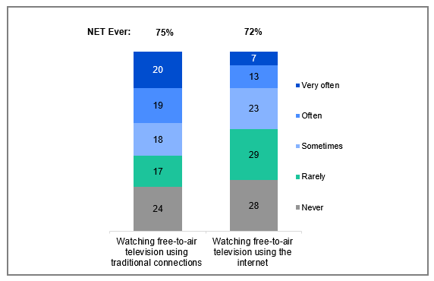

Source: ANTEN10. In general, how often do you watch free-to-air television content using the internet, such as through an internet-connected television or an internet-enabled device, or through a broadcaster-video-on-demand (BVOD) service? ANTEN11. In general, how often do you watch free-to-air television content using traditional connections, such as a broadcast signal, aerial, antenna, or pay-TV set-top box?

Base: TVCS, MCCS, All respondents. 2024 n=4,490.

Notes: Don’t know/refused responses not shown. 2024 DK = 0.2%, Ref = 0% for ANTEN10 and ANTEN11. NET Ever includes ‘Rarely’, ‘Sometimes’, ‘Often’, and ‘Very often’.

A bar chart comparing the frequency of watching free-to-air television content using the internet versus traditional connections.

For "Watching free-to-air television using the internet":

Never: 28%

Rarely: 29%

Sometimes: 23%

Often: 13%

Very often: 7%

NET ever (very often, often, sometimes, rarely): 72%

For "Watching free-to-air television using traditional connections":

Never: 24%

Rarely: 17%

Sometimes: 18%

Often: 19%

Very often: 20%

NET ever (very often, often, sometimes, rarely): 75%

#### Subgroups

NET Ever watching free-to-air television using the internet was higher for:

* Ages 35-44 (80%), 45-54 (78% vs 67% of ages 18-24, 68% of ages 55-64, 68% of ages 65-74, 60% of ages 75+)
* Those living in a capital city (74% vs 68% of those living outside a capital city)
* Those with dependent children in the household (79% vs 69% of those without children, 66% of those with non-dependent children only)
* Owned with a mortgage (77% vs 68% of those owned outright, 69% of those rented)
* Those with fixed home internet (73% vs 56% of those without fixed home internet)

NET Ever watching free-to-air television using traditional connections was higher for:

* Ages 55-64 (86%), 65-74 (90%), 75+ (93% vs 57% of ages 18-24, 63% of ages 25-34, 70% of ages 35-44, 79% of ages 45-54)
* Those living outside a capital city (80% vs 72% of those living in a capital city)
* Those owned outright (86%), owned with a mortgage (75% vs 62% of those rented)
* Those without fixed home internet (83% vs 75% of those with fixed home internet)
* Those received Government pensions, benefits or allowances (83% vs 73% of those did not)
* Those watching offline content in the past 7 days (90% vs 75% of those watching online content)

#### Note

Persona definitions:

* No FTA: ANTEN10 = 1,98,99 AND ANTEN11 = 1,98,99
* Online only: ANTEN10 = 2-5 AND ANTEN11 = 1,98,99
* Broadcast only: ANTEN10 = 1,98,99 AND ANTEN11 = 2-5
* Hybrid FTA: ANTEN10 = 2-5 AND ANTEN11 = 2-5

The frequency of ‘ever’ watching free-to-air television using traditional connections was more common than online, especially for older Australians and those outside capital cities.

### Free-to-air television viewing: Personas

Respondents’ free-to-air television viewing patterns were categorised into four personas, with hybrid free-to-air TV being the most common (58%), followed by broadcast-only (17%) and online-only (13%), and one in ten (11%) who did not watch any free-to-air TV.

* Those who consumed **hybrid FTA TV** were more likely to be aged 35-74, have fixed home internet, own a newly purchased TV, and watch sports.
* Those who **exclusively watched FTA TV via broadcast** were typically older, live in regional areas, have lower household incomes, reside in older homes, and lack access to fixed home internet.
* Those who consumed **only FTA TV online** were more likely to be younger (aged 18-54), live in metro areas, have a high household income, fixed home internet, and do not have access to an external FTA aerial.
* Those who **did not consume FTA TV** were more likely to be younger, live in metro areas, lack access to an external FTA TV aerial, and reside in newer homes.

Source: ANTEN10. In general, how often do you watch free-to-air television content using the internet, such as through an internet-connected television or an internet-enabled device, or through a broadcaster-video-on-demand (BVOD) service? ANTEN11. In general, how often do you watch free-to-air television content using traditional connections, such as a broadcast signal, aerial, antenna, or pay-TV set-top box?

Base: TVCS, MCCS, All respondents. 2024 n=4,490.   
Notes: Don’t know/refused responses not shown. 2024 DK = 0.2%, Ref = 0% for ANTEN10 and ANTEN11. NET Ever includes ‘Rarely’, ‘Sometimes’, ‘Often’, and ‘Very often’.

#### Personas

Hybrid free-to-air TV (58%)

* Ages 35-74 (62%)
* Had access to an average of 2.7 online video subscription streaming services
* Had access to an external free-to-air TV aerial (63%)
* Watching FTA Broadcast (67%), FTA BVOD (69%), Pay-TV (71%), SVOD in P7D (61%)
* Had fixed home internet (59%)
* Purchased a new TV in P12M (63%)
* Watched sports in P7D (64%)
* More likely to have a VAST box in their household (3%)

Broadcast only (17%)

* Ages 55+ (29%)
* Live outside a capital city (23%)
* Had access to an average of 1.5 online video subscription streaming services
* Had access to an external free-to-air TV aerial (21%)
* Household income <$78,000 per year (23%)
* House more than 24 years old (21%)
* Watching FTA Broadcast (24%), FTA BVOD (15%), Pay-TV in P7D (16%)
* Did not have fixed home internet (34%)
* Spent an average of >10 hours watching FTA Broadcast per week (36%)
* Spent an average of 11-20 hours watching FTA BVOD per week (29%)

Online only (13%)

* Ages 18-54 (17%)
* Live in a capital city (15%)
* Had access to an average of 3 online video subscription streaming services
* Did not have access to an external free-to-air TV aerial (27%)
* Household income >$155,999 per year (19%)
* Those living in a semi-detached terrace house or town house (15%), a flat or apartment in a storey block (18%)
* Those watching free video streaming services (17%), SVOD (15%), other websites or apps in P7D (16%)
* Those had fixed home internet (14%)
* Those spent an average of <11 hours watching FTA Broadcast per week (11%)
* Did not watch sports in P7D (15%)

No free-to-air TV (11%)

* Ages 18-34 (21%)
* Live in a capital city (13%)
* Had access to an average of 2.4 online video subscription streaming services
* Did not have access to an external free-to-air TV aerial (20%)
* Living in a flat or apartment attached to a house (41%)
* House was less than 3 years old (21%)
* Watching free video streaming services (12%), SVOD (12%), other websites or apps in P7D (13%)
* Spent an average of >35 hours watching SVOD per week (37%)
* Did not watch sports in P7D (16%)

#### Note

Persona definitions:

* No FTA: ANTEN10 = 1,98,99 AND ANTEN11 = 1,98,99
* Online only: ANTEN10 = 2-5 AND ANTEN11 = 1,98,99
* Broadcast only: ANTEN10 = 1,98,99 AND ANTEN11 = 2-5
* Hybrid FTA: ANTEN10 = 2-5 AND ANTEN11 = 2-5

#### Further reading

Research in the United Kingdom (UK) through both the UK Department of Culture, Media and Sport and through the UK’s media regulator, Ofcom, has similarly examined the characteristics of different population groups by their access to Free-to-air (FTA) television (TV).5,6 Our survey shows the growth in ‘online only’ versus research from RMIT in 2023.7

### TV smart accessories used in the past 12 months

TV smart accessory adoption remained stable, with 47% of households reporting no usage, while Google Chromecast led among respondents at 23%. These patterns held consistent despite extending the measurement period from 6 to 12 months.

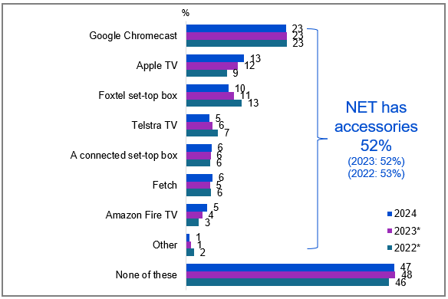

Source: NEW12. Which, if any, of the following TV smart accessories have you used in your house in the past 12 months?

Base: TVCS, All respondents. 2024: n=3,890. 2023: n=3,861. 2022: n=4016.

Notes: Don’t know/refused responses not shown: 2024 DK = 0.4%, Ref = 0.2%. 2023 DK = 0.3%, Ref = 0.1%. 2022 DK= 0.7%, Ref = 0.1% Code change in 2023 for ‘Apple TV’ (previously ‘Apple TV box’ in 2022). *Reference period updated from 6 months to 12 months in 2024, comparisons with previous years should be made with caution.

A bar chart showing the usage of various TV smart accessories in households over the past 12 months for the years 2024, 2023, and 2022. Usage of any TV smart accessories was 52% in 2024 (vs 52% in 2023, 53% in 2022).

Google Chromecast: 23% in 2024, 23% in 2023, 23% in 2022.

Apple TV: 13% in 2024, 12% in 2023, 9% in 2022.

Foxtel set-top box: 10% in 2024, 11% in 2023, 13% in 2022.

Telstra TV: 5% in 2024, 6% in 2023, 7% in 2022.

A connected set-top box: 6% in 2024, 6% in 2023, 6% in 2022.

Fetch: 6% in 2024, 5% in 2023, 6% in 2022.

Amazon Fire TV: 5% in 2024, 4% in 2023, 3% in 2022.

Other: 1% in 2024, 1% in 2023, 2% in 2022.

None of these: 47% in 2024, 48% in 2023, 46% in 2022.

#### Subgroups

NET Has accessories was higher for:

* Those with dependent children in the household (59% vs 49% of those without children)
* Those who watched Pay-TV (88%), FTA BVOD (59%), SVOD in P7D (59% vs 52% of those who watched FTA Broadcast, 54% of those who watched free video streaming services, 54% of those who watched other websites or apps in P7D)
* Those with a HH income >$155,999 (59% vs 47% of those with a HH income <$41,600)
* Those who watched sports in P7D (59% vs 48% of those who did not watch sports in P7D)
* Those who had access to online subscription streaming services (60% vs 22% of those did not have access)

Google Chromecast was higher for:

* Ages 25-34 (31%), 35-44 (29% vs 17% of ages 55-64, 16% of ages 65-74, 14% of ages 75+)
* Those with dependent children in the household (29% vs 20% of those without children)
* Those employed full time or part time (29% vs 16% of those who are retired, 16% of those engaging in home duties, 16% of non-workers)
* Those who watched exclusively online content in P7D (27% vs 6% of those who watched exclusively offline content)
* Those who watched sports in P7D (26% vs 21% of those who did not watch sports)
* Those had access to online subscription streaming services (27% vs 6% of those did not have online subscription streaming services)
* Those with fixed home internet (24% vs 12% of those without fixed home internet)

#### Note

* FTA BVOD includes ‘Commercial free-to-air on-demand TV (e.g. 9Now, 10 Play, 7plus)’ and ‘Publicly owned free-to-air on-demand TV (e.g. ABC iview, SBS On Demand, ABC News, ABC Kids)’
* FTA Broadcast includes ‘Commercial free-to-air TV (e.g. Seven, Nine, 10, WIN, Imparja, NBN Television), including recorded content but excluding on-demand TV’ and ‘Publicly owned free-to-air TV (i.e. ABC, SBS), including recorded content but excluding on-demand TV’
* SVOD includes ‘Online subscription services (e.g. Netflix, Binge, YouTube Premium)’ and ‘Sports specific website or app (e.g. AFL Live, NRL Live, Cricket Australia Live, Kayo Sports, Stan Sport)’
* Pay-TV includes ‘Pay-per-view services (e.g. Google Play)’ and ‘Pay TV (e.g. Foxtel, Fetch TV), including recorded content but excluding streaming’

Overall usage of TV smart accessories over 12 months in 2024 remained consistent with results from 2023 over a 6-month period.

### Purchase of a new TV in past 12 months

New TV purchases (16%) showed particular demographic patterns, with higher rates among younger viewers, Aboriginal and or Torres Strait Islander people, those who watched screen content using a television, and those who had watched sports in the past seven days. Comparisons with previous years should be made with caution, as the reference period for new TV purchases changed from the past 6 months to the past 12 months, and the broader reference period may explain the slight increase in purchases in 2024.

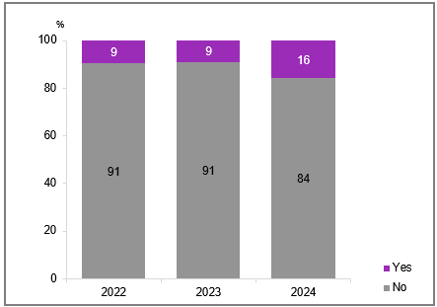

Source: NEW16. Did you buy a new TV in the past 12 months?

Base: TVCS, All respondents. 2024: n=3,890. 2023: n=3,861. 2022: n=4,016.

Notes: Don’t know/refused responses not shown: 2024 DK and Ref = 0%. 2023 DK and Ref = 0%. 2022 DK and Ref = 0%. Reference period updated from 6 months to 12 months in 2024, comparisons with previous years should be made with caution.

A bar chart showing the percentage of people who bought a new TV in the past 12 months, categorised by the years 2022, 2023, and 2024.

Yes: 16% in 2024, 9% in 2023, 9% in 2022.

No: 84% in 2024, 91% in 2023, 91% in 2022.

#### Subgroups

Yes was higher for:

* Ages 25-34 (21%), 35-44 (20% vs 12% of ages 45-54, 11% of ages 75+)
* Aboriginal and / or Torres Strait Islander respondents (27% vs 15% of non-Aboriginal or Torres Strait Islander respondents)
* Those who watched screen content using a television (18% vs 6% of those who did not)
* Those had access to online subscription streaming services (18% vs 10% of those did not have online subscription streaming services)
* Those who watched sports in P7D (20% vs 14% of those who did not watch sports)
* Those who watched sports specific website or app in P7D (24% vs 14% of those watched free video streaming services, 17% of those who watched commercial or publicly owned free-to-air TV excluding on-demand TV, and 16% of those who watched other websites or apps in P7D)

One-sixth of respondents reported purchasing new TVs in 2024 over a 12-month period.

### VAST Box ownership

VAST Box ownership was minimal at 2.56% of households, with most of these homes (69%) having a single unit. Various installation timelines were reported by VAST Box owners. One-sixth (17%) installed it within the past year, while longer-term installations were more common: 21% dating back 5-9 years and 22% exceeding 10 years. Nearly three-quarters of VAST Box owners (72%) reported reliable performance, with their units working most or all of the time. That said, up to 29% claimed it is broken or only works some of the time.

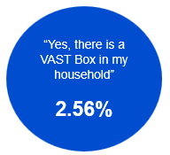

Source: VAST1. Is there a VAST Box in your household?

Base: TVCS, MCCS. All respondents. 2024: n=4,490.

Notes: No/Don’t know/refused responses not shown: No = 96%, DK = 1%, Ref = 0.2%

A blue circular graphic showing that 2.56% of respondents reported, "Yes, there is a VAST box in my household”.

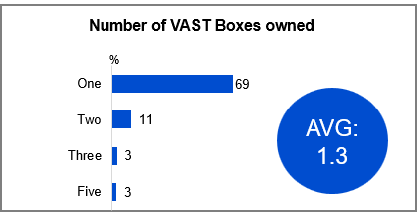

Source: VAST2. How many VAST Boxes do you have in your household?

Base: TVCS, MCCS. Respondents who have VAST Box in their house. 2024: n=105.

Notes: Don’t know/refused responses not shown: 2024 DK = 12%, Ref = 1%. (Six and above not shown on chart).

A bar chart showing the number of VAST Boxes in households for the year 2024: One: 69%; Two: 11%; Three: 3%; Five: 3%.

A blue circular graphic showing there was an average of 1.3 VAST Boxes in households for the year 2024.

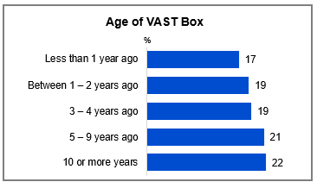

Source: VAST3. When was your VAST dish installed?

Base: TVCS, MCCS. Respondents who have VAST Box in their house. 2024: n=105.

Notes: Don’t know/refused responses not shown: 2024 DK = 2%, Ref = 0%.

A bar chart showing the installation age of VAST dishes in households for the year 2024.

Less than 1 year ago: 17%

Between 1 – 2 years ago: 19%

3 – 4 years ago: 19%

5 – 9 years ago: 21%

10 or more years: 22%

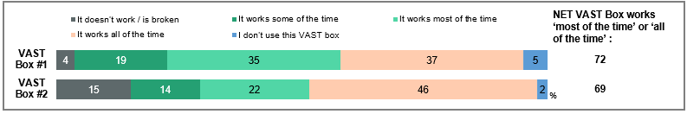

Source: VAST4. How well does your VAST Box work?

Base: TVCS, MCCS. Respondents who have at least one VAST Box in their household. 2024: n=from 1 to 99.

Notes: Don’t know/refused responses not shown and varied by VAST Boxes. VAST Box #3 and over not shown in chart. ‘NET VAST Box works’ includes ‘It works some of the time’, ‘It works most of the time’, and ‘It works all of the time’.

A bar chart showing how well VAST Boxes work in households, categorised by the first 2 VAST Box owned.

For VAST Box #1:

It doesn’t work / is broken: 4%

It works some of the time: 19%

It works most of the time: 35%

It works all of the time: 37%

I don’t use this VAST box: 5%

NET: VAST Box works ‘most of the time’ or ‘all of the time’: 72%

For VAST Box #2:

It doesn’t work / is broken: 15%

It works some of the time: 14%

It works most of the time: 22%

It works all of the time: 46%

I don’t use this VAST box: 2%

NET: VAST Box works ‘most of the time’ or ‘all of the time’: 69%

#### Callout

* Those **with a VAST box** tended to be younger (29% of those aged 25-34), have children (64%), and have a lower income ($41,599 or less, 39%). There were no significant differences by regions / location.

Those who owned a VAST box generally had only one in their household, with ownership being driven by age, income, and household structure. Installation times varied among respondents with a VAST Box in their household. VAST Box performance was rated highly among those who owned it.

## Audio content

### Chapter Summary – Audio Content

Audio content consumption has decreased across various channels in 2024

* FM radio remained the most commonly listened to audio content (51%), followed closely by online music streaming services (47%).
* Having listened to FM radio, online music streaming services, AM radio, radio via the internet or an app (excluding podcast), and digital radio (DAB) have decreased in 2024, while not having listened to any audio has increased.

Smartphones were mainly used to listen to online audio, while traditional radio was listened to in the car

* Respondents most commonly reported listening to FM radio (84%) and AM radio (73%) in the car, while smartphones were more commonly used to listen to podcasts (86%) and online music streaming services (83%).

### Audio listened to in the past 7 days

FM radio (51%) narrowly led online music streaming (47%) in audio consumption over the past 7 days, despite both experiencing 2024 declines. Other formats, recording lower engagement, included podcasts (23%), AM radio (17%), internet radio (12%), and DAB (11%). NET AM radio and FM radio (57% in 2024 vs 64% in 2023, 64% in 2022) and NET Online (online music streaming, podcasts, radio via internet or app, DAB) (61% in 2024 vs 71% in 2023, 67% in 2022) listenership experienced significant declines in 2024 compared to 2023.

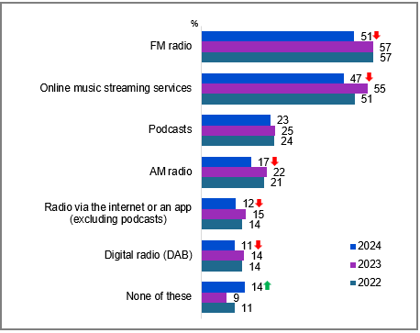

Source: NEW28. Which, if any, of the following have you listened to in the past 7 days? This includes all listening at home, in a car, or somewhere else on any device.

Base: TVCS, MCCS. All respondents. 2024: n=4,490. 2023: n=3,730. 2022: n=4002.

Notes: Don’t know/refused responses not shown: 2024 DK = 0.3%, Ref = 0% 2023 DK and Ref = 0%. 2022 DK = 0.1%, Ref = 0.0%

Bar chart showing the percentage of people who have listened to various audio sources in the past 7 days for the years 2024, 2023, and 2022.

FM radio: 51% in 2024, 57% in 2023, 57% in 2022.

Online music streaming services: 47% in 2024, 55% in 2023, 51% in 2022.

Podcasts: 23% in 2024, 25% in 2023, 24% in 2022.

AM radio: 17% in 2024, 22% in 2023, 21% in 2022.

Radio via the internet or an app (excluding podcasts): 12% in 2024, 15% in 2023, 14% in 2022.

Digital radio (DAB): 11% in 2024, 14% in 2023, 14% in 2022.

None of these: 14% in 2024, 9% in 2023, 11% in 2022.

#### Subgroups

‘NET AM radio / FM radio’ was higher for:

* Ages 55+ (69% vs 50% of ages 18-54).
* Those living outside a capital city (63% vs 53% of those living in a capital city)
* Those with a TAFE, Trade Certificate, Diploma (65% vs 57% of those with education up to Year 12, 47% of those with a Bachelor Degree, 53% of those with a Postgraduate Degree)

‘NET Online’ (online music streaming, podcasts, radio via internet or app, DAB) was higher for:

* Ages 18-54 (72% vs 43% of ages 55+).
* Those living in a capital city (66% vs 55% of those living outside a capital city)
* Those with a Bachelor Degree (72%), a Postgraduate Degree (70% vs 50% of those with education up to Year 12, 60% of those with a TAFE, Trade Certificate, Diploma)

FM radiowas higher for**:**

* Ages 25-34 (46%), 35-44 (53%), 45-54 (58%), 55-64 (60%), 65-74 (58%), and 75+ (51% vs 26% of ages 18-24)
* Those living outside a capital city (57% vs 46% of those living in a capital city)
* Those without children in the household (51%), those with dependent children (57%), and those with non-dependent children only (53% vs 30% of adults living in a share house)
* Those with a TAFE qualification / Trade Certificate / Diploma (59% vs 48% of those with education up to Year 12, 41% of those with a Bachelor degree and 48% of those with a Postgraduate degree)

Online music streaming services was higher for:

* Ages 18-24 (76%), 25-34 (67%), 35-44 (54%), and 45-54 (47% vs 30% of ages 55-64, 24% of ages 65-74, and 14% of ages 75+)

#### Callout

* Having listened to FM radio (51% vs 57% in 2023), online music streaming services (47% vs 55% in 2023), AM radio (17% vs 22% in 2023), radio via the internet or an app (excluding podcast) (12% vs 15% in 2023), and digital radio (DAB) (11% vs 14% in 2023) have decreased significantly in 2024, while not having listened to any audio (14% vs 9% in 2023) has increased in 2024.

Audio content consumption has decreased across various channels in 2024

### Devices used to listen to audio content

Device usage preferences remained consistent with 2023: car radios were most often used when listing to FM (84%) and AM (73%) radio, while smartphones were the preferred choice for podcasts (86%) and music streaming (83%). Car audio system (NET) was used to listen to 81% of any audio content (2023: 84%), while smart speaker (NET) was used to listen to 11% of any audio content (2023: 9%). Note that NETs only include AM radio, FM radio, Digital radio (DAB), and Radio via the internet or an app.

Table Devices used to listen to audio content (%)

|  |  |  |  |  |  |  |  |
| --- | --- | --- | --- | --- | --- | --- | --- |
| Audio content | Base  (n) | Car audio system | Dedicated radio | Smartphone | Smart Speaker | Computer / Tablet / Laptop | Other |
| **FM radio** | 2,266 | 84 | 26 | 10 | 7 | 4 | 1 |
| **Online music streaming services** | 1,904 | 30 | 2 | 83 | 24 | 31 | 3 |
| **Podcasts** | 1,082 | 19 | 2 | 86 | 7 | 20 | 1 |
| **AM radio** | 921 | 73 | 41 | 17 | 9 | 10 | 1 |
| **Digital radio (DAB)** | 638 | 62 | 37 | 15 | 14 | 8 | 1 |
| **Radio via the internet or an app (excluding podcasts)** | 576 | 32 | 11 | 56 | 26 | 37 | 3 |

Source: NEWG29. In general, what do you use to listen to [‘insert NEW28 Response of codes 1-6’]

Base: MCCS, Respondents who listened to audio content in the past 7 days. 2024 n= from 576 to 2,266.

Notes: Don’t know/refused responses not shown, % vary per statement.

#### Subgroups

**FM radio** was higher for:

Car audio system:

* Ages 25-34 (90%), 35-44 (86%), and 45-54 (89% vs 71% of ages 75+)
* Those with dependent children in the household (90% vs 81% of those without children, 78% of those with non-dependent children only)
* Those self-employed (94%), employed full time or part time (88% vs 76% of those retired)

Online music streaming services was higher for:

Smartphone:

* Ages 18-24 (94%), 25-34 (88%), and 35-44 (87% vs 71% of ages 55-64, 50% of ages 65-74 and 34% of ages 75+)
* Those living in a capital city (86% vs 77% of those living outside a capital city)

FM and AM radio were most commonly listened to in the car, while smartphones were used primarily for podcasts and online music streaming.

## News & Emergency Information content

### Chapter Summary – News & Emergency Information Content

News consumption declined in general in 2024, but Australian national news remained most consumed news type

* Consumption of national, state or territory and local news all declined in 2024, at 53%, 46%, and 40% NET respectively (net 3-5 times per week and more often than 5 times per week). This was driven by declines amongst the frequent consumers of news.
* More than half of respondents (53%) reported that they consume Australian national news content at least 3-5 times a week (net 3-5 times per week and more often than 5 times per week).

Online remained the most common source for news consumption, while TV and audio categories showed declines

* When considering sources of news by access category, online remained the most commonly used (net 84%), followed by TV (net 71%). TV and audio (net 55%) sources of news have declined in 2024.
* Commercial free-to-air TV remained the most common main source of local (25%), state or territory (26%), Australian national (27%), and international news (20%).
* 11% of respondents reported paying for a paid news and current affairs subscription, with the majority paying for only one subscription.

Passive news consumption was driven by youth, females, and those with children in the household

* One-in-five (19%) respondents reported that the majority or all of the news they consumed came from activities where they were not primarily trying to engage with (net the majority of it, all of it). Passive news consumption was driven by those who are younger, female, of have children in the household.
* Local health issues (81%) and local crime, legal issues or court decisions (80%) were the types of local news content most commonly considered important (net very important and somewhat important). Perceived importance of local events (76%) and sports (37%) declined in 2024.

Emergency information sources results show that radio and Government weather / emergency websites and apps are vital

* Emergency information (access, sources, importance) was included as a new area for exploration in 2024.
* One-in-ten (11%) respondents reported having experienced an emergency situation in the past 12 months.
* Online sources were the most commonly used source of information (NET 56%), especially amongst younger people. Radio was also used (31%), especially by those not living in a capital city.
* Important factors to consider when seeking emergency information varied by experiences of emergencies. Those who had experienced an emergency valued accessibility (58%), timeliness (57%), and official sources (54%), while those who had not prioritised official sources (62%) the most.

### Frequency of consuming news and current affairs content

2024 saw declining news consumption among frequent consumers (those who read, watch, or listen to news at least 3-5 times per week), particularly affecting domestic coverage at all levels, though international news remained stable. Australian national news retained the highest regular viewership at 53%, compared to local news at 40%.

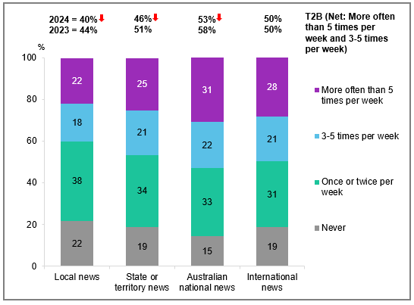

Source: D1. On average per week, how often do you read, watch, or listen to any of the following types of news and current affairs? This includes TV, radio, newspapers, and online.

Base: MCCS, All respondents. 2024 n=3,773. 2023 n=3,730.

Notes: Don’t know/refused responses not shown, % vary per statement. Note that in 2022 and prior ‘Local news’ and ‘State or territory news’ were combined as one code, ‘Local, state or territory news’. In 2023, this was separated out to two codes.

Bar chart showing the average frequency per week that people read, watch, or listen to various types of news and current affairs, including TV, radio, newspapers, and online. The categories are International news, Australian national news, State or territory news, and Local news.

International News:

Never: 19%

Once or twice per week: 31%

3-5 times per week: 21%

More often than 5 times per week: 28%

T2B (Net: More often than 5 times per week and 3-5 times per week): 50% in 2024, 50% in 2023

Australian National News:

Never: 15%

Once or twice per week: 33%

3-5 times per week: 22%

More often than 5 times per week: 31%

T2B (Net: More often than 5 times per week and 3-5 times per week): 53% in 2024, 58% in 2023

State or Territory News:

Never: 19%

Once or twice per week: 34%

3-5 times per week: 21%

More often than 5 times per week: 25%

T2B (Net: More often than 5 times per week and 3-5 times per week): 46% in 2024, 51% in 2023

Local News:

Never: 22%

Once or twice per week: 38%

3-5 times per week: 18%

More often than 5 times per week: 22%

T2B (Net: More often than 5 times per week and 3-5 times per week): 40% in 2024, 44% in 2023

#### Subgroups

T2B International news was higher for:

* Men (58% vs 41% of women)
* Ages 55+ (69% vs 42% of those ages 18-54)
* Those with a Postgraduate degree (62% vs 47% of those with education up to Year 12, 46% of those with a TAFE, Trade Certificate, Diploma, 49% of those with a Bachelor degree)
* Those born in a mainly non-English speaking country (57% vs 48% of those born in a mainly English speaking country)

T2B Australian national news was higher for:

* Men (57% vs 49% of women)
* Ages 65+ (83% vs 46% of those ages 18-64)
* Those with a Postgraduate degree (60% vs 47% of those with a Bachelor degree)

T2B State or territory news was higher for:

* Men (50% vs 44% of women)
* Ages 55+ (71% vs 37% of those ages 18-54)
* Those with a Postgraduate degree (50%), education up to Year 12 (49%), a TAFE, Trade Certificate, Diploma (48% vs 40% of those with a Bachelor degree)
* Those born in a mainly English speaking country (49% vs 37% of those born in a mainly non-English speaking country)

T2B Local news was higher for:

* Ages 55+ (61% vs 32% of those ages 18-54)
* Those with education up to Year 12 (44%), a TAFE, Trade Certificate, Diploma (42% vs 33% of those with a Bachelor degree, 39% of those with a Postgraduate degree)
* Those born in a mainly English speaking country (42% vs 34% of those born in a mainly non-English speaking country)

#### Callout

* In 2024, the proportion of people consuming news and current affairs at least three times per week declined significantly across local news (40% vs 44% in 2023), state or territory news (46% vs 51%), and Australian news (53% vs 58%).

Australian national news was the most frequently consumed type of news, followed by International news.

### Sources of news

Commercial free-to-air TV remained the most commonly reported source of news (53%), followed by domestic / Australian news website or app (48%), social media (45%), and radio (43%).

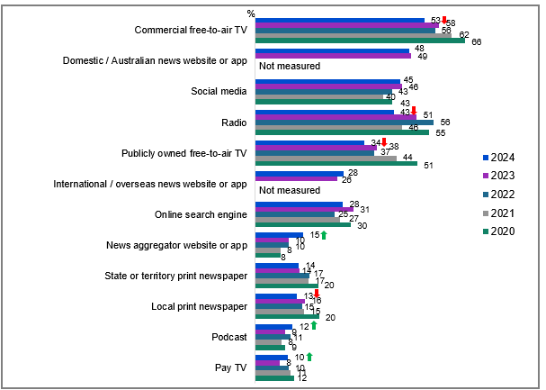

Source: D2. In general, how do you currently access most of your news and/ or current affairs?

Base: MCCS, Respondents who consume news content. 2024: n=3,488. 2023: n=3,454. 2022: n=3,807. 2021: n=3,981. 2020: n=3,942.

Notes: Don’t know/refused responses not shown: 2024 DK = 0.1%, Ref = 0.2%. 2023 DK = 0%, Ref = 0.1%. 2022 DK = 0.3%, Ref = 0.0%. 2021 DK = 0.1%, Ref = 0.0%. 2020 DK = 0.1%, Ref = 0.0%. Responses for codes not shown on chart if <10% in 2024. Note that ‘News website or app’ was used prior to 2023, however, was split into ‘Domestic / Australian news website or app’ and ‘International / overseas news website or app’ since 2023. Codes with ‘Not measured’ for previous years were new in 2023.

Bar chart showing how people accessed most of their news and current affairs from 2020 to 2024.

Commercial free-to-air TV: 53% in 2024, 58% in 2023, 56% in 2022, 62% in 2021, 66% in 2020.

Domestic / Australian news website or app: 48% in 2024, 49% in 2023.

Social media: 45% in 2024, 46% in 2023, 43% in 2022, 40% in 2021, 43% in 2020.

Radio: 43% in 2024, 51% in 2023, 56% in 2022, 46% in 2021, 55% in 2020.

Publicly owned free-to-air TV: 34% in 2024, 38% in 2023, 37% in 2022, 44% in 2021, 51% in 2020.

International / overseas news website or app: 28% in 2024, 26% in 2023.

Online search engine: 28% in 2024, 31% in 2023, 25% in 2022, 27% in 2021, 30% in 2020.

News aggregator website or app: 15% in 2024, 10% in 2023, 10% in 2022, 8% in 2021, 8% in 2020.

State or territory print newspaper: 14% in 2024, 14% in 2023, 17% in 2022, 17% in 2021, 20% in 2020.

Local print newspaper: 13% in 2024, 16% in 2023, 15% in 2022, 15% in 2021, 20% in 2020.

Podcast: 12% in 2024, 9% in 2023, 11% in 2022, 8% in 2021, 9% in 2020.

Pay TV: 10% in 2024, 8% in 2023, 10% in 2022, 11% in 2021, 12% in 2020.

#### Subgroups

Commercial free-to-air TV was higher for:

* Women (56% vs 51% of men)
* Ages 45-54 (59%), 55-64 (63%), 65-74 (70%), and 75+ (73% vs 42% of ages 18-24, 40% of ages 25-34 and 46% of ages 35-44)

Domestic / Australian news website or app was higher for:

* Those with a Bachelor’s degree (55%), a Postgraduate degree (62% vs 38% of those with education up to Year 12, 43% of those with a TAFE, Trade Certificate, Diploma)

Social media was higher for:

* Women (51% vs 40% of men)
* Ages 18-24 (74%), 25-34 (56%), and 35-44 (50% vs 37% of ages 45-54, 27% of ages 55-64, 23% of ages 65-74 and 28% of ages 75+)
* Those born in a mainly non-English speaking country (54% vs 43% of those born in a mainly English speaking country)

#### Callout

* Commercial free-to-air TV (53% vs 58% in 2023), radio (43% vs 51% in 2023), publicly owned free-to-air TV (34% vs 38% in 2023), and local print newspaper (13% vs 16% in 2023) have declined as sources of news in 2024, while news aggregator website or app (15% vs 10% in 2023), podcast (12% vs 9% in 2023) and pay TV (10% vs 8% in 2023) have increased.

#### Note

* Respondent base used in 2022 – those who consume news content.
* Note - The chart shows figures for 2020/2021 rebased to use the same base as 2022-2023 for consistency (only those who consumed news).

Commercial free-to-air TV, domestic / Australian news websites or apps, social media and radio remained the dominant channels for accessing news or current affairs.

### Sources of news by category

Online platforms led news consumption (84%), followed by television (71%) and audio sources (55%), with both TV and audio showing declines in 2024.

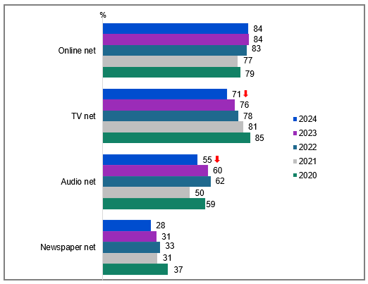

Source: D2. In general, how do you currently access most of your news and/ or current affairs?

Base: MCCS, Respondents who consume news content. 2024: n=3,488. 2023: n=3,454. 2022: n=3,807. 2021: n=3,981. 2020: n=3,942.

Note: The chart shows figures for 2020/2021 rebased to use the same base as 2022 for consistency (only those who consumed news). Note that ‘News website or app’ was used prior to 2023, however, was split into ‘Domestic / Australian news website or app’ and ‘international / overseas news website or app’ since 2023.

Bar chart showing how people accessed most of their news and current affairs from 2020 to 2024.

Online net: 84% in 2024, 84% in 2023, 83% in 2022, 77% in 2021, 79% in 2020.

TV net: 71% in 2024, 76% in 2023, 78% in 2022, 81% in 2021, 85% in 2020.

Audio net: 55% in 2024, 60% in 2023, 62% in 2022, 50% in 2021, 59% in 2020.

Newspaper net: 28% in 2024, 31% in 2023, 33% in 2022, 31% in 2021, 37% in 2020.

#### Subgroups

**Online net** was higher for:

* Ages 18-24 (96%), 25-34 (92%), 35-44 (88%), and 45-54 (82% vs 72% of ages 55-64, 69% of ages 65-74 and 68% of ages 75+)
* Those with dependent children in the household (87%) and adults living in a share house (95% vs 78% of those without children in the household)
* Those with a Bachelor’s degree (91%), a Postgraduate degree (91% vs 75% of those with education up to Year 12, 80% of those with a TAFE, Trade Certificate, Diploma)
* Those born in a mainly non-English speaking country (90% vs 81% of those born in a mainly English speaking country)

#### Note

* Note – In 2021 it had a base of all.
* In 2022 the base was those who access news content.
* The chart shows figures rebased for 2021 to use a consistent base for 2022 data. (i.e. those who consumed news only).
* **‘NET: TV’** includes: ‘Commercial free-to-air TV, including catch-up TV’, ‘Publicly owned free-to-air TV, inc. catch-up TV’, and ‘Pay TV, inc. streaming’.
* **‘NET: Online’** includes: ‘Domestic / Australian news website or app’ (since 2023), ‘International / overseas news website or app’ (since 2023), ‘News website or app’ (2020-2022), ‘Social media’, ‘Online search engine’, ‘News aggregator website or app’, and ‘Other website or app’.
* **‘NET: Audio’** includes: ‘Radio’, ‘Podcast’, and ‘Online radio station’ (2023 only)
* **‘NET: Newspaper’** includes: ‘National print newspaper’, ‘State print newspaper’, and ‘Local print newspaper’.

#### Callout

* Accessing news via TV (net) (71% vs 76% in 2023) and Audio (net) (55% vs 60% in 2023) decreased significantly in 2024.

While online sources of news remained the most popular, TV and audio sources of news continued to trend downwards in 2024.

### Sources of news in past 7 days

In the past 7 days, online sources led news consumption (88%) despite overall declines in 2024, with social media (59%) driving digital engagement. Traditional platforms showed varying weekly access levels: commercial free-to-air TV (53%), radio (50%), and Australian news websites/apps (49%), while public broadcast TV reached 46%. All categories recorded decreased weekly access: online (88%), television (74%), audio (67%), and newspapers (46%).

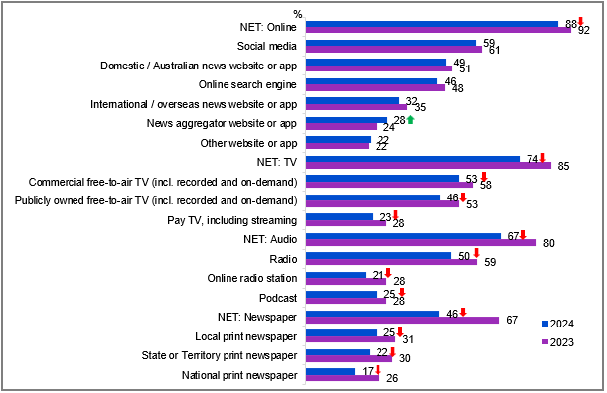

Source: D17. In the past 7 days, did you access news from any of the following sources?

Base: MCCS, All respondents. 2024: n=3,773. 2023: n=3,730.

Notes: No/Don’t know/refused responses not shown, % vary per statement.

Bar chart showing the percentage of people who accessed news from various sources in the past 7 days for the years 2024 and 2023.

NET: Online: 88% in 2024, 92% in 2023.

Social media: 59% in 2024, 61% in 2023.

Domestic / Australian news website or app: 49% in 2024, 51% in 2023.

Online search engine: 46% in 2024, 48% in 2023.

International / overseas news website or app: 32% in 2024, 35% in 2023.

News aggregator website or app: 28% in 2024, 24% in 2023.

Other website or app: 22% in 2024, 22% in 2023.

NET: TV: 74% in 2024, 85% in 2023.

Commercial free-to-air TV (incl. recorded and on-demand): 53% in 2024, 58% in 2023.

Publicly owned free-to-air TV (incl. recorded and on-demand): 46% in 2024, 53% in 2023.

Pay TV, including streaming: 23% in 2024, 28% in 2023.

NET: Audio: 67% in 2024, 80% in 2023.

Radio: 50% in 2024, 59% in 2023.

Online radio station: 21% in 2024, 28% in 2023.

Podcast: 25% in 2024, 28% in 2023.

NET: Newspaper: 46% in 2024, 67% in 2023.

Local print newspaper: 25% in 2024, 31% in 2023.

State or Territory print newspaper: 22% in 2024, 30% in 2023.

National print newspaper: 17% in 2024, 26% in 2023.

#### Subgroups

Social media was higher for:

* Ages 18-54 (68% vs 37% of ages 55+)
* Those with a Bachelor’s degree (71%), a Postgraduate degree (62% vs 52% of those with education up to Year 12, 55% of those with a TAFE, Trade Certificate, Diploma)
* Those with dependent children in the household (67%), non-dependent children only (66%), adults living in a share house (74% vs 49% of those without children in the household)
* Those born in a mainly non-English speaking country (67% vs 56% of those born in a mainly English speaking country)

Commercial free-to-air TV was higher for:

* Ages 45+ (66% vs 43% of ages 18-44)
* Those without children in the household (58% vs 50% of those with dependent children, 38% of adults living in a share house)
* Those with education up to Year 12 (58%), with a TAFE, Trade Certificate, Diploma (59% vs 45% of those with a Bachelor’s degree, 44% of those with a Postgraduate degree)
* Those born in a mainly English speaking country (55% vs 46% of those born in a mainly non-English speaking country)

**Those did not consume any news in P7D** were more likely to be aged 18-54 years (4%), living in a capital city (4%) or with education up to Year 12 (5%).

#### Note

The methodology for D17 was a grid question with a forced yes/no choice for each option and an extended code frame for print newspaper.

#### Callout

* NET consumed news from any source in the past 7 days declined significantly in 2024 compared to 2023 (96.95% vs 99.11%).
* While news access via online sources (net) (88% vs 92% in 2023) declined significantly in 2024, access via news aggregator website or app increased (28% vs 24% in 2023).
* News access via TV decreased across all categories in 2024 (net) (74% vs 85% in 2023), including commercial free-to-air TV (53% vs 58% in 2023), publicly owned free-to-air TV (46% vs 53% in 2023), and pay TV (23% vs 28% in 2023).
* News access via audio sources also decreased across all categories in 2024 (net) (67% vs 80% in 2023), including radio (50% vs 59% in 2023), online radio station (21% vs 28% in 2023), and podcast (25% vs 28% in 2023).
* Similarly, the overall news access via newspapers also declined significantly (net) (46% vs 67% in 2023), and across local (25% vs 31% in 2023), state or territory (22% vs 30% in 2023), and national print newspaper (17% vs 26% in 2023).

News access has declined across all categories in 2024. Social media was the most used news source in the past 7 days.

### Main sources of local, national, and international news

Commercial free-to-air TV remained the most common main source of local (25%), state or territory (26%), Australian national (27%), and international news (20%).

Table Main sources of local, national, and international news (%)

|  |  |  |  |  |  |  |  |  |
| --- | --- | --- | --- | --- | --- | --- | --- | --- |
| News source | Local news | | State or territory news | | Australian national news | | International news | |
| 2023 | 2024 | 2023 | 2024 | 2023 | 2024 | 2023 | 2024 |
| **NET: Online** | 44 | 46 | 43 | 46 | 45 | 46 | 55 | 55 |
| **Domestic / Australian news website or app** | 16 | 17 | 18 | 20 | 20 | 20 | 12 | 13 |
| **Social media** | 16 | 18 | 14 | 17 | 14 | 16 | 19 | 20 |
| **Online search engine** | 7 | 4 | 6 | 4 | 6 | 4 | 9 | 4 |
| **News aggregator website or app** | 2 | 2 | 2 | 3 | 2 | 3 | 3 | 4 |
| **International / overseas news website or app** | 2 | 3 | 1 | 2 | 2 | 2 | 10 | 11 |
| **Other website or app** | 1 | 1 | 1 | 1 | 1 | 1 | 2 | 2 |
| **NET: TV** | 37 | 36 | 42 | 39 | 42 | 41 | 35 | 34 |
| **Commercial free-to-air TV** | 26 | 25 | 30 | 26 | 28 | 27 | 20 | 20 |
| **Publicly owned free-to-air TV** | 9 | 8 | 11 | 10 | 13 | 12 | 12 | 10 |
| **Pay TV** | 1 | 2 | 1 | 2 | 2 | 3 | 2 | 4 |
| **NET: Audio** | 13 | 10 | 10 | 9 | 9 | 7 | 6 | 6 |
| **Radio** | 12 | 9 | 9 | 8 | 8 | 6 | 5 | 4 |
| **Podcast** | 0.3 | 1 | 0.5 | 1 | 1 | 1 | 1 | 2 |
| **NET: Newspapers** | 6 | 5 | 4 | 5 | 4 | 3 | 3 | 3 |
| **Local print newspaper** | 3 | 2 | 1 | 1 | 0.1 | 0.4 | 0.1 | 0.1 |
| **State or territory print newspaper** | 2 | 2 | 3 | 3 | 2 | 2 | 2 | 2 |
| **National print newspaper** | 1 | 1 | 1 | 1 | 2 | 1 | 1 | 1 |
| **Other** | 0.3 | 0.4 | 0.5 | 0.4 | 0.4 | 1 | 1 | 1 |

Source: D3. In general, what is your main source for accessing news about each of the following?

Base: MCCS, Respondents who recall source/s of news they use. 2024: n= from 2,924 to 3,293. 2023: n= from 2,958 to 3,269.

Notes: Don’t know/refused responses not shown, % vary per statement.

#### Subgroups

Commercial free-to-air TV was higher for:

Australian national news:

* Ages 45-54 (31%), 55-64 (36%), 65-74 (37%), and 75+ (37% vs 14% of ages 18-24, 14% of ages 25-34 and 21% of ages 35-44)
* Those without children in the household (31%), those with dependent children (23%), and those with non-dependent children only (28% vs 10% of adults living in a share house)
* Those with education up to Year 12 (32%) and those with a TAFE qualification / Trade Certificate / Diploma (33% vs 17% of those with a Bachelor degree and 13% of those with a Postgraduate degree)

#### Callout

* In 2024, the proportion of respondents citing online search engines as the main source of local (4% vs 7% in 2023), state or territory (4% vs 6% in 2023), Australian (4% vs 6% in 2023), and international news (4% vs 9% in 2023) decreased significantly.
* News aggregator websites or apps increased as a main source for state or territory news (3% vs 2% in 2023).
* Pay TV saw an increase as a main source for local (2% vs 1% in 2023), state or territory (2% vs 1% in 2023), and international news (4% vs 2% in 2023), while radio decreased as a main source for local (9% vs 12% in 2023) and Australian (6% vs 8% in 2023) news.

Commercial free-to-air TV, domestic / Australian news websites or apps, and social media remained the main sources across the different types of news in 2024.

### Paid news subscriptions

Paid news subscriptions continued their decline since 2022, with just 11% of respondents maintaining subscriptions, and most subscribers (62%) limiting themselves to a single service.

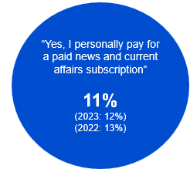

Source: D5. Do you currently personally pay for a paid news and current affairs subscription? This includes print or digital subscriptions to news and magazine publications.

Base: MCCS, All respondents. 2024: n=3,773. 2023: n=3,730. 2022: n=4,002.

Notes: No/Don’t know/refused responses not shown: 2024: No = 88%, DK = 0%, Ref = 0.3%. 2023: No = 88%, DK = 0%, Ref = 0%. 2022: No = 86%, DK = 0.1%, Ref = 0%

A blue circular graphic showing the proportion of respondents reported, "Yes, I personally pay for a paid news and current affairs subscription": 11% in 2024 (vs 12% in 2023, 13% in 2022)

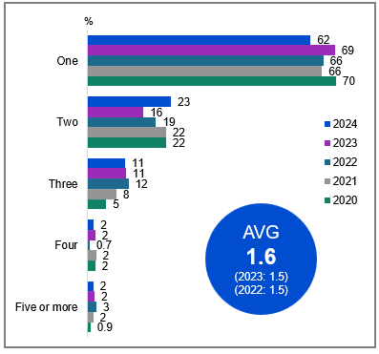

Source: D6. How many news subscriptions are you currently personally paying for?

Base: MCCS, Respondents who pay for a paid news and current affairs subscription. 2024: n=598. 2023: n=655. 2022: n=721. 2021: n=746. 2020: n=750.

Notes: Don’t know/refused responses not shown: 2024 DK = 0%, Ref = 0%. 2023 DK = 0%, Ref = 0%.2022 Dk = 0.0%, Ref = 0.0%. 2021 DK = 0.1% Ref = 0.0%. 2020 DK = 0.0%, Ref = 0.0%.

Bar chart showing the number of news subscriptions people are currently personally paying for, broken down by year from 2020 to 2024.

One: 62% in 2024, 69% in 2023, 66% in 2022, 66% in 2021, 70% in 2020.

Two: 23% in 2024, 16% in 2023, 19% in 2022, 22% in 2021, 22% in 2020.

Three: 11% in 2024, 11% in 2023, 12% in 2022, 8% in 2021, 5% in 2020.

Four: 2% in 2024, 2% in 2023, 0.7% in 2022, 2% in 2021, 2% in 2020.

Five or more: 2% in 2024, 2% in 2023, 3% in 2022, 2% in 2021, 0.9% in 2020.

A blue circular graphic showing the average number of news subscriptions people paid for: 1.6 in 2024 (vs 1.5 in 2023, 1.5 in 2022)

#### Subgroups

**One** was higher for:

* Ages 45-54 (79%), 65-74 (73% vs 41% of ages 25-34)

**Three** was higher for:

* Those receiving Government pensions, benefits or allowances (20% vs 7% of those did not)

#### Note

D6 AVG: Avg for D6 set no value for Ref and DK to exclude from avg calculation

The proportion of those with a paid news subscription remained consistent with levels in 2023.

### Importance of local news content

Local health issues (81%) and local crime, legal issues or court decisions (80%) were considered most important to respondents (net very important and somewhat important), while interest in local events (76%) and sports (37%) declined in 2024.

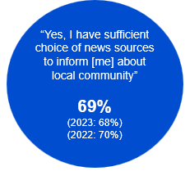

Source: D10. Do you feel you have sufficient choice of news sources to inform you about your local community?

Base: MCCS, All respondents. 2024: n=3,773. 2023: n=3,730. 2022: n=4,002.

Notes: No/Don’t know/refused responses not shown: 2024 No = 29%, DK = 1%, Ref = 0.4%. 2023 No = 31%, DK = 0.5%, Ref = 0.2%. 2022 No = 30%, DK = 0.4%, Ref = 0%

A blue circular graphic showing the proportion of respondents reported, "Yes, I have sufficient choice of news sources to inform [me] about local community": 69% in 2024 (vs 68% in 2023, 70% in 2022)

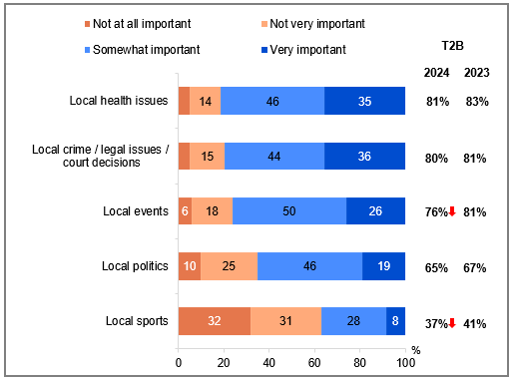

Source: D16. Thinking now about watching local news and coverage of various topics, to what extent are each of the following topics important or not important to you...

Base: MCCS, All respondents. 2024: n=3,773. 2023: n=3,730.

Notes: Don’t know/refused responses not shown, % vary per statement. Labels for responses <5% not shown on chart. ‘T2B’ includes ‘Somewhat important’ and ‘Very important’.

Bar chart showing the importance of various local news topics to viewers, comparing the years 2024 and 2023.

Local health issues: 5% Not at all important, 14% Not very important, 46% Somewhat important, 35% Very important, T2B: 81% in 2024, 83% in 2023.

Local crime/legal issues/court decisions: 5% Not at all important, 15% Not very important, 44% Somewhat important, 36% Very important, T2B: 80% in 2024, 81% in 2023.

Local events: 6% Not at all important, 18% Not very important, 50% Somewhat important, 26% Very important, T2B: 76% in 2024, 81% in 2023.

Local politics: 10% Not at all important, 25% Not very important, 46% Somewhat important, 19% Very important, T2B: 65% in 2024, 67% in 2023.

Local sports: 32% Not at all important, 31% Not very important, 28% Somewhat important, 8% Very important, T2B: 37% in 2024, 41% in 2023.

#### Subgroups

NET Very important + Somewhat important was higher for:

Local health issues:

* Women (84% vs 78% of men)
* Ages 75+ (90% vs 78% of ages 18-24, 77% of ages 25-34, 81% of ages 35-44, 80% of ages 45-54)

Local crime / legal issues / court decisions:

* Women (86% vs 74% of men)

Local events:

* Women (79% vs 73% of men)
* Ages 35-44 (80%), 45-54 (80%), 55-64 (80%), 65-74 (85%), and 75+ (89% vs 63% of ages 18-24, 68% of ages 25-34)

#### Callout

* Perceived importance (somewhat important or very important) of local news covering local events (76% vs 81% in 2023) and local sports (37% vs 41% in 2023) both saw a significant decline in 2024.

Local health issues and crime continued to be seen as the most important local news topics in 2024.

### Extent of incidental news consumption

One in five (19%) reported that the majority or all of the news they consumed came from activities where they were not primarily trying to engage with (net the majority of it, all of it). Passive news consumers, who consumed most or all of their news passively, were more likely to be younger, women, who viewed posts, images, and videos on social media at least once a day and accessed most of their news from online sources.

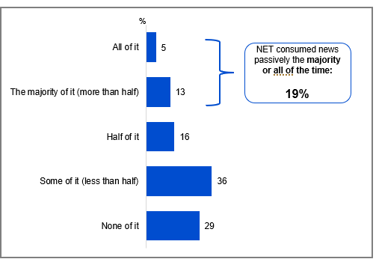

Source: NCONSUM1. How much of your news consumption comes from activities where you are not primarily trying to engage with news content?

Base: TVCS, MCCS. All respondents. 2024: n=4,490.

Notes: Don’t know/refused responses not shown: 2024 DK = 1%, Ref = 0.2%.

Horizontal bar chart showing the percentage distribution of how much news consumption comes from activities where individuals are not primarily trying to engage with news content for the year 2024.

All of it: 5%

The majority of it (more than half): 13%

Half of it: 16%

Some of it (less than half): 36%

None of it: 29%

NET consumed news passively the majority or all of the time: 19%

#### Subgroups

NET consumed news passively the majority or all of the time was higher for:

* Ages 18-24 (31%), 25-34 (24%), 35-44 (24% vs 14% of those ages 45-54, 14% of ages 55-64, 8% of ages 65-74, 8% of ages 75+)
* Women (20% vs 17% of men)
* Those living with dependent children in the household (22%), adults living in a share house (26% vs 15% of those without children)
* Those viewing posts, images, and videos on social media sites once a day or more (23% vs 13% of those viewing less than once a day)
* Accessed most news from online sources in general (18% vs 16% of those from audio, 14% of those from newspaper, 15% of those from TV sources)
* Accessed news via online sources in P7D (33% vs 16% did not)
* Those watching free video streaming services (21%), SVOD (21%), other websites or apps in P7D (22% vs 15% of those watching FTA Broadcast, 15% watching FTA BVOD, 14% watching Pay-TV)

#### Callout

* **Those who consumed ‘none’ of the news passively** were more likely to be those aged 65+ (47%), living outside a capital city (32%), with no children in household (35%), with education up to Year 12 (35%), retired (45%), received Government pensions, benefits or allowances (38%), accessed news generally from publicly owned free-to-air TV (31%), watched FTA Broadcast (32%) in P7D.
* **Polarisation of incidental news consumption:** for those who are heavy media consumers (over 35 hours per week on any platform), there is polarisation of incidental news consumption at each extreme end of the scale (with some who say ‘all of their news consumption is when they’re not trying to engage with it’, and some say ‘none of it’. (Note small base size of n=26 for those with over 35 hours per week).

19% of respondents reported passively consuming the majority or all of the news they consumed, with this more common among women and younger respondents, and those with children in their household.

### Attitudes and behaviours around news consumption

Half (51%) of all respondents agreed or strongly agreed that they actively sought out news on topics of interest. Moderate levels of agreement were recorded for trying to avoid uncomfortable topics (38% net agree), adjusting news consumption habits due to the volume of news (37%), and feeling fatigued by the high volume of news (32%).

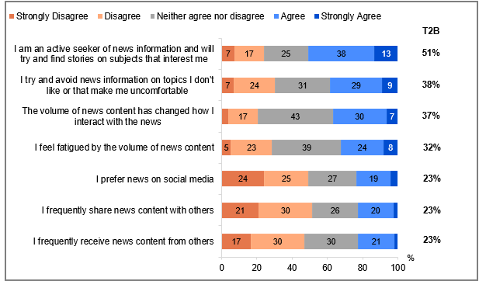

Source: NCONSUM2. To what extent do you agree or disagree with the following statements:

Base: TVCS, MCCS. All respondents. 2024: n=4,490.

Notes: Don’t know/refused responses not shown, % vary per statement. Labels for responses <5% not shown on chart. ‘T2B’ includes ‘Agree’ and ‘Strongly agree’.

Bar chart showing the extent to which respondents agree or disagree with various statements about their news consumption habits.

I am an active seeker of news information and will try and find stories on subjects that interest me:

Strongly Disagree: 7%

Disagree: 17%

Neither agree nor disagree: 25%

Agree: 38%

Strongly Agree: 13%

T2B (Top Two Box): 51%

I try and avoid news information on topics I don't like or that make me uncomfortable:

Strongly Disagree: 7%

Disagree: 24%

Neither agree nor disagree: 31%

Agree: 29%

Strongly Agree: 9%

T2B (Top Two Box): 38%

The volume of news content has changed how I interact with the news:

Strongly Disagree: 4%

Disagree: 17%

Neither agree nor disagree: 43%

Agree: 30%

Strongly Agree: 7%

T2B (Top Two Box): 37%

I feel fatigued by the volume of news content:

Strongly Disagree: 5%

Disagree: 23%

Neither agree nor disagree: 39%

Agree: 24%

Strongly Agree: 8%

T2B (Top Two Box): 32%

I prefer news on social media:

Strongly Disagree: 24%

Disagree: 25%

Neither agree nor disagree: 27%

Agree: 19%

Strongly Agree: 4%

T2B (Top Two Box): 23%

I frequently share news content with others:

Strongly Disagree: 21%

Disagree: 30%

Neither agree nor disagree: 26%

Agree: 20%

Strongly Agree: 3%

T2B (Top Two Box): 23%

I frequently receive news content from others:

Strongly Disagree: 17%

Disagree: 30%

Neither agree nor disagree: 30%

Agree: 21%

Strongly Agree: 2%

T2B (Top Two Box): 23%

#### Subgroups

**Active seeker of news information** (net agree + strongly agree) were more likely to be:

* Men (56%)
* Ages 65+ (58%)
* Those with a Postgraduate degree (61%)
* Retired (58%)
* Looking for information over the internet once a day or more (55%)
* Accessed news from newspaper (61%), online (57%) and audio (57%) sources in general

**Frequently share news content with others** (net agree + strongly agree) were more likely to be:

* Ages 18-24 (35%)
* Students (38%)
* Comment or post images to social media sites (35%) or post to blogs / forums / interest groups once a day or more (38%)
* Accessed news from online sources (27%) in general

**Frequently receive news content with others** (net agree + strongly agree) were more likely to be:

* Ages 18-24 (33%)
* Those living in a capital city (26%)
* Those with dependent children in the household (28%)
* Comment or post images to social media sites (33%), post to blogs / forums / interest groups (40%), or view posts, images and videos on social media sites (26%) once a day or more
* Accessed news from online sources (26%) in general

**Avoid news on topics don’t like** (net agree + strongly agree) were more likely to be:

* Women (42% vs 35% of men)

**Volume of news content changed interaction with news** (net agree + strongly agree) were more likely to be:

* Ages 18-24 (45%), 25-34 (43%), 35-44 (38%), 45-54 (37% vs 26% of those ages 75+)

**Fatigued by the volume of news** (net agree + strongly agree) were more likely to be:

* Women (37% vs 27% of men)
* Ages 18-24 (39%), 25-34 (38%), 35-44 (34%), 45-54 (32%), 55-64 (31% vs 23% of those ages 65-74, 22% of ages 75+)
* Those who were neurodivergent (48% vs 33% of those who were not)

#### Further reading

The University of Canberra’s *Digital News Report: Australia* provides complementary data on how Australians use the news, including on rates of news avoidance and news fatigue amongst Australian and global news consumers.8

Half of respondents reported being active seekers of news on topics of interest, with this being more common among men and older respondents.

### Sources used for emergency information

One-in-ten (11%) respondents reported having experienced an emergency situation, such as a natural disaster or extreme weather event, in the past 12 months. Online (NET 56%) was the most commonly used source of information, radio was also used to find out information (31%), especially for those not living in capital cities.

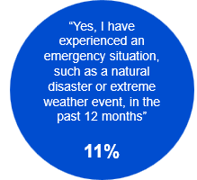

Source: EMERG1. Have you experienced an emergency situation, such as a natural disaster or extreme weather event, in the past 12 months?

Base: TVCS, All respondents. 2024: n=3,890.

Notes: No/Don’t know/refused responses not shown: No = 89%, DK = 0.4%, Ref = 0%

A blue circular graphic showing the proportion of respondents reported, "Yes, I have experienced an emergency situation, such as a natural disaster or extreme weather event, in the past 12 months": 11% in 2024.

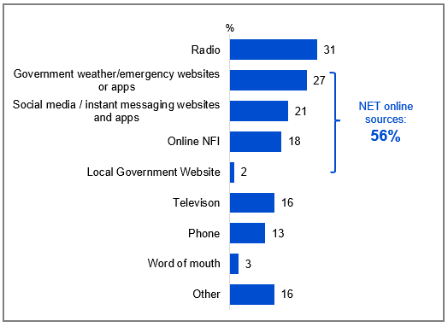

Source: EMERG2. What services, platforms, or sources did you use to find out information about the most recent emergency situation you experienced?

Base: TVCS, Respondents who have encountered an emergency situation. 2024: n=421.

Notes: Don’t know/refused responses not shown: 2024 DK = 2%, Ref = 3%.

Bar chart showing the services, platforms, or sources used to find information about the most recent emergency situation experienced by respondents in 2024.

Radio: 31%

Government weather/emergency websites or apps: 27%

Social media / instant messaging websites and apps: 21%

Online NFI: 18%

Local Government Website: 2%

Television: 16%

Phone: 13%

Word of mouth: 3%

Other: 16%

NET online sources: 56%.

#### Subgroups

**Radio** was higher for:

* Those living outside a capital city (40% vs 13% of those living in a capital city)

NET online sources was higher for:

* Women (72% vs 42% of men)
* Ages 18-64 (62% vs 33% of those ages 65+)
* Those born in a mainly English speaking country (60% vs 38% of those born in a mainly non-English speaking country)
* Those looking for information over the internet once a day or more (64% vs 34% of those did it less than once a day)
* Those viewing posts, images, and videos on social media sites once a day or more (69% vs 40% of those did it less than once a day)

NET online sources was higher for:

* those with no Free-to-air TV (10% vs 0.42% Broadcast only).

11% of respondents experienced an emergency situation in the past 12 months. Radio, Government weather / emergency website or apps, and social media / instant messaging websites and apps were the key emergency information sources.

### Preferred source of emergency information

For those who have experienced an emergency, online sources and radio were the two primary preferred sources of emergency information. Usage of service types in an emergency also tend to align with their general usage. Online sources were favoured by those aged 64 and under and with fixed home internet, whereas radio was preferred by men, adults aged 55+, and those living outside a capital city. Online sources (NET) for emergency information were preferred by 49% of those who experienced an emergency and 52% of those who did not experience an emergency.

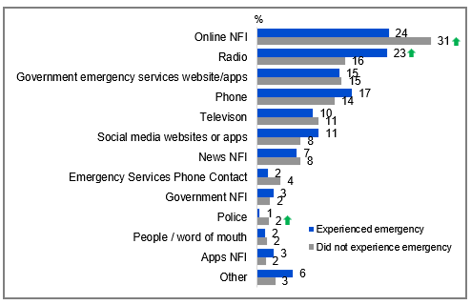

Source: EMERG3. If you were seeking information in an emergency, where would you prefer to get your information?

Base: TVCS, All respondents. 2024: n=3,890.

Notes: Don’t know/refused responses not shown: 2024 DK = 5%, Ref = 3%. ‘Emergency Services Phone Alerts’ not displayed due to small base size at total level (n=24). ‘NET online sources’ includes ‘Online NFI’, ‘Government emergency services website/apps’, ‘social media websites or apps’, ‘Apps NFI’.

Bar chart showing the preferred sources of information in an emergency, comparing people who did not experience an emergency with those who did.

Online NFI: 31% (Did not experience emergency), 24% (Experienced emergency)

Radio: 16% (Did not experience emergency), 23% (Experienced emergency)

Government emergency services website/apps: 15% (Both groups)

Phone: 14% (Did not experience emergency), 17% (Experienced emergency)

Television: 11% (Did not experience emergency), 10% (Experienced emergency)

Social media websites or apps: 8% (Did not experience emergency), 11% (Experienced emergency)

News NFI: 8% (Did not experience emergency), 7% (Experienced emergency)

Emergency Services Phone Contact: 4% (Did not experience emergency), 2% (Experienced emergency)

Government NFI: 2% (Did not experience emergency), 3% (Experienced emergency)

Police: 2% (Did not experience emergency), 1% (Experienced emergency)

People/word of mouth: 2% (Both groups)

Apps NFI: 2% (Did not experience emergency), 3% (Experienced emergency)

Other: 3% (Did not experience emergency), 6% (Experienced emergency)

#### Subgroups

NET online sources was higher for:

* Ages 18-24 (62%), 25-34 (61%), 35-44 (60%), 45-54 (56%), 55-64 (48% vs 33% of ages 65-74, 29% of ages 75+)
* Those with a Bachelor degree (60%), a Postgraduate degree (56%), a TAFE, Trade Certificate, Diploma (51% vs 43% of those with education up to Year 12)
* Those born in a mainly non-English speaking country (59% vs 49% of those born in a mainly English speaking country)
* Those with fixed home internet (52% vs 43% of those without fixed home internet)

Radio was higher for:

* Men (20% vs 14% of women)
* Ages 55-64 (27%), 65-74 (27%), 75+ (23% vs 5% of ages 18-24, 10% of ages 25-34, 12% of ages 35-44)
* Those with education up to Year 12 (17%), a TAFE, Trade Certificate, Diploma (20% vs 11% of those with a Bachelor degree)
* Those living outside a capital city (22% vs 12% of those living in a capital city)
* Those who experienced an emergency situation (23% vs 16% of those who did not)
* Those born in a mainly English speaking country (18% vs 11% of those born in a mainly non-English speaking country)

Context: General usage of sources (past 7 days):

* ‘NET AM radio / FM radio’ usage in P7D (NEW28) was higher for older ages aged 55+ (69%).
* ‘Other websites or apps’ content watched P7D (C1) was higher for younger ages aged 18-54 (55%).
* ‘NET TV’ in P7D (C1) was higher for older ages aged 45+ (88%)

#### Note

**‘NET TV’ in P7D** includes: Commercial free-to-air TV (e.g. Seven, Nine, 10, WIN, Imparja, NBN Television), including recorded content but excluding on-demand TV, Publicly owned free-to-air TV (i.e. ABC, SBS), including recorded content but excluding on-demand TV, Pay TV (e.g. Foxtel, Fetch TV), including recorded content but excluding streaming, Commercial free-to-air on-demand TV (e.g. 9Now, 10 play, 7plus), Publicly owned free-to-air on-demand TV (e.g. ABC iview, SBS On Demand, ABC News, ABC Kids)

#### Callout

* Respondents who did not experience an emergency situation in the past 12 months were more likely than those who did experience an emergency to prefer online sources (31% vs 24%) or the police (2% vs 1%) for emergency information.
* In contrast, those who experienced an emergency were more likely to prefer radio (23% vs 16%) as their source of information.

Online was the preferred source of emergency information, followed by radio. Those who had experienced an emergency situation also favoured radio, while those who had not experienced an emergency preferred online.

### Important factors for those who have experienced an emergency

Emergency news priorities differed between those with and without recent crisis experience. Those with recent crisis experience valued accessibility (58%), timeliness (57%), and official sources (54%), while also emphasising community reputation. Those without emergency experience prioritised official sources of information (62%) above all else.

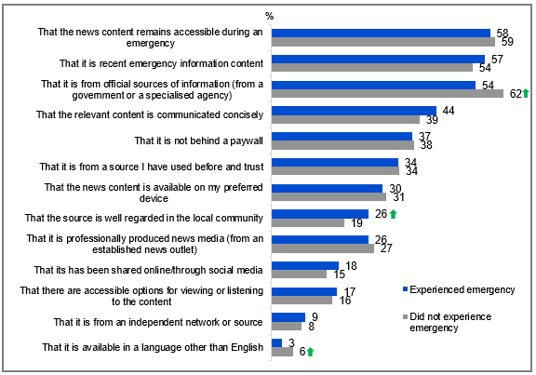

Source: EMERG4. If you were seeking information in an emergency, such as a natural disaster or extreme weather event, which of the following factors would be important to you when choosing content? EMERG1. Have you experienced an emergency situation, such as a natural disaster or extreme weather event, in the past 12 months?

Base: TVCS, All respondents. 2024: n=3,890. Those who have experienced an emergency, 2024: n=421.

Notes: Other (please specify)/ Don’t know/refused responses not shown: 2024 Other = 0.2%. DK = 0.6%, Ref = 0.4%.

Bar chart showing the importance of various factors when choosing content during an emergency, such as a natural disaster or extreme weather event. The chart compares responses from two groups: those who did not experience an emergency and those who did.

That the news content remains accessible during an emergency: 59% (Did not experience emergency), 58% (Experienced emergency)

That it is recent emergency information content: 54% (Did not experience emergency), 57% (Experienced emergency)

That it is from official sources of information (from a government or a specialised agency): 62% (Did not experience emergency), 54% (Experienced emergency)

That the relevant content is communicated concisely: 39% (Did not experience emergency), 44% (Experienced emergency)

That it is not behind a paywall: 38% (Did not experience emergency), 37% (Experienced emergency)

That it is from a source I have used before and trust: 34% (Both groups)

That the news content is available on my preferred device: 31% (Did not experience emergency), 30% (Experienced emergency)

That the source is well regarded in the local community: 19% (Did not experience emergency), 26% (Experienced emergency)

That it is professionally produced news media (from an established news outlet): 27% (Did not experience emergency), 26% (Experienced emergency)

That it has been shared online/through social media: 15% (Did not experience emergency), 18% (Experienced emergency)

That there are accessible options for viewing or listening to the content: 16% (Did not experience emergency), 17% (Experienced emergency)

That it is from an independent network or source: 8% (Did not experience emergency), 9% (Experienced emergency)

That it is available in a language other than English: 6% (Did not experience emergency), 3% (Experienced emergency)

#### Subgroups

It is from official sources of information was higher for:

* Women (63% vs 58% of men)
* Ages 65-74 (68%), 75+ (74% vs 56% of those aged 18-24, 55% of ages 25-34, 52% of ages 35-44)
* Those retired (72% vs 59% of those employed full time or part time, 49% of those employed casually, 49% of self-employed, 53% of non-worker)
* Non-Aboriginal or Torres Strait Islander respondents (61% vs 49% of Aboriginal and / or Torres Strait Islander respondents)
* Those did not experience emergency situation (62% vs 54% of those who did)

News content remains accessible during an emergency was higher for:

* Women (62% vs 57% of men)
* Ages 45-54 (62%), 55-64 (64%), 65-74 (68%), 75+ (63% vs 46% of ages 18-24)
* Those born in a mainly English speaking country (62% vs 50% of those born in a mainly non-English speaking country)

It is recent emergency information content was higher for:

* Women (57% vs 50% of men)
* Those living outside a capital city (57% vs 51% of those living in a capital city)

#### Callout

* Those who had not experienced an emergency in the past 12 months were more likely than those who had to consider official sources from the government or specialised agencies (62% vs 54%), as well as information availability in languages other than English (6% vs 3%), as important when seeking emergency information, while those who had experienced an emergency placed greater importance on widely trusted local community sources (26% vs 19%).

Credibility of sources, availability or accessibility, and timeliness of news were the top important factors identified when seeking information in an emergency.

## Sports content

### Chapter Summary – Sports Content

Sports viewership declined significantly in 2024

* Just under two-in-five respondents (39%) reported that they consumed sports content in the past seven days, while the majority (61%) did not watch any sports content.
* Live sports remained the most commonly consumed type of sports content (26%), although viewership across all sports content categories declined significantly compared to 2023, except for sports highlights.
* The proportion of respondents reporting no sports consumption in the past seven days (61%) increased significantly in 2024.
* Consumption of men’s sports also declined (51%), while more respondents reported watching both men’s and women’s sports (45%) or only women’s sports (4%).
* The most commonly consumed sport types overall (net men’s, women’s, and both) continued to be the Olympic Games events (80%), Commonwealth Games events (66%), and Australian Rules Football (62%). The most commonly consumed women’s sports were netball (13%) and Australian soccer/football (5%), while the most commonly consumed men’s sports were Australian Rules Football (35%) and international test cricket matches (32%).

Shift toward online sports consumption

* The consumption of sports content via free-to-air TV (net 62%) saw a significant decline in 2024, largely driven by reduced viewership on commercial free-to-air TV (40%).
* Consumption of sports content via online methods increased significantly (56% net online).

Importance of free access to sports content

* The most commonly cited feature of sports content was its availability on free-to-air broadcast TV (20%).
* Sports viewership was likely boosted by content being ‘free to watch’ (51% net watched a little or a lot more), while gambling advertising negatively impacted viewership (44% net decreased watching a little or a lot).

#### Note

Survey fieldwork dates:

* 2024 survey fieldwork: 28 October – 21 November 2024
* 2023 survey fieldwork: 25 September – 16 October 2023
* 2022 survey fieldwork: 12 September – 5 October 2022
* 2021 survey fieldwork: 13 September – 27 September 2021
* 2020 survey fieldwork: 14 September – 28 September 2020

2024 Field (28 October to 21 November 2024)

* Melbourne Cup, 5 November 2024
* Australia co-hosted the 2024 Rugby League Pacific Championship, October-November 2024
* Championship series of Major League Baseball, October 25 to November 2, 2024
* The Bathurst 1000, 10-13 October 2024 **(outside of the 2024 survey fieldwork period)**
* NRL & NRLW Grand Finals, 6 October, 2024 **(outside of the 2024 survey fieldwork period)**
* Australia Cup Final, 29 September, 2024 **(outside of the 2024 survey fieldwork period)**
* AFL Grand Final, 28 September, 2024 **(outside of the 2024 survey fieldwork period)**

2023 Field (25 September – 16 October 2023)

* Australia Cup Final, 7 October 2023
* The Bathurst 1000, 5-8 October 2023
* NRL & NRLW Grand Finals, 1 October 2023
* AFL Grand Final, 30 September 2023
* Australia hosted the FIFA Women’s World Cup one month before field began for the 2023 survey.

### Sports content consumed in the past 7 days

Sports content consumption reached 39% of viewers in the past 7 days, with live sports leading (26%) despite a 16-percentage point decline in 2024. Note: The 61% non-engagement rate may reflect fieldwork for the survey in 2024 being conducted outside of the grand final window (AFL and NRL*).

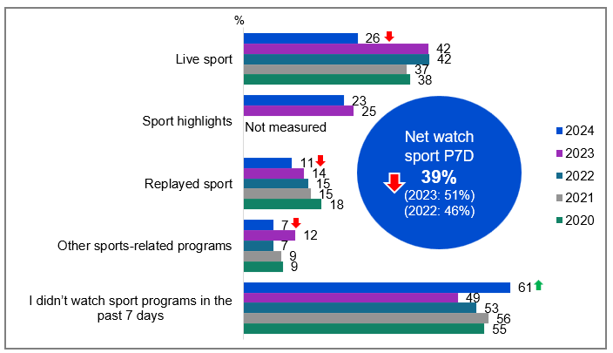

Source: E1. In the past 7 days, did you watch or listen to…?

Base: TVCS, All respondents. 2024: n=3,890. 2023: n=3,861. 2022: n=4,016. 2021: n=4,135. 2020: n=4,096.

Notes: Don’t know/refused responses not shown: 2024 DK = 0.2%, Ref = 0.3%. 2023 DK = 0.1%, Ref = 0.2%. 2022 DK = 0.3%, Ref = 0.2%. 2021 DK and Ref = 0%. 2020 DK and Ref = 0%.  
*AFL grand final: 28 September 2024, NRL grand final: 6 October 2024.

Bar chart showing the percentage of people who watched or listened to various types of sports content in the past 7 days for the years 2020 to 2024.

Live sport: 26% in 2024, 42% in 2023, 42% in 2022, 37% in 2021, 38% in 2020.

Sport highlights: 23% in 2024, 25% in 2023 (not measured for other years).

Replayed sport: 11% in 2024, 14% in 2023, 15% in 2022, 15% in 2021, 18% in 2020.

Other sports-related programs: 7% in 2024, 12% in 2023, 7% in 2022, 9% in 2021, 9% in 2020.

I didn’t watch sport programs in the past 7 days: 61% in 2024, 49% in 2023, 53% in 2022, 56% in 2021, 55% in 2020.

A blue circular graphic showing NET proportion of watching sport in the past 7 days: 39% in 2024 (vs 51% in 2023, 46% in 2022)

#### Subgroups

Net watch sport P7D was higher for:

* Those had access to any sports SVODs (e.g. Kayo Sports, Optus Sports, Stan Sport) (71% vs 32% of those did not have access)
* Those had access to any sports SVODs (e.g. Kayo Sports, Optus Sports, Stan Sport, Foxtel Now and Foxtel (NFI)) (66% vs 30% of those did not have access)

Live sport was higher for:

* Men (36% vs 16% of women)
* Ages 65-74 (33%), 75+ (34% vs 22% of ages 18-24, 19% of ages 25-34, 24% of ages 35-44, 24% of ages 45-54)
* Those born in a mainly English speaking country (29% vs 16% of those born in a mainly non-English speaking country)
* Those with education up to Year 12 (29%), with a TAFE, Trade Certificate, Diploma (30% vs 21% of those with a Bachelor’s degree, 19% of those with a Postgraduate degree)
* Those watching commercial free-to-air TV in P7D (33% vs 31% of those watching publicly owned free-to-air TV in P7D)
* Those watching sports specific website or app (75%), commercial free-to-air TV (35), Pay TV in P7D (48% vs 33% of those watching publicly owned free-to-air TV, 33% of those watching commercial free-to-air on-demand TV, 29% of those watching publicly owned free-to-air on-demand TV, 25% of those watching free video streaming, 24% of those watching online subscription services, 34% of those watching pay-per-view services, 24% of those watching other websites or apps in P7D)

#### Callout

* In 2024, the net consumption of sports content in the past 7 days decreased significantly (39% vs 51% in 2023).
* This decline was observed across live sports (26% vs 42% in 2023), replayed sports (11% vs 14% in 2023), and other sports-related programs (7% vs 12% in 2023).

Consumption of sports content has declined significantly across all categories in 2024. Live sport remained the most commonly consumed.

#### Whether non-consumers of sport in past 7 days consume sports in a normal year

When non-recent sports viewers were asked about their typical annual consumption of sport, 54% indicated that they watch or listen to sports during a normal year, with most (31%) engaging specifically during major sporting events, while 13% focus on specific seasons and 10% watch or listen through-out the year. This represents an increase in potential sports audience for 2024.

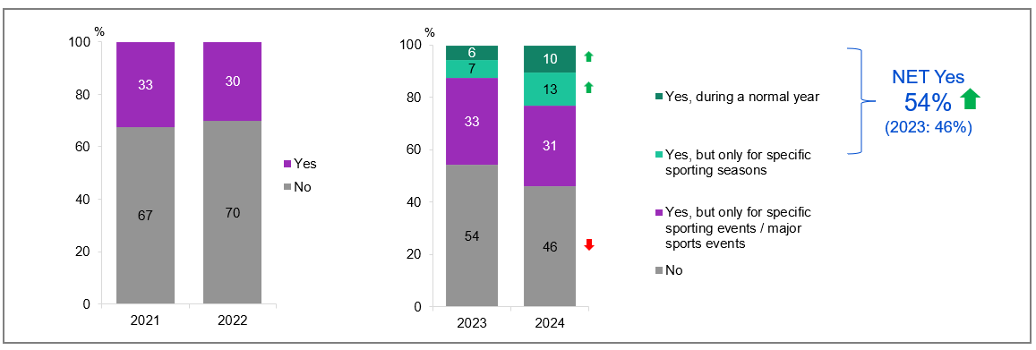

Source: E5. Do you watch or listen to sports at all during a normal year?

Base: TVCS, Respondents who have not consumed sports content in the past 7 days. 2024: n=2,329. 2023: n=1,838. 2022: n=2,060. 2021: n=2,211

Notes: Don’t know/refused responses not shown: 2024 DK = 0%, Ref = 0.2%. 2023 DK = 0.1%, Ref = 0.1%. 2022 DK = 0.1%, Ref = 0.0%. 2021 DK = 0%, Ref = 0%.   
Question updated in 2023 to split out ‘Yes’ into three options as shown on the 2023 chart. Therefore results between 2023 and prior years are not directly comparable and are included for reference only.

Bar chart showing the percentage of people who watch or listen to sports during a normal year, categorised by response options across the years 2021, 2022, 2023, and 2024. The data is divided into four categories for 2023 and 2024: 'Yes, during a normal year,' 'Yes, but only for specific sporting seasons,' 'Yes, but only for specific sporting events / major sports events,' and 'No.' For 2021 and 2022, the data is divided into two categories: 'Yes' and 'No.'

Yes, during a normal year:

10% in 2024

6% in 2023

Yes, but only for specific sporting seasons:

13% in 2024

7% in 2023

Yes, but only for specific sporting events / major sports events:

31% in 2024

33% in 2023

No:

46% in 2024

54% in 2023

NET Yes 54% 2024, 46% 2023

Yes:

30% in 2022

33% in 2021

No:

70% in 2022

67% in 2021

#### Subgroups

NET Yes was higher for:

* Ages 75+ (66% vs 49% of those ages 25-34, 51% of those ages 35-44, 49% of those ages 45-54)

#### Callout

* In 2024, there was a significant increase in sports consumption during a normal year among those who did not consume sports in the past 7 days (net 54% vs 46% in 2023). This increase was mainly driven by higher sports consumption during a normal year (10% vs 6% in 2023) and for specific sporting seasons (13% vs 7% in 2023).

Of those who hadn’t consumed sports content in the past 7 days, over half did watch or listen to sport in a normal year, mostly for specific or major sporting events, an increases in 2024.

### How respondents consumed sports content

Commercial free-to-air TV, excluding on-demand, remained the most commonly accessed source of sports content (40%), though it declined in 2024. Around three-in-ten (29%) used a sports specific website or app, while a slightly smaller proportion watched sports on commercial free-to-air on-demand TV (20%) or Pay TV (20%).

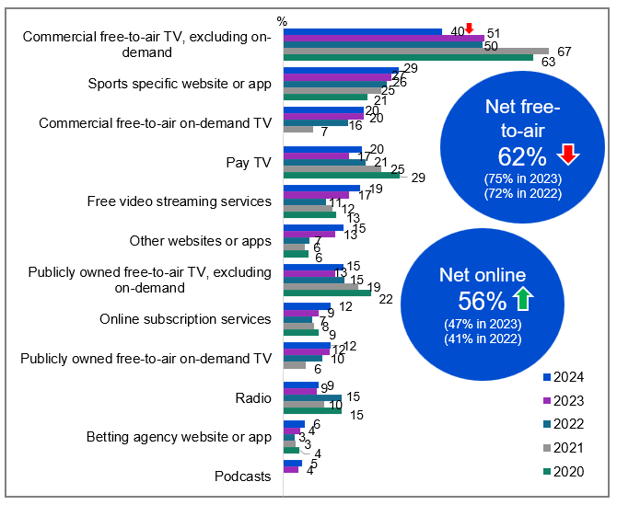Source: E2. How did you watch or listen to sports related programs in the past 7 days?

Base: TVCS, Respondents who consumed sports content in the past 7 days. 2024: n=1,561. 2023: n=2,023. 2022: n=1,956. 2021: n=1,924. 2020: n=1,903.

Notes: Other/Don’t know/refused responses not shown: 2024 Other = 0.2% DK = 0%, Ref = 0.1%. 2023 Other = 0.2% DK = 0.2%, Ref = 0%. 2022 DK = 0.3%, Ref = 0%. 2021 DK = 0.1, Ref = 0.0%. 2020 DK and Ref = 0%. Responses <4% in 2023 not shown on chart.

Bar chart showing how people watched or listened to sports-related programs in the past 7 days from 2020 to 2024.

Commercial free-to-air TV (excluding on-demand): 63% in 2020, 67% in 2021, 50% in 2022, 51% in 2023, and 40% in 2024.

Sports specific website or app: 21% in 2020, 25% in 2021, 26% in 2022, 27% in 2023, and 29% in 2024.

Commercial free-to-air on-demand TV: 0% in 2020, 7% in 2021, 16% in 2022, 20% in 2023, and 20% in 2024.

Pay TV: 29% in 2020, 25% in 2021, 21% in 2022, 17% in 2023, and 20% in 2024.

Free video streaming services: 13% in 2020, 12% in 2021, 11% in 2022, 17% in 2023, and 19% in 2024.

Other websites or apps: 6% in 2020, 6% in 2021, 7% in 2022, 13% in 2023, and 15% in 2024.

Publicly owned free-to-air TV (excluding on-demand): 22% in 2020, 19% in 2021, 15% in 2022, 13% in 2023, and 15% in 2024.

Online subscription services: 9% in 2020, 8% in 2021, 7% in 2022, 9% in 2023, and 12% in 2024.

Publicly owned free-to-air on-demand TV: 0% in 2020, 6% in 2021, 10% in 2022, 12% in 2023, and 12% in 2024.

Radio: 15% in 2020, 10% in 2021, 15% in 2022, 9% in 2023, and 9% in 2024.

Betting agency website or app: 4% in 2020, 3% in 2021, 3% in 2022, 4% in 2023, and 6% in 2024.

Podcasts: 5% in 2024, 4% in 2023.

Sports consumption last 7 days via free-to-air TV (net): 62% in 2024, 75% in 2023, 72% in 2022)

Sports consumption last 7 days via online (net): 56% in 2024, 47% in 2023, 41% in 2022)

#### Subgroups

Commercial free-to-air TV, excluding on-demand was higher for:

* Ages 55-64 (50%), 65-74 (55%), 75+ (58% vs 21% of ages 18-24, 24% of ages 25-34 and 32% of ages 35-44)
* Those living outside a capital city (52% vs 32% of those living in a capital city)
* Those without children in the household (43% vs 29% of those with dependent children)
* Those with education up to Year 12 (49%), with a TAFE, Trade Certificate, Diploma (47% vs 24% of those with a Bachelor’s degree, 31% of those with a Postgraduate degree)
* Those born in a mainly English speaking country (43% vs 26% of those born in a mainly non-English speaking country)

Sports specific website or app was higher for:

* Ages 18-24 (37%), 35-44 (37%), 45-54 (37% vs 19% of ages 65-74)
* Those employed full time or part time (33%), students (46% vs 20% of those retired)

#### Note

Net free-to-air includes ‘Commercial free-to-air TV, excluding on-demand’, ‘Commercial free-to-air on-demand TV’, ‘Publicly owned free-to-air TV, excluding on-demand’, and ‘Publicly owned free-to-air on-demand TV’. Net online includes ‘Sports specific website or app’, ‘Free video streaming services’, ‘Online subscription services’, ‘Betting agency website or app’, ‘Pay-per-view services’, and ‘Other websites or apps’.

#### Callout

* NET free-to-air TV has decreased as sources of sports content in 2024 (62% vs 75% in 2023), mainly driven by the decline in commercial free-to-air TV (40% vs 51% in 2023), while NET online has increased (56% vs 47% in 2023).

Sports content consumption via free-to-air TV declined significantly in 2024, while consumption via online sources increased.

### Importance of various features of sports content

The most commonly cited feature of sports content that respondents valued most was its availability on free-to-air broadcast TV (20%). The second most important feature was that it was freely accessible either online or on broadcast TV (16%).

Table Importance of various features of sports content (%)

|  |  |  |  |
| --- | --- | --- | --- |
| Feature | 2022 | 2023 | 2024 |
| **That it is freely available on broadcast TV** | 24 | 20 | 20 |
| **That it is freely available either online or on broadcast TV** | 20 | 16 | 16 |
| **That it is freely available online** | N/A | 8 | 8 |
| **That the game/event is shown in full** | N/A | 8 | 6 |
| **That it is available on-demand so I can watch matches/events when I want to watch them** | 8 | 6 | 5 |
| **That it is easily accessible, even if I have to pay for it** | 7 | 4 | 4 |
| **That the sports season or series is shown in full** | N/A | 3 | 2 |
| **Other (specify)** | 1 | 0.2 | 0.2 |
| **I don't watch sports** | N/A | 35 | 37 |

Source: NEW20. Thinking about access to watching sports, which of the following features is the MOST important to you?

Base: TVCS, All respondents. 2024: n=3,890. 2023: n=3,861. 2022: n=4,016.

Notes: Don’t know/refused responses not shown: 2024 DK = 0.1%, Ref = 0.2%. 2023 DK = 0.1%, Ref = 0%. 2022 Dk=1%, Ref=0.2% Note that in 2023, the base for NEW20 was changed to ‘All TVCS respondents’. The 2022 data on this slide has been rebased to all TVCS respondents to be comparable with 2023 data, and is different to what is reported in the 2022 report. Significance testing not conducted between 2022 and 2023 due to code frame additions / differences in 2023.

#### Subgroups

That it is freely available on broadcast TV was higher for:

* Men (22% vs 18% of women)
* Ages 45-54 (20%), 55-64 (26%), 65-74 (34%), 75+ (36% vs 8% of ages 18-24, 9% of ages 25-34, 14% of ages 35-44)
* Those living outside a capital city (25% vs 16% of those living in a capital city)
* Those without children in the household (24% vs 15% of those with dependent children and 9% of adults living in a share house)
* Those born in a mainly English speaking country (21% vs 14% of those born in a mainly non-English speaking country)
* Those without fixed home internet (28% vs 19% of those with fixed home internet)
* Those with access to an external free-to-air television aerial, antenna, or broadcast signal (24% vs 12% of those without)
* Those watching commercial free-to-air TV in P7D (28% vs 26% of those watching publicly owned free-to-air TV)

The most important feature of sports content was its availability on broadcast TV (with online access to sports content also being important).

### Whether sports content consumed was men’s, women’s, or both

Consumption of men’s sports (51%) in the past 7 days declined in 2024, with increasingly more respondents consuming both men’s and women’s sport (45%) or women’s sport (4%). (Note that fieldwork for the survey in 2024 was conducted outside of the grand final window).

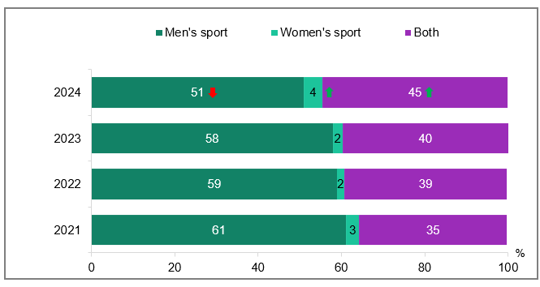Source: E3. Were the sports programs you watched or listened to focused on:

Base: TVCS, Respondents who consumed sports content in the past 7 days. 2024: n=1,561. 2023: n=2,023. 2022: n=1,956. 2021 n=1,924.

Notes: Don’t know/refused responses not shown: 2024 DK = 0.1%, Ref = 0%. 2023 DK and Ref = 0%. 2022 DK = 0.1%, Ref = 0.1%, 2021 DK = 0.2, Ref = 0%.

Bar chart showing the percentage distribution of sports programs watched or listened to, categorised by the focus on men's sport, women's sport, or both for the years 2021 to 2024.

2024: Men's sport - 51%, Women's sport - 4%, Both - 45%

2023: Men's sport - 58%, Women's sport - 2%, Both - 40%

2022: Men's sport - 59%, Women's sport - 2%, Both - 39%

2021: Men's sport - 61%, Women's sport - 3%, Both - 35%

#### Subgroups

Men’s sport was higher for:

* Men (56% vs 41% of women)
* Ages 18-24 (60%), 25-34 (69%), 35-44 (53%), 55-64 (50% vs 34% of ages 75+)
* Those living in a capital city (54% vs 46% of those living outside a capital city)
* Those watching free video streaming services (56%), online subscription services (56%), pay-per-view services (67%), other websites or apps in P7D (56% vs 48% of those watching commercial free-to-air TV, excluding on-demand TV in P7D)

Women’s sport was higher for:

* Women (10% vs 2% of men)
* Aboriginal and / or Torres Strait Islander respondents (13% vs 4% of non-Aboriginal or Torres Strait Islander respondents)

Both was higher for:

* Ages 65-74 (54%) and 75+ (64% vs 32% of ages 18-24 and 26% of ages 25-34)
* Those living outside a capital city (49% vs 41% of those living in a capital city)
* Those watching commercial free-to-air TV, excluding on-demand TV (48%), publicly owned free-to-air TV, excluding on-demand TV (50%), commercial free-to-air on-demand TV in P7D (49% vs 39% of those watching free video streaming services, 39% of those watching online subscription services, 39% of those watching other websites or apps in P7D)

#### Callout

* In 2024, the consumption of men's sports (51% vs 58% in 2023) decreased significantly, while the consumption of women's sports (4% vs 2% in 2023) and mixed-gender sports (45% vs 40% in 2023) both increased.

Consumption of both men’s and women’s sport and women’s only sport increased in 2024, while consumption of men’s only sport decreased.

### Types of sports content consumed

Major sporting events dominated overall viewership, led by the Olympics (80%), Commonwealth Games (66%), and Australian Rules Football (62%). Gender-specific viewing showed distinct patterns: women's sports were led by netball (13%) and soccer (5%), while men's sports saw highest engagement with Australian Rules Football (35%) and international test cricket (32%).

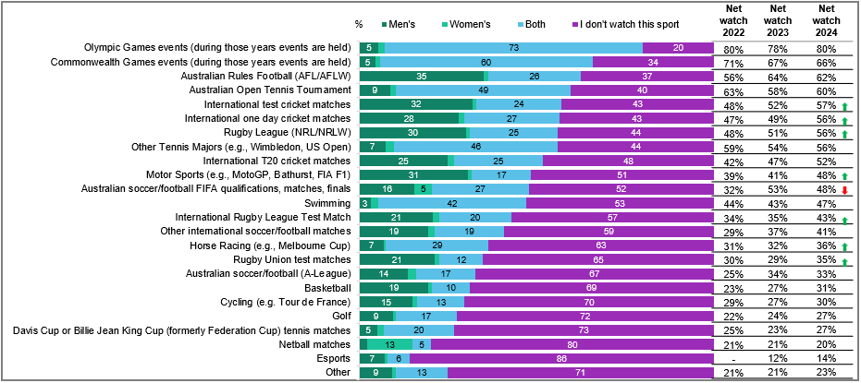

Source: E4. Which of the following sports events do you typically watch online or on TV during a normal year?

Base: TVCS, Respondents who consume sports content. 2024: n=1,816. 2023: n=2,126. 2022: n=2,629.

Notes: Don’t know/refused responses not shown, % vary per statement. Labels not shown for responses <5%. Note: Horse racing statistics may be affected by survey timing (Melbourne Cup in November).

Bar chart showing the percentage distribution of sports events people typically watch online or on TV during a normal year, categorised by men's, women's, both, and those who don't watch the sport. The chart also includes net watch percentages for 2022, 2023, and 2024.

Olympic Games events (during those years events are held): Men's - 5%, Women's - 2%, Both - 73%, I don't watch this sport - 20%, Net watch 2022 - 80%, Net watch 2023 - 78%, Net watch 2024 - 80%

Commonwealth Games events (during those years events are held): Men's - 5%, Women's - 1%, Both - 60%, I don't watch this sport - 34%, Net watch 2022 - 71%, Net watch 2023 - 67%, Net watch 2024 - 66%

Australian Rules Football (AFL/AFLW): Men's - 35%, Women's - 1%, Both - 26%, I don't watch this sport - 37%, Net watch 2022 - 56%, Net watch 2023 - 64%, Net watch 2024 - 62%

Australian Open Tennis Tournament: Men's - 9%, Women's - 2%, Both - 49%, I don't watch this sport - 40%, Net watch 2022 - 63%, Net watch 2023 - 58%, Net watch 2024 - 60%

International test cricket matches: Men's - 32%, Women's - 1%, Both - 24%, I don't watch this sport - 43%, Net watch 2022 - 48%, Net watch 2023 - 52%, Net watch 2024 - 57%

International one day cricket matches: Men's - 28%, Women's - 2%, Both - 27%, I don't watch this sport - 43%, Net watch 2022 - 47%, Net watch 2023 - 49%, Net watch 2024 - 56%

Rugby League (NRL/NRLW): Men's - 30%, Women's - 1%, Both - 25%, I don't watch this sport - 44%, Net watch 2022 - 48%, Net watch 2023 - 51%, Net watch 2024 - 56%

Other Tennis Majors (e.g., Wimbledon, US Open): Men's - 7%, Women's - 2%, Both - 46%, I don't watch this sport - 44%, Net watch 2022 - 59%, Net watch 2023 - 54%, Net watch 2024 - 56%

International T20 cricket matches: Men's - 25%, Women's - 2%, Both - 25%, I don't watch this sport - 48%, Net watch 2022 - 42%, Net watch 2023 - 47%, Net watch 2024 - 52%

Motor Sports (e.g., MotoGP, Bathurst, FIA F1): Men's - 31%, Women's - 1%, Both - 17%, I don't watch this sport - 51%, Net watch 2022 - 39%, Net watch 2023 - 41%, Net watch 2024 - 48%

Australian soccer/football FIFA qualifications, matches, finals: Men's - 16%, Women's - 5%, Both - 27%, I don't watch this sport - 52%, Net watch 2022 - 32%, Net watch 2023 - 53%, Net watch 2024 - 48%

Swimming: Men's - 3%, Women's - 2%, Both - 42%, I don't watch this sport - 53%, Net watch 2022 - 44%, Net watch 2023 - 43%, Net watch 2024 - 47%

International Rugby League Test Match: Men's - 21%, Women's - 2%, Both - 20%, I don't watch this sport - 57%, Net watch 2022 - 34%, Net watch 2023 - 35%, Net watch 2024 - 43%

Other international soccer/football matches: Men's - 19%, Women's - 2%, Both - 19%, I don't watch this sport - 59%, Net watch 2022 - 29%, Net watch 2023 - 37%, Net watch 2024 - 41%

Horse Racing (e.g., Melbourne Cup): Men's - 7%, Women's - 1%, Both - 29%, I don't watch this sport - 63%, Net watch 2022 - 31%, Net watch 2023 - 32%, Net watch 2024 - 36%

Rugby Union test matches: Men's - 21%, Women's - 1%, Both - 12%, I don't watch this sport - 65%, Net watch 2022 - 30%, Net watch 2023 - 29%, Net watch 2024 - 35%

Australian soccer/football (A-League): Men's - 14%, Women's - 2%, Both - 17%, I don't watch this sport - 67%, Net watch 2022 - 25%, Net watch 2023 - 34%, Net watch 2024 - 33%

Basketball: Men's - 19%, Women's - 1%, Both - 10%, I don't watch this sport - 69%, Net watch 2022 - 23%, Net watch 2023 - 27%, Net watch 2024 - 31%

Cycling (e.g. Tour de France): Men's - 15%, Women's - 1%, Both - 13%, I don't watch this sport - 70%, Net watch 2022 - 29%, Net watch 2023 - 27%, Net watch 2024 - 30%

Golf: Men's - 9%, Women's - 1%, Both - 17%, I don't watch this sport - 72%, Net watch 2022 - 22%, Net watch 2023 - 24%, Net watch 2024 - 27%

Davis Cup or Billie Jean King Cup (formerly Federation Cup) tennis matches: Men's - 5%, Women's - 2%, Both - 20%, I don't watch this sport - 73%, Net watch 2022 - 25%, Net watch 2023 - 23%, Net watch 2024 - 27%

Netball matches: Men's - 2%, Women's - 13%, Both - 5%, I don't watch this sport - 80%, Net watch 2022 - 21%, Net watch 2023 - 21%, Net watch 2024 - 20%

Esports: Men's - 7%, Women's - 1%, Both - 6%, I don't watch this sport - 86%, Net watch 2023 - 12%, Net watch 2024 - 14%

Other: Men's - 9%, Women's - 1%, Both - 13%, I don't watch this sport - 71%, Net watch 2022 - 21%, Net watch 2023 - 21%, Net watch 2024 - 23%

#### Callout

* Consumption of international test cricket matches (57% vs 52% in 2023), international one day cricket matches (56% vs 49% in 2023), and rugby league (NRL/NRLW) (56% vs 51% in 2023), motor sports (48% vs 41% in 2023), international Rugby League Test Match (43% vs 35% in 2023), horse racing (36% vs 32% in 2023), and Rugby Union test matches (35% vs 29% in 2023) all increased significantly in 2024, while the consumption of Australian soccer/football FIFA qualifications, matches, finals decreased (48% vs 53% in 2023).

A variety of sports were watched in 2024, with notable increases in men’s motorsports, men’s Australian soccer, and men’s basketball. There were also increases in cricket, international rugby/rugby union test matches, cycling, and golf for both women and men.

### Impact of various factors on amount of sports content consumption

Likelihood to increase how much sports content watched on a screen (net watch a little bit more and watch a lot more) was most influenced by cost and quality: free access would increase sports consumption for 51% of viewers, while content being shown in high quality was mentioned by 34%. Conversely, gambling advertising emerged as the strongest deterrent, with 44% reporting it would reduce their viewing (net decrease watching a little bit and decrease watching a lot).

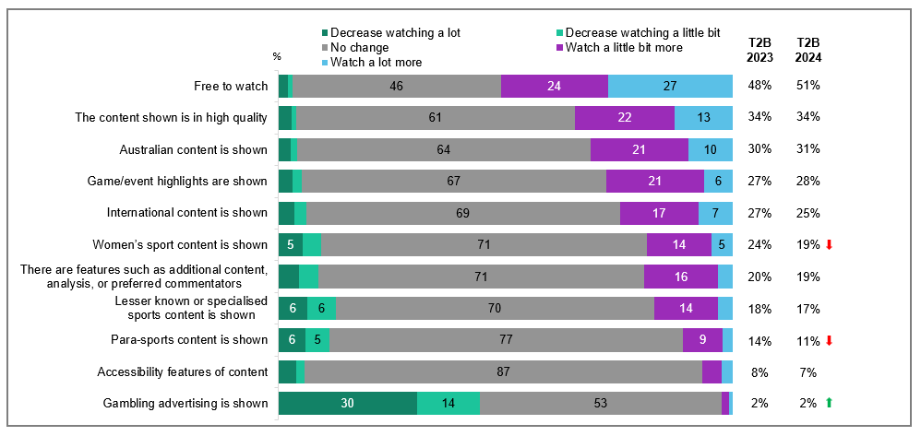

Source: E8. What factors are likely to increase or decrease how much sports content you would watch on a screen?

Base: TVCS, All respondents. 2024: n=3,890. 2023: n=3,861.

Notes: Don’t know/refused responses not shown, % vary per statement. Labels for responses <5% not shown. ‘T2B’ includes ‘Watched a little bit more’ and ‘Watched a lot more’.

Bar chart showing factors likely to increase or decrease how much sports content people would watch on a screen.

Free to watch: Decrease watching a lot - 2%, Decrease watching a little bit - 1%, No change - 46%, Watch a little bit more - 24%, Watch a lot more - 27%, T2B 2023 - 48%, T2B 2024 - 51%

The content shown is in high quality: Decrease watching a lot - 3%, Decrease watching a little bit - 1%, No change - 61%, Watch a little bit more - 22%, Watch a lot more - 13%, T2B 2023 - 34%, T2B 2024 - 34%

Australian content is shown: Decrease watching a lot - 3%, Decrease watching a little bit - 1%, No change - 64%, Watch a little bit more - 21%, Watch a lot more - 10%, T2B 2023 - 30%, T2B 2024 - 31%

Game/event highlights are shown: Decrease watching a lot - 3%, Decrease watching a little bit - 2%, No change - 67%, Watch a little bit more - 21%, Watch a lot more - 6%, T2B 2023 - 27%, T2B 2024 - 28%

International content is shown: Decrease watching a lot - 3%, Decrease watching a little bit - 3%, No change - 69%, Watch a little bit more - 17%, Watch a lot more - 7%, T2B 2023 - 27%, T2B 2024 - 25%

Women’s sport content is shown: Decrease watching a lot - 5%, Decrease watching a little bit - 4%, No change - 71%, Watch a little bit more - 14%, Watch a lot more - 5%, T2B 2023 - 24%, T2B 2024 - 19%

There are features such as additional content, analysis, or preferred commentators: Decrease watching a lot - 4%, Decrease watching a little bit - 4%, No change - 71%, Watch a little bit more - 16%, Watch a lot more - 3%, T2B 2023 - 20%, T2B 2024 - 19%

Lesser known or specialised sports content is shown: Decrease watching a lot - 6%, Decrease watching a little bit - 6%, No change - 70%, Watch a little bit more - 14%, Watch a lot more - 3%, T2B 2023 - 18%, T2B 2024 - 17%

Para-sports content is shown: Decrease watching a lot - 6%, Decrease watching a little bit - 5%, No change - 77%, Watch a little bit more - 9%, Watch a lot more - 2%, T2B 2023 - 14%, T2B 2024 - 11%

Accessibility features of content: Decrease watching a lot - 4%, Decrease watching a little bit - 2%, No change - 87%, Watch a little bit more - 4%, Watch a lot more - 2%, T2B 2023 - 8%, T2B 2024 - 7%

Gambling advertising is shown: Decrease watching a lot - 30%, Decrease watching a little bit - 14%, No change - 53%, Watch a little bit more - 2%, Watch a lot more - 1%, T2B 2023 - 2%, T2B 2024 - 2%

#### Callout

* In 2024, the likelihood of women's sports (19% vs 24% in 2023) and para-sports content (11% vs 14% in 2023) increasing sports consumption (net watch a little bit more or a lot more) decreased.

Sports viewership was likely boosted by being ‘free to watch’, while the presence of gambling advertising likely reduced the amount of sports content watched.

## Advertising and Content Attitudes

### Chapter Summary – Advertising

Advertisements were increasingly seen on online subscription platforms

* Free video streaming services (45%) remained the most commonly reported platform for advertisements seen in the past 7 days, followed by other websites or apps (38%), and commercial free-to-air TV, excluding on-demand (36%).
* Advertisements on online subscription services continued to increase in 2024 (26%), while those on commercial free-to-air TV, excluding on-demand (36%), publicly owned free-to-air TV, excluding on-demand (18%), and sports specific website or app (8%) declined.

Gambling, repetition and pressure to buy goods/services were common reasons for inappropriate advertisements

* Over a quarter of respondents disagreed (net strongly disagree and disagree) that advertisements were appropriate on other websites or apps (27%) and sports specific website or apps (26%).
* Advertisements on free video streaming services were increasingly regarded as inappropriate (22%).

Support for applying restrictions on permitted advertising increased across all platforms in 2024

* Protecting children from exposure to harmful or inappropriate content remained the most important reason for restricting permitted advertisements (38%), followed by limiting content that may encourage bad habits, such as gambling, tobacco, or alcohol use (37%).

Awareness of Ad Standards by just under half of respondents, with gambling or other inappropriate content and repetition being drivers for complaints

* Just under half (46%) of respondents recognised that Ad Standards was an avenue for lodging advertising complaints.
* Three-quarters (76%) of respondents had not made any complaints about any inappropriate advertising in the past 12 months.
* Gambling advertisements (19%), other inappropriate content (18%), and repetitive or excessive ads (17%) were the top three reasons cited for complaints about inappropriate advertising in the past 12 months. Social media websites or apps (26%) was the main platform where complaints were made about inappropriate advertising in the past 12 months.
* Online and social media platforms showed the greatest lack of confidence in distinguishing advertising content.

Concern about inappropriate content was mostly driven by ‘other websites or apps’ (such as Facebook, Tik Tok and Instagram)

* The most commonly mentioned platforms where concerns were expressed were other websites or apps (e,g., Facebook, Tik Tok, Instagram) (17%), followed by commercial free-to-air TV (15%), and free video streaming services (13%).
* The most common reason for concern about inappropriate content across platforms was due to advertising gambling.

Awareness of Codes of Practice was highest for the Commercial Television Industry Code of Practice

* Awareness of various Codes of Practice related to television and radio in Australia showed that recognition for the Commercial Television Industry Code of Practice was 50%, and the Commercial Radio Code of Practice was 42%. In general, these were driven by familiarity amongst males, older age groups, and those outside of capital cities.

### Platforms that respondents saw advertisements on in the past 7 days

While viewership of online subscription services was stable (slide 28), increased ad exposure was recorded in 2024 (26%). Meanwhile, ad viewing declined on traditional platforms, matching overall viewing trends for free-to-air television in the past 7 days: commercial free-to-air TV fell to 36% and public broadcast TV to 18%.

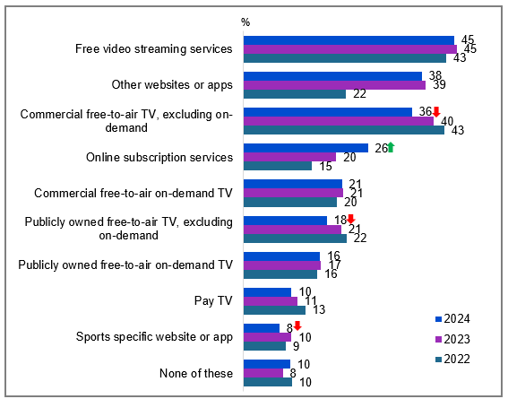

Source: NEW22. In the past 7 days, on which of the following did you see advertisements?

Base: MCCS, Respondents who watched screen content in past 7 days. 2024: n=3,715. 2023: n=3,692. 2022: n=3,935.

Notes: Don’t know/refused responses not shown: 2024 DK = 0.3%, Ref = 0.2%. 2023 DK = 0.1%, Ref = 0.1%. 2022 DK = 0.2%, Ref = 0.0%. ‘Pay-per-view services’ not displayed due to small base size (n=24 in 2024).

Bar chart showing the percentage of people who saw advertisements on various platforms in the past 7 days for the years 2022, 2023, and 2024.

Free video streaming services: 45% in 2024, 45% in 2023, 43% in 2022

Other websites or apps: 38% in 2024, 39% in 2023, 22% in 2022

Commercial free-to-air TV, excluding on-demand: 36% in 2024, 40% in 2023, 43% in 2022

Online subscription services: 26% in 2024, 20% in 2023, 15% in 2022

Commercial free-to-air on-demand TV: 21% in 2024, 21% in 2023, 20% in 2022

Publicly owned free-to-air TV, excluding on-demand: 18% in 2024, 21% in 2023, 22% in 2022

Publicly owned free-to-air on-demand TV: 16% in 2024, 17% in 2023, 16% in 2022

Pay TV: 10% in 2024, 11% in 2023, 13% in 2022

Sports specific website or app: 8% in 2024, 10% in 2023, 9% in 2022

None of these: 10% in 2024, 8% in 2023, 10% in 2022

#### Subgroups

Free video streaming services was higher for:

* Men (49% vs 39% of women)
* Ages 18-24 (61%), 25-34 (53%), and 35-44 (50% vs 41% of ages 45-54, 37% of ages 55-64, 23% of ages 65-74 and 20% of ages 75+)
* Those with dependent children in the household (46%), with non-dependent children only (56%), adults living in a share house (62% vs 37% of those without children)
* Those born in a mainly non-English speaking country (60% vs 40% of those born in a mainly English speaking country)
* Those watching online content in the past 7 days (47% vs 39% of those watching offline content in the past 7 days)

Other websites or apps was higher for:

* Ages 18-24 (63%), 25-34 (42%), and 35-44 (39% vs 26% of ages 55-64, 20% of ages 65-74 and 16% of ages 75+)
* Those living outside a capital city (44% vs 36% of those living in a capital city)
* Those viewing posts, images, and videos on social media sites once a day or more (53% vs 17% of those did it less than once a day)
* Those commenting or posting images to social media sites once a day or more (48% vs 36% of those did it less than once a day)

#### Note

Examples for each platform:

* Commercial free-to-air TV (e.g. Seven, Nine, 10, WIN, Imparja, NBN Television), including recorded content but excluding on-demand TV
* Publicly owned free-to-air TV (i.e. ABC, SBS), including recorded content but excluding on-demand TV
* Pay TV (e.g. Foxtel, Fetch TV), including recorded content but excluding streaming
* Commercial free-to-air on-demand TV (e.g. 9Now, 10 Play, 7plus)
* Publicly owned free-to-air on-demand TV (e.g. ABC iview, SBS On Demand, ABC News, ABC Kids)
* Free video streaming services (e.g. YouTube, Twitch, Tubi)
* Online subscription services (e.g. Netflix, Binge, YouTube Premium)
* Pay-per-view services (e.g. Google Play)
* Sports specific website or app (e.g. AFL Live, NRL Live, Cricket Australia Live, Kayo Sports, Stan Sport)
* Other websites or apps (e.g. Facebook, TikTok, Instagram)

#### Callout

* There was a significant increase in advertisements seen on online subscription services (26% vs 20% in 2023), while advertising on commercial free-to-air TV (36% vs 40% in 2023), publicly owned free-to-air TV (18% vs 21% in 2023), and sports-specific websites or apps (8% vs 10% in 2023) all decreased in 2024.

Advertising was most seen on free video streaming services, websites or apps such as Facebook, TikTok and Instagram, and commercial free-to-air TV (excluding on demand).

### Appropriateness of advertisements

Overall, advertisements from online sources were regarded as more inappropriate than those from free-to-air TV sources (16% vs 10% net strongly disagree or disagree). Over a quarter of respondents *disagreed* (net strongly disagree and disagree) that advertisements were appropriate on other websites or apps (27%) and sports specific website or apps (26%). This was driven in particular by those outside capital cities. Advertisements on free video streaming services were increasingly regarded as inappropriate in 2024 (22% vs 17% in 2023).

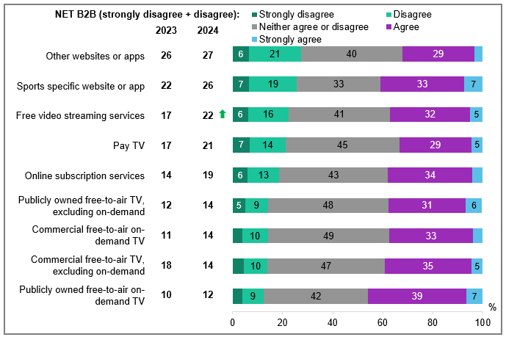

Source: NEW23. Thinking generally about the advertisements you saw on each of the following platforms over the past 7 days, to what extent do you agree or disagree that they were appropriate?

Base: MCCS, Respondents who saw advertisements in past 7 days. 2024: n= from 24 to 1,571. 2023: n= from 62 to 1,502.

Notes: Don’t know/refused responses not shown, % vary per statement. Labels for responses less than 5% are not shown on chart. ‘Pay-per-view services’ not displayed due to small base size (n=24 in 2024)

Bar chart showing survey results about the appropriateness of advertisements on various platforms over the past 7 days.

Other websites or apps: Strongly disagree - 6%, Disagree - 21%, Neither agree nor disagree - 40%, Agree - 29%, Strongly agree - 3%, NET B2B 2023 - 26%, NET B2B 2024 - 27%

Sports specific website or app: Strongly disagree - 7%, Disagree - 19%, Neither agree nor disagree - 33%, Agree - 33%, Strongly agree - 7%, NET B2B 2023 - 22%, NET B2B 2024 - 26%

Free video streaming services: Strongly disagree - 6%, Disagree - 16%, Neither agree nor disagree - 41%, Agree - 32%, Strongly agree - 5%, NET B2B 2023 - 17%, NET B2B 2024 - 22%

Pay TV: Strongly disagree - 7%, Disagree - 14%, Neither agree nor disagree - 45%, Agree - 29%, Strongly agree - 5%, NET B2B 2023 - 17%, NET B2B 2024 - 21%

Online subscription services: Strongly disagree - 6%, Disagree - 13%, Neither agree nor disagree - 43%, Agree - 34%, Strongly agree - 4%, NET B2B 2023 - 14%, NET B2B 2024 - 19%

Publicly owned free-to-air TV (excluding on-demand): Strongly disagree - 5%, Disagree - 9%, Neither agree nor disagree - 48%, Agree - 31%, Strongly agree - 6%, NET B2B 2023 - 12%, NET B2B 2024 - 14%

Commercial free-to-air on-demand TV: Strongly disagree - 4%, Disagree - 10%, Neither agree nor disagree - 49%, Agree - 33%, Strongly agree - 4%, NET B2B 2023 - 11%, NET B2B 2024 - 14%

Commercial free-to-air TV (excluding on-demand): Strongly disagree - 4%, Disagree - 10%, Neither agree nor disagree - 47%, Agree - 35%, Strongly agree - 5%, NET B2B 2023 - 18%, NET B2B 2024 - 14%

Publicly owned free-to-air on-demand TV: Strongly disagree - 4%, Disagree - 9%, Neither agree nor disagree - 42%, Agree - 39%, Strongly agree - 7%, NET B2B 2023 - 10%, NET B2B 2024 - 12%

#### Subgroups

NET Strongly disagree + Disagree was higher for:

* NET Online (16% vs 10% of FTA TV)

Other websites or apps:

* Those living in a capital city (30% vs 22% of those living outside a capital city)

Sports specific website or app:

* Non-Aboriginal or Torres Strait Islander respondents (27% vs 2% of Aboriginal or Torres Strait Islander respondents)

FTA TV:

* Men (13% vs 6% of women)

#### Note

* **NET Online** includes: free video streaming services, online subscription services, sports specific website or app, other websites or apps
* **NET FTA TV** includes: Commercial free-to-air TV, including recorded content but excluding on-demand TV; Publicly owned free-to-air TV, including recorded content but excluding on-demand TV; Commercial free-to-air on-demand TV; Publicly owned free-to-air on-demand TV

Other websites or apps (e.g. Facebook, TikTok, Instagram) were most seen as an inappropriate platform for advertisements.

### Reasons for disagreeing that advertisements were appropriate

Advertisements seen on commercial free-to-air TV were considered inappropriate due to gambling themes (78%), excessive frequency (66%), and sales pressure (41%). Platform-specific trends showed notable changes from 2023: social media sites saw reduced concern about sales pressure (62% to 50%); free streaming services recorded lower concerns about sexual content (26% to 16%) and child-inappropriate content (34% to 24%); and public broadcast on-demand TV saw decreased concern about alcohol advertising (28% to 21%).

Table Reasons for disagreeing that advertisements were appropriate (%)

|  |  |  |  |  |  |  |  |  |  |  |  |  |
| --- | --- | --- | --- | --- | --- | --- | --- | --- | --- | --- | --- | --- |
| Platform | Content | | | | | | | | Practices | | |  |
| Gambling or betting | Alcohol | Inappropriate for children | Encouraging unhealthy eating habits | Depiction of harmful behaviour | Depiction of violence | Sex / nudity / sexually suggestive content | Scam ads | Frequency and / or repetition | Pressure to buy goods or services | Already paid for service | Other (specify) |
| **Other websites or apps** | 43 | 12 | 26 | 20 | 15 | 12 | 27 | 3 | 65 | 50 | 0 | 5 |
| **ChecSports specific website or app** | 67 | 13 | 18 | 34 | 3 | 6 | 8 | 0 | 53 | 23 | 5 | 0 |
| **Free video streaming services** | 51 | 12 | 24 | 26 | 9 | 6 | 16 | 3 | 66 | 47 | 0 | 6 |
| **Pay TV** | 53 | 23 | 29 | 10 | 12 | 12 | 7 | 0 | 43 | 11 | 12 | 3 |
| **Online subscription services** | 41 | 13 | 18 | 16 | 11 | 11 | 15 | 0 | 57 | 32 | 13 | 6 |
| **Publicly owned free-to-air TV** | 58 | 9 | 32 | 19 | 20 | 6 | 11 | 0 | 61 | 35 | 0.2 | 9 |
| **Commercial free-to-air on-demand TV** | 77 | 21 | 23 | 26 | 17 | 3 | 12 | 0 | 60 | 30 | 0 | 4 |
| **Commercial free-to-air TV** | 78 | 23 | 33 | 37 | 13 | 8 | 13 | 0 | 66 | 41 | 0 | 5 |
| **Publicly owned free-to-air on-demand TV** | 38 | 11 | 16 | 25 | 7 | 7 | 9 | 0 | 65 | 43 | 1 | 9 |

Source: NEW23a. Why did you disagree that the advertisements were appropriate on <insert statement from NEW23>?

Base: MCCS, Respondents who disagree that the advertisements they saw in past 7 days were appropriate. 2024: n= from 4 to 348.

Notes: Don’t know/refused responses not shown, % vary per statement. Results for ‘Pay-per-view’ not shown on chart due to small base size (n=4). The top three reasons for each platform are highlighted in green.

Showing gambling or betting related content, frequency and / or repetition, and pressure to buy goods or services were the main reason Australians disagreed that advertising was appropriate across various platforms.

#### Subgroup

* Gambling or betting was more commonly cited as a reason by those ages 65+ (78%), without children in the household (67%), retired (74%)
* Already paid for service was more commonly cited as a reason by those ages 55-64 (14%), born in a mainly English speaking country (5%), watching online subscription services in P7D (5%) or had access to streaming services (4%).
* Depiction of harmful behaviour was more common cited as a reason by women (15%)
* Inappropriate for children was more common cited as a reason by those with dependent children in the household (43%)

### Platforms respondents want restrictions on permitted advertising

Just under half of respondents (46%) supported applying restrictions on permitted advertising to online subscription services (46%), free video streaming services (44%), and commercial free-to-air TV excluding on-demand (41%). A desire for restrictions on permitted advertising has increased across all platforms in 2024, although the net proportion of those who want restrictions to apply has not changed. Respondents primarily nominated platforms they use as those where they want restrictions applied.

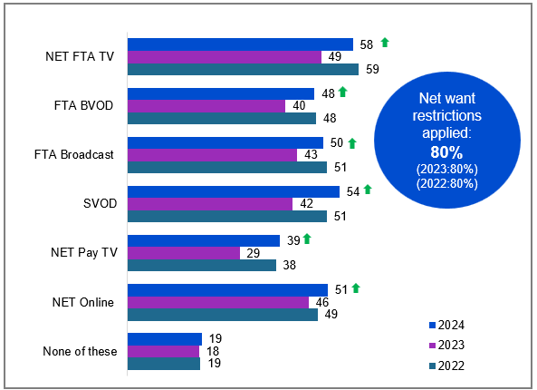

Source: NEW24. On which, if any, of the following platforms would you want restrictions on permitted advertising to be applied?

Base: MCCS, All respondents. 2024: n=3,773. 2023: n=3,730. 2022: n=4,002

Notes: Don’t know/refused responses not shown: 2024 DK = 1%, Ref = 0.2%. 2023 DK = 1%, Ref = 0.1%. 2022 DK = 1%, Ref = 0.1%

Bar chart showing the percentage of respondents who want restrictions on permitted advertising to be applied across various platforms for the years 2022, 2023, and 2024.

NET FTA TV: 58% in 2024, 49% in 2023, 59% in 2022

FTA BVOD: 48% in 2024, 40% in 2023, 48% in 2022

FTA Broadcast: 50% in 2024, 43% in 2023, 51% in 2022

SVOD: 54% in 2024, 42% in 2023, 51% in 2022

NET Pay TV: 39% in 2024, 29% in 2023, 38% in 2022

NET Online: 51% in 2024, 46% in 2023, 49% in 2022

None of these: 19% in 2024, 18% in 2023, 19% in 2022

Net want restrictions applied: 80% in 2024 (vs 80% in 2023, 80% in 2022)

#### Subgroups

Online subscription services was higher for:

* Ages 18-64 (48% vs 35% of ages 65+)
* Those had access to Binge (59%), Stan (59%), Amazon Prime video (57%), Disney+ (57%), YouTube Premium (56%), and Netflix (50%)
* Those who paid for any online video subscription streaming services (50% vs 35% of those who did not pay for any)
* Those who look for information over the internet once a day or more (49% vs 38% of those did it less than once a day)
* Those who view posts, images, and videos on social media sites once a day or more (49% vs 42% of those who did it less than once a day)

Free video streaming services was higher for:

* Ages 18-64 (46% vs 33% of ages 65+)
* Men (46% vs 41% of women)
* Those with dependent children in the household (48% vs 39% of those without children)
* Those watching free video streaming services (52%) and other websites or apps (49%) in P7D

FTA Broadcast was higher for:

* Ages 65+ (66% vs 47% of ages 18-64)
* Those watching publicly owned FTA TV (63%), publicly owned FTA on-demand TV (63%), commercial FTA on-demand TV (56%), and commercial FTA TV (55%) in P7D

FTA BVOD was higher for:

* Ages 35+ (54% vs 37% of ages 18-34)
* Those watching publicly owned FTA on-demand TV (61%), publicly owned FTA TV (59%), commercial FTA on-demand TV (55%) in P7D

Sports specific website or app was higher for:

* Those watching sports specific website or app (47%), publicly owned FTA on-demand TV (40%), and publicly owned FTA TV (38%) in P7D

Pay TV was higher for**:**

* Those watching Pay TV (50%) in P7D

#### Note

* NET Online includes: free video streaming services, other websites or apps
* NET FTA TV includes: Commercial free-to-air TV, including recorded content but excluding on-demand TV; Publicly owned free-to-air TV, including recorded content but excluding on-demand TV; Commercial free-to-air on-demand TV; Publicly owned free-to-air on-demand TV
* FTA BVOD includes ‘Commercial free-to-air on-demand TV (e.g. 9Now, 10 Play, 7plus)’ and ‘Publicly owned free-to-air on-demand TV (e.g. ABC iview, SBS On Demand, ABC News, ABC Kids)’
* FTA Broadcast includes ‘Commercial free-to-air TV (e.g. Seven, Nine, 10, WIN, Imparja, NBN Television), including recorded content but excluding on-demand TV’ and ‘Publicly owned free-to-air TV (i.e. ABC, SBS), including recorded content but excluding on-demand TV’
* SVOD includes ‘Online subscription services (e.g. Netflix, Binge, YouTube Premium)’ and ‘Sports specific website or app (e.g. AFL Live, NRL Live, Cricket Australia Live, Kayo Sports, Stan Sport)’
* NET Pay-TV includes ‘Pay-per-view services (e.g. Google Play)’ and ‘Pay TV (e.g. Foxtel, Fetch TV), including recorded content but excluding streaming’

#### Callout

* In 2024, there was a significant increase in support for restrictions on permitted advertising across various platforms, including FTA TV (58% vs 49% in 2023), FTA BVOD (48% vs 40% in 2023), FTA Broadcast (50% vs 43% in 2023), SVOD (54% vs 42% in 2023), pay TV (net) (39% vs 29% in 2023), and online (net) (51% vs 46% in 2023).

Support for applying restrictions in 2024 returned to 2022 levels across all platforms after dipping in 2023, although the overall proportion of people favouring restrictions remained consistent with 2023.

### Most important reason for restricting permitted advertisements

Protecting children from exposure to harmful or age-inappropriate content remained the most important reason for restricting permitted advertisements (38%), followed by limiting content that may encourage bad habits, such as gambling, tobacco, or alcohol use (37%).

Table Most important reason for restricting permitted advertisements (%)

|  |  |  |  |
| --- | --- | --- | --- |
| Reason for restricting permitted advertisements | 2022 | 2023 | 2024 |
| **Protecting children from exposure to harmful or inappropriate content** | 39 | 38 | 38 |
| **Limiting content that may encourage bad habits, such as gambling, tobacco, or alcohol use** | 34 | 35 | 37 |
| **Limiting the influence of advertising on consumer behaviour** | 21 | 19 | 18 |
| **Already paid for service** | N/A | N/A | 1 |
| **Other** | 4 | 4 | 2 |
| **None of these** | 3 | 3 | 4 |

Source: NEW24b. Which of the following do you consider to be the most important reason for restricting permitted advertisements?

Base: MCCS, Respondents who want restrictions to apply to permitted advertisements. 2024: n=3,084. 2023: n=3,013. 2022: n=3,256.

Notes: Don’t know/refused responses not shown: 2024 DK = 0.0%, Ref = 0.1%. 2023 DK = 0.0%, Ref = 0.1%. 2022 DK = 0.1%, Ref = 0%

#### Subgroups

Protecting children from exposure to harmful or inappropriate content was higher for:

* Women (45% vs 31% of men)
* Ages 25-34 (43%), 35-44 (45%), and 45-54 (46% vs 28% of ages 18-24, 22% of ages 55-64, 30% of ages 75+)
* Those with dependent children in the household (53% vs 30% of those without children, 31% of those with non-dependent children only, 28% of adults living in a share house)
* Those born in a mainly non-English speaking country (43% vs 36% of those born in a mainly English speaking country)

Limiting content that may encourage bad habits was higher for:

* Men (41% vs 32% of women)
* Ages 18-24 (43%), 55-64 (51%), 65-74 (45%), 75+ (52% vs 28% of ages 25-34, 29% of ages 35-44, 31% of ages 45-54)
* Those without children in the household (44% vs 27% of those with dependent children)
* Those born in a mainly English speaking country (39% vs 31% of those born in a mainly non-English speaking country)

Protecting children from exposure to harmful or inappropriate content remained the primary reason to restrict permitted advertising.

### Confidence in distinguishing advertising from other content

Consumer confidence in identifying advertising from other content varied by platform: traditional media like print and broadcast TV recorded greatest confidence, despite declining viewership in past 7 days for free-to-air television. Digital platforms generated more uncertainty, with 16% lacking confidence in distinguishing advertising content on social media platforms and 14% unsure about content generated in online search results.

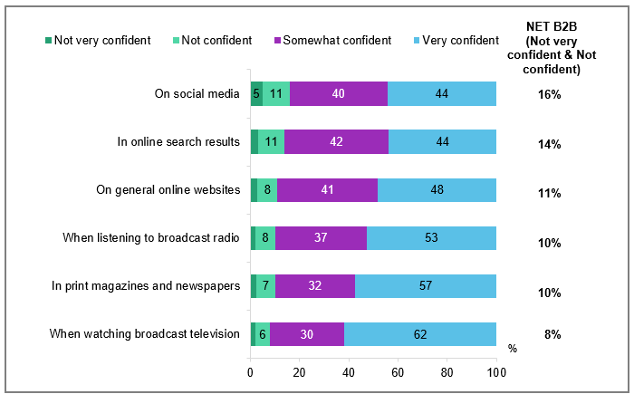

Source: ADVERT4. How confident are you that you can distinguish a piece of advertising from other content in the following locations?

Base: MCCS. Vary by users of each media type. Social media (n=3,404), online search results (n=3,616), general online websites (n=3,613), broadcast radio (n=3,404), print magazines and newspapers (n=3,354), broadcast television (n=3,563).

Notes: Don’t know/refused responses not shown, % vary per statement. Labels for responses <5% not shown on chart. ‘T2B’ includes ‘Somewhat confident’ and ‘Very confident’.

Bar chart showing the confidence levels of individuals in distinguishing advertising from other content across various locations.

On social media: Not very confident - 5%, Not confident - 11%, Somewhat confident - 40%, Very confident - 44%, NET B2B - 16%

In online search results: Not very confident - 3%, Not confident - 11%, Somewhat confident - 42%, Very confident - 44%, NET B2B - 14%

On general online websites: Not very confident - 3%, Not confident - 8%, Somewhat confident - 41%, Very confident - 48%, NET B2B - 11%

When listening to broadcast radio: Not very confident - 2%, Not confident - 8%, Somewhat confident - 37%, Very confident - 53%, NET B2B - 10%

In print magazines and newspapers: Not very confident - 3%, Not confident - 7%, Somewhat confident - 32%, Very confident - 57%, NET B2B - 10%

When watching broadcast television: Not very confident - 2%, Not confident - 6%, Somewhat confident - 30%, Very confident - 62%, NET B2B - 8%

#### Subgroups

B2B (Not very confident + Not confident) was higher for:

social media;

* Those in a mainly non-English speaking background (22% vs 14% mainly English speaking background)
* Those who view posts, images, and videos on social media sites less than once a day (21% vs 13% those who look once a day or more)

Broadcast radio:

* Ages 18-24 (16%), 25-34 (13% vs 5% of ages 65-74)
* Those born in a mainly non-English speaking country (18% vs 8% of those born in a mainly English speaking country)

Broadcast television:

* Those living in a capital city (9% vs 5% of those living outside a capital city)
* Those born in a mainly non-English speaking country (15% vs 6% of those born in a mainly English speaking country)

Print magazines and newspapers:

* Those ages 18-24 (14%), 25-34 (12%), 35-44 (11% vs 3% of ages 55-64)
* Those living in a capital city (11% vs 7% of those living outside a capital city)
* Those born in a mainly non-English speaking country (18% vs 7% of those born in a mainly English speaking country)

Social media platforms had the lowest reported confidence in distinguishing advertising from other content compared to other platforms.

### Awareness of Ad Standards

Less than half of all respondents (46%) recognised Ad Standards as Australia’s advertising regulator handling advertising complaints under the advertising industry codes in Australia. Those aware of Ad Standards were more likely to complain to the Ad Standards body (2% vs 1% of those who were not aware). Those who were aware were also more likely to make a complaint by certain channels, including websites, social media, and government agencies. Awareness of Ad Standards was higher among those aged 25+, living outside a capital city, born in a mainly English speaking country, and those with a disability.

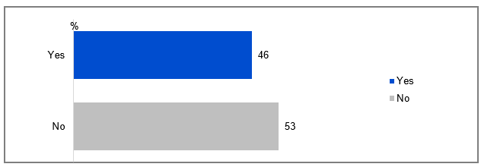

Source: ADVERT1. Ad Standards is a body that manages some complaints about advertising. Before today, were you aware that you could complain about advertising to Ad Standards?

Base: MCCS, All respondents. 2024: n=3,773.

Notes: Don’t know/refused responses not shown: 2024 DK = 0.4%, Ref = 0.2%.

Bar chart showing the responses to the question: 'Before today, were you aware that you could complain about advertising to Ad Standards?' The chart has two bars representing the responses 'Yes' and 'No.' The 'Yes' bar corresponds to 46% of respondents, while the 'No' bar corresponds to 53% of respondents.

#### Subgroups

Yeswas higher for:

* Ages 25-34 (42%), 35-44 (47%), 45-54 (52%), 55-64 (58%), 65-74 (63%), 75+ (48% vs 25% of those ages 18-24)
* Those living outside a capital city (56% vs 43% of those living in a capital city)
* Those without children in the household (50%), those with dependent children (48%), those with non-dependent children only (48% vs 31% of adults living in a share house)
* Those with education up to year 12 (46%), those with a TAFE qualification / Trade Certificate / Diploma (54% vs 37% of those with a Bachelor Degree, 43% of those with a Postgraduate degree)
* Those employed full time or part time (44%), employed casually (48%), self-employed (47%), retired (57%), non-worker (60% vs 25% of students)
* Those born in a mainly English speaking country (52% vs 28% of those born in a mainly non-English speaking country)
* Those watching offline content in the past 7 days (53% vs 46% of those watching online content in the past 7 days)
* Those with a disability (57% vs 45% of those without a disability)

#### Callout

* Of those who were aware of the Ad Standards, 2% had made a complaint to a broadcaster about an advertisement.
* Those who were aware of the Ad Standards were more likely than those who were not aware to have:
* Complained by making public comments on a website, such as a social media page (3% vs 1%)
* Complained to the Ad Standards body (2% vs 1%)
* Complained through another Government agency (1% vs 0.4%)
* Those with no Free-to-air were less likely to be aware of the Ad Standards (31%).

#### Further reading

Research from Ad Standards in 2024 found similar levels of prompted awareness of the Ad Standards body amongst Australians, as well as similar levels of engagement with different advertising content complain avenues within the community.9

Only half of respondents were aware of Ad Standards as a channel for advertising complaints.

### Actions taken to complain about inappropriate advertising in past 12 months

Three-quarters (76%) of respondents had not made any complaints about any inappropriate advertising in the past 12 months. Meanwhile, one-sixth (15%) reported complaining to friends or family, 8% used an online interface to request seeing less of a certain type of advertising, and 4% raised concerns through a service or platform’s reporting systems.

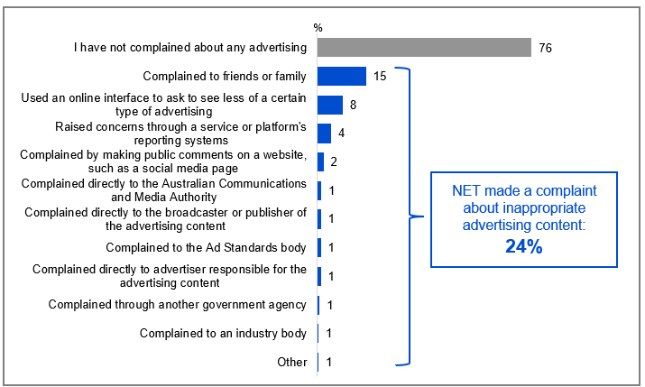

Source: ADVERT2. In the past 12 months, have you performed any of the following actions to try and complain, or raise concerns, about a piece of advertising content you found inappropriate?

Base: MCCS, All respondents. 2024: n=3,773.

Notes: Don’t know/refused responses not shown: 2024 DK = 0.4%, Ref = 0.3%.

Bar chart showing the percentage of people who have performed various actions to complain or raise concerns about inappropriate advertising content in the past 12 months. The actions and their corresponding percentages for 2024 are as follows:

I have not complained about any advertising: 76%

Complained to friends or family: 15%

Used an online interface to ask to see less of a certain type of advertising: 8%

Raised concerns through a service or platform's reporting systems: 4%

Complained by making public comments on a website, such as a social media page: 2%

Complained directly to the Australian Communications and Media Authority: 1%

Complained directly to the broadcaster or publisher of the advertising content: 1%

Complained to the Ad Standards body: 1%

Complained directly to advertiser responsible for the advertising content: 1%

Complained through another government agency: 1%

Complained to an industry body: 1%

Other: 1%

A note on the right side of the chart states, 'NET made a complaint about inappropriate advertising content: 24%.'

#### Subgroups

NET made a complaint about inappropriate advertising content was higher for:

* Ages 18-24 (34%), 25-34 (27%), 35-44 (26% vs 17% of ages 45-54, 16% of ages 55-64, 14% of ages 65-74)
* Those with a Bachelor degree (29% vs 19% of those with education up to Year 12)
* Those employed full time or part time (26%), students (31% vs 15% of retired)
* Aboriginal and / or Torres Strait Islander respondents (32% vs 23% of non-Aboriginal or Torres Strait Islander respondents)
* Those posting to blogs / forums / interest groups once a day or more (41% vs 23% of those who did it less than once a day)
* Those who were neurodivergent (37% vs 22% of those who were not)

#### Callout

* There was overlap between formal and informal complaint channels: Those who complained directly to the broadcaster or publisher of the advertising content also complained to friends or family (51%).

#### Note

**Further reading:** Research from Ad Standards in 2024 found similar levels of prompted awareness of the Ad Standards body amongst Australians, as well as similar levels of engagement with different advertising content complain avenues within the community.9

Most respondents had not made any complaints about inappropriate advertising in the past 12 months. Complaining to friends or family, requesting seeing less of inappropriate advertising, and raising concerns through a platform’s reporting system were common actions taken.

### Reasons for complaints about inappropriate advertising content in past 12 months

The top three reasons cited for complaints about inappropriate advertising in the past 12 months were gambling (19%), inappropriate content (18%), and excessive repetition (17%). Complaint patterns aligned with respondents' broader concerns: gambling ad critics were more likely to support betting / alcohol / tobacco restrictions; complaints about misleading ads were more frequent among those worried about consumer manipulation; while adult content issues were most frequently reported by advocates for child protection. ‘Other inappropriate content’ includes items such as ads are generally inappropriate and ads are generally offensive. ‘Other’ items such as: disliking ads on paid services, ads on any platform, disliking radio ads, junk food / unhealthy food ads.

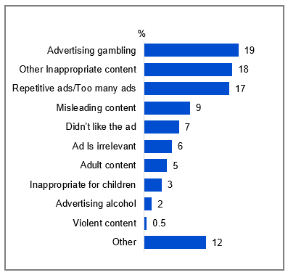

Source: ADVERT3_1. Thinking of your most recent complaint, why did you make this complaint?

Base: MCCS, Respondents who have made a complaint about any inappropriate advertising. 2024: n=903.

Notes: Don’t know/refused responses not shown: 2024 DK = 10%, Ref = 9%.

Bar chart showing the reasons for complaints about advertisements in 2024.

Advertising gambling: 19%

Other inappropriate content: 18%

Repetitive ads/Too many ads: 17%

Misleading content: 9%

Didn't like the ad: 7%

Ad is irrelevant: 6%

Adult content: 5%

Inappropriate for children: 3%

Advertising alcohol: 2%

Violent content: 0.5%

Other: 12%

#### Subgroups

#### Advertising gambling was higher for:

* Ages 65-74 (44%), 75+ (47% vs 19% of ages 18-24, 12% of ages 25-34, 13% of ages 35-44, 13% of ages 45-54, 19% of ages 55-64)
* Those living outside a capital city (26% vs 17% of those living in a capital city)
* Those without children in households (25% vs 13% of those with dependent children)
* Those retired (42% vs 17% of those employed full time or part time, 15% of those employed casually, 10% of self-employed, 2% of those engaging in home duties)
* Those watching offline content in the past 7 days (25% vs 18% of those watching online content)
* Those watching commercial free-to-air TV (25%), publicly owned free-to-air TV in the past 7 days (30% vs 17% of those watching free video streaming services, 18% of those watching online subscription services).
* Those supporting restrictions on advertisements that may encourage bad habits such as gambling, tobacco, or alcohol use (39% vs 9% of those supporting limits on the influence of advertising on consumer behaviour, 9% of those supporting restrictions to protect children from exposure to harmful or inappropriate content)

#### Misleading content was higher for:

* Those supporting restrictions on advertisements to limit the influence on consumer behaviour (18% vs 5% of those supporting restrictions to protect children from exposure to harmful or inappropriate content, 4% of those supporting restrictions on advertisements that may encourage bad habits such as gambling, tobacco, or alcohol use)

#### Adult content was higher for:

* Those supporting restrictions on advertisements to protect children from exposure to harmful or inappropriate content (10% vs 2% of those supporting restrictions to limit the influence on consumer behaviour, 2% of those supporting restrictions on advertisements that may encourage bad habits such as gambling, tobacco, or alcohol use)

Gambling, inappropriate content in general, and excessive ads were the main reasons for complaints about inappropriate advertising.

### Service or platforms complained about inappropriate advertising in the past 12 months

Social media websites or apps (26%) was the main platform where complaints were made about inappropriate advertising in the past 12 months, followed by free video streaming services (12%) and free to air TV (9%).

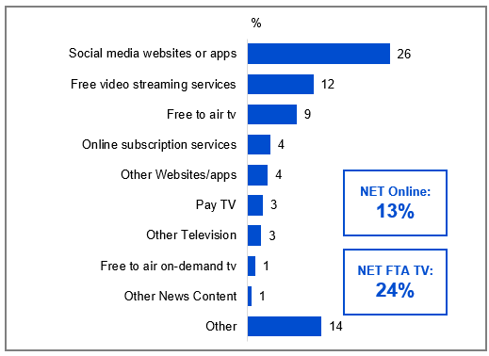

Source: ADVERT3_2. What service or platform were you complaining about?

Base: MCCS, Respondents who have made a complaint about any inappropriate advertising. 2024: n=903.

Notes: Don’t know/refused responses not shown: 2024 DK = 12%, Ref = 10%. ‘NET FTA TV’ includes ‘Free to air TV’, ‘Free to air on-demand TV’, ‘Other Television’, ‘NET Online’ includes ‘social media websites or apps’, ‘free video streaming services’, ‘online subscription services’, ‘other websites/apps’.

Bar chart showing the percentage of respondents who complained about various services or platforms in 2024.

Social media websites or apps: 26%

Free video streaming services: 12%

Free to air TV: 9%

Online subscription services: 4%

Other Websites/apps: 4%

Pay TV: 3%

Other Television: 3%

Free to air on-demand TV: 1%

Other News Content: 1%

Other: 14%

Net online: 13%

Net free-to-air TV: 24%

#### Subgroups

NET Online were more likely to complain about:

* Other inappropriate content (25%)
* Repetitive ads / Too many ads (22%)
* Misleading content (16%)

NET FTA TV were more likely to complain about:

* Advertising gambling (48%)
* Repetitive ads / Too many ads (25%)
* Other inappropriate content (23%)

Social media websites or apps was the main platform where complaints were commonly made about inappropriate advertising.

### Concern about inappropriate content in past 12 months by platform

39% reported being concerned about inappropriate content on any platform. The most commonly mentioned platforms where concerns were expressed were other websites or apps (e,g. Facebook, Tik Tok, Instagram) (17%), noteworthy with 48% using other websites or apps in the past 7 days. This was driven in particular by younger age groups, those in capital cities, those with children, those born in a mainly non-English speaking country or frequent social media users.

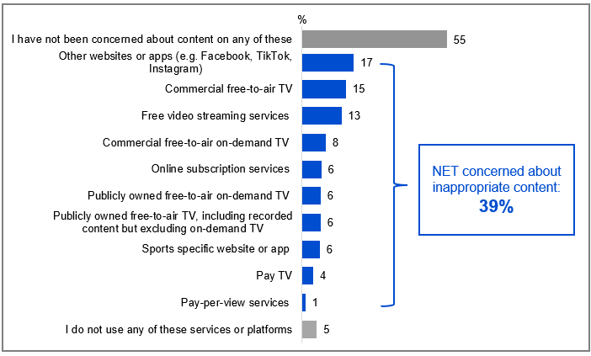

Bar chart showing the percentage of people concerned about inappropriate content on various platforms over the past 12 months in 2024.

I have not been concerned about content on any of these: 55%

Other websites or apps (e.g., Facebook, TikTok, Instagram): 17%

Commercial free-to-air TV: 15%

Free video streaming services: 13%

Commercial free-to-air on-demand TV: 8%

Online subscription services: 6%

Publicly owned free-to-air on-demand TV: 6%

Publicly owned free-to-air TV, including recorded content but excluding on-demand TV: 6%

Sports specific website or app: 6%

Pay TV: 4%

Pay-per-view services: 1%

I do not use any of these services or platforms: 5%

NET Concerned about inappropriate content 39%

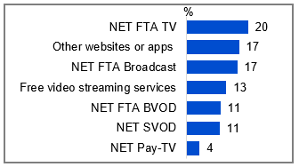

Source: BROAD1. In the past 12 months, have you been concerned about content you felt was inappropriate on any of the following?

Base: TVCS, MCCS. All respondents. 2024: n=4,490.

Notes: Don’t know/refused responses not shown: 2024 DK = 1%, Ref = 0.3%. Note code label descriptions are condensed on chart for readability.

Bar chart showing the percentage of people concerned about inappropriate content on various platforms over the past 12 months in 2024. NET FTA TV: 20%, Other websites or apps: 17%, NET FTA Broadcast: 17%, Free video streaming services: 13%, NET FTA BVOD: 11%, NET SVOD: 11%, NET Pay-TV: 4%

#### Subgroups

* **Other websites or apps** was higher for ages 18-54 (22%), living in a capital city (20%), with dependent children in the household (24%) or adults living in a share house (26%), born in a mainly non-English speaking country (22%), those who viewed posts, images, and videos (23%) or commented, posted images to social media sites (23%) once a day or more
* **FTA TV Broadcast** was higher for men (19%), ages 65+ (27%), those without dependent children in the household (19%) or empty nesters (20%), retired (24%), those watching publicly owned FTA TV (26%) or publicly owned FTA on-demand TV (25%) in P7D
* **FTA BVOD** was higher for men (13%), ages 55+ (14%), living in a capital city (13%), those watching publicly owned FTA on-demand TV (19%) in P7D

#### Note

* NET FTA TV includes: Commercial free-to-air TV (e.g. Seven, Nine, Ten, WIN, Imparja, NBN Television); Publicly owned free-to-air TV (i.e. ABC, SBS), including recorded content but excluding on-demand TV; Commercial free-to-air on-demand TV (e.g. 9Now, 10 Play, 7plus) ; Publicly owned free-to-air on-demand TV (e.g. ABC iview, SBS On Demand, ABC News, ABC Kids)
* NET FTA BVOD includes: Commercial free-to-air on-demand TV (e.g. 9Now, 10 Play, 7plus) + Publicly owned free-to-air on-demand TV (e.g. ABC iview, SBS On Demand, ABC News, ABC Kids)
* NET FTA Broadcast includes: Commercial free-to-air TV (e.g. Seven, Nine, Ten, WIN, Imparja, NBN Television), Publicly owned free-to-air TV (i.e. ABC, SBS), including recorded content but excluding on-demand TV
* NET SVOD includes: Online subscription services (e.g. Netflix, Binge, YouTube Premium), Sports specific website or app (e.g. AFL Live, NRL Live, Cricket Australia Live, Kayo, Stan Sport)
* NET Pay-TV includes: Pay TV (e.g. Foxtel, Fetch TV), including recorded content but excluding streaming, Pay-per-view services (e.g. Google Play)

The main concern about inappropriate content on platforms in the past 12 months was on other websites or apps (Facebook, TikTok, Instagram etc.)

### Reasons for concerns about inappropriate content by platform

The most common reason for concerns about inappropriate content across platforms was gambling advertising.

Table Reasons for concerns about inappropriate content by platform (%)

|  |  |  |  |  |  |  |  |  |  |  |  |  |  |  |
| --- | --- | --- | --- | --- | --- | --- | --- | --- | --- | --- | --- | --- | --- | --- |
| Platform | Limit content that may encourage bad habits | | | Protect children from exposure to harmful or inappropriate content | | | | Limit influence on consumer behaviour | | | Limit inappropriate practices | | Didn't like the ad | Other |
| Advertising gambling | Advertising Drugs/Alcohol/ Tobacco | Advertising unhealthy lifestyles | Other Inappropriate content | Inappropriate for children | Adult content | Violent content | Misleading content | Biased media/ news | Advertising Politics | Repetitive ads/Too many ads | Expense of streaming services/ subscriptions |
| **Commercial free-to-air TV** | 52 | 7 | 4 | 15 | 7 | 7 | 3 | 4 | 2 | 1 | 19 | 0 | 1 | 12 |
| **Free video streaming services** | 14 | 3 | 2 | 17 | 21 | 13 | 3 | 12 | 1 | 2 | 10 | 0 | 1 | 17 |
| **Commercial free-to-air on-demand TV** | 45 | 8 | 4 | 12 | 6 | 8 | 2 | 5 | 2 | 1 | 12 | 1 | 1 | 10 |
| **Sports specific website or app** | 62 | 7 | 3 | 3 | 3 | 3 | 1 | 2 | 0 | 1 | 14 | 6 | 2 | 9 |
| **Publicly owned free-to-air TV** | 22 | 2 | 1 | 16 | 5 | 9 | 4 | 7 | 4 | 3 | 7 | 0 | 1 | 19 |
| **Publicly owned free-to-air on-demand TV** | 21 | 5 | 1 | 12 | 7 | 12 | 3 | 3 | 8 | 1 | 8 | 0 | 1 | 16 |
| **Online subscription services** | 17 | 4 | 1 | 27 | 13 | 14 | 2 | 5 | 2 | 2 | 7 | 5 | 4 | 13 |
| **Pay TV** | 38 | 3 | 2 | 5 | 1 | 8 | 1 | 2 | 2 | 2 | 15 | 6 | 2 | 14 |
| **Pay-per-view services** | 14 | 2 | 0 | 7 | 2 | 4 | 6 | 3 | 1 | 4 | 7 | 23 | 7 | 11 |

Source: BROAD2. What were your concerns for content on [insert service type from [BROAD1]?

Base: TVCS, Respondents who were concerned about inappropriate content on any platform. 2024: n=from 57 to 725.

Notes: Don’t know/refused responses not shown, % vary per statement. Green box indicates top item per platform

#### Subgroups

Concerned about gambling advertising was higher for:

* Ages 45-54 (30%) 55-64 (35%), 65-74 (56%), 75+ (53% vs 15% of ages 18-24, 17% of ages 25-34)
* Those without children in the household (38% vs 21% of those with dependent children, 17% of adults living in a share house)
* Those with education up to Year 12 (37%), a TAFE, Trade Certificate, Diploma (34% vs 23% of those with a Bachelor degree, 23% of those with a Postgraduate degree)
* Those employed full time or part time (26%), employed casually (26%), self-employed (28%), non-worker (29%), retired (54% vs 7% of those unemployed)
* Non-Aboriginal or Torres Strait Islander respondents (31% vs 13% of Aboriginal and / or Torres Strait Islander respondents)
* Those born in a mainly English speaking country (35% vs 14% of those born in a mainly non-English speaking country)

Gambling was the most common reason for concerns about inappropriate content across various platforms.

### Awareness of the types of Codes of Practice

Industry-developed codes of practice ensure broadcasting content is in line with community expectations. Industry groups have developed codes of practice in consultation with the ACMA. The ACMA monitors these codes and deals with unresolved complaints from viewers and listeners. (The ABC and SBS have different code arrangements).   
Half of all respondents (50%) recognised the Commercial Television Industry Code of Practice and just over two in five (42%) recognised the Commercial Radio Code of Practice. Recognition of the Commercial Television Industry Code of Practice and the Commercial Radio Code of Practice was more likely to be reported by men and older Australians.

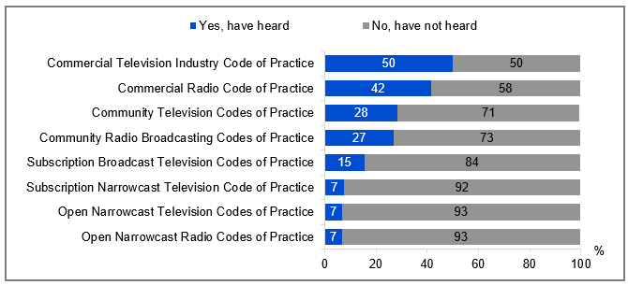

Source: BROAD3. Before today, had you heard of the following types of Codes of Practice?

Base: TVCS, MCCS, All respondents. 2024: n=4,490.

Notes: Don’t know/refused responses not shown, % vary per statement.

Bar chart showing the awareness levels of different types of Codes of Practice among respondents.

Commercial Television Industry Code of Practice: Yes, have heard - 50%, No, have not heard - 50%

Commercial Radio Code of Practice: Yes, have heard - 42%, No, have not heard - 58%

Community Television Codes of Practice: Yes, have heard - 28%, No, have not heard - 71%

Community Radio Broadcasting Codes of Practice: Yes, have heard - 27%, No, have not heard - 73%

Subscription Broadcast Television Codes of Practice: Yes, have heard - 15%, No, have not heard - 84%

Subscription Narrowcast Television Code of Practice: Yes, have heard - 7%, No, have not heard - 92%

Open Narrowcast Television Codes of Practice: Yes, have heard - 7%, No, have not heard - 93%

Open Narrowcast Radio Codes of Practice: Yes, have heard - 7%, No, have not heard - 93%

#### Subgroups

Commercial Television Industry Code of Practice was higher for:

* Men (54% vs 46% of women)
* Ages 45-54 (57%), 55-64 (68%), 65-74 (67%), 75+ (63% vs 20% of ages 18-24, 37% of ages 25-34, 45% of ages 35-44)
* Those living outside a capital city (58% vs 45% of those living in a capital city)
* Those with education up to Year 12 (54%), a TAFE, Trade Certificate, Diploma (60% vs 33% of those with a Bachelor degree, 43% of those with a Postgraduate degree)
* Those born in a mainly English speaking country (56% vs 28% of those born in a mainly non-English speaking country)
* Those watching exclusively offline content in the past 7 days (51% vs 36% of those watching exclusively online content)
* Those watching screen content using a television (52% vs 40% of those who did not)

Commercial Radio Code of Practice was higher for:

* Men (46% vs 37% of women)
* Ages 45-54 (48%), 55-64 (56%), 65-74 (53%), 75+ (47% vs 15% of ages 18-24, 33% of ages 25-34)
* Those living outside a capital city (46% vs 38% of those living in a capital city)
* Those with education up to Year 12 (41%), a TAFE, Trade Certificate, Diploma (51%), a Postgraduate degree (37% vs 29% of those with a Bachelor degree)
* Those born in a mainly English speaking country (46% vs 24% of those born in a mainly non-English speaking country)

Awareness of types of Codes of Practice by service type users

* Awareness of the Commercial Television Industry Code of Practice was higher among those who watched Commercial free-to-air TV (62%), Publicly owned free-to-air TV (62%), Commercial free-to-air on-demand TV (63%), Publicly owned free-to-air on-demand TV (62%), Pay TV (59%), and Sports specific website or app (62%) in P7D
* Awareness of the Subscription Broadcast Television Codes of Practice was higher among those who watched Sports specific website or app (25%) and Pay TV (24%) in P7D.
* Awareness of the Community Radio Broadcasting Codes of Practice was higher among those who listened to FM radio (32%), Podcasts (33%), AM radio (34%), Radio via the internet or an app (excluding podcasts) (42%), Digital radio (DAB) (40%) in P7D
* Awareness of the Subscription Broadcast Television Codes of Practice was higher among those who listened to Radio via the internet or an app (23%) and Digital radio (DAB) (22%) in P7D.
* Awareness of the Commercial Radio Code of Practice was higher among those who listened to Radio via the internet or an app (excluding podcasts) (62%), Digital radio (DAB) (60%), AM radio (57%), and FM radio (50%) in P7D.

#### Note

Industry-developed codes of practice ensure broadcasting content is in line with community expectations. Industry groups have developed codes of practice in consultation with the ACMA. The ACMA monitors these codes and deals with unresolved complaints from viewers and listeners. The Codes were registered in:

* 2017 - Commercial radio code of practice
* 2015 - Commercial television industry code of practice
* 2013 - Subscription broadcast television codes of practice
* 2013 - Subscription narrowcast radio codes of practice
* 2013 - Subscription narrowcast television codes of practice
* 2011 - Community television codes of practice
* 2009 - Open narrowcast television codes of practice
* 2008 - Community radio broadcastings codes of practice
* New Community radio broadcasting codes of practice (2025) to commence 1 July 2025

The ACMA has registered a new Community radio broadcasting codes of practice (2025) which will commence from 1 July 2025. The ABC and SBS have different code arrangements.

Respondents most commonly reported awareness of Commercial television or radio Codes of Practice and recognition was more common amongst men and older Australians.

### Familiarity with the Codes of Practice

Although awareness of the Open Narrowcast Radio Codes of Practice was the lowest among all Code types, it had the highest proportion of respondents who reported familiarity amongst those aware of it (36% NET Heard of it and had some familiarity, very familiar). In contrast, the Commercial Television Industry Codes of Practice and Commercial Radio Code of Practice had the highest overall awareness, but most respondents had only heard of them in passing (70% and 72% respectively).

Additionally, respondents living in capital cities were more likely than those outside capital cities to be very familiar with the Commercial Radio (5% vs 1%) and Commercial Television Industry (5% vs 1%) Codes of Practice. Familiarity with the Subscription Broadcast Television Codes of Practice was higher among those who watched Pay TV (15% very familiar) and pay-per-view services (28% very familiar) in P7D. Those who listened to radio via the internet or an app in the P7D were more likely to have some familiarity or be very familiar with the Open Narrowcast Radio Codes of Practice (72%), the Commercial Radio Code of Practice (40%), and the Community Radio Broadcasting Codes of Practice (42%).

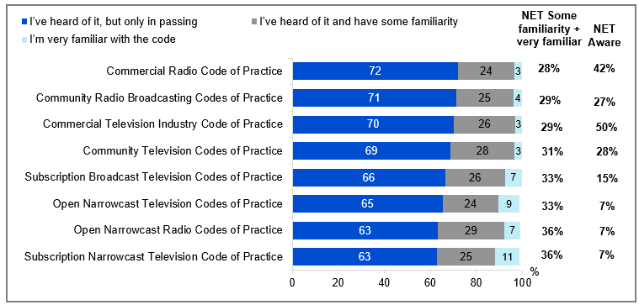

Source: BROAD4. You said you’d heard of the following Codes, how familiar are you with the codes?

Base: TVCS, MCCS. Respondents who have heard of any type of Code of Practice. 2024: n=from 276 to 2,418.

Notes: Don’t know/refused responses not shown, % vary per statement.

Bar chart showing the familiarity levels with various broadcasting codes of practice.

Commercial Radio Code of Practice: I’ve heard of it, but only in passing - 72%, I’ve heard of it and have some familiarity - 24%, I’m very familiar with the code - 3%, NET Some familiarity + very familiar - 28%, NET Aware - 42%

Community Radio Broadcasting Codes of Practice: I’ve heard of it, but only in passing - 71%, I’ve heard of it and have some familiarity - 25%, I’m very familiar with the code - 4%, NET Some familiarity + very familiar - 29%, NET Aware - 27%

Commercial Television Industry Code of Practice: I’ve heard of it, but only in passing - 70%, I’ve heard of it and have some familiarity - 26%, I’m very familiar with the code - 3%, NET Some familiarity + very familiar - 29%, NET Aware - 50%

Community Television Codes of Practice: I’ve heard of it, but only in passing - 69%, I’ve heard of it and have some familiarity - 28%, I’m very familiar with the code - 3%, NET Some familiarity + very familiar - 31%, NET Aware - 28%

Subscription Broadcast Television Codes of Practice: I’ve heard of it, but only in passing - 66%, I’ve heard of it and have some familiarity - 26%, I’m very familiar with the code - 7%, NET Some familiarity + very familiar - 33%, NET Aware - 15%

Open Narrowcast Television Codes of Practice: I’ve heard of it, but only in passing - 65%, I’ve heard of it and have some familiarity - 24%, I’m very familiar with the code - 9%, NET Some familiarity + very familiar - 33%, NET Aware - 7%

Open Narrowcast Radio Codes of Practice: I’ve heard of it, but only in passing - 63%, I’ve heard of it and have some familiarity - 29%, I’m very familiar with the code - 7%, NET Some familiarity + very familiar - 36%, NET Aware - 7%

Subscription Narrowcast Television Code of Practice: I’ve heard of it, but only in passing - 63%, I’ve heard of it and have some familiarity - 25%, I’m very familiar with the code - 11%, NET Some familiarity + very familiar - 36%, NET Aware - 7%

#### Subgroups

NET Some familiarity + very familiar was higher for

Commercial Television Industry Code of Practice

* Men (32% vs 26% of women)
* Those with a disability (39% vs 27% of those without a disability)
* Those concerned about inappropriate content on commercial free-to-air TV (36%), commercial free-to-air on-demand TV (43%), publicly owned free-to-air TV, excluding on-demand TV (41%), Pay T V(47%), Pay-per-view services (65% vs 26% of those have not been concerned about any content)

Commercial Radio Code of Practice

* Men (31% vs 24% of women)
* Those concerned about inappropriate content on sports specific website of app (42%), Pay TV (48%), publicly owned free-to-air TV, excluding on-demand TV (39%), commercial free-to-air on-demand TV (40%), commercial free-to-air TV (36% vs 25% of those have not been concerned about any content, 24% of those concerned about inappropriate content on other websites or apps)

Commercial Television and Radio Codes had broader awareness but limited familiarity, driven by the male demographic.

## Advertising and Content Attitudes: Children aged 0-17

### Chapter Summary – Advertising (Children aged 0-17)

Children were increasingly being exposed to advertisements on free streaming services and social media

* Free video streaming services was most commonly reported by children aged 0-7 (45%), 8-10 (64%) and 11-15 (60%) where advertisements were seen in the past 7 days, whereas social media websites (e.g. Facebook, TikTok, Instagram) (58%) was more commonly reported by children aged 16-17.
* Parents’/legal guardians’/carers’ responses were largely consistent with children’s responses, although older children reported seeing advertising on social media at a higher level than parents/legal guardians/carers reported.

Advertisements on online platforms were increasingly regarded by parents as inappropriate

* Parents/legal guardians/carers most commonly reported that they disagreed (net strongly disagree and disagree) that the advertisements their child saw on other websites or apps (e.g. Facebook, TikTok, Instagram) (35%), free video streaming services (e.g. YouTube, Twitch, Tubi) (26%), and sports specific websites or apps (e.g. AFL Live, NRL Live, Cricket Australia Live, Kayo Sports, Stan Sport) (21%) were appropriate.
* The main reasons that parents/legal guardians/carers disagreed that the advertisements their child saw were appropriate were pressure to buy goods or services (57%), frequency and / or repetition (48%), and gambling or betting (43%).

Gambling ad exposure increased with age, varying by platform

* Exposure to gambling or betting advertisements in the past 7 days increased with age (35% of children aged 8-10, 43% of children aged 11-15, 55% of children aged 16-17)
* Gambling or betting advertisements were most commonly seen on commercial free-to-air TV for children aged 8-10 (35%), and free video streaming services for children aged 11-15 (29%), and social media websites and apps for children aged 16-17 (38%).

### Platforms children saw advertisements on in the past 7 days (children aged 0-17)

Free video streaming services (e.g. YouTube, YouTube Kids, Twitch, Tubi) was most commonly reported by children aged 8-10 (64%) and 11-15 (60%) where advertisements were seen in the past 7 days. Social media websites (e.g. Facebook, TikTok, Instagram) was the most common platform on which advertisements were seen for children aged 16-17 (58%). Parents who answered on behalf of their children aged 0-7 reported that the platforms where advertising was most commonly seen or heard by children in this age group remained free video streaming services (e.g. YouTube ,YouTube Kids, Twitch, Tubi) (45%), outdoor advertising such as posters or billboards (34%), and in-store advertising (30%).

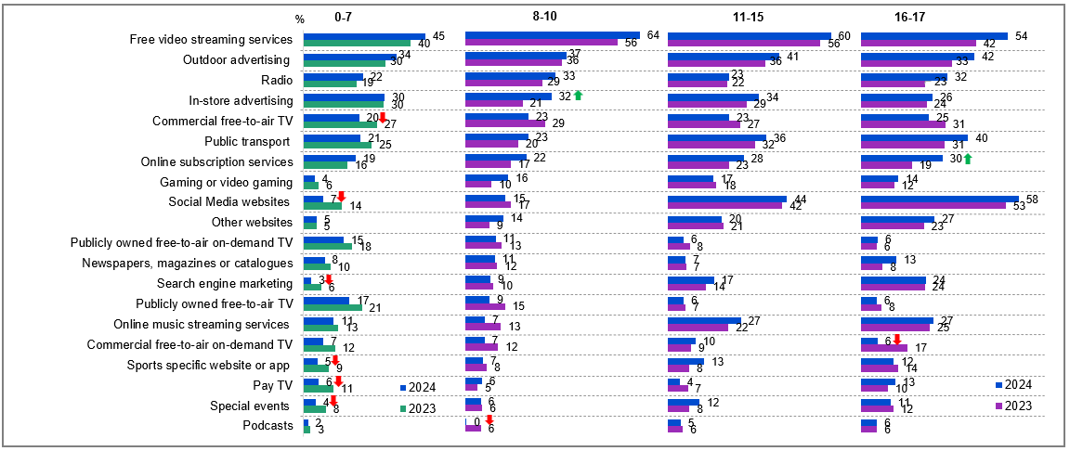

Source: F6. Where has your child seen or heard advertising in the past 7 days? KB5, KC5, KD5. KD5. Of the following, where have you seen or heard advertising in the past 7 days?

Base: MCCS, All children aged 8-17. 2024: 8-10 (n=199), 11-15 (n=199), 16-17 (n=141). 2023: 8-10 (n=197), 11-15 (n=191), 16-17 (n=137). All parents/legal guardians/carers answering on behalf of their 0-7 year old child (2024: n=336. 2023: n=359).

Notes: Don’t know/refused responses not shown: 2024: 0-7 DK=7%, Ref =2%. 8-10 DK=2%, Ref=1%. 11-15 DK=2%, Ref=0%. 16-17 DK=1%, Ref = 0%. 2023: 0-7 DK = 5%, Ref=1%. 8-10 DK=5%, Ref=0%. 11-15 DK=1%, Ref=0%. 16-17 DK=1%, Ref=1%. Responses <5% across all age groups not shown on chart

Bar chart showing the percentage of people who saw advertisements on various platforms in different age groups (0-7, 8-10, 11-15, 16-17) for the years 2023 and 2024.

Age group 0-7:

Free video streaming services: 45% in 2024, 40% in 2023

Outdoor advertising: 34% in 2024, 30% in 2023

Radio: 22% in 2024, 19% in 2023

In-store advertising: 30% in 2024, 30% in 2023

Commercial free-to-air TV: 20% in 2024, 27% in 2023

Public transport: 21% in 2024, 25% in 2023

Online subscription services: 19% in 2024, 16% in 2023

Gaming or video gaming: 4% in 2024, 6% in 2023

Social Media websites: 7% in 2024, 14% in 2023

Other websites: 5% in 2024, 5% in 2023

Publicly owned free-to-air on-demand TV: 15% in 2024, 18% in 2023

Newspapers, magazines or catalogues: 8% in 2024, 10% in 2023

Search engine marketing: 3% in 2024, 6% in 2023

Publicly owned free-to-air TV: 17% in 2024, 21% in 2023

Online music streaming services: 11% in 2024, 13% in 2023

Commercial free-to-air on-demand TV: 7% in 2024, 12% in 2023

Sports specific website or app: 5% in 2024, 9% in 2023

Pay TV: 6% in 2024, 11% in 2023

Special events: 4% in 2024, 8% in 2023

Podcasts: 2% in 2024, 3% in 2023

Age group 8-10:

Free video streaming services: 64% in 2024, 56% in 2023

Outdoor advertising: 37% in 2024, 36% in 2023

Radio: 33% in 2024, 29% in 2023

In-store advertising: 32% in 2024, 21% in 2023

Commercial free-to-air TV: 23% in 2024, 29% in 2023

Public transport: 23% in 2024, 20% in 2023

Online subscription services: 22% in 2024, 17% in 2023

Gaming or video gaming: 16% in 2024, 10% in 2023

Social Media websites: 15% in 2024, 17% in 2023

Other websites: 14% in 2024, 9% in 2023

Publicly owned free-to-air on-demand TV: 11% in 2024, 13% in 2023

Newspapers, magazines or catalogues: 11% in 2024, 12% in 2023

Search engine marketing: 9% in 2024, 10% in 2023

Publicly owned free-to-air TV: 9% in 2024, 15% in 2023

Online music streaming services: 7% in 2024, 13% in 2023

Commercial free-to-air on-demand TV: 7% in 2024, 12% in 2023

Sports specific website or app: 7% in 2024, 8% in 2023

Pay TV: 6% in 2024, 5% in 2023

Special events: 6% in 2024, 6% in 2023

Podcasts: 0% in 2024, 6% in 2023

Age group 11-15:

Free video streaming services: 60% in 2024, 56% in 2023

Outdoor advertising: 41% in 2024, 36% in 2023

Radio: 23% in 2024, 22% in 2023

In-store advertising: 34% in 2024, 29% in 2023

Commercial free-to-air TV: 23% in 2024, 27% in 2023

Public transport: 36% in 2024, 32% in 2023

Online subscription services: 28% in 2024, 23% in 2023

Gaming or video gaming: 17% in 2024, 18% in 2023

Social Media websites: 44% in 2024, 42% in 2023

Other websites: 20% in 2024, 21% in 2023

Publicly owned free-to-air on-demand TV: 6% in 2024, 8% in 2023

Newspapers, magazines or catalogues: 7% in 2024, 7% in 2023

Search engine marketing: 17% in 2024, 14% in 2023

Publicly owned free-to-air TV: 6% in 2024, 7% in 2023

Online music streaming services: 27% in 2024, 22% in 2023

Commercial free-to-air on-demand TV: 10% in 2024, 9% in 2023

Sports specific website or app: 13% in 2024, 8% in 2023

Pay TV: 4% in 2024, 7% in 2023

Special events: 12% in 2024, 8% in 2023

Podcasts: 5% in 2024, 6% in 2023

Age group 16-17:

Free video streaming services: 54% in 2024, 42% in 2023

Outdoor advertising: 42% in 2024, 33% in 2023

Radio: 32% in 2024, 23% in 2023

In-store advertising: 26% in 2024, 24% in 2023

Commercial free-to-air TV: 25% in 2024, 31% in 2023

Public transport: 40% in 2024, 31% in 2023

Online subscription services: 30% in 2024, 19% in 2023

Gaming or video gaming: 14% in 2024, 12% in 2023

Social Media websites: 58% in 2024, 53% in 2023

Other websites: 27% in 2024, 23% in 2023

Publicly owned free-to-air on-demand TV: 6% in 2024, 6% in 2023

Newspapers, magazines or catalogues: 13% in 2024, 8% in 2023

Search engine marketing: 24% in 2024, 24% in 2023

Publicly owned free-to-air TV: 6% in 2024, 8% in 2023

Online music streaming services: 27% in 2024, 25% in 2023

Commercial free-to-air on-demand TV: 6% in 2024, 17% in 2023

Sports specific website or app: 12% in 2024, 14% in 2023

Pay TV: 13% in 2024, 10% in 2023

Special events: 11% in 2024, 12% in 2023

Podcasts: 6% in 2024, 6% in 2023

#### Callout

* In 2024, advertising exposure increased in-store (32% vs 21% in 2023) among children aged 8-10 and on online subscription services (30% vs 19% in 2023) among those aged 16-17.
* In contrast, there was a significant decrease in advertising seen on commercial free-to-air TV (20% vs 27% in 2023), social media websites (7% vs 14% in 2023), search engine marketing (3% vs 6% in 2023), sports-specific websites or apps (5% vs 9% in 2023), pay TV (6% vs 11% in 2023), and special events (4% vs 8% in 2023) among children aged 0-7.
* Additionally, advertising exposure declined in podcasts (0% vs 6% in 2023) for children aged 8-10 and in commercial free-to-air on-demand TV (6% vs 17% in 2023) for those aged 16–17.

Children aged 8-17 most commonly reported being exposed to advertising via free video streaming services. Exposure to advertisements on social media websites was higher among older children. Parents/legal guardians/carers reported that children aged 0-7 most commonly saw or heard advertising on free video streaming services.

### Where children saw advertising in past 7 days

Parents/legal guardians/carers were also asked about their child’s exposure to advertising. The most common places that parents/legal guardians/carers reported their child had seen advertising were free video streaming services (50%), outdoor advertising (31%), and social media websites and apps (28%). Parents’/legal guardians’/carers’ responses were largely consistent with children’s responses, although older children reported seeing advertising on social media and free video streaming services at a higher level than parents/legal guardians/carers reported.

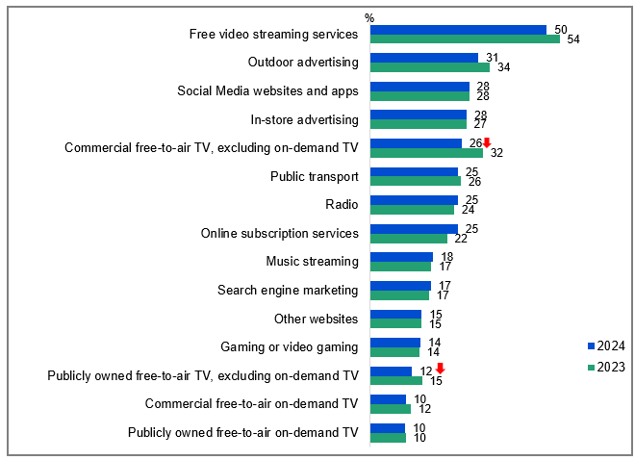

Source: F6. Where has your child seen or heard advertising in the past 7 days?

Base: MCCS, Respondents who are parents/legal guardians/carers of a child aged 17 or under. 2024: n=2,054. 2023: n=2,409.

Notes: Don’t know/refused responses not shown: 2024 DK = 3%, Ref = 2%. 2023 DK = 4%, Ref = 1%. Responses <10% not shown on chart.

Bar chart showing where children have seen or heard advertising in the past 7 days for the years 2023 and 2024.

Free video streaming services: 50% in 2024, 54% in 2023

Outdoor advertising: 31% in 2024, 34% in 2023

Social Media websites and apps: 28% in both 2024 and 2023

In-store advertising: 28% in 2024, 27% in 2023

Commercial free-to-air TV, excluding on-demand TV: 26% in 2024, 32% in 2023

Public transport: 25% in 2024, 26% in 2023

Radio: 25% in 2024, 24% in 2023

Online subscription services: 25% in 2024, 22% in 2023

Music streaming: 18% in 2024, 17% in 2023

Search engine marketing: 17% in both 2024 and 2023

Other websites: 15% in both 2024 and 2023

Gaming or video gaming: 14% in both 2024 and 2023

Publicly owned free-to-air TV, excluding on-demand TV: 12% in 2024, 15% in 2023

Commercial free-to-air on-demand TV: 10% in 2024, 12% in 2023

Publicly owned free-to-air on-demand TV: 10% in both 2024 and 2023

#### Subgroups

Free video streaming services was higher for:

* Men (54% vs 48% women)
* Those whose child is aged 8-10 (59% vs 44% of those whose child is aged 0-7)
* Those with fixed home internet (51% vs 33% of those without fixed home internet)
* Non-Aboriginal or Torres Strait Islander respondents (52% vs 31% of Aboriginal and / or Torres Strait Islander respondents)

#### Callout

* There was a significant decrease in parents’ reports of advertising children had seen on commercial free-to-air TV (26% vs 32% in 2023) and publicly owned free-to-air TV (12% vs 15% in 2023) in 2024.

Parents/legal guardians/carers reported that children mostly saw advertising on free video streaming services.

### Platforms children saw advertisements on in past 7 days

Free video streaming services (e.g. YouTube, Twitch, Tubi) (56%), online subscription services (e.g. Netflix, Binge, YouTube Premium) (29%), and other websites or apps (e.g. Facebook, TikTok, Instagram) (23%) were the most common platforms that parents/legal guardians/carers reported their child had seen advertisements on.

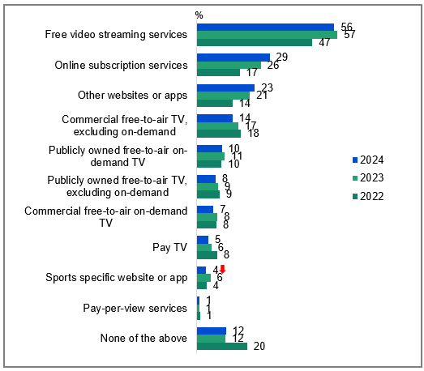

Source: NEW27. On which, if any, of the following did your child see advertisements in the past 7 days?

Base: MCCS, Respondents whose child watched screen content in past 7 days. 2024: n=1,924. 2023: n=2,285. 2022: n=1,490.

Notes: Don’t know/refused responses not shown: 2024 DK = 1%, Ref = 0.3%. 2023 DK = 0.5%, Ref = 0.1%. 2022: DK = 0.4%, Ref = 0.1%

Bar chart showing the percentage of children who saw advertisements on various platforms over the past 7 days for the years 2022, 2023, and 2024.

Free video streaming services: 56% in 2024, 57% in 2023, 47% in 2022

Online subscription services: 29% in 2024, 26% in 2023, 17% in 2022

Other websites or apps: 23% in 2024, 21% in 2023, 14% in 2022

Commercial free-to-air TV, excluding on-demand: 14% in 2024, 17% in 2023, 18% in 2022

Publicly owned free-to-air on-demand TV: 10% in 2024, 11% in 2023, 10% in 2022

Publicly owned free-to-air TV, excluding on-demand: 8% in 2024, 9% in 2023, 9% in 2022

Commercial free-to-air on-demand TV: 7% in 2024, 8% in 2023, 8% in 2022

Pay TV: 5% in 2024, 6% in 2023, 8% in 2022

Sports specific website or app: 4% in 2024, 6% in 2023, 4% in 2022

Pay-per-view services: 1% in 2024, 1% in 2023, 1% in 2022

None of the above: 12% in 2024, 12% in 2023, 20% in 2022

#### Subgroups

Free video streaming services was higher for:

* Those with children aged 8-10 (62%), 11-15 (61% vs 50% of those whose child is aged 0-7, 53% of those whose child is aged 16-17)
* Those born in a mainly non-English-speaking country 59% vs 51% of those born in a mainly English speaking country)

Online subscription services was higher for:

* Those whose child is aged 8-10 (28%), 11-15 (28%), 16-17 (35% vs 22% of those whose child is aged 0-7)
* Those living outside a capital city (27% vs 23% of those living in a capital city)
* Those with a TAFE qualification / Trade Certificate / Diploma (28% vs 20% of those with education up to Year 12, 20% of those with a Bachelor degree and 23% of those with a Postgraduate degree)

Other websites or apps was higher for:

* Those whose child is aged 11-15 (32%), 16-17 (48% vs 5% of those whose child is aged 0-7, 12% of those whose child is aged 8-10)
* Those living outside a capital city (24% vs 18% of those living in a capital city)
* Those with a TAFE qualification / Trade Certificate / Diploma (23%), education up to Year 12 (20% vs 14% of those with a Bachelor degree)

#### Callout

* There was a significant decrease in parents’ reports of advertising children had seen on sports specific website or app (4% vs 6% in 2023) in 2024.

Parents/legal guardians/carers reported that children most commonly saw advertising on free video streaming services, followed by online subscription services and other websites or apps.

### Appropriateness of advertisements child saw

Parents/legal guardians/carers were asked the extent to which they agreed or disagreed that the advertisements their child saw were appropriate. Parents/legal guardians/carers most commonly reported that they disagreed (net strongly disagree and disagree) that the advertisements their child saw on other websites or apps (e.g. Facebook, TikTok, Instagram) (35%), free video streaming services (e.g. YouTube, Twitch, Tubi) (26%), and sports specific websites or apps (e.g. AFL Live, NRL Live, Cricket Australia Live, Kayo Sports, Stan Sport) (21%) were appropriate.

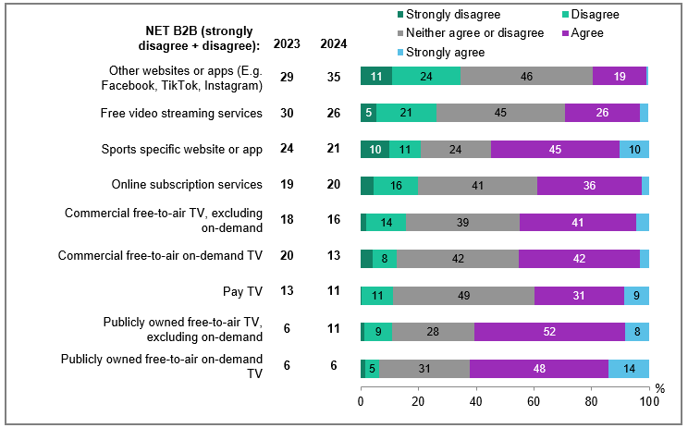

Source: NEW27a. Thinking generally about the advertisements your child saw on each of the following over the past 7 days, to what extent do you agree or disagree that they were appropriate?

Base: MCCS, Respondents whose child saw advertisements in past 7 days. 2024: n= from 17 to 1,076. 2023: n= from 37 to 1,190.

Notes: Don’t know/refused responses not shown, % vary per statement. Labels for responses <5% are not shown on chart. ‘Pay-per-view services’ result is not shown due to small sample size (n=-17)

Bar chart showing the extent to which respondents agree or disagree that advertisements their child saw on various platforms over the past 7 days were appropriate.

Other websites or apps : Strongly disagree - 11%, Disagree - 24%, Neither agree nor disagree - 46%, Agree - 19%, Strongly agree - 0%, NET B2B 2024 - 35%, NET B2B 2023 - 29%

Free video streaming services : Strongly disagree - 5%, Disagree - 21%, Neither agree nor disagree - 45%, Agree - 26%, Strongly agree - 3%, NET B2B 2024 - 26%, NET B2B 2023 - 30%

Sports specific website or app : Strongly disagree - 10%, Disagree - 11%, Neither agree nor disagree - 24%, Agree - 45%, Strongly agree - 10%, NET B2B 2024 - 21%, NET B2B 2023 - 24%

Online subscription services : Strongly disagree - 4%, Disagree - 16%, Neither agree nor disagree - 41%, Agree - 36%, Strongly agree - 2%, NET B2B 2024 - 20%, NET B2B 2023 - 19%

Commercial free-to-air TV , including recorded content but excluding on-demand TV: Strongly disagree - 2%, Disagree - 14%, Neither agree nor disagree - 39%, Agree - 41%, Strongly agree - 4%, NET B2B 2024 - 16%, NET B2B 2023 - 18%

Commercial free-to-air on-demand TV: Strongly disagree - 4%, Disagree - 8%, Neither agree nor disagree - 42%, Agree - 42%, Strongly agree - 3%, NET B2B 2024 - 13%, NET B2B 2023 - 20%

Pay TV, including recorded content but excluding streaming: Strongly disagree - 0%, Disagree - 11%, Neither agree nor disagree - 49%, Agree - 31%, Strongly agree - 9%, NET B2B 2024 - 11%, NET B2B 2023 - 13%

Publicly owned free-to-air TV , including recorded content but excluding on-demand TV: Strongly disagree - 1%, Disagree - 9%, Neither agree nor disagree - 28%, Agree - 52%, Strongly agree - 8%, NET B2B 2024 - 11%, NET B2B 2023 - 6%

Publicly owned free-to-air on-demand TV: Strongly disagree - 1%, Disagree - 5%, Neither agree nor disagree - 31%, Agree - 48%, Strongly agree - 14%, NET B2B 2024 - 6%, NET B2B 2023 - 6%

#### Subgroups

NET Strongly disagree + Disagree was higher for:

Other websites or apps:

* Those whose child is aged 0-7 (89% vs 34% of those whose child is aged 8-10, 36% of those whose child is aged 11-15, 26% of those whose child is aged 16-17)

Free video streaming services:

* Men (32% vs 21% of women)
* Those living in a capital city (28% vs 19% of those living outside a capital city)
* Those born in a mainly non-English-speaking country (36% vs 22% of those born in a mainly English speaking country)

Sports specific website or app:

* Women (31% vs 12% of men)

Parents/legal guardians/carers indicated other websites or apps such as Facebook, TikTok and Instagram had the most inappropriate advertisements seen by children.

### Reasons for disagreeing that advertisements child saw were appropriate

The main reasons that parents/legal guardians/carers disagreed that the advertisements their child saw were appropriate were pressure to buy goods or services (57%), frequency and / or repetition (48%), and content relating to gambling or betting (43%).

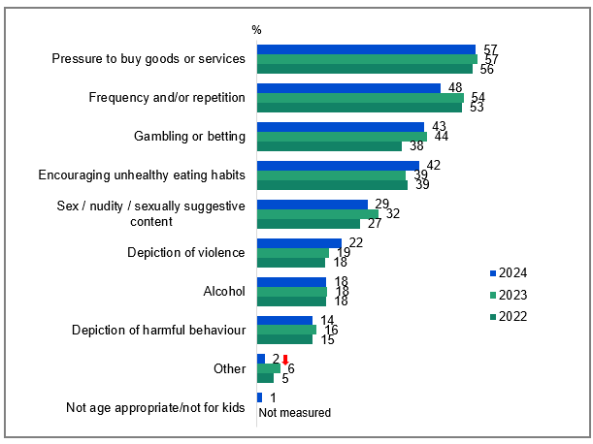

Source: NEW27b. Why did you disagree that the advertisements on <insert source from NEW27a> were appropriate?

Base: MCCS, Respondents who disagree that the advertisements their child saw in past 7 days were appropriate. 2024: n=457. 2023: n=536. 2022: n=307.

Notes: Don’t know/refused responses not shown: 2024 DK = 0.2%, Ref = 0.1%. 2023 DK = 0.4%, Ref = 0%. 2022 DK = 0.5%, Ref = 0.3%. Label changed from ‘Sex/sexuality and / or nudity’ to ‘Sex / nudity / sexually suggestive content’ in 2023. Code with ‘Not measured’ for previous years was new for back coding in 2024.

Bar chart showing the reasons why respondents disagreed that advertisements on various sources were appropriate for the years 2022, 2023, and 2024.

Pressure to buy goods or services: 57% in 2024, 57% in 2023, 56% in 2022

Frequency and/or repetition: 48% in 2024, 54% in 2023, 53% in 2022

Gambling or betting: 43% in 2024, 44% in 2023, 38% in 2022

Encouraging unhealthy eating habits: 42% in 2024, 39% in 2023, 39% in 2022

Sex / nudity / sexually suggestive content: 29% in 2024, 32% in 2023, 27% in 2022

Depiction of violence: 22% in 2024, 19% in 2023, 18% in 2022

Alcohol: 18% in 2024, 18% in 2023, 18% in 2022

Depiction of harmful behaviour: 14% in 2024, 16% in 2023, 15% in 2022

Other: 2% in 2024, 6% in 2023, 5% in 2022

Not age appropriate/not for kids: 1% in 2024

#### Subgroups

Pressure to buy goods or services was higher for:

* Those born in a mainly English-speaking country (64% vs 44% of those born in a mainly non-English speaking country)

Frequency and / or repetition was higher for:

* Those whose child watched publicly owned free-to-air TV in P7D (51% vs 35% of those whose child watched commercial free-to-air TV in P7D)

Gambling or betting was higher for:

* Men (52% vs 37% of women)
* Those ages 55-64 (81% vs 34% of those ages 25-34, 43% of those ages 35-44, 48% of those ages 45-54)

Parents/legal guardians/carers reported that pressure to buy, frequency / repetition, and gambling or betting were the main reasons for disagreeing that advertisements were appropriate for children.

### Advertisements for gambling or betting in past 7 days (children aged 8-17)

Children were then asked specifically about exposure to advertising for gambling or betting. One third (35%) of children aged 8-10 reported they had seen advertisements for gambling in the past 7 days, while a larger proportion of children aged 11-15 (43%) and 16-17 (55%) reported this. Among children who had seen gambling advertising in the past 7 days, it was most commonly seen on commercial free-to-air TV for children aged 8-10 (35%), and free video streaming services for children aged 11-15 (29%), and social media websites and apps for children aged 16-17 (38%).

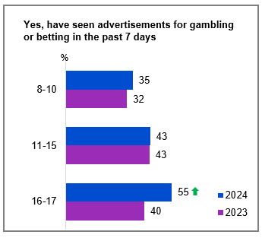

Source: KB6, KC6, KD6. Have you seen any advertisements for gambling or betting in the past 7 days?

Base: MCCS, All children aged 8-17. 2024: 8-10 (n=199), 11-15 (n-199), 16-17 (n=141). 2023: 8-10 (n=197), 11-15 (n-191), 16-17 (n=137).

Notes: No/Don’t know/refused responses not shown: 2024: 8-10 No = 65%, DK = 0%, Ref = 0%. 11-15 No = 56%, DK = 0.4%, Ref = 0%. 16-17 No = 45%, DK = 1%, Ref = 0%. 2023: 8-10 No = 68%, DK = 0.5%, Ref = 0%. 11-15 No = 56%, DK = 1%, Ref = 0%. 16-17 No = 60%, DK = 0%, Ref = 0%.

Bar chart showing the percentage of people who have seen advertisements for gambling or betting in the past 7 days, categorised by age groups for the years 2023 and 2024.

Age group 8-10: 35% in 2024, 32% in 2023

Age group 11-15: 43% in both 2024 and 2023

Age group 16-17: 55% in 2024, 40% in 2023

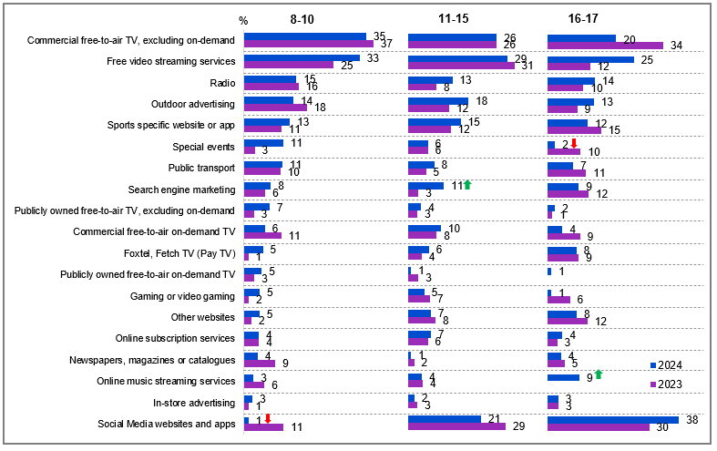

Source: KB7, KC7, KD7. Where have you seen advertisements for gambling or betting on any of the following in the past 7 days?

Base: MCCS, Children aged 8-17 who have seen advertisements for gambling in the past 7 days. 2024: 8-10 (n=70), 11-15 (n=86), 16-17 (n=76). 2023: 8-10 (n=61), 11-15 (n=84), 16-17 (n=58).

Notes: Don’t know/refused responses not shown: 2024: 8-10 DK = 4%, Ref = 0%. 11-15 DK = 4%, Ref = 0%. 16-17 DK = 0%, Ref = 0%. 2023: 8-10 DK = 2%, Ref = 2%. 11-15 DK = 0%, Ref = 0%. 16-17 DK = 0%, Ref = 0%. Responses <1% for all ages not shown.

Bar chart showing the percentage of children who have seen advertisements for gambling or betting on various platforms over the past 7 days, categorised by age groups (8-10, 11-15, 16-17) for the years 2023 and 2024.

Age group 8-10:

Commercial free-to-air TV, excluding on-demand: 35% in 2024, 37% in 2023

Free video streaming services: 33% in 2024, 25% in 2023

Radio: 15% in 2024, 16% in 2023

Outdoor advertising: 14% in 2024, 18% in 2023

Sports specific website or app: 13% in 2024, 11% in 2023

Special events: 11% in 2024, 3% in 2023

Public transport: 11% in 2024, 10% in 2023

Search engine marketing: 8% in 2024, 6% in 2023

Publicly owned free-to-air TV, excluding on-demand: 7% in 2024, 3% in 2023

Commercial free-to-air on-demand TV: 6% in 2024, 11% in 2023

Foxtel, Fetch TV (Pay TV): 5% in 2024, 1% in 2023

Publicly owned free-to-air on-demand TV: 5% in 2024, 3% in 2023

Gaming or video gaming: 5% in 2024, 2% in 2023

Other websites: 5% in 2024, 2% in 2023

Online subscription services: 4% in both 2024 and 2023

Newspapers, magazines or catalogues: 4% in 2024, 9% in 2023

Online music streaming services: 3% in 2024, 6% in 2023

In-store advertising: 3% in 2024, 1% in 2023

Social Media websites and apps: 1% in 2024, 11% in 2023

Age group 11-15:

Commercial free-to-air TV, excluding on-demand: 26% in both 2024 and 2023

Free video streaming services: 29% in 2024, 31% in 2023

Radio: 13% in 2024, 8% in 2023

Outdoor advertising: 18% in 2024, 12% in 2023

Sports specific website or app: 15% in 2024, 12% in 2023

Special events: 6% in both 2024 and 2023

Public transport: 8% in 2024, 5% in 2023

Search engine marketing: 11% in 2024, 3% in 2023

Publicly owned free-to-air TV, excluding on-demand: 4% in 2024, 3% in 2023

Commercial free-to-air on-demand TV: 10% in 2024, 8% in 2023

Foxtel, Fetch TV (Pay TV): 6% in 2024, 4% in 2023

Publicly owned free-to-air on-demand TV: 1% in 2024, 3% in 2023

Gaming or video gaming: 5% in 2024, 7% in 2023

Other websites: 7% in 2024, 8% in 2023

Online subscription services: 7% in 2024, 6% in 2023

Newspapers, magazines or catalogues: 1% in 2024, 2% in 2023

Online music streaming services: 4% in both 2024 and 2023

In-store advertising: 2% in 2024, 3% in 2023

Social Media websites and apps: 21% in 2024, 29% in 2023

Age group 16-17:

Commercial free-to-air TV, excluding on-demand: 20% in 2024, 34% in 2023

Free video streaming services: 25% in 2024, 12% in 2023

Radio: 14% in 2024, 10% in 2023

Outdoor advertising: 13% in 2024, 9% in 2023

Sports specific website or app: 12% in 2024, 15% in 2023

Special events: 2% in 2024, 10% in 2023

Public transport: 7% in 2024, 11% in 2023

Search engine marketing: 9% in 2024, 12% in 2023

Publicly owned free-to-air TV, excluding on-demand: 2% in 2024, 1% in 2023

Commercial free-to-air on-demand TV: 4% in 2024, 9% in 2023

Foxtel, Fetch TV (Pay TV): 8% in 2024, 9% in 2023

Publicly owned free-to-air on-demand TV: 1% in 2024, 0% in 2023

Gaming or video gaming: 1% in 2024, 6% in 2023

Other websites: 8% in 2024, 12% in 2023

Online subscription services: 4% in 2024, 3% in 2023

Newspapers, magazines or catalogues: 4% in 2024, 5% in 2023

Online music streaming services: 9% in 2024, 0% in 2023

In-store advertising: 3% in both 2024 and 2023

Social Media websites and apps: 38% in 2024, 30% in 2023

#### Callout

* In 2024, a significantly higher percentage of children aged 16-17 reported seeing advertisements for gambling or betting in the past 7 days (55% vs 40% in 2023).
* Additionally, more children aged 11-15 saw gambling or betting ads through search engine marketing (11% vs 3% in 2023), and more children aged 16-17 encountered gambling ads on online music streaming services (9% vs 0% in 2023).
* Conversely, there was a significant decrease in gambling ads seen on social media websites and apps among children aged 8-10 (1% vs 11% in 2023), as well as during special events among children aged 16-17 (2% vs 10% in 2023).

Exposure to gambling advertisements increased with age, with viewing platforms shifting from commercial free-to-air TV for younger children to social media websites / apps and free streaming services for older teens.

### Advertisements for gambling or betting in past 7 days (children aged 0-7)

One-sixth (17%) of children aged 0-7 had seen advertisements for gambling or betting in the past 7 days. The most common platforms these advertisements were seen on were free video streaming services (e.g. YouTube, YouTube Kids, Twitch, or Tubi) (36%), commercial free-to-air TV (31%), sports specific websites or apps (21%), and outdoor advertising (e.g. Posters, billboards) (15%). Gambling or betting advertisements seen on social media website (e.g. Facebook, TikTok, Instagram) declined significantly in 2024.

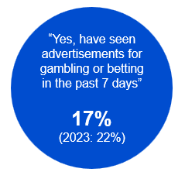

Source: KA6. Has your child seen any advertisements for gambling or betting in the past 7 days?

Base: MCCS, All parents/legal guardians/carers answering on behalf of their 0-7 year old child. 2024: n=336. 2023: n=359.

Notes: No/Don’t know/refused responses not shown: 2024: No = 82%, DK = 1%, Ref = 0% 2023: No = 77%, DK = 0.3%, Ref = 0%

A blue circular graphic showing the proportion of respondents reported, "Yes, have seen advertisements for gambling or betting in the past 7 days": 17% in 2024 vs 22% in 2023.

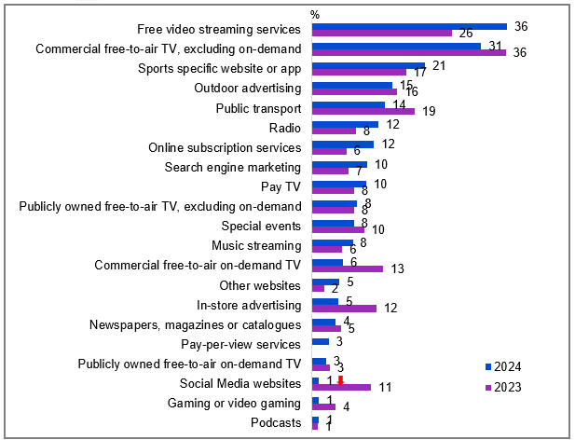

Source: KA7. Where has your child seen advertisements for gambling or betting on any of the following in the past 7 days?

Base: MCCS, Parents/legal guardians/carers whose 0-7 year old child saw advertisements for gambling in the past 7 day. 2024: n=60. 2023: n=80.

Notes: Don’t know/refused responses not shown: 2024 DK = 1%, Ref = 0%. 2023 DK = 2%, Ref = 0%. Responses <1% not shown on chart.

Bar chart showing the percentage of children who have seen advertisements for gambling or betting on various platforms over the past 7 days for the years 2023 and 2024, reported by parents/legal guardians/carers.

Free video streaming services: 36% in 2024, 26% in 2023

Commercial free-to-air TV, excluding on-demand: 31% in 2024, 36% in 2023

Sports specific website or app: 21% in 2024, 17% in 2023

Outdoor advertising: 15% in 2024, 16% in 2023

Public transport: 14% in 2024, 19% in 2023

Radio: 12% in 2024, 8% in 2023

Online subscription services: 12% in 2024, 6% in 2023

Search engine marketing: 10% in 2024, 7% in 2023

Pay TV: 10% in 2024, 8% in 2023

Publicly owned free-to-air TV, excluding on-demand: 8% in both 2024 and 2023

Special events: 8% in 2024, 10% in 2023

Music streaming: 8% in 2024, 6% in 2023

Commercial free-to-air on-demand TV: 6% in 2024, 13% in 2023

Other websites: 5% in 2024, 2% in 2023

In-store advertising: 5% in 2024, 12% in 2023

Newspapers, magazines or catalogues: 4% in 2024, 5% in 2023

Pay-per-view services: 3% in 2024, 0% in 2023

Publicly owned free-to-air on-demand TV: 3% in both 2024 and 2023

Social Media websites: 1% in 2024, 11% in 2023

Gaming or video gaming: 1% in 2024, 4% in 2023

Podcasts: 1% in both 2024 and 2023

#### Callout

* There was a significant decrease in gambling or betting ads seen on social media websites among children aged 0-7 in 2024 (1% vs 11% in 2023).

Parents/legal guardians/carers reported that free video streaming services and commercial-free-to air TV channels were the primary platforms on which children aged 0-7 saw advertisements for gambling or betting.

## Appendix

### Methodology Summary

For the 2024 Television and Media survey, the Social Research Centre’s probability based online panel – Life in Australia™ was used as the primary data collection vehicle for the probability-based sample estimates. The Social Research Centre established Life in Australia™ – Australia’s first and only national probability-based online panel – in December 2016. Cohorts included adults, parents/legal guardians/carers, children, Aboriginal and / or Torres Strait Islanders, and those in regional Australia.

An opt-in online panel, Online Research Unit (ORU), was used to source a non-probability sample boost of parents/legal guardians/carers of children aged 0 to 17, children aged 0-17, Aboriginal and / or Torres Strait Islanders and regional Australians.

Data from the Life in Australia™ and ORU panels were then blended and weighted using statistical techniques to minimise the bias associated with non-probability samples.

The 2024 Television and Media survey conducted via Life in Australia™ had a combined average completion duration of 34.5 minutes.

More details on the survey methodology can be found in the Technical Report which will be delivered to the Department (named ‘Attachment 2 - 3253 Television and Media Survey 2024 Technical Report’)

### Survey design

The instrument and questions for the Television and Media Survey 2024 were developed off the basis of the 2023 Television and Media Survey. Approximately one third of the questions in 2024 were new or revised since 2023. This new content was designed to reflect the changing media environment, new technologies, and areas of contemporary policy significance.

### Questionnaire

The survey instrument was delivered to the Department (named ‘Attachment 1 - 3253 TV and Media Survey 2024 - Final clean_29102024’).

### Ethics Approval and Considerations

All aspects of this research were undertaken in accordance with the National Health and Medical Research Council’s (NHMRC) National Statement on Ethical Conduct in Human Research (the National Statement), ISO 20252:2019 Market, Opinion and Social Research Standard, The Research Society Code of Professional Behaviour, the Australian Privacy Principles and the Privacy (Market and Social Research) Code 2021.

The Social Research Centre is accredited under the ISO 20252:2019 scheme (certification number MSR 20015, first issued by SAI Global, on 11 December 2007 and recertified on 24 November 2022 by ISO Experts for a further 3 years to 2025).

Human research ethics review and approval was provided by Bellberry Limited (approval number 2024-09-1207, 21 October 2024).

### Coding

Code frames were developed for new open-ended questions in 2024. Draft code frames and coding rules were provided to the Department for comment and approval before finalising the coding frames and applying the codes to the survey data file.

Approved code frames extensions and back-coding rules developed for previous iterations of the study were used, as appropriate, for ‘other specified’ questions to ensure overall consistency of approach to coding over time.

### Weighting

Weights for 18+ respondents

The survey consisted of two components that were combined for weighting purposes:

A random (probability) sample of adults from Life in Australia™.

A convenience (non-probability) sample to support extended reporting and analysis.

The usual approach to weighting random (probability) samples is a two-step process that aims to reduce biases caused by non-coverage and non-response and to align weighted sample estimates with external data about the target population (Kalton and Flores-Cervantes, 2003). First, base weights are calculated to account for each respondent’s initial chance of selection and for the survey’s response rate. Next, the base weights are adjusted to align respondents with the population on key socio-demographic characteristics. Refer to Särndal et al. (1992) for detailed information about model-assisted survey sampling and estimation, and to Valliant et al. (2018) for a contemporary treatment of weighting and estimation for sample surveys.

The convenience (non-probability) sample used a non-random mechanism to recruit participants to the survey, which means that the design-based approach just described does not apply. Refer to Elliott and Valliant (2017) for a discussion and further references about the challenges of making inferences from non-random samples. There are several methods for weighting such samples and making estimates from them, however (refer to Valliant, 2020). One of these methods, used here, is “quasi-randomisation” which requires a reference sample chosen at random from the target population. The reference sample is used to estimate pseudo-selection probabilities for the convenience sample, to adjust for selection bias. For this survey, the reference sample were the probability cases from Life in Australia™.

The combined sample had base weights for the two sample components. To derive the adjusted weights, consideration was given to aligning the base weights with the population in terms of characteristics that:

* are most different between the probability and convenience samples
* are most associated with the survey’s key questionnaire items
* are most different between the combined sample and the population, and
* were used in previous iterations of the survey.

Characteristics used to adjust the weights are provided in the Technical Report, and include population counts and percentages from ABS TableBuilder for the 2021 Census and adjusted to the latest Demographic Statistics and from Life in Australia™. All population counts refer to the Australian adult population aged 18+ years.

The method used to adjust the base weights was regression calibration (Deville et al., 1993), implemented in R (R Core Team, 2023) using the survey package (Lumley, 2020). For more information on weighting of sample surveys, refer to Valliant et al. (2018).

#### Weights for child respondents

A second weight for respondents who completed the child section of the questionnaire was also calculated. This weight reflects the child in the context of the population of Australian 0–17-year-old children. Like the non-probability sample, the design-based approach to weighting does not apply to child respondents, as there is a non-random mechanism of recruitment. Unlike the adult weighting, there is no probability-based reference sample with which the quasi-randomisation approach can be applied. Instead, a super-population approach is taken, in which all respondents are assigned the same base weight of 1, and regression calibration is used to adjust base weights. More information on the super-population approach can be found in Elliott and Valliant (2017).

The set of characteristics used to adjust the child weights are those shown in the Technical Report, which also includes the population counts and percentages, obtained from Census 2021 TableBuilder (Australian Bureau of Statistics, 2021). All population counts refer to the Australian 0-17-year-old population.

### Summary of historic field dates

Table Summary of historic field dates

|  |  |  |
| --- | --- | --- |
| Year | Survey | Dates |
| **2024** | Television and Media Survey | 28 October 2024 – 21 November 2024 |
| **2023** | Television and Media Survey | 25 September 2023 - 16 October 2023 |
| **2022** | Media Content Consumption Survey and Television Consumer Survey | 12 September 2022 – 5 October 2022 |
| **2021** | Media Content Consumption Survey | 13 September 2021 – 27 September 2021 |
| **2020** | Media Content Consumption Survey | 14 September 2020 – 28 September 2020 |

### References

1. Scarlata, A., Dharmawardhana, A. (2024). Is a 24-hour Home and Away channel the answer to subscription fatigue? The Conversation. <https://theconversation.com/is-a-24-hour-home-and-away-channel-the-answer-to-subscription-fatigue-226738>.
2. Australian Communications and Media Authority. (2024). Communications and media in Australia: Trends and developments in telecommunications 2023–24. <https://www.acma.gov.au/publications/2024-12/report/communications-and-media-australia-trends-and-developments-telecommunications-2023-24>.
3. Lotz, A & McCutcheon, M. (2023). Australian Screen Stories Viewing Report: Part 2: Streaming Behaviour and Content Discovery. [https://eprints.qu](https://eprints.qut.edu.au/239388/1/ASSVR_Part2.pdf)
4. Balanzategui, J., Baker, D., & Clift, G. (2024). What is ‘children’s television’ in the streaming era?: Assessing content discoverability through Australian children’s streaming platform fluencies. Convergence, 30(4), 1529-1554. https://doi.org/10.1177/13548565241264002 <https://journals.sagepub.com/doi/10.1177/13548565241264002>
5. Ofcom. (2024). Future of TV Distribution, early market report to government. <https://www.ofcom.org.uk/siteassets/resources/documents/consultations/category-1-10-weeks/269636-call-for-evidence-future-of-tv-distribution/future-of-tv-distribution-report-to-government.pdf?v=344045>
6. Vernon, J., Johnson, C., Evans, J., Collier, R., Ellis, R., Sumanasena, A., Mills, G., Kumar, A., Jacks, T., Moullier, B., Taylor, A. (2024). Future of TV distribution. The University of Exeter with the University of Leeds. <https://assets.publishing.service.gov.uk/media/672cafe262831268b0b1a2f4/Future_of_TV_Distribution_FINAL__7_Nov_2024_-accessible.pdf>
7. Lobato, R., Scarlata, A., Schivinski, B. (2023). Smart TVs and local content prominence; A submission to the Prominence Framework for Connected TV Devices proposals paper. RMIT University. <https://apo.org.au/node/321605>
8. Park, S., Fisher, C., McGuinness, K., Lee, J., McCallum, K., Cai, X., Chatskin, M., Mardjianto, L. & Yao, P. (2024). Digital News Report: Australia 2024. Canberra: News & Media Research Centre, University of Canberra. <https://www.canberra.edu.au/uc-research/faculty-research-centres/nmrc/digital-news-report-australia>
9. Where To Research. (2024). Community Perceptions Research. <https://adstandards.com.au/wp-content/uploads/2024/09/Ad-Standards-Community-perceptions-research_2024.pdf>