



# Supporting Australian stories on our screens

Options paper

March 2020

Contents

Executive summary 5

Background 5

What is the problem? 5

Why does it matter? 6

What does government do? 6

What does industry do? 7

What has changed? 8

What is the effect of change? 8

What is the opportunity? 9

What can be done? 9

Australian Government support for the screen sector 11

Producer, Location and PDV Offsets and Location Incentive 11

Direct funding through Screen Australia 12

Funding and Australian content on national broadcasters 12

Australian and children’s quotas for commercial FTA broadcasters 13

Expenditure obligations for subscription broadcasters 13

Australian content in advertising requirement 13

Training, promotion and distribution support 13

Other sources of screen content support 13

State of play 14

Economic contribution of Australia’s screen industry 14

Cultural contribution of Australian stories on our screens 14

Indigenous screen stories 16

Digital disruption and changing audiences 16

Adult audiences 17

Child audiences 21

Subscription broadcast audiences 23

Impacts on independent content creators 23

Local and international film production and distribution 26

Worsening economics of broadcast television 27

Impacts on the efficacy of current support arrangements 30

Content quotas on commercial FTA television 30

Spend requirements on subscription TV broadcasters 33

Tax incentives and direct funding 33

Funding and commissioning of content 33

Long-term effects of maintaining the status quo 36

Options for change 37

Model considerations 37

Model 1: Status quo 38

Policy objective 38

Obligations 38

Transmission quotas and sub-quotas on commercial FTA broadcasters 38

NEDE scheme for subscription broadcasters 38

Australian content on national broadcasters 38

Australian content on subscription streaming services 38

Incentives 38

Consultation questions 38

Model 2: Minimal 39

Policy objective 39

Obligations 39

Transmission quotas on commercial FTA broadcasters 39

Sub-quota requirements on Commercial FTA broadcasters 39

NEDE scheme for subscription broadcasters 39

Voluntary undertakings for subscription streaming services 39

Reporting requirements for national broadcasters 39

Incentives 40

Consultation questions 40

Model 3: Significant 41

Policy objective 41

Obligations 41

Australian content investment requirements 41

National broadcasters to allocate specific funding to children’s programming 41

Promotion and discoverability 41

Reporting requirements 41

Incentives 42

Consultation questions 42

Model 4: Deregulation 43

Policy objective 43

Obligations 43

All obligations removed 43

National broadcasters 43

Incentives 43

Consultation questions 43

Appendix A: Additional matters 44

Implementation issues 44

Australia’s international obligations 44

Definitions 44

Australian ‘link’ 44

Form of regulation 44

Implementation timing 44

Legislative amendments 44

Transitioning to a new model 44

Appendix B: Glossary of terms 45

Appendix C: Figure 4 in detail 47

Appendix D: International approaches to content regulation and funding 50

Content quotas on broadcast television and online 50

Expenditure and revenue obligations 51

Content funding and incentives 53

Tables / images

Figure 1: Rebates provided by the Australian Screen Production Incentive 7

Model 1—Status Quo 9

Model 2—Minimal 9

Model 3—Significant 10

Model 4—Deregulation 10

Table 1: Australian Screen Production Incentive 11

Figure 2: FTA television viewing—average weekly cumulative reach (five minutes consecutive, percentage) 17

Figure 3: Top 20 shows on FTA television by genre 18

Figure 4: Highest-rating Australian TV dramas on FTA networks, 2016–19 19

Figure 5: Genre of Australian content on SVODs, June 2015 to October 2019 20

Figure 6: Age of content on Australian SVODs, June 2015 to October 2019 21

Figure 7: Average time (minutes) spent viewing FTA TV per day by age group 21

Figure 8: Average broadcast television audience aged 0 to 4 years 23

Figure 9: Total Australian expenditure on drama 25

Figure 10: Proportion of box office by release strategy of all films released in Australia 2007–19 26

Table 2: IBISWorld television broadcast segment only revenue figures 28

Revenue forecast—subscription TV vs SVOD 29

Figure 12: Total expenditure on genre sub-quotas 31

Figure 13: Investment into, and hours of Australian drama (including children’s) by first-release TV and online platforms 31

Table 3: Compliance of commercial broadcasters with quotas (2014–18) 32

Figure 14: Finance sources for Australian drama feature films, five-year average (2014–15 to 2018–19) 34

Figure 15: Finance of Australian TV drama (excluding children’s), five-year average 2014–15 to 2018–19 34

Figure 16: Spend in Australia on Australian drama 2016–17 to 2018–19 35

Glossary of terms 45

Highest-rating Australian TV dramas on FTA networks, 2016–19 47

2017—series average audiences for the highest-rating Australian TV dramas on each FTA network (first-release only, exc. children’s) 48

2018—series average audiences for the highest-rating Australian TV dramas on each FTA network (first-release only, exc. children’s) 48

2019—series average audiences for the highest-rating Australian TV dramas on each FTA network (first-release only, exc. children’s) 49

Table 4: Categories and financial obligations of media content undertakings 52

## Executive summary

### Background

In response to the Australian Competition and Consumer Commission’s (ACCC) Digital Platforms Inquiry (DPI), the government requested that Screen Australia and the Australian Communications and Media Authority (ACMA) co-author an options paper considering how to best support Australian stories on our screens in a modern, multi-platform environment. Specifically, the government requested an immediate focus on:

The extent of Australian content obligations on free-to-air television broadcasters (including drama and children’s content), and whether there should be Australian content obligations on subscription video-on-demand services.[1]

This paper considers government intervention and support for Australian screen content and stories, particularly drama, documentary and children’s programming. In line with the request from the government, the paper’s emphasis is on commercial free-to-air (FTA) television, subscription television and online streaming services that distribute curated or commissioned video content to Australians.

The paper is further guided by the following principles articulated in the government’s response to the DPI report:

The government’s role is not to protect domestic businesses from digital competition, but rather to ensure the proper functioning of markets and a fair approach to regulation that ensures the rules of the physical world apply equally to the digital world.

[...]

The government will commence a staged process to reform media regulation towards an end state of a platform-neutral regulatory framework covering both online and offline delivery of media content to Australian consumers.[2]

### What is the problem?

Access to Australian stories, including drama, documentary and children’s content, has been traditionally provided through a framework of regulatory intervention and funding support. This framework includes funding of the national broadcasters, broadcast quotas, expenditure obligations, direct funding and a suite of platform-specific tax rebates. Audiences, however, are increasingly using online services, specifically subscription video on demand (SVOD), as a primary way of accessing narrative content. These online services have no Australian content obligations and provide and commission comparatively few Australian stories. Audiences are no longer guaranteed access to Australian stories in their increasing screen content diet.

It is expensive to create screen content. Drama, documentary and children’s content is easier and cheaper to import than to commission and produce in Australia. Successful overseas content, especially American television programming, usually recovers its costs in its home territory. Distributing that content internationally represents only an incremental additional cost but can deliver significant returns. While the cost of importing content can vary, an Australian network can generally import a high-quality program for $100,000 to $300,000 per hour. Commissioning an equivalent Australian program may cost a broadcaster anywhere from $500,000 to more than $1 million per hour. Older foreign content can be imported for as little as $1,000 per hour. In many circumstances, the broadcaster can expect a similar return on investment (revenue and audiences) for foreign and local programs. Australian content, therefore, is very often a less attractive option than foreign programming.

As audiences migrate to different, unregulated platforms, the value of government intervention reduces, and the strain on the regulated domestic sector increases. The relative cost of making drama and children’s programming further increases as it becomes less profitable. This dynamic frustrates opportunities for local content makers as pressure is exerted on budgets domestically, while regulation does not support growth on streaming services.

### Why does it matter?

Australian stories reflect who we are as a nation, to ourselves and to the world. These stories make sense of our past (First Australians, Gallipoli, The Sapphires), define ourselves in the present (The Castle, Home and Away, Mystery Road, Offspring, Bluey) and promote our people, our creativity and our country to the world (Crocodile Dundee, Australia, Mad Max, Lion, Wentworth, McLeod’s Daughters, Cleverman, Miss Fisher’s Murder Mysteries). Australian stories help define us as a nation and make us recognisable on the international stage. The cultural significance of Australian content is not easily quantifiable, but it is highly recognisable, and supported by the vast majority (76 per cent) of surveyed Australians who are in favour of government support to the sector.[3]

The total economic contribution of Australian screen content (under Australian creative control) is over $2.6 billion.[4] The sector as a whole directly contributes $5.34 billion in industry value-add to the economy, employing more than 30,500 people.[5] More than 230,000 international tourists visit or extend their stay in Australia each year as a result of viewing Australian screen content, generating an estimated $725 million in tourism expenditure.[6]

Our stories are seen and sold across the world and our creative talent behind and in front of the screens is world renowned. Our global brand and standing are punctuated by Australian screen stories and those who bring them to life. Recent successes include Academy Award-recognised films and talent such as Lion, Tanna, Margot Robbie and 2018 winner for Best Film Editing on Dunkirk, Lee Smith[7], globally popular television series such as Home and Away, Neighbours and the critically acclaimed Total Control, and online creators such as RackaRacka, Wengie, BrainCraft and Superwog, who have amassed hundreds of millions of views.

### What does government do?

In acknowledgement of the tangible and intangible benefits of Australian screen content, successive governments have provided the foundations of the ecosystem that has supported the production and distribution of Australian content. Government support is diverse:

* Tax rebates are offered for Australian content (via the Producer Offset), international footloose productions shot in Australia (via the Location Offset), and post, digital and visual effects work (via the Post, Digital and Visual Effects (PDV) Offset). In 2018–19, total certified rebates worth $383.7 million were provided. Rebates are shown in Figure 1.
* The government provided $22 million in 2018–19 in a one-off grant to attract the production Aquaman to locate in Australia. Following this, the government announced in 2018–19 that it would provide $140 million over four years from 2019–20 through the Location Incentive Program to attract large budget international footloose productions to Australia.
* Screen Australia received $81.8 million from government in 2018–19 to support quality Australian content with cultural value.
* The Australian Film, Television and Radio School ($22.6 million in 2018–19), Australian Children’s Television Foundation ($2.8 million in 2018–19), Ausfilm ($1.7 million in 2018–19) and other institutions provide targeted support.
* The Australian Broadcasting Corporation (ABC) and Special Broadcasting Service (SBS) received approximately $1.046 billion and $282 million respectively in 2018–19. While not subject to quotas, over 70 per cent of the content broadcast on the ABC’s primary channel and 30 per cent on its two children’s channels is Australian content.[8]

This funding-based support is complemented by regulation overseen by the ACMA, which guarantees the broadcast of Australian content, including drama, documentary and children’s programs. Broadly speaking, commercial FTA broadcasting licensees must fulfil a complex set of content quota requirements, and subscription broadcasting licensees must meet expenditure obligations for drama programming.

Government interventions work in tandem. Indirect funding (tax rebates) provides incentives to produce a broad range of Australian programs, direct funding (provided for specific programs) ensures additional support for drama and documentary content, and regulation (quotas) guarantees that Australian programs are broadcast and seen on commercial television.

Figure 1: Rebates provided by the Australian Screen Production Incentive

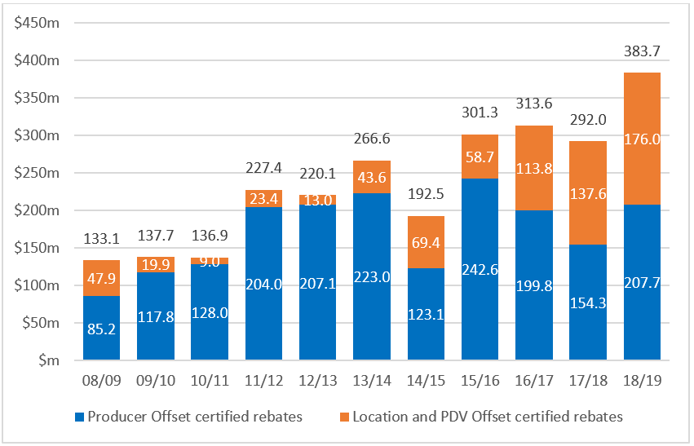

Source: Screen Australia and the Department of Infrastructure, Transport, Regional Development and Communications data. Figures may not total exactly due to rounding

### What does industry do?

The commercial television sector is currently the most significant contributor to the production of Australian content. Across the board (including sport, news, reality, lifestyle and drama programs), it spends the most on Australian content ($1.6 billion in 2017–18).[9]

Total spend in Australia on drama has reached recent highs, influenced by foreign investment into Australian feature films and TV dramas. Drama expenditure and hours broadcast by the commercial FTA sector, however, have decreased over the last decade. Expenditure on children’s programs has remained static at levels broadly commensurate with quota requirements. While the quota for documentaries is currently comfortably met, the number of individual documentary titles produced each year is in decline with a clear shift towards more observational series.

A PricewaterhouseCoopers (PwC) economic study stated that if quotas were eliminated on commercial television, children’s programs would cease to be produced, drama programs would reduce by 90 per cent and documentary programs would be halved.[10] In the absence of supporting regulatory mechanisms culturally significant Australian content would struggle to make it on screen.

### What has changed?

Importantly, Australian audiences are still watching drama, documentary and children’s programs. The appetite for such programs has in fact increased, as demonstrated by the uptake of streaming services such as Netflix and Stan. It is estimated that 71 per cent of all Australian adults have at least one subscription television or pay-as-you-go streaming service in their household.[11] Streaming services, offering uninterrupted and complete series, have fast become a preferred destination for viewing long-form narrative stories. Commercial television broadcasters have pivoted toward sports, news, information, entertainment and reality programs.

A decade ago, top Australian FTA dramas such as Packed to the Rafters could reasonably aim for around two million viewers on terrestrial TV, but now, any show with more than a million viewers would be considered a hit. This decline follows an overall reduction in the number of adults watching live FTA television. In 2018–19, 76 per cent of Australian adults watched live FTA television, down from 86 per cent in 2014–15.[12]

FTA and subscription television broadcasters have been operating in a demanding environment for several years. High levels of competition from within the industry and externally from new platforms, including streaming services, have eroded audiences and significantly affected advertising revenues.

Some broadcasters are experiencing declining share prices, with some recently reaching record lows. The rapidly evolving content environment is also seeing broadcasters increasingly consolidate their businesses and expand their activities to include a more diverse range of media and entertainment platforms. While this adaptation is likely to assist broadcasters to counteract weaker performance in their television broadcasting businesses, further consolidation and ownership changes may result in fewer broadcasters.

Cinema audiences are also changing. Admissions are steady, but the number of films released in cinemas has more than doubled over the last decade, while audiences are increasingly choosing United States (US) studio ‘blockbuster’ films with big budgets and extensive marketing. Independent films from around the world are finding it increasingly difficult to cut through at the cinema, and Australian films are particularly challenged, given the comparatively small size of the Australian market.

### What is the effect of change?

Existing regulatory arrangements aim to provide access to Australian content such as children’s programming, documentary and drama, but their effectiveness is declining. Audiences are shifting to watch these programs on streaming services, which have no obligation to make or source Australian content. While Australian programs do appear on streaming services, particularly the Australian streaming service Stan, they represent a very small percentage of the overall catalogue. In the case of Netflix, Australian programs represent 1.7 per cent of titles for the entire catalogue.[13] Stan has Australian content levels at 9 per cent.[14]

This changed environment necessitates the review of existing regulatory inconsistencies to advance opportunities for the production sector on popular platforms. Maintaining the status quo ties the Australian industry to a domestically regulated content slate that, while providing some guarantee of annual demand, provides for little innovation and longer-term growth.

While broadcasters’ revenues from their online platforms are increasing, the market will not revert to the conditions of a decade ago. If current regulatory and funding arrangements remain unchanged, in our view the ecosystem that supports Australian content will contract. In response, production levels may fall to a new ‘floor’, cheaper productions may be used to fill quotas and international production may leave Australia with a downward impact on jobs in the sector. Over time, broadcasters may be unable to meet quota requirements if they can no longer afford to produce the required content, and investment in the broadcasting sector could stall or fail. Audiences would enjoy great choice of foreign content but lack access to quality Australian stories that help us understand ourselves and each other. Changes to regulation and support may provide better opportunities to succeed in this evolving environment.

### What is the opportunity?

Significant change has occurred in content production and distribution. In the last 10 years, this change has been particularly palpable. High-speed broadband, new interfaces and business models and mobile devices provide an all-you-can-eat, wherever you want, screen diet. Going to the theatre or watching television at an appointed time is being challenged by ‘on demand’ viewing.

Disruption and competition of course have a considerable upside for the consumer—more choice and flexibility. Australian producers also have more choice and flexibility regarding commissioning platforms, raising finance and growing audiences. Numerous streaming services are entering the Australian market and competing for content and audiences. Business models are evolving to allow producers of Australian content greater access to international audiences. A number of high-profile Australian programs such as Stateless and Picnic at Hanging Rock are now broadcast domestically on FTA and subscription television, and internationally through streaming services. Great Australian stories have the potential to garner international success in ways unimagined only a few years ago. These opportunities are being realised by a small but growing number of content creators.

### What can be done?

As the ACCC’s DPI report indicated, continuing to heavily regulate a sector under pressure while allowing a booming sector to remain unregulated does not represent a level-playing field. Urgent consideration should therefore be given to updating government support measures and regulatory interventions to appropriately reflect the contemporary context. Platform neutral funding and regulation and a modernised, consistent approach to Offsets could assist Australian content to be more competitive in the new environment.

The ACMA and Screen Australia have considered a number of models that range from retaining the status quo to complete deregulation. This paper poses a series of questions to help design key elements of the models including regulatory scope, application thresholds, definitions and practical implementation issues. It is anticipated that these matters will be further explored in consultation with the industry, to underpin the stated government objective of supporting Australian stories on our screens in a modern, multi-platform environment.

The indicative models and their objectives follow.

Model 1—Status Quo

|  |  |
| --- | --- |
| **Objective** | To retain existing regulations and incentives to make and show Australian programs, which focus on traditional platforms. The status quo will prevail in circumstances where no future regulatory option can be implemented. |
| **Features** | **Commercial FTA broadcasters**: retain transmission quota requirements (primary and secondary) and existing sub-quota obligations.  **Subscription broadcasters**: retain New Eligible Drama Expenditure (NEDE) scheme.  **Subscription streamers**: no obligations.  **National broadcasters**: no change. |
| **Features** | **Offsets**: no change. |

Model 2—Minimal

|  |  |
| --- | --- |
| **Objective** | To fine-tune and modernise existing regulatory and funding arrangements to better reflect the contemporary media landscape. This model seeks to engage subscription streaming services on a voluntary basis, potentially as a precursor to future regulation, if needed. |
| **Features** | **Commercial FTA broadcasters**: revise transmission quota requirements and flexibly apply them across all channels, revise sub-quotas to give greater flexibility, including removal of requirements for preschool (P) programs.  **Subscription broadcasters**: revise the NEDE scheme, and provide flexibility to acquit obligations across program genres.  **Subscription streamers**: set voluntary content investment undertakings with the ACMA.  **National broadcasters**: request better reporting to Parliament on Australian content hours and expenditure. |
| **Features** | **Offsets**: a Producer Offset with a single flat rate applying to one-off feature length films and children’s content distributed on any platform (other Offset rates unchanged). |

Model 3—Significant

|  |  |
| --- | --- |
| **Objective** | To establish platform-neutral, future facing obligations and incentives that take into account individual platform offerings and audience engagement. |
| **Features** | All commercial content service providers (including subscription services): require investment in a percentage of revenue into new Australian content, under one of two implementation approaches:   1. invest a percentage of Australian revenue into Australian content that must be made available on their Australian services, or make an equivalent contribution to a new Australian Production Fund (APF) 2. negotiate individual Australian content investment plans in line with expectations set by the ACMA.   **National broadcasters**: allocated funding for Australian children’s programming |
| **Features** | Offsets: a single flat rate Offset for all platforms with modified thresholds and potential for a ‘cultural uplift’. |

Model 4—Deregulation

|  |  |
| --- | --- |
| **Objective** | To remove all regulation and remove or revise incentives to make Australian programs, in order to support platform neutral deregulation. |
| **Features** | All services: all content obligations removed. |
| **Features** | Offsets: either:   1. all Offsets removed, or 2. all Offsets provided at a single rate to projects of scale which attract significant market investment. |

## Australian Government support for the screen sector

Governments of most economically-developed nations support their local screen industries due to the cultural importance of screen stories, competition from foreign markets (notably the US), and the relative cost of creating local content. The Australian Government provides significant support to the screen sector through a range of regulatory measures and direct and indirect financial contributions.

The government provided more than $510 million in 2018–19 to support screen content creation and the wider industry,[15] as well as $1,328 million in funding to the national broadcasters.[16] In addition, government requirements on commercial FTA and subscription broadcasters, in tandem with funding supports, are estimated to have underpinned the production of $1.683 billion[17] of Australian content in 2017–18. Government support also triggers investment by the advertising market, feature film industry, public broadcasters and online content creators.

In recognition of the cultural importance of free, televised content, FTA broadcasters access broadcast spectrum at comparatively low rates and gain the first opportunity to purchase broadcast rights for events on the anti-siphoning list. Commercial FTA broadcasters are currently protected from competition from new entrants to the FTA market.

A glossary of key terms is provided at Appendix B. An overview of government interventions in comparable jurisdictions is at Appendix D.

### Producer, Location and PDV Offsets and Location Incentive

The government provides various tax rebates to incentivise production in Australia, together known as the Australian Screen Production Incentive (ASPI).[18] These are set out in Table 1.

Table 1: Australian Screen Production Incentive

| Incentive | Policy objective | Incentive amount, and selected features |
| --- | --- | --- |
| **Producer Offset**  Producer Offset certificates valued at a total of $207.69 million were issued in 2018–19.[19] | To assist the industry to be more competitive and responsive to audiences.  To provide a real opportunity for producers to retain substantial equity in their productions and build stable and sustainable production companies.  To increase private investor interest in the industry. | 40% rebate on qualifying Australian production expenditure (QAPE) on eligible feature films.  20% rebate on qualifying spend for content released on other platforms such as broadcast TV or online services.  Productions must have significant Australian content, and minimum spend thresholds apply. |
| **PDV Offset**  The estimated rebate payable to productions receiving the Location and PDV Offsets was $176 million in 2018–19.[20] | To attract post-production, digital and visual effects production to Australia, regardless of where the film is shot. | 30% rebate on qualifying expenditure for productions undertaking PDV work in Australia.  The expenditure threshold for eligibility is $500,000 on activities reasonably required to perform the PDV production in Australia. |
| **Location Offset**  The estimated rebate payable to productions receiving the Location and PDV Offsets was $176 million in 2018–19.[21] | To attract large budget international productions to Australia to provide greater economic, employment and skill development opportunities for the Australian sector. | 16.5% rebate on QAPE for eligible productions.  Productions must have a minimum Australian spend of $15 million. |
| **Location Incentive**  The Incentive will provide $140 million over four years from 2019–20 to attract large budget international productions to Australia.[22] | To compete with higher foreign incentives and make Australia a globally competitive production destination. | Grant of up to 13.5% of QAPE to eligible international footloose productions.  Designed to be combined with the Location Offset, effectively increasing support to 30% of QAPE. |

The Producer, Location and PDV Offsets are mutually exclusive. Unlike some rebates in foreign jurisdictions, the Offsets are uncapped, and guaranteed by the government through the taxation system. Projects often access an Offset in tandem with state or territory funding through relevant organisations. Australian content can also apply for direct funding via Screen Australia.

### Direct funding through Screen Australia

Screen Australia offers development and production funding programs for high quality, culturally impactful and innovative dramas and documentaries across cinema, television and online screens.[23] Specific funding is available for projects created by Indigenous Australians, children’s content, documentary content, promotion and distribution assistance, and talent and sector development. Screen Australia supports and represents the industry nationally and internationally, and provides research and other industry resources. Screen Australia received $81.8 million from government in 2018–19 to support quality, Australian content with cultural value.

### Funding and Australian content on national broadcasters

The ABC’s functions include broadcasting programs that contribute to Australia’s national identity, inform and entertain, and reflect cultural diversity, as well as programs of an educational nature.[24] The ABC provides news and weather, drama, documentary, children’s and other content. The government provided approximately $1.046 billion in funding to the ABC in 2018–19. In that year, the ABC broadcast 74 per cent Australian content on the ABC main terrestrial channel (between 6.00 am and midnight), two-thirds of which was first-release.[25] Australian children’s content made up over 33 per cent of total programming on ABC ME and ABC KIDS in the same year.[26]

The SBS’s principal function is to provide multilingual and multicultural broadcasting and digital media services that inform, educate and entertain all Australians, and reflect Australia’s multicultural society.[27] SBS provides multicultural and multilingual programming comprising international and local content. The government provided approximately $282 million in funding to the SBS in 2018–19. SBS’s Charter requires Australian content balanced with a degree of programs in languages other than English. Excluding news and current affairs and sport, first-release Australian content accounts for approximately seven per cent of programs across all SBS television channels.[28]

### Australian and children’s quotas for commercial FTA broadcasters

Under the Broadcasting Services Act 1992 (BSA) commercial broadcasters are required to broadcast a minimum of 55 per cent Australian content on their primary channel and an additional 1,460 hours across their secondary channels each year (between 6.00 am and midnight)[29], totalling 5,074 hours of Australian content per year.

In addition, the Broadcasting Services (Australian Content) Standard 2016 (ACS) and Children’s Television Standards 2009 (CTS) set out sub-quotas for Australian drama, documentary and children’s programming, which are recognised for their cultural value and are particularly vulnerable to loss without government intervention.

Accordingly, commercial television licensees must broadcast:

* 860 points of first-release Australian drama in prime time over three years
* 20 hours of first-release Australian documentary per year
* 260 hours of children’s (C) programs per year (of which 130 hours must be first-release, 25 hours must be first-release Australian children’s drama[30] and eight hours must be repeat programs)
* 130 hours of preschool (P) programming per year.

### Expenditure obligations for subscription broadcasters

Under the NEDE scheme, subscription broadcasting licensees and channel providers are required to spend at least 10 per cent of total program expenditure for each drama channel on new Australian drama programs.

### Australian content in advertising requirement

Under the BSA, a standard must be in place to ensure that the majority of advertisements on commercial television are Australian made.[31] The effect of the standard is that at least 80 per cent of the total advertising time (between 6.00 am and midnight) is occupied by Australian-produced advertisements.

### Training, promotion and distribution support

The government also provides funding to educate future industry professionals, promote the industry, and support the distribution and preservation of content. In 2018–19, a total of $64 million was provided to the Australian Film, Television and Radio School, Australian Children’s Television Foundation, Ausfilm, and the National Film and Sound Archive, as well as to the National Institute of Dramatic Art.

### Other sources of screen content support

The International Co-production Program encourages production and fosters relationships with international screen content creators. Australia is party to 12 co-production arrangements under the Program, with Canada, China, France, Germany, Ireland, Israel, Italy, New Zealand, Republic of Korea, Singapore, South Africa and the United Kingdom (UK), and an agreement with Malaysia was signed in November 2019. Since the inception of the program in 1986, 194 co-productions have been completed or commenced production.

In addition to government support, state and territory agencies also provide a range of funding programs. These programs differ across agencies, but largely focus on the development and production of Australian content. Some states offer funding to attract foreign production and post-production activity. Funding is generally provided via direct grants and investments, as well as via tax concessions, while some states offer ‘top up’ tax rebates for PDV activity.

Australian screen content is also significantly supported by investment from the marketplace. Funding from marketplace sources such as film distributors, TV broadcasters or online platforms is generally a requirement for major public funding.

## State of play

### Economic contribution of Australia’s screen industry

The Australian screen industry adds significant value to the economy through extensive and innovative activity. Australian Bureau of Statistics (ABS) research indicates that film and video production businesses, film and video post-production businesses, commercial FTA broadcasters and subscription broadcasters and channel providers directly contributed $5.34 billion in industry value add to the economy in 2015–16.[32] This is a large sum despite being a small contribution to Australia’s overall gross domestic product of almost $1.7 trillion at June 2016.[33] The value added by the sector grew 7.2 per cent from 2011–12 to 2015–16.[34]

The industry also generates important indirect benefits to the economy, driving demand for goods and services including rental services, financial services and electricity.[35] Other creative industries, such as the performing arts, music and design, also gain significant work and income from screen production.[36]

These direct and indirect economic contributions are important to the Australian economy. It is estimated that the total economic contribution of screen content under Australian creative control amounted to $2.6 billion in 2014–15.[37] Of this amount, scripted/narrative drama and documentary screen content under Australian creative control was estimated to generate $847 million in value add. An additional $382 million in value add was contributed by production and PDV services provided by Australian businesses to foreign screen productions.[38]

Australian content significantly drives international tourism. An estimated 230,000 international tourists visit or extend their stay in Australia each year as a result of viewing Australian film and television content, generating an estimated $725 million in tourism expenditure.[39]

The screen industry generates creative, innovative and skilled jobs. Film and video production businesses, film and video post-production businesses, commercial FTA broadcasters, and subscription broadcasters and channel providers employed approximately 30,528 people at June 2016.[40] While comparisons between surveys should be used with caution, this indicates growth of 4.9 per cent from June 2012 to June 2016.[41]

The industry also contributes to Australia’s international trade. Total screen export earnings, including international box office earnings, and licence fees and royalties, for scripted, narrative Australian film and television screen content exceeded $252 million in 2014–15.[42]

### Cultural contribution of Australian stories on our screens

It is widely recognised that stories create a range of cultural and social impacts. Stories influence us in many ways, ultimately reflecting, shaping and challenging our perceptions of ourselves and each other. Successive governments have recognised the value of Australian screen content and maintained a comprehensive regulatory and support framework.

Screen stories are uniquely powerful. They combine other art forms such as narratives, sound and vision, and are widely viewed. Drama and documentary content strongly resonates in terms of popularity and impact, and children’s content is specifically important, helping children to understand the world and their place in it, acquire language and other skills, and gain age-appropriate guidance on complex issues such as birth, death, friendship and bullying.

According to the research project Screen Currency, Australians believe that Australian screen content is recognisably different, important to support and valued for its diversity. It is similarly preferred by both low and heavy viewers of online content.[43] This research also showed that 76 per cent of surveyed Australians are in favour of government providing support to the sector.

The social and cultural impacts of screen stories are diverse. This impact can range from the adoption of common use of phrases from The Castle and Kath and Kim, to the influence of content on our national pride, cultural identity, social cohesion and points of connection.

Screen Currency uses a framework to describe how content can create combinations of impacts:

* **Instrumental impacts**, or direct social, cultural or economic impacts.

These include the influence of content authored by Indigenous Australians such as First Australians, Redfern Now and Mystery Road on all Australians, and on international audiences; the historic influence of Gallipoli on perceptions of the Gallipoli campaign; the diverse educational and inspirational impacts of documentaries and children’s content; and the ability of screen stories including TV dramas to foster conversations and change through storylines that include issues such as racism, sexuality, disability and mental health.

* **Institutional impacts**, which influence trust and esteem of organisations, governments or countries.

These include the ability of Indigenous-authored content to conserve, celebrate and influence Indigenous communities and institutions, as well as conversations around Australian history and institutions; the influence of Gallipoli on respect for Anzacs; and the unique insights provided by documentaries, including those that encourage political change.

* **Intrinsic enrichment from aesthetic excellence**, including engagement with ideas and themes.

The aesthetic excellence of leading Australian content has been locally and internationally recognised by audiences, critics, festivals and awards.

Australian screen stories and stars generate considerable impact abroad:

* Diverse Australian screen stories depict Australian life, history and culture, showcase Australia’s flora and fauna, and promote an understanding of, and openness to, Australian values.
* Screen stars are highly recognisable ‘unofficial ambassadors’ for Australia, and have been heavily involved in many official, high-profile and successful tourism campaigns.

This institutional and global impact is often described as ‘soft power’. It is particularly obvious in the significant role that screen content plays in attracting tourism. Crocodile Dundee greatly influenced perceptions of Australia, combining with the ‘Come and Say G’day’ campaign to create a notable surge in tourism. The film’s enduring influence was re-employed in the successful 2018 ‘Dundee’ campaign. The ‘Come Walkabout’ and ‘There’s Nothing Like Australia’ campaigns have also utilised Australian stories and stars.

The cultural impact of Australian screen content is increasingly important in our on-demand, fast-evolving world. While online platforms provide new opportunities to distribute Australian stories to local and foreign audiences, they have also opened audiences to unprecedented levels of foreign content. As audiences easily access high-quality foreign stories, the social and cultural importance of home-grown stories is expected to grow.

#### Indigenous screen stories

Indigenous Australian screen stories have unique and pivotal cultural value. Government and industry support have been crucial for the Indigenous screen sector’s growth from very little representation and participation, to the quality Indigenous stories enjoyed on Australian screens today. A 2002 study, Broadcast in Colour, found that in 1992, there were no Indigenous Australians in sustaining roles on Australian television during the surveyed period, and in 1999 there were two.[44] By 2011–15, five per cent of main characters in Australian television drama were Indigenous Australians.[45]

Titles created by and featuring Indigenous Australians have achieved audience and critical acclaim and been selected for international festivals. Total Control recently won three Australian Academy of Cinema and Television Arts (AACTA) awards and was Australia’s first series selected for the Toronto International Film Festival. Mystery Road series 1 also took home three AACTA awards, was voted Most Popular Drama by the Australian public at the TV Week Logie Awards, and series 2 premiered at the Berlin International Film Festival. Consultation with industry by Screen Australia’s Indigenous Department suggests a new phase of government and industry support will be crucial to continued growth and success.[46]

### Digital disruption and changing audiences

The rise of online streaming services, supported by high-speed broadband, has given Australians unprecedented choice over the type and volume of content they consume. Audiences have more diverse content available to them than ever before, delivered by multiple different providers at competitive prices and/or for free. This includes professionally produced content on subscription streaming services, as well as new forms of content on social media platforms such as YouTube and Facebook, using innovative and interactive formats.

Australians are consuming more content delivered by the internet. The ACMA reported that 12.9 million Australian adults (around 65 per cent) watched professionally produced online content, compared with 9.63 million Australian adults in the previous year.[47] While a TV set is still the most common way to watch video content, Australians are using multiple devices and services to access content. Sixty-four per cent of Australians have access to a device or service to stream video content in their home (such as a smart TV, Google Chromecast and Apple TV).[48] Advanced mobile streaming will soon be available through the 5G network, creating more opportunities for streaming larger volumes of digital content.

Uptake of SVOD services is increasing for all households at all age groups.[49] Australian SVOD subscriptions totalled 12.3 million at the end of June 2019, which represents a 29 per cent increase from 9.5 million at June 2018.[50] At May 2019, 71 per cent of Australian adults (with a TV set at home) had at least one subscription or pay-as-you-go service in their household, an increase from 69 per cent at June 2018.[51]

Netflix is now the dominant subscription service in Australia, with research estimating 4.9 million individual subscriptions in August 2019 and 5.6 million individual subscriptions in February 2020[52] (out of a total 167 million subscribers worldwide[53]), while Stan is the second largest single provider with 1.8 million individual subscriptions.[54] Due to account sharing, the number of people with access to SVOD content (referred to as a ‘household subscription) is estimated to be much higher than the number of subscribers. On this count, Netflix significantly exceeds Foxtel—over 11 million Australians versus five million, respectively.[55]

Other services, such as Amazon Prime, continue to grow. Newly launched service Disney+ has quickly become a strong player since its launch in November 2019, with an estimated 1.2 million subscribers in Australia by February 2020.[56]

#### Adult audiences

Increased online viewing is one of the key drivers of a steady decline in FTA viewing. Between January and June 2019, Australians spent an average of 59 hours and 49 minutes per month watching FTA television in 2019, compared to 62 hours and 16 minutes per month in 2018.[57]

The percentage of Australian adults watching FTA television is also declining, as illustrated by the following graph.

Figure 2: FTA television viewing—average weekly cumulative reach (five minutes consecutive, percentage)

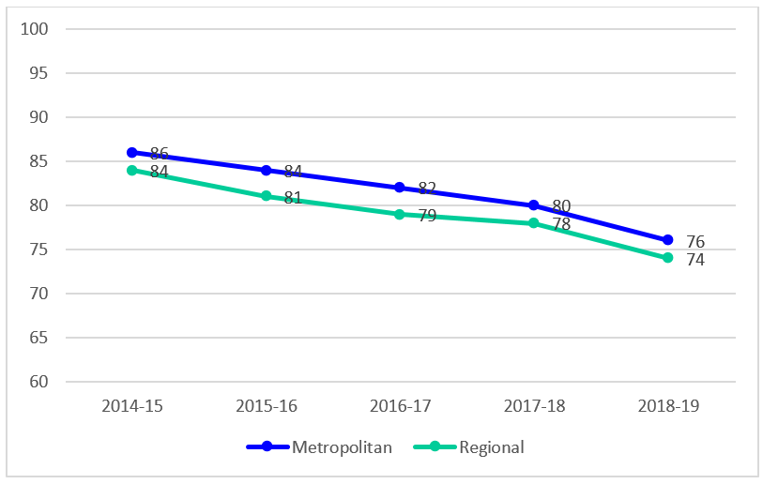

Source: OzTAM Pty Limited and Regional TAM Pty Limited 2019. Apart from any use permitted under the Copyright Act 1968, the data may not be reproduced, published or communicated (electronically or in hard copy) without the prior written consent of OzTAM and/or RegionalTAM.[58]

Broadcast television audience numbers are declining and fragmenting across platforms. Although Australians still spend most of their viewing time watching broadcast television, this share is decreasing, driven by younger Australians’ demand for online content.[59] Australians aged 18 to 34 are spending most of their total viewing time watching online content.[60]

Digital disruption is also affecting the type of content that people prefer to watch via broadcast television, which is increasingly emphasising time-sensitive content such as live news and sport that consistently rates well[61] and reality television programs that also continue to be popular. Nine Entertainment’s CEO, while discussing the company’s 2020 half-yearly financial results, asserted that its FTA television channels would concentrate on the more profitable content in a digital era, such as regular sport, news and current affairs and shows like Married at First Sight.[62]

The following figure shows the significant and persistent shift towards sports and reality programming as the most popular program genres with FTA television audiences over the past decade.

Figure 3: Top 20 shows on FTA television by genre

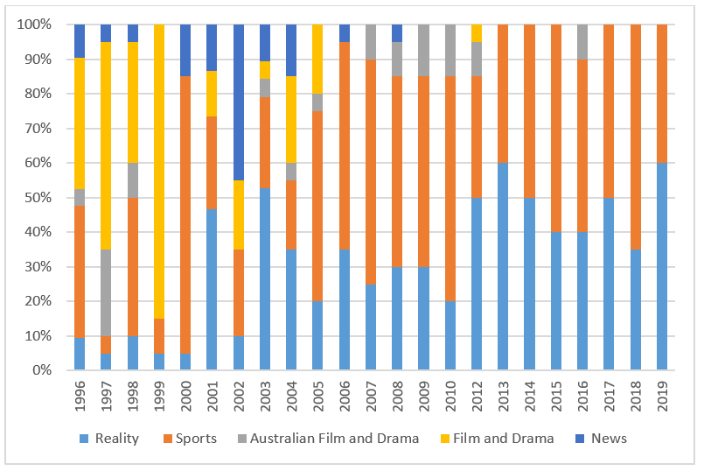

Sources: OzTam, Screen Australia and TV Tonight, Bureau of Communications and Arts Research (BCAR) analysis.

Drama is proving to be particularly well-suited to online, on-demand consumption, which facilitates the viewing of multiple episodes in succession. Although top-performing Australian dramas still attract significant audiences on FTA television, broadcast drama audiences have declined, as illustrated by the following graph.

Figure 4: Highest-rating Australian TV dramas on FTA networks, 2016–19

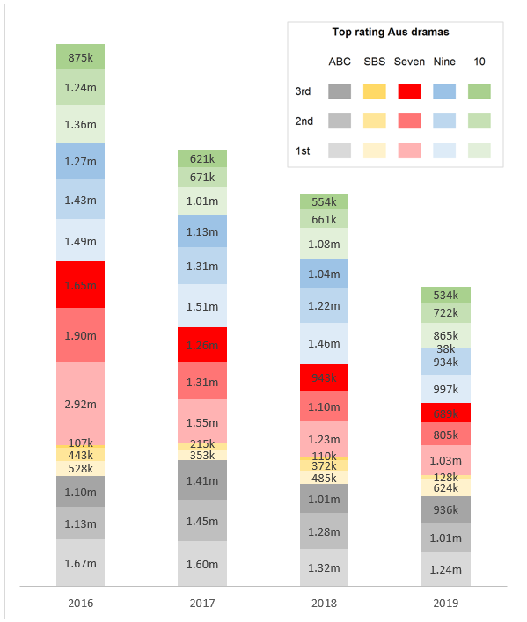

Source: OzTAM and RegionalTAM, 5-city-metro, combined markets, total people, average audience, consolidated 28.[63]

The graph ‘stacks’ the highest-rating Australian dramas on each broadcast FTA network for the last four years. Each network is represented by a colour, and each title’s series average audience[64] is shown by a shade of that colour.

While drama audiences on FTA and recorded playback services are declining, drama viewing online is growing. Drama content is the top-rating genre on broadcaster video on demand (BVOD) services and makes up 28 per cent of all BVOD viewing.[65] Broadcasters are using these services to respond to digital disruption and attract online audiences. BVOD consumption grew 1.3 per cent in the second half of 2019, and 36.9 per cent over the whole of 2019.[66] An upcoming audience measurement system, Virtual Australia (VOZ), is expected to measure TV content viewing across all screens in early 2020.

Documentary audiences on FTA television have also declined, though analysis of the top 50 documentary titles for each year suggests this decline is more gradual than that seen in broadcast drama audiences. Titles such as Australian Story and Back Roads often exceed one million average viewers, while feature films Jimmy Barnes: Working Class Boy and Mystify enjoyed strong FTA audiences after grossing more than $1 million at the Australian box office. Feature film The Final Quarter averaged 700,000 viewers on Ten[67], while series such as Australia In Colour and War on Waste have also reached wide audiences for the ABC and SBS.[68]

While viewing data for SVOD content is not generally released by SVOD platforms, the popularity of these platforms clearly demonstrates the ongoing popularity of drama and documentary content. PwC has observed that as SVODs increasingly become the dominant platform for professionally produced drama, FTA television will rely more heavily on its traditional ratings drivers, such as news, sports and reality television.[69]

Research by RMIT indicates that, in 2019, Australian titles made up 1.7 per cent of Netflix’s Australian catalogue and 9 per cent of Stan’s catalogue.[70] The proportion of Australian titles in Amazon Prime’s catalogue was, however, too difficult to quantify due to its ‘unique catalogue structure’.[71]

Different online services offer content to users in different ways. Algorithms, which offer content choices based on user data, can play a significant role. Some services offer dedicated search options and categories for Australian content. Platforms offer an abundance of content, and for Australian content to be seen, it must be discovered. The ‘discoverability’ of content is an important issue in any on-demand environment.

The following figure indicates that drama for general audiences makes up the greatest proportion of Australian content available across SVOD services in Australia.

Figure 5: Genre of Australian content on SVODs, June 2015 to October 2019

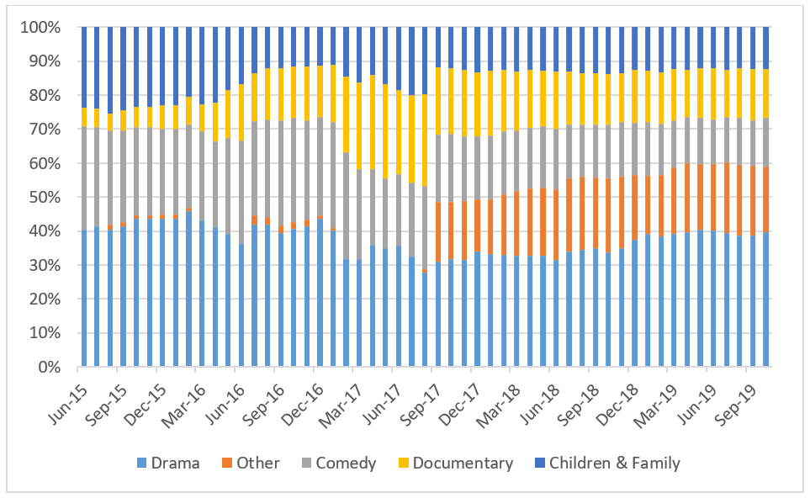

Source: Ampere Analysis, Bureau of Communications and Arts Research (BCAR) analysis.[72]

It should be noted that definitions of ‘Australian’, and the classification of genres such as drama and documentary, may vary between services and research methodologies.

The following figure indicates that the majority of content (including Australian and foreign content) available on Australian SVODs is at least five years old.

Figure 6: Age of content on Australian SVODs, June 2015 to October 2019

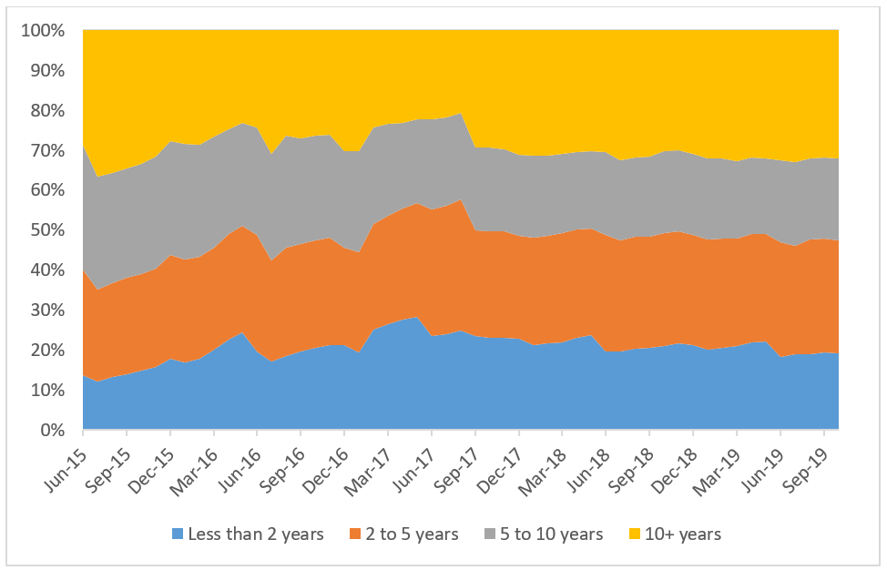

Source: Ampere Analysis, Bureau of Communications and Arts Research (BCAR) analysis.[73]

The national broadcasters have for some time responded to digital disruption by developing digital services that maintain their reach and relevance. ACMA research notes that ABC iview and SBS On Demand were the first and second most watched BVOD services for FTA programs in 2018–19.[74]

#### Child audiences

Child audiences are increasingly shifting to online platforms, including subscription streaming services and user-generated services.[75] Fewer children are watching FTA television compared with the early 2000s, as illustrated by the following figure.

Figure 7: Average time (minutes) spent viewing FTA TV per day by age group

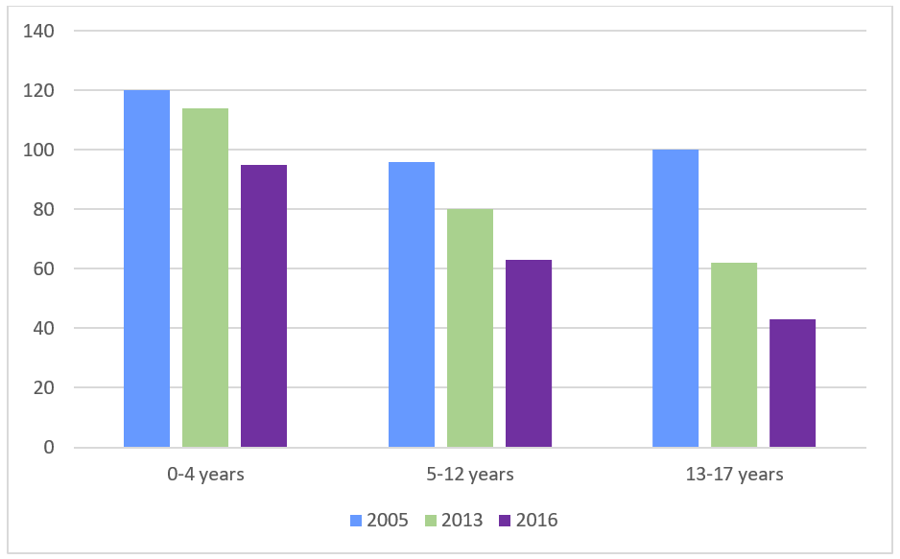

Source: OzTAM. Average time in minutes spent viewing, 5 city metro, 1 January to 31 December 2005, 2013 and 2016, Sun–Sat. Consolidated from 2013.[76]

The average audience of children watching commercial FTA fell by a third, from 168,000 in 2005 to 113,000 in 2016.[77] This was also the first year in which the total time Australian children spent online on computers, tablets or mobile devices exceeded the time they spent watching television.[78] While this data has been drawn from a research project completed in 2016, the declining trend in children’s FTA viewing has continued. Free TV notes that in 2018 children’s content was watched by an average audience of 3,600 (0 to 3 years).[79] Seven reportedly recorded average audiences of under 1,000 viewers for most children’s programs across the almost 400 hours of programming that it produced in the last calendar year.[80]

In 2016, nearly half of all children aged 0 to 14 watched television programs on BVOD or SVOD services. This is roughly the same proportion as those viewing FTA television.[81] Video sharing sites, such as YouTube, also account for a significant proportion of children’s content consumption. In 2016, 68 per cent of children aged 0 to 14 watched children’s programs on these services. Their appeal for parents and caregivers will likely continue as measures to better protect child audiences are introduced.[82]

Children’s content is the second highest-rating genre on BVOD services (behind drama) and makes up 18 per cent of all viewing on this kind of platform (includes ABC iview and commercial FTA online services).[83] Bluey, which was first broadcast on the ABC in October 2018, is the most played program ‘in the history of iview measurement’[84] and has reached more than 200 million program plays on iview.[85]

Children who are watching commercial FTA television are watching increasingly less C classified content. In 2005, the top rating C program broadcast on commercial television averaged 185,000 viewers, compared to 41,000 in 2016.[86] In 2010, 14 per cent of dedicated C and P programs drew an audience of more than 25,000. This fell to only seven per cent of dedicated programs in 2016. In 2016, the top five programs watched by children aged 0 to 14 were broad appeal ‘family’ programs, including reality and light entertainment programs.[87]

In addition to digital disruption, two policy changes may have influenced shifts in viewing behaviour—amendments to the BSA in 2013 that allowed commercial broadcasters to acquit children’s content obligations on multi-channels (that generally attract lower audiences), and the introduction of dedicated commercial-free children’s channels on the ABC in 2001 and 2009. The ABC’s dedicated channels are widely acknowledged to have had a significant impact on the decline in younger children watching P-classified programs on commercial TV. ABC KIDS is the highest ranked FTA channel during the day for child audiences aged 0 to 4 years, as illustrated in the following figure.[88]

Figure 8: Average broadcast television audience aged 0 to 4 years

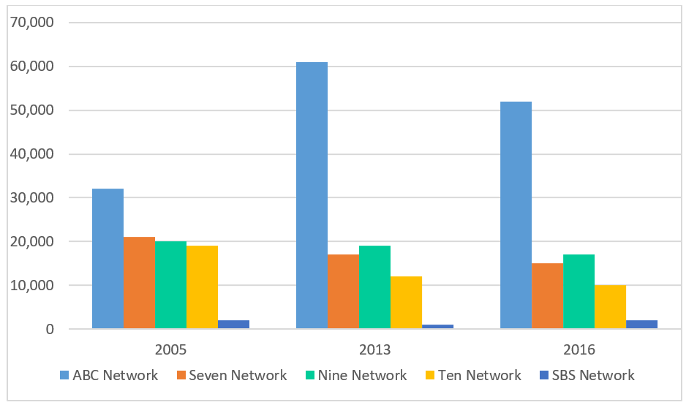

Source: OzTAM. Average audience figures based on 1 January–31 December 2005, 2013 and 2016, Sun–Sat, five city metro. Consolidated from 2013.[89]

Children aged 13 to 17, who are not catered to under current children’s content sub-quotas, have demonstrated the largest decrease in time spent viewing FTA television overall, with a 57 per cent decrease between 2005 and 2016.[90]

#### Subscription broadcast audiences

The revenue of subscription television broadcasters has been challenged by the fast uptake of online services that offer on demand, mobile and competitively priced services. Telsyte estimates that the total subscription broadcasting market ‘maintained just over three million subscriptions at the end of June 2019’, accounting for about a fifth of the total subscription (SVOD and subscription broadcasting) market.[91]

In 2018–19, News Corp reported that its ‘streaming base in Australia doubled since calendar year end to approximately 777,000 customers in June 2019, which was accompanied by a ‘decline in average churn among sports tier subscribers to Foxtel broadcast’.[92] Subscriber churn increased to 14.7 per cent, compared to 12.5 per cent the year before.[93]

### Impacts on independent content creators

Digital disruption and the globalisation of content are affecting business models for production and distribution. The Australian independent production sector is diverse, ranging from large companies that often have significant foreign investment, smaller companies that ‘staff up’ for productions, and ‘cottage’ producers. The 2016 ABS Industry survey recorded 2,819 screen production businesses at the end of June 2016, up seven per cent on the previous survey.[94] Content is developed and produced at the lead of key creatives such as producers working with writers and directors (common in Australian TV content), or writer/directors. This differs from the United States, where large studios or writer/producer ‘showrunners’ often steer productions.

While there is growth in the overall number of drama and documentary titles produced and in total spend on those titles, many independent producers are struggling to generate sustainable incomes. Production can be segmented into a very small number of high-budget titles with significant foreign finance, a group of medium-budget titles with varying returns, and a large number of low-budget, independent titles that often struggle to reach audiences and generate real revenue. The large number of independent producers and small number of commissioning platforms has led to calls from producers for mandated terms of trade. The entry into the Australian market of more commissioning platforms, in partnership with other reform options outlined in this paper, may assist producers to bargain and retain more equity in their projects. Analysis of market competition is beyond the scope of this paper but may warrant further review.

Australian content creators are shifting development and production strategies to compete for international finance and audiences. For example, the cost of Australian TV drama is increasing, and international investment into Australian TV drama is also rising.[95] Entirely new forms are evolving on platforms such as YouTube and Facebook, with a number of Australian stories achieving millions of views, and a small number of creators generating significant and sustained revenue. Several Australian screen stories have enjoyed local and global success in this new environment. Titles such as The Kettering Incident, Bluey, Mako Mermaids and Miss Fisher’s Murder Mysteries have generated considerable international sales,[96] Sweet Country, Total Control, Lion and Sherpa have received critical and festival praise, while online titles such as Meta Runner, Superwog and Starting From Now have been viewed millions of times. It is clear that in an era of vast audience choice, high-quality content is most likely to succeed.

Content creators have generally sold limited rights to distribute their content via means such as a limited broadcast ‘window’ or DVD and Blu-ray sales. This business model has been profoundly disrupted by video on demand (VOD) services, creating pressure on producers, distributors and sales agents, and leaving some analogue revenues yet to be fully replaced by digital returns. Additionally, some SVOD services often seek to purchase perpetual, global rights to content, meaning content creators receive one sum via a unique payment structure. Current Australian incentives encourage producers to retain equity in productions to generate long-term profits. This focus may not be suitable if commissioning strategies shift significantly towards global and perpetual rights. While competition amongst SVOD platforms and broadcasters for viewers has created an international content production boom, this may not create enduring benefits for content creators.

Total expenditure on drama and documentary across the sector has risen in recent years, though expenditure from commercial broadcasters has declined over time and production of some formats is falling. Total spend on drama in Australia reached $1.179 billion in 2018–19, above the five-year average of $1 billion.[97]

Figure 9: Total Australian expenditure on drama

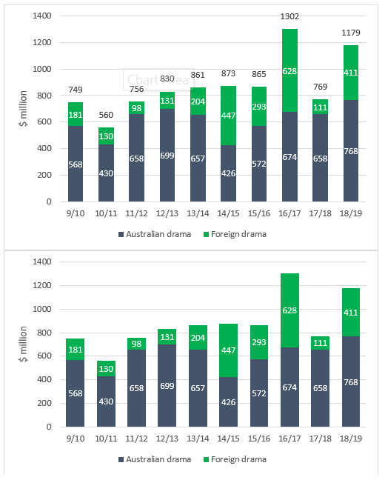

Source: Screen Australia drama expenditure data.[98]

Spend has increased in recent years, but digital disruption is affecting the ability of the production industry to experience profits. FTA and subscription broadcasters have been severely disrupted and challenged by online platforms, while production of Australian drama for online platforms remains comparatively low. Increased spend is often driven by larger-budget Australian feature films such as Hacksaw Ridge and the Peter Rabbit franchise, which are principally backed by foreign studios, as well as foreign investment into TV and online drama titles, such as Stateless, Tidelands and The Gloaming. In 2018-19, foreign investment into Australian TV and online drama reached the highest level since 2000–01.[99] There is an opportunity to continue to attract foreign investment, though this investment may not flow as strongly to stories that feature specific Australian elements.

Broadcasters will remain significant customers for producers, and new opportunities exist on online platforms. However, these opportunities are shared with an increasingly competitive global market and foreign competitors, particularly in the US and UK, are generally better resourced. There is a need to calibrate support to ensure the Australian industry can continue to compete in the modern environment.

#### Local and international film production and distribution

With the support of government, the Australian industry has produced a range of creatively and technically ambitious films, including Mad Max: Fury Road, The Babadook, Lion and Peter Rabbit, and attracted foreign films such as Godzilla vs Kong, Thor: Ragnarok and Pirates of the Caribbean: Dead Men Tell No Tales, providing skills and training opportunities for Australia’s crews and technicians, and investing in technology and infrastructure. Australian production and post-production companies are globally recognised, and Australian talent in front of and behind the camera regularly works on prominent films and is nominated for leading awards.[100] This support and success has also extended to high-budget television series on foreign networks and VOD services. However, shifting audience preferences at the cinema have profoundly disrupted feature film creators, distributors and exhibitors.

Australian cinemas are widely attended, and several Australian films have reached wide audiences in recent years.[101] But many independent films, including many Australian films, are struggling to reach audiences in cinemas. The number of films released in Australia has more than doubled in the last 10 years[102], with a greater number of independent films competing for audiences. At the same time, larger budget ‘blockbusters’, generally created by US studios, backed by extensive marketing and released on hundreds of screens, have more than doubled their share of the Australian yearly box office.

Figure 10: Proportion of box office by release strategy of all films released in Australia 2007–19

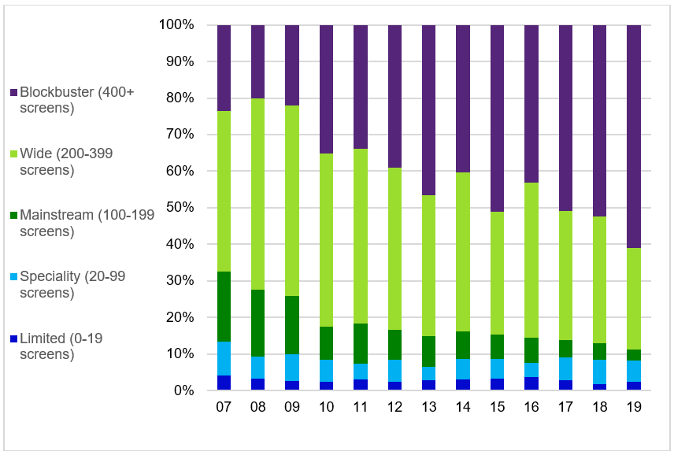

Source: Screen Australia analysis of MPDAA data.[103]

Competition is growing at both ends of the market, but gross box office takings have been fairly static over the last five years.[104] National cinema admissions have not risen in line with population growth,[105] and Australians are visiting cinemas less frequently.[106] Australian films that lack the marketing support of large foreign studios are finding it increasingly difficult to reach audiences at the cinema. Australia is a relatively small market and films are high cost. Significant investment in marketing can be seen as a further risk, and exhibitors are quick to remove any film that has comparatively low earnings. Pressure on producers and distributors to generate returns is growing in the changing cinema landscape. The scale of the Australian market is a natural barrier to increased production and the ambition of individual productions. A lack of scale makes it difficult for Australian features to compete against foreign studios with broader production slates, larger budgets and better access to cinema screens.

SVOD platforms such as Netflix and Amazon Prime are increasingly commissioning and acquiring feature films. These films are typically dramas and ‘genre’ films such as science fiction, comedy or horror films that may not ‘cut through’ in the modern box office environment. Recent Australian films acquired by SVOD platforms include Cargo and I Am Mother (Netflix) and True History of the Kelly Gang (Stan). Distribution on a VOD service may be preceded by a theatrical release. SVOD platforms do not generally release viewing data, making it difficult to assess the performance of individual titles or formats. However, research indicates that Hollywood and Australian films are popular genres for SVOD users.[107]

Several Australian documentaries have achieved recent success—six of the top ten Australian documentaries at the box office were released in the last five years. Recent documentaries to gross more than $1 million include 2040, Mystify: Michael Hutchence, The Australian Dream and Gurrumul.[108] More Australian documentaries are being released in cinemas[109], but despite some breakout successes, many struggle to generate significant returns at the box office.

Audience choice and competition from VOD services has ‘raised the bar’ for all content. While cost is no guarantee of quality, competition appears to be driving up budgets. It is notable that foreign series drama is often budgeted at levels previously reached by feature films, and the cost of Australian series drama is rising.

### Worsening economics of broadcast television

FTA television broadcasters have been operating in a challenging environment for some time. Broadcasters face high levels of domestic competition from within their industry and more notably externally from online services (including large global players, such as Netflix, The Walt Disney Company and Amazon Inc, who, at 13 February 2020 had market capitalisations of $US170.1 billion, $US251.2 billion, and $US1,073.1 billion[110] respectively) as they vie for audiences and advertising revenue.

The commercial broadcasting industry’s major reliance on advertising revenue has a significant impact on their financial performance. Digital disruption has created new avenues for advertising online, ‘often at lower cost than traditional forms of advertising’[111], and has driven significant shifts in viewing towards online streaming services. As TV viewing by the 18–34 year old demographic (generally considered especially valuable to advertisers) shrinks[112], the remaining audience will be less desirable to advertisers, making it increasingly difficult for broadcasters to attract advertising business.

Advertising expenditure is stagnating as digital disruption as well as economic uncertainty in the market continues to reduce consumer and business confidence.[113] Consequently, the Australian advertising market declined by 2.3 per cent in the 2018–19 financial year compared to the previous year.[114] For the 12 months to December 2019, the total TV market (which includes broadcasters’ online services but excludes SBS) recorded $3.86 billion in advertising revenue, down 4.8 per cent compared to the 12 months to December 2018.[115] The metro FTA market was down 6.1 per cent to $2.6 billion in 2019, while regional FTA fell 4.9 per cent to $697.9 million.[116] By contrast, digital advertising expenditure for the 2018–19 financial year increased by 7.1 per cent year-on-year to reach $9 billion.[117] The ACCC noted that:

Digital platforms, in particular Google and Facebook, have succeeded in attracting significant advertising expenditure due to their ability to offer highly targeted advertising, based on data they collect from users, and because of the large amount of time consumers spend on these platforms.[118]

According to analysis of the industry, the FTA television broadcasting industry is in a decline stage of its economic life cycle. Industry revenue overall is forecast ‘to fall at an annualised 2.8 per cent over the five years through 2023–24, to $3.8 billion’ (from $4.4 billion on the preceding five-year period).[119]

Nine Entertainment Co half-yearly results for the six months to December 2019 reported revenue of $1.2 billion, with Nine network reporting a revenue decline of six per cent from $564 million to $531 million.[120] Seven West Media in its results for the half year ended 28 December 2019, reported revenues of $772.4 million, down 3.2 per cent on the prior period, fuelled by a decline in television advertising revenues (–7 per cent for the FTA metro market).[121] Ten Network Holdings, originally an Australian company, is now owned by CBS Corporation, after entering voluntary administration in June 2017.

Table 2 records revenues over the past five years for the broadcast segments only of Seven West Media, Nine Entertainment Co and Ten Network Holdings.

Table 2: IBISWorld television broadcast segment only revenue figures

|  | **Seven West Media Limited[122]** | **Seven West Media Limited[123]** | **Nine Entertainment Co Holdings[124]** | **Nine Entertainment Co Holdings[125]** | **Ten Network Holdings Limited**[126]** | **Ten Network Holdings Limited**[127]** |
| --- | --- | --- | --- | --- | --- | --- |
| **Year** | Revenue ($ million) | per cent change | Revenue ($ million) | per cent change | Revenue ($ million) | per cent change |
| 2013–14 | 1,305.6 | N/C | 1,215.1 | N/C | 623.9 | N/C |
| 2014–15 | 1,279.1 | –2.0 | 1,221.2 | 0.5 | 630.7 | 1.1 |
| 2015–16 | 1,256.1 | –1.8 | 1,131.3 | –7.4 | 675.9 | 7.2 |
| 2016–17 | 1,275.9 | 1.6 | 1,080.4 | –4.5 | 660.1 | –2.3 |
| 2017–18 | 1,264.9 | –0.9 | 1,152.4 | 6.7 | 631.4* | –4.3 |
| 2018–19* | 1,259.0 | –0.5 | 1,047.5 | –9.1 | 606.8* | –3.9 |

* estimated figures ** Ten Network figures are for year-end August

According to ASX data for Seven West Media, Prime Media Group and Southern Cross Media Group, all three companies as at 31 January 2020, had recorded their lowest share prices for five years.[128]

Subscription television broadcasters’ revenue has also been declining due to ‘lower broadcast subscribers and changes in the subscriber package mix’.[129] From 2013–14 to 2016–17, News Corp reported a decline in Foxtel revenue from $2,900 million to $2,400 million[130], while revenue from Fox Sports fluctuated between $500 million and $494 million in the same period. However, following the restructuring and consolidation of Foxtel and Fox Sports properties, total revenues from News Corp Australia’s subscription video services across all platforms increased between 2017–18 and 2018–19 from $1,004 million to $2,202 million, principally due to ‘higher revenues from Foxtel’s OTT products, Kayo Sports and Foxtel Now’ (reflecting an increase in subscribers for these services).[131]

Unlike subscription broadcasting, SVODs, have displayed strong growth mainly likely due to the number of Australians willing to pay for streaming services that are on demand and ad-free. PwC has forecasted that SVOD revenue will grow strongly and exceed subscription broadcast television revenue by 2022,[132] as shown in the figure below, with this trend likely to continue.

Revenue forecast—subscription TV[133] vs SVOD

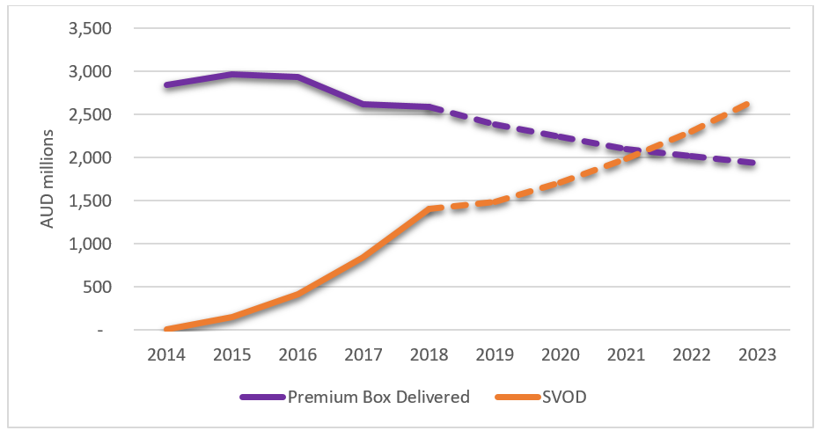

Source: PwC, [Subscription TV 2014-2023](https://www.pwc.com.au/industry/entertainment-and-media-trends-analysis/outlook/subscription-television.html), 12 June 2019.

Dashes represent projected revenues while lines represent actual revenues.

In the wake of media regulatory reform, broadcasters have pursued consolidation opportunities and ownership changes to improve longer-term sustainability. Such consolidation may help television broadcasters combat competition from online services. Nine’s merger with Fairfax and complete ownership of Stan has created one of the largest multi-platform media companies in Australia with more diversified sources of revenue and larger consumer data holdings. In October 2019, Nine announced a unified data strategy[134], in which it will leverage audience data, including from its BVOD service 9Now, to better target advertising.[135] Nine Entertainment CEO, Hugh Marks has recently stated that the company is ‘aggressively transitioning’ from linear television and print newspapers to video on demand and subscription models as almost 40 per cent of the company’s earnings are now generated by digital platforms.[136] Notably, Nine Entertainment Co Holdings Ltd share price at 27 February 2020 was $1.70, giving it a market capitalisation of $2.90 billion.[137]

Changes in the environment have been even more acute for regional broadcasters, who have been less able to withstand competition from online services, including those provided by FTA broadcasters. In April 2016, WIN Corporation lost a court case challenging the streaming of Nine Entertainments’ 9Now BVOD service into regional areas where WIN had the rights to broadcast Nine’s terrestrial channels.[138] Consolidation was anticipated through acquisition of regional operators by their metropolitan counterparts after media ownership laws were relaxed in 2017, however it is noted that no such acquisition has been successful to date.[139]

Current regulatory interventions also carry associated costs that are only applicable to commercial and subscription television broadcasters. These include costs for some mandated Australian content, providing captions and preparing compliance reports for government. Broadcasting infrastructure also generates a unique set of costs to industry. To support the viability and longevity of commercial broadcasting licensees, the government announced it would abolish broadcast licence fees and datacasting charges in 2017 (around $130 million per year, at that time) as part of the Broadcast and Content Reform Package. This package also introduced a new transmitter licence tax[140], anticipated at that time to raise a total of around $40 million in revenue per annum.[141]

### Impacts on the efficacy of current support arrangements

The existing suite of government funding and broadcasting-centric regulatory measures have provided valuable support for the sector to date. However, digital disruption continues to undermine the effectiveness of these support measures, which were largely designed for traditional media and industry structures. To sustain the economic and cultural benefits delivered by our screen sector, adjustments are necessary.

#### Content quotas on commercial FTA television

Broadcasters consistently exceed the general Australian content transmission quotas, broadcasting an average of 7,733 hours of Australian content annually per licensee.[142] However, the sheer volume of content now available to Australians across platforms has diluted the impact of transmission quotas. In other words, as the volume of available content increases, the proportion that is regulated Australian content shrinks and is less visible. A plethora of online services now effectively offer on-demand access to almost all screen content that has been produced.

In particular, the effectiveness of interventions designed to protect vulnerable genres is being strained. Australian drama, documentary and children’s content has recognised cultural value and can drive significant revenue but is also vulnerable without government intervention. While the cost of importing content will shift depending on factors such as cast, currency and audience, an Australian network can generally import a high quality program for $100,000 to 300,000 per hour, while commissioning an equivalent Australian program may cost a broadcaster anywhere from $500,000 to more than $1 million per hour. Older foreign content can be imported for as little as $1,000 per hour. The broadcaster could expect similar potential advertising revenue and audience for foreign and local programs.

Research commissioned for previous reviews indicated that there would be a significant decrease in overall Australian content expenditure if existing quotas were removed, with decreases most acute for drama and children’s programming and, to a lesser extent, documentary.[143]

However, the fragmentation of audiences across entertainment platforms and resultant decline in terrestrial broadcast viewing with a corresponding influx of high-budget international English-language programs available on SVODs, has reduced the effectiveness of Australian content sub-quota arrangements. Regulatory imbalance means that television broadcasters are bearing the primary responsibility of producing drama, documentary and children’s content, which is increasingly at odds with their evolving business models.[144]

Although budgets for Australian dramas are increasing, total annual expenditure on Australian drama by commercial broadcasters has decreased since 2010–11. Expenditure on Australian documentaries and children’s programs, meanwhile, has been relatively consistent. This is illustrated in the figure below.

Figure 12: Total expenditure on genre sub-quotas

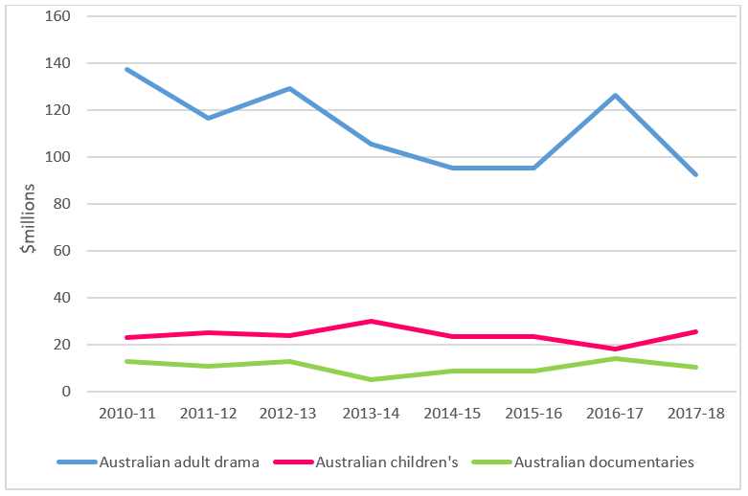

Source: ACMA program commercial television aggregated expenditure information 2010 to 2018.

Screen Australia data analyses new titles based on their first-release platform, and sorts titles into the year in which they commenced production. This analysis also shows a drop in investment by commercial FTA broadcasters, and a corresponding fall in hours.

Figure 13: Investment into, and hours of Australian drama (including children’s) by first-release TV and online platforms

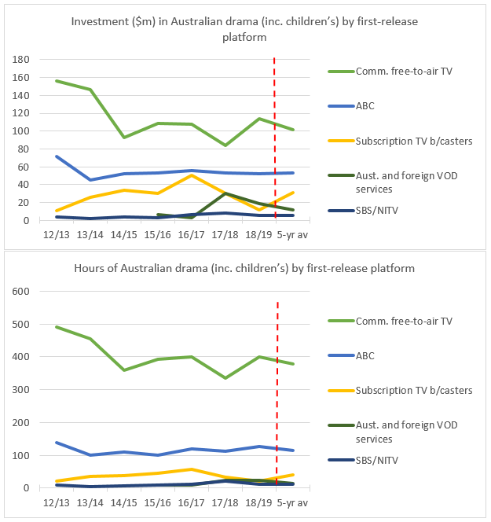

Source: Screen Australia drama production statistics, recently featured in 2018–19 Drama Report.[145]

Broadcasters are concentrating their drama investments into shorter-running dramas, with the total hours of Australian TV drama dropping from a peak of 852 hours in 1997–1998 to 441 hours in 2018–2019.[146] The average cost per hour of all Australian drama titles increased seven per cent between 2017–18 and 2018–19.[147]

The table below shows the quantity of vulnerable genres provided to audiences under the sub-quota requirements for commercial broadcasters.[148]

Table 3: Compliance of commercial broadcasters with quotas (2014–18)

| **Sub-quotas on commercial broadcasters** | **First-release Aus doco** | **First-release Aus drama** | **First-release Aus children’s drama** | **First-release Aus children’s programs** | **All children’s programs** | **All Aus preschool programs** |
| --- | --- | --- | --- | --- | --- | --- |
| **Sub-quotas on commercial broadcasters** | Five-year average | (triennial score 2014–2016) | (triennial score 2015–2017) | Five-year average | Five-year average | Five-year average |
| Minimum annual requirement | 20  hours | 860 points | 96  hours | 130  hours | 260 hours | 130  hours |
| Seven | 87 | 883 | 96 | 130 | 261 | 131 |
| Nine | 27 | 870 | 97 | 130 | 314 | 130 |
| Ten | 34 | 874 | 96 | 132 | 262 | 130 |

Broadcasters tend to meet or only marginally exceed sub-quotas for Australian drama, children’s and preschool programs.

A decade ago, top Australian FTA dramas could reasonably aim for two million viewers on FTA television. In 2019, the highest rating drama program was series 4 of Utopia, with 1.2 million average viewers.[149] As audiences move away from traditional broadcast platforms, particularly to view drama programs online, the production of drama for FTA broadcast becomes more commercially unsustainable.

As already highlighted, child audiences for dedicated P- and C-classified programming on commercial FTA channels have significantly reduced, as the ABC’s children’s offerings increase in popularity and child audiences shift online.[150]

Stakeholders have also raised concerns that children’s drama quotas are often acquitted via animated content without obvious Australian elements. Children’s drama can cost as much as adult drama, but with a smaller potential audience. It is also difficult to finance and monetise, in part due to complex scheduling and advertising restrictions on children’s content broadcast on commercial television contained in the CTS. These rules have not kept pace with changes in children’s viewing behaviours, broadcasting practice (including new dedicated channels for ‘destination viewing’) and the rise of on demand viewing.

The ACMA’s compliance results show that broadcasters are comfortably exceeding the first-release documentary sub-quota each year. In addition to traditional nature and social documentaries, broadcasters are counting long running observational series such as RBT, Bondi Rescue, Highway Patrol and Border Security towards their obligation. The number of individual documentary titles produced each year is in decline, with a clear shift towards series production.[151]

#### Spend requirements on subscription TV broadcasters

Unlike quota requirements, the NEDE scheme for subscription broadcasters links Australian content to total overall program expenditure, allowing levels of expenditure on new Australian drama content to rise and fall depending on industry conditions. Under the scheme, expenditure on new Australian drama programs has increased since 2012–13, with 2017–18 marking a record high expenditure of $56.72 million on Australian and New Zealand drama programs.[152] However, given the declining performance of Foxtel’s subscription broadcasting service, the dominant subscription broadcaster, it is anticipated that this trend will not continue for 2018–19 and is likely to decline.

#### Tax incentives and direct funding

Indirect funding via tax offsets has proven successful, but current rebate settings are not suited to a converging environment. The Producer Offset is available for projects with significant Australian content, providing a 40 per cent rebate for eligible feature films, and a 20 per cent rebate for other eligible content. Distinctions between films released in cinemas, and content released via television and online, are disappearing for both industry and audience, leading to calls for a harmonised Producer Offset that would allow creators to seek audiences on their preferred platform.

In addition, pressures on the budgets of feature films will often incentivise producers to invest their own money into productions on the basis that a tax offset will cover their expenses. In these circumstances the Producer Offset serves as a way of propping up individual project budgets and is less effective in supporting the ongoing sustainability of businesses.

The Location Offset is the primary mechanism for attracting large budget international productions to Australia to provide greater economic, employment and skill development opportunities for the Australian sector. However, at the current rate of 16.5 per cent, the policy objective of the Location Offset is not being realised because Australia is not competitive with other jurisdictions that offer more attractive incentives. To compete with higher foreign incentives, the Location Incentive program offers funding up to 13.5 per cent of QAPE for eligible international footloose productions. It can be combined with the Location Offset to effectively provide a 30 per cent rebate. As at 10 March 2020, $123 million has been announced to attract ten productions which will generate over $970 million in investment in Australia’s economy. Several sections of the production industry have called for the Location Offset to be raised to 30 per cent to create a guaranteed, competitive rebate. Others are concerned that 30 per cent rebates offer higher subsidy for foreign productions than the 20 per cent Producer Offset rebate for Australian projects that are not feature films.

The PDV Offset offers a 30 per cent rebate for eligible post-production, digital and visual effects work. The objective of the PDV Offset is to attract post-production, digital and visual effects production to Australia, regardless of where the project is shot. The content formats that are eligible under the Location and PDV Offsets are broader than under the Producer Offset. A broader range of eligible content formats maximises the benefits of attracting international investment, creating jobs and providing training opportunities for the local industry. The broader eligibility settings and a minimum QAPE threshold of $500,000 has resulted in a significant and unexpected rise in domestic reality television and infotainment/lifestyle/light entertainment productions applying to the PDV Offset. The PDV Offset, given its higher rate of 30 per cent, is also being accessed by children’s animated series rather than the 20 per cent Producer Offset. This may encourage the production of animation over live action.

Direct funding via Screen Australia is under pressure from fragmenting audiences and rising costs. Screen Australia funds high quality, culturally valuable content released in cinemas, on broadcast and subscription television, and online (including via SVOD and social media platforms). The fragmentation of audiences across these multiple platforms has increased demand for funding, spreading it thinner at the same time as production costs are increasing as producers seek to compete with international content.

#### Funding and commissioning of content

Changes in audience behaviour are challenging the traditional financial models for Australian content creation.

When cinemas and commercial and FTA broadcasters show new content, they generally try to attract a very large audience during a limited period. Producers retain the rights to distribute their content via other means such as foreign box offices and broadcasters, Blu-ray and DVD sales, online platforms and other services. Public funding such as the Offsets and Screen Australia funding was largely designed to support these traditional models and encourage producers to retain meaningful equity and future revenue streams.

Every feature film is financed from unique sources, but trends are evident across budget brackets.

Figure 14: Finance sources for Australian drama feature films, five-year average (2014–15 to 2018–19)

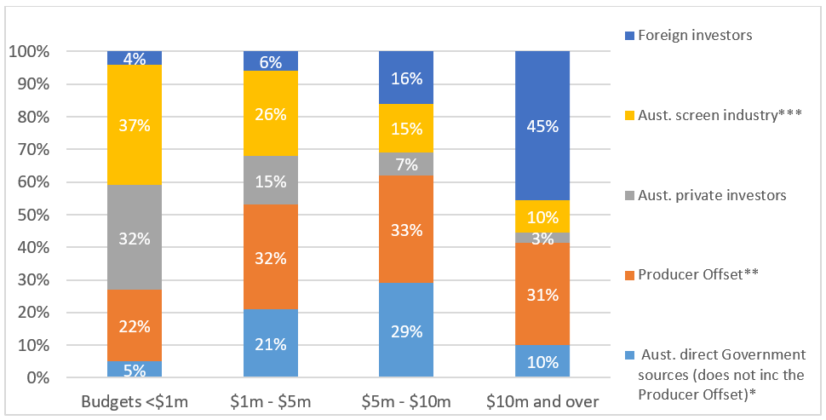

Source: Screen Australia production statistics. Figures based on five-year averages for titles entering production 2014–15 to 2018–19. See footnote for more information.[153]

The films that source a higher percentage of their budgets from government support are mid-budget films. These films often have limited releases, and due to changing cinema audience preferences and growing competition, can struggle to compete. If lower and mid-budget films do not quickly find an audience, they can quickly disappear from cinema screens.

Figure 15: Finance of Australian TV drama (excluding children’s), five-year average 2014–15 to 2018–19

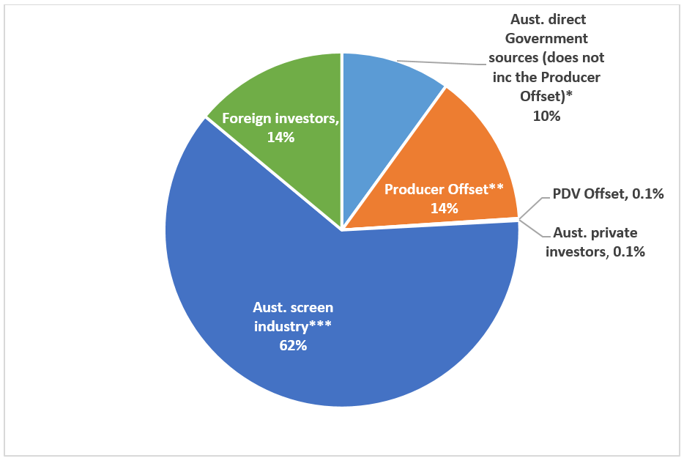

Source: Screen Australia production statistics. Figures based on five-year averages for titles entering production 2014–15 to 2018–19. See footnote for more information.[154]

Television projects are chiefly financed by broadcasters, which pay a licence fee for the rights to show content during a limited premiere run, and often invest for a share of equity in the project. The amount of foreign investment in Australian TV drama has increased in recent years.

The content commissioning model for SVODs differs from broadcasters in several ways. Australian drama created for SVOD platforms tends to have higher production values. The average cost per hour of Australian SVOD drama miniseries is around 1.5 times the average cost per hour of Australian TV drama miniseries.[155] However, total spend in Australia on online drama, which includes SVOD content, remains low compared to TV drama and features.

Figure 16: Spend in Australia on Australian drama 2016­–17 to 2018­–19

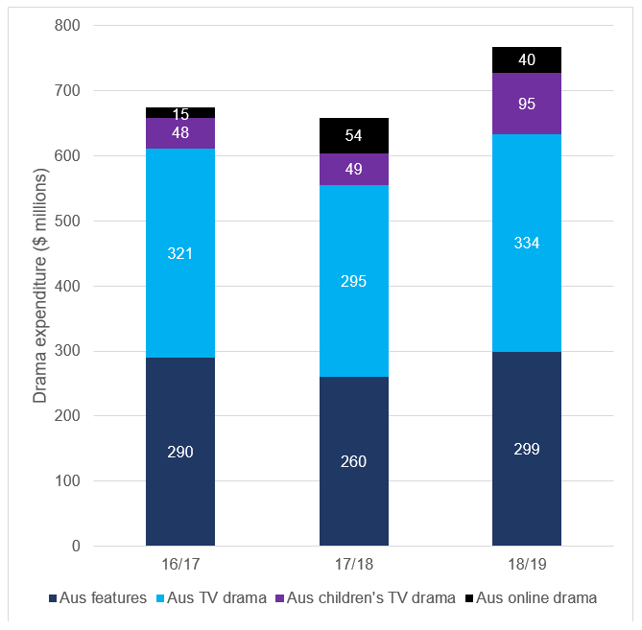

Source: Screen Australia drama statistics.[156]

The global SVOD market is growing quickly and is contested by large international platforms, some national services such as Stan, and a variety of niche services. When SVOD platforms commission new content, they may pay a large upfront fee for all rights to show the content, in all territories, for several years if not forever. A platform may provide the vast majority of finance, with some support from tax rebates and direct government funding. Producers may earn a significant sum up front, but no longer gain from the traditional ‘long tail’ of revenue.

Competition for fragmenting audiences is challenging the financing of all content. Government funding does not fully reflect current financing models, costs, and audience behaviour. Rising budgets can increase the quality of a project but test financially challenged Australian broadcasters. And the increasing role of foreign investment may lead to lesser influence over content from Australian commissioners and key creatives. These challenges are particularly acute for children’s content, where costs may be comparable to adult drama, but broadcaster investment is often much lower and financing pathways via theatrical and online distribution can be limited.

#### Long-term effects of maintaining the status quo

If current arrangements are maintained without adjustment, it seems likely that the ecosystem that supports Australian content will continue to contract. Production levels may fall to a new ‘floor’, cheaper productions may be used to fill broadcast quotas, and international productions may leave Australia with a downward impact on sector jobs. The Producer, Location and PDV Offsets, which are not targeted to the ‘new normal’ of production and viewing of content on online platforms, may also generate unintended consequences.

Over time, broadcasters may not be able to meet quota requirements if they can no longer afford to produce the required content and investment in the broadcasting industry could stall or fail. At worst, this could ultimately result in less, and lower quality, Australian content for Australian audiences. Meanwhile, the newer and growing content services may continue to make no or comparatively minimal investment in Australian content. Australian users of these services may not have new Australian content to view, while Australian content creators may miss pivotal opportunities for international finance and audiences.

This changed environment necessitates review of existing regulatory inequities to advance opportunities for the production sector on popular platforms. To maintain the status quo, guides the Australian industry to a domestically regulated content slate that, while providing some guarantee of annual demand, provides for little innovation and longer-term growth. Reforms can encourage the industry towards more diverse, future-facing opportunities that reflect modern viewing, and enable Australian content to ‘cut through’ global competition for audiences.

As the ACCC’s DPI final report indicated, continuing to heavily regulate a sector under pressure while allowing a booming sector to remain unregulated, does not represent a level-playing field. Government support measures and regulatory interventions must therefore be updated, such that all content providers and distributors that derive a significant financial benefit from Australian consumers, contribute to the broader ecosystem by way of investment and/or production of Australian content.

## Options for change

The indicative models outlined below propose various new obligations and incentives for services whose primary purpose in Australia is the commissioning or acquisition of narrative video content. These services include national and commercial FTA broadcasters, subscription broadcasters (and channel providers) and subscription streaming (online) services.

The models have been developed following broad policy principles:

* Australian screen stories are important culturally and economically
* Our stories should be available on the screens we watch
* Regulation and incentives should be fit for purpose, effective and efficient.

The models and associated questions have been designed to stimulate informed debate. It is recognised that regulatory reform does not necessarily mean imposing identical regulations across all entities. Rather, the models seek greater consistency across services, while taking into account relevant differences, to best support Australian stories on our screens.

Reforms should be undertaken following consultation with stakeholders, and include a practical transition pathway.

### Model considerations

* It is proposed that new obligations for online services are limited to subscription streaming services, the primary purpose of which is to commission and/or acquire narrative content and which meet certain scale thresholds. For example, thresholds could be nominally set at Australian revenue exceeding $200–300 million and total monthly paid Australian subscribers of 500,000–700,000. The thresholds aim to limit the application of Australian content rules to broadcasting services and large SVOD services, while providing flexibility to capture other services if required as they grow and evolve.
* It is proposed that BVOD and online services provided for free by FTA commercial and national broadcasters, would be excluded from obligations proposed for subscription streaming services under model 1 (status quo) and 2 (minimal). However, should FTA broadcasters’ online services, under model 2, more closely resemble those of subscription streaming services in future, they could eventually be subject to the same requirements. Model 3 revenue provisions, relate to all the services of commercial content service providers, therefore, FTA catch-up and online revenue would be included as would revenue from any online services associated with subscription broadcasting.
* Terms such as ‘new’, ‘first-release’, ‘commissioned’, ‘scripted’, and ‘Australian content’ are proposed to be defined in the context of further consultation. These terms should not be assumed to reflect existing legislated definitions.

Further matters for consideration are discussed at Appendix A.

## Model 1: Status quo

### Policy objective

This model would retain the existing regulations and incentives to make and show Australian programs, which focus on traditional platforms. The status quo would prevail in circumstances where no future regulatory option can be implemented.

### Obligations

#### Transmission quotas and sub-quotas on commercial FTA broadcasters

Transmission quotas, including sub-quotas set out in the ACS and CTS, on commercial FTA licensees would be retained under current arrangements.

#### NEDE scheme for subscription broadcasters

The NEDE scheme that applies to subscription broadcasting licensees and channel providers, would remain in place under current regulatory settings.

#### Australian content on national broadcasters

No new obligations would be introduced.

#### Australian content on subscription streaming services

No new obligations would be introduced.

#### Incentives

The Producer Offset, PDV and Location Offsets and Location Incentive would be retained under current arrangements. Screen Australia direct funding would continue.

### **Consultation** questions

1. What outcomes for audiences and industry will the current system support, and for how long?

## Model 2: Minimal

### Policy objective

The purpose of this model is to fine-tune and modernise existing regulatory and funding arrangements to better reflect the contemporary media landscape. This model seeks to engage subscription streaming services on a voluntary basis, potentially as a precursor to future regulation, if needed.

### Obligations

#### Transmission quotas on commercial FTA broadcasters

A transmission quota on commercial FTA licensees would be required but measured across all channels annually affording broadcasters’ greater flexibility to acquit obligations and more freedom to establish niche channels. These requirements recognise broadcasters’ access to public spectrum and ensures that all Australians would continue to have access to a minimum amount of free Australian content.

The distinction between primary and non-primary channels would be removed.

#### Sub-quota requirements on Commercial FTA broadcasters

Requirements for the transmission of minimum amounts of Australian drama, documentary and children’s programming would be revised to provide greater flexibility. This could include requiring a proportion of the overall transmission quota to be dedicated to one or more of these formats.

Measures currently contained in the ACS and CTS would be amended to ensure obligations were more suitable to the contemporary media environment, including:

* removing requirements for P programs and repeat C programs
* removing prescriptive rules on the amount, scheduling and content of advertising to children, where these elements are adequately covered by other industry codes
* revising the definition of ‘first-release’ to address anomalies in the treatment of New Zealand content
* simplifying the drama points attribution system to better target new, commissioned Australian content.

This model could provide the flexibility for commercial FTA broadcasters to contribute to an Australian Children’s Content Fund in lieu of broadcasting children’s content.

#### NEDE scheme for subscription broadcasters

The NEDE scheme that applies to subscription broadcasters could be revised and rebalanced, including allowing broadcasters to flexibly acquit their obligation across formats.

#### Voluntary undertakings for subscription streaming services

The model proposes that subscription streaming services that meet scale and service thresholds would be requested to voluntarily make undertakings to the ACMA to invest in and promote Australian content on their services. For example, undertakings could include a certain level of hours of Australian content in catalogues, and potential investment as a proportion of Australian revenue. Individual services would outline their plans for meeting these expectations (which would be made publicly available) including reporting periodically on performance.

#### Reporting requirements for national broadcasters

National broadcasters’ boards would be requested to report annually to Parliament on expenditure on, and hours of, Australian drama, documentary and children’s content, to provide greater transparency and acknowledgement of their Australian content contribution.

#### Incentives

The Producer Offset would be reformed in response to audience and marketplace changes since its introduction in 2007. To recognise audience viewing of feature films across new platforms, a single flat rate Producer Offset would be provided to one-off, feature-length films regardless of platform. This single flat rate Producer Offset would also be provided to children’s content distributed on any platform in recognition of the increasing pressure on financing this content. The current 20 per cent Producer Offset for other content would continue. The 65-hour cap on drama would be removed, to support long-running, successful titles. Minimum thresholds for some content would be raised, and reforms to clarify qualifying spend would be introduced. Projects could be required to demonstrate an appropriate pathway to their audience.

The Location and PDV Offsets would remain unchanged. The Location Incentive would be renewed in future years, to ensure targeted, ongoing support to attract international footloose, large budget production to enhance the capacity of the Australian industry.

### Consultation questions

1. In the context of an Australian content transmission requirement for commercial FTA broadcasters what percentage requirement across all channels should apply?
2. How should requirements to support Australian drama, documentary and children’s programming be prioritised? For example, should sub-quota arrangements (or elements of these) be retained, or should a proportion of the overall transmission requirement be dedicated to these formats?
3. Would contribution to an Australian Children’s Content Fund by commercial FTA broadcasters, in lieu of broadcasting children’s content, be feasible, and if so, at what level?
4. What, if any, amendments could be made to the NEDE scheme to improve outcomes for the sector?
5. How should Australian content be defined in the minimal and significant models? Is there a need to revise key definitions, including first-release, documentary and children’s programs?
6. To ensure a better understanding of the levels of Australian content broadcast on FTA television what additional data should be provided by the public broadcasters?
7. In the context of the model considerations listed on page 40, what revenue and subscriber thresholds would be appropriate for the minimal and significant models?
8. What investment levels and library catalogue requirements might be considered appropriate voluntary undertakings for subscription streaming services?
9. At what level should the Producer Offset be set for children’s programs and one-off feature length programs, and what other settings around minimum spend, qualifying spend and pathway to audience, would appropriately target support?

## Model 3: Significant

### Policy objective

The purpose of this model is to establish platform-neutral, future facing obligations and incentives that take into account individual platform offerings and audience engagement.

### Obligations

#### Australian content investment requirements

All commercial content service providers, including subscription services, that meet scale thresholds, would be required to invest a percentage of their revenue (across all services) in new Australian scripted programming and report their investment to the ACMA. The investment rate, as a proportion of Australian revenue, would be approved by the ACMA, potentially reflecting the various platforms’ business models, program formats and content genres.

The following options outline two alternative approaches for implementing an investment requirement across all service providers:

**Option A:** Service providers would be required to make Australian content available on their Australian service/s (investment in children’s and one-off documentary formats could be incentivised by reducing the overall investment obligation for that provider), ***or***

Service providers would be required to contribute to an Australian Production Fund (APF), to be administered by Screen Australia (APF funding would be allocated to drama, documentary and children’s programming).

**Option B:** Service providers would be required to negotiate bespoke Australian content investment plans with the ACMA. The ACMA would take into account the specific business model of each service and how services would collectively achieve certain policy objectives. Investment expectations could be set by the ACMA to achieve outcomes in the public interest. The ACMA may also set specific investment expectations for certain genres, including new Australian drama, documentary and children’s programs.

#### National broadcasters to allocate specific funding to children’s programming

The ABC and SBS would be required to allocate specified amounts of funding for Australian children’s programming to distribute on their services, whether linear or online. This requirement would counter-balance the likely reduction in preschool and children’s production by commercial FTA broadcasters, and ensure that the particularly vulnerable genre of children’s programming continues to be made available to audiences for free.

#### Promotion and discoverability

Flexible, principles-based promotion and discoverability requirements for Australian content would be applied across all platforms. This would enable platforms to tailor their approach according to their unique business models.

#### Reporting requirements

To ensure compliance across services, new reporting and transparency requirements are proposed across all platforms in line with their respective obligations. Under this model, reporting requirements would include revenue information to ensure that percentage investment requirements are correctly calculated.

In addition to reporting on compliance with requirements to fund certain levels of content, national broadcasters would be required to report to Parliament on total Australian drama, documentary and children’s programming expenditure and hours broadcast/provided online.

#### Incentives

The Producer, Location and PDV Offsets would be set at a single rate for content on all platforms, creating a platform neutral approach.

The Location Incentive would not be continued. Format and threshold eligibility would be refined across the new Offset regime.

Under this model, some Australian content would require further support. A ‘cultural uplift’ could be introduced to provide further support via the Producer Offset for children’s content and one-off, feature-length content. A points-based test for significant Australian content could measure factors such as presence of lead Australian writers, producers and directors; presence of Australian key cast; and whether most of the production occurs in Australia. Alternatively, children’s content and one-off, feature-length content of quality and cultural significance could receive additional support through increased direct funding from Screen Australia. Further reforms to the Producer Offset would include removal of the 65-hour cap on drama and minimum duration requirements. Minimum spend thresholds would be revised, and various QAPE reforms to clarify allowable expenditure would be introduced. Projects could be required to demonstrate an appropriate pathway to their audience. Screen Australia would continue to directly fund quality content of cultural significance.

### Consultation questions

1. Should scripted Australian content be limited to Australian drama, documentary and children’s content, and are revisions to those terms necessary? Should it be limited to ‘new’ content, however defined?
2. How should revenue be calculated and what would be an appropriate investment percentage rate? Should that percentage be consistent across service providers or varied according to business models?
3. In relation to implementation option B for commercial content service providers, how often should these investment plans be negotiated?
4. In relation to option B for commercial content service providers, what authority should the ACMA have to negotiate investment plans and impose minimum requirements?
5. What promotion and discoverability requirements would be effective in the minimal and significant model?
6. What would be an appropriate level of funding for national broadcasters to allocate to children’s content?
7. What level of Offset rebate should be provided across all platforms? Why would some Australian content require additional support, and should this be provided via direct or indirect funding? What other settings around minimum spend, qualifying spend and pathway to audience, would appropriately target support?

## Model 4: Deregulation

### Policy objective

The purpose of this model is to remove all regulation and remove or revise incentives to make Australian programs, in order to support platform neutral deregulation.

### Obligations

#### All obligations removed

All content providers would have the ability to make programming decisions based on their business models, audience preferences and objectives, without government intervention. A level playing field would be established as a consequence of deregulating screen sector support arrangements.

#### National broadcasters

No change to current funding arrangements.

#### Incentives

Two alternative implementation options are proposed under this model.

**Option A:** That all Screen Australia (direct) and Offset (indirect) funding would be removed, resulting in full deregulation of Australian screen content support mechanisms.

**Option B:** The Producer, Location and PDV Offsets would all be set at a single rate for content distributed on any platform. Minimum spend thresholds would be examined and reformed to ensure the rebates efficiently target content of scale. The Location Incentive would not be continued. Eligibility of formats would be modernised and standardised across the new Offset regime. Screen Australia direct funding would be discontinued to focus support on content of scale that has secured finance from sources other than government.

### Consultation questions

1. What Australian content would be provided in the absence of content regulations or incentives?
2. If a single rate Offset was provided to support market-based projects what level should it be set at? What formats should be included and excluded? What qualifying expenditure thresholds and other settings should apply?

## Appendix A: Additional matters

### Implementation issues

A number of implementation issues have been identified which may impact the composition and feasibility of the models proposed in this paper.

#### Australia’s international obligations

Australia has obligations under the New Zealand Closer Economic Relations Trade Agreement (ANZCERTA) Services and Investment Protocols, and the Australia-United States Free Trade Agreement (AUSFTA). Any proposed changes to Australian content support arrangements would need to be considered with respect to their feasibility under these agreements.

#### Definitions

Successful implementation will depend on key definitions, including Australian content, drama, documentary, children’s programming, scripted, first-release and new programs. Under current arrangements, definitions vary between schemes and legislation. Ideally, definitions would be harmonised to create greater consistency between regulatory interventions and government incentives. However, the precise scope of each definition may differ between proposed models, depending on a model’s core objective and the actual regulatory mechanisms employed.

#### Australian ‘link’

In addition to establishing appropriate service and scale thresholds, the Australian ‘link’ for services captured by any new arrangements will also need to be clearly defined. Options could include services ‘targeting’ Australians, services ‘available’ to Australians or definitions in Schedule 8 to the BSA, the *Interactive Gambling Act 2001* and e-Safety legislation.

#### Form of regulation

The models outlined in this paper consider various regulatory obligations which may be placed on content services. Consideration will need to be given to whether the obligations would take the form of direct regulation or co-regulation. For instance, obligations could be imposed directly on content services by way of legislation/legislative instrument or under co-regulatory arrangements, in which regulated entities are required to include minimum requirements in codes of practice that would be overseen by the ACMA. The appropriate form of regulation may differ depending on the final agreed model and mix of obligations.

In conjunction with this, consideration will need to be given to the way regulations are to be applied to services. For instance, whether obligations would be expressed as licence conditions, as is currently the case for broadcasters. International examples, such as proposals included in a recent review of Canada’s screen support arrangements to establish a new system for ‘registering’ services, might also provide useful guidance. Another option may be to follow the model applied under the BSA gambling advertising rules.

### Implementation timing

#### Legislative amendments

All models, other than model 1, are likely to require some degree of legislative amendment. The degree and complexity of this change will affect the timeframes for full implementation of each model.

#### Transitioning to a new model

The transition approach will depend, in part, on how soon a new model is agreed, the composition of the final model, and decisions about the timeframes for completing full implementation of the new arrangements. In any case, it is proposed that the final agreed model be implemented in stages over three to four years.

## Appendix B: Glossary of terms

Glossary of terms

| Term | Description |
| --- | --- |
| AACTA awards | Australian Academy of Cinema and Television Arts Awards |
| ABC | Australian Broadcasting Corporation |
| ABS | Australian Bureau of Statistics |
| ACCC | Australian Competition and Consumer Commission |
| ACMA | Australian Communications and Media Authority |
| ACS | [Broadcasting Services (Australian Content) Standard 2016](https://www.legislation.gov.au/Details/F2016L00392) |
| ANZCERTA | [Australia-New Zealand Closer Economic Relations Trade Agreement](https://www.dfat.gov.au/trade/agreements/in-force/anzcerta/Pages/australia-new-zealand-closer-economic-relations-trade-agreement.aspx) |
| Australian drama program | Currently defined for the purposes of Australian content transmission quotas at [ACS 7](https://www.legislation.gov.au/Details/F2016L00392) |
| Australian program | Currently defined for the purposes of Australian content transmission quotas at [ACS 6](https://www.legislation.gov.au/Details/F2016L00392) |
| APF | Australian Production Fund is a proposal within model 3 of this paper |
| ASPI | The Australian Screen Production Incentive provides tax incentives for film, television and other screen production in Australia, including the Producer Offset, Location Offset, PDV Offset and Location Incentive. |
| AUSFTA | [Australia-United States Free Trade Agreement](https://www.dfat.gov.au/trade/agreements/in-force/ausfta/Pages/australia-united-states-fta.aspx) |
| AVOD | Advertising-based video on demand services |
| AVMSD | [EU’s Audiovisual Media Services Directive](https://ec.europa.eu/digital-single-market/en/audiovisual-media-services-directive-avmsd) |
| BCAR | Bureau of Communications and Arts Research |
| BSA | [*Broadcasting Services Act 1992* (Cwlth)](https://www.legislation.gov.au/Details/C2019C00338) |
| BVOD | Broadcaster video on demand services |
| Children | Currently defined for the purposes of Australian content transmission quotas at [CTS 5](https://www.legislation.gov.au/Details/F2014C01386) as people younger than 14 years of age. |
| Children’s programming | Programming made specifically for children. |
| C program | Currently defined for the purposes of Australian content transmission quotas at [CTS 5](https://www.legislation.gov.au/Details/F2014C01386) as a program that has been classified by the ACMA, or a person or body appointed by the ACMA for that purpose, as a program which meets the criteria of suitability for children in CTS 6(1), and is broadcast in a C period. |
| CRTC | Canadian Radio-Television and Telecommunications Commission |
| CTS | [Children’s Television Standards 2009](https://www.legislation.gov.au/Details/F2014C01386) |
| Discoverability | The ability for a piece of content to be ‘discovered’ or found by its audience |
| DPI | [The ACCC’s *Digital Platforms Inquiry*](https://www.accc.gov.au/publications/digital-platforms-inquiry-final-report) |
| Documentary program | Currently defined for the purposes of Australian content transmission quotas at [ACS 6](https://www.legislation.gov.au/Details/F2016L00392) as a program that is a creative treatment of actuality other than a news, current affairs, sports coverage, magazine, infotainment or light entertainment program.  See also the ACMA [Documentary guidelines](https://www.acma.gov.au/publications/2019-11/guide/documentary-guidelines) 2004. |
| Drama program | Currently defined for the purposes of the NEDE scheme at section 103B of the [BSA](https://www.legislation.gov.au/Details/C2019C00338) |
| Eligible drama program | Currently defined for the purposes of the NEDE scheme at section 103B of the [BSA](https://www.legislation.gov.au/Details/C2019C00338) |
| First-release | Currently defined for the purposes of Australian content transmission quotas at [ACS 8](https://www.legislation.gov.au/Details/F2016L00392) |
| Footloose international productions | A production that takes place in a different country to where it originated: for example, an American feature that is filmed in Australia. |
| ITAA | [*Income Tax Assessment Act 1997* (Cwlth)](https://www.legislation.gov.au/Details/C2020C00083)  The Producer Offset, Location Offset and PDV Offset are provided for in Division 376 |
| Independent producer | Currently defined for the purposes of Australian content transmission quotas at [ACS 6A](https://www.legislation.gov.au/Details/F2016L00392) |
| Location Offset | A 16.5 per cent rebate that supports the production of large-budget film and television projects shot in Australia. Set out in section 376-10 of the ITAA |
| National broadcasters | The ABC and SBS |
| NEDE | New Eligible Drama Expenditure scheme as set out at division 2A of part 7 of the [BSA](https://www.legislation.gov.au/Details/C2019C00338) |
| Ofcom | UK Office of Communications |
| Online streaming services | All video on demand services, including AVOD, BVOD, SVOD and TVOD |
| OTT | Media services delivered via online technology ‘over-the-top’ of traditional services |
| P program | Currently defined for the purposes of Australian content transmission quotas at [CTS 5](https://www.legislation.gov.au/Details/F2014C01386) as a program which has been classified by the ACMA, or a person or body appointed by the ACMA for that purpose, as a program which meets the criteria of suitability for preschool children in CTS 6(2), and is broadcast in a P period |
| PDV Offset | A 30 per cent rebate that supports work on post, digital and visual effects production (PDV) in Australia, regardless of where a project is shot. Set out in section 376-35 of the ITAA |
| Preschool children | Currently defined for the purposes of Australian content transmission quotas at [CTS 5](https://www.legislation.gov.au/Details/F2014C01386) as children who have not yet started school |
| PSBs | Public service broadcasters in the UK |
| Producer Offset | Entitles production companies to a 40 per cent rebate on eligible feature films and 20 per cent on other eligible formats for productions with significant Australian content. Set out in section 376-55 of the ITAA |
| QAPE | Qualifying Australian Production Expenditure—as defined in Division 376 of the [ITAA](https://www.legislation.gov.au/Details/C2020C00083) |
| SAC | Significant Australian Content is a test set out in section 376-70 of the ITAA, and described in Screen Australia’s Producer Offset guidelines, which sets out eligibility for the PO |
| SBS | Special Broadcasting Service |
| SVOD | Subscription video on demand services |
| TVOD | Transactional video on demand services |
| VOD | Video on demand services, also known as online streaming services |
| VOZ | A new system to measure viewing of broadcast content across all screens and platforms, currently being introduced by industry |

## Appendix C: Figure 4 in detail

Highest-rating Australian TV dramas on FTA networks, 2016–19

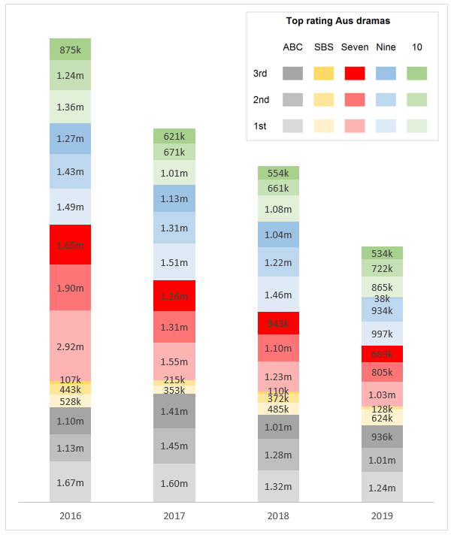

Source: OzTAM and RegionalTAM, 5-city-metro, combined markets, total people, average audience, 28 day consolidated.

Titles are first-release Australian TV drama only: titles that were initially released on other platforms, such as online content and films released in cinemas, have been excluded. Children’s titles excluded.

Metropolitan data is copyright to OzTAM and Regional data is copyright to RegionalTAM and may not be reproduced, published or communicated in whole or part without the prior consent of OzTAM or RegionalTAM.

See below for individual titles.

**2016—series average audiences for the highest-rating Australian TV dramas on each FTA network (first-release only, exc. children’s)**

| Title | Channel | Metro + regional | Metro only |
| --- | --- | --- | --- |
| The Doctor Blake Mysteries series 4 | ABC | 1,669,000 | 1,148,000 |
| Jack Irish | ABC | 1,133,000 | 782,000 |
| Janet King series 2 | ABC | 1,102,000 | 751,000 |
| Deep Water | SBS | 528,000 | 390,000 |
| The Family Law | SBS | 443,000 | 349,000 |
| The Wizards of Aus | SBS Viceland | 107,000 | 73,000 |
| Molly | Seven | 2,915,000 | 2,020,000 |
| Wanted | Seven | 1,904,000 | 1,215,000 |
| The Secret Daughter | Seven | 1,645,000 | 1,040,000 |
| Doctor | Nine | 1,488,000 | 965,000 |
| Here Come the Habibs! | Nine | 1,428,000 | 1,058,000 |
| Love Child series 3 | Nine | 1,272,000 | 901,000 |
| Brock | Ten | 1,359,000 | 876,000 |
| Offspring series 6 | Ten | 1,243,000 | 921,000 |
| The Wrong Girl | Ten | 875,000 | 635,000 |

2017—series average audiences for the highest-rating Australian TV dramas on each FTA network (first-release only, exc. children’s)

| Title | Channel | Metro + regional | Metro only |
| --- | --- | --- | --- |
| Doctor Blake Telemovie: Family Portrait | ABC | 1,601,000 | 1,091,000 |
| Doctor Blake series 5 | ABC | 1,450,000 | 990,000 |
| Utopia series 3 | ABC | 1,407,000 | 1,059,000 |
| Sunshine | SBS | 353,000 | 275,000 |
| The Family Law series 2 | SBS | 215,000 | 165,000 |
| Hoges: The Paul Hogan Story | Seven | 1,552,000 | 1,017,000 |
| 800 Words | Seven | 1,309,000 | 805,000 |
| Home and Away | Seven | 1,256,000 | 764,000 |
| True Story with Hamish & Andy | Nine | 1,512,000 | 1,059,000 |
| Doctor series 2 | Nine | 1,307,000 | 855,000 |
| House of Bond | Nine | 1,128,000 | 793,000 |
| Offspring series 7 | Ten | 1,014,000 | 756,000 |
| The Wrong Girl series 2 | Ten | 671,000 | 506,000 |
| Wake In Fright | Ten | 621,000 | 425,000 |

2018—series average audiences for the highest-rating Australian TV dramas on each FTA network (first-release only, exc. children’s)

| Title | Channel | Metro + regional | Metro only |
| --- | --- | --- | --- |
| Jack Irish series 2 | ABC | 1,323,000 | 846,000 |
| Mystery Road | ABC | 1,275,000 | 913,000 |
| Harrow | ABC | 1,011,000 | 693,000 |
| Dead Lucky | SBS | 485,000 | 369,000 |
| Safe Harbour | SBS | 372,000 | 271,000 |
| On The Ropes | SBS | 110,000 | 82,000 |
| Olivia Newton-John: Hopelessly Devoted To You | Seven | 1,232,000 | 791,000 |
| Home and Away | Seven | 1,095,000 | 683,000 |
| The Blake Mysteries: Ghost Stories | Seven | 943,000 | 642,000 |
| Underbelly Files: Chopper | Nine | 1,455,000 | 982,000 |
| Doctor series 3 | Nine | 1,218,000 | 810,000 |
| True Story with Hamish & Andy series 2 | Nine | 1,037,000 | 738,000 |
| Russell Coight's All Aussie Adventures | Ten | 1,076,000 | 721,000 |
| Playing For Keeps | Ten | 661,000 | 513,000 |
| How To Stay Married | Ten | 554,000 | 394,000 |

2019—series average audiences for the highest-rating Australian TV dramas on each FTA network (first-release only, exc. children’s)

| Title | Channel | Metro + regional | Metro only |
| --- | --- | --- | --- |
| Utopia series 4 | ABC | 1,235,000 | 941,000 |
| Total Control | ABC | 1,012,000 | 693,000 |
| The Cry | ABC | 936,000 | 675,000 |
| The Hunting | SBS | 624,000 | 475,000 |
| The Family Law series 3 | SBS | 128,000 | 100,000 |
| Home and Away | Seven | 1,031,000 | 659,000 |
| Ms Fisher's Modern Murder Mysteries | Seven | 805,000 | 518,000 |
| Secret Bridesmaids' Business | Seven | 689,000 | 459,000 |
| Seachange | Nine | 997,000 | 695,000 |
| Bad Mothers | Nine | 934,000 | 686,000 |
| Metro Sexual | Go! | 38,000 | 27,000 |
| Five Bedrooms | Ten | 865,000 | 629,000 |
| My Life Is Murder | Ten | 722,000 | 504,000 |
| Mr Black | Ten | 534,000 | 383,000 |

## Appendix D: International approaches to content regulation and funding

### Content quotas on broadcast television and online

Content quota systems remain in use in a number of comparable jurisdictions. The European Union (EU), the UK, Ireland and Canada are examples of jurisdictions that impose content quotas on broadcast television to protect the production, distribution and accessibility of national productions.

In Canada, television licensees are subject to Canadian exhibition quotas (content quotas) which vary in size, and the time of day to which they apply, depending on the type of service.[157]

The EU’s [Audiovisual Media Services Directive](https://ec.europa.eu/digital-single-market/en/audiovisual-media-services-directive-avmsd) (AVMSD) governs the coordination of national legislation for all audio-visual media, including the promotion and distribution of European works. Articles 16 and 17 specify that qualifying broadcast channels must devote at least 50 per cent of their transmission time to European works, and of that, 10 per cent to independently produced European works.[158] These rules are in force in both the UK and Ireland.

The UK applies additional content quotas on broadcasting services. The UK Office of Communications (Ofcom) is required by the *Communications Act 2003* (UK) to set specific content quota obligations on public service broadcasters (PSBs).[159] Quotas are established as licence conditions and are set for original productions, independent productions, out of London productions, news and current affairs and regional programs (Scotland, Wales, Northern Ireland).[160]

In 2003, the UK removed children’s content quota requirements from PSBs, other than the BBC which continues to have in place content quotas for its two dedicated children’s channels CBBC and CBeebies. Between 2003 and 2014, investment in first run children’s UK originations by ITV, Five and Channel 4, fell by 95 per cent (£59m to £3m).[161] Over the same period the number of first run originations on commercial PSBs fell by 85 per cent from 621 hours to 93 hours.[162]

In November 2017, Ofcom commenced a children’s content review of PSB children’s (people under 16 years) programming on television and online. The review identified a number of areas of concern, including a limited range of ‘original, high-quality children’s programs available that allow UK children to see their lives, reflective of the UK today, played out on screen’.[163]

Each broadcaster has submitted a plan responding to concerns raised by Ofcom. Ofcom has stated it will monitor and consider these plans as part of its PSB Review and its licensing renewal process.[164]

In some of these jurisdictions, quota regimes have been extended to apply to online services to help level the playing field. Amendments to the AVMSD in November 2018 specified that European works must comprise 30 per cent of on demand audio-visual service providers’ catalogues and member states must implement the new rules by September 2020.[165]

Ireland has recently completed consultation on the implementation of this new obligation and published a new Online Safety and Media Regulation Bill. Responses to the consultation called for the regulator to consider the different nature of services and their business models in applying the quota. It is understood that in France, a 60 per cent European works quota is already in place.[166] The UK has not announced further steps since its exit from the European Union.

### Expenditure and revenue obligations

Quotas can be complemented by expenditure requirements, taxes and levies. In Europe, the AVMSD allows member states to require on-demand service providers to contribute to the development of European audio-visual productions, either by investing directly in content or by contributing to national funds. The level of contribution in each country should be proportional to their on-demand revenues in that country.[167]

Some European jurisdictions such as France and Germany already require domestic and international streaming services to contribute a percentage of their revenue to a national film funding body.[168] Germany imposes a levy of 1.8 per cent of turnover up to €20 million and 2.5 per cent in excess of €20 million which is paid to Filmförderungsanstalt.[169] In France, obligations extend beyond the scope of the AVMSD to capture free video sharing services, such as YouTube, provided they target French audiences.[170] The percentage and method of calculation for a direct investment obligation in France is quite complicated and depends on the type of service, the size of the catalogue and the window from theatrical release. A single Video and VOD tax is also imposed at two per cent of the price paid (raised to 10 per cent for pornographic works).[171] France also has in place a direct investment obligation for catch-up services (provided their income is not included in the resources of the television service they originate from).

In 2015, the Canadian Radio-Television and Telecommunications Commission (CRTC) shifted its regulatory policy away from content quotas to one based more heavily on expenditure.[172] Canadian programming expenditure requirements are set out in individual licences.

Industry concerns have been raised in Canada in relation to a reported decline in Canadian children’s programming, following regulatory changes since 2010, including more flexible Canadian content spending arrangements for broadcasters, and reduced Canadian content quotas implemented in 2016.[173]

The Canadian government is currently working towards introducing new legislation by the end of 2020, ‘that will take appropriate measures to ensure that all content providers, including internet giants, offer meaningful levels of Canadian content in their catalogues, contribute to the creation of Canadian content in both Official Languages, promote this content and make it easily accessible on their platforms’.[174]

In June 2018, the Canadian Government appointed an external panel to review broadcasting and telecommunications legislation. The panel’s recently published final report recommended that the Canadian Governmentregulate media content undertakings.*[175]* These undertakings would be sorted into three defined categories and have different obligations (see table below).*[176]* Traditional licensed services remain under the current licensing regime.[177] Online services, including those owned by foreign companies, come under a new registration scheme.[178]

Table 4: Categories and financial obligations of media content undertakings

| Definition | Example | Financial obligation |
| --- | --- | --- |
| **Media curation undertaking** means an undertaking whose primary purpose is to provide a service of the dissemination of media content over which it exercises editorial control  In this context, editorial control means effective control over the creation or selection of media content, including through agreements with rights holders with respect to its creation or dissemination | Traditional Canadian programming services, as well as online streaming services (Amazon Prime, Crave, Netflix, TVOD services, Spotify and illico.tv) | **Primary obligation**: **Spending requirements**   * Based on a percentage of Canadian-derived revenue (to be set by CRTC)   **Alternative obligation** where spending requirements are not appropriate (e.g. audio streaming services): **Levy** |
| **Media aggregation undertaking** means an undertaking that, in whole or in part, provides a service that aggregates and disseminates media content provided by media curation undertakings | Cable companies (traditional Broadcast Distribution Undertakings (BDUs) as well as their online offerings); new virtual BDUs that package a number of online streaming services (e.g. StackTV); and news aggregators (MSN News and Yahoo! News) | **Primary obligation**: **Levy**   * Proceeds go to a Certified Independent Production Fund (CIPF), and other funds or approved programs |
| **Media sharing undertaking** means an undertaking that, in whole or in part, provides a service that enables users to share media content for which the provider does not have editorial control, but which the provider organises or controls | YouTube, Facebook, and other sharing platforms to the extent they enable the sharing of audio or audiovisual content, or alphanumeric news content | **Primary obligation**: **Levy**   * Proceeds go to a CIPF and other funds or approved programs[179] |

Other key recommendations made by the panel’s final report relevant to this paper include that:

* ‘the Broadcasting Act be amended to establish that it applies to undertakings carried on in part within Canada, irrespective of whether they have a place of business in Canada’[180]
* CRTC may by regulation, condition of licence, or condition of registration impose:
* discoverability requirements on all media content undertakings[181], including ‘catalogue or exhibition requirements; prominence obligations; the obligation to offer Canadian media content choices; transparency requirements, notably that companies be transparent with the CRTC regarding how their algorithms operate, including audit requirements’[182]
* CRTC should have the power to regulate economic relationships between media content undertakings and content producers, including terms of trade, and the power to resolve disputes between these undertakings.[183]

The Canadian Government is considering the report and its recommendations.

### Content funding and incentives

Most developed economies provide a mixture of content funding support via tax incentives and creatively assessed project funding. Countries offer varying levels of support for content, but generally provide a mix of ‘indirect’ tax incentives for eligible content regardless of its perceived quality, and ‘direct’ funding for projects based on assessable criteria including a project’s quality and cultural impact.

EU member states provide a range of indirect and direct funding. The EU also offers funding and support via the Creative Europe program.

The UK provides indirect tax-based funding for film, high-end television (including children’s television) and digital games. Direct, qualitatively-assessed funding is provided for films by a range of agencies and funds, while direct support for television content is more limited.

New Zealand operates a contestable fund in lieu of regulatory intervention (New Zealand has never imposed local production quotas on broadcasting services).[184] Direct funding is provided for local, foreign and PDV content by way of a grant. Additional funding is available for foreign projects that demonstrate significant economic benefits to New Zealand. Local projects that spend above a certain amount receive support as an equity share rather than a grant. Indirect support is capped at various levels. Funding for television content is administered by New Zealand On Air, which is charged under the *Broadcasting Act 1989* (NZ), with reflecting and developing New Zealand identity and culture through promoting programs about New Zealand or New Zealand interests. Te Mangai Paho (Maori Broadcasting Funding Agency) was established in 1993 and is responsible for promoting Maori language and Maori culture through the provision of funding to audio-visual works.

The Canadian Government offers tax incentives for film and television programs. Several Government agencies provide direct funding for drama and documentary films, while funding for television productions, related digital media content and interactive digital media projects is funded by the Canada Media Fund through contributions from Government and Canadian broadcasters.

The Canadian independent panel’s final report (referenced above) also recommended that the Canadian government:

* ‘establish a single public institution tasked with funding the creation, production and discoverability of Canadian productions on all screens’[185]
* target funding at projects supporting cultural outcomes regardless of screen, platform or format[186]
* ensure that a significant portion of financing go to productions where ‘all key creative positions are occupied by Canadians’.[187]

Digital disruption is having common effects around the world, with countries affected to varying degrees and considering different regulatory responses. The effects may be more acute in English-speaking countries, where foreign content, particularly from the US and UK and often created at high cost, exerts considerable influence in an ‘on demand’ world. Amazon Prime, Disney, Netflix and others are spending record amounts to create compelling content and compete for audiences. The global reach, audience impact and significant resources of these businesses is driving change for content creators, consumers and governments.

1. Australian Government, [*Regulating in the digital age, Government Response and Implementation Roadmap for the Digital Platforms Inquiry*](https://treasury.gov.au/publication/p2019-41708), p. 12.
2. ibid, pp. 6. and 9.
3. Screen Australia, [*Screen currency: valuing our screen industry*](https://www.screenaustralia.gov.au/getmedia/1b1312e5-89ad-4f02-abad-daeee601b739/ScreenCurrency-SA-Report.pdf), 2016, p. 8.
4. ibid., p. 5.
5. Australian Bureau of Statistics, [*8679.0—Film, Television and Digital Games, Australia, 2015–16*](https://www.abs.gov.au/ausstats/abs@.nsf/mf/8679.0), 2017, with further data from Screen Australia, [*Production industry ABS survey*](https://www.screenaustralia.gov.au/fact-finders/people-and-businesses/production-businesses/abs-industry-survey), 2018.
6. Screen Australia, [*Screen currency: valuing our screen industry*](https://www.screenaustralia.gov.au/getmedia/1b1312e5-89ad-4f02-abad-daeee601b739/ScreenCurrency-SA-Report.pdf), 2016, p. 5.
7. Screen Australia, [*data on Academy Awards nominations and awards*](https://www.screenaustralia.gov.au/australian-success/academy-awards-nominations-and-awards/2010-current).
8. ABC, [*Annual Report 2018–19*](https://about.abc.net.au/reports-publications/2018-19-annual-report/), p. 236.
9. Free TV Australia, [*2019-2020 Pre-Budget Submission to Treasury*](https://treasury.gov.au/2019-20-pre-budget-submissions), February 2019.
10. PwC, *How Do Local Content Requirements Impact Australian Productions? Review and Analysis of Broadcast Sector Minimum Content Requirements*, report prepared for the Department of Broadband, Communications and the Digital Economy, 2011, p. 49.
11. ACMA, [*Communications report 2018–19*](https://www.acma.gov.au/publications/2020-02/report/communications-report-2018-19), 2020, pp. 7 and 91.
12. ibid., p. 89. The figures represent the average weekly cumulative reach in metropolitan areas.
13. Dr Ramon Lobato and Alexa Scarlata, [*Australian content in SVOD Catalogues: Availability and Discoverability*](https://apo.org.au/sites/default/files/resource-files/2019/10/apo-nid264821-1395521.pdf), RMIT University, 2019, p. 7.
14. ibid.
15. Includes the Producer, Location and PDV Offsets, one-off grant provided to an international production, funding for Screen Australia, the Australian Children’s Television Foundation, Ausfilm, Australian Film, Television and Radio School. Excludes funding for the national broadcasters and other agencies such as the National Film and Sound Archive and National Institute of Dramatic Art.
16. Communications and the Arts Portfolio, *Portfolio Budget Statements* *2019-20*, 2019, pp. 80, 294.
17. Total Australian content expenditure by commercial television licensees and total expenditure on new eligible Australian drama by subscription television licensees for 2017–18.
18. Division 376 of the *Income Tax Assessment Act 1997* (Cwlth)*.*
19. Screen Australia, [*Annual Report 2018–19*](https://www.screenaustralia.gov.au/getmedia/98d29914-2704-4c9b-aab2-ae6fc9ee0b68/SA-Annual-Report-2018-2019.pdf?ext=.pdf), 2019, p.106.
20. Department of Communications and the Arts, [*Annual Report 2018–19*](https://www.communications.gov.au/sites/default/files/doca_annual_report_2018-19.pdf), 2019, p. 63.
21. ibid.
22. Department of Infrastructure, Transport, Regional Development and Communications, [*$140 million boost for Australian screen industry jobs*](https://www.arts.gov.au/departmental-news/140-million-boost-australian-screen-industry-jobs)*,* May 2018.
23. Section 6(1) of the *Screen Australia Act 2008*.
24. Section 6(a)(i) of the *Australian Broadcasting Corporation Act 1983* (Cwlth).
25. ABC, [*Annual Report 2018–19*](https://about.abc.net.au/reports-publications/2018-19-annual-report/), p. 236.
26. ibid.
27. Section 6(1) of the *Special Broadcasting Service Act 1991* (Cwlth).
28. Special Broadcasting Service, [*Australian content on SBS and related matters*](https://www.aph.gov.au/Parliamentary_Business/Committees/Senate/Environment_and_Communications/AustralianContent/Submissions)*, submission to the Senate Environment and Communications Reference Committee: Inquiry into Australian content on broadcast, radio and streaming services*, 2018, p 4.
29. Section 121G of the BSA.
30. A minimum requirement of 25 hours per year and 96 hours over three years applies.
31. Broadcasting Services (Australian Content in Advertising) Standard 2018.
32. Australian Bureau of Statistics, [*8679.0—Film, Television and Digital Games, Australia, 2015–16*](https://www.abs.gov.au/ausstats/abs@.nsf/mf/8679.0), 2017, with further data from Screen Australia, [*Production industry ABS survey*](https://www.screenaustralia.gov.au/fact-finders/people-and-businesses/production-businesses/abs-industry-survey), 2018.
33. Australian Bureau of Statistics, [*5204.0—Australian System of National Accounts, 2015–16*](https://www.abs.gov.au/AUSSTATS/abs@.nsf/allprimarymainfeatures/E9CCCC02AC633175CA2581C500149A1A?opendocument), 2016.
34. Australian Bureau of Statistics, [*8679.0—Film, Television and Digital Games, Australia, 2015–16*](https://www.abs.gov.au/ausstats/abs@.nsf/mf/8679.0), 2017 and [*5206.0—Australian National Accounts: National Income, Expenditure and Product, Sep 2019*](https://www.abs.gov.au/ausstats/abs@.nsf/mf/5206.0), 2019.
35. Deloitte Access Economics, [*What are our stories worth? Measuring the economic and cultural value of Australia's screen sector*](https://www.screenaustralia.gov.au/getmedia/13dceb59-0a88-432f-adb3-958fcc04e6bb/Deloitte-Access-Economics-Screen-Currency.pdf), 2016, p. 14.
36. Olsberg SPI, [*Film and the Creative Economy: How Film and Television Drama Productions Grow the Creative Industries*](https://www.o-spi.co.uk/wp-content/uploads/2017/07/SPI-Creative-Industries-Report-2017-07-31.pdf)*,* 2017.
37. Deloitte Access Economics, [*What are our stories worth? Measuring the economic and cultural value of Australia's screen sector*](https://www.screenaustralia.gov.au/getmedia/13dceb59-0a88-432f-adb3-958fcc04e6bb/Deloitte-Access-Economics-Screen-Currency.pdf), 2016, p. 14.
38. ibid., p. 17.
39. ibid., p. 3 and 27.
40. Australian Bureau of Statistic, [*8679.0—Film, Television and Digital Games, Australia, 2015–16*](https://www.abs.gov.au/ausstats/abs@.nsf/mf/8679.0), 2017.
41. ibid.
42. Deloitte Access Economics, [*What are our stories worth? Measuring the economic and cultural value of Australia's screen sector*](https://www.screenaustralia.gov.au/getmedia/13dceb59-0a88-432f-adb3-958fcc04e6bb/Deloitte-Access-Economics-Screen-Currency.pdf), 2016, p. 25. Measured content is defined as ‘screen content made under the creative control of Australians and is scripted, narrative content, capturing feature film, drama TV and documentaries only.’ This estimate is based on Screen Australia funded titles and should be regarded as a lower bound on export earnings. Other export statistics are available from the ABS; see Australian Bureau of Statistics, [*5302.0—Balance of Payments and International Investment Position, Australia, Sep 2019*](https://www.abs.gov.au/AUSSTATS/abs@.nsf/DetailsPage/5302.0Sep%202019?OpenDocument), 2019. And Australian Bureau of Statistics, [*5368.0—International Trade in Goods and Services, Australia, Nov 2019*](https://www.abs.gov.au/AUSSTATS/abs@.nsf/DetailsPage/5368.0Nov%202019?OpenDocument), 2020.
43. Screen Australia,[*Screen Currency: valuing our screen industry*](https://www.screenaustralia.gov.au/fact-finders/reports-and-key-issues/reports-and-discussion-papers/screen-currency)*,* 2016. For other studies on cultural value and titles that resonate, see: *Screen Australia,* [*Online and On Demand: Trends in Australian online viewing habits 2017*](https://www.screenaustralia.gov.au/fact-finders/reports-and-key-issues/reports-and-discussion-papers/online-and-on-demand-2017)*,* 2017; Screen Australia and Ipsos Australia, [*Hearts and Minds*](https://www.screenaustralia.gov.au/fact-finders/reports-and-key-issues/reports-and-discussion-papers/hearts-and-minds)*: How local screen stories capture the hearts & minds of Australians*, a qualitative study by The Mind & Mood Report for Screen Australia, 2013.
44. Harvey May, *Broadcast in Colour: Cultural Diversity and Television Programming in Four Countries*, commissioned by the Australian Film Commission, 2002; Screen Australia, [*Seeing Ourselves*](https://www.screenaustralia.gov.au/getmedia/157b05b4-255a-47b4-bd8b-9f715555fb44/TV-Drama-Diversity.pdf), 2016, p. 6.
45. Screen Australia, [*Seeing Ourselves*](https://www.screenaustralia.gov.au/getmedia/157b05b4-255a-47b4-bd8b-9f715555fb44/TV-Drama-Diversity.pdf), 2016, p. 10.
46. Screen Australia, [*The Next 25 Years: Screen Australia Indigenous Department strategy*](https://www.screenaustralia.gov.au/getmedia/0e703ea4-7fc2-46cf-abbe-63e6966f8068/The-Next-25-Years.pdf?ext=.pdf), 2019.
47. ACMA, [*Communications report 2018–19*](https://www.acma.gov.au/publications/2020-02/report/communications-report-2018-19), pp. 11 and 95.
48. ibid., p. 96.
49. Deloitte, [*Media Consumer Survey 2018: Australian media and digital entertainment preferences—Seventh edition*](https://www2.deloitte.com/content/dam/Deloitte/au/Documents/technology-media-telecommunications/deloitte-au-tmt-media-consumer-survey-2018-081019.pdf), 2018.
50. Telsyte, ‘[media release](https://www.telsyte.com.au/media-coverage-2019)’, 19 August 2019.
51. ACMA, [*Communications report 2018–19*](https://www.acma.gov.au/publications/2020-02/report/communications-report-2018-19), 2020, p. 91.
52. Max Mason, ‘Disney+ makes strong debut as streaming market continues to grow’, [*Australian Financial Review,* 9 March 2020](https://www.afr.com/companies/media-and-marketing/disney-makes-strong-debut-as-streaming-market-continues-to-grow-20200306-p547l5), accessed 9 March 2020.
53. Travis Clark, ‘Netflix is still growing wildly, but its market share has fallen to an estimated 19% as new competitors emerge’, [Business Insider Australia](https://www.businessinsider.com.au/netflix-market-share-of-global-streaming-subscribers-dropping-ampere-2020-1?r=US&IR=T), 25 January 2020.
54. Nine Entertainment Co, [*2020 Half yearly results presentation*](https://www.nineforbrands.com.au/investors/financial-reports/), 2020, slide 4.
55. Roy Morgan, [*Tomorrow 2 million Foxtel subscribers are set to gain to Netflix*](http://www.roymorgan.com/findings/8067-foxtel-netflix-pay-tv-subscription-tv-july-2019-201907230815), 23 July 2019, accessed on 2 January 2020.
56. Max Mason, ‘Disney+ makes strong debut as streaming market continues to grow’, [*Australian Financial Review*](https://www.afr.com/companies/media-and-marketing/disney-makes-strong-debut-as-streaming-market-continues-to-grow-20200306-p547l5)*,* 9 March 2020, accessed 9 March 2020. Note that there are data gaps in relation to online streaming services. Some services release subscriber numbers e.g. Stan and Foxtel (due to stock market reporting) while some services are only measured via surveys of a sample of the population. Netflix, Amazon and Disney do not release Australian subscriber numbers. Discrepancies may also exist between total subscriber numbers and paid subscriber numbers, due to customer drop-off after free trial periods end.
57. ACMA, [*Communications report 2018–19*](https://www.acma.gov.au/publications/2020-02/report/communications-report-2018-19), 2020, p. 89.
58. ibid. Base: People aged 18 and over in the five mainland metropolitan markets (Sydney, Melbourne, Brisbane, Adelaide and Perth) for OzTAM, and for the combined regional markets for RegionalTAM. Note 1: Definition of reach—the sum of unique viewers expressed as a percentage of the universe for the target demographic that has been counted as viewers at least once during a specified interval. From 27 December 27 December 2015, figures are consolidated to 28 days. Note 2: Data in graph is only representative of those who are watching traditional FTA TV and does not include viewing of broadcasters’ online catch-up services or other online video viewing.
59. ibid., p. 94.
60. ibid.
61. Tom Miller, *Against the stream: Competition from streaming video services has negatively affected revenue*, IBISWorld Pty Ltd, 2019, p. 7.
62. Amanda Meade, ‘Nine could cut Ashes and T20 World Cups from free-to-air TV as profits fall’, [*The Guardian*](https://www.theguardian.com/media/2020/feb/26/nine-could-cut-ashes-and-t20-world-cups-from-free-to-air-tv-as-profits-fall), 26 February 2020.
63. Titles are first-release Australian TV drama only: titles that were initially released on other platforms, such as online content and films released in cinemas, have been excluded. Children’s titles excluded. See Appendix C for full notes and title information.
64. See Figure 4 source note.
65. [ThinkTV Fact Pack July to December 2019, slide 19](https://thinktv.com.au/facts-and-stats/fact-pack-jul-to-dec-2019/). Source: OzTAM VPM VOD Viewing, 1 July 2019 00h00 to 31 Dec 2019 23h59.
66. [ThinkTV Fact Pack July to December 2019, slide 13](https://thinktv.com.au/facts-and-stats/fact-pack-jul-to-dec-2019/). Source: OzTAM VPM.
67. Source: OzTAM and RegionalTAM, 5-city-metro, combined markets, total people, average audience, consolidated 28. Metro viewers 1st release: 532,000. Metropolitan data is copyright to OzTAM and Regional data is copyright to RegionalTAM and may not be reproduced, published or communicated in whole or part without the prior consent of OzTAM or RegionalTAM.
68. OzTAM and RegionalTAM data compiled by Screen Australia. See [historical data](https://www.screenaustralia.gov.au/fact-finders/television/australian-content/top-documentary-titles) and [2019 in review](https://www.screenaustralia.gov.au/sa/media-centre/news/2020/01-21-ceo-2019-year-in-review-2020-preview).
69. PwC, ‘Special features: Streamed Content’, [*Media and Entertainment Outlook 2019*](https://www.pwc.com.au/entertainment-and-media/2019/pdfs/fta-television.pdf), 2019, accessed 31 January 2019.
70. Dr Ramon Lobato and Alexa Scarlata, [*Australian content in SVOD Catalogues: Availability and Discoverability*](https://apo.org.au/sites/default/files/resource-files/2019/10/apo-nid264821-1395521.pdf), RMIT University, 2019, p. 6.
71. ibid.
72. Includes Australian content only. Drama includes drama, crime and thriller, action and adventure, horror, romance, sci-fi and fantasy. Other includes entertainment, miscellaneous, reality, adult, news and current affairs.
73. Includes all SVOD content (Australian and non-Australian) on Australian SVODs.
74. ACMA, [*Communications report 2018–19*](https://www.acma.gov.au/publications/2020-02/report/communications-report-2018-19), 2020, p. 90.
75. ibid., p. 94.
76. ACMA, [*Children’s Television Viewing and Multi-Screen Behaviour: Analysis of 2005–16 OzTAM Audience Data and 2017 Survey of Parents, Carers and Guardians*](https://www.acma.gov.au/sites/default/files/2019-08/Childrens-television-viewing-and-multi-screen%20behaviour.pdf), 2017, p. 9.
77. ibid., p. 7.
78. Roy Morgan, [*Kids now spend more time online than watching TV*](http://www.roymorgan.com/findings/7139-internet-overtakes-television-for-kids-time-australia-december-2016-201702140842), 14 February 2017.
79. Free TV Australia, [*Submission: Implementing the recommendations of the Digital Platforms Inquiry*](https://www.freetv.com.au/wp-content/uploads/2019/09/2019-007-Free-TV-Submission-Implementing-the-DPI-recommendations-FINAL.pdf), September 2019, p. 13.
80. Zoe Samios and Fergus Hunter, ‘Seven halts children’s production in Australian content quota protest’*,* [*Sydney Morning Herald*](https://www.smh.com.au/business/companies/seven-halts-children-s-production-in-australian-content-quota-protest-20200225-p5445r.html), 26 February 2020.
81. ACMA, [*Children’s Television Viewing and Multi-Screen Behaviour: Analysis of 2005–16 OzTAM Audience Data and 2017 Survey of Parents, Carers and Guardians*](https://www.acma.gov.au/sites/default/files/2019-08/Childrens-television-viewing-and-multi-screen%20behaviour.pdf), p. 20.
82. For example, in January 2020, YouTube implemented changes to its children’s content policies including a requirement to identify content as being ‘directed to children’and the removal of comments and targeted advertising from children’s content.
83. [ThinkTV Fact Pack July to December 2019, slide 19](https://thinktv.com.au/facts-and-stats/fact-pack-jul-to-dec-2019/). Source: OzTAM VPM VOD Viewing, 1 July 2019 00h00—31 Dec 2019 23h59.
84. ABC, [*Annual Report 2018–19*](https://about.abc.net.au/reports-publications/2018-19-annual-report/), 2019, pp. 13 and 79.
85. A McMillen, ‘[Hit cartoon ‘Bluey’ to return with second season from March 2020](https://www.theaustralian.com.au/nation/hit-cartoon-bluey-to-return-with-second-season-from-march-2020/news-story/3399164e542c56397ece792bdf0bc9db)’, *The Australian*,   
    15 February 2020*.*
86. ACMA, [*Children’s Television Viewing and Multi-Screen Behaviour: Analysis of 2005–16 OzTAM Audience Data and 2017 Survey of Parents, Carers and Guardians*](https://www.acma.gov.au/sites/default/files/2019-08/Childrens-television-viewing-and-multi-screen%20behaviour.pdf), p. 15.
87. ibid., p. 12. It should be noted that such programs are more likely to be heavily promoted and broadcast in prime time.
88. ibid., p. 32.
89. ibid., p. 32.
90. ibid., p. 9.
91. Telsyte, [*Australians turn to multiple subscriptions for entertainment*](https://www.telsyte.com.au/announcements/2019/8/19/svod-feeds-australians-insatiable-appetite-for-streaming-content-ybrdk), 2019.
92. News Corp, [*Annual Report 2018–19*](https://newscorpcom.files.wordpress.com/2019/10/news-corp-2019-annual-report.pdf), message from Robert Thomson.
93. Jennifer Duke, ‘Foxtel subscriber growth fails to stem revenue fall’*,* [*Sydney Morning Herald*](https://www.smh.com.au/business/companies/foxtel-subscriber-growth-fails-to-stem-revenue-fall-20190809-p52fex.html),   
    9 August 2019.
94. Australian Bureau of Statistics, [*Film, Television and Digital Games, Australia, 2015–16 (8679.0)*](https://www.abs.gov.au/ausstats/abs@.nsf/mf/8679.0), 2017.
95. Screen Australia*,* [*2018-19 Drama Report*](https://www.screenaustralia.gov.au/fact-finders/reports-and-key-issues/reports-and-discussion-papers/drama-report), 2019, p. 14 and p. 19. See report for further details.
96. Screen Australia, [*International TV Sales snapshot for 2017*](https://www.screenaustralia.gov.au/sa/screen-news/2018/06-18-international-tv-sales-snapshot-for-2017).
97. Screen Australia, [*2018-19 Drama Report*](https://www.screenaustralia.gov.au/fact-finders/reports-and-key-issues/reports-and-discussion-papers/drama-report), 2019, p. 6. Expenditure is allocated to the date principal photography or PDV work in Australia began rather than to the actual date of spend. See report for further details.
98. Screen Australia drama production statistics.
99. Screen Australia, [*2018-19 Drama Report*](https://www.screenaustralia.gov.au/fact-finders/reports-and-key-issues/reports-and-discussion-papers/drama-report), p. 19.
100. See Screen Australia data on festivals and awards, available on the [Screen Australia website](https://www.screenaustralia.gov.au/australian-success).
101. [Screen Australia, *Top 100 Australian feature films of all time*](https://www.screenaustralia.gov.au/fact-finders/cinema/australian-films/top-films-at-the-box-office), 2019.
102. Screen Australia, [*Australian release strategies for local films compared to overseas films*, 2019.](https://www.screenaustralia.gov.au/fact-finders/cinema/industry-trends/films-screened/release-strategies) 
103. Screen Australia, [*Cinema industry trends release strategies*](https://www.screenaustralia.gov.au/fact-finders/cinema/industry-trends/box-office/release-strategy-of-all-films), 2019.
104. Screen Australia, [Cinema industry trends gross box office and admissions](https://www.screenaustralia.gov.au/fact-finders/cinema/industry-trends/box-office), 2019.
105. ibid.
106. Screen Australia, [Cinema industry trends attendance patterns](https://www.screenaustralia.gov.au/fact-finders/cinema/audiences/attendance-patterns), 2019.
107. Screen Australia, [*Online and On Demand: Trends in Australian online viewing habits 2017*](https://www.screenaustralia.gov.au/fact-finders/reports-and-key-issues/reports-and-discussion-papers/online-and-on-demand-2017), slide 28.
108. [Data from Motion Picture Distributors Association of Australia (MPDAA), Nielsen EDI (Australia) and Ronin; compiled by Screen Australia](https://www.screenaustralia.gov.au/fact-finders/cinema/australian-films/theatrical-documentaries/top-documentaries).
109. [Screen Australia data on documentary releases](https://www.screenaustralia.gov.au/fact-finders/cinema/australian-films/theatrical-documentaries/titles-released).
110. Nasdaq, [Common Stock](https://www.nasdaq.com/market-activity/stocks), accessed 13 February 2020. It is noted that, of these companies, only Netflix is exclusively a streaming service.
111. ACCC, [*Digital Platforms Inquiry Final Report*](https://www.accc.gov.au/publications/digital-platforms-inquiry-final-report), 2019, p. 131.
112. ACMA, [*Communications report 2018–19*](https://www.acma.gov.au/publications/2020-02/report/communications-report-2018-19), 2020, p. 89.
113. Seven West Media, [*2018–19 Annual Report*](https://www.sevenwestmedia.com.au/assets/pdfs/2019-SWM-Annual-Report2.pdf), 2019, p. 9.
114. ibid., p. 13.
115. Think TV [Media Release](https://thinktv.com.au/news-category/media-releases/), ‘Total TV market records $1.95 billion in advertising revenue for first half of FY2020’, 5 February 2020.
116. ibid.
117. Interactive Advertising Bureau, Media Release, [*Online advertising continues year-on-year growth to reach $9 billion*](https://www.iabaustralia.com.au/news-and-updates/latest-news/item/27-latest-news/2796-online-advertising-continues-year-on-year-growth-to-reach-9-billion), 2 September 2019.
118. ACCC, [*Digital Platforms Inquiry Final Report*](https://www.accc.gov.au/publications/digital-platforms-inquiry-final-report), 2019, p. 40.
119. Tom Miller, *Against the stream: Competition from streaming video services has negatively affected revenue*, IBISWorld Pty Ltd, 2019, p. 4.
120. Nine Media Release, [2020 Half Year Results Announcement](https://www.nineforbrands.com.au/investors/financial-reports/), 26 February 2020.
121. Seven West Media, [*Seven West Media 1HFY20 Results Presentation 18 February 2020, results for the half year ended 28 December 2019*](http://www.sevenwestmedia.com.au/assets/pdfs/Presentation-of-Results-for-the-Half-Year-ended-28-December-2020.pdf), 2020, accessed 24 February 2020.
122. Tom Miller, *Against the stream: Competition from streaming video services has negatively affected revenue*, IBISWorld Pty Ltd, 2019, p. 22.
123. Tom Miller, *Against the stream: Competition from streaming video services has negatively affected revenue*, IBISWorld Pty Ltd, 2019, p. 22.
124. ibid., p. 23.
125. ibid., p. 23.
126. ibid., p. 24.
127. ibid., p. 24.
128. ASX share price charting, January 2015 to 31 January 2020, accessed 13 February 2020.
129. News Corp, [*News Corp Reports Second Quarter Results for fiscal 2020*](https://newscorp.com/2020/02/06/news-corp-reports-second-quarter-results-for-fiscal-2020/), 2020, p. 4.
130. Reported by News Corporation as equity investment in accordance with generally accepted US accounting principles.
131. News Corp, [*News Corp Reports Second Quarter Results for fiscal 2020*](https://newscorp.com/2020/02/06/news-corp-reports-second-quarter-results-for-fiscal-2020/), 2020, p. 4.
132. PwC, ‘Subscription television’, [*Media and Entertainment Outlook 2019*](https://www.pwc.com.au/entertainment-and-media/2019/pdfs/fta-television.pdf), 2019, accessed 31 January 2019.
133. ibid. Premium box delivered, also known as a set-top-box or cable box, refers to a device that converts video content into TV display signals. These are mostly used to provide premium channels for a periodic subscription-based fee.
134. Vanessa Mitchell, ‘Nine announces data unification, advertising effectiveness and cost per view’, [*IDG Communications*](https://www.cmo.com.au/article/667616/nine-announces-data-unification-advertising-effectiveness-cost-per-view/), 17 October 2019. In addition, on 15 October 2019, Nine announced the compulsory acquisition of Macquarie media shares and rebranded Macquarie’s marketing department to Nine audio sales.
135. Ibid.
136. Amanda Meade, ‘Nine could cut Ashes and T20 World Cups from free-to-air TV as profits fall’, [*The Guardian*](https://www.theguardian.com/media/2020/feb/26/nine-could-cut-ashes-and-t20-world-cups-from-free-to-air-tv-as-profits-fall), 26 February 2020.
137. ASX, [Prices and research: NEC](https://www.asx.com.au/asx/share-price-research/company/NEC), accessed 27 February 2020.
138. Tom Miller, *Against the stream: Competition from streaming video services has negatively affected revenue*, IBISWorld Pty Ltd, 2019, p. 18.
139. David Simmons, ‘Seven-West Media merger blocked by shareholders’, [Business News Australia](https://www.businessnewsaus.com.au/articles/seven-west-prime-media-merger-blocked-by-shareholders.html), 19 December 2019, accessed 12 March 2020.
140. See *Commercial Broadcasting (Tax) Act 2017* (Cwlth).
141. See the Minister’s second reading speech for *Commercial Broadcasting (Tax) Bill 2017*, 22 June 2017.
142. The requirements of the transmission quota equate to approximately 5074 hours of Australian content per commercial television licensee.
143. PwC, *How Do Local Content Requirements Impact Australian Productions? Review and Analysis of Broadcast Sector Minimum Content Requirements*, report prepared for the Department of Broadband, Communications and the Digital Economy, 2011, p. 49.
144. As discussed above, commercial television broadcasters are increasingly focussing their program offerings on sport and reality programming, as well as news and current affairs, differentiating their content offerings form other players in the market.
145. Screen Australia, [2018-19 Drama Report](https://www.screenaustralia.gov.au/fact-finders/reports-and-key-issues/reports-and-discussion-papers/drama-report), 2019, p. 22. Figures show production activity by first-release platform, i.e. first-release broadcaster or online streaming service. Financial contributions provided for subsequent release rights are not included. See report for further details.
146. [Screen Australia drama productions statistics](https://www.screenaustralia.gov.au/fact-finders/production-trends/tv-drama-production/all-tv-drama-formats) and Screen Australia, [*2018-19 Drama Report*](https://www.screenaustralia.gov.au/fact-finders/reports-and-key-issues/reports-and-discussion-papers/drama-report), 2019,   
     p. 14.
147. Screen Australia*,* [*2018-19 Drama Report*](https://www.screenaustralia.gov.au/fact-finders/reports-and-key-issues/reports-and-discussion-papers/drama-report), 2019, p. 14.
148. Explanatory statement to the Broadcasting Services (Australian Content) Standard 2016.
149. OzTAM and RegionalTAM, 5-city-metro, combined markets, total people, average audience, consolidated 28 day. Metro viewers = 941,000. Compiled by Screen Australia, [*‘CEO’s 2019 Year in Review and 2020 Preview’*](https://www.screenaustralia.gov.au/sa/media-centre/news/2020/01-21-ceo-2019-year-in-review-2020-preview), 2020, accessed 26 February 2020.
150. Although the ABC’s dedicated children’s channels have successfully captured the broadcast television audience for children’s content including drama content, the ABC Charter does not specifically require the ABC to provide Australian children’s content. The ABC relies entirely on government support to deliver high quality children’s productions.
151. Screen Australia, [*Documentary production statistics: activity summary*](https://www.screenaustralia.gov.au/fact-finders/production-trends/documentary-production/activity-summary), 2018.
152. ACMA, [Spending-and-targets](https://www.acma.gov.au/spending-and-targets), accessed 12 December 2019.
153. Notes: Figures may not total exactly due to rounding.

     * Includes direct funding from Australian state and federal agencies and funding bodies. Equity investments and grants only—distribution guarantees, loans and underwriting are not included.  
     ** The Producer Offset amount is taken from the finance plan of each title. For Screen Australia funded projects—the agency only requires 90 per cent of the anticipated Offset in the finance plan for features and television projects. A producer is entitled to retain the difference for their own purposes, but many producers still include it in the finance plan. For this reason, the Producer Offset amounts listed above may be lower than what is eventually received from the Australian Taxation Office for each project.  
     *** Finance provided by Australian-based producers and production companies, distribution companies, FTA broadcasters (commercial and public) and subscription TV channels. The Producer Offset, cash flowed in various ways, is listed separately.
154. Notes: Figures may not total exactly due to rounding. Children’s TV Drama titles have been excluded. Online titles have been excluded, though titles of 60 minutes or more, that entered production prior to 2016-17 and were made for an SVOD or BVOD, are included due to a change in reporting method. See the Screen Australia, [*2018-19 Drama Report*](https://www.screenaustralia.gov.au/fact-finders/reports-and-key-issues/reports-and-discussion-papers/drama-report)*,* p. 42 for more details, and footnote above for *, ** and ***.
155. Screen Australia production statistics.
156. Screen Australian, [*2018-19 Drama Report*](https://www.screenaustralia.gov.au/fact-finders/reports-and-key-issues/reports-and-discussion-papers/drama-report), p. 5. See page 4 for definitions.
157. See, CRTC, [*Let’s talk TV—the way forward: Broadcasting Regulatory Policy 2015-86*](https://crtc.gc.ca/eng/archive/2015/2015-86.pdf).
158. Some exceptions apply to these rules.
159. This includes the BBC and the main channels of Channel 3 services, Channel 4, Channel 5 and S4C.
160. These apply to Channel 3 and BBC only.
161. Communications and Media Research, *Policy Solutions and International Perspectives on the Funding of Public Service Media Content for Children: A Report for Stakeholders*, University of Westminster, 2016, p. 7.
162. ibid., p. 7.
163. Ofcom, [*Open letter to ITV, Channel 4 and Channel 5*](https://www.ofcom.org.uk/__data/assets/pdf_file/0025/116548/Open-letter-ITV-Channel-4-Channel-5.pdf), 24 July 2018.
164. Ofcom, [*Children’s content review: our response to ITV, Channel 4 and Channel 5 plans*](https://www.ofcom.org.uk/__data/assets/pdf_file/0017/155015/childrens-content-review-response-to-plans.pdf), 3 July 2019.
165. This rule applies regardless of the ‘country of origin’ of the service, that is, a member state may impose a requirement on services established in a different member state. See Article 13 of the AVMSD.
166. See David Koskas, ‘In addition to a 20 per cent European content quota, new legislation would allow countries, such as France, to force streaming giants to invest in European films and TV series’, [*The Hollywood Reporter*](https://www.hollywoodreporter.com/news/europe-calls-netflix-amazon-quota-897265), 25 May 2016, accessed 10 December 2019.
167. This rule applies regardless of the ‘country of origin’ of the service, that is, a member state may impose a requirement on services established in a different member state. See Article 13 of the AVMSD.
168. Netflix disputed the German Federal Film Board levy, but the European Court of Justice dismissed the suit. See Martin Blaney, ‘Netflix finally agrees to contribute to Germany’s national film fund’, *Screen Daily*, 16 February 2019, accessed 16 January 2020.
169. Prof Dr Karen Donders et al, *Obligations on on-demand audiovisual media services providers to financially contribute to the production of European works*, Vrije Universiteit Brussel, 2018, p. 69.
170. ibid., p. 37.
171. ibid., pp. 35, 36 and 63.
172. See, CRTC, [*Let’s talk TV—the way forward: Broadcasting Regulatory Policy 2015-86*](https://crtc.gc.ca/eng/archive/2015/2015-86.pdf).
173. Krashinsky Robertson, S, [*Why Canada’s reputation as a kids TV production powerhouse is under threat*](https://www.theglobeandmail.com/business/article-why-canadas-reputation-as-a-kids-tv-production-powerhouse-is-under/), 24 August 2018, accessed 6 January 2020.
174. Minister of Canadian Heritage Mandate, [*Letter to Minister Guilbeault*](https://pm.gc.ca/en/mandate-letters/minister-canadian-heritage-mandate-letter), 13 December 2019, accessed 15 January 2020.
175. Broadcasting and telecommunications legislative review panel, [*Canada’s Communications Future: Time to Act*](http://www.ic.gc.ca/eic/site/110.nsf/eng/00012.html), 29 January 2020. The panel made 97 recommendations to the Minister of Innovation, Science and Industry and the Honourable Minister of Canadian Heritage.
176. ibid., pp. 131, 145-7 and150. CRTC should also have flexibility to establish classes for those conducting more than one activity. Table 4 outlines recommendations 54, 61-2 and 66.
177. ibid., p. 135. Recommendation 56-7.
178. ibid.
179. Ibid., p. 150. Recommendation 66.
180. Ibid., pp. 134 and 149. Recommendation 55. This would include undertakings, persons, and entities that disseminate media content by telecommunications to Canadians or make media content available to Canadians for compensation.
181. Except those whose primary purpose is to provide a service for the dissemination of alphanumeric news content over which it exercises editorial control.
182. Ibid., p. 148. Recommendation 63.
183. Ibid., p. 145. Recommendation 61.
184. Roger Horrocks, [*A History of Television in New Zealand*](https://www.nzonscreen.com/history), NZOnScreen, accessed 25 December 2019. No comparable jurisdictions with content quotas in place have removed them entirely in favour of an exclusively funding based model.
185. This body would combine the functions of the Canada Media Fund and Telefilm Canada. Recommendation 65. ibid., p. 150.
186. ibid., pp. 149-50.
187. ibid., pp. 151.