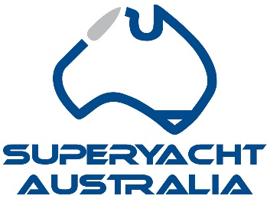

**Special Recreational Vessel (SRV) Act 2019**

The SRV Act was introduced in December 2019 to allow foreign owned superyachts to operate commercially in Australia. A sunset clause of 30 June 2021 was negotiated at the time in order to gain bipartisan support and passage through the senate. It was agreed that changes to the Coastal Trading Act that were already underway would provide the permanent solution. Unfortunately, the Coastal Trading Act reforms for passenger vessels have been put on hold indefinitely. An extension of the sunset clause through to 30 June 2023 was provided in 2021.

It is recommended that the SRV Act sunset clause be removed completely allowing the continued growth of Australian jobs, GST revenue for the government and stability for Olympic planning past 2032.

* **Allowing Foreign Owned Superyachts to Charter** – Charter vessels make up more than half of the world’s superyacht fleet. The SRV Act has therefore doubled the number of vessels attracted to visit Australia and utilise our skilled tradespeople, shipyards, and marinas.
* **Economic Benefit** – The ability for these vessels has created an additional 5,123 jobs and $1.072B from 2019 to 2021. It is forecast that the continuation of the SRV Act will create a further 10,541 jobs and $1.336B by 2025. An independent economic study for the Brisbane 2032 Olympics commissioned by the Qld Government has forecast that visiting superyachts will be worth $1.8B in economic benefit under the current legislative arrangements that include the SRV Act.
* **Foreign Superyachts Now Pay GST**- Prior to the SRV Act, foreign superyachts came into Australia under a control permit which incurs no taxation. The SRV Act has provided millions in GST revenue paid on charter fees in the short pandemic effected time this has been in place.
* **Australia’s New Seafarers** - Australians dominate the industry with over a quarter of the worlds crew Australian. By supporting superyacht charter in Australia, the government is also supporting over 14,000 crew, Australia’s new age, highly skilled and well-paid seafarers.
* **Blue Collar Workers Receive the Benefit**- Tradesmen and small businesses are the big winners from Superyacht spending in Australia. Each vessel spends millions of dollars (10-12% of the vessel value annually) in maintenance directly into predominantly small family owned businesses.

**Conclusion**

The SRV Act has been very successful in growing jobs, increasing GST income, increasing economic benefit and investment into Australia. In order to continue this growth and meet its full potential, it is essential for the Australian government to remove the SRV Act sunset clause.