Correcting information on the RAV
  - ROVER guide
June 2026

This guide explains how to notify the department about one or more errors on the Register of Approved Vehicles (RAV) and how to check the status of your request and identify any errors.
Follow these instructions to notify us of an error in single or multiple RAV entries. You can complete all the form fields manually or upload the RAV entry details in ROVER using ROVER template: Bulk RAV corrections.
Once we have assessed and accepted your request, the RAV entry will be updated with the amended information provided in your request.

Notify us of a correction
To notify us of a correction, ensure you are signed in to ROVER (navigate to Welcome to ROVER and select the Sign in button) and complete the following steps.
- Select the RAV icon. You can also access the RAV corrections button through the AVV page.
You can also access the RAV corrections button through the AVV page.
- Select the RAV Correction button.
- Select the Notify of an error on the RAV button.
- Select the relevant checkbox to identify whether you, or someone you represent, is responsible for entering the relevant vehicle(s) on the RAV?
- Provide the error details by following the steps on how to complete the form fields or upload a bulk RAV corrections template.
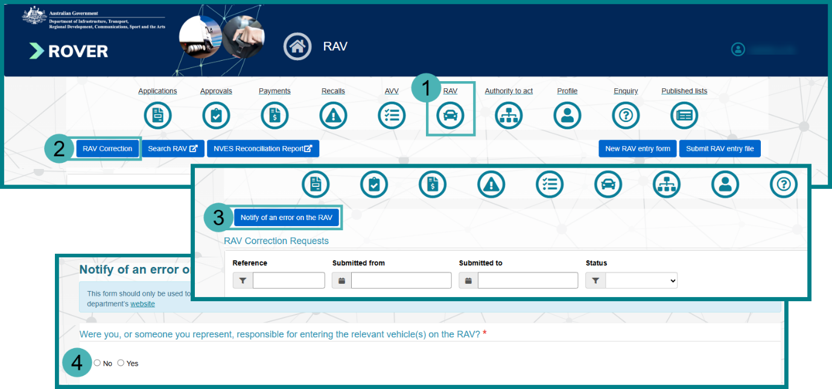

Complete the form fields
To provide the RAV error details by completing the form fields, ensure you have the vehicle’s Approval number, VIN and Entry pathway details that are currently published on the RAV. You can check these details by searching the RAV Public Search site for the vehicle record using the vehicle’s VIN.
- Select the Provide details on this form checkbox.
- Select the Add button.
- Enter the current Approval number.
- Enter the current VIN.
- Select the Entry pathway from the dropdown options.
- Select the Search button to find the RAV Entry.
Review the RAV entry to ensure it is the correct record.
- Select the Edit button at the bottom of the pre populated field.
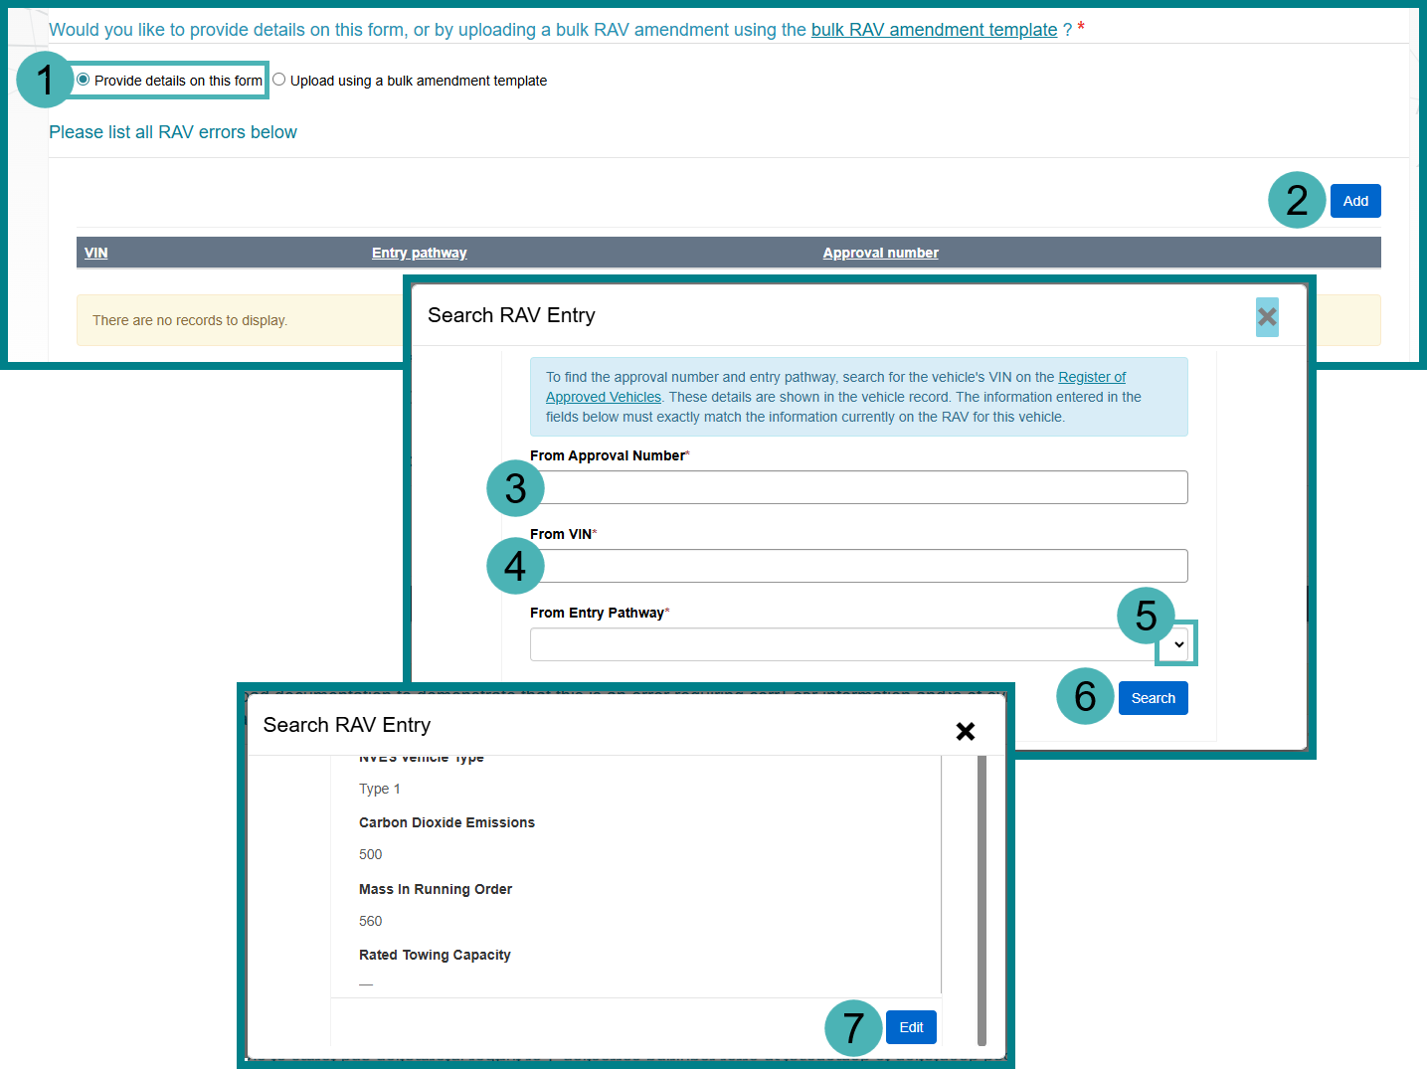
- Enter the correct information into the relevant fields.
- Select the Update button when complete.
- Repeat steps 2 to 9 for adding multiple RAV entries that contain errors.
- Next, follow the instructions on how to Provide supporting information.
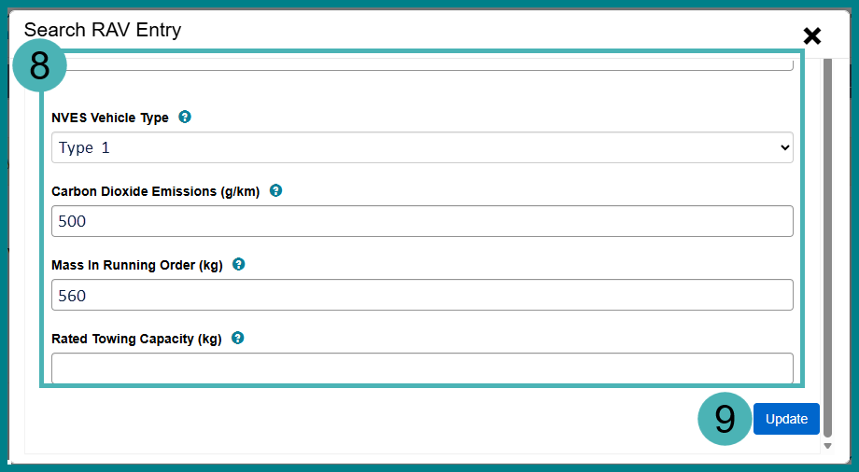

Upload a bulk RAV corrections template
To provide the RAV error details by uploading a CSV file, ensure you have downloaded ROVER template: Bulk RAV corrections. Fill in all the relevant vehicle details for the RAV entry, even if the existing information is accurate. If a field does not apply to your vehicle, or you need to remove a field value, leave the field blank. If you need to correct the VIN, approval number or entry pathway, you will also need to enter the corrected values in columns Y, Z or AA.
Save the file to your device in CSV file format and follow these steps:
- Select the Upload using a bulk amendment template checkbox.
- Select the Upload button.
- Select the Choose File button.
- Select the saved CSV file from your device.
- Select the Open button.
- Select the Upload button.
- Next, follow the instructions on how to Provide supporting information.
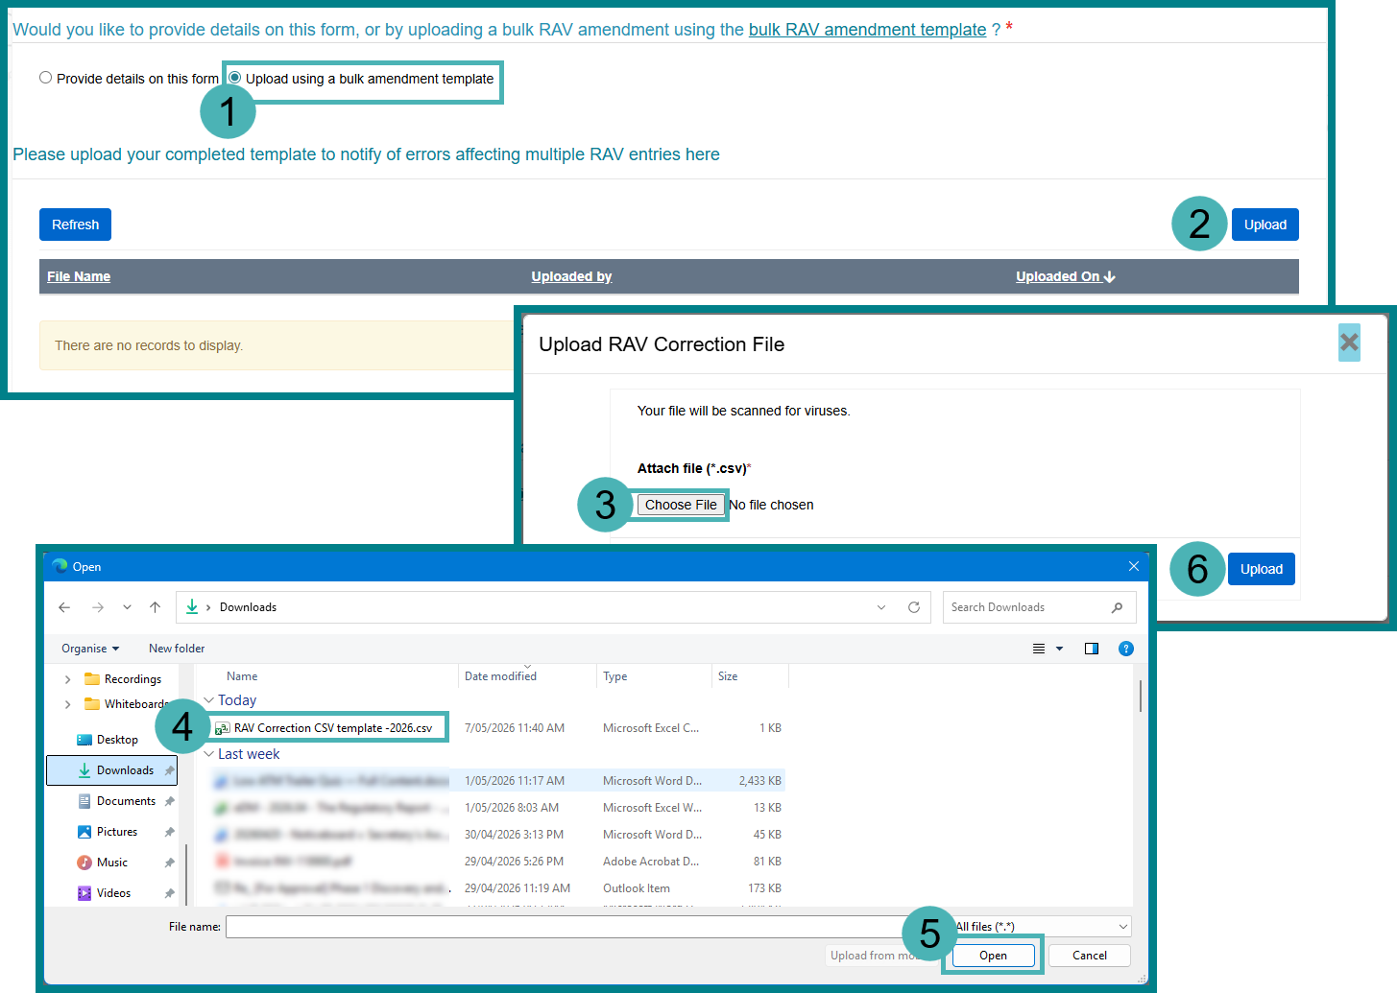

Provide supporting information
To provide supporting information that demonstrates that this is an error requiring correction, you can complete the free text field manually or upload supporting documentation.
- Enter the information in the free text field.
- Upload the relevant documents:
  - Select the Upload button.
  - Select the Choose File button.
  - Select a .pdf, .jpg, .png or .bmp type from your device.
  - Select the Open button.
  - Select the Upload button.
- Select the checkbox to confirm you understand that it is a contravention of section 32 of the Road Vehicle Standards legislation to provide false or misleading information.
- Select the Submit button.
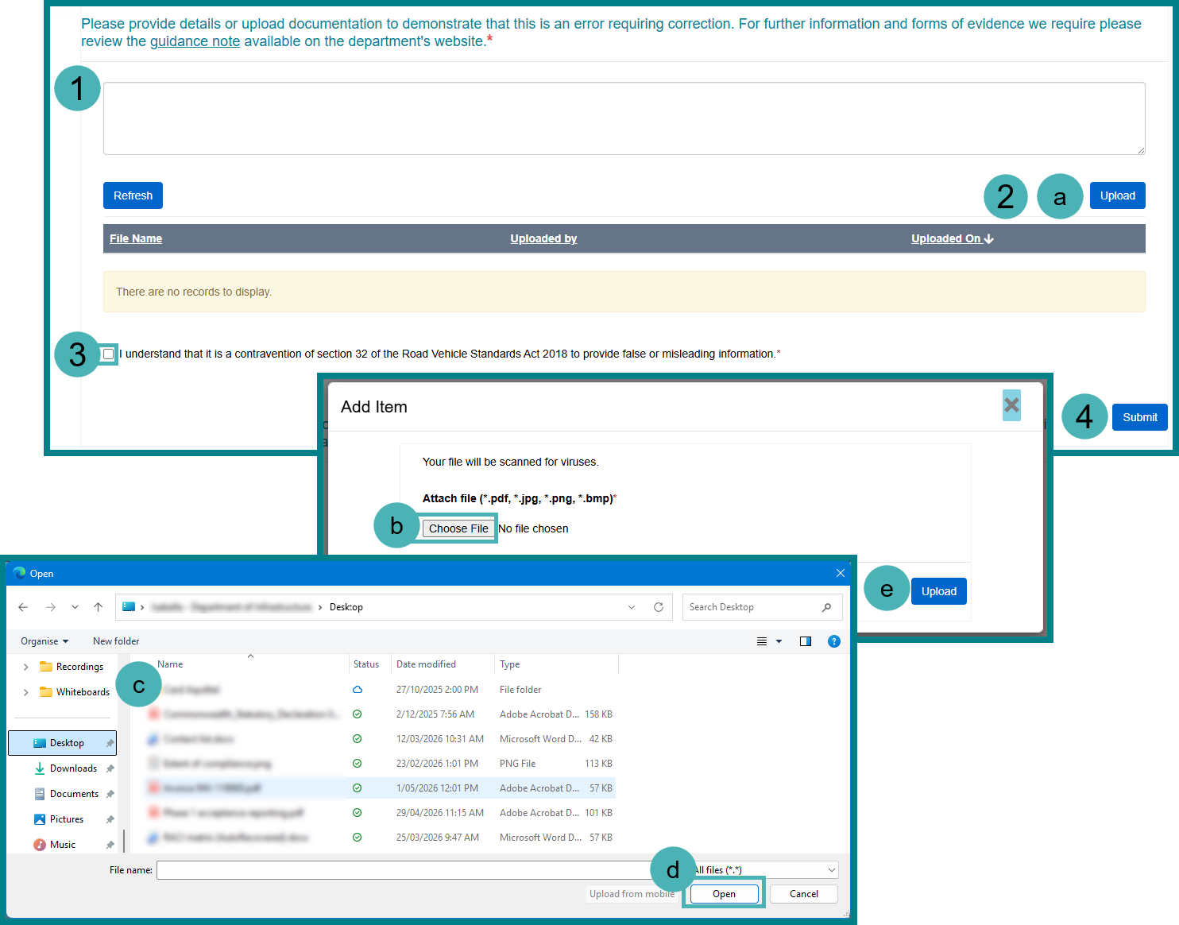

Check the status of a submitted RAV correction request
- Select the RAV icon.
- Select the RAV Corrections button.
- In the RAV Corrections Requests table, you will be able to monitor the status of your submitted requests.
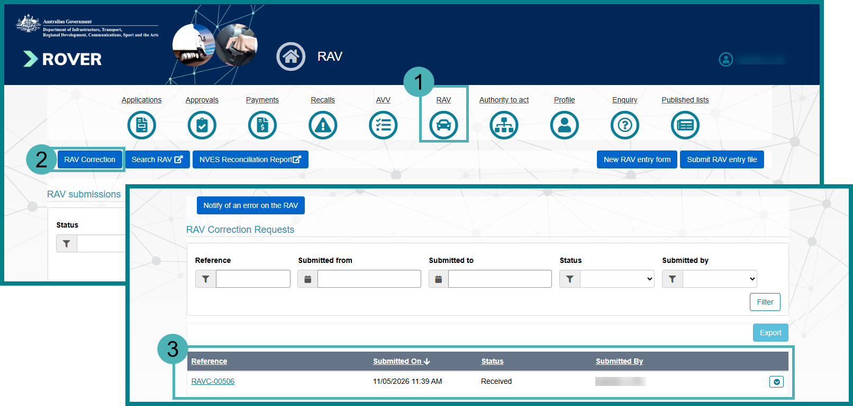

Check the error reason of an invalid RAV correction request
An invalid status means that the RAV Correction request contained one or more errors and did not pass the system validations. You will need to resubmit your RAV Correction request without errors by following the steps outlined under Notify us of a correction. To check why a submitted RAV Correction request is invalid, complete the following steps.
- Select the RAV icon.
- Select the RAV Corrections button.
- View the error using one of the following methods:
  - In the RAV Corrections Items - Errors table, you will be able to view the individual Error Message.
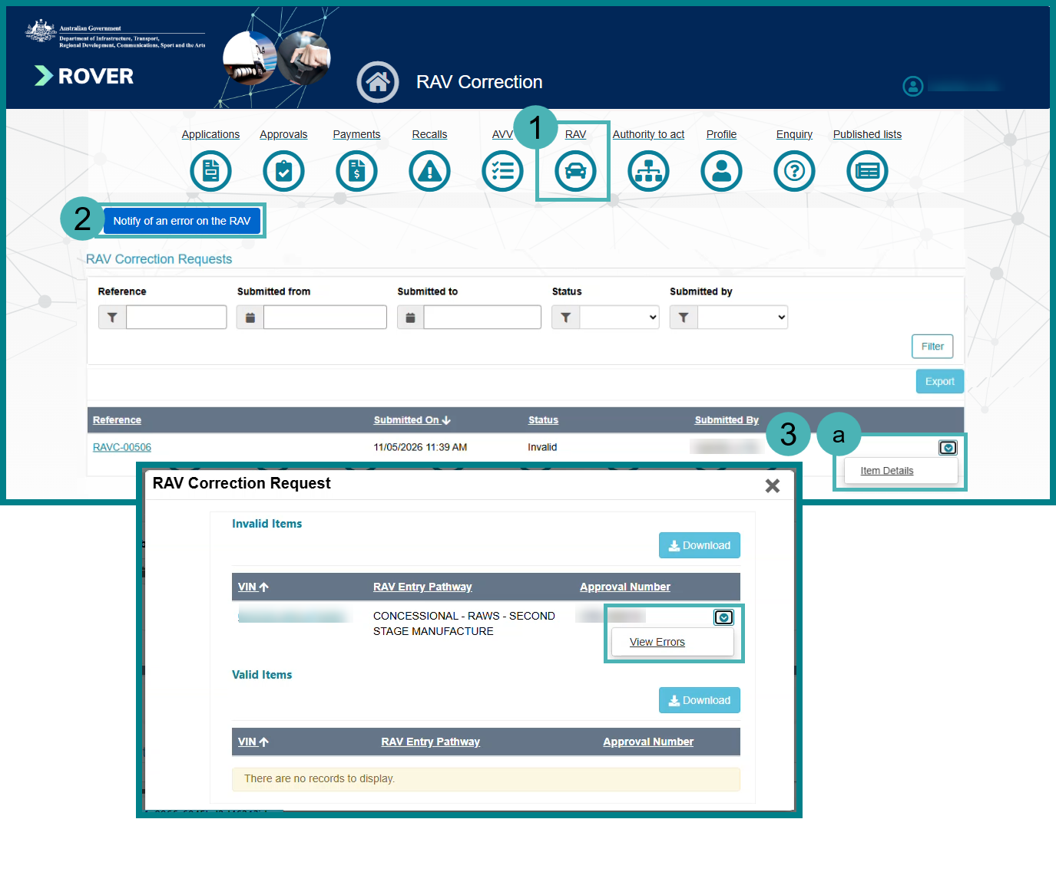
  - In the RAV Corrections Requests table, you will be able to view all errors related to a RAV Correction request. Select Item Details from the action menu and then select View Error from the action menu.
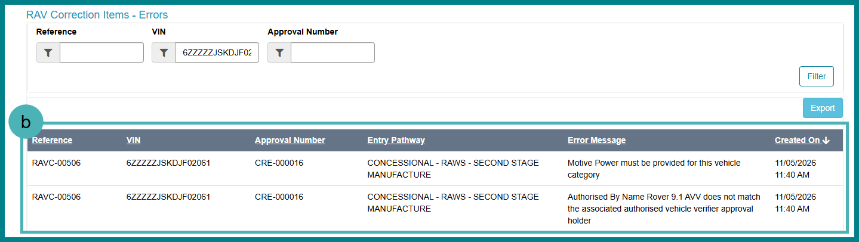
Example: What you will see if there is an issue with the file you have submitted.
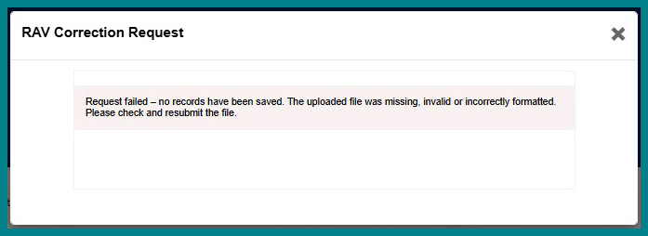

Further information
For further information, please visit Vehicles | Department’s website or submit an online enquiry via the Contact us—RVS | Department’s website page.

Quick links
- Welcome to ROVER
- RAV Public Search
- Guidance note—Amending entries on the Register of Approved Vehicle | Department’s website
- RVS guides and resources | Department’s website
- RVS legislation glossary of terms | Department’s website
- ROVER template: Bulk RAV corrections | Department's website

