Revoke an RVS approval
  - ROVER guide
August 2026

This guide provides instructions on how to make a request in ROVER to revoke an approval under the Road Vehicle Standards (RVS) legislation. Once revoked, an approval is no longer in force and cannot be reinstated. Revocation is different from suspension, which is a temporary measure that may be lifted in some circumstances.
To revoke an RVS approval, ensure you are signed in to ROVER (navigate to Welcome to ROVER and select the Sign in button) and complete the following steps.
- Select the Approvals icon.
- Select the approval type from the dropdown options. Please note it automatically defaults to Type and Role approvals.
- Select the approval you want to revoke.
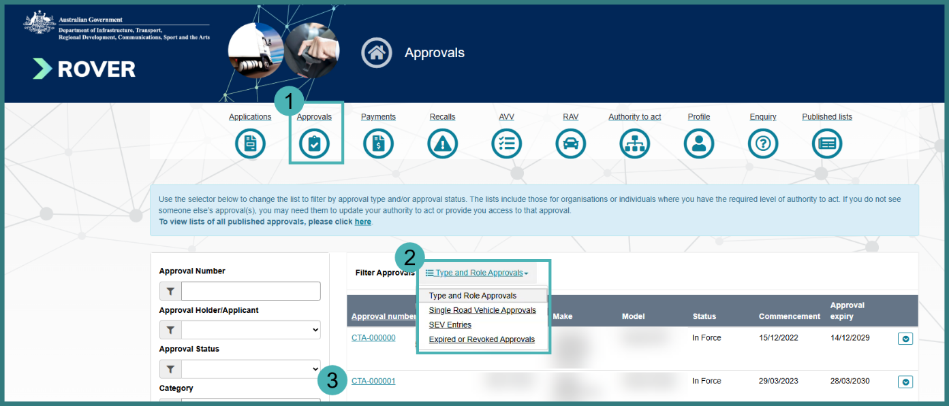
- Select the Revoke button.
- Read the Declaration and select the checkbox to acknowledge you have read and understood the declaration.
- Select the calendar icon to select the date of revocation. Please note the revocation date will be effective from midnight on the date chosen.
- Enter why you would like to revoke your approval in the free text field.
- Upload supporting files by selecting the Upload button.
- Select the Submit button.
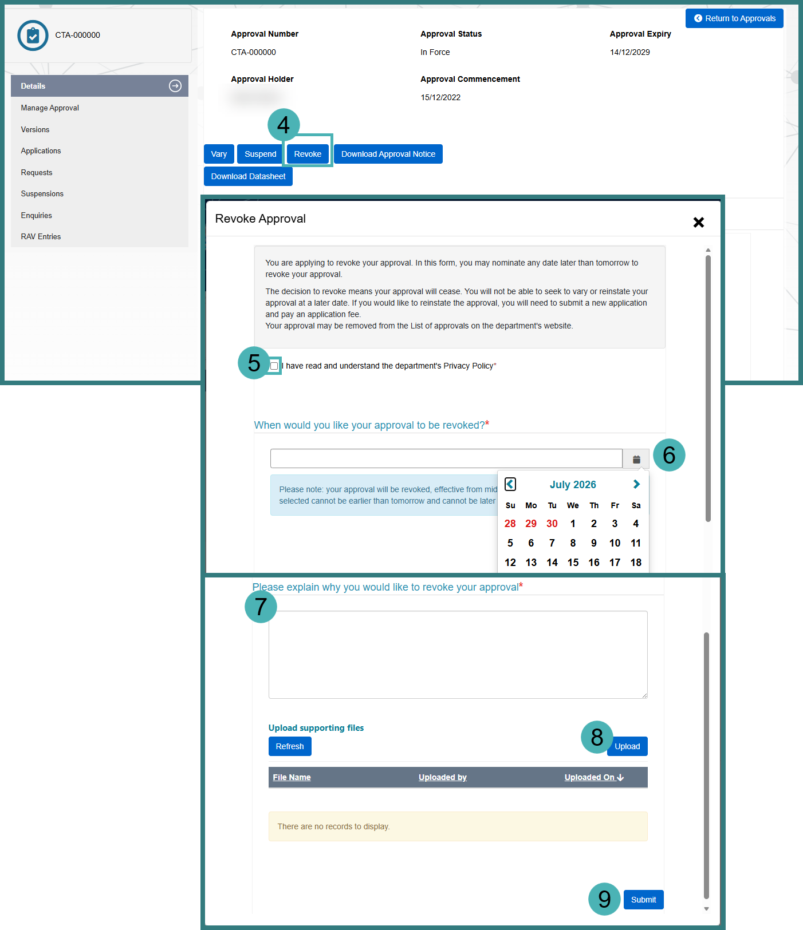

What happens once your request is submitted?
ROVER will automatically send you an email confirming your request has been received. The approval will be revoked on the date you requested and appear in the Expired or Revoked Approvals list on the Approvals page.

Further information
For further information, please visit Vehicles | Department’s website or submit an online enquiry via the Contact us—RVS | Department’s website page.

Quick links
- Welcome to ROVER
- RAV Public Search
- Road Vehicle Standards legislation | Department’s website
- RVS guides and resources | Department’s website
- RVS legislation glossary of terms | Department’s website

