

Sydney Airport Demand Management (Recovery Period) Declaration (No. 1) – 30 June 2026
I, Benjamin Meagher, Assistant Secretary, Sydney Airport Slots and Consumer Aviation Reforms Branch, Domestic Aviation & Reform Division, acting as a delegate of the Minister for Infrastructure, Transport, Regional Development and Local Government (the Minister), declare under subsection 9A(1) of the Sydney Airport Demand Management Act 1997 (the Act), a recovery period of one hour at Sydney Airport commencing from 12:00 on 30/6/2026 and concluding at 14:00 on 30/6/2025.

Under section 9A of the Act, the Minister is empowered to make decisions in relation to recommendations from Airservices Australia for a recovery period at Sydney Airport. I am the Minister’s delegate for the purposes of Section 9A of the Act.

In making this declaration, I am satisfied that aircraft movements at Sydney Airport are significantly disrupted and that the requirements provided in Section 9A(1) of the Act, and the criteria prescribed in Section 7 of the Sydney Airport Demand Management Regulations 2025, have been met due to the disruption relating to the restriction or unavailability of aircraft operations in Australian airspace caused by un-forecast fog and low visibility procedures being enacted and ground stop of all departures from other domestic ports to Sydney Airport on the day of 30/6/2026. This declaration is consistent with the recommendation provided by Airservices Australia received at 11:02 on 30/6/2026 and subsequent phone conversation with the NOMC about a time change from 12:00 to 14:00.

Dated 30 June 2026
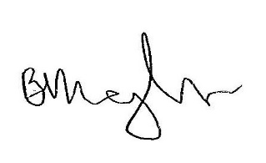

Benjamin Meagher
Assistant Secretary, Sydney Airport Slots and Consumer Aviation Reforms Branch, Domestic Aviation & Reform Division

