

Road vehicle standards

Reapplying for an expiring or expired approval
November 2025

This guide explains what to do when an approval has either expired or is expiring soon. This includes retaining an approval number, paying a commencement levy (when applicable), and how the department determines ADR applicability for vehicle type approvals.
The Road Vehicle Standards (RVS) legislation sets a defined approval period of either 5 or 7 years for several approval types on the condition that they are not suspended or revoked. Specifically:
- testing facility approvals, registered automotive workshop approvals, authorised vehicle verifier approvals and opted-in vehicle type approvals will expire after 5 years, and
- component type approvals and vehicle type approvals will expire after 7 years.
Due to the timing of the RVS legislation implementation, some approvals either have or will soon expire, with key examples being the early testing facility approvals and opted-in vehicle type approvals. You cannot use an expired approval to either operate as a regulated entity under the RVS legislation or to provide road vehicles to the Australian market.
Importantly, the RVS legislation does not make provisions for either extending or renewing an approval. As your approvals will expire, you must apply for and be granted a new approval to continue operations. While the RVS legislation does not set an explicit time limit on when you may apply for a new approval in these circumstances, the department:
- advises that there is no scope to accommodate multiple versions of the same approval and therefore recommends approval holders exercise common sense when timing applications for a new approval to take the place of an expiring approval;
- recommends that regulated entities and other approval holders continue to consider the department’s legislated decision-making timeframes when seeking approvals under the RVS legislation, including when managing an expiring approval;
- to support this, the RVS legislation application decision-making timeframes document lists the timeframes by application type; and
- recommends vehicle type approval holders consider the impact of obtaining a new approval on the expiring approval as outlined at below under the Type approval commencement dates heading.

How to apply
You are required to apply for a new approval. This means you must complete a new application in ROVER and provide all required supporting information.
The department cannot approve a request to vary your approval so that it remains in-force beyond the 5 or 7 year duration that the RVS legislation provides for the relevant approval type. You must make a new application in ROVER.

Retaining an approval number
The RVS legislation treats all applications as being for a new approval. ROVER will therefore allocate a new approval number to a successful application by default. If you wish to have a prior/existing approval number attached to a new approval, you need to request this when you make your application.
In ROVER, you can request this in the field provided on the Comments and any other matters page of your new application. Please provide your existing approval number and a brief statement that confirms:
- you wish to retain the previously issued approval number should a new approval be granted to you, and
- that your new approval covers the same vehicle make and model as the approval that was previously granted with the approval number that you are seeking to retain.
The following is an example of a request being made as part of a vehicle type approval application.
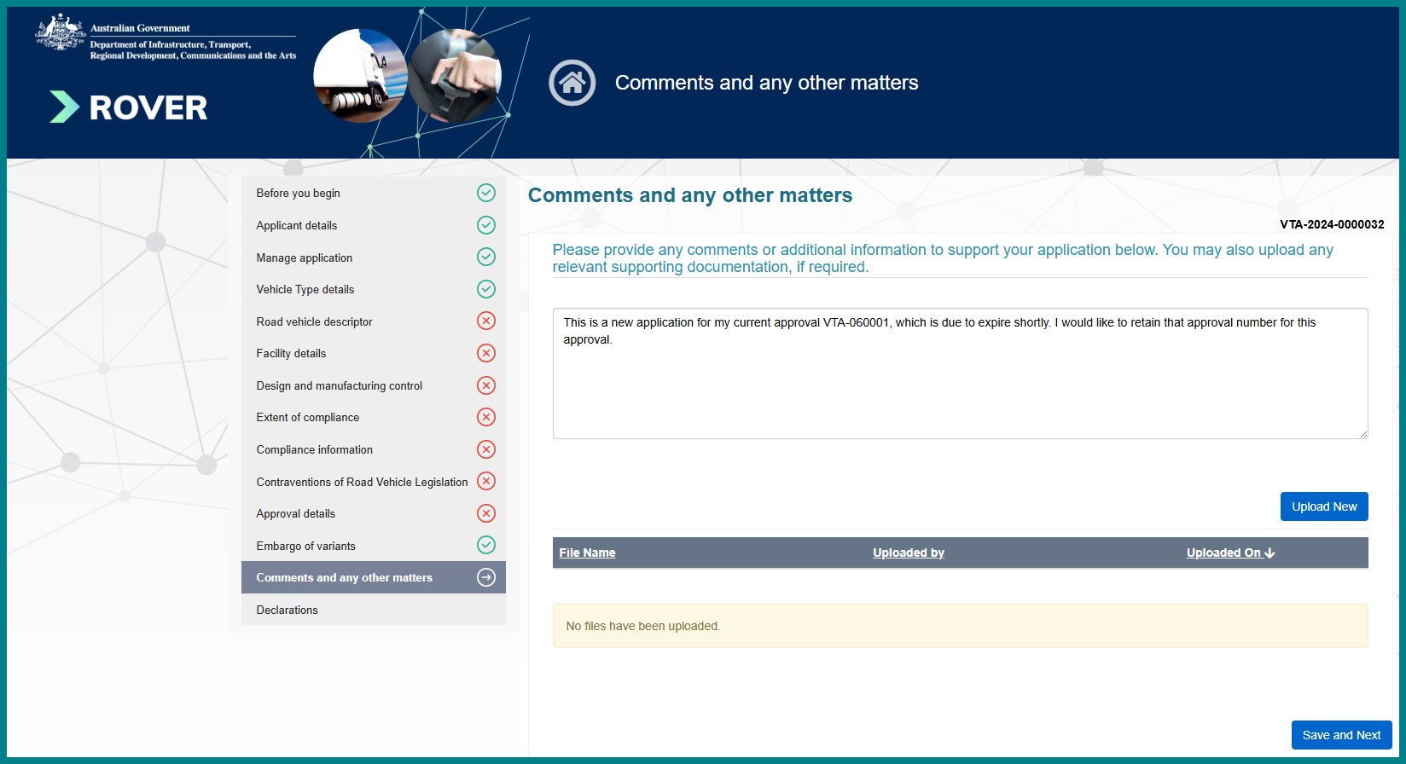

Existing models and ADR applicability
The department may determine that a vehicle model is an existing model (rather than a new model) for ADR applicability purposes if the vehicle model is the subject of a previously granted vehicle type approval. The vehicle model as presented in the new vehicle type approval application must be exactly the same as that listed in a prior approval for the department to apply this consideration. For the department to apply this consideration, the model in the new vehicle type approval application must:
- have the same names or codes for make, model and generation;
- be of the same type (as defined in the Guide to vehicle type approvals); and
- be the subject of a vehicle type approval that is not revoked before the new approval application is decided.
When completing your new vehicle type approval application, you will be required to confirm the vehicle’s extent of compliance with each applicable ADR. This includes selecting ‘Not applicable’ for ADRs that are not yet applicable to all vehicle models.

Type approval commencement dates
When applying for a new vehicle type approval and seeking to have the same approval number applied and the vehicle model treated as an existing vehicle model under the conditions specified above, you will not be able to specify a commencement date for the new approval. If your application is successful, your:
- new approval will commence on the day that it is granted, and
- prior approval will be revoked* if it is in-force on the day that your new application is assessed.
This is because the RVS legislation does not contemplate renewing an approval, and two approvals of the same number covering the same vehicle cannot co-exist in ROVER.
Please also note that the RVS legislation allows vehicle type approvals to be in force for a maximum period of 7 years, noting the potential for it to be revoked. The department therefore cannot grant a new approval that extends beyond 7 years to account for the remainder of a revoked approval.
For new vehicle type approvals that are not linked to any prior approvals, you can nominate a forward commencement date.
* You will need to request the department to revoke your prior approval when applying for a new approval under these circumstances. Detailed information on how to do this will be provided in November 2025.

Timing and handling of Opted in-approvals
The department will provide additional information to support opted-in approval holders with seeking a new vehicle type approval in November 2025. This will include advice on when to make new applications and how to provide advice to ensure the department’s assessment of your new vehicle type approval application is linked to the opted-in approval that you hold.

Paying a commencement levy
Testing facilities, registered automotive workshops and authorised vehicle verifiers must pay a commencement levy upon receiving notification that the department intends to grant a new approval. The new approval will not commence in lieu of the department receiving the commencement levy.
ROVER will generate an invoice for your granted approval once your current approval expires.
The new approval is only in-force once you have paid the commencement levy, after which you can operate under that approval.

Further information
For further information, please visit Vehicles | Department’s website or submit an online enquiry via the Contact us—RVS | Department’s website page.

Quick links
- Welcome to ROVER
- Road Vehicle Standards legislation | Department’s website
- RVS guides and resources | Department’s website
- RVS legislation glossary of terms | Department’s website
First published May 2025
Updated November 2025 – Removed restriction on reapplication timeframe and altered information on type approval commencement date.

