Logo: Australian Government, Department of Communications and the Arts.
http://www.communications.gov.au
http://www.arts.gov.au
http://www.classification.gov.au


GPO Box 2154, Canberra ACT 2601 Australia.
Telephone 02 6271 1000

# Possible amendments to telecommunications carrier powers and immunities

Consultation paper

June 2017

Disclaimer

The material in this consultation paper is of a general nature and should not be regarded as legal advice or relied on for assistance in any particular circumstance or emergency situation. In any important matter, you should seek appropriate independent professional advice in relation to your own circumstances.

The Commonwealth accepts no responsibility or liability for any damage, loss or expense incurred as a result of the reliance on information contained in this consultation paper.

This consultation paper has been prepared for consultation purposes only and does not indicate the Commonwealth’s commitment to a particular course of action. Additionally, any third party views or recommendations included in this consultation paper do not reflect the views of the Commonwealth, or indicate its commitment to a particular course of action.

Copyright

© Commonwealth of Australia 2017

Logo:  Creative Commons.  The material in this discussion paper is licensed under a Creative Commons Attribution—3.0 Australia licence, with the exception of:

* the Commonwealth Coat of Arms
* this Department’s logo
* any third party material
* any material protected by a trademark, and
* any images and/or photographs.

More information on this CC BY licence is set out at the creative commons website: [www.creativecommons.org/licenses/by/3.0/au/](http://www.creativecommons.org/licenses/by/3.0/au/). Enquiries about this license and any use of this discussion paper can be sent to: Market Structure Branch, Department of Communications and the Arts, GPO Box 2154, Canberra, ACT, 2601.

Attribution

Use of all or part of this consultation paper must include the following attribution:

© Commonwealth of Australia 2017

Using the Commonwealth Coat of Arms

The terms of use for the Coat of Arms are available from the It’s an Honour website (see [www.itsanhonour.gov.au](http://www.itsanhonour.gov.au/) and click ‘Commonwealth Coat of Arms’).

Contents

Overview 4

Background 5

Demand for telecommunications 5

Carrier powers and immunities 5

Telecommunications Act 6

Low-impact Facilities Determination 7

Telecommunications Code 7

Mobile Base Station Deployment Code 8

Radiofrequency electromagnetic energy 8

Regulation Impact Statement 9

Possible amendments 10

Proposed amendments to the LIFD 10

1. Definition of co-located facilities 10

2. Local government heritage overlays 10

3. Radio shroud as ancillary facilities 11

4. Size of radiocommunications and satellite dishes 12

5. Maximum heights of antenna protrusions on buildings 13

6. Use of omnidirectional antennas in residential and commercial areas 14

7. Radiocommunications facilities 14

8. Equipment installed inside a non-residential structure in residential areas 15

9. Tower extensions in commercial areas 16

10. Radiocommunications lens antennas 16

11. Cabinets for tower equipment 18

12. Size of solar panels used to power telecommunications facilities 18

13. Length of trench that can be open to install a conduit or cable 18

14. Cable & conduit installation on or under bridges 19

15. Volume restrictions on co-located facilities 19

16. Updates to environmental legislation references in the LIFD 21

Proposed amendments to the Tel Code 22

17. Clarify requirements for joint venture arrangements 22

18. LAAN objection periods 22

19. Allow carriers to refer land owner and occupier objections to the TIO 23

20. Updates to references in the Tel Code 23

Possible amendments to the Act 25

21. Allowing some types of poles to be low-impact facilities 25

22. Portable temporary communications facilities 25

23. Replacement mobile towers 27

24. Tower height extensions 28

How to make a submission 29

Publication of submissions 29

Release of submissions where authorised or required by law 29

Contact us 30

Glossary 31

## Overview

Telecommunications services play an important and expanding role in how people, businesses and governments go about their daily lives. The Australian Government is committed to Australians having ready access to high-quality, reliable and affordable telecommunications services.

To help provide Australians with better telecommunications services more quickly and cost‑effectively, telecommunications carriers have powers and immunities under Schedule 3 of the *Telecommunications Act 1997* (the Act). These powers and immunities help them install and maintain telecommunications network facilities.

So they can better meet consumer’s needs faster and at lower cost, telecommunications carriers have asked the Australian Government to consider making changes to carrier powers and immunities. This would include changes to the *Telecommunications (Low-impact Facilities) Determination 1997* (LIFD), the *Telecommunications Code of Practice 1997* (Tel Code) and potentially Schedule 3 to the Act itself.

The telecommunications industry has indicated that the changes could lead to significant time and cost savings and improved services to the community. It will also reduce burden on government and other agencies to administer these regulations.

Generally, the proposed changes would:

* clarify the operation of existing powers and immunities (e.g. heritage overlays),
* allow some increases in the size of existing facilities (e.g. solar cells),
* allow some new type of facilities (e.g. lens antennas) ,
* allow some types of facilities in new areas (e.g. omnidirectional antennas),
* alter some land owner and occupier notification and objection timeframes and processes in the Tel Code, and
* potentially, enable temporary or replacement towers or extensions to be installed in some limited circumstances.

The Department of Communications and the Arts (the Department) is seeking feedback on whether the changes should proceed, and if they should proceed in the form proposed, or in an amended form. The Government is seeking community feedback on the proposals to assist it in deciding on the way forward.

The proposals are discussed in further detail in the Possible amendments section of this consultation paper. Draft amendments to the LIFD and the Tel Code based on the carrier proposals have been drafted to help inform consideration, and are available on the Department’s website. There is a glossary at the end of this consultation paper.

The Department welcomes feedback from all stakeholders on these proposals. The proposals may be amended further based on the feedback we receive. Details on how to provide your views are given in the How to make a submission section.

## Background

### Demand for telecommunications

There is strong demand from the community, business and government for improved telecommunications services in Australia. Telecommunications carriers are continually installing and upgrading telecommunications infrastructure to deliver better services.

The number of telecommunications connections in Australia continues to increase, and demand for data over mobile and fixed line services is growing rapidly.

Mobile phones and mobile broadband are important to Australians and Australian businesses. Mobile device ownership continues to grow, and mobile broadband data use is increasing rapidly. Recent data[1] show that Australia had around 25.5 million mobile handset subscribers at 1 December 2016, an increase of 2.6 per cent since the end of December 2015. Mobile handset users downloaded 146 050 Terabytes of data in the quarter to December 2016, averaging 5.73 Gigabytes of data downloaded per subscriber per month. This was a 61 per cent increase in data downloads to mobile handsets compared to the December quarter 2015. Carriers need to roll out new mobile phone network infrastructure and upgrade existing sites to continue to meet this demand as well as to improve coverage, network capacity and connection quality.

There is still strong demand for fixed line telecommunications services in Australia too, and the overwhelming majority of data is downloaded via these services. Recent data[2] show that between the December quarter 2015 and the December quarter 2016, the volume of data downloaded by fixed line broadband increased by 51 per cent. This accounted for 93 per cent of all data downloads. Fixed line broadband subscribers downloaded 2.532 million Terabytes of data in the December quarter 2016, averaging 352 Gigabytes of data downloaded per subscriber per month.

### Carrier powers and immunities

Carrier powers and immunities give telecommunications carriers the ability to enter land and install and maintain some types of telecommunications network facilities. They are critical to the efficient construction and maintenance of telecommunications networks. They minimise the regulatory burden on carriers so that they can quickly and cost-effectively meet the community’s need for access to affordable, fast and reliable telecommunications services.

Most aspects of carrier powers and immunities have been in place since 1997. Since then, communications technologies have evolved rapidly, and demand for services and data has increased dramatically. For example, in 1997, Wi-Fi was a new technology and not widespread, mobile phones did not connect to the internet, and only 25 per cent of Australians had a mobile phone subscription[3].

Telecommunications carriers have proposed that powers and immunities should be amended to reflect new technologies, enhanced work practices, and reduce the regulatory cost and burden. Where carrier powers and immunities do not apply, carriers are typically required to seek planning approval for their activities under differing state and territory planning laws. These approval processes can significantly increase the time and costs for carriers to install facilities that are important for improving telecommunications services to the community and businesses. These costs flow through to consumer prices. Giving carriers uniform, streamlined powers and immunities under Commonwealth law helps them meet consumer demand for services while reducing the administrative burden on carriers and state, territory and local governments.

Carriers have estimated that if the proposed changes proceed, they could result in over $100 million per year in regulatory cost savings to industry and government and over $50 million per year in economic and social productivity benefits to consumers.

#### Telecommunications Act

Carrier powers and immunities are set out in Schedule 3 to the Act. Schedule 3 provides carriers with powers to enter land (including public areas of buildings) for inspection, and to install and maintain certain types of facilities. It also provides certain immunities, including from a range of State and Territory laws when carrying out those activities, such as those laws relating to land use, planning, design, construction, siting, tenancy, environmental assessments and protection. These are collectively referred to as ‘planning laws’ in this paper.

Most importantly, Schedule 3 covers the installation of ‘low‑impact facilities’, which are specified in the LIFD and discussed further below.

When using carrier powers and immunities, the Act requires carriers to notify affected land owners and occupiers of their intended activities, and give them the opportunity to object. The Act also imposes a range of conditions on carriers engaging in authorised activities, including a requirement to comply with the conditions in the Tel Code which are discussed below. It requires carriers to do as little damage as practicable and restore land to a condition that is similar to before the activity began. They must act in accordance with good engineering practice, protect the safety of people and property, interfere with other users of the land as little as practicable, and protect the environment. Compliance with the requirements under Schedule 3 to the Act is a carrier licence condition.

If Schedule 3 to the Act does not cover a particular telecommunications facility, carriers need to comply with applicable State and Territory planning laws and obtain landowner consent. For example, Schedule 3 does not permit new free‑standing telecommunications towers (Figure 1) to be specified as low‑impact facilities. These facilities must be authorised through relevant state and territory planning laws, which typically require a development application.

Figure 1: Free-standing tower Figure 2: Low-impact mobile phone network panel antennas flush mounted to a building

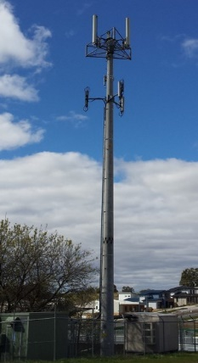 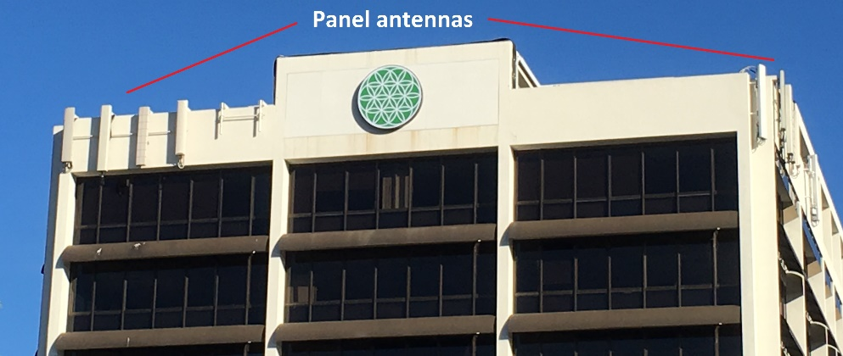

#### Low-impact Facilities Determination

Schedule 3 to the Act gives the Minister for Communications the ability to specify facilities as ‘low‑impact facilities’ which can be installed using Schedule 3 carrier powers and immunities. They are the most common type of carrier facilities installed under Schedule 3. The current low‑impact facilities are specified in the LIFD. They include some types of radiocommunications facilities, underground and above-ground housing, underground and some aerial cables, public payphones, emergency and co‑located facilities. For example, mobile phone network facilities installed on existing towers or buildings can be low-impact radiocommunications facilities listed in the LIFD. Figure 2 above is an example.

As well as specifying types of facilities, the LIFD also designates the areas in which carriers can install facilities as low-impact facilities. For this purpose, the LIFD uses four types of areas:

* Residential area—an area where its principal designated use is for residential purposes, and parts of built up areas that cannot otherwise be described as a commercial, industrial or rural area.
* Commercial area—an area where its principal designated use is for commercial purposes.
* Industrial area—an area where its principal designated use is for industrial purposes.
* Rural area—an area where its principal designated use is for rural purposes, and areas not part of built up areas that cannot otherwise be described as a commercial, industrial or residential area.

In this context, certain low-impact facilities may only be installed in rural or industrial areas, whereas other low-impact facilities may be installed in all areas.

If an area is described under a planning law as having a sole or principal use, the use is the principal designated use of the area. Section 1.4 of the LIFD provides more information about how to determine the principal designated use of an area in circumstances where an area has two or more uses under planning law.

The types of facilities that are currently specified in the LIFD as low-impact are those considered to be essential to the effective and efficient operation of telecommunications networks in providing services to the public, but are considered to be of low visual impact and unlikely to cause significant disruption to the community during installation or operation.

The LIFD encourages carriers to roll out networks using facilities of the specified type, size and colour. This minimises the impact of telecommunications infrastructure on the community while expediting the supply of services.

Facilities cannot be low‑impact facilities if they are to be installed in areas of environmental significance—including those listed under Commonwealth, State or Territory heritage registers. Such facilities are subject to other Commonwealth, State or Territory approval processes. Telecommunications facilities in these areas remain subject to other Commonwealth laws which would ordinarily apply, such as the Environment Protection and Biodiversity Conservation Act 1999(Cth).

#### Telecommunications Code

Carriers exercising their powers under Schedule 3 must do so in accordance with obligations set out in the Tel Code. The Tel Code details the notification and objection procedures for carriers using Schedule 3 powers and immunities. It also sets out further obligations on carriers when inspecting land and installing and maintaining facilities using their Schedule 3 powers under the Act. Compliance with the Tel Code is a carrier licence condition.

The Act and Tel Code require carriers to notify land owners and occupiers of intended activities, which is in the form of a Land Access and Activity Notice (LAAN). Land owners and occupiers may object to proposed activities under certain circumstances. The Tel Code requires carriers to make reasonable efforts to resolve valid objections from land owners or occupiers. If the land owner or occupier is not satisfied with the carrier’s proposed resolution or response to the objection, and/or no agreement can be reached, they may ask the carrier in writing to refer the objection to the Telecommunications Industry Ombudsman (TIO) for resolution if the carrier wishes to continue with the proposed activity. The carrier must comply with the request to refer the matter to the TIO. Carriers must comply with any direction made by the TIO.

Additionally, the Tel Code sets out more detailed carrier conditions for each type of activity enabled by Schedule 3 to the Act. These conditions include carrying out activities in accordance with best practice, complying with relevant noise restrictions under state and territory law, complying with relevant standards and codes and seeking co-location opportunities for facilities.

#### Mobile Base Station Deployment Code

Telecommunications carriers installing low-impact facilities for mobile phone networks are also required to comply with the Industry Code for Mobile Phone Base Station Deployment C564:2011 (the Mobile Base Station Deployment Code). It sets out additional processes and conditions that mobile carriers are to follow when they are installing low-impact facilities for mobile base stations. The Mobile Base Station Deployment Code was developed by the Communications Alliance, and is registered with the Australian Communications and Media Authority (ACMA). The ACMA can warn or direct sections of the industry that are covered by the Mobile Base Station Deployment Code to comply with it.

### Radiofrequency electromagnetic energy

Radiocommunications transmitters, such as those used for mobile phone services and Wi-Fi, use radiofrequency electromagnetic energy (RF EME) to provide users with wireless services. The classification of facilities as ‘low-impact’ does not consider the levels of RF EME they produce as this is subject to separate and rigorous stand‑alone regulation.

The Australian Radiation Protection and Nuclear Safety Agency (ARPANSA) is the Government agency responsible for setting the exposure standard for RF EME. The ARPANSA exposure limits are set well below the level at which adverse health effects are known to occur and include a wide safety margin to protect the public. Typically transmitters on mobile phone and nbn fixed wireless towers operate at a small percentage of the ARPANSA Standard.

The ACMA regulates EME from radiocommunications transmitters by imposing conditions on the radiocommunications licences it issues to telecommunications carriers. The ACMA imposes licence conditions through the Radiocommunications Licence Conditions (Apparatus Licence) Determination 2015. Under the conditions, telecommunications carriers must ensure that RF EME exposure from a transmitter does not exceed the levels set in the ARPANSA Standard.

The effects of RF EME exposure have been, and continue to be, the subject of extensive and rigorous scientific study around the world. It is the assessment of ARPANSA and other leading health authorities such as the World Health Organization that there are no known health effects at low RF EME levels, such as those emitted by telecommunications transmitters. ARPANSA maintains continual oversight of emerging research into the potential health effects of RF EME emissions. Further information about RF EME is available at ARPANSA’s website [www.arpansa.gov.au/Science/rf/](http://www.arpansa.gov.au/Science/rf/).

### Regulation Impact Statement

The Office of Best Practice Regulation has advised that at this stage a Regulation Impact Statement is not required for the proposed amendments. This is due to the reduction in the regulatory burden that would result from the amendments for telecommunications carriers seeking to build, maintain and improve telecommunications networks, and the lack of any significant increase in costs to other members of the community.

The Department will self-assess the regulatory cost savings resulting from amendments that proceed.

## Possible amendments

The Government is considering amending the LIFD, the Tel Code, and the Act, to better facilitate the efficient deployment of telecommunications facilities. The potential amendments are discussed below. Marked up versions of the LIFD and the Tel Code are available on the Department’s website [www.communications.gov.au](http://www.communications.gov.au) to assist readers. For further information about commenting on the proposals, please see the How to make a submission section of this document.

### Proposed amendments to the LIFD

The amendments are generally discussed in the order they appear in the marked-up version of the LIFD. The relevant parts of the LIFD, Tel Code or Schedule 3 to the Act are cited below in relation to the proposal, where relevant. In commenting on the proposed amendments, readers should consider both the facility concerned, and the LIFD area it would be located in (see page 7 for more information about LIFD areas).

#### 1. Definition of co-located facilities

##### Proposal—LIFD Part 1, Section 1.3

If adopted, the amendment would add a note to the definition of co‑located facilities at Part 1, Section 1.3, to clarify that a facility is not a co-located facility unless it is installed on or within an original facility (e.g. a tower or equipment shelter) or a public utility structure (e.g. a road sign or water tank).

##### Rationale

Carriers have requested that the LIFD be amended to clarify that a low-impact telecommunications facility being installed near a pre-existing telecommunications facility is not a co-located facility of the other facility where it is not installed on an original telecommunications facility (e.g. a tower or equipment shelter) or a public utility structure (e.g. a road sign or water tank). A radiocommunications antenna installed on a tower or water tank would be a co-located facility if all the other requirements are met. However, an antenna being installed on the roof of a commercial building near a pre-existing radiocommunications antenna is not a co-located facility because it is not being installed in or on an original facility or public utility structure. As such it is not subject to the co-location rules in Part 7 of the Schedule of the LIFD, but is subject to the other requirements applying to a facility of the kind being installed. This is intended to provide greater certainty as to when the co-location rules apply and when other rules apply.

##### Issues for discussion

* 1.1—Are there any issues with this proposed clarification to the definition of co-location?

#### 2. Local government heritage overlays

##### Proposal—LIFD Part 2, 2.5(7A)

If adopted, the amendment would clarify that low-impact facilities can be installed in an area subject to a local government heritage overlay or urban conservation map, provided the area or building directly being used is not listed on a heritage register, in accordance with relevant Commonwealth, State or Territory law. The heritage register rules are currently set out in Part 2, Section 2.5 (7) of the LIFD.

##### Rationale

Under the LIFD, facilities cannot be low-impact facilities if the area they are installed or intended to be installed in is an area of environmental significance. Areas of environmental significance include areas or buildings that are entered on a heritage conservation register under Commonwealth, State or Territory law. Carriers need to seek planning approval under relevant Commonwealth, State or Territory law to install facilities in these areas.

Some local governments in Australia have introduced heritage overlays to control development in a designated area in order to maintain the character of the area. There is some confusion about the role of these heritage overlays in relation to the LIFD. A local government heritage overlay may cover whole suburbs or localities, including land and buildings not on a heritage register that meets the requirements of Part 2, Section 2.5 (7) of the LIFD. Some local governments have asked that carriers lodge development applications for facilities listed in the LIFD in heritage overlay areas, even if they are not to be installed on land or buildings that are in themselves listed on heritage registers. This increases the time and cost to install telecommunications facilities in these areas, which affects the availability of telecommunications services to the community. To remove any confusion on this issue, this amendment would make it clear that carriers are able to install facilities in the LIFD using their powers and immunities under Schedule 3 to the Act in the heritage overlay areas (other than on land or buildings specifically listed in heritage registers).

##### Issues for discussion

* 2.1—Are there any issues with this clarification in relation to local government heritage overlays?

#### 3. Radio shroud as ancillary facilities

##### Proposal—LIFD Part 3, 3.1(4)

If adopted, this amendment would make it clear that shrouds for radiocommunications facilities are ancillary facilities in the LIFD.

Shrouds are visual screens for radiocommunications facilities that make the facilities less obtrusive, while allowing radiofrequency signals to pass through easily. Figure 3 shows examples of shrouds.

Figure : Radio shrouds

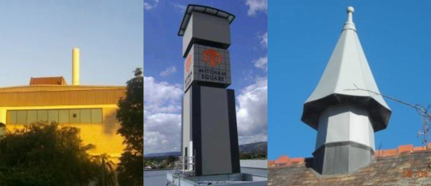

##### Rationale

Carriers are encouraged to look at design solutions to improve the appearance of mobile communications facilities, including radio shrouds. Radio shrouds can improve the visual amenity of an area by screening low-impact facilities such as mobile phone antennas.

Currently, a radio shroud is not clearly included in the LIFD as an ancillary facility. Under the LIFD, a facility is considered to be ancillary to a low-impact facility if it is necessary for the operation or proper functioning of the low-impact facility and is installed to ensure the protection or safety of the low‑impact facility or persons or property close to the low-impact facility. As they seek to improve the visual amenity of a facility rather than ensure its safe or proper function, radio shrouds are not clearly covered by these provisions. This change would enable greater use of radio shrouds to screen mobile phone facilities.

##### Issues for discussion

* 3.1—Should radio shrouds be considered ancillary facilities to low-impact facilities, or should radio shrouds be listed as distinct facilities in the Schedule of the LIFD?
* 3.2—If listed as distinct facilities in the Schedule of the LIFD, should there be any criteria for radio shrouds, for example in terms of size and dimensions?

#### 4. Size of radiocommunications and satellite dishes

##### Proposal—LIFD Schedule, Part 1, Items 1A and 5A

If adopted, these amendments would increase the permitted maximum size of radiocommunications and satellite dishes located in rural and industrial areas from 1.8 to 2.4 metres in diameter. These dishes can either be installed for subscriber connection (LIFD Schedule, Part 1, Item 1A) or for use in the network more generally (LIFD Schedule, Part 1, Item 5A). Figure 4 below shows examples of these types of dishes.

The amendment to Item 1A would also allow a similar increase in size for radio terminal antennas in rural and industrial areas.

Figure : Satellite dishes for subscriber connection (LIFD Schedule, Part 1, Item 1A) (left) and  
radiocommunications dish for general use (LIFD Schedule, Part 1, Item 5A) (right)

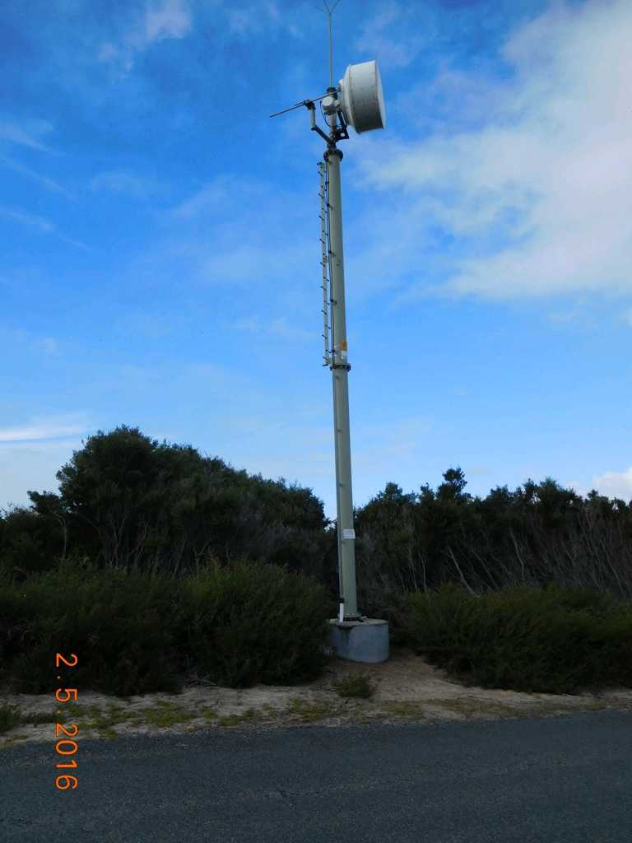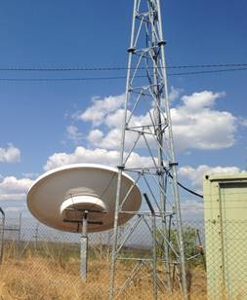

The LIFD currently enables carriers to connect subscribers to telecommunications services using radiocommunications and satellite dishes (or terminal antennas) as low-impact facilities if the dish or antenna is up to 1.8 metres in diameter and located in rural and industrial areas. It also enables the installation of radiocommunications dishes up to 1.8 metres for general use in rural and industrial areas. The dish must either be colour-matched to its background or in a colour agreed in writing between the carrier and the relevant local government authority (e.g., the local council).

##### Rationale

Carriers advise that 1.8 metre dishes do not always support the signal strength required for high quality data transmission. Larger radiocommunications and satellite dishes can support stronger signals and increase reliability, improving services to a wider range of areas of Australia. They advise that requiring planning approvals for suitable dishes that are up to 2.4 metres in diameter delays service provision to customers.

Because the increase to 2.4 metres would only apply in rural and industrial areas, it is considered to have minimal visual impact on the community.

##### Issues for discussion

* 4.1—Are there any issues with permitting 2.4 metre subscriber radiocommunications dishes or terminal antennas in rural and industrial areas (LIFD Schedule, Part 1, Item 1A)?
* 4.2—Are there any issues with permitting other 2.4 metre radiocommunications dishes in rural and industrial areas, including those located on telecommunications structures (LIFD Schedule, Part 1, Item 5A)?

#### 5. Maximum heights of antenna protrusions on buildings

##### Proposal—LIFD Schedule, Part 1, Item 3

If adopted, this amendment would allow antennas and their mounts to protrude up to 5 metres above the building or structure to which they are attached. Currently, antennas and the mounts they are attached to can protrude up to 3 metres from a building in any area.

##### Rationale

Carriers advise that this proposal would allow more flexible design solutions to address topography and terrain issues, and increase coverage areas, reducing the number of new towers needed.

The proposal would also assist with the management of worker health and safety on rooftops. By raising antennas, concerns about exposure to RF EME for workers accessing rooftop areas close to transmitters could be reduced.

Figure : 3 metre protrusion (L) and 5 metre protrusion (R)

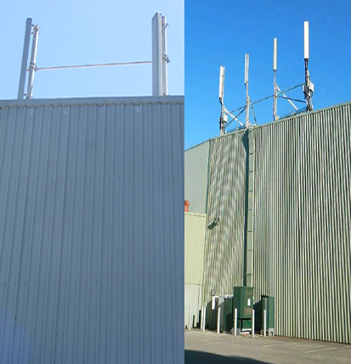

Issues for discussion

* 5.1—Is a 5 metre protrusion height acceptable, or is there a more appropriate height?
* 5.2—Are higher protrusions more acceptable in some areas than others? Could protrusions higher than 5 metres be allowed in industrial and rural areas?

#### 6. Use of omnidirectional antennas in residential and commercial areas

##### Proposal—LIFD Schedule, Part 1, Item 4

Figure : Omnidirectional antennas on a rooftop

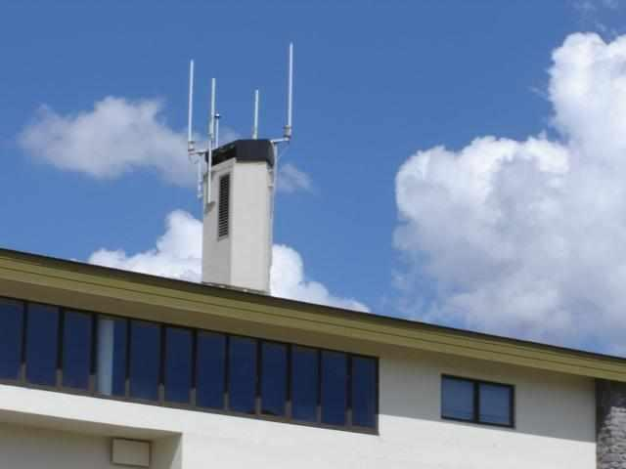

If adopted, this amendment would allow omnidirectional radiocommunications antennas to be low‑impact facilities in residential and commercial areas.

Currently, omnidirectional antennas are only covered in industrial and rural areas, and must not be more than 4.5 metres long and must not more than 5 metres apart. If they are attached to a structure, such as a building, they must not protrude from the structure by more than 2 metres.

##### Rationale

This amendment is intended to enable greater use of slimline omnidirectional antennas as an alternative to panel or yagi antennas in residential and commercial areas. Omnidirectional antennas are thinner and considered to be less visually intrusive than panel or yagi antennas, which can already be used in such areas.

##### Issues for discussion

* 6.1—Are there any issues with permitting omnidirectional antennas in residential and commercial areas in the manner proposed, in addition to industrial and rural areas?

#### 7. Radiocommunications facilities

##### Proposal—LIFD Schedule, Part 1, Items 6 and 6A

If adopted, these amendments would replace the technology-specific term, micro-cell, with the general term, radiocommunications facility, and define the facilities by the size of their components, providing greater flexibility in the installation of such facilities. This would ensure that radiocommunications network equipment could be installed on the basis of the size of the equipment, rather than the size of any wireless cell or footprint the equipment produces. Currently, a micro-cell is a low-impact facility under the LIFD if it has a cabinet of not more than one cubic metre in volume and a separate antenna not more than one metre long. Low‑impact micro-cells are permitted in all areas.

In addition, the amendments would make it clear that other radiocommunications equipment such as Wi-Fi transmitters can be installed using the LIFD and attached to an existing structure if they are up to a certain size.

Under the amendment, the permissible antenna height for a ‘radiocommunications facility’ at Item 6, Part 1 of the LIFD Schedule, would increase from 1 metre to 1.2 metres. The associated cabinet would still have a maximum size of up to 1 cubic metre in volume. This item is intended to cover radiocommunications facilities including a cabinet and a separate antenna which meet the size requirements.

Figure : Wi-Fi transmitter (L) small cell antenna (R)

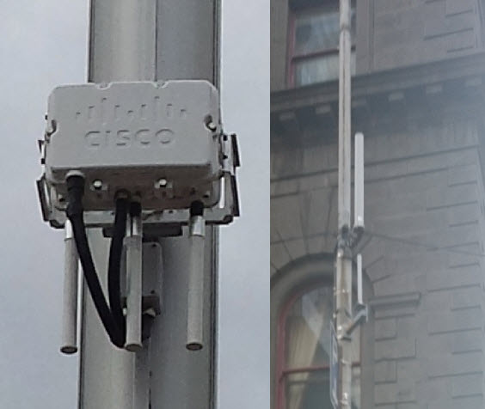

Another ‘radiocommunications facility’ would also be added to the Part 1 of the LIFD Schedule (Item 6A), which would give carriers the ability to attach facilities up to a certain size to existing structures. This is intended to cover small transmitter units attached to existing structures, such as a Wi-Fi transmitter attached to a building or utility pole. The transmitter unit could be up to 0.03 cubic metres in volume, and the maximum antenna height would also be 1.2 metres long.

##### Rationale

This amendment is intended to ensure all small radiocommunications facilities are covered by the LIFD, regardless of the size of their wireless coverage footprints. It would give carriers greater flexibility to improve mobile and wireless broadband coverage for customers using a wider variety of small radiocommunications facilities, without the need for state and territory planning approvals. Under theMobile Base Station Deployment Code carriers would still be required to notify local authorities and nearby residents about any proposed mobile base station facilities.

##### Issues for discussion

* 7.1—Does the proposed approach raise any issues?
* 7.2—Are the proposed dimensions for these facilities appropriate?

#### 8. Equipment installed inside a non-residential structure in residential areas

##### Proposal—LIFD Schedule, Part 1, Item 8A

If adopted, this amendment would allow equipment installed inside a structure located in residential areas to be low-impact provided that the structure, or the building the structure is attached to, is not for residential occupancy or use under applicable planning laws. For example, this would allow equipment to be installed inside a commercial building in a residential area.

Equipment installed in an existing structure in commercial, industrial and rural areas is currently low‑impact. This includes radiocommunications antennas concealed inside existing structures. There is currently no limitation in the LIFD on installing equipment inside a residential building in a commercial area.

##### Rationale

Carriers are currently able to install some types of low-impact facilities on the outside of buildings in a residential area. However, they are unable to use the same powers to install these facilities internally, for example, inside a roof space.

The proposed amendment would make it easier for carriers to reduce the visual impact of facilities installed at non-residential buildings in residential areas by concealing them inside existing structures. Under theMobile Base Station Deployment Code carriers would still be required to notify local authorities and nearby residents about proposed mobile base station facilities.

However, the amendment would grant carriers the right to enter land (including public areas of buildings) in residential areas to install facilities inside structures that are for non-residential use only. Land owners and occupiers would have the right to object to the installation of facilities inside structures. This is currently the case for all types of buildings and structures in commercial, industrial and rural areas.

##### Issues for Discussion

* 8.1—Should carriers be able to enter land (including buildings) to install facilities in existing structures not used for residential purposes in residential areas?

#### 9. Tower extensions in commercial areas

##### Proposal—LIFD Schedule, Part 1, Item 9

If adopted, this amendment would allow tower height extensions of up to five metres in commercial areas if the height of the tower has not previously been extended, or was extended by less than five metres. Currently, the LIFD only allows tower height extensions of up to five metres in rural and industrial areas, and does not permit them in commercial and residential areas.

##### Rationale

Height extensions allow carriers to place more antennas and associated equipment on each tower to cater for the increasing demand for mobile telecommunications services. Extensions also improve carriers’ ability to co-locate their equipment with other carriers’ equipment on existing towers, reducing the need for carriers to build new towers.

##### Issues for discussion

* 9.1—Are there any issues permitting tower height extensions of up to five metres in commercial areas?

#### 10. Radiocommunications lens antennas

##### Proposal—LIFD Schedule, Part 1, Item 10

If adopted, this amendment would add a new type of facility to the LIFD, radiocommunications lens antennas. This facility could have a substantive volume of up to 4 cubic metres, and would be permitted in residential, commercial, industrial and rural areas. For example, the dimensions of the facility could be at least 140 x 140 x 160 centimetres. The antenna would need to be either colour‑matched to its background, or be a colour agreed in writing between the carrier and the relevant local government authority. If the antenna is attached to a supporting structure (such as an existing tower or building), the total protrusion from the structure could not be more than 5 metres.

##### Rationale

Lens antennas have not previously been commonly used in wireless telecommunications network deployments in Australia, and are not currently covered by the antenna types listed in the LIFD. Figure 8 shows a lens antenna mounted on a tower.

NBN Co Limited (nbn), the company building the National Broadband Network, has advised that it is starting to install lens antennas as part of its fixed wireless network rollout in regional and rural areas. Where these antennas will be attached to existing towers or other types of existing structures, nbn would like to be able to install them as low‑impact facilities.

It is possible that other carriers may also want to install this type of antenna in their wireless networks in the future using carrier powers and immunities.

Figure : Lens antenna mounted on a tower

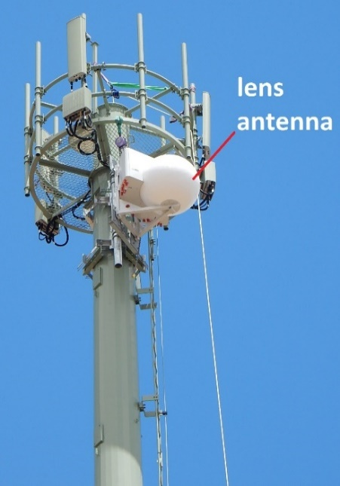

Lens antennas are used to transmit and receive radio signals across the surrounding landscape in a similar way to the panel antennas, which are already being used in the fixed wireless network. However, lens antennas are able to provide more focused coverage and capacity from a single elevation than a standard panel antenna. This is useful when the demand for the facility is coming from a single direction. In this instance, only one lens antenna may be required on a tower, with no need to install any panel antennas.

Lens antennas also increase the ability to co-locate on other carriers’ towers when there is limited available space on the tower at the height needed to provide good coverage. This could reduce the need for new towers. This type of antenna can also be used to increase capacity on towers that have high demand from customers. In these instances, up to three lens antennas could be installed at each elevation on the tower.

##### Issues for discussion

* 10.1—Is lens antenna the best term to describe this type of antenna?
* 10.2—Are 4 cubic metres in volume and 5 metres of protrusion from structures appropriate?
* 10.3—Should this type of antenna be allowed in all areas, or restricted to only industrial and rural areas?

#### 11. Cabinets for tower equipment

##### Proposal—LIFD Schedule, Part 3, Item 2A

If adopted, this amendment would add a new type of facility to the LIFD, a cabinet to be sited near, and used in conjunction with a designated radiocommunications facility (for example a mobile phone or fixed wireless tower). This facility could be up to 3 metres high with a base area of not more than 2 square metres. It must be colour-matched to its background, be of neutral colour (for example, off-white, beige or light grey), or in a colour agreed in writing between the carrier and the relevant local authority.

##### Rationale

Industry is interested in installing a new type of cabinet near fixed wireless towers, which is used to house equipment that controls the radio facilities on the tower. These cabinets also house air conditioning systems for the equipment in the cabinet. These cabinets could be installed in conjunction with new towers, or replace cabinets at existing tower sites. These new cabinets are not covered by any existing items in the LIFD.

While these cabinets are taller than existing cabinets in the LIFD, they are the same height as one type of equipment shelter already in the LIFD, and have much smaller base area. Their use by carriers would be limited by the requirement for them to be used in close proximity to towers or base stations. The visual impact on the community is expected to be minimal because of the similar facilities that can already be installed under the LIFD and the requirement that they be sited near a tower or base station.

##### Issues for discussion

* 11.1—Are there any issues with the proposed new cabinet type?

#### 12. Size of solar panels used to power telecommunications facilities

##### Proposal—LIFD Schedule, Part 3, Item 7

If adopted, this amendment would increase the maximum size of solar panels in rural areas used to power telecommunications facilities to 12.5 square metres. Currently, solar panels are low‑impact facilities if they are up to 7.5 square metres in a rural area.

##### Rationale

Carriers use solar panels to power facilities in rural areas that do not have access to the power grid. They advise that 7.5 square metre solar panels do not generate sufficient energy to power some current generation radiocommunications facilities, and that 12.5 square metres is a more useful size. Requiring planning approvals for suitable panels that are up to 12.5 square metres delays service provision to customers. Given the larger panels could only be installed in rural areas and would most likely only be used in remote areas, the visual impact on the community is not expected to be significant.

##### Issues for discussion

* 12.1—Are there any issues with permitting 12.5 square metre solar panels for telecommunications facilities in rural areas?

#### 13. Length of trench that can be open to install a conduit or cable

##### Proposal—LIFD Schedule, Part 4, Item 1

If adopted, this amendment would allow 200 metres of trench to be open at any time for the installation of conduit or cable in residential areas. Currently, the LIFD allows not more than 100 metres of trench to be open at any time in residential areas to minimise disturbance of residential streets. No limit applies in other areas. The trenches would still need to be closed before additional trenches are opened. Carriers would also still need to ensure that vehicle access to each property is not lost for more than 8 hours in total.

##### Rationale

Since the LIFD was introduced, changes in deployment practices have meant that longer lengths of conduit or cable can be laid in one day. Allowing 200 metres of trench to be open in residential areas would mean that carriers would be able to lay more conduit or cable each day, reducing the days they need to work in an area and reducing disruption to the community. It would also reduce carriers’ costs.

##### Issues for discussion

* 13.1—Are there reasons not to increase the length of trench that can be open at any time from 100m to 200m in residential areas?
* 13.2—Is 200m an appropriate length, or should the length be higher if more than 200m of conduit or cabling can be laid per day and the trench closed?

#### 14. Cable & conduit installation on or under bridges

##### Proposal—LIFD Schedule, Part 4, Item 2

If adopted, this amendment would enable carriers to install cable and conduit on or under bridges as low-impact facilities, including installing cable within existing conduits on bridges. Currently, conduit and cabling cannot be installed on a bridge as a low-impact facility, and carriers must seek the agreement of the relevant state or territory road transport agency.

##### Rationale

Telecommunications carriers have expressed concern that the requirement to seek the agreement of road transport agencies delays the deployment of conduit and cabling and adds to the costs of infrastructure deployment. Carriers would still have to notify bridge owners about planned activities, and bridge owners would still have the opportunity to object to these installations, in accordance with the Act and Tel Code.

Clause 20 of Schedule 3 to the Act requires carriers to ensure that facilities on a bridge are installed in a way that allows passage by people, vehicles and vessels. Clause 10 of Schedule 3 to the Act also requires carriers to take all reasonable steps to ensure that the activities, whether they be inspection, installation or maintenance, interfere as little as practicable with roads, paths and traffic. No changes are proposed to the existing conditions under the Tel Code and the Act relating to bridge activities.

##### Issues for discussion

* 14.1—Are there any issues with allowing cable and conduit on bridges to be low-impact facilities?

#### 15. Volume restrictions on co-located facilities

##### Proposal—LIFD Part 1, Section 1.3 and Schedule, Part 7, Items 2 and 3

If adopted, this amendment would remove the current volume restriction on adding facilities to an existing facility (e.g. a tower) or public utility structure (e.g. a road sign, street lamp, water tank) in commercial areas. Carriers would still be required by the Act to act in accordance with good engineering practice, even though there would no longer be a volume limit in the LIFD. In addition, the amendment would make the volume increase limit higher in residential areas. Carriers would be able to add facilities whose volume is up to 50 per cent of the volume of the original facility or structure to which they are attached, rather than the 25 per cent limit that is currently in place.

| Areas | Current restriction | Proposed restriction |
| --- | --- | --- |
| **Residential** | 25% | 50% |
| **Commercial** | 25% | Nil |
| **Industrial** | Nil | Nil |
| **Rural** | Nil | Nil |

Currently, the LIFD requires that co-located facilities installed on or within an original facility or public utility structure in commercial and residential areas must not exceed 25 per cent of the original volume of the original facility or original infrastructure. This restriction does not apply in rural and industrial areas.

The LIFD defines co-located facilities as one or more telecommunications facilities installed on or within an original telecommunications facility, or a public utility structure. Figure 9 shows examples of co-located facilities on public utility structures. Co‑location volume means the volume of materials that constitute the newly co‑located facilities, or an original facility or a public utility structure, where the materials are visible from a point outside the co‑located facilities, original facility or public utility structure. A proposed note to the definition of ‘located facility’ (item 1 above) will remind readers that a facility cannot be considered a co-located facility if it is not installed in or on and existing facility or public utility structure. That is, a facility on a commercial building is not a co-located facility for the purposes of Section 1.3 of Part 1 of the LIFD.

Figure : Antennas co-located on public utility structures

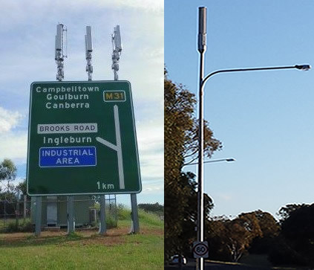

##### Rationale

Carriers advise that the current volume increase limit of 25 per cent for co-located telecommunications facilities in residential and commercial areas is making it difficult for them to co-locate mobile phone network facilities on existing mobile phone towers, and on public utility structures. This can mean that new towers are required when they need to upgrade their networks, increasing the visual impact and costs. It can also mean that it is easier to install facilities on an existing public utility structure at a new site using the LIFD, rather than gaining approval under state or territory planning law to install them on a public utility structure already hosting telecommunications facilities, increasing the number of structures in the community hosting facilities. Schedule 3 to the Act would still require carriers to act in accordance with good engineering practice when installing co-located facilities, regardless of any volume limits.

##### Issues for discussion

* 15.1—Are there any issues with removing volume limits for adding co-located facilities to existing facilities and public utility structures in commercial areas?
* 15.2—Are there any issues with permitting new co-located facilities that are up to 50 per cent of the volume of the original facility or public utility structure in residential areas?
* 15.3—Is another volume limit more appropriate in commercial or residential areas?
* 15.4—Should alternative arrangements for co-located facilities be developed in the LIFD?

#### 16. Updates to environmental legislation references in the LIFD

##### Proposal—LIFD, various

If adopted, these amendments would update references to environment law in Sections 1.3 and 2.5 of the LIFD to reflect changes since the LIFD was drafted.

In addition, minor corrections have been made to the definitions of ‘external building connection equipment’ and ‘internal building connection equipment’ in Section 1.3.

##### Rationale

Environmental laws have been changed without consequential amendments being made to the LIFD. These changes need to be reflected in the LIFD to ensure it is up-to-date.

##### Issues for discussion

* 16.1—Are there any issues with the proposed updates?
* 16.2 —Are there any further suggestions for updates to terms and references in the LIFD?

### Proposed amendments to the Tel Code

The amendments are generally discussed in the order they appear in the marked up version of the Tel Code.

#### 17. Clarify requirements for joint venture arrangements

##### Proposal—Tel Code, Section 1.4(4)

If adopted, this amendment to the Tel Code would clarify that for unincorporated joint venture arrangements where two or more carriers are installing or upgrading facilities, only one carrier’s signature is required on relevant documentation.

##### Rationale

Carriers can operate a joint venture arrangement where mobile telecommunications facilities are jointly built or upgraded, with one carrier leading the project as the ‘lead’ carrier. However, the Tel Code requires all carriers forming part of a joint venture to sign documents relating to proposed Schedule 3 activities, such as site inspection and installation if there are facilities used for each carrier’s network to be installed at a particular site. This results in extra time and costs to obtain signatures from each carrier on documents required by the Tel Code. This change would clarify that only one carrier’s signature is required for documents relating to activities of a carrier joint venture.

##### Issues for discussion

* 17.1—Are there any issues with making it clear in the Tel Code that only one carrier’s signature is required on documents for facilities being installed as part of a carrier joint venture arrangement?

#### 18. LAAN objection periods

##### Proposal—Tel Code, Sections 2.31, 4.32 and 6.31

If adopted, these amendments would change the objection periods in the Tel Code to 5 business days from the receipt of a notice for some types of land entry activities, all low-impact facility installation activities, and all maintenance activities. When objections are lodged, carriers would still be required to try to resolve the objection with landowners and occupiers, and refer the objection to the TIO for resolution if an agreement cannot be reached.

For low-impact facility installations and maintenance activities, carriers must give land owners and occupiers at least 10 business days’ notice of the work. The objection period currently ends 5 business days before the work is scheduled to commence, regardless of when the notice was issued by the carrier. Where carriers only give 10 business days’ notice of planned activities, these amendments would still allow land owners and occupiers to object up to 5 days before work commences. However, where carriers have given longer notice periods, land owners and occupiers would need to lodge an objection during the first five business days after they receive the notice. For example, if a carrier gave a land owner 20 business days’ notice, the land owner would need to object within 5 business days, not 15 business days (i.e. 5 business days before the work) as would now be the case.

For land entry activities such as inspecting and surveying land, carriers are not always required to give landowners notice. Where carriers are required by the Act to give at least 10 business days’ notice to inspect and survey land, Section 2.31 of the Tel Code requires land owners and occupiers to give carriers objections within 9 days of receiving the notice. This can lead to objections being lodged up to the day before the planned land entry activity.

The amendments to Section 2.31 would reduce the objection period from 9 business days after the notice is received to 5 business days after it is received. This would ensure that carriers receive objections at least 5 business days before planned land entry activities, as would be the case for low‑impact facility installations and maintenance activities if the amendments are adopted.

##### Rationale

The current rules allow land owners and occupiers to object to carrier activities shortly before work is due to commence, even after carriers have given them a longer notice period than the 10 business days required by the Tel Code. This can result in significant ‘last‑minute’ stand‑down costs when contractors have been engaged and materials purchased. Carriers would like to reduce the likelihood of such late objections, while still giving people adequate opportunity to object.

##### Issues for discussion

* 18.1—Is it reasonable to end the objection period for low-impact facility activities and maintenance work according to when the notice was issued, rather than the date work is expected to commence?
* 18.2—Is 5 business days from the receipt of a notice a sufficient time period for land owners and occupiers to object to carrier activities where carriers have given more than 10 days’ notice about planned activities?

#### 19. Allow carriers to refer land owner and occupier objections to the TIO

##### Proposal—Tel Code, Sections 2.32, 2.36, 4.32, 4.37, 6.32 and 6.36

If adopted, this amendment would allow carriers to refer land owner and occupier objections to carrier use of powers and immunities to the TIO for resolution at their own discretion. Currently, the Tel Code only clearly allows carriers to refer objections to the TIO at the request of land owners and occupiers.

##### Rationale

Carriers would like to be able to quickly refer disputes over land entry activities to the TIO for resolution. This would be useful when they think it is unlikely that they will be able to resolve the matter directly with the objectors. This proposal would speed up the resolution to the objections. This would also benefit land owners and occupiers because their disputes with carriers could be referred to the TIO for resolution more quickly.

Given that carriers fund the TIO’s dispute resolution, they would still have an incentive to try to resolve objections through direct discussions with land owners and occupiers.

##### Issues for discussion

* 19.1—Are there any issues with allowing carriers to refer objections to the TIO before land owners and occupiers have requested them to?

#### 20. Updates to references in the Tel Code

##### Proposal—Tel Code, various sections

If adopted, these amendments would update the Tel Code to reflect changes to legislation, standards and organisations since the Tel Code was drafted.

References to the Australian Communications Authority and ACA need to be replaced with references to the Australian Communications and Media Authority and ACMA respectively.

References to environment legislation, registers and positions in the Tel Code have been reviewed in consultation with the Department of the Environment and Energy and need to be updated to align them with current environmental law.

References to *Australian Standard AS 2772.1 (1990) Radiofrequency Radiation (Part 1): Maximum Exposure Level-100kHz-300GHz* need to be replaced with references to the *Australian Radiation Protection Standard for Maximum Exposure Levels to Radiofrequency Fields—3kHz to 300GHz (RPS3)*.

Section 1.4 Notification procedures—The timeframe for delivery to an addressee when a notice is sent by post needs to be updated to reflect current standard postal delivery timeframes in Australia. The current delivery timeframes are set out in the table at Regulation 6 of the *Australian Postal Corporation (Performance Standards) Regulations 1998*. This is available at [www.legislation.gov.au/Details/F2016C00078](http://www.legislation.gov.au/Details/F2016C00078).

The rules about notices to land owners and occupiers for land entry activities at Sections 2.23(4) and 2.23(5) need to be updated to reflect the current requirements in clause 17 of Schedule 3 to the Act.

The rules for the height of subscriber connections in Section 3.16 need to be updated to reflect the current standard, *AS/CA S009: 2013 Australian Standards—Installation Requirements for Customer Cabling (Wiring Rules)*.

In the dictionary for the Tel Code, definitions for earth station, sensitive area and station need to be removed because they are no longer used in the Tel Code.

##### Rationale

These changes need to be reflected in the Code to ensure it is up-to-date.

##### Issues for discussion

* 20.1—Are there any issues with the proposed changes?
* 20.2—Are there any further suggestions for updates to the Tel Code?

### Possible amendments to the Act

Telecommunications carriers have also asked the Government to consider some changes to Schedule 3 to the Act. While the proposed changes discussed earlier could be made by the Minister be amending subordinate legislation, changes to the Act would need to be made by the Parliament. Possible legislative amendments have not yet been drafted. As with the other matters in this paper, the Government is seeking community views on these proposals to help it determine whether to proceed with them. Public feedback would guide any future development of legislation to address the proposals. It is general practice to consult on legislative changes if they are proposed.

#### 21. Allowing some types of poles to be low-impact facilities

nbn has requested that poles up to 12 metres high and up to 500 millimetres in diameter, used to support telecommunications and electricity cabling for the National Broadband Network, be specified in the LIFD as low-impact facilities in all types of areas.

The proposal is to amend the definition of tower in the Act so that poles to support telecommunications cabling are not considered towers by the Act. The Act currently defines tower as a tower, pole or mast. The Act prohibits the Minister from specifying towers as low-impact facilities.

If adopted, consequential amendments would also need to be made to the LIFD to give effect to the measure. The LIFD would restrict low‑impact poles to national networks, used, or for use, for the high speed carriage of communications on a wholesale-only and non-discriminatory basis.

##### Rationale

If poles to support telecommunications and electricity cabling for the network are not specified as low‑impact facilities, underground cabling would be required, which is more expensive. Alternatively, development approval from relevant state and territory planning laws to install the poles and overhead electricity cabling would be needed. This would increase costs and delay the rollout in some areas.

The poles would be used to support fibre and copper cables for transit, distribution and service. Poles would also be used to support power cables to connect network facilities such as fixed wireless towers to the electricity network.

##### Issues for discussion

* 21.1—Is it reasonable for poles for telecommunications and electricity cabling for telecommunications networks to be low-impact facilities?
* 21.2—Should low-impact facility poles be allowed in other areas, or be restricted to particular areas?
* 21.3—Is the proposed size restriction of up to 12 metres high with a diameter of up to 500mm suitable?
* 21.4—Would the existing notification and objection processes for land owners and occupiers in the Tel Code be sufficient, or should there be additional consultation requirements?

#### 22. Portable temporary communications facilities

##### Proposal

Carriers would like to be able to install portable temporary communications facilities using carrier powers and immunities. These facilities are used during maintenance of existing facilities, to provide coverage during construction or installation of replacement facilities, and at sporting events, music festivals and other events.

Examples of these facilities include cells on wheels (COWs), satellite cells on wheels (SatCOWs) and mobile exchanges on wheels (MEOW®s). A COW is a mobile cell site that consists of a cellular antenna tower, electronic radio transceiver equipment and a generator on a truck or trailer. It connects to telecommunications networks using microwave links or cables. A SatCOW is similar to a COW, but connects to telecommunications networks using satellite transmissions and includes a satellite dish. Both are then able to provide mobile phone services to users near the cell. For example, COWs are often used during major events such as the Melbourne Cup carnival, New Year’s Eve and music festivals to increase capacity. A MEOW is a portable telephone exchange that can provide temporary landline and broadband services to an area when an exchange is damaged, being repaired, or being replaced. It is usually attached to a trailer and can be quickly transported by truck. Figure 10 shows examples of these facilities.

Figure : COW (L), SatCOW (M), MEOW (R)

(left) Photo of a cell on wheels (COW). There is an orange box sitting on a small trailer with a collapsible mast, and three panel antennas attached to the top of the mast.
(middle) Photo of a satellite cell on wheels (SatCOW). There is a small satellite dish, a small transmitter unit, and a mast, all attached to tripods and sitting on the ground.
(right) Photo of a mobile exchange on wheels. There are several orange boxes sitting on a small trailer.

COWs and SatCOWs typically include radiocommunications antenna masts, which are types of towers according to the Act. The Act does not currently permit towers other than replacement towers to be installed using carriers and immunities. If this proposal proceeds, the Act would be amended to allow these towers used for COWs and SatCOWs to be installed temporarily under certain conditions.

Under New South Wales (NSW) and Victorian state planning laws, temporary facilities such as COWs and SatCOWs may be installed without planning approval in limited circumstances. For example, under Schedule 3A, item 17 of the NSW *State Environment Planning Policy Infrastructure 2007,* temporary telecommunications facilities may be installed without a planning permit to provide service or coverage during routine maintenance to existing facilities, during construction or installation of replacement facilities or to provide additional coverage at events. Conditions on the installations are that the building or site where the facility is to be located is not left in a substantially different condition than it was prior to installation; and the facility is to be removed within 28 days of the end of the need for the facility. *A Code of Practice for Telecommunications Facilities in Victoria* also grants planning permit exemptions to temporary telecommunications facilities in some circumstances.

If the Act was amended to permit temporary facilities to be installed subject to appropriate conditions, the NSW and Victorian policies could be models for the conditions in the Act. This would enable a consistent approach to these facilities nationally.

##### Rationale

COWs and SatCOWs require local government planning approval in many jurisdictions. Carriers are often required to obtain development approval from local governments to temporarily install these facilities, which increases costs and timeframes for deployment, and affects the business case for their use. The inability to provide temporary facilities can mean there is insufficient capacity for customers to connect to mobile networks during major events.

Unlike COWs and SatCOWs, MEOWs can be installed in emergencies using Part 6 of the Schedule to the LIFD. During non-emergency network maintenance activities, it may also be possible to install MEOWs using the carrier maintenance powers under Schedule 3 to the Act, even though they are not included in the list of examples at subclause 7(3) of Schedule 3. The Act could be amended to remove any doubt about the ability for carriers to temporarily install MEOWs as part of maintenance activities.

##### Issues for discussion

* 22.1—Are there any issues with making portable temporary communications equipment exempt from state and territory planning approvals under certain conditions?
* 22.2—Are there any suggestions for appropriate conditions for the installation of COWs and SatCOWs, such as circumstances in which they can be used and timeframes for their removal?
* 22.3—Should the Act be amended to remove any doubt that MEOWs can be installed using the maintenance powers or another power under Schedule 3 to the Act?
* 22.4—Are there any suggestions for appropriate conditions for the installation of MEOWs if the maintenance powers are amended?

#### 23. Replacement mobile towers

##### Proposal

Carriers would like to be able to install replacement towers within 20 metres of the original tower, with carriers required to decommission and remove the original tower within 12 weeks. The replacement tower would need to be constructed on the same lot or a neighbouring lot under the same ownership. The Act would still require carriers to act in accordance with good engineering practice, protect the safety of persons and property, minimise interference with other activities and protect the environment.

The maintenance provisions in Part 1, Division 4 of Schedule 3 to the Act currently require replacement towers to be located in the original location. State, territory and local government planning approvals are not required for replacement towers that comply with these maintenance provisions.

##### Rationale

Currently, carriers wanting to use the powers in the Act to replace towers are required to decommission and demolish the existing tower prior to building a new tower on the same site. They must use any other nearby existing facilities to provide services to customers during this time. As discussed in Proposal 22 above, portable temporary communications equipment such as COWs can be used but require development applications in many states and territories. Temporary equipment is not always available, which can result in temporary loss of coverage for customers.

The proposal would enable a carrier to maintain coverage and services for customers while the old tower is decommissioned and demolished.

##### Issues for discussion

* 23.1—Is the proposal reasonable?
* 23.2—Is 20 metres a suitable distance restriction for replacement towers?
* 23.3—Is 12 weeks a reasonable maximum time period for installation of replacement towers?

#### 24. Tower height extensions

##### Proposal

Carriers have asked to be able to extend existing towers by up to 10 metres in commercial, industrial and rural areas without the need for state and territory planning approvals. The Act would also be amended to clarify that if a tower was previously extended by less than 10 metres, further extensions can occur up to a maximum of 10 metres higher than the original height of the structure before any extensions occurred. If this proposal proceeds, carriers would only be able to use this power if the tower has not previously been extended, or was extended by less than 10 metres.

The Act currently allows extensions to towers of up to 5 metres, if the tower has not previously been extended. If this proposal is adopted, consequential amendments would need to be made to Item 9 of Part 1 of the Schedule to the LIFD after the legislation is passed to fully implement the proposal.

##### Rationale

Height extensions allow carriers to place more antennas and associated equipment on each tower, better catering for the increasing demand for mobile telecommunications services, and at a lower cost. This would improve carriers’ ability to co-locate their equipment with other carriers’ equipment on existing towers and reduce the need for carriers to build new towers.

##### Issues for discussion

* 24.1—Are one-off 10 metre tower height extensions suitable in commercial, industrial and rural areas, or only some of these areas? If they are only suitable in some areas, which are they and why?

## How to make a submission

We welcome your views on the proposed amendments. Submissions should:

* identify:
* the name of the party making the submission
* the organisation represented (if applicable)
* contact details, including telephone number, postal and email address
* confirm whether or not your submission can be made public—published—or kept confidential if it contains confidential information
* be submitted:
* through the [Have your say](https://www.communications.gov.au/have-your-say) link on our website, or
* by email to [powersandimmunities@communications.gov.au](http://ims.dept.gov.au/tccache03/4419003/powersandimmunities@communications.gov.au), or
* by mail to:  
  Director, Construction Policy  
  Department of Communications and the Arts  
  GPO Box 2154  
  CANBERRA ACT 2615
* be lodged by 21 July 2017.

A submission template is available on the Department’s website for those who wish to use it. If you would like to comment on specific proposals we would be grateful if you could refer to their number in the consultation paper and/or the relevant provisions in the LIFD or Tel Code.

### Publication of submissions

In general, we publish submissions we receive. We will not publish a submission or part of a submission if we consider material is defamatory or otherwise unlawful or to be unsuitable for any other reason.

We prefer to receive submissions that are not claimed to be confidential. However, we accept that a submitter may wish to provide information in confidence. In these circumstances, submitters are asked to identify the material over which confidentiality is claimed and provide a written explanation for the claim. We will consider each confidentiality claim on a case-by-case basis. If we accept a claim, we will not publish the confidential information unless authorised or required by law to do so.

We will acknowledge receipt of submissions if they are submitted through the ‘Have your say’ button above. We may not acknowledge submissions emailed or mailed to us.

### Release of submissions where authorised or required by law

Any submissions provided to us may be released under the *Freedom of Information Act 1982* (unless an exemption applies) or shared with other Commonwealth Government agencies or certain other bodies. We may also be required to release submissions for other reasons including for the purpose of Parliamentary processes or where otherwise required by law (for example, under a court subpoena). While we seek to consult submitters of confidential information before that information is provided to another party, we cannot guarantee that confidential information will not be released through these or other legal means.

### Contact us

For further information about carrier powers and immunities or the proposed amendments in this consultation paper, please contact us using the email address above or by phoning **02 6271 1000** and asking for the Director, Construction Policy.

## Glossary

**ACMA**—Australian Communications and Media Authority—the telecommunications-specific industry regulator dealing with carrier powers and immunities issues ([www.acma.gov.au](http://www.acma.gov.au)).

**the Act**—*Telecommunications Act 1997*.

**ARPANSA**—Australian Radiation Protection and Nuclear Safety Agency—the agency responsible for setting the exposure standard for radiofrequency electromagnetic energy (RF EME) ([www.arpansa.gov.au](http://www.arpansa.gov.au)).

**Carrier—**the owner of a network unit used to supply carriage services - such as telephony or internet - to the public. Must hold a carrier licence from the ACMA in accordance with the Act.

**Commercial area (LIFD)**—an area where its principal designated use is for commercial purposes.

**Communications Alliance**—the peak industry body for the Australian communications industry ([www.commsalliance.com.au](http://www.commsalliance.com.au)).

**the Department**—the Department of Communications and the Arts ([www.communications.gov.au](http://www.communications.gov.au)).

**Industrial area (LIFD)**—an area where its principal designated use is for industrial purposes.

**Mobile Base Station Deployment Code**—Industry Code for Mobile Phone Base Station Deployment C564:2011 ([www.commsalliance.com.au/Documents/all/codes/c564](http://www.commsalliance.com.au/Documents/all/codes/c564)).

**Internet of Things**—a technology concept whereby everyday objects (e.g. cars, bus stops, street lights, sensor, monitors) are connected to the internet to enhance functionality.

**LAAN**—Land Access Activity Notice—a notice issued by telecommunications carriers seeking entry to land to conduct activities authorised by Schedule 3 to the Act.

**LIFD**—*Telecommunications (Low-impact Facilities) Determination 1997*.

**nbn**—NBN Co Limited, the company building the National Broadband Network, a high‑speed broadband network being constructed for the Australian Government ([www.nbnco.com.au](http://www.nbnco.com.au)).

**Residential area (LIFD)** —an area where its principal designated use is for residential purposes, and parts of built-up areas that cannot otherwise be described as a commercial, industrial or rural area.

**RF EME**—radiofrequency electromagnetic energy.

**Rural area (LIFD)** —an area where its principal designated use is for rural purposes, and areas not part of built-up areas that cannot otherwise be described as a commercial, industrial or residential area.

**Schedule 3**—Schedule 3 to the *Telecommunications Act 1997*, which sets out carrier powers and immunities.

**Tel Code**—*Telecommunications Code of Practice 1997*.

**TIO**—Telecommunications Industry Ombudsman—the independent dispute resolution service for telecommunications consumers, which also covers some powers and immunities issues ([www.tio.com.au](http://www.tio.com.au)).

1. Bureau of Statistics (ABS), *8153.0 – Internet Activity, Australia, December 2016* at [www.abs.gov.au/ausstats/abs@.nsf/mf/8153.0](http://www.abs.gov.au/ausstats/abs@.nsf/mf/8153.0)
2. Ibid.
3. ‘Mobile cellular subscriptions (per 100 people)’, International Telecommunication Union, World Telecommunication/ICT Development Report and database. <http://data.worldbank.org/indicator/IT.CEL.SETS.P2?end=2014&locations=AU&start=1997>