

OUR NORTH | OUR FUTURE

Developing Northern Australia  
2017 Implementation Report

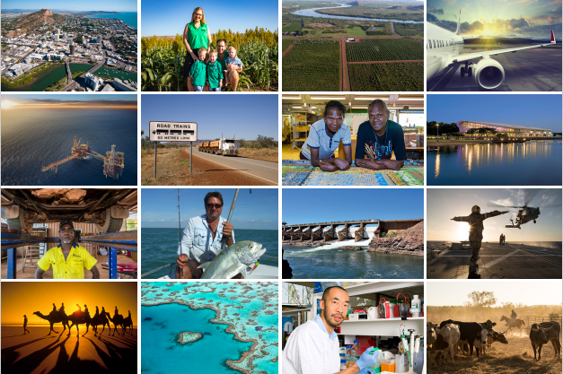

**northernaustralia**.gov.au

Key pillars of the northern Australia agenda

Key pillars of the northern Australia agenda

The *Our North, Our Future* White Paper on Developing Northern Australia sets out the priorities for driving progress and growth in the north.

The priorities are support for:

* a northern trade and investment gateway
* a diversified economy
* Indigenous entrepreneurs and businesses
* world-class infrastructure
* investment in water infrastructure
* world-leading research and innovation

*Cover images:*

*Top, 2nd left: The Gray family, Ceres Farm, WA.*

*2nd row left: Woodside North Rankin Complex, WA. Photo © woodside.com.au.*

*2nd row centre: Margaret Apuatimi & Carmel Therese Kantilla, Bima Wear Wurrumiyanga, Bathurst Island, NT.*

*3rd row left: Charlie Tapim, Ironbark Aboriginal Corporation, Wadeye, NT.*

*3rd row second left: Andrew Bates catching Trevally, Arafura Sea.*

*Bottom, 3rd left: HOT NORTH’s Steven Tong.*

Working in partnership

This report was produced in October 2017 by the Australian Government’s Office of Northern Australia.   
Visit: [*northernaustralia.gov.au*](http://www.northernaustralia.gov.au/) | 08 8923 4403

The office is working to deliver the Australian Government’s northern agenda in partnership with agencies and organisations including:

1. Attorney-General’s Department
2. AusIndustry
3. Australian Trade and Investment Commission
4. Cooperative Research Centre for Developing Northern Australia
5. Department of Agriculture and Water Resources
6. Department of Defence
7. Department of Education and Training
8. Department of Employment
9. Department of the Environment and Energy
10. Department of Foreign Affairs and Trade
11. Department of Immigration and Border Protection
12. Department of Industry, Innovation and Science
13. Department of Infrastructure and Regional Development
14. Department of the Prime Minister and Cabinet
15. Government of Western Australia
16. Interdepartmental Committee on Northern Australia
17. Joint Standing Committee on Northern Australia
18. Major Projects Facilitation Agency
19. Ministerial Forum on Northern Development
20. Northern Australia Advisory Council
21. Northern Australia Infrastructure Facility
22. Northern Australia Senior Officials Networking Group
23. Northern Australia Strategic Partnership
24. National Health and Medical Research Council
25. Northern Territory Government
26. Queensland Government
27. The Treasury

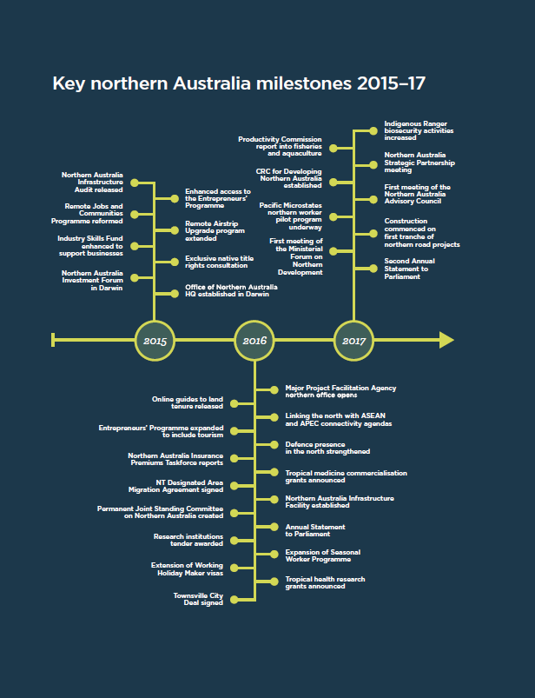

Overview

The Australian Government released *Our North, Our Future*, the first ever White Paper on Developing Northern Australia in June 2015.

The White Paper outlines a vision of a strong north where northern Australia’s great potential is unlocked, with benefits flowing to all Australians.

It is a 20-year implementation schedule that involves 51 measures, backed by government investment of over $6 billion.

Now, two years into the implementation plan, over half of the White Paper’s 51 measures have been delivered and the remaining are well underway.

*Northern priorities*

The government’s northern agenda has created an environment that encourages investment and diverse business growth, including for Indigenous businesses and communities.

Investment forums are an important element of this work—they bring international and domestic investors to the north to meet business people and community leaders and view investment opportunities.

Through this agenda, improvements have been made to ensure northern businesses have access to the skilled and unskilled labour needed to drive the region’s economy.

To underpin the growth of the north, the government has invested in improved infrastructure across the region, with a focus on roads, rail, aviation and water infrastructure.

Smart Cities Plans are already making a difference in Townsville and are under development for Darwin. They support vibrant and productive northern city centres and communities.

The government has also invested in world-class industry-led innovation and research to grow the role of the north as a centre of globally competitive businesses and excellence in tropical medicine.

*Northern partnerships*

Unlocking the north’s full potential is not without challenges. Much of the work needed to make the vision of a stronger north a reality involves long-term commitment and a united effort across governments, industry and the community.

The structures to achieve this long-term, joint endeavour are now in place. The government’s Office of Northern Australia is actively leading the implementation of the northern agenda, in close collaboration with 27 partners.

Critical coordination and collaboration to make the north an easier and more productive place to live and do business is taking place at all levels.

This includes the Northern Australia Strategic Partnership, led by the Prime Minister, the Ministerial Forum on Northern Development and the Northern Australia Advisory Council, which is drawn from the north’s local council, industry, Indigenous, farming, education and scientific sectors.

Strong working relationships have also been forged with key northern stakeholders including the Northern Regional Development Australia Alliance.

Indigenous leadership and involvement is critical to the continued success of this agenda and the participation of senior Indigenous leaders from across northern Australia at the 2017 Ministerial Forum on Northern Development was an important step forward in achieving this.

Expert boards are now in place for the Northern Australia Infrastructure Facility and the new Cooperative Research Centre for Developing Northern Australia, adding to the network of good governance and expertise that is serving the interests of the north.

*3*

A trade and investment gateway

Northern Australia’s proximity to Asia and other international trading partners makes it a critical global gateway for the nation.

The government’s northern Australia agenda has created an environment that encourages investment and business in the north, including by building better physical and institutional links across and into the region, so that goods, services and people can move quickly and efficiently across borders.

*Investment and business*

To increase investment in the north, the government hosted the 2015 Northern Australia Investment Forum in Darwin, which bought together international and domestic investors and northern producers and businesses. The forum was attended by more than 350 global investors from over 20 countries and the Australian Trade and Investment Commission continues to monitor post-forum investment outcomes and ongoing interest from international investors.

The Ministers for Resources and Northern Australia and Trade, Tourism and Investment will host the second Northern Australia Investment Forum in Cairns in November 2017.

The 2017 forum will focus on resources and energy; food and agribusiness; and tourism investment opportunities. It will bring global investors together with northern companies and entrepreneurs, particularly on early-stage and greenfield ventures. It will also showcase successful and potential Indigenous investment projects with land holders available to engage directly with investors on specific projects.

Stronger connections have been forged with our regional neighbours and links between northern Australia and the Association of Southeast Asian Nations (ASEAN) and the Asia-Pacific Economic Cooperation (APEC) connectivity agendas have been strengthened. The White Paper has provided $2.5 million in development assistance to enhance business links between Australian businesses and Papua New Guinea and Timor-Leste, with Indonesia also to participate.

The government has built on the success of its “single point of entry” for major projects in northern Australia by establishing the Major Projects Facilitation Agency Darwin office. The agency is assisting 19 projects across northern Australia in industries like resources, energy and aquaculture that represent an estimated CAPEX value of approximately $120 billion.

*Free Trade Agreements*

Australia’s Free Trade Agreements with China, Japan, Korea and ASEAN members, are providing new opportunities for northern Australian producers and businesses to scale-up and export—be it a West Australian melon producer or a Queensland fashion designer. Opportunities to increase our exports from the north are immense, from horticulture to higher education, from advanced manufacturing to tourism.

In 2016, Australian exports of fresh and chilled boneless beef to South Korea increased by over 57 per cent, to Japan by over 22 per cent and to China by over 12 per cent compared to the year before Free Trade Agreements came into force with these countries.

*Insurance*

Ensuring personal and business insurance is affordable in the north will support new investment and population growth. A taskforce has been established to look at options to reduce the cost of home and contents insurance in northern Australia. The Australian Competition and Consumer Commission has commenced a three-year inquiry to monitor and report on the market for home, contents and strata insurance in northern Australia. The commission will publish an annual public report at the end of each financial year.



A diversified economy

Building a more diversified economy is critical to unlock the north’s full potential.

The government is creating an environment in the north where entrepreneurs and small businesses and a range of diverse industries such as agriculture, tourism and resources thrive.

Three Developing Northern Australia conferences, held in Townsville in 2015, Darwin in 2016 and Cairns in 2017, have brought together key stakeholders with a focus in 2017 on progress, growth and investment.

The government’s Entrepreneurs’ Programme is supporting small and medium businesses in the north through management advice and business grants. These services have been extended to an additional 500 northern businesses.

The Entrepreneurs’ Programme has supported Paspalis Enterprises to operate Darwin’s first innovation hub to assist Northern Territory start-ups succeed in international markets, particularly in the Asia Pacific and China.

The programme is also providing tailored support to northern tourism businesses through the $13.6 million Northern Australia Tourism Initiative.

The Australian Parliament’s Joint Standing Committee on Northern Australia is well progressed in examining the tourism potential of the north through its Inquiry into Opportunities and Methods for Stimulating the Tourism Industry in Northern Australia.

The north has been and will continue to be the backbone of Australia’s mining and resources sector.

To secure future investment in this sector, the Australian Government’s $100.5 million Exploring for the Future program will help industry target areas likely to contain the next major oil, gas and mineral deposits.

Led by Geoscience Australia, the collection of pre-competitive geoscience data in the north (and parts of South Australia) began in the second half of 2016 and will conclude in 2020. This data is being progressively released through the Geoscience Australia website.

*A stronger workforce*

Employers across the north’s diverse industries need a reliable source of labour to ensure they have the right staff in place through peak and low seasons.

To support a vibrant diversified economy, significant work has taken place to grow a sustainable supply of skilled and unskilled labour in the north.

Two White Paper initiatives have contributed: the Pacific Microstates Northern Australia Worker Pilot and the Seasonal Worker Programme. The Skilling Australians Fund has also helped to build a stronger labour pool for the north and will continue to provide assistance.

*A growing defence force presence*

Australia’s defence industry already contributes almost 7 per cent of economic growth across the Top End and the Australian Defence Force’s strong presence and investment in the north will continue to fuel regional growth.

Over 20 years, the defence force is investing $20 billion to upgrade defence facilities in the Northern Territory; $930 million to upgrade facilities and infrastructure in Western Australia; and $8 billion over ten years to build new or strengthen existing infrastructure and introduce a fleet of lightly armed boats in Queensland.

Northern defence infrastructure and assets will include new strike and patrol aircraft as well as the Landing Helicopter Docks, Australia’s largest ever warships. The increasing presence of US Marine rotations within northern Australia is also stimulating the development of additional infrastructure and base capacity.

The defence force is working with local businesses to encourage their participation in defence projects and to ensure local contractors and suppliers are considered for major construction projects. At RAAF Base Tindal near Katherine, work to build new air combat capability has supported local jobs and works packages for local sub-contractors.

*Case study: Ceres Farm*

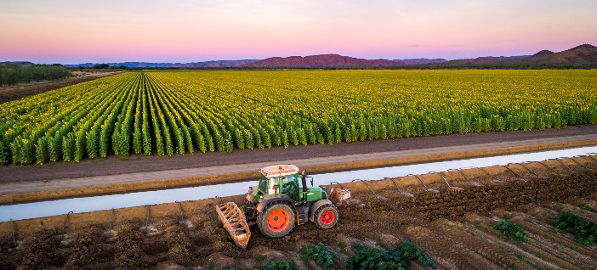

For seven years, Melanie and Matt Gray have made a life and living for themselves and their three young boys near Kununurra in the northwest of Western Australia.

On their Ceres Farm, they are making the most of the region’s water supplies and rich soil to produce watermelons, pumpkins, sweetcorn, and grain crops such as sunflower, maize, sorghum, chickpeas and mung beans.

“Farming in the north is great because the opportunities on offer are endless and every year we trial growing something new—it’s what gets us out of bed every day,” says Matt.

Melanie is a second generation Kununurra farmer, with her parents Wilhelm and Gabi Bloecker moving to the East Kimberley in the early 1970s. Matt, who hails from the south, says the reliable supply of water from the Ord River Irrigation Scheme was key to he and Melanie establishing their family business in the north.

“For us as investors and horticultural farmers, secure water is number one,” he says.

The Grays say living remote—they are over 3,000 kilometres from the state capital Perth—can be challenging, especially managing the costs and time involved in freighting equipment and supplies into their farm and getting their fresh, high-quality products out to markets, including overseas.

Another challenge can be securing a reliable and predictable supply of labour, especially across peak seasons when it is critical to harvest and pack produce within tight time limits.

“Previously we were relying mainly on backpacker labour,” says Melanie. “It could be unreliable and at times we’d be short of staff unexpectedly and had to do a lot of training, which was hard on the business.”

Now, where needed, they are employing workers from Timor-Leste for periods of up to six months with support from the Australian Government’s Seasonal Worker Programme, which has allowed them to establish a more reliable workforce.

The Grays have had cultural advice and assistance from local consultants on how to make the employment of East Timorese workers a success, and up to eight East Timorese staff now work on Ceres Farm alongside 15 other casual and permanent staff during busy periods.

While Kununurra, which is home to about 7,000 people, is remote, the Grays say it is not isolated.

“It is a small town but because it is remote we have a very strong community and a lot of support,” says Melanie.

“In a community like this you are a part of the netball team, the football and soccer clubs and there is just so much on offer. We rely on and help each other and are like a big close knit family.”

The town is home to a diverse range of industries, such as mining, agriculture, tourism and government services.

“We love living and working here and being able to grow our children up in such a beautiful, natural environment,” Matt says. “The Kimberley is renowned for its huge red ranges and they border our farm, so when you take five minutes to look up it is breathtaking.”

“We love what we can teach our children here and are very lucky to be working and living in this community.”

Read more at *northernaustralia.gov.au* and *ceresfarm.com.au*.

*Image: Ceres Farm, East Kimberley, WA.*

*Case study: Small World Journeys*

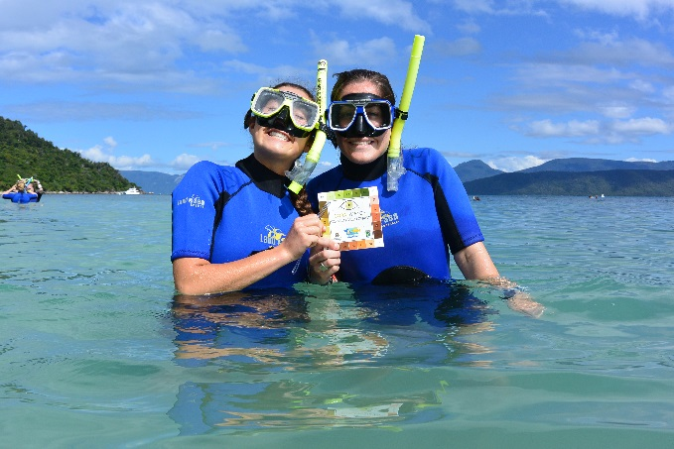

Previously working in the US travel industry, Laurie Pritchard spotted northern Australia as an ideal place to set up her own edu-tourism business—Small World Journeys.

Cairns was an obvious choice for Laurie—she saw the area as a “paradise” with its pristine natural assets and rich Indigenous culture.

“The Cairns region and surrounds have so much to offer visitors—the climate is amazing and there is so much natural beauty and endemic flora and fauna,” she says.

“Go west and you find the outback, red dirt, kangaroos and cattle stations. Go north and you’re in untouched tropical rainforest. Or go east and you’re out in clear waters on the World Heritage listed Great Barrier Reef. There is so much diversity within a short radius of Cairns.”

The Australian Government’s Entrepreneurs’ Programme has provided business advice to Small World Journeys through the Northern Australia Tourism Initiative, which Laurie says has opened doors and helped her company’s long-term business development.

As the 2017 Cairns Small Business Woman of the Year and a state finalist in the Institute of Managers and Leaders Owner/Entrepreneur category, Laurie recognises the strong potential for tourism across northern Australia.

She says Cairns is a tourism driven town that makes the most of its natural advantages and values the flow-on benefits of year round visitors.

Small World Journeys, which Laurie established in 2008, sets itself apart from other tour companies by offering educational experiences for high school and university students that combine fun and adventure with learning.

“Our company tailors every tour to match the needs of the curriculum and the specific educational requirements of each group. There are other tours out there but ours is the only one that I know, that has the learning and new knowledge of participants at its heart,” Laurie says. “It is more than just sightseeing with us.”

The company’s tours focus on Aboriginal culture and the natural sciences and include coral reef, marine, biology, community service and sustainability studies. The company has strong partnerships with local suppliers such as two Aboriginal brothers who have a tour business sharing their culture and showing students how to catch seafood the traditional way. The company also engages researchers, wildlife experts, farmers and scientists, all with local knowledge and expertise.

“There are a lot of grass roots tourism ventures up here and people are really connected to land and country,” Laurie says.

Read more on the Entrepreneurs’ Programme at *business.gov.au* and on Small World Journeys at *smallworldjourneys.com.au.*

*Image: US students on a Small World Journeys reef tour, QLD*

World-class infrastructure

Building better infrastructure is critical to making living and doing business in the north easier and more productive.

Our northern regional and remote communities need better roads, rail links, airports and telecommunications so they can stay connected, travel safely, access health and education services and run their businesses, regardless of the season.

Better infrastructure allows our farmers, miners and other producers to get their products to markets more easily and reliably; and will help grow the tourism industry.

Infrastructure Australia’s 2015 Northern Australia Infrastructure Audit identified key pinch points and infrastructure needs across all northern jurisdictions and the three northern governments have identified additional priority northern road projects.

*Improving key supply chain and network roads*

The government has committed $700 million to construct 38 high-priority road projects across the north to create quicker, safer and more reliable transport links for residents, tourists, producers and businesses.

This includes approximately $280 million for Queensland, $222 million for the Northern Territory and $184 million for Western Australia. Funding is available over four years from 2016–17 to 2019–20, with works already underway on some key projects.

The Northern Australia Roads Programme will improve the safety and productivity of roads in Queensland, Western Australia and the Northern Territory. The Northern Australia Beef Roads Programme will improve the reliability and efficiency of cattle supply chains in the north, better linking producers to markets and reducing freight costs.

With 11.7 million cattle in northern Australia, 45 per cent of the national herd, and cattle exports worth almost $3 billion a year—these road upgrades are critical.

A key feature of the Beef Roads Programme is the use of CSIRO’s Transport Network Strategic Investment Tool (TraNSIT) to support scenario analysis and the prioritisation of proposed road upgrades, to maximise cost savings and returns on investment.

Work is also continuing on other vital northern Australian roads, which will continue through to 2023. For example, the government is investing $100 million to upgrade the Outback Way which is an essential east–west link across the heart of Australia and has committed up to $6.7 billion over ten years for Queensland’s Bruce Highway Upgrade project.

The $7.88 million joint Australian and Northern Territory governments’ Plenty Highway project in the lower Barkly region will upgrade a vital regional route for the cattle industry, local communities and tourists.

*Better roads: connecting the north*

The northern roads programme includes a commitment of $700 million across 38 road projects to improve safety; community access to services; and better connect communities and producers to domestic and international markets.

This investment includes the Northern Australia Roads Programme:

* five projects worth $192.19 million in the Northern Territory
* ten projects worth $223.8 million in Queensland
* five projects worth $171.81 million in Western Australia.

And, the Northern Australia Beef Roads Programme:

* two projects worth $30 million in the Northern Territory
* fifteen projects worth $56.87 million in Queensland
* one project worth $12.51 million in Western Australia.

Work underway:

* Hann Highway) in Queensland, with the first stage to be completed by early 2018 and the final stage by late 2019, weather permitting
* In August 2017, works to upgrade seven culverts commenced on Queensland’s Flinders Highway between Charters Towers and Richmond.
* Works have been contracted for the construction of a $38.49 million bridge over Bow River in the Kimberley.

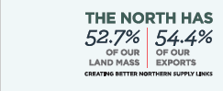

*Northern Australia Infrastructure Facility*

The government’s Northern Australia Infrastructure Facility (NAIF) is a fundamental driver of economic and population growth in the north. In partnership with other lenders, the NAIF provides finance for infrastructure projects that will help transform and provide public benefit for northern Australia.

The NAIF board is leveraging its Investment Mandate to catalyse private sector interest in northern Australian infrastructure by complementing, not competing with, the finance sector. This will enable eligible projects to proceed, or proceed much earlier than they would otherwise, thereby accelerating the economic and public benefit of development.

Examples of eligible projects include ports, airports, railways, roads and communication, energy, pipeline, water network, multi-user supply chain infrastructure and training facilities. Infrastructure attached to or embedded in a broader project is also eligible for NAIF finance.

NAIF’s independent, expert and commercially focused board decides which projects receive finance based on comprehensive due diligence assessments.

Fifty-five of the enquiries received by NAIF were active at the time of publication, 10 projects were in the due diligence stage. These projects are across all three northern jurisdictions and a range of sectors: renewables, transport, resources and tourism. This is significant progress given the long lead times for infrastructure projects and the comprehensive assessments undertaken by the NAIF.

Updated information on NAIF and its investment pipeline is at *naif.gov.au*.

*Upgrading remote airfields*

The government has invested over $15 million to upgrade remote northern airstrips to improve northern Australian’s access to essential medical and education services, fresh foods, and employment, particularly during the wet season.

Twenty-two northern Australia Remote Airstrip Upgrade program projects have been completed, 25 are on schedule and a further funding round is in progress.

*Our*

*Case study: Genex Power*

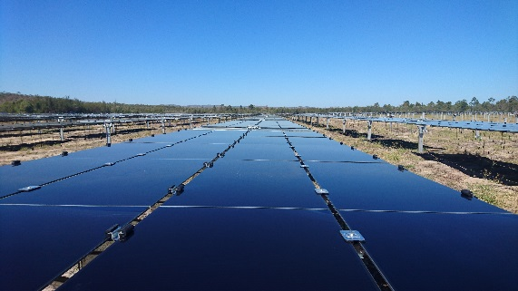

A 100-year-old gold mine, 270 kilometres northwest of Townsville in Queensland, is now home to one of Australia’s most exciting energy projects—Genex Power’s $1 billion Kidston solar and pumped hydro energy hub.

Supported by ARENA and the Clean Energy Finance Corporation, the project has been designated as critical infrastructure by the Queensland Government and Stage Two is in full due diligence for potential support from the Northern Australia Infrastructure Facility.

The project is transforming a remote site, which was once Australia’s largest gold mine, into a 21st century renewable energy hub. It will use the valuable infrastructure left behind after the mine’s closure and the region’s high solar radiation levels to supply the national electricity grid via Townsville.

By 2021, the Kidston facility will be using around 3.5 million solar panels and two water reservoirs to sustainably generate, store and transmit reliable and affordable power.

Stage One of the project will supply 50 megawatts of power by the end of 2017, enough to power 26,000 homes. Stage Two, scheduled to commence in June 2018, in a world-first, will use pumped hydro to store solar generated power, with the capacity to produce 520 megawatts of power, enough to supply over 200,000 homes.

“Our energy project will assist the supply of affordable and reliable power in the north Queensland region and into the national grid,” says Genex Power’s Executive Director Simon Kidston.

“We will be able to provide reliable, renewable energy on tap during peak demand periods, supressing power prices and stabilising the grid.”

“Our project will encourage other renewable energy projects to start up nearby and will open up opportunities for other businesses.”

The legacy of the old gold mine to the Kidston project includes an existing airstrip, good road access to Townsville and Cairns, onsite accommodation, electricity transmission lines into the national grid via Townsville and permits and regulatory approvals.

The jewel in the project’s crown is two 300-metre-deep disused mine pits situated in very stable, hard rock. They will be used for pumped hydro, creating a giant ‘water battery’ so that the solar power generated when it is sunny can be stored and supplied to the national grid during peak demand periods.

“Pumped storage hydro, which is in use, for example in the Snowy Hydro scheme, makes intermittent solar power available as and when required which is what the grid needs up in north Queensland,” Mr Kidston says.

“We will use the two pits or reservoirs, an upper pit and a lower pit. Solar power will be used to pump water to the upper pit, and hydro power will be generated when we drop the water down into the lower pit.”

Already 35,000 solar panels are being installed on the Kidston site each week, and what was once a mining ghost town, is now thriving.

One hundred and twenty workers are employed on the project with the majority living onsite, and that figure will rise to 500 in Stage Two, with a remaining 25 to 30 people required to manage the facility in the long term.

“We want to provide jobs to surrounding, local communities,” Mr Kidston says.

“Pumped storage hydro facilities have very long lives so this asset should still be operating for 100 years or more, underpinning stable power supply in the north.”

Read more at *northernaustralia.gov.au* and *genexpower.com.au*

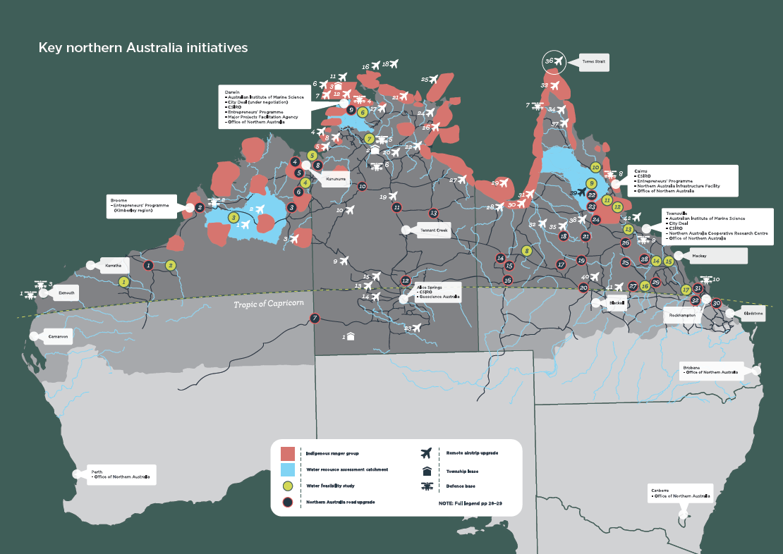

*Stronger communities and vibrant cities*



The northern agenda is supporting the development of strong and resilient communities that attract workers, families, businesses and investors because of the great opportunities they offer. City Deals help to develop productive, accessible, liveable cities that encourage innovation and create opportunities for residents. They support job creation, economic growth, investment in local infrastructure and urban revitalisation.

The 2016 Townsville City Deal involves the construction of the North Queensland Stadium which is already underway; the Townsville Eastern Access Rail Corridor rail freight line; and investment in new renewable energy projects.

Three major associated public–private joint investment projects are the Ross River Solar Farm, Kidston Solar and Pumped Hydro Project and the Kennedy Energy Park. In May 2017, the Australian and Northern Territory Governments agreed to work together to create a Darwin City Deal and progress to negotiate the deal is underway.

The government’s Building Better Regions Fund and the $472 million Regional Growth Fund are delivering improvements in the north as well. The north is receiving $57 million in the first round of Building Better Regions Fund grants which support projects that will create jobs, drive economic growth and build stronger regional communities.

For example, the Top End Association for Mental Health has received $1.9 million to construct a new mental health facility in Darwin containing rehabilitation and transitional housing elements.

*Image: Artist’s impression of the North Queensland Stadium in Townsville. Part of the Townsville City Deal, it is a joint project of the Queensland Government, the Australian Government and the Townsville City Council and is supported by the National Rugby League and the North Queensland Cowboys. Construction will support 750 design and construction jobs, Indigenous employment opportunities and maximise local procurement.*

High-quality water infrastructure

The availability of water is a major driver of economic activity, particularly for key northern industries like agriculture, aquaculture, mining, energy and tourism.

While this region receives more than 60 per cent of national rainfall, it is highly seasonal and capturing and utilising it is challenging.

Because it is vital to understand what the best solutions are to make northern water supplies more sustainable, the government has invested $25.5 million in 15 water infrastructure feasibility studies in the north.

The government is also investing $15 million for the CSIRO to conduct northern water resource assessments. The CSIRO assessments are actively involving northern jurisdictions, research partners and communities and will mean we will have a better understanding of how much water is available across the north and where it should be captured and stored to underpin the region’s growth.

“These CSIRO studies are identifying and evaluating: soil and water resources; water capture and storage options; the commercial viability of irrigated agriculture opportunities; and the potential impacts and risks of water resource and irrigation development,” says CSIRO Project Director, Dr Chris Chilcott.

The government has also committed $130 million to co-fund the construction of the Rookwood Weir on the Fitzroy River, west of Rockhampton, which has the potential to kick-start an agricultural boom in central Queensland. The project, which has already obtained Commonwealth environmental approval, would create 2,000 jobs and boost agricultural production by more than $1 billion.

The feasibility studies and the investment in Rookwood Weir are part of the government’s $500 million funding commitment under the National Water Infrastructure Development Fund. Around $147 million in funding remains available for water infrastructure investments under the capital component of the fund, including a minimum of $40 million for investments in northern Australia.

Governments in northern Australia can also partner with the Australian Government through the National Water Infrastructure Loan Facility which is providing a further $2 billion in concessional loans for the development of water infrastructure.

*Investing in water resources*

Under the National Water Infrastructure Development Fund, 15 water feasibility studies are underway across northern Australia:

1. three in Western Australia
2. one in the Northern Territory
3. one across the Northern Territory and Western Australian borders
4. ten in Queensland.

Under this initiative:

1. the Oakover Valley Irrigation Pre-feasibility Study in Western Australia was completed in April 2017
2. nine feasibility studies are on track to be completed by April 2018
3. five feasibility studies will be completed by April 2019.

The $15 million CSIRO water resource assessments are on track for completion in June 2018. They are located in:

1. Fitzroy River Basin in Western Australia
2. Mitchell River Basin in Queensland
3. Darwin region (Adelaide, Mary, Wildman and Finniss catchments) in the Northern Territory.

*Case study: Mowanjum Aboriginal Corporation*

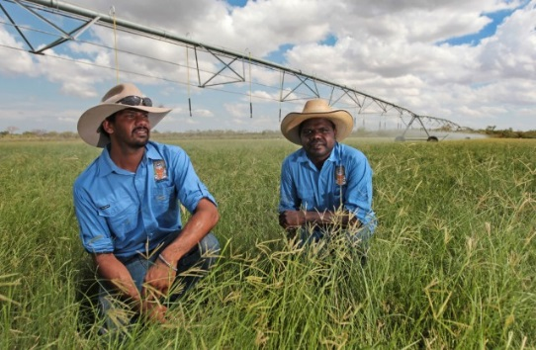

The Mowanjum Aboriginal Corporation just outside Derby in the Kimberley is lifting the productivity of its cattle breeding operations.

The community’s 55,000 hectare cattle station is prime grazing land with the capacity to produce high-quality beef for domestic and export markets.

Improved access to water supplies is key to the community achieving its aspirations—the property needs dry-season feeding capability which requires reliable irrigated water supply.

Successes are already on the board: Mowanjum has installed a trial $3.6 million pivot irrigation system that uses underutilised groundwater to grow fodder crops on a 38 hectare area. It has developed a stand and graze beef operation through the trial which has exported cattle via the port at Broome and is planning to extend the project.

The Mowajum trial is a model for other pastoral stations in the Kimberley. Crop research, irrigation data and herd analysis from the project will inform the growth of other pastoral operations in the north so the region can capitalise on the world’s expanding beef market.

“Our pastoral station is providing an innovative model that other farmers can learn from, including other Indigenous-owned pastoral stations,” Steven Puemorra, Chairman of the Mowanjum Aboriginal Corporation says.

“Mowanjum continues to improve and seek out new opportunities for growth to cement and build on our achievements and we are looking forward to a bright economic future,” he says.

Mowanjum CEO Stephen Austin says the irrigation project offers more employment and greater self-reliance for the community.

“This can open up new activity and create more jobs for Mowanjum and that’s what we need,” he says.

Read more at *northernaustralia.gov.au*.

*Image: Trainee stockmen Ashton Lockyer and Mark Laylay, Mowanjum, WA. Photo: Danella Bevis, © The West Australian.*

Research and innovation

The government is improving north Australia’s competitiveness by fostering innovation and research, and wants northern-based businesses and industries to be world leading and cutting edge.

The Australian and Northern Territory Governments have committed $8 million to establish a new biosecurity hub in Darwin. It will be an effective early warning system against destructive pests and diseases and will ensure expert rapid diagnosis of the exotic diseases that could cripple Australia’s agricultural industries.

Northern Australia is a centre of excellence in tropical medicine research and the northern agenda is helping industries generate new ideas and innovation.

*Tropical health*

The government has committed an additional $20.3 million to the development of tropical medicine research in the north.

As home to a number of internationally recognised tropical disease research hubs such as the Menzies School of Health Research and James Cook University, the north is already playing a leading role in this field.

The new funding has boosted tropical research capacity in the north, fostered commercialisation opportunities and strengthened links with international research partners through several cutting edge initiatives such as the HOT NORTH project led by the Menzies School of Health Research.

The Australian Tropical Medicine Commercialisation Grants program has provided support for the commercialisation of Australian tropical medicine research in partnership with international companies.

New government investment has helped build links between Australian and international research institutions and a Tropical Health Short Course program has provided education and training to Indonesian health professionals in areas such as malaria prevention and treatment, with courses run in 2016, 2017 and planned for 2018.

*Images: HOT NORTH researchers Dr Matthew Grigg in Sabah and colleagues (top); Dr Dagmar Meyer.*

*21*

*Case study: HOT NORTH*

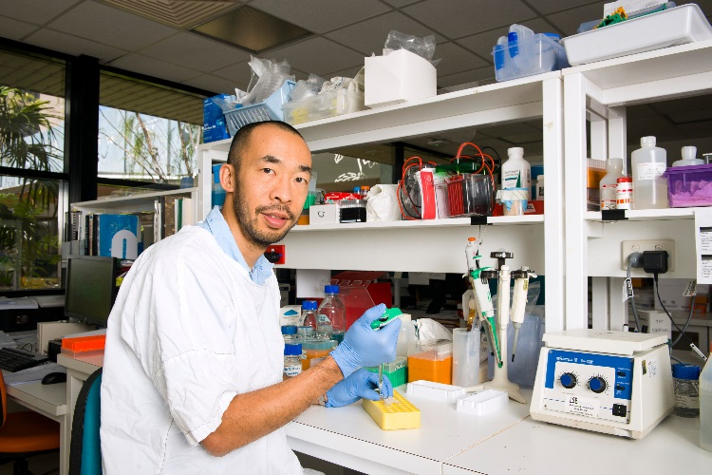

The Australian Government funded HOT NORTH project has hit the ground running in 2017, and is building north Australia’s expertise and capacity in tropical medicine through research projects that will transfer new knowledge to communities.

HOT NORTH is building the north’s tropical health expertise in a way that is making a real difference to the people of the north, including Aboriginal and Torres Strait Islander communities.

The Darwin-based Menzies School of Health Research is leading the project in partnership with James Cook University, Doherty Institute/Melbourne University, Telethon Kids Institute, Marie Bashir Institute/The University of Sydney, the South Australian Health and Medical Research Institute, Burnet Institute and the QIMR Berghofer Medical Research Institute.

HOT NORTH Director, Menzies’s Professor Bart Currie, says bringing these expert institutions together is helping to build “a community of medical researchers and clinicians focused on the north’s critical health issues”.

“There’s no better place to be than the north if you want to do tropical research and HOT NORTH is helping high-quality medical scientists and clinicians to feel part of a broader movement in the north of Australia,” he says.

Over four years HOT NORTH will fund 12 research projects each year and up to 20 fellowships and scholarships. Already, 12 research grants have been awarded to tackle issues such as antimicrobial resistance and chronic lung, rheumatic heart and vector-borne diseases.

“We are focusing our research so we can fairly quickly translate findings into practical outcomes on issues such as antimicrobial resistance and the concerns about superbugs which are continuing to come into Australia,” Professor Currie says.

“We want to understand where resistant organisms are present geographically across the north, how they are spreading and what can be put in place to reduce that spread.”

HOT NORTH projects will transfer the knowledge gained through research to frontline communities and health workers in every corner of the north, with workshops held or being planned in communities such as Broome, Kununurra, Katherine, Mount Isa and the Torres Strait.

HOT NORTH PhD scholarship researcher Pamela D’Sylva says HOT NORTH funding is supporting the employment of an Aboriginal researcher on her project into life threatening chronic lung disease in Aboriginal children in Western Australia.

“If we can catch this disease early in childhood we can prevent it becoming a very serious illness so our project is being done in partnership with young Aboriginal researchers and communities so they can be part of the solution,” she says.

A quarter of HOT NORTH’s work focuses on the health issues facing Australia’s northern neighbours, such as malaria and tuberculosis (TB).

“The saying is that TB anywhere is TB everywhere,” says Professor Currie.

“For us, multidrug resistant TB in PNG and links through the Torres Strait is a risk for northern Australia, so we need to be good global partners in the work on TB and it will benefit Australians as well.”

Read more at *northernaustralia.gov.au* and *menzies.edu.au*

*Image: HOT NORTH researcher Assoc. Professor Steven Tong.*

*Industry-led research*

To help northern businesses generate new ideas and innovation that leverage the north’s strengths and address its challenges, the government has invested $75 million to establish the new Cooperative Research Centre (CRC) for Developing Northern Australia.

The CRC brokers collaboration between industry and researchers to grow the north’s economy and trade and attract investment. It supports industry-led projects where the north has particular strengths, including agriculture, food, tropical health service delivery and Traditional Owner led business development.

The CRC’s $8 million 2017–18 funding call closes in October 2017.

An additional $13.9 million has been granted to support seven CRC for Developing Northern Australia collaborative research projects in the north.

Read more about the Cooperative Research Centre for Developing Northern Australia at *crcna.com.au* and on the CRC project grants at *business.gov.au*

*Innovation for a pioneering north*

Sheriden Morris, Chair of the Cooperative Research Centre for Developing Northern Australia, believes “the future of northern Australia is whatever we are prepared to make it”.

“There is an incredible enthusiasm in the north for development because people can see its significant potential,” she says.

“It’s a pioneering culture where people are looking for innovative and constructive ways to make things happen.”

The CRC for Developing Northern Australia aims to tap into the north’s innovative culture—it will bring some of Australia’s top scientific, engineering and innovative minds to the table, to work with local northern businesses and industries to overcome local challenges.

With CRC support, investors, innovators and businesses will collaborate to apply digital technologies and expertise to solve food, agriculture and supply chain challenges, harnessing for example, sensors, robotics and advanced genetics.

“Remoteness, regulations across jurisdictions and lack of infrastructure are some of the challenges in the north and local people want to see how innovation can help us overcome these obstacles to growth,” Sheriden says.

“These are challenges that we Australians are very good at getting over. We want to bring innovative knowledge and expertise into the pioneering communities of northern Australia and attract domestic and international investment.”

Summary of White Paper measures

For updates on White Paper measures visit *northernaustralia.gov.au*

|  |  |
| --- | --- |
| 1. Pilot land reform projects in the north | The Australian Government and northern jurisdictions have supported innovative changes to the governance of land use arrangements to simplify and boost investment in the north. |
| 1. Aspiration to finalise native title claims within a decade | The Attorney-General’s Department is developing proposals for legislative reform arising from the COAG Investigation into Indigenous Land Administration and Use and is examining other initiatives to assist in the resolution of claims. |
| 1. More efficient native title processes | The Attorney-General’s Department, northern jurisdictions, Indigenous Australians and businesses are developing a range of options to improve the efficiency of the native title system, including a simplified Indigenous Land Use Agreement process. |
| 1. Capacity building for native title corporations | Changes to Prescribed Body Corporates will support native title landholders to obtain stronger economic outcomes from their native title, including direct funding for native title corporations to manage native title on behalf of native title holders. |
| 1. Options to use exclusive native title rights for commercial purposes | The Australian Government and the northern jurisdictions are committed to removing legal barriers to the creation of bankable interests on exclusive possession native title land, while retaining underlying native title. |
| 1. Land administration and township leasing | Township leasing is building economic activity in towns on Aboriginal land. The leases support housing investment, community and economic development and home ownership. |
| 1. New models to manage native title funds for development | The determination of native title can provide a valuable income stream for Indigenous people through Indigenous land related payments. These funds can be instrumental in supporting Indigenous economic independence, including business development and job creation. |
| 1. More business friendly information on different land tenure arrangements | Austrade has delivered web-based, business friendly, investor focused guides on land tenure and native title systems in northern Australia. |
| 1. Pursue a set of principles and actions to improve the security, bankability and efficiency of pastoral land | The implementation of pilot land reform projects across northern Australia will provide a sound framework for jurisdictions to work with the Australian Government, Indigenous communities and other stakeholders to identify potential pastoral tenure improvements. |
| 1. National Water Infrastructure Development Fund northern component | The Australian Government has committed $210.5 million to the National Water Infrastructure Development Fund to facilitate greater investment in northern water infrastructure. The fund will support the detailed planning necessary to inform new and augmented water infrastructure investment decisions and provide capital contributions for some projects. |
| 1. Northern Australia Investment Forum and Northern Australia Value Proposition | The Australian Government’s Northern Australia Investment Forum in 2015 brought together international investors to promote secure investment in northern Australia, and delivered a Northern Australia Value Proposition. A similar investment forum will be held in Cairns in November 2017. |
| 1. Northern Australia Insurance Premiums Taskforce | The Northern Australia Insurance Premiums Taskforce has investigated options to lower insurance premiums in areas subject to high cyclone risk and reported to the Australian Government in November 2015. |
| 1. Linking the north with ASEAN and APEC connectivity agendas | The Department of Foreign Affairs and Trade has identified actions within the ASEAN and APEC connectivity agendas that could benefit northern Australian business and investment, and continues to pursue opportunities for connectivity. |
| 1. Fostering business-to-business links with Indonesia, Papua New Guinea and Timor-Leste | Northern Australia businesses are using their expertise to assist the reduction of red tape in Timor-Leste business registration and licencing programs, and to improve the productivity and business skills of Papua New Guinea cocoa farmers. |
| 1. Expanding the Entrepreneurs’ Programme to assist tourism | The $13.6 million Northern Australia Tourism Initiative launched in 2015 is providing management advice and business support services to eligible businesses in the northern Australia tourism industry. |
| 1. Enhancing access to the Entrepreneurs’ Programme | The Entrepreneurs’ Programme eligibility guidelines have been amended, lowering the minimum turnover or operating expenditure threshold to $750 000 for small and medium business in the north. As a result, management advice and business support services have been extended to an additional 500 small and medium northern businesses. |
| 1. A Cooperative Research Centre (CRC) for Developing Northern Australia | The $75 million CRC will support industry-led collaborative research projects where the north has particular strengths, including agriculture, food and tropical health. |
| 1. Bolstering tropical health research capacity | A $6.8 million investment to support a new tailored tropical health and medical research strategy is driving innovative, high-quality research into the diagnosis, treatment and prevention of tropical disease, and is building strong collaborative networks and domestic capacity in tropical health. |
| 1. Turning tropical research into commercial opportunities | Australian Tropical Medicine Commercialisation grants are developing pathways to commercialise Australian research on new tropical therapeutics, vaccines and diagnostics in partnership with international companies. |
| 1. Links between tropical health research institutions and world class research institutions and the Tropical Health Short Course program for Indonesian professionals | To help address regional tropical health issues with the capacity to impact Australia, the Australian Government has funded the Menzies School of Health Research to undertake advanced research into high-priority tropical disease threats and to deliver tropical health short courses to Indonesian professionals |
| 1. Increased Indigenous ranger biosecurity activities | The Australian Government has provided $12.4 million to expand the northern Australian biosecurity surveillance activities of Indigenous ranger groups. The expansion has almost doubled the ranger groups undertaking this work and provides employment opportunities for Aboriginal and Torres Strait Islander communities. |
| 1. Single point of entry for major projects | The Major Projects Facilitation Agency delivers a single point of entry for major projects nationally, and through its Darwin office is supporting projects that are investing billions of dollars across northern Australia. |
| 1. Reforms to tourism visas | Online lodgement of visitor visas for Chinese citizens was made available in February 2017, with an online application facility in simplified Chinese. Further enhancements will make online lodgement available to citizens of India. |
| 1. Improve protections and cut red tape around Indigenous cultural heritage | The Australian Government is consulting Indigenous and industry stakeholders on possible amendments to the Aboriginal and Torres Strait Islander Heritage Protection Act 1984, including the introduction of a system to accredit appropriate state and territory Indigenous heritage protection regimes. |
| 1. Cutting red tape for fisheries | The Australian Government is working with northern jurisdictions to develop options for the transition to single jurisdiction management of certain fisheries, including by assessing the risks and benefits for specific species. |
| 26. Wildlife trade reform | The Australian Government is streamlining the Convention on International Trade in Endangered Species of Wild Fauna and Flora permit processes to provide greater certainty for the commercial wildlife trade in northern Australia and remove permit requirements for low-risk native species. |
| 1. Productivity Commission Inquiry into Australia’s Fisheries and Aquaculture Regulation | The Productivity Commission Inquiry Report on Marine Fisheries and Aquaculture was tabled in Parliament and released publicly along with the Australian Government’s response on 24 May 2017. |
| 1. Northern Australia Infrastructure Facility (NAIF) | The NAIF offers up to $5 billion in financing on concessional terms to encourage and complement private sector investment in infrastructure that benefits northern Australia. Preference is given to projects which demonstrate the potential for broader public benefit. |
| 1. Northern Australia roads package | The $600 million Northern Australia Roads Programme funds high-priority projects in northern Australia which are essential to the movement of people and freight and support the north’s economic development. |
| 1. Improving cattle supply chains | The $100 million Northern Australia Beef Roads Programme upgrades key roads that are essential for transporting cattle. The programme is improving the reliability, productivity and resilience of cattle supply chains in northern Australia by reducing freight costs and strengthening market links. |
| 1. Northern Australia freight rail feasibility analysis | The Australian Government has committed to undertake freight rail feasibility studies in northern Australia, beginning with a pre-feasibility study on a potential rail line between Mount Isa and Tennant Creek. |
| 1. Northern Australia pipeline of projects | A new infrastructure projects pipeline will highlight infrastructure priorities in northern Australia to potential investors. It will be informed by the priorities identified in Infrastructure Australia’s Northern Australia Infrastructure Audit, and through liaison with northern jurisdictions. |
| 1. Northern Australia Infrastructure Audit | The Northern Australia Infrastructure Audit has assessed critical economic infrastructure gaps and requirements to meet projected northern Australia population and economic growth through to 2031. |
| 1. Extension to the Remote Airstrip Upgrade program and additional support for the Remote Air Services Subsidy | The Remote Airstrip Upgrade program has provided assistance for safety and access works at eligible remote aerodromes across northern Australia and continues to do so. The Remote Air Services Subsidy Scheme subsidises regular weekly air transport for the carriage of passengers and goods to communities in remote and isolated areas of Australia. |
| 1. Improving aviation and surface transport connections–business stakeholder group | A group of industry experts is assisting in preparing the Northern Australia Transport Study which will inform northern Australia aviation and surface transport connections to, from and within northern Australia. |
| 1. Support enterprises in the north through the Industry Skills Fund | The Australian Government continues to support training for businesses and individuals through a range of skills programs, including the Skilling Australians Fund, Australian Apprenticeship Incentives Program, Trade Support Loans and the VET Students Loans Program. |
| 1. Employment targets for Indigenous Australians, for road projects (and other relevant expenditure) funded through the White Paper | White Paper initiative projects are required to establish Indigenous procurement targets, and the Australian Government is working with the northern jurisdictions to set Indigenous employment and procurement targets for Northern Australia Roads Programme projects. |
| 1. Support the NT Government to allow workers licenced from other Australian jurisdictions to have their licences more easily recognised in the territory | The Department of Education and Training is able to assist the Northern Territory Government to fast-track implementation of streamlined occupational licencing processes. |
| 1. Reforms to the Remote Jobs and Communities Programme (RJCP) to allow participants to work in local businesses | The Community Development Programme (CDP), which replaced the RJCP, allows any organisation or business to place CDP job seekers in their workplace to build job seekers’ skills and experience. Employers are also eligible to take up financial incentives to employ job seekers in local businesses over the long term. |
| 1. Designated Area Migration Agreements | Designated Area Migration Agreements (DAMAs) increase the supply of the labour required for businesses to continue to operate and grow. A Northern Territory DAMA has been operational under a MoU since 2014 and a Deed of Agreement was executed in 2015. |
| 1. Expanded Seasonal Worker Programme | The Seasonal Worker Programme has been expanded by removing a cap on programme places, including in the agricultural sector, and by launching a tourism pilot in northern Australia |
| 1. Working Holiday Maker–an additional six months with one employer | Working Holiday Maker Visa program guidelines have been amended to allow Working Holiday Maker (Subclass 417) and Work and Holiday Maker (Subclass 462) visa holders to work for an additional six months with one employer in specified industries in northern Australia. |
| 1. Work and Holiday Visa–second visa if they worked in tourism or agriculture in northern Australia | Work and Holiday (Subclass 462) Visa holders who complete three months’ work in the tourism and hospitality or agriculture, forestry and fisheries industries in northern Australia are now eligible to apply for a second Work and Holiday Visa. |
| 1. Pacific Microstates – Northern Australia Worker Pilot Programme | A five-year pilot programme for workers from the Pacific microstates of Kiribati, Nauru and Tuvalu is helping to address unmet demand for workers in industries experiencing acute labour shortages in lower skilled occupations in northern Australia. |
| 1. Northern Australia Strategic Partnership | The Prime Minister, Deputy Prime Minister, the Minister for Resources and Northern Australia and the First Ministers of the northern jurisdictions meet through the Northern Australia Strategic Partnership to drive the northern Australia development agenda. |
| 1. Shift the Office of Northern Australia to the north | In December 2015 the Head of the Office of Northern Australia (ONA) was appointed and the ONA’s Darwin office was officially opened. ONA also has offices in Cairns, Townsville, Brisbane, Perth and Canberra. |
| 1. Joint Select Committee on Northern Australia be made a standing committee | A Joint Standing Committee on Northern Australia was appointed in the Senate in September 2016 and will therefore be part of all future Parliaments. |
| 1. Annual Statement to Parliament | The Australian Government delivered a progress statement on the northern Australia development agenda on 11 October 2016. The 2017 Annual Statement was delivered on 17 October 2017. |
| 1. Public Sector Secondment | An agreement between the Office of Northern Australia and the Australian Public Service Commission reconfirmed processes are in place for secondments across the north to improve the links between tiers of government. |
| 1. A northern Australia themed regulation repeal day in March 2016 | Following the regulation repeal day, the Australian Government now takes immediate action on any Australian Government regulations considered to be red tape (rather than wait for any further repeal days). |
| 1. Strengthen the Australian Defence Force presence in northern Australia | Through the 2016 Defence White Paper, the Australian Government is making a significant investment over the next decade to upgrade defence bases and facilities and establish new facilities in northern Australia. It is further developing international military partnerships with a number of countries, including Singapore. |

