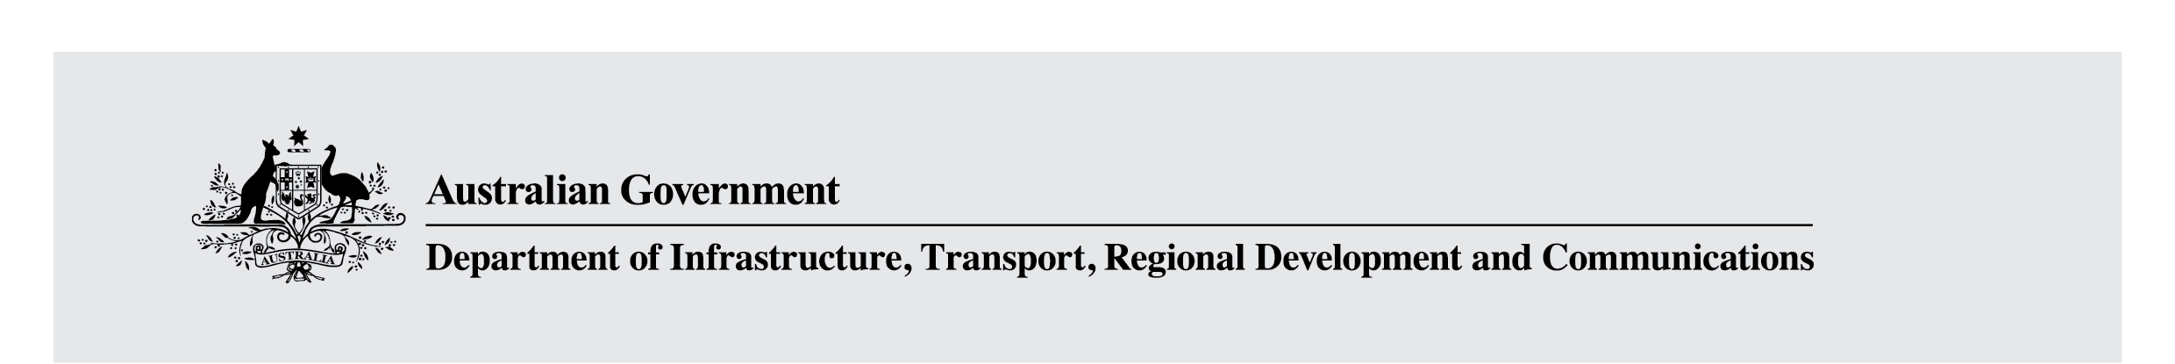

Online Safety Bill – Reading Guide
December 2020

Benefit of Legislative Reform
The internet has brought great social, educational and economic benefits. But just as a small proportion of human interactions go wrong offline, so too are there risks online. By establishing proper protections to help keep Australians safe online, we can in turn help Australians to realise the substantial benefits that come from using the internet.
Over the past two decades, Australia has been at the forefront of online safety policy and regulation. We have had laws to deal with harmful online content since 1999 and the establishment of an eSafety Commissioner in 2015 was a world first. Australia’s main legislative structures – the online content scheme contained in Schedules 5 and 7 of the Broadcasting Services Act 1992 and the Enhancing Online Safety Act 2015 (EOSA) – have served us well.
However, the rapid pace of technological change and the emergence of new platforms and services – including messaging apps, interactive games and live-streaming services – have given rise to new ways for users to interact online and created new risks.
That is why the Morrison Government committed to the development of a new Online Safety Act to enhance the powers of the eSafety Commissioner, boost protections for Australians, and increase the responsibility on industry to keep their users safe online.

The Government’s Approach to Online Safety Reform
Like other sectors, industry must take responsibility for making sure that the digital services they develop are safe for Australians to use. This responsibility applies from the moment that new platforms, applications, or services first enter the market. Online safety features are not something to be ‘retrofitted’ following the launch of a new product or following commercial success. Legislation should reflect the primary responsibility of industry, and allow the regulator to assess this effort and act where industry falls short.
Sufficient powers should also be available for the regulator to quickly address known threats to online safety. An appropriately equipped regulator, with clear statutory powers, is necessary to provide industry with certainty about their compliance obligations. It is also necessary that, when Australians encounter online harms, they can be sufficiently supported.

Improving Australia’s Online Safety Laws
In the lead up to the 2019 Federal Election, the Government committed to developing a new Online Safety Act to consolidate regulatory arrangements and update them in light of changes in the digital environment. In December 2019, the Minister for Communications, Cyber Safety and the Arts, the Hon Paul Fletcher MP, released a detailed proposal for reform. The Minister and the Department led a consultation process with stakeholders including non-government organisations, interested members of the public and digital businesses and service providers.
The findings of this consultation have been drawn upon to develop draft legislation, which has now been released for consultation. The Government is inviting submissions from interested individuals and organisations about how this legislation could be improved.
The consultation will remain open until 5pm (AEDT) Sunday 14 February 2021. More information, including how to participate, is available at communications.gov.au/online-safety.

Key Elements of the Bill
This document provides a thematic guide to the draft legislation, collating reference points across the Bill so readers can quickly navigate the elements most relevant to their interests. It is structured as follows:

Basic Online Safety Expectations (pg. 3)
The Bill builds upon the basic online safety requirements in the EOSA by establishing a framework for Basic Online Safety Expectations (BOSE) for providers of online services. The BOSE will provide the eSafety Commissioner with reporting powers, to hold providers accountable for meeting those expectations.

Schemes (pg. 4 – 10)
The Bill proposes five schemes to deal with different types of harmful online material. Four already exist in law (but are being appropriately updated). One is new – the adult cyber abuse scheme.
- Cyber-bullying Scheme – Provides for the removal of material that is harmful to Australian children. This scheme reflects the current regime in the EOSA, however reduces the take-down time for such material from 48 hours to 24 hours and extends the scheme to more services.
- Adult Cyber-abuse Scheme – Provides for the removal of material that seriously harms Australian adults. This scheme is new. It extends similar protections in the cyber-bullying scheme to adults, however with a higher threshold of ‘harm’ to reflect adults’ higher levels of resilience.
- Image-based Abuse Scheme – Provides for the removal of intimate images shared without the depicted person’s consent. This scheme reflects the current regime in the EOSA, however reduces the take-down time for such material from 48 hours to 24 hours.
- Online Content Scheme – Provides for the removal of harmful material in certain circumstances. This scheme reflects and simplifies the current regime in Schedules 5 and 7 of the BSA, with some clarifications of material and providers of services captured by the scheme, and extending the eSafety Commissioner’s take-down powers for some material to international services in some circumstances.
- Abhorrent Violent Material Blocking Scheme – Provides for the blocking of abhorrent violent material, such as images or video of terrorist attacks. This scheme is new, but mirrors existing legislation in the Criminal Code Act 1995 (the Criminal Code).

Governance (pg. 11 – 12)
The Bill replicates the existing governance arrangements, with minor amendments to list the eSafety Commissioner as an official of Australian Communications and Media Authority (ACMA) for the purposes of the Public Governance, Performance and Accountability Act 2013 (PGPA Act), and to clarify the eSafety Commissioner’s ability to direct staff and the Commissioner’s independence from the ACMA.

1. Basic Online Safety Expectations
Proposed provisions for the BOSE are primarily in Part 4 of the Bill. The BOSE framework is an enhancement of the basic online safety requirements, coupled with new powers for the eSafety Commissioner to require service providers to report on compliance with the BOSE.
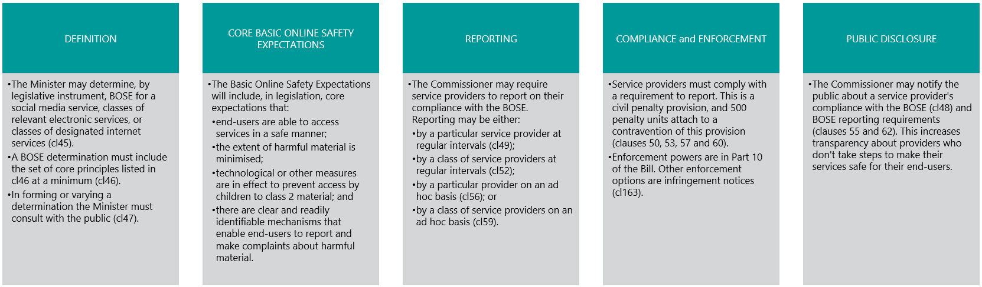

2. Cyber-bullying Scheme
Proposed provisions for the Cyber-bullying Scheme are primarily in Part 5 of the Bill. The Cyber-bullying Scheme includes minor enhancements on the existing scheme, and extends the scheme to more services.
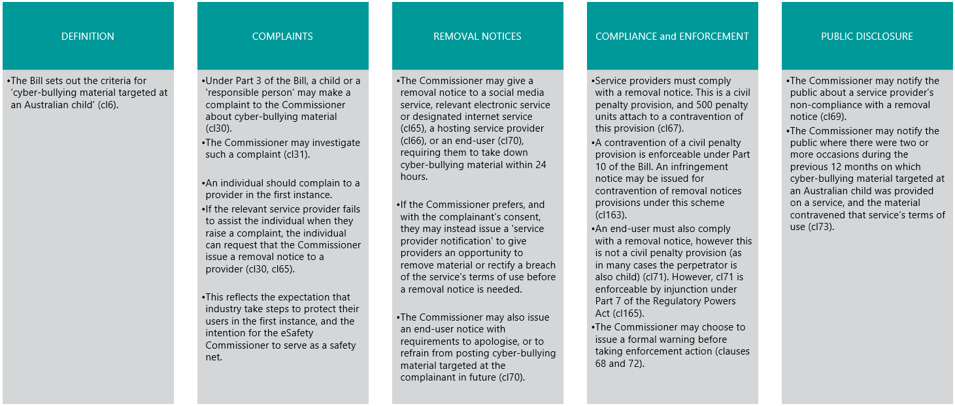

3. Adult Cyber-abuse Scheme
Proposed provisions for the Adult Cyber-abuse Scheme are primarily in Part 7 of the Bill. The Adult Cyber-abuse Scheme is a new scheme. It provides the same mechanism to have content removed as the Cyber-bullying Scheme, but with a higher threshold of harm and with the addition of civil penalties for end-users.
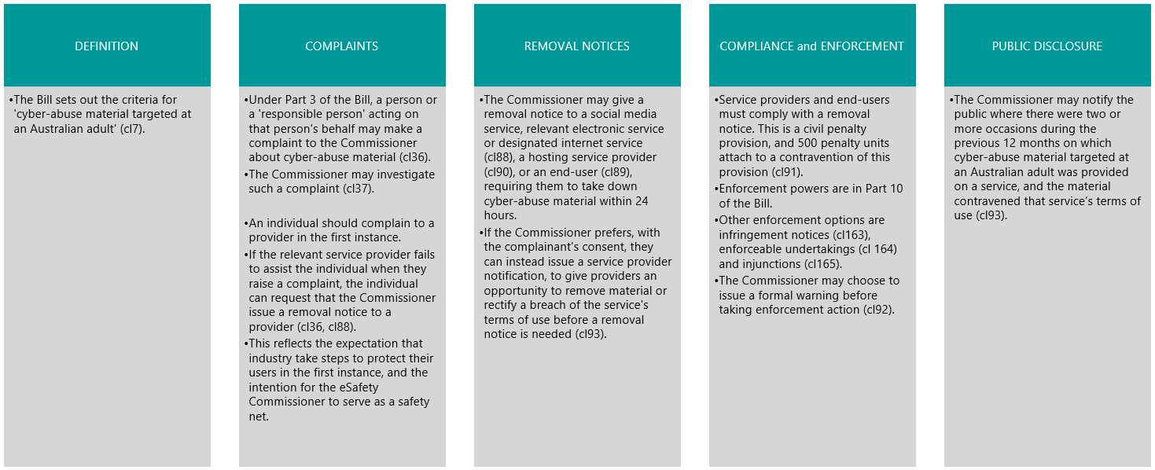

4. Image-based Abuse Scheme
Proposed provisions for the Image-based Abuse Scheme are primarily in Part 6 of the Bill. The Image-Based Abuse Scheme includes minor enhancements on the existing scheme.
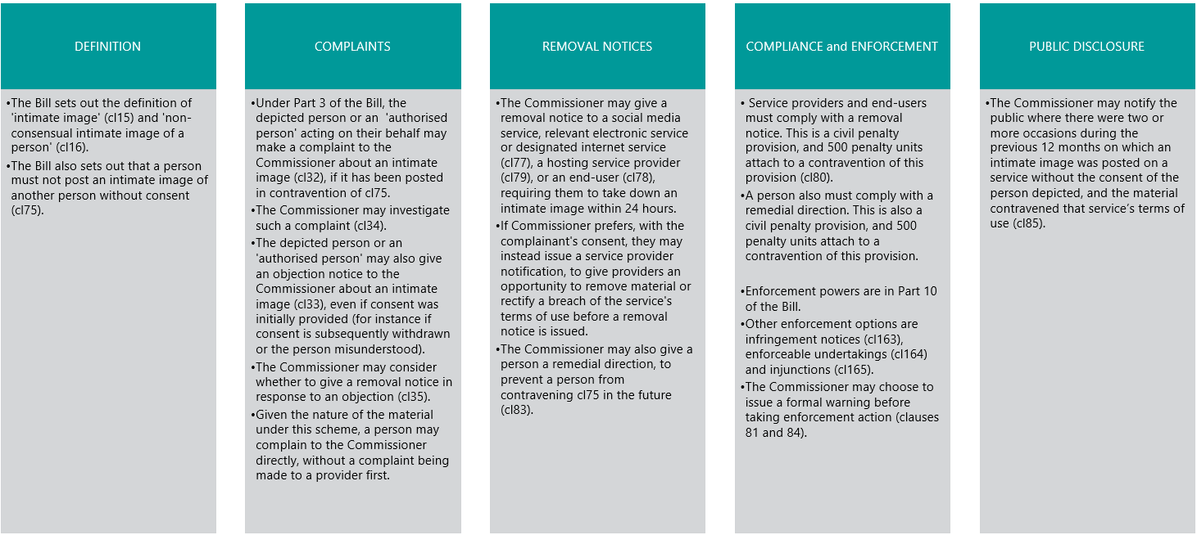

5. Online Content Scheme
Proposed provisions for the Online Content Scheme are primarily in Part 9 of the Bill. The Online Content Scheme is an enhancement on the existing scheme, and extends the eSafety Commissioner’s take-down powers for class 1 material to international services in some circumstances.
Take-down powers related to class 1 material:
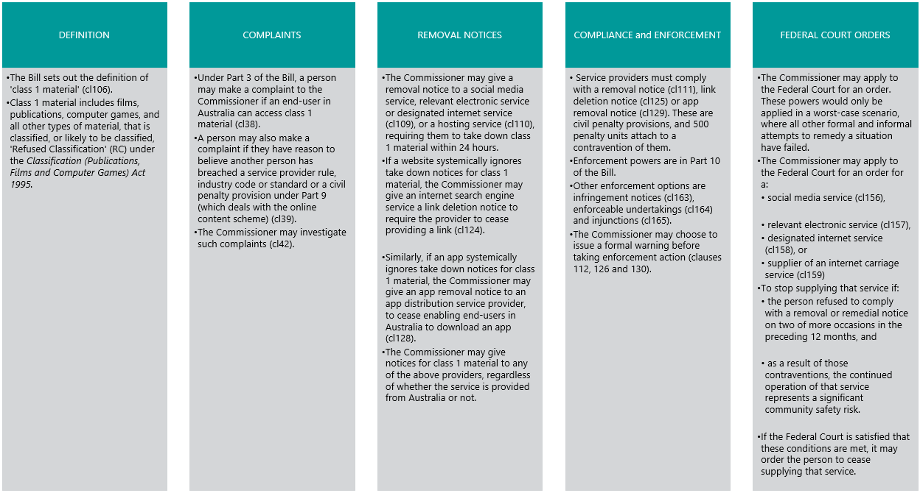
Take-down powers related to class 2 material:
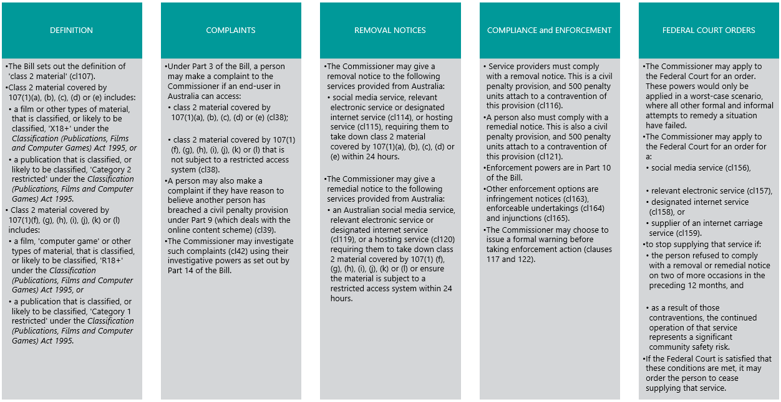
Industry codes, standards, etc
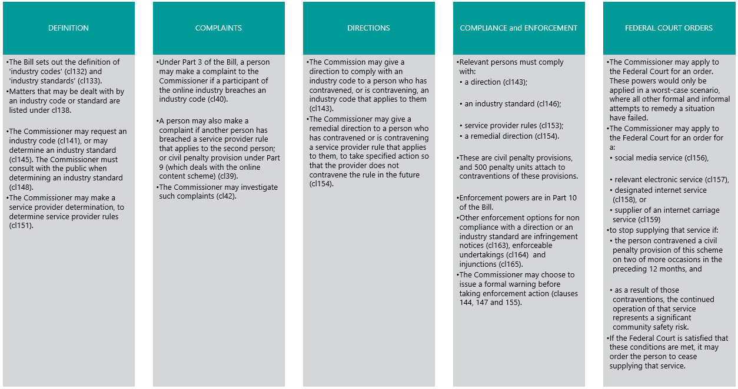

6. Abhorrent Violent Material Blocking Scheme
Proposed provisions for the Abhorrent Violent Material Blocking Scheme are primarily in Part 8 of the Bill. This is a new scheme. This scheme introduces new powers to protect the Australian community from the same type of material captured by the Criminal Code Act 1995, enacted by the Criminal Code Amendment (Sharing of Abhorrent Violent Material) Act 2019, in extreme circumstances.
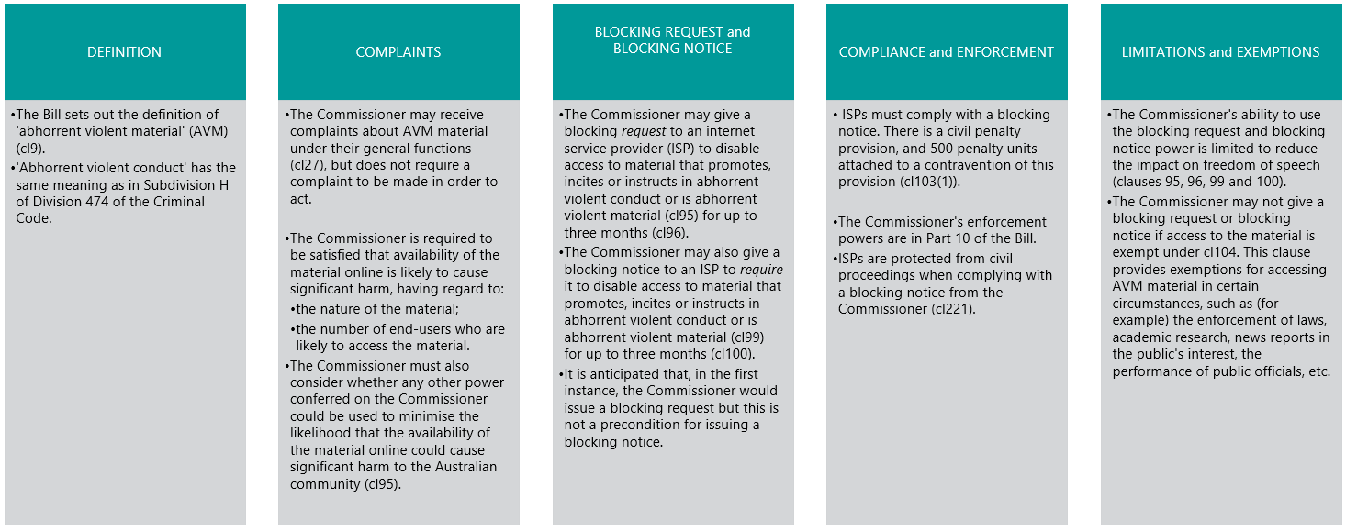

7. Governance arrangements
Proposed provisions for the governance arrangements for the Office of the eSafety Commissioner are primarily in Parts 2, 11 and 12 of the Bill. These arrangements are an enhancement to the existing arrangements in the EOSA.
The Bill largely replicates the existing arrangements in the EOSA. The eSafety Commissioner remains an independent statutory office holder, supported by staff from ACMA. The Bill includes small changes to clarify and enhance the eSafety Commissioner’s ability to manage the Office’s operations.
The Bill retains and clarifies the eSafety Commissioner’s immunity from direction from ACMA (cl186), and includes a new provision to make clear that ACMA staff who support the eSafety Commissioner are subject to direction by the eSafety Commissioner. The Bill also clarifies that the eSafety Commissioner is an official of ACMA for the purposes of Commonwealth finance law (cl170). The Bill also specifically allows for the eSafety Commissioner to delegate some functions and powers to contractors (cl182).
The Bill does not include provisions from the EOSA that are no longer appropriate given the expanding role of the eSafety Commissioner. For example, it does not include expertise in ‘child welfare or child wellbeing’ as a criterion for appointment as the eSafety Commissioner. This is because the role has substantially expanded since it was first established as the Children’s eSafety Commissioner. The Bill also does not include the ability for the eSafety Commissioner to delegate functions or powers to a body corporate.

8. eSafety Commissioner’s information gathering, investigative and disclosure powers
Proposed provisions for the eSafety Commissioner’s information gathering, investigative and disclosure powers are in Parts 13, 14 and 15 of the Bill respectively. These arrangements are an enhancement on the existing arrangements in the EOSA and the BSA.
Part 13 sets out a new power for the eSafety Commissioner to obtain information about the contact details or identity of an end-user from a social media service, relevant electronic service or designated internet service if necessary.
Part 14 of the Online Safety Bill deals with how the eSafety Commissioner conducts investigations, and replicates existing powers currently in Part 13 of the BSA. The eSafety Commissioner will have the power to summon a person by written notice to appear before the eSafety Commissioner to produce documents or to answer questions; or to provide documents or other information to the eSafety Commissioner relevant to the subject matter of the investigation.
Part 15 of the Online Safety Bill largely replicates the disclosure powers in the EOSA to enable the eSafety Commissioner to disclose information in certain circumstances, including to the Minister, APS employees for the purpose of advising the Minister, Royal Commissions, certain authorities, teachers or school principals, parents or guardians. This Part will enable the eSafety Commissioner to disclose information to a parent or guardian of an Australian child, teachers or school principals to assist in the resolution of complaints made under the Online Safety Bill, which may be particularly important in cases of cyber-bullying among school children.

