Geotagged photo guidance for Primary Producers and Approved Suppliers
  - On Farm Connectivity Program Round 3
September 2026

Under the Round 3 On Farm Connectivity Program Grant Opportunity Guidelines, the Approved Supplier is required to provide the following evidence when submitting a rebate claim:
- Where a single claim or the cumulative total of claims linked to the same Primary Producer ABN reaches $10,000 or greater:
  - the Approved Supplier must obtain a geotagged photograph of each delivered and where applicable, installed eligible equipment item, and;
  - provide the photographs to the Commonwealth prior to receiving the rebate payment
As the Primary Producer, if your equipment attracted a rebate of $10,000 or more and you have installed it yourself, you will need to take a geotagged photograph of the equipment with your smartphone or tablet and provide it to the Approved Supplier (the business that sold it to you). The Approved Supplier will then submit it with the rebate claim.
This guide outlines how to:
- take a geotagged photograph
- verify that the location data has been captured
- take a screenshot of the location information
- upload the photo
Instructions for both Android and Apple devices are below. Follow these steps to make sure your photo(s) show the location and can be uploaded as evidence.

Android Devices
If you have an Android device such as a Samsung Galaxy or Google Pixel, follow the steps below to enable location services, take a photo, check that the location information has been captured and screenshot the location information.

Enabling Location (geotagging)
- Open Settings and tap Location. | 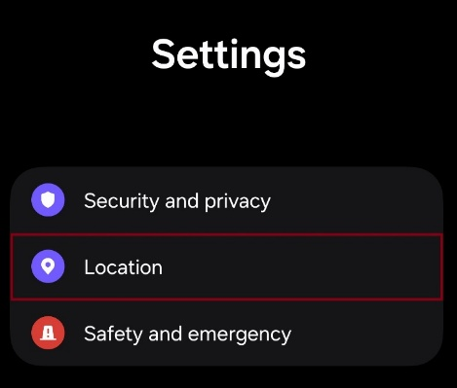
- Turn Location on.  - Open App permissions, scroll down and select camera. | 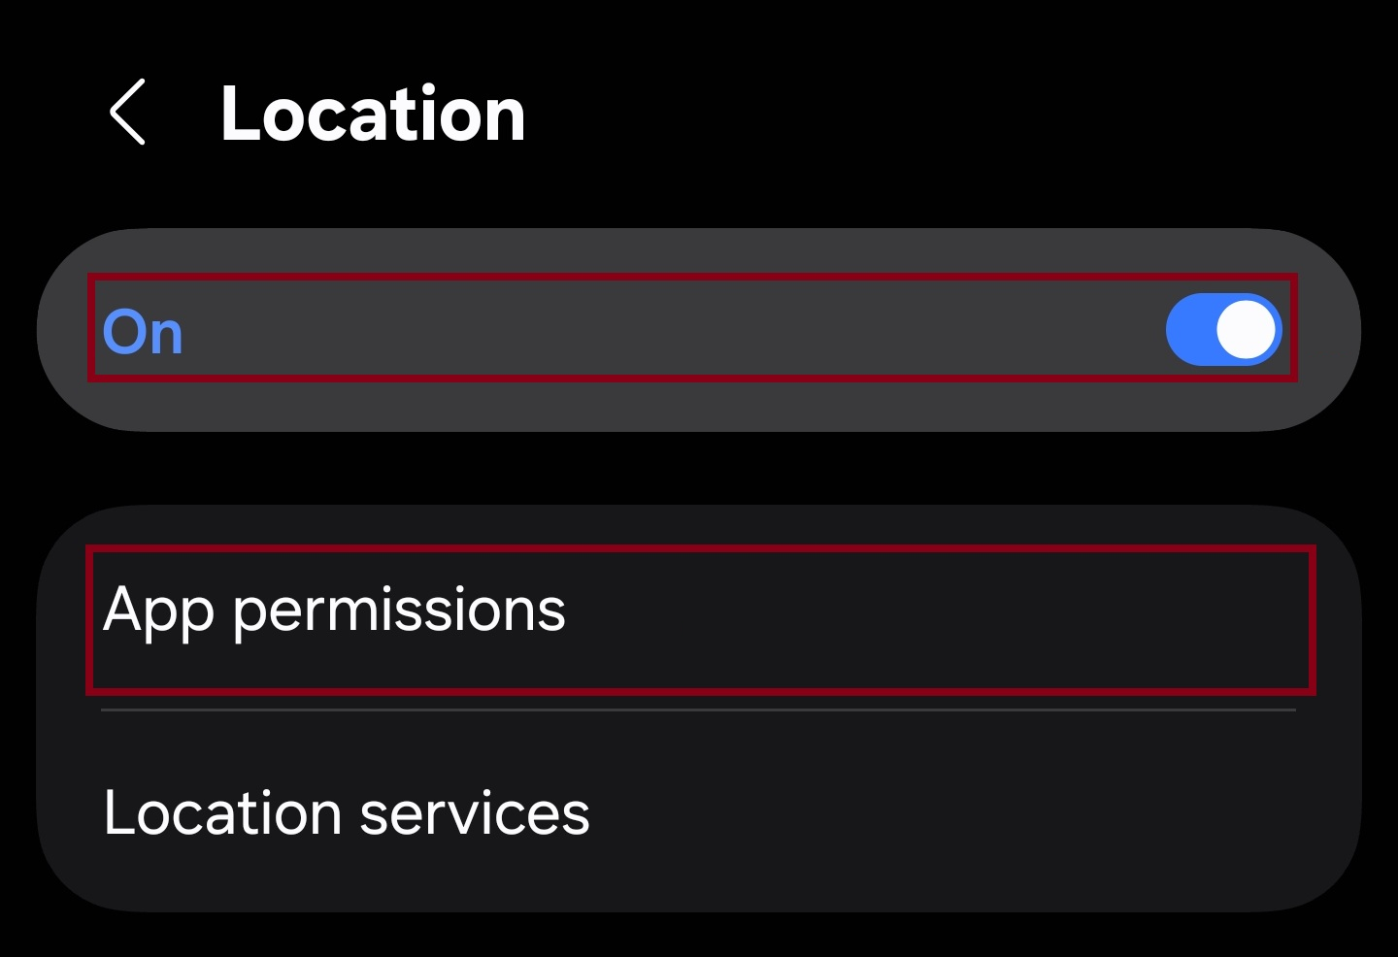
- Select Allow only while using the app (or similar).  - Select use precise location (if available). | 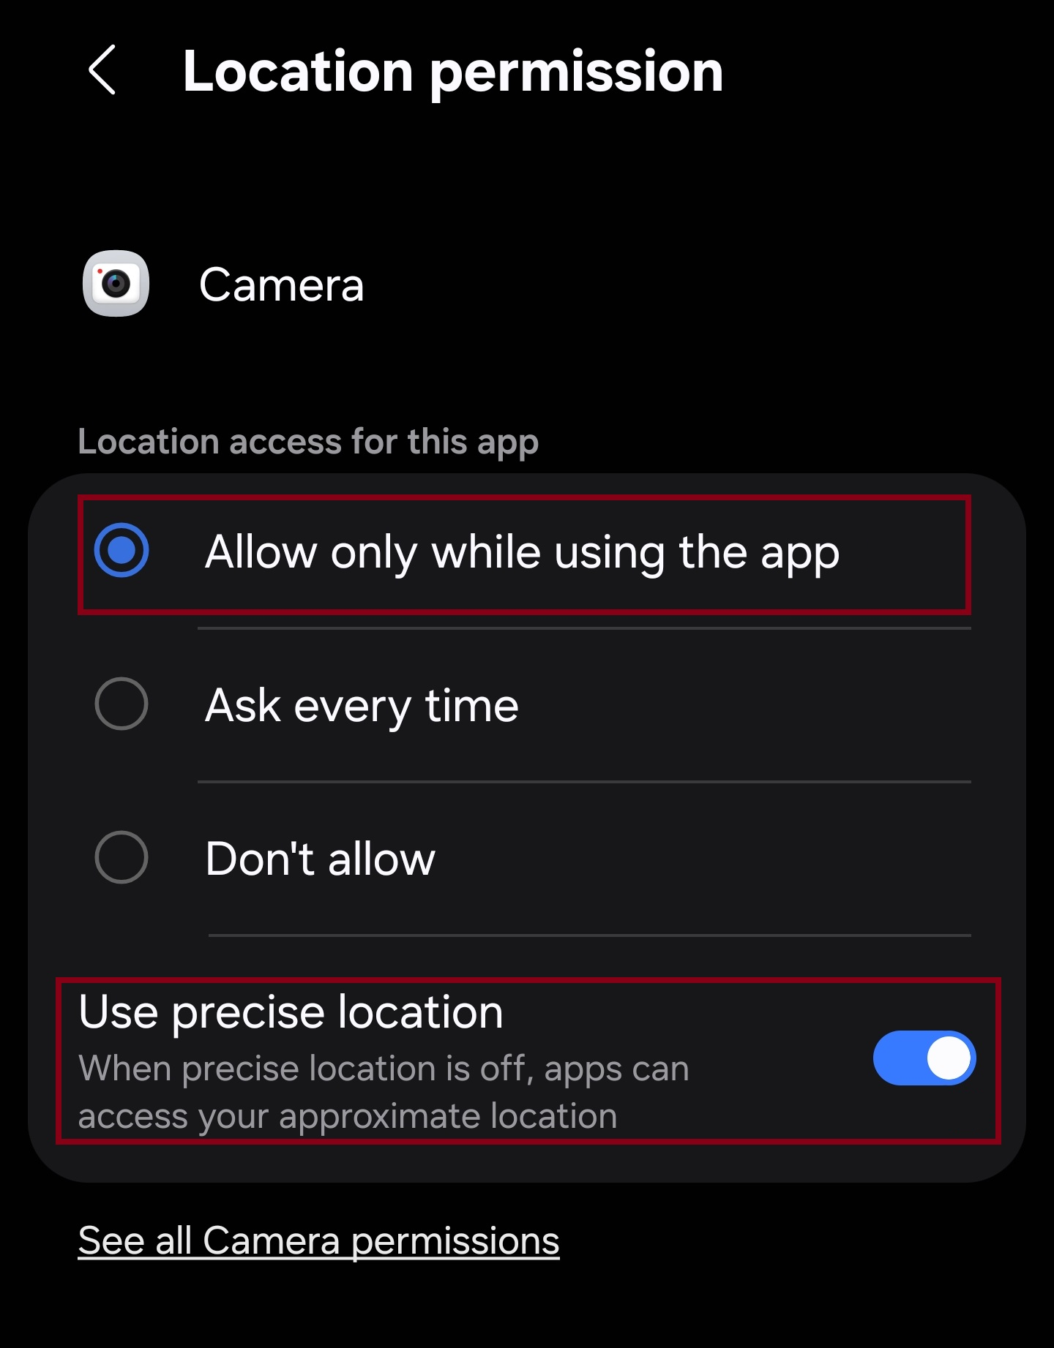
- Close settings.

Following these steps will enable location services on your device and grant the camera access to location data. Photos you take will now include geotagged information embedded within the image files.
Take a photo
- Tap the Camera icon on your home screen or from your app drawer.
- Point the camera (device) at the equipment.
- Tap the white circular Capture button.
- Tap the small thumbnail in the corner to view your picture in the gallery.

Confirm the photo location
- Open the photo in your photos app.  - Swipe up on the photo or tap the 3 dots. | 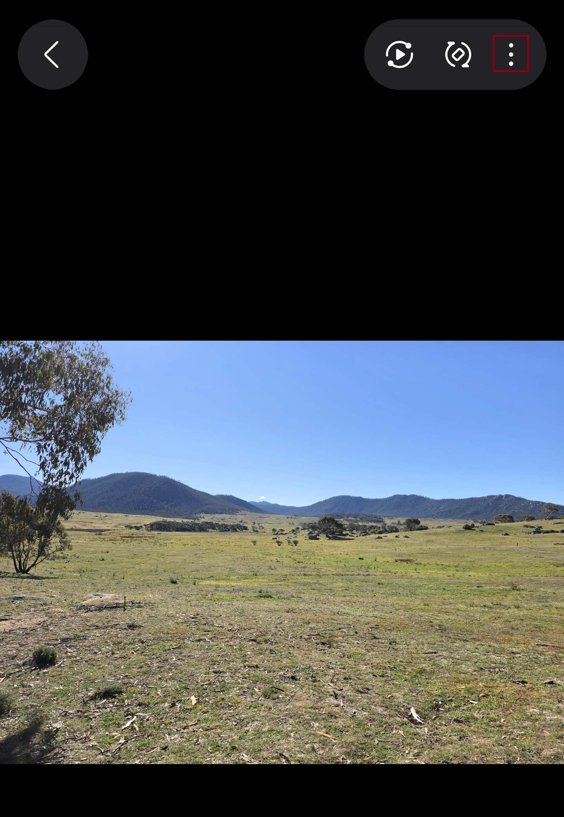
- Tap details | 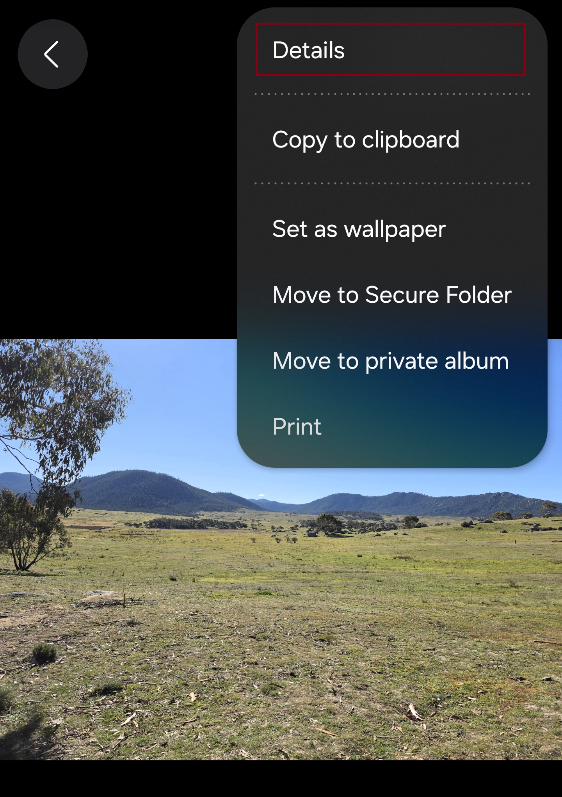
- Check that a map or location details appear. | 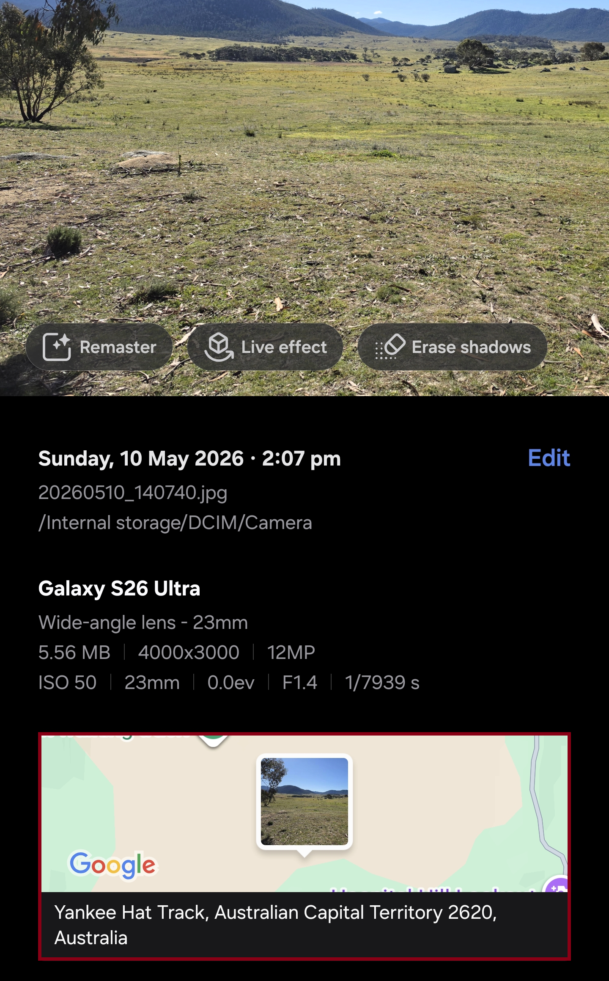

Screenshot the location (geotagged) details
- With the map or location details still showing, press the power button and the volume down button at the same time, and save the screenshot to your device. See uploading instructions on page 6.

Apple Devices
If you have an Apple iPhone or iPad, follow the steps below to enable location services, take a photo, check that the location information has been captured and screenshot the location information.

Enabling Location (geotagging)
- Open Settings and tap Privacy & Security. | 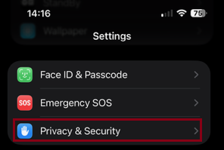
- Tap Location Services | 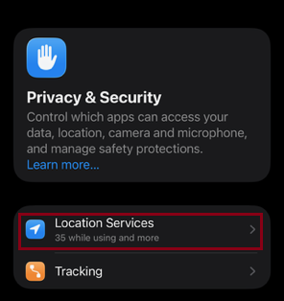
- Turn on Location services  - Scroll down and tap Camera. | 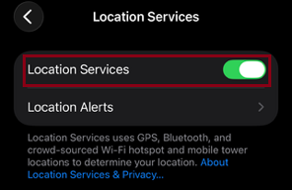
- Select while using the app (or similar).  - Select keep Precise Location on (if available). | 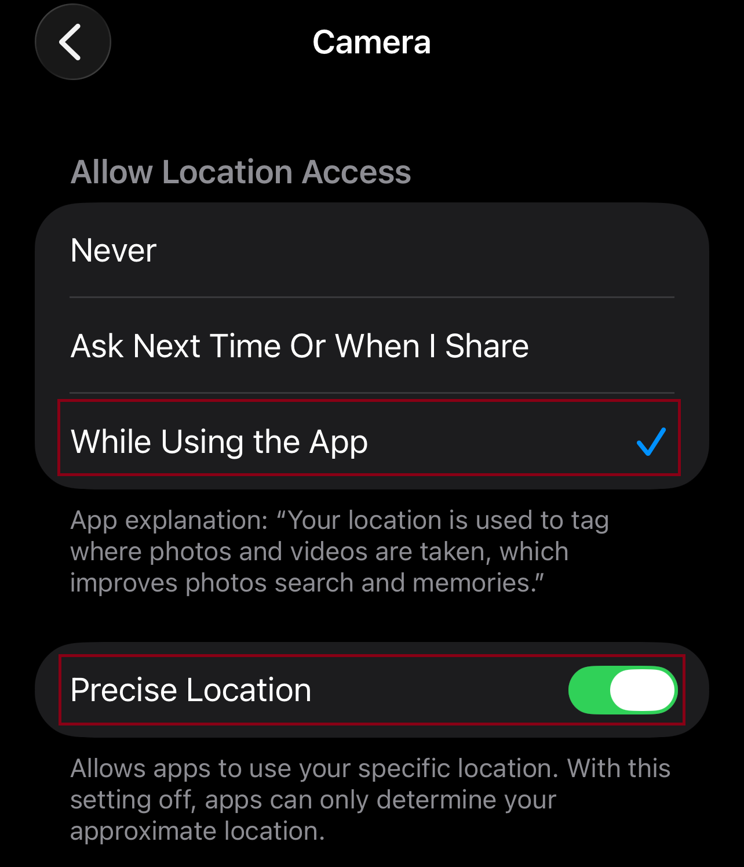
- Close settings.

With location services enabled on the device and the camera application granted access to location data, photos you take will now include geotagged information embedded within the image files.

Take a photo
- Tap the Camera icon on your home screen or from your app drawer.
- Point the camera (device) at the equipment.
- Tap the white circular Capture button.
- Tap the small circle in the left-hand bottom corner to view your picture.

Confirm the photo location
- Open the photo in your photos app.  - Swipe up on the photo or tap info icon on the bottom of the screen. | 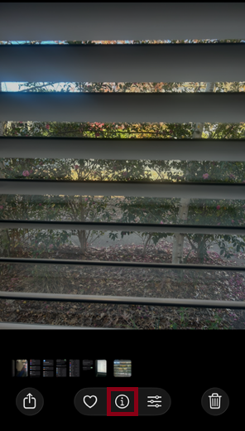
- Check that a map or location details appear. | 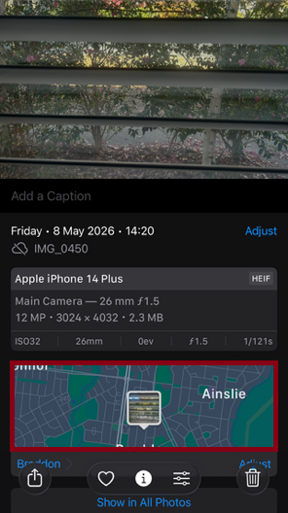

Screenshot the location (geotagged) details
If your iPhone or iPad has Face ID | with the map or location details still showing, press the side button and the volume up button at the same time.
If your iPhone or iPad has a home button | with the map or location details still showing, press the side or top button and the home button at the same time.
Save the screenshot to your device. See uploading instructions below.

Uploading to Rebate Claim
- Send the geotagged photo to your email account.
- From your computer, save the image as a PDF with these steps.
  - Open the photo.
  - Go to Print.
  - Change printer settings to Print to PDF.
  - Set the photo size to full page.
  - Ensure the photo fit is set to shrink to fit.
  - Press Print.
  - A dialogue box will open, enter a file name, and press Save.
- Send the photo PDF to your Approved Supplier, who will access your saved rebate application in the Business Grant Hub portal and upload the PDF.

