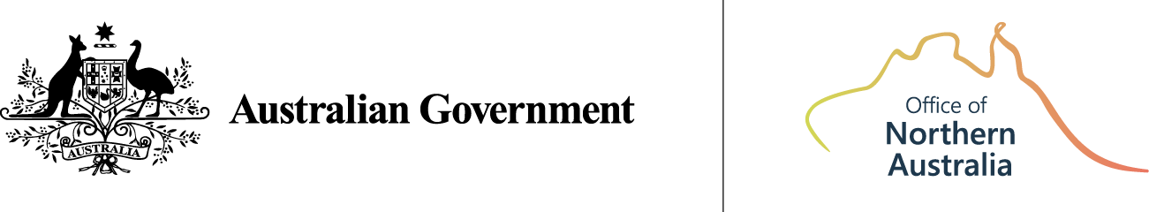

Northern Australia Action Plan 2024–2029:
Annual Progress Report 2025


Acknowledgement of Country
We acknowledge the Traditional Owners of lands and waters across northern Australia and pay our respects to Aboriginal and Torres Strait Islander peoples and Elders.
We recognise the strength and diversity of the world’s oldest continuing cultures, and the enduring connections that Aboriginal and Torres Strait Islander peoples hold with country, languages and traditions.
In reporting on the Northern Australia Action Plan 2024–2029, we reaffirm our commitment to genuine partnership with Aboriginal and Torres Strait Islander peoples, listening to their voices and supporting sustainable opportunities that reflect the uniqueness of each place.
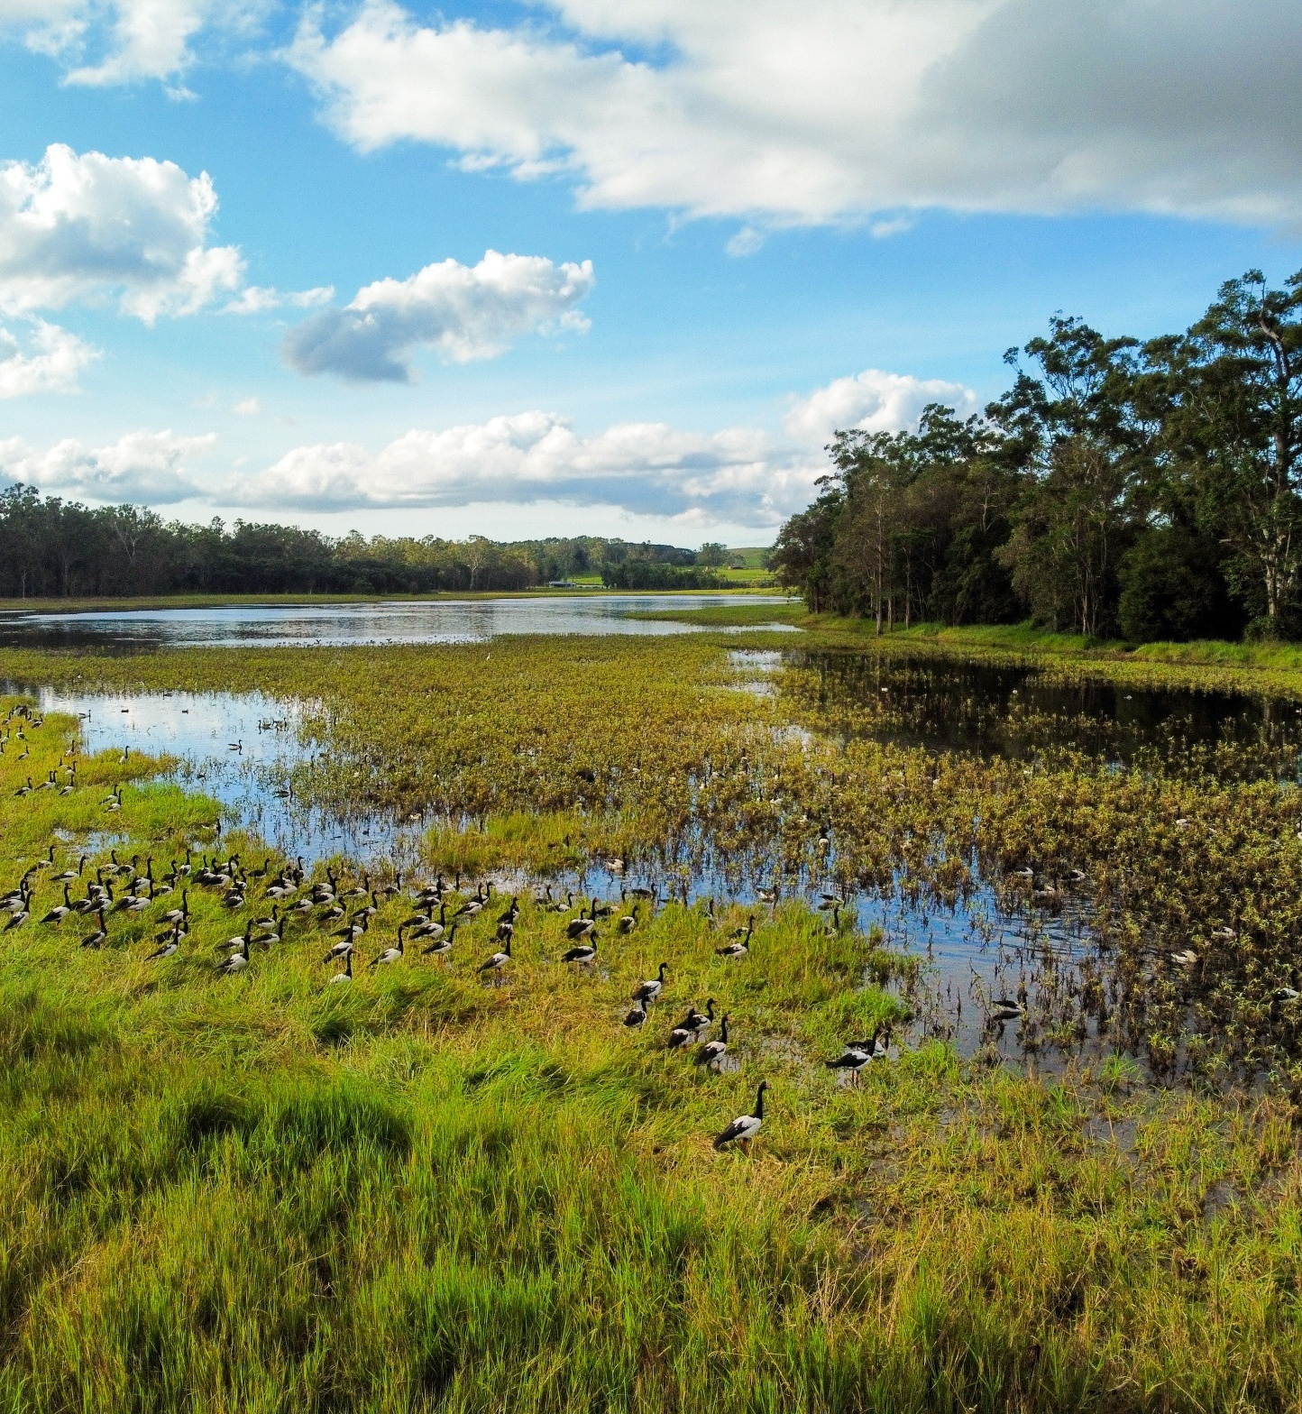
Figure 1 – Flock of magpie geese in the Atherton Tablelands, QLD Credit: ONA

Ministerial Foreword
The Australian Government remains committed to turning northern Australia’s enormous potential into economic and social development. This first Annual Progress Report to the Northern Australia Action Plan 2024–2029 demonstrates how we are delivering on that commitment.
We are proud of the progress to date and equally focused on the work ahead. A strong north is essential to a strong Australia. It will power our economic future, support regional security, and create opportunities for generations to come.
Over the past year, we have continued to attract investment, strengthen local communities, and respond to challenges. These achievements reflect the resilience and ingenuity of northern Australians and the strength of collaboration across governments.
We are delivering this agenda through practical, place-based action across northern Australia. We are supporting private investment, upgrading critical infrastructure, improving housing and workforce pathways, strengthening digital and transport connectivity, investing in and protecting our natural environment, growing our critical minerals industry, and boosting resilience to disasters.
We acknowledge the vital contributions of Senator the Hon Malarndirri McCarthy, Minister for Indigenous Australians, whose involvement in the Northern Australia Ministerial Forum and the Indigenous Reference Group has strengthened this work.
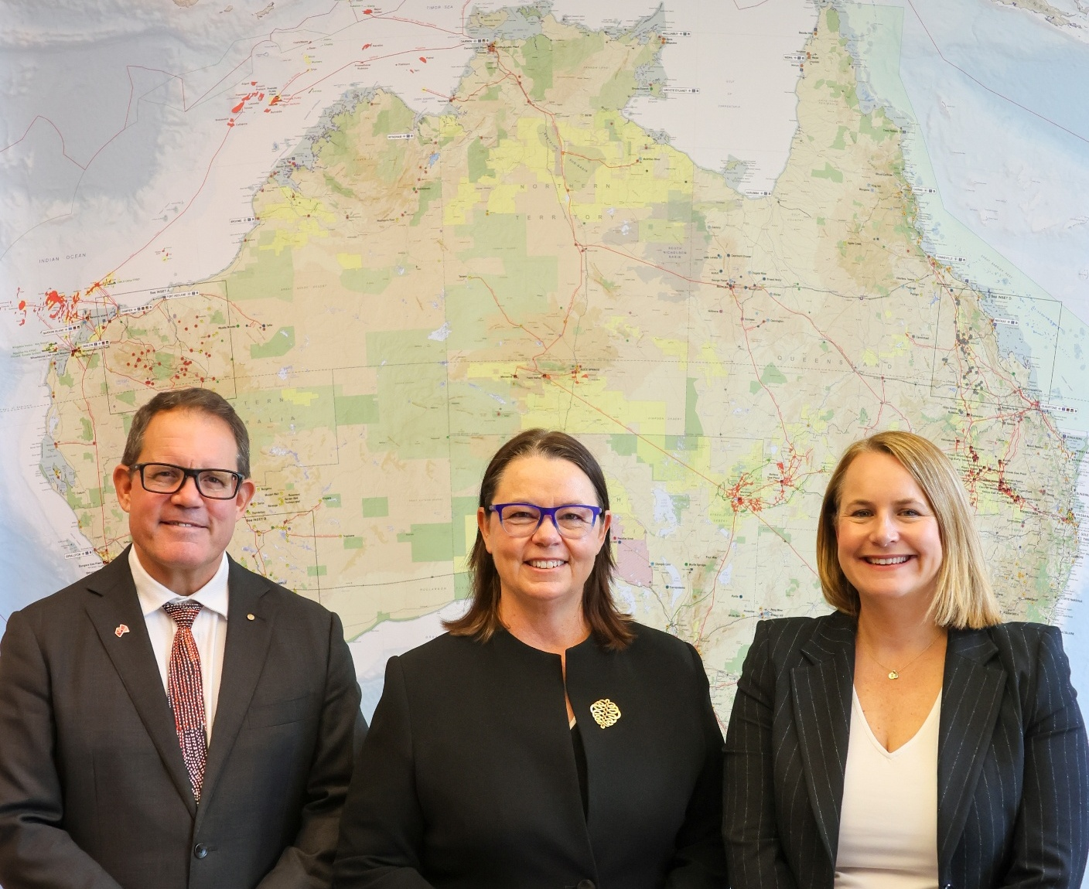
We thank our partners in Queensland, Western Australia and the Northern Territory along with local government and local communities. The Action Plan is being realised through our collective efforts, and we look forward to continuing this shared journey in the years ahead.
Mr Luke Gosling OAM MP  Special Envoy for Defence, Veterans' Affairs and  Northern Australia | The Hon Madeleine King MP  Minister for Northern Australia | Senator the Hon Nita Green  Assistant Minister for  Northern Australia

Progress on the Action Plan
The Australian Government remains committed to developing the northern Australia agenda. The Northern Australia Action Plan 2024-2029 (Action Plan) outlined a whole of Australian Government effort in six policy priority areas that were identified by northern Australia stakeholders. These are:
- Activating the northern economy
- Infrastructure to unlock growth
- A safe and secure north
- Growing the northern Australia workforce
- Liveable, healthy and resilient communities
- Protecting the north’s environment and cultural heritage
To enable progress on these six policy priority areas, the Action Plan identified 17 areas for continued focus for short to medium term government action.

What this report covers
This Annual Progress Report highlights the Australian Government’s delivery on the commitments under the Action Plan and highlights additional commitments since its release. As the Action Plan is a five-year plan, progress will vary across the policy priority areas relative to their complexity and scale.
By reporting annually, we aim to provide transparency, support accountability and ensure the voices and aspirations of northern Australians remain central as the plan evolves.

Policy Priority Area 1: Activating the northern economy
Central to the Australian Government’s northern agenda is supporting a resilient northern economy to reach its full potential. The Government continues to deliver major national initiatives that underpin growth in the north, including the Future Made in Australia agenda and significant investments in renewable energy, critical minerals and agriculture.
Major infrastructure projects financed through the Northern Australia Infrastructure Facility (NAIF) continue to drive investment and create jobs. An independent review of the Northern Australia Infrastructure Facility Act 2016 (NAIF Act) was tabled in Parliament on 27 August 2025. The Report reflects stakeholders’ views that the NAIF remains a core part of the north’s economic framework, with resounding support for its continuation. The Review found that the NAIF and its workforce have evolved, and confirmed the NAIF plays a significant role in supporting government priorities and addressing the significant challenges of securing infrastructure financing in the north.
In 2024–25, five renewable energy projects in northern Australia were given the green light to proceed under the Environment Protection and Biodiversity Conservation Act 1999. These projects have a combined capacity exceeding seven gigawatts, enough to power over 3.6 million homes.
In October 2025, Australia and the US signed an historic framework on critical minerals and rare earths that will assist both countries in achieving resilience and security of supply chains. To complement the framework, both countries committed to take measures to provide at least US$1 billion in investments towards a US$8.5 billion pipeline of priority critical minerals projects over the next six months. Northern Australia has significant deposits of critical minerals and this framework will support the north’s natural comparative advantage.
The Government is also investing an additional $75 million in Prescribed Bodies Corporate (PBCs) to support First Nations economic empowerment, taking total PBC funding to more than $200 million over the three years to 2028–29. The additional PBC funding will help Native Title holders to build capacity and work with the private sector to build wealth.
In March 2025, the Government awarded $814 million to the Murchison Green Hydrogen Project, north of Kalbarri, WA – one of two projects to help catalyse Australia’s renewable hydrogen industry. The project is expected to create around 3,600 construction jobs (at peak) and 600 ongoing jobs in the region.
Under the Future Made in Australia agenda, Australian small to medium enterprises (SMEs) and start-ups are being supported by the Industry Growth Program to commercialise their ideas and grow. To date, 33 businesses in northern Australia have received support through the Advisory Service.
Through the Government’s Indigenous Advancement Strategy, the Indigenous Business and Employment Hubs program is providing $49.9 million from 2022–23 to 2025–26 to strengthen First Nations businesses and employment pathways. In the first half of 2025, the Northern Territory Hub supported 103 businesses, delivered 28 training and networking activities, and assisted 253 job seekers with employment services.
In support of the Government’s Net Zero Plans, $11.4 million was allocated in the 2024–25 Budget to support First Nations groups to participate in the Australian Carbon Credit Unit Scheme consent and agreement processes on Native Title land.
Area of Continued Focus | 2025 Annual Progress Report Update
1. Support northern Australia to capitalise on opportunities presented under the Future Made in Australia agenda and other major government investment opportunities. | The Australian Government remains steadfast in its commitment to northern Australia capitalising on the Future Made in Australia agenda.  In 2025, the Government announced a landmark $5 billion Net Zero Fund to support Australian heavy industry to decarbonise, as well as the scale-up of low emissions technologies needed for our transition to net zero.  Further, the new Green Iron Fund and $2 billion investment in Australian made aluminum have been announced and government will continue to work with local communities to capitalise on these investments and shore up local jobs.  Government agencies such as the Australian Renewable Energy Agency (ARENA) and the Clean Energy Finance Corporation (CEFC) support investments that progress the Future Made in Australia agenda. ARENA under its Advancing Renewables Program has funded $1.67 million to support a feasibility study for the East Kimberley Clean Energy Project. Led by the Aboriginal Clean Energy Partnership, it is giving First Nations partners equal ownership and decision-making. Phase 1 of this project concluded in 2024, with Phase 2 progressing. The project is targeting a final investment decision in 2026.
2. Build on northern Australia’s comparative advantages to harness the opportunities created by global commitments to transition to a net zero economy. | This Government is investing around $500 million in regional hydrogen hubs, including Townsville and the Pilbara. In addition, the CEFC is supporting clean energy projects across northern Australia, with major investments in renewable energy generation, storage and grid infrastructure in Queensland. The Government’s regional planning pilots will guide development in energy, urban growth and critical minerals.  The $8.5 billion critical minerals framework agreed with the United States will help unlock a pipeline of development, including in the north.  Building on existing Australian support, the Australian Government announced a US$100 equity investment in the Arafura Nolans project in the Northern Territory. Once operational, the project is expected to produce five per cent of global rare earths – essential for energy security and defence.  The NAIF will invest up to $50 million to create jobs and give a further boost to Western Australia’s economy by providing support for the Butcherbird manganese project.
3. Scope a First Nations Economic Partnership to improve economic outcomes for First Nations peoples, including northern perspectives. | The Prime Minister delivered on this by announcing the First Nations Economic Partnership at the 2025 Garma Festival. This partnership will enable the Australian Government to work genuinely with key First Nations bodies to advance comprehensive and lasting economic empowerment. First Nations partners include the Coalition of Peaks and the First Nations Economic Empowerment Alliance.
4. Enhance self-determined, sustainable opportunities for First Nations peoples and business, including Prescribed Bodies Corporates to leverage and protect their land, water, Traditional Knowledge, expertise, ingenuity and cultural heritage and other assets. | The Government has committed an additional $75 million to support Prescribed Bodies Corporate.  The Australian Law Reform Commission is reviewing the Native Title Act 1993 to improve its efficiency, fairness and effectiveness. Its report is due by early 2026.  The Government is working with the Indigenous Carbon Industry Network to deliver First Nations carbon farming training. The Government is also developing two new savanna fire management methods under the Australian Carbon Credit Unit (ACCU) Scheme, creating more opportunities for projects that support First Nations communities through jobs on Country, income from ACCU sales, and strengthened capacity to care for Country, culture and community.
5. Enhance participation of Aboriginal and Torres Strait Islander community-controlled organisations and First Nations business in delivering services in the north. | The Department of Infrastructure is working with states and territories to develop a new First Nations Employment and Procurement Framework to deliver greater socioeconomic outcomes for First Nations people through their participation on infrastructure projects jointly funded through the Infrastructure Investment Program.
6. Investigate opportunities to address higher costs of doing business in the north. | The Treasury commenced the Review of the Terrorism and Cyclone Insurance Act 2003 on 30 September 2025. The review will assess whether the cyclone reinsurance pool is meeting its purpose of improving insurance access and affordability for households, small businesses and strata properties with medium to high cyclone and flood risk.

Policy Priority Area 2: Infrastructure to unlock growth
Investment in infrastructure remains critical to unlocking the north’s potential. Infrastructure challenges increase the cost of living and doing business, restrict access to essential services, and make it harder to attract and retain workers. This Government recognises these issues and is implementing a range of programs to address them, improve liveability, and drive economic growth.
Robust supply chains and cost-effective access to markets are essential to the north’s development. In August 2025, the Government released the refreshed National Freight and Supply Chain Strategy and the new National Action Plan. Actions under the Strategy will improve freight productivity and resilience in northern Australia, including defining and modelling the current freight network and developing a national freight resilience plan.
In September 2025, the Government released draft legislation on the Universal Outdoor Mobile Obligation (UOMO) alongside its response to the 2024 Regional Telecommunications Review. UOMO will require mobile carriers to provide reasonable access to outdoor mobile voice and text services almost everywhere across Australia.
Recognising housing as central to the region’s future the Northern Australia Ministerial Forum (NAMF) established a senior officials working group in late 2024 to identify north-specific barriers and opportunities to increase housing supply, and to support evidence-based action to inform decision making.
The working group found that while there is a national housing crisis, northern Australia faces added challenges. These include distorted housing markets, above average homelessness and overcrowding rates, high and escalating construction costs, a highly constrained workforce in a very competitive labour market, and a complex land tenure and regulatory environment. Continued dialogue across Australian, state and territory governments will help ensure program delivery is better aligned to the unique needs of northern Australia.
To address acute housing shortages in remote First Nations communities, the Government is investing $220 million over five years from 2022–23 through the Homelands Housing and Infrastructure Program. The Australian and NT governments are also jointly investing $4 billion over 10 years from 2024–25 through the Northern Territory Remote Housing Package. As at 30 June 2025, 34 of 37 projects from the initial $100 million Homelands Housing and Infrastructure Program had been completed. In 2024–25, 222 houses were built, and property and tenancy management services were delivered under the Northern Territory Remote Housing Package.
The 2025–26 Budget outlined major commitments in the north under the Infrastructure Investment Program, including $7.2 billion for safety upgrades on the Bruce Highway in Queensland, $245 million to replace the Barron River Bridge in Queensland, and $200 million to duplicate priority sections of the Stuart Highway between Darwin and Katherine in the Northern Territory. The Government is also investing $1.1 billion for the Tanami Road Upgrade across Western Australia and the Northern Territory, $1 billion for the Outback Way across all three northern jurisdictions, and $400 million for the Queensland Beef Corridors. These investments will improve freight reliability, boost flood and disaster resilience, create Indigenous and local jobs, and deliver long-term benefits across the north.
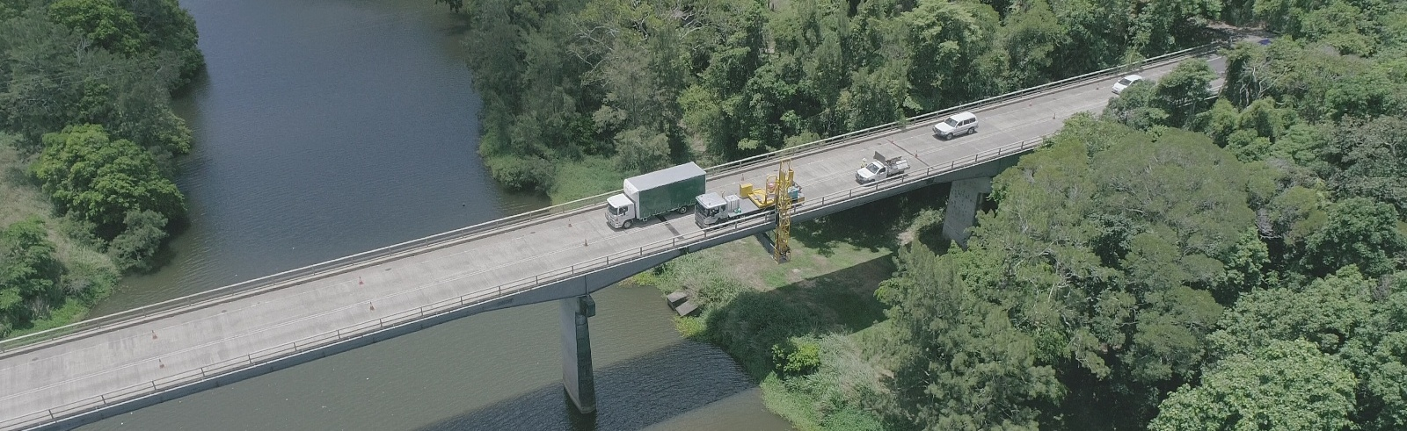
Figure 2 - Barron River Bridge, QLD. Credit Queensland Department of Transport and Main Roads
Digital and mobile connectivity directly affect the north’s ability to conduct business and access services. In 2024–25, key investments to increase availability and reliability included the completion of 31 projects in northern Australia through the Regional Connectivity Program, and continued NBN upgrades, with around 52,000 premises in the north to be upgraded through the Government’s $3 billion equity investment. The Government also provided $50 million in grant funding to state and territory governments for pilot programs under the Regional Roads Australia Mobile Program.
The outcomes of Round 3 of the Mobile Network Hardening Program were announced in September 2025, with $9.8 million in grant funding being provided for 303 projects to improve the resilience of Australia's mobile network telecommunications infrastructure. In northern Australia $3 million is being provided for 71 resilience upgrade projects.
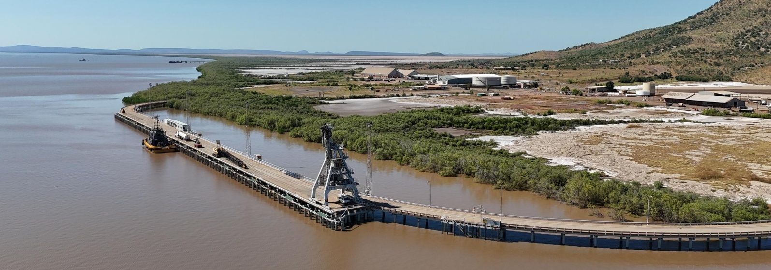
Figure 3 – Port of Wyndham, WA. Credit Kimberley Ports Authority
Expanded border services for critical ports in Western Australia’s north
In January 2025 the government announced that it had supported applications for expanded border services for three critical ports in Western Australia’s north – the Ports of Wyndham, Ashburton and Dampier. The expansion of services at these ports will allow for more direct international shipping, meaning businesses, farmers and other industry in the north will be able to import and export goods closer without having to transit through ports such as Darwin or Fremantle.
The changes are expected to greatly increase throughput at the ports. At the Port of Wyndham for example, exports at the time of the announcement were 212,199 tonnes, and this is expected to increase to over 1.36 million tonnes.
In October 2025 the Australian and Western Australian governments welcomed the first Kimberley Cotton Gin export from the Port of Wyndham in a boost for diversifying regional economies and trade. The Kimberley Cotton Gin Project was supported by a $9 million investment by the Western Australian Government and a NAIF loan of up to $34 million over 12 years. The processing facility is intended to make cotton an economically feasible broadacre crop in the Kimberley region by removing the need to transport unprocessed cotton interstate.
The expansion of border services in Western Australia’s north will benefit businesses and communities particularly in the East Kimberley and Pilbara regions, cutting costs, boosting productivity, providing jobs, and improving the resilience of supply chains, including for clean energy and green fuel projects.
Area of Continued Focus | 2025 Annual Progress Report Update
7. Raise awareness of the specific circumstances and needs of northern Australia in policy initiatives and investments in housing. | The Government this year established the Northern Australia Housing Working Group to provide expert advice and advocate for housing solutions in the north. It presented its findings and recommendations to the Northern Australia Ministerial Forum in October 2025.
8. Continue to work with state and territory governments to understand and address current and future infrastructure needs and priorities in northern Australia. | The Government allocated $17.1 billion for nation building road and rail projects in the 2025–26 Budget. In northern Australia, this includes $7.2 billion for Bruce Highway safety upgrades in Queensland, $245 million to replace the Barron River Bridge on the Kennedy Highway in Queensland and $200 million to duplicate priority sections of the Stuart Highway between Darwin and Katherine in the Northern Territory.  Current key land transport infrastructure projects in northern Australia also include $1.1 billion for the Tanami Road Upgrade across Western Australia and the Northern Territory and $1 billion for the Outback Way across Queensland, Northern Territory and Western Australia.
9. Continue efforts to improve the affordability, accessibility and reliability of air services in the north. | In August 2024, the Government released the Aviation White Paper outlining 56 initiatives to improve passenger experience, industry efficiency and regional connectivity. Nearly $25 million was provided for 45 regional airport upgrades, including $3.1 million for five projects in northern Australia, and subsidised air services continued to support up to 275 remote communities.
10. Continue to work with jurisdictions and regions to ensure there is adequate water planning and infrastructure to support a quadruple bottom line of industry, community, First Nations peoples and environmental sustainability objectives. | Over $1.2 billion is being delivered through the National Water Grid Fund towards critical water infrastructure in northern Australia. The Government has exceeded its $150 million commitment to improve First Nations water access and is developing a new National Water Agreement to strengthen sustainable planning and First Nations influence, and a Closing the Gap Inland Waters Target (15c) to improve First Nations peoples’ access to, ownership of, and management of water.

Policy Priority Area 3: A safe and secure north
Northern Australia makes a vital contribution to both national security and the national economy. The north has significant potential for sustainable and resilient growth, including the further development of natural resources and greater use of renewable energy sources. The north is also a key component of the National Defence Strategy.
The 2023 Defence Strategic Review and the 2024 National Defence Strategy (NDS) observed that Australia is facing the most complex and challenging strategic environment since the Second World War. The NDS also identified the need for investment in connected northern bases to enhance force projection and improve Defence’s ability to operate through disruption. For this purpose, the Integrated Investment Program committed $14-18 billion over the next decade in investment in northern bases.
Over the past year, Defence capital works projects in the north have awarded the large majority of sub-contracts to local businesses, as shown in Table 1. This has provided significant flow-on economic and social benefits to supporting communities and regions. Across five key Defence projects, $1.77 billion is estimated to have been delivered to date, with a further $749 million expected in 2025–26. This local focus lifts industry participation and workforce opportunities, strengthens regional resilience and national civil preparedness, and positions northern Australia to underpin national security, Defence and economic growth.

Table 1: Defence - a focus on local sub-contractors
Initiative / Project | Estimated delivery to date ($m) | Local sub-contracts awarded to date | Sub-contracts within state/territory awarded to date | Location
RAAF Base Tindal Redevelopment and USFPI Airfield Works | 1,040 | 80% | 92% | RAAF Base Tindal (NT)
USFPI Northern Territory Training Areas & Ranges | 561 | 83% | 92% | NT (Bradshaw, Kangaroo Flats, Mount Bundey, Robertson Barracks Training Area)
Cocos (Keeling) Islands Airfield Upgrade | 79 | N/A | 99% | Cocos (Keeling) Islands (IOT)
Robertson Barracks Base Improvements | 70 | 96% | 96% | Robertson Barracks (NT)
Army Aviation Program of Works | 19 | 84% | 96% | RAAF Base Townsville & Townsville Field Training Area (QLD)
The region’s proximity to neighbouring countries, high potential for cross-border movement and unique biodiversity create heightened risks of pests, diseases and invasive species entering the country. Biosecurity is critical to maintaining a safe and secure northern Australia. Biosecurity risk management arrangements are being strengthened in relation to unauthorised maritime arrivals and illegal foreign fishing vessels across the northwest region of Western Australia, the Northern Territory, and the Torres Strait.
The Northern Australia Quarantine Strategy (NAQS) Targeted Surveillance Program has contributed to additional preparedness and response activities across a range of plant and aquatic pests and diseases (e.g. foot-and-mouth disease, lumpy skin disease and a suite of exotic citrus and banana diseases), supporting state and territory responses and broader national efforts.
Over the past year, the Indigenous Rangers Program through the National Indigenous Australian Agency, has also been expanded to create more than 1,000 new Indigenous ranger jobs across Australia, including in the north, building capability, improving resilience, and strengthening early detection of exotic diseases, weeds and pests, while supporting on-country regional jobs and knowledge sharing. In addition, the Indigenous Ranger Biosecurity Program, through the Department of Agriculture, Fisheries and Forestry, partners with 67 Indigenous ranger groups and two Indigenous cattle stations across the 10,000 km northern coastline from Cardwell (QLD) to Bidyadanga (WA).
Area of Continued Focus | 2025 Annual Progress Report Update
11. Work with local communities, businesses, governments and other stakeholders to maximise local benefits from Defence investments in the north. | Across five key Defence projects in the north, $1.77 billion is estimated to have been delivered to date, with a further $749 million expected in 2025–26, providing significant economic opportunities for local businesses.  The United States Force Posture Initiatives are upgrading key Defence facilities in the NT, with $561 million delivered and 83% of sub-contracts awarded locally. Major upgrades at RAAF Base Tindal and Robertson Barracks are also progressing, alongside the Army Aviation Program of Works in Townsville, with over 80% and 96% of sub-contracts respectively going to local businesses.
12. Continue work to reduce northern Australia’s vulnerability to the impacts of biosecurity threats. | The Maritime Border Command is targeting unauthorised arrivals and illegal foreign fishing across northern Australia. The NAQS program has strengthened preparedness for major pest and disease threats, while the Indigenous Ranger Biosecurity Program now partners with 67 ranger groups and two cattle stations. Biosecurity capability is being further supported at expanding northern ports. The Office of the Chief Veterinary Officer maintains an ongoing presence in northern Australia and is supporting work to strengthen First Nations engagement in emergency animal disease preparedness.

Policy Priority Area 4: Growing the northern Australia workforce
Northern Australia’s development relies on a growing and skilled workforce to unlock the region’s vast economic potential and ensure sustainable growth. Addressing workforce shortages is essential not only to attract investment and deliver major projects, but also to support thriving local communities and improve service delivery in health, education and infrastructure.
Over the past year, progress has been made through investments in foundation skills, new education policy design and targeted training programs, including dedicated support for First Nations Australians, as well as support for northern Australia’s skilled migration needs.
In March 2025, the Government embedded Free TAFE as an enduring feature of the national vocational education and training system, by legislating the Free TAFE Act 2025, supporting 100,000 Free TAFE places a year from 2027. As at 30 June 2025, Fee-Free TAFE has supported more than 3,255 enrolments in the Northern Territory alone.
In the second half of 2024, the Government replaced the Community Development Program with the Remote Jobs and Economic Development (RJED) Program to create 3,000 new jobs in remote communities that offer proper wages and employment conditions, including superannuation and leave. A key feature is that communities help decide the jobs needed. The program was designed in partnership with First Nations peoples.
The Government is also continuing to collaborate with industry and state and territory governments on a range of visa programs and policy reforms to assist employers and communities in northern Australia to address their skilled workforce needs. Designated Area Migration Agreements (DAMAs) play a significant role in addressing labour shortages. The Government has pursued a state-led approach to DAMAs, giving states and territories a greater role in determining their migration needs, complementing their migration plans, and aligning the use of DAMAs to jurisdictional levers vital to attracting and retaining migrants in regional Australia, including the north.
In January 2025, the Government confirmed that the Far North Queensland DAMA will remain in effect until April 2027. In addition, in March 2025, the Government expanded the Townsville North Queensland DAMA by introducing 14 new occupations, adjusting income thresholds for select occupations, and providing age and English language concessions for high-demand positions.
In March 2025, the Australian and Northern Territory governments signed the third NT DAMA, which will be in effect until 2030. This agreement increases the total number of overseas workers who can be nominated under the DAMA to 7,500 across 325 occupations (up from 135 occupations) over the term of the agreement.
In addition, the State and Territory Nominated Migration Program granted 1,143 skilled visas to migrants nominated by the Northern Territory and 2,772 skilled visas to migrants nominated by Queensland in the year to February 2025. These initiatives are helping to build a pipeline of skilled workers to meet the north’s growing demand through workforce development, population growth and migration strategies.
Broome Employment Services Trial
The Broome Employment Services Trial is a place-based initiative designed to improve employment outcomes for people who use the service in the Broome region, until 30 June 2027.
Delivered by a First Nations provider and supported by locally embedded Australian Public Service (APS) staff, the trial is tailored to meet local needs.
APS staff work in close partnership with the provider and local stakeholders to better understand and respond to community priorities. This includes supporting participants to navigate complex service systems, streamlining pathways to secure employment, and strengthening relationships across government, business, and community. This work has directly improved education access for prison-based clients by connecting the Skills for Education and Employment (SEE) provider with the local correctional facility.
The trial has achieved meaningful outcomes in Broome by addressing existing challenges with mainstream models, including fragmented services and infrastructure constraints. Between November 2023 and July 2025:
- 375 job placements were achieved-an average of 18.7 per month, compared to 6.3 under the previous model.
- Participant satisfaction reached 86.9%, with improved service delivery, reduced client issues, and increased community trust.
- Seven First Nations participants progressed into regional Defence service roles supporting the Northern Australia Defence Strategy.
Key learnings from the trial include the importance of APS stewardship, the effectiveness of place-based approaches in thin markets, and the needs to remove artificial boundaries between services.
Insights from Broome are informing broader employment services reform and supporting other First Nations providers across Australia.

Area of Continued Focus | 2025 Annual Progress Report Update
13. Work with industry and state and territory governments to support northern Australia accessing the skilled workforce required for economic growth. | The redesigned Skills for Education and Employment Program includes a dedicated stream to deliver place-based training for First Nations communities. The Remote Australia Employment Service will commence on 1 November 2025. A $3 million grant has also been awarded to deliver mobile training units in Central Australia across in-demand industries.  A strengthened Free TAFE system across the country is continuing to fund thousands of places across northern Australia.  Ongoing collaboration and refinement of regional DAMAs is helping to meet workforce needs in the north.  In the NT, under a Pacific Australia Labour Mobility (PALM) scheme pilot, workers from Papua New Guinea are training and working in the early childhood sector in Katherine and Alice Springs where local educators have been difficult to find.

Policy Priority Area 5: Liveable, healthy and resilient communities
The ability of people to live, work and thrive in the north requires investment in community infrastructure and services. Over the past year, a range of initiatives have been delivered to improve amenity, expand access to health care and strengthen resilience.
Investments are also supporting economic transition and justice outcomes, with targeted funding directed to First Nations-led initiatives in health, climate resilience and justice.
In December 2024, the Government announced funding for 72 projects under round two of the Growing Regions Program. Of these, 19 are located in northern Australia. Of the $386 million in national funding, around 33% ($127 million) was directed to projects in northern communities, delivering significant investment in local infrastructure that will enhance liveability, bolster social cohesion and support local amenity throughout Australia's regions. The Regional Precincts and Partnerships Program (rPPP) is driving place-based investment in regions including the north. Ten projects in northern Australia shared in nearly $20 million for design, development and delivery of new precincts, strengthening regional communities and supporting the delivery of vibrant, connected communities.
Actions aimed at improving the liveability of northern communities are complemented by initiatives to enhance improve community resilience and adaptive capacity. In September 2025, the Government released the National Climate Risk Assessment (NCRA) and National Adaptation Plan (NAP). The NCRA is Australia’s first comprehensive, system-wide analysis of climate risks. It identifies how climate change poses risks to people, the economy, the environment and national systems that support wellbeing and has particular findings for northern Australia. The NAP responds to the risks identified in the assessment and provides the Government’s policy framework for addressing them. The Government will work with states, territories, and local government to create an action agenda for the NAP by the end of 2026.
The risk assessment and adaptation plan build on extensive work undertaken by the Government, including initiatives such as the $1 billion Disaster Ready Fund (DRF) and the $91.8 million North Queensland Recovery and Resilience Package (NQRRP). Under Rounds 1 and 2 of the DRF, 53 projects worth a total of $107.5 million in Australian Government funding are being delivered in northern Australia. Under the NQRRP over the past year, 77 new resilience initiatives were funded, ranging from major infrastructure upgrades to flood mitigation infrastructure, emergency shelters, community generators and the sealing of frequently washed-out roads. Farmers impacted by floods in 2023 were able to apply for grants of up to $150,000 to help restock and rebuild, and a $2 million study was undertaken to explore solutions for building livestock mounds as flood-safe areas.
In 2024–25, the Government also announced $23.3 million over four years to improve emergency preparedness and safety measures on the Cocos (Keeling) Islands in the event of severe weather events and rising sea levels. The Torres Strait and Northern Peninsula Area Climate Resilience Centre is a First Nations-led response to the on-ground impacts of climate change. The Department of Climate Change, Energy, the Environment and Water is are working with regional leaders and Traditional Owners to design, establish and deliver the $15.9 million investment over 6 years (2022–23 to 2027–28).
Three regional organisations have been awarded grants under Torres Strait and Northern Peninsula Area Climate Resilience Grant Program to lead practical climate adaptation projects and community education.
The Government’s National Justice Reinvestment Program is a $69 million package supporting six place-based initiatives in northern Australia aimed at reducing the over-representation of First Nations people in the criminal justice system. This is complemented by the Justice Reinvestment Unit, which is currently engaging with stakeholders to design its future governance and operational model ahead of transitioning to an Aboriginal Community Controlled, or First Nations-led, organisation next year.
Additional First Nations-led initiatives contributing to justice and wellbeing outcomes include:
- $3.5 million over five years for the delivery of integrated, culturally appropriate social and emotional wellbeing and mental health services across four wellbeing centres in Cape York, Queensland.
- $11.9 million over four years to deliver culturally appropriate mental health and wellbeing programs across 18 remote communities in northern Australia.
- $76.8 million over five years through Culture Care Connect for First Nations providers to deliver localised health and suicide prevention programs, including ten in northern Australia.
- $1.2 million to target chronic hepatitis B, which has the highest national prevalence in the Northern Territory.
Together, these investments are strengthening place-based, culturally grounded approaches that enhance liveability, resilience and justice outcomes for northern Australian communities.
Area of Continued Focus | 2025 Annual Progress Report Update
14. Work to overcome challenges that northern Australians may face in equitably accessing Australian Government investment. | The Office of Northern Australia is undertaking an analysis of government grant program funding to better understand the distribution of national investments in northern Australia and inform actions to improve access to funding in northern Australia.
15. Continue efforts to ensure government funding and policy decisions consider northern Australia’s unique climate adaption needs. | The National Climate Risk Assessment, released on 15 September 2025, is Australia’s first system-wide analysis of climate risks and shows northern Australia is highly vulnerable. The National Adaptation Plan sets the Government’s framework for action. Climate resilience grants are funding First Nations-led adaptation, and Parks Australia is progressing climate-informed planning in protected areas.
16. Work with industry, community representatives, First Nations peoples, state and territory governments and local governments to collectively assist communities undergoing significant economic transition. | The Australian Government is partnering with the Queensland Government on a support package to secure the Mount Isa Copper Smelter and Townsville Refinery, protecting more than 600 direct jobs and 500 at Phosphate Hill. Engagement continues on the Gove Peninsula transition, supported by the National Skills Plan to align training with regional and emerging industry needs.
Cairns Seniors Community Housing Project
The Northern Australia Infrastructure Facility (NAIF) is supporting the Cairns Seniors Community Housing project with a loan of up to $140 million, in partnership with the Queensland Government, ANZ and Housing Australia.
As one of Queensland’s largest social and affordable housing developments, it will deliver 490 dwellings, comprised of 245 social, 223 affordable and 22 specialist disability accommodation apartments, providing housing to around 690 people, thereby helping to address the housing shortage in Cairns.
The project is forecast to contribute $140.8 million to the Far North Queensland economy, creating 290 jobs during construction and 32 ongoing roles.
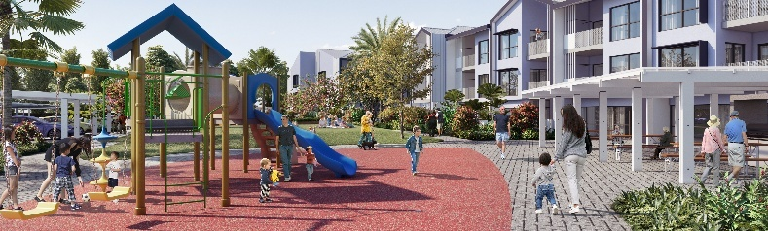
Figure4 3- Artists impression of the Cairns Seniors Community Housing project. Credit NAIF

Policy Priority Area 6: Protecting the north’s environment and cultural heritage
To protect, conserve and promote Australia’s natural and cultural values, the Australian Government is working with states, territories, First Nations communities, industry and research organisations to facilitate sustainable development.
Significant progress has been made to streamline approval processes, invest in conservation and strengthen cultural heritage protections in partnership with First Nations communities.
From July 2025, the Australian Bushland Program (ABP) is investing $250 million over five years to grow Australia’s protected and conserved areas. The program will make a significant contribution to Australia’s 30 by 30 target to protect and conserve 30% of Australia’s landmass by 2030, as well as supporting progress towards Australia’s Strategy for Nature. A portion of the ABP is committed to expanding Indigenous Protected Areas (IPAs), as an addition to the existing $231.5 million over five years (2023 to 2028) for improving and expanding Indigenous Protected Areas (IPAs).
In March 2025, the Government opened the world first Nature Repair Market, a national, voluntary, legislated biodiversity market. The Government is developing methods that will provide opportunities for land managers in the north to attract investment into projects that enhance or protect biodiversity. The legislation underpinning the Market recognises and upholds the rights and interests of First Nations people. The objects of the Act specifically call for First Nations engagement and participation enabling the use of Indigenous knowledge guided by the owners of that knowledge. In addition to opportunities to undertake projects, there are opportunities for First Nations groups to provide paid expert advice on method development and to deliver advisory and other services to project proponents.
Guided by the Reef 2050 Long-Term Sustainability Plan, the Australian and Queensland governments have committed more than $5 billion from 2014–15 to 2029–30 to support the health and resilience of the Great Barrier Reef. Of this, more than $3.7 billion is from the Australian Government.
The Australian Government has committed a record $1.2 billion over nine years to protect and restore the Great Barrier Reef including:
• priority actions to accelerate efforts to improve water quality;
• protecting coral and enhance the resilience through targeted control of crown-of-thorns starfish;
• delivering innovative, world-leading science and research;
• reducing the impact of high-risk fishing; and
• strengthening partnerships with First Nations people.
Since 2022, the Government has invested and delivered more targeted programs, informed by latest science and expert advice, and accelerated action to improve water quality. The government continues to work with and support farmers, landholders, Traditional Owners, Natural Resource Management groups and other partners to help progress towards water quality targets through practical programs like the $200 million Landscape Repair Program, $28.5 million for the Reef Coastal Restoration Program and the $192 million through the Clearer Water for a Healthy Reef Program.
To provide easier access to data and tools to support environmental assessments and approvals, Environment Information Australia launched its new web portal in February 2025. It also released the first National Ecosystem Account and is progressing environmental-economic accounts to inform future State of the Environment reporting, with the next report due in 2026.
Protecting cultural heritage in northern Australia is crucial to honouring First Nations’ continuing connection to Country, preserving diverse traditions and strengthening the region’s cultural identity for future generations. From 2024-25, the Government is investing $53.8 million over four years on urgent priorities in First Nations languages sector. The network of 25 First Nations language centres, throughout Australia each received a $200,000 funding boost, including 11 centres across northern Australia totalling $2.2 million in 2024–25 to support language conservation, revitalisation and sustainability. In addition, 2,200 objects have been returned to First Nations communities (around 60% of these in northern Australia) under the $10.4 million Return of Cultural Heritage Program.

Northern Australia Indigenous Reference Group
The Indigenous Reference Group (IRG) provides key advice to government on the delivery of the Northern Australia Action Plan 2025–2029, ensuring First Nations voices are central to decisions shaping the future of the north and the Australian Government’s commitment to the National Agreement on Closing the Gap.
The 2021–24 IRG concluded its term in December 2024. I thank the outgoing Chair and members for their commitment, leadership, and valued contributions. Their work laid strong foundations for the next phase of First Nations economic participation in northern development.
The IRG has now commenced under refreshed Terms of Reference, Chaired by Professor Martin Nakata. Continuing members Troy Fraser, Flora Warrior and Nini Mills bring valuable experience and continuity, while Damien Djerrkura and Alinta McGuire bring fresh perspectives.
The group met in Cairns in July 2025, held a virtual meeting in September, and is planning a third meeting in November in Canberra alongside the Minister’s Annual Statement to Parliament on Developing Northern Australia.
The IRG has identified three priorities:
- Supporting the education to employment pipeline to deliver economic empowerment
- Supporting First Nations enterprises
- Data collection, impact measures, and alignment of departmental expenditure to national commitments.

Strengthening knowledge and evidence for the north
National initiatives in science, research and innovation are delivering tangible outcomes for northern Australia.
The Australian Government is strengthening how national initiatives serve the north, ensuring that investment, programs and evidence are better aligned with the region’s unique opportunities and challenges. Since the launch of the Action Plan, work has continued across government to embed First Nations partnerships, tailor approaches to place and strengthen the resilience of northern communities. An additional key priority has been to enhance the availability and usability of data and evidence to better inform decision making.
The National Science Statement and National Science and Research Priorities are embedding and elevating Aboriginal and Torres Strait Islander knowledge systems. The National Science and Technology Council is developing an implementation plan that will harness First Nations knowledge and voices to inform future work.
Geoscience Australia's 10-year, $566.1 million Resourcing Australia’s Prosperity initiative is collecting geological, geochemical and geophysical datasets to assess the resource potential for minerals, energy and groundwater. Two of the three regional deep dives are in northern Australia:
- Birrindudu, which is already underway and scheduled for completion in 2029. Engagement with First Nations communities is actively progressing in this region.
- Georgetown–Julia Creek, announced in August, is in the early stages of engagement. Joint seismic work has been undertaken in collaboration with the Queensland Government, but broader stakeholder engagement is just beginning.
The work underway provides comprehensive insights into the natural features, assets and potential of the regions. Geoscience Australia is committed to engaging with First Nations people and communities in these regions, to learn their requirements for data and information and build strong, lasting relations that create collaborative opportunities and support self determination
Through the National Environmental Science Program (NESP), the Government is funding projects in partnership with relevant research organisations to articulate research priorities across northern Australia. Initiatives within the NESP include building knowledge, skills and partnerships with First Nations communities to progress important environmental priorities such as seagrass management, and partnering with Traditional Owners of globally significant ecosystems, including Kakadu National Park, to better understand knowledge gaps and priorities and to inform monitoring and management practices.

Closing the distance: Telehealth innovations
Cooperative Research Centre for Developing Northern Australia telehealth projects are reshaping rural and remote healthcare in northern Australia, ensuring equity despite distance. Project Echo Telehealth Skills and Health eMinds strengthen frontline workforce capability, while the Tele-Diabetic Foot Disease project is trialling a remote multidisciplinary model to prevent amputations, hospitalisations, and costs in dispersed communities. New eye screening services are saving sight for remote patients, reducing avoidable blindness through timely detection and treatment. The Telehealth Technician project builds local sustainability by training First Nations community members to deliver ICT, diagnostics, and telehealth facilitation under Medicare and public funding. A streamlined satellite-ready system ensures reliable access for remote First Nations health services. Together, these initiatives create resilient, locally driven telehealth solutions that improve outcomes and advance equity across the north.

Figure 5 - Telehealth conference. Credit Belinda Carlson.

Area of Continued Focus | 2025 Annual Progress Report Update
17. Partner with research organisations to develop research priorities for the north. | The National Environmental Science Program is funding projects to define northern Australia’s research priorities, including regional planning, seagrass management with First Nations communities, and work with Traditional Owners in places like Kakadu. It is also supporting the National Indigenous Environmental Research Network, while an independent panel is examining Australia’s research and development system.
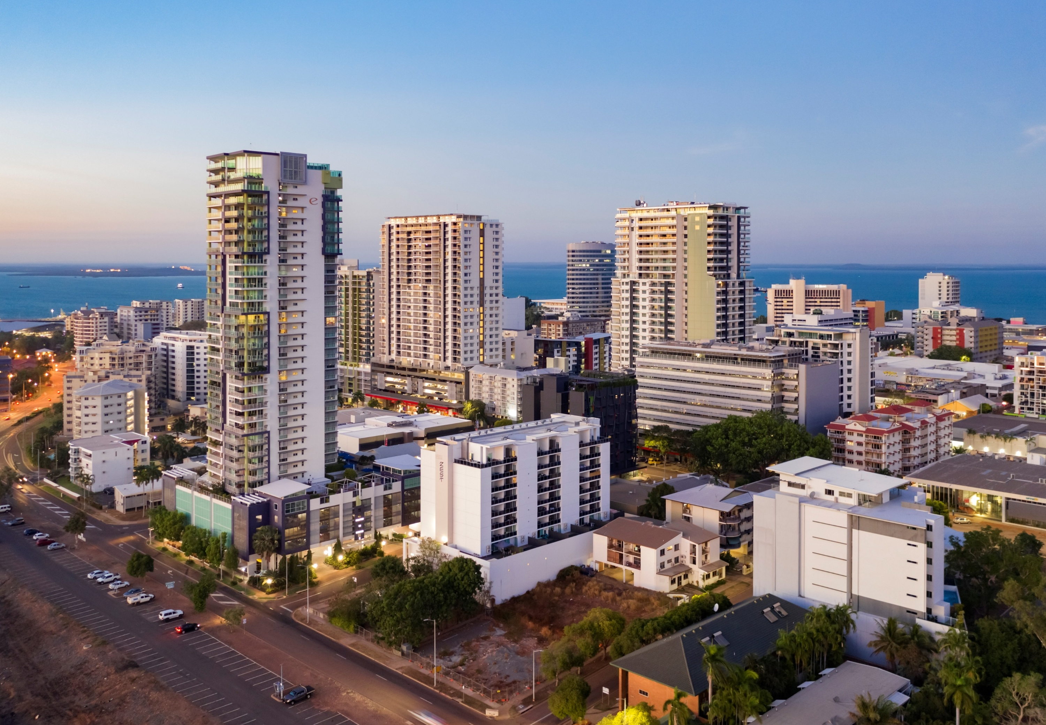
Darwin City, NT. Credit Jeremy Woodhouse.

