Our North, Our Future: White Paper on Developing Northern Australia

Contents
Foreword iv
DEVELOPING THE NORTH 1
Our north, our future 1
Our vision 2
Realising our vision 4
Action summary 10
SIMPLER LAND ARRANGEMENTS TO SUPPORT INVESTMENT 1
Overview 1
Land in the north 2
Economic opportunity in native title 4
Supporting investment on Indigenous land 10
More economic activity on pastoral land 17
DEVELOPING THE NORTH’S WATER RESOURCES 23
Overview 23
Information supports development 24
The way forward 24
Providing greater certainty for investment 27
The way forward 29
Investing in water infrastructure 30
OUR BUSINESS, TRADE AND INVESTMENT GATEWAY 36
Overview 36
Industries with bright growth prospects 37
Challenges for business, trade and investment 39
The way forward 40
Attracting more investment 41
Fostering greater innovation and leadership 44
Making it easier to do business 53
INFRASTRUCTURE TO SUPPORT GROWTH 62
Overview 62
More infrastructure for the north 63
Better use of infrastructure 70
A NORTHERN WORKFORCE FOR GROWTH 79
Overview 79
Challenges for the northern workforce 81
The way forward 83
More Australians working in the north 83
Allowing business to address unmet labour demand 86
GOOD GOVERNANCE FOR NORTHERN AUSTRALIA 91
Overview 91
Governance challenges 91
Responses to the challenge 92
The way forward 93
Next steps 96
IMPLEMENTATION PLAN 97
A plan for the north 97
A framework for delivering White Paper actions 97
Who will deliver the plan? 99
Two, five, 10 and 20 year plans 99
PROFILE OF NORTHERN AUSTRALIA 107
Overview 107
A vast, diverse and vibrant region 107
Climate 109
Population 111
Indigenous culture 112
Education and health 114
Employment and income 116
The public sector and defence 117
Investment and trade 120
Infrastructure 122
Minerals and mining 124
Liquefied natural gas 126
Agriculture 128
Biodiversity 129
Heritage places and protected areas 132
Tourism 135
Selection of Existing Policies and Programmes 136
Commonwealth Government 136
Queensland Government 148
Western Australian Government 153
Northern Territory Government 157
Private Sector 159
List of tables and figures 166
Bibliography 168
Image Credits 179

Foreword
Northern Australia can grasp its full potential and become an economic powerhouse within our great country.
Our north’s future will come from its people, its ingenuity, its diversity, and its proximity to Asia. Covering 40 per cent of Australia’s land mass, our north has the resources, the connections across the tropics, and the land, skills and institutions that the Indo-Pacific region needs; a region that has the savings and the markets to drive northern prosperity.
This White Paper is an essential part of our plan to build a strong, prosperous economy and a safe, secure Australia. We can take advantage of our strengths and our natural advantages.
We will fix the roads and telecommunications, build the dams and deliver the certainty that landholders and water users need.
We will drive down the costs of operating in the north for business; making it a more attractive place to invest and work. By making the right regulations and infrastructure investments, we can encourage jobs and tackle the costs of living far from major cities.
Governments alone cannot develop northern Australia, they can only set the right environment for businesses to profitably invest and communities to flourish. The north will only truly achieve its potential with the participation of all the people who live there, including Indigenous Australians.
We acknowledge the contribution of everyone who made submissions and participated in this White Paper; particularly the Hon. Warren Entsch MP who chairs the Joint Select Committee on Northern Australia, and the Hon. Shane Stone and his Northern Australia Advisory Group. For many years Senator the Hon. Ian Macdonald has been a driving force for development in northern Australia.
We want this White Paper to be the foundation on which successive Commonwealth governments can continue this important work over coming decades.

The Hon Tony Abbott MP
Prime Minister
The Hon Warren Truss MP
Deputy Prime Minister
Minister for Infrastructure and Regional Development

The Hon Andrew Robb AO MP
Minister for Trade and Investment

DEVELOPING THE NORTH

Our north, our future
The north has untapped promise, abundant resources and talented people. It is also Australia’s closest connection with our key trading markets and the global scale changes occurring in Asia.
A strong north means a strong nation. Even though over one million people live in the north — all of the Northern Territory and those parts of Western Australia and Queensland above the Tropic of Capricorn — it accounts for over half of our sea exports (Ports Australia, 2014). Thriving and diverse exports in minerals, energy, agriculture and tourism underpin our national income. The earnings from the Pilbara alone are larger than the individual economies of 119 countries but are generated by only 60,000 people (Pilbara Development Commission, 2013).
Many previous efforts to develop the north have floundered through a lack of foresight and the absence of markets in our region for high value goods and services. Through this, the first ever White Paper on Developing Northern Australia (the White Paper), the Commonwealth Government is putting in place the right policies, at the right time, to unlock the north’s vast potential. This White Paper has been developed to stand the test of time — it should be the first, and last, White Paper for the north.
Australia’s north is unique in the developed world. It sits at the intersection of the two great regions of global economic and population growth — Asia and the Tropics:
- The booming economies of south east Asia and southern China are within three to five hours flying time from Darwin.
- The Tropics account for 40 per cent of the world’s population today, rising to 50 per cent by 2050 (State of the Tropics, 2014).
- By 2030 Asia will represent approximately two thirds of the global middle class population and of middle class consumption (Pezzini, n.d.).
- The north operates in similar time zones to the most dynamic economies in Asia — a particular advantage for service industries.
- The region is integrating fast — Australia has recently concluded Free Trade Agreements (FTA) with Japan, South Korea and China, and is in ongoing negotiations with India, Indonesia and on regional FTAs such as the Trans-Pacific Partnership (TPP), the Regional Comprehensive Economic Partnership (RCEP) and the Pacific Agreement for Closer Economic Relations (PACER) Plus.
- It is a gateway for our defence and security cooperation into the Indo-Pacific region and supports Australia’s ability to project and sustain forces into the region for surveillance, humanitarian assistance and disaster relief.
The north is fast developing as a trade gateway for all of Australia. The Darwin-Adelaide railway has helped lift the volume of exports through Darwin Port to be thirteen times larger in just 10 years (Darwin Port Corporation, 2014; Ports Australia, 2014). Global supply chains are increasingly important. The share of trade in intermediate goods — goods used to produce other goods and services — has nearly doubled as a share of global output since the early 1990s (Kelly & La Cava, 2013).
The north has brand advantages associated with being part of Australia, with a well-earned reputation for quality, safety, sound governance and a pristine natural environment. Further development should not be at the cost of these advantages.
It is the frontline for our nation’s defence, border protection and biosecurity. Its proximity to our neighbours gives it a crucial role in helping to protect Australia’s environment, population and agricultural industries, and to maintain and increase access to markets by managing pest and disease risks. It is also home to a large, relatively young Indigenous population which will play a major role in the north’s long term development.
The north also presents challenges. Business and household living costs are much higher than they should be, and much higher relative to the rest of Australia and many other developed economies. High business costs discourage investment, while high living costs can discourage settling in the north.
Governments need to focus on making a difference where they are best able, and enable business and markets to do the rest. Many failed projects and plans litter the north. It is essential that development ambitions recognise these challenges.

Our vision
If the history of northern development teaches us one thing, it is that business and governments should stick to what they do best.
Governments’ role is to create successful business environments, not successful businesses. This is best achieved through prudent economic policies, the right infrastructure to get things moving, regulation that minimises costs on business, a workforce with the right skills, and basic research necessary for business to identify opportunities in the north.
It is not the Commonwealth Government’s role to direct, or be the principal financier of, development. Developing the north is a partnership between investors (local and international investors who provide capital and know-how) and governments (that create the right investment conditions).
World class risk management is shown by the northern resources industry, which has built vast infrastructure in difficult operating environments with innovative technology to supply distant customers. Chevron Australia is building the nation’s largest natural resource project, the Gorgon Project (US$54 billion) in northern Western Australia, involving a logistics exercise of almost unprecedented scale.
Governments have facilitated, rather than led this growth. Business is far better placed to understand the risks and rewards from northern economic development. Governments further support growth by providing essential information, especially where there are basic knowledge gaps.
But government-facilitated, rather than government-led growth, still requires some government action. The Commonwealth Government can remove impediments to growth, reduce regulatory risk (while maintaining protections), provide essential information, underwrite enabling infrastructure and lift the growth speed limits in the north on the foundations of land, labour, water and infrastructure. If this is achieved, more private sector capital will follow.
The Government has widely discussed the five industry pillars that play to Australia’s strengths and have the most potential for growth:
- food and agribusiness
- resources and energy
- tourism and hospitality
- international education
- healthcare, medical research and aged care.
These, and other emerging industries, will benefit from the White Paper tackling the biggest barriers first. In doing so, the cost of doing business and living in the north will more closely match that across the rest of Australia.
With the right policies, success in the north will mean that within a few generations we can expect that there will be a sharp increase in the scale and breadth of activity in each of these industry sectors. The north will be an exemplar of sustainable development. The development of major population centres of more than a million people will underwrite substantial exports of planning, design, architecture and construction services to the Tropics.
Key enabling infrastructure will create greenfield supply chains across agriculture, aquaculture and previously stranded energy and minerals resources. This will serve as the catalyst for new large scale projects in the key investment priority areas.
But to do all this within a generation or two, and do it right, requires decisive action. It cannot be done with incremental approaches. It will need private sector capital — and lots of it. It will need governments to create the right environment through cuts to unnecessary red tape and strategic investments in infrastructure.
Developing the north will need to be done in full partnership with Indigenous Australians, with a focus on creating opportunities through education, job creation and economic development. These opportunities for Indigenous Australians will contribute to achieving the objectives of the Government’s Indigenous Advancement Strategy.
It will need to be consistent with safeguarding the incredible northern environment for future generations. It is, after all, the north’s exceptional environment that draws visitors from around the world. It is particularly important to understand our role as stewards of our unique natural wonders, such as the Great Barrier Reef, ensuring all development is done in a way that protects the outstanding universal value of such special places.
Development will require many more people living in the north. Transformation won’t happen if its population inches up by a few hundred thousand over the next 20 years. It would remain a high cost, small scale economy; more of a pilot project than a powerhouse. We need to lay the foundations for rapid population growth and put the north on a trajectory to reach a population of four to five million by 2060.
History has been built on the application of ingenuity to the challenges of development. More human capital means more dynamism, creativity and innovation. It means more entrepreneurs to tackle the opportunities and challenges of the north, and provide the workforce for the cities that will grow there.
The purpose of this White Paper is to lay out the policy framework that will achieve this vision.

Realising our vision
To unlock the north’s full potential, the Commonwealth Government will address challenges to development by:
- making it easier to use natural assets, in close consultation with, and the support of, Indigenous communities
- providing a more welcoming investment environment
- investing in infrastructure to lower business and household costs
- reducing barriers to employing people
- improving governance.
These themes are explored throughout this White Paper. The actions needed to develop northern Australia will be rolled out over the next two, five, 10 and 20 years. These actions reflect community views, expressed through the Joint Select Committee on Northern Australia’s report: “Pivot North — Inquiry into the Development of Northern Australia” (Pivot North) and submissions to the Government’s Green Paper on Developing Northern Australia (the Green Paper).

Reduced barriers to better use of land and water resources
The north will never reach its potential without secure, tradeable titles to land and water. Complex land tenure systems across the north are not easily understood by potential investors or financial institutions.
Much of the north is Crown land held under state and territory pastoral leases. Pastoral leaseholders are generally unable to use their land for activities other than grazing, such as horticulture or tourism. Pastoralists trying to broaden economic activity often need approvals from various government bodies. Further, lessees do not have the same security as those with freehold tenure.
The Commonwealth Government supports the efforts of northern jurisdictions to accelerate pastoral lease reforms, making it easier for pastoral owners to diversify their businesses.
The Government will support their work with willing communities and jurisdictions to pilot land reform projects, targeting practical ‘next steps’ for projects that demonstrate the benefits of reform for Indigenous and non-Indigenous investors.
Native title recognises Indigenous Australians as the first inhabitants of Australia and their continuing cultural attachment to the land. However, both Indigenous and non-Indigenous stakeholders highlight the complexity, time and uncertainty that the native title process can create. Innovation, investment and industry development can be stifled.
Native title should be seen as a source of Indigenous economic opportunity. By requiring the engagement of native title holders, native title rights ensure development occurs in ways that enhance the quality of life for Indigenous Australians.
To provide greater certainty and opportunity for Indigenous Australians and potential investors, the Government will improve capabilities of native title bodies so that they can more efficiently negotiate with business. Land surveys will be completed for northern communities to provide the basic building blocks for secure tenure. More township leases will be rolled out in the Northern Territory to provide more certainty for Indigenous and non-Indigenous investors and more economic opportunities for Indigenous communities.
The Government will explore mechanisms to support long term leasehold arrangements for exclusive native title.
These actions will drive more economic activity on Indigenous and pastoral land and ensure that Indigenous and native title land can be an economic asset as well as a cultural and spiritual one.
Even with a welcoming investment environment, there are many challenges for investors in the north.
Information on basics such as land tenure, water availability and soils is often poor. That is why the Government will commission water resource assessments in the Mitchell River catchment (Queensland), West Kimberley (Western Australia) and Darwin region (Northern Territory), to identify the water and soils necessary for development. Such assessments will identify available water that jurisdictions should quickly move to secure through offering water rights.
A new National Water Infrastructure Development Fund will be established with a simple mandate: to accelerate investment in water infrastructure. This means supporting investment in new dams and other water infrastructure, as well as improving information and understanding of surface and groundwater resources — particularly in economic priority areas. The Government will commit up to $200 million towards northern water infrastructure, starting with examinations of the economic feasibility of Nullinga Dam near Cairns and Ord Stage 3 in Western Australia and the Northern Territory. A condition of the Government contributing to northern water infrastructure is that investors and farmers will have access to secure water rights.

A more welcoming investment environment
For too long, governments have tied up private sector investment in needless red tape — forgoing the benefits of growth for fear of risks. In assessing regulations, the Commonwealth Government will apply a risk neutral, rather than risk averse, framework for assessing the impact of development on the north.
Working with the Northern Territory Government, the Commonwealth Government will establish a ‘single point of entry’ for investors in major projects to help them through all regulatory hurdles. This will provide an important mechanism for feeding back information to governments on unnecessary regulation that is hampering business.
This White Paper also cuts other red tape. Fisheries regulation will be streamlined. The northern Australia crocodile industry and other low risk commercial and tourism traders covered by the Convention of International Trade in Endangered Species of Wild Fauna and Flora (CITES) will face less red tape.
The north needs investment to grow — and the rest of Australia and the world have the means to do it.
Open capital markets allow Australia to benefit from the tremendous opportunities flowing from Chinese growth and financial integration in the region more generally. Foreign investment also helps spread new technologies and techniques and can lead to other business opportunities. It helps forge deeper trade, strategic and cultural links with other nations. For example, Indonesian investment in northern cattle exporting facilities could smooth access to the Indonesian markets for all Australian cattle producers. The Foreign Investment Review Board will continue to ensure that investments are in the national interest, particularly Australia’s national security interests.
To bring together international investors and promote secure investment in northern Australia, the Government will host a major northern investment forum in late 2015. The Government has also produced a value proposition, “Northern Australia emerging opportunities in an advanced economy”, under the Australia Unlimited branding to showcase investor ready projects and specific northern opportunities.
A new $75 million Cooperative Research Centre (CRC) for Developing Northern Australia located in the north will provide necessary research and development (R&D), utilising the expertise and experience of northern researchers and business. This CRC will initially focus on agriculture, food and tropical medicine.
Agriculture will be protected through a commitment to strengthen biosecurity in the north, including a $12.4 million boost to Indigenous Ranger groups. Human disease threats will be tackled with a $15.3 million Tropical Health Strategy.
More foreigners visiting Australia creates more business opportunities and jobs for Australians. Longer multiple entry visas and a trial to allow visa applications to be lodged in Chinese will give Australia the edge in attracting China’s booming outbound tourism market. Faster and easier online applications for China and India will also help create further opportunities in the north — and the rest of Australia.

Improved infrastructure
Infrastructure is critical in linking the dispersed populations and remote businesses of the north. Many northerners say that southern decision makers do not take sufficient account of the north’s needs or opportunities. This White Paper will change that.
Most northern infrastructure is funded by business (such as resources) or by charging users (such as electricity generation). Businesses can determine where and how much infrastructure needs to be built based on an assessment of what users are prepared to pay for. But to fast track growth in the north, the Commonwealth Government is providing a new $5 billion Northern Australian Infrastructure Facility to provide concessional loans for the construction of major infrastructure such as ports, roads, rail, pipelines, and electricity and water supply.
Where there is difficulty charging users or where there are broader social benefits, infrastructure is often better funded directly by governments. Under a new $600 million northern Australia roads package, funding will be directed to priority projects on the Great Northern Highway, Arnhem Highway, Flinders Highway, Barkly Highway, Hann Highway, Outback Way and the Tanami Road.
Governments tend to be poorer managers than the private sector of the complex networks needed to get the most value from infrastructure. Individual jurisdictions face reduced incentives to prioritise projects where benefits spill across borders. Informed by the latest logistics technology, a $100 million beef roads fund will improve cattle supply chains in the north. Remote airstrips will also be upgraded and a new business stakeholder group will assist the Government develop a plan for improving air and surface transport connections in the north.
Government plans can be uncertain and infrastructure projects sometimes lack appropriate cost benefit analyses. It can be difficult for governments to determine which projects are most valued because users may overstate their benefits if they do not have to pay for them. Cost benefit analysis is an important tool for governments to evaluate projects and determine spending priorities – so this White Paper is funding such a study for a Mount Isa to Tennant Creek railway.
Building on Infrastructure Australia’s audit, a new northern Australia infrastructure projects pipeline will help guide investors about the infrastructure plans of northern jurisdictions. Investors will be welcome to bring forward bids if they can build infrastructure projects better or cheaper. Projects wanting funding from the Northern Australian Infrastructure Facility will benefit from being on the pipeline.

A workforce that meets the needs of the north
Workers’ wages and skills, and levels of unemployment and participation vary widely across the north. While some specialised workers receive well above average wages, they exist alongside pockets of extreme disadvantage.
To boost opportunities for Indigenous workers and businesses, the Commonwealth Government will require Indigenous procurement targets for all road projects funded through this White Paper to drive Indigenous employment and supplier use. This commitment builds on the Government’s new Indigenous Procurement Policy which is putting Indigenous businesses front and centre in the way the Government does business.
Reflecting its diverse and sometimes harsh environment, the north has many businesses that require flexible employment conditions; effectively shutting down or cutting back during the wet season, contrasted with extended hours in the dry season. Tourism workers are often needed outside standard business hours, such as on weekends, at night, or ‘on call’. Many mining or agriculture businesses require workers onsite in challenging conditions, and away from families. Northern businesses are especially subject to ‘boom and bust’ cycles, moving on to new projects at the end of resource construction projects.
A more flexible labour market system in the north, and across Australia, will allow businesses to bargain over wages and conditions specific to their business needs, as well as encourage increased investment, more jobs and income growth. That is why the Government has asked the Productivity Commission to examine the workplace relations framework and identify improvements that can be made to better suit workers and businesses.
The Government’s approach to improving the northern workforce will build on existing policies and initiatives across Australia. The national reforms to higher education, skills and training will mean better skilled and more adaptable workers across Australia, including in the north. Efforts to remove disincentives to work inherent in the welfare system will also encourage greater workforce participation, particularly at the lower skilled end of the labour market.
The Northern Territory Government, in partnership with the Commonwealth Government, is working to streamline recognition of occupational licences given by jurisdictions. This will enable a seamless transition for workers moving to the Northern Territory and expands job opportunities for workers across the country.
The Government will also broaden the availability of the Industry Skills Fund’s skills advice services to businesses seeking to expand in the north.
Despite these measures, there are likely to be remaining shortages in some sectors where it is difficult to source Australian labour.
Accordingly, the Government will:
- continue to pursue Designated Area Migration Agreements (DAMAs) to support the workforce strategies and labour markets of northern jurisdictions, including in the Northern Territory and the Pilbara
- expand the Working Holiday Maker Visa Programme by increasing the amount of time visa holders can work in high demand areas
- expand and streamline the Seasonal Worker Programme to support seasonal industries, including in agriculture, tourism and hospitality
- enhance links with the important and increasingly vulnerable Pacific microstates with a new worker pilot visa for 250 citizens.

Improved governance
The vision for northern Australia in 2035 includes stronger governance arrangements. We do not want to look back in 20 years and regret missed opportunities.
To achieve our vision, the Commonwealth Government has made substantial policy and fiscal commitments and will be held accountable for them (see the Implementation Plan on page 98). The Northern Australia Strategic Partnership — a biannual gathering of the Prime Minister, Deputy Prime Minister and First Ministers of northern jurisdictions — will continue to ensure these commitments are kept. The Joint Select Committee on Northern Australia will also have a continuing role aimed at ensuring ongoing bipartisan support.
The Office of Northern Australia (ONA) will be shifted to the north and report to the Deputy Prime Minister. It will coordinate implementation of this White Paper across Commonwealth agencies and with northern jurisdictions — with the Deputy Prime Minister to give an Annual Statement to Parliament on progress. Northern jurisdictions are encouraged to participate in ONA, including through providing staff and secondment opportunities.
Governments have been asked to regulate less and facilitate business more. Governments have committed to trialling and testing policies, rather than just relying on the lessons of the south. Businesses bring with them high standards of accountability and management — more private investment should therefore improve governance in the north.

Action summary

Land
- $10.6 million to support pilot reforms that broaden economic activity on land and demonstrate the benefits of reform to investors, Indigenous Australians and other stakeholders.
- Supporting the native title system ($110 million a year over the next four years) with the aspiration of finalising all existing native title claims within a decade.
- More efficient native title processes that create more certainty for investors and opportunities for native title claimants and holders (through the COAG Indigenous land review).
- $20.4 million to better support native title holders engage with potential investors.
- Consult on options to use exclusive native title rights for commercial purposes (through the COAG Indigenous land review).
- $17 million to support freehold/99 year leases for willing Indigenous communities, including rolling out more township leases in the Northern Territory and finalising cadastral surveys and area mapping across the north.
- Consult on new models to manage native title funds for development.
- More business friendly information on the different land tenure arrangements to increase the appeal of investing in the north.
- Pursue a set of principles and actions to improve the security, bankability and efficiency of pastoral land.

Water
- $200 million to build water infrastructure in the north and tied to developing secure and tradeable water rights as part of a new National Water Infrastructure Development Fund, starting with:
- $15 million to determine available water and best locations for water infrastructure in the Mitchell River catchment (Queensland), West Kimberley (Western Australia) and the Darwin region (Northern Territory).
- Up to $5 million each for detailed examinations of the economic feasibility of Nullinga Dam (Queensland) and Ord Stage 3 development (Western Australia/Northern Territory).

Business, trade and investment
- A major investment forum in Darwin in late 2015 to attract investors and expose them to opportunities in the north; supported by a publication of investor ready projects in the north.
- A Northern Australia Insurance Premiums Taskforce to investigate actions that lower the cost of insurance in the north.
- Stronger economic connections with the booming Asia-Pacific region by linking the north with ASEAN and APEC connectivity agendas.
- $2.5 million to foster business to business links with Indonesia, Papua New Guinea and Timor-Leste.
- $13.6 million to extend management advice and other business support services to businesses in the northern tourism industry (under the Entrepreneurs’ Infrastructure Programme).
- Extending similar services to around 500 small businesses in the north by lowering the minimum turnover or operating expenditure threshold to $750,000.
- $75 million for a new Cooperative Research Centre on Developing Northern Australia, located in the north, with an initial focus on agriculture, food and tropical health.
- $15.3 million for a Tropical Health Strategy aimed at protecting our people and economy from the increased risks of disease, while commercialising Australian tropical disease R&D.
- $2 million to build links between world class institutions researching tropical health.
- $12.4 million to boost Indigenous Ranger groups in northern Australia, with further announcements on biosecurity in the Agricultural Competitiveness White Paper.
- $2 million to set up a ‘single point of entry’ office in Darwin with the Northern Territory Government to cut red tape and facilitate major project approvals.
- Reforms to visitor visas from China and India — including further roll out of e-lodgement for China and India; trial a fast track service and a 10-year longer validity visa for Chinese visitors; and a trial of Chinese language lodgement of visitor visa applications.
- Consult key Indigenous groups on options to improve protections and cut red tape around Indigenous cultural heritage through amendments to the Aboriginal and Torres Strait Islander Heritage Protection Act 1984 (Cwlth).
- Cut red tape around fisheries by shifting to single jurisdiction fisheries management; devolve aquaculture management to the states and territories; share licensing and compliance services; and extend export approvals to 10 years for low-risk fisheries.
- Cut red tape on tourist souvenirs and exports of low risk species, and look at options to streamline and expedite processing and extend the length of CITES permits for commercial trade in low risk industries (such as the northern Australia crocodile industry).
- A Productivity Commission Inquiry to identify duplicative or poorly implemented regulations that are harming investment in Australia’s fisheries and aquaculture industries.

Infrastructure
- $5 billion in concessional loans for projects through the Northern Australia Infrastructure Facility.
- $600 million for priority road projects in northern Australia including consideration of the Great Northern Highway, Arnhem Highway, Flinders Highway, Barkly Highway, Hann Highway, Outback Way and Tanami Road.
- $100 million to improve cattle supply chains through a northern Australia beef roads fund; using CSIRO modelling and livestock transport and beef industry experts to identify investment and deregulation priorities.
- $5 million for analyses of freight rail projects in northern Australia, with an initial focus on a pre-feasibility study, including a high level cost benefit analysis, of the proposed Mount Isa to Tennant Creek railway.
- $3.7 million to develop an infrastructure pipeline with the jurisdictions to provide investors information on potential infrastructure needs so more can be built sooner and cheaper.
- Release Infrastructure Australia’s northern Australia infrastructure audit.
- $39.6 million to upgrade airstrips and subsidise air services in remote Australia.
- Establish a business stakeholder group to develop a plan for improving aviation and surface transport connections in northern Australia.

Workforce
- Making make it easier for businesses seeking to expand into northern Australia to receive advice and grants that upgrade their skills under the Industry Skills Fund.
- Employment targets for Indigenous Australians, reflecting local Indigenous working age population, for road projects (and other relevant expenditure) funded through this White Paper.
- Support the Northern Territory Government to allow workers licensed from other Australian jurisdictions to have their licences more easily recognised in the Northern Territory.
- Reforms to the Remote Jobs and Communities Programme to allow participants to work in local businesses.
- Pursue more flexible foreign worker arrangements in high demand areas by finalising the Northern Territory DAMA; continue to work with Western Australia on a DAMA for the Pilbara; and invite Queensland to propose a DAMA.
- Expand and streamline the Seasonal Worker Programme by reducing costs to business, increasing worker numbers and allowing more countries and industries to participate.
- Expand the Working Holiday Maker Visa Programme to allow participants to work for longer in high demand areas in northern Australia, with a small number allowed a second year on their visa if they work in northern tourism and agriculture.
- Pilot a two-year visa for up to 250 citizens of the Pacific microstates (Nauru, Tuvalu and Kiribati) for work in the north.

Governance
- Regular meetings between the Prime Minister, Deputy Prime Minister and the First Ministers of the northern jurisdictions through the Northern Australia Strategic Partnership.
- Shift the Office of Northern Australia to northern Australia.
- Recommend to the Parliament that the Joint Select Committee on Northern Australia be made an enduring feature of future Parliaments.
- An annual statement to Parliament from the Deputy Prime Minister on progress of White Paper initiatives, as well as new Commonwealth Government initiatives affecting the north.
- A public sector secondment programme to improve links between different levels of government and support implementation of the White Paper.
- A northern Australia themed regulation repeal day in March 2016.
- Strengthen the Defence presence in northern Australia, with details to be announced in the 2015 Defence White Paper.

SIMPLER LAND ARRANGEMENTS TO SUPPORT INVESTMENT

Overview
Secure land rights underpin investment and development.
The Commonwealth Government will work with Indigenous communities, business and northern jurisdictions to simplify and modernise land arrangements in the north. This will create more certainty for investors and increase the value of land for all Australians.
Quote: Secure land tenure, such as through freehold and long term leasing, is a fundamental building block of economic development. Secure property rights support investor confidence, encourage employment and underpin productivity (Northern Australia Advisory Group, 2015).
Native title and Indigenous land holding is of particular importance to northern Australia as the majority of determinations and current native title claimant applications are in Western Australia, Northern Territory and Queensland.
Land in northern Australia has the potential to support greater and more diverse economic activity. However, some of the rules governing land use in the north adversely affect economic development and discourage investment.
The complexity of land arrangements has slowed development to date. Indigenous groups, business and communities generally recognise the need for change. This White Paper’s 20 year vision provides the clear policy direction needed for sustained reform.
Land is of fundamental importance to Indigenous Australians for cultural, social and economic purposes. However, in many cases, Indigenous Australians do not have the same opportunities as other Australians to leverage their land assets to generate wealth. The Government is determined that native title holders and Indigenous businesses and communities should have this opportunity. While the focus of this paper is on northern Australia, any changes to native title would benefit Indigenous Australians across the whole nation.
There is strong support in the north to try new ways of using land to promote economic opportunity. This means increasing the value of land for all — to create a native title regime that has a greater focus on economic opportunity for Indigenous Australians, to increase individual property rights in township areas for willing Indigenous communities, and to develop pastoral leasehold into a simpler and broader form of tenure.
The following actions will result in more diversified and productive economic activities in the north. They will simplify land arrangements, making the north more competitive as a location for domestic and international investment.

Land in the north
Land arrangements are more diverse across the north than the south.
Northern Australia has proportionately more determined native title, more Indigenous land and more pastoral leases than southern Australia (PM&C, 2015). Together, these interests in land make up an area in the north which is about double that of New South Wales and Victoria combined (PM&C, 2015)(see Figure 1).
Figure 1: Land tenure in the north compared with the south
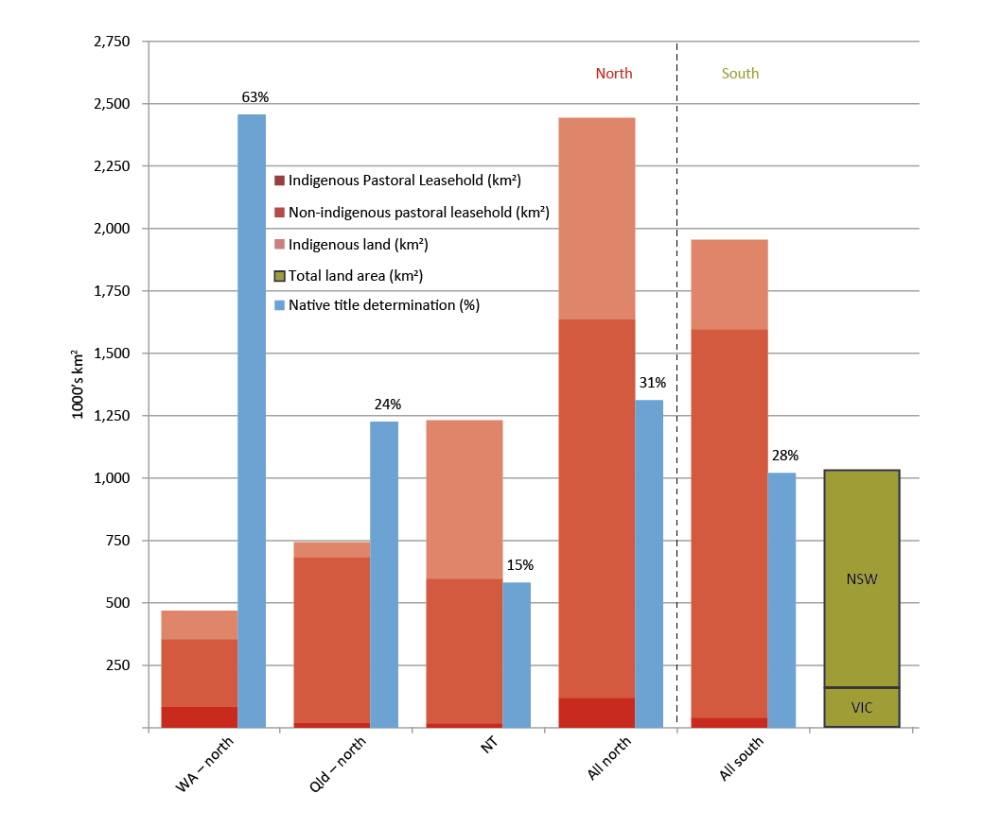Source: National Native Title Tribunal, 2014; Geoscience Australia, 2015a; PM&C, 2015
Each jurisdiction has separate arrangements (and legislation) for Indigenous freehold and trust arrangements, and pastoral leases. The Commonwealth Government administers the Native Title Act 1993 and Northern Territory land rights (see Table 1). As with the south, these arrangements require investors to navigate multiple regimes. The Torres Strait also has treaty arrangements that affect interests in that area.
Table 1: Thirteen legislative acts govern land use in the north
Jurisdiction: Northern Territory
Pastoral leasehold: Pastoral Land Act 2011
Indigenous Land: Associations Act 2012; Crown Lands Act 1992; Special Purposes Lease Act 1953

Jurisdiction: Queensland
Pastoral leasehold: Land Act 1994
Indigenous land: Aboriginal and Torres Strait Islander Land Holding Act 2013; Land Act 1994; Aboriginal Land Act 1991

Jurisdiction: Western Australia:
Pastoral leasehold: Land Administration Act 1997
Indigenous land: The Aboriginal Affairs Planning Authority Act 1972

Jurisdiction: Commonwealth
Pastoral leasehold: Not applicable
Indigenous land: Native Title Act 1993; Aboriginal Land Rights (Northern Territory) Act 1976

Multiple interests often co-exist in one area of land (see Figure 2). For example, a cattle station may be on Crown land and subject to pastoral lease and native title rights.
Figure 2: Land tenure in northern Australia
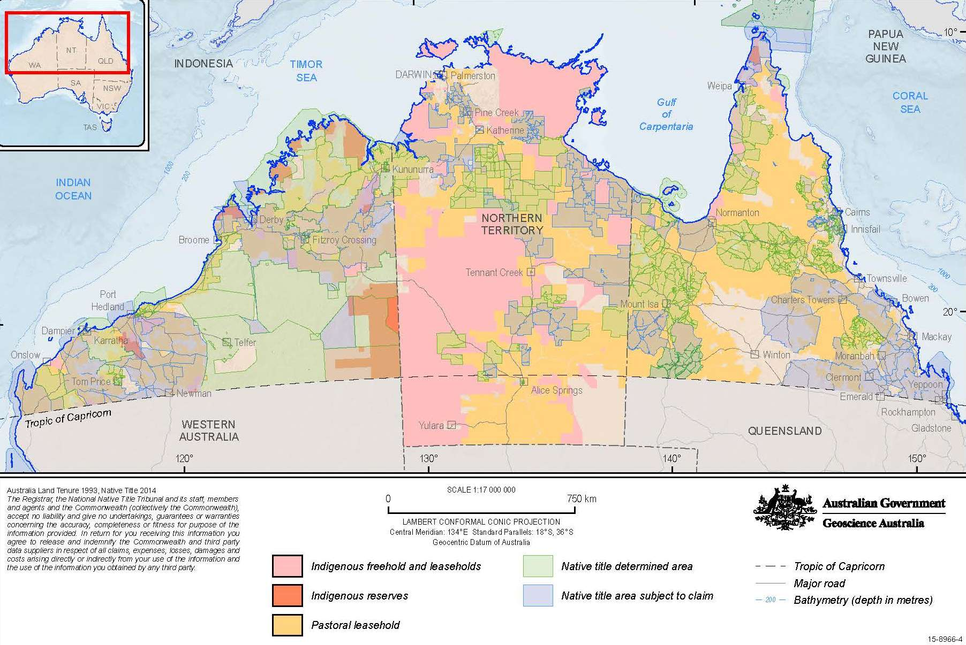Source: Geoscience Australia, 2015a

A new pilot approach to supporting more economic activity on land in the north
The Commonwealth Government will work closely with northern jurisdictions to support innovative changes to the arrangements governing land use to simplify these arrangements and attract more investment in the north. The goal is to fund practical ‘next steps’ for projects that demonstrate the benefits of land tenure reform for Indigenous and non-Indigenous investors.
The Government will invest $10.6 million to support pilot land projects which will be developed in partnership with business and Indigenous Australians, including land owners, to provide simpler and more efficient ways of investing in a wider range of activities. Projects will focus on economic development and home ownership. They will cover native title, the range of Indigenous land types and pastoral leasehold.
Possible projects could include:
- pilots which expand economic activity on pastoral land
- resource assessments of Indigenous pastoral land
- supporting home ownership on communal land
- investigating options for long lease arrangements for exclusive native title
- providing better information for business and Indigenous land holders.
Simpler land administration arrangements will make the north a more competitive investment location across a wider range of activities. It will also make home ownership for Indigenous Australians on Indigenous land more realistic.
Critically, pilots will be supported by willing communities, not undermine Indigenous land rights more broadly, and offer economic (and possibly other) gains to communities.
A pilot approach to land tenure reform in the north offers a way to work with communities to develop reforms that have their support. Individual projects will help develop model approaches for Indigenous, pastoral and Crown land, subject to native title, that could be shared more widely and rolled out over time where there is support in Indigenous communities and the private sector.

Economic opportunity in native title
This White Paper, with its 20 year horizon, looks forward to when native title holders can fully participate in developing the north.
Land is of deep significance to Indigenous Australians and is a foundation for economic development in the north. The concept of native title acknowledges this significance by recognising Indigenous traditional rights and interests in land and water (Box 1).
Quote: The concept of native title as an impediment to development and economic growth, both for the community generally and for Aboriginal people, must be put aside. Native title is a significant property asset of one of the largest constituencies in Northern Australia (Kimberley Land Council, 2014).
Indigenous Australians have native title rights in significant parts of northern Australia. Some 94 per cent of the landmass of north Western Australia is subject to a native title claim or determination, as is 62 per cent of north Queensland and 30 per cent of the Northern Territory (National Native Title Tribunal, 2014) (see Figure 3). This is an area more than twice the size of New South Wales (PM&C, 2015).
Many Indigenous Australians say that native title rights do not provide a basis for active participation in the economy. Indigenous Australians sometimes talk about being ‘land rich, dirt poor’. In many cases, native title does not currently provide a secure asset that promotes investment, unlike most Australians who can borrow against their freehold title in their own home or business.

Box 1: What is native title?
Native title is the recognition by Australian law (under the Commonwealth’s Native Title Act) of Aboriginal and Torres Strait Islander peoples’ traditional rights and interests in land and waters held under traditional law and custom. Native title is recognised by a Court after either litigation or agreement among the native title party, relevant government party and other land interest holders.
The nature of native title ranges from case to case. It can comprise exclusive possession, which makes up 13 per cent of Crown Land in the north. Most instances of native title provide non-exclusive native title rights, for example, a right to collect ochre from the land, or rights to hunt, fish and camp on the land. Native title no longer exists on land which has been issued as freehold. This is why there is more native title in the less developed north.
Native title rights are generally communally held and cannot be sold. This protects Indigenous peoples’ ongoing connection to their land. It also means that much of the land that can be developed in the north is different from the mainly freehold south, and this can cause confusion for investors, including financial institutions.
A native title claim is an application made for the legal recognition of native title rights and interests held by Indigenous Australians. A determination is a decision by an Australian court or other recognised body that native title does exist (or does not exist).

Figure 3: Native title determinations and claims in northern Australia by share of land mass
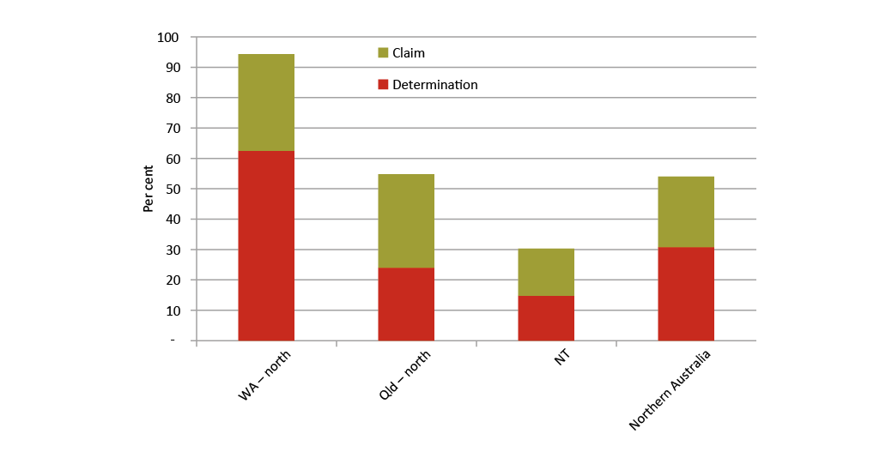Source: National Native Title Tribunal, 2014
Native title should not be seen as a barrier to development, but essential to it. However, the costs associated with unduly long native title negotiations can be an impediment for some developments. Empowering native title groups to use their land rights in the wider economy is fundamental to developing the north and closing the gap between Indigenous and non-Indigenous Australians. The growing recognition and acceptance of Indigenous interests in land as part of our legal, social and business landscape means that business and governments are increasingly engaged with Indigenous Australians through innovative land developments. Businesses with experience working in the north know that early effective engagement with Indigenous communities is essential. Legislative frameworks for Indigenous interests in land have supported thousands of successful developments across the north.
Nevertheless, some stakeholders observe that existing native title frameworks are still too complex or too time consuming. For example:
- certainty around native title only arises once there is a determination over an area
- Indigenous organisations managing native title often lack capacity to proactively engage in development activity
- the costs and time delays associated with native title processes can make some developments unviable.
Indigenous and non-Indigenous Australians are seeking better ways to leverage native title in order to develop the north.
Quote: It is vital - both for Indigenous people and for the nation as a whole - that these lands and rights are managed in a way that makes it easier for people to do business and enables us to tap into the unlocked potential of our vast geography (Mr Warren Mundine, Chair Prime Minister’s Indigenous Advisory Council 2014a).
In 2014, the Council of Australia Governments (COAG) agreed to investigate how Indigenous land administration and use can be improved to support Indigenous economic development. The views and support of Indigenous land owners and native title holders are of central importance in the COAG investigation. The investigation is being guided by an Expert Indigenous Working Group, which is providing leadership on consultations and engagement with Indigenous stakeholders.
Through COAG, the Commonwealth Government is seeking to create economic opportunities for Indigenous communities, and reduce uncertainty around native title for Indigenous Australians and businesses alike.

More certainty over native title rights
The Commonwealth Government aspires to have all current native title claims finalised within a decade.
Efficient resolution of native title claims allows native title holders to more easily use their rights or interests for economic development opportunities, including training and employment. More certainty over rights gives businesses greater clarity around what land is subject to native title and who they should be negotiating or consulting with.
Quote: The time taken to settle native title claims (including the backlog of claims) is a serious impediment to some developments. Importantly many Indigenous claimants are frustrated and disappointed by delays as we risk a whole generation never realizing the benefit of their entitlements. (Northern Australia Advisory Group, 2015)
The Government already commits around $110 million annually to support the native title system.
Funding supports native title representative bodies, determined native title holders, native title respondents and anthropologists. It also supports the administration of the National Native Title Tribunal (the independent body that assists Indigenous Australians reach native title outcomes) and the Federal Court of Australia (which makes native title determinations).
The efficiency of the native title system has improved. As part of native title claims management, the Federal Court now identifies priority claims for resolution. But even priority claims take approximately two years and three months to resolve, and the uncertainty continues in areas where native title remains unresolved. The time taken by the native title claims process can be very lengthy when parties are required to provide stringent tenure analysis and connection evidence, and where there is a strategic behaviour by some parties.
The Commonwealth Government will work through COAG and with native title stakeholders to accelerate the resolution of native title claims. The Government supports:
- streamlining the processing of native title claims
- seeking to resolve native title by consent, with reference to precedent
- applying a less technical and legalistic approach to and a stronger policy focus on litigation
- improving the coordination of the native title system between the Federal Court, the National Native Title Tribunal, government agencies and key parties in native title claims
- clarifying that a court can determine native title exists where an Indigenous company holds a pastoral lease.
Greater certainty about native title rights will generate more economic opportunities for Indigenous Australians and support a stronger northern and national economy.

Efficient processes for dealing with native title
The Commonwealth Government aims to continually improve the native title system’s efficiency, in close cooperation with all jurisdictions, Indigenous Australians, business and other stakeholders.
The Native Title Act sets standards for dealings affecting native title, including in decisions concerning the development of their land. Depending on the nature of the activity, the Act gives native title parties rights to be notified, to be consulted, to negotiate or to consent. Clear, simple and effective native title processes improve certainty for private sector investment on land subject to native title.
Quote: Native title is only the starting point for our people in reclaiming land … the next step is being able to freely exercise our rights to promote economic development and build housing to the advantage of our communities … it’s about understanding what are those barriers, what are those extra layers of regulation that hinder people in using their assets and participating in economic development (Mr Mick Gooda, Aboriginal and Torres Strait Islander Social Justice Commissioner, 2015).
Current processes could be improved. The costs of negotiating and dealing in native title could be more proportionate to the expected impact on native title. At times, there is too much red tape constraining bargaining. Jurisdictions are seeking actions to reduce native title transaction costs. Through COAG, the Commonwealth Government will consider these views and options to make such processes more efficient and transparent, while protecting Indigenous interests.

Stronger native title corporations
Most of Australia’s native title corporations are located in the north. They need to be efficient if native title holders are to achieve strong economic outcomes from their native title.
Native title corporations are registered following native title determinations. The primary duty of these corporations is to properly represent native title holders in decisions affecting their land. Investors who want to undertake developments on land where native title exists must deal with native title holders through these corporations. Stronger native title corporations can improve business confidence by reducing the delays and costs caused by drawn out negotiations in making an agreement. When they are working well, these bodies ensure that when potential investors ring, there is someone to answer the call.
Quote: Native title is seen more and more in Australia as a cultural right; as a form of interest in land – a ‘bundle of rights’ that is different to and less substantial than interests in land held by other Australians. We can use land to practice our culture on, to hold our ceremonies on, but we can’t use the leverage it should give us to build an economic base (Mr Wayne Bergmann, CEO KRED Enterprises, 2012).
Currently, many corporations are not in a position to carry out such responsibilities. This creates uncertainty for business, delaying negotiations and threatening jobs, income and other benefits potentially available to Indigenous communities.
The Commonwealth Government will provide $20.4 million to better support native title holders to effectively engage with potential investors. This includes direct funding for native title corporations to manage native title on behalf of native title holders, and measures to improve the long term capacity of these bodies. The funding will ensure corporations move beyond basic compliance to active engagement in development.
A panel of service providers will help corporations to build long term capacity. One-off funding will be available to support the costs of agreement making at critical times, such as when native title corporations need to make quick decisions to secure time sensitive investments.
In addition, the COAG investigation will consider whether other mechanisms, such as improving Indigenous land administration and use, can strengthen native title corporations.
More effective native title corporations will create more certainty for investors and traditional owners, lower transaction costs and expedite agreement making. Funding will be for native title corporations across Australia, not just the north.

Long term, tradable native title rights
The Commonwealth Government wants to reinforce the importance of native title in our economy and create opportunities for native title holders to drive private sector development.
Currently, around 13 per cent of Crown land in northern Australia is covered by exclusive native title (see Box 1) — an area around 458,000 km², which is about twice the size of Victoria (PM&C, 2015). In northern Western Australia, around 45 per cent of land is already the subject of exclusive native title (National Native Title Tribunal, 2014). Over coming decades, exclusive native title is likely to cover even more of the north as claims are settled.
Around 7 per cent or 120,000 km² of northern pastoral leases is Indigenous owned or controlled (including those held by the Aboriginal Land Trust) (see Figure 4). This is an area about twice the size of Tasmania. Many Indigenous pastoralists also have the exclusive native title rights to the land.
Indigenous Australians should be able to use their exclusive native title to attract capital necessary for economic development. But banks do not lend against native title because native title is not transferable in the event of a default. Even though they have native title rights, Indigenous people cannot use them as financial security.
Figure 4: Pastoral leases held by Indigenous individuals and businesses
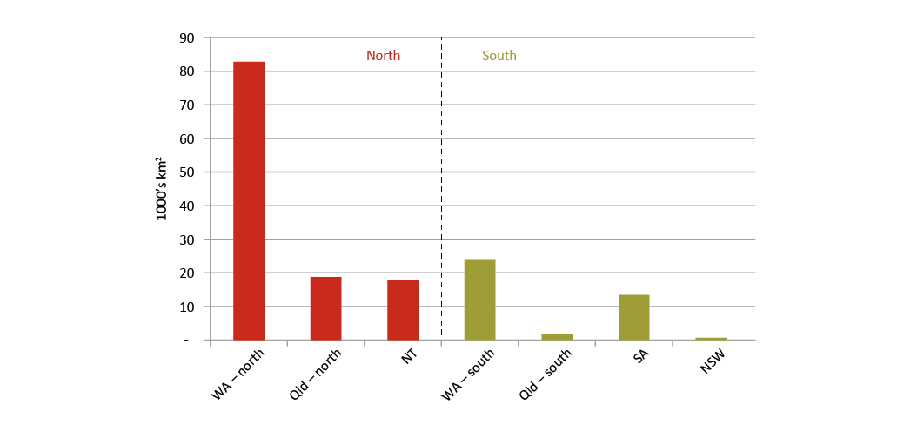
Source: PM&C, 2015. Note data may under-estimate the extent of Indigenous pastoral leasehold.
The Government will therefore progress options, in consultation with stakeholders, to support the use of exclusive native title rights for commercial purposes, including where they co-exist with an Indigenous pastoral lease.
The aim is to assist Indigenous landowners and businesses to create, on a voluntary basis, transferable interests that can be used as collateral for commercial loans, without extinguishing native title. Modern, flexible arrangements would allow Indigenous landowners to expand activities on land which has exclusive native title. For the first time, exclusive native title could itself be used to attract commercial loans and support new partnerships with investors. The Government will explore these options further, consulting with native title holders, jurisdictions and the financial sector.
Quote: The difficulty with Indigenous groups is that they do not have access to the capital in the main, so we have to find a way to make capital available without placing at risk the nature of the tenure in order to get enterprises up and running (Professor Patrick Dodson, Chair Yawuru Native Title Holders, 2014).

Improved management of native title related payments
Indigenous land related payments provide a valuable income stream for Indigenous people in northern Australia. Currently, Indigenous communities who receive income from mining on their land use various types of entities (such as charitable trusts) to receive, hold and distribute income payments. These arrangements:
- can be costly and complex to establish and manage
- often lack transparency and may be difficult to access
- are particularly onerous for organisations that receive smaller payments.

In consultation with stakeholders, the Commonwealth Government will consider options for managing and investing land related payments and other income to better support Indigenous economic independence.
Quote: A shift in thinking is needed instead to focus on how land tenure reform can facilitate economic development of our remote indigenous communities without comprising the cultural connections to the land (Winun Ngari Aboriginal Corporation, 2014).

Supporting investment on Indigenous land
Native title recognises pre-existing legal rights to land. Various legislative schemes allow ownership of land in addition to native title (Box 2). Indigenous land is controlled and owned exclusively by Indigenous Australians. While legislation in each jurisdiction is different, generally Indigenous land is ‘inalienable’. This means it cannot be sold and is held in perpetual trust for the communal benefit of Indigenous Australians.
Quote: Why is it that people in Indigenous communities are effectively denied the same opportunity to own their own home or business premises that every other Australian has? Surely it is reasonable to allow the owners of currently communally held indigenous titles in land to choose to allow private individual ownership of parcels of that land if they wish (Mr Ken Chapman, Northern Australia Advisory Council 2014).

Box 2: What is Indigenous land?
Indigenous Australians hold rights or interests in significant parts of northern Australia (separate from native title). These interests exist in a number of forms, including communal freehold, land held in trust and Indigenous heritage sites. Generally each jurisdiction has different approaches to Indigenous land.
ALRA was the first Australian law which allowed a claim of title if claimants could provide evidence of their traditional association with the land. Under ALRA, approximately half of the Northern Territory’s land mass and 80 per cent of the coastline is now Aboriginal land. Aboriginal land is held by Land Trusts and is inalienable, communal freehold title. This means that the land cannot be sold and decisions about the land must be made by traditional owners as a group according to traditional law and custom. ALRA establishes Land Councils which assist Aboriginal people to acquire and manage their land and protect their interests.
The Commonwealth Government supports Queensland’s recent legislative reforms that allow for the conversion of Indigenous land to ordinary freehold and remove restrictions on commercial leasing. These reforms support the intentional leveraging of land for economic purposes by Indigenous communities where this is on an informed and voluntary basis.
In Western Australia, the Aboriginal Lands Trust (ALT) is constituted under the Aboriginal Affairs Planning Authority Act 1972. The ALT is a significant landholder with responsibility for approximately 24 million ha or 10 per cent of the state's land mass. This land comprises different tenures including reserves, leases and freehold properties. The ALT is seeking to divest much of the estate back to Aboriginal people through land tenure reform processes. Tenure reform will support improved land use planning, private land ownership, regularised service delivery, home ownership opportunities and economic development initiatives such as joint venture arrangements for the management of Aboriginal pastoral leases. Conversion to freehold is not available.

There is much more Indigenous land (separate from native title) in the north than the south. It makes up around half or 635,192 km² of the Northern Territory (inalienable Aboriginal freehold under the Aboriginal Land Rights (Northern Territory) Act 1976 (ALRA), around five per cent or 59,489 km² of northern Queensland and around 12 per cent or 114,567 km² of northern Western Australia (PM&C, 2015) (see Figure 5). In comparison, Indigenous land makes up around nine per cent of southern Western Australia, less than one per cent or 665 km² in southern Queensland, New South Wales and Victoria, and does not exist in the Australian Capital Territory or Tasmania (PM&C, 2015). Most Indigenous land in the south is in South Australia, where it covers around 22 per cent of the state (PM&C, 2015).
Figure 5: Indigenous land
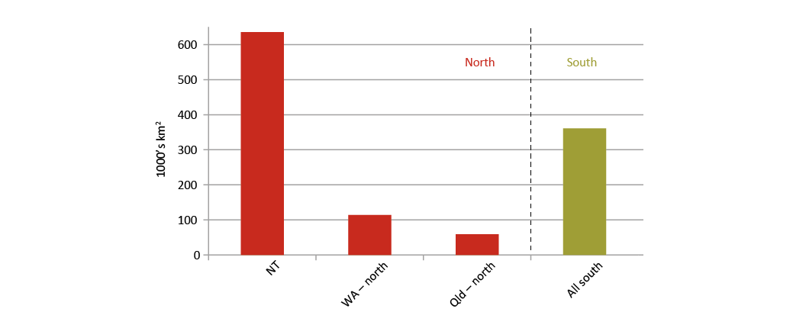
Source: PM&C, 2015

Better land planning arrangements
Land administration arrangements — including cadastral surveys, area plans and zoning maps — are fundamental to economic development. A cadastral survey is an official register showing the boundaries in a district. Without these basics of land administration, property rights will not generally be recognised by a bank. The south has strong land administration underpinning an effective property rights structure that includes long term leases and freehold.
Quote: Any future development of northern Australia will require the engagement of Aboriginal and Torres Strait Islander peoples, not only as land owners but as participants and potentially partners and leaders in the development process (Joint Select Committee on Northern Australia, 2014).
In the north, most remote Indigenous communities lack these basics, including land planning frameworks. This discourages potential investors and residents from using land as an asset for lending and also makes it more difficult to deal with and develop the land.
In response, the Commonwealth Government will work with the Northern Territory, Queensland and Western Australian Governments to support improved land planning arrangements for Indigenous communities and the negotiation of Indigenous Land Use Agreements (ILUAs). This will facilitate further economic development and commercial activity on Indigenous land in northern Australia.
Quote: There has not been a single home ownership outcome within any Cape York Indigenous town. This is not for a lack of local aspiration. The core problem that always was, and remains, is the lack of enabling tenure and local land administration systems. A functional land administration and tenure system is essential infrastructure that is missing from these towns (Cape York Institute, 2014).
The aim is to improve land arrangements for the remaining Indigenous communities in the north that do not have cadastral surveys, area plans and zoning maps.
Initially, the focus could be on surveys, area plans and zoning maps for 50 minor communities in the Northern Territory, which are designated by population and location. This will provide clear, transparent and streamlined development consent processes in these communities, reduce transaction costs and processing times, and support economic development activity.
Funding could be available for similar reforms in Western Australia and Queensland, for example:
- supporting tenure mapping of Western Australian communities to support changes that make land tenure more consistent with freehold, reducing costs and burdens associated with land use and development
- assisting with negotiation costs for ILUAs, to enable long term tradeable leases to be granted and converted to freehold where desired. Already there have been 16 individuals transferring from communal to home ownership on existing freehold land in Hopevale and Wujal Wujal.
These actions will help bring the north on a par with the south — completing necessary land administration work for Indigenous communities in northern Australia within five years.

Owning your own home
Long term, tradeable rights should be extended to Indigenous Australians who wish to own their own homes.
Quote: Tiwi people are for the first time in a position to own their own home, realising the ‘great Australian dream’ that the rest of Australia takes for granted (Homebuyer and Traditional Owner, 2012)
Ordinary freehold title is the most widely understood form of land tenure among individuals, business and lending institutions across Australia. Indigenous land should not be regarded as an obstacle to home ownership, especially when home ownership is consistent with community values, and where financing is available.

Box 3: Making the decision to be a home owner
The Commonwealth Government recognises that the decision to become a home owner is a significant one. To prepare Indigenous Australians for home ownership, the Government’s Indigenous Home Ownership Education (IHOME) programme assists Indigenous Australians to appreciate the benefits, risks and obligations of home ownership, and make an informed decision about whether or not to become a home owner. IHOME is available for people looking to purchase or build their own home in certain Indigenous communities across all jurisdictions.
The Government also supports Indigenous Australians who choose to become home owners. The Indigenous Home Ownership Programme (IHOP), administered by Indigenous Business Australia, provides concessional and low deposit home loans to Indigenous Australians who have difficulty obtaining finance from a mainstream lender. In some remote areas, including on Indigenous land, where the barriers to Indigenous home ownership are particularly significant, extra support is available. This includes help to pay for upfront costs, such as conveyancing, and with sustaining home loans, such as paying for repairs, maintenance and insurance.

Northern Territory
ALRA establishes the basis upon which Aboriginal people in the Northern Territory can claim rights to land based on traditional ownership. It gives Indigenous Australians control over what happens on their land and the right to consent to developments with governments and investors.
Notwithstanding the significant recognition of Indigenous land ownership (approximately half of the Northern Territory land mass and around 80 per cent of the coastline is Aboriginal land), Indigenous people in the Northern Territory are some of the most disadvantaged in Australia, as there are limited economic development and job opportunities afforded to Indigenous communities in remote Northern Territory.
The era of processing land claims is coming to an end and Indigenous Australians now want to use their land to build an economic foundation for the future. To achieve this, many Indigenous land owners, Indigenous proponents and investors are seeking a more effective and efficient land administration system in the Northern Territory.
Some stakeholders consider the complex processes, delays and high costs associated with developments on Aboriginal land a constraint on economic development. For example:
- While traditional owners can use their own land without a formal agreement with the land trust, other Aboriginal people who wish to establish a business on a portion of the communal land must get permission from the traditional owners.
- Land Councils are set up to perform statutory functions under ALRA, including consulting with traditional owners. While fundamental to the Aboriginal land administration system, Land Council processes involve significant time and expense for both Indigenous people and businesses. This is a potential barrier to economic development on Aboriginal land. Delays involved in negotiating an agreement can mean that funding opportunities are lost.
- Community members and traditional owners may hold different views on how to best use the land, which may delay or deter investment by Indigenous people and business.
These constraints make it difficult for Indigenous and other people in the Northern Territory to access land for commercial purposes. Home ownership, outside of township lease communities, is virtually unachievable for the high proportion of Indigenous residents who live on Aboriginal land.
The Commonwealth Government is committed to actions that reflect the aspirations of Indigenous Australians by making it simpler to use land for economic development. Actions could include:
- Working with land councils to develop more efficient decision-making processes. For example, where appropriate, certain Land Council functions could be delegated to sustainable Aboriginal corporations to bring decision making closer to those who want to use the land.
- Consideration of different options that could facilitate the tradability and bankability of rights and interests in Aboriginal land. Options include 99 year township leasing to the Executive Director of Township leasing or a community entity.
- In consultation with stakeholders, implementing certain recommendations made by the Aboriginal Land Commissioner in his review of Part IV of ALRA to add flexibility in the process, meaning less red tape and quicker decisions.
In the short to medium term, many of these actions can be achieved by working more efficiently within the existing legislation and processes. The Government has committed to amending ALRA only with the agreement of the Northern Territory Land Councils, and has commissioned the COAG investigation (which is consulting with Indigenous Northern Territorians) to consider any agreed reform directions to Indigenous land administration and use.
Township leasing
Township leases provide an option for traditional owners that will facilitate not only security in home ownership in communities, but also the tradability and bankability of interests in Aboriginal land. Under the township leasing model the Executive Director of Township Leasing leases the township from the Aboriginal land trust and subleases the land to interested parties. The subleases are freely assignable without the need to consult with or obtain further consent from traditional owners.
To date, the only home ownership on commercial terms on Aboriginal land in the Northern Territory has occurred where a township lease is in place. For Indigenous Australians, the primary reason for town ownership is security of tenure. Township leases also give certainty to investors. These leases enable security of tenure for private sector investment and create land administration arrangements, which give confidence to business and financial institutions, while maintaining traditional ownership of the land.
The Commonwealth Government will invest $17 million to improve land administration and support new township leases in the Northern Territory. This will involve working with traditional owners, Land Councils and the Northern Territory Government to pursue the negotiation of 99 year township leases for communities on Aboriginal land in the Northern Territory. Landowners will be closely consulted on leasing decisions. Funding will include identifying essential services upgrades required to help attract more investment to these communities.

Box 4: Township leasing
The headlease sublease model of township leasing provides for decisions in commercial timeframes and delivers certainty for business.
There are three township leases (headlease over a whole town) covering six communities on Aboriginal land in the Northern Territory: the Tiwi Island communities of Wurrumiyanga, Milikapiti and Wurankuwu and the Groote Eylandt region communities of Angurugu, Umbakumba and Milyakburra. These headleases are held and administered on behalf of the Commonwealth by the Executive Director of Township Leasing.
By creating land administration arrangements that deliver the characteristics of ordinary freehold, such as transferable tenure, township leasing aims to facilitate better economic development and home ownership outcomes for residents. Existing headleases have achieved home ownership and supported commercial enterprise development via subleases.
Further development of a sustainable Community Entity Township Lease model can give traditional owners and community residents the choice to enter into or transition to a Community Entity holding the headlease.

Partnering Indigenous landholders with investors
Businesses wanting to invest in the north are sometimes unsure how to navigate the various land arrangements. Information on land tenure boundaries is presented differently across jurisdictions with varying levels of access ranging from user pays to free of charge. In some cases, data is not up to date, making negotiations over land use more difficult than they need to be.
Whether it is unallocated Crown land, freehold, native title, a pastoral lease or an Indigenous lease, investors are often unsure about where to start negotiating to develop land, what regulations are involved and what can be done on the land. A lack of certainty increases business risks and deters potential investment.
There is strong support for readily accessible information on the different tenure arrangements, advice on how to negotiate access to land and relevant contact details for further information.
The Government, in partnership with northern jurisdictions, will develop and disseminate information that helps bring investors to Indigenous communities. This includes collecting information on land arrangements from state and territory authorities, the National Native Title Tribunal, the Indigenous Land Corporation (a Commonwealth statutory authority that helps Indigenous Australians acquire and manage Indigenous-held land) and other bodies.

Box 5: De-risking investment by increasing knowledge of land
The Northern Territory Government is investing $12 million to map, describe and report on the land, soil and water resources suitable for agricultural use across a range of land tenures including pastoral leasehold land, Aboriginal Land Trusts, Crown and private land. The information will provide greater investor confidence and de-risk potential developments. The Commonwealth Government will consider enhancing this programme to help attract more investment to and in the north.

The Government will establish a ‘single point of entry’ office in Darwin (see page 55), to help dispense business friendly advice to landholders, investors and decision makers on investment opportunities. In addition, these initiatives will provide information about available services for negotiation and tenure resolution in the north.
Educating business and banks about the various land arrangements will increase the appeal of northern Australia to potential investors. It will also help Indigenous landholders and businesses seeking a partnership in development opportunities with other private sector interests.
The Government will also encourage partnerships between Indigenous businesses and landowners and other interested parties. The Government will work with Indigenous stakeholders and northern jurisdictions to explore options for developing a new register of interests encompassing northern Indigenous landowners, business and industry. This will provide a mechanism by which parties identify and contact those with whom they may be interested in doing business. This will be supported by a series of Indigenous networking events across northern Australia that will bring corporate Australia and global investors to Indigenous communities in the north, such as the new major investment forum (see page 43).
These actions are part of the Government’s broader objective to enhance investor decision making by providing the public with better access to information.

Box 6: Joint management of national parks
Kakadu and Uluru-Kata Tjuta National Parks are managed in a cooperative arrangement between the Commonwealth Government and Aboriginal traditional owners. This arrangement (known as Joint Management) is seen as a leading model within national parks in Australia and overseas.
To further strengthen this partnership the Parks Boards of Management — which comprises a majority Indigenous representation — and the Director of National Parks, have initiated the Joint Management Futures Project which will improve access to the economic opportunities parks provide. This includes significantly improving Indigenous participation in related job opportunities and building the capacity of local Indigenous business and contractors to deliver park services.

More economic activity on pastoral land
The north is made up of large tracts of land held under pastoral leases — much more than in the south, where freehold dominates (see Figure 6 and Box 7). Pastoralists make an important contribution to the northern and national economies but, beyond this, the restrictions, uncertainties and delays associated with pastoral leases are otherwise stemming the flow of capital to the north.
In northern Queensland, 56 per cent of the land (683,495 km²) is held under pastoral lease; in the Northern Territory, 45 per cent (596,312 km²); and, in northern Western Australia, 38 per cent (354,660 km²). While pastoral leasehold is also widespread in southern parts of Western Australia, Queensland and South Australia, there are fewer leases in New South Wales and none in Victoria, Tasmania and the Australian Capital Territory.
Pastoral lease arrangements were established in the early 19th century to assert government ownership over land in the face of uncontrolled pastoral occupation.
Today, while some jurisdictions have more flexible arrangements than others, pastoral leaseholders often face a number of challenges:
- Lease arrangements can restrict leaseholders from using their land for activities other than grazing.
- The expansion of activities into horticulture or tourism may require additional approvals from government.
- Approvals for additional activities may not be registrable on title and therefore may not be transferable.
- Leasehold does not have the same security as freehold, which can mean business is less likely to invest in infrastructure.
- Potential investors can face unfamiliar and complicated regulations, compared with those surrounding less restrictive forms of tenure.
Figure 6: Pastoral leases
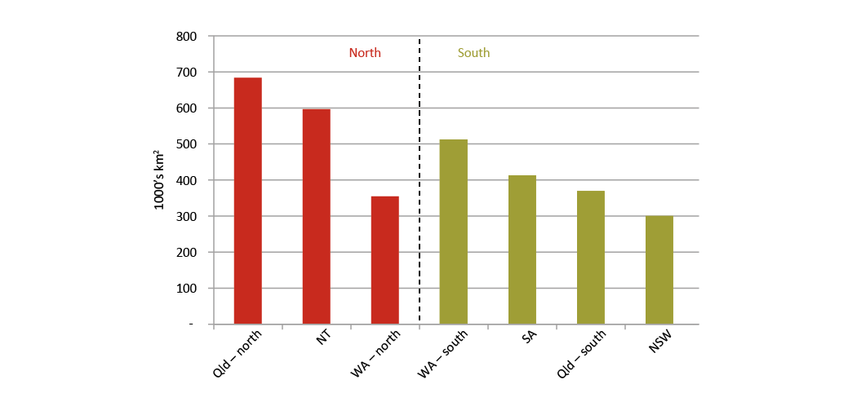
Source: PM&C, 2015
Importantly, pastoral leases and native title rights co-exist over Australia’s north. Broadening and securing these leases through negotiation will create opportunities for partnership that benefit both Indigenous and non-Indigenous people.
Much more of the land across the north can potentially be used for a variety of agriculture projects (Petheram, et al., 2015). Removing unnecessary restrictions imposed on pastoral leaseholds will help to unlock the potential of this land, to the benefit of pastoral leaseholders, including Indigenous leaseholders and the Australian economy in general.

Box 7: Pastoral leasehold
A pastoral lease is Crown land managed by state and territory governments which is leased to the public, generally for the purposes of grazing livestock. They are mostly situated in the arid and semi-arid regions that predominate in the north and regional Western Australia.
The terms and conditions of pastoral leasehold differ significantly across northern jurisdictions, with distinct legislation for their administration. Overall they provide a more restrictive range of property rights than freehold land. Specific conditions are attached to a pastoral lease, such as the term or length of the lease and controls on the type of economic activity permitted. Pastoral leases in Australia generally co-exist with native title rights and interests. This means leaseholders can continue to undertake activities that were being conducted when the Native Title Act was introduced, which for the most part, are pastoral activities. For activities beyond this, such as farm tourism, forest operations, horticulture or aquaculture, the leaseholder can carry out the activity as long as it is permitted under state or territory law and the requirements satisfy the Act. This can involve seeking a permit from government and entering into an ILUA with native title claimants or native title holders for the land.

The Commonwealth Government supports northern jurisdictions removing unnecessary restrictions on pastoral leases. This will make the land tenure system simpler for all leaseholders and investors. Pastoral leases that provide longer tenure and broader forms of economic activity will attract more investment to the north and create a more resilient and diversified northern economy.

Removing pastoral restrictions to support investment
If pastoralists are allowed to do more with their land (such as tourism or horticultural activities) and have longer and more secure tenure (such as 99 year leases), then they have more incentive to invest.
The Commonwealth Government supports a set of principles to guide pastoral leasehold reform in the north (see Box 8). These principles underpin the Government’s support for ongoing actions to improve the security, bankability and efficiency of pastoral land. These reforms should be consistent with the rights recognised under the Native Title Act and should not include restrictions normally related to good land care, such as environmental management or pest control.

Box 8: Principles for pastoral leasehold reform in the north
- Private rights, which include pastoral leases and native title, are the basis of economic development.
- Pastoral leases are a restrictive form of land tenure. Jurisdictions should remove restrictions that limit economic development, retaining those necessary for land care.
- Pastoral leasehold reform will often involve close engagement with native title claimants and leaseholders and should not diminish the importance of Indigenous interests in land.
- Each jurisdiction will adopt reforms at its own pace towards emerging best practice (see Table 2).
- Pastoral leaseholders should have the ability to apply for broader, more secure and tradeable forms of tenure, including freehold, in a manner that complies with the Native Title Act.
- Agreement making under the Native Title Act needs to be streamlined and proportionate to the impact on native title.
- Compensation due to changes to native title arrangements should be the responsibility of pastoralists who benefit from the broader tenure.

The Northern Territory, Queensland and Western Australia Governments are already taking important steps to reduce the regulatory burden imposed by the north’s pastoral leasehold arrangements. For example:
- new arrangements to grant permits for non-pastoral use that allow additional activities on up to less than half of all pastoral leasehold land — this gives leaseholders the option of undertaking aquaculture, horticulture, tourism and forestry as defined in the Native Title Act (Northern Territory)
- new arrangements to allow rolling leases for grazing, agriculture and pastoral purposes for terms of up to 50 years (Queensland)
- a proposal to consider rangelands leases for multiple uses of land (Western Australia).
Business supports further efforts to simplify pastoral arrangements, to give greater clarity and certainty to investment while protecting legitimate land management, environmental and native title interests. These principles will guide the implementation of the White Paper and aim to cut red tape on pastoral lease rules across the north.
The Government supports rolling actions that remove unnecessarily prescriptive government imposed development requirements from pastoral leases (see Table 2). These actions involve jurisdictions sharing innovations across the north.
Table 2: Actions to support investment
Outcome: More certainty for investment
Actions: Bring forward the point at which leaseholders can apply for renewal of leases; introduce rolling pastoral lease renewal

Outcome: More diverse economic activity
Actions: Introduce business friendly information on approvals to make investment simpler; Introduce enabling legislation to allow transferable permits for non-pastoral use on pastoral leases; Introduce template leases for large capital investments (eg 100 years); Introduce templates for permits for a greater range of activities

Outcome: Pathways to freehold
Actions: Develop template ILUAs to assist conversion of pastoral leases to freehold

Outcome: Easier administration
Actions: Transfer control of ‘inputs’ (for example stocking) to other legislation; Compensation costs to be borne by the prospective grantee or lessee; Renew leases with minimal conditions; More data and maps for tenure, including surface and subsurface details

Such administrative reforms would improve certainty and increase the economic value of the land. Reforms to allow early renewal of leases and ensure that tenure is registrable will minimise the risk of leases terminating. This will increase the likelihood that business will invest in substantial infrastructure, with expected paybacks beyond the lease renewal date.
Making leases broader, more secure and tradable will increase their value. Who gets this increase in value is a matter for northern jurisdictions. In principle though, the beneficiary of the broader tenure should be responsible for the costs of conversion, including potential native title compensation. This ensures that moves to broader tenure happen where the economic gains are greatest and consistent with native title interests.
Northern jurisdictions can enact enabling legislation to support all these actions without affecting native title interests. In turn, this creates the conditions for an increase in certainty for investors. Pastoralists will be empowered to consider development options in light of their local circumstances, including any native title impact.
The Government will help drive these reforms as well as demonstrate their benefits to the wider community. This will involve the Government working with Indigenous business and communities, and attracting global investment to new and diverse investment in the north. The aim is also to demonstrate to investors the potential of the north and drive greater certainty in pastoral reforms (see Box 9).

Box 9: Expanding economic activity on pastoral land
The Government supports actions that make it possible for the pastoral lease of the future to support more wide-ranging, high value food products, more tourism activities and possibly new emerging industries, such as renewable energy investments. For example:
The Western Australian Government is investing in tenure reform to expand economic activity in the Kimberley. The area has the potential to utilise one million ML of sustainable fresh water in the Kimberley and the Pilbara. This includes engaging with Aboriginal pastoralists, traditional owners and Indigenous leaders to negotiate partnerships and pathways to lift agricultural productivity in the Kimberley. The Western Australian Government is spending $55 million on the Water for Food initiative to support an expansion of these pilots in the Kimberley and the Pilbara.
An increasing global demand for pain management, primarily derived from opium poppies, has resulted in the establishment of the first commercial trial of poppies in the Northern Territory.
Seafarms Group Limited proposes to develop the largest aquaculture development in Australia and one of the biggest ventures of its type in the world — a $1.45 billion prawn aquaculture project on Legune Station pastoral lease near the Western Australia and Northern Territory border.
One of Australia’s pioneering pastoral families is creating a new horticultural industry in central Australia. Undoolya Station — a perpetual pastoral lease — near Alice Springs has been granted a permit to clear 345 ha to expand the production of onions.
Under the pilot land tenure programme, the Commonwealth Government will work with the northern jurisdictions to drive more diverse activities on pastoral land.

DEVELOPING THE NORTH’S WATER RESOURCES

Overview
Northern development depends on water. There are up to 17 million ha of land in the north that have soils which are potentially suitable for agriculture, but there is only water sufficient to irrigate about one tenth of that area (Petheram, et al., 2015). Building the right water infrastructure in the right place will be crucial to realise the full potential of the north.
Northern Australia receives an average of more than two million GL of rainfall every year (CSIRO, 2015c), more than 60 per cent of the national total. That is enough water to fill a bucket the size of the Melbourne Cricket Ground to a height of more than 80,000 km, or more than 20 per cent of the way to the moon. However, this rainfall is highly variable and seasonal, with most of the year's rain falling in the summer months. In the dry season, zero monthly rainfall totals are common.
Quote: … water is the single biggest driver for economic prosperity in Australia. The food and beverage industry, agribusiness, power and energy, mining and tourism, all depend on water and its proper management to succeed (Australian Water Assocation, 2014).
About 65 per cent of the north’s rainfall evaporates or is used by plants before it can recharge groundwater or flow through the north’s many rivers (CSIRO, 2010). About 15 per cent of the north’s water finds its way into underground aquifers, with the remaining 20 per cent entering rivers (CSIRO, 2010). The north’s evaporation rates are high — Australia’s largest mainland permanent water body, Lake Argyle in northern Western Australia, loses about a quarter of its water every year to evaporation (CSIRO, 2010). These conditions present challenges for capturing and storing water, but the sheer volume of water in the north creates opportunities for growth if water storage and use can be managed efficiently.
Both surface and ground water in northern Australia serves a variety of functions, including cultural and spiritual use by Indigenous communities. River flows and groundwater are vital for supporting natural environments as well as other productive uses. They provide opportunities to supply water to growing regional and urban communities and for new and existing industries. In some regions, river flows and suitable terrain combine to provide scope for dams. Sometimes conditions make off-stream storages, such as farm dams, the most effective way to provide secure water resources. In other cases larger in-stream storages are more suitable.
Predicting and meeting demand for new water users and uses is an important driver of water resource development. This will require improved information and analysis of water and soil resources. Governments can play a role in conducting such work. It is rare that one investor can capture all the gains, or afford to assume all the costs, of this work so it is often not done. Water managers and investors alike need better information upon which to base allocation and investment decisions, about both surface and ground water.
State and territory governments can also facilitate water resource development by providing access to secure water rights to encourage investment. The north can learn important lessons from many of the problems previously faced in the south, where communities, the environment and business suffered from over allocation of water entitlements, resulting in too little available water. Providing long term, secure and tradeable water entitlements will attract business investment and reduce demand on governments. When allocating water rights, governments should consider the economic opportunities that water can provide to existing water users, including traditional users.
Support for new water infrastructure should not be prescriptive. It should match the best available supply options with demand to ensure ongoing economic viability. It is important for consideration of investments in new dams to be underpinned by robust economic analysis to ensure returns are commensurate with the level of investment. There must also be strong state or territory government support for projects given they have responsibility for water resources.

Information supports development
Compared with the south, there are substantial knowledge gaps around northern surface water and groundwater systems. Knowledge is often insufficient to enable investors or governments to make informed decisions. In many regions, the long term effects of extensive groundwater extraction, including the time it takes for underground aquifers to naturally refill, are not well understood. This can vary significantly across the north. As with rainfall and runoff, these processes can also vary considerably within and between years.
Resource assessments
Detailed water resource assessments can provide a comprehensive and integrated evaluation of the feasibility, economic viability and sustainability of water resource development.
The recent Flinders and Gilbert Agricultural Resource Assessment by CSIRO focused on just two catchments in northwest Queensland and found that the area could add up to 50,000 ha to the north’s irrigation stocks, supplied by a combination of in-stream and on-farm dams (CSIRO, 2015b). That is about four times the size of the current Ord scheme in northern Western Australia, and would increase the total area under irrigation in the north by almost 40 per cent. Before this assessment, such irrigation potential went largely unrecognised. The Queensland Government is proposing to release 755 GL of previously unallocated water in these catchments as a direct result of this assessment.
Quote: Further data on available water resources, cost/benefit analysis of potential infrastructure investment and sustainable consumptive use levels is needed to ensure that further development will be resilient and sustainable (AgForce Queensland, 2014).

The way forward
The Commonwealth Government will work with northern jurisdictions to undertake more water resource assessments in priority catchments. These will be rolled out over the next four years.
Assessments will target areas likely to deliver the most valuable water for economic development and provide the information needed to establish water management plans.
To inform this White Paper, CSIRO was asked to undertake a rapid appraisal of river catchments across northern Australia to identify new opportunities for water storage and irrigated agriculture (CSIRO, 2015b). This appraisal has provided important information to guide decisions on the most promising regions for further investigation.
Figure 7: River basins in northern Australia
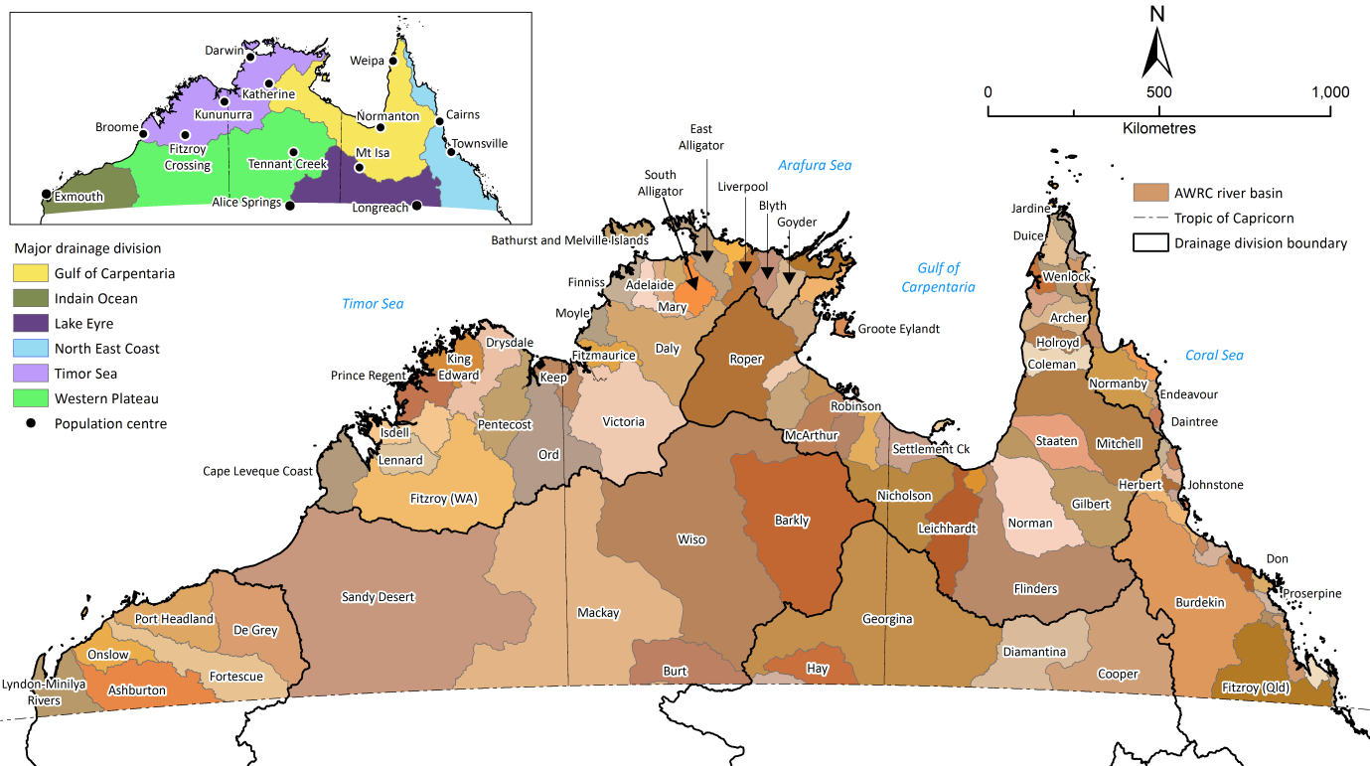
The figure identifies the larger river basins in northern Australia (as defined by the Australian Water Resources Council). The inset shows the major drainage divisions and key population centres in northern Australia. Source: Petheram, et al., 2015.

Box 10: Water to support increased agricultural production
The following areas were amongst those identified by northern jurisdictions and CSIRO (Petheram, et al., 2015) as having potential for increased irrigated agricultural production. More detailed examination, such as through water resource assessments, would guide governments and investors on how best to realise this potential.
Queensland
Mitchell River — The Mitchell River basin of far north Queensland currently supports extensive grazing of native pastures and irrigated production worth about $100 million annually from the 17,000 ha Mareeba Dimbulah Irrigation Scheme. Preliminary analyses of land suitability and water capture and storage options indicate the ability to support a further 60,000-80,000 ha of irrigated agriculture in the catchment, drawing on water stored in new in-stream or off-stream dams.
Burdekin River — The Burdekin river basin has the capacity to improve agricultural output subject to overriding concerns of sediment and reef water quality management.
Cape York Peninsula — Western Cape York comprises a large number of small catchments, each of which discharges significant quantities (1,000–4,000 GL) of water, very little of which is currently captured and stored. Large in-stream or off-stream dams in Cape York catchments could potentially supply water sufficient to irrigate up to 60,000 ha, for which adequate soil is also available. However, these river systems contain areas of environmental significance, which will be an important consideration in the development of water infrastructure.
Northern Territory
Ord River — Expanding the size of the Ord irrigation area offers the potential to achieve scale and establish a variety of commercial crops in the district, which would enhance both the profitability and economic resilience of the region. Ord Stage 3 is a proposed development of 14,500 ha of irrigated farmland in the Northern Territory that would leverage investments already made by governments and the private sector in Stage 2. Discussions with native title holders about expansion into 1800 ha in the Northern Territory, known as Ord Stage 3A, are underway. The availability of water is not a limiting factor, but there are concerns about potential salinity and flood risk that need to be addressed.
Darwin region — The Greater Darwin region comprises the Northern Territory’s largest (3,000 ha) and most valuable (about $200 million production pa) irrigation area, watered mainly using groundwater. The development of a number of small to moderate sized dams would enable this area to be increased tenfold, up to 30,000 ha. The region’s proximity to Darwin would provide opportunities for dams with multiple uses.
Victoria River — The Victoria River basin has three distinct areas with irrigation potential, realisation of which would require further investigation. CSIRO identified that 100,000 ha may be possible in the lower catchment, supplied by large in-stream dams. The mid-catchment may be able to support a couple of thousand hectares based on groundwater, while the upper catchment may be able to support 40,000 ha based on a number of small to moderate sized dams.
Western Australia
West Kimberley — The West Kimberley region includes the Fitzroy River basin and La Grange groundwater area and is primarily used for extensive grazing on natural pastures and irrigated agriculture. The region currently has no water storages of regional significance, however has expanding nodes of irrigated agriculture utilising groundwater. It has extensive areas of soil that are suitable for agriculture, up to 60,000 ha, that could be developed for medium scale mosaic irrigated agriculture, utilising overland flow and groundwater.
North Kimberley — The North Kimberley region (excluding the Fitzroy River and Ord River catchments) currently has no water storages of regional significance, and no irrigated agriculture. When coupled with the region’s better soils, a combination of small to moderate sized dams could support up to 20,000 ha of irrigated agriculture, with the Drysdale catchment offering potential for further investigation.
Pilbara region — The Pilbara groundwater made available through mine dewatering has the capacity to support more than 6,000 ha of new irrigation. There is also potential for new irrigated agriculture in the western part of the Canning basin.

The Government will immediately commission water resource assessments in the Mitchell River catchment (Queensland), West Kimberley (Western Australia) and the Darwin region (Northern Territory). The Government will commit up to $5 million for each assessment, with details to be settled with the northern jurisdictions. This is a first step. There are over 30 surface water catchments in the north that have been identified as having further potential but lack the foundational science and data on water and agricultural resources that a water resources assessment would provide.

Providing greater certainty for investment
A clear lesson from Australia’s past is that when water is under-priced, it will be wasted.
The first tentative steps toward trading in water in Australia were taken in the 1980s. Larger changes were signalled by the National Water Initiative (NWI) in June 2004. The NWI is a commitment by the Commonwealth and state and territory governments to increase the efficiency of Australia's water use.
Australia’s water markets are now internationally recognised as a reform success story. These markets boast an average annual turnover of around $2 billion (National Water Commission, 2013) and channel water to its most productive uses, for a price determined by water users. Trading generates economic benefits valued at hundreds of millions of dollars annually. The success of Australian water markets is based on secure, tradeable water rights, with a well-defined cap based on available water. In turn, a robust system of water rights requires a deep understanding of surface and groundwater systems. Both these systems have the potential to provide water for irrigation in the north, but a lack of information makes it difficult to assess and manage these resources.

Challenges for northern water markets
The allocation of water entitlements in the north is still unfinished. Water markets in which water users and investors can trade entitlements are under-developed or non-existent in the north, partly due to the small number of water users compared with the south. Existing water rights can be overly prescriptive or uncertain due to the lack of a transparent water planning process. This imposes unnecessary risks on businesses and communities.
Quote: More information is needed about the available water in the north to support investment in economically viable water infrastructure, regardless of its source (surface and groundwater) or use (urban and water dependent industries). Information will also support the development of water markets in priority catchments (which tend to be underdeveloped or non-existent in the north). (Northern Australia Advisory Group, 2015).
While northern river systems are less interconnected than in the south, and so will not experience the scale of water trading present in the Murray-Darling Basin, there are still clear benefits to be gained from a secure tradeable water rights system. Long term investments require long term certainty over water supply. While Australia will always be a land of drought and flooding rains, governments should not compound uncertainty through opaque planning processes.

Box 11: Benefits of secure tradeable rights for water users
The ability to trade water entitlements, separate from land, provides flexibility in water use, production and farm management that would be otherwise unavailable. This can help water users manage production and asset risk in response to their business objectives and external factors such as drought, commodity prices and exchange rates.
Statutory water planning arrangements provide a secure basis for water users by providing a legally defined entitlement that, in turn, provides business certainty regarding the available water resource and transparency about how the resource will be shared.

Water for Indigenous economic development
Water has social, cultural and spiritual value to many Indigenous Australians. It should also provide economic value, although native title over water provides very little economic opportunity for Indigenous Australians (see Box 12).

Box 12: Existing Indigenous rights to water
Indigenous statutory land rights generally do not explicitly confer rights to water. However, the right to control access to land, inherent in most statutory titles, in practice allows Indigenous communities to control access to water on Indigenous land.
By contrast, native title rights are sourced in traditional law and custom and generally include specific rights to access and take water, and the right to take and use resources found in water. This is usually limited to personal, domestic and cultural purposes. Occasionally, commercial interests related to water may be recognised. For example the native title right to take fish in the Torres Strait extends to commercial purposes.
Where exclusive native title is recognised over the land, this confers the right to control access to water, subject to relevant regulation.
The NWI commits state and territory governments to recognise Indigenous needs in relation to water access and management. Indigenous representation in water planning was envisaged so as to reflect Indigenous views on social, spiritual and customary objectives. The NWI requires that state and territory water planning processes take account of the possible existence of native title rights and that such rights are recognised and provided for in water plans.
However, outside of native title, it is up to each jurisdiction to establish specific policy or legislative initiatives for Indigenous access to water.

There are a few examples of efforts to allocate or license water for Indigenous organisations, including through ‘Indigenous reserves’ in some Queensland water resource plans. However, uptake and use of the water by Indigenous Australians is limited. A challenge is that Indigenous communities often lack the capacity and experience needed to successfully engage in water based enterprises, such as irrigation, and/or lack the capital to purchase water and the infrastructure required to use it.
The Commonwealth Government supports northern jurisdictions taking actions that support Indigenous Australians to derive greater economic benefits from water on Indigenous land. Water can provide opportunities for Indigenous Australians in diverse areas such as aquaculture, nature based tourism and intensive horticulture. Access to water can also provide an opportunity to participate in water markets, where they exist.

The way forward
In southern catchments where NWI principles have been implemented, investment has been encouraged, access to business finance has increased, and more efficient water use has been promoted (National Water Commission, 2013). This benefits communities, the environment and business.
The challenge is to extend the implementation of the NWI approach more broadly across the north. New investments in water infrastructure will only go to projects where there is a commitment to accelerate water reform through securing water rights for farmers and other investors. Water resource assessments in priority catchments will fill gaps in the knowledge base, and provide the basis for states and territories to develop a water plan (see Figure 8).
Figure 8: Accelerating secure water rights in northern catchments
Step 1. Determine sustainable yield (water resource assessment).
Step 2. Establish regulatory framework for water trading.
Step 3. Publish water plan (including allocation).
Step 4. Auction water entitlements (tradeable, separate from land, secure).
A water plan provides:
- information on sustainable extractions before scarcity becomes critical
- entitlements that are clearly specified, monitored and enforced. This reduces business risk and investor uncertainty as business knows exactly what it can buy and sell. This is of benefit for large scale projects where the risks are greatest
- sound regulatory and governance frameworks that provide a platform for water trading
- best practice water management, such as water metering or accounting.
The Commonwealth Government, through the Bureau of Meteorology, will continue to:
- undertake periodic assessment and accounts of Australia’s water use
- provide forecasts and projections of future climate and water supply to assist in planning and development.
This approach builds on existing work in northern jurisdictions (see Box 13).

Box 13: Key achievements in water policy in northern Australia
Western Australia
- Released the ‘Securing Western Australia’s Water Future’ policy position paper in 2013 that proposes legislative reform to improve water management, particularly where water resources are scarce and demand is increasing.
- Invested in scientific assessments of its water resources which have served to progress the development of water plans covering the state’s most used water systems.
- Reviewed and implemented operational guidelines to support water management.
- The Water for Food program undertakes targeted groundwater investigations in the West Kimberley to support expansion of irrigated agriculture and regional economic development.
Northern Territory
- Established four water plans for large surface and groundwater systems — several other water plans are in draft form.
- Invested in the scientific assessment and monitoring of water resources which helps to inform sustainable water management.
- Invested $2.4 million a year for four years in an expanded programme of land and water suitability assessment to identify potential new agricultural precincts.
Queensland
- Legislated reform to improve water management, including the creation of secure water rights and statutory water plans.
- Invested in developing water resource plans which now cover all identified priority catchments in Queensland.
- Committed to review the Gulf Water Resource Plan and Gulf Resource Operations Plan based on new foundational CSIRO research on the Flinders and Gilbert River catchments.
- Progressively unbundled water rights from land, enabling the establishment of water trading in some areas.

Investing in water infrastructure
The Commonwealth Government will establish a National Water Infrastructure Development Fund (the Fund), with $200 million committed to facilitate greater investment in northern water infrastructure. The Fund was highlighted in the 2030 Vision for Northern Australia. It is the first step in delivering on the Government’s commitment to do the detailed work necessary to build the water infrastructure needed to secure the nation’s water supplies while protecting the environment. Further details on the Fund will be announced in the Agricultural Competitiveness White Paper.
The Fund is complemented by already announced measures to help farmers invest in productive water infrastructure such as farm dams, tanks, bores and irrigation channels by allowing capital expenditure to be immediately deducted. The Government has already extended the Great Artesian Basin Sustainability Initiative, providing a further $15.9 million to repair uncontrolled bores that threaten the long term viability of the Basin (see Box 14).

Box 14: Great Artesian Basin Sustainability Initiative (GABSI)
On 16 October 2014, the Commonwealth Government announced funding of up to $15.9 million over three years to continue the Great Artesian Basin Sustainability Initiative (GABSI). This funding will go to repairing the uncontrolled bores that threaten long term secure access to water by communities, pastoralists, irrigators, and mining and extractive industries, as well as the health of important groundwater dependent ecosystems. This extension will give governments the opportunity to work with industry and communities to develop a new delivery model which is less dependent upon government funding, to ensure a sustainable future for the Basin.
Up until the 1950s, artesian water that came to the surface under natural pressure by the sinking of bores had been allowed to flow uncontrolled into open drains and creeks for distribution to stock. Even where infrastructure was well maintained, up to 95 per cent of water flowing through open drains and creeks was wasted through evaporation and seepage.
Such uncontrolled flow of water from bores and open earth bore drains in the Basin threatened the health of important groundwater dependent ecosystems and the continued access to artesian water by water users. During this time, it had become difficult for new water users in or near the Basin to obtain access to groundwater resources.

Prioritising northern water infrastructure
Access to reliable water is a key constraint on development in northern Australia. In southern Australia, dams have been an effective means of providing reliable water supplies in a dry and variable climate. Much of the irrigated land in the Murray-Darling Basin, Australia’s major food bowl, could not be watered without critical storage infrastructure such as the Hume and Dartmouth dams.
Figure 9: Major dams and large irrigation areas across Australia
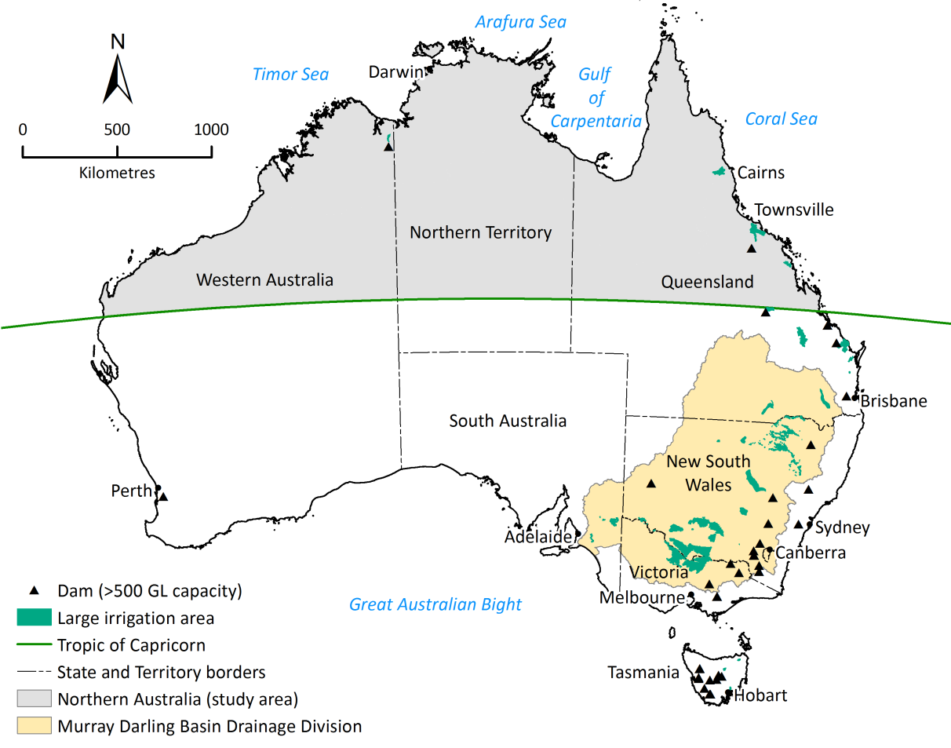
Source: Petheram, et al., 2015
The construction of new dams in Australia started to plateau in the mid 1990s — a trend also seen in other developed countries. In areas where water resources have already been developed, this trend may reflect declining marginal economic and social returns to constructing additional water storage. Given there is less existing water storage infrastructure in the north compared with the rest of Australia (Figure 10), northern Australia could present greater opportunities than the more developed south.
Figure 10: Large dams in Australia and northern Australia since European settlement
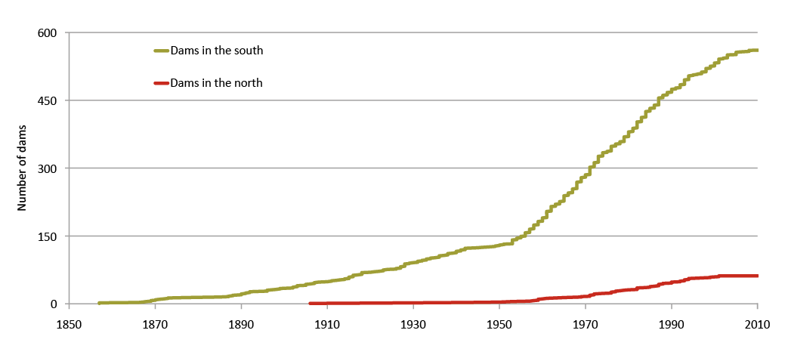
Source: Petheram, et al., 2015
Infrastructure must be tailored to the diverse and highly variable climate and water needs in the north. The Fund will be flexible enough to support water infrastructure investments in different ways across the north.

Box 15: Principles to drive water infrastructure investment in the north
The National Water Infrastructure Development Fund will continue to support greater investment in water infrastructure over the long term according to the following principles:
- Projects need to be nationally significant and in the national interest.
- There must be strong state or territory government support with capital contribution and involvement of the private sector and where appropriate local government.
- The investment should provide the highest net benefit of all options available to increase access to water, taking into account economic, social and environmental impacts.
- Projects should address a market failure which cannot be addressed by proponents, state and territory governments or other stakeholders and limits a project of national significance from being delivered.
- Projects should align with the Government’s broader infrastructure agenda to promote economic growth and productivity, or provide a demonstrable public benefit and address a community need.
- Projects should align with the National Water Initiative principles including appropriate cost recovery and, where full cost recovery is not deemed feasible, any subsidies are fully transparent to the community.
- If providing capital, a consistent robust analysis of costs and benefits is used and assessment is undertaken by Infrastructure Australia or similar experts.

Dams can support large scale irrigated agriculture and provide water and, in some cases, energy security for regional centres. Recharging suitable aquifers may increase the availability of groundwater for inevitable future droughts. In parts of the north, aquifer recharge is likely to be more cost effective than other water storage solutions. In areas unsuitable for large scale irrigation it may nevertheless be possible to utilise local groundwater or on-farm storages for smaller irrigation developments — supporting intensification and the concept of ‘mosaic agriculture’. Opportunities may also exist to make greater use of surplus water produced by mining which could also relieve pressure on existing water resources.
Providing support for feasibility assessments will assist governments make informed judgements about the best sites for new water infrastructure and allow potential investors and water users to make informed decisions based on sound technical and financial information.
Quote: New funding mechanisms are needed to leverage private sector investment in the construction and ongoing maintenance of water infrastructure (Northern Australia Advisory Group, 2015).

The Commonwealth Government will support water projects identified by northern jurisdictions that meet the needs of users and encourage private sector investment in water (see Figure 11). Similar, successful funding models have been applied in Tasmania, resulting in the construction of nine high performing and financially viable water irrigation schemes across the state (see Box 16). As water is primarily a state and territory responsibility, it would be expected that they contribute funding to the projects. The Commonwealth Government would generally not fund more than 50 per cent of a proposal or exceed the state or territory contribution where there is also private sector contribution.

Box 16: Tasmanian Irrigation Tranche II
Tasmanian irrigation projects are jointly funded by public and private investment. Commonwealth funding committed for Tasmanian Irrigation Tranche II projects builds on the existing funding of $140 million for nine Tranche I projects. The Tasmanian Government provided $80 million and the private sector $90 million through the purchase of tradeable water entitlements in each scheme. All nine projects under this programme have been completed.
A further $9 million of Commonwealth funding was provided through the Tasmanian Jobs and Growth Package for the Dial Blythe irrigation scheme.
The Commonwealth Government has committed a further $60 million to Tranche II irrigation projects. The Tasmanian Government is contributing $30 million, with the private sector providing $27.1 million towards the capital costs of the Tranche II projects through the purchase of tradeable water entitlements.
These schemes are demand driven and a true private-public partnership. A crucial first step to confirm financial viability is the private financial commitment upfront through the pre-purchase of water entitlements.
Prior to approval, each irrigation scheme is subject to Commonwealth due diligence assessment to ensure it is technically feasible, financially viable, and complies with both the Tasmanian and Commonwealth environmental legislation.
The results have been:
- greater water storage and 95 per cent reliability of water supply ensuring the sustainable delivery of water to Tasmanian farmers
- higher value agricultural production, facilitating investment in increased value-adding in agriculture
- direct economic benefits from assisting farmers to diversify from traditional cropping and livestock production into higher value crops
- increased regional employment

To kick start this process, the Government will support the detailed planning necessary to accelerate investment in water infrastructure by providing funding of up to $5 million each for detailed examinations of economic feasibility of Nullinga Dam (Queensland) and Ord Stage 3 development (Western Australia/Northern Territory). Addressing potential production risks such as soil salinity will be a key component of the Ord Stage 3 investigation.
Water infrastructure requires substantial capital and maintenance for many years due to its longevity. It must be built to the right scale, at the right time, with sufficient demand and with the right supporting infrastructure, such as roads. Early planning is necessary if major infrastructure proposals are to be properly considered to meet future demands.
By providing funding for feasibility assessments the Government will ensure that the right water infrastructure is built. Water users in northern Australia can’t be saddled with unviable projects nor operational and maintenance costs they can’t afford.
Figure 11: Northern Australia water infrastructure priorities
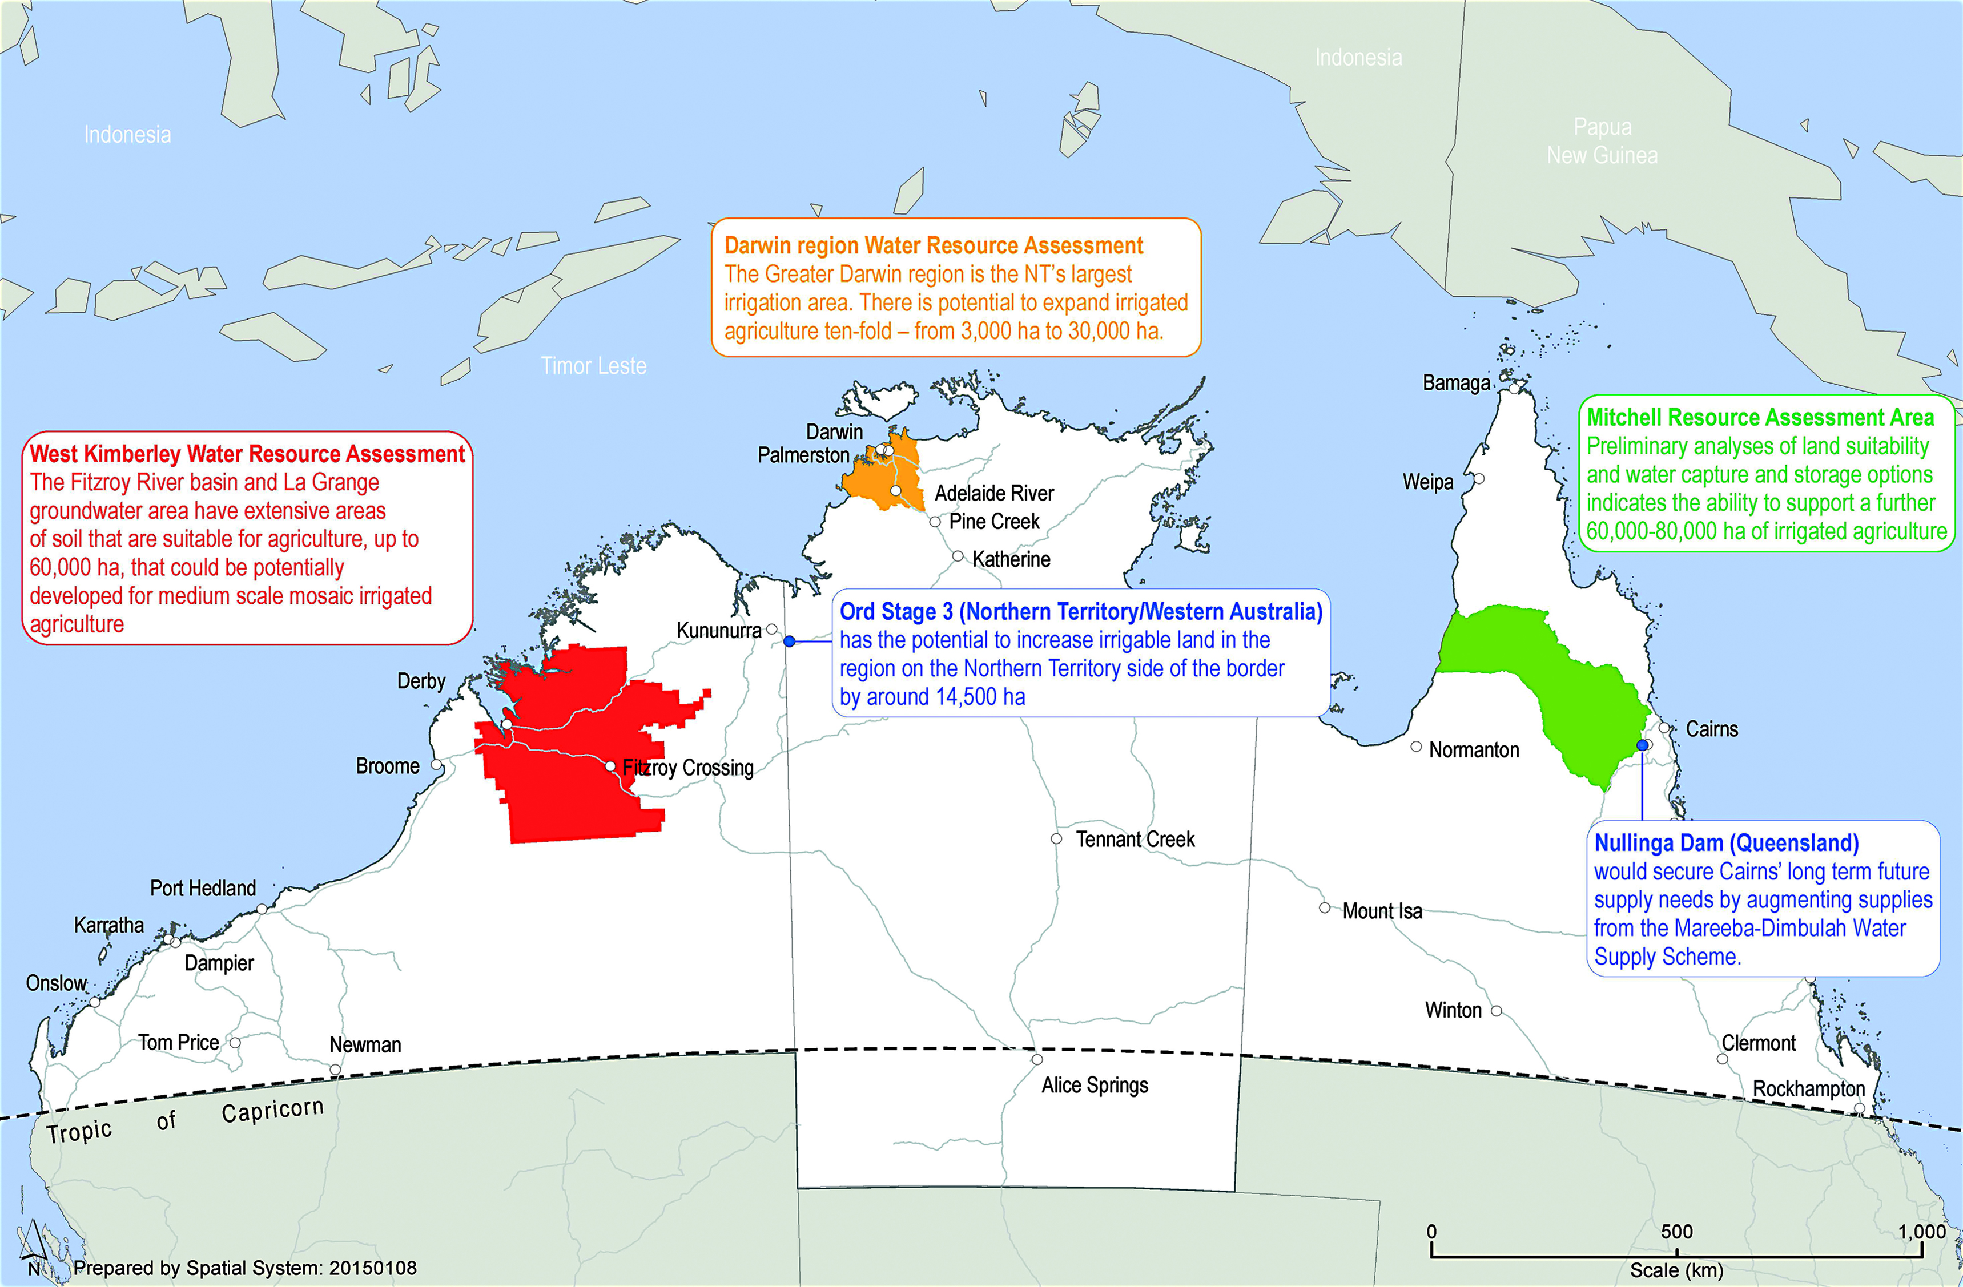
These projects were identified as priorities by jurisdictions. Consistent with the recommendations of the Northern Australia Advisory Group (Northern Australia Advisory Group, 2015), and Joint Select Committee on Northern Australia (Joint Select Committee on Northern Australia, 2014) they offer potential to drive further agricultural development in the north or service existing or future planned population centres.

OUR BUSINESS, TRADE AND INVESTMENT GATEWAY

Overview
Developing the north presents a significant economic opportunity for all of Australia, but it’s also a strategic one.
No matter how fast the north grows, our broader region is likely to grow much faster. By 2030, half of the world’s gross domestic product (GDP) growth will be generated in Asia. By some estimates, China’s economy is already larger than that of the United States of America (USA) and could more than double in size by 2030. The economies of the Association of Southeast Asian Nations (ASEAN) — led by Indonesia — are collectively already around the same size as fast growing India. Indonesia could rise to be the world’s sixth largest economy by 2030 (Au-Yeung, et. al., 2015). These are tectonic shifts in economic weight.
Figure 12: Asia’s share of world output
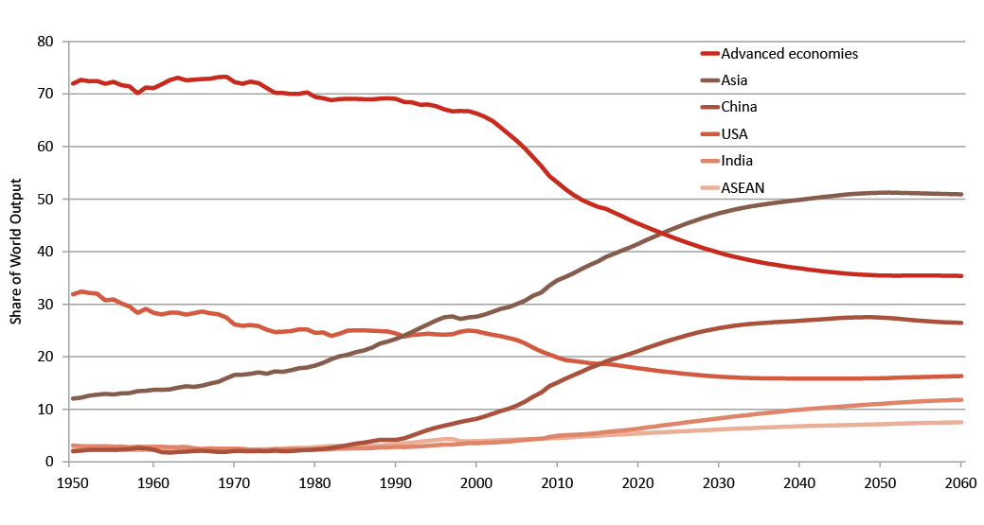
Source: Au-Yeung, et. al. 2015
How we develop the north matters.
Rising incomes in the region present immense opportunities for Australia — and the north. The north has the land, resources and knowledge that the rest of the region needs. But the north needs more investment and the region has the savings, as well as the access to world markets.
By relying on markets and international business norms to develop the north, Australia is reinforcing a message fundamental to its national interest. The United Kingdom, USA and Japan remain Australia’s major investors. China and other emerging countries are likely to provide increasing sources of capital. These links bring countries closer together through mutual prosperity. By welcoming partners to develop our north, Australia is signalling to the region a commitment to shared prosperity through development. This was a driving factor behind the Commonwealth Government’s conclusion of the three FTAs with the economic powerhouses of Asia: China, Japan and the Republic of Korea.
Northern Australia shows the world that opportunities usually seen in emerging economies are available in an advanced economy. Notwithstanding the substantial economic activity that exists in northern Australia, it is rich in untapped opportunities and unrealised potential.

Industries with bright growth prospects
More investment is needed in the north to diversify the economy as the investment phase of the mining boom transitions to its production phase. Until recently, economic growth across the northern jurisdictions has been strong, with the Northern Territory and Western Australia growing well above the national rate (ABS, 2014a).
The north’s economic output accounted for 11.7 per cent of Australia’s GDP and supported 5.9 per cent of Australia’s jobs in 2012-13. As a result, average production per worker was almost double that of Australia’s. The resources sector is heavily capital intensive. Although it accounted for most production (55.7 per cent) in the north, it provided just 13.4 per cent of the jobs. The construction industry is the second largest contributor to economic output, having grown over the past decade to support the expansion of the resources sector (Infrastructure Australia, 2015).
Reflecting the dominant industries in northern jurisdictions, goods exports are largely resource based, including iron ore, natural gas, coal, and gold. In 2013, northern Australia was responsible for over two thirds of Australia’s minerals and fuel exports. Agricultural exports include live animals, meats and cotton. Resources will remain the dominant industry in the north, but a more diversified economy will reduce the impact of future economic shocks and encourage jobs growth. The Commonwealth Government anticipates that five industries have bright growth prospects in the north: food and agribusiness; resources and energy; tourism and hospitality; international education; and healthcare, medical research and aged care.

Food and agribusiness
The north could become an agricultural powerhouse — on par with Brazil's Cerrado — and be recognised globally as a leading region in high quality food production. Reforms to land tenure and improved land surveys could open up a quarter of the north’s land area — equivalent to half the size of New South Wales — for new development opportunities.
The north's agribusiness and food sector could also build on the north’s water resources. Improved knowledge of water flows, reforms to water markets and improved infrastructure could see the present area of the north under irrigation grow by up to five times — equivalent to a 20 per cent boost to Australia’s total land under irrigation. To achieve this, the Commonwealth Government is committed to supporting growth right across the north.
The Government’s aspirations for food and agribusiness are:
- intensive beef production as its cornerstone, leveraging research leadership in beef genetics and value added processing
- aquaculture developments on a large scale incorporating world’s best environmental practices
- irrigated cropping sustaining multiple clusters of small scale, high premium horticultural and niche crop production, together with broadacre farming of crops such as sugar, soybeans and cotton. These will be enabled by the development of sustainable water harvesting from monsoonal flood water diversions, groundwater and selective development of dams.

Resources and energy
Australia’s north could expand its market share as the ultra-reliable supplier of the minerals and energy that our trading partners need to fuel their growth.
The Government’s aspirations for resources and energy are:
- Australia positioned as Asia’s energy supplier of choice from a balance of sources —natural gas, uranium, coal and next generation biofuels
- a diverse portfolio of mining across the north including existing large scale resources such as iron ore, base metals and gold, and new mines for strategic minerals such as rare earths or uranium
- the north playing a leading role as the fertiliser supplier to Asia’s agricultural sector, becoming a net exporter of phosphate based fertiliser through new projects in the north, an entry into potash production, and capitalising on abundant gas to expand nitrogen fertiliser production
- rail links from the Northern Territory to Queensland through Mount Isa to transport minerals and agricultural products from the gulf country to Darwin, cutting shipping time and costs compared with hauling out to east coast ports
- expanded energy networks including connecting the north’s gas resources with east coast markets, and delivering cost competitive energy to projects in the north
- large scale development of next generation biofuels using algae, capitalising on the north’s abundant land, water and sunshine.

Tourism and hospitality
The north can capitalise on its iconic locations, open spaces and clean environment to host millions of tourists every year. Reforms to visitor visa processing and infrastructure improvements could see annual international tourist numbers double, exceeding two million visitors a year by 2035.
The Government’s aspirations for tourism and hospitality are:
- development of a range of hotels and resorts across the north
- lifting overseas tourist horizons beyond the wonders of the Great Barrier Reef and the Daintree Rainforest, to an expanded appreciation for Kakadu National Park, the Kimberley and Broome.

International education
Reforms to the higher education sector could foster the further development of centres of excellence in disciplines including tropical health and medicine, tropical engineering and architecture, tropical aquaculture, tropical environmental sciences, and sustainable planning and design for tropical cities.
Based on growing demand for international education across the world, the number of international student enrolments in northern Australian education institutions could more than double by 2035. There are also significant opportunities for education providers from northern Australia to provide quality education services to students offshore, particularly in nearby growing economies of Asia which already have significant skills shortages.
The Government is leading the development of a national strategy for international education that will recognise the role of international education in extending cultural and economic relationships and driving economic growth in regional hubs, including in northern Australia.

Healthcare, medical research and aged care
Australia can leverage its unique strengths — combining world class medical research across Australia, with a large biosphere in the Tropics — to position itself as a leading hub for the development of tropical medicine.
Its healthcare services and aged care providers could be at the forefront of tropical health solutions, delivered both in Australia and across the booming middle income markets of Asia and the Tropics.

Challenges for business, trade and investment
Investment has always been a key element of northern success. For over 50,000 years Indigenous Australians have lived on and managed northern Australia’s land and seas, engaging and trading with Australia’s neighbours. Since the First Fleet, foreign investment has supplemented our own savings and investment to support economically viable projects. Currently Australia draws on net overseas savings of about US$40 billion per year (IMF, April 2015).
But substantial private investment, including from overseas, will be needed if we are to see an ambitious vision implemented. Foreign direct investment alongside our significant domestic savings pool is needed to grow our agricultural and aquaculture enterprises, bolster our R&D capability, build resorts and tourist attractions, and expand our role in tropical healthcare and medical research. Investment underpins essential infrastructure and continues to foster a globally renowned resources sector, allowing us to capitalise on the expanding markets in our region.
For too long governments have hindered investment — and businesses are frustrated by the barriers to investing in the north. The lengthy timeframes for regulatory approvals, high costs (such as for insurance) and duplication across governments are frequently raised as obstacles. Smaller businesses, in particular, may feel a disproportionate impact from red tape. Yet it is these businesses — tourism, agriculture, transport and services, including tropical health — that need to grow if the north is to have a more diversified economy. Accordingly, regulatory uncertainty and the costs of doing business must be reduced as investors seek to minimise the time, risk and costs associated with establishing new operations.

The way forward
Promoting greater business, trade and investment in the north will benefit all Australians through stronger economic growth, more jobs, higher incomes and better living standards.
The Commonwealth Government’s role is to create the conditions for business and communities to thrive. Government is best placed to improve investor security over land and water property rights, but does not need to develop projects itself.
Quote: Governments can’t develop Australia’s north. Governments can only create an environment that will foster the flow of capital into Northern Australia and provide the conditions that encourage investment (Mr Warren Mundine, Chair Prime Minister’s Indigenous Advisory Council 2014b).
In addition, the Government can help protect people and industries from increased biosecurity and health threats as more people and goods navigate international borders. This means bringing together research bodies, institutions and individuals in the north and across Australia, and partnering with regional countries to develop new technologies and greater capacity to protect northern investment. This will also generate new commercial and employment opportunities in tropical agriculture and health sectors, positioning the north as a global leader.
The Government will promote our northern business, trade and investment gateway by:
- accessing northern Australia’s untapped potential by attracting greater investment, and building greater business and education links with our regional partners
- fostering greater innovation and leadership through dedicated R&D, biosecurity and tropical health measures in the north
- getting out of the way of business by providing a supportive regulatory and economic environment in which businesses operate.

Box 17: Why the Government is not declaring the north a Special Economic Zone
A Special Economic Zone (SEZ) is a geographically limited region in which special taxation and/or regulatory arrangements apply such as duty concessions for manufactured exports. Since the establishment of the first modern free trade zone in Ireland in 1959, it is estimated that 3,500 such zones have been established in around 130 countries (Boyenge, 2007). SEZs have been successfully used to trial reforms before being applied more broadly. More often, SEZs have been useful in attracting investors who are particularly sensitive to taxation and/or regulatory hurdles.
The creation of SEZs must be considered carefully to ensure that they attract new investment, given their ability to potentially lead to misallocation or distorted investment decisions. The World Bank found that if a SEZ is to be successful then “the commercial case must be present” and that case “must be based on sustainable sources of competitiveness, not on fiscal incentives” (Farloe & Akinci, 2011).
In Australia, the Constitution prohibits Commonwealth taxation that discriminates between states or parts of states as well as Commonwealth laws or regulation of trade, commerce or revenue that gives preference to one state or part of a state over another.
If the policies within SEZs (for example, lower taxation or regulatory requirements) have net advantages for an economy, there is an argument for extending the logic of these policies to the nation as a whole — and not confining the benefits of SEZs to specific regions. This principle underpins many of the measures in this White Paper, which are national in scope while being of particular significance to the north.

Attracting more investment
More private investment, which leads to more production, more jobs and higher wages, is required to support the Commonwealth Government’s ambitious northern Australia agenda.
All investment is financed by peoples’ savings — either Australians or foreigners. In total, Australians are already net borrowers from overseas, so any new wave of investment in the north will rely significantly on global sources of investment. Foreign investment has other potential benefits, including early adoption of new technologies, new management techniques and other business opportunities. Open capital markets allow Australia to benefit from the tremendous opportunities from markets in China and economic integration in the region more generally.
Quote: The northern Australian economy attracts significant foreign investment, with the majority of foreign direct investment in Australia’s mining industry in 2012 (totalling $206 billion) focused on the northern states (Department of Foreign Affairs and Trade, 2014).
Foreign investment can also help cement trust and confidence across trading partners. For example, Indonesian investment in northern Australian cattle exporting facilities provides a basis for strengthening mutual understanding, creating more stable access to Indonesian markets for the broader cattle industry.
The Government will therefore showcase business opportunities to attract more investors to the north and reach out to its neighbours, building on business, education and industry links. There is also great potential for northern Australia to engage more meaningfully and better integrate trade, investment and labour markets with regional partners, enhancing our influence and security. The Government will also develop the north with partner countries, building on bilateral and multilateral links.

Bringing global capital and capability to the north
Many of the challenges and uncertainties of northern Australia deter investment. Unlocking new investment requires renewed confidence and certainty about the scale and nature of opportunity and risk. However, it can be difficult for investors to find information on northern Australia’s overall potential and on credible investment opportunities. In addition, efforts to attract investment have sometimes been ad hoc or wasted.
Quote: The basic test for the sustainable development of the north will be its ability to attract the necessary private capital. That will only happen if there is a return on private sector investment (Consolidated Pastoral Company, 2014).
Perceptions of northern Australian capabilities and opportunities may not align with reality. Global corporations, high net worth individuals and the international capital market are more likely to respond to investment opportunities that are well articulated and highlight Australia’s capabilities. Packaging these opportunities with information on the Commonwealth Government’s northern Australia agenda — commitments to infrastructure, water, land and regulatory reforms — will improve the risk adjusted rates of return for projects in the north.
The Government is hosting a major investment forum in Darwin in late 2015. The primary purpose is to attract major investors to the north and expose them to the opportunities both on offer and in prospect.
The forum will also disseminate investment data to a targeted audience. It will build business-to-business and business-to-government relationships essential to win new foreign investment and boost reinvestment from existing businesses in the north. As well as sharing information and building relations with the region, the forum offers a way to show investors actual investment locations, including site visits, and to build relationships at the local level. Indigenous business participation will be an important part of this forum.
The Government has released a publication “Northern Australia — emerging opportunities in an advanced economy” profiling some of the investment opportunities available in the north (Austrade, 2015).
Building on the success of recent business delegations, the Government will continue to lead investment delegations with jurisdictions to send a single, unified message that the north is open for business. This will mean better coordination among Commonwealth, state and territory investment and trade missions in the region to promote the northern development agenda.
Business missions with participation from all governments will allow for a consistent representation of Australia’s capabilities and provide a national view of Australia’s investment priorities.

Deeper trade and strategic links
To develop a stronger economic connection with the booming Indo-Pacific region and its economic opportunities, the Commonwealth Government will encourage stronger people-to-people links with neighbouring countries.
The Government will capitalise on the region’s strengths through a $2.5 million initiative to foster business-to-business links and improve business enabling environments in Indonesia, Papua New Guinea and Timor-Leste. The initiative recognises that the business community in northern Australia has highly relevant capabilities and existing connections which can be drawn on to promote economic growth and poverty reduction in these countries, and deliver new employment opportunities in our regions.
The Government will also work with northern jurisdictions to attract investment in ‘gateway’ infrastructure projects that will link Australia’s north with the Indo-Pacific region, improving our ability to access international markets. Greater engagement will also enhance regional productivity by providing the region’s businesses with a more open and predictable business environment, which is being encouraged by the regulatory harmonisation and economic reform initiatives in ASEAN and Asia-Pacific Economic Cooperation (APEC) connectivity agendas.
Better integrating northern Australia’s trade, investment and labour markets with regional partners will mutually enhance our economic prosperity and security.

Box 18: Tapping into the rise of Asia — Australia’s free trade agreements in the region
Northern Australia relies heavily on international trade and investment. Its principal industries, including minerals, energy and agriculture, are all highly export oriented. Australia has embarked on an ambitious FTA agenda to unlock Asian markets and provide better access to Australian exporters.
In 2013 and 2014, Australia concluded FTAs with China, Japan and the Republic of Korea. Over three quarters of merchandise exports from Queensland, Western Australia and the Northern Territory are to these three markets. These countries are also the source of significant and growing investment flows that contribute to the development of northern Australia, including the Sun Metals Zinc refinery near Townsville, an investment led by Korea Zinc, and the Ichthys liquefied natural gas (LNG) plant, an investment led by Japanese company Inpex alongside France’s Total, just outside Darwin.
These three FTAs will help northern Australia capitalise on its existing strengths and natural advantages. China, Korea and Japan have committed to eliminate import tariffs on all Australian resources and energy products ⎯ guaranteeing stability and predictability in the trade of these commodities. Elsewhere, high tariffs on beef are being progressively cut, wheat and wheat gluten market access is being eased, and tariffs on mangoes, macadamia nuts, prawns and many other horticultural and seafood products of importance to northern Australia are being progressively eliminated. These FTAs will also promote further capital flows from these north Asian economies to join the already significant investment presence there. Together, these results will drive increased business links between northern Australia and the Asian region, with flow on effects for employment and regional communities.
Importantly, these FTAs are creating new export opportunities. For example, MSF Sugar, with sugar mills throughout regional Queensland, dispatched its first ever shipment of high polarity (international standard) raw sugar to Japan in March 2015. Previously, Japan imposed prohibitively high tariff costs on this product. This shipment was a direct result of the market access openings negotiated in the Japan-Australia Economic Partnership Agreement.
Since 1 January 2010, the ASEAN-Australia New Zealand Free Trade Agreement (AANZFTA) has been providing Australian industry and exporters, particularly agricultural producers in northern Australia, stronger links into fast growing Southeast Asian markets. It is complemented by FTAs with Malaysia (MAFTA, 2013), New Zealand (CER, 1983), Singapore (SAFTA, 2003) and Thailand (TAFTA, 2005). Negotiations to conclude a Comprehensive Economic Cooperative Agreement between Australia and India were launched in May 2011, and in September 2012 we commenced negotiations on an Indonesia-Australia Comprehensive Economic Partnership Agreement (IA-CEPA).
Australia is participating in two mega regional FTA negotiations: the TPP and RCEP and, along with New Zealand is also negotiating a trade agreement with Pacific Island Forum countries on the PACER Plus.
The TPP includes some of Australia’s established trade and investment partners such as the USA, Japan, Singapore and Canada as well as emerging markets in the region. These countries account for over one quarter of world trade and over 35 per cent of the world’s economy. RCEP’s importance for Australia’s economic and geopolitical engagement is clear. RCEP countries (10 ASEANs, China, India, Japan, Korea and New Zealand) include seven of Australia’s top 10 trading partners and account for almost 60 per cent of our two way trade. Together, these two regional FTAs will cover a significant portion of the Indo-Pacific region, secure greater market access to Australia’s key trade and investment partners and simplify trading arrangements in larger regional bases.

Fostering greater innovation and leadership
By mid-century, the weight of the world’s population will live in the Tropics. And within the decade, the sum of the world’s tropical economies — the global tropical product — is projected to reach around US$40 trillion (Expert Working Group on Science Engagement into and for Australia's Tropical Region, 2012). Income from the tropical economy will be used on importing goods and services to the region as well as providing foreign direct investment to develop new industries.
The north will be presented with increasing opportunities as well as challenges, including competing with the world’s best and safeguarding Australia from the increasing threat of disease and pest transmission. Northern businesses, particularly small businesses, will be supported to respond to these changing dynamics.
Australia’s biosecurity and health systems are already world leading. Australia is free from many exotic pests and diseases prevalent abroad, including across the Tropics. Effective biosecurity and health mitigation has enhanced Australia’s reputation as an exporter of high quality, clean and safe agricultural produce. But as the north develops, there will be a greater movement of people and goods, increasing animal and human biosecurity threats.
Fostering greater innovation and leadership in the north will also assist in improving Australia’s competitiveness — a central part of the Commonwealth Government’s Economic Action Strategy — to build a strong, prosperous economy. The Government has already established an Entrepreneurs’ Infrastructure Programme (EIP) and is providing $188.5 million over four years to establish Industry Growth Centres to drive entrepreneurship and innovation in five growth sectors: advanced manufacturing; food and agribusiness; medical technologies and pharmaceuticals; mining equipment, technology and services; and oil, gas and energy resources. The Government also improved taxation arrangements for employee share schemes to help business attract and retain high quality staff.

Helping business access new markets and supply chains
In the north, small and medium businesses face unique challenges that are not prevalent in the south, such as a lack of information and uncertainty around basic economic infrastructure. Such constraints leave these businesses at a disadvantage to pursue growth and new market opportunities, and too risk averse to access, or develop, supply chains.
In response, the Commonwealth Government will increase accessibility to the EIP for small and medium businesses in the north. The EIP provides business with access to services such as market and industry information and advice, business management advice and skills from experienced private sector business advisers, access to researchers and innovators to re-engineer business operations and products, and connections to supply chains and potential markets.
Quote: Management, planning and finances were assessed to be the most important factors in determining the ongoing viability of agricultural developments. In particular, unrealistic expectations for achieving a reasonable return on investment in the first few years brought a number of developments to a premature end (Dr Andrew Ash, 2014).
Previously, businesses in the north that were not in remote areas were required to demonstrate annual turnover or operating expenditure of between $1.5 million and $100 million to access the EIP’s advisory services. The Government is lowering this threshold for all businesses across northern Australia to the existing remote area threshold of $750,000.
The Government will also extend EIP services to eligible northern businesses in the tourism sector. Much of the tourism sector in the north is made up of small businesses employing fewer than five people. These businesses have faced declining international visitor numbers over time as a proportion of Australia’s tourism market. This tailored programme targets business planning and addresses labour and skills shortages, and better positions the north’s tourism sector to capture significant growth opportunities from Asia.

Dedicated research and development in the north
Northern Australia’s natural resources and close proximity to a growing Asian market present significant opportunities to help drive growth for the nation. However, growing demand from Asian economies does not necessarily guarantee business success. For example, northern agriculture faces knowledge gaps about land and water resources, pests and diseases, cropping techniques, infrastructure, market prospects and supply chain logistics.
Knowledge gaps have led to many investments over the past century being abandoned with significant losses, including large scale agriculture such as rice and cotton and more modest ‘mosaic’ approaches. The Commonwealth Government is investing in further research to understand the unique northern environment (see Box 19).
There is a strong case for further public investment in R&D in the north. Private agricultural businesses typically underinvest in R&D because the benefits tend not to be exclusively captured by the investor. There is also a need for R&D that can increase the competitiveness and productivity of industry in the north by supporting collaboration between specific industry and research organisations to improve commercialisation outcomes and returns.

Box 19: National Environmental Science Programme
The $142.5 million National Environmental Science Programme (NESP) is a long term commitment to world class environment, biodiversity and climate research. NESP consists of six thematic hubs that will deliver practical research to improve on-ground outcomes, policy and planning. Three of these hubs are of particular relevance to the north:
- The Northern Australia Environmental Resources hub, led by Charles Darwin University, will undertake research to support sustainable development in northern Australia.
- The Tropical Water Quality hub, led by the Reef and Rainforest Research Centre Ltd, will research coastal water quality and coastal management focused on the Great Barrier Reef.
- The Threatened Species Recovery hub, led by the University of Queensland, will support improved recovery of threatened species and biodiversity in terrestrial and freshwater ecosystems.
Through these hubs the NESP will support the integration of science into decision making as a key principle of good environmental policy.

The Government’s CRC Programme supports industry-led collaborations between industry and research organisations. It was established in 1990 and since then CRCs have developed important new technologies, products and services that help solve major economic, environmental and social challenges facing Australia.
The Government will invest $75 million in a new CRC for Developing Northern Australia to assist businesses, governments and researchers to work together to find northern solutions to northern problems. The CRC will be industry led and located in the north, with an initial focus on agriculture, food and tropical health — where pre-commercial R&D is needed to establish new industries.
The CRC will build on the growNORTH proposal and include multiple agricultural and food businesses, other industry organisations, northern jurisdictions, universities, other research bodies, financial and professional services companies, and regional development organisations. It will develop its research agenda over the coming months and commence projects by late 2015.
The CRC will establish strong links with the Commonwealth Government’s flagship Industry Growth Centres Initiative. The Industry Growth Centres:
- provide industry insights and foresight relevant to priority and emerging northern sectors
- identify customer demand for products (therefore informing potential research needs)
- identify small and medium-sized enterprises that could contribute to, or could utilise, the research being undertaken
- link to international supply chains so products get offshore
- provide practical insights on getting a product to market.
The Government will work with the CRC to identify suitable international partners to invest in joint research projects. Many countries have particular expertise relevant to developing the north and have already indicated interest in partnering on R&D projects (see Table 3).
Table 3: Bringing international partners to research projects in the north
Potential partner: Canada
Expertise: Forest and forest products. Horticulture, arid land use and animal husbandry and health.

Potential partner: China
Expertise: Improved crop production, animal husbandry and meat processing, efficient tropical agricultural products, offshore mariculture and processing of agricultural products with special characteristics, such as the processing of honey and fish oil.

Potential partner: Indonesia
Expertise: Work with the Australia Indonesia Centre on domestic beef production chains and tropical health. Tropical horticulture production, tropical dairy, tropical meat production, aquaculture, timber and cut flower production.

Potential partner: Japan
Expertise: Infrastructure, efficient crop production, animal husbandry, offshore aquaculture and use of geospatial (satellite) technology to evaluate land use and water.

Potential partner: Latina America
Expertise: Tropical and dryland agriculture through existing Memoranda of Understanding with Argentina and Brazil. Work with the International Centre for Tropical Agriculture headquartered in Colombia.

Potential partner: Middle East
Expertise: Agriculture, food security, water and biotechnology (Gulf Cooperation Council, United Arab Emirates, Qatar, Saudi Arabia, Kuwait, Oman and Israel).

Potential partner: Singapore
Expertise: Substantial capital and agricultural expertise. Cut flower production, aquaculture and intensive poultry. Food manufacturing.

Potential partner: Thailand
Expertise: Tropical medicine, agriculture and aquaculture. Tropical horticulture production, tropical dairy and meat, timber and cut flower production

Potential partner: USA
Expertise: Given the USA's similar climate and number of industries (and their work in Central and South America) there are any number of potential areas for co-operation in relation to northern Australia: horticulture production (including cotton), dairy and meat production, aquaculture, forest and forest products.

Potential partner: Vietnam
Expertise: Rice and sugar cane production, tropical horticulture, tropical dairy, tropical meat, aquaculture, timber and cut flower production.

Positioning the north as a global leader in tropical health
Research into tropical health provides a significant opportunity for Australia. The population of tropical regions account for 40 per cent of the global population. This is expected to grow to 50 per cent by 2050 (State of the Tropics, 2014). Tropical economies will make an increasing contribution to the world’s future — Australia is an advanced economy with significant land situated within the Tropics.
The Commonwealth Government is determined to position Australia as a global leader in tropical health.
Australia already has a number of excellent, internationally recognised researchers and research hubs working in tropical disease research, including at the Menzies School of Health Research and James Cook University. The Government will further bolster tropical research capacity and commercialisation through a $15.3 million funding injection as part of developing northern Australia.

Bolstering tropical health research capacity
The Commonwealth Government will invest $6.8 million to support a new tailored tropical health and medical research strategy, building on the Northern Research Futures Collaborative Research Network. This will drive innovative high quality research into the diagnosis, treatment and prevention of tropical disease, building strong collaborative networks and domestic capacity in tropical health. Research will focus on tropical diseases with a high potential impact on health in Australia and the region including dengue fever, malaria, melioidosis, Australian bat lyssavirus, hendra, nipah, chikungunya, Murray Valley encephalitis, multi-drug resistant tuberculosis and other emerging pathogens.
This builds on the Government’s previous contribution of $42 million to James Cook University, funding tropical health facilities in Townsville, Cairns, Mackay and the Torres Strait. James Cook University has world class specialties in immunology, medical microbiology, vascular and neurosciences. But establishing partnership arrangements with one or more leading international institutions — and a research institution in a neighbouring country in our region (for example Papua New Guinea or Indonesia) — can increase capacity and expertise on tropical health and technology transfer, as well as training.
Box 20: Health risks to the growth of the tropical economy
Economic and population growth in northern Australia has the potential to be affected by trans-border tropical health threats. Growing economic integration and population movements mean that disease pandemics are likely to happen more frequently and are likely to reach Australia. The 2003 SARS epidemic, for example, spread to 37 countries and is estimated to have resulted in a US$40 billion global economic loss. The Asia-Pacific region is a global epicentre for emerging infectious diseases and drug resistance.
More specifically, dengue fever is a growing problem for northern Australia as it is widespread throughout the Tropics and the Asia-Pacific region has the heaviest burden globally. There is no vaccine or cure for dengue fever and currently all outbreaks are the result of imported cases. In 2008-09 there were over 1,000 locally acquired cases of dengue fever in northern Queensland and this level of incidence has the potential to increase. However, dengue research programmes undertaken in northern Queensland are showing encouraging results in the prevention of dengue infection.
Multi-drug resistant tuberculosis is also a growing concern in the Asia-Pacific, including our near neighbours such as Papua New Guinea. Australia has an interest and the expertise to work with neighbours to address this public health threat.
Indigenous Australians also suffer from a range of Neglected Tropical Diseases (NTDs) and research into programmes to target NTDs in northern Australia would contribute to improved Indigenous health outcomes. For example, scabies is endemic in remote Northern Territory communities, with up to 50 per cent of children and 25 per cent of adults affected at some time. Secondary infection of scabies lesions is common. Links between scabies and high rates of acute rheumatic fever in remote Indigenous communities in the Northern Territory have also been suggested so further research into this link would be highly valuable.

Turning research into commercial opportunities
While Australian medical research institutes are world class, there is an opportunity to build greater expertise to help translate knowledge about disease patterns and laboratory findings into affordable and operational health system solutions both for Australia and for low and middle income countries in our region.
The pathway for commercialisation of R&D into new medical technologies is usually in partnership with global philanthropies, such as the Gates Foundation and the Wellcome Trust, and multinational pharmaceutical companies such as Sanofi, GSK and Merck. There may be opportunities where the route to market is through an Australian company, but generally companies headquartered overseas can expedite commercialisation of Australian tropical disease research. These multinational companies can register and manufacture tropical medicines on a global scale and distribute these products throughout neighbouring countries. Australian biotechnology and pharmaceutical companies do not always have the necessary scale or resources to commercialise early stage, discovery research in tropical medicine.
The Commonwealth Government will provide $8.5 million to lift Australia’s position in global supply chains, generating new opportunities for Australian researchers and businesses to gain greater access to foreign direct investment. The funding will specifically target business plan development, early proof of concept activities and collaboration in tropical medicine.

Building international links and northern capacity in tropical research
To further build the north’s capacity in tropical research, the Commonwealth Government will invest $2 million to strengthen links between research institutions working in tropical health with world class health research institutions and with selected regional partners.
The Government will also introduce a new tropical health and medical research theme for fellowships under the Australia Awards programme. The Australia Awards programme provides prestigious international scholarships. Fellowships aim to build a new generation of global leaders with strong links to Australia at government, business, professional and community levels, promoting knowledge and education links, and ties between Australia and our neighbours, particularly in the Indo-Pacific region.
The Government will also invest $3 million to trial a new tropical health and medical research short course for Indonesian professionals.
These actions are part of the Government’s commitment to transform northern Australia into a centre of excellence for tropical medicine research. They will also stimulate new business and investment opportunities, increase international student enrolments, and encourage new opportunities for commercialisation of research and investment in northern Australia.

Box 21: Northern Australia: harnessing opportunities for investment through sport
Northern Australia is continuing to grow in importance as a place for the staging of significant sporting events as well as providing a home to a number of elite and community sporting facilities.
Northern Australia hosts four national sporting teams, the North Queensland Cowboys, the Cairns Taipans, Townsville Crocodiles and the Townsville Fire, along with a range of high profile sporting events such as the Oceania Track and Field Championships, Test Series Cricket, Rugby League World Cup and Australian Football League, National Rugby League and A-League matches. The north can also provide a base for tropical sports conditioning for many Australian and international athletes.
The north supports many annual Indigenous sporting events and carnivals, including the Imparja Cup, the all-Indigenous cricket carnival hosted in Alice Springs, the Aboriginal and Torres Strait Islanders National Basketball Association Championships in Cairns as well as the Indigenous Football Festival in Townsville and the Indigenous Reconciliation Rugby League Carnival in Rockhampton. The Commonwealth and Northern Territory Governments have also invested in first class sporting infrastructure for young Indigenous athletes with accommodation and training facilities at the Michael Long Learning and Leadership Centre at Darwin’s TIO Stadium.
Northern Australia continues to benefit from significant investments in sporting facilities and events by all levels of government and the private sector, particularly resource companies. Northern Western Australia has recently benefited from $15 million in Commonwealth and $33.9 million in Western Australian Government funding for the Karratha Leisureplex, as well as significant investments from the Western Australian Government through the Pilbara Cities initiative for the South Hedland Aquatic Centre ($3.6 million) and Wanangkura Stadium ($11.1 million). A further $10 million of Pilbara Cities funding has also been provided for sporting precincts in Newman and Tom Price.
In Darwin, the Commonwealth Governments has committed $4.4 million to upgrade the Darwin pool to Olympic standard and build a second 25 metre pool. The Northern Territory Government has also committed $8 million towards a world class tennis venue at Marrara. The Commonwealth Government is also providing $4.8 million towards the upgrade of the Tobruk Memorial Pool in Cairns.
The development of the north will offer new opportunities to advance Australian sport, including through Australia’s role in hosting the 2017 Rugby League World Cup and preparing our athletes for the Tokyo 2020 Olympics. It presents new opportunities for investing in facilities and hosting new events. The north also offers new sporting development opportunities through training and acclimatisation, which will attract both Australian and international athletes.
This also aligns with the Government’s new sports diplomacy strategy which will capitalise on Australia’s sporting assets and expertise to promote Australia’s diplomatic, development and economic interests. The development of sport across the north will support the strategy’s goals to develop and sustain international partnerships and networks that maximise people-to-people links, development, cultural, trade, investment, education and tourism opportunities.

Enhancing biosecurity to protect Australia
The north’s proximity to our international neighbours, extensive coastline and sparse population makes it particularly vulnerable to biosecurity threats. Most biosecurity outbreaks in the past 10 years have occurred in the north. The growth in agriculture, mining and tourism, alongside greater flows of goods and people into the north, adds to this biosecurity threat, creating new pathways for pest and disease incursion.
Quote: Agriculture intensification of the northern region would serve as a ‘green bridge’ for exotic pests to enter the southern region of Australia. Likely increase in movement of goods, people, ships, containers, etc. would further enhance the exposure of this region to invasion of exotic biosecurity threats of importance to plant and animal sectors. The natural environment could also be at risk of collateral damage from these activities (Professor Shashi Sharma, Chair in Biosecurity and Food Security, Murdoch University, 2014).
The Commonwealth Government is committed to strengthening biosecurity for northern Australia. We have very little information about tropical diseases compared with the south. There are over 10,000 km of coastline, islands and inlets, and more critical threats are emerging on our doorstep (including foot and mouth), meaning we need to work cooperatively with our neighbours to stop biosecurity risks before they arrive. This involves sharing biosecurity expertise with scientists and officials in Indonesia, Papua New Guinea and Timor-Leste.
Frontline staff — biosecurity officers, Indigenous Rangers, entomologists, botanists, plant pathologists, and vets — and the knowledge and expertise of Aboriginal and Torres Strait Island communities are crucial in maintaining an effective biosecurity system. The Government will provide further funding of up to $12.4 million to expand surveillance and compliance activities in northern Australia for Indigenous Ranger groups. This ensures threats are identified early and will create more employment opportunities for Aboriginal and Torres Strait Islander communities.
It is important that a strengthened approach to biosecurity in the north be part of the national biosecurity framework. The Government will announce further detail on biosecurity as part of the Agricultural Competitiveness White Paper.
Enhancing our biosecurity will keep Australia at the forefront of global biosecurity protection. This commitment will protect future northern investments and Australian industry, while increasing our expertise, technology and commercialisation opportunities in relevant tropical markets.

Box 22: Building on the existing Northern Australia Quarantine Strategy to protect investment in the north
The Northern Australia Quarantine Strategy (NAQS) is an iconic programme that, in its 25 year history, has helped to safeguard Australia, our agricultural industries and unique environment. The programme was set up in 1989 to provide an early warning system for exotic pest, weed and disease detections and address the unique biosecurity risks faced by Australia’s north. Biosecurity safeguards our $51 billion agriculture industry from pests and diseases that can destroy livestock, crops and the environment. Pests and diseases pose a significant risk to more intensive agriculture in northern Australia. The tropical climate provides fewer natural breaks to life cycles of many pests and diseases. A recent incursion of the disease banana freckle is threatening Australia's $490 million a year banana industry and it is estimated it will cost $26 million to eradicate. Northern Australia is also close to Indonesia and Papua New Guinea which have many pests and diseases not yet present in Australia. This Government will look to build on NAQS to help safeguard existing and new investment and reduce the incursion of new pests and diseases establishing in the north and potentially moving south.

Making it easier to do business
The development of the north is best achieved through private sector investment and ingenuity. Stronger business means more jobs, optimism and confidence in our economy. The Commonwealth Government plays an important role in providing a supportive regulatory and economic environment in which businesses operate.
It is important we strike a balance between regulation that supports markets, innovation and investment in Australia as well as protecting the community; and removing excessive regulatory burden on business that stifles innovation and productivity.
The Government has already reduced the cost of regulation by $2.45 billion since September 2013, and this will be further reduced by a regulation repeal day with a northern Australia focus in March 2016. The 2015-16 Budget announced a number of measures to support Australia’s small business — a new $5.5 billion Jobs and Small Business Package will help small businesses invest more, grow more and employ more. This package includes a $1.5 billion tax cut for small companies, a $1.8 billion tax cut for small unincorporated businesses, $70 million across a number of measures to encourage start-ups and entrepreneurship, a further $40 million in cuts to red tape for small business, and immediate deductibility on every asset costing less than $20,000 until the end of June 2017.

Box 23: Insurance affordability in northern Australia
Insuring a house or business in the north can be expensive — costs in north Queensland are five times higher than Sydney and Melbourne for strata insurance and two-and-a-half times higher for home insurance. This is unsurprising given the prevalence of extreme weather events and their level of destructiveness. A lack of competition and contestability in northern Australia’s insurance market, compared with the south, also contributes to this high cost (Australian Government Actuary, 2014).
The Commonwealth Government recently established the Northern Australia Insurance Premiums Taskforce, which will explore the feasibility of options to reduce the high cost of insurance premiums due to the risk of cyclones in northern Australia, including options that use the Commonwealth balance sheet. The Taskforce is headed by Mr Mike Callaghan AM and made up of staff from the public and private sectors. The Taskforce will be assisted by a reference panel of expert representatives from industry and stakeholder groups.
The Government is also delivering on a number of other initiatives to tackle the high cost of insurance in the north — particularly in north Queensland with the launch of the north Queensland home insurance comparison website (www.nqhomeinsurance.gov.au) and continuing to work with the Queensland Government to develop an engineering assessment programme for strata properties in north Queensland.

Single point of entry for investors
Investors wanting to pursue major projects in the north currently face multiple hurdles. This includes identifying all of the regulatory requirements for establishing new projects. Furthermore, regulations are administered by different agencies across various governments. Proponents of major projects may need to undertake costly impact assessments and obtain approvals relating to environmental protection, planning and zoning, land use, and heritage, social, cultural and Indigenous issues before the development can proceed.
Quote: … to realise the potential of Northern Australia we need a regulatory approval framework that embraces agility and entrepreneurship, provides certainty and predictability for people wanting to do business and is not ridiculously expensive (Mr Warren Mundine, Chair Prime Minister’s Indigenous Advisory Council 2014b).
In response, the Commonwealth Government will establish a ‘single point of entry’ office in Darwin to help investors deal with regulatory requirements. This will be an extension of the Major Projects Approval Agency model in Tasmania. The office will work closely with the Northern Territory’s Coordinator-General to assist in facilitating approvals for priority projects. Should the agency prove successful, the Government will consider a second phase, including working with Queensland and Western Australia on similar arrangements.
The new office will provide significant potential investors a single contact for Commonwealth and Northern Territory Government regulatory approvals. The office will work with major project investors to streamline their development process, including approvals under Commonwealth legislation in areas such as native title, customs and quarantine, and under Northern Territory legislation in areas such as planning and infrastructure. The office’s work will target investments commencing at $50 million — but with flexibility for less capital intense but important projects for the north, such as in tourism. It will work closely with the Northern Territory to progress environmental assessments and approvals under the Government’s new One-Stop Shop arrangements (See Box 24).

Box 24: One-Stop Shop for environmental approvals
The Commonwealth Government is committed to delivering a One-Stop Shop for environmental approvals that will accredit state planning systems under national environmental law, to create a single environmental assessment and approval process for nationally protected matters. This aims to simplify the approvals process for businesses, lead to swifter decisions and improve Australia's investment climate, while maintaining high environmental standards.
In addition, the National Review of Environmental Regulation and continued implementation of efficiencies in the administration of the Commonwealth Government’s Environment Protection and Biodiversity Conservation Act 1999 (EPBC Act) will remove barriers to development in northern Australia by providing a simpler, faster assessment and approval processes with increased certainty for investors.

More international tourists
In its 2030 Vision for Developing Northern Australia, the Commonwealth Government committed to growing the tourist economy in the north to two million international tourists annually.
Quote: Tourism is a lead industry in the north and one of the largest employers. The private sector is key to increasing northern tourism. Government also has a role to play in promoting visitation and reducing disincentives to visit the north (Northern Australia Advisory Group, 2015)
Northern Australia has a significant tourism industry already, including high end visitor and Indigenous tourism experiences. In the Northern Territory it is worth more than $1.8 billion annually (Northern Territory Government, 2015), with 5.7 per cent of Territorians directly employed in the tourism industry, with related employment at 11.5 per cent, compared to 8.1 per cent nationally (Tourism Research Australia, 2015). The north has tremendous natural attractions for tourism and provides many of the destinations and attractions that draw visitors from across the globe to Australia’s shores. The Great Barrier Reef, Kakadu National Park, Cable Beach and Uluru provide some of the most iconic images of Australia’s natural environment and have long been used to promote Australia to the world.

Box 25: The Great Barrier Reef – an Australian icon
The Great Barrier Reef is one of Australia’s, and the world’s, environmental wonders. It is the size of Italy with a maze of nearly 3,000 coral reefs and 1,050 islands which can be seen from space. From an economic perspective, it supports nearly 70,000 jobs and is worth at least $5.6 billion per year to the economy. The Government will ensure that it continues to be a source of pride for Australia and enjoyed by global audiences for its outstanding natural value. The Commonwealth and Queensland Governments are jointly investing a projected $2 billion over the next decade in the reef’s health, and have banned the disposal of capital dredge material in the marine park. The Great Barrier Reef still retains the outstanding universal value for which it was listed as a world heritage property in 1981, and we are demonstrating our determination to ensure this remains the case for future generations.

However, the proportion of domestic and international visitors to northern Australia has declined in the last decade relative to the rest of Australia.
The Government is determined to increase tourism in the north and across Australia by targeting the world’s fastest growing outbound tourist markets — China and India. By 2020, 200 million Chinese (CLSA, 2014) and 50 million Indians (World Tourism Organization and European Travel Commission, 2009) will be travelling overseas every year. At current growth rates, it is anticipated that by 2016-17, Australia will receive over one million visitors per annum from Chinese nationals. Forecast arrivals from India to Australia will reach almost 300,000 by 2022-23 (Tourism Research Australia, 2014a).
Figure 13: Forecast international arrivals to Australia from China and India
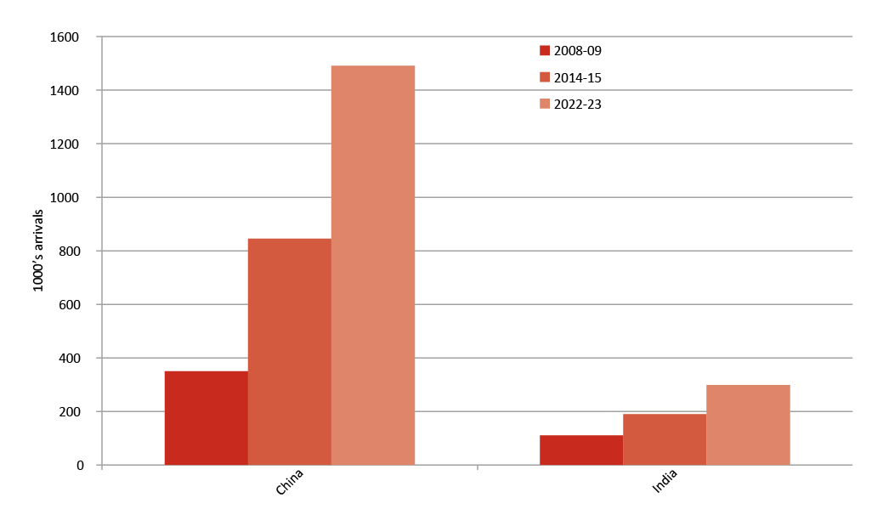Source: Tourism Research Australia, 2014a
Global competition for international visitors is intense. Overall, Australia’s visa requirements compare well with our competitors. But some simple actions could significantly boost tourist numbers in the north and Australia wide.
From 2016 onwards, all visitors from China will be able to lodge visitor visa applications electronically. By the end of 2017, Indian applicants will be similarly enabled. The Government will trial a fast track service (for example, 48 hour turnaround) and a longer validity visa of 10-years for Chinese visitors. A trial allowing visitor visa applications to be lodged in Chinese will also give Australia a clear edge on its competitors such as Singapore, Canada and the United Kingdom.
These measures will make Australia more attractive as both a first time and a repeat destination, with particular benefits for the northern tourist economy. These actions will particularly grow the tourist economy in the north to capitalise on the increased affluence of Asia, its ageing population, and the north’s proximity to the region.

Box 26: Australia can do even better around tourism visas for Chinese nationals
Australia currently offers a highly competitive visitor visa process for Chinese nationals, both in absolute terms and relative to our key competitors. Australia has already streamlined application arrangements by reducing the documentary requirements, not requiring an interview or the submission of original supporting documents, and is currently trialling online lodgement of visitor visa applications in China, offering a three year, multiple entry visa. Checklists and visa application forms for the tourist stream of the Visitor visa are available in English or Chinese. Additionally, three year validity for the business stream of the Visitor visa was introduced in February 2014.

Simpler cultural heritage regulation
The Commonwealth Government is committed to preserving Indigenous heritage in a way that allows Indigenous Australians to benefit more easily from their cultural and natural assets.
Indigenous Australians deserve a high level of support from governments to protect their economic, intellectual and cultural assets, which are essential to the wellbeing of Indigenous individuals and the broader community. But current regulations can impede major projects, including those supported by traditional owners. This creates obstacles to economic development in the north.
The Government will consult Indigenous Australians and industry on possible amendments to the Aboriginal and Torres Strait Islander Heritage Protection Act to reduce duplication in the heritage protection regimes across jurisdictions, while safeguarding decision making powers for traditional owners. This includes considering the establishment of a system to accredit appropriate state and territory Indigenous heritage protection regimes, thus reducing the potential for regulatory duplication once Commonwealth requirements and standards are met.
This accreditation of states and territories is consistent with the Productivity Commission’s recommendations (Productivity Commission, 2013). It would bring a more efficient approach to protecting Indigenous heritage and would reduce costs and uncertainty for Indigenous communities and industry. States and territories would be accredited when they meet prescribed standards.
Ultimately, the Government is seeking a more efficient system that safeguards cultural heritage without discouraging investment. Within two years, the Government will consult with Indigenous and industry interests as part of developing a new accreditation system for consideration. Consultation will be progressed in the first instance through the Indigenous Advisory Committee to the Minister for the Environment.

Box 27: A stronger and more efficient approach to managing cultural heritage
Any Aboriginal or Torres Strait Islander person may apply to the Commonwealth Government to protect an area or object from a threatening activity at any time. Applications may be made repeatedly, without supporting evidence, and do not require the agreement of traditional owners or native title holders, who may wish to utilise their land for possible development opportunities. The Aboriginal and Torres Strait Islander Heritage Protection Act was originally established to enable the Commonwealth Government to intervene and, where necessary, preserve and protect some areas and objects that are particularly significant for traditional reasons, where there were gaps in other legislation. However, since its introduction, very few applications (about five per cent of more than 450) have resulted in declarations of protected areas under the Act. Applications have taken extensive time to resolve, and at the taxpayer’s expense. Statutory reporting processes cost from $20,000 to $50,000 every time the Commonwealth Government is asked to protect an area for longer than 60 days. This is in addition to the ordinary costs of administration and legal advice.

Simpler fisheries regulation
The Commonwealth Government will work with the northern jurisdictions to establish more efficient management of northern fisheries and aquaculture. These northern industries turn over more than $400 million dollars annually (Department of Agriculture, 2015). Northern Australia’s tropical marine estate is comparable in size to its land area. Global tastes for fresh fish and seafood, during a period of limited growth in natural stocks, will lead to greater aquaculture investment opportunities in the north. And aquaculture will increasingly become a driver of new growth in both coastal and on land operations with CSIRO research estimating some 1.5 million ha of land suitable for pond based saltwater aquaculture across northern Australia (ABARES, 2015).
Quote: It is clear that aquaculture will continue to fill the growing supply-demand gap in the face of rapidly expanding global fish demand and relatively stable capture fisheries (World Bank, 2014).
Northern Australia has a strong reputation for providing high quality products including wild catch fisheries, pearls, prawns and barramundi aquaculture. However, existing regulations are complex and may stop further investment in northern Australia. Some fisheries activities are managed by northern jurisdictions, some jointly with the Commonwealth, and some solely by the Commonwealth. In each case, often multiple agencies are involved. Streamlining and better coordinating arrangements are consistent with findings of the Joint Select Committee on Northern Australia (Joint Select Committee on Northern Australia, 2014).
In response, the Government will introduce single jurisdiction oversight of fisheries and aquaculture operations, along with longer licence periods, and trialling third party environmental accreditation.
Initially, the Commonwealth Government will establish (along with Queensland, Western Australia and the Northern Territory governments) a new fisheries ‘northern shopfront’:
- This will transition the seven jointly managed fisheries in the north under a single jurisdiction building on the success of the northern prawn fishery.
- It will reduce complexity and, in many cases, allow fishers to operate in a single fishery under a single licence, where they now currently require separate licences from different jurisdictions.
- The Government will share licensing and compliance services with northern jurisdictions. This will result in standardised services to minimise the costs to industry and save taxpayers tens of millions of dollars.
- Part of this consolidation will include streamlining oversight of aquaculture in Commonwealth waters to provide greater certainty for investors and encourage growth in offshore aquaculture.
Aquaculture will be incorporated into the Government’s ‘One-Stop Shop’ policy for environmental approvals. The Government will accredit states and territories to conduct a single assessment and approval process for developments, including aquaculture in state waters, which currently require assessment and approval under the EPBC Act.
The Government will extend the maximum duration of Commonwealth environmental approvals for low risk fisheries from five to 10 years. This will:
- reduce the number of environmental assessments required
- reduce time and costs for both fisheries and government for 20 low risk fisheries in northern Australia (of 60 nationally)
- increase certainty for fishers who will have longer licences
- reward best environment practice and create an incentive for industry overall to move towards more sustainable fishing practices in the north.
The Government is investigating whether internationally recognised third party accreditation of sustainable management practices could be used to demonstrate adherence with EPBC Act requirements. Fisheries that receive accreditation by a third party against sustainability standards, for example the Marine Stewardship Council, would have streamlined approvals under the EPBC Act — this would save time and money for industries and further encourage sustainable businesses.
To further consolidate and target these reforms, the Government has asked the Productivity Commission to identify other existing duplicative or poorly implemented regulations that are harming investment in Australia’s fisheries and aquaculture industries and report back in 2016.
The Productivity Commission report will provide a platform for the government to ensure the fishing and aquaculture sectors in the north can grow unhindered by excessive and inconsistent regulatory and compliance costs. It will also contribute to strengthened economic development, including optimal social returns, and the sustainable use and management of the fisheries resources.

Simpler regulation of wildlife product trade
The saltwater (‘salty’) crocodile is an iconic species, immediately associated with the north. Trade in crocodile products is a unique northern Australian industry currently worth tens of millions of dollars annually (Department of the Environment, 2015).
The Commonwealth Government will streamline the processing and issuing of CITES permits. This will provide greater certainty for commercial wildlife trade in northern Australia, including for the crocodile industry. The Government will also examine the potential of e-permits to further simplify the permit process for both exporters and importers.
Removing permit requirements for tourist souvenirs where those requirements are more stringent than required under CITES will reduce the regulatory burden for the tourism industry, particularly the sale of Indigenous artwork that may use plant material listed under CITES.
To further assist Australian wildlife industries, the Government will remove export permit requirements for several low risk native species, such as some kangaroo and emu products. This will reduce the regulatory burden on Australian businesses trading in these species, while maintaining appropriate safeguards and monitoring.

Box 28: Fire management and greenhouse gas emissions in the northern savannas
Fire, greenhouse gas emissions and biodiversity have a complex relationship in northern Australia. The idea that land management could be funded by carbon credits emerged from Aboriginal owned Arnhem Land in the Northern Territory. By the 1990s it was clear that the region’s enormous biodiversity values were being eroded by frequent, intense late dry season fires, which result in considerable greenhouse gas emissions.
In response, scientists, land managers and Aboriginal traditional owners developed a programme of prescribed burning early in the dry season to pre-empt large, intense wildfires late in the dry season. Improved burning regimes can enhance pasture vigour, control weeds, provide habitat for native animals, and protect against wildfires.
Improvements in fire management were also linked to reductions in greenhouse gas emissions (abatement). This is because early dry season fires tend to be patchier and less intense than late season fires, and therefore burn less fuel. Because combustion is less complete, fewer emissions are produced.
Importantly, abatement can be used to secure resources for land management. The Commonwealth Government’s Emissions Reduction Fund (ERF) provides opportunities for Indigenous communities to earn carbon credits from early dry season fire management. Projects register under the ERF and are issued with Australian Carbon Credit Units, which can be sold to the Government via reverse auction or sold into secondary markets to others wishing to offset their emissions.
Managing fires early in the dry season across northern Australia has the potential to reduce greenhouse gas emissions by more than 2.25 million tonnes of carbon dioxide equivalent each year (CSIRO, 2015b).
So far there are 38 registered savanna abatement projects across the north, largely managed by Indigenous Australians. For example, in far north Queensland the Olkola Aboriginal Corporation are providing 455,000 tonnes of abatement by maintaining savanna land, providing Indigenous Ranger jobs, improving biodiversity and providing income for the local community.

INFRASTRUCTURE TO SUPPORT GROWTH

Overview
Infrastructure plays an integral role in unlocking economic opportunities globally, nationally and especially in the north. It facilitates investment, increases accessibility to markets (especially for remote areas) and helps attract and retain workers. With careful planning around timing and location, it is a fundamental driver of productivity and growth.
But uncertainty about demand can create significant challenges for infrastructure planning. The right infrastructure investment can be transformative for regions, but the wrong infrastructure wastes resources and can lock communities and governments into poor outcomes through, for example, expensive maintenance and long term debt.
To improve infrastructure in northern Australia, the Commonwealth Government will focus on funding high priority public infrastructure (such as roads), while making it easier for the private sector to invest in the infrastructure where it can get a return. These targeted investments and policy and regulatory reforms will build on previous successes.
The north is already home to some of the largest private infrastructure projects in Australia such as the US$54 billion Gorgon LNG project, the US$33 billion Ichthys projects and the US$29 billion Wheatstone project (Commonwealth Government, 2014). Such investment has been driven by the global resources boom, which has transformed the northern economy — propelling jobs and income growth.
For its part, the Government has already committed nearly $5 billion of its $50 billion nationwide investment in transport infrastructure to the north. These investments include over $3 billion for northern sections of the Bruce Highway, $208.4 million for the Cape York Region Package, $172.2 million for the North West Coastal Highway and $90 million for the Northern Territory Regional Roads Productivity Package.
Despite this investment, infrastructure in northern Australia continues to face cost and service challenges, resulting in critical infrastructure gaps (Infrastructure Australia, 2015). Northern Australia’s low population density and (with the exception of the resources sector) smaller dispersed industry makes it difficult to capture the economies of scale that support commercially viable infrastructure at competitive prices. Distance, remoteness and the north’s unique climate also add to these challenges. In particular, the wet season compresses construction and maintenance schedules into a six or seven month window.
These barriers are not insurmountable. Existing and planned infrastructure projects in the north provide examples of how these challenges can be overcome through new technologies and innovations. The north’s proximity to growing Asian markets also provides a stronger economic rationale than in the past.
The challenge for governments, investors and communities is to identify those projects with the greatest benefit and potential to support development in the north, while minimising the burden on taxpayers and ensuring development is sustainable.
This can be achieved, in part, through reforms to strengthen institutional arrangements and project governance, and by facilitating greater private sector competition, investment and expertise. In 2014, the Government announced new reforms to address these issues in its response to the Productivity Commission’s Inquiry into Public Infrastructure (Department of Infrastructure and Regional Development, 2014). These reforms will further improve the selection, prioritisation and delivery of public infrastructure in northern Australia.

Box 29: Northern Australia Audit: Infrastructure for a Developing North Report
The Government has released the Northern Australia Audit: Infrastructure for a Developing North Report (the northern Australia audit).
This audit, prepared by Infrastructure Australia, is the first of its kind and outlines northern Australia’s current infrastructure asset base and potential long term needs.
The northern Australia audit found the north has distinct advantages arising from its proximity to the growing Asian and tropical regions as well as a number of underutilised assets across a range of sectors including agriculture, minerals, energy and tourism. Northern regions are challenged by limited population, small industry size, distance, remoteness and climatic conditions. Northern cities, like many of their southern counterparts, are grappling with increasing demands on water supplies and transport, communications and energy networks.
It noted that, from an infrastructure perspective, northern Australia’s economic development requires:
- resilient export related infrastructure with sufficient capacity
- good connections with southern Australia
- links between the growing urban economies of Darwin, Cairns, Townsville and Mackay and their hinterlands.

More infrastructure for the north
The Commonwealth Government is committed to ensuring northern Australia has the appropriate infrastructure to support economic and population growth. To do this, the Government will continue to work with state and territory governments to identify the north’s infrastructure needs and priorities, provide targeted funding for priority projects and establish a new financing mechanism to encourage increased private sector investment. This will, in part, be achieved as a result of an expected $800 million underspend from the Asset Recycling Initiative, primarily as a result of the Queensland Government’s decision not to participate in the initiative.
The Government’s efforts in northern Australia will build on national approaches and existing investments, such as the reforms to Infrastructure Australia, the rollout of the National Broadband Network, the National Partnership Agreement on Land Transport Infrastructure, the Energy White Paper and the work of the COAG Energy Reform Council.

Box 30: Cape York Region Package
The Commonwealth Government is providing $208.4 million to improve infrastructure in Cape York in northern Queensland under the Cape York Region Package. Under the package, communities are being widely consulted on how the funding is allocated — ensuring local priorities are at the centre of decision making and that infrastructure projects will deliver economic, social, cultural and environmental benefits.
The package will fund projects that support growth in local mining, hospitality, transport, tourism and maintenance industries — providing both direct and indirect employment opportunities for local people. It will also support improved social outcomes for Indigenous Australians living in the Cape through increased access to health, education and other community services.

A new Northern Australia Infrastructure Facility
As announced in the 2015-16 Budget, the Commonwealth Government will establish a new $5 billion Northern Australia Infrastructure Facility.
The Government will look to partner with the private sector and northern jurisdictions to provide concessional loans to finance infrastructure projects in the north. Concessional loans could be provided to a range of projects — such as airports, ports, rail, roads, energy, water and communications infrastructure. Project proposals will be accepted from 1 July 2015.
The Facility will provide concessional loans to projects that would not otherwise have been able to be built and will be aimed at infrastructure that will increase the productive capacity of northern Australia. Supported projects should have benefits that flow beyond project proponents.
The Government will assess all projects for financial viability before issuing a loan. This assessment will ensure that the proponent is capable of repaying the loan.
Eligibility criteria, covering geographic eligibility, types of infrastructure and financial criteria are currently being developed. The Government plans to release draft criteria for consultation with interested parties shortly.
This measure aligns with the recommendations of the Northern Australia Advisory Group, which called for “mechanisms by which strategic ‘game changing’ and ‘nation building’ infrastructure investments in the north can be identified and funded by the public and private sector” (Department of Infrastructure and Regional Development, 2015).
More information on the Northern Australia Infrastructure Facility can be found at www.naif.treasury.gov.au.

Box 31: Communications infrastructure investments
Better mobile phone and internet coverage
Access to reliable and affordable mobile phone and internet coverage in remote and regional areas is essential to Australia’s future growth. Access to mobile phone coverage and broadband internet is increasingly essential but in some areas, such as remote and regional areas of northern Australia, communication services are often not available, or are unreliable or expensive. The Government is committed to improving access to communications technology for all Australians, particularly those in regional areas who often face the greatest difficulties with service.
National Broadband Network (NBN)
The Government is investing $29.5 billion in the rollout of the NBN to deliver fast, affordable broadband, at less expense to taxpayers. The Fixed Wireless and Satellite infrastructure represents a $4.7 billion capital expenditure. NBN’s two new state of the art satellites have been specifically designed to deliver broadband in Australia and will revolutionise the delivery of broadband in the bush, providing faster speeds than most metropolitan ADSL users can access today.
The next-generation fixed wireless network is being engineered specifically to deliver high speed broadband to regional and remote communities. Fixed wireless networks are not like mobile phone networks in terms of congestion. They are designed to meet the speed and service requirements for the specific number of users in each coverage area and, unlike mobile phone networks, are specifically configured for the area so the speed and connection remain consistent and stable, even during peak times like early evening.
Major centres and larger regional towns in the north will also have access to fast broadband via fibre to the premises and fibre to the node networks. Already more than 105,000 premises in northern Australia are able to access an NBN service and work is underway to deliver fast broadband to a further 128,000 homes and business. Over the next 18 months, this number is set to increase by over 90,000 more. Communities in northern Australia will reap significant economic and social benefits from increased connectivity which will open educational, health and business opportunities that were previously beyond reach.
Mobile Black Spots Programme
The Government is committed to improving access to mobile services, particularly for those in regional areas who often face the greatest difficulties with service. While mobile carriers claim to provide coverage to 99 per cent of Australia’s population, around 70 per cent of Australia’s landmass does not have terrestrial mobile coverage.
Expanding mobile coverage to areas where it is currently inadequate or non-existent has clear economic, social and safety benefits. A study commissioned by the Australian Communications and Media Authority found that in the seven years to 2013, mobile broadband contributed 2.1 per cent of productivity gains in the agricultural sector.
Due to comparatively higher costs and lower levels of revenue, mobile network operators are reluctant to invest in extending coverage into regional areas on a commercial basis. To help address this, the Australian Government established the $100 million Mobile Black Spot Programme. The policy is designed to attract co-funding from other levels of Government and the private sector.
The programme will improve coverage along major transport routes, in small communities and in locations prone to experiencing natural disasters, as well as addressing mobile coverage problems unique to northern Australia.

A new northern Australia roads package
Northern Australia’s road network is essential for the movement of people and freight. Often the only transport link available, the reliability of the north’s roads can be hampered by the climate with road closures or significant restrictions often occurring during the wet season. The quality of roads can also be significantly affected by intensive heavy vehicle use and many roads being unsealed and single lane (Infrastructure Australia, 2015).
The Commonwealth Government will commit $600 million over five years for priority road projects in northern Australia. Key roads to be considered under the package include the Arnhem Highway, Barkly Highway, Flinders Highway, Great Northern Highway, Hann Highway, the Outback Way and the Tanami Road.
These roads were identified in Infrastructure Australia’s northern Australia audit as warranting further investigation, with many seen as priorities by jurisdictions (see Figure 14 and Box 32). Consistent with the recommendations of the Northern Australia Advisory Group, they offer alternative north south, east west and inter jurisdictional links, adding to overall network connectivity and capacity.
Work to be undertaken will include safety and productivity improvements, such as widening, overtaking lanes and pavement renewal. The Government will also work with jurisdictions to agree Indigenous employment and supplier use targets for road projects.
Other roads identified as priorities by jurisdictions, such as those connecting communities, or regional towns to ports and airports, will also be considered under this roads package.
Funded projects are expected to be announced by early 2016.
Figure 14: Northern Australia transport infrastructure
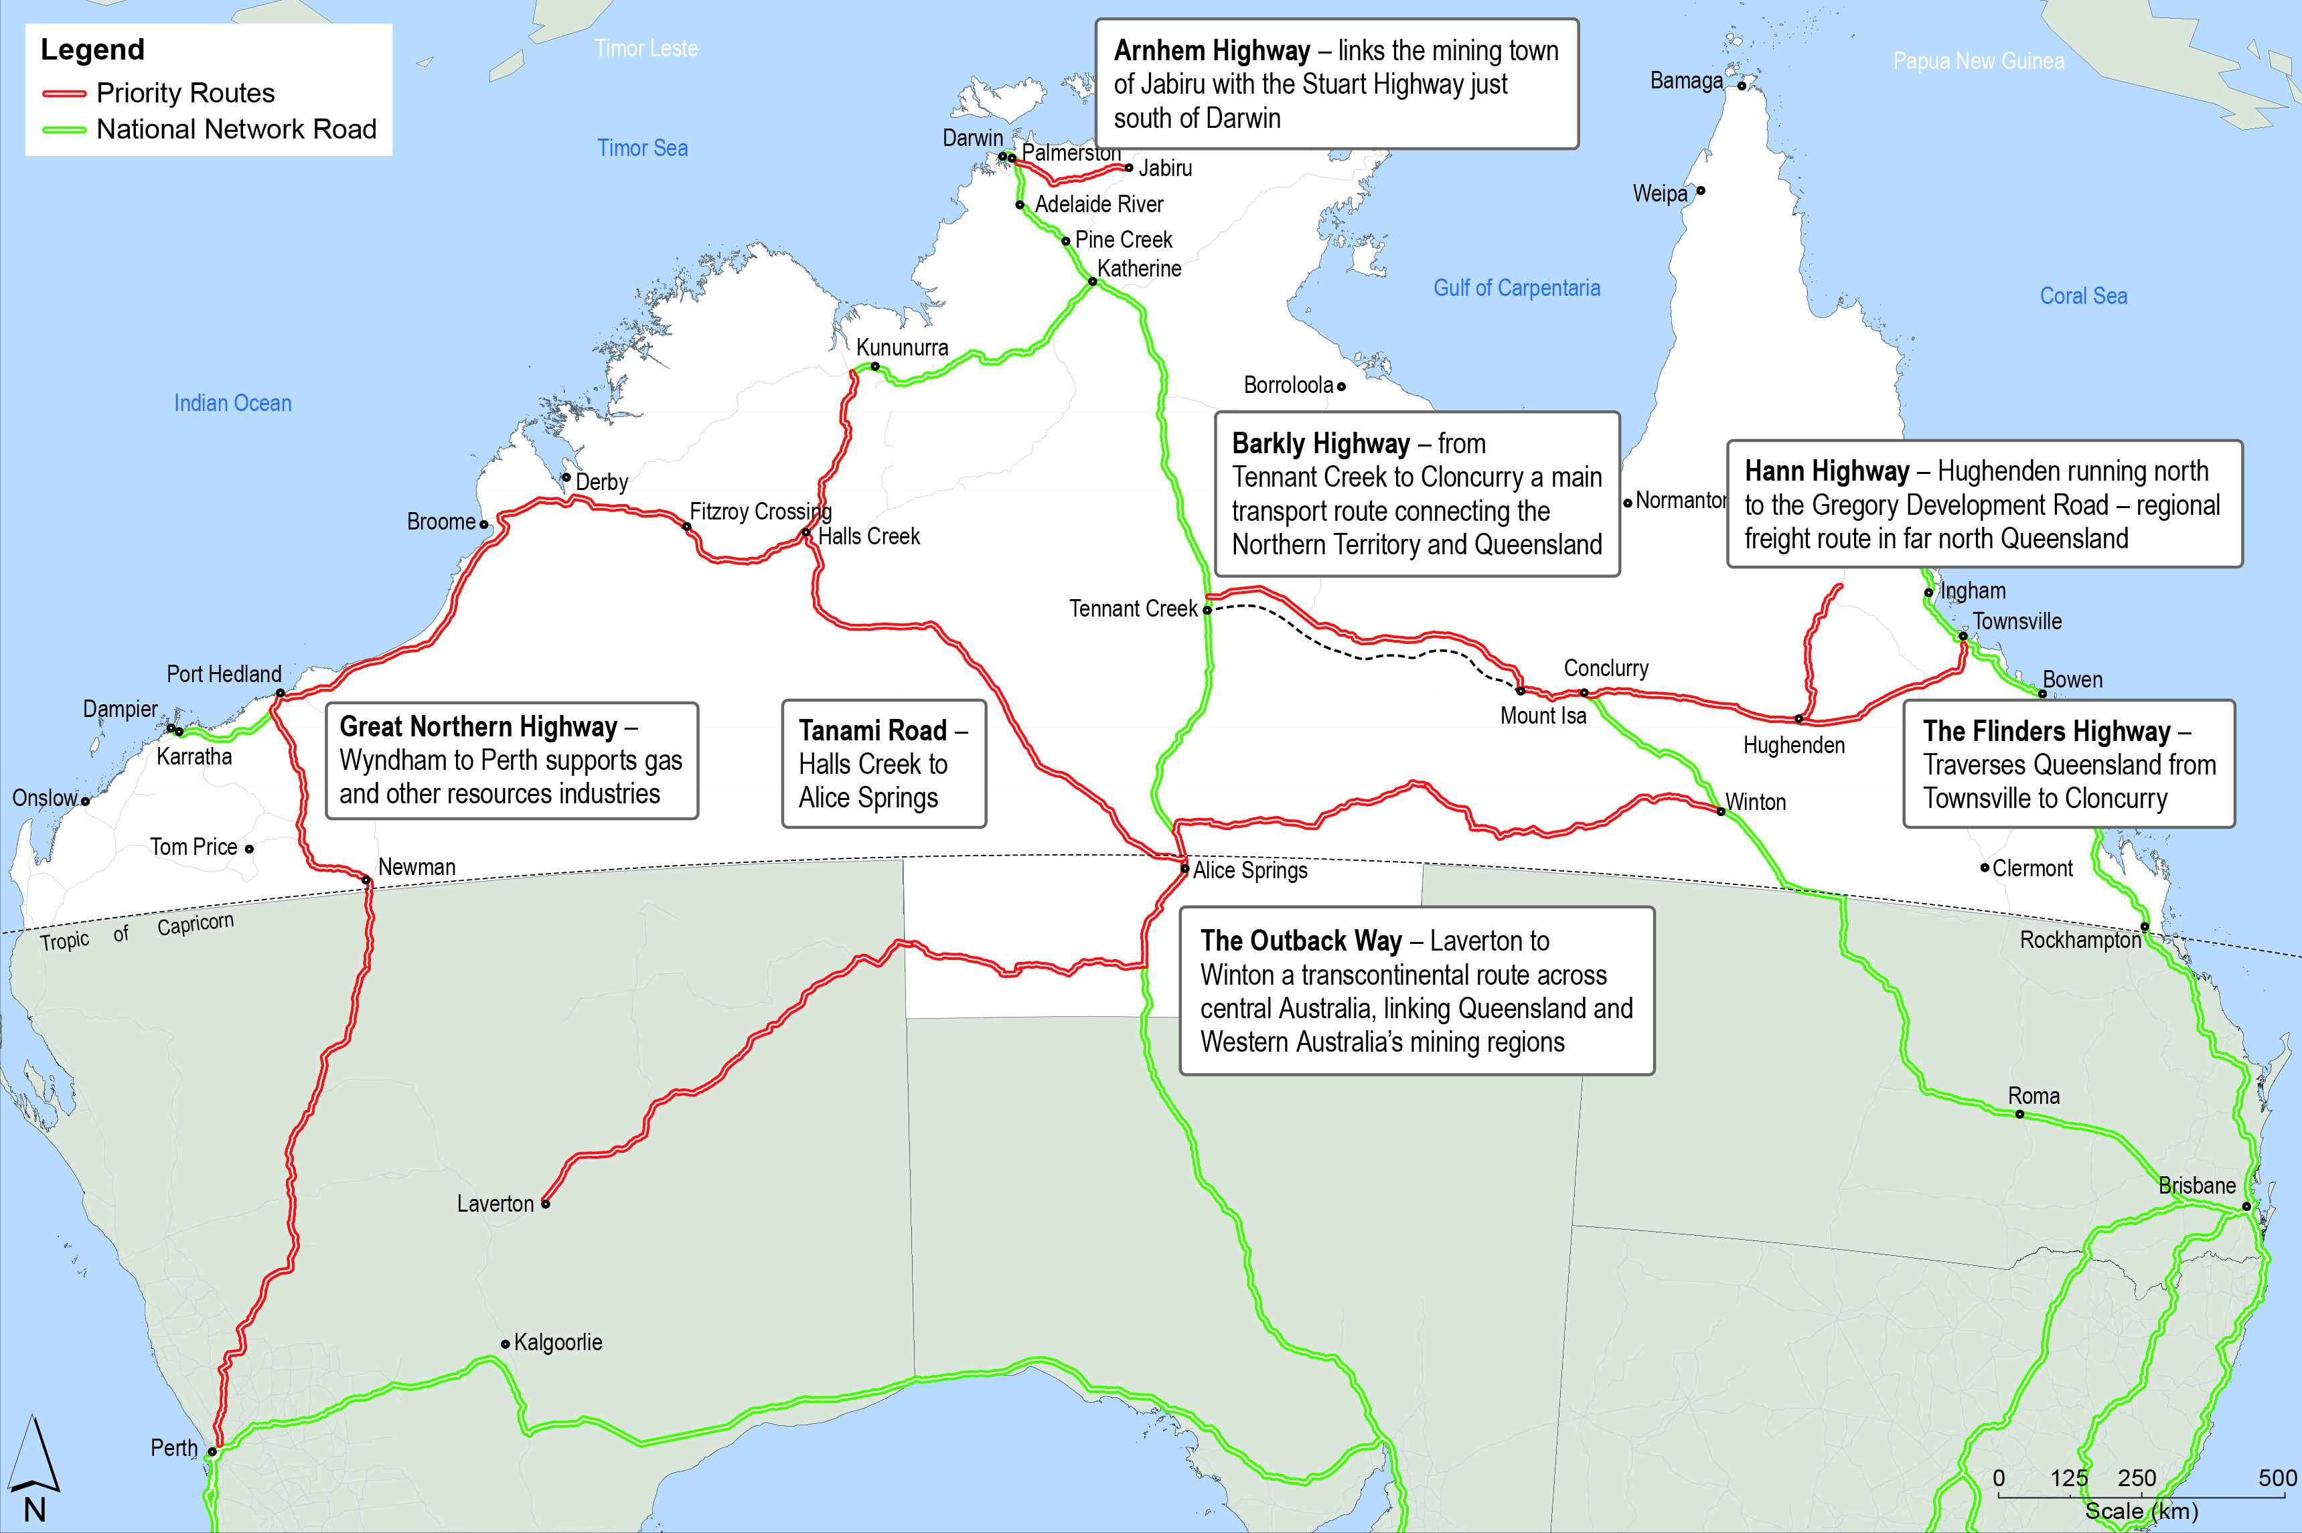
Source: Department of Infrastructure and Regional Development, 2015a

Box 32: Key Queensland, Western Australian and Northern Territory roads
- Arnhem Highway — a 230 km highway linking the mining town of Jabiru with the Stuart Highway (35 km south of Darwin).
- Barkly Highway — part of the National Land Transport Network, the Highway is the main transport route between the Northern Territory and Queensland. The Commonwealth Government is currently funding resurfacing and pavement strengthening works on the Barkly Highway as part of its $77 million Northern Territory Roads Package.
- Bruce Highway — Queensland’s 1,700 km north south road corridor connecting coastal populations from Brisbane to Cairns and supporting around 58 per cent of Queensland’s population. The Commonwealth and Queensland Governments have already committed $8.5 billion over 10 years under the Bruce Highway Upgrade Programme.
- Flinders Highway — also part of the National Land Transport Network that traverses Queensland from Townsville west to Cloncurry where it joins the Barkly Highway.
- Great Northern Highway — an important transport link between Perth and northern Western Australia, supporting the resources and gas industries.
- Hann Highway — a 255 km stretch of road providing local and intra-regional access.
- Keep River Road — a new road into the Keep River Plain to provide access to the area’s gas reserves and minerals deposits, enable new agricultural developments and support a new aquaculture project estimated to be worth $1.5 billion.
- Marble Bar Road — a 430 km largely unsealed alternative to the Great Northern Highway running north from Newman to east of Port Hedland, increasingly used in iron ore mine development.
- Minilya Exmouth Rd — the road runs south from Exmouth to Learmonth and then south to the North West Coastal Highway.
- North West Coastal Highway — a 1,320 km highway between Geraldton and Port Hedland. The Highway supports agricultural, pastoral, fishing, and tourism industries, as well as mining and offshore oil and gas production. The Commonwealth Government has already committed $172.2 million to upgrade priority sections between Minilya and Barradale.
- Outback Way — a 2,800 km transcontinental route across central Australia, linking Queensland and Western Australia mining regions and providing access to many remote Indigenous communities. The Commonwealth Government has committed $42 million to seal and maintain sections of the Outback Way in Queensland and the Northern Territory.
- Tanami Road — a 1,014 km direct freight route from Halls Creek, Western Australia to the south east (Alice Springs), including providing a link to the national rail network.
- Victoria Highway — a 520 km highway between Katherine and Kununurra. The Commonwealth Government is currently funding resurfacing and pavement strengthening works on the Victoria Highway as part of its $77 million Northern Territory Roads Package. The Commonwealth and Northern Territory Governments jointly funded a $35.5 million upgrade to Little Horse and Big Horse Creeks under the National Highway Upgrade Programme.

Improving freight rail planning capacity
Rail in northern Australia is the main transport mode for moving bulk minerals and coal and also supports the movement of agricultural products such as grains and livestock. As with roads, the north’s rail networks are hampered by weather related events and capacity limitations (Infrastructure Australia, 2008).
The Commonwealth Government will commit $5 million to undertake freight rail feasibility analyses and develop proposals for future investment planning for rail projects in northern Australia. Co-funding from jurisdictions will be required.
The first priority is a pre-feasibility study, including a high level cost benefit analysis, for a new railway between Tennant Creek and Mount Isa. While a railway may not be needed until after 2031, a cost benefit analysis was a priority recommendation of the Joint Select Committee on Northern Australia (Joint Select Committee on Northern Australia, 2014). The study will consider the viability and economic opportunities of a new freight link between Queensland and the Northern Territory. The Northern Territory Government has already committed $1 million towards this project.

Box 33: Energy in northern Australia
Beyond the north east coast of Queensland, all of northern Australia’s energy networks are isolated and/or dispersed — serving relatively small populations in specific geographic areas or a particular industry demand.
Isolated networks and stand-alone systems servicing remote communities and mining operations also exist and are likely to be of growing importance. In Western Australia, the Chamber of Minerals and Energy has estimated that electricity consumption could increase by approximately 52 per cent by 2018, driven by projects in the resources sector, with the majority of this new demand (95 per cent) expected to be met through self-generation (Chamber of Minerals and Energy, 2012). For remote communities, commonalities and technical developments offer prospects for reducing costs, for example through the integration of renewable energy and diesel generation.
In regard to gas, both onshore and offshore areas across northern Australia are largely under explored, with good potential for further discoveries. In addition, technological advancements, such as floating LNG, and increased geographical knowledge are making known resources more viable. The proposed North/East Gas Interconnector being advocated by the Northern Territory Government to connect with Australia’s eastern natural gas market will be an opportunity to test the gas market’s appetite to grow the industry. Such a link has the potential to contribute to a more efficient gas market through infrastructure that links markets, builds resilience and enables new gas resources to be developed.
Australia’s eastern natural gas market has undergone substantial development over the past 20 years, transitioning from an isolated and self-sufficient market to one linked to high value international gas markets. While some of this reform has been mirrored in the unconnected northern and western gas markets, more work is required in this area. Linking markets will assist in facilitating reform across the sector if commercial realities support the development required to achieve this aim.
Under the Commonwealth Government’s Renewable Energy Target scheme more than 23 per cent of Australia’s electricity is expected to come from renewable sources by 2020, with renewables continuing to play an important ongoing role in the development of the north. In the Kimberley region, the Western Australian Government has approved plans for the State’s first tidal energy power station. The facility will be able to generate up to 40 MW of electricity — enough to power 10,000-15,000 homes. In Mackay, the Queensland University of Technology’s (QUT) Renewable Biocommodities Pilot Plant is converting cellulosic biomass into renewable transport fuels. This project is jointly funded by the Commonwealth, the Queensland Government, QUT and Mackay Sugar Limited. In the Northern Territory, over $55 million is being invested across 30 remote communities through the Solar Energy Transformation Programme.

A new infrastructure pipeline for northern Australia
The Commonwealth Government has announced it will develop a new infrastructure projects pipeline.
The pipeline will be based on the priorities identified in Infrastructure Australia’s northern Australia audit. It will provide business and jurisdictions with information on potential roads, rail, water, electricity, ports, airports and communications projects.
The pipeline will allow the private sector to bring forward bids that could reduce costs and progress projects faster. Finance for projects may also be made available through the new Northern Australia Infrastructure Facility.
The pipeline aligns with the Joint Select Committee on Northern Australia’s recommendation for a 20 year strategy for the staged development of capital infrastructure in northern Australia (Joint Select Committee on Northern Australia, 2014).
The pipeline will form part of the broader National Infrastructure Construction Schedule and complement Infrastructure Australia’s national infrastructure priority list, and relevant state and territory infrastructure plans.
Quote: There is a history [in northern Australia] of “build it and they will come”… which has in many cases seen the development of major infrastructure without a master plan, coordination or supply chain considerations … resulting in inefficiencies and cost benefit issues (Northern Territory Cattlemen's Association, 2014b).

Better use of infrastructure
Northern Australia has a significant amount of existing infrastructure, including an extensive road network characterised by long isolated roads and low daily traffic volumes, 25 ports, 20 major airports, five energy networks, three railway systems, and communications infrastructure (see Figure 15). It is on this existing base that much of northern Australia’s economic growth and success to date has been built (Infrastructure Australia, 2008).
Quote: We need to collectively explore how we can make better use of existing infrastructure throughout northern Australia and how we can increase access to, and use of, these to enable growth (Northern Territory Government, 2014b).
Figure 15: Significant infrastructure – road, rail and ports in northern Australia
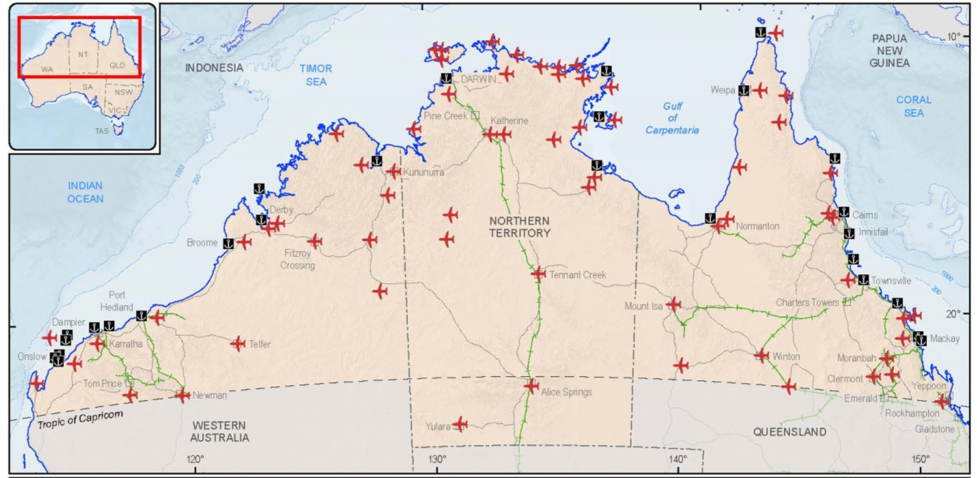Source: Geoscience Australia, 2015b
Governments across Australia recognise the substantial economic and productivity benefits of making better use of existing infrastructure and are already taking steps to ensure the north’s infrastructure is being used to its full potential.
Quote: [I]n prioritising infrastructure investment, maximising the efficiency of existing infrastructure is critical to the development of northern Australia and, in many cases, equal or of greater importance than new infrastructure (Infrastructure Australia, 2015).
But with the transition of the mining boom from construction to production and the considerable budgetary constraints facing governments, ensuring the effective and efficient use of existing infrastructure assets will be increasingly important.
Changes in the operation and management (including through privatisation), pricing or better utilisation of existing infrastructure can solve problems without the need for investment in additional infrastructure (Infrastructure Australia, 2012), as can abolishing overly restrictive regulations and adopting new technologies.
Where investment is required, upgrades and regular maintenance often provide the same desired productivity gains as larger and more costly projects. This is especially the case for transport infrastructure that completes or improves a supply chain. For example, it is often better to have a well maintained graded road than a sealed road where the bitumen falls into disrepair. In such instances, co-investment models with the private sector and users should also be considered.

Box 34: Defence’s approach to joint infrastructure development
The Department of Defence will consider co-investing in state and territory or commercial infrastructure where it cost effectively meets Defence’s capability needs.
Defence’s approach aims to promote more efficient use of Defence and civilian infrastructure that is used by Defence, without compromising strategic or operational requirements. Access to civilian infrastructure is critical to delivering Defence outcomes. Defence recognises that investment in select components of civilian infrastructure, fundamental to the delivery of Defence outcomes, has the potential to provide greater regional benefit where a common use environment can be accommodated.
As an example of co-investment, Defence provided a contribution of $30 million to the Port of Townsville in order to upgrade Berth 10A to allow its use as a primary amphibious mounting port. A further $5.3 million was provided to lease and develop a staging area. Defence access to Berth 10A and its support infrastructure is provided under a tri-partite Deed of Licence between the Port of Townsville Ltd, Queensland Government and the Commonwealth (Defence). The Deed of Licence provides per financial year 110 days to the Port of Townsville, 45 days to Defence and the State is allocated 30 days (for cruise ship visits and visiting foreign warships). If the State does not require the full 30 days, then unallocated days can be used by Defence.
When looking at joint infrastructure development, Defence would consider co-investment in state and territory or commercial infrastructure:
- on a case by case basis
- where it cost effectively meets Defence’s capability needs
- where it does not compromise Defence requirements
- where Defence’s use of the shared facility/infrastructure is ensured when such use is required
- where suitable arrangements have been made for ongoing operational cost recovery (for example air traffic control, fire and rescue services, facility maintenance, etc).
While Defence may express an interest in the potential use of private infrastructure, investors should be aware this does not reflect a commitment to purchase.

Improving northern cattle supply chains
The northern cattle industry is a stand out success story. Northern Australia’s beef herd comprises 12.5 million cattle and contributes approximately 90 per cent of Australia’s live cattle exports (CSIRO, 2014). In 2010-11 the gross value of agricultural production in the north reached $5.2 billion (ABARES, 2013) around $3 billion of which was from cattle.
However the industry is particularly exposed to the costs of moving cattle — the longest land transport distances of any Australian commodity. Cattle in the Northern Territory travel, on average, just under 1,000 km between farm to market, and sometimes as much as 2,500 km to abattoirs on the east coast (Higgins, 2013).
Such long distances raise costs — land transport costs comprise up to 35 per cent of the market price of livestock (CSIRO, 2014) — and increase risks to production, with floods and seasonal road closures isolating producers from markets for extended periods of time. Key arterial roads are often subject to use restrictions and closures due to weather events which affect the movement of freight and people. Outmoded logistics, poorly designed or out dated regulations, or regulatory inconsistencies between jurisdictions, also add to costs.
To address this, the Commonwealth Government has announced a new $100 million beef roads fund for northern Australia. As part of this fund the Government, in close consultation with northern jurisdictions, local governments and transport and beef industry experts, will identify investment and reform priorities for the northern beef industry.
Commonwealth funding for improvements to the supply chain will be subject to the jurisdictions working with the Government to identify and address opportunities to reduce red tape.
This work will be informed by CSIRO’s state of the art logistics modelling tool — the TRAnsport Network Strategic Investment Tool (TRANSIT) (see Box 35). The TRANSIT model will ensure funding goes towards strategic projects that will make the biggest difference (such as known pinch points or last mile access issues). Examples of potential improvements include:
- upgrades to key roads that might facilitate alternative, shorter and more direct routes to market
- addressing capacity limitations (vehicle weight and/or size limits) on roads or at specific points in the supply chain (often related to bridges or urban areas) that require road trains to be broken down
- examining the potential to change inspection and treatment requirements when moving cattle through tick free and control zones.

Box 35: CSIRO TRAnsport Network Strategic Investment Tool
CSIRO’s TRAnsport Network Strategic Investment Tool (TRANSIT) analyses transport options to identify potential cost savings.
TRANSIT works by analysing every possible combination of transport routes and methods (road and rail) and determining those that optimise vehicle movements between enterprises in the agriculture supply chain.
It incorporates factors such as road/rail conditions, temporary closures and diversions and availability of supporting facilities such as truck stops and holding yards. It can be used to manage logistics costs for individual enterprises or whole industries.
TRANSIT has been used to analyse various infrastructure scenarios in northern Australia, including upgrades to the Carnarvon and Gregory Highways between Clermont and Roma, and removal of tick clearing for cattle transported to abattoir.
Under current arrangements, cattle being moved from a tick infected zone to a tick free zone in Queensland must be presented at a livestock inspection centre before they can enter the tick free zone. While a large proportion of Queensland cattle are sourced from central and northern parts of the state, 70 per cent of Queensland’s abattoir capacity is located in the south east. This means many cattle are being moved through the tick free zone enroute to the abattoir. This process is considered by stakeholders to be expensive and disruptive (about $6 per head and four days in a holding yard).
CSIRO estimated that targeted road upgrades and the removal of tick clearing requirements between Clermont and Roma would have saved $75.6 million (19 per cent) in livestock transport costs between 2007 and 2011 (CSIRO, 2014).

Heavy vehicle charges to fund better roads
Historically most roads have been built in order to link communities, and have been funded from general revenue. As a consequence, past road investments have only loosely taken into account the benefits to road transport operators and the broader economy. Currently, heavy vehicle charges in Australia reflect heavy vehicles’ share of past expenditure by governments on roads. This means that the current charging regime is not well suited to efficiently provide the infrastructure needed to support current and future needs of heavy vehicle users. This has flow on impacts to road freight productivity and economic prosperity more broadly.
Under the banner of Heavy Vehicle Road Reform, the Commonwealth, state, territory and local governments are currently working together on longer term reforms of heavy vehicle investment and charging arrangements.
Currently in its initial phase, the Heavy Vehicle Road Reform is aimed at optimising the supply and use of heavy vehicle related road infrastructure to ensure that road services best meet the current and future needs of users at least cost. These reforms could provide heavy vehicle users the opportunity to negotiate additional high productivity vehicle access to roads, or roads of a higher service standard, than currently exist. This could extend to industry priorities for maintenance and upgrades of the road network.
The Heavy Vehicle Road Reform will include trialling alternative options for road user charging arrangements to determine the most appropriate investment and charging model. Such models could incorporate developer contributions and specific charges for new roads where transport operators benefit substantially from the investment.
As part of its commitment to the north, the Commonwealth Government will also explore industry’s willingness to pay for upgrades or alternative service outcomes. Upgrading roads can reduce vehicle repair and maintenance costs, reduce travel times, increase safety, as well as improve access throughout the year.
For example, on the Tanami Road that links Alice Springs in the Northern Territory with Halls Creek in Western Australia, some road users have indicated a willingness to contribute to upgrades and maintenance. One northern beef producer has estimated that sealing the Tanami Road, or maintaining it to a better standard, could improve the profitability of their operations by up to $800,000 a year.
Other roads may also be considered where there is industry support. Such a trial would take into account that operators should not have to cover the full cost of upgrades or enhancements, with governments also contributing based on the social benefits road improvements provide to remote communities and industries, such as tourism.

Box 36: Supporting live exports
The Commonwealth Government supports the livestock export industry and is committed to re-invigorating the livestock export trade. In 2013, live cattle, sheep and goat exports were valued at $685.5 million (Deards, et. al. 2014) and the industry is predicted to grow. This industry is an important driver of economic development and is estimated to employ between 8,000 and 10,000 people. It is also a significant source of Indigenous employment in northern Australia (LiveCorp, 2015).
The live cattle trade provides significant opportunities for northern Australia. The business models of many top end cattle producers are closely linked with those of importing countries, such as Indonesia, where low weight animals reach slaughter condition in foreign feedlots. This allows cattle ranching in the north where seasonality prevents animals from putting on weight year round. As such, livestock of certain ages are more suited to growing out and processing in some overseas markets, which can command higher prices than meat exports.
However, there is still great potential for the industry to grow and contribute to the further development of the north. The Government is boosting economic returns to the farm gate by identifying infrastructure projects to reduce transport bottlenecks, support simpler and more secure pastoral land tenure arrangements to provide more flexibility for on farm investment and promoting further opportunities for expanding market access. Improvements in road infrastructure will improve the resilience of the supply chain and have the potential to extend the current seasonal supply of cattle to export markets.

More support for aviation
The limited ground transport options and vast distances in the north increase reliance on air transport for purposes as diverse as medical emergencies, cattle mustering and passenger and freight movement during the wet season. However, air travel within the region is difficult due to a lack of demand to support commercially viable services. The thin population density means most aviation infrastructure is directed at connecting communities with large population centres that are often located in the south, and the services within the north that do exist are generally limited and expensive.
Northern Australia’s remote airstrips provide critical transport links for many remote Indigenous communities, towns and outstations — particularly in the wet season when many roads are impassable. These airstrips support critical services such as the Royal Flying Doctor Service and the provision of mail and essential health, food, emergency response and educational supplies.
To provide ongoing certainty for the industries and communities that depend on these services, the Commonwealth Government has announced an extra $39.6 million for airstrip upgrades and additional essential air services under two funding components of the Regional Aviation Access Programme. $33.7 million over four years has been committed to continue the Remote Airstrip Upgrade funding component and $5.9 million over three years for the Remote Air Services Subsidy Scheme. It is anticipated that a significant proportion of the funding under these initiatives will be sought for northern Australia.

Improving aviation access across the north
By 2030, two thirds of the world’s middle class will reside in the Asia-Pacific region (see Figure 16). Global air passenger numbers are expected to more than double to over 7 billion a year within the next 20 years (IATA, 2014).
Figure16: Global middle class by region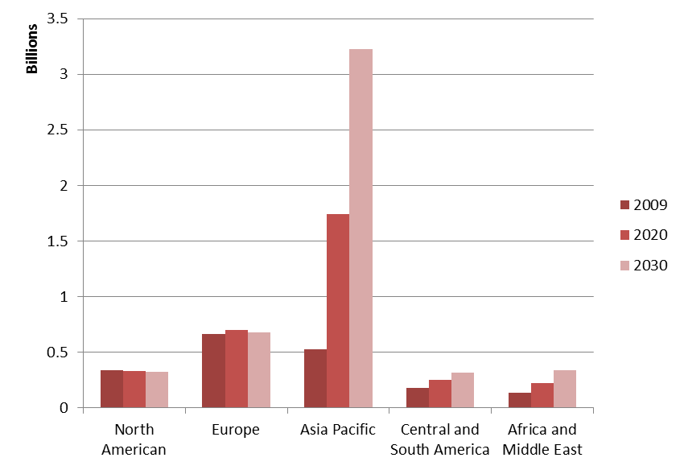
Source: Kharas & Gertx, 2010
Around half of the world's air traffic growth over the next 20 years will be to, from, or within the Asia-Pacific region with passenger numbers expected to grow by 1.8 billion (IATA, 2014). Yet, even though it lies between Asia and our southern cities, and right next to services offered by low cost Asian carriers, the north is failing to benefit. Australia currently receives around 7 million passengers a year, but the vast majority stick to the major cities (Productivity Commission, 2015).
Tourism numbers are recovering in the north. While some locations have seen declining numbers, such as a 20 per cent reduction in international visitor numbers to tropical Queensland between 2006 and 2014 (Productivity Commission, 2015), there has been strong growth in domestic visitors (Queensland Government, 2015).
In order to facilitate improved tourism and trade opportunities in northern Australia, the Government has provided additional funding to enable the establishment of a permanent border agency presence at Townsville Airport. This will enable Townsville Airport to attract new services from international airlines, providing another international gateway for foreign tourists directly into northern Australia.
Recognising that aviation and land transport services to northern Australia will play a critical role in the long term development of the region, the Deputy Prime Minister will establish a business stakeholder group to assist him in preparing a plan for improving aviation and surface transport connections to northern Australia. This will include developing measures to support the sustainable and long term growth of both Australian and international airlines’ air services to and from northern Australia and identifying opportunities to better integrate the north with ASEAN trading partners and the region.

Reforms to coastal shipping
The Commonwealth Government is working to build a more competitive and efficient shipping industry and is committed to reforming the coastal shipping sector. We need better policy and regulatory settings to meet our growing needs and to ensure that shipping can undertake, as effectively as possible, its key role in the national transport system.
Quote: The development of coastal shipping in northern Australia … would significantly open up transport and economic benefits to northern Australia (Far North Queensland Ports Corporation, 2014)
The north has over 10,000 km of coastline (Department of Agriculture, 2014) and is between key Asian markets and Australia’s industrial south. The large distances involved in travel across northern Australia means that high transport costs and low service levels can have a disproportionate effect on business opportunities in the north, and on the supply of commodities to southern regions.
Current regulation of coastal shipping imposes additional costs on shippers by restricting the use of efficient international shipping services operating in Australian waters to carry domestic cargo and passengers. One sector particularly affected is the northern expedition cruise industry, where potential market growth and innovative cruise offerings are hindered by the contestability provisions of the current legislation. Because of these arrangements, new cruise offerings are limited and operators may even decide to make detours to international destinations in order to avoid the restrictions imposed by the legislation. Likewise, shipping plays a critical role in moving bulk commodities and raw materials both within northern Australia and to southern Australia, but the current coastal shipping legislation imposes significant additional costs and regulatory burdens on shippers seeking to utilise efficient shipping services.
The Government will substantially deregulate the current coastal shipping framework to ensure efficient and reliable coastal shipping services is part of the national transport system. The Coastal Trading (Revitalising Australian Shipping) Act 2012 (Cwlth) will be amended to introduce a single permit system. Permits will provide unrestricted access to the Australian coast for both Australian and foreign ships for up to 12 months. Contestability provisions present in the current legislation will be removed.
Superyachts can currently operate on coastal voyages under the existing legislation, however, this is complex and, to date, has not been utilised by the industry. Under the new permit framework, it will be clear a superyacht can obtain a licence to operate on the coast. This will provide significant benefits to the broader economy through increased tourist visitation and maintenance work being undertaken in Australia.
In addition, the new framework will have protections to retain critical Australian maritime skills and ensure the payment of appropriate wages and conditions. Any vessel that undertakes more than 183 days of coastal shipping in a permit period will be required to employ two senior Australian crew for the entire permit period and to pay wages set out by Australian law for the entire permit period. The Australian International Shipping Register will be changed to improve the viability and attractiveness of the Register.

A NORTHERN WORKFORCE FOR GROWTH

Overview
Businesses in the north require an adaptable and mobile labour force with a range of skills: from engineers to fruit pickers; from welders to medical specialists and managerial staff.
However, the north is hampered by localised worker shortages and high wage costs which deter investment. Retaining workers and better matching their skills — combined with better use of capital and natural assets — will drive future growth in the north.
To support further development in the north, the Commonwealth Government is reducing barriers to employment both in the north and across Australia. We will achieve this by drawing from Australia’s untapped workforce potential — getting ‘job ready’ Australians into the work they value, including for remote Indigenous communities. In some cases, these strengths will need to be supplemented with workers from overseas to address legitimate unmet labour demand from business. As the north develops, supported by actions taken as part of the Government’s northern development agenda, the population will grow, the amenity of the region will improve and workers across Australia will be more easily recruited and retained.
Currently, there are around 646,000 jobs occupied by workers spread unevenly across the north, which is 5.5 per cent of the nation’s workers. Over half of these jobs are located in Queensland (Department of Employment, 2015a).
Jobs and industries in the north do not always match the national profile. Rather, they reflect the opportunities and challenges that northern industries have to offer in comparison with the rest of Australia. Some areas, like Cairns and Townsville, most closely represent the types of jobs found in the south, while others like Darwin and remote Western Australia, differ significantly.
The overall share of jobs in education and training, utilities, administration and agriculture, forestry and fishing closely reflect the national average. However, other northern industries vary significantly from the national profile. Unsurprisingly, mining represents around 9 per cent (around 59,000) of all jobs in the north — compared with only 2 per cent nationally (Department of Employment, 2015b). Around two thirds of these are in remote areas of Western Australia, the Mackay region and the Queensland Outback. Around 125,000 miners also reside in Perth servicing projects across Australia, including in the north (Department of Employment, 2015b). The mining sector also supports a large indirect workforce through the provision of goods and services.
The strength of the construction industry in the north is closely related to this, and was a significant contributor across all northern regions. Traditionally non-market sectors, including public administration and safety, and the health sector also have a significant presence in the north, with these sectors accounting for around 40 per cent of jobs in the Northern Territory alone (Department of Employment, 2015b).
Figure 17: Employment by sector in northern Australia
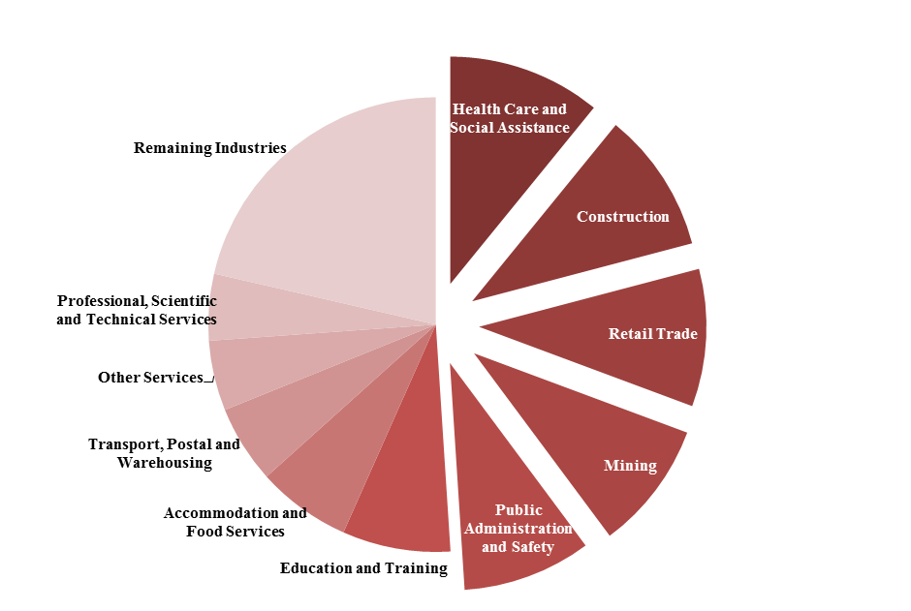
A large number of jobs in the north are from Government, Mining and Construction
Source: Department of Employment, 2015b
The north’s skill sets reflect its industry structure, with its share of (largely) ‘blue collar’ jobs well above the national average. Collectively, technicians, trade workers, machine operators, drivers and labourers represent over 40 per cent (around 267,000) of northern jobs — well above the national average of around 30 per cent (Department of Employment, 2015b).
The relative strength in blue collar jobs is offset by relatively fewer ‘white collar’ jobs — that is, professionals, managers, sales workers, clerks and administrators.

Box 37: Reforming the zone tax offset
The Government provides taxation support for individuals in remote and regional areas through the Zone Tax Offset (ZTO). The cost to the Budget of providing the ZTO is estimated to be around $300 million a year.
There is general agreement that the current offset, which has been in place since 1945, is out of date and poorly targeted. The Joint Select Committee on Northern Australia noted in its final report that the offset was “one of the principle areas of tax reform identified in the evidence presented to the Committee” (Joint Select Committee on Northern Australia, 2014).
The original intent of the offset was to support individuals living in remote and regional areas. However, nowadays, recipients of the offset benefit from on average around $420 per year (2011-12 figures). It is also estimated that around 20 per cent of claimants are FIFO workers living outside the zone. In its inquiry into the use of FIFO workforce practices in regional Australia, the House of Representatives Standing Committee on Regional Australia expressed concern around the appropriateness and application of the offset and recommended the Government review arrangements.
Increased activity in the resources sector has had various implications for regional communities around Australia, particularly for the north. One of these implications is the high demand for skilled workers to construct and operate resources projects, contributing to the continued use of FIFO workers. FIFO workers and their settlements can mean more incomes to local communities, but can also place pressure on amenities and cultures.
The Government acknowledges these work practices are a legitimate way for employers to get the workers they need, particularly in the north where there are areas of significant labour shortages. But the Government should not subsidise FIFO, which is why it is changing the rules to ensure the offset goes to its intended recipients.
In the 2015-16 Budget the Government announced it will amend the eligibility criteria for the ZTO so that it is only available to those who genuinely live in specified remote areas (The Treasury, 2015a). The change will exclude FIFO workers who live outside the zone, ensuring the ZTO is targeted to those who need it most and better reflects its intended purpose.

Challenges for the northern workforce
The northern workforce faces a number of challenges — some experienced nationally and some unique to the north.
First, key industries in the north require flexible and mobile labour but are regularly faced with a shortage of workers. Some businesses will effectively shut down or cut back on staffing during the wet season or as tourist numbers reduce. Others, such as in mining and agriculture, require workers to be on-site, often in difficult conditions, away from their families and without typical suburban conveniences such as shopping malls, medical facilities, services and entertainment and sporting facilities.
Further, given the large weight of construction in the northern economy, many businesses and their workers are more vulnerable to volatile (‘boom and bust’) economic conditions. Typically, these businesses relocate their workplaces to new projects at the end of each construction project.
Second, there are significant personal and financial barriers for labour to move to, and within, the north. They include the financial costs of relocating including housing and occupational licensing, a (real or apparent) lack of infrastructure and services, and strong family and community ties to current locations. These barriers are a major source of high wage costs — identified as one of the top 10 constraints on investment in Australia (ACCI, 2014).
Large globally driven resource projects have pulled labour from some areas in the north to others, pushing up wages for some local (‘non traded’) business. But the response needs to address barriers to labour mobility, not to discourage new projects with their many advantages for the north and Australia more broadly.
Third, economic and labour market conditions differ significantly both at regional and sub-regional level. The reasons for these differences are many and varied — including age, family and industry structures. Unemployment in Alice Springs, Darwin and Katherine regularly falls under four per cent, whereas other northern areas face unemployment rates of around 40 per cent (Department of Employment, 2015c). As with much of Australia, youth unemployment is significantly higher (Department of Employment, 2015a).
Figure 18: Most northern working age people are in Queensland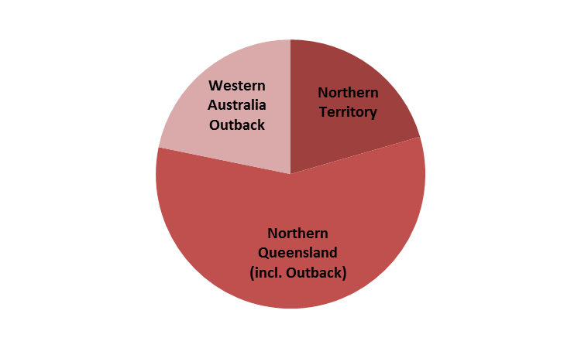
Queensland contains the majority share of the working age population in northern Australia
Source: Department of Employment, 2015a
Figure 19: Big differences in regional labour markets

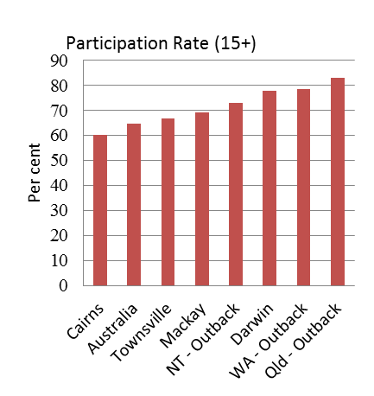
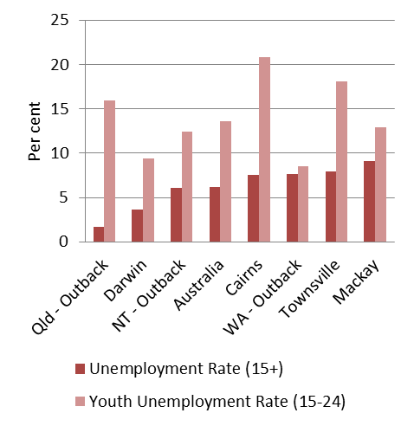
There are wide differences in labour market conditions across the major statistical regions in northern Australia
Source: Department of Employment, 2015a
Local pockets of high unemployment go hand-in-hand with large differences in incomes. The average earnings in some parts of the north are almost double the national average, while other areas are lucky to earn half (Glover, 2015). This reflects the widely different skills and labour market conditions in different regions. For example, major resource projects have contributed to localised wage booms, but sit alongside remote communities with extreme rates of unemployment and other severe disadvantage.
These challenges mean labour is not moving to where it is needed most — there are shortages of labour in some areas, while other areas have surplus labour. This also highlights the broader issue of ‘job ready’ Australians wherever they are, being unable or reluctant to relocate to areas where workers are needed.

The way forward
Getting more Australians into work does not just benefit business — individuals, families and the broader community reap the economic rewards of higher incomes. People with jobs are also socially rewarded through the enjoyment and fulfilment derived from work, improved health outcomes, social connectedness and mental wellbeing.
The Commonwealth Government’s first priority is getting ‘job ready’ Australians into work. Employee relocation costs can be kept to a minimum by filling jobs with local northern workers first. If local workers are not available, then the search can be expanded to Australians from further afield. Willing Australians who do not have the right skills can also be encouraged to undertake further training.
However, there will be situations when Australians are not available to fill positions. Where Australian workers cannot be found, businesses will need improved access to foreign workers.
The north’s workforce needs will be addressed by:
- getting more Australians working, by helping them gain the right skills and reducing barriers to relocating within, or to, the north
- allowing businesses to address unmet labour demand, by reducing barriers to accessing foreign workers.

More Australians working in the north
There are Australians available to help address labour shortages in the north. But they need the right support and incentives to take up these jobs. This includes help to gain the right skills through training and development opportunities, gaining access to work experience and overcoming personal and financial barriers to finding and keeping a job.
The Commonwealth Government has implemented a number of measures to help Australians into work. This includes the new $6.8 billion jobactive programme which also includes a reinvigorated Work for the Dole programme. The key objective of the new arrangements is to help job seekers into sustainable work, especially in regional communities. The Job Commitment Bonus for Young Australians and the Relocation Assistance to Take Up a Job Programme also assist young, long term unemployed job seekers to move off welfare and into paid work.
Building on this, the 2015-16 Budget provided funding for a number of initiatives to support Australians transitioning into work (The Treasury, 2015a). The Government will help small business to create work experience opportunities for Australia’s unemployed through a $1.2 billion national wage subsidy pool to support employers who offer job seekers an ongoing job. A further $18 million over four years will be provided to get 6,000 job seekers a year to undertake work experience while receiving income support and $330 million to implement a Youth Employment Strategy to make it easier for Australia’s youth to enter the workforce. This will include the new $212 million Youth Transition to Work Programme to assist young people disengaged from work and study to find and maintain employment or get back into training and $106 million for intensive support for key groups of vulnerable job seekers.

Streamlining recognition of occupational licenses in the Northern Territory
It makes no sense that some unemployed Australians are deterred from accessing job openings across jurisdictional borders. The Commonwealth Government is determined to make it simpler and less costly for Australian workers to move to the north. The complicated and restrictive system of state based trades licensing provides a time and cost barrier to skilled workers wishing to relocate to the north — slowing the north’s development.
The Government will support the Northern Territory to streamline its occupational licensing processes. This will allow licensed workers from the rest of Australia to be issued with an equivalent Northern Territory licence immediately.
Under these new arrangements, a qualified electrician working in Shepparton, Victoria could move to Katherine in the Northern Territory, receive an equivalent Northern Territory licence on-the-spot from a centralised Northern Territory shopfront (or electronically), and start work on the same day.
Streamlined licence recognition in the Northern Territory will be staged, but ambitious. It will add to the Northern Territory’s reputation as being a business friendly place to work and live.
The Government will assist the Northern Territory to fast track implementation of streamlined occupational licensing processes through the secondment of Australian Public Service (APS) employees to the Northern Territory public service (see page 96).

Supporting businesses to invest in skills in northern Australia
A strong skill set increases the likelihood of acquiring a job. There is a gap of nearly 20 percentage points between the labour force participation rate of lower skilled workers and those who hold post school qualifications (Australian Workforce and Productivity Agency, 2014). The Commonwealth Government’s national reforms to higher education, skills and training will mean better skilled and more adaptable workers across Australia, including in the north.
Building on this, the Government will broaden the availability of the $664 million Industry Skills Fund to businesses seeking to expand their operations in northern Australia. The Industry Skills Fund offers businesses two types of support:
- skills advice, which provides tailored advice and training recommendations to increase the likelihood of the business meeting its growth objective
- a training grant, which involves co-investment by Government and business to cover the cost of any type of training that the business has identified as necessary to help it achieve its identified growth opportunities and improve its competitiveness.
Co-contribution rates under the Industry Skills Fund for businesses in northern Australia will be reduced, and the availability of skills advice tied to business strategy will encourage businesses to invest in up-skilling or re-skilling their workforces.
By reducing co-contributions the Government is lowering the costs to businesses seeking to expand their operations in the north of Australia by investing in the skills of the workforce. Additional assistance under the Industry Skills Fund will facilitate greater Indigenous participation and encourage more investment in skills — targeting training solutions to business needs.

Getting remote unemployed to work in real jobs
Some areas of the north have the highest unemployment levels in the country. Encouraging people off welfare is much more difficult in areas where there are few businesses. This is particularly the case in remote northern Australia where the majority of jobseekers are Indigenous, and many have had little or no work experience.
Experience in a real work environment can be an important step in a job seeker’s transition from income support into a real job.
Quote: … the economic benefits of closing the gap in Indigenous employment outcomes would benefit Australia’s GDP by $24 billion by 2031, with the biggest gains to be made in the north (Northern Territory Government, 2014b).
As part of the reforms to the Remote Jobs and Communities Programme, job seekers will have the opportunity to fulfil their ‘work for the dole’ requirements through placements in local businesses. Job seekers will typically be placed with a business for up to six months, but may be longer depending on local circumstances.
This experience will:
- boost job seekers’ employability
- introduce long term job seekers to workplace norms
- improve job seekers’ self-esteem
- encourage job seekers to aspire to a real job rather than remain on welfare.
The programme will also encourage investment in local communities by supporting businesses in communities with significant unemployment.
Businesses can use the opportunity to host a ‘work for the dole’ placement for a trial period to get to know the job seeker before offering them a job. Business will also be given a range of financial incentives to provide remote jobseekers with ongoing employment at the end of their placement. This will make it easier and more attractive for remote businesses to employ local and Indigenous jobseekers rather than foreign workers.
Enhancing the supply of local and Indigenous workers will boost remote economies, support business investment in Indigenous communities and help meet the increased demand for labour as a result of the White Paper.

Box 38: Securing Indigenous employment opportunities
The Commonwealth Government’s northern development agenda presents a once-in-a-lifetime opportunity to drive Indigenous economic development. Experience tells us that where clear, unambiguous targets for Indigenous employment and supplier use are adopted, governments and the private sector pull together and make it happen. The Government has already set its own target of awarding three per cent of new Commonwealth contracts to Indigenous suppliers by 2020. There will also be minimum mandatory Indigenous participation requirements for certain contracts to help drive more Indigenous employment and supplier use in some of Australia’s biggest companies.
In implementing the White Paper, the Government will work with jurisdictions to achieve Indigenous employment and/or supplier use targets for road projects in the north. The targets will reflect the working age Indigenous population in the part of the jurisdiction that falls within northern Australia. The Government will also seek a commitment from jurisdictions to implement other specific Indigenous employment and supplier use targets that reflect the working age Indigenous population in the part of the jurisdiction that falls within northern Australia, for all other relevant expenditure proposals in the White Paper. These efforts will leverage reforms to the Remote Jobs and Communities Programme to get more Indigenous adults into work.

Allowing business to address unmet labour demand
Australians are not always available to fill positions for a variety of reasons, leaving businesses without the workers they need to continue producing the goods and services required. Where Australian workers cannot satisfy the labour needs of the north, businesses will have access to foreign workers in areas of labour shortages.
Quote: Geographical dispersion is fundamentally important for Australia to gain maximum benefit from skilled migration, but [geographical dispersion] is currently not occurring effectively (Northern Territory Government, 2014a).

Supporting the workforce strategies of northern Australia
The Commonwealth Government is increasing the supply of labour needed for business to continue to operate and grow through DAMAs.
DAMAs address the continued difficulties faced in recruiting and retaining Australian workers, providing the flexibility that regions need to respond to their own economic and labour market conditions. DAMAs allow employers in areas experiencing skills and labour shortages to sponsor skilled and semi-skilled overseas workers, as long as they recruit Australians as a first priority. A DAMA has a two tiered structure:
- an overarching agreement between a Designated Area Representative that is endorsed by a state or territory government and the Commonwealth Government to bring overseas workers to a designated area
- individual agreements between employers and the Commonwealth Government that allow employers to sponsor overseas workers to the designated area under the terms and conditions agreed to in the overarching agreement.
DAMAs can also be used to provide pathways to permanent residency for temporary skilled workers (457 visa holders) after two years employment in designated areas — helping provide a longer term workforce for the north.
Australia’s first DAMA commenced in the Northern Territory on 10 February 2014. A memorandum of agreement for up to 500 workers is currently in place pending a three year agreement. This is an umbrella agreement that will allow employers in the Northern Territory to sponsor temporary workers including chefs, child care and aged care workers, office managers, and truck drivers.
The Western Australia Government is currently working with the Department of Immigration and Border Protection and the Pilbara Regional Council on a proposed DAMA for the Pilbara region.
The Queensland Government is yet to consider its position in regard to DAMAs. The Commonwealth Government will continue to promote the DAMA programme with the Queensland Government and if a DAMA is endorsed, it will be fast tracked.
Box 39: Migration framework for growth
Immigration has been an important source of labour supply for Australia (The Treasury, 2015b). Migrants, on average, are younger, helping slow the rate of the population ageing — a significant issue for Australia. This in turn increases workforce participation and economic growth.
Australia’s migration intake is determined by the Government and is subject to review each year to reflect changes in economic and social circumstances. Attracting skilled migrants can provide both economic and social benefits to Australia. In an increasingly competitive global labour market, skilled migration that is well targeted to our economic needs will support Australian businesses and provide more workers to support the rest of the community.
The Government has asked the Productivity Commission to undertake an inquiry into Australia’s migrant intake and will make recommendations on benefits and costs, and how to achieve an optimal balance between temporary and permanent migration.

Expanding the Working Holiday Maker Visa Programme
Australia’s Working Holiday Maker (WHM) Visa Programme encourages youth mobility and tourism by allowing young adults aged 18-30 years to have an extended holiday in Australia of up to 12 months, during which they can offset their travel costs by engaging in short term work. A total of 239,592 visas were granted to participants in 2013-14.
The Commonwealth Government will amend the WHM Visa Programme to allow both Working Holiday (Subclass 417) and Work and Holiday (Subclass 462) visa holders to work an additional six months with one employer in northern Australia if they work in the following high demand areas in the north:
- agriculture, forestry and fishing
- tourism and hospitality
- mining and construction
- disability and aged care.
The Government will also be giving Work and Holiday (Subclass 462) visa holders the opportunity to access a second 12 month visa if they work for three months in agriculture or tourism in the north. Working Holiday (Subclass 417) visa holders already have access to a second 12 month visa and this change means WHM Visa Programme participants could potentially be able to work for the entire duration of their two year stay in Australia — increasing the supply of seasonal and temporary labour in the north.
This will be of particular benefit to the agriculture and tourism sectors which are highly seasonal, relying on WHM visa holders to provide the labour flexibility they need in peak periods. This will also help employers get more back from those WHM visa holders that they have trained to undertake particular roles.
These measures will be subject to monitoring and reviewed after two years for their impact on the domestic labour market and to ensure foreign workers are not being exploited.

Expanding and streamlining the Seasonal Worker Programme
The Seasonal Worker Programme (SWP) helps Australian businesses to employ workers from participating Pacific Island countries and Timor-Leste when they cannot find enough local labour to satisfy seasonal demand. The Commonwealth Government will streamline and expand the SWP to better address seasonal labour shortages in the north.
From 1 July 2015, the national cap on the number of workers participating in the SWP will be removed entirely so that businesses are no longer constrained from accessing seasonal labour they cannot find domestically. This will build on the Government’s recently announced changes to the SWP, which removed caps on individual sectors so that this programme is demand driven by Australian employers.
The Government will also expand the SWP to the broader agriculture industry and the accommodation sector on an ongoing basis, and invite northern Australia’s tourism industry to suggest proposals to trial the SWP in tourism sectors other than accommodation from 1 July 2015.
To support the expansion of the SWP, the Government will remove the minimum stay requirement of 14 weeks, provided workers receive a net financial benefit of at least $1,000 during their stay. The Government will also simplify cost sharing arrangements by combining the employer’s contribution to each seasonal worker’s international and domestic airfare to a total of $500. Further measures to cut red tape for business will be announced by 1 July 2016.
In addition to supporting Australian businesses meet their labour needs, the SWP supports economic development in Pacific Island countries and Timor-Leste, and the Government’s foreign policy objectives. The SWP fosters stability and economic growth in the region, and improves incomes, employment and enterprise prospects for low income citizens from rural and urban areas.
Subject to the conclusion of the Pacific Agreement on Closer Economic Relations, the Government will also invite additional Pacific Island Forum countries to participate in the SWP, potentially adding the Cook Islands, Federated States of Micronesia, Niue, Palau and Republic of Marshall Islands.
Domestic workers need to be given first opportunity at getting jobs in the north, so employers will still be required to test the local labour market to see if Australian workers are available. Further, the Government will have the discretion to cap, exclude and review the placement of seasonal workers in areas with high unemployment and low workforce participation rates.

A new pilot programme for workers from Pacific microstates
The Commonwealth Government will introduce a new pilot programme for workers from the Pacific microstates of Kiribati, Nauru and Tuvalu to help address unmet labour demands in northern Australia. This new five year pilot programme will provide up to 250 citizens from the Pacific microstates access to a multi-year visa to work in lower skilled occupations in selected industries in the north.
The programme will target non-seasonal industries and occupations that are unable to access Australian workers, in turn supporting northern Australia’s economic development.
The programme will strengthen Australian’s foreign policy objectives in the Pacific, including by encouraging enduring links with the region. The programme will also support Pacific microstates’ interests in expanding employment opportunities for their citizens, and provide an opportunity for individuals to gain skills and experience not available in their home countries.
Increased labour mobility is a priority for Pacific Island countries as remittances are a significant driver of their economic growth — for example, remittances represent 15 and 20 per cent of Gross National Income in Tonga and Samoa respectively.

GOOD GOVERNANCE FOR NORTHERN AUSTRALIA

Overview
This is the first White Paper for developing the north. With the policy framework provided in this White Paper, it should be the last. Twenty years from now we don’t want the regret of missed chances. The White Paper is ambitious and will require good governance if it is to be successfully implemented.
The Commonwealth Government has made substantial policy and fiscal commitments and will be held accountable for them (see implementation tables on page 107). Northern jurisdictions have been asked to regulate business less and facilitate more, including undertaking their own work to complement the Commonwealth’s northern Australia themed regulation repeal day in March 2016. The Northern Australia Strategic Partnership will be made permanent and ensure these commitments are kept. The Joint Select Committee on Northern Australia has already been continued for the life of the Parliament to ensure ongoing bipartisan support for developing the north.
This White Paper is not a giveaway. Each dollar spent requires effort from someone living or working in the north — more infrastructure is linked to improved assessments and the prospect of user charging; better employment opportunities linked to more foreign workers paying a fair amount of tax; and funding for dams only happens if secure water rights are assured for farmers and investors.

Governance challenges
Unique challenges in the north shape the behaviour, interactions and decision making required to effectively govern northern Australia. The north’s small and widely dispersed population makes the machinery of government exceptionally challenging, and distance from the major centres in the south can make it difficult to engage with decision makers.
Effective governance requires consultation and engagement with a wide range of public and private stakeholders. While this is rarely easy, it is more challenging in the north with one million people spread over an area more than eight times the size of Japan.
The dispersed population also creates difficulties for maintaining strong and effective policy capabilities within governments. Maintenance and improvement of capacity — including skills, training and career structures to attract and retain expertise — is an ongoing challenge.
There is already an established government presence in the north — including the Commonwealth, Queensland, Western Australian and Northern Territory Governments and 74 local governments.
However we recognise the importance of improving coordination and reducing duplication of government functions. The costs of duplication are twofold. It creates a bigger and more costly government sector and it creates red tape for business and other stakeholders.
We need to improve the coordination of policies across the north, from east to west — especially infrastructure development where benefits flow across jurisdictional borders. This is a challenge for the Commonwealth Government and northern jurisdictions.

Responses to the challenge
Governments agree that good governance is critical to reducing business uncertainty and costs, and attracting investment to the north. That is why governments have not been complacent in responding to these challenges.
Importantly, governments recognise that function, rather than structure, must be the focus of efforts to improve northern governance — we need to get behind existing systems to improve their efficacy at driving development beyond the immediate term.
Northern Australia has its own innovative and solutions based governance arrangements — both government and non-government — to manage issues that are prominent in the region. These include:
- The newly established Northern Australia Alliance: a grass roots initiative that unites businesses across the north through Broome Futures, the Northern Territory Chamber of Commerce and Advance Cairns.
- The Empowered Communities project, where the Government, jurisdictions and Indigenous leaders collaboratively designed a new and flexible Indigenous governance model for regions.
- The Northern Regional Development Australia (RDA) Alliance: a collaboration of the eight RDA committees above the Tropic of Capricorn, which tightens the relationship between the Commonwealth Government and the jurisdictions, and identifies shared priority policies and investment opportunities.
- The Greater Northern Australia Regional Training Network (GNARTN), which drives collaboration across northern Australia’s clinical health sector. It aims to improve health care (particularly in Indigenous communities) and build the capacity of the local health workforce. GNARTN is also exploring the unique opportunities for development and innovation flowing from the north’s proximity to Asia and the Tropics.
- The National Critical Care and Trauma Response Centre, based in Darwin, which coordinates Australia’s emergency medical response to major incidents (see Box 40).

Box 40: National Critical Care and Trauma Response Centre
Perhaps the most well-known example of northern Australian leadership of a national initiative is the National Critical Care and Trauma Response Centre (NCCTRC) based in Darwin. The NCCTRC is a key element of the Commonwealth Government's disaster and emergency medical response to incidents of national and international significance, known for its work during the Bali bombings. Funded by the Commonwealth Government, the NCCTRC is focused on enhancing Australia’s capacity to provide clinical and academic leadership in disaster and trauma care.
The NCCTRC provides a local response capability and an internationally unique education, training and exercising capacity, as well as state of the art research in disaster response and the physiology of heat management in first responders. The location of the NCCTRC in northern Australia ensures that nationally we are prepared to respond to major onshore and offshore incidents in Australia and South East Asia.

Additionally, the Commonwealth Government’s regulation of the Northern Territory energy market from July 2015 is an example of the implementation of specific governance mechanisms to respond to northern challenges. This model, at the request of the Northern Territory Government, allows the market to be regulated by the Commonwealth at lower cost — freeing up the Territory’s resources for other activities, and ultimately delivering benefits to northern communities.

The way forward
There is more that will be done to advance the progress that has already been made. Further measures are aimed at facilitating joint action and building capacity. They are not about the Commonwealth Government taking over the jurisdictions’ duties.

Better information to support decision making and growth
A range of initiatives will provide land owners and investors with information about the north that is essential for improving people’s lives and investment decisions.
Infrastructure Australia’s northern Australia audit is an evidence based examination of northern Australia’s infrastructure, outlining the north’s current infrastructure asset base and potential long term needs.
The Commonwealth Government’s “Northern Australia — emerging opportunities in an advanced economy” provides an illustrative prospectus of investment ready opportunities for partnering investors (Austrade, 2015).
The ‘Northern Australia Profile’ (see page 94) provides an overview of the north for stakeholders. This will be complemented by publication, in the second half of 2015, of a detailed report focusing on the progress of northern Australia. Bringing together current research and Census data, the report will examine indicators relating to productivity, sustainability and liveability, and present a comprehensive snapshot of northern Australia.
The Government’s ‘National Map Open Data Initiative’ has been enhanced with a northern Australia layer http://nationalmap.research.nicta.com.au/na/. This gives users access to a single platform for state, territory and Commonwealth geospatial datasets relating to northern Australia. It will provide information on land, water, infrastructure, broadband access, population and more.
Water resource assessments will support the development of northern water markets. This will provide the detailed information needed for investors and governments to make decisions to invest in new water infrastructure.
Land surveys, area plans and zoning maps will be developed for a range of Indigenous communities in Queensland, Western Australia and the Northern Territory. And tenure mapping of Western Australian communities will support changes to land tenure more consistent with freehold.

Northern Australia Strategic Partnership
To support coordination across governments, the Northern Australia Strategic Partnership — consisting of the Prime Minister, Deputy Prime Minister, Premiers of Queensland and Western Australia, and Chief Minister of the Northern Territory — will continue. The Partnership will promote ongoing collaboration at the highest levels of governments. It will also help manage the delivery of White Paper initiatives including the Implementation Plan.
The Prime Minister’s Business and Indigenous Advisory Councils will continue to advise the Prime Minister on their areas of expertise with respect to the north, and eminent individuals from the Asia-Pacific region will advise the Strategic Partnership on an occasional basis.
The Deputy Prime Minister continues to have responsibility for northern Australia issues, including coordination and collaboration on northern Australia across the Commonwealth. The Deputy Prime Minister will report on progress of White Paper initiatives, as well as new government initiatives affecting the north, in an annual statement to the Parliament.
To encourage a northern focus for investment, the Minister for Trade and Investment will continue to play a lead role in promoting development of the north to investors abroad and at home.

Bipartisan support for the north
At the Government’s recommendation, the 44th Australian Parliament established the Joint Select Committee on Northern Australia. The Committee has played an important role in gathering views from the north about their priorities, and in garnering support across party lines in the Parliament.
The Committee’s Pivot North report made 42 recommendations based on stakeholder feedback — many of which have been reflected in the White Paper policies.
The Committee has already been extended for the life of the current Parliament. To continue to drive bipartisan support for the development of the north, the Government recommends that the Committee be made an enduring feature of future Parliaments.
As part of this, the Committee could provide an annual report on progress in developing the north to Parliament to complement the Deputy Prime Minister’s annual statement. The Committee could also undertake subject specific inquiries on relevant aspects of northern development arising from the White Paper.

Coordination and leadership in the public service
The Government notes the Joint Select Committee’s recommendation to establish a ‘Department of Northern Australia’. To achieve this objective, ONA will remain within the Department of Infrastructure and Regional Development, but shifted to the north to drive the northern development agenda.
This will provide a focus on the north within the Commonwealth Government, without the cost of establishing a new department.
As all relevant APS agencies must play a part in developing the north — ONA will manage cross-Commonwealth agency collaboration, and lead coordination and reporting on implementation of the White Paper measures.
Additionally, ONA will be responsible for liaison and stakeholder engagement in the north — identifying and managing whole of government consideration of future opportunities and issues, and will continue to support the Deputy Prime Minister.
The implementation of this and other White Paper measures, including the new CRC on Developing Northern Australia (page 47) and ‘single point of entry’ (page 55), will also deliver on the Government’s 2030 Vision by increasing the APS presence (and that of other professionals) in the north — without incurring the expense involved in the wholesale relocation of agencies.

Building capability in governing bodies
The Commonwealth Government will improve work links between the tiers of government through a programme of public service secondments — building government employees’ understanding of regional issues, and addressing identified gaps in specialist and technical expertise.
Initially, secondments will support the implementation of White Paper measures by providing additional APS capacity in the region. For example, the Commonwealth Government will provide technical assistance to support the Northern Territory Government to streamline the recognition of occupational licenses (see page 85).
Later, the programme aims to develop a broader knowledge of the north in Commonwealth public servants, and facilitate skills transfer across a range of public sector areas and levels of government.
The Government also welcomes approaches from the private and non-profit sector to participate in the programme.

Increased Defence presence in the north
The north is of critical geostrategic importance to Australia’s defence. Similarly, Defence investment, construction, employees and their families deliver significant benefits to the north by boosting local economies and populations, and improving infrastructure.
The Joint Select Committee and submissions on the Green Paper have advocated for an increased Defence presence in northern Australia. Decisions on where to locate Defence capabilities, bases and personnel are based on strategic considerations relating to our nation’s defence and security.
The Commonwealth Government is committed to a balanced Defence force disposition across Australia that maximises our capacity to efficiently and effectively sustain our Defence capabilities, pre-empts and responds to contingencies at home and overseas, and minimises strategic vulnerabilities.
The Government expects Defence capital investment in northern Australia over the next decade to be significantly higher than the historical Defence average, reflecting the importance of the north to our nation’s current and future defence and national security. This will bring a range of economic and broader opportunities for this region.
As part of this White Paper, the Government commits to a strengthened Defence presence in northern Australia, with details to be announced in the 2015 Defence White Paper. This will include Defence capital investment priorities (see Box 34 for Defence’s approach to infrastructure) to support the Australian Defence Force and the implementation of our force posture initiatives with the USA.

Next steps
Through the White Paper’s 20 year Implementation Plan, the Commonwealth Government strives to achieve lasting focus and commitment to the development of northern Australia. With this timeframe, the plan will necessarily span multiple governments, and as such, the successful long term development of the north will be contingent on bipartisan support and engagement at the highest levels of government through the Strategic Partnership.

IMPLEMENTATION PLAN

A plan for the north
The Government has a clear plan to develop northern Australia. The plan encompasses commitments from the Commonwealth, Northern Territory, Queensland and Western Australian Governments and will involve working closely with local governments.
The White Paper outlines a pathway to capitalise on the strengths of the region, improve the regulatory and economic environment for business and provide critical infrastructure for long term growth, public and private planning and investment.
Having a long term implementation strategy over two decades will help provide certainty for investors. Many of the actions will take years and, in some instances, decades to achieve. A long term focus will help bring substantial, structural changes to the north — which will benefit all Australians — and support meaningful advances in areas such as property rights, more secure and accessible water supplies, better roads, and an internationally competitive business environment.
Governments want, by 2035, northern Australia to be meeting its full potential, to benefit people living there as well as those around the country. To achieve this, governments have committed to a series of actions in the coming two decades, which are presented in this White Paper. These actions will lay the right foundations for long term growth by delivering better infrastructure, less red tape and more services in the north.
This plan will act as both a guide to implementing the White Paper’s actions, and an information source for business and the community. It sets out which actions will be implemented, by when and by whom. This will support businesses in making decisions to invest and re-invest in the north. It will also support governments to work together to implement the actions needed to bring the White Paper plan to fruition. It provides a framework for reporting progress within a coordinated framework and is a key part of the Government’s commitment to developing the north.

A framework for delivering White Paper actions
We will demonstrate our commitment by providing a comprehensive account of what we are seeking to achieve under each of the White Paper’s six policy directions, with progress measures.
Table 4: Developing the north: what progress would look like
Policy Direction: Simpler land arrangements to support investment
Goal: More opportunities for Indigenous Australians from their land
Progress: Clear and secure rights for Indigenous land owners, easily recognised by banks; exclusive native title being used for commercial purposes; proactive native title owners partnering with investors to develop the north; a quick and clear native title agreement making process; township leases in the Northern Territory supporting and attracting private investment
Goal: Clear and efficient land arrangements
Progress: farmers able to engage in a wider range of activities without a permit; simple pastoral rules and land access arrangements across the north

Policy Direction: Developing the north’s water resources
Goal: Greater access to water across the north
Progress: more water infrastructure built where it is needed; increased private sector investment
Goal: Efficient allocation and use of available water through water plans and tradeable water access entitlements
Progress: investors knowing where water is to support new developments; first tranche of resource assessments of priority catchments completed by 2018; water plans and secure tradeable water access entitlements in priority catchments by 2020; accounting, metering and enforcement systems to support efficient use

Policy Direction: Our business, trade and investment gateway
Goal: Growing economy with diverse industries
Progress: more investment projects in a wider range of sectors; competitive insurance market offering competitive prices; clear, low cost regulatory framework that supports flexibility and entrepreneurship; substantial and growing number of international tourists visiting the north each year; a thriving and sustainable fishing industry; a thriving crocodile export industry; a large and growing, profitable agricultural sector informed by world class R&D
Goal: Deep business links into the region
Progress: northern industries integrated with global supply chains; the north viewed as an attractive place for foreign investors; strong people-to-people and business-to-business links with our neighbours

Policy Direction: Infrastructure to support growth
Goal: More infrastructure for the north
Progress: increased public and private investment in infrastructure in the north; innovative infrastructure funding and financing; greater clarity on governments’ infrastructure plans; better information to support robust business cases
Goal: Better use of northern infrastructure
Progress: a more productive and resilient cattle industry; increased numbers of passengers through emerging international airports; better air and surface transport connectivity

Policy: A northern workforce for growth
Goal: More Australians working in the north
Progress: a northern workforce with the right skills; a resilient and profitable SME sector; quick and easy recognition of trade licenses from other jurisdictions in the Northern Territory; more Indigenous Australians with jobs
Goal: Allow business to address unmet labour demand in the north
Progress: simpler Seasonal Worker Programme for business; northern businesses to have greater access to working holiday makers; Designated Area Migration Agreements in targeted areas across the north

Policy: Good governance for northern Australia
Goal: Strengthened decision making
Progress: continuing leadership from the Strategic Partnership; ongoing bipartisan support for developing the north; ongoing accountability through annual statement to Parliament and a northern Australia repeal day; greater capacity in governing bodies through secondments
Goal: More APS in the north
Progress: basing the Office of Northern Australia in the north; a strengthened Defence presence

The Commonwealth Government will use this framework when assessing the public sector’s delivery of programmes in the north. This framework will form the basis of the Government’s annual statement to Parliament on the progress of the White Paper.

Who will deliver the plan?
Successful development of the north will be enhanced by significant joint effort from the Commonwealth, Queensland, Western Australia and Northern Territory Governments. The Northern Australia Strategic Partnership will provide coordinated national leadership and work collaboratively to inform the best implementation of the White Paper.
The Deputy Prime Minister will be responsible for working with Commonwealth Ministers to implement the actions outlined in this plan and will also report on progress against White Paper initiatives with an annual statement to the Parliament. Commonwealth departmental Secretaries will be responsible for adequately resourcing their departments to ensure they are able to drive the northern Australia agenda.
The Minister for Trade and Investment will continue to promote the development of the north to investors at home and abroad.
As Queensland, Western Australia and the Northern Territory are responsible for a significant proportion of the actions outlined in the White Paper, the support and collaboration of these governments will be crucial to implementing the inter-jurisdictional elements of the Government’s agenda. This includes land and water reforms, priority infrastructure projects and ongoing deregulation.

Two, five, 10 and 20 year plans
The goals in this plan reflect the views of those Australians and businesses living and working in the north, and international business interested in investing in the north. It has been informed through extensive consultation and the numerous relevant reports over the past century. Any change in government — at either the Commonwealth or jurisdiction level — should not undermine the long term aspirations and objectives outlined in this plan.
Many of the longer term goals will build on the work of the first two years. For example, developing new water markets in priority catchments can be achieved within the decade, but will firstly require resources assessments to determine sustainable water allocations. Building or upgrading dams must be informed by sound feasibility studies. Identifying more economic opportunities for Indigenous Australians from their land will come with piloting and trialling new ways to attract investment for Indigenous tenure.
A two, five, 10 and 20 year implementation plan is provided for each policy direction. These longer term time horizons provide snapshots of the likely pathways of development under the White Paper’s six key policy areas of land; water; business, trade and investment; infrastructure; workforce capability; and governance.

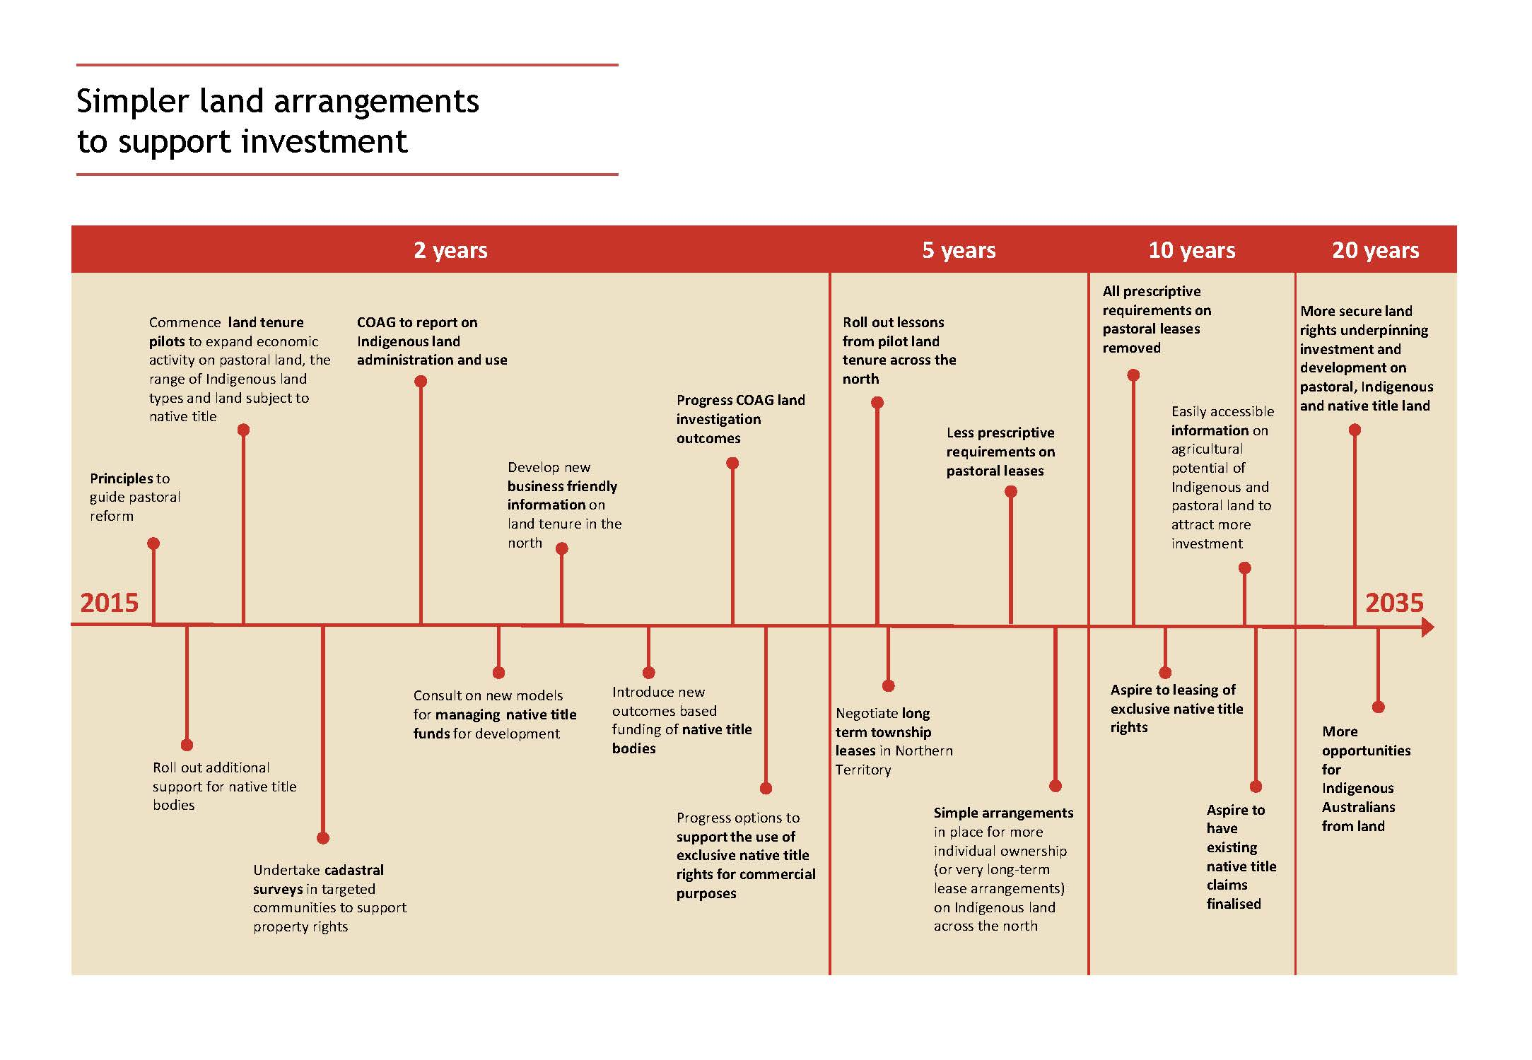
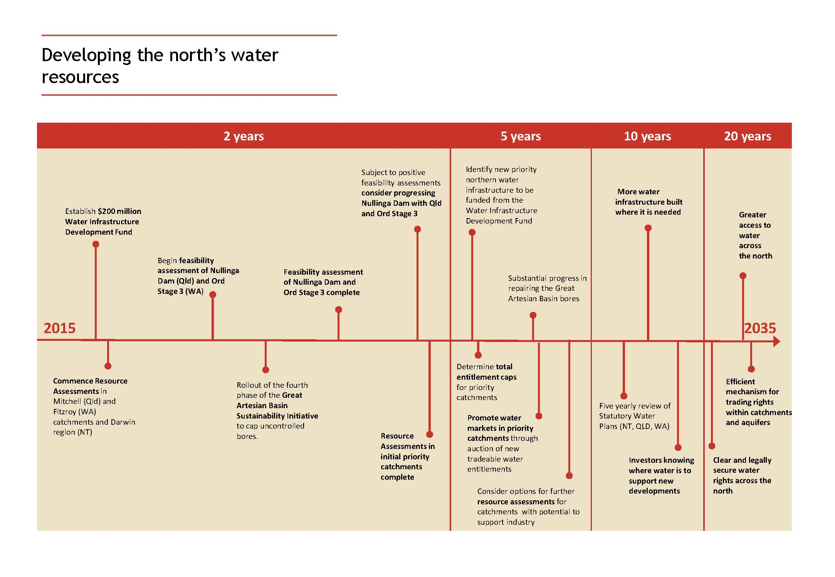
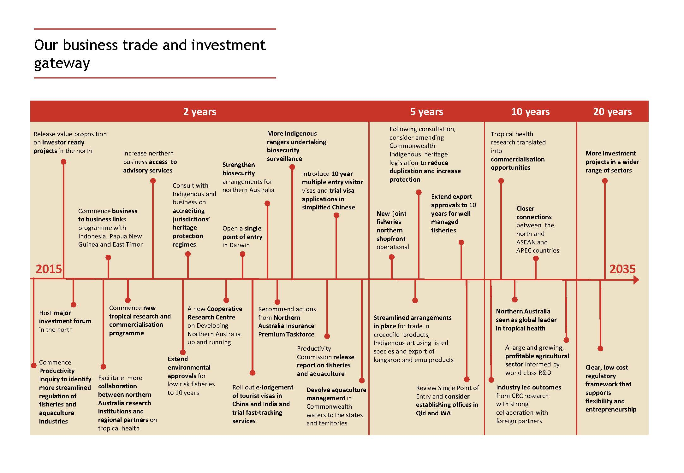
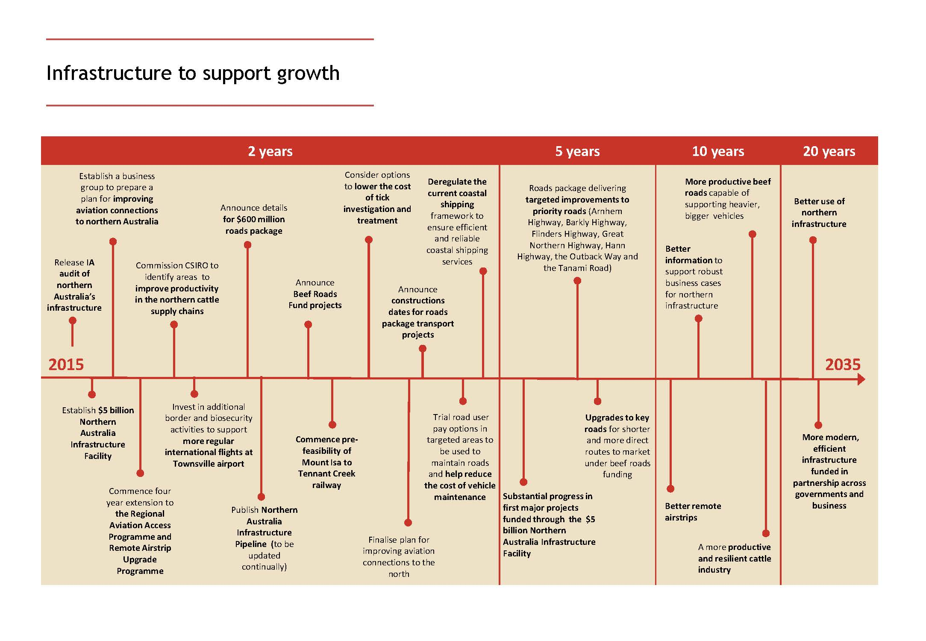
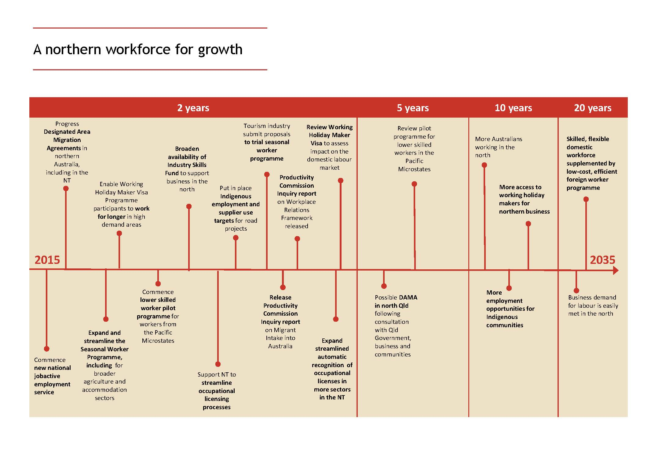
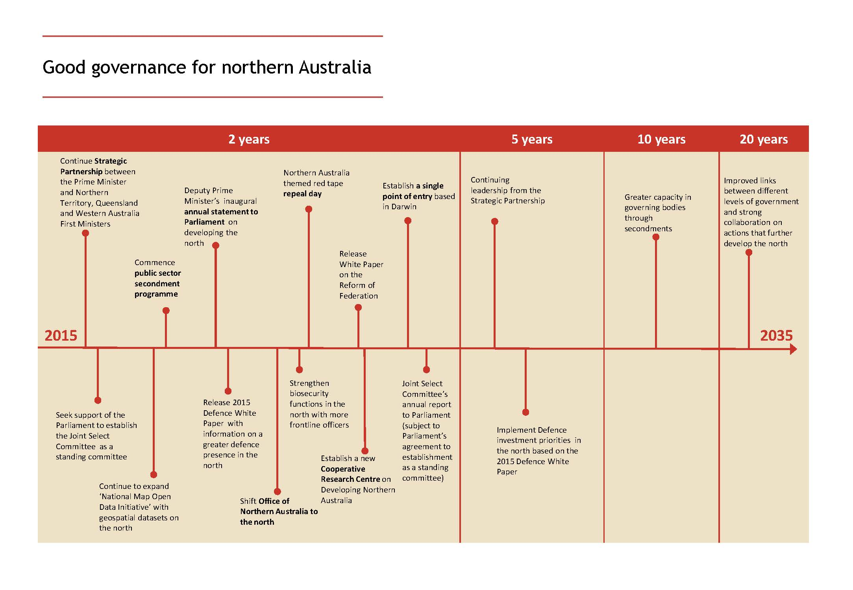

PROFILE OF NORTHERN AUSTRALIA

Overview
This profile provides an overview of northern Australia’s population and demographics, the economy, natural resources and geography, climate and government, including Defence presence in the north. It is not intended to provide all possible information about the north, but aims to provide an easy to read overview to help people, governments and business develop a deeper understanding of northern Australia.
The Department of Infrastructure and Regional Development will publish in the next 12 months a more detailed State of Northern Australia report, which will be updated periodically.

A vast, diverse and vibrant region
Northern Australia, covering those parts of Western Australia and Queensland above the tropic of Capricorn as well as all of the Northern Territory, is a huge and diverse region of over 3 million km², with a population of over one million people.
Northern Australia boasts abundant and diverse mineral and environmental assets, which underpin many of the business, recreational and lifestyle opportunities in the region. The northern economy is very reliant on extractive (resource based) industries and global markets for bulk commodities and is subject to highly variable weather conditions during the wet and dry seasons.
The people of the north have successfully dealt with the challenges of living and working in the region. The continued rapid growth of the north is bringing with it a wide range of new employment and business opportunities, as well as challenges.
Figure 20: Northern Australia
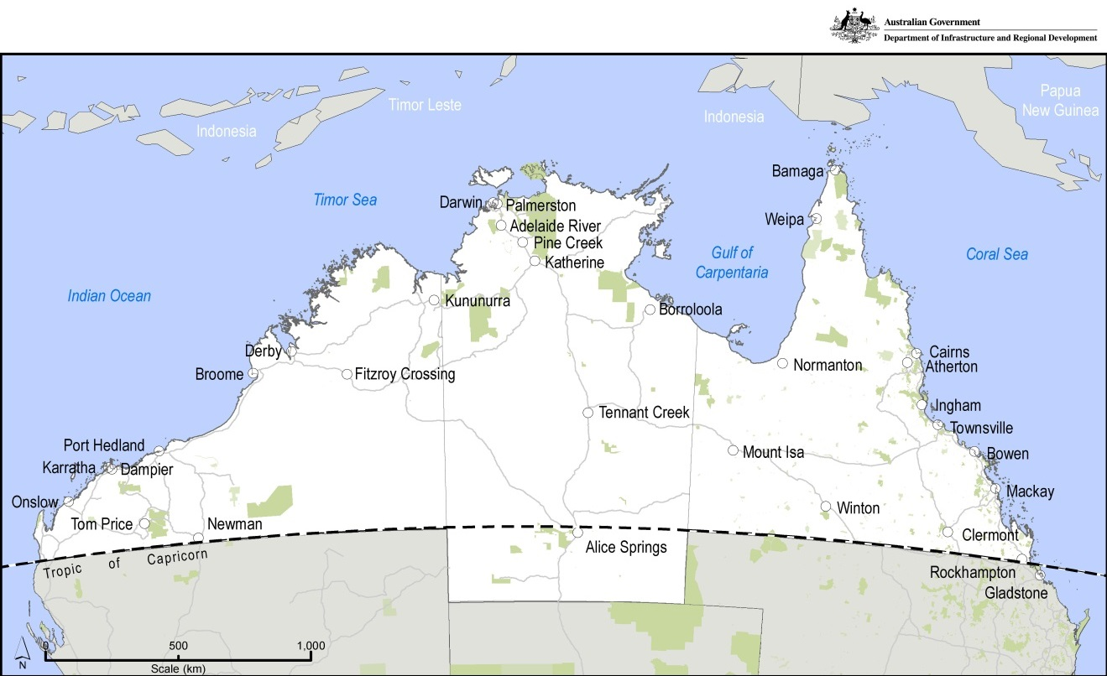
Source: Department of Infrastructure and Regional Development, 2015b

Climate

Dealing with seasonal variability
Northern Australia comprises three main climatic zones: wet tropics, grasslands and deserts (BOM, 2014).
The wet and dry seasons in northern Australia are distinguished by rainfall with the vast majority occurring during the wet season from October to April.
Average rainfall of over 1,000 mm is typical for the wet season across much of coastal northern Australia, including in cities in the Kimberley, Top End and Far North Queensland (Figure 21 shows an average across various parts of northern Australia compared with southern cities).
Rainfall is highly variable between seasons and years, with the seasonal switch between wet and dry more marked than in the south.
The tropical cyclone season typically occurs from November through to April and can bring gale force winds, tidal surges and significant rainfall. Tropical cyclones can cause significant damage, such as Cyclone Tracy in Darwin (1974) and Cyclone Yasi in northern Queensland (2011).
Northern Australia is also characterised by frequently high maximum temperatures, commonly ranging between 30-40 degrees throughout the year (Figure 21).
Figure 21: Average rainfall and maximum temperature
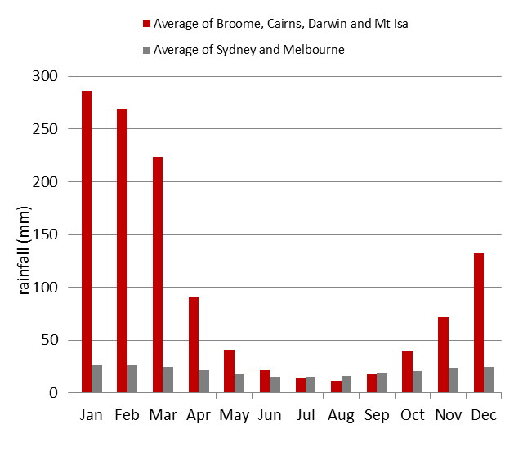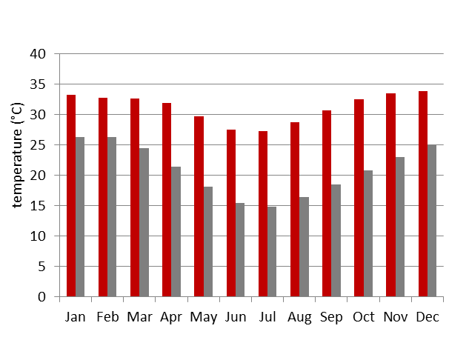
Notes: Data from weather stations closest to city centres, over periods for which data is available for a given station.
Source: BOM, 2015

Population

Continuing to grow
Over 1.3 million people—or more than five per cent of all Australians—live in the north (ABS, 2015a). Almost 30 per cent of Australia’s Indigenous population (over 190,000 people) also live in northern Australia (ABS, 2013). The majority of people in northern Australia live along the coastline in Townsville, Cairns, Mackay and Darwin. Outside these major regional centres, most of northern Australia is sparsely settled (ABS, 2011a).
In the decade from 2004 to 2014, the population has been growing at around 2.0 per cent per annum, which is above the national average of 1.7 per cent (ABS, 2015a). This trend is expected to continue into the late 2020s (BITRE, 2015)
The rate of population growth varies across northern communities. Some areas are growing at more than twice the national average, while others are growing at less than half this rate (BITRE, 2015).
The north’s major urban areas are likely to continue to grow in coming decades, with the largest northern cities experiencing some of the highest projected growth rates in the country (Figure 22).
Northern Australia has a relatively young population. Around 21 per cent of people are under 15 years of age and only 3.7 per cent are aged 75 and over, compared with the national averages of 19 per cent and 6.4 per cent (ABS, 2014c).
Figure 22: Estimated and projected population index, northern Australian centres, northern Australia, and Australia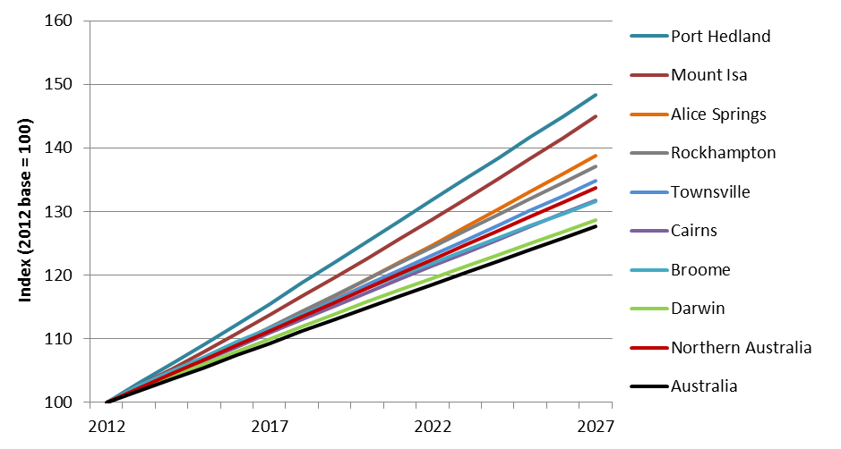

Source: BITRE, 2015

Indigenous culture

The Aboriginal and Torres Strait Islander culture of northern Australia
Northern Australia is an area with significant cultural value. The Indigenous inhabitants of the region overlay the area with layers of traditional knowledge. The occupation of northern Australia by Indigenous people dates back more than 60,000 years.
Over this time traditional culture and complex knowledge systems involving spiritual and sustainable relationships with the land have developed. Traditional knowledge and culture is intrinsically linked to customary law, and people carry important legal and social obligations in sharing and maintaining the knowledge as part of their broader cultural responsibilities for managing and using country.
Aboriginal and Torres Strait Islander traditional languages and dialects are prolific in northern Australia. English is a second, third or even more distant language for many Indigenous people in the region.
Most Indigenous people in northern Australia live in the towns and cities throughout the region (see Figure 23). There are over 200 discrete Indigenous communities and 600 outstation or homelands in northern Australia, some with populations that fluctuate in accordance with seasons.
Indigenous communities in northern Australia are governed under a variety of different arrangements including statutory shire councils and regional bodies under local government legislation, peak Indigenous organisations, and traditional governance arrangements. Businesses are increasingly recognising the value of traditional knowledge. The incorporation of Indigenous expertise in land management practices and agricultural ventures is successfully occurring across northern Australia (as evidenced in successful ventures such as carbon farming and the establishment of international bush food markets).
The application of traditional Indigenous cultural knowledge to improve environmental understanding, inform ecological management and create new technologies, medical treatments and industries has the potential to strengthen the economic future of northern Australia.
Figure 23: Map of Indigenous population across northern Australia, 2006
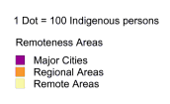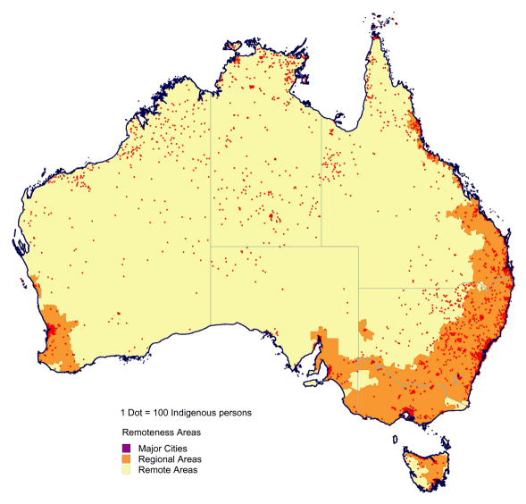
Source: ABS, 2010

Education and health

Building skills and healthy communities
Northern Australia has over 750 primary and secondary schools, a number of research institutes and centres, more than 350 registered training organisations, 36 technical and further education (TAFE) campuses, and three universities headquartered in the north. Several southern universities also have campuses in the north (Department of Education and Training, 2015).
School sizes and enrolments in northern Australia are typically smaller than elsewhere in the country and distance education is more prominent. A variety of higher education study options exist in the north, from largely on campus study at James Cook University, to largely external study through Charles Darwin University (64 per cent external) and Central Queensland University (54.6 per cent external), with external students often supported through local study centres (Department of Education and Training, 2015).
Enrolment in tertiary education in northern Australia is lower than nationally, despite northern Australia’s younger age profile. In 2011, 2.6 per cent of the population were attending university, compared with 4.3 per cent nationally; while 1.6 per cent of the population were attending further education (such as TAFE), compared with 2.2 per cent nationally (ABS, 2011a).
Of Australia’s 746 public hospitals, 91 (12.2 per cent) are in northern Australia, along with 21 of Australia’s 613 private hospitals. Most of these hospitals are in the more populous areas of northern Queensland (Department of Health, 2015). The proportion of health workers, including general practitioners, nurses, dentists, pharmacists, optometrists and psychologists is lower in northern Australia than in the rest of Australia (BITRE, 2009). Overall, health outcomes in northern Australia are lower than for Australia as a whole.
Table 5. Life expectancy and prevalence of major health issues, Northern Territory and Australia.
Estimated life expectancy at birth, 2011-13
Northern Territory:
Male: 74.9 years
Female: 79.2 years
Rates of overweight and obesity: 62.9 per cent
Australia
Male: 80.1 years
Female: 84.3 years
Rates of overweight and obesity: 62.7 percent
Proportion of adults who are daily smokers, 2011-13
Northern Territory
Indigenous: 47.9 per cent
Non-indigenous: 22.1 per cent
Australia
Indigenous: 41.1 per cent
Non-indigenous: 16 per cent
Proportion of adults at risk of long term harm from alcohol, 2011-13
Northern Territory
Indigenous: 14.2 per cent
Non-indigenous: 24.9 per cent
Australia
Indigenous: 19.2 per cent
Non-indigenous: 19.5 per cent
Source: ABS, 2014b, ABS, 2012c, ABS, n.d.

Employment and income

Creating job opportunities
Generally speaking, northern Australia has experienced solid employment and rising incomes (see Figure 24). Around 85 per cent of employment in the north is located in towns and cities (ABS, 2011a).
Unemployment across northern Australia has been generally low over recent years, with the Northern Territory having the second lowest unemployment rate in the country. More recently, northern Australia has experienced increased unemployment, with sharp rises in some areas, reflecting the transition from the construction phase of the mining boom to the less labour intensive production phase.
The employment situation in Remote and Very Remote Australia (as defined under the ABS’s Australian Statistical Geography Standard) differs markedly from the situation in the rest of northern Australia. Remote Australia is characterised by weak labour markets and low labour force participation stemming from a lack of economic development.
Indigenous Australians of working age who live in remote areas are over three times more likely to be on welfare than other Australians of working age. The major source of personal income for more than 50 per cent of Indigenous Australians (aged 18-64) in remote areas is income support or Community Development Employment Projects (CDEP). In very remote regions this jumps up to more than 60 per cent. A range of factors contribute to higher levels of income support and CDEP in remote and very remote areas including the lack of job opportunities, participation in customary activities and entrenched intergenerational poverty and social dysfunction.
Figure 24: Wage and salary growth, 2001 to 2011, northern Australian towns, northern Australia, and Australia
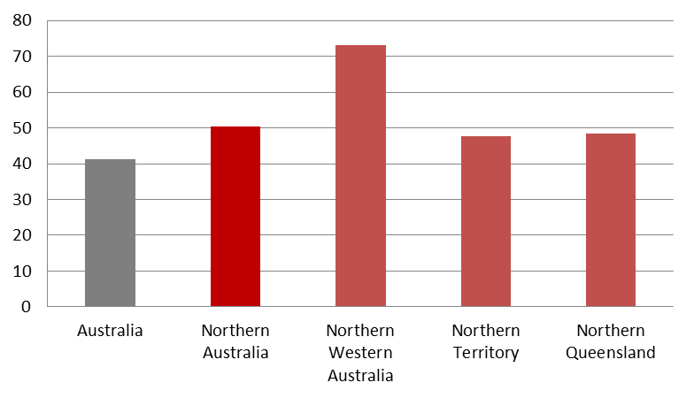
Source: ABS, 2011b

The public sector and defence

An important player in northern Australia
The public sector also plays a major role in the northern economy with nearly one in ten workers employed in public administration (ABS, 2011a).
The Australian Public Service (APS) presence in the north totals over 5,400 across 38 agencies including the Departments of the Prime Minister and Cabinet, Defence, Human Services, Agriculture, and Immigration and Border Protection (Australian Public Service Commission, 2014).
Locations of APS staff vary from major centres such as Broome, Darwin and Townsville, to remote locations including Fitzroy Crossing, Nhulunbuy and Weipa (see Figure 25).
Figure 25: APS employee locations in northern Australia
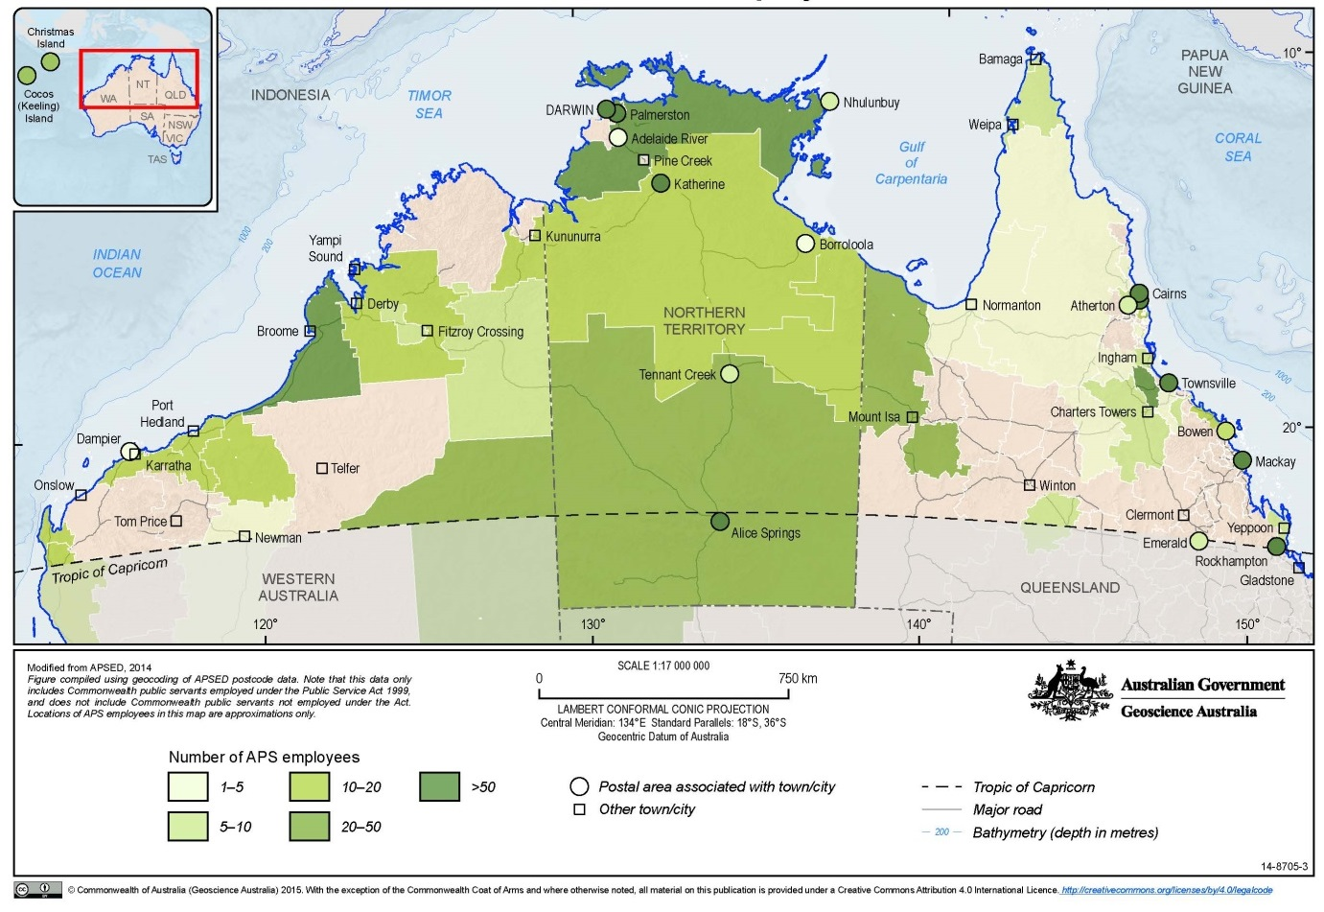
Source: Geoscience Australia, 2015c
Northern Australia is a hub for Australia’s Defence capability and is essential for defence and security cooperation in the Indo-Pacific region. The Department of Defence reports spending of $1.5-$2 billion in northern Australia each year, primarily through military employee expenses and capital investment. Since 2010, around $900 million has been spent on Defence capital investment alone, with significant flow on effects to local economies.
There are approximately 14,000 service personnel and public servants working for Defence in northern Australia (Department of Defence, 2015). Defence personnel numbers in northern Australia fluctuate in accordance with Australian Defence Force (ADF) posting cycles, operational tempo, capability and operational imperatives and seasonal Defence activities in the north.
Chief operational imperatives of northern Australia’s Defence contingent include:
- defending Australia and protecting our borders and resources
- supporting rapid security, stabilisation and humanitarian assistance and disaster relief into the region (such as Tropical Cyclone Pam in the South Pacific in March-April in 2015) and in northern Australia (such as in response to Tropical Cyclones Lam and Marcia in late February 2015).
Northern Australia is also a hub for our defence cooperation with regional partners and the primary staging ground for the US force posture initiatives over the next decade. This will include rotational US Marine Corps deployments and enhanced aircraft cooperation. Northern Australia hosts a range of combined exercises and activities with international defence partners, including:
- Exercise Talisman Sabre – the major biennial Australia-US exercise
- Exercise Kakadu – the Royal Australian Navy’s largest multinational maritime warfare exercise held biennially
- Exercise Pitch Black – the Royal Australian Air Force’s largest and most complex biennial air exercise
- Exercise Kowari – held for the first time in October 2014, and is the first land based trilateral military exercise between Australia, China and the United States of America.

Figure 26: Significant Defence facilities
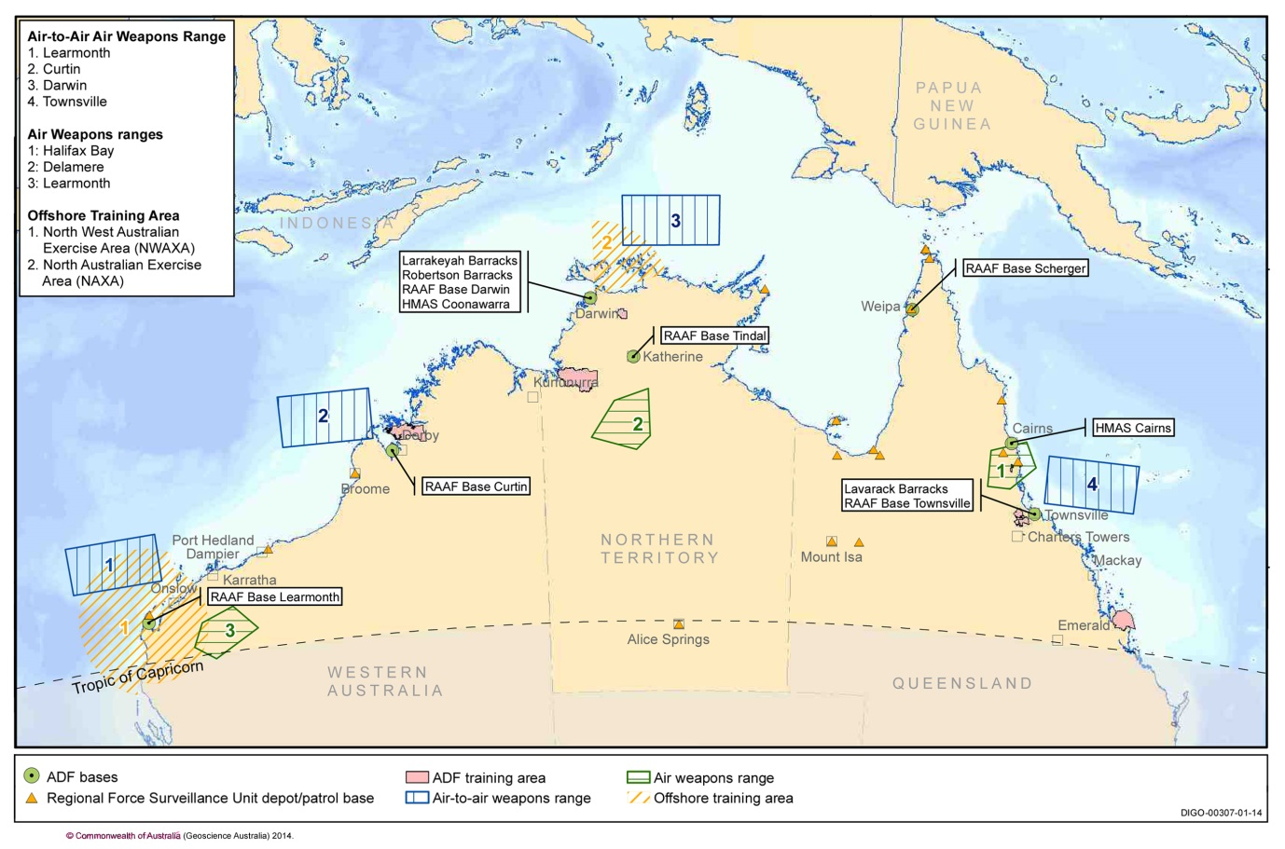 Source: Department of Defence, 2014

Investment and trade

Attracting capital and supplying international markets
Largely as a result of the mining boom, over the last decade total capital expenditure in Queensland, Western Australian and the Northern Territory has risen to around twice the level of investment in the rest of Australia (Figure 27). This investment is dominated by liquefied natural gas (LNG) projects, including the US$54 billion Gorgon LNG project and the US$33 billion Ichthys LNG Project (Chevron, 2015) (ABC, 2012). Coal and iron ore projects have also attracted significant investment and are now valued at over $23 billion (BREE, 2014b). In 2012, total foreign direct investment in Australia’s resources industry was $206 billion, much of it in the northern jurisdictions (ABS, 2012a).
Northern Australia accounts for a significant share of Australia’s exports. In 2012-13, the value of international exports by sea via northern ports reached $121 billion, or 55 per cent of the Australian total. Of these exports, 84 per cent (by value) were coal, petroleum, gas (and related) and crude materials including iron ore (BITRE, 2015).
Long term prospects for the northern economy remain strong. Projections suggest that by 2040 northern jurisdictions will account for nearly 42 per cent of the Australian economy, up from 35 per cent in 2011 (Deloitte Access Economics, 2011).
Figure 27: Private capital expenditure in Australia
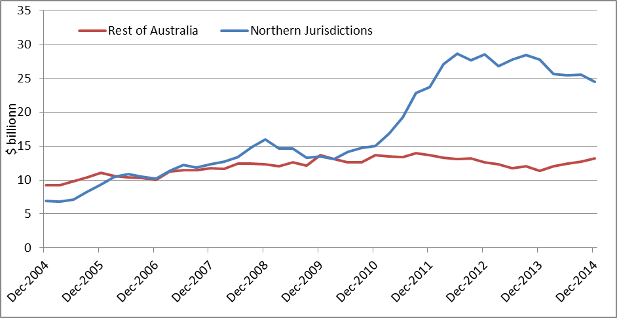
Source: ABS, 2015b

The majority of Australian goods and services exports in 2013-14 were sent to Asia, as shown in the graphic below:

Figure 28: Australia’s major goods and services exports markets, 2013-14

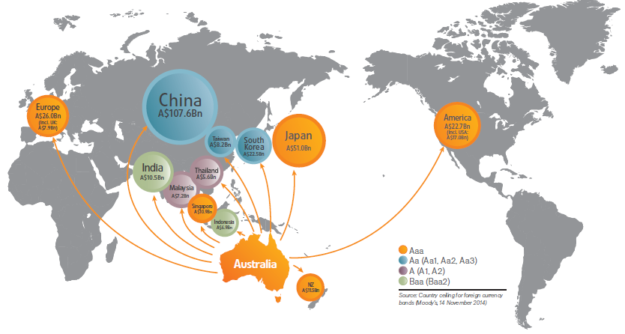
Source: ABS, 2014d

Box 41: Trade with Australia’s neighbours
Northern Australia supplies regional economies with many of their major imported goods and services.
The most important of these imports include mineral and agricultural goods. Australia’s $19 billion of investment in Papua New Guinea includes major exports of petroleum, meat and wheat. Indonesia is also a major market for Australian wheat, as well as sugar, molasses and honey. Australia is Indonesia’s largest supplier of beef and the fourth largest supplier of horticultural products. Australian companies are also involved in more than 120 mining ventures across the country.
Northern Australia is also well placed to support the infrastructure development of Australia’s northern neighbours, especially as countries such as Timor-Leste benefit from the accrual of oil revenues.

Infrastructure

Connecting nationally and internationally
Northern Australia relies heavily on its transport infrastructure, including regionally significant road networks, 20 airports, 25 ports and three railway systems (see Figure 29 on the value of goods shipped from northern Australian sea ports). It is also the case that large volumes of goods produced in northern Australia are shipped from southern ports.
The larger northern cities such as Darwin, Broome and Townsville contain important sea ports, airports and major road and rail logistic centres that are key gateways for Australia into international markets. Major road networks in northern Australia connecting cities and towns include the Barkly, Victoria, and Great Northern Highways.
Across northern Australia there are five energy networks. In the Northern Territory and northern Queensland the networks are government owned, while in north Western Australia ownership is mixed. Outside these networks, towns and communities across northern Australia run on standalone power systems (off grid systems).
Communications infrastructure plays an important role in northern Australia. The region currently has greater access to broadband fibre to the premises (six per cent compared with three per cent) and fixed wireless services (two per cent compared with 0.4 per cent) than the south. However, overall access to ‘high speed’ broadband technologies is less (seven per cent of premises compared to 30 per cent in the south) (Department of Communications, 2014).
Mobile coverage is variable across northern Australia, with lower levels of access to 4G mobile broadband services (26 per cent of premises compared with 63 per cent in the south) (Department of Communications, 2014).
Figure 29: Export value of major commodities through northern Australian sea ports 2013-14
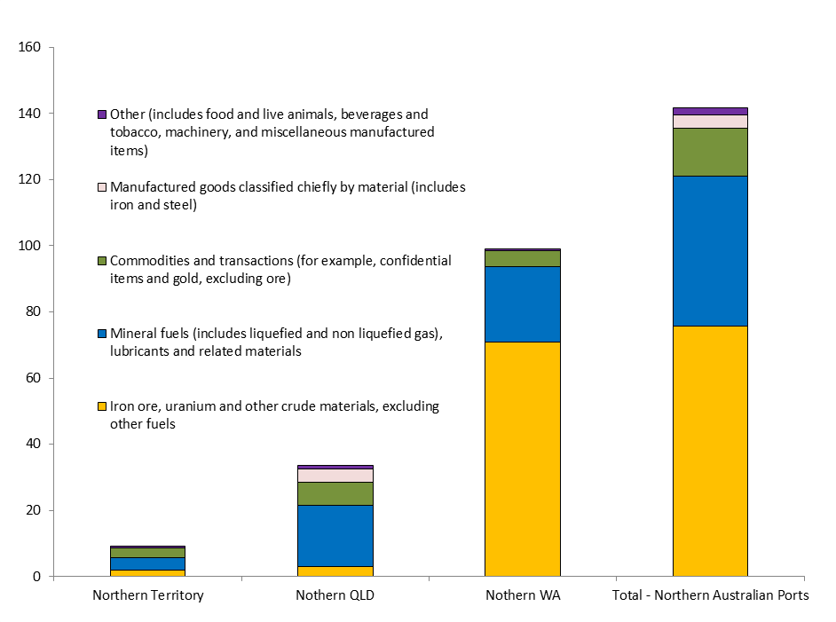

Source: BITRE, 2015

Minerals and mining

Extracting abundant and valuable resources
Northern Australia has world class deposits of coal, natural gas, uranium, base metals, bauxite, oil and iron ore.
Over 70 per cent of Australia’s known resources of iron ore, lead, zinc and silver, as well as significant deposits of bauxite, tungsten and molybdenum are found in northern Australia. All of Australia’s known manganese (iron) ore and diamonds are in the north, along with almost all of Australia’s phosphate rock (Geoscience Australia, 2013).
Australia is the fourth largest coal producer, the second largest coal exporter and has the fourth largest reserve of coal in the world (BREE & Geoscience Australia, 2014), with northern Australia holding in excess of 60 per cent of Australia’s economically demonstrated black coal reserves mostly in Queensland (BREE & Geoscience Australia, 2014) (see Box 42).

Box 42: Queensland coal exports
Queensland has an estimated 34 billion tonnes of raw, in situ coal. Most of the state’s hard coking coal (i.e. coal used for steel production) is located in the Bowen Basin, an area in central Queensland covering over 60,000 km².
In 2014, there were 75 operating coal mines in Queensland. In 2014, the state exported 217 million tonnes of coal, an amount worth an estimated $23.6 billion. Over 85 per cent of sales were to countries in Asia, especially Japan, China and India. In 2014, coal companies paid 83 per cent of all royalties to the Queensland Government, a total of $2 billion (Queensland Government, 2015).
As of June 2014, companies had received Exploration Permits for Coal covering an area of 270,000 km². Although coal production and investment has recently slowed, ongoing exploration for coal and mine expansions will ensure the industry continues to meet demand from international markets (Queensland Department of Natural Resources and Mines, 2014).

There were a number of new mineral discoveries in northern Australia over the last decade, including Merlin (Queensland), Jervois (Northern Territory) and Browns Range (Western Australia). More discoveries are likely, especially where the extensions of mineral rich geology extends under shallow cover rocks and sediments.
Figure 30 shows the majority of resources and energy projects at the committed stage of development are located in northern Australia.
Northern Australia’s mineral resources have created a large mining equipment, technology and services sector. Around 200 companies in the north supply resource projects around the world, providing leading edge technologies and services, with a niche in tropical or remote environment operations.
Box 43: The Pilbara resources region
The Pilbara is responsible for a significant portion of the production, value, exports and investments of extraction industries commodities particularly iron ore and liquefied natural gas (LNG) in Australia (Regional Development Australia Pilbara, 2014).
Pilbara iron ore accounts for around 95 per cent of Australia’s iron ore exports, which have flourished given northern Australia’s large high grade reserves, proximity to key strategic markets and industry efficiency compared with international suppliers (Pilbara Development Commission, 2015).
The overwhelming majority of Australia’s iron ore (25 per cent of world resources) is located in the Pilbara (Britt, et. al. 2013). In 2012, approximately 455 million tonnes of iron ore was exported from the Pilbara, an amount worth $48.6 billion.
Based on 2014 mine production rates, iron ore reserves will last approximately 85 years (Britt, et. al. 2013)
Currently the Pilbara produces 80 per cent of Australia’s liquid natural gas exports and this will expand significantly by 2019 (see section on LNG below).
The Pilbara is also home to significant deposits of copper, and manganese. The second largest gold mine in Australia and the second largest solar salt fields in the world are also located in the Pilbara (Regional Development Australia Pilbara, 2014).

Liquefied natural gas

Meeting regional energy needs
LNG involves converting gas into liquid. When it reaches its final destination, the liquid is heated up and converted back into gas.
LNG has rapidly become an important export for Australia (Figure 31) and is now Australia’s third largest export after iron ore and coal (Department of Foreign Affairs and Trade, 2015). LNG exports are projected to be 76.6 million tonnes in 2019–20, by which time Australia will overtake Qatar as the world’s largest LNG exporter (Department of Industry and Science, 2015).
Northern Australia is at the centre of this phenomenal growth, with current LNG production activity taking place in Western Australia (80.3 per cent of Australia’s supply by value in 2013-14) and the Northern Territory (19.7 per cent). A further four major LNG projects (Gorgon, Prelude, Wheatstone and Ichthys) are under construction in the gas fields in the Carnarvon and Browse Basins off the coast of Western Australia.
Another source of gas exists in Queensland in the form of coal seam gas. This has led to the Queensland Curtis LNG project commencing production in early 2015, with a second LNG train under construction. The current production of the Surat Basins in southern Queensland will be supplemented soon by the development of the Bowen Basin. These resources have underpinned the development of the port of Gladstone. A further two LNG projects are in development.
Figure 30: Australian LNG exports
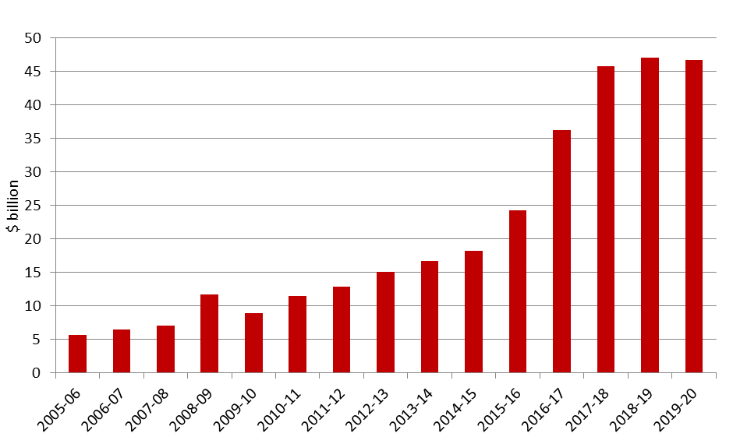

Source: Department of Industry and Science, 2015

Agriculture

Feeding a growing global population
Agriculture is integral to the economic, environmental, and cultural fabric of the north. In 2010-11, the gross value of agricultural production at the farm gate in northern Australia was $5.2 billion (ABARES, 2013), around 11 per cent of Australia’s total production of $46 billion (ABS, 2012b). The distribution of agricultural industries in the north largely reflects water availability and soil type as well as distance and access to national and international markets.
The pastoral industry is by far the largest agricultural industry in northern Australia, generating around 57 per cent of the region’s total agricultural production. There are around 11.7 million cattle in northern Australia, 45 per cent of the entire national herd (ABARES, 2013).
Northern Australia is also an important producer of crops. It accounts for the majority of Australia’s 30 million tonnes of sugarcane produced each year and more than 90 per cent of Australia’s mango and banana production.
Many other products are also grown, such as melons, pumpkins, red grapefruit, maize, chia, chickpeas, beans, cotton, sunflowers, millet, sorghum and sandalwood. Other primary industries include native and plantation forestry and aquaculture.
Table 6: Top 10 northern Australian agricultural commodities by gross value of production (GVP), 2010-11
- Cattle – GVP $2897.1 million
- Sugar cane – GVP $762.4 million
- Bananas – GVP $286.5 million
- Mangoes - GVP $89.9 million
- Tomatoes - GVP $86.4 million
- Cotton – GVP $79.7 million
- Melons - GVP $78.5 million
- Wheat - GVP $71.6 million
- Sorgum - GVP $63.6 million
- Hay - GVP $55.8 million
Source: ABARES, 2015

Biodiversity

Declining species richness within unique environments
Northern Australia possesses exceptional biodiversity, holding spiritual and cultural significance for its Indigenous peoples, and underpinning human wellbeing. It contains unique ecological zones, a vast coastline and a rich marine environment. The region represents some of the highest accumulations of species richness and endemism in the country, meaning many of northern Australia’s native species are unique and cannot be found anywhere else in the world (Department of the Environment, 2015).
The region is dominated by four broad ecological zones, each of which contains unique biodiversity values:
- the northern savanna — the largest intact tropical savanna in the world
- the Mitchell grasslands — the most extensive tussock grasslands of Australia
- the rainforests of north eastern Australia — the most complete and diverse living record of the evolutionary history of the world’s land plants
- the Arid Rangelands — covering over 48 per cent of Australia’s land mass and better known to most Australians as the ‘Outback’.
Northern Australia is also bounded by a rich marine environment that includes the north-west, north, and the Great Barrier Reef and Coral Sea marine regions. These tropical marine regions are important whale, dolphin, bird, marine turtle and dugong breeding, feeding and nursery sites (Department of the Environment, 2015).
Figure 31 Northern Australia’s ecological zones and marine regions
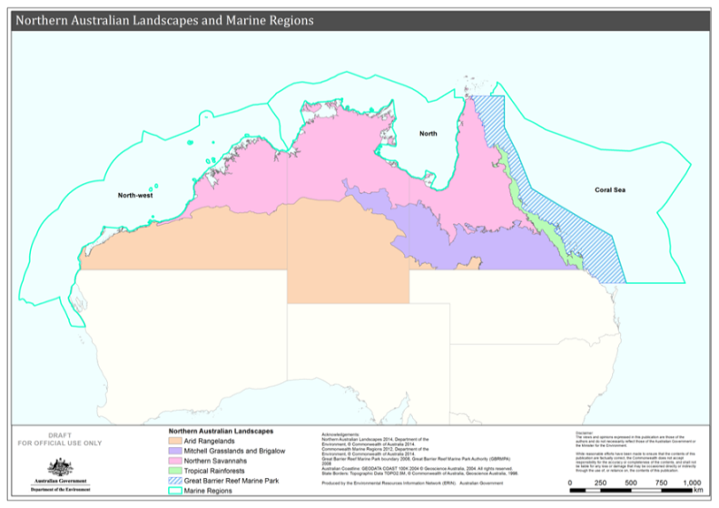
Source: (Department of the Environment, 2015a)

The region’s rich natural assets underpin a range of economic activities including tourism, agriculture and fishing. For instance the Great Barrier Reef region is estimated to contribute up to $5.6 billion to the Australian economy, with much of this from commercial uses such as marine tourism and fishing (Deloitte Access Economics, 2013).
Despite its importance, there are a range of pressures causing decline in biodiversity across northern Australia as highlighted in Box 44. For example there are 301 nationally listed threatened species found in northern Australia, 215 of which are endemic (Department of the Environment, 2015).
Climate variability, such as temperature and rainfall, can affect biodiversity because such factors are key determinants of soil health and fertility levels, essential for efficient and productive landscapes.

Box 44: Key threats to northern Australia’s biodiversity
- Fire frequency and intensity
- Weeds
- Overgrazing
- Coastal development
- Water quality in catchments
- Feral animals
- Climate change
- Land clearing
- Fishing
Source: Department of the Environment, 2015

Heritage places and protected areas

Conserving exceptional biodiversity and heritage values
Northern Australia’s extensive conservation reserves include World, National and Commonwealth Heritage listed places, protected areas, Indigenous Protected Areas and wetlands recognised under the Ramsar Convention.
In total there are 65 places listed in the World, National, and Commonwealth Heritage Lists, covering around 600,000 km² (see Figure 34) (Department of the Environment, 2015). These protected areas are a major drawcard for the region’s domestic and international visitors.
Figure 32: Northern Australia’s protected places
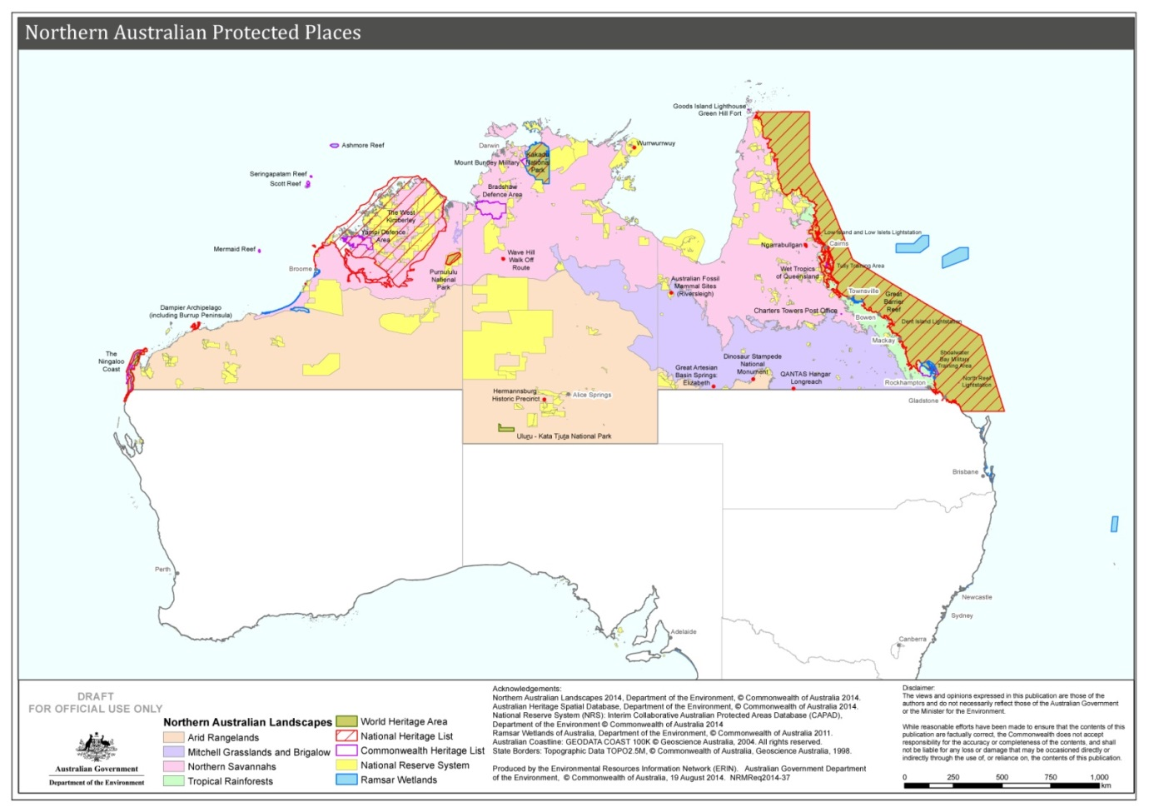Source: (Department of the Environment, 2015b)
Northern Australian places on the World Heritage and National Heritage Lists are famous for their outstanding natural heritage values, such as the Great Barrier Reef (the world's largest coral reef); or for their Indigenous and cultural values, such as the Wave Hill Walk Off Route in Kalkarindji in the Northern Territory (Department of the Environment, 2015).
Northern Australia also contains many places of heritage significance which are less well known — such as the Adelaide River War Cemetery in the Northern Territory. Other historic places include lighthouses and military sites on the Commonwealth Heritage List, such as Green Hill Fort on Thursday Island (Department of the Environment, 2015).
Australia’s National Reserve System of protected areas is important for securing the long term protection and survival of our unique and diverse ecosystems and the plants and animals they support. While the responsibility for managing most protected areas rests with the relevant state or territory government, the Commonwealth Government collaborates with other governments, Indigenous communities and not for profit organisations in efforts to protect and manage Australia’s National Reserve System.
In northern Australia, there are 726 protected areas covering 495,265 km². These protected areas range from iconic National Parks such as Kakadu to small protected areas that are important for connectivity. Of the 726 protected areas properties, 240 properties covering approximately 163,000 km² are managed mainly for ecosystem protection (Department of the Environment, 2015).
Indigenous Protected Areas (IPAs) form part of National Reserve System. In northern Australia there are 32 IPAs covering 349,300 km². These areas are managed to achieve conservation, economic, cultural and social outcomes. Most IPAs are declared under IUCN Category 6 which allows for multiple land uses to support sustainable economic development activities that are compatible with the broad conservation objectives. The Southern Tanami IPA located in the Northern Territory is the largest Protected Area in Australia covering approximately 101,000 km² (Department of the Environment, 2015). In addition, there are 78 Working on Country (WOC) ranger groups operating across northern Australia.
Australia is a contracting party to the Convention on Wetlands of International Importance, commonly known as the Ramsar Convention. Northern Australia contains ten Ramsar listed wetlands. These wetlands support migratory birds, internationally and nationally listed threatened species and biodiversity, and offer critical habitat and refuge.

Box 45: Kakadu and Uluru-Kata Tjuta National Parks
A number of northern Australia’s sites are recognised as being multiple types of protected areas. For example, the World and National Heritage listed sites of Uluru-Kata Tjuta and Kakadu are also National Parks. Kakadu is listed as a Ramsar wetland as well.
These sites and others in the region serve as important destinations for tourists who are attracted to the natural landscapes and cultural heritage.
Uluru-Kata Tjuta National Park is Aboriginal land, jointly managed with its Anangu, traditional owners, and Parks Australia. The park, 1,325 km² in size, is in the spiritual heart of Australia’s Red Centre in the Northern Territory. There were approximately 170,000 international visitors and 128,000 domestic overnight visitors to Uluru and Kata Tjuta in the year ending September 2014 (Tourism Research Australia, 2014b).
Kakadu is an ancient landscape of exceptional beauty and great diversity. It stretches over 19,000 km² and is ecologically and biologically diverse. It is listed under the World Heritage Convention for its natural and cultural values. There were approximately 67,000 international visitors and 144,000 domestic overnight visitors to the Kakadu National Park in the year ending September 2014 (Tourism Research Australia, 2014b). The traditional owners Bininj/Mungguy have lived on and cared for this country for more than 50,000 years and jointly manage the Kakadu National Park with Parks Australia.
Protected places make significant contributions to regional economies through tourism and conservation related revenue and jobs. Uluru-Kata Tjuta National Park and Kakadu National Park are estimated to contribute $238.6 million and $85.4 million per year to regional economies (Gillespie Economics and BDA Group, 2008).

Tourism

Showcasing natural and cultural assets
Tourism plays an important role in the northern Australian economy. In the Northern Territory, for example, the industry provides 8.1 per cent of the total income. A total of 11.5 per cent of Territorians work in the tourism industry, both directly and indirectly, compared with the national average of 8.1 per cent (Tourism Research Australia, 2015).
The vast majority of visitors to northern Australia (around 90 per cent) are domestic tourists (Tourism Research Australia, 2015). Traditionally, international visitors have been European or American, but visitors from Asia have recently become the dominant visitors in some areas and are now the subject of targeted marketing campaigns (ABC, 2014). Cairns in particular has benefited from an increase in direct flights from Japan and China. Northern Australia is popular with international backpackers because of the diverse work and recreation opportunities, and almost one in five young tourists who come to Australia visit the Northern Territory (Tourism NT, 2014). The region also appeals to older Australians who divide their time between the northern dry season and the southern summer.
In 2013-14, northern Australia was the destination of choice for 15.9 per cent of international overnight visitors compared with only 6.7 per cent of domestic overnight visitors (Tourism Research Australia, 2014b). Of visitors to northern Australia, approximately 36.9 per cent went to Tropical North Queensland, making it the most popular destination for overnight visitors in 2013-14 (Tourism Research Australia, 2015).
Following a period of declining tourist numbers in the Northern Territory, visitors in 2014 stayed longer and spent the most money they had in five years ($1.85 billion) (Conlan, M., 2014). Some tourist operators are also reporting an increase in the number of international tourists visiting central Australia (Tourism NT, 2015).

Box 46: The Great Barrier Reef
Spanning more than 344,400 km², an area bigger than the combined size of Victoria and Tasmania, the Great Barrier Reef is the largest living structure in the world and the only one visible from outer space (Department of the Environment, 2012). The Reef is one of the major tourist attractions of northern Australia. In 2013, a study by Deloitte Access Economics estimated the Reef attracted over 2 million visitor days in the previous year and contributed $5.6 billion of direct and indirect value to the Australian economy (Deloitte Access Economics, 2013).
The most distinctive feature of the Reef ais the coloured corals that are formed by tiny living creatures which join together to form colonies (Commonwealth Government, 2014). Tourists are also drawn to the Reef for its array of molluscs, rays, dolphins, tropical fish and birdlife. The region is also home to some of the most pristine beaches in the world, as well as numerous Indigenous archaeological sites (Department of the Environment, 2012).The Great Barrier Reef was declared a UNESCO World Heritage site in 1981.

Selection of Existing Policies and Programmes
The White Paper outlines new actions the Government is taking to promote the further development of northern Australia. There are many existing policies and programmes the Commonwealth, Queensland, Northern Territory and Western Australian governments are already undertaking that are of particular benefit to northern Australia. A selection of these is outlined below.

Commonwealth Government

Agriculture
Agricultural Competitiveness White Paper — will identify pathways and approaches for growing farm profitability and boosting agriculture’s contribution to economic growth, trade, innovation and productivity.
Drought and Rural Assistance — a range of measures, including Farm Household Allowance; water infrastructure rebates; pest animal management projects; social and community support; and a number of concessional loans products. Free rural financial counselling, taxation concessions and Farm Management Deposits are also available.
Carbon Farming Futures — research programme to assist farmers and land managers cut greenhouse gas emissions and increase storage of carbon in soil while maintaining or improving farm productivity, including in northern Australia.
Indonesia-Australia Partnership on Food Security in the Red Meat and Cattle Sector — funding to increase agricultural cooperation, improve long term trade and boost Australian investment in Indonesia's red meat and cattle sector.
National Landcare Programme — invests in projects that address environmental and sustainable agriculture issues, including in northern Australia.
Northern Australia Quarantine Strategy — identifies and evaluates the biosecurity risks facing northern Australia; develops and implements measures for the early detection of targeted pests, diseases and weeds; contributes to national and international initiatives on pest and disease monitoring; and manages the biosecurity aspects of border movements through the Torres Strait.
National Plant Health Surveillance Programme — enables early detection of exotic pests that may enter northern Australia, which is vulnerable due to its sparse population and close proximity to other countries.
Pest and Disease Eradication — programmes minimising the potential impact of pests and disease incursions on agricultural production, human health, the environment and social amenity. Includes projects that target Banana Freckle, Cocoa Pod Borer, Electric Ants, Red Imported Fire Ant and Torres Strait Fruit Fly.

Communications
- National Broadband Network (NBN) — a national, open access communications network is being built to deliver high speed broadband and telephone services across Australia.
- Mobile Black Spot Programme — funding to improve mobile phone coverage in some outer metropolitan, regional and remote communities.

Foreign Affairs and Trade
- Free Trade Agreements (FTA) — in 2013 and 2014, Australia concluded FTAs with China, Japan and the Republic of Korea, the destinations of over three quarters of merchandise exports from Queensland, Western Australia and the Northern Territory.

Education and Training
• Commonwealth Grants Scheme — through this scheme the Government subsidises the tuition costs of Australian students enrolled in a bachelor degree at a public university, as well as some students enrolled in higher education courses below the bachelor level and postgraduate courses. Additional funding is provided through this scheme to universities with a regional campus to assist them with higher costs of provision in regional areas. Many students from northern Australia receive support to study through this programme, and higher education institutions in northern Australia also benefit.
• The Higher Education Loan Programme (HELP) — through HELP, many tertiary students can borrow money from the Government to pay for their share of the cost of study. Students are only required to repay their loan when they are earning a decent income (over $50,000).
• Higher Education Participation Programme (HEPP) — ensures that people from disadvantaged backgrounds are supported to participate and succeed at university.
• In addition to these key programmes the Government is seeking to reform higher education to expand access and create one of the best higher education systems in the world. The proposed reforms are subject to the passage of legislation and include:
- Increased Availability of Tuition Subsidies — the government would provide tuition subsidies for all Australians studying accredited undergraduate courses at any registered Australian higher education institution.
- New Commonwealth Scholarships scheme — most higher education institutions would be required to set aside funding for scholarships to support student access, participation and success.
- Removal of FEE and VET FEE HELP loan fees — the fees that currently apply to FEE HELP and VET FEE HELP loans would be removed so that all students are subject to the same rules when they take out a HELP loan. This will also have benefits for institutions in northern Australia.
• Boosting the Commercial Returns from Research — working with the research sector and industry on a strategy to increase commercial returns from publicly funded research which will include northern Australia. The strategy is designed to drive innovation, grow Australian businesses and boost productivity and exports.
• National Collaborative Research Infrastructure Strategy — support for priority national scale research infrastructure projects. There are a number of existing initiatives funded under the strategy that impact on northern Australia.
• The Government supports states, territories and non-government systems and schools in funding the operating costs of primary and secondary schools, with an investment of $69.5 billion in total Commonwealth funding for government and non-government schools over 2015–16 to 2018–19. This funding is based on arrangements contained in the Australian Education Act 2013 (Cwlth), which includes loadings that target disadvantage. In 2015, this will include:
- $340.5 million in loadings for schools in regional, rural and remote areas
- $249.1 million in loadings for small schools, which will benefit many small regional schools
- $221.7 million in loadings for Indigenous students.
• The Government has provided $22 million over four years to Good to Great Schools Australia to implement the Flexible Literacy for Remote Primary Schools programme, which aims to reduce the disparity between metropolitan and remote students’ literacy outcomes in remote areas of northern Australia. Teachers in participating schools will improve their pedagogical practice through the implementation of Direct or Explicit Direct Instruction teaching approaches.
• VET Reforms — trades and vocational education are being elevated to the centre of Australia’s economy putting the focus on ensuring Australian workers are highly skilled and job ready, which is needed to support economic growth in northern Australia.
- Trade Support Loans help to ensure that trade apprenticeships, including those undertaking certain qualifications in agriculture or horticulture in rural or regional Australia, are appropriately valued and utilised as a career pathway by providing financial support to assist students with the costs of living and learning while undertaking an apprenticeship.
- The new Australian Apprenticeship Support Network, will include new support services across northern Australia from full time and part time sites as well as via outreach servicing arrangements that will provide targeted advice and support to help ensure employers and apprentices make well informed decisions and remain engaged in the apprenticeship relationship to completion.
- The $664 million Industry Skills Fund which aims to deliver close to 250,000 targeted training places and training support services to small and medium size businesses to successfully diversify and improve competitiveness, supporting businesses in northern Australia to move into the global market.
- School Enrolment and Attendance Measure (SEAM) — the School Enrolment and Attendance Measure (SEAM) — provides practical support to parents in selected Northern Territory communities to help get their kids to school. As a last resort, if parents do not comply with their legal requirements and no special circumstances apply, their income support payment may be suspended.
- The Remote School Attendance Strategy (RSAS) — provides a community based model to provide targeted assistance to improve school attendance in around 70 remote communities with long standing school attendance issues in the Northern Territory, Western Australia, South Australia, Queensland and New South Wales.

Environment
- National Landcare Programme — will help communities take practical action to protect and manage Australia’s important environmental assets and productive landscapes, including in northern Australia.
- Green Army — will provide young Australians, including those in Indigenous communities and remote areas of northern Australia, with opportunities to gain training and experience in environmental and heritage conservation fields, and explore careers in conservation management, while participating in projects that generate benefits for the environment.
- Twenty Million Trees — will be undertaken in urban and regional Australia, including northern Australia, to re-establish green corridors and urban forests. Projects will work with communities to support local environmental outcomes.
- 'One stop shop' for Environmental Approvals — streamlining environmental regulation, leading to an improved investment climate in northern Australia, while maintaining high environmental standards. New or revised assessment agreements have been implemented in Western Australia, Northern Territory and Queensland. Draft approval agreements have been exhibited for public comment with Western Australia and Queensland.
- Improved scientific understanding of the impacts of coal seam gas and large coal mining development on water resources, through:
- The Independent Expert Scientific Committee on Coal Seam Gas and Large Mining Development that provides advice to Commonwealth and state government regulators.
- The Bioregional Assessment Programme — through collaboration with the Bureau of Meteorology, CSIRO and Geoscience Australia, undertaking scientific analysis of the potential cumulative impacts of these activities in specific geographic locations, including in the Galilee Basin in Queensland.
- A suite of research, including, examining the hydrogeology of sedimentary basins in northern Australia in collaboration with Geoscience Australia.
- Management of the Great Barrier Reef Marine Park — funding for the long term protection, ecologically sustainable use, understanding and enjoyment of the reef through on ground conservation, regulation, engagement, stewardship and education programmes.
- Australian Government Reef Programme — supports land managers to improve the quality of water entering the reef. This is achieved through supporting the adoption of improved land management practices that will reduce the discharge of nutrients, sediments and pesticides into the reef lagoon, as well as supporting research and monitoring the health and resilience of the reef.
- Reef Trust — delivered in collaboration with the Queensland Government, the Reef Trust provides innovative, targeted investment focused on improving water quality, restoring coastal ecosystem health and enhancing species protection.
- Reef 2050 Long-term Sustainability Plan — an overarching strategy for the protection and management of the Great Barrier Reef, responding to the challenges facing the Reef and presenting actions to protect its values, health and resilience while allowing ecologically sustainable development and use. Tangible outcomes, objectives and measurable targets have been identified across seven themes — biodiversity, ecosystem health, heritage, water quality, community benefits, economic benefits and governance — to form an integrated management framework. They build on existing targets such as those in the Reef Water Quality Protection Plan 2013 and focus on activities which will safeguard the Outstanding Universal Value of the Reef.
- Arafura and Timor Seas Ecosystem Action — supports the sustainable management and use through collaboration between government and non-government stakeholders in Australia, Indonesia and Timor-Leste.
- North-west Marine Bioregional Plan and North Marine Bioregional Plan — marine bioregional plans provide information that enables people to better understand the Government's marine environment protection and biodiversity conservation responsibilities, objectives and priorities in Commonwealth managed waters.
- Management of World Heritage sites (Great Barrier Reef, Wet Tropics of Queensland, Ningaloo Coast, Purnululu National Park and Australian Fossil Mammal Site (Riversleigh)) — funding supports the management of these properties in partnership with stakeholders, including traditional owners, and promotes management of natural heritage.
- Threat Abatement Plans — provide for the research, management, and any other actions necessary to reduce the impact of a listed key threatening process on native species and ecological communities, for the purposes of assisting the long term survival in the wild of affected native species or ecological communities. Includes the Threat Abatement Plan targeting invasive grasses in northern Australia and vertebrate species such as foxes, rabbits, cane toads and cats.
- Environmental Research Institute of the Supervising Scientist — undertakes environmental monitoring and scientific research into the potential impacts of uranium mining on the environment within the Alligator Rivers region to support the Supervising Scientist.
- Torres Strait Treaty — Environmental Management Committee — assesses environmental issues of concern to the Treaty Zone communities, including protection of the marine environment and biodiversity in and around the Protected Zone.
- Biodiversity fund — Northern Australia Targeted Investment 2013-14 — $8.2 million over four years to restore and manage northern Australia’s biodiversity.
- Emissions Reduction Fund — provides positive incentives to businesses across the economy to reduce emissions at lowest cost and contribute towards Australia’s 2020 emissions reduction target. Opportunities in northern Australia include reducing emissions from savanna burning and beef cattle production.
- Management of Uluru-Kata Tjuta National Park and Kakadu National Park — funding supports the conservation and appreciation of these national parks in partnership with traditional owners and includes safe visitor access, maintenance of biodiversity and ecosystems and management of cultural and natural heritage.
- National Environmental Science Programme — is a long term commitment to environment and climate research with ongoing funding of $25.5 million per year. There are six research hubs in the programme, including a Northern Australian Environmental Resources Hub and a Tropical Water Quality Hub, both focused on northern Australia. The programme builds on its predecessors — the National Environmental Research Programme and the Australian Climate Change Science Programme — which will continue through to their scheduled completion in June 2015 and June 2016 respectively.
- National Climate Change Adaptation Research Facility — $9 million over three years to support the delivery of practical, hands-on tools and information on managing climate risks in the coastal zone, which in northern Australia include ocean acidification and sea-level rise, as well as higher average temperatures, more hot days and warm spells, and increased intensity of extreme rainfall events. NCCARF also manages four adaptation research networks, including the Natural Ecosystems Adaptation Network hosted by James Cook University, in Townsville.
- National Water Account — provides nationally consistent information on water resource availability, use and management, including annual reporting of water assets, water liabilities, and water transfers for the Ord River and Daly River basins through the Improving Water Information Programme.

Health and Social Services
- Remote Jobs and Community Programme — assists remote job seekers find and retain real jobs. From 1 July 2015, reforms to the programme will be rolled out that: provide meaningful work like experience for remote job seekers; strengthen incentives for employment services providers and employers to retain job seekers in employment; and support the establishment of local businesses in remote communities. The Government also announced the name of the programme will change to the Community Development Programme to better reflect its objectives of reducing passive welfare and provide real pathways to employment for job seekers in remote communities.
- Australian Institute of Tropical Health and Medicine — $42 million to establish the institute (administered by the Australian Research Council).

Labour and immigration
- Initiatives to Increase Migration to Regional Australia — includes the Regional Sponsored Migration Scheme, Temporary Work (Skilled) visas and Designated Area Migration Agreements. Designated Area Migration Agreements target areas where local labour is in short supply.
- SkillSelect — enables prospective migrants and potential Subclass 457 visa applicants to indicate their willingness to live and work in regional Australia. The model enables state and territory governments and approved regional employers to access skilled workers through a central database.
- Seasonal Worker Programme — enables workers from participating countries to undertake between up to six months work with Australian agricultural and accommodation employers who can demonstrate an unmet demand for low skilled labour. The programme will be open to eligible northern Australian tourism businesses on a trial basis from 1 July 2015.
- Working Holiday Visa Programme — encourages youth mobility and tourism by allowing young adults to have an extended holiday in Australia, during which they can offset their travel costs by engaging in short term work. Working Holiday visa holders often work in agriculture and tourism/hospitality sectors, which are important parts of the northern Australia economy.
- Relocation Assistance to Take Up A Job — provides financial assistance for long term unemployed job seekers to relocate to take up jobs or apprenticeships.

Industry
• AusIndustry Regional Manager Network — operates from 15 regional centres across Australia, including offices in Darwin and Townsville working with businesses in northern Australia. The network assists businesses in regional Australia access government information, services and incentives to support growth, investment, research and development, innovation and commercialisation, and structural adjustment.
• The $188.5 million Industry Growth Centres Initiative will lift competitiveness and productivity to help Australia transition into smart, high value and export focused industries. It will enable national action on key issues such as deregulation, skills, collaboration and commercialisation. The Initiative will concentrate investment on key growth sectors: Advanced Manufacturing; Food and Agribusiness; Medical Technologies and Pharmaceuticals; Mining Equipment, Technology and Services; and Oil, Gas and Energy Resources. Northern Australia has competitive strengths in areas such as: Food and Agribusiness; Mining Equipment, Technology and Services; and Oil, Gas and Energy Resources. Businesses in these sectors will be able to leverage the outcomes of the Industry Growth Centres to drive their competitiveness.
• Science for Australia’s Future — $28.1 million initiative that will promote science and reward scientific excellence through programmes like National Science Week, the Prime Minister’s Prizes for Science, and Questacon educational campaigns. Each of these operate in and deliver programs and opportunities for northern Australia. Through arrangements with state/territory governments and local organisations, appropriate programmes will be developed and delivered to meet state/territory policy priorities and local needs, including the hubs, pathways and leadership mentioned below.
• Regional Hub Program — over the next four years Inspiring Australia will develop a network of regional hubs across Australia to establish local self-sustaining collaborations of organisations that will work together to deliver science, technology, engineering and mathematics (STEM) programmes for their region. Currently Broome, Karratha, Geraldton and Darwin are in place with Alice Springs, Katherine, Cairns and Townsville identified for development.
• Pathway Programs — Inspiring Australia is encouraging each regional hub to develop combined community calendars of STEM activities which will provide the people of the north in these regions mentioned above with clear year-round opportunities to engage with the sciences.
• Leadership/Strategy - Inspiring Australia — having engaged with experts in Northern Australia in regards to the tropics, the deserts and Indigenous Australians Inspiring Australia will continue to support them in their delivery and advocacy of their recommendations in regards to for better science engagement for the people of the north in order to bring about systemic change.
• Cooperative Research Centres (CRCs) — there are currently 35 CRCs undertaking leading-edge research and developing new technologies, products and services to help solve major economic, environmental and social challenges. In the north, CRCs are working in areas such as economic development, agriculture, water security, resource exploration and extraction, spatial information, health and Indigenous issues.
• The Exploration Development Incentive (EDI) — encourages shareholder investment in small exploration companies undertaking greenfields mineral exploration in Australia. It provides an economic incentive to invest in the future prosperity of the Australian mining sector. This benefits the Australian economy by enabling the mining sector to continue making new mineral discoveries. Exploration activity will be almost exclusively carried out in regional areas, particularly in northern Australia where there are substantial under-explored and unexplored areas. The EDI enables eligible exploration companies with eligible expenditure to distribute exploration credits to shareholders. The shareholders will then be entitled to a refundable tax offset. The incentive applies from 1 July 2014 and is capped at a total of $100 million over a three year period.
• The Working in Partnership (WIP) initiative — supports cultural change in relations between mining, business, service providers and communities (including Indigenous communities) in regional and remote northern Australia. For example, in 2014 WIP workshops were held in Tennant Creek, Northern Territory and in Weipa, Queensland. Workshops aim to establish long term, effective partnerships through an ‘informed’ workshop model that is underpinned by pre-workshop consultations with stakeholders. Outcomes include integrated strategies to meet stakeholder needs that are underpinned by trust. A particular focus of WIP is to build Indigenous business capacity and employment opportunities.
• Australian Institute of Marine Science (AIMS) — Australia's tropical marine science agency with a head research office in Townsville and research facilities in Darwin and Perth. AIMS provides the research and knowledge of Australia’s tropical marine estate required to support growth in its use, effective environmental management and protection of its unique ecosystems.
• Commonwealth Scientific and Industrial Research Organisation (CSIRO) — has staff at northern locations in Queensland and the Northern Territory. Significant capability from other locations (particularly Brisbane) is deployed to northern issues, delivering scientific expertise and research capability and linking with the local innovation infrastructure. CSIRO has a long history of achievements underpinning development in northern regions.
• Geoscience Australia — is a Government entity providing geoscience information, services and capability to a wide range of challenges in regional Australia. Geoscience Australia is engaged in the assessment of natural resources of Northern Australia including: hydrocarbons (on and off shore), minerals, and groundwater; and contributing to bioregional assessment programs.
• Australian Renewable Energy Agency (ARENA) — established in July 2012 to improve the competitiveness of renewable energy technologies and to increase the supply of renewable energy in Australia. $1 billion is currently allocated to projects across renewable energy research and development, demonstration and deployment.
- ARENA is providing financial support to 10 renewable energy projects involving 44 communities in remote off grid or fringe-of-grid areas of northern Australia. This support is being provided through the Regional Australia’s Renewables Initiative. These projects include the integration of solar photovoltaic systems into existing diesel generation at remote mine sites and indigenous communities, which will reduce the cost of electricity generation in these areas. Knowledge gleaned from these projects will be shared with other indigenous communities, remote network operators and mining companies.
• Questacon — Australia’s award winning National Science and Technology Centre runs a suite of national programmes — including travelling exhibitions which make regular visits to northern Australia including the Shell Questacon Science Circus; a world class outreach programme that has a significant impact on engaging regional Australia with science by setting up hands on science exhibitions and delivering science shows in regional schools. The programme includes workshops focused on building STEM skills in schools in Alice Springs and Darwin as well as delivering activities at the Garma Festival 2015.

Infrastructure and Regional Development
• Infrastructure Investment Programme (IIP) — is the Commonwealth Government’s primary funding programme comprising a number of sub programmes including major investment projects on the National Land Transport Network and other key roads, the Heavy Vehicle Safety and Productivity Programme, Black Spot Projects, Bridges Renewal Programme and the Roads to Recovery Programme. Recent funding commitments include projects on the Bruce Highway, the North West Coastal Highway and the Outback Way, on the Cape York Peninsula and the Northern Territory Regional Roads Productivity Package.
• National Stronger Regions Fund — $1 billion will be invested over five years to fund investment ready priority infrastructure projects which support economic growth and sustainability of regions across Australia, including Northern Australia.
• Remote Airstrip Upgrade Programme — funding for remote airstrip upgrades in isolated outback communities.
• PortLink Inland Freight Corridor Concept Plan — considers linking ports at Port Hedland, Geraldton, Esperance and the proposed Oakajee Port with Kalgoorlie, as a freight hub, to improve freight movements and the productivity of Western Australian resource industries.

Indigenous Affairs
• Indigenous Advancement Strategy — from 1 July 2014 the strategy has replaced more than 150 individual programmes and activities with five streamlined programmes focusing on Jobs, Land and the Economy; Children and Schooling; Safety and Wellbeing; Culture and Capability; and Remote Australia Strategies.
• Review of Indigenous Training and Employment (‘Forrest Review’) — In response to the Forrest Review, the Government has put in place new targets to boost the number of Indigenous employees in the Commonwealth public sector to 3 per cent by 2018 and increase its procurement from Indigenous businesses to 3 per cent in 2020. The Government has also announced the new Employment Parity Initiative to partner with some of Australia’s largest employers to get an additional 20,000 Indigenous Australians into real jobs by 2020. The Government’s response to remaining recommendations will be progressively rolled out as the reforms are ready to be implemented.
• Stronger Futures in the Northern Territory — is a significant, long term investment by the Commonwealth Government which aims to improve outcomes for Indigenous Australians in the Northern Territory, in particular in remote and very remote areas. As announced in the 2014-15 Budget, Stronger Futures is currently being revised to improve outcomes and ensure funding is being used to the greatest effect. The revision will realign the investment with the Government priorities of getting children to school, adults into work and making communities safer.
• ABSTUDY — helps with costs for Aboriginal and Torres Strait Islander Australians who are studying or undertaking an Australian Apprenticeship.
• Working on Country — builds on Indigenous traditional knowledge to protect and manage land and sea country. As at April 2015, 760 Indigenous rangers are employed in 104 ranger teams across Australia to deliver environmental outcomes.
• National Partnership Agreement on Remote Indigenous Housing — funding is provided to the states and the Northern Territory to address significant overcrowding, homelessness, improve housing conditions and increase the housing stock in remote Indigenous communities.
• Working in Partnership Initiative — seeks to deliver increased benefits to Indigenous communities and the mining industry and supports cultural change between Indigenous communities and the mining industry. Workshops bring together interested parties in significant regional centres to discuss local issues to achieve local employment outcomes for Indigenous communities and businesses.
• Native Title — the Commonwealth Government’s investment in the native title system to support efficient and equitable resolution of native title matters includes $3.2 million funding over 2 years for the Native Title Respondent funding Scheme; approximately $89 million funding in 2014/15 supporting native title representative bodies, service providers and registered native title corporations; $582,000 in funding for the Native Title Anthropologist Grants Program in 2014 15; and investment in the Federal Court, including the National Native Title Tribunal.

Trade and Investment
• Approved Destination Status Scheme (ADS) — a bilateral tourism arrangement between the Chinese and Australian Governments that allows Chinese tourists to undertake leisure travel in groups to Australia. Approved ADS inbound tour operators and tour guides are required to comply with the ADS Code of Business Standards and Ethics. While most ADS tours are currently focused on Sydney, Melbourne and Brisbane/Gold Coast, ADS tours also regularly visit Cairns and are being trialled in Central Australia.
• Building Brand Australia Program — aims to project a well-balanced and accurate image of Australia internationally in order to attract international buyers, investors, visitors and students. Promoting Australia’s credentials in business, science, technology, education, creativity and innovation is important to enriching Australia’s reputation as a global business partner and global citizen, for the benefit of the nation as a whole, and the 2.5 million people in export related jobs.
• Export Market Development Grants — a key Government financial assistance programme for small to medium aspiring and growing export ready businesses. It encourages businesses to increase international marketing and promotion expenditure to achieve more sustainable international sales by reimbursing up to 50 per cent of eligible export promotion expenses. Eligible Businesses in northern Australia are able to access EMDG.
• Tourism Demand Driver Infrastructure— $43.1 million over four years to fund infrastructure that drives demand, improves quality and increases tourism expenditure. Funds will be provided to states and territories, which will fund projects that best meet tourism infrastructure priorities. Projects have been funded in the 2014-15 programme year in the Northern Territory, north Western Australia and north Queensland and are likely to be funded in these regions in future programme years.
• Tourism Employment Plans (TEPs) — $1.1 million to develop and pilot TEPs in eight regions across Australia, including three in northern Australia: Broome, the Red Centre and Tropical North Queensland. The TEPs help regions develop practical measures to address their labour and skills issues and help businesses better link into government and industry programmes that can support their employment needs.
• Tourism Major Project Facilitation service — provides assistance to proponents of significant tourism projects (over $50 million) to navigate federal government approvals in a streamlined manner. Of the five projects currently receiving assistance, three are located in northern Australia (Queensland).
• Tourism Research Australia’s Research — conducts surveys and analysis of data to provide quality tourism intelligence across both international and domestic markets. This information is made available to a range of stakeholders through free publications, a Statsline service and subscription database services to strengthen policy, marketing, and business decisions.

Queensland Government

Mining and Energy
• Bowen and Galilee Basins — there is in excess of 50 proposed mines or mine expansions under consideration in these two basins. The Queensland Government is supportive of the opening up of the Galilee Basin on a commercially viable and environmentally sustainable basis. It is working with proponents to assist them navigate through the necessary approval processes and to facilitate the provision, where possible, of common use infrastructure. The Bowen Basin is also a coal seam gas producing region, with gas going to the Australian domestic gas market or to the Curtis Island LNG export facility at Gladstone.
• North West Queensland Mineral Province — Queensland is Australia’s and one of the world’s largest producers of zinc, lead and silver. It ranks second in Australia as a copper and bauxite producer and is also an important producer of gold, mineral sands, phosphate fertilisers and magnesite. The North West Queensland Mineral Province in the Mount Isa region dominates Queensland base metal production. North Queensland is also a leading mineral province and an important producer of bauxite, silica sand, base metals, gold and, more recently, tungsten. The Queensland Government provides support for the mining and exploration industry through initiatives lead by the Geological Survey of Queensland.
• South of the Embley Bauxite Project, Weipa — Queensland is the largest bauxite producer in Australia, and Australia is the largest bauxite producer in the world with 30 per cent of the world’s production in 2012. The Cape York bauxite deposits are some of the richest and largest in the world, second only to Guinea. The South of Embley Bauxite Project represents a new mine with up to 40 years of production at 25 to 50 million tonnes per year. The Weipa mine has been in operation since 1963. The new South of Embley mine will sustain the mining town of Weipa and provide ongoing employment for up to 1500 workers.

Infrastructure and Construction
Infrastructure planning is positioning the region to capitalise on the next wave of resource developments
• The Sustainable Ports Development Bill — protects the Great Barrier Reef through management of future port-related development in and adjacent to the area. Prohibits sea-based disposal of port-related capital dredge material in the Great Barrier Reef World Heritage Area. Mandates port master planning for Gladstone, Abbot Point, Hay Point/Mackay and Townsville.
• Gladstone Port Master Planning (draft master planning boundary out for public consultation until 20 July 2015)
• Opening up of the Galilee Basin — A large expansion in coal output driven by development of the Galilee Basin would have significant positive impacts for regional economic growth and the Queensland economy as a whole. For example, if six coal mines and the associated rail and port infrastructure were to achieve full production, there could be expenditure of between $14-$55 billion on coal mines, rail and port infrastructure to support additional coal exports of between 110 and 215 million tonnes per annum by 2026, creating up to 35,000 new jobs. Opening up of the Galilee Basin would involve construction of new railway infrastructure to link the proposed mines to the Port of Abbot Point. It would also involve the expansion of port facilities at Abbot Point
• The Building our Regions program — the new $200 million Building our Regions Regional Infrastructure Fund will commence in 2016-17 as a targeted infrastructure program for local government projects. The primary purpose of the Building our Regions program is to provide funding for critical infrastructure in regional areas of the state, while also supporting jobs, fostering economic development and improving the liveability of regional communities.
• Central Queensland Resources Supply Chain — Development of an integrated overarching infrastructure framework to maximise economic growth opportunities in the Bowen and Galilee basins through identifying key infrastructure bottlenecks and contributing to better informed infrastructure policy and prioritised infrastructure projects.

Projected infrastructure and associated opportunities in northern Queensland include:
• New transport links between Queensland and the Northern Territory. Opportunities exist to shift increasingly large supply lines across to rail freight, limiting the increase in demand on the road network.
• The use and disposal of waste and sustainable development principles and technology will play significant role in the future of the minerals industry.
• The Queensland Government has committed $100 million towards the development of a sports stadium facility project in Townsville. The total cost and scope of the project is still to be confirmed but indicative estimates indicate a project cost of $250 million.
• Development of facilities and industry capability to accommodate and support a new class of Offshore Combatant Vessels for the Royal Australian Navy by 2025-2030.
• Logistics infrastructure to support petroleum oils and lubricants supply for future defence needs in the north is being managed by the Department of Defence and progress on this matter will become clearer following the release of the Defence White Paper 2015 and the Force Structure Review.
• Mount Emerald Wind Farm on the Atherton Tablelands, where State Government approval has been given to develop a 63 turbine windfarm capable of powering 70,000 homes.
• Upgrade of the Cairns International Airport to provide a dedicated commercial and aviation precinct, significantly increasing the capacity of the airport to accommodate additional general aviation, maintenance and servicing capacity, as well as potential freight operations.
• $200m+ upgrade to the Peninsula Development Road in Cape York — to better connect areas of economic opportunity with local communities and support the growth of the hospitality, transport, tourism and maintenance industries.
• Expansion of the Townsville port — to accommodate forecast growth in trade at the port and address current capacity constraints. The prohibition of sea based disposal of capital dredge material from the proposed port expansion means that significant additional funding will be required to allow the expansion to progress. Key features of the project include: new deep-water outer harbour, six additional berths in new harbour, deepening and widening of existing approach channels, new or upgrades to road and rail infrastructure and installation of new services infrastructure.

Agriculture
- The Integrated Food and Energy Development (I-FED) near Georgetown which proposes to crop predominately irrigated sugar cane and guar bean has been declared a coordinated project with an EIS to be prepared for consideration by the Coordinator-General.
- Olivevale Station in Cape York has approval to develop land for cropping.
- The Finalisation of the Gulf Water Plans will identify additional volumes of unallocated water for the Flinders and Gilbert River catchments.
- The Cape York Water Strategy provides a vision for the sustainable water allocation and management across Cape York, which allows for a balanced approach to support development while being sympathetic to the cultural, recreational and environmental values of the region.
- Finalising the Barron Water Plans to expand the water trading market and improve water entitlement security.
- Finalisation of the Wet Tropics Resource Operations Plan to establish a water trading market and to unlock significant volumes of unallocated water for irrigated agriculture, while providing environmental protection for ecological assets including world heritage areas.
- Implementing the Burdekin Water Resource Plan to support irrigated agriculture through an expanded water trading market and future releases of unallocated water.

Queensland Government supports:
- Working with proponents, including the agricultural precinct west of Rockhampton. The Gilbert River Agricultural Precinct in northern Queensland envisages mosaic style irrigation along the Flinders River Valley by harvesting river water and pumping from underground streams and river bed sands.
- Developing and implementing water plans that allow for the sustainable allocation and management of water resources.
- Lower Fitzroy River Infrastructure Project — Facilitates the allocation of water entitlements and implements management strategies to ensure equitable sharing of the resource amongst water users including the environment

Tourism
- Tourism Opportunity Plans — to provide strong direction including for investment and product development – and define actions to drive sustainable development of tourism in each region.
- DestinationQ Tourism Plans and associated tourism investment attraction projects aimed at doubling visitor expenditure by 2020.
- The recently released Next Generation Tourism Planning Guidelines will be used by local government planners when writing plans, or considering tourism proposals.
- Destination Tourism Plans — guide tourism and events in each destination towards 2020, highlighting the resources to create sustainable and competitive tourism destinations. They link to state (and national) targets to double the value of tourism, while recognising local challenges and opportunities and each destination’s unique tourism assets, unique development, marketing and management needs.
- The release of two potential additional casino licences for regional Queensland as part of the Integrated Resort Development program.
- Cairns Aquarium and Reef Research Centre, a $35 million investment into a new visitor attraction in the Cairns CBD
- $40 million upgrade to the Sheraton Mirage Hotel in Port Douglas by owners the Fullshare Group
Queensland Government supports:
- Working with proponents to facilitate private investment, infrastructure and resource access around tourism projects, including the Ella Bay integrated resort development and redevelopment of Lindeman Island Resort.
- Working with local governments to identify opportunities to bring forward surplus land for commercial tourism development.

Education
- Establishment of the Tropical Health Hub with James Cook University and Townsville Hospital.
- Development of the Discovery Rise (a new residential, knowledge community being developed alongside James Cook University’s Townsville campus) to create a university town which incorporates academic, social, artistic and commercial environments.
- Central Queensland University Rockhampton Priority Infrastructure Area and Priority Development Infrastructure for intersection ($8.5 million) The Central Queensland University Rockhampton Priority Development Area (PDA) was declared in December 2011 and a development scheme approved in April 2013. The aim of the PDA is to demonstrate a ‘best practice’ knowledge based urban development incorporating research, commercial and university uses, supported by an evolving urban precinct. The key infrastructure to kick-start the development is a four way signalised intersection off the Bruce Highway and the first stage of Main Street.

Small Business
- Queensland Small Business Week promotes the importance of small businesses to the community and offers a range of free and low-cost events and activities across the state, to give small business owners and operators the chance to hear new ideas and gain knowledge, to upskill and connect with other businesses, and access information and services to help them grow and become more productive.
- State-wide Buy locally campaign assists small businesses across the state by encouraging all Queensland residents and visitors to buy goods and services in their local area. Small businesses make up around 97% of Queensland's businesses and employ around 43% of private sector workers, and each dollar spent in a local business returns many times that amount to the local economy through employee wages, rates, and the purchase of goods and materials.
- Mentoring for Growth (M4G) offers eligible businesses a panel mentoring experience. M4G assists businesses with challenges relating to business growth investment innovation and export. It provides access to a panel of 6 to 8 expert provide sector mentors who are matched to the needs of the business. The programme has been running successfully for the past 12 years providing assistance to businesses state-wide the majority of which are outsides south east Queensland.

Western Australian Government

Agriculture
Seizing the Opportunity Agriculture — this programme aims to position the agricultural sector to capitalise on the growing global demand for food and agricultural products. Projects within this programme directly related to northern Western Australia are:
- Water for Food — a $40 million programme to support the expansion of irrigated agriculture in the East Kimberley and develop environmentally and culturally appropriate irrigated agriculture in the Fitzroy River catchment, at Mowanjum and Knowsley near Derby, the Bonaparte Plains area north of Kununurra and La Grange area, south of Broome.
- Northern Beef Industry Development Centre — $15 million to establish this Centre in Broome.
Pilbara Hinterland Agricultural Development Initiative (including Agricultural Pathways) — development of irrigated agriculture opportunities through the use of surplus mine dewater (the removal of water from solid materials). The large volumes of surplus mine dewater will increase as mining operations intensify production, and provide an opportunity to investigate how surplus dewater can be used to irrigate land for agriculture.

Commerce
Regional Mobile Communication Project (RMCP) and Regional Telecommunications Project (RTP) — the RMCP and RTP were designed to enhance telecommunications in regional Western Australia. Both were established to support emergency service organisations and improve the communication capacity for regional industries.
- Under RMCP, $40 million was invested to improve coverage deficiencies along major roads and highways in rural Western Australia through the installation of 113 mobile towers identified in a State Telecommunications Needs Assessment. The Department of Commerce, in partnership with Telstra, installed 16 towers in the Pilbara and 24 in the Kimberley.
- As a result of RMCP’s success the State Government invested an additional $45 million to establish approximately 85 mobile base stations at priority locations. RTP is expected align with the Commonwealth Government’s Mobile Black Spot Programme.

Parks and Wildlife
Kimberley Science and Conservation Strategy — implementation of the $81.5 million Kimberley Science and Conservation Strategy will involve a range of Western Australian Government agencies, traditional owners, local governments and non-government and commercial organisations. The centrepiece of the strategy is to establish and manage a network of marine and terrestrial parks to be jointly managed with traditional owners and provide opportunities for Aboriginal employment. The parks will also add to the nature and culture based tourism opportunities in the region, including the new David Attenborough Field Research Station that will study threatened species in the Artesian Range.

Pilbara Cities
Pilbara Cities Initiatives — the implementation of the Pilbara Cities vision, spanning from its inception in 2009 until 2017, will see in excess of $1.7 billion invested in the Pilbara region, transforming it into a vibrant network of communities that are economically successful and socially sustainable.

Regional Development
Royalties for Regions — Royalties for Regions has funded $5.6 billion on over 3,500 wide ranging projects across the whole of regional Western Australia since late 2008.
Ord-East Kimberley Expansion Project — $322 million was spent to increase the size of the Ord River Irrigation Area through developing agriculture and constructing irrigation infrastructure. Further commitments are planned to expand the Ord River Irrigation Area into the Northern Territory and other areas on the Western Australian side of the state border, to help realise the full potential of irrigated agriculture in the East Kimberley.
West Kimberley Revitalisation — this revitalisation programme includes Broome China Town Redevelopment, West Kimberley Transitional Housing Project, West Kimberley Strategic Development Unit, Fitzroy Crossing Courthouse, and Broome Road Industrial Area, which includes $14.9 million to fund power, water, telecommunications and road and stormwater drainage infrastructure.
Remote Indigenous Health Clinics — $22.2 million to fund redevelopment costs of six to eight remote health clinics in the Kimberley and Pilbara regions of Western Australia. The upgrades will improve the communities’ clinics ensuring access to modern primary health care and eliminating forced closures due to safety and health concerns.
Aboriginal Pastoral Renewals Project — indirect funding of $300,000 to monitor, advise and support the Indigenous Landholder Service to assist Aboriginal pastoral leaseholders through engagement and direct strategies that address issues of non-compliance preventing their leases from being renewed in 2015. Future land use diversification and economic opportunities for Aboriginal leaseholders will be assessed using property management plans once compliance matters are addressed. This includes the involvement of other agencies and industry partners as key investors.

Small Business
Regional Buy Local Program — assists regional small businesses identify and address gaps in their knowledge and skills, and facilitate opportunities to supply to major government and resource projects. The programme has been allocated $1 million for Stage 2 (2014-15 fiscal year), with a further $9 million in funding expected in the forward estimates.

State Development
Anketell Port and Strategic Industrial Area — the Western Australian Government is developing a new deep water port and strategic industrial area at Anketell for the development of iron ore exports and industry in the Pilbara. The Anketell Port and Strategic Industrial Area will include: a multi user port with more than 350 million tonnes per annum export capacity; industrial land to accommodate future heavy industry development by third parties; and a multi user infrastructure corridor to accommodate utilities and transport infrastructure including roads and rail lines.
Ashburton North Strategic Industrial Area — the Ashburton North Project is establishing the Ashburton North Strategic Industrial Area (ANSIA) at a greenfield site 12 km² south west of Onslow, primarily to enable the $29 billion Wheatstone LNG Project to proceed. It is also creating an industrial precinct and port facilities to accommodate hydrocarbon processing and related industries, including the $1.5 billion Macedon domestic gas project. The main elements of the ANSIA have been established; construction of the Wheatstone Project commenced in December 2011, and the Macedon project became operational in September 2013.

Training and Workforce Development
Pilbara and Kimberley — construction of a new $15.5 million trade training centre at Broome has been completed. In Derby, a $6.9 million project to upgrade a trade workshop, provide new classrooms and an art studio has been completed.
- In addition, a $15.6 million project to construct a new Health and Community Services training centre at South Hedland has commenced.
- Karratha campus is also experiencing major redevelopment through the completion of a $4.8 million new Industrial Skills Training Centre, and a new $9.5 million Electrical Instrumentation Centre of Specialisation will commence construction in 2015.

Transport
Regional Airports Upgrades — the Western Australian Government has provided a total of $17.1 million in northern Western Australia from 2009-15 under its Regional Airports Development Scheme to provide infrastructure upgrades to regional airports.
Ports — projects being undertaken are:
- Port Hedland – Channel Marker Replacement Programme (navigational aid) funded from the Port Improvement Rate
- Port Hedland – BHP Billiton Nelson Point shiploader replacement
- Broome – Wharf Extension of Life.
Northern Western Australia road projects — Existing works in progress in the north include the:
- Gibb River Road $24.6m in 2015-16 to 2018-19
- Marble Bar Rd Coongan Gorge $22.9 million
- Marble Bar Rd Fortescue River Bridge $23 million ($12.66 million Royalties for Regions, $10.34 million private)
- Marble Bar Rd Newman to Rippon Hills $20 million (including $10 million Royalties for Regions)
- North West Coastal Highway – Minilya to Barradale upgrade – a total of $217.5 million ($172.2 million Cwlth, $43.5 million state)
- Onslow Road post construction upgrades $66.5 million
- Dampier Hwy Duplication $108.5 million (completed) ($90 million Commonwealth, $28.5 million state)
- Great Northern Highway Port Hedland Upgrade (Completed) $260 million ($190 million Commonwealth, $70 million state)
- Great Northern Highway Floodways Kumarina and Karalundi $10.45m ($8.36 million Commonwealth, $2.09 million state) National Highway Upgrade Programme
- Broome Cape Leveque Rd (State Initiative Program) $14.4 million from 2015/16 to 2018/19
- Great Central Road (Outback Highway) $22 million ($11 million Commonwealth, $11 million State Initiative Program) (included in Northern Australia Audit)
- Great Northern Highway/North West Coastal Hwy and Great Northern Highway/Marble Bar Road Intersection Upgrade (Heavy Vehicle Safety and Productivity Programme) $8.6 million ($4.3 million Commonwealth, $4.3 million state).

Northern Territory Government

Infrastructure and Construction
- Plenty Highway — the Plenty Highway is a rural arterial road providing for interstate and inter regional travel and is a major freight route in the Northern Territory as well as being part of the Outback Way the third and shortest major road link between Perth and Cairns. It is being upgraded by extending the existing seal to a 2 lane sealed road standard towards the Northern Territory/Queensland border as well as widening the single lane seal to 2 lanes.
- Sealing of the Mereenie Loop Road — $25 million; Tourism NT has identified a $16.25 million annual tourism economic benefit from the project. The road also services pastoral properties and Aboriginal communities.
- Expansion of the Ord Irrigation Scheme in Northern Territory — the Northern Territory Government under this project aims to offer 14,500 ha of new agricultural land with clear land title to the market as a development opportunity
- AustralAsia Railway Productivity and Safety Improvements — the project involves the upgrading of the ‘light rail’ sections of the AustralAsia Railway between Tarcoola and Alice Springs. It is proposed as a private public partnership with the Genesee and Wyoming Australia to undertake the upgrading project in conjunction with upgrade works south of Tarcoola to address productivity issues (operating at reduced speeds) and safety issues from brittle rail failures and derailments. By combining the two projects it will capture efficiencies in terms of utilisation of specialised plant, equipment and expertise as well as enabling GWA to fulfil its obligations under the Concession Deed for Tarcoola - Darwin Railway.
- Port of Darwin Redevelopment and Associated Works — the combined Port of Darwin project is to facilitate the development of the resources rich Northern Territory and further growth in its agricultural industries, in particular the livestock market and to capitalise on the potential for Darwin to be the gateway to Asia.
- Marine Industry Park — the Northern Territory Government is seeking to develop a marine industry park in Darwin. Centrally located on Australia’s northern coastline, Darwin is the gateway of choice to Asia. Located within a deep water harbour with port and rail access, immediately adjacent to major onshore and offshore gas and oil developments, a marine industry park will provide a unique opportunity to capitalise on Darwin’s significantly expanding oil and gas, marine services and defence industries.
- North East Gas Interconnector — the Request for Initial Proposals closed on 2 March 2015. Nine responses were received and evaluated by an expert panel comprising of two private sector members and two senior public servants. Four proponents were subsequently selected to participate in the final stage of the competitive process, the Request for Final Proposals stage will close in September 2015 with a successful proponent being announced shortly thereafter.

Telecommunications
- Project 13 was a joint Telstra/Northern Territory Government project to deliver ADSL2+ broadband services to six remote communities and 3G mobile services to eight communities and was completed in September 2014.

Minerals and Resources
- Creating Opportunities for Resource Exploration — a four year (2014-18) $23.8 million initiative aimed at stimulating minerals and petroleum exploration through new geoscience and exploration incentives.

Territory Development
- Tiwi Islands Economic Development Partnership Agreement — the Tiwi Land Council, Commonwealth and Northern Territory governments are negotiating an Economic Development Partnership Agreement to coordinate opportunities for business and industry development, investment and trade, and create jobs across the Tiwi Islands region.
- Harbour Foreshore — development of an over-arching strategy to attract investment in economic infrastructure around Darwin harbour and the industrial foreshore. It will also include long term planning for industrial and residential land use.
- International Engagement and Strategic Partnerships — the Northern Territory Government has developed an Asian Engagement, Trade and Investment Strategy to drive its engagement with priority partners, recognising the important of maintaining strong relationships while delivering greater economic returns through increased trade and investment.
- Strategic Planning and Land Release — the Northern Territory Government has undertaken an audit of the Crown Land Estate it manages to make suitable land available to the market, and to ensure land is available for the highest and best use.
- Pastoral Lease Diversification — working with pastoral leaseholders to diversify their business to capitalise on new Northern Territory laws allowing a portion of leases to be developed for other commercial purposes such as agriculture, horticulture, forestry, aquaculture or tourism ventures.
- Tourism Infrastructure Development Fund — $4.75 million to support new and improved tourism products across the Territory, particularly in regional and remote communities.
- Special Needs Students - the Northern Territory Government is investing $152.4 million in a range of education infrastructure projects, with a focus on special needs students. This includes $31.5 million to continue the construction of the new Henbury School for high support special needs students, $21.35 million for the construction of a new special school in Palmerston and $2.65 million to complete the staged upgrade of Kintore Street special school in Katherine.
- Northern International Education and Training Strategy 2014-2024 — a key initiative strengthening the Northern Territory’s position as a gateway between Australia and Asia through education. The strategy aims to position the Northern Territory as the destination of choice for students from Asia and for international education to become one of the Northern Territory’s top five export earners.
- Darwin Waterfront — the Northern Territory Government will invest more than $8 million in the Darwin Waterfront to make it an even more attractive and vibrant precinct for tourists and local families.
- Litchfield National Park — the Northern Territory Government is investing $39 million in improvements to Litchfield National Park as part of Budget 2015, including funding to complete sealing of the Litchfield Park Road.
- Richardson Park — $20 million to expand facilities and seating capacity at Richardson Park, a rectangular field in Darwin for use by sports and community groups such as Rugby League, Rugby Union and Football.

Private Sector

Complete
Darwin abattoir – Northern Australia Beef Limited: Currently the only facility in northern Australia processing cattle that cannot be live exported (350 kg live weight). Prior to construction, the abattoir was estimated to have capacity to process 200,000 cattle a year, enabling the northern cattle industry to double production by 2050 and will inject $126 million a year into the northern Australia economy (ACIL Tasman ‘The economic impact of the proposed AACo abattoir’, May 2012).
Pluto LNG: Woodside LNG project in Western Australia
Hope Downs mine: Rio Tinto iron ore project in Western Australia
Pilbara 230 to 290 expansion : Rio Tinto iron ore project in Western Australia
Marandoo expansion : Rio Tinto iron ore project in Western Australia
Western Australia Iron: BHP Billiton iron ore project in Western Australia
Ore inner harbour: CITIC Pacific Mining iron ore project in Western Australia
Sino Iron: CITIC Pacific Mining iron ore project in Western Australia
Fortescue Metals Group Chichester iron ore, rail and port development: FMG iron ore project in Western Australia
BHP Rapid Growth and Expansion projects: BHP Billiton iron ore project in Western Australia
Western Australia Iron Ore power station and orebody station: Joint project between BHP Billiton and Mitsubishi Development in Western Australia
Jimblebar iron ore mine expansion: BHP Billiton project in Western Australia
Daunia and Broadmeadow mine: BHP Billiton and Mitsubishi Development coal project in Queensland
North Rankin Redevelopment project: Oil and gas joint project between Woodside, BHB Billion, BP, Chevron, Japan Australia LNG and Shell
Caval Ridge mine: Joint BHP Billiton and Mitsubishi Development coal project in Queensland
Darwin International Airport Terminal Expansion: Northern Territory Airports is spending $60 million in total upgrades which has seen the terminal double in size growing from 16,000 to 27,000 m2, creating room for improved baggage systems and security screening areas, additional departure lounge facilities and a larger check in area. Works also include three new aircraft parking bays and an upgrade of the airside lighting. The construction is in its final stages of completion.
Asia Pacific Aircraft Storage (APAS): An aircraft storage facility on a 100 ha site within the Alice Springs Airport complex, catering for short, medium and long term storage needs for the airlines industry. APAS is the first facility of its kind outside of the USA, providing an Asia-Pacific alternative for customers with aircraft based, or operating in the region. Phase 1 is completed.

Under Construction
Ichthys LNG processing plant: Located on Blaydin Point on Middle Arm Peninsula in Darwin Harbour, the processing plant is expected to produce 8.4 million tonnes of LNG and 1.6 million tonnes of LPGs (propane and butane) each year, along with 15,000 barrels of condensate per day at peak.
Subsea optical fibre cable system: Joint project between INPEX, Shell and Nextgen Group to construct a subsea optical fibre cable system
Pilbara Iron Ore Expansion (phase 2): Rio Tinto iron ore project in Western Australia to increase annual ore production to 360 million tonnes
Roy Hill ore mine and infrastructure: Hancock Prospecting iron ore project in Western Australia
Gorgon Project (Barrow Island): Joint LNG project between Chevron, Exxon Mobile and Shell in Western Australia
Wheatstone LNG development: Chevron LNG project in Western Australia
Greater Western Flank Phase 1: Joint oil and gas project between Woodside, BHP Billiton, Chevron, Japan Australia LNG and Shell in Western Australia
Hay Point Coal Terminal expansion : BHP Billiton coal project in Queensland
Wiggins Island Coal Export Terminal: Joint project between Aquila Resources, Bandanna Energy, Caledon Resources, Cockatoo Coal, Northern Energy Corporation, Wesfarmers, Yancoal and Xstrata Coal in Queensland

Projects where an Environment Impact Statement (EIS) has been completed
Alpha Coal: An open cut coal mine with an initial export capacity of 30 million tonnes per annum (mtpa), supported by new rail and port infrastructure.
Aquis Resort at the Great Barrier Reef: Redevelopment of 323 ha of rural land into a large scale integrated tourism resort.
Ella Bay Integrated Resort: Redevelopment of a 470 ha cattle station into an integrated tourism and residential community.
Great Keppel Island Resort: Redevelopment including demolition of the existing resort and construction of a substantial low rise, eco-tourism resort.
Kevin’s Corner: Combined underground and open cut mine with ultimate capacity of 30 mtpa.
South of the Embley: New bauxite mine, initially producing 22.5 million dry product tonnes per annum (mdpt/a) with the potential to increase to 50 mdpt/a.
Galilee Coal Project: Open cut and underground coal mines with total yield of 40 mtpa; and a railway line from the mine site to the Abbot Point state development area.
Shute Harbour Marina: An integrated marina, resort hotel and residential community development.
North Galilee Basin Rail Project: 300 km rail line linking the proposed Carmichael coal mine west of Moranbah to the port of Abbot Point.
Carmichael Coal Mine and Rail: Open cut and underground coal mine with an expected yield of 60 mtpa and 189 km railway line to the west of Moranbah.
West Pilbara Iron Ore Project: Joint Venture of Aurizon Infrastructure and three steel companies to construct a 245 km railway and port facilities (Anketell) to support an initial 45 mtpa iron ore export project.
Elimatta Project: Green field open-cut thermal coal mine near Wandoan in south-central Queensland, to produce 5 mtpa. Pending Surat Basin Rail Project solution to connect to export facility at Gladstone.
Foxleigh open-cut coal mine: Expansion to increase the life of the existing mine by up to 15 years and produce up to 3.2 mtpa of pulverised coal injection coal for steelmaking. Located approximately six kilometres south of Middlemount within the central region of the Bowen Basin.
Rolleston Coal Mine: Expansion to increase production from 14 mtpa to up to 19Mtpa, extending the life of mine by approximately 30 years. The total project area would be 12,758 ha and consist of up to 10 open-cut pits that would either be extensions to the existing mine operation or new adjacent pits. Located in the Bowen Basin, Central Highlands Region.
Sarsfield Gold mine: Expansion, expand the existing open-pit gold mining operation, processing plant would treat 5 mtpa ore for expected life of 20 years. Ravenswood, about 150 km south-west of Townsville.

Projects where an EIS process is underway
Capricorn Integrated Resort: Development of a 1,500 ha integrated resort community.
China Stone: Large scale, greenfield coal mine with an expected peak production of 55 mtpa.
Etheridge Integrated Agricultural Project: Development of large scale farm and integrated agri-processing facilities.
Townsville Port Expansion: Expansion of the Port to accommodate forecasted growth in trade and address capacity constraints.
Seafarms Sea Dragon Project: Development of 10 000 ha of Tiger Prawns on Legune Pastoral Lease, adjacent to Ord Stage 3.
Private Sector Ports (Western Australia):
• Roy Hill (Hancock Prospecting) development of mine and port facilities/infrastructure
• Dampier – Floating Deck Transhipment System
• East Cape Preston – Iron Ore Holdings proposes development of small, third party access, iron ore export facility
• Balla Balla – Rutila Resources (Todd Corporation) development of rail and port facilities to facilitate iron ore exports from central Pilbara using transhipment shuttle vessels.
Port of Gladstone Chanel Duplication: Gatcombe and Golding Cutting Channel duplication to provide a two-way passage from the outer harbour, around East Banks, to the western side of Facing Island. Dredging of a new channel of 9.12 km, depth of RL -16.1 m and width of 200 m and investigation of onshore and offshore locations for disposal of approximately 12 million m³ of dredged spoil.
Santos GLNG Gas field Development: Install 6100 gas production and monitoring wells and supporting activities including: underground gas storage; water injection wells; fixed above-ground gas field facilities; water management infrastructure; above and below-ground gas and water pipelines. Over 1.1 million ha in Bowen and Surat basins, in central and southern Queensland.
Wilton coking coal: Approximately 45 km north-east of Emerald and 50 km north-west of Blackwater. 12,000 ha open cut mine to produce up to 10 mtpa coking coal and other coal products over 50 years.
$188 million Mount Emerald Wind Farm: The Port Bajool and Ratch Australia partnership propose to build the Mt Emerald Wind Farm on private land on the plateau adjacent to the Mt Emerald/ Springmount area approximately half way between Mareeba and Atherton, 5 km west of Walkamin.
Lindeman Great Barrier Reef Resort Project: Redevelopment and expansion of the existing resort at Lindeman Island.

Abbreviations
ABARES — Australian Bureau of Agricultural and Resource Economics and Sciences
ADF — Australian Defence Force
ADS — Approved Destination Scheme
AEC — ASEAN Economic Community
AER — Australian Energy Regulator
ALRA — Aboriginal Land Rights (Northern Territory) Act 1976
APEC — Asia-Pacific Economic Cooperation
APS — Australia Public Service
ASEAN — Association of South East Asian Nations
ATSIHP Act — Aboriginal and Torres Strait Islander Heritage Protection Act
BOM — Bureau of Metrology
CITES — Convention on International Trade in Endangered Species of Wild Fauna and Flora
COAG — Council of Australia Governments
CRC — Cooperative Research Centre
CSIRO — Commonwealth Science Industrial Research Organisation
DAMA — Designated Area Migration Agreement
EIP — Entrepreneurs Infrastructure Programme
EPBC Act — Environment Protection and Biosecurity Conservation Act 1999
FIFO — Fly-in Fly-Out
FTA — Free Trade Agreement
GABSI — Great Artesian Basin Sustainability Initiative
GDP — Gross Domestic Product
GL — Gigalitres
ha — hectare
HEPP — Higher Education Participation Programme
I-FED — Integrated Food and Energy Development
IHOME — Indigenous Home Ownership Education
IHOP — Indigenous Home Ownership Programme
ILUA — Indigenous Land Use Agreement
IPA — Indigenous Protected Area
LNG — Liquefied Natural Gas
ML — Megalitres
MSC — Marine Stewardship Council
NAER — Northern Australia Environmental Resource
NBN — National Broadband Network
NESP — National Environmental Science Programme
NWI — National Water Initiative
OECD — Organization for Economic Co-operation and Development
ONA — Office of Northern Australia
PM&C — The Department of the Prime Minister and Cabinet
R&D — Research and Development
RDA — Regional Development Australia
SEAM — School Enrolment and Attendance Measures
SEZ — Special Economic Zone
SIV — Significant Investor Visa
STEM — Science, Technology, Engineering and Mathematics
SWP — Seasonal Worker Programme
TAFE — Technical and Further Education
TEPs — Tourism Employment Plans
TRANSIT — TRAnsport Network Strategic Investment Tool
TSR — Threatened Species Recovery
TWQ — Tropical Water Quality
UK — United Kingdom
USA — United States of America
VET — Vocational Education and Training
WHM — Working Holiday Maker
ZTO — Zone Tax Offset

List of tables and figures
Figures
Figure 1: Land tenure in the north compared with the south 2
Figure 2: Land tenure in northern Australia 3
Figure 3: Native title determinations and claims in northern Australia by share of land mass 5
Figure 4: Pastoral leases held by Indigenous individuals and businesses 9
Figure 5: Indigenous land 12
Figure 6: Pastoral leases 18
Figure 7: River basins in northern Australia 25
Figure 8: Accelerating secure water rights in northern catchments 29
Figure 9: Major dams and large irrigation areas across Australia 32
Figure 10: Large dams in Australia and northern Australia since European settlement 32
Figure 11: Northern Australia water infrastructure priorities 35
Figure 12: Asia’s share of world output 36
Figure 13: Forecast international arrivals to Australia from China and India 56
Figure 14: Northern Australia transport infrastructure 67
Figure 15: Significant infrastructure – road, rail and ports in northern Australia 70
Figure 16: Global middle class by region 76
Figure 17: Employment by sector in northern Australia 80
Figure 18: Most northern working age people are in Queensland 82
Figure 19: Big differences in regional labour markets 82
Figure 20: Northern Australia 108
Figure 21: Average rainfall and maximum temperature 110
Figure 22: Estimated and projected population index, northern Australian centres, northern Australia, and Australia 111
Figure 23: Map of Indigenous population across northern Australia, 2006 113
Figure 24: Wage and salary growth, 2001 to 2011, northern Australian towns, northern Australia, and Australia 116
Figure 25: APS employee locations in northern Australia 117
Figure 26: Significant Defence facilities 119
Figure 27: Private capital expenditure in Australia 120
Figure 28: Australia’s major goods and services exports markets, 2013-14 121
Figure 29: Export value of major commodities through northern Australian sea ports 2013-14 123
Figure 30: Australian LNG exports 127
Figure 31 Northern Australia’s ecological zones and marine regions 130
Figure 32: Northern Australia’s protected places 132

Tables
Table 1: Thirteen legislative acts govern land use in the north 17
Table 2: Actions to support investment 36
Table 3: Bringing international partners to research projects in the north 61
Table 4: Developing the north: what progress would look like 108
Table 5: Life expectancy and prevalence of major health issues, Northern Territory and Australia 125
Table 6: Top 10 northern Australian agricultural commodities by gross value of production (GVP), 2010-11 138

Bibliography
ABARES, 2013, Agricultural commodity statistics 2013. Australian Bureau of Agricultural and Resource Economics and Sciences, Canberra. Available at: http://data.daff.gov.au/data/warehouse/agcstd9abcc002/agcstd9abcc0022013/ACS_2013_1.0.0.pdf.
ABARES, 2015, Land Use in northern Australia (unpublished). Australian Bureau of Agricultural Resource Economics and Sciences, Canberra.
ABC, 16 January 2012, Inpex confirms $33bn Top End gas project. Available at: http://www.abc.net.au/news/2012-01-13/130112-inpex-announcement/3770578.
ABC, 22 May 2014, As Northern Territory tourist numbers double, Indigenous operators prepare. Available at: http://www.abc.net.au/news/2014-05-22/northern-territory-tourism-chinese-aboriginal-experience-arnhem/5471408.
ABS, 2010, Measures of Australia's Progress. Australian Bureau of Statistics, Canberra. Available at: http://www.abs.gov.au/ausstats/abs@.nsf/Lookup/by%20Subject/1370.0~2010~Main%20Features~Home%20page%20(1).
ABS, 2011a, Census of Population and Housing. Australian Bureau of Statistics, Canberra. Available at: http://www.abs.gov.au/census.
ABS, 2011b, Estimates of Personal Income for Small Areas, cat. no. 6524.0.55.002. Australian Bureau of Statistics. Australian Bureau of Statistics, Canberra. Available at: http://www.abs.gov.au/ausstats/abs@.nsf/mf/6524.0.55.002.
ABS, 2012a, International Investment Position, Australia: Supplementary Statistics, cat. no. 53520.0. Australian Bureau of Statistics, Canberra. Available at http://www.abs.gov.au/ausstats/abs@.nsf/mf/5352.0.
ABS, 2012b, Year Book Australia, cat. no. 1301.0. Australian Bureau of Statistics, Canberra. Available at: http://www.abs.gov.au/ausstats/abs@.nsf/mf/1301.0.
ABS, 2012c, Australian Health Survey 2011-2013 (2011-12 Core component). Australian Bureau of Statistics, Canberra. Available at: http://abs.gov.au/AUSSTATS/abs@.nsf/Lookup/4364.0.55.009Explanatory%20Notes12011-12?OpenDocument.
ABS, 2013, Estimates of Aboriginal and Torres Strait Islander Australians, June 2011, cat no. 3238.0.55.001. Australian Bureau of Statistics, Canberra. Available at: http://www.abs.gov.au/ausstats/abs@.nsf/mf/3238.0.55.001.
ABS, 2014a, Australian National Accounts: State Accounts, 2013-14, cat. no. 5220.0. Australian Bureau of Statistics, Canberra. Available at: http://www.abs.gov.au/AusStats/ABS@.nsf/MF/5220.0.
ABS, 2014b, Life Tables, 2011-2013, cat. no. 3302.0.55.001. Australian Bureau of Statistics, Canberra. Available at: http://www.abs.gov.au/ausstats/abs@.nsf/mf/3302.0.55.001.
ABS, 2014c, Population by Age and Sex, Regions of Australia, 2013, cat. no. 3235.0. Australian Bureau of Statistics, Canberra. Available at: http://www.abs.gov.au/ausstats/abs@.nsf/mf/3235.0.
ABS, 2015a, Regional Population Growth, Australia, 2013-14, cat. no. 3218.0. Australian Bureau of Statistics, Canberra. Available at: http://www.abs.gov.au/ausstats/abs@.nsf/mf/3218.0/.
ABS, 2015b, Private New Capital Expenditure and Expected Expenditure, Australia, cat no. 5625.0. Australian Bureau of Statistics , Canberra. Available at: http://www.abs.gov.au/ausstats/abs@.nsf/mf/5625.0.
ABS, 2015d, Trade data on DFAT STARS database and ABS unpublished data (released 20 November 2014). Cited in Austrade, 2015, Why Australia: benchmark report. Australian Trade Commission, Canberra. Available at: https://www.austrade.gov.au/Invest/Reports-Resources/Benchmark-Report.
ABS, n.d., Australian Aboriginal and Torres Strait Islander Health Survey 2012-13 (2012-13 NATSIHS component), unpublished.
ACCI, 2014, ACCI Survey of Investor Confidence December Quarter 2014. Australian Chamber of Commerce and Industry, Canberra. Available at: http://www.acci.asn.au/getattachment/5e2806f4-4da0-4c92-89f5-040f0bfffd79/ACCI-Survey-of-Investor-Confidence---December-Quar.aspx.
AgForce Queensland, 2014, Submission to the Green Paper on Developing Northern Australia. Available at: http://northernaustralia.dpmc.gov.au/public-submissions.
Ash, A, 2014, Appendix 3.1: Factors driving the viability of major cropping investments in Northern Australia - a historical analysis. Commonwealth Scientific and Industrial Research Organisation, Canberra. Available at: http://www.regional.gov.au/regional/ona/files/NA-food-fibre-supply-chain-appendix-3-1.pdf.
Austrade, 2015, Emerging opportunities in Northern Australia. Australian Trade Commission, Canberra. Available at: https://www.austrade.gov.au/invest/investor-updates/2015/emerging-opportunities-in-northern-australia
Australian Government Actuary, 2014, Report on Home and Contents Insurance Prices in North Queensland. Australian Government Actuary.
Australian Water Assocation, 2014, Submission to the Green Paper on Developing Northern Australia. Available at: https://northernaustralia.dpmc.gov.au/public-submissions.
Au-Yeung, W., Kouparitsas, M., Luu, N., & Sharma, D, 2013, Long-Term International GDP Projections: Working Paper 2013-02. The Treasury, Canberra. Available at: http://www.treasury.gov.au/PublicationsAndMedia/Publications/2013/Long-term-international-GDP-projections.
AWPA, 2014, Issues in labour force participation: Youth at risk and lower skilled mature-age people. Australian Workforce and Productivity Agency, Canberra. Available at: http://www.industry.gov.au/skills/Publications/Documents/Issues-in-labour-force-participation-2014.pdf.
Bergmann, W., 2012, National Press Club of Australia Address. Available at: http://www.npc.org.au/speakerarchive/wayne-bergmann.html.
BITRE, 2009, Northern Australia Statistical Compendium. Bureau of Infrastructure, Transport and Regional Economics, Canberra. Available at: https://www.bitre.gov.au/publications/2009/other_003.aspx.
BITRE, 2015, Analysis based on Australian Bureau of Statistics International Cargo Statistics, unpublished, various years.
BOM, 2014, The key climate groups. Australian Bureau of Meteorology. Available at: http://www.bom.gov.au/iwk/climate_zones/map_1.shtml.
BOM, 2015, Rainfall and Temperature Records. Australian Bureau of Meteorology. Available at: http://www.bom.gov.au/climate/extreme/records.shtml.
Boyenge, J.-P. S., 2007, ILO database on export processing zones (Revised). Working Paper. International Labour Office, Geneva. Available at: http://staging.ilo.org/public/libdoc/ilo/2007/107B09_80_engl.pdf.
BREE & Geoscience Australia, 2014, Australian Energy Resources Assessment. Bureau of Resources and Energy Economics and Geoscience Australia, Canberra. Available at: http://www.ga.gov.au/scientific-topics/energy/resources/australian-energy-resource-assessment.
BREE, 2014a, Resources and Energy Major Projects, October 2014. Bureau of Resources and Energy Economics, Canberra. Available at: http://www.industry.gov.au/Office-of-the-Chief-Economist/Publications/Pages/Resources-and-energy-major-projects.aspx.
BREE, 2014b, unpublished data.
Britt, A.F., Barber, J., Carson, L., Penney, K., Skirrow, R.G., Shael, T., Dulfer, H., Cowling, S., Senior, A.B., McKay, A.D., Whitaker, A.J., Summerfield, D., Miezitis, Y., Porritt, K.R., Cadman, S. & Barnicoat, A.C., 2013, Australia's Mineral Resource Assessment 2013. 2 ed. Report. Geoscience Australia and Bureau of Resources and Energy Economics, Canberra. Available at: http://www.ga.gov.au/metadata-gateway/metadata/record/gcat_78803.
Cape York Institute, 2014, Submission to the Green Paper on Developing Northern Australia. Available at: https://northernaustralia.dpmc.gov.au/public-submissions.
Chamber of Minerals and Energy, 2012, WA State Growth Outlook 2013. PricewaterhouseCoopers Australia, Perth. Available at: http://www.infomercatiesteri.it/public/images/paesi/119/files/Studio%20West%20Australia%5B1%5D.pdf.
Chapman, K., 2014, Northern Australia Advisory Group.
Chevron, 2015, Australia Business Portfolio. Retrieved 14 May 2015, from Chevron: http://www.chevron.com/countries/australia/businessportfolio/.
CLSA, 2014, Outbound Chinese tourist double by 2020 propelling global growth in travel sectors. Hong Kong: CLSA. Available at: https://www.clsa.com/about-clsa/media-centre/2014-media-releases/outbound-chinese-tourists-to-double-by-2020-propelling-global-growth-in-travel-related-sectors.php.
Commonwealth Government Government, 2014, Great Barrier Reef. Retrieved from http://www.australia.gov.au/about-australia/australian-story/great-barrier-reef.
Commonwealth Government, 2014, Green Paper on Developing Northern Australia. Commonwealth of Australia, Canberra. Available at: http://northernaustralia.dpmc.gov.au/green-paper.
Conlan, M., 2014, Visitors to NT spend $1.85 billion. Northern Territory Government. Available at: http://newsroom.nt.gov.au/mediaRelease/10331.
Consolidated Pastoral Company, 2014, Submission to the Green Paper on Developing Northern Australia. Available at: https://northernaustralia.dpmc.gov.au/public-submissions.
CSIRO, 2010, Northern Australia Land and Water Science Review. A report to the Northern Australia Land and Water Taskforce. Commonwealth Scientific and Industrial Research Organisation, Canberra. Available at: http://www.regional.gov.au/regional/ona/nalwt_files/337388_NLAW_Review_2009.pdf.
CSIRO, 2014, Livestock Logistics. Available at: http://www.csiro.au/en/Research/LWF/Areas/Landscape-management/Livestock-logistics.
CSIRO, 2015a, Burning to manage greenhouse gas emissions. Commonwealth Scientific and Industrial Research Organisation, Canberra Available at: http://www.csiro.au/en/Research/LWF/Areas/Ecosystems-biodiversity/Managing-landscapes-for-biodiversity/Fire-ecology/Burning-emissions.
CSIRO, 2015b, Flinders and Gilbert Agricultural Resource Assessment - Key Findings. Commonwealth Scientific and Industrial Research Organisation, Canberra. Available at: http://www.csiro.au/en/Research/LWF/Areas/Water-resources/Assessing-water-resources/Flinders-Gilbert.
CSIRO, 2015c, unpublished.
Darwin Port Corporation, 2014, 2013-14 Annual Report. Darwin Port Corporation, Darwin. Available at: http://www.darwinport.nt.gov.au/news/2013-14-darwin-port-corporation-annual-report.
Deards, B., Leith, R., Mifsud, C., Murray, C., Martin, P., & Gleeson, T. (2014). Live Export Trade Assessment, ABARES Report to client prepared for the Live Animal Export Reform Taskforce of the Department of Agriculture. Australian Bureau of Agricultural and Resource Economics and Sciences, Canberra. Available at: http://www.herefordsaustralia.com.au/Portals/0/PDF/ABARES%20Live%20Export%20Trade%20Assessment.pdf.
Deloitte Access Economics, 2011, Long term economic and demographic projections: ADF Posture Review. Available at: http://www.defence.gov.au/Publications/Reviews/ADFPosture/Docs/AttachD.pdf.
Deloitte Access Economics, 2013, Economic Contribution of the Great Barrier Reef. Great Barrier Reef Marine Park Authority, Townsville. Available at: http://www.gbrmpa.gov.au/__data/assets/pdf_file/0006/66417/Economic-contribution-of-the-Great-Barrier-Reef-2013.pdf.
Department of Agriculture, 2014., Northern Australia Quarantine Strategy. Available at: http://www.agriculture.gov.au/biosecurity/australia/naqs.
Department of Agriculture, 2015, unpublished.
Department of Communications, 2014, unpublished.
Department of Defence, 2014, Significant defence facilities in the north. Department of Defence, Canberra.
Department of Defence, 2015, unpublished.
Department of Education and Training, 2015, Northern Australia Education Statistics (unpublished). Department of Education and Training, Canberra.
Department of Employment, 2015a, Labour Market Information Portal SA4 - Area Profile, April 2015, ABS Labour Force Survey. Department of Employment, Canberra. Available at: http://lmip.gov.au/default.aspx?LMIP/DownloadableData/LabourForceRegionLFR.
Department of Employment, 2015b, Labour Market Information Portal; ABS Labour Force Survey, February 2015 - four quarter average. Department of Employment, Canberra Available at: http://lmip.gov.au/default.aspx?LMIP.
Department of Employment, 2015c, LGA Data tables - Small Area Labour Markets - December quarter 2014. Department of Employment, Canberra. Available at: http://docs.employment.gov.au/documents/lga-data-tables-small-area-labour-markets-december-quarter-2014.
Department of the Environment, 2015a, Northern Australia’s ecological zones and marine regions (unpublished). Department of the Environment, Canberra.
Department of the Environment, 2015b, Northern Australia’s protected places (unpublished). Department of the Environment, Canberra.
Department of Foreign Affairs and Trade, 2014, Submission to the Joint Select Committe on Northern Australia. Available at: http://www.aph.gov.au/Parliamentary_Business/Committees/Joint/Northern_Australia/Inquiry_into_the_Development_of_Northern_Australia/Submissions.
Department of Foreign Affairs and Trade, 2015, Australia's Liquefied Natural Gas (LNG) exports, 2003-04 to 2013-14 and beyond. Available at: http://dfat.gov.au/about-us/publications/Documents/australias-lng-exports-2003-04-to-2013-14.pdf.
Department of Health, 2015, List of all Commonwealth declared hospitals for the purposes of the Private Health Insurance Act 2007,unpublished.
Department of Industry and Science, 2015, Resources and Energy Quarterly, March Quarter 2015. Department of Industry and Science (Office of the Chief Economist), Canberra. Available at: http://www.industry.gov.au/Office-of-the-Chief-Economist/Publications/Pages/Resources-and-energy-quarterly.aspx.
Department of Infrastructure and Regional Development, 2014, Australian Government Response Productivity Commission Inquiry Report into Public Infrastructure. Department of Infrastructure and Regional Development, Canberra. Available at: http://www.infrastructure.gov.au/infrastructure/publications/files/Productivity_Commission_Inquiry_Report_into_Public_Infrastructure.pdf.
Department of Infrastructure and Regional Development, 2015a, Northern Australia transport infrastructure. Department of Infrastructure and Regional Development, Canberra.
Department of Infrastructure and Regional Development, 2015b, Map of northern Australia. Department of Infrastructure and Regional Development, Canberra.
Department of the Environment, 2012, Fact Sheet - The Great Barrier Reef World Heritage Area. Available at: http://www.environment.gov.au/system/files/resources/d9257a3b-566a-4f9c-98b1-779a3da78153/files/gbr-factsheet.pdf.
Department of the Environment, 2015, unpublished.
Dodson, P., 2014, Joint Select Committee on Northern Australia — Broome Public Hearing (5 May 2015). Available at: http://www.aph.gov.au/Parliamentary_Business/Committees/Joint/Northern_Australia/Inquiry_into_the_Development_of_Northern_Australia/Public_Hearings.
Expert Working Group on Science Engagement into and for Australia's Tropical Region, 2012, Science Engagement and Tropical Australia: building a prosperous and sustainable future for the north. Department of Industry, Innovation, Science, Research and Tertiary Education, Canberra. Available at: http://www.science.gov.au/scienceGov/Documents/TropicalRegionEWGreport.pdf.
Far North Queensland Ports Corporation, 2014, Submission to the Green Paper on Developing Northern Australia. Available at: https://northernaustralia.dpmc.gov.au/public-submissions.
Farloe, T., & Akinci, G., 2011, Special economic zones: progress, emerging challenges, and future directions. The World Bank, Washington D.C.
GBRMPA, 2014, Great Barrier Reef Outlook Report 2014. Great Barrier Reef Marine Park Authority, Townsville. Available at: http://www.gbrmpa.gov.au/managing-the-reef/great-barrier-reef-outlook-report.
Geoscience Australia, 2013, unpublished data.
Geoscience Australia, 2015a, Land tenure in northern Australia. Geoscience Australia Canberra.
Geoscience Australia, 2015b, Significant infrastructure - road, rail and ports in northern Australia. Geoscience Australia, Canberra.
Geoscience Australia, 2014c, Australian Public Service Employment Figures by Postcode, unpublished.
Gillespie Economics and BDA Group, 2008, Economic Activity of Australia's World Heritage Areas. Report to the Department of the Environment, Water, Heritage and the Arts. Final Report. Report to the Department of the Environment, Water, Heritage and the Arts. Department of the Environment, Water, Heritage and the Arts, Canberra. Available at: http://www.environment.gov.au/system/files/resources/c890e9a0-6462-4412-8b74-14054966b8c0/files/economic-activity-report.pdf.
Glover, J., 2015, Northern Australia Atlas. Public Health Information Development Unit, University of Adelaide. Retrieved from: http://www.publichealth.gov.au/pmc/atlas_northern_aust.html.
Gooda, M., 2015, Broome Roundtable on property rights after native title. Australian Human Rights Commission, Canberra.
Homebuyer and Traditional Owner, 2012, Office of Township Leasing, Canberra.
IATA, 2014, The Global Passenger Forecast Report. International Air Transport Association, Geneva. Available at: https://www.iata.org/publications/Pages/20-passenger-forecast.aspx.
IMF, 2015, World Economic Outlook; Uneven Growth: Short- and Long-Term Factors, April 2015. International Monetary Fund, Washington D.C. Available at: http://www.imf.org/external/pubs/ft/weo/2015/01/.
Infrastructure Australia, 2008, A Report to the Council of Australian Governments, December 2008. Infrastructure Australia.
Infrastructure Australia, 2012, Themes and Challenges. Available at: http://www.infrastructureaustralia.gov.au/themes_challenges/.
Infrastructure Australia, 2015, Northern Australia Audit - Infrastructure for a Developing North: Final Report. Infrastructure Australia. Available at: http://www.infrastructureaustralia.gov.au/policy-publications/publications/Northern-Australia-Infrastructure-Audit.aspx.
Joint Select Committee on Northern Australia, 2014, Pivot North: Inquiry into the Development of Northern Australia: Final Report. The Parliament of the Commonwealth of Australia, Canberra. Available at: http://www.aph.gov.au/Parliamentary_Business/Committees/Joint/Northern_Australia/Inquiry_into_the_Development_of_Northern_Australia/Tabled_Reports .
Kelly, G., & La Cava, G., 2013, Value-added Trade and the Australian Economy. Bulletin — March Quarter 2013. Available at: http://www.rba.gov.au/publications/bulletin/2013/mar/4.html.
Kharas, H., & Gertx, G., 2010, The New Global Middle Class: A Cross-Over from West to East. (27 November 2010). Wolfensohn Centre For Development at Brookings, Washington D.C. Available at: http://www.brookings.edu/~/media/research/files/papers/2010/3/china%20middle%20class%20kharas/03_china_middle_class_kharas.pdf.
Kimberley Land Council, 2014, Submission to the Joint Select Committee on Northern Australia. Available at: http://www.aph.gov.au/Parliamentary_Business/Committees/Joint/Northern_Australia/Inquiry_into_the_Development_of_Northern_Australia.
LiveCorp, 2015, An Overview: Industry Information. Available at: http://www.livecorp.com.au/industry-information/an-overview
Mundine, W., 2014a, The next era of reform. Address to the Chamber of Minerals &Energy of WA —Annual General Meeting & Business Lunch. 29 April 2014. Nyungga Black Group. Available at: http://www.indigenouschamber.org.au/the-next-era-of-reform/.
Mundine, W., 2014b, Human Capital: Utilising our greatest asset. Speech to the Future of Tropical Economies Conference. 18 September 2014, Cairns. Nyungga Black Group. Available at: http://www.nyunggablack.com/#!speech---human-capital/c19pr.
National Native Title Tribunal, 2014, Statistics. Available at: http://www.nntt.gov.au/Pages/Statistics.aspx.
National Water Commission, 2013, Annual Water Markets Report 2012-13. National Water Commission, Canberra. Available at: http://www.nwc.gov.au/publications/topic/water-industry/australian-water-markets-report-2012-13.
Northern Australia Advisory Group, 2015, Final Advice to the Northern Australia Stategic Partnership, unpublished.
Northern Territory Cattlemen's Association, 2014, Supplementary Information to the Joint Select Committee on Northern Australia. Available at: http://www.aph.gov.au/Parliamentary_Business/Committees/Joint/Northern_Australia/Inquiry_into_the_Development_of_Northern_Australia.
Northern Territory Government, 2014a, Submission to the Green Paper on Developing Northern Australia. Available at: https://northernaustralia.dpmc.gov.au/public-submissions.
Northern Territory Government, 2014b, Submission to the Joint Select Committee on Northern Australia. Available at: http://www.aph.gov.au/Parliamentary_Business/Committees/Joint/Northern_Australia/Inquiry_into_the_Development_of_Northern_Australia.
Northern Territory Government, 2015, unpublished.
Petheram, C., Gallant, J., Wilson, P., Stone, P., Eades, G., Roger, L., et al., 2015, Northern rivers and dams: A preliminary assessment of surface water storage potential for northern Australia (unpublished). Commonwealth Scientific and Industrial Research Organisation Canberra.
Pezzini, M. An emerging middle class. OECD Observor. Available at: http://www.oecdobserver.org/news/fullstory.php/aid/3681/An_emerging_middle_class.html.
Pilbara Development Commission, 2013, Economic Development Australia: The Pilbara - Feeding the Future. Government of Western Australia, Perth. Available at: http://www.pilbararesearchonline.com.au/article/economic-development-australia-the-pilbara-feeding-the-future-pdf-1-3mb/.
Pilbara Development Commission, 2015, Pilbara Regional Economy. Available at: http://www.pdc.wa.gov.au/industry .
PM&C, 2015, Derived from data from Northern Territory, Queensland, Western Australia, South Australia, New South Wales, Geoscience Australia, unpublished.
Ports Australia, 2014, Total Throughput (mass tonnes) for 2012/2013. Available at: http://www.portsaustralia.com.au/aus-ports-industry/trade-statistics/?id=3&period=13 .
Productivity Commission, 2013, Mineral and Energy Resource Exploration Inquiry Report No. 65. Productivity Commission, Canberra. Available at: http://www.pc.gov.au/inquiries/completed/resource-exploration/report/resource-exploration.pdf.
Productivity Commission, 2015, Australia's International Tourism Industry, Commission Research Paper. Productivity Commission, Canberra. Available at: http://www.pc.gov.au/research/completed/international-tourism/international-tourism.pdf.
Queensland Department of Natural Resources and Mines, 2014, Queensland's coal - mines and advanced projects. Queensland Government, Brisbane. Available at: https://publications.qld.gov.au/dataset/queensland-coal-mines-advanced-projects.
Queensland Government, 2015, unpublished.
Regional Development Australia Pilbara, 2014, The Pilbara: Resources and Beyond. Available at: http://www.rdapilbara.org.au/resources/site1/General/Publication%20Reports/RDA%20Pilbara%20Resources%20and%20Beyond.pdf.
Sharma, S., 2014, Submission to the Joint Select Committee on Northern Australia. Available at: http://www.aph.gov.au/Parliamentary_Business/Committees/Joint/Northern_Australia/Inquiry_into_the_Development_of_Northern_Australia.
State of the Tropics, 2014, 2014 State of the Tropics Report. James Cook University, Cairns. Available at: http://stateofthetropics.org/the-report.
The Treasury, 2015a, Budget 2015. Commonwealth of Australia, Canberra. Available at: www.budget.gov.au.
The Treasury, 2015b, The 2015 Intergenerational Report. Commonwealth of Australia, Canberra. Available at: http://www.challengeofchange.gov.au/.
Tourism NT, 2014, Kakadu & Arnhem Land Regional Report YE September & December 2014. Northern Territory Government. Available at: http://tourismnt.com.au/en/research/regional-profiles.
Tourism NT, 2015, Centre Industry Sentiment Poll March Quarter 2015. Northern Territory Government. Available at: http://tourismnt.com.au/en/research/industry-sentiment.
Tourism Research Australia, 2014a, Tourism Forecasts Autumn 2014. Tourism Research Australia, 2014. Available at: http://www.tra.gov.au/documents/forecasts/Tourism_Forecasts_Autumn_2014_FINAL_18062014.pdf.
Tourism Research Australia, 2014b, unpublished data.
Tourism Research Australia, 2015, State Tourism Satellite Accounts 2013-14. Available at: http://www.tra.gov.au/research/State-tourism-satellite-accounts-2013-14.html.
Winun Ngari Aboriginal Corporation, 2014, Submission to the Green Paper on Developing Northern Australia. Available at: https://northernaustralia.dpmc.gov.au/public-submissions.
World Bank, 2014, Fish to 2030: Prospects for Fisheries and Aquaculture; Agriculture and Environmental Services Discussion Paper 03; World Bank Report Number 83177-GLB. The World Bank, Washington D.C.
World Tourism Organization and European Travel Commission, 2009, The Indian Outbound Travel Market with Special Insight into the Image of Europe as Destination. World Tourism Organization and European Travel Commission, Madrid. Available at: http://asiapacific.unwto.org/publication/indian-outbound-travel-market-special-insight-image-europe-destination .

Image Credits
Front cover images.
Main:
- Mango Seedling. Commonwealth of Australia
From left to right:
- Bardi Jawi Rangers, Western Australia. Commonwealth of Australia
- Pilbara. Commonwealth of Australia
- Loading at Bing Bong Port, Northern Territory. Commonwealth of Australia
- Broome Shire Administration Centre, Western Australia, Regional Development Australia Kimberley
- Cairns, Queensland, Tourism Tropical North Queensland

© Commonwealth of Australia 2015
978-1-925237-66-5 Our North, Our Future: White Paper on Developing Northern Australia (Hardcopy)
978-1-925237-67-2 Our North, Our Future: White Paper on Developing Northern Australia (PDF)
978-1-925237-68-9 Our North, Our Future: White Paper on Developing Northern Australia (DOCX)
978-1-925237-69-6 Our North, Our Future: White Paper on Developing Northern Australia (HTML)
Ownership of intellectual property rights in this publication
Unless otherwise noted, copyright (and any other intellectual property rights, if any) in this publication is owned by the Commonwealth of Australia (referred to below as the Commonwealth).
Creative Commons licence
With the exception of the Coat of Arms, this publication is licensed under a Creative Commons Attribution 3.0 Australia Licence.
Creative Commons Attribution 3.0 Australia Licence is a standard form license agreement that allows you to copy, distribute, transmit and adapt this publication provided that you attribute the work. A summary of the licence terms is available from http://creativecommons.org/licenses/by/3.0/au/deed.en. The full licence terms are available from http://creativecommons.org/licenses/by/3.0/au/legalcode.
The Commonwealth’s preference is that you attribute this publication (and any material sourced from it) using the following wording:
Source: Licensed from the Commonwealth of Australia under a Creative Commons Attribution 3.0 Australia Licence.
The Commonwealth of Australia does not necessarily endorse the content of this publication.
Use of the Coat of Arms
The terms under which the Coat of Arms can be used are set out on the Department of the Prime Minister and Cabinet and Website (see http://www.dpmc.gov.au/pmc/about-pmc/core-priorities/guidelines-and-procedures-other-agencies).
Inquires
http://www.northernaustralia.dpmc.gov.au/

