|  |
| --- |
| National Audit of  Mobile Coverage  Audit Methodology Fact Sheet  October 2025 |
| Image of Accenture Logo. |

Contents

Introduction 2

Overview 2

Objective 2

Purpose 2

Audit Methodology 2

Audit Modules 2

Data Collection 2

Key Metrics and User Scenarios 3

Audit Towns Test Setup 4

Audit Roads Test Setup 6

Data Processing and Validation 7

Metrics Measured and Calculated 7

Quality Assurance and Quality Control 9

Data Visualisation 10

Non-Aligned Road Segments (Audit Roads only) 13

Frequently Asked Questions 15

# Introduction

## Overview

Accenture Australia have been engaged by the Department of Infrastructure, Transport, Regional Development, Communications, Sport and the Arts to deliver the National Audit of Mobile Coverage (the Audit) every year for 3 years until 30 June 2027. The Audit is a component of the Government's *Better Connectivity Plan for Regional and Rural Australia*.

## Objective

The Audit aims to better identify mobile coverage black spots across Australia to help target future investment, and to provide an independent resource that better reflects on the ground experiences of mobile services provided commercially by Mobile Network Operators (MNOs) Optus, Telstra and TPG.

## Purpose

This document provides an overview of the methodology used in the Audit to measure, process and display coverage and performance data from testing performed across Australia.

# Audit Methodology

## Audit Modules

The Audit will be conducted through 3 distinct modules:

* **Module A:** A Pilot Audit was conducted in 2024, with road and static testing undertaken at selected locations. This assessed the validity of the Audit methodology and provided learnings that informed the Main Audit rollout. Data collected is available now.
* **Module B:** The Main Audit commenced in late 2024 and consists of road and static location testing every year for 3 years until June 2027. Data is published monthly.
* **Module C:** Crowd-sourced data provided by Accenture and released quarterly.

## Data Collection

The Audit is designed to test the end-user experience for coverage, voice calls, SMS and data services. 3 methods are used to collect network coverage and performance data:

* **Drive Testing (Audit Roads)**: Testing is conducted across Australia using measurement equipment setup in vehicles. The Pilot Audit covered approximately 35,000 km across the major roads in each state and territory. The Main Audit will cover a total of 186,984 km per year for 3 years, with a focus on regional and rural areas. Accenture will collaborate with Australia Post and use some of their vehicles to cover routes in the most efficient manner.
* **Static Location Testing (Audit Towns)**: Measurement equipment is installed in 77 fixed locations across rural and regional Australia. Australia Post local post offices will predominantly be used, with some alternatives such as rural fire service buildings hosting equipment in areas without a local post office.
* **Crowd-Sourced Data:** Data collected by the Accenture Crowd-sourced solution has been provided. Background data is collected from end user devices through an SDK (Software Development Kit) embedded in mobile phone applications. End-users that download and install these applications need to provide consent for Accenture to collect coverage and performance data.

The data collected via these 3 methods can be compared to MNO coverage map data, which is provided via the Australian Competition and Consumer Commission (ACCC) annually and is published alongside Audit data on the [visualisation tool](https://d1zckiwudrcznp.cloudfront.net/).

## Key Metrics and User Scenarios

The Audit collects data on network coverage and performance using off-the-shelf Samsung S23+ smartphones. Metrics tested include:

* **Network Coverage and Quality:** Mobile devices measure signal strength and signal quality of the mobile network for each MNO.
* **Voice Calls:** Mobile devices are programmed to periodically perform mobile voice calls (originating and terminating). Each test calls a stationary counterpart device inside Accenture premises.
* **Text Messaging:** Mobile devices perform SMS transactions (text messaging), with the message received by the counterpart device at Accenture premises.
* **Data Download, Upload and Latency:** Mobile devices perform data download and upload tests using known content providers to test the data speed and latency (time for a data packet to travel between 2 devices). These results will also contribute to other user experience metrics described in more detail below.

The drive testing data collected is mapped to 3 different user scenarios:

* **In-Vehicle Scenario:** Accenture testing vehicles have smartphones mounted on the rear windows (simulating a phone in the vehicle console), with one device dedicated to each MNO. The devices perform voice, SMS and data tests on a repeating cycle, while also collecting data on signal strength and quality. The placement of these devices is optimised based on the vehicle type to minimise signal loss. Australia Post vehicles have the smartphones mounted in testing kits located in the passenger footwell or in the rear cargo compartment (depending on vehicle model).
* **Outdoor Scenario:** This simulates mobile network usage at street level, reflecting how end-users interact with their devices in an outdoor environment. Using data collected from the in-vehicle user scenario, a correction factor is applied to account for the impact of the car's structure on signal strength and quality.
* **High-Gain Antenna Scenario (Pilot Audit only):** People in regional and remote Australia often use high-gain external antennas mounted on their vehicles, which are then connected internally to their devices. This amplifies mobile phone signals in areas with poor coverage. During the pilot, Accenture applied a correction factor to the in-vehicle user scenario results to come up with these figures. However, subsequent field testing found limited correlation between in-vehicle and high-gain antenna data. Due to the lack of statistical confidence this user scenario was excluded from the Main Audit.

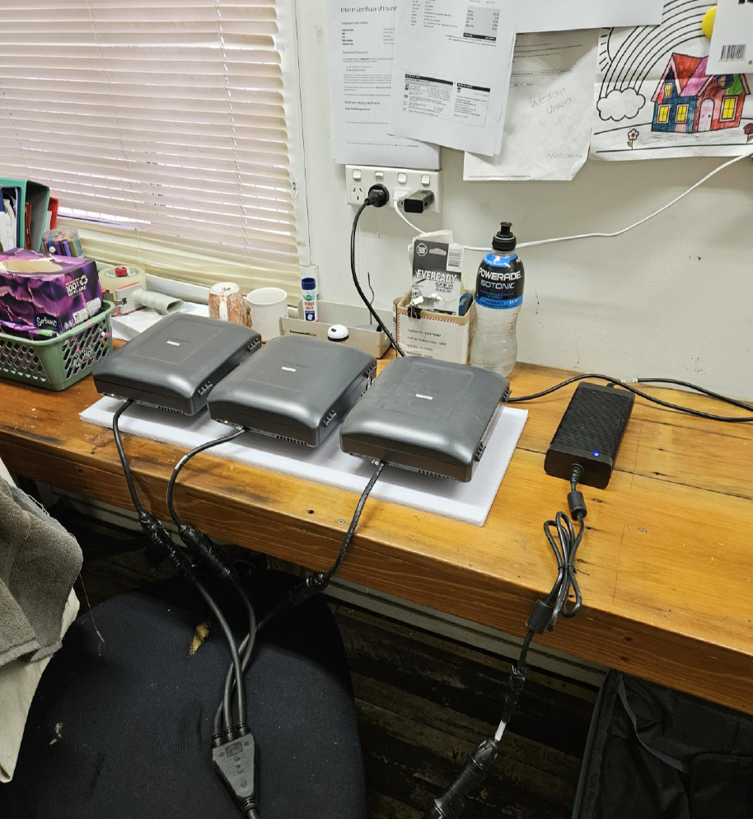

**Figure 1:** Typical Audit Towns setup, with testing kits placed close to a window.

## Audit Towns Test Setup

One probe is used per MNO at each site, consisting of a Samsung S23+ device running Keysight Nemo Handy software. The phone's GPS information is integrated into Nemo. The probes are housed in an enclosure that manages both ventilation and power for the device. It is placed on a shelf or mounted on a board attached to the building wall, and positioned close to a window to reduce signal interference.

Voice test cases are conducted in conjunction with a stationary setup at Accenture premises, where a dedicated voice terminal is used. The system connects to the most advanced available technology and cell with the strongest signal strength (starting with 5G, falling back to 4G), mimicking typical phone operation. A series of test cases is run, measuring signal strength and quality, upload/download and latency, voice call quality, and SMS transactions. The testing follows a repeated script cycle shown in the figure below.

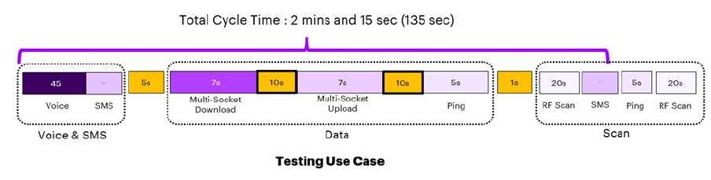

**Figure 2:** Testing cycle script for Audit Towns.

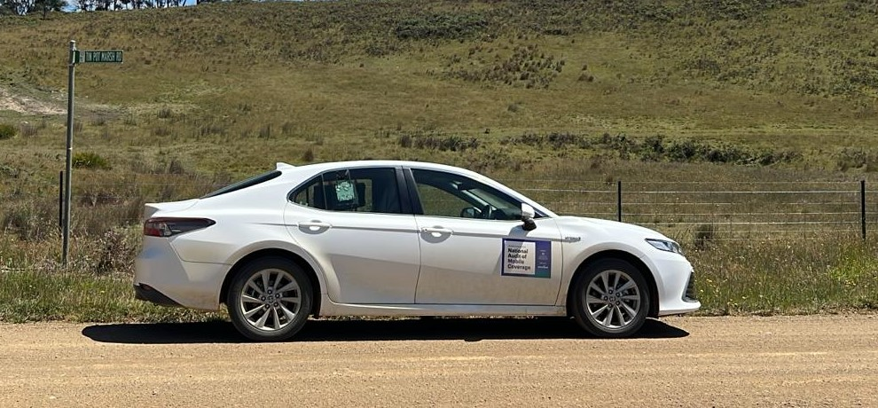

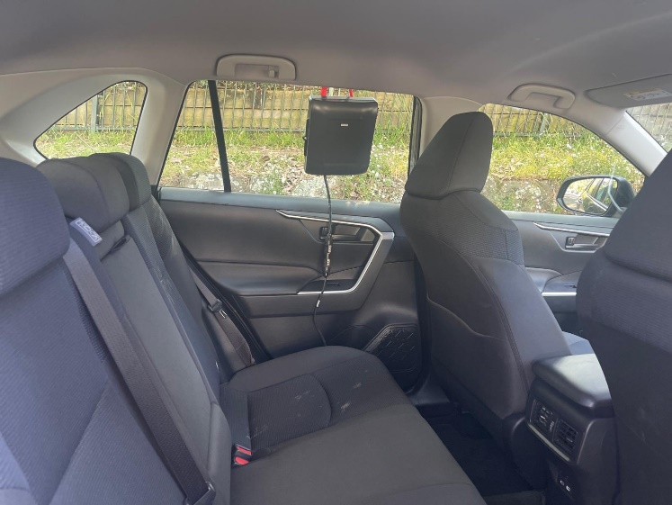

**Figure 3:** Typical Audit Roads setup for Accenture vehicles, with window-mounted testing kits.

## Audit Roads Test Setup

This setup is designed to accommodate in-vehicle, outdoor, and high-gain antenna user scenarios. One probe is used per MNO in each vehicle, consisting of a Samsung S23+ device running Nemo Handy software. The phone's GPS information is integrated into Nemo. The probes are housed in an enclosure that manages both ventilation and power for the device. The 3 probes are mounted on the testing vehicle rear window for Accenture vehicle testing, and in the passenger footwell or rear cargo compartment (depending on vehicle model) for Australia Post vehicles. During the Pilot Audit only, a scanner system was used to enhance visibility across all frequency bands and to validate the testing methodology.

Voice test cases are conducted in conjunction with a stationary setup at Accenture premises, where a dedicated voice terminal is used. The system connects to the most advanced available technology and cell with the strongest signal strength (starting with 5G, falling back to 4G), mimicking typical phone operation. A series of test cases is run, measuring signal strength and quality, upload/download and latency, voice call quality, and SMS transactions. The testing follows a repeated script cycle shown in the figure below.

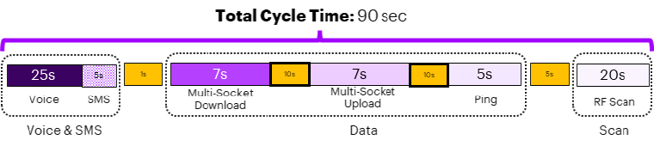

**Figure 4:** Testing cycle script for Audit Roads (Accenture test vehicles).

The cycle time is shorter for Audit Roads compared to Audit Towns so the data samples taken on high-speed roads are a shorter distance apart. A higher frequency of samples is more useful for data analysis.

For Australia Post vehicle drive testing, due to variations in vehicle design compared to Accenture vehicles, the probes are installed in different positions. The probes are mounted within a protective plastic enclosure, either inside the cargo compartment behind the front seats, or in the footwell of the passenger seat (depending on vehicle model used). Due to operational practicalities, mounting on the delivery van window was not feasible. The different probe positions led to more signal attenuation compared to Accenture vehicles. Therefore, testing was performed on Australia Post vehicles to determine an appropriate correction factor to apply to the measured data.

The Australia Post vehicle testing follows a repeated script cycle shown in the figure below.

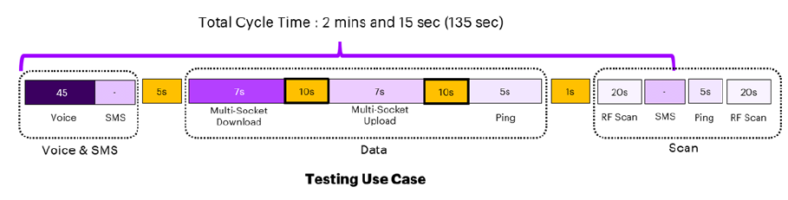

**Figure 5:** Testing cycle script for Audit Roads (Australia Post vehicles).

The 135 second cycle was used for Australia Post vehicles due to slower measured speeds while travelling routes. A 135 second script cadence was considered sufficient for these test cases.

## Data Processing and Validation

After data is measured, it is uploaded to a secure cloud platform where a stringent validation process is undertaken, including multiple stages of aggregation to calculate the metrics that will be used for the coverage evaluation. The data cleansing process ensures samples not meeting the standards are discarded (e.g. no GPS data or wrong timestamp).

## Metrics Measured and Calculated

The metrics selected for measurement in the Audit are based on international benchmarking frameworks. Table 1 outlines the metrics used, units and thresholds.

**Table 1:** Metrics measured in the Audit, and thresholds for display on the visualisation tool **\***.

| Metric | Unit | Description | Thresholds |
| --- | --- | --- | --- |
| RSRP (Reference Signal Received Power) | dBm | 4G/5G signal strength. Includes 3G when it was available. This metric is the most comparable to MNO coverage map data. | **Acceptable:** > -115 dBm.  **Modest:** > -122 dBm (4G), > -126 dBm (5G).  **Limited:** ≤ -122 dBm (4G), ≤ -126 dBm (5G).  **No Service:** No coverage or service measured. |
| UL THPT (Uplink Throughput) | Mbps | Data upload speed. | **Excellent:** UL THPT > 50 Mbps.  **Good:** UL THPT > 20 Mbps.  **Fair:** UL THPT > 5 Mbps.  **Modest:** UL THPT > 1 Mbps.  **Limited:** UL THPT < 1 Mbps.  **No Service:** No coverage or service measured. |
| DL THPT (Downlink Throughput) | Mbps | Data download speed. | **Excellent:** DL THPT > 100 Mbps.  **Good:** UL THPT > 25 Mbps.  **Fair:** UL THPT > 5 Mbps.  **Modest:** UL THPT > 2 Mbps.  **Limited:** UL THPT < 2 Mbps.  **No Service:** No coverage or service measured. |
| Latency – RTT (Round Trip Time) | ms | Time taken for a data packet to be sent by one device and received by the destination device. | **Excellent:** RTT < 20 ms.  **Good:** RTT < 50 ms.  **Fair:** RTT < 20 ms.  **Modest:** RTT > 100 ms.  **Limited:** RTT > 500 ms.  **No Service:** No coverage or service measured. |
| Voice Quality | POLQA-MOS Value (1 to 5) | Perceptual Objective Listening Quality Analysis – Mean Opinion Score. A model that analyses the quality of digital voice signals. | **Excellent:** POLQA-MOS ≥ 4.  **Good:** POLQA-MOS ≤ 4 to >3.  **Fair:** POLQA-MOS ≤ 3 to >2.  **Modest:** POLQA-MOS ≤ 2 to >1.3.  **Limited:** POLQA-MOS < 1.3.  **No Service:** No coverage or service measured. |
| SMS Success Rate | Binary (Qualified or Non-Qualified) | Standard text messages. | **Qualified if:** At least 75% of the text message is received by the device. Otherwise, Limited/No Service. |
| Web Browsing | Binary (Qualified or Non-Qualified) | Predicted performance using a web browser. | **Qualified if:** DL THPT > 1 Mbps of chunk aggregation (per 1s). Otherwise, Limited/No Service. |
| SD Video Streaming (Standard Definition) | Binary (Qualified or Non-Qualified) | Predicted performance of streaming applications such as Netflix. | **Qualified if:** DL THPT > 3 Mbps. Otherwise, Limited/No Service. |
| HD Video Streaming (High Definition) | Binary (Qualified or Non-Qualified) | Predicted performance of streaming applications such as Netflix. | **Qualified if**: DL THPT > 5 Mbps. Otherwise, Limited/No Service. |
| eGaming | Binary (Qualified or Non-Qualified) | Predicted performance of online video game applications. | **Qualified if:** RTT < 50ms. Otherwise, Limited/No Service. |
| Teleconference (Voice Only) | Binary (Qualified or Non-Qualified) | Predicted performance of applications such as WhatsApp. | **Qualified if:** RTT < 100ms. Otherwise, Limited/No Service. |
| Teleconference (Voice and Video) | Binary (Qualified or Non-Qualified) | Predicted performance of applications such as Zoom. | **Qualified if:** RTT < 100ms & DL THPT > 2 Mbps & UL THPT > 2 Mbps. If 75% of the samples are meeting the criteria. Otherwise, Limited/No Service. |
| Combined User Experience | Aggregate score | Overall user experience  based on several metrics (UL THPT, DL THPT, Latency, Voice Quality, SMS Success Rate, Call Setup Failure, Dropped Call, Web Browsing, SD Video Streaming, Teleconference (Voice Only)) in which a score is assigned to each metric and then a combined score is averaged across all metrics. | **Excellent:** Combined User Experience (CUE) score = 5.  **Good:** CUE score < 5 to ≥4.  **Fair:** CUE score < 4 to ≥3.  **Modest:** CUE score < 3 to ≥ 2.  **Limited:** CUE score < 2 to ≥ 1.  **No Service:** No coverage or service measured. |
| Call Success Rate * | Aggregate score | Call success rate based on several metrics (Dropped Call, Call Setup Failure, and Voice Quality) in which a weighted percentage is assigned to each metric and then aggregated. | **Qualified if:** ≥ 75% of samples show successful call setup, no dropped call, and Fair to Excellent voice quality. Otherwise, Limited/No Service. |
| Stability Rate * | Aggregate score | Voice and data service success rate based on several metrics (UL THPT, DL THPT, Latency, Call Success Rate and SMS Success Rate) in which each individual metric is assessed separately based on the individual metric success criteria, then the percentage of samples meeting the success criteria from the entire population is calculated to assess the service stability during the measurement period (monthly). | **Excellent:** Stability Rate (SR) ≤ 100% to >80%.  **Good:** SR ≤ 80% to >60%.  **Fair:** SR ≤ 60% to >40%.  **Modest:** SR ≤ 40% to > 20%.  **Limited:** SR ≤ 20% to > 0%.  **No Service:** No coverage or service measured. |

**\*** These metrics are only visualised in Audit Towns.

## Quality Assurance and Quality Control

Accenture has multiple layers of quality assurance:

* **Field Measurement Process and Test Setup:** A structured, standard operating procedure is followed during vehicle preparation and while conducting functional testing to assess the confidence level of the data before drive testing commences.
* **Measurement equipment calibration:** Keysight probes utilised in the Audit go through test measurements and functionality assessments to verify that the devices can perform measurement scenarios with the expected outcomes. Software updates are installed to the devices over the air wherever feasible, but if there are issues, tech support will attend in person. Scanner devices undergo a calibration process conducted annually by the device manufacturer to ensure that accurate measurements are obtained across the configured frequencies.
* **Measurement scripts design:** Test measurements adhere to a systematic sequence of test tasks, including downlink file transfer, uplink file transfer, ping tests, voice calls, and SMS tests, to evaluate the user experience. Each test is conducted during designated intervals to accumulate sufficient data. Additionally, wait periods between the tasks are used to prevent test overruns and to mitigate any potential impact on each test case.

Quality control is conducted through:

* **Online monitoring:** Accenture monitors the field and in-office devices, performing measurements, maintaining operations, and resolving any issues that arise. With the help of satellite phones and Starlink communications, an established communications channel between the backend team and field teams is available even in poor coverage areas.
* **Data Validation Process:** Measurement logs from scheduled sessions are automatically uploaded into the cloud server after the session, where network is available. In poor coverage areas, the log files are transferred manually by field teams to the server over other network channels, such as Wi-Fi. After transfer, log files go through data processing.
* **Scheduling redrives:** If the field measurements are determined to be invalid and unrecoverable, redrives of the identified areas are conducted. This minimises gaps in Audit Roads data for publishing on the visualisation tool.

## Data Visualisation

The metrics above are presented through a geographically based [visualisation tool](https://d1zckiwudrcznp.cloudfront.net/#A), available via the [department’s website](https://www.infrastructure.gov.au/media-communications-arts/better-connectivity-plan-regional-and-rural-australia/national-audit-mobile-coverage). A qualitative description of the metric thresholds is included below.

* **RSRP (Coverage):** The signal strength of the radio signal received by a device from a cell tower. A higher RSRP value generally means better signal quality and coverage for mobile users. It is based on the following thresholds:
  + **Acceptable Coverage:** Consistent and reliable user experience for voice and data services, with minimal service interruptions or dropped calls.
  + **Modest Coverage:** Below average user experience for voice and data services, with frequent service interruptions and dropped calls.
  + **Limited Coverage:** Poor user experience for voice and data services, with high likelihood of service interruptions, dropped calls, and slow application performance.
  + **No Service:** No operation is possible within this area.
* **Uplink Throughput & Downlink Throughput:** The speed of the mobile connection. It is based on the following thresholds:
  + **Excellent:** Fast and uninterrupted speed for all applications.
  + **Good:** Stable and consistent speed for most applications, with minimal instances of slower speeds.
  + **Fair:**Adequate speed for basic applications, but occasional failure for applications with higher speed requirements.
  + **Modest:** Below average speed for most applications, with frequent failure of applications with higher speed requirements.
  + **Limited:**Poor speed for all applications, with high likelihood of application failures and long loading times.
  + **No Service:** No operation is possible within this area.
* **Latency:** Measures the response time from the device to the data packet destination. It is based on the following thresholds:
* **Excellent:** Near-instantaneous response times for all applications.
* **Good:** Fast response times for most applications, with minor delays for applications with lower latency requirements.
* **Fair:**Adequate response timesfor most applications, but occasional delays for applications with lower latency requirements.
* **Modest:** Below average response times for most applications, with frequent delays for all but basic applications.
* **Limited:** Poor response times for all applications,with high likelihood of delays or application failure.
* **No Service:** No operation is possible within this area.
* **Voice Quality:** Measures the voice quality and clarity during a telephone call. It is based on the following thresholds:
  + - * **Excellent:** High quality audio fidelity for all voice calls.
      * **Good:** Stable and consistent audio fidelity for most voice calls, with minimal distortion.
      * **Fair:** Adequate audio fidelity for voice calls, with occasional distortion.
      * **Modest:** Below average audio fidelity for voice calls, with frequent distortion.
      * **Limited:**Poor audio fidelity for voice calls, with high likelihood of distortion and limited functionality.
      * **No Service:** No operation is possible within this area.
* **SMS** **Success Rate:** The availability of text messaging functionality. This is a binary (success or failure) metric. It is based on the following binary thresholds:
  + - * **Fair:** SMS functioning effectively, with text message received.
      * **Limited /** **No Service:** SMS likely not functioning, with no text message received, or no operation is possible within this area.
* **User Experience Metrics:** The predicted functionality of popular applications. It is based on Upload Throughput, Download Throughput and Latency data measured in the area. These are binary (success or failure) metrics, so non-qualification means the application could not be used effectively for that particular data point. User experience metrics include:
  + Web Browsing.
  + SD Video Streaming.
  + HD video Streaming.
  + eGaming.
  + Teleconference Voice.
  + Teleconference Voice and Video.

The user experience metrics are based on the following binary thresholds:

* + - * **Fair:** Application functioning effectively.
      * **Limited /** **No Service:** Application likely to fail, or no operation is possible within this area.

* **Combined User Experience:** Overall user experience based on an aggregation of several metrics (UL THPT, DL THPT, Latency, Voice Quality, SMS Success Rate, Call Setup Failure, Dropped Call, Web Browsing, SD Video Streaming, Teleconference (Voice Only)). It is based on the following thresholds:
* **Excellent**: High quality user experience for voice and data applications, with seamless connectivity and performance.
* **Good**: Stable and consistent user experience for voice and data applications, with minimal disruptions to connectivity and performance.
* **Fair**: Adequate user experience for voice and data applications, with occasional disruptions to connectivity and performance.
* **Modest**: Below average user experience for voice and data applications, with frequent disruptions to connectivity and performance.
* **Limited**: Poor user experience for voice and data applications, with a high likelihood of disruptions to connectivity and performance.
* **No service:** No operation is possible within this area.
* **Call Success Rate (Audit Towns only):** The success rate of voice calls, based on an aggregation of several metrics (Dropped Call, Call Setup Failure, and Voice Quality). It is based on the following thresholds:
* **Excellent: High quality voice call performance and success rate, with near-continuous functionality.**
* **Good: Stable and consistent voice call performance and success rate, with minimal disruptions to functionality**
* **Fair: Adequate voice call performance and success rate, with** occasional disruptions to functionality.
* **Modest: Below average voice call performance and success rate, with** frequent disruptions to functionality.
* **Limited: Poor voice call performance and success rate, with** high likelihood of disruptions to functionality.
* **No service: No operation is possible within this area.**
* **Stability Rate (Audit Towns only):** Voice and data service success rate based on several metrics (UL THPT, DL THPT, Latency, Call Success Rate and SMS Success Rate). It is based on the following thresholds:
* **Excellent: High quality voice and data application performance and success rate, with near-continuous functionality.**
* **Good: Stable and consistent voice and data application performance and success rate, with minimal disruptions to functionality**
* **Fair: Adequate voice and data application performance and success rate, with** occasional disruptions to functionality.
* **Modest: Below average voice and data application performance and success rate, with** frequent disruptions to functionality.
* **Limited: Poor voice and data application performance and success rate, with** high likelihood of disruptions to functionality.
* **No service: No operation is possible within this area.**

## Non-Aligned Road Segments (Audit Roads only)

After Audit Roads data is measured, validated and processed, road segments where the RSRP value does not match the MNO coverage maps in that area are identified. These data points are analysed to determine whether they should be classified as ‘non-aligned.’

The MNO mobile coverage maps show outdoor handheld predicted mobile coverage. There may be some direct measurement by MNOs, but it is largely calculated through a predictive algorithm. The assumptions and constants used for the predictive algorithm are determined by each individual MNO. The MNO coverage maps are included as a selectable layer on the visualisation tool, using data sourced from the ACCC’s Audit of Telecommunications Infrastructure Assets – Record Keeping Rules (Infrastructure RKR) handheld coverage datasets. This was last published on 31 January 2024.

Variance between Audit results and MNO coverage maps can arise due to:

* Interference with the mobile signal due to factors such as physical obstructions (buildings, trees, terrain) and certain electromagnetic sources.
* Network development (new mobile cells or enhanced infrastructure) that may not yet be reflected in the MNO coverage maps (these are updated annually).
* Network faults or outages (planned and unplanned).
* User demand saturating mobile cells and impacting network performance.
* Issues originating with the user device that affects connection to the network.
* MNO coverage maps not accurately predicting real-world mobile coverage.

Accenture considers these and other relevant factors as part of the non-alignment analysis. The non-alignments identified by Accenture are shared with the MNOs, who are given the opportunity to provide feedback on causation. This feedback and other supporting data gathered during the Audit (crowdsourced data, RF scanner readings), is used by Accenture to classify non-aligned road segments into categories:

**Table 2:** Audit Roads data non-alignment categories.

|  |  |
| --- | --- |
| Non-Alignment Category | Description |
| Network development/maintenance (planned outage) | A known and planned outage identified by the MNO that occurred at the same time as the Audit drive testing. |
| Network fault (unplanned outage) | An unplanned outage identified by the MNO that occurred at the same time as the Audit drive testing (e.g. due to power outage, cable damage, software/network management issues, etcetera). |
| Coverage not found | An area where no coverage was found during Audit drive testing, but the MNO predictive coverage maps show there is coverage. MNOs state that the signal strength may be marginal or inconsistent due to distance from the nearest mobile tower (such as at the cell edge) or where there are environmental obstacles. |
| Pending Feedback from MNO | The MNO is in the process of providing feedback on the areas of non-alignment to Accenture, and it is expected to be received soon. |
| No feedback from MNO | Feedback not received from MNO. |
| Not explained by MNO | The MNO acknowledged the non-alignment but did not provide feedback on causation. |

The non-alignments are published on the [visualisation tool](https://d1zckiwudrcznp.cloudfront.net/) as a geospatial layer that can be toggled on and off. Hovering the mouse over a road segment will show the information for that road segment, including the non-alignment category. New data is added to the visualisation tool each month as the Audit drive testing progresses, and historical non-alignment data can be viewed using the date filtering field in the visualisation tool.

The most recent non-alignment data is also available in a spreadsheet published on the [department website](https://www.infrastructure.gov.au/media-communications/better-connectivity-plan-regional-and-rural-australia/national-audit-mobile-coverage/national-audit-mobile-coverage-mobile-coverage-non-alignments).

# Frequently Asked Questions

* **Q: What type of mobile phones are used in the Audit?**

**A:** Commercial off the shelf Samsung S23+ devices.

* **Q: Which metrics does Accenture use to determine coverage?**

**A:** The Audit focuses on RSRP (Reference Signals Received Power) in conjunction with coverage quality metrics such as SINR (Signal to Interference & Noise Ratio) as per the 3GPP standards.

* **Q: Does the Audit cover user experience metrics relating to performance?**

**A:** The goal of the Audit is to measure the overall experience including the quality of the service the end-user receives from the MNOs in the target areas. Under the current methodology, Accenture measures the quality of the voice call, SMS success rate, the connection speed (download and upload), latency (the delay between the smart phone device and the network), and the availability of acceptable level of services such as web browsing, SD and HD video streaming, eGaming, Teleconferencing (Voice), Teleconferencing (Voice & Video). Aggregated metrics include Combined User Experience, Call Success Rate and Service Stability.

* **Q: Does the Audit cover the use of mobile boosters and/or repeaters?**

**A:** The methodology of the Audit does not cover whether the device is receiving a signal from a booster or repeater. Devices connect to the best available network, but are affected by the network parameters and settings controlled by the MNOs.

* **Q: Does the Audit consider any planned/unplanned outages by the Mobile Network Operators?**

**A:** During the Main Audit**,** MNOs are briefed on the results of testing prior to publication on the visualisation tool and are able to inform Accenture of any outages where applicable. If notified, Accenture will endeavor to account for outages in the published data.

* **Q: Does the Audit measure the mobile network coverage for user scenarios such as the use of high-gain antennas, outdoor usage, and indoor usage?**

**A:** The Audit focuses on 3 user scenarios: The experience of users inside a moving vehicle, the experience of users outdoors, and the experience using an external high-gain antenna at the edge of MNO networks. Note that the high-gain antenna data will be present for the first year of the Audit only, and will not be measured or published for years 2 and 3.

* **Q: How does Accenture validate the different user scenarios such as outdoor usage and the use of an external high-gain antenna?**

**A:** Accenture leverages both international research on similar test cases and its own findings to establish correction factors. These factors are used to transform the data collected from drive testing, enabling accurate simulation of various user scenarios.

* **Q: How does the crowd-sourced data collection differ from data collected from drive and static testing?**

**A:** Crowd-sourced data is derived from people who agree to participate in data collection through the use of apps with the SDK embedded. Therefore, the geographical areas tested cannot be planned, and tends to produce data where population levels are greater. The crowd-sourced data is concentrated in cities and regional centres, with comparatively less data available in smaller regional and remote towns.

* **Q: How do crowd-sourced data metrics differ from Audit Roads and Audit Towns testing metrics?**

**A:** Crowd-sourced data metrics include Coverage (RSRP), Combined User Experience and Latency, which is fewer individual metrics available compared to Audit Roads and Audit Towns. However, Combined User Experience does include Upload Throughput, Download Throughput, latency and Connectivity metrics combined to produce an aggregate figure. Accenture Crowd-sourced data does not contain application-specific user experience metrics (such as Web Browsing, SD Video Streaming).

* **Q: Why does the crowd-sourced data appear in hexagons on the visualisation tool?**

**A:** Crowd-sourced data from multiple users in a geographical area is combined to produce an aggregate figure that is calculated for each individual hexagon. Each hexagon contains more samples than an individual data point on an Audit Road or in an Audit Town. It is useful to compare the different data collection methods (if available for an area), because it can help corroborate any unexpected measurements. However, the difference in methodology and geospatial aggregation between crowd-sourced data and drive testing data should be considered when comparing individual locations.

* **Q: Is the data collected from the Audit publicly available?**

**A:** The public can access the results of Audit testing via the [visualisation tool](https://d1zckiwudrcznp.cloudfront.net/), which is available through the department’s website. New data is published monthly for Audit Roads and Audit Towns (additional Towns will be added as the data becomes available). Crowd-sourced data is refreshed quarterly.

* **Q: What happens if the Audit data measured is different from MNO coverage maps?**

**A:** For the Audit Roads data collection method, road segments where the RSRP value does not match the MNO coverage maps in that area are identified by Accenture. These data points are analysed to determine whether they should be classified as ‘non-aligned.’ Accenture seeks feedback from the MNOs on potential causation for non-aligned road segments. This feedback and other supporting data gathered during the Audit (crowdsourced data, RF scanner readings) is used to classify non-aligned road segments into categories, as described in Table 2. The results are then published on the visualisation tool as a selectable layer.

|  |
| --- |
| Image of Accenture logo. |

Copyright © 2025 Accenture

All rights reserved.

Accenture and its logo are trademarks of Accenture.