|  |
| --- |
| National Audit of  Mobile Coverage  Audit Methodology Fact Sheet  June 2025 |
| Image of Accenture Logo. |

Contents

Introduction 2

Overview 2

Objective 2

Purpose 2

Audit Methodology 2

Audit Modules 2

Data Collection 2

Key Metrics and User Scenarios 3

Audit Towns Test Setup 4

Audit Roads Test Setup 6

Data Processing and Validation 7

Metrics Measured and Calculated 7

Data Visualisation 9

Frequently Asked Questions 13

# Introduction

## Overview

Accenture Australia have been engaged by the Department of Infrastructure, Transport, Regional Development, Communications, Sport and the Arts to deliver the National Audit of Mobile Coverage (the Audit) every year for 3 years until 30 June 2027. The Audit is a component of the Government's *Better Connectivity Plan for Regional and Rural Australia*.

## Objective

The Audit aims to better identify mobile coverage black spots across Australia to help target future investment, and to provide an independent resource that better reflects on the ground experiences of mobile services provided commercially by Mobile Network Operators (MNOs) Optus, Telstra and TPG.

## Purpose

This document provides an overview of the methodology used in the Audit to measure, process and display coverage and performance data from testing performed across Australia.

# Audit Methodology

## Audit Modules

The Audit will be conducted through 3 distinct modules:

* **Module A:** A Pilot Audit was conducted in 2024, with road and static testing undertaken at selected locations. This assessed the validity of the Audit methodology and provided learnings that informed the Main Audit rollout. Data collected is available now.
* **Module B:** The Main Audit commenced in late 2024 and consists of road and static location testing every year for 3 years until June 2027. Data is released at the end of each month as the Audit progresses.
* **Module C:** Crowd-sourced data provided by Accenture and released quarterly.

## Data Collection

The Audit is designed to test the end-user experience for coverage, voice calls, SMS and data services. 3 methods are used to collect network coverage and performance data:

* **Drive Testing (Audit Roads)**: Testing is conducted across Australia using measurement equipment setup in vehicles. The Pilot Audit covered approximately 35,000 km across the major roads in each state and territory. The Main Audit will cover a total of 186,984 km per year for 3 years, with a focus on regional and rural areas. Accenture will collaborate with Australia Post and use some of their vehicles to cover routes in the most efficient manner.
* **Static Location Testing (Audit Towns)**: Measurement equipment is installed in 77 fixed locations across rural and regional Australia. Australia Post local post offices will predominantly be used, with some alternatives such as rural fire service buildings hosting equipment in areas without a local post office.
* **Crowd-Sourced Data:** Data collected by the Accenture Crowd-sourced solution has been provided. Background data is collected from end user devices through an SDK (Software Development Kit) embedded in mobile phone applications. End-users that download and install these applications need to provide consent for Accenture to collect coverage and performance data.

The data collected via these 3 methods can be compared to MNO coverage map data, which is provided via the ACCC annually and is published alongside Audit data on the Audit [Visualisation Tool](https://d1zckiwudrcznp.cloudfront.net/).

## Key Metrics and User Scenarios

The Audit collects data on network coverage and performance using off-the-shelf Samsung S23+ smartphones. Metrics tested include:

* **Network Coverage and Quality:** Mobile devices measure signal strength and signal quality of the mobile network for all 3 MNOs.
* **Voice Calls:** Mobile devices are programmed to periodically perform mobile voice calls (originating and terminating). Each test calls a stationary counterpart device inside Accenture premises.
* **Text Messaging:** Mobile devices perform SMS transactions (text messaging), with the message received by the counterpart device at Accenture premises.
* **Data Download, Upload and Latency:** Mobile devices perform data download and upload tests using known content providers to test the data speed and latency (time for a data packet to travel between 2 devices). These results will also contribute to other user experience metrics described in more detail below.

The drive testing data collected is mapped to 3 different user scenarios:

* **In-Vehicle Scenario:** Accenture testing vehicles have smartphones mounted on the rear windows (simulating a phone in the vehicle console), with one device dedicated to each MNO. The devices perform voice, SMS and data tests on a repeating cycle, while also collecting data on signal strength and quality. The placement of these devices is optimised based on the vehicle type to minimise signal loss. Australia Post vehicles have the smartphones mounted in testing kits located in the passenger footwell or in the rear cargo compartment (depending on vehicle model).
* **Outdoor Scenario:** This simulates mobile network usage at street level, reflecting how end-users interact with their devices in an outdoor environment. Using data collected from the in-vehicle user scenario, a correction factor is applied to account for the impact of the car's structure on signal strength and quality.
* **High-Gain Antenna Scenario (Pilot Audit only):** People in regional and remote Australia often use high-gain external antennas mounted on their vehicles, which are then connected internally to their devices. This amplifies mobile phone signals in areas with poor coverage. During the pilot, Accenture applied a correction factor to the in-vehicle user scenario results to come up with these figures. However, subsequent field testing found limited correlation between in-vehicle and high-gain antenna data. Due to the lack of statistical confidence this user scenario was excluded from the Main Audit.

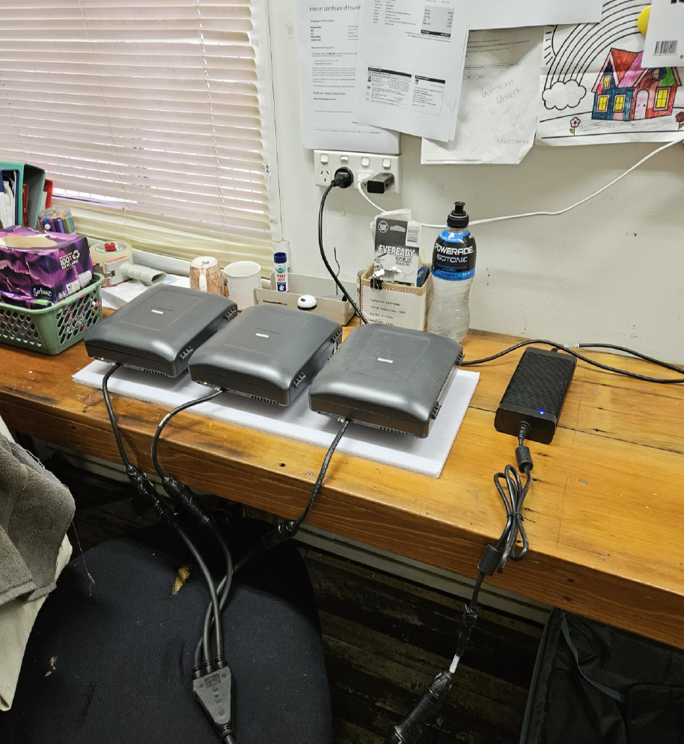

**Figure 1:** Typical Audit Towns setup, with testing kits placed close to a window.

## Audit Towns Test Setup

One probe is used per MNO at each site, consisting of a Samsung S23+ device running Keysight Nemo Handy software. The phone's GPS information is integrated into Nemo. The probes are housed in an enclosure that manages both ventilation and power for the device. It is placed on a shelf or mounted on a board attached to the building wall, and positioned close to a window to reduce signal interference.

Voice test cases are conducted in conjunction with a stationary setup at Accenture premises, where a dedicated voice terminal is used. The system connects to the most advanced available technology and cell with the strongest signal strength (starting with 5G, falling back to 4G), mimicking typical phone operation. A series of test cases is run, measuring signal strength and quality, upload/download and latency, voice call quality, and SMS transactions. The testing follows a repeated script cycle shown in the figure below.

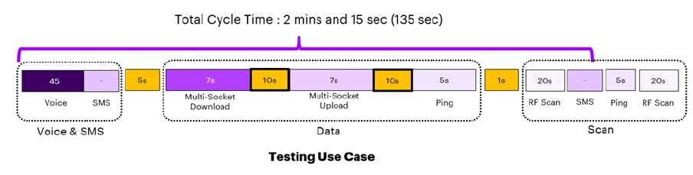

**Figure 2:** Testing cycle script for Audit Towns.

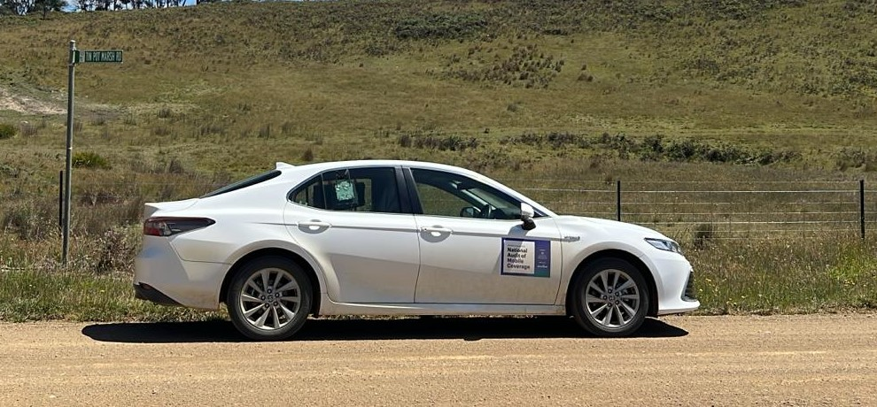

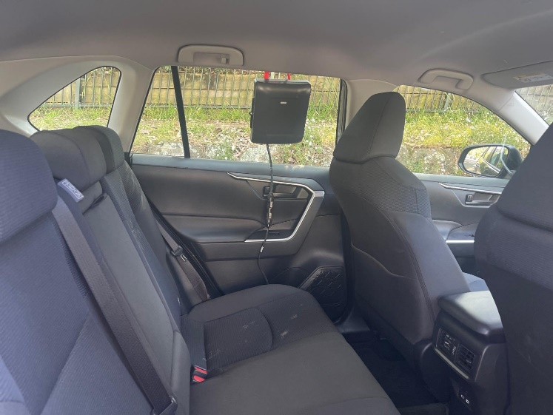

**Figure 3:** Typical Audit Roads setup for Accenture vehicles, with window-mounted testing kits.

## Audit Roads Test Setup

This setup is designed to accommodate in-vehicle, outdoor, and high-gain antenna user scenarios. One probe is used per MNO in each vehicle, consisting of a Samsung S23+ device running Nemo Handy software. The phone's GPS information is integrated into Nemo. The probes are housed in an enclosure that manages both ventilation and power for the device. The 3 probes are mounted on the testing vehicle rear window for Accenture vehicle testing, and in the passenger footwell or rear cargo compartment (depending on vehicle model) for Australia Post vehicles. During the Pilot Audit only, a scanner system was used to enhance visibility across all frequency bands and to validate the testing methodology.

Voice test cases are conducted in conjunction with a stationary setup at Accenture premises, where a dedicated voice terminal is used. The system connects to the most advanced available technology and cell with the strongest signal strength (starting with 5G, falling back to 4G), mimicking typical phone operation. A series of test cases is run, measuring signal strength and quality, upload/download and latency, voice call quality, and SMS transactions. The testing follows a repeated script cycle shown in the figure below.

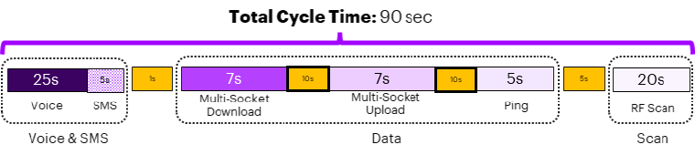

**Figure 4:** Testing cycle script for Audit Roads (Accenture test vehicles).

The cycle time is shorter for Audit Roads compared to Audit Towns so the data samples taken on high-speed roads are a shorter distance apart. A higher frequency of samples is more useful for data analysis.

For Australia Post vehicle drive testing, due to variations in vehicle design compared to Accenture vehicles, the probes are installed in different positions. The probes are mounted within a protective plastic enclosure, either inside the cargo compartment behind the front seats, or in the footwell of the passenger seat (depending on vehicle model used). Due to operational practicalities, mounting on the delivery van window was not feasible. The different probe positions led to more signal attenuation compared to Accenture vehicles. Therefore, testing was performed on Australia Post vehicles to determine an appropriate correction factor to apply to the measured data.

The Australia Post vehicle testing follows a repeated script cycle shown in the figure below.

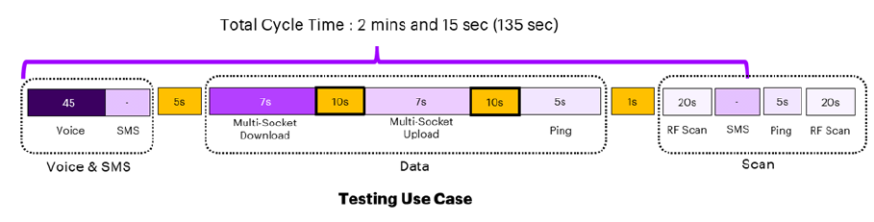

**Figure 5:** Testing cycle script for Audit Roads (Australia Post vehicles).

The 135 second cycle was used for Australia Post vehicles due to slower measured speeds while travelling routes. A 135 second script cadence was considered sufficient for these test cases.

## Data Processing and Validation

After data is measured, it is uploaded to a secure cloud platform where a stringent validation process is undertaken, including multiple stages of aggregation to calculate the metrics that will be used for the coverage evaluation. The data cleansing process ensures samples not meeting the standards are discarded (e.g. no GPS data or wrong timestamp).

## Metrics Measured and Calculated

The metrics selected for measurement in the Audit are based on international benchmarking frameworks. Table 1 outlines the metrics used, units and thresholds.

**Table 1:** Metrics measured in the Audit, and thresholds for display on the Visualisation Tool **\***.

| Metric | Unit | Description | Thresholds |
| --- | --- | --- | --- |
| RSRP (Reference Signal Received Power) | dBm | 4G/5G signal strength. Includes 3G when it was available. This metric is the most comparable to MNO coverage map data. | **Acceptable:** > -115 dBm.  **Modest:** > -122 dBm (4G), > -126 dBm (5G).  **Limited:** ≤ -122 dBm (4G), ≤ -126 dBm (5G).  **No Service:** No coverage or service measured. |
| UL THPT (Uplink Throughput) | Mbps | Data upload speed. | **Excellent:** UL THPT > 50 Mbps.  **Good:** UL THPT > 20 Mbps.  **Fair:** UL THPT > 5 Mbps.  **Modest:** UL THPT > 1 Mbps.  **Limited:** UL THPT < 1 Mbps.  **No Service:** No coverage or service measured. |
| DL THPT (Downlink Throughput) | Mbps | Data download speed. | **Excellent:** DL THPT > 100 Mbps.  **Good:** UL THPT > 25 Mbps.  **Fair:** UL THPT > 5 Mbps.  **Modest:** UL THPT > 2 Mbps.  **Limited:** UL THPT < 2 Mbps.  **No Service:** No coverage or service measured. |
| Latency – RTT (Round Trip Time) | ms | Time taken for a data packet to be sent by one device and received by the destination device. | **Excellent:** RTT < 20 ms.  **Good:** RTT < 50 ms.  **Fair:** RTT < 20 ms.  **Modest:** RTT > 100 ms.  **Limited:** RTT > 500 ms.  **No Service:** No coverage or service measured. |
| Voice Quality | POLQA-MOS Value (1 to 5) | Perceptual Objective Listening Quality Analysis – Mean Opinion Score. A model that analyses the quality of digital voice signals. | **Excellent:** POLQA-MOS ≥ 4.  **Good:** POLQA-MOS ≤ 4 to >3.  **Fair:** POLQA-MOS ≤ 3 to >2.  **Modest:** POLQA-MOS ≤ 2 to >1.3.  **Limited:** POLQA-MOS < 1.3.  **No Service:** No coverage or service measured. |
| SMS Success Rate | Binary (Qualified or Non-Qualified) | Standard text messages. | **Qualified if:** At least 75% of the text message is received by the device. Otherwise, Limited/No Service. |
| Web Browsing | Binary (Qualified or Non-Qualified) | Predicted performance using a web browser. | **Qualified if:** DL THPT > 1 Mbps of chunk aggregation (per 1s). Otherwise, Limited/No Service. |
| SD Video Streaming (Standard Definition) | Binary (Qualified or Non-Qualified) | Predicted performance of streaming applications such as Netflix. | **Qualified if:** DL THPT > 3 Mbps. Otherwise, Limited/No Service. |
| HD Video Streaming (High Definition) | Binary (Qualified or Non-Qualified) | Predicted performance of streaming applications such as Netflix. | **Qualified if**: DL THPT > 5 Mbps. Otherwise, Limited/No Service. |
| eGaming | Binary (Qualified or Non-Qualified) | Predicted performance of online video game applications. | **Qualified if:** RTT < 50ms. Otherwise, Limited/No Service. |
| Teleconference (Voice Only) | Binary (Qualified or Non-Qualified) | Predicted performance of applications such as WhatsApp. | **Qualified if:** RTT < 100ms. Otherwise, Limited/No Service. |
| Teleconference (Voice and Video) | Binary (Qualified or Non-Qualified) | Predicted performance of applications such as Zoom. | **Qualified if:** RTT < 100ms & DL THPT > 2 Mbps & UL THPT > 2 Mbps. If 75% of the samples are meeting the criteria. Otherwise, Limited/No Service. |
| Combined User Experience | Aggregate score | Overall user experience  based on several metrics (UL THPT, DL THPT, Latency, Voice Quality, SMS Success Rate, Call Setup Failure, Dropped Call, Web Browsing, SD Video Streaming, Teleconference (Voice Only)) in which a score is assigned to each metric and then a combined score is averaged across all metrics. | **Excellent:** Combined User Experience (CUE) score = 5.  **Good:** CUE score < 5 to ≥4.  **Fair:** CUE score < 4 to ≥3.  **Modest:** CUE score < 3 to ≥ 2.  **Limited:** CUE score < 2 to ≥ 1.  **No Service:** No coverage or service measured. |
| Call Success Rate * | Aggregate score | Call success rate based on several metrics (Dropped Call, Call Setup Failure, and Voice Quality) in which a weighted percentage is assigned to each metric and then aggregated. | **Qualified if:** ≥ 75% of samples show successful call setup, no dropped call, and Fair to Excellent voice quality. Otherwise, Limited/No Service. |
| Stability Rate * | Aggregate score | Voice and data service success rate based on several metrics (UL THPT, DL THPT, Latency, Call Success Rate and SMS Success Rate) in which each individual metric is assessed separately based on the individual metric success criteria, then the percentage of samples meeting the success criteria from the entire population is calculated to assess the service stability during the measurement period (monthly). | **Excellent:** Stability Rate (SR) ≤ 100% to >80%.  **Good:** SR ≤ 80% to >60%.  **Fair:** SR ≤ 60% to >40%.  **Modest:** SR ≤ 40% to > 20%.  **Limited:** SR ≤ 20% to > 0%.  **No Service:** No coverage or service measured. |

**\*** These metrics are only visualised in Audit Towns.

## Data Visualisation

The metrics above are presented through a geographically based [Visualisation Tool](https://d1zckiwudrcznp.cloudfront.net/#A), which is available via the [Department’s website](https://www.infrastructure.gov.au/media-communications-arts/better-connectivity-plan-regional-and-rural-australia/national-audit-mobile-coverage). A qualitative description of the metric thresholds is included below.

* **RSRP (Coverage):** The signal strength of the radio signal received by a device from a cell tower. A higher RSRP value generally means better signal quality and coverage for mobile users. It is based on the following thresholds:
  + **Acceptable Coverage:** Signal strength compatible with functional user experience for voice and data services, yet with probability of data failure or call drops.
  + **Modest Coverage:** Tolerable user experience for basic internet services and voice with fair possibility of service failure or call drops.
  + **Limited Coverage:** Coverage value presenting high possibility of data service failures and call drops.
  + **No Service:** No operation is possible within this area.
* **Uplink Throughput & Downlink Throughput:** The speed of the mobile connection. It is based on the following thresholds:
  + **Excellent:** Ensures smooth and uninterrupted experience for data all services.
  + **Good:** Stable and efficient user experience of internet-based services.
  + **Fair:**Adequate performance for majority of applications but might not support more demanding services.
  + **Modest:** Generally, below average standard for many applications but still sufficient for basic internet usage.
  + **Limited:**High probability of data failures, slow application loading times and long buffering during video streaming.
  + **No Service:** No operation is possible within this area.
* **Latency:** Measures the communication delay from the device to the data packet destination. It is based on the following thresholds:
* **Excellent:** Near-instantaneous feedback when accessing websites or performing online tasks.
* **Good:** Allowing efficient and timely communication, while not as fast as excellent category.
* **Fair:**Noticeable delays might be perceived while operating latency-sensitive applications.
* **Modest:** Minor service disruption or delays might be perceived but is still usable for most data applications
* **Limited:**Performance and responsiveness of online activities can significantly be impacted
* **No Service:** No operation is possible within this area.
* **Voice Quality:** Measures the voice quality and clarity during a telephone call. It is based on the following thresholds:
  + - * **Excellent:** Highest level of audio fidelity and clarity achieved during a voice call.
      * **Good:** Voice transmission is clear allowing easy comprehension and exhibiting minimal distortion.
      * **Fair:** Voice transmission is acceptable, but some imperfections might impact the flow of conversation
      * **Modest:** Conversation may experience frequent interruptions and noticeable distortion impacting the communication.
      * **Limited:**Severe interruptions and distortion provoke a very limited telephony service usability
      * **No Service:** No operation is possible within this area.
* **SMS** **Success Rate:** The availability of text messaging functionality. This is a binary (success or failure) metric.
* **User Experience Metrics:** The predicted functionality of popular applications. It is based on Upload Throughput, Download Throughput and Latency data measured in the area. These are binary (success or failure) metrics, so non-qualification means the application could not be used effectively for that particular data point. User experience metrics include:
  + Web Browsing.
  + SD Video Streaming.
  + HD video Streaming.
  + eGaming.
  + Teleconference Voice.
  + Teleconference Voice and Video.

* **Combined User Experience:** Overall user experience based on an aggregation of several metrics (UL THPT, DL THPT, Latency, Voice Quality, SMS Success Rate, Call Setup Failure, Dropped Call, Web Browsing, SD Video Streaming, Teleconference (Voice Only)).
* **Excellent**: Users consistently experience outstanding performance across both voice and data services, with seamless connectivity and high reliability.
* **Good**: Good user experience with voice and data services, encountering negligible issues that do not significantly impact usability. Common applications function smoothly, and voice calls and text messaging are consistently successful.
* **Fair**: Users experience acceptable voice and data service, with only occasional disruptions. Overall, the service remains usable for basic functions such as voice calls, text messages, and standard data applications.
* **Modest**: Users experience inconsistent service quality, including frequent voice call drops and degraded performance across commonly used applications.
* **Limited**: Users experience poor service, with a high likelihood of failure when attempting to use common applications, make voice calls, or send text messages.
* **No service:** No operation is possible within this area.
* **Call Success Rate (Audit Towns only):** The success rate of voice calls, based on an aggregation of several metrics (Dropped Call, Call Setup Failure, and Voice Quality).
* **Excellent: Voice service consistently performs at or above expectations, with near-continuous availability and reliability. Interruptions, if any, are negligible and virtually unnoticeable.**
* **Good: Voice service reliably meets acceptable standards most of the time, with only occasional and minor disruptions that do not significantly impact performance.**
* **Fair: Voice service meets acceptable levels with moderate consistency. Users may experience noticeable but manageable interruptions or degradations in performance.**
* **Modest: Voice service struggles to maintain acceptable performance levels, with frequent disruptions or inconsistencies that may hinder user experience or operational efficiency.**
* **Limited: Voice service rarely meets acceptable standards, with persistent issues or downtime that significantly impair usability and reliability.**
* **No service: No operation is possible within this area.**
* **Stability Rate (Audit Towns only):** Voice and data service success rate based on several metrics (UL THPT, DL THPT, Latency, Call Success Rate and SMS Success Rate).
* **Excellent: Data and voice service consistently performs at or above expectations, with near-continuous availability and reliability. Interruptions, if any, are negligible and virtually unnoticeable.**
* **Good: Data and voice service reliably meets acceptable standards most of the time, with only occasional and minor disruptions that do not significantly impact performance.**
* **Fair: Data and voice service meets acceptable levels with moderate consistency. Users may experience noticeable but manageable interruptions or degradations in performance.**
* **Modest: Data and voice service struggles to maintain acceptable performance levels, with frequent disruptions or inconsistencies that may hinder user experience or operational efficiency.**
* **Limited: Data and voice service rarely meets acceptable standards, with persistent issues or downtime that significantly impair usability and reliability.**
* **No Service: No operation is possible within this area.**

# Frequently Asked Questions

* **Q: What type of mobile phones are used in the Audit?**

**A:** Commercial off the shelf Samsung S23+ devices.

* **Q: Which metrics does Accenture use to determine coverage?**

**A:** The Audit focuses on RSRP (Reference Signals Received Power) in conjunction with coverage quality metrics such as SINR (Signal to Interference & Noise Ratio) as per the 3GPP standards.

* **Q: Does the Audit cover user experience metrics relating to performance?**

**A:** The goal of the Audit is to measure the overall experience including the quality of the service the end-user receives from the MNOs in the target areas. Under the current methodology, Accenture measures the quality of the voice call, SMS success rate, the connection speed (download and upload), latency (the delay between the smart phone device and the network), and the availability of acceptable level of services such as web browsing, SD and HD video streaming, eGaming, Teleconferencing (Voice), Teleconferencing (Voice & Video). Aggregated metrics include Combined User Experience, Call Success Rate and Service Stability.

* **Q: Does the Audit cover the use of mobile boosters and/or repeaters?**

**A:** The methodology of the Audit does not cover whether the device is receiving a signal from a booster or repeater. Devices connect to the best available network, but are affected by the network parameters and settings controlled by the MNOs.

* **Q: Does the Audit consider any planned/unplanned outages by the Mobile Network Operators?**

**A:** During the Main Audit**,** MNOs are briefed on the results of testing prior to publication on the Visualisation Tool and are able to inform Accenture of any outages where applicable. If notified, Accenture will endeavor to account for outages in the published data.

* **Q: Does the Audit measure the mobile network coverage for user scenarios such as the use of high-gain antennas, outdoor usage, and indoor usage?**

**A:** The Audit focuses on 3 user scenarios: The experience of users inside a moving vehicle, the experience of users outdoors, and the experience using an external high-gain antenna at the edge of MNO networks. Note that the high-gain antenna data will be present for the first year of the Audit only, and will not be measured or published for years 2 and 3.

* **Q: How does Accenture validate the different user scenarios such as outdoor usage and the use of an external high-gain antenna?**

**A:** Accenture leverages both international research on similar test cases and its own findings to establish correction factors. These factors are used to transform the data collected from drive testing, enabling accurate simulation of various user scenarios.

* **Q: How does the crowd-sourced data collection differ from data collected from drive and static testing?**

**A:** Crowd-sourced data is derived from people who agree to participate in data collection through the use of apps with the SDK embedded. Therefore, the geographical areas tested cannot be planned, and tends to produce data where population levels are greater. The crowd-sourced data is concentrated in cities and regional centres, with comparatively less data available in smaller regional and remote towns.

* **Q: How do crowd-sourced data metrics differ from Audit Roads and Audit Towns testing metrics?**

**A:** Crowd-sourced data metrics include Coverage (RSRP), Combined User Experience and Latency, which is fewer individual metrics available compared to Audit Roads and Audit Towns. However, Combined User Experience does include Upload Throughput, Download Throughput, latency and Connectivity metrics combined to produce an aggregate figure. Accenture Crowd-sourced data does not contain application-specific user experience metrics (such as Web Browsing, SD Video Streaming).

* **Q: Why does the crowd-sourced data appear in hexagons on the Visualisation Tool?**

**A:** Crowd-sourced data from multiple users in a geographical area is combined to produce an aggregate figure that is calculated for each individual hexagon. Each hexagon contains more samples than an individual data point on an Audit Road or in an Audit Town. It is useful to compare the different data collection methods (if available for an area), because it can help corroborate any unexpected measurements. However, the difference in methodology and geospatial aggregation between crowd-sourced data and drive testing data should be considered when comparing individual locations.

* **Q: Is the data collected from the Audit publicly available?**

**A:** The public can access the results of Audit testing via the [Visualisation Tool](https://d1zckiwudrcznp.cloudfront.net/), which is available through the department’s website. New data is uploaded at the end of every month for Audit Roads and Audit Towns (additional Towns will be added as the data becomes available). Crowd-sourced data is refreshed quarterly.

|  |
| --- |
| Image of Accenture logo. |

Copyright © 2025 Accenture

All rights reserved.

Accenture and its logo are trademarks of Accenture.