|  |  |
| --- | --- |
| Mobile Black Spot Program Evaluation | |
|  |  |
|  | **For the Department of Infrastructure, Transport, Regional Development, Communications and the Arts** |
|  | **Final Report** |
|  | 7 January 2025 |

Table of Contents

Abbreviations 3

Definitions 4

1 Executive Summary 5

1.1 About the Mobile Black Spot Program (MBSP) 5

1.2 About the evaluation 5

1.3 Conclusions 6

1.4 Recommendations 9

1.5 Summary of findings 12

2 Introduction 15

2.1 Context 15

2.2 About the program 15

2.3 About the evaluation 16

2.4 About the evaluation report 16

3 Evaluation approach 17

3.1 Methodology 17

3.2 Data limitations 18

4 Discussion and Findings 19

4.1 Implementation (KEQ 1) 19

4.2 Effectiveness (KEQ 3) 39

4.3 Appropriateness (KEQ 2) 54

5 Conclusions and Recommendations 66

5.1 Conclusions 66

5.2 Recommendations 69

6 Appendices 72

Appendix A - Methodology 72

Appendix B – Program Logic 73

Appendix C – Key Evaluation Questions (KEQs) 74

Appendix D – Stakeholders List 75

Appendix E – Community Visits 78

Contact us 104

This independent evaluation was funded by the Department of Infrastructure, Transport, Regional Development, Communications and the Arts (DITRDCA).

The Grosvenor team would like to thank all the stakeholders who gave their time and input to support the evaluation. This includes representatives from DITRDCA, state and territory governments, MNOs, and MNIPs, the First Nations Digital Inclusion Advisory Group, and community members who responded to the survey and attended the community consultations.

Your time, insights, and candour are very much appreciated.

*The images in the report are either publicly available or were taken by the Grosvenor team during community visits.*

# Abbreviations

| Abbreviation | Full form |
| --- | --- |
| ACCC | Australian Competition and Consumer Commission |
| ANAO | Australian National Audit Office |
| DITRDCA | Department of Infrastructure, Transport, Regional Development, Communications and the Arts |
| FSG | Field Solutions Group |
| GRN | General Radio Network |
| GST | Goods and Services Tax |
| KEQ | Key Evaluation Question |
| km | Kilometres |
| km2 | Kilometres squared |
| KPI | Key Performance Indicator |
| LEO Satellite | Low Earth Orbit Satellite |
| MBSP | Mobile Black Spot Program |
| MNO | Mobile Network Operators |
| MNIP | Mobile Network Infrastructure Providers |
| OFCP | On Farm Connectivity Program |
| RFDS | Royal Flying Doctors Service |
| MNHP | Mobile Network Hardening Program |
| NVD | National Vendor Declaration, eNDV (electronic application of NVD) |
| NWD | National Wool Declaration |
| PUMP | Peri-Urban Mobile Program |
| RCP | Regional Connectivity Program |
| RRAMP | Regional Roads Australia Mobile Program |
| USO | Universal Service Obligation |
| TDRI | Telecommunications Disaster Resilience Innovation Program |

# Definitions

|  |  |
| --- | --- |
| Term | Definition |
| Connectivity | Connectivity refers to the ability to access telecommunications related services, such as voice calls, mobile applications, online services, platforms, etc., that are central to participation in society |
| Coverage (of mobile services) | Coverage refers to a strong and consistent mobile signal such that a person can use their phone for voice calls, text messaging and data connectivity. |
| GRN | The Government Radio Network is a network of various systems in place across Australia that enable statewide trunked radio communication. The network operates through inter-linked sites for government and public services such as police, ambulance, fire, or roads authorities which require such a system to function properly. The main aim of the GRN is to consolidate all resources into one network, ensuring greater coverage and reliability than if each department had its own independent communication system. |
| Macro cells | Macro cells are cellular mobile phone base stations on large towers that provide coverage up to several kilometres.[1] |
| Quality (of mobile services) | Quality refers to the overall performance of a person’s mobile service, including clear, uninterrupted calls, fast and reliable data, and video streaming and online gaming without interruptions. |
| Reliability (of mobile connection) | Reliability refers to how consistently a person’s mobile service performs as expected, including the ability to complete a call, send texts, or access the internet without issues or interruptions like dropped calls, inability to load webpages, and outages. |
| Small cells | Small cells are smaller than macro cells and have a coverage range of 50 to 200 metres.[2] They can be installed inside residential and office buildings and have a lower power output. They can also be located in remote environments. |

# Executive Summary

## About the Mobile Black Spot Program (MBSP)

The MBSP was launched in 2014 to provide grant funding for investment in telecommunications infrastructure by Mobile Network Operators (MNOs) and Mobile Network Infrastructure Providers (MNIPs) to improve and expand telecommunications coverage and reception nationwide.

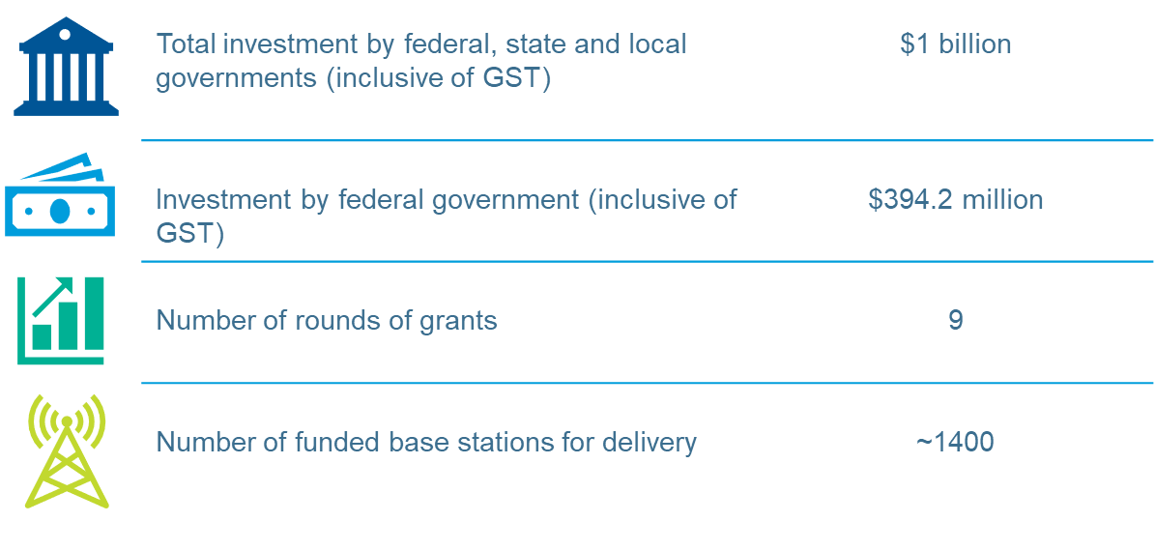

## About the evaluation

Four Key Evaluation Questions guided the evaluation:

1. (Implementation) To what extent has the program been successfully implemented?
2. (Appropriateness) To what extent is the program fit for purpose?
3. (Effectiveness) To what extent have the MBSP’s intended short- and medium-term outcomes been achieved?
4. What lessons does the program offer for future program and policy design?

Data was collected via:

* consultations with representatives from the Department of Infrastructure, Transport, Regional Development, Communications and the Arts (DITRDCA), MNOs and MNIPs, the First Nations Digital Inclusion Advisory Group, and state and territory governments
* an online survey of residents living near MBSP-funded base stations
* community visits to seven sites across the country, including in the states of Tasmania, South Australia, Queensland, New South Wales, and Western Australia
* reviewing available desktop data and documentation.

## Conclusions

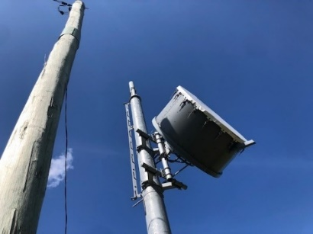The evaluation’s conclusions are set out below relating to the program’s implementation, effectiveness, and appropriateness.

Lessons learned have been identified as applicable throughout.

For ease of reference, the associated 26 evaluation findings that led to the formulation of these conclusions are summarised at 1.5.

### Implementation

The program has been successfully implemented, as intended.

Since its launch in 2014, the MBSP has successfully opened nine funding rounds and leveraged co-contributions of $661.7 million (including GST) from state and local governments, industry, and third parties. It has awarded funding for up to 1,400 base stations, with the program being taken up by all jurisdictions and multiple MNOs and MNIPs participating.

DITRDCA’s program administration and management have supported successful implementation.

Lessons learned through the delivery of the program relate to:

* delivery of the funded solutions taking longer than planned, with a common pain point being the sites that cannot be built, most often due to not being able to find a viable location or willing landholder
* community engagement and awareness and the need for a consistent experience by targeted communities so that they are aware of, and have informed expectations about the base station
* performance measurement and reporting – to have a planned approach to monitoring and evaluation readiness activities that supports reduced reporting burden for grantees and provides holistic and validated data sets.

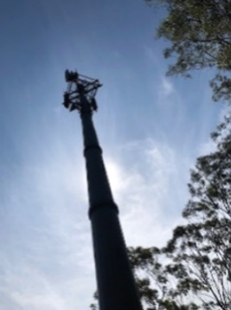Initiated in 2014, as a four-year grants program, the MBSP’s lifespan has been extended via an additional eight funding rounds. As of October 2024, a tenth round (called Round 8) is expected to open in late 2024.

While grantees, jurisdictions, and base station community recipients have welcomed the ongoing program extensions, the round-by-round funding approach has meant associated planning has been timebound for each round and calibrated to the budget appropriation for that round.

Providing certainty that comes with a longer program lifecycle would allow for timeframes that enable longer-term strategic planning for program administrators, grantees, and jurisdiction participants. It would also allow for increased flexibility in program offerings, such as offering more money in fewer rounds and offering funding certainty to co-investors. It would enable opportunities for increased alignment with jurisdictional planning priorities and funding cycles.

A longer program lifecycle would also assist DITRDCA with managing resourcing for longer timeframes for project delivery and accounting for outer years in delivery date extensions.

### Effectiveness

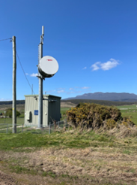The program has successfully increased mobile coverage as indicated by program reporting that showed all related KPIs relating to coverage were exceeded, with most of the reported increase achieved under Rounds 1 and 2.

Responses via the survey and community visits identified a level of increased coverage and examples of ensuing social, safety, and economic benefits.

Significant connectivity issues remain, and coverage, reliability, and access are ongoing problems for the majority of community members consulted. The communities highlighted an ongoing need for mobile connectivity; however, the level of additional support required to meet this need was tricky to determine in the absence of any agreed standards.

While a Universal Service Obligation (USO) for landline is in place, there is no agreed-upon set of standards for mobile coverage, reliability, and quality. Thus, what is ‘acceptable’ to one individual in a remote area and what is ‘unacceptable’ to another in a regional area may translate as the same technical levels of connectivity, but it is difficult to calibrate these in the absence of any uniform standards.

Intended competition outcomes have not been achieved. Co-location has been limited and the choice of mobile carriers has not improved for people living proximal to the base stations.

However, it is important to note that competition was a secondary program outcome to coverage. Stakeholders across the board highlighted that while choice was important to them, it was of secondary importance to increased coverage, primarily because they equated increased coverage with increased safety.

Nevertheless, survey and community respondents did express an appetite for increased choice in mobile carriers, and many respondents were actively testing alternative technology solutions, including LEO satellite.

### Appropriateness

The MBSP's design at inception was appropriate to meet consumer needs at the time. However, a decade on, there are signs that the program’s current form is not keeping up with evolving consumer needs and a rapidly changing technological context.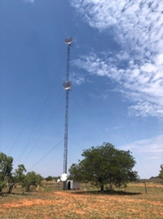 MBSP now operates in a complex environment of Commonwealth, state, and territory telecommunications policy, regulation, and programs, along with emerging technologies and changing consumer needs.

The consumer need is shifting from mobile to data, but the need for connectivity remains. Most people today have smartphones and an associated preference and expectation for using them for their digital service and transaction needs.

The vast proportion of the Australian land mass still has little to no mobile coverage, with terrestrial coverage concentrated where people live, work, and travel. Community concerns about the reliability of coverage, particularly during emergencies, persist. Safety (including medical and emergency situations) was identified as a paramount priority for the communities.

MNOs indicated that commercial incentives for investment via the program are declining, and the sector is experiencing long-term declines in returns on invested capital.

There is still a perceived need for future government investment in telecommunications infrastructure, but likely not in the program’s current form. Moving forward, alternative technology solutions may provide an additional option to mobile base station infrastructure, particularly for users in remote and very remote areas where the geographic footprint is large and the population sparse.

Therefore there are signals that the program in its current form has been pushed as far as it can go.

Digital inclusion is now a standard expectation, along with healthcare, education, and energy. Digital literacy is an accompanying feature of this. From a community perspective, the program was perceived as synonymous with the Australian Government’s response to a complex problem of connectivity and intrinsically connected to issues of access, safety, well-being, and equality. It is important to note that the MBSP is only one program swimming towards a solution in the sea of a national connectivity problem.

Criticisms of the program need to be contextualised as part of a much bigger connectivity issue. This problem is complex in size and scale and cannot be fixed by any one program, let alone the MBSP.

The MBSP has left a legacy of increased coverage across the country, but it is likely a program overhaul is required. Both design and systems thinking will be needed to respond to the above current, complex environment and leveraging the experience of the DITRDCA team and lessons learned from program delivery to date.

## Recommendations

The evaluation has made five recommendations.

|  |
| --- |
| **Recommendation 1:**  As part of future program design and delivery, DITRDCA should consider a program reset within the context of a strategic national frame, using systems thinking and a co-design approach. |

The approach should account for the following:

1. Engagement and collaboration with teams across the department, the First Nations Digital Inclusion Advisory Group, associated portfolio agencies, state and industry counterparts, and communities, and building on the Better Connectivity Plan. It should include continuing to work closely with states and territories to identify their connectivity needs and to provide solutions accordingly, as well as engagement with MNOs and MNIPs to maintain cognisance of industry expectations and technologies that can be leveraged.
2. A focus on providing new coverage and improving the quality and reliability of existing coverage.
3. A market scan/assessment of whether co-investment in mobile infrastructure is the optimal mechanism to address the existing need for connectivity in underserved areas.
4. Digital literacy as a factor for consideration for future grants guidance and criteria, and leveraging the Regional Tech Hub[3] and the First Nations Digital Support Hub[4] (yet to commence), assessing how their resources can be utilised, promoted, and shared.
5. Minimum standards for coverage (national standards currently not available) to inform understanding of project and program performance and to inform prioritisation of government investment.
6. Enhancing the resilience of existing mobile infrastructure (E.g., to prevent outages and power failures due to bad weather and natural disasters).
7. Engaging First Nations communities early in the design phase to ensure digital inclusion that is centred around their specific needs and environment (as recommended by the First Nations Digital Inclusion Advisory Group).
8. Provision of ongoing funding, possibly in the form of subsidies to the MNOs and MNIPs, given the high costs of deployment and operations and the longevity of operations for the MNOs and MNIPs across remote and very remote areas.
9. Lessons learned from MBSP delivery to date should inform future program design and be incorporated where possible into the delivery of future rounds.

|  |
| --- |
| **Recommendation 2:**  Extend timeframes for grant rounds (including for rollout and completion of base stations) and calibrate departmental resourcing accordingly. |

In future grant funding rounds, extend timelines to:

1. account for the complexity of base station solutions and provide industry players with sufficient time to submit quality proposals
2. provide adequate buffer periods within the grant rounds for unexpected delays, scope changes, and unforeseen issues, ensuring quality and reducing the risk of rushed delivery
3. enable time for planning and adjustment of resource allocation as needed by increasing team size and/or skill sets over the increased lapsed time period.

|  |
| --- |
| **Recommendation 3:**  Conduct the grant application and assessment process as a two-staged approach. |

In future rounds, adapt the grant process as a two-staged approach:

* Stage 1 – MNOs and MNIPs to conduct an initial feasibility study (desktop and site visit feasibility) before submitting the proposals
* Stage 2 – following a successful feasibility study, MNOs and MNIPs submit proposals. Once the proposal is successful, approvals, site acquisitions, design and construction stages to follow.

MNOs and MNIPs should engage and consult early with communities in the identified base station sites when preparing their applications for in-principle approval. They should continue to engage throughout the build to raise awareness of the base station in the community.

|  |
| --- |
| **Recommendation 4:**  Develop a monitoring and evaluation framework in consultation with grantees and co-funding partners. |

With a view to supporting a planned approach to monitoring and evaluation readiness activities that:

1. supports continued program administration, management, and risk mitigation
2. helps to streamline reporting by:

* minimising duplication and considers making the reporting process for KPIs and variation processes more efficient for the MNOs and MNIPs
* developing consistent reporting requirements between federal and state levels to ensure uniformity in data presentation, frequency, and required information
* establishing a centralised system to integrate both federal and state reporting, ensuring real-time access and alignment

1. uses a variety of data sources to complement and minimise excessive reliance on carrier reporting. For example, future data collection and reporting should consider inclusion and validation by external sources, including verification by the audit process and potentially community feedback (for example, via survey and or community consultations) to confirm receipt of delivery standards and areas of ongoing need
2. considers how the program can contribute to the Measuring What Matters framework. (In particular, the digital preparedness measure and in the context of the well-being framework.)**[5]** (Note, the MBSP contributes to Outcome 17 of the Closing the Gap National Agreement as identified in the Closing the Gap Implementation Plan.)**[6]**

|  |
| --- |
| **Recommendation 5:**  Strengthen the program's approach to raising awareness and recognise the Australian Government’s commitment to increasing connectivity among communities in need. |

DITRDCA should consider ways to promote the Australian Government’s investment in future telecommunications projects through community engagement, sharing of testimonials of positive impact, and press and media coverage.

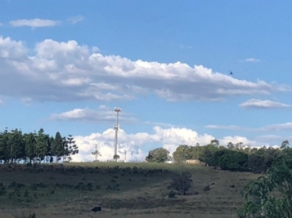

## Summary of findings

### Findings - implementation

| **Findings (1-13)** | |
| --- | --- |
|  | Since its commencement in 2014, nine grant funding rounds have been opened under the MBSP. Over the nine rounds, the program has consistently maintained a goal of extending mobile coverage in underserved areas. Each round has focused on a specific area through targeted guidelines. Grantee financial co-contributions have also been an ongoing requirement. |
|  | In total, the MBSP has enabled investment of over $1 billion (including GST) in mobile telecommunications infrastructure with:   * an Australian Government contribution of $394.2 million (including GST), and * co-contributions of $661.7 million (including GST) from state and local governments, industry, and third parties. |
|  | MBSP funding has been awarded for 1,400 new base stations. As of October 2024, 1,133 base stations had been completed across the country. There are currently 206 base stations remaining to be completed. |
|  | Over 6% of Australia’s base stations have been funded as part of this program. This equates to 17% remote and very remote and 12% inner and outer regional base stations. |
|  | Successful grants were allocated across the country but with much higher numbers of funded solutions in New South Wales, Western Australia, Queensland, and Victoria. |
|  | Telstra has been the program’s dominant participant in terms of both the number of applications and the delivery of base stations funded under the program (73%), followed by Optus (19%), TPG (5%), OneWiFi (2%) and FSG (1%). |
|  | The number of proposals received was highest in the earlier rounds (555 and 429 in Rounds 1 and 2, respectively). This has tapered over subsequent rounds, with significantly fewer proposals in Rounds 5A (95), Round 6 (105), and Round 7 (73). |
|  | Round 1 delivered the highest number of base stations by far, with numbers declining over subsequent rounds. The amount of funding awarded per round was highest in Round 1, trended downwards over Rounds 2 to 5A, and increased again over Rounds 6 and 7. The average funding per base station has generally increased over time, with the exception of Round 4. |
|  | DITRDCA’s delivery model and governance approach enabled successful program implementation, validated through external audits. DITRDCA consulted with stakeholders after each round and adapted the delivery of the next round, including recalibrating the focus for target communities and contributions from the Commonwealth. |
|  | Feedback from the survey and community visits indicated inconsistent levels of awareness of the MBSP and the funded base station's existence. |
|  | The average delivery duration for the base stations is four to five years, much longer than originally planned. Sites that cannot be built are a key pain point and a contributing factor to the extension of program timelines. |
|  | Initiated as a program with a single four-year round, the MBSP’s lifespan has been extended by additional rounds. |
|  | Opportunities for improvement were identified in performance measurement. These included the need for a more strategic approach to evaluation that would support streamlining of carrier reporting requirements and the use of a variety of data sources that would complement (and minimise reliance on) carrier reporting. |

### Findings - effectiveness

| **Findings 14-19** | |
| --- | --- |
|  | Project reporting evidenced that all of the program’s coverage-related KPIs have been exceeded.  To that end, the MBSP has delivered 1,133 base stations across the country, which have enabled:   * 301,645 km2 of land area to receive mobile coverage using an external antenna * 184,358 km2 of land area to receive mobile coverage using a handheld device * 28,691 km2 of land area where only external antenna mobile coverage was available previously to now receive handheld mobile coverage * 12,898 km of major rail and/or road transport routes to receive new handheld and new external antenna coverage * 135,864 premises to receive new mobile coverage. |
|  | Feedback from the survey and community visits indicated a degree of perceived positive change in coverage, reliability, and quality.  However, improved coverage was limited to users within the immediate vicinity of the base station and customers of the base station provider. (This limitation reflects the typical constraints of mobile network infrastructure, such as terrain, the number of concurrent users, and physical obstacles like trees and buildings.) |
|  | The survey and community visits identified examples of social, economic, and safety benefits resulting from the MBSP base stations. |
|  | Only 9% of the eligible MBSP-funded macro cell base stations built have MNOs co-located. MNOs indicated rates of co-location were low due to the base stations being built in locations they perceived to be commercially unviable.  The majority of survey and community respondents indicated that the base stations had not increased competition by enabling more choices of mobile carriers. |
|  | Survey and community respondents evidenced an appetite for increased choice. These stakeholders indicated they were also looking to additional and new technologies, including satellite solutions, to fill that need. |
|  | Intended competition outcomes have not been achieved. However, it is important to note that outcomes relating to competition entered the MBSP’s narrative as part of its explanatory statement and following its legislative authority.  Co-location was always encouraged as part of the program, including through weighted assessment criteria. However, it was never a mandatory requirement, and many stakeholder groups viewed competition as a secondary outcome to new/increased coverage. |

### Findings - appropriateness

| **Findings 20-26** | |
| --- | --- |
|  | Expectations relating to connectivity have evolved since the program’s inception - from mobile connectivity to data/internet connectivity (e.g., when the program commenced, consumer expectations were simpler, such as making and receiving calls and texts).  The program now fits within an updated frame of consumer expectations, which extend to using mobile devices as the preferred interfaces for accessing essential services, conducting business, and for education and health purposes. |
|  | The program was designed to provide a commercial incentive for telecommunications providers to increase new mobile terrestrial coverage in black spot areas.  Potential sites that offer a sufficient consumer base to afford a commercial return for MNOs have already likely been taken up as part of the program.  While communities in need remain; their location and context mean increased complexity and higher costs for the delivery of mobile base station solutions, and there is a diminishing appetite from MNOs to participate under the current incentives provided by the grants. |
|  | When the program commenced, it was one of only a few grant opportunities of its kind. Ten years on, it now operates in an expanded ecosystem of Commonwealth, state, and territory programs with aligned objectives. |
|  | The telecommunications industry has evolved rapidly since program commencement, with the advent of new technologies, including 5G and LEO satellites, which are now also available to consumers. Mobile terrestrial base stations remain an option for connectivity solutions, but they are now not the only option. |
|  | Survey results and community visits showed most people used mobile devices and had an associated preference and expectation for using them for their calls, digital services, and transaction needs. |
|  | All community stakeholder groups consulted emphasised the ongoing problem of limited/no mobile coverage in many areas across Australia – particularly in regional, remote, and very remote parts of the country.  This also included feedback from many community stakeholders where base stations were delivered. Not only was new coverage required, but also improved coverage, with respect to reliability, quality, and continuity to meet consumer expectations. Digital literacy was also identified as a key feature in optimising consumer experiences. |
|  | Well-being factors relating to safety (including medical and emergency situations) and accessing essential services related to health, financial, and social connectivity were identified as the priorities in driving the need for improvement.  The ongoing need for reliable communications during emergency situations and natural disasters was paramount. Using mobile services for streaming, browsing, and even business was viewed as secondary in people’s hierarchy of needs relating to mobile connectivity. |

# Introduction

## Context

Telecommunications infrastructure is critical for businesses, education, social cohesion, workplaces, and well-being throughout Australia. The 2011-12 Regional Telecommunications Review recognised the urban and rural and regional digital divide wherein poor mobile coverage was raised as a priority issue for regional Australia.[7]

Loss of business due to a lack of mobile coverage in regional areas was also highlighted as a pain point. The 2011-12 Regional Telecommunications Review stressed the importance of mobile coverage in attracting and retaining staff in rural and regional areas and dealing with emergency situations and accidents.

The Mobile Black Spot Program (MBSP) was designed and delivered in response to the findings and recommendations of the 2011-12 Regional Telecommunications Review, which recommended: “*a co-investment program, jointly funded by the Commonwealth and interested states or territory governments, to expand the mobile coverage footprint in regional Australia, focusing on priority regions selected with community input*”.

## About the program

The MBSP was launched in 2014 by the then-Department of Communications[8] to provide grant funding for investment in telecommunications infrastructure by Mobile Network Operators (MNOs) and Mobile Network Infrastructure Providers (MNIPs) to improve and expand telecommunications coverage and reception nationwide.

After Round 1 in 2014, which was implemented to improve mobile coverage in locations with unique coverage problems, eight more rounds have been opened (as of 16 December 2024). An overview of the program is illustrated in Figure 1.

The median project delivery timeframe of mobile black spot solutions is around three years, and it typically takes around four years for proximal communities to realise the benefits. In general, small cell base stations take less time to build than macro cell base stations.



Figure 1: MBSP overview reported as of 31 October 2024, based on information from DITRDCA

## About the evaluation

The MBSP program is ongoing. The purpose of the evaluation was to:

* assess the appropriateness, efficiency, and effectiveness of the MBSP in delivering on its policy intent and outcomes
* identify lessons learned for future program and policy design
* develop practical and realistic recommendations to support DITRDCA in further improving mobile access and delivery of future programs.

## About the evaluation report

Section 4 of this report presents discussion and findings against Key Evaluation Questions (KEQs) in separate subsections, relating to program implementation (KEQ1), effectiveness (KEQ 3), and appropriateness (KEQ2). Lessons learned (KEQ4) are discussed as relevant and applicable in each subsection.

Conclusions and recommendations are set out in Section 5.

A significant amount of qualitative data was collected via consultations, a community survey, and community site visits. Selected comments are provided throughout the report to highlight the key themes identified.

# Evaluation approach

## Methodology

Grosvenor developed a six-step methodology for the MBSP evaluation focused on Rounds 1 to 7 (outlined in Appendix A).

A program logic was developed in consultation with DITRDCA to support evaluation planning (provided in Appendix B).

Four KEQs were developed to guide the evaluation:

1. (Implementation) To what extent has the program been successfully implemented?
2. (Appropriateness) To what extent is the program fit for purpose?
3. (Effectiveness) To what extent have the MBSP’s intended short- and medium-term outcomes been achieved?
4. What lessons does the program offer for future program and policy design?

The sub-KEQs sitting under each of these KEQs are listed in Appendix C.

The evaluation involved the following data collection steps:

1. Workshopping and refining program logic with DITRDCA.
2. Conducting consultations with seven members of the DITRDCA project team, six representatives from the Mobile Network Operators (MNOs) and Mobile Network Infrastructure Providers (MNIPs), two co-chairs of the First Nations Digital Inclusion Advisory Group, 12 representatives across state and territory governments and one industry stakeholder from Northern Territory. The list of stakeholders is provided in Appendix D.
3. Conducting an online survey of residents living near the list of 1,133 completed base stations provided by DITRDCA.[9]
4. Undertaking five community visits to seven sites (including a visit to a First Nations community) across the country, including the states of Tasmania, South Australia, Queensland, New South Wales, and Western Australia. A list of these community visits is provided in Appendix E along with a case study for each community visit.
5. Reviewing available desktop data and documentation (referenced throughout the evaluation report).

Draft evaluation findings were provided to DITRDCA for comment prior to the development of the evaluation report, and feedback has been incorporated.

## Data limitations

There are no material limitations to this evaluation. Minor limitations are noted below:

* The MBSP survey may be affected by voluntary response bias, which means that there might be an overrepresentation of individuals with strong opinions, often those who are dissatisfied, while those with neutral or positive experiences may be less motivated to participate. As a result, the survey results may not accurately represent the views of the broader population.
* Certain questions in the survey posed to the people who were aware of the base stations focused on the degree of positive change experience and may have elicited positively biased responses.
* Grosvenor could not be provided with all available data for inclusion in the evaluation analysis due to the commercial and confidential nature of some data relating to MNOs and MNIPs.
* The five community visits constitute a very small sample size and should be considered indicative but not representative of the overall target population of the MBSP.

A contextual nuance to the evaluation relates to the fact that connectivity issues identified by community stakeholders during the evaluation often related to their broader connectivity problems as a whole – and were not necessarily attributable to the MBSP. That is, the MBSP is only one program – playing one part in addressing a broader and systemic national connectivity issue.

# Discussion and Findings

## Implementation (KEQ 1)

### Grant rounds

|  |
| --- |
| **Finding 1:** Since its commencement in 2014, nine grant funding rounds have been opened under the MBSP.  Over the nine rounds, the program has consistently maintained a goal of extending mobile coverage in underserved areas. Each round has focused on a specific area through targeted guidelines. Grantee financial co-contributions have also been an ongoing requirement. |

MBSP was initiated in 2014 as a $110 million (including GST) Australian Government competitive grants funding program; to be made available over four financial years (2014-15 to 2017-18). DITRDCA has been responsible for administering the program on behalf of the Government since program inception.

MBSP Round 1 was launched in December 2014. Open to MNOs and MNIPs, grant funding was available for the delivery of new or upgraded base stations to improve mobile coverage and the potential for competition in locations reported to DITRDCA as having inadequate mobile coverage.[10] (See Figure 5 in pages following for an overview of MBSP rounds opened as of 16 December 2024.)

Since Round 1, eight more rounds have been opened. Over the course of the nine rounds opened (to 16 December 2024), the program has maintained a consistent objective to extend mobile coverage in underserved areas, with each round having a specific focus through targeted guidelines criteria. As of October 2024, a tenth round (called Round 8) is expected to open in late 2024.

Grantee financial co-contributions have also been a consistent requirement of program participation.

### Funding, co-funding and infrastructure built

|  |
| --- |
| **Finding 2:** In total, the MBSP has enabled investment of over $1 billion (including GST) in mobile telecommunications infrastructure with:   * an Australian Government contribution of $394.2 million (including GST), and * co-contributions of $661.7 million (including GST) from state and local governments, industry, and third parties. |

|  |
| --- |
| **Finding 3:** MBSP funding has been awarded for 1,400 new base stations. As of October 2024, 1,133 base stations had been completed across the country. There are currently 206 base stations remaining to be completed. |

|  |
| --- |
| **Finding 4:** Over 6% of Australia’s base stations have been funded as part of this program. This equates to 17% remote and very remote and 12% inner and outer regional base stations. |

Under **Rounds 1-7**, the MBSP awarded funding for 1,400 base stations across the country:

* the Australian Government has contributed $394.2 million (including GST),
* the program has leveraged co-contributions of $661.7 million (including GST) from state and local governments, industry, and third parties.

A total investment of over $1 billion (including GST) has been enabled under the MBSP.[11]

As of October 2024, for **Rounds 1 to 7**:

* 1,133 base stations are operational (Site is On Air)[12]
* and a further 206 base stations are currently in the program.

Base stations built have included both macro cells and small cells. Around 80% (906) of the base stations built under MBSP are macro-cell solutions, while the remaining 20% (227) are small-cell solutions.[13]

A map of the locations of the base stations, both complete and in progress, is shown in Figure 2.

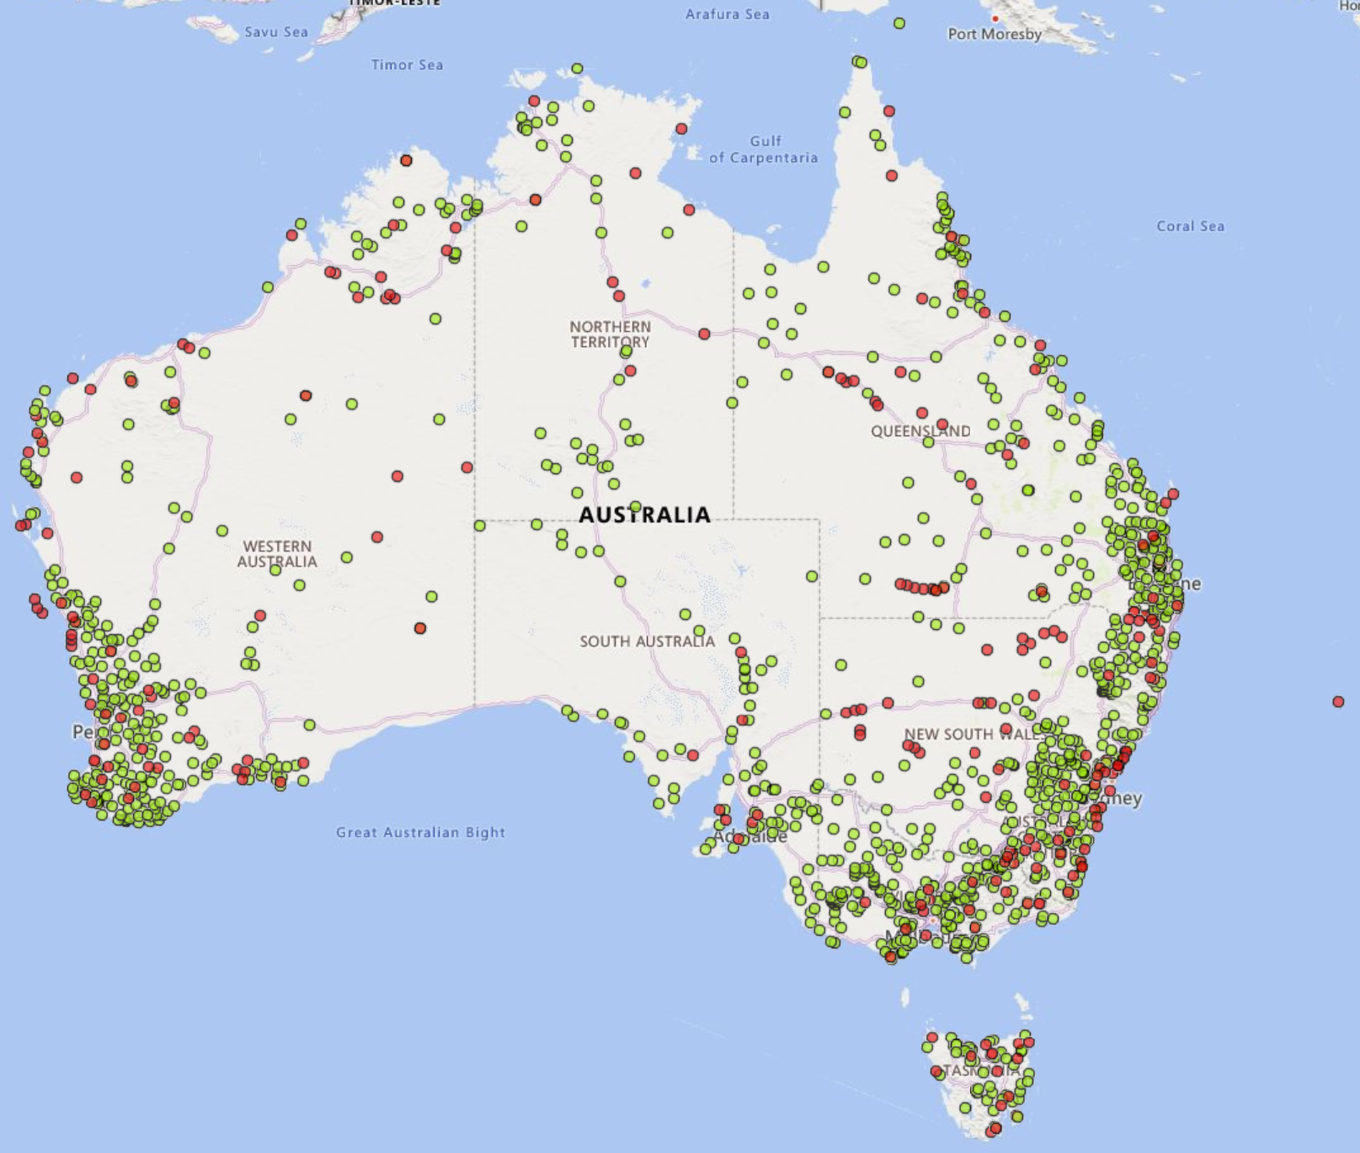

Site Status

Complete

In progress

Figure 2: Funded base stations across Rounds 1-7 (November 2024) according to [MBSP National Map](https://nationalmap.gov.au/#share=s-gkv23r0VJd2moboY280M2BsN2xR)

From a national context, **Rounds 1 to 5A[14]** have led to the establishment of 17% of base stations with equivalence to the program’s eligible areas for funding (by Optus, Telstra, TPG and FSG) in remote and very remote areas of Australia and 12% in inner and outer regional areas (illustrated in Figure 3).

The MBSP accounts for over 6% (1,133) of the total number of base stations across the country. Three-quarters (850) of these MBSP base stations were built by Telstra (850), 20% (221) by Optus, 5% (60) by TPG, and less than 1% (2) by FSG (see Figure 4).

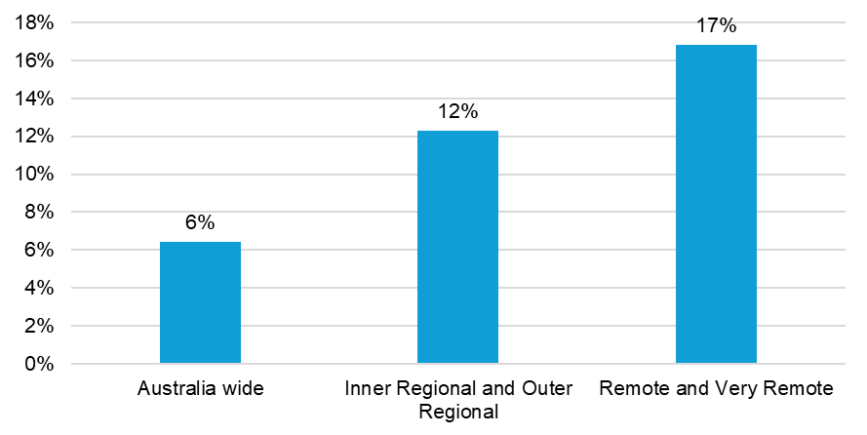

Figure 3: Base stations by area built by Optus, Telstra, TPG and FSG under MBSP as a percentage of the total number of base stations across the country based on data from ACCC Mobile Infrastructure Report 2024 (31 January 2024) and DITRDCA (reported as of 31 October 2024)[15]

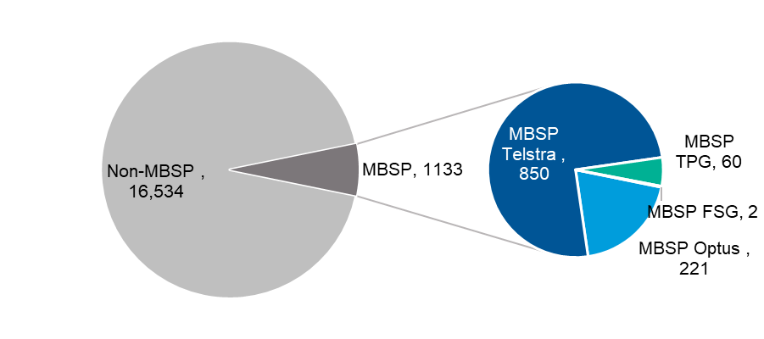

Figure 4: Base stations built by Optus, Telstra, TPG and FSG under MBSP as a percentage of the total number of base stations across the country based on data from ACCC Mobile Infrastructure Report 2024 (31 January 2024) and DITRDCA (reported as of 31 October 2024)

Figure 5 (overleaf) provides a snapshot of the MBSP’s nine rounds and rollout from 2014 to 16 December 2024, including the focus for each round, the amount of funding awarded, and the number of base stations built.

Diagram showing features of nine Mobile Black Spot Program rounds, from Round 1 onwards. 

Round 1, June 2015, focus on Improved coverage (From priority 6,000 Database of Reported Locations), funding awarded $110 million, program criteria, Extend mobile phone coverage and competition in regional Australia, Encouraged co-location weighted in assessment criteria, Cap $500,000 for single base station, co-contributions included, funded base stations 499.

Round 2, December 2016, focus on Improved coverage (From priority 10,668 Database of Reported Locations), funding awarded $57.2 million, program criteria, Deliver new mobile coverage to areas which did currently receive handheld coverage from any MNO or going to receive new handheld coverage from base station funded under Round 1, funded base stations 266.

Round 3 (Priority Locations Round), April 2018, focus on Priority Locations improved coverage, funding awarded $45.4 million, program criteria, Address specific mobile coverage and quality of service issue/s at the Priority Locations, Must co-locate or provide evidence as to why not, funded base stations 102.

Round 4, March 2019, focus on Public Interest Premises, funding awarded $28.3 million, program criteria, Improve mobile coverage and competition in regional and remote Australia,
Improve voice and data connectivity at Public Interest Premises, funded base stations 180.

Round 5, April 2020,  focus on Public Interest Premises and General Areas, funding awarded $36.7 million, program criteria, Improve mobile coverage and competition in regional and remote Australia, Improve mobile coverage at Public Interest Premises in regional and remote Australia, funded base stations 182.

Round 5A, July 2021, focus on Experimental round seeking innovative solutions / trialing new technologies, funding awarded $20.8 million, program criteria, Deliver new handheld coverage, 
Focus on new handheld coverage to High Priority Natural Disaster Prone Area and transport corridors, Trial of new solutions, funded base stations 68.

Round 6 (Improving Mobile Coverage Round Stage 1), October 2023, focus on Improved mobile coverage in target locations, funding awarded $40.9 million, program criteria, Extend and improve mobile phone coverage and competition in regional and remote Australia, Encourage sharing or co-locate - if not, must provide evidence as to why not, Cap $680,000 for single microcell base station and $250,000 for single small cell base station, funded base stations 41.

Round 7, December 2023, focus on New coverage in rural and regional areas, funding awarded $54.9 million, program criteria Deliver new handheld coverage to regional, rural and remote Australia, Includes targeted funding for solutions in First Nations communities, Includes capitalised operational costs in funding, funded base stations 62.

Improving Mobile Coverage Round Stage 2, July 2024, focus on Improved mobile coverage in two target locations, funding awarded $3 million.

Diagram shows that department consultations occurs across all rounds with industry and state and territory government stakeholders post each round to inform new / next round.

1,133 base stations built (as of 31 October 2024) across all rounds.

Delivery commitments continue until 2026-27.

Figure 5: Summary of MBSP Rounds[16],[17]

### Geographic footprint

|  |
| --- |
| **Finding 5:** Successful grants were allocated across the country but with much higher numbers of funded solutions in New South Wales, Western Australia, Queensland, and Victoria. |

Out of the 1,400 base stations funded under MBSP across **Rounds 1 to 7**, 26% (357) are located in New South Wales, 25% (346) in Western Australia, 19% (271) in Queensland, and 16% (217) in Victoria (Figure 6). Across South Australia, Tasmania, the Northern Territory, and the Australian Capital Territory, 90, 67, 49, and three base stations are funded, respectively.

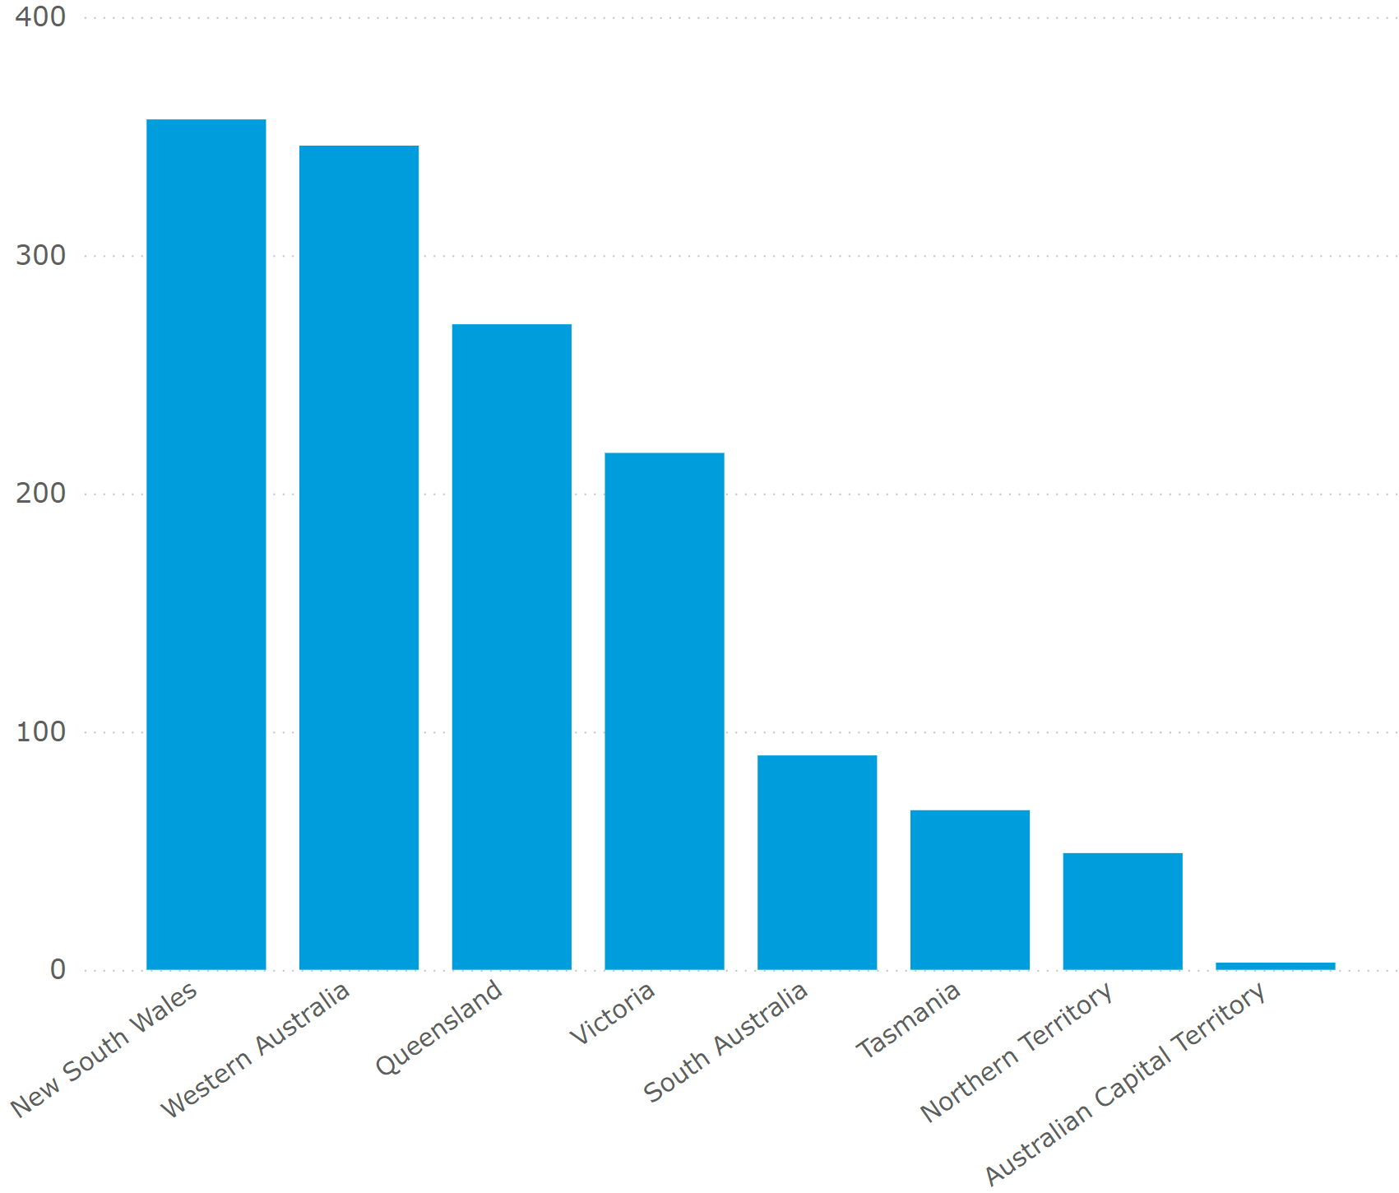

Figure 6: Number of funded solutions by state/territory based on data from DITRDCA (reported as of 31 October 2024)

In interviews, jurisdictions that had not participated as actively as some other states expressed interest in leveraging the program more fully.

### Industry participation

|  |
| --- |
| **Finding 6:** Telstra has been the program’s dominant participant in terms of both the number of applications and the delivery of base stations funded under the program (73%), followed by Optus (19%), TPG (5%), OneWiFi (2%) and FSG (1%). |

As seen in Figure 7, Telstra has been responsible for most (1,018) of the 1,400 MBSP base stations funded under the MBSP, followed by Optus (264) and TPG (76). OneWiFi, an MNIP, is responsible for 25 base stations under Round 7. FSG, another MNIP, is responsible for two base stations funded under Round 5 and 15 under Round 5A.

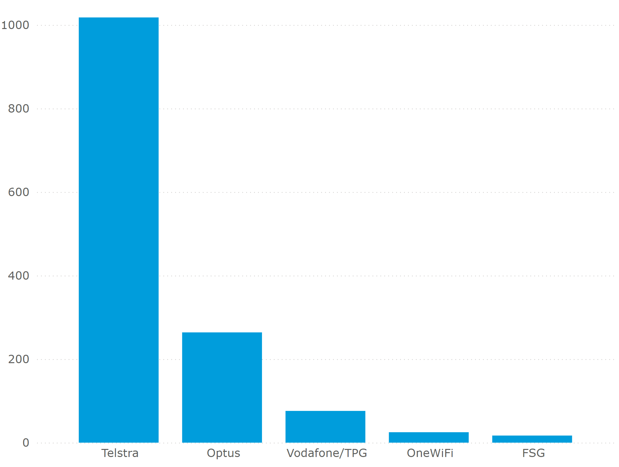

Figure 7: Number of funded solutions by carriers based on data from DITRDCA (reported as of 31 October 2024)

### Program activity over time

|  |
| --- |
| **Finding 7:** The number of proposals received was highest in the earlier rounds (555 and 429 in Rounds 1 and 2, respectively).  This has tapered over subsequent rounds, with significantly fewer proposals in Rounds 5A (95), Round 6 (105), and Round 7 (73). |

|  |
| --- |
| **Finding 8:** Round 1 delivered the highest number of base stations by far, with numbers declining over subsequent rounds. The amount of funding awarded per round was highest in Round 1, trended downwards over Rounds 2 to 5A, and increased again over Rounds 6 and 7. The average funding per base station has generally increased over time, with the exception of Round 4. |

The number of base stations built and funding amounts for **Rounds 1 to 7** are presented in Table 1.[18] The majority of the base stations under MBSP, 486 and 258, were built under Rounds 1 and Round 2, respectively. The average funding per base station was also lower in these initial rounds compared to later rounds, with the exception of Round 4. The funding allocated to Rounds 1 and 2 as a percentage of the total funding was higher than the subsequent rounds (Figure 8). The percentage of total funding awarded decreased over Rounds 2 to 5A, and increased again over Rounds 6 and 7.

In interviews, DITRDCA reported that while the program had continued to attract strong applications and, at times, exhausted the funding available for each grant funding round, Rounds 5 and 5A were undersubscribed. DITRDCA acknowledged that the number of proposed sites applied for had declined relative to early rounds, but noted that there were still quality applications from industry for each round.

DITRDCA indicated that funded solutions had become more difficult to deliver in regional and remote areas, inflation had impacted overall construction and operating costs, the total costs of sites had become higher, and costs to the Commonwealth had increased as well. To address this, funding of operational costs was introduced from Round 6, consistent with the design of the Peri-Urban Mobile Program (PUMP) Round 1, increasing the total cost of solutions that were eligible for funding. This is also discussed further in Section 4.3.2.

MNO consultations indicated that the initial rounds accounted for most of the commercially viable sites. MNOs indicated that as the program progressed, the base stations had to be located in less commercially attractive sites, which meant that the average funding per base station increased due to higher set-up and ongoing operational costs.

“It’s a scale of diminishing returns for us - heavily populated areas were the originally targeted scope…As we get further out, the number of premises drops off – it’s a problem because less people are out there...They (the sites) are also more challenging areas - hilly and valley areas… a lot of money, little outcome.” (MNO)

|  |  |  |  |  |  |  |
| --- | --- | --- | --- | --- | --- | --- |
| Round | Number of base stations funded | Number of base stations built (reported as of 31 October 2024) | Funding awarded per round (inclusive of GST) | Average Commonwealth funding per base station funded | Average Commonwealth funding per Macro Cell funded | Average Commonwealth funding per Small Cell funded |
| Round 1 | 499 | 486 | $110m | $220,000 | $0.22m | $0 |
| Round 2 | 266 | 258 | $57.2m | $215,025 | $0.24m | $0.09m |
| Round 3 (Priority Locations Round) | 102 | 86 | $45.4m | $440,278 | $0.47m | $0.13m |
| Round 4 | 180 | 163 | $28.3m | $157,187 | $0.24m | $0.09m |
| Round 5 | 182 | 125 | $36.7m | $202,338 | $0.38m | $0.11m |
| Round 5A | 68 | 15 | $20.8m | $305,783 | $0.42m | $0.10m |
| Round 6 (Improving Mobile Coverage Round Stage 1) | 41 | In Progress | $40.9m | $998,841 | $1m | $0.84m |
| Round 7 | 62 | In Progress | $54.9m | $886,532 | $0.95m | $0.59m |

Table 1: Number of base stations and funding awarded per round as per data from DITRDCA, Auditor-General Report No.28 2023–24 Performance Audit Award of Funding under the Mobile Black Spot Program[19]

Bar graph showing percentage of total base stations funded, percentage of total base stations built and percentage of total funding awarded from Round 1 to Round 7.
Round 1: total base stations funded, about 36%, total base stations built, about 43%; total funding awarded, about 23%.
Round 2: total base stations funded, about 19%, total base stations built, about 23%; total funding awarded, about 14%.
Round 3 (Priority Locations Round): total base stations funded, about 7%,  total base stations built, about 13%; total funding awarded, about 11%.
Round 4: total base stations funded, about 13%, total base stations built, about 14%; total funding awarded, about 12%.
Round 5: total base stations funded, about 13%, total base stations built, about 11%; total funding awarded, about 9%.
Round 5A: total base stations funded, about 5%, total base stations built, about 2%; total funding awarded, about 5%.
Round 6 (Improving Mobile Coverage Round Stage 1): total base stations funded, about 3%, total base stations built, 0%; total funding awarded, about 10%.
Round 7: total base stations funded, about 4%, total base stations built, 0%; total funding awarded, about 14%.

Figure 8: Comparison of percentage of base stations and funding awarded by round as per data from DITRDCA and Auditor-General Report No. 28 2023–24 Performance Audit Award of Funding under the Mobile Black Spot Program

The number of proposals from MNOs was the highest in Rounds 1 and 2 at 555 and 429, respectively (see Figure 9). Only a limited number of the proposed solutions were deemed ineligible by DITRDCA across the rounds.

There was interest from new applicants in Round 5, with MNIPs such as FSG entering the program. However, with industry applicants reporting increasing difficulty and higher costs of deployment of base stations to more complex sites or with smaller populations, the number of proposals received from MNOs and MNIPs has tapered significantly over time.

Bar graph showing number of proposed solutions, ineligible proposed solutions, and funded solutions, from Round 1 to Round 7.
Round 1: proposed solutions, about 550; ineligible proposed solutions, about 25; funded solutions, about 500.
Round 2: proposed solutions, about 430; ineligible proposed solutions, about 25, funded solutions about 265.
Round 3 (Priority locations round): proposed solutions, about 150; ineligible proposed solutions, 0, funded solutions about 100.
Round 4: proposed solutions, about 280; ineligible proposed solutions, about 25, funded solutions 180.
Round 5: proposed solutions, about 400; ineligible proposed solutions, about 60, funded solutions about 185.
Round 5A: proposed solutions, about 100; ineligible proposed solutions, about 2, funded solutions about 70.
Round 6 (Improving Mobile Coverage Round 1): proposed solutions, about 110; ineligible proposed solutions, about 5, funded solutions about 40.
Round 7: proposed solutions, about 70; ineligible proposed solutions, 0, funded solutions about 60.

Figure 9: Number of proposed solutions, ineligible proposed solutions, and funded solutions by round based on data from DITRDCA (reported as of 31 October 2024)

### Delivery model and governance approach

|  |
| --- |
| **Finding 9:** DITRDCA’s delivery model and governance approach enabled successful program implementation, validated through external audits. DITRDCA consulted with stakeholders after each round and adapted the delivery of the next round, including recalibrating the focus for target communities and contributions from the Commonwealth. |

DITRDCA’s documentation relating to the program’s governance, accountability mechanisms, and risk management were reviewed, including:

* Corporate Plan[20]
* Risk Management and Policy Framework (2023)[21]
* Probity framework (2022)[22]
* Integrity Framework[23]
* Examples of Assessment Plans and Probity Plans for different rounds (including the Improving Mobile Coverage Round [IMCR] Stage 2).[24]
* Grosvenor reviewed the 2023-24 Supplementary Budget Estimates[25] and assessed that MBSP's expenditures to 20 December 2024 have aligned with funding round allocations and have not exceeded the planned program budget.

External Australian National Audit Office (ANAO) audits of **Rounds 1[26]** and **6[27]** of the program showed governance, probity, and risk-related documentation had been developed for each of those rounds.

At a corporate level, the program currently sits within Outcome 5—Communications Connectivity of the Department’s Corporate Plan,[28] and its performance is published in annual reports, most recently as part of Performance Measure 25—Total amount of new and improved mobile coverage delivered through the Mobile Black Spot Program and the Peri-Urban Mobile Program.[29]

Consultations with DITRDCA incorporated discussions of the above, and further described:

* the department’s program team structure – split into areas that focus on (1) the development of Guidelines, the application and assessment process, contract negotiations and (2) the delivery of funded solutions
* the processes utilised in the review of each (previous) round to inform the planning of each subsequent round. This included consultation with stakeholders from industry and jurisdictions to inform the design and development of guidelines, criteria, and the application and assessment process for each funding round. For example, over the nine rounds, the focus for target communities and contributions from the Commonwealth has been recalibrated
* their approach to managing and administering the delivery of funded solutions, including how:
* project milestone data was collected and monitored against planning
* Key Performance Information (KPI) related data was collected and monitored regularly against grant agreements
* the department was engaged in supporting MNOs, MNIPs and state counterparts to manage risk and to support effective delivery of projects, including revising timelines for delivery and assisting in stakeholder management where possible and appropriate. To date the program has received an exemption from using the Grants Hub due to the highly technical nature of the assessment process and complexities of program delivery and administration. The department reported a significant amount of time and experience was required to liaise with applicants to reassess, adapt and manage risks for each solution.

In consultation with industry, state, and territory stakeholders, a number of interviewees commented on the level of telecommunications-related expertise currently housed in DITRDCA’s program team, which was regarded as advantageous in supporting efficient and effective program delivery.

### Levels of awareness

|  |
| --- |
| **Finding 10:** Feedback from the survey and community visits indicated inconsistent levels of awareness of the MBSP and the funded base station's existence. |

Out of the 536 survey respondents,[30] only 49% (260) were aware of the base station built under the MBSP in their area, while 51% (276) were unaware of it (Figure 10).

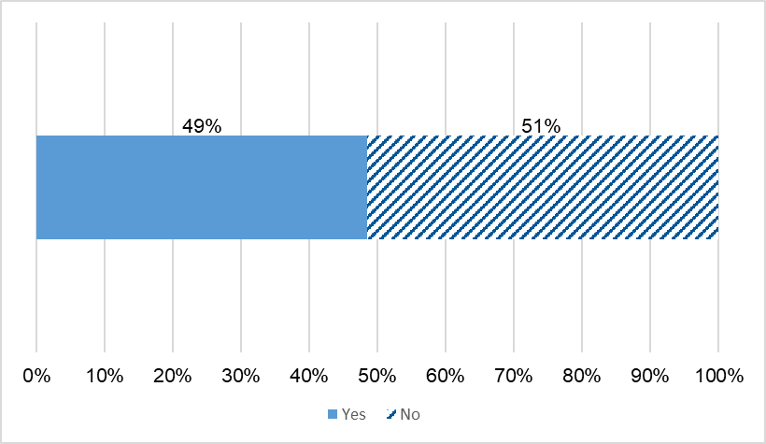

Figure 10: Survey response for awareness about the MBSP mobile base station in the area (n=536)

Community visits also highlighted the range in levels of awareness of the funded base station. For example, in one community, only a minority of people interviewed were either aware of or recalled the delivery of the base station in 2022, and in another community, a number of interviewees erroneously thought that the base station was a Telstra tower. In another community, residents reported that the tower “seemed to appear on the landscape one day”.

“There was no information provided to us about the base station being built, and suddenly there was mobile reception on my phone.” (Blessington)

Stronger levels of awareness of the base stations were more evident in communities where there had been active community champions who had driven community engagement and maintained the project's momentum from a community perspective.

Community visits also indicated inconsistent levels of community engagement, ranging from a lack of awareness to high levels of awareness to polarising views about where the base station was located.

“Why did they build it there? Why didn’t they build it on one of the peaks to get more coverage?” (Blessington)

“The consultation process went on for two to three years and threw up polarised views.” (Laguna)

“Where the tower was built is just dumb. There are only 20 people that live out there.” (Robertstown)

### Timeframes for delivery

|  |
| --- |
| **Finding 11:** The average delivery duration for the base stations is four to five years, much longer than originally planned. Sites that cannot be built are a key pain point and a contributing factor to the extension of program timelines. |

Delivery of funded solutions has taken longer than planned.

Interviews with DITRDCA highlighted that:

* when the program was established, it was assumed that projects could be delivered within a two to two-and-a-half-year timeframe (depending on whether the solution was small cell or macro cell)
* the actual median timeframe for delivery for each funded solution was three years, and 90% were completed within four to five years (small cell site builds can take less time than macro cell base stations to build). A small number of complex projects are taking even longer. It can take approximately four years for the benefits to be realised by proximal communities
* the length of time for funding appropriations for each round has been provided over a variety of financial years. Completion of some base stations has extended beyond the grant round’s funding appropriation (for example, in the case of Round 1, the completion of some base stations has extended out as far as nine years from the commencement of the round). The department described processes in place to manage grantee variation requestions, including requestions for variations to site locations and extension of time to complete
* while these processes have assisted the department in managing the delivery of sites and program outcomes, in some complex cases, despite additional time, some sites have been unable to be built. Base station deployment is a complex process. A number of separate phases are involved, including site inspection, detailed design, planning approvals, site acquisition, construction, and final activation. As well as the MNO building the base station, a number of external parties are directly and indirectly involved in the deployment process. These other parties include landowners, local communities, local councils, state government departments, power authorities, other MNOs, equipment manufacturers, and infrastructure providers. Planning approvals and site acquisition, in particular, are subject to external processes that are typically outside of the direct control of the MNOs. In some instances, these external factors may impact the delivery timeframe for a base station. For example, additional fauna or flora surveys may be required before local planning approval is granted, or negotiations with landowners may take longer than anticipated.[31]

DITRDCA staff noted that the bulk of sites are completed over the first few years after contracting, but the difficult sites take longer. Anecdotal estimations by DITRDCA staff indicated that around 90% of base stations are delivered within 4-5 years with the remaining 10% being more challenging to complete.

DITRDCA staff also indicated that every round (between Rounds 1 to 5A so far) has been extended. Staff reflected that the levers to drive faster delivery are weak as there are a range of external factors and parties involved. There is also a sunk cost dimension to extensions in that the funding has been awarded, and the industry is working to deliver a site – if the site were to be cancelled because it takes too long, an applicant could reapply in a later round, but the process starts again.

Industry stakeholders affirmed that two to two and a half years was unrealistic for delivering telecommunications infrastructure projects, particularly some of the more complex solutions.

“Timeframes are impacted by property tenure, power, and weather. It’s often only once you start to dive deeper into the project you discover some of the issues.” (MNO)

“Generally, if you consider any greenfield deployment, we are working towards a 36-month window from release, finding suitable land, then planning, procurement, and construction. That generally applies to 80%; for the other 20%, it extends by another 24 months. (This is not just a government program but an internal program as well.)” (MNO)

The community visit to Laguna provided an example of a lengthy and complex process. In interviews, residents recalled the process of securing the base station as both a protracted and polarising experience for the community:

* initially, Telstra initiated the process in June 2018 but then withdrew in the face of objections from a portion of the community that was concerned that the tower:
* would compromise visual amenities and
* had the potential for untested harm from the 5G radio wave frequencies on the population.
* post Telstra’s withdrawal from the process, the Laguna community petitioned in support of a mobile tower
* Optus delivered the tower in December 2023 (five years after the initial investigations by Telstra).

(See further Laguna case study in Appendix E.)

Further analysis of delivery timelines of funding solutions for each round is presented in Figure 11.

Bar graph showing duration of rounds.
Round 1: Duration (Application Opening to Closing), around December 2014 to April 2015; Duration (Application Closing to Announcement), around April 2015 to June 2015; Duration (Announcement to Development Closure), around June 2015 to March 2025.
Round 2: Duration (Application Opening to Closing), around February 2016 to July 2016; Duration (Application Closing to Announcement), around July 2016 to December 2016; Duration (Announcement to Development Closure), around December 2016 to March 2025.
Round 3 (Priority Location Round): Duration (Application Opening to Closing), around November 2017 to December 2017; Duration (Application Closing to Announcement), around December 2017 to April 2018; Duration (Announcement to Development Closure), around April 2018 to November 2024.
Round 4: Duration (Application Opening to Closing), around October 2018 to January 2019; Duration (Application Closing to Announcement), around January 2019 to March 2019; Duration (Announcement to Development Closure), around March 2019 to March 2025.
Round 5: Duration (Application Opening to Closing), around April 2019 to September 2019; Duration (Application Closing to Announcement), around September 2019 to April 2020; Duration (Announcement to Development Closure), around April 2020 to March 2025.
Round 5A: Duration (Application Opening to Closing), around November 2020 to March 2021; Duration (Application Closing to Announcement), around March 2021 to July 2021; Duration (Announcement to Development Closure), around July 2021 to March 2025.
Round 6 (Improving Mobile Coverage Round Stage 1): Duration (Application Opening to Closing), around February 2023 to April 2023; Duration (Application Closing to Announcement), around April 2023 to October 2023; Duration (Announcement to Development Closure), around October 2023 to December 2026.
Round 7: Duration (Application Opening to Closing), around March 2023 to August 2023; Duration (Application Closing to Announcement), around August 2023 to December 2023; Duration (Announcement to Development Closure), around December 2023 to June 2027.
Improving Mobile Coverage Round Stage 2: Duration (Application Opening to Closing), around July 2024 to September 2024; Duration (Application Closing to Announcement), from September 2024, ongoing.

Figure 11: Duration of rounds

*Note: (1) The vertical lines at each bar refer to the delivery milestones in terms of the percentage of base stations delivered for each round (e.g. 25% of sites under Round 1 were completed by May 2017), (2) The development closure period refers to rollout completion for the base stations and does not include the final milestone payment or ten-year operational period, (3) For the Improving Mobile Coverage Stage 2 round only the application opening and closing dates were reported at the time of the evaluation as the grant for this round was under assessment, (4) Duration relates to all base stations funded under that particular round. It is important to note that 90% of base stations are delivered within 4 – 5 years.*

A key pain point related to base stations that could not be built, most commonly due to not being able to find a viable location or willing landholder.

The complexity of delivering base stations has led to extensions of time for all earlier rounds (1 to 5A) of the program. Despite extensions, some base stations could still not be built. Across **Rounds 1 to 7**, there have been 111 such base stations. Out of these, 62 (approximately 4.4% of all 1,400 funded base stations) were removed over the program's lifespan, and 49 replacement sites were added to the program.[32]

Grant requirements under the MBSP require MNOs to propose alternative locations and explore all options to provide new and improved coverage to the location before designating a base station as unbuildable.

Common difficulties with these base stations included obtaining state government/authority approvals, unforeseen design and build requirements and associated costs, and difficulty obtaining reasonable access to supporting infrastructure.[33] The prominent reason, however, has been the inability to find a viable location and a willing landowner (private, local, and state government landowner).[34]

DITRDCA staff noted that more challenging sites can take a long time to be delivered and, in some cases, end up not being built.

“Barriers…Overlaps where Native Title covers National Parks / Crown Lands (where we see two parties trying to both extract rent as the landlord).” (MNO)

Mitigating risks associated with challenging and/or base stations that could not be built, as part of the application and assessment process, was highlighted as an opportunity for improvement:

* by increasing the length of time for the development of grant applications (The length of time from the release of guidelines to the closing date for applications ranged from one month to four and a half months. MNOs indicated this was an insufficient timeframe to research and deliver well-informed bids.)
* by splitting the grant application and assessment process into two stages at the front end – (1) feasibility study (desktop and site visit feasibility) and (2) site acquisition, design and construction
* by providing schedules attuned to realistic timeframes, not calibrated to funding round end dates.

“Let’s be real about the timeframes for delivery of the projects, particularly in remote settings.” (MNO)

“The biggest thing in preparing an application is coverage simulation and analytics. There has to be a better way of doing this. If applicants could assess their proposals before submitting them. It would help if there was a pre-screening before a lot of effort is put into the application.” (MNO)

### Ongoing program extensions

|  |
| --- |
| **Finding 12:** Initiated as a program with a single four-year round, the MBSP’s lifespan has been extended by additional rounds. |

The MBSP was initially planned as a single four-year grants round (2014-15 to 2017-18).[35] Ten years since, and eight rounds on, its completion date has currently been extended to 3 June 2027.

DITRDCA staff noted that it was not envisaged at the start of the program that it would still be running ten years later. The round-by-round funding of the program has seen its continuation over a long period.

While stakeholder groups were positive about the program's extension, noting the additional infrastructure enabled by subsequent funding rounds, there were a number of industry, state, and territory representatives that highlighted the year-on-year extensions made for:

* lack of alignment between program funding cycles with those of the jurisdictions (co-contributors)
* community perception of the MBSP as an ongoing (rolling) program rather than a series of extended near-annual funding rounds
* lack of flexibility in grant options, such as considering multiple stages of grant programs and demand-driven (rather than competitive) to offer place-based solutions, for example, in the case of First Nations communities
* onset of carrier fatigue driven by the short turnaround amount time between rounds, and delivery already at capacity due to previous rounds.

While most Commonwealth grant programs are time-limited to serve a particular policy objective and are funded on a round-by-round basis, opportunities identified for improvement (by stakeholders including DITRDCA, jurisdictions and industry) related to future positioning of the program within longer lapsed timeframes (i.e., greater than one year) with a view to:

* giving industry and jurisdictional counterparts more time to understand what the program’s intentions are and to provide more certainty around funding available
* enable more flexibility in funding options, for example:
* considering multiple stages of grant programs or demand-driven (rather than competitive) approaches
* offering smaller amounts of money annually but over a longer time period (when industry has limited capacity to respond)
* offering more money per round rather than more rounds
* enabling longer-term planning so that outcomes and delivery align with the strategic settings and budgeting of other programs and jurisdictions and for increased connectivity between counterparts across the communications portfolio and states and territories.

DITRDCA staff reported that one of the main criticisms from industry and state governments is that the program rounds have not been signalled early enough in order to allow alignment with state funding cycles or industry capital budgeting processes. States and industry want to plan budget allocations over three to four years, but the round-by-round funding of the program has prevented an early and routine program cycle from being implemented.

“It is very difficult to coordinate our budget processes with the Rounds, but we were generally able to link some funding with the program.” (State counterpart)

“We need time to plan and to make sure the communication mechanisms are better between local, state and federal governments.” (MNO)

### Understanding performance

|  |
| --- |
| **Finding 13:** Opportunities for improvement were identified in performance measurement. These included the need for a more strategic approach to evaluation that would support streamlining of carrier reporting requirements and the use of a variety of data sources that would complement (and minimise reliance on) carrier reporting. |

Some MNOs noted opportunities to streamline program reporting within DITRDCA and to enhance consistency across the states and Commonwealth regarding problem escalation.

“It is quite onerous on me as a single resource to compile and send the reports. There is a variation agreement and battery upgrade agreement - they initially said an email statement of completion was enough, and now I have (to) provide a whole report on it, which is quite onerous…Try to streamline some of the reporting rather than have duplication across the project.” (MNO)

“We do deal with various government agencies and departments. There are a lot of inconsistencies in how the state and federal departments operate. There needs to be some form of uniformity between the federal and state and bring communication together to escalate issues.” (MNO)

Reliance on carrier’s data was also identified by some jurisdictional representatives as a potential weakness. They pointed to the current mobile coverage audit[36] (underway by Accenture) as a positive step in validating project reporting against KPIs.

Interviews in some community visits also identified a disconnect between carrier data relating to coverage and their user experience.

“I’m being told that according to their (the mobile carrier’s) map, I have coverage… And I am saying to them – I live here, and I can tell you now, I am not getting any service.” (Riverton community member)

“People get caught off guard when the maps indicate there is coverage – and then there isn’t.” (Memerambi / Wooroolin community member)

The most recent external audit recommended that DITRDCA develop an evaluation plan and commence an evaluation (this evaluation) within 12 months.[37]

A more strategic and planned approach to conducting evaluation activities would benefit future program design and delivery.[38]

This could include developing an evaluation framework to provide a planned and outcomes-based approach to evaluation that would inform:

* consistent data collection and reporting of performance information, including resourcing of such and identifying opportunities for streamlining data collection and reporting activities, and corresponding reporting templates
* identify data vulnerabilities and how to plug these, including providing a balance of data sets to provide a holistic picture of performance

## Effectiveness (KEQ 3)

### Coverage

|  |
| --- |
| **Finding 14:** Project reporting evidenced that all of the program’s coverage-related KPIs have been exceeded.  To that end, the MBSP has delivered 1,133 base stations across the country, which have enabled:   * 301,645 km2 of land area to receive mobile coverage using an external antenna * 184,358 km2 of land area to receive mobile coverage using a handheld device * 28,691 km2 of land area where only external antenna mobile coverage was available previously to now receive handheld mobile coverage * 12,898 km of major rail and/or road transport routes to receive new handheld and new external antenna coverage * 135,864 premises to receive new mobile coverage. |

|  |
| --- |
| **Finding 15:** Feedback from the survey and community visits indicated a degree of perceived positive change in coverage, reliability, and quality.  However, improved coverage was limited to users within the immediate vicinity of the base station and customers of the base station provider. (This limitation reflects the typical constraints of mobile network infrastructure, such as terrain, the number of concurrent users, and physical obstacles like trees and buildings.) |

Program reporting showed most related KPIs relating to coverage were exceeded, with most of the reported increase achieved under Rounds 1 and 2.

Schedule 2 of Grant Agreements includes KPI thresholds for base stations built under MBSP. Each base station's performance is tracked against these thresholds.

Under the program, major rail and/or road transport routes that received new handheld and new external antenna coverage from the final built base station (12,898 km) exceeded the expected requirements of Schedule 2 (see Figure 12).

Bar graph showing number of major rail and/or route transport routes to receive new handheld and new external antenna, as linear kilometres.
Expected as per KPI Schedule 2, 9,986.
Actual built, 12,898.

Figure 12: Road coverage statistics for MBSP base stations as per data from DITRDCA (reported as of 31 October 2024)

Similarly, KPS thresholds were also exceeded for areas that receive mobile coverage from the final built base stations using an external antenna (301,645 km2), using a handheld device (184,358 km2), and areas where only external antenna mobile coverage was available previously, and can now receive handheld mobile coverage (28,691 km2) (see Figure 13).

Bar graph showing coverage for MBSP base stations, in kilometres squared.

New External Antenna: Expected as per KPI Schedule 2, 236,149; Actual built, 301,645.

New Handheld: Expected as per KPI Schedule 2, 153,134; Actual built, 184,358.

External Antenna upgraded to Handheld: Expected as per KPI Schedule 2, 14,218; Actual built, 28,691.

Figure 13: Coverage statistics for MBSP base stations as per data from DITRDCA (reported as of 31 October 2024)

The number of premises receiving coverage (135,864) was 15% higher than the expected requirements of Schedule 2 (see Figure 14). Around 135,130 premises received new external antenna mobile coverage, and 134,912 premises received new handheld mobile coverage.[39]

Bar graph showing number of premises receiving new mobile coverage.
Expected as per KPI Schedule 2, 118,109.
Actual built, 135,864.

Figure 14: Number of premises receiving new mobile coverage statistics for MBSP base stations as per data from DITRDCA (reported as of 31 October 2024)

Given that most base stations were built under Rounds 1 and 2, most of the reported increase in mobile coverage as per the KPI tracker was achieved under these rounds.

Other data sets also showed improvement relating to coverage and connectivity, as described below.

Mobile coverage audits across all the states and territories of a sample of base stations (15 in total) built under Rounds 1, 2, and 3 confirmed that coverage provided by all the sampled base stations was broadly comparable with the predicted coverage provided by the respective MNOs.[40]

Survey results showed approximately 55% of respondents (who knew about the base stations built under MBSP) experienced some degree of positive change in coverage. Around 53% of the respondents who knew about the base stations experienced some degree of positive change in reliability, and 52% experienced some degree of positive change in quality. (See Figure 15.

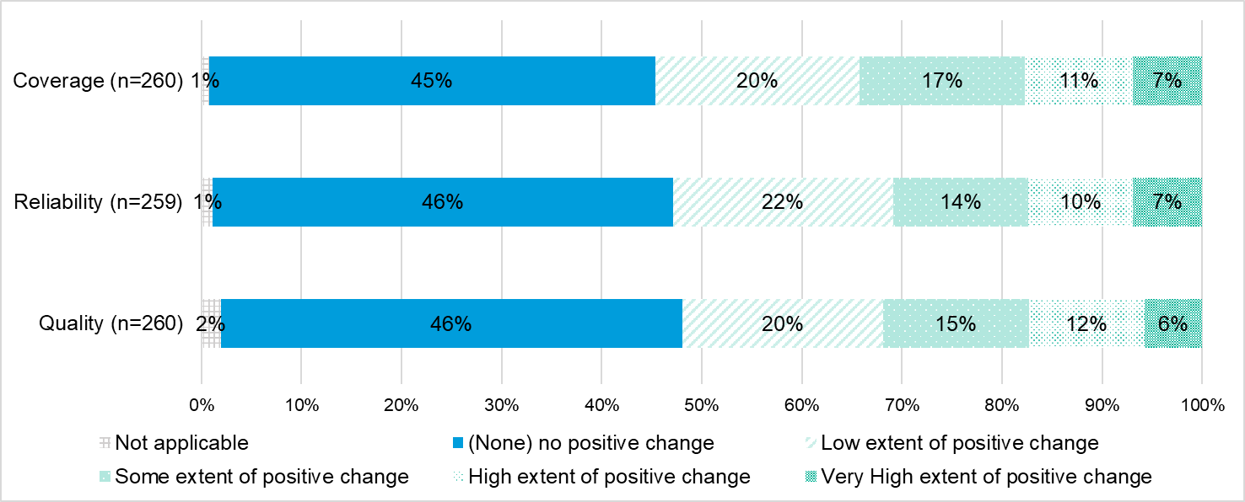

Figure 15: Survey response to positive change experienced or observed in coverage, reliability and quality since the base station was built/upgraded (answered by survey respondents who were aware of the base station)

Several stakeholders interviewed during community visits reported improvements in mobile coverage attributable to the MBSP base stations in their area.

“It (the base station) has made a massive difference. We don’t have a landline anymore.” (Blessington)

“The tower has made a huge difference in coverage down the main strip of Laguna and for the businesses there.” (Laguna)

“The towers did improve coverage. I remember there was no coverage in Wooroolin and Tingoora – and there is now.” (Memerambi and Wooroolin)

“We went from nothing to connectivity across the whole community.” (Yakanarra)

“Since the Tower went up, it’s been so much better. I don’t need the antenna (booster) anymore.” (Robertson)

(See further community visit case studies in Appendix E.)

Notwithstanding the above, the survey and community visits also highlighted high levels of dissatisfaction with their mobile service and their ongoing need for improved coverage (also discussed further in Section 4.3.3).

As shown in Figure 16, 77% (411) of all survey respondents strongly disagreed to disagreed with the statement ‘continuous day-to-day mobile coverage’. Similarly, around three-quarters (393) of the survey respondents strongly disagreed to disagreed with the statement ‘important services can be reliably accessed (health, safety, social, financial)’. Only 17% (89) of survey respondents stated that they could reliably use internet services, and 6% (30) stated that they had new sources of business income from improved connectivity.

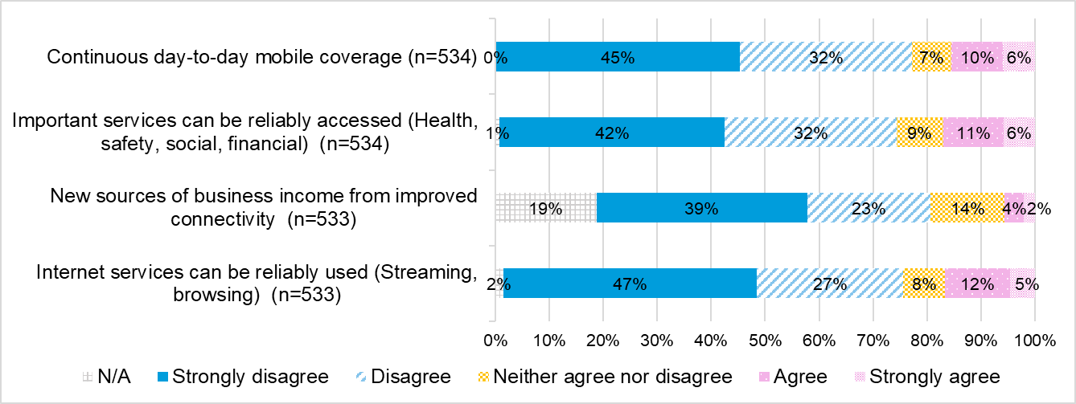

Figure 16 - Survey response to social, economic, and safety impacts

Further, the overwhelming majority of survey respondents unaware of the base station indicated their current coverage, reliability, and quality were poor or very poor (see Figure 17).

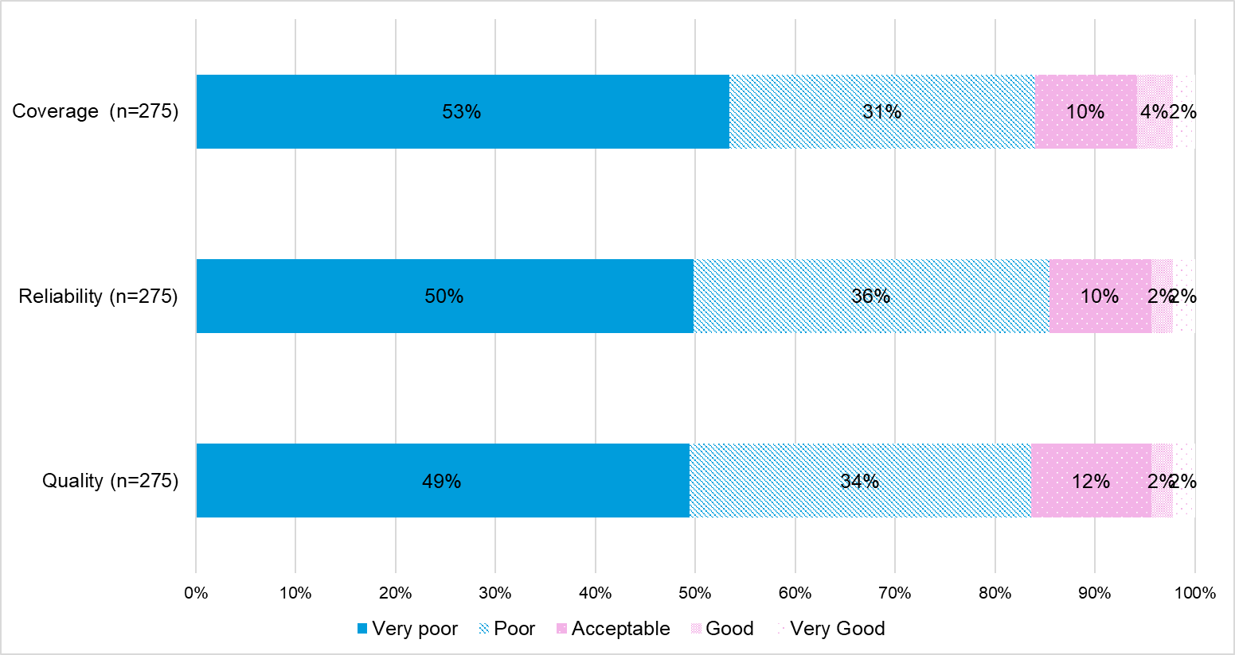

*Figure 17: Survey response to rate the current coverage, reliability, and quality (answered by survey respondents who were not aware of the base station)*

Many stakeholders in community visits also indicated general levels of dissatisfaction with their coverage.

“The service is terrible. You never know when you’ll have service.” (Memerambi/Wooroolin)

“I’ve heard the township has enjoyed a boost in coverage, but it has not made a bit of difference to us on the farm.” (Robertstown)

“We are 100 kilometres from Adelaide, and the reception is crap.” (Riverton)

Interviews with DITRDCA indicated that mobile coverage outcomes can be influenced by several factors such as location, terrain, distance from the base station, number of concurrent users (capacity limitations), and other physical obstacles such as trees and buildings (including their internal structure) that may degrade the quality of the signal being received from the nearest mobile base station. The department noted that these factors can also change over time. The particular type of handset and its settings can also affect mobile reception, and mobile customers will need a compatible device in order to access the 4G and 5G networks.

Further, the community visits showcased a sliding scale of what an acceptable level of connectivity looks like. While a Universal Service Obligation (USO) is in place in relation to a landline, there is no agreed-upon set of standards for mobile coverage, reliability, and quality. Thus, what is ‘acceptable’ to one individual in a remote area and what is ‘unacceptable’ to another in a regional area may translate as the same technical levels of connectivity and it is difficult to calibrate these in the absence of uniform standards.

### Social, economic, and safety benefits

|  |
| --- |
| **Finding 16:** The survey and community visits identified examples of social, economic, and safety benefits resulting from the MBSP base stations. |

While some interviewees from state and industry cohorts highlighted the challenges in measuring social and economic benefits from a single base station, the survey[41] and community visits offered some examples of positive changes due to the base stations in the area – ranging across social, economic, and safety perspectives.

Home and business

Both survey and community visits showed that mobile devices used were predominantly mobile phones, with some examples of individuals using tablets and smartwatches.

Mobile devices were primarily used for personal and business voice calls and for services such as banking. Many interviewed highlighted their dependence on their mobile device for authentication and authorisation codes.

Some survey respondents highlighted examples of positive impacts experienced via the base station in their area on their home, personal life, community, and business.

“It is great to have connection in the village.” (Survey)

“I can now receive/make calls on my mobile. This was not possible before the tower.” (Survey)

“It means that our community is better connected. Our volunteer services such as our Community First Responders and volunteer buggy service to help people with mobility issues are always contactable.” (Survey)

“The Pichi Richi site has been great for events we run e.g. Pichi Richi Marathon and ensures communications and provides a safety assurance.” (Survey)

“Huge benefits as a resident and business owner. We have been fighting for a tower for more than 10 years. It’s also made our landlines more reliable. Game changer for our family and business and every visitor to the area.” (Survey)

“Business confidence that our POS sales system is more reliable.” (Survey)

In community visits, some people interviewed were business owners based in the area who ran their businesses from a local office and/or home base. In these cases, their mobile device was of primary importance for work purposes. They also provided examples of some of the positive impacts resulting from the base station in their area.

In farming communities, some interviewees indicated that the base station had enabled them to consider using agricultural apps in their farm businesses (which they had not considered before they had mobile reception).

“This is the best community for mobile phone service. The mobile signal is stronger in Yakanarra than in the other communities we visit. In some other communities, we have to climb up a hill to get mobile reception.” (Yakanarra visitor)

“I run my business from home. I do all my banking online, and I need my mobile for authentication, authorisation codes, and calls.” (Laguna)

“We rely heavily on mobile reception for running our business because internet connectivity is unreliable.” (Blessington)

“I run a business as an artist. I use social media and Instagram. I am dependent on my mobile phone for advertising, bookings, and banking.” (Riverton)

Safety

MBSP has facilitated public safety to a certain degree, as evidenced by the number of triple-zero calls made through the base stations built under the program. According to DITRDCA, for the completed and active MBSP base stations from **Round 1 to 5A**, MNOs reported that over 105,000 triple-zero emergency calls were made. DITRDCA is of the view that the actual number of triple zero emergency calls is expected to be higher due to different reporting timeframes in grant agreements and because MNOs are only required to report triple zero emergency calls in the first two years of a base station commencing operation.

Survey respondents[42] reported the following kinds of safety benefits since the construction of the base stations.

“I’m aware that there has been a positive change for a service on the island that I use: CFR Community First Responders. No more black spots with no coverage, no phone dropouts.” (Survey)

“Much improved service allowing improved response to MVA’s (motor vehicle accidents).” (Survey)

“Yes, we can now receive a signal in our fire brigade shed.” (Survey)

“Feel more at ease knowing I can now call emergency services if I have to.” (Survey)

Community visits highlighted that safety benefits were particularly appreciated in emergency management contexts.

“The fact that we have mobile coverage in the CBD has made a big difference. We had to rely on it last week because the Wi-Fi is terrible at the fire station, and we were able to hotspot to our mobile.” (Laguna)

“We go out hunting on foot. We worry about snake bites. It’s good to know we can get a signal if we need to call for help.” (Yakanarra)

The visit to Yakanarra, in particular, highlighted some of the positive health impacts resulting from the tower. The base station enabled the Royal Flying Doctors Service (RFDS) personnel to connect more easily with their Yakanarra-based patients to arrange and confirm medical appointments and follow-up contact. The base station also supported the delivery of medical appointments on the ground. It was reported that doctors could now tether to their mobiles for connectivity when accessing patient health records during their weekly visits to the community. The RFDS team could also contact specialists via mobile when in situ with patients in the clinic.

“It has definitely delivered health benefits for the community because of the ability to communicate from within their own home.” (RFDS representative, Yakanarra)

(See further Yakanarra case study in Appendix E.)

### Co-location, choice and competition

|  |
| --- |
| **Finding 17:** Only 9% of the eligible MBSP-funded macro cell base stations built have MNOs co-located. MNOs indicated rates of co-location were low due to the base stations being built in locations they perceived to be commercially unviable.  The majority of survey and community respondents indicated that the base stations had not increased competition by enabling more choices of mobile carriers. |

There are several ways in which carriers can share telecommunication infrastructure. These range from active sharing, which includes sharing infrastructure such as base stations, backhaul, and radio access networks, to passive sharing, which includes the owner of a base station, such as an MNIP, providing access to facilities (base station, site, power connection, power back up) for an MNO to install its own equipment.[43]

Through the program guidelines for Rounds 1 and 2, MBSP aimed to “*maximise the choice of mobile service provider for consumers”* by encouraging MNOs to undertake passive sharing by co-locating and co-building, by including it in the assessment criteria for the funding applications. For Rounds 3, 4, 5 and 5A, applicants were expected to provide co-location solutions or evidence stating the proposed solution cannot be supported by an additional MNO. From Round 6 onwards, there has been a focus on multi-MNO solutions with both active sharing and co-location included in the program guidelines.

A review of program documentation revealed very limited co-location among MNOs and MNIPs. Of the program’s 768 macro cell base stations[44] where co-location is potentially viable and could be considered, co-location has been achieved at 9% (71 base stations) across **Rounds 1 to 5A**. Additionally, MNOs have expressed interest in co-locating at another 4% (32 base stations).

Figure 18 illustrates the extent of the five different types of co-locations delivered as part of the program in Rounds 1 to 5A. While a total of 347 co-location base stations were delivered, only 20% (71) of these had MNOs co-located. The majority (37%, 130 base stations) of co-locations under MBSP took place on a third-party tower/facility such as councils, BAI Communications, etc. Thus, even at a micro-level, co-location among MNOs was limited.

Graph showing types of co-locations as a percentage of total co-located base stations.
Total number of MBSP base stations built where another mobile network operator has co-located, 20%.
Total number of MBSP funded sites where NBN Co has co-located., 4%.
Total number of additional MBSP sites where a third party has expressed interest to co-locate, but co-location has not yet occurred, 9%.
Total number of additional MBSP funded sites which have been co-located on a third-party tower/facility, 37%.
Total number of MBSP base stations which have been co-located on an NBN Co tower only, 29%.

Figure 18: Types of co-locations as a percentage of total MBSP co-located base stations across Rounds 1-5A based on data from DITRDCA (n=347) (reported as of 31 October 2024)

MNIPs reported to have trialled active sharing with Optus across seven base stations along highways under Round 5A. In consultations, certain carriers indicated that rates of co-location were low due to the base stations being built in locations they perceived to be commercially unviable. MNIPs indicated that while they perceived active sharing as an optimal solution for remote and regional areas, co-location was more realistic, given the restricted degree to which MNOs would collaborate.

“A key objective of the Guidelines was focused on establishing sites with multiple carriers broadcasting their services at the sites established via the program funding. This element was a complete failure due to the nature of the locations and the absolute absence of any commercial viability to the mobile network carriers…Provisioning for second carrier capacity on structures led to over-engineering / over-investment by the lead carrier, with no potential recovery of those costs.” (MNO)

“The money you will make in remote and very remote, you can make money only by co-locating…Active share is the ultimate model, but a lot of them won’t do it, so co-location is the one.” (MNIP)

“Someone needs to take co-location with greater than two (players) seriously.” (MNIP)

While the survey and community visits offered examples of positive change relating to choice, community feedback indicated that overall, competition had not increased, and their choice of carriers remains limited.

For example, survey results showed only 32% of respondents who knew about the base stations built under MBSP experienced some degree of positive change in their choice of mobile phone carriers (Figure 19). Out of these respondents, only 7% had moved to a new carrier as a result of the positive change (Figure 20). The majority (63%) of survey respondents unaware of the base station indicated their current choice of mobile carriers was poor or very poor (Figure 21).

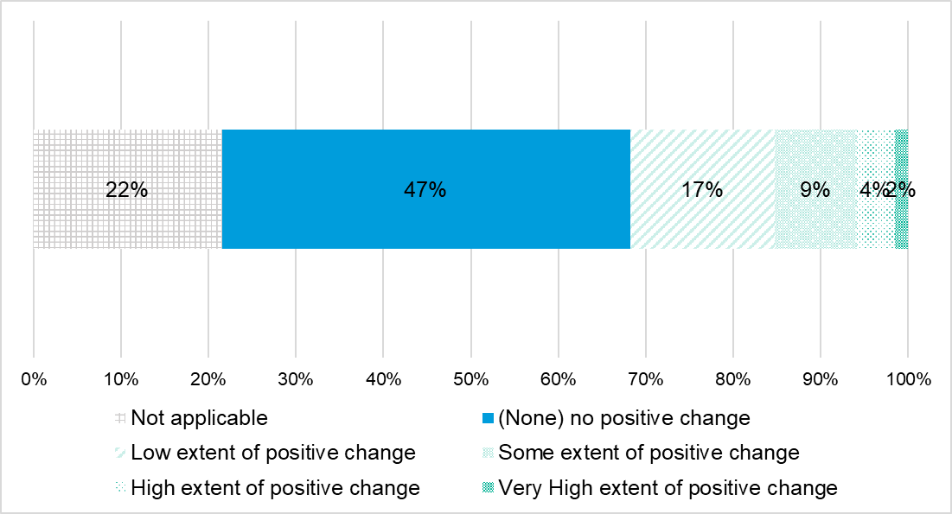

Figure 19: Survey response to positive change experienced or observed in **choice of mobile phone carriers** since the base station was built/upgraded (answered by survey respondents who were aware of the base station) (n=255)

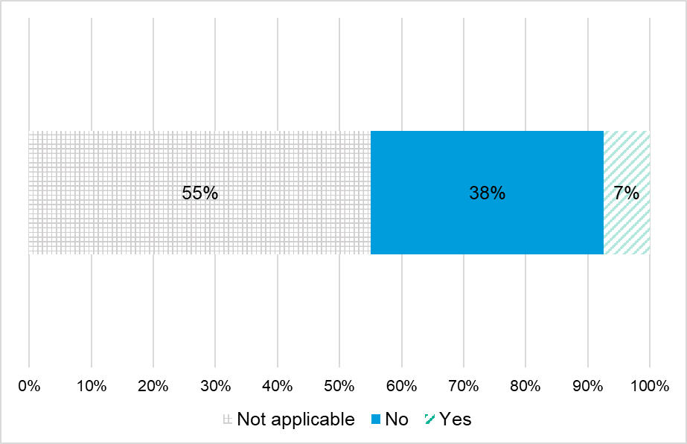

Figure 20: Survey response to ‘if you experienced or observed a positive change in **choice of mobile phone carriers**, did you move to a new network carrier’ since the base station was built/upgraded (answered by survey respondents who were aware of the base station

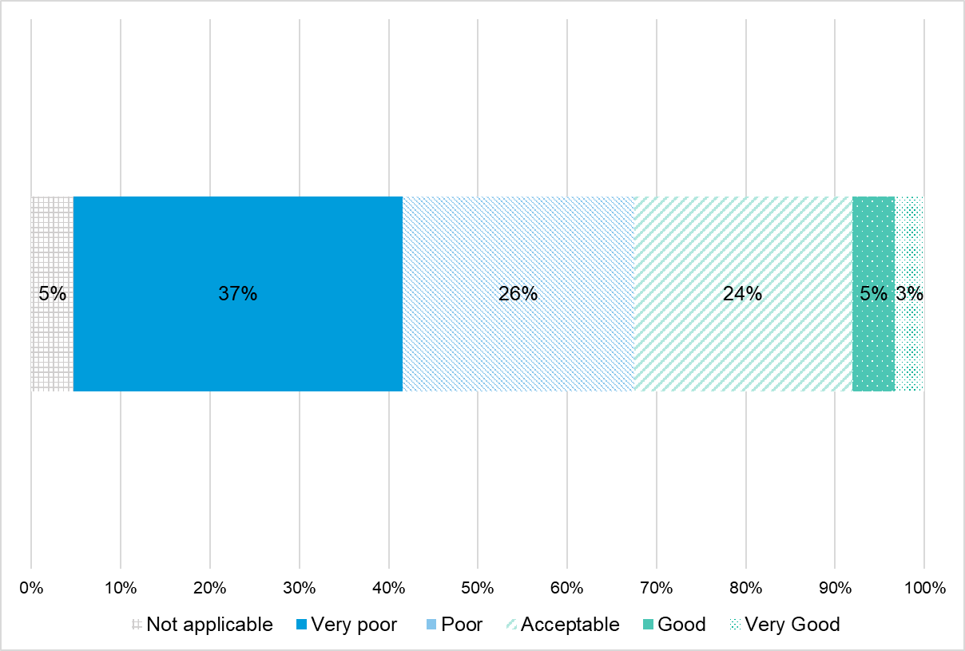

Figure 21: Survey response to rate the current **choice of mobile carriers** (answered by survey respondents who were not aware of the base station) (n=274)

Community consultations also indicated that competition had not increased as a result of the MBSP base stations in their area.

“Competition has not happened. The Government should have mandated sharing.” (Laguna)

“It seems crazy that we have Optus here and Telstra over there. Surely the hardest bit is building the tower! Surely the easy bit is sharing it.” (Memerambi)

“Co-location doesn’t work …You can shop around for electricity, but not for this.” (Riverton)

### Community appetite for increased choice

|  |
| --- |
| **Finding 18:** Survey and community respondents evidenced an appetite for increased choice. These stakeholders indicated they were also looking to additional and new technologies, including satellite solutions, to fill that need. |

Survey and community respondents also evidenced an appetite for increased choice. These stakeholders indicated they were also looking for additional and alternative options, including new technologies, such as mobile boosters/repeaters and satellite solutions, to fill that need.

“We would love for the tower to be used by other tenants.” (Laguna)

(Via satellite) “The software lets us see the paddock, feed levels, etc.” (Blessington)

“I’ve had two satellites. Starlink has been a game-changer. I paid for the installation and pay per month, and it is hugely portable. It gives me open data, no data cap, and no outages.” (Laguna)

“We’ve put in another repeater in at an additional cost.” (Riverton)

(See further community visit case studies in Appendix E.)

Survey respondents[45] also raised concerns about the reliability of mobile and internet connectivity. This was mainly attributed to poor and patchy coverage by carriers and partly to weather and terrain. To address these concerns, a number of the respondents stated that they have started using satellite internet services.

“Phone coverage is unreliable, especially in times of power outages. Locals are footing the cost of Starlink just to have guaranteed service.” (Survey)

“My mobile phone does not work at all at home, where my office and small business are located. I have now got Starlink, which means I can use Wi-Fi calling, which enables me to get calls, make calls, etc.” (Survey)

“There is no good reception. I have had to get Starlink and stay close to Wi-Fi for any consistency in phone calls. I have had messages for missed calls but no phone calls.” (Survey)

“We have terrible mobile phone reception in Valla rural, and many people have had to go to Starlink. We would love adequate mobile phone reception.” (Survey)

The fact that consumers are already actively testing these alternatives suggests that going forward, there is potential to increase the choice of solutions as part of future program offerings (in addition to increasing the choice of mobile carriers). Alternative technology solutions may provide an additional and practical option for users in regional areas, particularly remote and very remote areas where the geographic footprint is large and the population sparse.

### Competition secondary to increased coverage

|  |
| --- |
| **Finding 19**: Intended competition outcomes have not been achieved. However, it is important to note that outcomes relating to competition entered the MBSP’s narrative as part of its explanatory statement and following its legislative authority.  Co-location was always encouraged as part of the program, including through weighted assessment criteria. However, it was never a mandatory requirement, and many stakeholder groups viewed competition as a secondary outcome to new/increased coverage. |

It is important to note that the MBSP’s legislative authority stated that the program’s objective was to provide funding for investment in telecommunications infrastructure to improve mobile voice and data coverage.[46] Outcomes relating to competition entered the program’s narrative as part of the explanatory statement following the legislative authority - which stated that the Commonwealth Government will provide further funding to MBSP to invest in telecommunications infrastructure to improve mobile phone coverage and competition at identified mobile black spot locations.[47]

Therefore, co-location was always encouraged as part of the program, including through weighted assessment criteria, however, it was never a mandatory requirement, and new coverage was the primary focus of MBSP.

Representatives from the jurisdictions also viewed competition as secondary to the program’s priority outcome of new/increased coverage.

“Not once has anyone said to me that they want choice in the carrier - they just want coverage - competition is not a priority at all.” (State counterpart)

“It (choice) is still a challenge as we don't have competition as it is not our priority, new coverage is our priority.” (State counterpart)

In community visits, interviewees also highlighted that while competition between mobile carriers was important to them, it was of secondary importance to increased coverage—primarily because they equated increased coverage with increased safety. (Also discussed in Section 4.3.3.)

“Safety is the main reason for getting a bigger spread of coverage. If there’s a medical emergency, we rely on calling the RFDS for help. Also, fire is a big risk here.” (Yakanarra)

“In the country, it is about safety.” (Clare Valley resident, as part of Riverton and Robertson community consultations)

“Farmers need reception for medical emergencies. It’s not just about business for me, but about the community.” (Blessington)

## Appropriateness (KEQ 2)

### Changing program ecosystem

|  |
| --- |
| **Finding 20:** Expectations relating to connectivity have evolved since the program’s inception - from mobile connectivity to data/internet connectivity (e.g., when the program commenced, consumer expectations were simpler, such as making and receiving calls and texts).  The program now fits within an updated frame of consumer expectations, which extend to using mobile devices as the preferred interfaces for accessing essential services, conducting business, and for education and health purposes. |

|  |
| --- |
| **Finding 21:** The program was designed to provide a commercial incentive for telecommunications providers to increase new mobile terrestrial coverage in black spot areas.  Potential sites that offer a sufficient consumer base to afford a commercial return for MNOs have already likely been taken up as part of the program.  While communities in need remain; their location and context mean increased complexity and higher costs for the delivery of mobile base station solutions, and there is a diminishing appetite from MNOs to participate under the current incentives provided by the grants. |

|  |
| --- |
| **Finding 22:** When the program commenced, it was one of only a few grant opportunities of its kind. Ten years on, it now operates in an expanded ecosystem of Commonwealth, state, and territory programs with aligned objectives. |

|  |
| --- |
| **Finding 23:** The telecommunications industry has evolved rapidly since program commencement, with the advent of new technologies, including 5G and LEO satellites, which are now also available to consumers.  Mobile terrestrial base stations remain an option for connectivity solutions, but they are now not the only option. |

After Round 5, carriers' interest in submitting applications for the program appears to have waned, as evidenced by the decline in the number of proposed solutions (see Figure 9).[48]

Further, in more recent years, the consumer need has also pivoted from mobile communication to an increased need for data.

As illustrated in Figure 22, the MBSP now operates in a rapidly changing environment of emerging technologies and changing consumer needs and expectations:

* essential services such as government and education services have also started moving to a digital delivery model
* the movement to a digital delivery model has been coupled with a rapidly changing technology environment and the onset of low-earth orbit (LEO) satellites and 5G networks, among other technologies;
* the advent of Starlink in Australia in 2021 has also affected the technology landscape and consumer demand for data.

Diagram showing the operation of the Mobile Black Spot Program in the context of changing emerging technology and changing need in regional Australia, from 2012-2014 to 2024.

From 2012 to 2014:
National Broadband Network (NBN) implementation since 2008; need for mobile communication considered essential for regional and remote areas of Australia.

From 2015 to 2017:
Round 1 (June 2015), Round 2 (December 2016); NBN's Sky Muster Long Term Satellite Service, small cell technologies, CSIRO WiFi Ngara, Project Loon by Google, 648 Low Earth Orbit (LEO) satellites by OneWeb; Mobile, voice over internet protocol and social media applications emerging and relevance of standard telephone service declining.

From 2018 to 2019: Round 3 Priority Locations (April 2018); 5G network, LEO satellites; Increase in the demand for data and digital technologies with government, health and education services moving to digital models.

From 2019 to 2020: Round 4 (March 2019), 783 base stations (2020), Round 5 (April 2020).

From 2021 to 2022: Round 5A (July 2021); Starlink launched in Australia in 2021.

From 2022 to 2024: Round 6 Improving Mobile Coverage Round (IMCR) Stage 1 (October 2023), 1,024 base stations (2023), Round 7 (December 2023), IMCT Stage 2 (July 2024), 1,133 base stations (October 2024); LEO satellites, Low Power Wide Area Networks, 5G cellular technology. 
From 2022 to 2024: Range of digital tools for work, study and entertainment have grown (post COVID-19 pandemic) and there is an increase in ongoing need for data.

In 2012 to 2014, there is a need for a technologically specific approach, which changes over time to a need for a technologically agnostic approach in 2024.

Throughout, there is an ongoing need for reliability of communication during emergency situations and natural disasters.

Figure 22: Operation of MBSP in a changing and complex environment[49],[50]

Further, the MBSP now operates in an expanded ecosystem of concurrently run Commonwealth programs with aligned objectives to enhance connectivity (see Figure 23).

Most of these programs, including MBSP, are supported by the Better Connectivity Plan (BCP).[51] This plan by the Australian Government aims to improve mobile and broadband connectivity and resilience across the rural and regional parts of the country. In the 2022-23 October budget, a funding of $400 million (inclusive of GST) across five years was awarded to programs such as the MBSP, Mobile Network Hardening Program (MNHP) and Regional Roads Australia Mobile Program (RRAMP), among others.

|  |  |
| --- | --- |
| Enhancing connectivity ecosystem | |
| MBSP | Mobile Network Hardening Program (MNHP) |
| Regional Connectivity Program (RCP) | Regional Roads Australia Mobile Program (RRAMP) |
| Peri-Urban Mobile Program (PUMP) | Telecommunications Disaster Resilience Innovation (TDRI) Program |
| On Farm Connectivity Program (OFCP) |  |

Figure 23: Programs run by the Commonwealth Government

There are also various state and territory-owned programs aimed at improving connectivity. States such as New South Wales, Victoria, Queensland, and Western Australia have invested in state-level strategies based on local knowledge and community engagement.

Examples of state-run programs include:

* the rollout of Remote Community Wi-Fi to remote Aboriginal communities in Western Australia: This initiative is worth around $20 million, under which free community Wi-Fi service will be provided to 20 First Nations communities[52]
* the Regional Telecommunications Project in Western Australia: Under this $85 million project, the state government is co-contributing to MBSP and RCP to deliver new and improved infrastructure solutions[53]
* connectivity improvement initiatives for regional and remote communities in Queensland: The Queensland Government has funded 22 connectivity improvement projects worth around $22.4 million focused on broadband, community Wi-Fi, mobile voice and data and mobile blackspots
* the Connecting Victoria Program in Victoria: This $540 million program, which has been running since 2014, has focused on investing in Victorian and Australian Government-led telecommunications projects focused on mobile, broadband, and public Wi-Fi.[54] (Stakeholder consultations stated that the project management office of the program allowed it to be very agile and adaptable in making decisions, noting that this approach could be beneficial for the MBSP as well.)
* the Connecting Country Communities Fund in New South Wales: The state created this $50 million fund to deliver telecommunications infrastructure through MBSP and broadband internet access[55]
* in the Northern Territory, work is underway to provide high-speed digital connectivity to all Territory schools, including those across remote areas, through a combination of technologies[56] and pilot localised voice and data service solutions through the Telecommunications for Remote Aboriginal Communities project[57], among a number of other initiatives
* the South Australian Government has invested in regional mobile connectivity through its MBSP Fund[58]
* Tasmania is delivering several initiatives to advance the technology sector as part of its Our Plan for a Stronger Economy.[59]

Of note, many of the above state and territory programs were specifically synchronised with the objectives and funding criteria required under the MBSP to better leverage the grant program’s opportunities.

“Before each program comes out, we know what Commonwealth (Government) wants to prioritise (e.g., 5A - disaster risk), so we look at our list for sites that suit their priority.” (State counterpart)

“We would establish a parallel grants funding process to Commonwealth effectively attached to their applications to make providers applications more competitive.” (State counterpart)

### Program adaption

|  |
| --- |
| ***(Refer) Finding 9:*** *DITRDCA’s delivery model and governance approach enabled successful program implementation, validated through external audits. DITRDCA consulted with stakeholders after each round and adapted the delivery of the next round, including recalibrating the focus for target communities and contributions from the Commonwealth.* |

The MBSP program was established to “*invest in telecommunications network infrastructure to improve both coverage of high-quality terrestrial mobile voice and wireless broadband services in regional Australia and competition in the provision of such services.”*[60]

DITRDCA, under successive governments, has adapted the program’s approach across its various rounds and in response to feedback collected as part of reviewing each round. This has included a recalibrated focus for target communities, trialling of new technologies, and increased funding:

* The application for Round 1 of the program was opened in December 2014, inviting MNOs and MNIPs to set up base stations in the locations with the highest need reported in the “Database of Reported Locations”, out of 6,000 individual regional locations with noted inadequate mobile phone coverage.[61]
* Round 2 expanded the list of locations to 10,668 locations under the “Database of Reported Locations”.[62] This round added battery backup for proposed solutions and removed certain restrictions to gauge the locations where the carriers were interested in building base stations.
* Round 3[63] and Round 6[64] were election commitment rounds and focused on a limited number of priority locations and improving coverage quality locations.
* The MBSP adapted its approach during Round 4[65] and Round 5[66] by focusing mainly on Public Interest Premises such as economic centres, emergency service facilities, educational facilities, and local government facilities.
* Under Round 5A,[67] the program sought applications for innovative solutions to trial ‘next technologies”, with priority given to natural disaster-prone areas and designated transport corridors.
* Round 7[68] had two streams of funding, including a dedicated stream for delivering solutions to First Nations communities. Of the 62 solutions funded, 31% (19 out of 62) were in these communities.

To expand on one of the key adjustments, consultations with MNOs confirmed that participation in later program rounds has been lower due to the increased complexity and cost of delivering mobile base stations and the reduced commercial return incentive.

With sites regarded as the ‘low hanging fruit’ being taken up in the early rounds, the program has recently faced the inclusion of some of the least commercially viable locations in remote and rural parts of the country, and which likely have some of the highest needs for connectivity.

“The program was initially received and welcomed by the industry and seen as an opportunity to expand coverage into areas not possible by normal market forces. Those initial responses have subsequently become ongoing, penalising operational cost burdens for the carriers without any meaningful growth in the participant’s customer base.” (MNO)

“When you get into these very remote areas… the cost increases because the challenges are so great. (MNO)

In interviews, the department reported that each successive round has progressively moved into areas that are increasingly less economic, resulting in an increase in the overall level of Commonwealth funding sought for projects in later rounds. By way of response, in Round 6 (Improving Mobile Coverage Round Stage 1), changes were made to the grant round parameters to adapt to the increasing costs associated with the delivery of base stations and higher cost for fibre and power connections across these less commercially viable locations. The funding cap from the Commonwealth Government was also increased from $500,000 (including GST) in the initial rounds to $680,000 (including GST) for a single macro cell base station in Round 6 (Improving Mobile Coverage Round Stage 1), along with the introduction of operational costs as a part of the funding. Furthermore, in recognition of the higher cost of operations in remote and very remote areas and in First Nations communities, the funding cap under Round 7 was increased to 75% of the combined estimated asset capital costs of the funding solutions.[69]

While there is still strong community demand for new coverage (see Section 4.3.3), it is likely that the industry will continue to seek higher levels of Commonwealth contribution as projects become less economic.

### Ongoing need

|  |
| --- |
| **Finding 24:** Survey results and community visits showed most people used mobile devices and had an associated preference and expectation for using them for their calls, digital services, and transaction needs. |

|  |
| --- |
| **Finding 25:** All community stakeholder groups consulted emphasised the ongoing problem of limited/no mobile coverage in many areas across Australia – particularly in regional, remote, and very remote parts of the country.  This also included feedback from many community stakeholders where base stations were delivered. Not only was new coverage required, but also improved coverage, with respect to reliability, quality, and continuity to meet consumer expectations. Digital literacy was also identified as a key feature in optimising consumer experiences. |

|  |
| --- |
| **Finding 26:** Well-being factors relating to safety (including medical and emergency situations) and accessing essential services related to health, financial, and social connectivity were identified as the priorities in driving the need for improvement.  The ongoing need for reliable communications during emergency situations and natural disasters was paramount. Using mobile services for streaming, browsing, and even business was viewed as secondary in people’s hierarchy of needs relating to mobile connectivity. |

Community visits and the survey showed mobile phones were the most common mobile devices. The survey showed tablets followed by way of common usage (see Figure 24). Other devices identified included laptops, computers, modems, routers, Eftpos machines, Cel-Fi boosters, and Agbot farm monitoring devices.

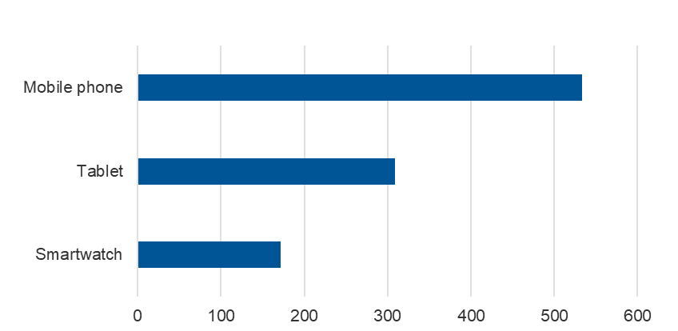

Figure 24: Survey response for mobile devices used (n=534)

Community visits and the survey identified the most common uses for mobile devices included conducting voice calls, accessing services, conducting business/work, and using social media (see Figure 25 for survey results). Some of the other uses identified included organising Zoom meetings, having online doctor’s appointments, contacting emergency services and family and conducting fire management under the local Rural Fire Service.

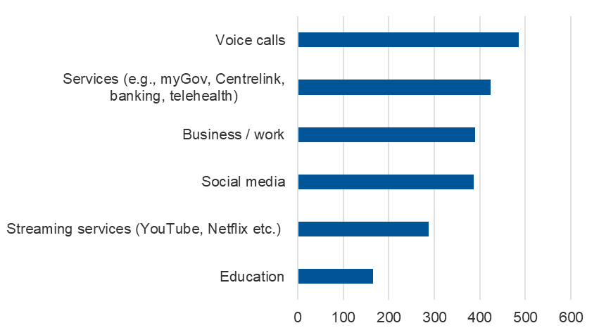

Figure 25: Survey response for main uses of mobile device (n=535)

Several of the respondents from the survey[70] reported significant issues with connectivity and reliability of mobile coverage, highlighting inadequate coverage, frequent outages, and poor service quality. They also expressed dissatisfaction with the base station upgrades, which were reported to worsen connectivity in some cases. There were emergency and safety concerns, along with some concerns about the aesthetics of the base station locations.

“The base station fails at times, leaving us with no mobile service at all, sometimes for extended periods. E.g. the mobile service was completely down [during] Christmas in 2022. There have been a number of outages since then, not as long as Christmas 2022. We are entirely dependent on the one base station. Could another base station be installed to cover a nearby black spot but located so as to overlap our Capertee station? Also, the Capertee base station coverage does not extend into the nearby Capertee Valley. It's a significant blackspot affecting valley residents and visitors.” (Survey)

“Mobile service is very unreliable in areas of the region, with no/limited coverage/reception whilst travelling on main roads between neighbouring towns.” (survey)

“Yes – in times of fire emergency, the tower can fail.” (Survey)

One survey respondent provided details submitted as part of the Regional Telecommunications Review 2024, which is included here to show the experiences of the community of Pingelly, Western Australia.[71]

|  |
| --- |
| Case of Pingelly  The town of Pingelly is located around 154 kilometres south-east of Perth in Western Australia. A base station was built in West Pingelly under Round 4 in 2021. The town is also supported by another mobile base station around 15 kilometres away. However, mobile connectivity is reported to be poor and unreliable, making the people and businesses in Pingelly disconnected, vulnerable, frustrated, and angry.  In most instances, mobile phone coverage is unavailable inside the shops and houses – it is necessary to go outside to make calls or to make purchases on payment devices that require mobile coverage.  Mobile phone coverage surveys conducted by the Shire of Pingelly confirmed that the coverage worsened from 2022 to 2024.[72] The lack of reliable and quality mobile coverage hampers the lives, livelihood and safety of the community members. The need for mobile coverage continues to exist in this town to deliver social, public safety and economic benefits comparable to metropolitan areas within the country.[73] |

Survey and community feedback[74] confirmed that the need for additional and improved mobile connectivity is ongoing. Survey respondents stated that there is a need for more mobile base stations as there are many areas that are still black spots, with some rural and regional areas not having reception for prolonged periods of time.

“I commute from Clarence to Oberon every day for work. There are numerous black spots along the drive where signal drops out and I cannot make or maintain calls.” (Survey)

“No phone reception between Gin and Mt Perry. Unacceptable that there are still huge black spots all around that location.” (Survey)

“More black spot towers required at least every 100km in southwest Queensland. Noccundra needs a tower.” (Survey)

A key issue for concern raised in community visits and the survey[75] was the unreliability of mobile coverage during emergencies such as road accidents and natural disasters, which posed safety risks. Examples of comments from the survey shown below.

“Too many blackspots on regional roads, especially the Peak Downs Highway for extensive patches between Eton and Nebo, and also from Caval Ridge Mine to the Gregory Highway. With so many car accidents, this is very problematic for emergency services and greatly impacts their capacity to respond and communicate effectively. The Dysart-Road is also patchy.” (Survey)

“Our lack of phone service is dangerous. It affects my business, and also how and if I can respond to emergency call outs as a fire fighter as I often don’t have service to be called out.” (Survey)

“Our community needs a tower to be installed in the heart of the Capertee Valley to ensure reliable & safe coverage. There is basically NO coverage currently. During emergencies & bushfires our community is at great risk - RFS communications need to revert to radios & multiple emergency & safety Apps & processes do not work due to no signal. This was highlighted during the 2019/2020 bushfires but has not yet been addressed.” (Survey)

“Both major 4G providers have extremely poor coverage and very poor connection speeds. Unreliable in emergency situations for checking fire or flood information.” (Survey)

Examples of comments from community visits are below.

“There are still gaps where the Laguna Tower’s reach ends and the Buckety Tower picks up. There are sections of the Great North Road that have nothing. It would be great to fill in the holes experienced along the Great North Road.” (Laguna)

“It’s a two-hour drive to Fitzroy Crossing. The signal drops out during the drive. If there’s a breakdown, we can’t get back, we have to walk on foot.” (Yakanarra)

“It’s a safety issue. During fire season, we’re especially on edge because mobile reception is our last resort to get people out. GRN is hit and miss.” (Riverton)

In consultations, the First Nations Digital Inclusion Advisory Group indicated that the program needed to be more flexible and adopt a place-based approach in alignment with the principles of the Discussion Paper – First Nations Digital Inclusion Roadmap.[76]

This means that First Nations communities should be engaged in the design and implementation of the program to ensure digital inclusion which is centred around their specific needs and environment. Furthermore, a technologically-agnostic approach should be adopted such that there is a focus on individual needs of First Nations communities, rather than a specific technological solution.

Interviews with community visitors during the Yakanarra visit indicated the ongoing need for coverage in proximal First Nations communities in the Fitzroy Valley.

“Coming back and forth from Fitzroy Crossing, there are lots of spots where we don’t get service, but we always get it when we reach Yakanarra.” (Yakanarra visitor)

The community visits also identified the need for better support across a broad spectrum of mobile literacy relating to:

* functionality of mobile devices and how to operate them, ranging from how to turn the volume up or down, to more sophisticated use of applications
* choice of mobile devices, carriers, and plans, ranging from no knowledge of options available and acceptance of urban myths about SIM cards to highly informed and technical understanding of choices available to make informed decisions about the best products and plans available, including other and additional technologies besides mobile.

I’m young, so I can keep up with all the changes in technology. Older people struggle, I am the tech support for my whole family!!” (Riverton)

“Mobile is just one part of the connection web. It’s hard to understand the situation as it’s hard to find information on what’s actually correct.” (Memerambi/Wooroolin)

# Conclusions and Recommendations

## Conclusions

### Implementation

|  |
| --- |
| *(Related findings 1,2,3,4,5,6,9,10,11,12,13)* |

The program has been successfully implemented, as intended.

Since its launch in 2014, the MBSP has successfully opened nine funding rounds and leveraged co-contributions of $661.7 million (including GST) from state and local governments, industry, and third parties. It has awarded funding for up to 1,400 base stations, with the program being taken up by all jurisdictions and multiple MNOs and MNIPs participating.

DITRDCA’s program administration and management have supported successful implementation.

Lessons learned through the delivery of the program relate to:

* delivery of the funded solutions taking longer than planned, with a common pain point being the sites that cannot be built, most often due to not being able to find a viable location or willing landholder
* community engagement and awareness and the need for a consistent experience by targeted communities so that they are aware of, and have informed expectations about the base station
* performance measurement and reporting – to have a planned approach to monitoring and evaluation readiness activities that supports reduced reporting burden for grantees and provides holistic and validated data sets.

Initiated in 2014, as a four-year grants program, the MBSP’s lifespan has been extended via an additional eight funding rounds. As of October 2024, a tenth round (called Round 8) is expected to open in late 2024.

While grantees, jurisdictions, and base station community recipients have welcomed the ongoing program extensions, the round-by-round funding approach has meant associated planning has been timebound for each round and calibrated to the budget appropriation for that round.

Providing certainty that comes with a longer program lifecycle would allow for timeframes that enable longer-term strategic planning for program administrators, grantees, and jurisdiction participants. It would also allow for increased flexibility in program offerings, such as offering more money in fewer rounds and offering funding certainty to co-investors. It would enable opportunities for increased alignment with jurisdictional planning priorities and funding cycles.

A longer program lifecycle would also assist DITRDCA with managing resourcing for longer timeframes for project delivery and accounting for outer years in delivery date extensions.

### Effectiveness

|  |
| --- |
| *(Related findings 14,15,16,17,18,19)* |

The program has successfully increased mobile coverage as indicated by program reporting that showed all related KPIs relating to coverage were exceeded, with most of the reported increase achieved under Rounds 1 and 2.

Responses via the survey and community visits identified a level of increased coverage and examples of ensuing social, safety, and economic benefits.

Significant connectivity issues remain, and coverage, reliability, and access are ongoing problems for the majority of community members consulted. The communities highlighted an ongoing need for mobile connectivity; however, the level of additional support required to meet this need was tricky to determine in the absence of any agreed standards.

While a Universal Service Obligation (USO) for landline is in place, there is no agreed-upon set of standards for mobile coverage, reliability, and quality. Thus, what is ‘acceptable’ to one individual in a remote area and what is ‘unacceptable’ to another in a regional area may translate as the same technical levels of connectivity, but it is difficult to calibrate these in the absence of any uniform standards.

Intended competition outcomes have not been achieved. Co-location has been limited and the choice of mobile carriers has not improved for people living proximal to the base stations.

However, it is important to note that competition was a secondary program outcome to coverage. Stakeholders across the board highlighted that while choice was important to them, it was of secondary importance to increased coverage, primarily because they equated increased coverage with increased safety.

Nevertheless, survey and community respondents did express an appetite for increased choice in mobile carriers, and many respondents were actively testing alternative technology solutions, including LEO satellite.

### Appropriateness

|  |
| --- |
| *(Related findings 7,8, 20, 21, 22, 23, 24, 25, 26)* |

The MBSP's design at inception was appropriate to meet consumer needs at the time. However, a decade on, there are signs that the program’s current form is not keeping up with evolving consumer needs and a rapidly changing technological context. MBSP now operates in a complex environment of Commonwealth, state, and territory telecommunications policy, regulation, and programs, along with emerging technologies and changing consumer needs.

The consumer need is shifting from mobile to data, but the need for connectivity remains. Most people today have smartphones and an associated preference and expectation for using them for their digital service and transaction needs.

The vast proportion of the Australian land mass still has little to no mobile coverage, with terrestrial coverage concentrated where people live, work, and travel. Community concerns about the reliability of coverage, particularly during emergencies, persist. Safety (including medical and emergency situations) was identified as a paramount priority for the communities.

MNOs indicated that commercial incentives for investment via the program are declining, and the sector is experiencing long-term declines in returns on invested capital.

There is still a perceived need for future government investment in telecommunications infrastructure, but likely not in the program’s current form. Moving forward, alternative technology solutions may provide an additional option to mobile base station infrastructure, particularly for users in remote and very remote areas where the geographic footprint is large and the population sparse.

Therefore there are signals that the program in its current form has been pushed as far as it can go.

Digital inclusion is now a standard expectation, along with healthcare, education, and energy. Digital literacy is an accompanying feature of this. From a community perspective, the program was perceived as synonymous with the Australian Government’s response to a complex problem of connectivity and intrinsically connected to issues of access, safety, well-being, and equality. It is important to note that the MBSP is only one program swimming towards a solution in the sea of a national connectivity problem.

Criticisms of the program need to be contextualised as part of a much bigger connectivity issue. This problem is complex in size and scale and cannot be fixed by any one program, let alone the MBSP.

The MBSP has left a legacy of increased coverage across the country, but it is likely a program overhaul is required. Both design and systems thinking will be needed to respond to the above current, complex environment and leveraging the experience of the DITRDCA team and lessons learned from program delivery to date.

## Recommendations

The evaluation has made five recommendations.

|  |
| --- |
| **Recommendation 1:**  As part of future program design and delivery, DITRDCA should consider a program reset within the context of a strategic national frame, using systems thinking and a co-design approach. |

The approach should account for the following:

1. Engagement and collaboration with teams across the department, the First Nations Digital Inclusion Advisory Group, associated portfolio agencies, state and industry counterparts, and communities, and building on the Better Connectivity Plan. It should include continuing to work closely with states and territories to identify their connectivity needs and to provide solutions accordingly, as well as engagement with MNOs and MNIPs to maintain cognisance of industry expectations and technologies that can be leveraged.
2. A focus on providing new coverage and improving the quality and reliability of existing coverage.
3. A market scan/assessment of whether co-investment in mobile infrastructure is the optimal mechanism to address the existing need for connectivity in underserved areas.
4. Digital literacy as a factor for consideration for future grants guidance and criteria, and leveraging the Regional Tech Hub[77] and the First Nations Digital Support Hub[78] (yet to commence), assessing how their resources can be utilised, promoted, and shared.
5. Minimum standards for coverage (national standards currently not available) to inform understanding of project and program performance and to inform prioritisation of government investment.
6. Enhancing the resilience of existing mobile infrastructure (E.g., to prevent outages and power failures due to bad weather and natural disasters).
7. Engaging First Nations communities early in the design phase to ensure digital inclusion that is centred around their specific needs and environment (as recommended by the First Nations Digital Inclusion Advisory Group).
8. Provision of ongoing funding, possibly in the form of subsidies to the MNOs and MNIPs, given the high costs of deployment and operations and the longevity of operations for the MNOs and MNIPs across remote and very remote areas.
9. Lessons learned from MBSP delivery to date should inform future program design and be incorporated where possible into the delivery of future rounds.

|  |
| --- |
| **Recommendation 2:**  Extend timeframes for grant rounds (including for rollout and completion of base stations) and calibrate departmental resourcing accordingly. |

In future grant funding rounds, extend timelines to:

1. account for the complexity of base station solutions and provide industry players with sufficient time to submit quality proposals
2. provide adequate buffer periods within the grant rounds for unexpected delays, scope changes, and unforeseen issues, ensuring quality and reducing the risk of rushed delivery
3. enable time for planning and adjustment of resource allocation as needed by increasing team size and/or skill sets over the increased lapsed time period.

|  |
| --- |
| **Recommendation 3:**  Conduct the grant application and assessment process as a two-staged approach. |

In future rounds, adapt the grant process as a two-staged approach:

* Stage 1 – MNOs and MNIPs to conduct an initial feasibility study (desktop and site visit feasibility) before submitting the proposals
* Stage 2 – following a successful feasibility study, MNOs and MNIPs submit proposals. Once the proposal is successful, approvals, site acquisitions, design and construction stages to follow.

MNOs and MNIPs should engage and consult early with communities in the identified base station sites when preparing their applications for in-principle approval. They should continue to engage throughout the build to raise awareness of the base station in the community.

|  |
| --- |
| **Recommendation 4:**  Develop a monitoring and evaluation framework in consultation with grantees and co-funding partners. |

With a view to supporting a planned approach to monitoring and evaluation readiness activities that:

1. supports continued program administration, management, and risk mitigation
2. helps to streamline reporting by:

* minimising duplication and considers making the reporting process for KPIs and variation processes more efficient for the MNOs and MNIPs
* developing consistent reporting requirements between federal and state levels to ensure uniformity in data presentation, frequency, and required information
* establishing a centralised system to integrate both federal and state reporting, ensuring real-time access and alignment

1. uses a variety of data sources to complement and minimise excessive reliance on carrier reporting. For example, future data collection and reporting should consider inclusion and validation by external sources, including verification by the audit process and potentially community feedback (for example, via survey and or community consultations) to confirm receipt of delivery standards and areas of ongoing need
2. considers how the program can contribute to the Measuring What Matters framework. (In particular, the digital preparedness measure and in the context of the well-being framework.)**[79]** (Note, the MBSP contributes to Outcome 17 of the Closing the Gap National Agreement as identified in the Closing the Gap Implementation Plan.)**[80]**

|  |
| --- |
| **Recommendation 5:**  Strengthen the program's approach to raising awareness and recognise the Australian Government’s commitment to increasing connectivity among communities in need. |

DITRDCA should consider ways to promote the Australian Government’s investment in future telecommunications projects through community engagement, sharing of testimonials of positive impact, and press and media coverage.

# Appendices

## Diagram illustrating the six step evaluation methodology: 1- Establish project; Step 2- Development evaluation plan: Step 3- Conduct due diligence; Step 4- Collect data; Step 5- Synthesise and analyse data, Step 6- draft and finalise evaluation report.Appendix A - Methodology

## Diagram displaying the logic for the program - stepping out the inputs, activities, outputs and short, medium and long term outcomes. Appendix B – Program Logic

## Appendix C – Key Evaluation Questions (KEQs)

|  |  |  |
| --- | --- | --- |
| **#** | **Proposed KEQ** | **Sub-KEQ** |
| **1** | To what extent has the program been successfully implemented? | 1. Has the program been delivered as intended? 2. Has there been sufficient resourcing to deliver the program effectively? / Could resources be allocated more efficiently? 3. Does the delivery model and governance approach support successful program delivery? |
| **2** | To what extent is the program fit for purpose? | 1. Has the program design met the identified needs? 2. Do the identified needs remain? / Has the program adapted to meet changing needs (if any)? 3. Are there other comparator initiatives that could be leveraged? |
| **3** | To what extent have the MBSP’s intended short- and medium-term outcomes been achieved? | Relating to short-term:   * New and/or improved availability of mobile coverage * Increased access to improved functionality of mobile phones * Increased opportunities for partnerships for carriers   Relating to medium-term:   * Increased mobile connectivity and associated access to social, public safety, and economic benefits in proximal areas * Increased choice of carrier and competition (MNO site sharing) |
| **4** | What lessons does the program offer for future program and policy design? | 1. Are there common factors for, or barriers to, success? 2. Are there opportunities for improvement? 3. Are there any unintended consequences? |

## Appendix D – Stakeholders List

Group 1: Stakeholder consultations – DITRDCA

|  |  |  |
| --- | --- | --- |
| Stakeholder group | Area | Consultation format |
| Program Executive | Assistant Secretary, Regional Mobile Infrastructure Programs | 2 x one-on-one interviews |
| Program Managers and Staff | Director, Mobile Investments – Strategy | One-on-one interview |
| Director, Mobile Programs Implementation | One-on-one interview |
| Assistant Director, Mobile Programs Implementation | One-on-one interview |
| Assistant Director, Mobile Programs Implementation | One-on-one interview |
| Assistant Director, Mobile Investments - Communities | One-on-one interview |
| Senior Program Officer, Mobile Investments - Communities | One-on-one interview |

Group 1: Stakeholder consultations – MNOs and MNIPs

|  |  |  |
| --- | --- | --- |
| Stakeholder group | Area | Consultation format |
| MNO | Representative, TPG Telecom (Rounds 1 PLR and Round 3) | One-on-one interview |
| Representative, Telstra (Rounds 1 – 5A) | One-on-one interview |
| Representative, Telstra (Rounds 1 – 5A) | One-on-one interview |
| Representative, Optus (Rounds 2 – 5A) | One-on-one interview |
| MNIP | Representative, Field Services Group (Rounds 5 – 5A) | One-on-one interview |
| Representative, Field Services Group (Rounds 5 – 5A) | One-on-one interview |

Group 2: Stakeholder consultations – Community

|  |  |  |  |  |  |
| --- | --- | --- | --- | --- | --- |
| Stakeholder group | Consultation format | State | Site visited | MNO/MNIP | Date |
| Community | Survey (online) | Residents living near the list of 1,133 base stations (completed sites to October 2024) | | All | September – October 2024 |
| Community visits and case studies | Tasmania | Blessington | Telstra | 2-4 October 2024 |
| New South Wales | Laguna | Optus | 7 October 2024 |
| South Australia | Riverton and Robertstown | Optus and Telstra | 9-11 October 2024 |
| Queensland | Memerambi and Wooroolin | Optus | 28-30 October 2024 |
| Western Australia | Yakanarra | Telstra | 20 November 2024 |

Group 2: Stakeholder consultations – Industry and other Professional Stakeholders

|  |  |
| --- | --- |
| Stakeholder group | Consultation format |
| First Nations Digital Inclusion Advisory Group representatives | Group interview |
| Departmental representative, Department of Government Services, Government of Victoria | One-on-one interview |
| Departmental representatives, Department of Primary Industries and Regions, Government of South Australia | Group interview |
| Departmental representatives, Department of State Growth, Government of Tasmania | Group interview |
| Departmental representative, Department of Corporate and Digital Development, Government of Northern Territory | One-on-one interview |
| Representative, New South Wales Telco Authority | One-on-one interview |
| Departmental representative, Department of Primary Industries and Regional Development, Government of Western Australia | One-on-one interview |
| Departmental representatives, Department of Transport and Main Roads, Government of Queensland | Group interview |
| Departmental representative, Department of the Chief Ministers and Cabinet, Government of Northern Territory | One-on-one interview |

## Appendix E – Community Visits

Visits to communities where MBSP base stations were delivered were conducted to explore the extent and nature of any resulting impacts experienced ‘on the ground’. Communities included:

* Blessington, Tasmania
* Laguna, New South Wales
* Riverton and Robertstown, South Australia
* Memerambi and Wooroolin, Queensland and
* Yakanarra, Western Australia.

Visits were advertised via a range of media, including online, print, posters, and postcards. Semi-structured interviews with community members explored:

* the nature and extent of mobile device use
* levels of awareness of the mobile base station, and the nature of any involvement
* any impacts relating to coverage, reliability and quality, competition, and any social, economic, and safety impacts
* perspectives on what was working and not working and what could be improved.

Presented as case studies in the following.

Blessington Community Visit

*A total of 16 people were interviewed in face-to-face consultations in and around Blessington on 3rd and 4th October 2024. The following feedback comes from Blessington residents, people working in Blessington, and people from nearby areas, including Launceston.*

Background and context

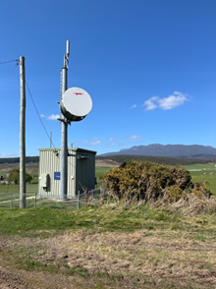Blessington, Tyerrernotepanner Country, is located approximately 32 kilometres south of Launceston, Tasmania. It is a small farming community of around 80 residents, distributed over 121.9 km2.

During the winter ski season, Blessington's population increases to include transient tourists travelling to Ben Lomond National Park. The area’s typography is very undulating, with no central amenities and infrastructure. The closest towns include St Leonards and Punchbowl, which are about a 30 minutes’ drive away.

The Telstra base station (macro cell solution) was built in Blessington in 2021 under Round 5 of the MBSP.

Key themes

Coverage

Blessington residents reported that there was no mobile connection in the area prior to the MBSP base station and that mobile connectivity had improved since the base station was operational. However, it was also noted that there was no information provided to the residents about the base station being operational.

“It (the base station) has made a massive difference. We don’t have a landline anymore.”

“It is so much better now. I definitely wouldn’t want to go back to before the base station was built.”

“There was no information provided to us about the base station being built and suddenly there was mobile reception on my phone.”

Home and business

Nearly all interviewees (except for two) had mobile phones, which they used for personal and work calls, banking, emailing, and social media. The majority were with Telstra.

Farmers interviewed indicated that the base station had enabled them to consider using agricultural apps in their farm businesses (which they had not considered before they had mobile reception.)

“We rely on mobile reception for running our business because internet connectivity is unreliable.”

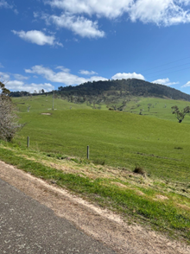They did caveat, however, that the connection overall was patchy, with no reception around Sawpitt Hill Road and houses on Musselboro Road.

This led to some degree of frustration while travelling on the roads as calls dropped off.

There were examples where residents used Starlink satellite services to improve connectivity within their houses and for their farm businesses.

“Less than 50% of our property is within mobile range.”

“At our home, there is zero mobile service. We rely on satellite internet for all communication, which is lost when the power goes out frequently! As a result, I have missed very important communications, including the death of my grandmother. I am unable to return to the job I was doing prior to living in this area as an on-call group practice midwife.”

“The (satellite) software lets us see the paddock, feed levels etc.”

Safety

Stakeholders' perceptions of the base station's importance were overwhelmingly related to safety, primarily connectivity to support emergency management. Notwithstanding their perception of increased coverage from the base station, conversations nearly always incorporated safety and emergency viewpoints with an emphasis on the need for increased coverage across the Blessington community, particularly to mitigate risks in the event of fire or road and farm accidents.

“Our biggest concern is if there is a fire, it’s trouble.”

“Farmers need reception for medical emergencies. It’s not just about business for me, but about the community.”

Competition

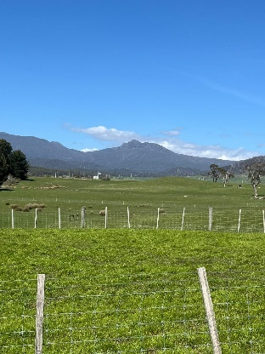The Telstra base station is not co-located with other providers.

The majority of people interviewed were with Telstra and perceived the carrier to have the greatest availability across the state. These interviewees also indicated a strong sense of brand loyalty, having “*always been with Telstra*”.

There were a couple of examples where individuals reported to have tried Optus but switched back to Telstra when Optus did not provide as much area in terms of coverage.

“Competition is lower here in Tasmania.”

Other

A number of interviewees queried the site choice for the base station, stating that they perceived the base station could have achieved increased coverage if it had been positioned in a more elevated site.

“Why did they build it there? Why didn’t they build it on one of the peaks to get more coverage?”

Further, power backup was top of mind for a number of people who had experienced recent storms in the area that disrupted power to the base station and left them without connectivity for an extended period.

“The storm took out the power, and there was no generator. We didn’t have connectivity for a week.”

Ongoing need

While it was generally acknowledged that the tower had increased coverage for the area, many interviewees were concerned about the safety risks associated with large remaining patches without connection.

“Blessington is an isolated area, I would love better service.”

Laguna Community Visit

*A total of 20 people were interviewed in face-to-face consultations at the Wollombi Markets, Wollombi, 7th October 2024. The following feedback comes from Laguna community members and from those living in nearby towns, including Wollombi.*

Background and context

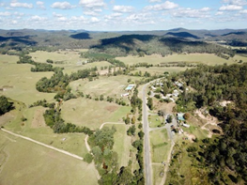Laguna, Darkinung Country, is approximately 40 kilometres southwest of Cessnock, in the Hunter Valley region, between the Yengo, Watagans, and Wollombi National Parks.

The 2021 Census identified a population of 310, but the community is likely bigger than this once the geographic footprint is extended to include residents living in proximal properties and bordering adjacent communities, such as Wollombi. Laguna has a school, church, fire station, shops, and restaurants situated along the main street.

Its topography is precipitous, including a spine of sharp interlocking ridges that cut through the area. In recent times, the region has experienced multiple natural disasters, including bushfires in 2019 and floods in 2022 and 2023.

The Optus mobile base station (macro cell solution) in Laguna was completed in December 2023 under Round 5 of the MBSP.

Key themes

Coverage

Interviewees indicated there was no mobile coverage in Laguna prior to the base station. Many highlighted that their mobile coverage had improved significantly since the tower was delivered.

“It’s way better than it used to be.”

“We now have great connection at home.”

“The tower has made a huge difference in coverage down the main strip of Laguna and for the businesses there.”

“The fact that we have mobile coverage in the CBD has made a big difference. We had to rely on it last week because the Wi-Fi is terrible at the fire station, and we were able to hotspot to our mobile.”

Home and business

Mobile devices used were predominantly mobile phones, with some examples of individuals using tablets and smartwatches. Mobile devices were primarily used for personal and business voice calls and for services such as banking. (Many interviewed highlighted their dependence on their mobile device for authentication and authorisation codes.) Some people interviewed were business owners based in the area, and either ran their business from a local office or from a home base. In these cases, their mobile device was of primary importance for work purposes.

“I run my business from home. I do all my banking online, and I need my mobile for authentication, authorisation codes, and calls.”

“How do you live in the 21st century if you can’t get a bank code on your mobile phone?”

Safety

Stakeholders' perceptions of the importance of the base station were overwhelmingly related to safety – primarily connectivity to support emergency management. To expand:

* many had experienced the recent floods firsthand, with little to no mobile coverage. The lack of mobile connectivity had left them feeling vulnerable and isolated, with limited ability to contact (and check) family, neighbours, and friends
* many commented that the base station had increased coverage to stretches of the Great Northern Road (leading into Laguna). This road is actively used by tourists and visitors, including motorcyclists. Stakeholders described the regularity of encountering an accident while driving home and the importance of being able to call 000 from the location for emergency services.

“There are many accidents at ‘Lemming Corner’. It’s a real problem to call 000 from that stretch to get help.”

“When we are out responding in the truck, we find out where we are going before we lose connection. If we don’t have specifics, we drive closer and then search for reception to get updated information and locations. Sometimes we have to drive a fair way to get reception.”

“There are lots of older people in the area who are vulnerable. In the floods last year, we were cut off for days.”

“Everybody’s got rid of their landline, and if they do have a landline, it usually doesn’t work when things get so wet.”

Competition

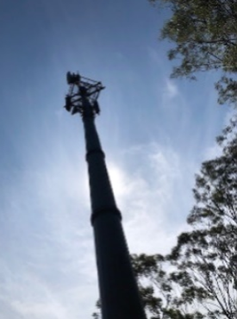The Optus base station is not co-located with other providers. A Telstra base station operates in nearby Wollombi. The sample of stakeholders interviewed included a mix of Telstra and Optus users. A couple of stakeholders held both Telstra and Optus accounts in their families so that at least one member of the family had connectivity at any one point in time*.*

A number of people perceived providers' lack of co-location as a pain point. This included co-location with emergency services and networks such as the Emergency Radio Network (ERN). These stakeholders indicated that competition had not increased since the base station, but they were keen for multiple providers to share it and expand their consumer choice.

“In Laguna, you get Optus. In Wollombi you get Telstra.”

“My family uses both Optus and Telstra due to our location between the towers (Laguna, Wollombi).”

“The irony is that we’ve got a new tower, but many people can’t use it because they are already with Telstra. If you’re a Telstra user, you won’t have connection for about 30 km.”

“Competition has not happened. The Government should have mandated sharing.”

“We would love for the tower to be used by other tenants.”

“It’s just common sense that the Emergency Radio Network (ERN) use the tower.”

Other

A key theme of conversations was the significant level of community interest in the project and polarised community views regarding the base station.

Residents recalled the process of securing the base station as both a protracted and polarising experience for the community:

* initially, Telstra initiated the process in June 2018 but then withdrew in the face of objections from a portion of the community that was concerned the tower:
* would compromise visual amenities and
* had the potential for untested harm from the 5G radio wave frequencies on the population.
* post Telstra’s withdrawal from the process, the Laguna community petitioned in support of a mobile tower
* Optus delivered the tower in December 2023 (five years after the initial investigations by Telstra).

Key individuals in the community were identified as having invested significant effort to facilitate the delivery of the tower. It was observed how important community “champions” had been in driving community engagement and maintaining the project's momentum from a community perspective.

“You wouldn’t believe the angst this town went through to get this tower!”

“The consultation process went on for two to three years and threw up polarised views.”

Further, consultations highlighted a spectrum of digital literacy in the community, ranging from little to none to extremely sophisticated and informed about providers, technologies, applications, and the range of services available. For example, some people interviewed were au fait with using a breadth of technologies and applications for personal and business use. Some people knew how to make and receive calls on their mobile only. While a minority, some people only had a landline.

Ongoing need

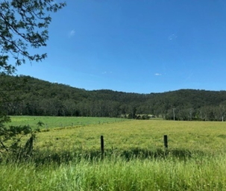While it was generally acknowledged that the tower had increased coverage for parts of the community, people identified significant stretches of Laguna’s geographic footprint that remained a communication void. This was a particularly acute pain point in an emergency management context.

The need to address the ongoing gaps in coverage featured in most conversations. Suggestions for how this might be done ranged from:

* additional mobile telecommunications infrastructure (more base stations)
* use of alternative and additional technologies

With respect to the latter, a number of people interviewed had turned to Starlink’s satellite service as either an alternative or an addition to their mobile devices. They had done so for a range of reasons, relating to:

* cost
* ease of use and portability and
* reliability, including in an emergency response context.

“There are still gaps where the Laguna Tower’s reach ends and the Buckety Tower picks up. There are sections of the Great North Road that have nothing. It would be great to fill in the holes experienced along the Great North Road.”

“We realistically need three to four towers for good coverage. For example, my personal coverage at home is great, but there is a gap in reception between Wollombi and Buckety.”

“Our biggest issue is topography. It’s so hard, where would you put the next tower?”

“A lot of people use Starlink now. From an emergency perspective, we can’t get a connection once we leave the fire station. In the next three years, we will have Starlink in all the trucks.”

“I’ve had two satellites. Starlink has been a game-changer. I paid for the installation and pay per month, and it is hugely portable. It gives me open data, no data cap, and no outages.”

“I went Starlink as a backup for when the tower goes out. One of the first issues in an emergency is the loss of communication – and the tower going down.”

“My wife has medical problems, so I’ve had to go to Starlink to make sure we can connect with medical support if we need to. It never drops below 200 megs per second.”

Riverton and Robertstown Community Visits

*Face-to-face consultations were conducted in Riverton on 10th October 2024 and Robertstown on 11th October 2024. 31 people were interviewed in Riverton, and 21 people were interviewed in Robertstown. The following feedback comes from people living and working in both communities and from those visiting from nearby towns, including Clare, Saddleworth, Rhynie, Burra, and Manoora.*

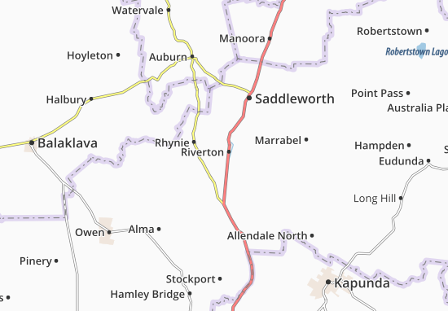

Figure 26: Map of Riverton and Robertson area (viamichelin.co.uk)

Riverton

Background and context

Riverton, Ngadjuri Country, is located near the Gilbert River, approximately 100 kilometres north of Adelaide, South Australia. Primarily a farming district, Riverton is the largest town in the Gilbert Valley. With a population of approximately 1,000 people, the town is regarded as a medium-sized service centre for the area with shops, cafes, pubs, a swimming pool, and a museum.

The Optus Base Station (macro cell solution) was completed in April 2022 under Round 4 of the MBSP.

Key themes

Coverage

Only a minority of people interviewed were either aware of or recalled the delivery of the base station in 2022. Therefore, rather than offering ‘before’ and ‘after’ perspectives, the interviewee’s observations related more to their general experiences with mobile coverage.

Only a handful were satisfied with their mobile coverage in the township.

“We changed to Optus, to get better coverage in the town. Now I have enough coverage to do everything”

“It’s not too bad in Riverton, but not good outside of the area.”

Most were dissatisfied with their mobile coverage, and many interviewed had invested in boosters and secondary repeaters to lift their reception.

“We are 100 kilometres from Adelaide, and the reception is crap.”

“There’s too much distance between the towers. We need boosters along the way.”

“We’ve put in another repeater at an additional cost.”

Home and business

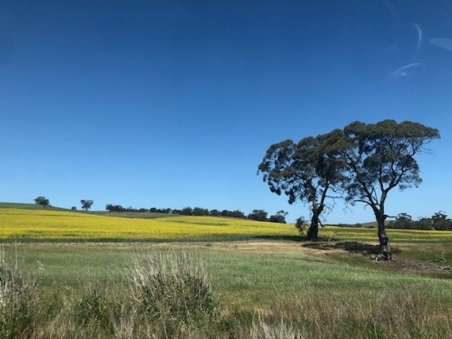Everyone interviewed had a mobile phone, and a few people also had smart devices, including tablets and smartwatches. Mobile devices were primarily used for voice calls and services such as banking, and a few individuals also used them for social media.

Some individuals interviewed were business owners based in the area who either ran their business from a local office or from a home base. In these cases, their mobile phones and tablets were their primary work devices.

“I run a business as an artist. I use social media and Instagram. I am dependent on my mobile phone for advertising, bookings, and banking.”

Many people interviewed were farmers who used a range of agricultural apps and technologies in their business, such as those used for autonomous tractors, automated spraying and irrigation systems, and livestock tracking.

“Tractors rely on mobile technology now. Automatic steering, spraying. it’s all getting high-tech”

Safety

Safety was the paramount reason for community members' concerns about mobile coverage, in particular, the need to be able to reach help quickly in the case of accidents (on the roads and farms) and natural disasters, such as bushfires.

“In the country, it is about safety.” (Clare Valley resident)

“We are emergency services volunteers; if you arrive at an accident and need to call for help, it's stressful if there’s no coverage. If you can’t talk to the (rescue) helicopter, they can’t land.”

“It’s a safety issue. During fire season, we’re especially on edge because mobile reception is our last resort to get people out. GRN is hit and miss.”

Competition

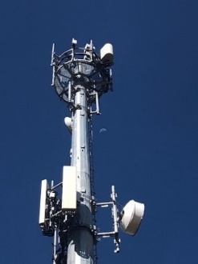The Optus base station is not co-located with other providers. Some interviewees were with Optus, but the majority were with Telstra. Telstra customers explained they were with the carrier because they lived and worked beyond the township's borders and perceived they would receive further coverage via the Telstra network. There were a couple of examples of families holding both Telstra and Optus accounts to maximise the mobile coverage area for the family. While a couple of people had switched carriers to Optus due to the base station, most of those interviewed felt there was no real competition between mobile carriers in their district due to the gaps in coverage between towers owned by the different carriers (e.g., if they opted for Optus, they could get mobile coverage in town but then a diminished signal when they left Riverton).

“I was with Telstra before and then changed to Optus. A lot of people in town went to Optus, because of the Optus tower, but as soon as they leave the town, they lose signal.”

“We split our accounts between Optus and Telstra to be able to get range.”

“Co-location doesn’t work …You can shop around for electricity, but not for this.”

Many of the farmers interviewed had purchased boosters to enable increased mobile coverage in their homes and across their paddocks. A number also utilised satellite technologies including Swoop, Beam, Starlink and Sky Muster.

“We’ve put in another repeater at an additional cost.”

“I don’t get any reception from the towers. I use Swoop satellite at home.”

Other

Key theme that emerged from the consultations related to digital literacy, including raising concerns about the impacts of:

* the 3G network closure
* the rapid rate of change and the difficulties associated with keeping up with the options available and how to use different technologies.

“I’m young, so I can keep up with all the changes in technology. Older people struggle, I am the tech support for my whole family!!”

“Everyone needs information about what can be received. This is basic stuff. Information needs to be given to both consumers and installers.”

“The telecoms technology is changing so quickly. How do you keep up?”

Another issue raised related to the perceived disconnect between the areas that were reported to have mobile coverage and the user experience. Users were informed by their carrier that they would receive connectivity under their plan, but that was not their experience.

“I am being told that according to their (the mobile carrier’s) map, I have coverage…And I am saying to them – I live here, and I can tell you now I am not getting any service”

Ongoing need

Everyone interviewed (even those who regarded the base station as improving coverage) expressed concerns for the areas of the district without mobile connectivity and the need to address the ongoing gaps in coverage featured in most conversations.

Robertstown

Background and context

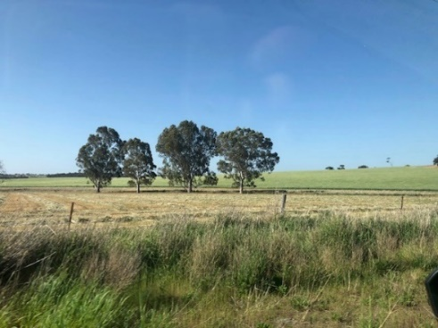**Robertstown**, Ngadjuri Country, is located 125km North of Adelaide (and about 60 kilometres from Riverton). It is a farming community with an approximate population of 300 people. It has a school and a small shopping precinct.

The Telstra base station (macro-cell solution) was completed in November 2018 under Round 3 of the MBSP.

Key themes

Coverage

Some interviewees reported that coverage had vastly improved since the base station had been built.

“Since the tower, it’s been much better. It’s made a big difference.”

“We live close to the tower, and we now get great service.”

“Since the Tower went up, it’s been so much better. I don’t need the antenna (booster) anymore.”

“I’ve spoken to so many people who say it is so much better than before in the centre of town.”

The majority interviewed reported they had experienced no improvement.

“I can see the tower from my house, but the signal is non-existent.”

“You still have to park the ute in the right spot.”

“I’ve heard the township has enjoyed a boost in coverage, but it has not made a bit of difference to us on the farm.”

Home and business

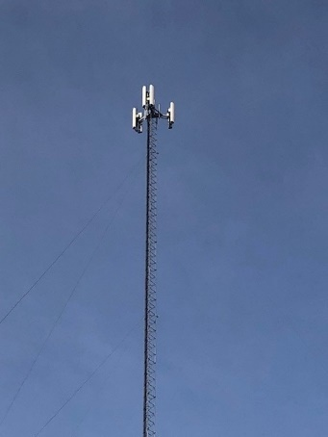Everyone interviewed had mobile phones, and a few people had smart devices, including tablets and smartwatches. Mobile devices were primarily used for voice calls and for services such as banking. A few individuals also used them for social media.

Many people interviewed were farmers who used a range of agricultural apps and technologies in their business, such as for cropping, spraying, and tracking livestock. Some individuals interviewed were business owners based in the area who either ran their business from a local office or from a home base. In these cases, their phones and tablets were their primary work devices.

Many of those interviewed were farmers, and most indicated that the lack of mobile coverage was problematic for their farm businesses.

“It’s frustrating to run a business like this.”

There are so many apps we could use, but we can’t. What’s the point of having all this technology if you can’t use it?”

“We have to do everything paper-based; we can’t submit our NDV[81] or wool clip[82] online from the site.”

Many had installed boosters on their farms (at an additional cost) to compensate, as well as utilised satellite technologies, including Sky Muster and Starlink.

We’ve put in another repeater for another $3,800. We have to pay extra just to use the service.”

Safety

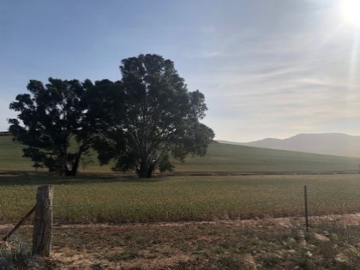Safety was the paramount reason for community members' concerns about mobile coverage, in particular, the need to be able to reach help quickly in the case of accidents (on the roads and farms) and bushfires.

Further, many interviewees were concerned about the lack of connectivity for at-risk groups in their community, including their growing aged population.

Competition

The Telstra base station is not co-located with other providers.

The majority of interviewees did not view the base station as increasing competition among mobile carriers. They saw more choices available via new technologies including satellite.

Other

Other key themes from the Robertstown consultations included:

* the advantages of having champions in the community who are respected, to advocate for the base station, and commit over time to raising community awareness and lobbying local government for the base station

“You need someone to be the dog with the bone and work with local members.”

* polarised views relating to the location of the base station – ranging from agreement to vehement disagreement that it had been built on the optimal site.

“I honestly reckon they’ve done the right thing building it there.”

“Where the tower was built is just dumb. There are only 20 people that live out there.”

Ongoing need

Everyone interviewed (even those who regarded the base station as improving coverage) expressed concerns for the areas of the district without mobile connectivity and the need to address the ongoing gaps in coverage featured in most conversations.

“Coverage should not be a luxury.”

“There are still lots of black spots.”

“Friends that live just out of range of the tower struggle.”

“That tower has done a fantastic job, but we just need a few more along the hills. The only way to beat it is with more towers along the ridge.”

Memerambi and Wooroolin Community Visits

*Face-to-face consultations were conducted in Memerambi on 29th October 2024 and Wooroolin on 30th October 2024. A total of 10 people were interviewed in Memerambi, and 10 people were interviewed in Wooroolin. The following feedback comes from people living and working in both communities and from those living in nearby towns, including Wondai, Ficks Crossing, and Kingaroy.*

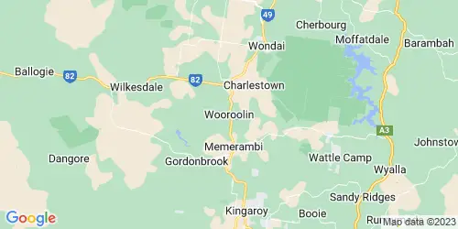

Figure 27: Map of Memerambi and Wooroolin district (aucrerate.com)

Background and context

Memerambi and Wooroolin, Waka Waka Country, are about five minutes’ drive apart, located in the South Burnett Region of Queensland, on the Bunya Highway, north of Kingaroy.

Memerambi has a population of approximately 350 people. There are a couple of businesses based in the town.

Wooroolin has a population of approximately 320 people. The main street includes shops, a post office, a café, and a pub. Wooroolin State School sits a few streets back.

Two MBSP solutions were delivered proximal to both towns:

* The Optus Base Station (Memerambi and macro cell solution) was completed in September 2022 under Round 5 of the MBSP.
* The Telstra Base Station (Tingoora and macro cell solution) was completed in October 2017 under Round 2 of the MBSP.

Key themes

Coverage

Only a handful of people from both sets of interviews were satisfied with their mobile coverage. This group of people was aware of the base stations in both locations and reported that the towers had improved coverage.

“The towers did improve coverage. I remember there was no coverage in Wooroolin and Tingoora – and there is now.”

“I have a great (mobile coverage) experience where I live.”

Most interviewees, however, were dissatisfied with their mobile coverage.

“We are used to not having coverage.”

“The service is terrible. You never know when you’ll have service.”

“I’d revert to the landline if I could re-activate it.”

“We are paying for a service that we are not getting.”

Home and business

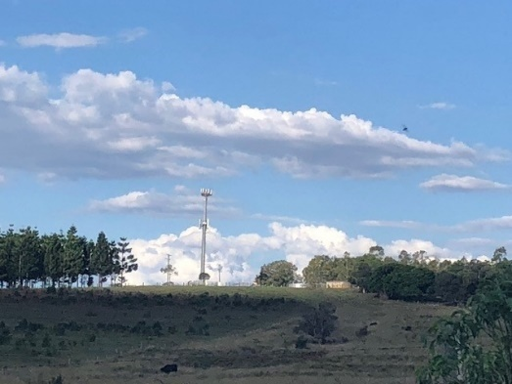Everyone interviewed had a mobile phone, which was primarily used for voice calls and services such as banking (authentication and authorisation codes). Some individuals interviewed were business owners based in the area. In these cases, their mobile phones were their primary work devices.

“I went with Optus for work because of the tower. My connection is excellent. Before, the connection was terrible.”

Safety

Safety was a paramount reason for concerns about mobile coverage, in particular, the need to be able to reach help quickly in the case of home and road accidents.

“Safety is an issue for tourism and events in town. When you run events, you need mobile coverage to obtain insurance.”

“You wouldn’t want to break down in Memerambi.”

A couple of interviewees had mobile medical alerts which they said were problematic due to their patchy mobile coverage.

Co**mpetition**

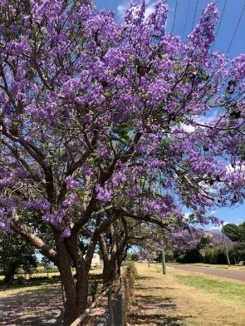The Optus base station in Memerambi and the Telstra base station (Tingoora) are not co-located with other providers. In consultations in both Memerambi and Wooroolin, only a few interviewees were with Optus, and the greater majority were with Telstra. Telstra customers explained they were with the carrier because they lived and worked beyond the township's borders and perceived they would receive further coverage via the Telstra network. Also, a number of interviewees erroneously thought that the Memerambi base station was a Telstra tower.

One interviewee had an e-sim to enable switching between Telstra and Optus accounts. There were also a couple of examples of families holding both Telstra and Optus accounts to maximise the mobile coverage area for the family.

Most interviewed perceived no increased competition resulting from the mobile base stations.

“It seems crazy that we have Optus here and Telstra over there. Surely the hardest bit is building the tower! Surely the easy bit is sharing it.”

A handful of interviewees had purchased boosters to enable increased mobile coverage in their homes and across their paddocks. A number of people commented on the alternatives presented by boosters and satellite technologies but were concerned about the associated costs.

“I don’t want a booster – it’ll be expensive.”

“Starlink could be a viable alternative. It could deliver everything we need – but it is expensive.”

Five people utilised satellite technologies in addition to their mobile devices, including Starlink and Sky Muster.

Other

A key theme that emerged from the consultations related to digital literacy, including raising concerns about their communities’ need for increased awareness of options available to them and not knowing where they could find independent information they could trust.

“People don’t know about their options. We need better comms about what our options are.”

“I’m considering other options, but there is not enough information about it for me.”

“Mobile is just one part of the connection web. It’s hard to understand the situation as it’s hard to find information on what’s actually correct.”

Another issue raised related to the perceived disconnect between the areas that were reported to have mobile coverage and the user experience. Whereby users understood they would receive connectivity under their plan but that was not their experience.

“People get caught off guard when the maps indicate there is coverage – and then there isn’t.”

Ongoing need

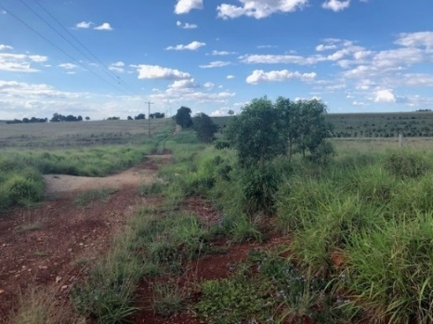The majority of people interviewed expressed concerns about mobile connectivity throughout the district. Suggestions for future improvement related to improved quality of coverage in the townships and increasing the area covered.

“It did improve coverage in town (Wooroolin), but our arterial roads still have no service.”

“Poor connection is a pain for life in general.”

“I had to ring for tech support to fix my printer. The call dropped out five times during the call.”

“The minimum standard is not being met out here.”

Yakanarra Community Visit

*16 people were interviewed in face-to-face consultations in Yakannara on 20th November 2024. The following feedback comes from community members, general store managers, school teachers, visiting service providers from community support programs and the Royal Flying Doctors Service (RFDS).*

Background and context

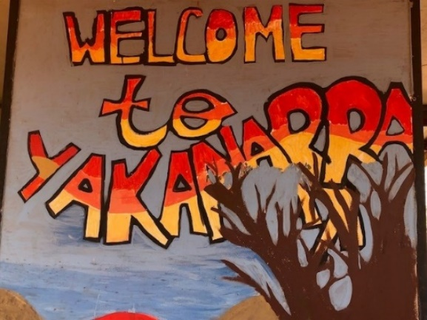Yakanarra, Walmajarri country, is located on the edge of the St Georges Ranges in Western Australia. It is one of several Indigenous communities in the Fitzroy Valley.

The Yakanarra community has an approximate population of 150 people, about 35 houses, a general store, and a school. The RFDS visits once a week.

The Telstra mobile base station (small cell solution) was completed in Yakanarra in December 2023 under Round 5 of the MBSP.

Yakanarra is one square kilometre in area. The landscape around the community is flat, except for the St Georges Ranges bordering one side. Accessible by charter flight and four-wheel drive, the closest town is Fitzroy Crossing (60 kilometres away and approximately two hours’ four-wheel drive away).

Key themes

Coverage

Community members reported that there was no mobile service prior to the Telstra base station. They recollected that representatives from the (Western Australian) government visited in person to discuss the lack of service with them before the tower was built.

Interviews suggested that:

* most Yakanarra community members had a mobile phone
* no one had a landline
* there were still two pay phones available in the community.

“Before you could not get a signal in your home.”

“We started with a payphone, and we used radios.”

Community members reported that before the base station, they could only receive (Wi-Fi) service near the general store.

“Before the tower, there used to be about 40 people coming to the store to use the Wi-Fi - all standing around in the heat.”

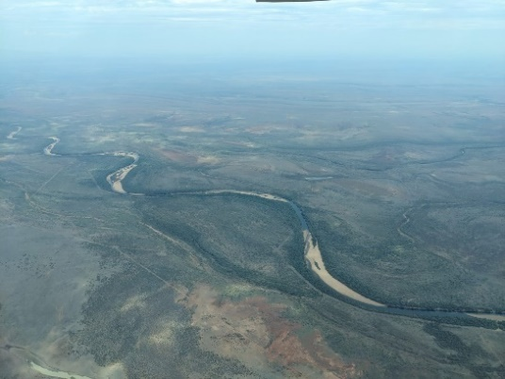They regarded the base station as a ‘game changer’ in connectivity because it gave them mobile access in their own homes.

Since the advent of the base station, they reported they had mobile coverage across the community’s geographic footprint as well as in a limited radius outside the community, extending down to parts of the river (a 30-minute drive away).

“We went from nothing to connectivity across the whole community.”

“We still get blackspots down at the river, but it’s so much better than it used to be. Service at the river is not as reliable, but you can find a signal – you just have to find the right spot.”

Visiting service providers to the community regarded Yakanarra as having the best mobile service of any of the communities that they also visited in the Fitzroy Valley.

“Coming back and forth from Fitzroy Crossing, there are lots of spots where we don’t get service, but we always get it when we reach Yakanarra.” (Yakanarra visitor)

“This is the best community for mobile phone service. The mobile signal is stronger in Yakanarra than in the other communities we visit. In some other communities, we have to climb up a hill to get mobile reception.” (Yakanarra visitor)

Home and business

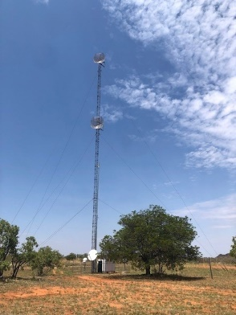Interviews indicated that phones were the only mobile devices used and primarily for voice calls and services such as banking and healthcare. Many interviewed highlighted their dependence on their mobile device for authentication and authorisation codes.

Community members that since the base station had been built, they could use their phones in and around their homes, for purposes of:

* staying connected with family living outside the community
* scheduling medical appointments
* contacting service providers outside the community and
* connecting with workmates and employers.

Safety

* Due to the community’s geographic isolation, community members highly valued the increased safety that came with mobile coverage made available by the base station, which gave them reassurance that they could call for help in the case of an accident or an emergency.

“We go out hunting on foot. We worry about snake bites. It’s good to know we can get a signal if we need to call for help.”

“Lots of people get bogged in the wet. We need our phones to call for help.”

RFD representatives highlighted the base station's positive impact on their ability to deliver services to the community. They reported the base station had enabled RFD personnel to connect more easily with their Yakanarra patients to arrange and confirm medical appointments and for follow-up contact.

“It has definitely delivered health benefits for the community because of the ability to communicate from within their own home.” (RFDS representative)

The base station also supported the delivery of medical appointments on the ground. It was reported that doctors could now tether to their mobiles for connectivity when accessing patient health records during their weekly visits to the community. The RFDs team could also contact specialists via mobile when in situ with patients in the clinic.

“The doctor is hot-spotting from her phone right now! She wouldn’t have been able to hotspot before the tower.” (RFDS representative)

Competition

The Telstra base station is not co-located with other providers. All interviewees were with Telstra.

“Telstra is the only option.”

However, interviews indicated the notion of increased choice was secondary (after coming from no mobile coverage at all). However, a couple of people did provide comments relating to getting a cheaper deal in the metropolitan part of the state.

“Everything about your phone is cheaper in Perth.”

Further, there were examples of the use of satellite alternatives. For example, the RFDS used Starlink at the clinic to support service delivery, and a couple of people living in the community also had Starlink and Activate Me accounts in addition to their mobile service. They used these satellite services to stay in contact with family members outside the community and to stream content.

Other

A large sandy field with a group of termite mounds.
A few people interviewed identified low levels of digital literacy among some members of the community, which meant they were not getting the most out of the mobile service.

For example, some members of the community:

* had a mobile phone but did not know how to use it properly, including not knowing their own mobile number
* dropped and broke their phones often and bought new devices regularly. Sometimes people thought that the problems with their phones were related to their SIM cards, and frequently changed their phone numbers (sometimes buying up to 2-3 different SIM cards a week). There were then complexities, and a laborious process attached to setting up their new phones, and it was hard to get help and advice to fix any issues.

Ongoing need

Community members interviewed unanimously acknowledged that the tower had enabled mobile coverage for their community. Suggestions for future improvement related to the community’s geographic isolation and extending coverage beyond the community’s footprint for safety reasons, particularly in the case of natural disasters or accidents.

“It would be good to have wider coverage in the event of a breakdown. Other communities come here to do their shopping. When they break down, it’s an issue.”

“It’s a two-hour drive to Fitzroy Crossing. The signal drops out during the drive. If there’s a breakdown, we can’t get back, we have to walk on foot.”

“Safety is the main reason for getting a bigger spread of coverage. If there’s a medical emergency, we rely on calling the RFDS for help. Also, fire is a big risk here.”

# Contact us

|  |
| --- |
| Evie Cuthbertson, Su-Ann Drew, Sumedha Gupta  t 02 6274 9200  e hello@grosvenor.com.au  abn 47 105 237 590 acn 105 237 590  w grosvenor.com.au  Level 15, 379 Collins Street Melbourne VIC 3000 t (03) 9616 2700  Level 4, 17 Moore Street Canberra ACT 2601 t (02) 6274 9200  Level 21, 60 Margaret Street Sydney NSW 2000 t (02) 8274 9200  Level 6, 200 Adelaide Street Brisbane QLD 4000 t (07) 3184 5724  217 Flinders Street, Adelaide, SA 5000 t (08) 8125 7502 |

1. Australian Government Telecommunications Infrastructure Fact Sheet
2. Australian Communications and Media Authority, A guide to small cells Fact Sheet
3. [Regional Tech Hub](https://regionaltechhub.org.au/)
4. [First Nations Digital Inclusion Measures](https://www.infrastructure.gov.au/sites/default/files/documents/first-nations-digital-inclusion-advisory-group-first-nations-digital-inclusion-measures-5june2024.pdf)
5. [Measuring What Matters](https://www.abs.gov.au/statistics/measuring-what-matters)
6. [Closing the Gap](https://www.closingthegap.gov.au/)
7. 2011-12 Regional Telecommunications Review
8. The Department of Communications became the Department of Infrastructure, Transport, Regional Development, Communications and the Arts (DITRDCA) in February 2020 and will be referred to as DITRDCA from this point forward.
9. List of completed sites, reported as of 31 October 2024
10. DITRDCA’s National Mobile Black Spot Database. The database contained mobile black spot locations reported by members of the public or nominated by members of parliament. The database was discontinued in 2018 and is no longer in use.
11. DITRDCA
12. DITRDCA
13. DITRDCA
14. Base stations for Round 6 (Improving Mobile Coverage Round Stage 1) and Round 7 are funded but under construction.
15. Note: Not all base stations across the country were eligible for MBSP funding in all rounds.
16. Based on (1) Program round guidelines, (2) Auditor-General Report No.28 2023–24 Performance Audit Award of Funding under the Mobile Black Spot Program, (3) [Mobile Black Spot Program](https://www.infrastructure.gov.au/media-communications-arts/phone/mobile-services-and-coverage/mobile-black-spot-program), (4) DITRDCA, (5) DITRDCA
17. Note: Funding figures from the Auditor-General Report No.28 2023–24 Performance Audit Award of Funding under the Mobile Black Spot Program are reported as inclusive of GST.
18. Note: The Improving Mobile Coverage Stage 2 round is not included as the grants for this round were under assessment at the time of the evaluation.
19. Note: Funding of operational costs was introduced from Round 6, consistent with the design of PUMP Round 1, increasing the total cost of solutions.
20. DITRDCA Corporate Plan 2024-25
21. DITRDCA
22. DITRDCA
23. DITRDCA
24. DITRDCA
25. DITRDCA as of February 2024
26. ANAO Award of Funding under the Mobile Black Spot Programme Report No. 10 2016-17
27. ANAO Award of Funding under the Mobile Black Spot Program, Report No. 28 2023-24
28. DITRDCA Corporate Plan 2024-25
29. DITRDCA Annual Report 2023-24
30. MBSP Survey (cleaned data)
31. DITRDCA
32. DITRDCA
33. DITRDCA
34. DITRDCA
35. MBSP Round 1 Guidelines
36. [Government kicks off national audit of mobile coverage (May 2024)](https://minister.infrastructure.gov.au/rowland/media-release/government-kicks-national-audit-mobile-coverage)
37. ANAO Award of Funding under the Mobile Black Spot Program, Report No. 28 2023-24
38. As per the Department of The Treasury *Commonwealth Evaluation Policy*
39. DITRDCA stated that this measure is not entirely representative of the actual number of premises, and work is being undertaken to set up a new measurement for premises from Round 8 onwards
40. Reports undertaken by Kordia in 2021 (unpublished)
41. MBSP Survey (cleaned data)
42. MBSP Survey (cleaned data)
43. Connecting the country: Mission critical Inquiry into co-investment in multi-carrier regional mobile infrastructure (2023)
44. Note: Only macro cell base stations (not small cell base stations) are suitable for co-location.
45. MBSP Survey (raw data)
46. Financial Framework (Supplementary Powers) Amendment (Communications and the Arts Measures No. 1) Regulations 2017
47. Explanatory Statement Financial Framework (Supplementary Powers) Amendment (Communications and the Arts Measures No. 1) Regulations 2017
48. In interviews, DITRDCA reported that later rounds had attracted sufficient interest for the funding available, but proposal numbers made in applications are objectively lower than in early rounds. Fewer projects have been funded because the number of proposals has decreased *and* the cost per project has increased.
49. Based on (1) Auditor-General Report No. 28 2023–24 Award of Funding under the Mobile Black Spot Program (2024), (2) Mobile Black Spot Program, (3) ACCC Mobile Infrastructure Report 2023, (4) DITRDCA, (5) 2011–12 Regional Telecommunications Review, (6) Regional Telecommunications Review 2015, (7) 2018 Regional Telecommunications Review, (8) 2021 Regional Telecommunications Review
50. Note: (1) The date of each round of MBSP is based on the ‘Date funding announced’ as per the Auditor-General Report No. 28 2023–24 Award of Funding under the Mobile Black Spot Program, (2) The data for IMCR Stage 2 round is based on publicly available information on Mobile Black Spot Program website, (3) The number of base stations built for 2020 and 2023 is based on the data from ACCC Mobile Infrastructure Report 2023 (Table 3.4), (4) The number of base stations built for 2024 is based on data from DITRDCA reported as of 31 October 2024
51. [Better Connectivity Plan for Regional and Rural Australia](https://www.infrastructure.gov.au/media-communications-arts/better-connectivity-plan-regional-and-rural-australia)
52. [Roll-out of Community Wi-Fi in remote communities](https://www.niaa.gov.au/our-work/closing-gap/roll-out-community-wi-fi-remote-communities)
53. [Digital Connectivity - Regional Telecommunications Project](https://www.agric.wa.gov.au/econnected/mobile-connectivity-regional-telecommunications#:~:text=Regional%20Connectivity%20Program,-The%20Regional%20Connectivity&text=In%20April%202021%20the%20Commonwealth,%248.252%20million%20under%20the%20Program.)
54. [Connectivity projects dashboard (Victoria)](https://www.vic.gov.au/find-a-project)
55. [Connecting Country Communities Fund (New South Wales)](https://www.nsw.gov.au/regional-nsw/regional-business-and-economy-nsw/regional-digital-connectivity-program/connecting-country-communities)
56. [Improving digital connectivity at Territory schools through the telecommunications uplift project](https://digitalterritory.nt.gov.au/digital-government/action-plans/action-items/improving-digital-connectivity-at-territory-schools-through-the-telecommunications-uplift-project)
57. [Piloting localised voice and data service solutions through the Telecommunications for Remote Aboriginal Communities (TRAC) project](https://digitalterritory.nt.gov.au/digital-government/action-plans/action-items/piloting-localised-voice-and-data-service-solutions-through-the-telecommunications-for-remote-aboriginal-communities-trac-project)
58. [Investment in regions (Government of South Australia)](https://www.pir.sa.gov.au/regions/investment_in_regions)
59. [Advancing the Technology Sector (Premier of Tasmania)](https://www.premier.tas.gov.au/our-plan/our-strong-plan-for-a-stronger-economy/advancing-the-technology-sector)
60. Mobile Coverage Programme Discussion Paper (December 2013)
61. The National Mobile Black Spot Database supported the operation of early rounds of the Mobile Black Spot Program. It closed for nominations on 11 October 2018 and is no longer used. (Mobile Black Spot Programme Guidelines – Accessible.)
62. mobile-black-spot-programme-round-2-guidelines-v1-1
63. Mobile Black Spot Program - Priority Locations Grant Guidelines (final)
64. mobile-black-spot-programme-round-imcr-grant-opportunity-guidelines
65. Round 4 guidelines - final (PDF Version)
66. mobile-black-spot-programme-round-5-guideline
67. mobile-black-spot-programme-round-5a-grant-opportunity-guidelines
68. mbsp7-round-7-funded-solution-list-december-2023
69. mobile-black-spot-programme-rcp-round-3-with-mbsp-round-7-opportunities-grant-opportunity-guidelines-v1.2
70. MBSP Survey (cleaned data)
71. Details received via survey
72. Inquiry into regional telecommunications in WA April 2024
73. Regional Telecommunications Review 2024 Submission for Policy Team Review (ID 711922)
74. MBSP Survey (raw data)
75. MBSP Survey (raw data)
76. Discussion Paper – First Nations Digital Inclusion Roadmap (2024)
77. [Regional Tech Hub](https://regionaltechhub.org.au/)
78. [First Nations Digital Inclusion Measures](https://www.infrastructure.gov.au/sites/default/files/documents/first-nations-digital-inclusion-advisory-group-first-nations-digital-inclusion-measures-5june2024.pdf)
79. [Measuring What Matters](https://www.abs.gov.au/statistics/measuring-what-matters)
80. [Closing the Gap](https://www.closingthegap.gov.au/)
81. National Vendor Declaration: Legal documents that communicate the food safety and treatment status of every animal as it moves through the supply chain. eNVDs capture livestock movement information digitally, including via a mobile app. Once the app has been downloaded consignments can be shared between transporter and receiver via QR code functionality. Producers must be accredited to access NVDs and eNVDs.
82. WoolClip is an online and smartphone app that allows used to create wool specifications and National Wool Declaration (NWDs) Provides transparency to buyers and the supply chain about mulesing status. Primary uses include wool classers and wool growers.