ITMM Members 2025
Commonwealth
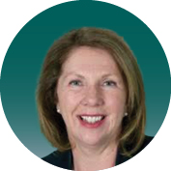 | The Hon Catherine King MP (Chair)  Minister for Infrastructure, Transport, Regional Development and Local Government
New South Wales
 | The Hon John Graham MLC  Special Minister of State  Minister for Transport  Minister for the Arts  Minister for Music and the Night-time Economy
 | The Hon Jenny Aitchison MP  Minister for Roads  Minister for Regional Transport

South Australia
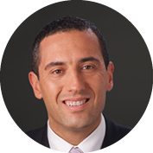 | The Hon Tom Koutsantonis MP  Minister for Infrastructure and Transport  Minister for Energy and Mining  Leader of Government Business in the House of Assembly

Victoria
 | The Hon Gabrielle Williams MP  Minister for Transport Infrastructure  Minister for Public and Active Transport
 | The Hon Melissa Horne MP  Minister for Ports and Freight  Minister for Roads and Road Safety  Minister for Health Infrastructure

Queensland
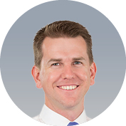 | The Hon Jarrod Bleijie MP  Deputy Premier  Minister for State Development,  Infrastructure and Planning  Minister for Industrial Relations
 | The Hon Brent Mickelberg MP  Minister for Transport and Main Roads
Western Australia
 | The Hon Rita Saffioti MLA  Deputy Premier  Treasurer  Minister for Transport  Minister for Sport and Recreation

Tasmania
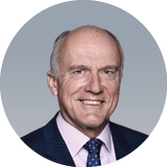 | The Hon Eric Abetz MP  Minister for Business, Industry and Resources  Minister for Transport  Leader of the House
 | The Hon Kerry Vincent MP  Minister for Infrastructure  Minister for Local Government

Northern Territory
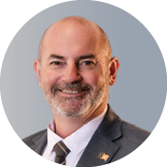 | The Hon William Yan MLA  Treasurer  Minister for Logistics and Infrastructure  Minister for Housing Construction

Australian Capital Territory
 | Ms Tara Cheyne MLA  Manager of Government Business  Attorney-General  Minister for Human Rights  Minister for City and Government Services  Minister for the Night-time Economy
Australian Local Government Association
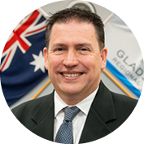 | Councillor Matt Burnett  President

