**Department of Infrastructure, Transport, Regional Development, Communications and the Arts


Indian Ocean Territories Health Service  • Telephone: 08 9164 8333 
33 Phosphate Hill Road PO Box 865 Christmas Island WA 6798 

“Working with Our Communities To Keep Us Healthy For The Whole of Our Lives”
**IOTA
Services to our community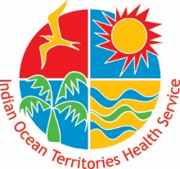

# NOTICE TO COMMUNITY

|  |  |  |  |
| --- | --- | --- | --- |
| **Number:** | IOTA-2022-02 | **Date:** | 24 August 2022 |
| **Relevant:** | Christmas Island and Cocos (Keeling) Islands | | |
| **Topic:** | IOT COVID-19 Weekly Update—17 August to 23 August 2022 | | |

|  |  |  |
| --- | --- | --- |
|  | **Christmas Island** | **Cocos (Keeling) Islands** |
| **New Cases: (week)** | **9** | **1** |
| **Total Recovered Cases:** | **523** | **249** |
| **Cases in Hospital** | **0** | **0** |

Please continue to maintain a safe distance from others, practise good hand hygiene, wear a mask in public places, cover your coughs and sneezes, stay home if sick and get tested if you develop symptoms.

Indian Ocean Territories Health Service

24 August 2022