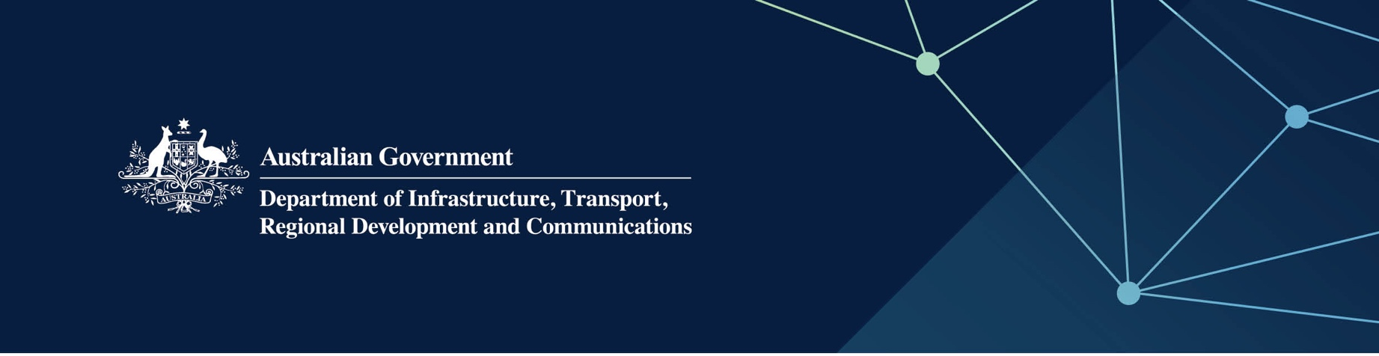

# Main Roads WA services

Delivered by Main Roads Western Australia in the Indian Ocean Territories

April 2022

## Services

The Western Australian Commissioner of Main Roads provides services, on behalf of – and fully funded by – the   
Australian Government, to achieve a safe, reliable and sustainable road network in the Territories.

Main Roads WA advises the Australian Government on road and road maintenance funding, programming and service delivery issues.

## What does this mean for me?

Main Roads WA will provide assistance and advice to the Territory local governments in satisfying the expectations of stakeholders and customers, and managing the road network in an effective, efficient and environmentally sensitive manner. Specifically:

* Main Roads WA will assist the Territory local governments to improve the management of their road network
* Main Roads WA will also provide advice on road construction including materials, road design standards and guidelines, road safety, environment and quality issues
* Training can also be provided to Territory local governments relating to road maintenance techniques and activities, and plant management and operation.

## For more information

|  |  |
| --- | --- |
| Area | Contact details |
| Telephone | 13 81 38 |
| Email | [enquiries@mainroads.wa.gov.au](mailto:enquiries@mainroads.wa.gov.au) |
| Website | [www.mainroads.wa.gov.au](https://www.mainroads.wa.gov.au/) |