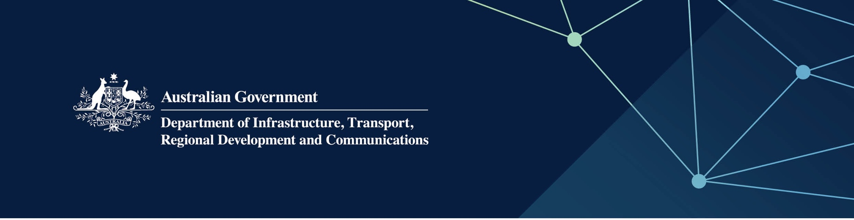

# Housing services

Delivered by the Department of Communities—Housing Authority in the Indian Ocean Territories

April 2022

## Services

The Department of Communities – Housing Authority, on behalf of – and fully funded by – the Australian Government, provides the following services:

* Housing management support – assists the Australian Government to manage social housing in the Territories in accordance with relevant policies, procedures and guidelines as well as providing advice about employee housing
* Policy advice and support to the Australian Government on a range of housing related issues
* Valuations – advice and assistance on Australian Government property valuations that are utilised in the setting of rents or property disposals
* Contracting and construction – advice and services to the Australian Government that facilitate the procurement process for future housing acquisition or upgrade.

## What does this mean for me?

The Australian Government manages social housing in the Territories using the Department of Communities’ policies and guidelines, including:

* eligibility policy, tenancy management policy and practices, and property rents
* procedures to assist the Australian Government in day-to-day tenancy control and management.

## For more information

|  |  |
| --- | --- |
| Area | Contact details |
| Telephone | 08 6217 6888 or 1800 176 888 |
| Email | [broome@communities.wa.gov.au](mailto:broome@communities.wa.gov.au) |
| Website | [www.housing.wa.gov.au](https://www.housing.wa.gov.au/Pages/default.aspx) |