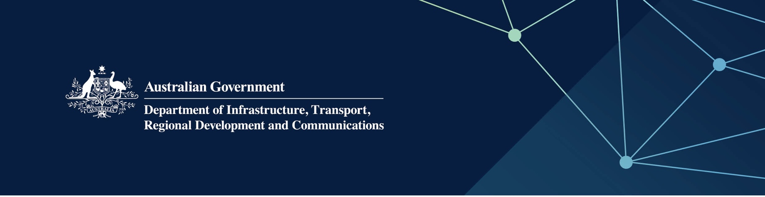

# Fire and emergency services

Delivered by the Western Australian Department of Fire and Emergency Services in the Indian Ocean Territories

April 2022

## Services

The Department of Fire and Emergency Services, on behalf of – and fully funded by – the Australian Government, supports the delivery of fire and emergency services in the Territories, through:

* community safety/prevention
* undertake fire safety assessments as required
* emergency preparedness and response
* advice on recovery from emergencies
* support to Fire and Emergency Services and Volunteer Marine Rescue Groups, including welfare programs.

## What does this mean for me?

Fire and emergency services are provided through the Indian Ocean Territories Administration’s Emergency Management Officer, to support the operation of the Fire and Emergency Services and Volunteer Marine Rescue groups. This includes providing training and exercises, advice on operational equipment and access to a welfare program.

Residents and students will benefit from community safety and prevention programs.

## For more information

|  |  |
| --- | --- |
| Area | Contact details |
| Telephone | 08 9395 9300 |
| Emergencies – fire or life threatening | 000 |
| Emergency information | 13 33 37 |
| District Officer | 9395 9388 or 0427 088 664 |
| IOTA Emergency Management Officer | 08 9164 7901 or 0418 766 703 |
| Website | [www.dfes.wa.gov.au](http://www.dfes.wa.gov.au) |