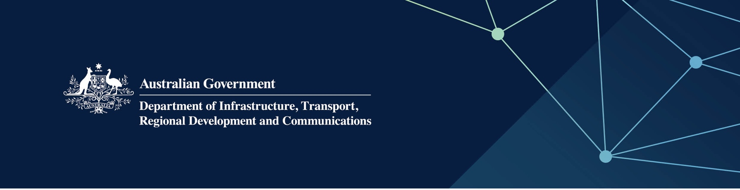

Liquor and gaming regulation services

Delivered by the Department of Local Government, Sport and Cultural Industries in the Indian Ocean Territories

April 2022

## Services

The Department of Local Government, Sport and Cultural Industries (DLGSC) – Racing, Gaming and Liquor, on behalf of – and fully funded by – the Australian Government, provides the following services to the Territories:

* Licensing – Evaluation and determination of applications: Receive, process and determine applications relating to the liquor industry and community gaming in accordance with legislation
* Compliance, audits and inspections: Perform audits and inspections every two years to evaluate the standards of licensed premises and whether the service of liquor is conducted in a responsible and lawful manner
* Educate existing and new licensees in terms of the requirements of the applied *Liquor Control Act 1988* (WA).

## What does this mean for me?

The DLGSC is responsible for promoting and maintaining the integrity of liquor and community gaming activities that are provided for the social and economic benefit of the people of the Indian Ocean Territories; these being:

* regulation of the sale, supply and consumption of liquor
* minimisation of harm or ill-health caused to people, due to the use of liquor
* catering for the requirements of consumers for liquor and related services, with regard to the proper development of the liquor, tourism and other hospitality industries.

## For more information

|  |  |
| --- | --- |
| Area | Contact details |
| Telephone | 08 6551 4888 |
| Email | [rgl@dlgsc.wa.gov.au](mailto:rgl@dlgsc.wa.gov.au) |
| Website | [www.dlgsc.wa.gov.au/racing-gaming-and-liquor](http://www.dlgsc.wa.gov.au/racing-gaming-and-liquor) |