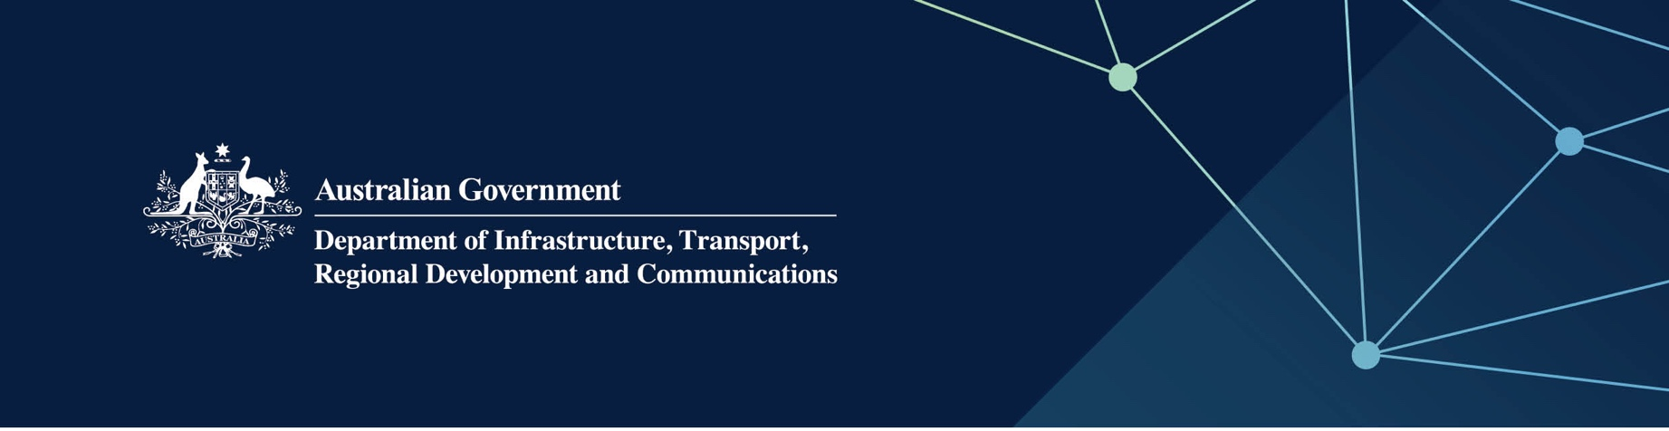

Culture and the arts services

Delivered by the Department of Local Government, Sport and Cultural Industries in the Indian Ocean Territories

April 2022

## Services

The Department of Local Government, Sport and Cultural Industries – Culture and the Arts, on behalf of – and fully funded by, the Australian Government provides the following services:

* promotes a diverse, vibrant and sustainable cultural sector
* supports the delivery of culture and arts activities across the Territories through policy development and grants funding.

## What does this mean for me?

The Department of Local Government, Sport and Cultural Industries — Culture and the Arts:

* Supports the delivery of arts and cultural activities across the Territories through funding programs and partnerships
* Develops arts and culture activities in the regions that contribute to increased participation
* Contribute to the development of the Territories by delivering strong evidence-based culture and the arts policy, research and planning to achieve Territory outcomes.

Each year, services could include a visual arts or performing arts tour, and recurrent funding to Arts and Culture   
Christmas Island Incorporated.

## For more information

|  |  |
| --- | --- |
| Area | Contact details |
| Telephone | 08 6552 7300 |
| Website | [www.dlgsc.wa.gov.au/culture-and-the-arts](https://www.dlgsc.wa.gov.au/culture-and-the-arts) |