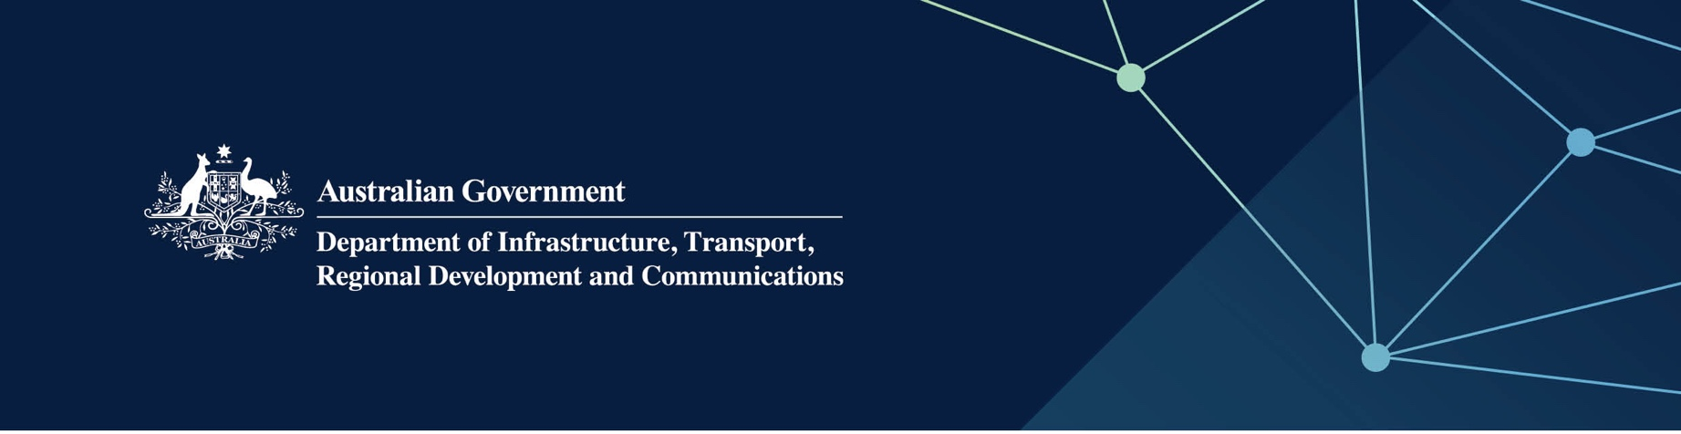

Communities services

Delivered by the Department of Communities in the Indian Ocean Territories

April 2022

## Services

The Department of Communities – Communities, on behalf of – and fully funded by – the Australian Government, provides the following services:

* Access to the WA Seniors Card.
* Assess education and care services against the National Quality Standard.
* Guidance and support to ensure compliance with the applied Education and *Care National Law (WA) Act 2012* (WA) and Education and Care Services National Regulations.

## What does this mean for me?

* Seniors who meet the eligibility requirements for the WA Seniors Card may apply online at [www.seniorscard.wa.gov.au](http://www.seniorscard.wa.gov.au) or download an application form.
* WA Seniors Card members can claim WA Government concessions for WA Seniors Card members and discounts from participating businesses.
* Children have greater individual care in a safe environment, and children’s learning and development is supported.
* All incidents and complaints regarding education and care services are investigated.

## For more information

|  |  |
| --- | --- |
| Area | Contact details |
| Seniors Card | Telephone: 08 6551 8800 Fax: 08 9226 4745  Email: [info@seniorscard.wa.gov.au](mailto:info@seniorscard.wa.gov.au)  Website: [www.seniorscard.wa.gov.au](https://www.seniorscard.wa.gov.au/) |
| Education and Care Regulatory Unit | Telephone: 08 6551 8333 or 1800 199 383  Email: [ecru@communities.wa.gov.au](mailto:ecru@communities.wa.gov.au)  Website: [www.wa.gov.au/organisation/department-of-communities/education-and-care-regulatory-unit](https://www.wa.gov.au/organisation/department-of-communities/education-and-care-regulatory-unit) |