Department of Infrastructure, Transport, Regional Development and Communications

Advice on Strategies to Support C-ITS Deployment

|  |  |
| --- | --- |
| March 2022 | Confidential |
| |  |  | | --- | --- | | WSP Logo | | | Deloitte logo | The University of Melbourne Logo | | |





 

WSP, Deloitte Financial Advisory Pty Ltd (Deloitte) and University of Melbourne acknowledge and thank the wider input received for this project from Knut Evensen, the project board (including TMR, TfNSW and Austroads), the project team, and stakeholders from government and industry.

Department of Infrastructure, Transport, Regional Development and Communications

WSP

Level 12, 900 Ann Street   
Fortitude Valley QLD 4006  
GPO Box 2907   
Brisbane QLD 4001  
  
Tel: +61 7 3854 6200  
Fax: +61 7 3854 6500

wsp.com

|  |  |  |
| --- | --- | --- |
| REV | DATE | DETAILS |
| A | 18/11/2021 | First Draft |
| B | 01/02/2022 | Second Draft with addition of policy analysis and rework from feedback |
| C | 21/02/2022 | Inclusion of final feedback (text) |
| D | 23/02/2022 | Clean document for review |
| E | 10/03/2022 | Final edits for release |

|  |  |  |  |
| --- | --- | --- | --- |
|  | Name | date | signature |
| Prepared by: | David Alderson, Jessica Tong, Shivaani Polley | 10/03/2022 |  |
| Reviewed by: | Scott Benjamin | 10/03/2022 |  |
| Approved by: | James Smithers | 10/03/2022 |  |

Table of contents

Abbreviations v

Use case Definitions vii

Executive Summary xiv

1 C‑ITS In Australia 1

1.1 What is C‑ITS? 1

1.2 Land Transport Issues for Australia 2

1.3 Policy Context 5

1.4 C‑ITS is an Ecosystem 6

1.5 Project Execution and Results 8

1.6 Current State of C‑ITS 18

2 Policy Impact Analysis 25

2.1 The Issue (challenge) 25

2.2 Policy approaches 26

2.3 Policy Impact Analysis 27

3 Key Findings 39

3.1 Problem aspect: Harmonised ecosystem for all 39

3.2 Problem aspect: Delivery of road safety, efficiency, sustainability, and accessibility benefits 40

3.3 Summary of Findings 40

CONTENTS (Continued)

4 Principles For National Approach 42

A. Engagement between governments and industry (specifically vehicle manufacturers), and agreement built on shared understanding of issues, are key to developing an interoperable C-ITS ecosystem 43

B. Uplifting digital capability in people and infrastructure will support informed agencies, service providers and road users 44

C. Standards combined with infrastructure availability provide a platform for interoperability and long-term operational deployment 45

D. Early focus on specific public benefit use cases can realise targeted benefits and help accelerate establishment of the ecosystem 47

E. A foundational ecosystem should allow for future growth and flexibility to accommodate a range of business models 49

5 The Road Ahead 50

5.1 National Framework and Shared Understanding 51

5.2 Technical Certainty 52

5.3 No Regrets Use Cases 55

5.4 The role of Government 56

5.5 Kickstarting A National C-ITS Ecosystem 57

6 Conclusion 59

References 60

List of tables

Table 1.1 Major Australian C‑ITS trials 18

Table 1.2 Deployment status of C‑ITS 19

Table 1.3 Current technical challenges 22

Table 2.1 Options comparison 30

Table 2.2 Intervention findings 31

Table 2.3 Standards comparison 34

Table 2.4 Standards findings 35

Table 2.5 Options Comparison 38

Table 2.6 Short-range communication Findings 38

Table 3.1 Findings 40

Table 5.1 Technical next steps 52

List of figures

Figure 1.1 Example C-ITS roadworks use case 2

Figure 1.2 All road deaths (left) and number of deaths by road user (right): 12-month total Australia 3

Figure 1.3 National Road Safety Strategy 2011–2020 statistical progress towards fatality target 3

Figure 1.4 Private-vehicle passenger kilometres travelled in capital cities since 1999–2000 4

Figure 1.5 Average travel speeds across arterial networks in major capital cities 2013-2018 (all hours by year) 4

Figure 1.6 National Road Safety Strategy Priorities 5

Figure 1.7 Key Challenge Areas for C‑ITS 6

Figure 1.8 The hybrid model with capability to share data through short-range and long-range communications 8

Figure 1.9 Project methodology 8

Figure 1.10 Use cases considered (definitions provided in Section B) 9

Figure 1.11 Progressive deployment of C‑ITS 10

Figure 1.12 Components of C‑ITS 11

Figure 1.13 High-Level Causal Loop 13

Figure 1.14 Starting point for potential C‑ITS options (freight scenario) 13

Figure 1.15 Cost-Benefit analysis options and results 15

Figure 1.16 Total cost by option (all values in $2021 AUD) 15

List of figures (continued)

Figure 1.17 Maximum annual safety benefit by project option and vehicle type (2021 dollars) 16

Figure 1.18 Maximum benefit from travel time savings in 2032 by project option and vehicle type (2021 dollars) 16

Figure 1.19 Comparisons of costs and benefits – consideration of stepping stones 17

Figure 1.20 Europe Deployment Map 21

Figure 1.21 US Deployment Map (USDOT, 2021) 21

Figure 4.1 Principles for national approach 42

Figure 5.1 Connected vehicle cone of uncertainty and potential of backbone deployment 50

Figure 5.2 Key areas of investment and options for deployment 55

Figure 5.3 C‑ITS deployment considerations 57

Abbreviations

|  |  |
| --- | --- |
| ACC | Adaptive Cruise Control |
| ACMA | Australian Communications and Media Authority |
| ADR | Australian Design Rules |
| AIMES | Australian Integrated Multimodal EcoSystem |
| ANCAP | Australasian New Car Assessment Program |
| ATAP | Australian Transport Assessment and Planning |
| BCR | Benefit Cost Ratio |
| CACC | Cooperative Adaptive Cruise Control Systems |
| Car2X | Car-2-Anything |
| CBA | Cost-Benefit Analysis |
| C2C-CC | Car 2 Car Communication Consortium |
| CAM | Cooperative Awareness Message |
| CAV | Connected and Automated Vehicle |
| CAVI | Cooperative and Automated Vehicle Initiative |
| CCAM | Cooperative and Connected Automated Mobility |
| CITI | Cooperative Intelligent Transport Initiative |
| C‑ITS | Cooperative Intelligent Transport Systems |
| CPM | Collective Perception Message |
| CV2X | Cellular-Vehicle to Everything |
| DENM | Decentralised Environment Notification Message |
| DSRC | Dedicated Short-Range Communications |
| DTA | Digital Transformation Agency |
| ERTRAC | European Road Transport Research Advisory Council |
| ETSI | European Telecommunications Standards |
| EU | European Union |
| FCC | Federal Communications Commission |
| FCAI | Federal Chamber of Automotive Industries |
| GLOSA | Green Light Optimal Speed Advisory |
| GM | General Motors |
| GNSS | Global Navigation Satellite System |
| HMI | Human Machine Interface |
| ICVP | Ipswich Connected Vehicle Pilot |
| ILM | Investment Logic Mapping |
| ISO | International Standards Organisation |
| ITS | Intelligent Transport Systems |
| IVI | In-vehicle Information |
| MAPEM | Map Extended Message |
| MCA | Multi-Criteria Analysis |
| NAP | National Access Point |
| NTC | National Transport Commission |
| OEM | Original Equipment Manufacturer (broader than only vehicle manufacturers) |
| PA | Policy Approach |
| PTW | Powered Two Wheelers |
| RADCAV | Road Authority Data for Connected and Automated Vehicles |
| RTCMEM | Radio Technical Commission for Maritime services Environmental Message |
| SCMS | C‑ITS Security Credential Management System |
| SPAT | Signal Phase and Timing |
| SSEM | Signal Status Extended Message |
| SSREM | Signal Request Extended Message |
| TfNSW | Transport for New South Wales |
| TMR | Queensland Department of Transport and Main Roads |
| TSC | Traffic Signal Controller |
| TTG | Time to Green |
| UNECE | United Nations Economic Commission for Europe |
| US | United States |
| VAM | VRU Awareness Message |
| V2I | Vehicle to Infrastructure |
| V2V | Vehicle to Vehicle |
| V2X | Vehicle to Everything |
| VRU | Vulnerable Road User |

Use case Definitions

For more information see the support study for Impact Assessment of Cooperative Intelligent Transport Systems (Levin, Skinner, & Nokes, 2019).

Day 1 and 1.5 Use Cases

| Use Case | Description  (Levin, Skinner, & Nokes, 2019) | Content Provision (who is creating the content) | Service Provision (who is providing the content) | Presentation Provision (who is showing the information) |
| --- | --- | --- | --- | --- |
| **Day 1 Use cases** | | | | |
| **Emergency Electronic Brake Light** | Aims to prevent rear end collisions by informing drivers of hard braking vehicles ahead. Drivers will be better prepared to adjust their speed accordingly. | Vehicle System | Vehicle System | Vehicle System |
| **Emergency Electronic Brake Light** | Aims to prevent rear end collisions by informing drivers of hard braking vehicles ahead. Drivers will be better prepared to adjust their speed accordingly. | Vehicle System | Vehicle System | Vehicle System |
| **Emergency Vehicle Approaching** | Gives an early warning of approaching emergency vehicles, prior to the siren or light bar being audible or visible. This should allow vehicles extra time to clear the road for emergency vehicles and help reduce the number of unsafe manoeuvres. | Vehicle System | Vehicle System | Vehicle System |
| **Slow or Stationary Vehicles** | Intended to deliver safety benefits by warning approaching drivers about slow or stationary/broken down vehicle(s) ahead, which may be acting as obstacles in the road. The warning helps to prevent dangerous manoeuvres. | Vehicle System | Vehicle System | Vehicle System |
| **Traffic Jam Ahead Warning** | Provides an alert to the driver on approaching the tail end of a traffic jam at speed. This gives the driver time to react safely to traffic jams. | Vehicle System/Detectors | Vehicle System/ Central Service/ Roadside | Vehicle System |
| **Hazardous Location Notification** | Gives drivers an advance warning of upcoming hazardous locations in the road. e.g., a sharp bend in the road, steep hill, pothole, obstacle, or slippery road surface. | Vehicle System/Traffic Operators | Vehicle System/ Central Service/ Roadside | Vehicle System |
| **Road Works Warning** | Enables road operators to communicate information about roadworks and restrictions to drivers. This allows drivers to be better prepared for upcoming roadworks and potential obstacles in the road, therefore reducing the probability of collisions. | Roadworkers/Traffic Operators | Central service/ Roadside | Vehicle System |
| **Weather Conditions** | Aims to increase safety by providing accurate and up-to-date local weather information. Drivers are informed about dangerous weather conditions ahead, especially where the danger is difficult to see. | BOM services/Vehicle System | Vehicle System/ Central Service/ Roadside | Vehicle System |
| **In-Vehicle Signage** | Informs drivers of relevant road signs in the vehicle’s vicinity, giving advance warning of upcoming hazards and increasing driver awareness. | Traffic/Road Operators | Central service/Roadside | Vehicle System |
| **In-Vehicle Speed Limits** | Intended to prevent speeding and bring safety benefits by informing drivers of speed limits. Speed limit information may be displayed to the driver continuously, or targeted warnings may be displayed in the vicinity of road signs. | Traffic/Road Operators | Central service/ Roadside | Vehicle System |
| **Probe Vehicle Data** | The purpose of probe vehicle data is to collect and collate vehicle data, which can then be used for various applications, e.g. to inform drivers about adverse road/weather conditions. | Vehicle System | Vehicle System/ Central Service/ Roadside | Central service |
| **Shockwave Damping** | Shockwave damping aims to smooth the flow of traffic, by damping traffic ‘shock waves’ or rapid changes acceleration/deceleration to the traffic flow by providing advisory speed information to lessen these rapid changes, smoothing the traffic’s flow and speed along a road. | Vehicle System | Vehicle System/ Central Service/ Roadside | Vehicle System |
| **Green Light Optimal Speed Advisory (GLOSA) / Time to Green (TTG)** | Provides speed advice to drivers approaching traffic lights, reducing the likelihood that they will have to stop at a red light, by providing advisory speed information to reduce the number of sudden acceleration or braking incidents, and improving the efficiency of vehicle operation, potentially reducing congestion and emissions. | Traffic Signal | Roadside | Vehicle System |
| **Signal Violation/ Intersection Safety** | The primary objective is to reduce the number and severity of collisions at signalised intersections, by warning drivers of possible red-light violations. | Traffic Signal | Roadside | Vehicle System |
| **Traffic Signal Priority (Request by Designated Vehicles)** | Allows drivers of priority vehicles (e.g., emergency vehicles, public transport, Heavy Goods Vehicles (HGVs)) to be given priority at signalised junctions. | Vehicle System | Roadside | Traffic Signal |
| **Day 1.5 Use cases** | | | | |
| **Off Street Parking Information** | Intended to bring efficiency benefits to drivers and help to reduce emissions in urban areas by reducing the time spent ‘cruising’ at low speeds. | Parking systems | Central service/ Roadside | Vehicle System |
| **On Street Parking Information and Management** | Intended to bring efficiency benefits to drivers and help to reduce emissions in urban areas by reducing the time spent ‘cruising’ at low speeds. | Parking systems | Central service/ Roadside | Vehicle System |
| **Park and Ride Information** | Intended to reduce congestion in urban areas and also shift travel from cars to public transport. | Parking systems | Central service/ Roadside | Vehicle System |
| **Information on AFV Fuelling and Charging Stations** | The objective is to broadcast electric vehicle charging point availability and alternative fuel vehicles (AFV) fuelling point information to relevant vehicles. | EV council/traffic operators | Central service/ Roadside | Vehicle System |
| **Traffic Information and Smart Routing** | Providing traffic information and smart routing services to vehicles is intended to improve traffic efficiency and aid traffic-flow management. | Traffic/Road Operators | Central service | Vehicle System |
| **Zone Access Control for Urban Areas** | The zone access control service is intended to manage access to specified zones. Using this information, drivers will be better informed and able to select the most appropriate route for their journey. | Traffic/Road Operators | Central service | Vehicle System |
| **Loading Zone Management** | This service is intended to support the driver, fleet manager and road operator in the booking, monitoring and management of urban parking zones specific to freight vehicles. |  | Central service | Vehicle System |
| **Vulnerable Road User Protection (pedestrians and cyclists)** | This is a safety focused service aimed at protecting vulnerable road users (VRUs) by providing information and warnings to the other road users (i.e., car or truck drivers) of a VRU’s presence. In this case only pedestrians and cyclists are considered VRUs. | Vehicle System/Ped Detector/Pedestrian system | Roadside/Vehicle | Vehicle System |
| **Cooperative Collision Risk Warning** | The cooperative collision risk warning is intended to minimise the risk of collisions between vehicles, e.g., when overtaking, or merging with traffic. | Vehicle System | Vehicle System | Vehicle System |
| **Motorcycle Approaching Indication** | This service is intended to increase safety and prevent collisions between motorcycles and other vehicles – likely to be by providing warning information to other road users (particularly car and truck drivers). | Vehicle/Motorcycle system | Vehicle System | Vehicle System |
| **Wrong Way Driving** | A vehicle moving against the regular traffic flow will detect countersense driving if equipped with the necessary capabilities, and disseminate a ‘wrong way driving’ message. Any other ITS stations detecting a vehicle moving against the regular traffic flow will disseminate ‘wrong way driving’ messages to Vehicle ITS stations. | Roadside system | Vehicle System | Vehicle System |

## Deployment Options

Options for analysis

|  | Option Description | Use Cases Included |
| --- | --- | --- |
| **1** | Do Minimum | No specific Day 1 and 1.5 use cases addressed from C‑ITS. |
| **2** | Improve safety (decrease crashes, fatalities and injuries) on motorways, arterial and rural roads | * Emergency Electronic Brake Light * Slow or Stationary Vehicles * Traffic Jam Ahead Warning * Hazardous Location Notification * Road Works Warning * Weather Conditions * In-Vehicle Signage * In-Vehicle Speed Limits * Probe Vehicle Data * Shockwave Damping * Cooperative Collision Risk Warning * Motorcycle Approaching Indication * Wrong-Way Driving |
| **3** | Reduce congestion in metro areas and on all motorways and arterials | * Slow or Stationary Vehicles * Traffic Jam Ahead Warning * Hazardous Location Notification * Road Works Warning * Weather Conditions * In-Vehicle Signage * In-Vehicle Speed Limits * Probe Vehicle Data * Shockwave Damping |
| **4** | Promote pedestrian and cycling modes of travel by improving safety and mobility for VRUs | * Vulnerable Road User Protection (pedestrians and cyclists) |
| **5** | Improve the convenience and ease of travel for road users | * Weather Conditions * In-Vehicle Signage * In-Vehicle Speed Limits * Green Light Optimal Speed Advisory (GLOSA) / Time to Green (TTG) * Off Street Parking Information * On Street Parking Information and Management * Park and Ride Information * Information on AFV Fuelling and Charging Stations * Traffic Information and Smart Routing |
| **6** | Improve the safety and efficiency of travel for commuters in urbanised areas | * Emergency Electronic Brake Light * Slow or Stationary Vehicles * Traffic Jam Ahead Warning * Hazardous Location Notification * Road Works Warning * Weather Conditions * In-Vehicle Signage * In-Vehicle Speed Limits * Probe Vehicle Data * Shockwave Damping * Green Light Optimal Speed Advisory (GLOSA) / Time to Green (TTG) * Signal Violation/ Intersection Safety * Traffic Signal Priority (Request by Designated Vehicles) * Off Street Parking Information * On Street Parking Information and Management * Park and Ride Information * Traffic Information and Smart Routing * Cooperative Collision Risk Warning |
| **7** | Enable more efficient movement of freight vehicles making deliveries in urban areas | * In-Vehicle Signage * Shockwave Damping * Green Light Optimal Speed Advisory (GLOSA) / Time to Green (TTG) * Traffic Signal Priority (Request by Designated Vehicles) * Traffic Information and Smart Routing * Zone Access Control for Urban Areas * Loading Zone Management |
| **8** | Enable the safe and efficient movement of long-haul freight traffic | * Emergency Electronic Brake Light * Emergency Vehicle Approaching * Slow or Stationary Vehicles * Traffic Jam Ahead Warning * Hazardous Location Notification * Road Works Warning * Weather Conditions * In-Vehicle Signage * In-Vehicle Speed Limits * Probe Vehicle Data * Shockwave Damping * Signal Violation/Intersection Safety * Traffic Information and Smart Routing * Zone Access Control for Urban Areas * Loading Zone Management |
| **9** | Deliver faster and safer travel for emergency vehicles | * Emergency Vehicle Approaching * Green Light Optimal Speed Advisory (GLOSA)/Time to Green (TTG) * Traffic Signal Priority (Request by Designated Vehicles) * Traffic Information and Smart Routing |
| **10** | Improve the safety of motorcycle travel on motorways | * Emergency Electronic Brake Light * Emergency Vehicle Approaching * Slow or Stationary Vehicles * Traffic Jam Ahead Warning * Hazardous Location Notification * Road Works Warning * Weather Conditions * In-Vehicle Signage * In-Vehicle Speed Limits * Probe Vehicle Data * Shockwave Damping * Signal Violation/ Intersection Safety * Motorcycle Approaching Indication |

Executive Summary

## C-ITS in Australia

This report summarises and presents the findings that emerged from the research project on the potential ‘Strategies to support Co-operative Intelligent Transport Systems (C‑ITS) deployment models’ undertaken by WSP and partners for the Department of Infrastructure, Transport, Regional Development and Communications. C‑ITS is a range of technologies that allows vehicles to communicate with each other and with road infrastructure, to share information and help drivers and road operators make better real-time decisions. Such enhanced decision making has the potential to benefit community safety, productivity, sustainability, and journey experience. The interrelationships underpinning cooperative vehicles and infrastructure are different from existing transport technology. Used wisely, C‑ITS could improve the benefits received from existing infrastructure use and defer/avoid capital-intensive infrastructure expansion.

Significant improvements have been made in vehicle operations and our roads. However, shortfalls remain in safety, efficiency and sustainability against targets sought by key strategies including towards Vision Zero deaths and serious injuries by 2050, reducing transport network congestion, and Towards Net Zero carbon emissions by 2050. New solutions to bridge the gap and meet the projections must be sought. C-ITS is one such solution available to Australia to target these issues.

Project research found C-ITS to be a viable technology, as proved in Australia and internationally. Strategic analysis determined that C-ITS could benefit many areas, particularly safety, efficiency and sustainability. Defining and delivering on a single business model has been a key C-ITS challenge. C-ITS in the long term will have many value-chains that will only eventuate from delivering a base ecosystem. Further, research has found that no single use case can individually deliver sufficient C-ITS benefits: the real value to society of C-ITS is realised when compatible technology and data is used to generate many uses and benefits.

This standard technology approach to C-ITS delivery formed the basis of the Cost-Benefit Analysis (CBA) where options based on bundles of use cases were analysed according to technology and market. A 10-year appraisal forecast for each investment option was used to align with the forecast methodology used in Austroads Future Vehicles 2030 and its 2031 update. The Austroads report outlined a medium scenario (by 2031) whereby 93 per cent of vehicle sales have embedded mobile data connectivity and 25 per cent have short-range communications. This connectivity offers more opportunity for services related to vehicle safety, efficiency, sustainability, and drivers’ comfort.

The CBA results were:

* *CBA-Option 1 (BCR 0.57)*: Vehicle-to-vehicle centric with minimal infrastructure support has a Benefit-Cost Ratio (BCR) below 1 and is not considered viable
* *CBA-Option 2 (BCR 2.91)*: Ports/Freight Corridors (Vehicle-to-vehicle, plus roadside stations at cities and central systems for intercity motorways focused on freight corridors), has the best economic return. However, the scale of its benefits are comparatively modest (~$1 billion)
* *CBA-Option 3 (BCR 2.32)*: Urban delivery of C‑ITS with mostly roadside station deployment, is also cost-effective with a broader range of benefits than option 2 (~$2 billion)
* *CBA-Option 4 (BCR 1.52)*: Advisory information through cellular communications has high social benefits return ($11.0 billion)
* *CBA-Option 5 (BCR 1.47)*: Balanced hybrid of city and rural deployment with both technologies realises the highest benefits ($11.8 billion).

C-ITS is a solution that has been around for over a decade. In Australia, two major pilots (CITI and CAVI) and further tests in multiple states, have provided opportunities to identify issues, benefits and understand what deployment requires. Both Europe (EU) and the United States (US) have had many different pilots and deployment sites with iterative testing that has improved the technology, functionality, standards and processes. Japan have deployed DSRC solutions since 2014. The US Federal Communications Commission (FCC) decision to redesignate a portion of the 5.9 GHz band previously reserved for Intelligent Transport Systems (ITS) use, and to mandate C-V2X as the technology standard for safety-related transportation and vehicular communications in the remaining spectrum, remains a point of concern to US transport sector stakeholders, including the US Department of Transportation, ITS America and the American Association of State Highway and Transportation Officials (AASHTO) – the latter two of whom have joined to file an appeal against the FCC’s order. The EU’s approach has been more ‘open’ and is focused on shared deployment, which has culminated in a proposed European directive amendment to include mandated sharing of safety data and availability of safety-related C‑ITS services (day 1 use cases) in new vehicles.

Short-range communication has two competing technologies: DSRC (the European standard for this is ITS-G5) and C‑V2X. Through the *Radiocommunications (Intelligent Transport Systems) Class Licence 2017* the Australian Communications and Media Authority (ACMA) has made available 70 MHz of spectrum in the 5.9 GHz band for ITS use in Australia. As a condition of the class licence, a ITS station operating in this spectrum must comply with the European Telecommunications Standards Institute (ETSI) Standard EN 302 571.

DSRC and C-V2X are not interoperable: they are unable to share information. Co-existence standards require that the two technologies must “detect and avoid” meaning each set of stations cannot hear the other, and one set of stations must stop broadcasting (potentially switching to another channel). This introduces a technical complexity where a vehicle’s equipment only works part of the time resulting in at-best equal benefits or at-worst less than half relative benefits realised.

Existing Australian road safety laws and Australian design rules for vehicles harmonise with the United Nations Economic Commission for Europe (UNECE) World Forum for Harmonization of Vehicle Regulations, Working Party 29 (known as WP.29). **This means vehicle designs entering the Australian market are currently harmonised to Europe**. Similarly, Australasia’s New Car Assessment Program (ANCAP) harmonises with Europe’s (Euro NCAP) which both have C-ITS on their roadmap for assessment in new vehicles by 2025. This provides a strong linkage for C-ITS and the European implementation.

## The problem

Based on the current issues on Australian roads and the opportunities presented by C-ITS, this project’s research has identified the ‘problem statement’ as answering – what is preventing the deployment of C-ITS in a way that achieves Australia’s national transport strategic objectives?

|  |
| --- |
| There is currently no harmonised C-ITS ecosystem available to all vehicle manufacturers and governments to share information that can deliver all Australians the desired road safety, efficiency, sustainability, and accessibility benefits that these technologies have to offer. |

### Options

To address the problem, three policy approaches (PAs) were considered:

1. **PA1** **Market-led**, allowing market participants (vehicle manufacturer industry) to make their own choices on technologies and standards.
2. **PA2 Government leadership and direction** to support creation of a national framework for the rollout of essential enabling technology.
3. **PA3 Introducing obligations for C-ITS services and data to be required in new vehicles,** thereby ensuring   
   C-ITS uptake.

### Policy Analysis and Outcomes

As part of this analysis, key policy issues are identified and examined to help guide the national strategies in relation to C‑ITS deployment:

1. To what extent does C-ITS need government direction and intervention? What are the benefits/risks in maintaining the wait-and-see approach taken to date?
2. How is progress with international standards relevant to Australia? What are the pros and cons of looking to align with a specific suite of these standards?
3. What kinds of decisions are needed in relation to the physical technology used for short-range communications?

Further detail on each of these policy issues is provided below. Fifteen key findings from the research are also outlined relating to the three policy issue areas.

### 1. WHAT LEVEL OF LEADERSHIP AND INTERVENTION IS APPROPRIATE?

In the absence of national action (PA1), C-ITS deployment, which relies on interoperability across the whole of an ecosystem, will fail or be severely limited in achieving the projected benefits. The introduction of requirements for C-ITS services and data in new vehicles (PA3) is premature without certainty of a national framework and deployment in place. The policy analysis resulted in the preferred approach of **PA2: Government leadership and direction**,given that it can help break the chicken-and-egg dilemma by acting to encourage and leverage industry development and investment. It creates certainty for industry to progress towards delivering solutions that align to strategic societal objectives. As the CBA evidenced, the introduction of a national framework with government-led infrastructure (roadside stations, central stations, security, etc) encourages an economically sustainable deployment.

| Number | Finding |
| --- | --- |
| 1 | The benefits that can be delivered by C‑ITS have been shown to target strategic priorities of the National Land Transport Technology Action Plan – safety, efficiency, sustainability and accessibility. |
| 2 | Deployment supported by government-led infrastructure (central or roadside or both) presented economically sustainable options with BCRs ranging between 1.4 and 2.9, while a vehicle-to-vehicle only deployment was unsustainable (BCR 0.57) within a 10-year period. |
| 3 | Government leadership based on a hybrid (both long-range and short-range distance communications) national deployment will likely achieve the greatest benefits and encourage accessibility in both urban and rural environments. |
| 4 | Government investment in enabling infrastructure (SCMS, central and roadside stations), of 1–7 per cent of the total cost, leverages the vehicle manufacturers investment (93–99 per cent) in achieving the significant public interest benefits possible. |
| 5 | Heavy vehicles were found to have the strongest benefit-cost ratio, due to higher vehicle operating costs and therefore increased benefits resulting from cost-efficiencies in targeted deployment. |
| 6 | Continued research and trialling are required to overcome the economic and scalability challenges for delivering beneficial C-ITS technology solutions to vulnerable road users. |

### 2. IS THERE A NEED TO ALIGN WITH A SPECIFIC SUITE OF INTERNATIONAL STANDARDS?

To provide the ***PA2 leadership and direction***, the analysis found that policy should provide certainty by supporting alignment to a **European standards suite.** Aligning implementation to Europe where possible, leverages the development and testing undertaken to date. Given vehicles imported to Australia are based on European designs, using the harmonised standards of WP.29, it is logical for C-ITS to follow a similar path to encourage consistency. It also reduces complexity and encourages industry uptake, given the need for maximum global harmonisation. Research in the Austroads C-ITS Standards Assessment (AP-R474-15) found that a single standard suite was likely necessary for C-ITS deployment. Vehicle manufacturer representatives (through the Federal Chamber of Automotive Industries (FCAI)) have noted their support for using a standards suite based on the European (and therefore also UN) approach.

| Number | Finding |
| --- | --- |
| 7 | Standardisation is essential to achieve the level of interoperability required to realise the full benefits of C‑ITS. |
| 8 | A consistent suite of standards (based on an international standards region) is needed to efficiently harmonise standards, specifications and guidelines, given that complexity increases as large-scale deployment evolves. |
| 9 | Europe has the most advanced and comprehensive set of standards and guidelines for deployment which are aligned to existing Australian vehicle standards through WP.29 and Australian vehicle manufacturer preference (as stated through FCAI). Europe is focusing effort now on implementing the standards consistently across all suppliers (government and industry). |
| 10 | The ISO/CEN “Cooperative intelligent transport systems (C-ITS) Guidelines on the usage of standards” provides the most comprehensive collation of a standards suite identified in the analysis. |
| 11 | Insights and learnings from other markets outside of Europe are beneficial to improve C-ITS deployment and should be considered within a governance framework that assesses the impacts of full harmonisation to European standards for delivery in Australia. |

### 3. IS A DECISION NEEDED TO DETERMINE PHYSICAL TECHNOLOGY USED FOR SHORT-RANGE COMMUNICATIONS?

The technology approach for short-range communications should also align with Europe as this provides the certainty and consistency for C-ITS interactions on Australian roads (as stated within findings 8 and 9 above). FCAI states that all vehicle manufacturer members support continued delivery of short-range communication to European standards. Europe **provides support for DSRC (**the European standard for this is ITS-G5**) as the mature priority technology (**as in **PA2), for safety-related use cases.** Potential to use DSRC (ITS-G5) or C-V2X for other use cases that add benefit to users and society should also be considered. However, these should not detract from the primary benefits presented by Day 1 C-ITS deployment and should be harmonised based on European direction which will, in turn, determine what technology vehicles will support.

|  |  |
| --- | --- |
| **Number** | **Finding** |
| 12 | Prioritising support for a single short-range communications standard will encourage uptake and achieve maximum benefits given by interoperability. Mixed technology delivering the same services will more than halve the CBA benefits due to splitting the vehicle market into two halves which cannot interact with each other. |
| 13 | Dedicated Short-range Communications (DSRC) is currently the most mature technology for short-range communication deployment, has been used in all Australian pilots, and is prioritised for the European uptake of safety-related use cases. |
| 14 | The progress of Cellular-V2X (C-V2X) should continue to be monitored for its potential to improve road safety and efficiency targets where the benefits of providing shared and nationally interoperable digital systems are not degraded. |
| 15 | Full scale deployment delays have not been due to the short-range communication method but rather due to solving challenges in delivering an operational ecosystem (such as user interaction and acceptance, business models with new interactions and processes, data readiness, security, etc.). |

## Principles

A nationally consistent approach to C‑ITS is needed to move to a market that allows industry to deploy at-scale with certainty. Defining and supporting common priorities between government, industry and users is essential for ensuring Australia has the right aspects of a foundational C‑ITS ecosystem in place. C‑ITS should complement other national transport strategies and benefit enhanced transport systems – not represent a competing solution. The following principles provide guidance in working towards national C-ITS deployment:

* + - 1. Engagement between governments and industry (specifically vehicle manufacturers), and agreement built on shared understanding of issues, are key to developing an interoperable C-ITS ecosystem.
      2. Uplifting digital capability in people and infrastructure will support informed agencies, service providers and road users.
      3. Standards combined with infrastructure availability provide a platform for interoperability and long-term operational deployment.
      4. Early focus on specific public benefit use cases can realise targeted benefits and help accelerate establishment of the ecosystem.
      5. A foundational ecosystem should allow for future growth and flexibility to accommodate a range of business models.

## Road Ahead

The principles highlight a need to kickstart the process of C‑ITS deployment given the ecosystem’s complexity. A robust national framework will provide initial national direction for many different industries, levels of government, and users. A framework needs to be adopted to meet the needs of all key parties and provide certainty through:

* A detailed roadmap with objectives, potential future state, integration needs, investment strategies and timeframes to galvanise a deployment approach
* Early deployments that occur with investment confidence
* Experts establishing delivery models for each aspect needed to deliver the roadmap
* Industry validating business models and technical delivery within the Australian context

Early action can help enable essential technology and establish the basis for future C-ITS deployment, including:

* Deploying short-range communications infrastructure that is interoperable and supports delivery of priority benefits
* Establishing a Security Credential Management System (SCMS) as soon as possible so trusted information can flow. Unsecured communications risk the end user receiving false information, damaging users’ trust, privacy and experience
* Providing support for positioning accuracy systems via guidelines, testing and infrastructure, and encouraging higher accuracy, reliable, cost-effective solutions
* Preparing central systems (such as traffic management centres) to provide event data to vehicles and receive data from vehicles. Establishing the needs and technical requirements for national data exchange to share information consistently from central systems
* Continuing the cellular network’s growth so it can support long-range communication services particularly on key corridors in remote areas
* Building guidelines and example datasets that demonstrate Australia’s implementation of nationally consistent standards: get the data flowing through the essential components to ensure it can be processed, stored, analysed and used
* Establishing clarity on how Australia intends to implement standards for deployment. The policy analysis suggests basing the standards on the International Standards Organisation (ISO) Europe standards guideline

## Conclusion

The intention behind adopting C-ITS is to build an ecosystem that encourages information sharing between many vehicle types, road users and road infrastructure. When this information is safety-critical, for example from a broken-down vehicle on the road ahead, the vehicle brand driven should not determine whether the information can be shared. If shared with everyone consistently (with trust), the safety and efficiency benefits are accessible to all. While other solutions exist (and will arise) for certain specific issues and markets, C-ITS is the only available solution that provides this open and harmonised ecosystem. National direction is needed through policy standards and guidelines to provide certainty and equal opportunity for vehicle manufacturers and industry to deliver beneficial solutions within a known framework.

The economic analysis found that positive BCRs between 1.4 and 2.9 exist when supporting infrastructure is available, highlighting the need for government-led initiatives that drive enabling technology and initial deployments. Given vehicles imported to Australia are largely harmonised with UN regulations, as are vehicles supplied to the European market, it makes sense to harmonise C-ITS requirements in Australia with European requirements. Leadership and direction (PA2) now will position government for critical future decision-making, including the ability to identify what aspects can be industry-led (PA1) and what to regulate (PA3).

# C‑ITS In Australia

The National Policy Framework for Land Transport Technology (Transport and Infrastructure Council, 2019), agreed by Australian Infrastructure and Transport Ministers, states that Co‑operative Intelligent Transport Systems (C‑ITS) is an emerging technology that can improve safety by providing drivers with warnings of imminent collisions or dangerous conditions ahead, including preventing 25–35 per cent of serious crashes (as estimated by Austroads). Further, a combination of Connected and Automated Vehicles (CAV) linked through C‑ITS is required to realise the largest improvements to congestion and safety.

This report provides advice on the capability of C‑ITS to deliver beneficial outcomes for Australian road users (including safety, efficiency, sustainability, and comfort) and the relevant deployment considerations for governments. This report provides an analysis of the resulting policy issues and findings for governments to consider when building on the previous project phases being:

* An overview of the technology and an assessment of Australia’s readiness to adopt the required technologies (see Section 1.5.1 for an overview and explanation of the technology work).
* Advice on the options and priorities to obtain benefits from the C‑ITS investment, for government consideration (see Section 1.5.2 for an overview and explanation of the priorities and options work).
* A cost-benefit analysis based on regions and types of C-ITS deployment (see Section 1.5.3 for an overview and explanation of the cost-benefit analysis work).

The report is delivered in partnership by WSP, Deloitte Financial Advisory Pty Ltd (Deloitte), and the University of Melbourne for the Australian Department of Infrastructure, Transport, Regional Development and Communications (DITRDC) and project partners.

## What is C‑ITS?

|  |
| --- |
| C-ITS – A focus on ‘Cooperative’  Co‑operative Intelligent Transport Systems share information between road users and operators through agreed, open and trusted channels to improve road safety, efficiency, sustainability, and travel comfort. |

Cooperative ITS (C‑ITS) is a standardised system for road users and road operators to share safety and real-time information.

C-ITS allows vehicles to communicate wirelessly with other vehicles, and with roadside infrastructure, management systems, and personal mobile devices. C‑ITS can improve the quality and reliability of information available to drivers about their immediate environment.

C‑ITS is often referred to as ‘connected vehicles’, Vehicle-to-Vehicle (V2V), Vehicle-to-Infrastructure (V2I), Vehicle-to-Anything (V2X), or Car-2-Anything (Car2X).

C‑ITS is a user-centric strategy to achieve safer journeys for all. For road agencies, C‑ITS can be viewed as an extension of ITS[1] that makes vehicles part of the system and prioritises sharing of transport information between road users and operators, improving their ability to make good decisions. Such communications from more locations enable road operators to better manage and inform drivers, pedestrians, and cyclists, thereby improving road users’ safety and efficiency.

| TECHNICAL Definition of C‑ITS  Co‑operative Intelligent Transport Systems (C‑ITS) is a subset of the overall ITS that communicates and shares information between ITS Stations to give advice or facilitate actions with the objective of improving safety, efficiency, sustainability, and comfort beyond the scope of stand-alone systems.  Source: IS0/TR 17465-1 (2014) |
| --- |

Source: 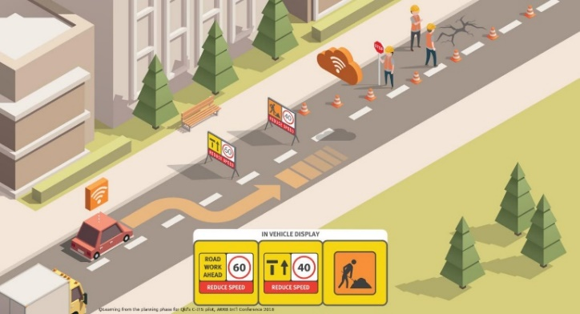Queensland Department of Transport and Main Roads: CAVI Components (Queensland Government, 2022a)

Figure 1.1 Example C-ITS roadworks use case

Australia’s Federal Chamber of Automotive Industries (FCAI) (2021) states that, overseas ‘Cooperative Intelligent Transport Systems (C-ITS) have been well proven to reduce traffic fatalities and increase traffic efficiency. And that automated driving functions will initially be supported by C-ITS and for level 3+ automated driving C-ITS will be a pre-condition.’

## Land Transport Issues for Australia

|  |
| --- |
| Benefits  Providing data direct to vehicles benefits (ITS Standards, 2020):   * **Safety** (e.g., crash avoidance, obstacle detection, emergency calls, contextual speed limits, dangerous goods) * **Efficiency** (e.g., navigation, green wave – continuous flow through several intersections, priority, lane access control, car sharing) * **Sustainability** (e.g., reduced vehicle pollution) * **Journey comfort** (e.g., nearby parking availability, electric vehicle charging, and infotainment) |

Australia has ongoing road network challenges that emerging technologies can help address. Many challenges align with the safety, efficiency, sustainability, and comfort benefits that C‑ITS can provide. Safety and traffic efficiency are the priority related issues. But benefits likely also flow for sustainability targets to meet ‘Towards Net Zero’, while road users’ journey experiences and comfort can directly benefit, encouraging technology uptake.

The number of fatalities and injuries is the primary safety measure that targets ‘Vision Zero’ (no fatalities or serious injuries) by 2050 (Infrastructure and Transport Ministers, 2021). For traffic efficiency, vehicle-hours travelled is the primary measure. Social and economic costs of congestion by 2030 will likely reach $30 billion a year based on current predictions of trip durations and lower average speeds (BITRE, 2015).

### Safety

While the number of deaths on Australian roads has decreased over the last 10 years by 1.2 per cent per annum, there are still about 1200 fatalities per year (see Figure 1.2 for trends). The social cost of road crashes has been estimated at $30 billion per year (Infrastructure and Transport Ministers, 2021).

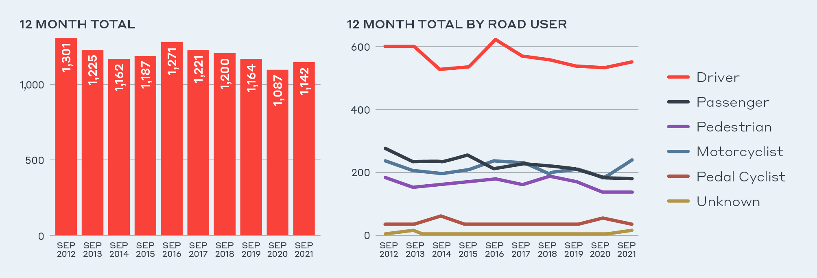

Source: Monthly Road Deaths Dashboard (BITRE, 2021a) <https://www.bitre.gov.au/statistics/safety> (accessed: 12/12/2021)

Figure 1.2 All road deaths (left) and number of deaths by road user (right): 12-month total Australia

Australia has made progress reducing the number of deaths and serious injuries on our roads, however, the 2020 target has not been achieved (see Figure 1.3). The National Road Safety Strategy 2021–30 has set the following 2030 targets:

* A 50 per cent reduction in fatalities, down to fewer than 571 (an approximate 55 per cent rate-per-capita reduction)
* An interim 30 per cent reduction in serious injuries, down to fewer than 29,000 (an approximate 38 per cent rate-per-capita reduction) (DITRDC, 2021).

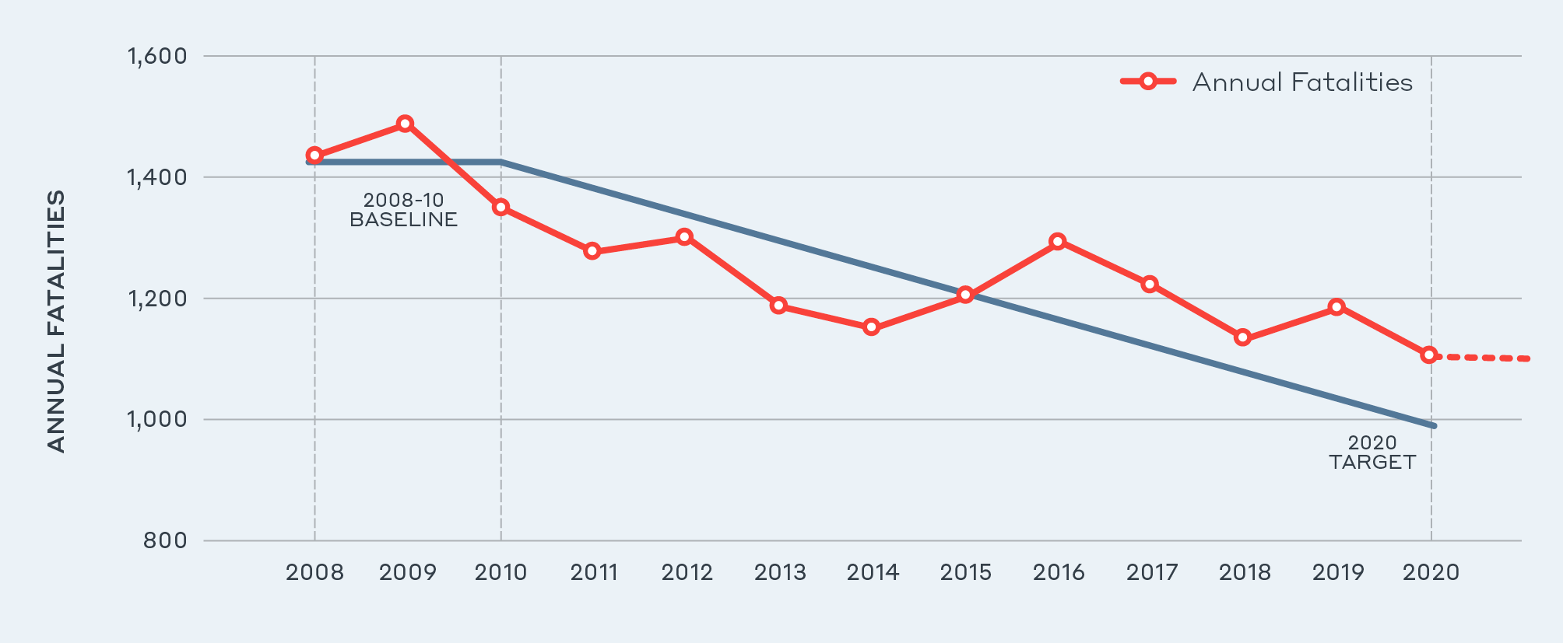

Source: Road Trauma Australia—Annual Summaries (BITRE, 2021b) <https://www.bitre.gov.au/sites/default/files/documents/road_trauma_australia_2020_statistical_summary.pdf> (accessed 12/12/2021)

Figure 1.3 National Road Safety Strategy 2011–2020 statistical progress towards fatality target

### Efficiency

In the last 20 years (1999 to 2019), private and commercial-vehicle passenger kilometres travelled in Australian capital cities have grown steadily (shown in Figure 1.4).

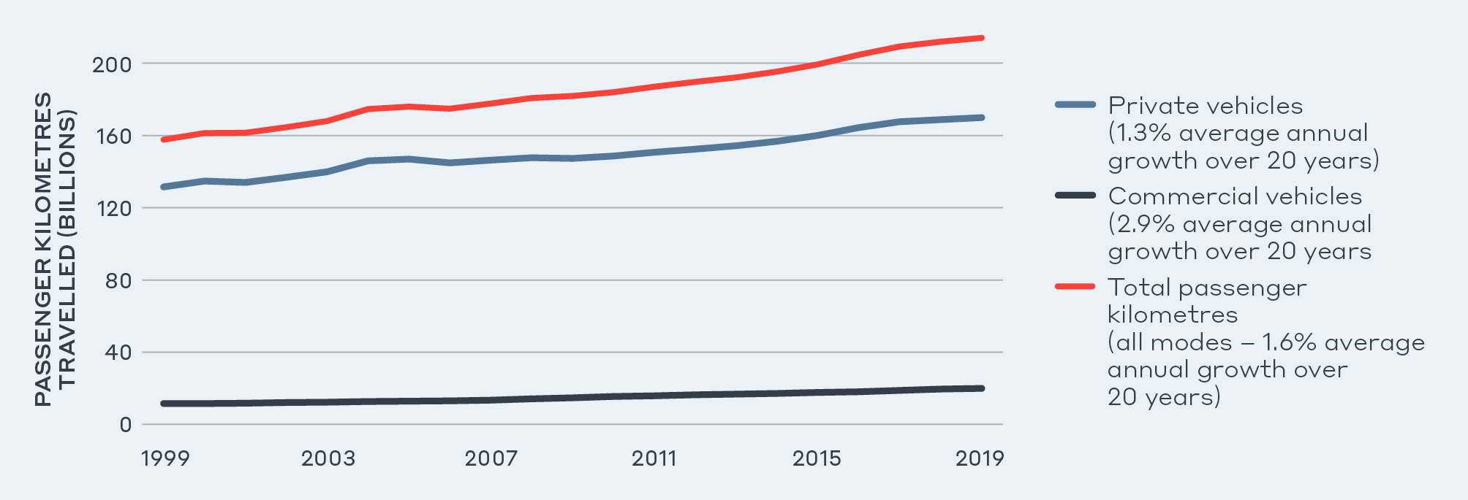

Source: Australian Infrastructure Statistics Yearbook 2020, Bureau of Infrastructure, Transport and Regional Economics (2020, p. 92)

Figure 1.4 Private-vehicle passenger kilometres travelled in capital cities since 1999–2000

Growth in traffic and demand for trips in localised areas contributes to the congestion observed in capital cities. A study on Road Congestion in Australia by the Australian Automobile Association found that between 2013 to 2018, across all major capital cities, average speeds declined, and travel-time reliability decreased (shown in Figure 1.5).

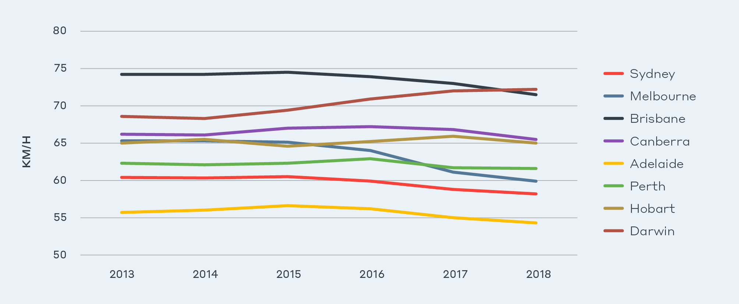

Source: Road Congestion in Australia, Australian Automobile Association <https://www.aaa.asn.au/wp-content/uploads/2018/10/AAA-Congestion-Report-2018-FINAL.pdf> (accessed 12/12/2021)

Figure 1.5 Average travel speeds across arterial networks in major capital cities 2013-2018 (all hours by year)

Considering that private-vehicle passenger kilometres travelled will likely continue to grow, congestion and time spent travelling is expected to worsen. A travel increase results in economic losses: the current travel-time value of a passenger-hour travelled is $14.99 per hour; commercial vehicles’ per passenger travel-time value ranges from $25.41 to $28.45 per hour in urban environments (ATAP, 2021).

## Policy Context

### National Land Transport Technology Policy Framework and Action Plan

C-ITS strongly aligns with the National Policy Framework for Land Transport Technology and its associated Action Plan 2020–23 (particularly Action 2.1). Safety, efficiency, sustainability and accessibility are of strategic focus for the framework. This report considers the key issues and lists the action plan areas related to the impact of C-ITS.

Key issues and C-ITS action areas are:

* Safety, security and privacy
* Digital and physical infrastructure
* Data
* Standards and interoperability
* Disruption and change.

Other key strategies, frameworks and agreements that also need considering to understand potential C-ITS opportunities are outlined, including the National Road Safety Strategy, Intergovernmental Agreement on Data Sharing for road safety, National Safety Framework for CAVs and State data strategies.

### National Road Safety Strategy 2021–30

The National Road Safety Strategy 2021–30 outlines the national priority areas for action. C-ITS could address the strategy’s priorities. The positive impacts of C-ITS can be expected in general vehicle safety, regional road safety, heavy vehicle safety and vulnerable road users.

The strategy identifies that in major cities, 2.2 road deaths and 148.7 hospitalised injuries occur per 100,000 people. Notably, this increases to 10.9 road deaths and 171.4 hospitalised injures in regional roads, and 23.6 road deaths and 213.6 hospitalised injuries in remote roads.

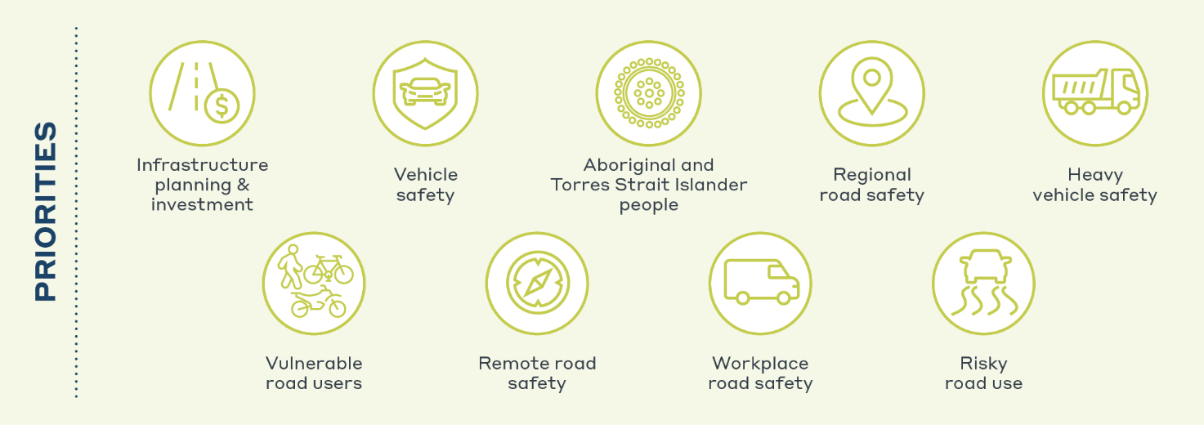

Figure 1.6 National Road Safety Strategy Priorities

### Intergovernmental data-sharing for road safety

In mid-2021, all Australian governments signed the Intergovernmental Agreement on Data Sharing (Department of the Prime Minister and Cabinet, 2021). This agreement states that action will be taken to address national priority data-sharing areas, and to reform the Commonwealth, state and territory data-sharing system. Road Safety was highlighted as one of the agreement’s three initial priority areas.

### CAV National Safety Framework

In May 2021, Infrastructure and Transport Ministers agreed on a roadmap for implementing a national safety framework for automated vehicles that aims to have national regulatory arrangements in place by 2026 (DITRDC, 2021). Given that CAVs will require C-ITS to extend their long-term functionality and operating domain (C2CCC, 2019), it is assumed that C-ITS will impact CAVs’ future capability.

### Digital Data strategy

C‑ITS is an avenue to improve or leverage existing transport systems. It can give vehicles highly contextual information based on their spatial, temporal, and behavioural attributes. This requires a secure, near-real-time, accurate data quality level with high positioning confidence. An opportunity exists to provide and gather high-quality contextual data by integrating existing traffic management systems and platforms with C‑ITS applications. This will give individuals more information and improve the overall user experience, while improving information systems’ quality and performance. Australian state and territory strategies to become cloud-based (NSW (Customer Service NSW, 2022), Victoria (Commissioner for Privacy and Data Protection, 2015), Queensland (Department of Communities, Housing and Digital Economy, 2022)) is a key element in upgrades to existing traffic management systems around the country. Nationally, this is aligned to the Australian Government Digital Transformation Agency (DTA) strategy (DTA, 2017).

## C‑ITS is an Ecosystem

C‑ITS can impact (and is influenced by) many societal aspects. Figure 1.7 presents an example of the key challenges posed by interactions between users and technology (summarised by European Road Transport Research Advisory Council (ERTRAC)). It shows how business models, services, data, and infrastructure relate to the societal benefits of safety, awareness, acceptance, policy, sustainability, and the end technology. Aligning these factors improves the ability to successfully deploy C‑ITS.

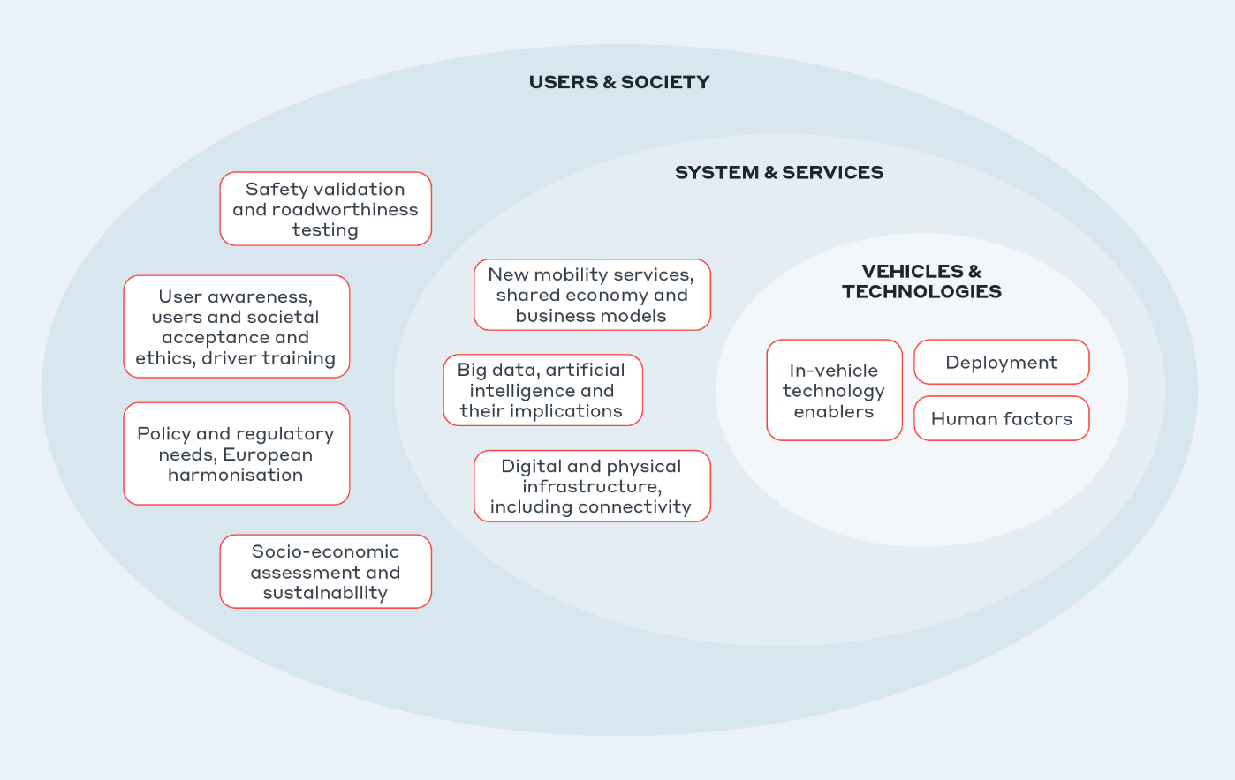

Source: ERTRAC Connected Automated Driving Roadmap version 8 (2019)

Figure 1.7 Key Challenge Areas for C‑ITS

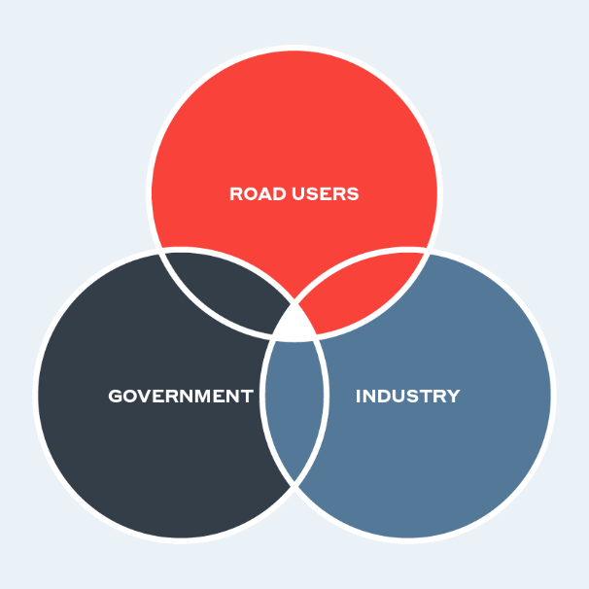The Office of Road Safety fact sheet for ‘Vision Zero’ states that there is a shared responsibility to deliver a safe-system approach that C‑ITS embraces (National Road Safety Strategy, 2021). A user-centric approach is essential for C‑ITS as road users’ acceptance and take-up of services in their vehicles is what will drive uptake. To address the factors in a C-ITS ecosystem, as illustrated in Figure 1.7, government and industry need to coordinate and agree, with users’ input and acceptance.

Government needs to consider whether to act/intervene, how to act/intervene, and at what government levels (federal, state only, or local). Along with the government agencies themselves, national bodies such as Austroads and the National Transport Commission (NTC) play an important role where cross-governmental advisory may be necessary. These organisations work nationally to support development of consistent national policy, regulation and standards, and are important C-ITS stakeholders.

For industry, vehicle manufacturers appear an essential stakeholder given they are the primary long-term equipment supplier with relationships to end users who purchase the vehicles. The FCAI is the peak representative organisation for companies distributing new passenger vehicles, light commercial vehicles, motorcycles and all-terrain vehicles in Australia. Together, they total 68 brands offering 380 models (FCAI, 2019). Beyond the vehicle manufacturers, a range of technology providers and communication and integration specialists sell C-ITS devices and systems. Others, such as service providers who help link information between manufactures, suppliers, and users and who leverage the C-ITS ecosystem, subsequently provide a robust network for deployment and generate further opportunities and insights.

### Technical Ecosystem

Figure 1.8 shows the minimum essential architecture of a C-ITS ecosystem. A hybrid model of short-range and long-range communications has been in C‑ITS architectures for more than a decade. Hybrid communications can deliver both safety-critical and advisory messages that support a wider region where cellular network or local communications are not available. Long-range communications allow central systems, such as traffic management centres and cloud services, to interact with vehicles via cellular communication through 3G, 4G or 5G networks. Short-range communications allow vehicles to interact locally with other vehicles or with infrastructure via roadside stations for near real-time safety-critical use cases. Two technologies: DSRC or C-V2X (LTE-V2X) have been considered for delivering short-range communications.

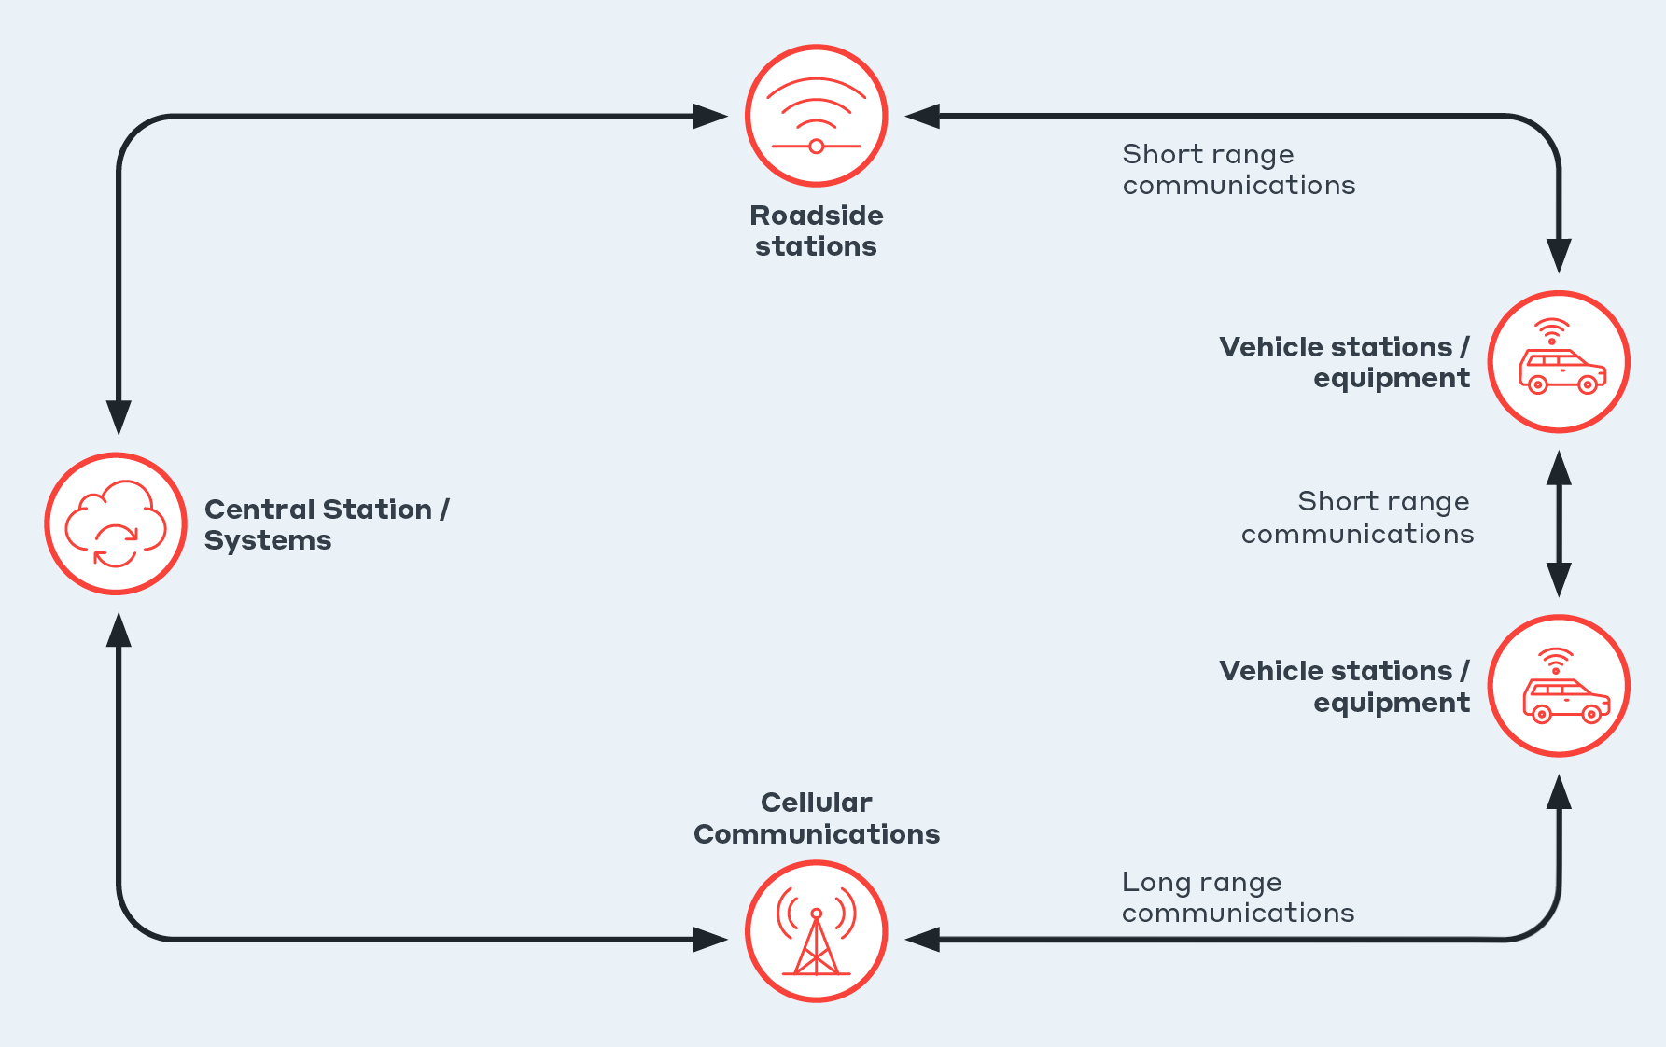

Figure 1.8 The hybrid model with capability to share data through short-range and long-range communications

## Project Execution and Results

WSP and partners, Deloitte and the University of Melbourne, have delivered interim reports (outlined in Figure 1.9) that support this policy findings report. Australia’s current state of C‑ITS and its ability to deliver Day 1 and 1.5 use cases was explored in a technical assessment, strategic deployment analysis, and a rapid Cost-Benefit Analysis (CBA). An Investment Logic Mapping (ILM) workshop was conducted initially to determine the key issues which were subsequently unpacked in project assessments.

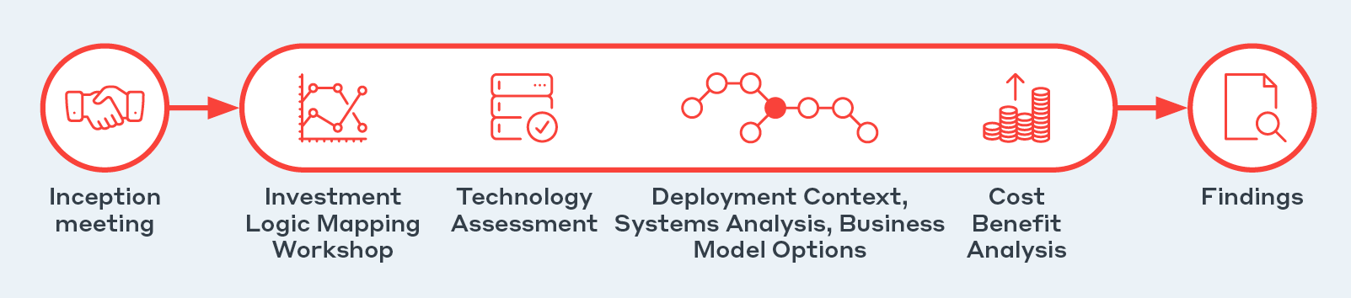

Figure 1.9 Project methodology

### Technical Assessment

The technical assessment focused on initial use cases that deliver C‑ITS benefits, the technology required, and the current state nationally and internationally. Use cases help understand how C‑ITS operates via many actors, data, and systems. Such use cases are typically based on their communication methods, whether:

* Vehicle to vehicle (V2V)
* Vehicle and infrastructure (V2I)
* Vehicle and other entities including motorcyclists, bicyclists, or pedestrians (V2P).

Use cases serve different functions and can be grouped into different services (or bundles) like those in Figure 1.10.[2]

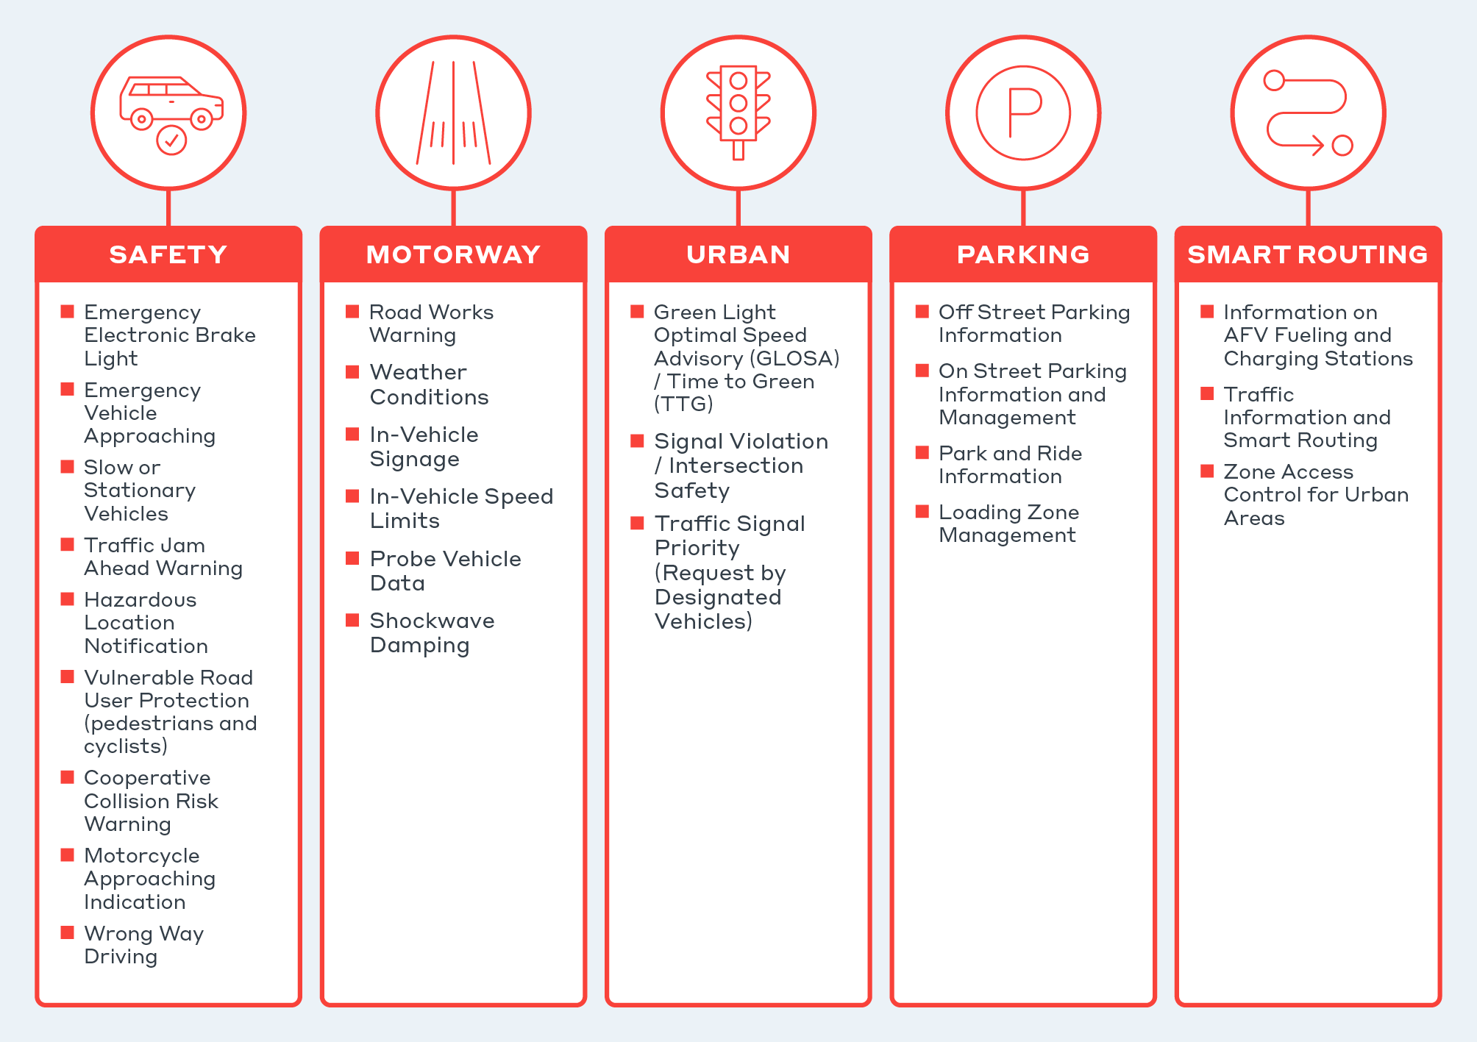

Figure 1.10 Use cases considered (definitions provided in Section B)

To help understand progression through capability, use cases are separated by standards as Day 1 (including 1.5), 2, and 3+ to represent their relative readiness and likely availability to market (refer Figure 1.11).

Day 1 and 1.5 use cases offer the most certainty for early deployment of C‑ITS operation where the driver is always in control, and determines if intervention is needed based on information provided. As automated driving technology develops, connected vehicle technology can maximise the benefits offered by automated vehicles (the Cooperative and Connected Automated Mobility (CCAM) program[3] developments support this).

Services providing Day 1 and 1.5 use cases are the focus of this deployment analysis.

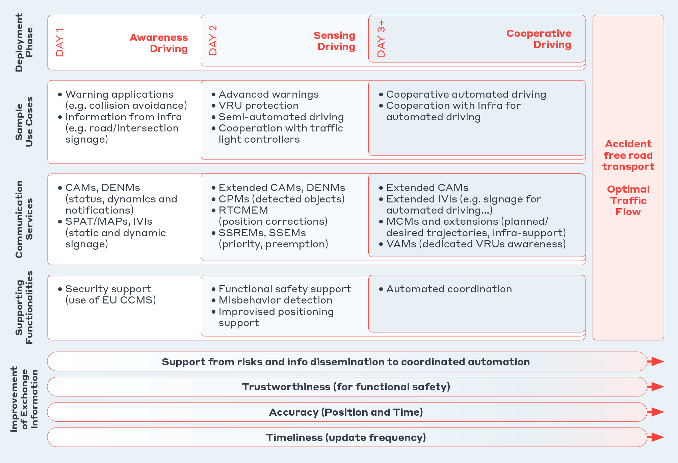

Source: C2C-CC: Car 2 Car Communication Consortium (C2CCC, 2019)

Figure 1.11 Progressive deployment of C‑ITS

Figure 1.12 presents the common elements of a C‑ITS system as identified in the technical assessment. The technical assessment identified the ecosystem as technically viable to deliver an initial set of Day 1 use cases. Note: depending on Australia’s C-ITS direction, technical aspects will need significant development and quality improvement to match other C-ITS deployments.

0+

1

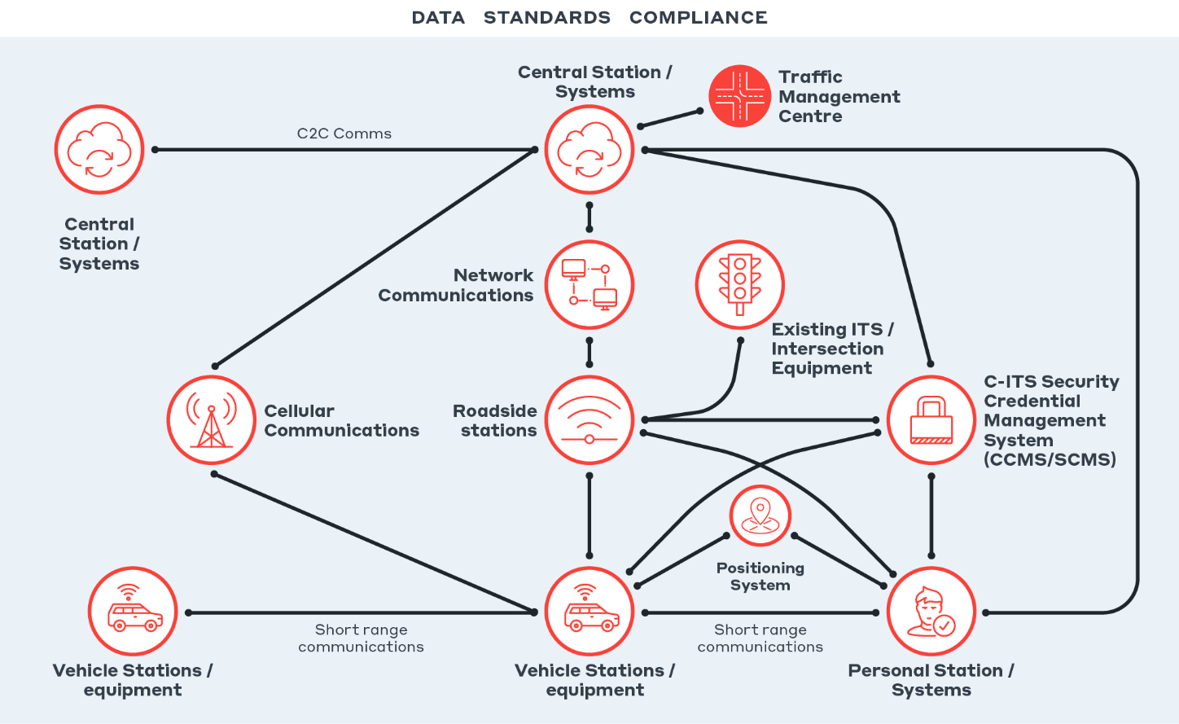

Figure 1.12 Components of C‑ITS

#### Vehicle stations/equipment

Vehicle stations refer to the equipment fitted in vehicles to enable C-ITS operation. This typically includes an on-board unit and a human machine interface (HMI) that may be implemented in different configurations for different vehicle types. The vehicle equipment assesses the driver’s interaction with events and provides the user with relevant information (using the HMI through a visual screen, audible sounds or haptic movements). In the future, the vehicle station could also inform automated vehicle systems. Vehicle stations and equipment are typically provided by vehicle manufacturers who are responsible for the end interaction with C-ITS. Therefore, vehicle manufacturers have an important role in the safety, effectiveness, and user experience of C-ITS. Vehicle stations can be provided for many vehicle types including passenger vehicles, heavy vehicles, public transport, motorcycles, and emergency vehicles.

#### Short-range communications

Vehicle-generated information (such as vehicle location and events detected by vehicle sensors) is broadcast to surrounding vehicles (V2V) so they can react according to the information’s relevance to their drive path. Roadside stations share information with vehicles using the same technology. The physical/access layer of communications is important as it creates the interface for local information exchange. Short-range communications have two primary technology options: DSRC and C-V2X (LTE-V2X), discussed further in Section 1.6.3.

#### C‑ITS Security Credential Management System (SCMS)

Security is essential for public trust, uptake, and communications across vehicles. Some use cases require transferring information about safety-critical events. All communications impact the driver’s attention. For information to be useful, stations must be able to trust the information’s source and credibility – that it comes from an authorised and verified system (SCMS). Without an SCMS, information received could be at high risk of being falsified and misleading the driver. An SCMS has been developed for TMR (in collaboration with DITRDC and iMove) and is operating effectively in the Cooperative and Automated Vehicle Initiative (CAVI) Ipswich pilot in Queensland.

#### Central systems (using long-range cellular communications)

A central system (or station) generates C-ITS compliant messages for vehicles from traffic network information or centrally managed events. It is also able to collect and utilise vehicle and roadside infrastructure data to improve network utilisation, system monitoring and maintenance. The use of a central system is like most ITS equipment where it is operated and maintained by road operators through traffic management centres. However, for C-ITS infrastructure, this will likely have greater needs on consistency such as the same standardised sharing of central-to-central information, which would allow a vehicle to understand the same type of data no matter which government jurisdiction it is in. For C‑ITS to operate usefully, it needs to present users with consistent, relevant and timely information that’s made available in near real-time from highly accurate source data. Much of the information required for C-ITS is available within transport agency systems. However, it needs significant improvement in quality and consistency to make it useful to end users.

The assessment identified the benefit of having a national data exchange with a standard interface between central systems as beneficial for rapidly utilising the data available across systems. In European regulation, this is referred to as a National Access Point (NAP).

#### Roadside stations (using short-range communications)

Roadside stations can communicate time-sensitive, dynamic information to nearby vehicles, such as traffic signal information and nearby hazards or events. Roadside stations are also able to collect information from surrounding stations building understanding of transport network behaviour. Note: portable roadside stations are a similar subset but allow greater flexibility to move with the events (such as temporary roadworks).

#### Advanced positioning

Provides location and time information to field stations. Some use cases require high accuracy levels for vehicle positioning (e.g., ‘lane level’) to be effective. It remains an ongoing challenge to improve the accuracy and consistency of vehicles and generated spatial information. This heavily influences the ability to provide relevant information to the user and improve the user experience.

#### Personal stations/equipment

Personal stations (or equipment) refer to the equipment used by vulnerable road users to enable C-ITS operation. This may be a mobile phone, a dedicated handheld device or other technology attached to a pedestrian or cyclist. Personal stations or equipment, while defined in architecture standards, have only recently been defined in detailed data standards. As a result, they are an area of emerging research and testing but have not yet been successfully integrated into the deployed C-ITS ecosystem. This emergence provides an opportunity to deliver benefits to Vulnerable Road Users (VRUs) in the future.

### Strategic Deployment Assessment

Analysing C‑ITS deployment explores the ecosystem’s roles and processes at play to identify ecosystem aspects that are most likely to succeed and offer Australia the greatest value. Systems-thinking (Figure 1.13) was used to understand and assess the key levers needing action or change to kickstart an iterative deployment loop. How users perceive C‑ITS benefits, for example, the way the services are targeted to meet user needs, can reinforce and influence their willingness to invest and consider taking up such technology. The order of the actions taken is considered in Section 5.5.

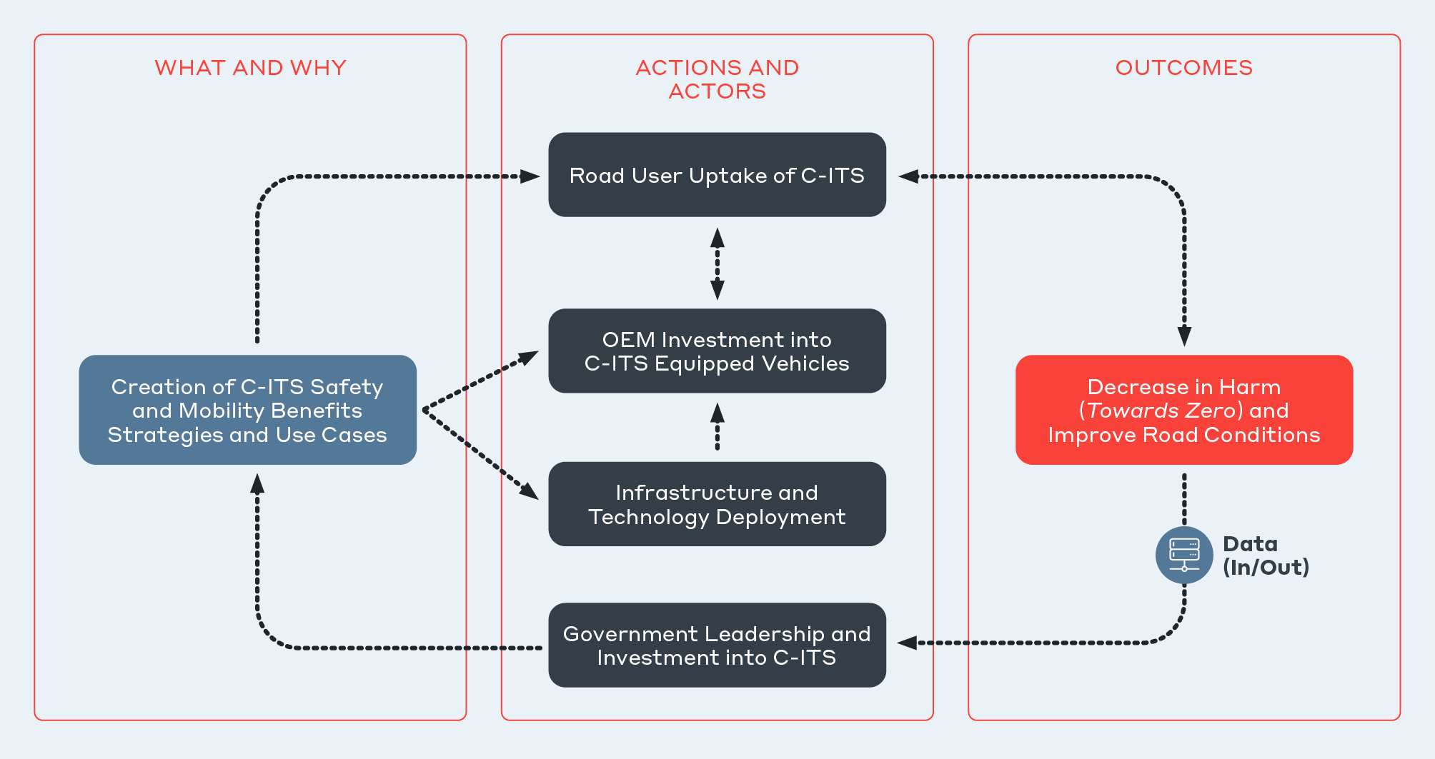

Figure 1.13 High-Level Causal Loop

|  |
| --- |
| Case Example – Freight  The option of an urban-based freight service focused on efficiency benefits is considered in Figure 1.14. It allows more clarity in assessing the technology needed to deliver. This is just one way to consider services’ deployment. This approach was used to consider which options may be prioritised or are likely to be the most beneficial. |

As outlined in Figure 1.10, a wide range of identified potential C‑ITS use cases can be bundled into different options that can be delivered together as a service (e.g., bundling all use cases targeting safety). One way to explore options development (outlined in Figure 1.14) is to consider geographic designation, user types, specific benefits sought, and technology needed to enable the service(s). The figure highlights consideration of urban, freight focused use cases focused on efficiency.

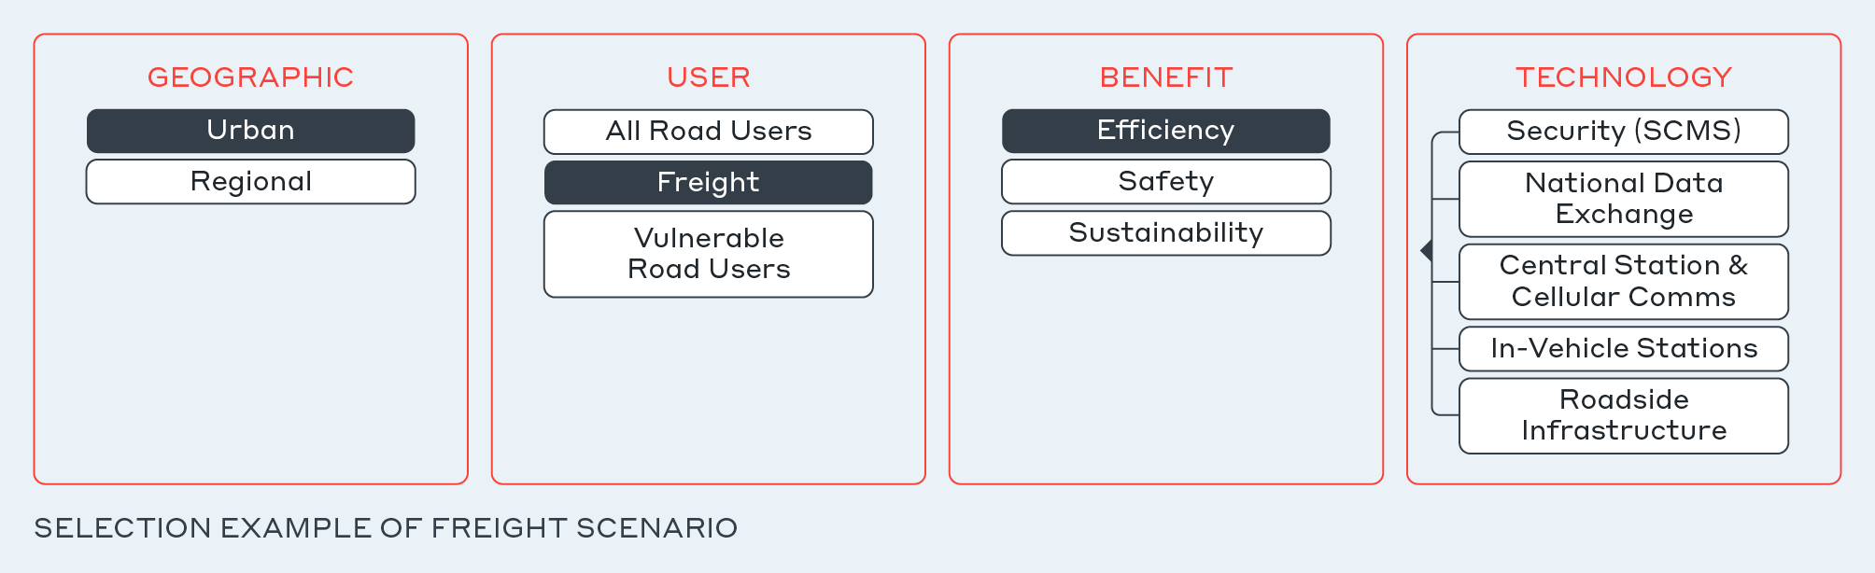

Figure 1.14 Starting point for potential C‑ITS options (freight scenario)

A Multi-Criteria Analysis (MCA) tool was used to prioritise options and problem statements. The preferred options help direct strategies to enable C‑ITS in Australia. Benefits were derived from a European deployment study since this was the main and only data source that met the Day 1 and 1.5 services results in a comparable view.

The bundling of use cases in to deployment options considered in the MCA as listed in the ‘definitions’ section. While all had merit, the shortlisted priority options were:

* Do Minimum (reflected as the base case)
* Improve safety (decrease crashes, fatalities, and injuries) on motorways, arterials, and rural roads
* Reduce congestion in metro areas and on all motorways and arterials
* Improve the safety and efficiency of travel for commuters in urbanised areas
* Enable the safe and efficient movement of long-haul freight traffic

Strategic analysis determined that C-ITS could benefit many areas, particularly safety, efficiency and sustainability. Defining and delivering on a single business model has been a key C-ITS challenge. C-ITS in the long term will have many value-chains that will only eventuate from delivering a base ecosystem. Further, it was found that no single use case will deliver C-ITS: the real value of C-ITS to society is realised when standard technology and data is used to generate many uses and benefits.

The strategic assessment considered the role of government from strategist, convenor and catalyst, operator and regulator. As deployment progresses, roles and needs will shift along a spectrum dependant on the specific function required. The analysis suggests that a high-level role for government focused on leadership and operation is beneficial to deploy C-ITS. Business models and financial strategies concerning who pays and who benefits were explored and had merit, however further efforts are required to establish C-ITS deployment direction before commercial potential can be understood.

### Rapid CBA

A rapid Cost-Benefit Analysis (CBA) was conducted consistent with the approach described in the Australian Transport Assessment and Planning (ATAP) Guidelines. The CBA aimed to monetise the project options’ costs and benefits and compare them with the equivalent information for the Do Minimum (Base-Case) option. The results were summarised in terms of the Net Present Value of discounted benefits minus costs, and in Benefit-to-Cost Ratios (BCR) for each option. A 10-year appraisal forecast for each investment option was used to align with the forecast methodology used in Austroads Future Vehicles 2030 and its 2031 update, to limit uncertainty associated with emerging technologies and align with the expected useful life of assets involved in the deployment options.

The Austroads report outlined a medium scenario (by 2031) whereby 93 per cent of vehicle sales have embedded mobile data connectivity and 25 per cent have short-range communications by 2031. This connectivity offers more opportunity for services related to vehicle safety, efficiency, sustainability, and drivers’ comfort. The overarching consideration is what happens without any specific intervention, and whether a sustainable ecosystem can encourage uptake towards a fast penetration rate.

Five options were formulated based on the technical enablers and user groups, each realising a different mix of use cases and priority outcomes. These options were an evolution of the five priority options considered in the strategic deployment assessment. Figure 1.15 illustrates the options and CBA results.

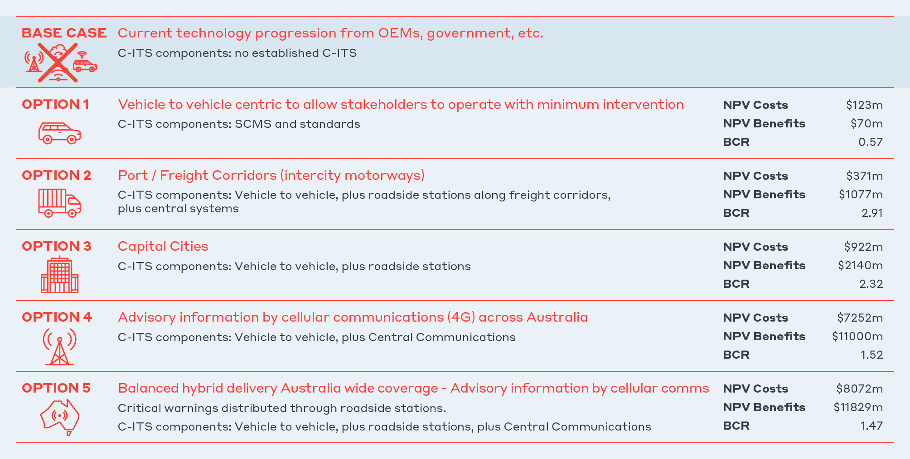

Figure 1.15 Cost-Benefit analysis options and results

The cost profile of each option is detailed in Figure 1.16. These costs reflect the major direct components covered in the technical assessment (Section 1.5.1). The proportion of relative national investment required between infrastructure (SCMS, roadside, national data exchange and central systems) and vehicle equipment, demonstrates the relative investment risk. Vehicle manufacturers represent the great majority of investment (93–99 per cent).

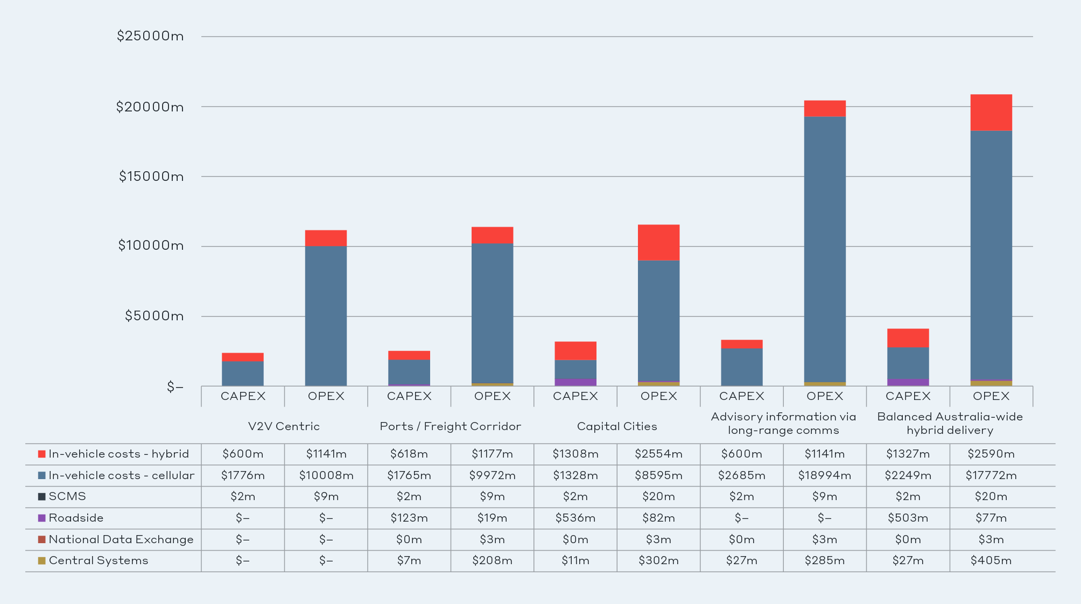

Figure 1.16 Total cost by option (all values in $2021 AUD)

The benefits focused on the primary areas of safety and efficiency, assuming that these would lead to sustainability and comfort benefits (not quantified in this analysis), and would therefore lead to a more attractive view of end benefits.

C-ITS technology crash reduction factors were applied to the annual cost of crashes in Australia. This resulted in a maximum annual crash reduction benefit (as shown in Figure 1.17 by vehicle type). This benefit was based on an assumed 2 per cent year-on-year traffic growth, and against C-ITS technology’s projected market penetration in vehicles.

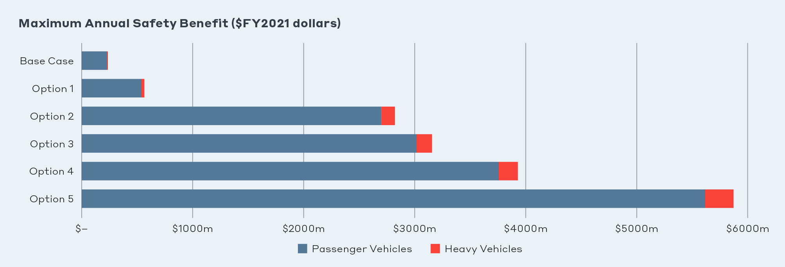

Figure 1.17 Maximum annual safety benefit by project option and vehicle type (2021 dollars)

The maximum travel-time saving benefit was calculated based on projected average travel speeds and projected vehicle-kilometres travelled. This was estimated by year for each vehicle type and project option, based on C-ITS technology’s projected market penetration in vehicles. Figure 1.18 shows the maximum travel-time saving.

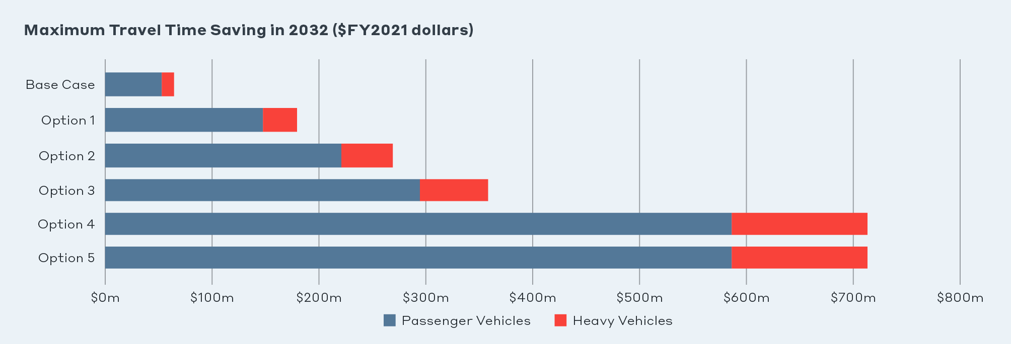

Figure 1.18 Maximum benefit from travel time savings in 2032 by project option and vehicle type (2021 dollars)

This appraisal considered two forms of C-ITS technology: cellular communications only, or a combination of cellular communications and short-range communications (hybrid). The analysis assumes that the vehicle penetration rates will be influenced by establishing systems that promote its introduction. Year 2031 total fleet trends for cellular-based services are based on: no services resulting in a slow uptake (11 per cent), some service introduction resulting in a medium uptake (40 per cent) and established services (62 per cent). While year 2031 total fleet trends for hybrid services are based on: no services resulting in a slow uptake (0.8 per cent), some service introduction resulting in a medium uptake (6 per cent) and established services (13 per cent). The expected year-on-year market penetration was then used to calculate the expected safety and travel-time benefits.

Figure 1.19 helps articulate the benefit of a steppingstone or iterative approach to development. A national deployment of central systems delivering long-range information or balanced hybrid (right two graphs in Figure 1.19) is viewed as the C‑ITS long-term target since it achieves the highest benefits (the figure’s tallest two blocks). This is important, as the scale of the benefits is over $11 billon for these two options, compared with $1–2 billion for the freight or capital city options.

The substantially lower cost is the benefit of developing the freight solution first (as one example of a minimum viable market) while providing a foundational or ‘backbone’ system that can be leveraged for larger scale deployment as new viable markets are recognised and developed. Examples may include value models whose benefits our assessment does not currently consider, such as the use of mobile phones to deliver a wide range of C‑ITS applications or the likely future introduction of Connected and Automated Vehicles. Section 5 offers some further discussion of this flexible approach to dealing with uncertainty.

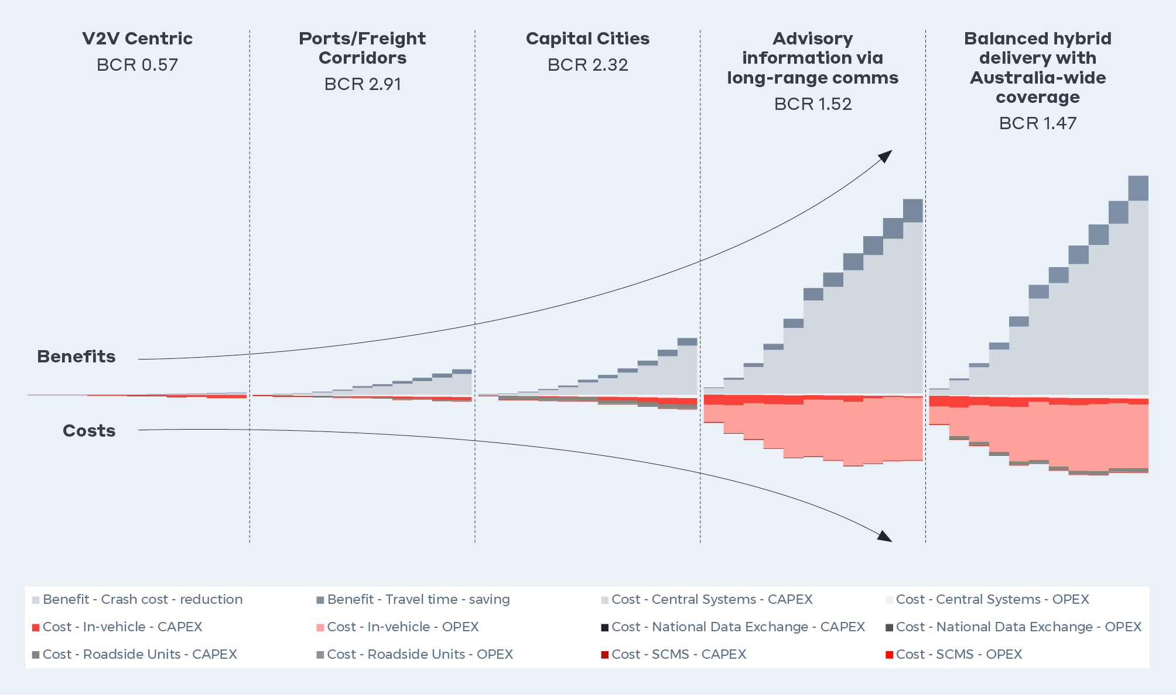

Figure 1.19 Comparisons of costs and benefits – consideration of stepping stones

The CBA results were:

* *CBA-Option 1*: Vehicle-to-vehicle centric with minimal infrastructure support has a Benefit-Cost Ratio (BCR) below 1 and is not considered viable.
* *CBA-Option 2*: Ports/Freight Corridors (Vehicle-to-vehicle, plus roadside stations at cities and central systems for intercity motorways focused on freight corridors), has the best economic return. However, its benefits are comparatively modest (~$1 billion).
* *CBA-Option 3*: Urban delivery of C‑ITS with mostly roadside station deployment, is also cost-effective with more and greater benefits than option 2 (~$2 billion).
* *CBA-Option 4*: Advisory information through cellular communications has a high social benefits return ($11.0 billion).
* *CBA-Option 5*: balanced hybrid of city and rural deployment with both technologies realises the highest benefits ($11.8 billion).

Option 2 could be viewed as a minimum viable market and might also be considered a ‘no regrets’ option as a step towards Option 5, which appears the most logical way to achieve the greatest societal benefits. While five options were investigated in the CBA, these are not the only available deployment options. Other deployments targeted at specific user needs or markets could also be considered.

## Current State of C‑ITS

Nationally and internationally, the basis of C‑ITS technology has been proved ready for deployment. Internationally, widespread trialling and deployment by vehicle manufacturers, federal and state governments, and academia, have tested C‑ITS technology and successfully demonstrated its viability for further deployment.

### Australian Trials

The Cooperative Intelligent Transport Initiative (CITI) provided initial Proof of Concept for DSRC in Australia. It validated the system’s capability across a range of vehicle types including passenger vehicles, heavy vehicles and motorcycles. CITI found the system needed quality improvements (specifically around information accuracy). It also found security that was not implemented, positioning that used standard GPS solutions was insufficient, and use cases that were based on vendor-specific implementation were not robust. CITI was unable to complete a quantitative safety analysis due to the system’s readiness and data collection processes in use at the time.

The Cooperative and Automated Vehicle initiative (CAVI) created one of the prominent C-ITS pilots nationally and internationally – the Ipswich Connected Vehicle Pilot (ICVP). CAVI’s model was built by creating a pilot to foster and measure C-ITS deployment readiness. CAVI learned from previous pilots’ issues and invested to improve vendors’ ability to deliver a pre-deployment pilot that demonstrated the value of both short-range and long-range use cases to safety benefits and user experience.[4]

Importantly, both CAVI and CITI feedback surveys showed a positive user experience. CITI participants agreed that connected vehicle technology would reduce crashes if fitted to all vehicles and traffic lights. Most participants agreed they would support a policy requiring all vehicles to be fitted with connected vehicle technology (Centre for Road Safety, 2021). CAVI’s user acceptance surveys received and maintained generally positive responses (iMove Australia and Department of Transport and Main Roads, 2021).

The following Australian projects outlined in Table 1.1 have progressed C‑ITS learnings:

Table 1.1 Major Australian C‑ITS trials

|  |  |
| --- | --- |
| Interior of a car from perspective of driver with steering wheel in the forefront. Shows a small rectangular display attached to the windscreen, with a participant selection menu.  Cooperative and Automated Vehicle initiative (CAVI) | The CAVI project run by TMR launched Australia’s largest C‑ITS pilot, ICVP (est. 2016; pilot active from 2020). This pilot is a pre-deployment project to ready government, industry, and users for C‑ITS.  ICVP uses hybrid communications of short-range DSRC and long-range cellular to exchange information as needed based on source data location and performance needs. ICVP uses real-world drivers from public participants over 12 months to evaluate road safety benefits, user acceptance, and system performance. As part of this project, Lexus developed their C‑ITS vehicle system to operate with the ICVP system and use cases. |
| Trucks on freeway with coloured rings surrounding each truck to demonstrate connectivity.  Cooperative Intelligent Transport Initiative (CITI) | The CITI project run by TfNSW was the first government-led pilot (est. 2012) and formed a Proof-of-Concept for C‑ITS in Australia.  Aimed at smaller scale testing of use cases and user groups, CITI aimed to test the capability of existing C‑ITS equipment to deliver road safety benefits. CITI focused on short-range ITS- G5 (DSRC) communications only. |
| AIMES project car parked on busy city street with bus driving past in the background.  Australian Integrated Multimodal EcoSystem (AIMES) | The AIMES project lead by University of Melbourne in Victoria is a testbed that allows technology providers to develop and test new equipment in the C‑ITS ecosystem. Established in 2016, AIMES prioritised consideration of vulnerable road users and public transport use cases and solutions.  AIMES announced partnerships with Lexus, including the use of CAVI’s (TMR) central system and further collaboration with TfNSW. This is a positive step in national understanding of interoperability for C‑ITS. |
| Two vehicles on a test track intersection.Advanced Connect Vehicles Victoria (ACV2) | The ACV2 project was an early Proof-of-Concept test for C-V2X demonstrating that two vehicles can transfer data directly to each other for V2V use cases. Information was also sent using 4G connectivity from central systems to demonstrate other use cases. |

Lexus Australia is a vehicle manufacturer that is actively committed to understanding the C‑ITS road safety capabilities, as demonstrated through its involvement in trials in Queensland (CAVI) and Victoria (AIMES and the ACV2 project). It demonstrates cross-state interoperability with a vehicle manufacturer. Lexus Australia and other partners in Victoria found that, ‘By seeking to integrate real-life traffic events, all stakeholders have recognised the need for robust, meaningful and current data streams to support use cases. As C‑ITS development and rollout progress, collaboration between government and industry will help define the data requirements and systems to support not only C‑ITS, but the wider management and optimisation of our transport networks’ (Lexus Australia et al, 2021).

### Status of C-ITS deployment globally

Europe, US and Asia were the primary regions to consider in the project assessment. The current state of deployment in these regions compared to Australia is shown in Table 1.2. Figure 1.20 and Figure 1.21 show the deployment coverage across Europe and the US respectively.[5]

Table 1.2 Deployment status of C‑ITS

| Region/Sub Area | cellular long-range Coverage | Roadside StatioNs | Vehicle Equipped |
| --- | --- | --- | --- |
| Australia/ CITI – NSW (TfNSW, 2019) | None | 12 | 60 heavy vehicles, 11 buses, 52 light vehicles and a motorcycle |
| Australia/ CAVI – QLD  (Queensland Government, 2022b) | 300km2 area | 29 | 350 in participant vehicles[6] |
| Australia/ AIMES – VIC (The University of Melbourne, 2022) | None | 21 | Adhoc network of 3 vehicles, 5 buses, trams, trucks |
| Europe (18 countries, 53 cities) (C-Roads, 2021) | +100,000km road length | 20,000 DSRC covering 20,000km | +500,000 in passenger vehicles |
| United States (USDOT, 2020) | Uncertain | 6,182 | 15,506 |
| Japan (Ministry of Land Infrastructure and Transport, 2017) | Uncertain | 1700 | +3.71 million |
| China[7] | Uncertain | Uncertain | Uncertain |
| South Korea (Ministry of Land Infrastructure and Transport, 2017) | Uncertain | 1570 | +15,800 |

#### Europe

Europe currently has an active proposal for amending the ITS directive which, if adopted, will mandate the use of C-ITS services and data sharing requirements for new vehicles. This amendment presents similar considerations to this analysis which is detailed an Impact Assessment (European Commission, 2021b). The proposed amendment aims to address the lack of interoperability and continuity of applications, systems and services; the lack of concertation and effective cooperation among stakeholders; and the unresolved issues related to the availability and sharing of data to support ITS services (European Commission, 2021a). An approved amendment, as supported by the Regulatory Scrutiny Board, will provide certainty for requiring C-ITS services in vehicles.

Europe recognised the need for formal collaboration between industry and government with three leading initiatives. The C-Roads Platform joint initiative of European Member States and road operators, which tests and implements C-ITS services for cross-border harmonisation and interoperability. C-Roads (2021) stated that Europe is actively deploying C-ITS. C2C-CC is the leading European and international vehicle manufacturers, equipment suppliers, engineering companies, road operators and research institutions working together through joint research and development of C-ITS solutions to reduce road accidents (vision zero) (C2CCC, 2022). CCAM (2021)is a new initiative bringing together the actors of the complex cross-sectoral connected, cooperative, automated mobility value chain.

The following progress is relevant to deployment in Europe:

* The release of the Volkswagen Golf MK8 and battery electric vehicles with C-ITS as standard
* Continued releases of specifications to implement the European standards’ suite from both government (C-Roads) and industry (C2C-CC: Car 2 Car Communication Consortium)
* Development of basic requirements for C-ITS deployment by Germany’s Federal Ministry of Transport and Digital Infrastructure has led to deployment of construction-site warning C-ITS messages across some motorway corridors, to be expanded to all remaining motorway sections by 2023 (C-ITS Deployment Group, 2020a)
* Deployment of operational systems across Europe (such as 525 roadside stations and a central station on Austrian motorways by 2023) (C-ITS Deployment Group, 2020b)
* Deployment of an operational, cross-jurisdictional SCMS
* Commitment at parliamentary level by some national jurisdictions (such as Italy (Mauro, 2020))
* The amendment to legislative documentation (European Union, 2010) for ITS in Europe (ITS Directive) is currently open for feedback. The Impact Assessment (European Commission, 2021b) lists 25 policy measures including:
  + Mandate availability of Day 1 C-ITS services all new vehicle models after 2028
  + Specifications for C-ITS (Day 1, Day 1,5 and Day 2 services)
  + Implement the European C-ITS Trust model
  + Introduce legal provisions on the European Union C-ITS Trust model
  + Mandate availability of crucial real time traffic information data
  + Mandate availability of Safe & Secure truck parking data
  + Mandate availability of safety related traffic information services
  + Revision of specification for real time traffic information data
  + Requirements for the access to in-vehicle generated data for road operation (asset and traffic management) services
  + Standards for in-vehicle generated data for road operation (asset and traffic management) services
  + Setting-up of governance and the facilitation of national & European Union wide operational co-ordination of National Access Points (NAPs)
* The announcement of CCAM which will develop the standards and deployment framework for combining C-ITS (co-operative and connected) with automated technology, leveraging the current and near-term deployment of C-ITS

#### United States

In the US, there are multiple planned and operational connected vehicle deployment locations (USDOT, 2021; MDOT and CAR, 2017). Recommendations made to increase regulators’, vehicle manufacturers’ and drivers’ awareness and uptake, include the need for:

* Complete standards for use cases and performance
* Improved consumer awareness by including technology as a criterion in the New Car Assessment Program’s 5-star rating system
* Consumer education on collision avoidance system features via vehicle manufacturers/dealers, and regulation.

In the US, uptake varies from state-to-state and from city-to-city as federal coordination was limited under the previous federal administration. Section 1.6.3 covers the recent US development that reallocated a portion of the 5.9GHz spectrum.

|  |  |  |
| --- | --- | --- |
| Figure 1.20 is a map of UK that demonstrates where roadside stations and cellular C-ITS services are in use.  Roadside stations  Cellular C-ITS services |  | Figure 1.21 is a Map of US to demonstrate where planned and operational connected vehicle deployments are located.  Planned Connected Vehicle Deployments  Operational Connected Vehicle Deployments |
| Figure 1.20 Europe Deployment Map |  | Figure 1.21 US Deployment Map (USDOT, 2021) |

#### Japan

Notably, the first C-ITS system in Japan ‘VICS (Vehicle Infrastructure Communication Systems)’ was launched in 1996. This system provides In-Vehicle Information using 2.4GHz radio wave communications. The Electronic Toll Collection (ETC) 2.0 C-ITS project launched in 2014, aimed to develop and deliver a range of applications for V2I and V2V communications that fully uses the 5.8GHz DSRC capacity and bidirectional capabilities. This project delivered the ability to collect probe data that accurately detailed congestion information, as well as an application that allowed for dynamic route guidance along Tokyo’s expressways (Makano, 2017). In August 2015, ETC 2.0 on-board units (vehicle stations) were available in the market, with about 3.71 million units were set up by March 2019 (Ministry of Land, Infrastructure, Transport and Tourism, 2019). About 1700 roadside stations are located on highways across Japan. C-ITS technology is promoted to users as a means of ‘smart road use’, including as a tool to avoid traffic congestion, traffic crashes, and for smart logistics management among other use cases. A large amount of data collected from this deployment includes vehicle speed data, route data, and sudden braking occurrences.

#### China

In China, General Motors (GM) pushes for safer roads and more sustainable travel through investment in electric and automated vehicles. As part of China’s Advanced Technology Roadmap, GM introduced “Drive to 2030” at the 2010 Shanghai World Expo and has built a large, connected customer base to enable long-term deployment of its electric and automated vehicles. GM will aim to have all its vehicles in China connected via flexible platforms. Cadillac models, as well as some Chevrolet and Buick vehicles, will also be 5G enabled in 2022 (GM, 2019). From this, China appears to be scaling up C-ITS deployment based on C-V2X. However, limited open information has been found on the specific standards or associated information on managing deployment.

#### South Korea

The South Korean deployment has historically been based on the US model using WAVE short-range communications (the US DSRC equivalent of ITS-G5) and aligning with the US suite of standards. South Korea’s deployment strategy creates a clear direction for C-ITS delivery including significant deployment nearing 1750 roadside stations. In preparing for Level 4 CAVs in 2027, C-ITS will be established throughout major roads in South Korea from 2021 (Korea Bizwire, 2021).

### Current Technical Challenges

Technical challenges to be resolved to improve readiness to deliver Day 1 and 1.5 use cases in Australia are summarised in Table 1.3.

Table 1.3 Current technical challenges

| Technical Area | Technical Challenges to be resolved |
| --- | --- |
| Short-range Communications | Depending on national direction of alternative technology: Coexistence of multiple solutions (ITS‑G5 and C-V2X). This is discussed further in Section 1.6.4. |
| C‑ITS Security | Ensure the SCMS for Australia is built to meet the security and privacy needs across Australia. |
| Positioning | Geoscience Australia progressing to higher positioning accuracy through SBAS. This will likely cost efficiently improve accuracy but needs testing and validation for in-vehicle systems. |
| Central systems and National Data Exchange | Requires clarity in terms of national consistency with central C‑ITS systems.  For each relevant use case, each road operator must assess the source data needed for input into C‑ITS central systems. |
| Cellular Connectivity | Continuity of cellular coverage for whole of journey. Particular consideration of rural and regional travel. |
| Data | The data’s accuracy, reliability, timeliness, completeness, and consistency is critical to allow vehicles to correctly interpret the data in a given situation or use case, and deliver alerts to drivers in a highly contextual manner.  C‑ITS’ two-way capability is expected to benefit Australia by creating dynamic data capture of road network operations, understanding of high-risk locations, and identifying on-road issues. This needs to be considered across regions and systems. |
| Standards | The use of standards and agreement between users is needed to achieve the operational intent. Australia could sensibly align to one region’s standards base, thereby minimising the complexity of a national implementation. This would avert the challenges of aligning different standard sets, e.g., European Access layer with Chinese geo-networking, Japanese security and US message types. |

### Short-range communication technology

Through the *Radiocommunications (Intelligent Transport Systems) Class Licence 2017* the Australian Communications and Media Authority (ACMA) has made available 70 MHz of spectrum in the 5.9 GHz band for ITS use in Australia. As a condition of the class licence, a ITS station operating in this spectrum must comply with the European Telecommunications Standards Institute (ETSI) Standard EN 302 571.[8] In December 2021, the FCAI (2021) reaffirmed, as representative of vehicle manufacturers importing to Australia, the need for this class licence. Most of Australia’s C‑ITS pilots (CAVI, CITI and AIMES) have deployed and tested DSRC technology. Proof-of-concept testing in Victoria used C-V2X in the ACV2 project that demonstrated C-V2X operation between vehicles.

#### What is DSRC (ITS-G5)?

DSRC (European version is called ITS-G5) is a mature communication method that has been used in the past 20 years as the basis for trials across the world. Current DSRC communication represents use of a specific Wi-Fi definition to build the physical and data-link layer required in each device to exchange information.[9] This report refers to the C-ITS Wi-Fi implementation as DSRC reflecting the European terminology, while WAVE is used in the US and South Korea. It is a subset of DSRC which supports other technology implementations such as electronic tolling systems.

#### What is C-V2X?

Component manufacturers have recently begun producing commercial C-V2X chipsets that can be used in trials (LTE-V2X release). Two chipsets of C-V2X have been defined: LTE-V2X uses the 4G network and is the technology currently used for C-V2X trials, while 5G-V2X (new radio NR) that uses the 5G network, is not yet commercially available. Following early milestones of C-V2X, a 10-year gap exists compared to the DSRC (ITS-G5) development and testing life cycle (NXP, 2020). The 5G Automotive Association (5GAA) is a global, cross-industry organisation of companies from the automotive, technology, and telecommunications industries, working together to develop end-to-end solutions for future mobility and transportation services, and track C-V2X progress.

Importantly, as shown in Figure 1.8, cellular long-range communications is not C-V2X, which focuses on short-range communication. This means that solutions and benefits identified using long-range cellular network communications to central systems such as traffic management centres cannot be considered as C-V2X benefits.

Qualcomm (2020) notes a performance benefit to C-V2X in range, latency and capacity (which may relate to LTE-V2X or the 5G-V2X variant yet to be released). In contrast, Toyota noted positive performance aspects for DSRC. Regardless of which is true, this makes no significant difference to the impact of real-world operation for Day 1 and 1.5 use cases, or to the outcomes for end users, since both perform with acceptable range and latency (Gettman, 2020).

#### Interoperability and coexistence?

DSRC (ITS-G5) and C-V2X are not interoperable. Further testing is needed to determine if they can co-exist. This is an essential difference: interoperability means information can be shared between all involved; co-existence means that systems operate independently without interfering with each other. Interoperability leads to more interactions and higher likelihood of success, whereas co-existence will limit benefits to specific groups. Current dual roadside stations (offering DSRC and C-V2X in one unit) cannot operate with both technologies at the same time. They must select a mode at power-up, i.e., a single roadside station cannot provide information to two vehicles operating with different technologies (Omniair Consortium, 2021).

Europe has begun studies on sharing spectrum between DSRC (ITS-G5) and C-V2X (LTE-V2X).[10] These technical reports discuss the potential for the competing technologies to minimise interference by using separate channels or ‘detecting and avoiding’ each other. This means that when both technologies are in use by surrounding stations, each set of stations cannot hear the other: one set of stations must stop broadcasting (possibly switch to another channel). New radio technologies (802.11bd and 5G-V2X) have not been considered in the co-existence studies undertaken to date.

#### International Consideration of short-range communication spectrum allocation

Europe did not adopt C-ITS as regulation in the delegated acts under Directive 2010/40/EU (delegates act that aimed to regulate the Intelligent Transport Systems (ITS) in 2019. However, 2021 saw most European countries push forward with DSRC (ITS-G5) – it is the mature technology, and stakeholders wish to realise associated C-ITS benefits. In 2020, the commission implementing the regulatory framework decision on spectrum policy, proposed keeping the designation of spectrum used by ETSI wireless short-range communications (DSRC) for safety-related ITS services. It recognised the development of a report investigating co-existence between DSRC and LTE-V2X. This presents DSRC as the preferred technology to deliver safety benefits with the potential to investigate C-V2X in the future. [11]

In the US, the Federal Communications Commission moved to allocate the spectrum partly to public Wi-Fi and partly to C-V2X (FCC, 2020). This requires removing existing DSRC equipment and replacing it with C-V2X technology. This was strongly opposed by the US Department of Transport, the Intelligent Transportation Society of America (ITS America) and the American Association of State Highway and Transportation Officials (AASHTO), with the latter two recently launching an appeal against this order (Intelligent Transportation Society of America and the American Association of State Highway and Transportation Officials, 2021).

Asia is taking different paths: China has regulated use of C-V2X as the single short-range communication technology. In Japan and South Korea, DSRC is the deployed technology.

### Vehicle Standards and Compliance

Globally, the United Nations Economic Commission for Europe (UNECE, 2010) World Forum for Harmonization of Vehicle Regulations (WP.29) sets the framework, based on European standards, for which innovative technology can be introduced while improving vehicle safety. This includes establishment of a dedicated working party to assess the global regulatory considerations of connected and automated vehicles (UNECE, 2021). Australian safety law (under the Road Vehicle Standards Act 2018) is modelled after WP.29 regulations with Australian Design Rules (ADRs) harmonised with international regulations (UNECE) and passenger vehicles and motorcycles almost 100 per cent harmonised with UNECE (2006) regulations. The US and Canada are the only two countries not aligned to the WP.29 regulations, instead implementing their own requirements (the Federal Motor Vehicle Safety Standards (FMVSS) and Canada Motor Vehicle Safety Standards (CMVSS) respectively).

Australasian New Car Assessment Program (ANCAP) is an independent vehicle safety assessment authority. The ANCAP assessment ratings are typically linked to the Euro NCAP Assessment Protocols. With the advent of connected and automated vehicles, ANCAP’s assessment rating will consider including C-ITS technologies V2V and V2X communications in the future. In 2025, V2X (C-ITS) capabilities will contribute to new vehicles’ 5-star rating (ANCAP, 2021). A 5-star rating represents the highest safety for vehicles sold in Australia. This is a significant factor when considering a roadmap for C-ITS progression as ANCAP ratings are likely to affect consumers’ purchasing decisions (ANCAP, 2016), although it does not fully determine the likelihood of C-ITS deployment in vehicles. Additionally, there remains uncertainty on specific details of V2X protocols.

# Policy Impact Analysis

This section discusses whether leadership and new policy direction for C‑ITS technology and services could help the Australian Government improve the safety, efficiency, sustainability and accessibility of the land transport network and Australian communities, as set out in the National Land Transport Act objectives.

## The Issue (challenge)

Section 1.2 outlines the core issues present for Australian road users and agencies. Australia is not currently on track to meet road safety targets such as Vision Zero. Too many people are being killed or injured on Australian roads. The cost of congestion keeps rising and demand for freight is expected to double between 2010 and 2040 (BITRE, 2014). Further, sustainability targets for net zero by 2050 require a collective effort across all industries including transport. To address this, the National Land Transport Technology Action Plan 2020–23 outlined the following outcomes sought with the use of technology:

* safety
* efficiency
* sustainability
* accessibility.

Section 1.6 outlines where the last 5 years of trials conducted assess the capability to achieve these benefits with C-ITS. These trials have generated learnings that improve Australia’s understanding and readiness. The CBA (Section 1.5.3) outlined a potential for a staged national C-ITS deployment to be an economically viable technology for Australia from a 10-year appraisal period. For this deployment to be feasible, services must be implemented consistently between stakeholders (outlined in Section 1.4) allowing road users access to the C-ITS benefits. For example, desirable C-ITS operation assumes that:

* As a road user, it shouldn’t matter which brand of vehicle I am driving to receive information about a critical event, such as a hazard on the road ahead.
* As a road user, I should be able to receive details of critical events regardless of which state or territory I am in or whether the event has been identified by another vehicle, infrastructure, or transport system.
* As a transport agency, I want information from many sources so that road operations are improved to benefit road users.

|  |
| --- |
| PROBLEM STATEMENT  There is currently no harmonised C-ITS ecosystem available to all vehicle manufacturers and governments to share information that can deliver all Australians the desired road safety, efficiency, sustainability, and accessibility benefits that these technologies have to offer. |

## Policy approaches

To address the problem, three policy approaches (PAs) have been considered:

1. **PA1** **Market-led**, allowing market participants (vehicle manufacturer industry) to make their own choices on technologies and standards.
2. **PA2 Government leadership and direction** to support creation of a national framework for the rollout of essential enabling technology.
3. **PA3 Introducing obligations for C-ITS services and data to be required in new vehicles,** thereby ensuring   
   C-ITS uptake.

### Market-Led

The market-led approach (PA1) is viewed as the current state or baseline in Australia. In this option, minimal controls are in place (for example the ACMA ITS class licence remains), research continues, and limited harmonisation exists between some stakeholders. As a result, there is a risk that industry and government agencies could implement different standards and parameters, resulting in limited, siloed information sharing between different vehicle manufacturers. Representatives such as FCAI would be crucial in efforts to gain industry consensus. Essential infrastructure such as the Security Credential Management System (SCMS) would require an industry-based business case and governance model across manufacturers. Government infrastructure may be delivered only after market penetration of C-ITS technology was certain and therefore V2I benefits are not assumed in the near-term.

### Lead and Direct

To establish government leadership, (PA2), a federated approach between federal and state governments would to develop clear statements about the path of C-ITS setting the policy direction for all stakeholders on how C-ITS will take shape in Australia to realise the benefits targeted in Section 2.1. Guidance for a range of key elements (like standards harmonisation and short-range communications) will create certainty that allows stakeholders to provide their own products and systems within an ecosystem. Further, national action plans will clarify support to stakeholders by establishing processes to govern the evolution of technology and information as part of wider delivery of critical infrastructure. Governments will act in delivering technology drawing on transport information using C-ITS standards. Progressive infrastructure deployment will need to be driven to scale a hybrid ecosystem including roadside stations, security system (SCMS), central systems and national data exchange.

### Regulate

For regulatory mandates (PA3), an option assumes alignment to the European Commission proposal, primarily to create regulation that focuses on the mandatory sharing of data and delivery of Day 1 C-ITS services in all new vehicle models after 2028. Regulation would need to be supported with guidance and investment and as such is considered an extension of leadership and direction (PA2).

*Note: the regulation option is focused on mandating C-ITS equipment in vehicles. This is separate to regulatory considerations such as enforcing data formats, communication channels or other specific aspects that impact C-ITS and should be considered across all options.*

## Policy Impact Analysis

National strategies and action plans have identified C‑ITS as an emerging technology that can improve road transport in Australia. But, to date, limited policy consideration and direction has created a research-focused wait-and-see approach. The National Land Transport Technology Action Plan 2016-2019 outlined two ongoing actions – the need to develop a roadmap, and the need for a statement of intent for standards and deployment – and the 2020-2023 Action Plan contains a new action to evaluate deployment models and C-ITS vehicle technologies’ costs and benefits (Transport and Infrastructure Council, 2019).

The following issues are identified as critical for assessing the problem statement and providing guidance to the national strategies in relation to C‑ITS:

1. To what extent does C-ITS need government direction and intervention? What are the benefits/risks in maintaining the wait-and-see approach taken to date?
2. How is progress with international standards relevant to Australia? What are the pros and cons of looking to align with a specific suite of these standards?
3. What kinds of decisions are needed in relation to the physical technology used for short-range communications?

These questions and the potential impact of the policy options outlined in Section 2.2 need to be considered. The primary consideration: whether an ecosystem exists for C-ITS services and supporting technologies to evolve into a sustainable market (PA1). Or whether action is needed from governments (federal, state, local) (PA2 or PA3), as explored in more detail in Section 2.3.1, to realise the CBA’s projected benefits (Section 1.5.3).

There is also a secondary consideration: should action be required, what action would be needed to kickstart this ecosystem? This would include the key consideration of the need to align with international standards (Section 2.3.2) and providing certainty for communication technology (Section 2.3.3).

### What Level of Leadership and Intervention Is APPROPRIATE?

This analysis examines the current land transport issues and current state of C-ITS to provide insight into whether government has a role in C-ITS deployment, and what the impact of intervention would be.

#### Drivers

*Is there a need for government to intervene to develop and deploy C-ITS?*

The following drivers influence the need for intervention:

* State, territory and local governments are road network custodians with responsibility to encourage technology that benefits road safety and efficiency.
* The Cost Benefit Analysis demonstrated that government-provided infrastructure is needed to return a positive BCR.
* Nationally and internationally, C-ITS has needed a high degree of coordination to establish services.
* Mass vehicle manufacturing no longer exists in Australia and therefore most vehicles are imported from international markets.
* 19 manufacturers supply 95 per cent of vehicles registered in Australia leading to a complex industry arrangement.
* Technology innovation can be influenced (encouraged/inhibited) by guidelines, rules and regulation.

#### Coherence With strategic plans

A market-led approach (PA1) will likely have reduced impact on land transport issues and reduced ability to achieve the strategic goals outlined in Sections 1.2 and 1.3. The short-term implication would be a very limited and siloed set of available C-ITS services realised, without the certainty of delivering key national transport objectives. The long-term risk is that C-ITS will not meet the necessary safety assurance level needed for integration into vehicles with higher levels of automation.

Creating C‑ITS safety and efficiency-focused leadership (PA2) will influence national strategies by:

* Targeting societal benefits of decreased harm (safety) and improved road conditions (network efficiency and sustainability)
* Providing an openly available framework for delivering hybrid C-ITS solutions and encouraging C‑ITS technology penetration by any industry Australia-wide
* Encouraging road users’ uptake of C‑ITS services
* Guiding government C‑ITS investment
* Helping use technology to address road issues, outlining pathways to successfully deploying new technologies (such as CAVs)
* Improving government digital capability.

PA2 aligns with the national land transport policy framework which aims to ‘eliminate barriers to deployment, encourage innovation and support technology uptake’. Similarly, PA2 can support national road safety strategy directions that aim to **measure transformation of the transport system** by improving digital capability to understand the road environment. PA2 can **help local governments embed road safety in business as usual** by enhancing deployment efficiencies through a nationally consistent approach. Finally, this approach can **reduce the age of the fleet and ensure modern safety features in all vehicles** by encouraging vehicle manufacturers to provide Australia with the latest globally available technology.

In the Australian context, a regulatory approach (PA3) could be viewed as a mechanism to achieve these strategies. But it appears premature without a long-term national framework and deployment already in place (such as demonstrated in Europe as it moves on regulatory proposals). Australian government technology principles preference collaborative agreements or self-regulation before pursuing formal regulation (Transport and Infrastructure Council, 2019). The proposed amendment to Europe’s ITS directive opened for comment in December 2021, and its outcome should be monitored. If PA3 were to be pursued it would take an extensive period to implement the regulation process. Significant changes to Australian Design Rules could also take a long time, potentially 5 years or more.

#### Socioeconomic Benefit

New transport technologies such as C-ITS provide the potential to disrupt the current transport environment trends where worsening road network efficiency does not sufficiently meet strategic priorities or Vision Zero road safety targets. The CBA, outlined in Section 1.5.3, analysed the socioeconomic benefits of safety and efficiency where the base case or limited infrastructure (V2V only) scenarios represented similarities to a market-led (PA1) approach and all other CBA options that include infrastructure align to a government leadership (PA2) approach. The BCRs at a national level found that the market-led (PA1) would not suffice for realising 10-year return-on-investment societal benefits in safety and efficiency. While all infrastructure options driven by government leadership (PA2), resulted in a positive return on investment.

Four economically viable options tested for national C‑ITS deployment have BCRs ranging between 1.4 and 2.9. In all cases, as much as 93–99 per cent of the costs (over time) are borne by vehicle manufacturer investment (and end users). This is positive as the costs are more directly linked to the vehicle manufacturer or technology provider selling more attractive, useful products and services over time. However, V2Vs’ (PA1) benefits are insufficient and cannot be immediately achieved. Government investment (PA2 minimum) is needed to support in-vehicle equipment investments underway, by providing data and infrastructure that gives end users information and encourages take up of equipped vehicles. From a government perspective, investment is attractive as societal benefits can realise yields of x25 fold return on that investment. This means all benefits considered in the CBA are relevant to governments’ strategic objectives, as government contribution would be in the order of 1–7 per cent of the total costs.

The CBA did not consider an uptake beyond the fast trend, which would be assumed if a regulation (PA3) was in place. This was due to the processes needed to develop and deliver approved regulation, which would likely not see benefits realised within a near-term (10-year) view. It was assumed from historical viewpoints that a regulatory process for C-ITS mandates in vehicles would take at least five years from this position. As stated in Section 2.2, government leadership and national coordination (PA2) would create a path that reduces the challenges should a regulatory framework for mandating new vehicles be desired.

#### Efficient Benefits Realisation

The basis of C-ITS long-term benefits compared to any other technology deployed, as identified through the project assessment (Section 1.5), is to generate economies of scale by utilising the same ecosystem to deliver many use cases across many locations. For example, the same vehicle equipment is used (and therefore same cost required) to identify a slow vehicle on a motorway, a potential red-light violation at an intersection and share its own vehicle information with nearby equipment.

There are additional, secondary objectives and benefits that can also be delivered through a carefully considered policy framework including the vehicle manufacturers delivering greater benefits and utility to drivers, and the wider technology industry supporting these services’ development and deployment. Government direction of the ecosystem (PA2) appears the most likely to align to realising long-term benefits. The market-led (PA1) will likely lead to limited benefits by siloed solutions and regulation (PA3) at this time may hamper the ability to encourage evolution.

#### The Chicken-and-egg Dilemma

Timelines for manufacturers to release vehicles equipped with C-ITS technology are still unknown. The Austroads Future Vehicles 2031 update report offered some additional insight and provides the main basis for predicting market trends (Section 1.5). Vehicle manufacturers note that government and wider ecosystem directions in each geography will impact rollout, while government does not want to over-invest in infrastructure that industry will not use. This forms part of the chicken-and-egg challenge for the C-ITS ecosystem interactions modelled in Figure 1.13.

The level of government investment required is comparatively low compared to that of industry and users. Considerable economic benefit can be gained by enabling infrastructure (PA2) and encouraging early adopters, in turn fuelling the system’s growth and capability. PA2 is not intended to place the burden on government, but to establish a positive cyclical development that drives benefits realisation. As such, it does not suggest that all costs in the CBA estimate would be incurred before vehicle manufacturers provided equipped vehicles. Instead, in relation to the chicken-and-egg dilemma, government would be proactive in ecosystem definition and initial investment for a minimal viable market. The potential order of actions and interventions is discussed further in Section 5 and outlined in Figure 5.3.

In the near term, this appears more beneficial than a regulatory approach (PA3) to services which may follow in the future after the initial uptake. As noted in earlier analysis, market-led (PA1) has a high risk of failure to market without infrastructure.

Internationally, all regions have had heavy government involvement to develop implementation frameworks and deliver C-ITS infrastructure aligned to PA2 (see Section 1.6.2). While most have regulated radiocommunication requirements for short-range communication, Europe is the first major region to propose regulatory requirements on vehicles to adopt C‑ITS (equivalent to PA3).

#### Accessibility

Public accessibility to emerging technology is a priority government objective. Safety systems such as C-ITS should be available to all. The strategic deployment assessment and CBA analysed C-ITS with respect to the following geographies and user groups:

1. All vehicles, representing the ability for C-ITS to be fitted to any consumer or commercial vehicle
2. Rural vs Urban, representing the different users based on location and driving environment
3. Heavy Vehicles, representing the focus on freight movement
4. Vulnerable Road Users (VRUs), representing the movement of road users unable to drive or preferring green travel options

Deployment of C-ITS to all vehicles has been the broad C-ITS objective such that anyone can benefit from its use. However, it is important to also consider how C‑ITS implementation can be targeted to achieve benefits in rural environments as well as urban. Road crashes in rural (regional and remote) environments cause relatively greater harm. Given regional and remote traffic’s dispersed nature, having truly whole-of-network solutions can benefit these environments with minimal additional costs. Compared to urban environments, regional and remote, as stated in Section 1.3, have 5x and 10x the number of deaths per capita respectively. While in 2019–20, the road freight industry moved 224.1 billion tonne-kilometres of goods (BITRE, 2020); this is expected to increase over the next decade.

Many Australian states have strong strategic policies to encourage key active modes like walking and cycling. Such VRUs generally experience greater safety risks than vehicle occupants. It is important that any improvement being delivered through new systems and services, provides at least as much benefit to VRUs as to vehicle occupants. This is unlikely to eventuate with a market-led approach. Market-led (PA1) will likely prioritise supply based on highest volume demand, such as cities. Regional and remote environments will recognise minimal benefits suffering greater inequity of potential compared to urban environments.

Focusing on government leadership and direction (PA2) through priority areas (such as heavy vehicles and rural), helps resolve the chicken-and-egg dilemma discussed in Section 2.3.1.5, while it progresses government’s accessibility objectives. Some deployment options tested were focused on urban areas, but relatively little deployment or testing has occurred in Australian rural environments. Intervening on behalf of VRUs, where the technology needs further maturity, will help benefits reach this important market sooner. Regulation (PA3) is an option available to government which could enforce technology availability in particular environments (such as rural, heavy vehicle and VRU-centric areas) triggering rapid uptake. As flagged in other analyses, the potential for regulation is likely to lag actual implementation.

#### Summary

The level of input (PA1 market-led; PA2 lead and direct; PA3 regulate) has been assessed in relation to coherence with strategic plans, socioeconomic benefit, efficient benefits realisation, breaking the chicken-and-egg dilemma, and accessibility. The estimated relative impact of each option is shown in Table 2.1.

Table 2.1 Options comparison

|  |  |  |  |
| --- | --- | --- | --- |
|  | PA1 Market-Led | PA2 LEAD & DIRECT | PA3 Regulation |
| Coherence With strategic plans | +/- | ++ | + |
| Socioeconomic Benefit | +/- | ++ | +/- |
| Efficient Benefits Realisation | +/- | ++ | +/- |
| The Chicken-and-egg Dilemma | - | ++ | ++ |
| Accessibility | - | ++ | + |

Legend: - (negative impact), + (positive impact), ++ (strong positive impact), +/- (neutral)

Overarching C-ITS policy analysis has shown a strong alignment with Australia’s national strategies. C-ITS can address the four land transport technology measures where safety, efficiency and sustainability (inferred through efficiency) are demonstrated through the positive benefit-cost ratios when infrastructure is available, and accessibility made possible through targeted intervention.

A market-led (PA1) option has the highest risk of not being able to establish sufficiently to gain widespread C-ITS adoption (referred to in the chicken-and-egg dilemma). This is likely to translate into reduced impact on national strategies, fewer socioeconomic benefits and less efficient benefits realisation. Further, any implementation of C-ITS under a market-led approach will likely need to follow high-volume sales rather than the needs of the wider community.

Regulation (PA3) was analysed as a mechanism to enforce C-ITS adoption, which would allow government to direct deployment from industry and towards strategic and accessibility objectives. However, at this stage it was viewed as generating a long timeline that may delay early deployment and impact socioeconomic benefits and efficient benefits realisation. Further, it detracts from the strategic principle to preference collaborative agreements or self-regulation before pursuing formal regulation.

The analysis suggests **PA2 –** **government leadership and direction to encourage deployment** is the best option. This initially creates a proactive ecosystem where the chicken-and-egg dilemma is resolved by government, encouraging vehicle manufacturers and other suppliers to deliver innovative solutions that align to improving land transport issues. It provides higher confidence in targeting national transport strategies, is accessible to the community, meets estimated socioeconomic benefits, and efficiently delivers realised benefits. It also positions government to be able to make decisions to leave aspects to market or regulate based on the functionality or issue raised.

Based on the preferred option, the findings in Table 2.2 are relevant for policy consideration.

Table 2.2 Intervention findings

|  |  |
| --- | --- |
| Number | Finding |
| 1 | The benefits that can be delivered by C‑ITS have been shown to target strategic priorities of the National Land Transport Technology Action Plan – safety, efficiency, sustainability and accessibility. |
| 2 | Deployment supported by government-led infrastructure (central or roadside or both) presented economically sustainable options with BCRs ranging between 1.4 and 2.9 while a vehicle-to-vehicle only deployment was unsustainable (BCR 0.57) within a 10-year period. |
| 3 | Government leadership based on a hybrid (both long-range and short-range distance communications) national deployment is likely to achieve the greatest benefits and encourage accessibility in both urban and rural environments. |
| 4 | Government investment in enabling infrastructure (SCMS, central and roadside stations), of between 1–7 per cent of the total cost, leverages the vehicle manufacturers investment (93–99 per cent) in achieving the significant public interest benefits possible. |
| 5 | Heavy vehicles were found to have the strongest benefit-cost ratio, due to higher vehicle operating costs and therefore increased benefits resulting from cost-efficiencies in targeted deployment. |
| 6 | Continued research and trialling are required to overcome the economic and scalability challenges for delivering beneficial C-ITS technology solutions to vulnerable road users. |

### Is there a need to align with a specific suite of international standards?

The ability to deliver the benefits consistently, as assumed in the CBA and analysed in Section 2.3.1, requires interoperability to ensure C-ITS-equipped vehicles and infrastructure has the best opportunity to receive and understand shared information. Interoperability depends on clear and consistent standards for vehicle manufacturers, service providers, and government agencies to implement. The complexity needed to develop, test and maintain C-ITS in the future must be considered early to ensure there is ability to scale and grow as deployment matures.

The options are considered on the following bases for the standardisation impact analysis:

1. **PA1** Create an **open combination of standards for Australia** such that the market can pick and choose which standard to implement
2. **PA2** Provide certainty by supporting creation of a specific **standardisation suite** and implementation guidelines (such as specifications) from **Europe, US, China, Japan or South Korea)**
3. **PA3** **Regulate a specific set of standards** for implementation.

#### Drivers

The following drivers impact the decisions relating to C-ITS standards:

* The data needed to provide services (particularly safety-based) should be consistent and available to all users regardless of vehicle manufacturer.
* A vehicle or subsystem (such as a traffic management centre) must be able to receive information from many sources to provide C-ITS services to users.
* Cross-border interoperability (state-state or state-territory) is essential for maintaining service availability to vehicles driving interstate.
* Vehicle manufacturing no longer exists in Australia and therefore all vehicles are imported from international markets.
* Standards provide assurance that a minimum, consistent set of requirements are met (enabling compliance testing).
* Standards direction would provide certainty that vehicle manufacturers (and other stakeholders) are seeking to proceed with development towards deployment.
* Development and testing is a long cycle if starting from scratch.

It is assumed that delivering unique Australian C-ITS standards is not an option. The National Land Transport Policy Framework refers to adopting ‘international standards and deployment approaches unless there is a clear need for a unique Australian requirement.’

#### Coherence to strategic plans

An open combination of C-ITS standards (PA1) that remains completely technology neutral could be desirable to the national land transport framework. However, given the drivers of cross-border operation, it is assumed unfeasible for standards to be different across Australia. Therefore, a nationally consistent approach is needed.

Alignment to a specific standards suite (PA2) through policy and implementation guidelines provides a basis for specific direction that aligns to priority policy measures of safety, efficiency, sustainability and accessibility. When considering region standard suites for C-ITS, all international regions align with similar benefits objectives. In PA2, policy frameworks should use standards to encourage a neutral and equal opportunity for the market to deliver solutions using the common minimum requirements to establish a sustainable ecosystem. As such, PA2, would align with strategic objectives to enable industry through government action where the priority transport issues are impacted.

The regulation of standards (PA3) aligns with the analysis in Section 2.3.1. Standards should be regulated when needed in accordance with the specific driver for regulation. For example, using standards referenced in the ACMA class licence gives certainty to interoperability outcomes needed for short-range communication.

#### Alignment to Australian vehicle standards and compliance Frameworks

Section 1.6.5 identified that Australian road safety law and existing Australian design rules are harmonised to WP.29, which is delivered by the United Nations Economic Commission for Europe (UNECE) and therefore also mirrors the European vehicle standards. As such, for new vehicles entering Australia, features are designed to align with WP.29 and European requirements. This is a strong indicator that international alignment to the European standards suite would be logical (PA2: Europe) to encourage the harmonisation requirements for C-ITS in Australia.

This is further supported in vehicle standards compliance testing where the peak representative body in Australia (ANCAP) typically harmonises with Europe (through their representative body: Euro NCAP). ANCAP has stated that V2X (C‑ITS) testing as part of the 5-star rating framework will begin in 2025.

#### Socioeconomic Benefit

It is essential that the standards used are appropriate to allow timely deployment of C-ITS services, and to begin realising benefits without undue cost burdens. New services requiring additional standards will be developed as deployment evolves. Overly complex needs for initial interactions will hamper the capability of a deployed system to deliver benefits. In this view, option PA1 appears most complex and most likely to reduce the economies of scale required by the C-ITS benefits analysis.

The CBA did not explicitly test the variance of each standard suite and assumed the same or similar benefits arise from implementing Day 1 use cases. PA2 alignment to a specific international standard, and regulation (PA3), are therefore assumed relatively equal, while noting the likely reduced benefits of following standards requiring technology to further mature (such as the US and China markets) and the likely delays leading to the longest time-to-market (see Section 1.6.2).

#### Efficient Benefits Realisation

Given the Australian vehicle market’s relatively small size, representing only 1.1 per cent of the global vehicle market, vehicle manufacturers will be less likely to invest in developing and deploying technology and services to Australian market subsections such as individual states. Austroads (Assessing Emerging C-ITS Standards for Local Adoption, 2015) found that it may not be feasible to mix and match the standards from multiple standards suites. This would be difficult to control in a market-led option (PA1). This is further supported by the ITS directive impact assessment that stated, ‘industry-led standardisation through the European Standardisation Organisations contributes to interoperability, but it is voluntary by nature and allows non-interoperable implementations, and with many different actors and strong network effects, no actor can introduce an interoperable solution on its own.’

To ensure an already complex ecosystem is able to be maintained, Australia should align to a single international standards region for establishing C‑ITS (PA2). This will encourage a consistent data framework that’s tested and improved.

Overall, standards and deployment are well developed in the US, and form a viable suite for consistent benefits realisation across an ecosystem. Nonetheless, uncertainty resulting from the restriction of the spectrum to 30MHz for C-ITS and new technology requirements for short-range communications (Section 2.3.3) may cause changes to the standards implementation.

Europe currently has a proposal to mandate C-ITS, which aims for coordinated adoption of specifications and standards. There is continued policy direction from Europe led through the European Commission. Implementation guidelines are driven through initiatives such as C-roads to ensure road agencies have a clear path for implementing infrastructure-based C-ITS services across many road agencies. The ISO/CEN “Cooperative intelligent transport systems (C-ITS) Guidelines on the usage of standards” (ISO/TR21186-1, 2021) provides the most comprehensive standards suite identified in the analysis.

This validates the momentum behind C‑ITS and its value to transportation. Austroads’ standards assessment excluded regions other than US and Europe due to less alignment with Australia and New Zealand. The assessment outlined in Section 1.6.2 found that China, Japan and South Korea were the most difficult to find any detailed information on standards they have employed, and implementation guidelines used. Alignment to these regions may result in more unknowns and greater risk in delivering scaled benefits when compared to the US and Europe.

#### Vehicle Manufacturer Position

The FCAI outlined the following key considerations around harmonisation in response to the ACMA’s December 2021 review of the 6GHz spectrum band, stating:

* Australian vehicle regulations are harmonised according to the World Forum for Harmonization of Vehicle Regulations (Working Party 29) which allows introduction of innovative technology.
* The Australian Government policy harmonises with international regulation wherever possible when forming Australian Design Rules (ADRs).
* The UN standards are heavily influenced by the European Union where there has been significant C-ITS development.
* Developed vehicle standards will likely be misaligned with wireless technology standards if Australia does not align with European standards.

These views align most strongly with the policy option of aligning with the European C-ITS model (PA2). The FCAI statement is understood to be the view that best represents all vehicle manufacturers delivering to Australia (see the following quote).

|  |
| --- |
| FCAI Statement on C-ITS relating to vehicle Manufacturers (FCAI, 2021)  “Australia is a signatory to both the UN 1958 Agreement and the 1998 Agreement. The Australian Government's policy is to harmonise its national vehicle safety standards, the Australian Design Rules (ADRs) with international regulations where possible and first consideration is given to the adoption of the international United Nations (UN) regulations. Under this environment it is expected that C-ITS technologies being introduced to the Australian environment are typically going to be introduced aligning to the UN standards which are heavily influenced by the European Union which is arguably in the forefront of developing C-ITS technologies. Any alignment away from the European standards (and by default UN Standards) will more than likely result in misalignment between vehicle standards development and wireless technology standards development. Therefore, RLAN equipment sourced from Europe should be considered the more appropriate and likely given the protections afforded in aligning with European specifications and interoperability with vehicles designed to operate in Australia.” |

#### Summary

The approach to standards has been assessed in relation to PA1: open to market-led; PA2: select a standard suite; PA3: regulate. This analysis and the resulting implications for deployment greatly depend on which standards are considered. In view of this, the options are overlaid with US, Europe, China, Japan and South Korean standard suite viewpoints. These options have been analysed in relation to coherence to strategic plans, alignment to Australian vehicle standards, socioeconomic benefit, efficient benefits realisation, and the vehicle manufacturer position.

Table 2.3 Standards comparison

|  | PA1 Market-Led | PA2 LEAD & direct | PA3 Regulation |
| --- | --- | --- | --- |
| Coherence With strategic plans | + | ++ All regions | + |
| Alignment to Australian vehicle standards and compliance Frameworks | - | ++ Europe - US, China, Japan, South Korea | +/- |
| Socioeconomic Benefit | - | ++ Europe + US, China, Japan, South Korea | + |
| Efficient Benefits Realisation | - | ++ US, Europe + China, Japan, South Korea | + |
| Vehicle Manufacturer Position | - | ++ Europe +/- US, China, Japan, South Korea | +/- |

Legend: - (negative impact), + (positive impact), ++ (strong positive impact), +/- (neutral)

Australia represents 1 per cent of the global vehicle sales and results in a small market for vehicle manufacturers, which restricts its ability to develop new systems for the Australian market. Standards policy analysis has shown that **support for standards that align to the European suite (PA2: Europe)** is the preferred option due to the existing alignment to Europe for vehicle standards in WP.29. Further, the FCAI, which represents the views of the manufacturers (the grouping of stakeholders likely to be required to make the most investment), supports this view. For C-ITS, Europe appears logical given its continued efforts to harmonise and deploy cross-border solutions resulting in the most openly available standards and implementation guidelines.

Relevant to this preferred option, harmonisation efforts exist globally. Hence, recommending the alignment to Europe does not suggest Australia should not learn from developments in US, China, Japan, South Korea or another region. Instead, considering operational improvements in the Australian ecosystem through new standards or guidelines should prioritise the European instance or assess how evolution would impact the harmonisation to Europe and the impact to associated stakeholders providing equipment and services. If future deployment aspects do not require interoperability to realise benefits, then adopting open technology standards should be available. This, however, is not the basis of the core cooperative nature of C-ITS and should not drive direction.

Market-led (PA1) determination of standards (or a mixed suite) was viewed as lower relative preference due to the likely fragmented state reducing the scale of societal benefits and creating a more complex, less efficient establishment of the system. With this approach, there is the potential of failure to market. Standards regulation (PA3) should be considered if overall intervention (policy question 1) shifts towards regulation of C-ITS aspects.

Based on the preferred option, the findings in Table 2.4 are relevant for policy consideration.

Table 2.4 Standards findings

| Number | Finding |
| --- | --- |
| 7 | Standardisation is essential to achieve the level of interoperability required to realise the full benefits of C‑ITS. |
| 8 | A consistent suite of standards (based on an international standards region) is needed to efficiently harmonise standards, specifications and guidelines, given that complexity increases as large-scale deployment evolves. |
| 9 | Europe has the most advanced and comprehensive set of standards and guidelines for deployment which are aligned to existing Australian vehicle standards through WP.29 and Australian vehicle manufacturer preference (as stated through FCAI). Europe is focusing effort now on implementing the standards consistently across all suppliers (government and industry). |
| 10 | The ISO/CEN “Cooperative intelligent transport systems (C-ITS) Guidelines on the usage of standards” provides the most comprehensive collation of a standards suite identified in the analysis. |
| 11 | Insights and learnings from other markets outside of Europe are beneficial to improve C-ITS deployment and should be considered within a governance framework that assesses the impacts of full harmonisation to European standards for delivery in Australia. |

### Is a decision needed to determine physical technology used for short-range communications?

The short-range communication technology used for C-ITS has recently been under scrutiny with the emergence of C‑V2X technology and the US FCC decision to redesignate a portion of the 5.9 GHz band previously reserved for ITS use, and to mandate C-V2X as the technology standard for safety-related transportation and vehicular communications in the remaining spectrum allocation. This policy needs to be considered in the context of the Australian environment and options.

The options are considered on the following basis for the impact analysis:

1. **PA1 Market-led determination of the communication technology** creating an open market for DSRC (ITS-G5) and C-V2X or alternative technologies
2. **PA2** **Government support for maintaining current alignment to European communication implementation and standards**, prioritising DSRC (ITS-G5) with C-V2X or alternative technologies coexisting if they do not detract from societal benefits
3. **PA3 Regulating short-range communication** in new vehicles.

It is assumed that an allocation of 70MHz bandwidth in the 5.9GHz region for vehicle related communications (C-ITS) continues. Reallocating any bandwidth for alternative use will compromise the ability to deliver road transport benefits.

An alternative option of government support aligning to the US (PA2-US) changing solely to C-V2X was not considered due to the analysis outcomes in Section 2.3.2 where Europe was the preferred reference point for standards.

The regulation (PA3) of short-range communication in all new vehicles (with either DSRC or C-V2X) has not been assessed given the overarching intervention outcomes in Section 2.3.1.

#### Drivers

The following drivers impact the decisions related to short-range communications:

* Uncertainty in short-range communication technology could impede C‑ITS deployment progress because industry will not invest without the assurance of supporting services’ continuity.
* Road agencies require certainty that vehicles will use technology deployed on the road network for the life of the asset.
* C-ITS has not used the spectrum allocated with large scale deployment in many regions. This has been inferred as an issue with DSRC (ITS-G5).
* C-V2X has been chosen as the only technology in the US.
* The cost to replace short-range technology in a future deployment will be high.
* Radiofrequency spectrum is a scarce and valuable resource, and its allocation and use is closely managed.

#### Coherence to strategic plans

Currently, Australian ITS stations must comply with European standards[12] in accordance with the ACMA (2017) Radiocommunications (Intelligent Transport Systems) Class Licence 2017. Opening short range communications to the market (PA1) encourages technology neutrality (preferred in the land transport technology framework) specifically for the access communication used. However, it reduces the ability for C-ITS to meet the priority benefit outcomes by segregating the market into separate ecosystems with an inability to cross share information (non-interoperable).

Selecting a priority technology (PA2) addresses this limitation by prioritising the land transport strategic outcomes of improving road safety, efficiency, sustainability and accessibility through a single interoperable technology. This encourages open industry deployment of emerging solutions across the wider ecosystem (wider than just short-range communication technology) by assuring that a common interface is available to share information and build towards beneficial systems for users, industry and society.

#### Effectiveness

The non-interoperability of the technologies (DSRC and C-V2X) is the most significant risk that short-range communication technology selection has on effective C-ITS deployment. With a market-led approach, where a split may eventuate, it is assumed that the resulting benefits will be halved while the costs will remain the same. This will reduce the economic viability of C-ITS as projected in the CBA, which assumed a single interoperable technology.

Market leadership that supports the existing ACMA ITS class licence requiring DSRC (ITS-G5)[13] (PA2), prioritises the single mature technology and will allow all stakeholders to focus on effective benefits delivery. As discussed in Section 1.6.3, efforts are underway to provide mechanisms that allow coexistence between DSRC (ITS-G5) and C-V2X sharing the same spectrum. This approach supports the ability for open technology solutions to generate additional benefits. However, this must be on the basis that the functionality and societal benefits provided by interoperability through DSRC (ITS-G5) is not degraded.

#### Socioeconomic Benefit

Along with the influences in effectiveness (Section 2.3.3.3) that impact the socioeconomic viability of deployment, the highest risk impacting the CBA projections relate to delays in timing. Market-led options (PA1) reduce certainty for industry which likely results in delays to their development plans. On the basis that DSRC had a 9-year development cycle to become a robust, mature technology ready for deployment, and C-V2X is still early in development and testing (NXP, 2020), if manufacturers do switch to C-V2X, this will likely cause significant delays to scaled deployment.

Government support for DSRC (ITS-G5) as the priority technology is most likely to align with the projected CBA benefits. As stated in Section 2.3.3.3, C-V2X may provide a future benefits streams outside the core C-ITS objectives.

#### Deployment realisation and Longevity

Maintaining current alignment to European communication standards (per analysis outcome PA2 in Section 2.3.2) provides continued certainty to deploy technology without further delays. This is particularly important for physical equipment which would be costly to replace. Further, this generates assurance of longevity for the life of products deployed for stakeholders including infrastructure providers and vehicle manufacturers.

Market-led (PA1) deployment assumes openness to multiple competing technologies in a very specific component, which results in targeting the same benefits. Full scale deployment challenges have not been related to short-range communications. Rather they revolve around issues of the ecosystem such as user interaction and acceptance, business models with new interactions and processes, data readiness, availability of a security system, availability of infrastructure to support V2X use cases, and capability of applications. Given a combination of short-range technologies is likely to increase deployment complexity, considering alternative short-range communications appears ill-directed if targeting a pragmatic pathway to deployment realisation.

#### Summary

The approach to short-range communications has been assessed in relation to PA1: open to market-led selection of technology, and PA2: following Europe by prioritising DSRC (ITS-G5). The regulation of short-range communication in all new vehicles (PA3) has not been assessed as it should be driven from the need for government intervention to meet strategic societal benefits (analysed in Section 2.3.1). Note: this does not preclude regulating system aspects such as currently defined in the ACMA ITS class licence. Further, an option considering C-V2X as a priority technology (PA2-US) has not been analysed due to the outcomes in Section 2.3.2 that align to Europe. While Europe are exploring C-V2X, our analysis has not indicated any likelihood of discarding DSRC (ITS-G5) for C-V2X.

Table 2.5 Options Comparison

|  | PA1 Market-Led | PA2 DIRECTION TO prioritisE DSRC |
| --- | --- | --- |
| Coherence to strategic plans | + | ++ |
| Effectiveness | +/- | ++ |
| Socioeconomic Benefit | +/- | + |
| Deployment realisation and Longevity | +/- | + |

Legend: - (negative impact), + (positive impact), ++ (strong positive impact), +/- (neutral)

**Direction to prioritise DSRC (ITS-G5)** (PA2) as the primary technology for short-range communication was found to be the preferred option. This is due to a stronger pull to prioritising societal benefits of safety, efficiency and sustainability. This aligns to the existing direction in Australia and supports the vehicle manufacturers’ preference (as stated through FCAI). It appears the most certain path for C-ITS in Australia is by using the most current, proven and readily available technology to proceed with deployment.

A market-led option where stakeholders can deliver either DSRC or C-V2X in the future, increases complexity and likely reduces the primary societal benefits, as the technologies are non-interoperable. Providing a consistent access (layer) technology to C-ITS enables stakeholders to build wider solutions in an equal environment.

Importantly, the use of DSRC has been proven to meet the C-ITS needs and is available for deployment. Scaled C-ITS deployment has been tempered to date due to the wider challenges across a cooperative operational ecosystem, which are unlikely to be resolved by a change in communication technology.

Based on the preferred option, the findings in Table 2.6 are relevant for policy consideration.

Table 2.6 Short-range communication Findings

| Number | Finding |
| --- | --- |
| 12 | Prioritising support for a single short-range communications standard will encourage uptake and achieve maximum benefits given by interoperability. Mixed technology delivering the same services will more than halve the CBA benefits due to splitting the vehicle market into two halves which cannot interact with each other. |
| 13 | Dedicated Short-range Communications (DSRC) is currently the most mature technology for short-range communication deployment, has been used in all Australian pilots, and is prioritised for the European uptake of safety-related use cases. |
| 14 | The progress of Cellular-V2X (C-V2X) should continue to be monitored for its potential to improve road safety and efficiency targets where the benefits of providing shared and nationally interoperable digital systems are not degraded. |
| 15 | Full scale deployment delays have not been due to the short-range communication method but rather due to solving challenges in delivering an operational ecosystem (such as user interaction and acceptance, business models with new interactions and processes, data readiness, security, etc.). |

# Key Findings

The overarching problem for C-ITS at a national level examined by the policy impact analysis was:

*There is currently no harmonised ecosystem available for all vehicle manufacturers and governments to share information to deliver road safety, efficiency, sustainability, and accessibility benefits for all Australians.*

The preferred policy option is PA2: government leadership and direction. This should be considered in the context of an approach that supports the European standards suite and implementation guidelines. Further, Europe should be followed for short range communications which appear to be prioritising DSRC (ITS-G5) as the mature technology. The analysis found that due consideration must be given to the societal benefits that could be delivered by all stations being interoperable, as a mixed technology implementation that co-exists (not interoperable) will degrade the benefits while maintaining the same, if not higher, costs. Consideration of viable benefits utilising either DSRC or C-V2X should be encouraged if interoperability is not needed.

PA2 is beneficial in positioning government and allowing an informed decision to shift towards a market-led approach or regulation depending if warranted on the specific component or issue raised. With regard to regulation, the proposed amendment to the ITS directive in Europe opened for comment in December 2021 and should be monitored for its outcome. This will likely shift European deployment roadmaps and implementation and have a flow on effect to Australia’s progress.

## Problem aspect: Harmonised ecosystem for all

There is merit in the ecosystems, standards and guidelines each region is progressing as part of their strategies to implement C-ITS. Australia should look to leverage learnings from all regions as they apply to the Australian context. However, the policy analysis found that a single region (Europe) should be leveraged as the basis for Australia’s deployment of C-ITS given 95 per cent of the Australian market is distributed across 19 overseas manufacturers. The need to follow Europe is primarily due to the extensive, open and harmonised cross-border and cross-manufacturer development of C-ITS framework (standards, specifications, guidelines) that the region has worked towards for over a decade. Further, this outcome, aligns to the existing vehicle standards harmonisation efforts to date where road safety law aligns to Europe through WP.29 and compliance efforts through ANCAP align with EURO NCAP.

Importantly, the use of DSRC (ITS-G5) has been proven to meet the needs of C-ITS and available for deployment. Scaled deployment of C-ITS has been tempered to date due to the wider challenges across a cooperative operational ecosystem which are unlikely to be resolved by a change in communication technology. The ramp up in delivery of integrated digital systems progressing in recent years to leverage the hardware technology that has been available for many years is triggering the movement to large-scale deployment.

## Problem aspect: Delivery of road safety, efficiency, sustainability, and accessibility benefits

C-ITS policy intervention described in Section 2 can influence priority objectives which are on a flatlining trend. This is supported by the project’s analysis – particularly the cost-benefit analysis.

* **Safety:** C-ITS has the potential to impact road safety with reduction of crashes resulting in lower fatalities and injuries. The safety benefit is most significant in a hybrid deployment which encourages the availability of more use cases.
* **Efficiency:**  Additional information about the road environment generates use cases that allow the user to experience less congested and smoother travel. Benefits are also found by returning vehicle-generated information into smarter network management systems that can, in turn, improve the overall network performance.
* **Sustainability:** Aligned to efficiency, C-ITS provisions services that allow vehicles and users to navigate their journeys more efficiently. In Europe, this has been a strong driver for C-ITS objectives to contribute to the ‘Green Deal’ initiatives.
* **Accessibility:** Accessibility areas all have merit at a national level in promoting the deployment of C-ITS. As such, there is explicit preference but a summary of the markets such as heavy vehicles, remote/rural and VRU’s demonstrate the breadth of areas C-ITS can reach with the same system.

Direction through policy is only one element to be considered. Having an established environment for vehicles to enter encourages the assurance that vehicle manufacturers can deliver valuable services to users. The establishment of minimum viable infrastructure helps mitigate the risk of investment for vehicle manufacturers, who are likely to be responsible for the majority of the cost. This is often referred to as the chicken-and-egg situation where both government and industry must act to realise a viable system.

Focusing on urban environments first may yield benefits more quickly, with a higher chance of V2V interaction in this environment. But this is a stepping stone to achieving wide-scale penetration across all environments. The CBA and policy analysis supported the potential to encourage C-ITS for heavy vehicles, regional/rural and VRU environments.

## Summary of Findings

Based on the policy outcome, the following findings are relevant:

Table 3.1 Findings

| Number | Finding |
| --- | --- |
| Government leadership and direction | |
| 1 | The benefits that can be delivered by C‑ITS have been shown to target strategic priorities of the National Land Transport Technology Action Plan – safety, efficiency, sustainability and accessibility. |
| 2 | Deployment supported by government-led infrastructure (central or roadside or both) presented economically sustainable options with BCRs ranging between 1.4 and 2.9 while a vehicle-to-vehicle only deployment was unsustainable (BCR 0.57) within a 10-year period. |
| 3 | Government leadership based on a hybrid (both long-range and short-range distance communications) national deployment is likely to achieve the greatest benefits and encourage accessibility in both urban and rural environments. |
| 4 | Government investment in enabling infrastructure (SCMS, central and roadside stations), of between 1–7 per cent of the total cost, leverages the vehicle manufacturers investment (93–99 per cent) in achieving the significant public interest benefits possible. |
| 5 | Heavy vehicles were found to have the strongest benefit-cost ratio, due to higher vehicle operating costs and therefore increased benefits resulting from cost-efficiencies in targeted deployment. |
| 6 | Continued research and trialling are required to overcome the economic and scalability challenges for delivering beneficial C-ITS technology solutions to vulnerable road users. |
| Standardisation | |
| 7 | Standardisation is essential to achieve the level of interoperability required to realise the full benefits of C‑ITS. |
| 8 | A consistent suite of standards (based on an international standards region) is needed to efficiently harmonise standards, specifications and guidelines, given that complexity increases as large-scale deployment evolves. |
| 9 | Europe has the most advanced and comprehensive set of standards and guidelines for deployment which are aligned to existing Australian vehicle standards through WP.29 and Australian vehicle manufacturer preference (as stated through FCAI). Europe is focusing effort now on implementing the standards consistently across all suppliers (government and industry). |
| 10 | The ISO/CEN “Cooperative intelligent transport systems (C-ITS) Guidelines on the usage of standards” provides the most comprehensive collation of a standards suite identified in the analysis. |
| 11 | Insights and learnings from other markets outside of Europe are beneficial to improve C-ITS deployment and should be considered within a governance framework that assesses the impacts of full harmonisation to European standards for delivery in Australia. |
| Short-range Communications | |
| 12 | Prioritising support for a single short-range communications standard will encourage uptake and achieve maximum benefits given by interoperability. Mixed technology delivering the same services will more than halve the CBA benefits due to splitting the vehicle market into two halves which cannot interact with each other. |
| 13 | Dedicated Short-range Communications (DSRC) is currently the most mature technology for short-range communication deployment, has been used in all Australian pilots, and is prioritised for the European uptake of safety-related use cases. |
| 14 | The progress of Cellular-V2X (C-V2X) should continue to be monitored for its potential to improve road safety and efficiency targets where the benefits of providing shared and nationally interoperable digital systems are not degraded. |
| 15 | Full scale deployment delays have not been due to the short-range communication method but rather due to solving challenges in delivering an operational ecosystem (such as user interaction and acceptance, business models with new interactions and processes, data readiness, security, etc.). |

# Principles For National Approach

As found from the policy analysis, a nationally consistent approach to C‑ITS is needed to move to a market that allows industry to deploy at-scale with certainty. Defining and supporting common priorities between government, industry, and users is essential to ensure the right aspects of a foundational C‑ITS ecosystem is in place. C‑ITS should complement other national transport strategies and benefit enhanced transport systems rather than representing a competing solution.

From the findings, five principles are identified as effective strategies to guide national consistency:

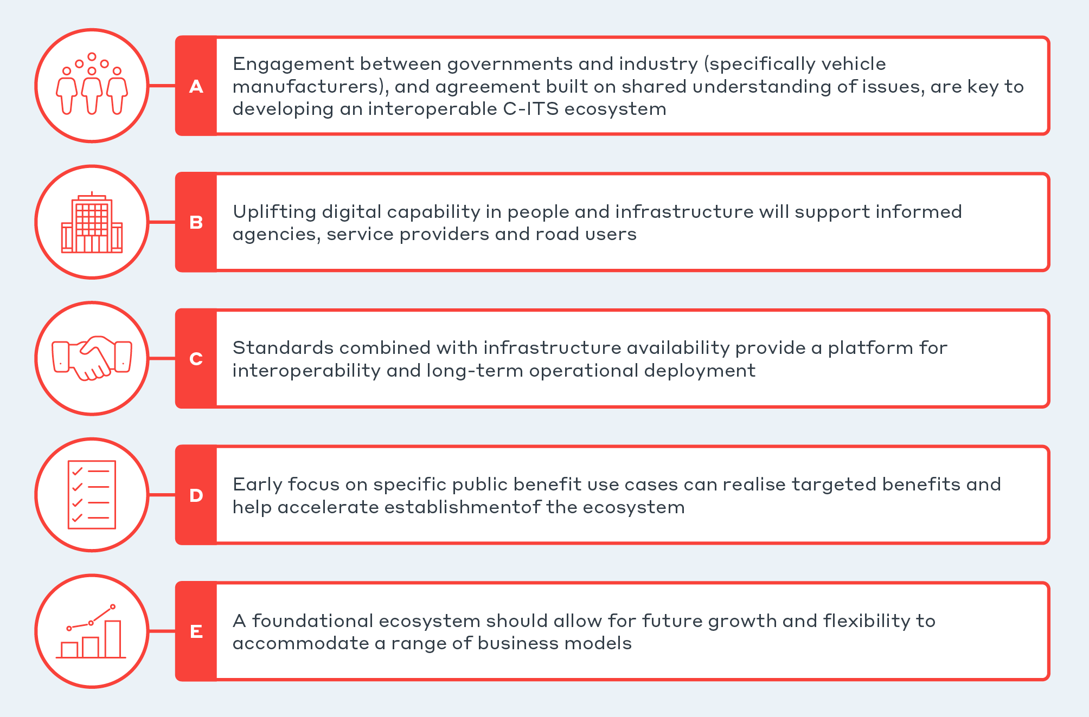

Figure 4.1 Principles for national approach

## A. Engagement between governments and industry (specifically vehicle manufacturers), and agreement built on shared understanding of issues, are key to developing an interoperable C-ITS ecosystem

***Action: Build and maintain a framework for engagement and agreement***

Most road authorities focus on the systems and services required to provide ITS. However, in a C‑ITS world, this focus will be coupled with a need to intrinsically understand the user and vehicle elements. System success will be influenced by extended complexity in the user, society, political, vehicle and technologies spaces. Appropriate controls such as policy, standards, compliance frameworks, regulation, and data frameworks will provide confidence that intended outcomes will be achieved.

### The user, industry, government relationship

Appropriate C‑ITS deployment requires alignment and enduring collaboration between many parties. Widespread deployment involves a broad group of stakeholders across all levels of government, multiple industry sectors, including vehicle manufacturers and a wide range of technology, service and data providers and end-users. Enduring and effective collaboration is essential to meeting these groups’ diverse needs and quickly realising the benefits of C‑ITS. A robust, transparent governance framework will encourage collaboration through effective communication, help define roles and responsibilities, and provide clear direction to all stakeholders. For industry, vehicle manufacturers should be prioritised due to their relative high investment cost and being the essential link to the user experience.

|  |
| --- |
| THE RAIL GAUGE CHALLENGE  Mismatched communication types and data standards between regions would impact on all users – in particular interstate truck operations. Different standards would be difficult to reconcile. The implementation of C-ITS in heavy vehicles could be compared to the different rail gauges in each state that plagued long-haul train operations Australia-wide. |

### National agreement

National consistency is essential to avoid market fragmentation and to deploy C‑ITS effectively. While infrastructure deployment trajectories may occur on different timescales, efforts must seek to ensure a commonality in processes, standards, and data so Australia gives industry an opportunity to deploy vehicles across jurisdictions. Agencies delivering independent solutions will increase the risk of failure. Vehicle manufacturers will not customise systems to meet differing needs for relatively small sales volumes across different Australian jurisdictions.

### International Cooperation

Australia can benefit from significant international effort and progress. In recognition of Australia’s international standing as a comparatively small market for vehicle manufacturers that relies heavily on the design origins driving new car sales, cooperation and alignment with international deployments will help Australia progress efficiently and consistently, and encourage the import to Australia of internationally deployed solutions. This can be seen to progress with ANCAP guidelines that align to WP.29 and Euro NCAP.

### The Importance of Governance

Efficient and mutually agreed decision making is essential for progressing C‑ITS deployment. As an ecosystem, there is a need for evolution and determination where each aspect can be either left open to implementation, or fully defined with commonality for interoperability. To support such decisions, a robust governance model (identifying and describing relevant working groups and steering committees) is needed to enable effective, authoritative decision making that recognises all stakeholders’ diverse needs and appreciates their relevance and importance to different decisions.

## B. Uplifting digital capability in people and infrastructure will support informed agencies, service providers and road users

***Action: Build digital capability to support and use future in-vehicle technology***

Existing in-vehicle solutions provide approximate, contextual advisory information about a limited number of non-safety critical events. To grow the benefits of C‑ITS, governments and industry must uplift digitalisation in their processes and approaches, to generate information that delivers a capable ecosystem. This effort benefits government agencies by creating smarter roads and greater digital capability regardless of the future direction of C‑ITS. Recent development in technology and processes including machine learning drive this development allowing insight to be gleaned from large data sets.

### Performance benefit of C‑ITS requirements

C‑ITS provides an avenue to improve transport data quality, which will benefit road users and road operators. There is potential for other solutions and other future technology to influence road safety, efficiency, and sustainability; however, C‑ITS benefits from being guided by interoperability in an ecosystem and has been tested and improved for more than a decade.

### Uplift in data readiness needed

Data accuracy, reliability, timeliness, completeness, and consistency is critical for vehicles to correctly interpret the data and deliver highly contextual alerts to drivers. Each agency has varying levels of data readiness to enable the appropriate performance level for C‑ITS operation. From the trials and analysis to date, much work appears needed to improve and prepare this data for vehicle consumption. This uplift of data quality and capacity to share information is a big task and one that is iterative. Most agencies have strategies and projects to deliver new data services by cloud-based providers. Work done to agree nationally to data standards and share learnings will lessen the burden for each region.

|  |
| --- |
| CASE EXample – CAVI’s C-ITS Pilot  The Ipswich Connected Vehicle Pilot (ICVP) has demonstrated it is possible to improve the quality of government data and systems to give a high level of user acceptance in C‑ITS solutions. |

### Data readiness – skills

Government agencies should look to ways of building capability into their existing systems to support C‑ITS. Examples include generating high accuracy spatial and temporal information related to events within traffic management systems. Agencies should look to benefit from the lessons learnt nationally and internationally to lower the cost and risk profile.

## C. Standards combined with infrastructure availability provide a platform for interoperability and long-term operational deployment

***Action: Establish shared standards framework and grow data maturity***

A standards framework is essential to share information between parties in the ecosystem in a trusted, secure, real-time environment. Data is a critical asset in C‑ITS. It can be valuable for many users but can also impede interoperability of use cases if not well defined. Access to information is essential for many services: using common data formats and consistent communication technology increases the ability to scale and enhance the ecosystem.

### Technology Neutral Interoperability

Interoperability will encourage new users, and technology will allow providers to continue improving functionality. C‑ITS is designed to be scalable from foundational systems. This is one of the major differences from other connected vehicle technologies where the solution is customised for a specific use, impacting a small ecosystem of systems and partners. As such, the difficulty for C‑ITS becomes the initial deployment of a foundational system, which will see benefits and cost efficiencies flow downstream for a much wider set of uses. While non-C‑ITS implementations are common, they tend to be targeted at specific issues or user groups. Non-C‑ITS implementations can connect information to vehicles using other systems, and these systems do not typically interact with each other.

Day 1 and 1.5 deployment (e.g., safety-related applications) requires interoperability that will only be achieved by selecting technology. This appears to still be DSRC (ITS-G5) providing the clearest ability for competitive solutions to be delivered in the wider ecosystem using investments in infrastructure. Technology neutral solutions (using DSRC or C‑V2X) should be encouraged to deliver wider benefits where interoperability is not essential.

### Get the data right to allow evolution in Use Cases and Bundles

There is an interrelationship between use cases, bundles and data:

* Use cases provide the concept, but become the industry’s realm to deliver.
* Bundles are a good way of identifying similarities and target areas.
* Data is the key interface between groups (e.g., government to/from industry).

Use cases are important to understand how solutions can be developed across ecosystem actors and systems. Bundles are used to help link use cases with commonalities together. They are essential to assessing costs, benefits, risks and capability. This can be complex in an ecosystem with different views on what is important, and the use cases that are of interest. Alternatives often exist to individual use cases, but C‑ITS provides most benefit in establishing common, interoperable connectivity with many vehicles. This allows scale in the numbers of users reached and the ability to leverage many use cases (bundling) with the same technology. Focusing on standards that provide consistent data, allows use cases or bundles of use cases to evolve for the end users benefit.

### Consistency is critical

It is essential that Australian deployment provides technical certainty. Completed pilots and learnings that focus on large scale deployment of mature C‑ITS aspects should be key considerations, including the following areas:

* A known security model and system that ensures all equipment is under the same security and privacy arrangement which conforms to federal and state government privacy law and principles
* Short-range communications with proven benefits for highly dynamic, low latency use cases
* Established systems, standards, and processes for sharing data between central systems
* Continued enhanced ability to reach vehicles for non-time critical applications using established long-range communications (3G/4G/5G). Continuing cellular coverage expansion including considering the potential for Low-Earth Orbit (LEO) satellite solutions to extend a network of communication provide non time critical connectivity in remote locations. These improvements and roll out in the physical communication layer strengthen the need for better quality data on our road network.

### Provision of infrastructure data

A common framework built off European standards and implementation should be established for sharing information from road agencies, such that:

* Agencies have a common understanding of what is needed for each message set/use case.
* Vehicles and other users can develop and test solutions with Australia-wide data format certainty.

Agencies can use project findings such as those described in the Austroads RADCAV (Road Authority Data for Connected and Automated Vehicles: Guidance for Agency Data Provision to Connected and Automated Vehicles, 2021) report to move toward these objectives.

A framework is needed for sharing information from central systems to others. A national data exchange must be determined based on the needs of each state and the complexity of over 20 different overseas vehicle manufacturers. In Europe, a National Access Point (NAP) system has been mandated to share information between countries[14]. However, consideration needs to be given to the model of exchange used in Australia given the existing traffic management systems and communication networks.

### Two-way sharing of data and vehicle generated data

The two-way capability of C‑ITS is expected to be beneficial to Australia in creating dynamic data capture of road network operation, understanding of high-risk locations, and identifying issues on roads. Providing vehicle-generated data would add to the benefits of C‑ITS for agencies operating road networks. However, at this time Australia has no regulation or agreed process which could result in vehicle manufacturers consistently sharing vehicle-generated data in an agreed format, as they do in Europe. This appears to be gaining momentum through NTC (2020) policy paper, “Government Access To Vehicle-Generated Data” and recent establishment of a joint industry-government National Vehicle Data Working Group, and the upcoming Austroads (2022) project seeking to trial an exchange of vehicle generated data with road agencies.

## D. Early focus on specific public benefit use cases can realise targeted benefits and help accelerate establishment of the ecosystem

***Action: Establish deployment models that focus on specific market segments to realise targeted benefits***

The policy analysis identified the chicken-and-egg dilemma as a situation impacting C-ITS where the projected benefits are clear for both government and industry, however, are dependent on each other (established infrastructure and vehicle fleet respectively). To break this situation, strategic interventions can be employed utilising market segments to build early benefits and gain momentum for ongoing wider deployment.

### Realising Benefits

The following principles should be considered for targeting early benefits relating to the priority land transport technology issues:

* Safety use cases are likely to provide the most measurable benefits in a relatively short time frame regardless of deployment environment or user group and should be promoted by governments. These will form the basis of ‘no regrets’ decision making.
* Efficiency use cases aim to resolve issues with congestion, travel time, and routing. While they have previously been a lower priority for analysis in pilots, they offer significant opportunity for C‑ITS to deliver compelling benefits to end users utilising vehicle generated data and new analytical technologies such as artificial intelligence.
* Sustainability – a long-term secondary C‑ITS benefit – has become a greater focus in many Australian agencies. The provision of C-ITS information allows vehicles and users to optimise their travel with a greater understanding of their upcoming road environment.

|  |
| --- |
| CASE ExampLe: Kickstarting deployment  An industry partner providing C‑ITS as standard to its customers (road users) helps with normalising the acceptance of the technology.  Volkswagen in Europe are delivering C‑ITS as standard in the Golf 8, ID.3 and ID.4 models. Along with other manufacturer efforts, **Europe has more than 500,000 C‑ITS equipped vehicles on the road**  Source: C-Roads: C‑ITS in Europe is reality today |

### Targeting user groups can focus service delivery to achieve national objectives

While long-term C‑ITS deployment is intended to benefit all user groups, major safety benefits can be realised relatively quickly by initially targeting freight and rural users. This will enable government to influence benefits in alignment with strategic national objectives. C‑ITS creates opportunity to target safety-critical measures more effectively than traditional ITS, such as benefits to VRUs.

### Complementary services and benefits to current solutions

Many vehicle manufacturers are beginning to deliver connected (via long range communications) vehicles to Australia and enabling connected services managed within their own brand ecosystems. These services provide services for comfort and convenience such as remote-control driving capability and emergency assistance services (e.g., e-call-like services). C‑ITS should aim to leverage existing and emerging technology (i.e., SIM cards in vehicles) to provide safety and efficiency use cases. This approach helps maintain and understand the broader suite of services being offered to road users, and creates an avenue for managing priority use cases (such as safety-critical warnings over general information notifications).

### Consider the environment (rural vs urban)

Considerations applying to rural environments differ from those in urban areas. Typically, a rural environment has the following characteristics:

* Higher percentage of fatal crashes
* Low traffic volumes and consequently low congestion
* Low availability of power beyond town centres
* Poor continuous cellular coverage

Due to less traffic volume (and therefore vehicle sales) in rural locations it is assumed that there will be less focus for industry in providing a cost-effective solution. The lower potential market penetration, coupled with a higher crash risk (500–1000 per cent more for regional and remote respectively) may warrant government support to encourage uptake for this market segment to realise the significant societal benefits sooner.

### Support major vehicle suppliers in delivering benefits to Australian road users

Nineteen vehicle manufacturers supply 95 per cent of the Australian market. Interest from large vehicle manufacturers should be supported and encouraged to provide C‑ITS as standard to increase the market penetration of vehicles to more Australians, speeding up and increasing benefits realisation.

### Mobile phones and aftermarket equipment

While the primary analysis and benefits focus on the introduction of C‑ITS-equipped new vehicles, there is an opportunity to provide C‑ITS-provisioned data to other end-user interfaces. Aftermarket devices provide industry an opportunity to sell equipment that can be retrofitted into current vehicles and provide C‑ITS information/use cases to road users. Further, an opportunity exists to provide C‑ITS data services (i.e. a subset of C-ITS services) to existing mobile phone applications so large user groups can benefit rapidly from the improved services offered. While these options are less likely to be as effective as an integrated C-ITS vehicle station, they provide the potential to gain early utilisation of services and begin realising benefits while C-ITS equipped new vehicles progressively arrive.

## E. A foundational ecosystem should allow for future growth and flexibility to accommodate a range of business models

***Action: Build a foundational backbone that allows future growth***

The hybrid model of deployed C-ITS creates a platform where data flows through communications protocols and paths, privacy and security are inherent in the system, and a user-accepted level of quality exists. This foundation allows expanding potential and is possible through new interfaces to users, new business models, new use cases and the existing system’s enhanced capability. The many assumptions that have been controlled through the analysis to quantify a Day 1 ecosystem represent opportunities that can be explored as future growth of the foundational system.

### Day 2, 3+ use cases

Establishing a Day 1 system creates easier justification and business cases for evolved and smarter future C‑ITS use cases. Evidence is shown where use cases have been expanded and adjusted over time by working groups such as C-Roads. This is natural given the move from theoretical use cases to trialled, tested, and operational use cases. As more complexity is added to the system (for example, the ability for vehicles to sense events and broadcast this information to others), a solid foundational system allows capability to grow. Service fragmentation makes it difficult to deliver more significant, complex systems with multiple actors. All components must build in operations and maintenance by design to allow benefits to progress.

|  |
| --- |
| South Korea – C‑ITS Strategy for AV introduction (Korea Bizwire, 2021)  South Korea is establishing strategic plans to deploy C‑ITS from 2021 to enable Level 4 automated vehicles by 2027. |

### Evolution of Connected and Automated Vehicles

While low levels of vehicle automation to date (SAE level 1 and 2) have already produced significant safety and efficiency benefits, there are a range of issues still to be resolved before highly automated vehicles (SAE level 3 and above) should be considered for mass deployment in anything other than relatively small operational design domains (ODD), e.g., ‘driverless shuttles’ (potentially SAE level 4 or 5) operating in low speed, relatively non-complex or controlled environments. C‑ITS is essential for realising more widespread use and higher levels of automation in the future.

### Cost Recovery Opportunities

Trials and international deployment have shown that C‑ITS can deliver services that are rich in information and targeted to individuals. This creates an opportunity for system providers to generate a return on investment from avenues such as subscriptions and levies. Return on investment opportunities exist to recover costs incurred. As with most technologies that require infrastructure investment, there will be a range of mechanisms to recover the costs of implementation. The best way to recover these costs will be best assessed in the future as the market potential of C-ITS becomes clearer. In the meantime, typical ITS and road safety funding mechanisms should be considered in relation to delivering the positive cost-benefits projected in the CBA options.

# The Road Ahead

The principles highlight a need to kickstart the process of C‑ITS deployment given the ecosystem’s complexity. Actions and activities should be prioritised to develop a viable C‑ITS ecosystem through a national framework. Actions range from leadership, policy, considering common use cases and user needs, to investing in data management, systems, and infrastructure. Clear leadership and broad agreement on approach will help support vehicle manufacturers’ decisions to confidently bring C‑ITS services and systems to Australia’s vehicle fleet.

The ‘no regrets’ principles for a national approach focus on building an ecosystem to deliver benefits now while adapting to changes in user needs, technology, or the potential of new business models that achieve the outcomes sought. This concept of defining a base system and allowing for evolution is illustrated in Figure 5.1.

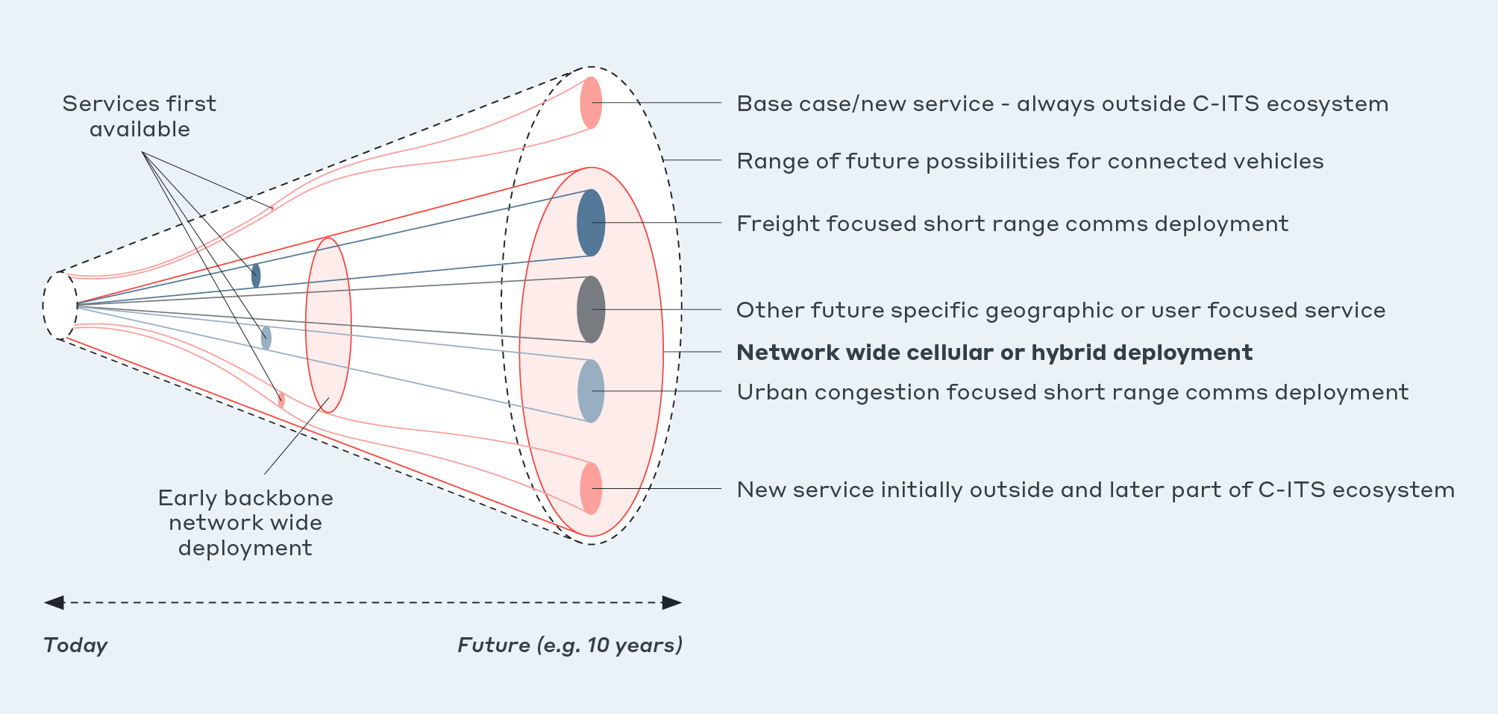

Figure 5.1 Connected vehicle cone of uncertainty and potential of backbone deployment

Key considerations regarding uncertainty for connected vehicles outlined in Figure 5.1:

* Possible futures for connected vehicles from today on the left-hand side to all possible futures on the right-hand side of the cone. Potential first available services that address the specific needs of a narrow but viable set of users - such as urban or freight C‑ITS implementation are realised earlier.
* The growth capability is present with a foundations system encouraging uptake of C‑ITS equipped vehicles and other C‑ITS services utilising the core elements.
* Solutions that are delivered outside of the C‑ITS ecosystem initially can be incorporated into a future large-scale deployment if a robust framework exists. There may be other solutions which will deliver benefits to road users while never forming part of the C‑ITS ecosystem.
* A no regrets pathway to developing a C‑ITS ecosystem would shift development from the left to the right of the cone and considers movement towards the preferable future. This preferable future can return benefits to the end users, the community and be attractive to all parties involved in the ecosystem, particularly recognising the need for private industry to understand the potential and establish viable business models.

## National Framework and Shared Understanding

|  |
| --- |
| A Common Language  The benefits of C‑ITS are dependent on agreement between parties that have had limited interaction previously. Working groups and forums are needed to build a shared understanding.  Misinterpretation will limit the benefits and efficiencies that would otherwise be possible when key parties recognise and work towards a common goal. |

A robust national framework should provide initial national direction for many different industries, levels of government and users. A framework needs to be developed to meet the needs of all key parties and to above all, provide certainty which allows:

* A detailed roadmap with objectives, target state (interoperability) and timeframes to galvanise an approach to deployment
* Early deployments to occur with investment confidence.
* Experts to establish delivery models for each aspect needed to deliver the roadmap including potential investment options
* Industry to validate business models and technical delivery within the Australian context

|  |
| --- |
| A FRamework for all  Certainty of timing and intent of key actions is critical to all parties involved in the C‑ITS ecosystem. C‑ITS requires considerable effort across a wide range of factors: technology, data, user experience, strategy, processes, financial, etc. A roadmap articulating these activities along with consideration of the necessity of parallel versus sequential tasks helps understand where collaboration is needed and where blockers exist. Some examples of frameworks include Zenzic (2021) in Europe and the SAE (2022) in the US . These examples help relay the volume of activities needed to achieve C‑ITS deployment. |

The framework should leverage the principles for a national approach to C‑ITS outlined in Section 4 and provide:

* **Clarity on C‑ITS and its potential benefits**: through clear agreed taxonomy, terminology, references, standards and examples the framework should align understanding of C‑ITS and make understanding of it and its potential benefits easy for stakeholders of all knowledge levels as far as is reasonably practicable. Consistent and accessible knowledge sharing should be facilitated by the framework to further understanding and optimise efforts to achieve benefits.
* **Clear governance and actions**: activities and actions should be clearly described including scope, objectives and context while stating the parties and persons responsible for completion. This provides accountability and encourages communication and collaboration while avoiding duplication of effort; improving efficiency and time to benefit realisation.
* **Flexibility**: recognising the rapidly evolving nature of technology and likely changes in use cases and user needs over time, the framework must be flexible and provide users with scope to respond to changes appropriately.
* **Robust compliance:** the framework should be scaled based on a risk profile of likelihood and severity to determine the compliance level required for each component. For example, roadside equipment, vehicle equipment and central systems operate with different requirements, each will require an appropriate, separate, standardised compliance model. ANCAP is a good example of harmonisation with alignment to WP29 and Euro NCAP. Testing required for Euro NCAP is likely to inform the compliance framework.

## Technical Certainty

Table 5.1 outlines the next steps to be considered for each of the base technical components of the ecosystem to encourage deployment.

Table 5.1 Technical next steps

| Technical Area | ReadY FOr Deployment | Technical Uncertainty to be resolved | Next Steps |
| --- | --- | --- | --- |
| Short-range Communications | DSRC (ITS-G5) is a mature communication method that has been used as the basis for trials across the world in the past 10 years including CITI, AIMES and ICVP in Australia. | Depending on national direction of alternative technology: Coexistence of multiple solutions (ITS‑G5 and C-V2X). This is discussed further in Section 1.6.3. | The deployment of short-range communications infrastructure that is interoperable and supports delivery of priority benefits. |
| C‑ITS Security | Technical standards for a C-ITS SCMS system exist. Systems have been established in Europe and the US. An SCMS has been developed for TMR and is operating effectively in the CAVI trial in Queensland. The SCMS ensures the authenticity of communications to stop incorrect messages being sent, which is particularly necessary in relation to safety critical messages. The SCMS is also designed to provide anonymity to the vehicle and occupant. | Ensure the SCMS for Australia is built to meet the security and privacy needs across Australia. | Unsecured communications leave the end user open to false information which could damage user trust, privacy, and experience. The sooner the SCMS is established, the sooner trusted information can flow. |
| Positioning | 10m accuracy is available as a baseline for standard available positioning systems. ICVP has proven 1m accuracy is possible using RTK augmentation. | Geoscience Australia progressing to higher positioning accuracy through SBAS. This will likely have cost efficiencies in improving accuracy, but needs testing and validation for in-vehicle systems. | Provide support through guidelines, testing and infrastructure for positioning accuracy systems encouraging higher accuracy, reliable, cost-effective solutions. |
| Central systems and National Data Exchange | ICVP showed that this component was critical to operating, monitoring and maintaining deployment equipment.  Lexus has proven that the same vehicle can operate across-borders.  Building data lakes with open data portals is a key common area of interest for state agencies. Most agencies have sought to share datasets openly with the public in near real time: despite limited data detail and quality. | Requires clarity in terms of national consistency with central C‑ITS systems.  For each relevant use case, each road operator must assess the source data needed for input into C‑ITS central systems. | Prepare central systems such as traffic management centres for the provision of event data to vehicles and receipt of data from vehicles.  Establish the needs and technical requirements for national data exchange to share information consistently from central systems. |
| Cellular Connectivity  (long-range communications) | Enough coverage to establish base cellular connectivity to vehicles across major Australian roads. | Continuity of cellular coverage for whole of journey. Particular considerations for rural and regional travel. | Continue growth of the cellular network will support long-range communication services particularly in remote areas. Continue monitoring LEO satellite development and potential use for vehicle connectivity. |
| Data | Generating C‑ITS compliant messages from traffic system information and sharing these with vehicles proven in pilots.  Collecting, storing and analysing data for improved transport system understanding | The data’s accuracy, reliability, timeliness, completeness, and consistency is critical to allow vehicles to correctly interpret the data in a given situation or use case, and deliver alerts to drivers in a highly contextual manner.  C‑ITS’ two-way capability is expected to benefit Australia by creating dynamic data capture of road network operations, understanding of high-risk locations, and identifying on-road issues. This needs to be considered across regions and systems. | Build guidelines and example datasets that demonstrate Australia’s implementation of the standards for national consistency.  Get the data flowing through the essential components to ensure data can be generated, processed, stored, analysed and used. |
| Standards | Both European and US standards suites contain a core set of message standards that Australia can adopt. | The use of standards and agreement between users is needed to achieve the operational intent. Australia could sensibly align to one region’s standards base, thereby minimising the complexity of a national implementation. This would avert the challenges of aligning different standard sets, e.g., European Access layer with Chinese geo-networking, Japanese security and US message types. | Establish clarity on how Australia intends standards to be implemented for deployment. The policy analysis determines this should be based on the International Standards Organisation (ISO) Europe standards guideline. |

### Priority Standards for Interoperability

The *ISO C-ITS Guidelines on the usage of standards* (ISO/TR21186-1, 2021) provides a detailed coverage of current standards to be implemented. The priority standards specified should be based on investment cost in physical components and data flow between systems such that data quality and assurance is maintained through to the end user. Clarity in the following areas from the European standards suite should be prioritised to encourage interoperability:

* **Architecture** defines the core components and interactions. This is critical to clarify what stakeholder can expect from to interact with. The essential components that make up the ecosystem are outlined in Sections 1.4 and 1.5.1.
* **Access Layer/Physical layer** is the initial interface between stations and the most difficult to replace. An incompatibility of standards at the access layer means there will be no information received even if subsequent layers have aligned standards.[15] As per section 2, the access technology for short-range communications should prioritise a single technology and this on the current analysis should be DSRC (ITS-G5).
* **Security** must be consistent and builds the trust layer between stations. The SCMS is the most sophisticated component of the C-ITS ecosystems and essential to trusted interoperability where privacy must be maintained, and safety critical decisions must be made based on the data derived from others (TCA, 2018).
* **Message Sets**/Facilities Layer generates consistent data that stations can understand. The contents of messages distributed through the ecosystem must be consistent and sufficiently detailed to be meaningful to the end user. The message standards (and more specifically the data specifications) determine what should be filled and therefore what should be expected. Getting the data right allows evolution in use cases and bundles to present simpler or more complex information to the driver (or end users).

## No Regrets Use Cases

Once clear technical directions, standards and guidelines are in place it is possible to consider the potential backbone needed to support services and priority use cases. The CBA developed in this project (see Section1.5.3 considered bundles of use cases or priority deployment options that are outlined in Figure 5.2 with key components required.

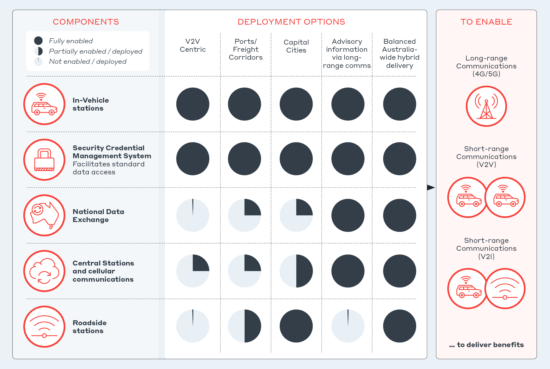

Figure 5.2 Key areas of investment and options for deployment

### Heavy Vehicle Use Cases

The priority options analysis showed how the heavy vehicle user group can benefit from C‑ITS. Heavy vehicles’ higher vehicle mass and slower braking profiles make them typically slower to respond to dynamic events. The value of time for heavy vehicle operation is also greater for the wider vehicle fleet. Providing C‑ITS solutions for heavy vehicles makes drivers aware of safety risks earlier, shortening the time they need to react and possibly prevent a crash. It also makes the drivers aware of events on the network that could impact or delay their journeys. C‑ITS solutions can also help road operators better understand corridor or network performance, which they can proactively consider to improve road network operation for heavy vehicles or the wider vehicle fleet.

The opportunity to support smooth vehicle movements through traffic signals is unique to C‑ITS. The CITI heavy vehicle pilot has focused on use cases and practical application of C‑ITS for heavy vehicles in urban and rural environments (wider Illawarra region).

### Vulnerable Road User Use Cases

|  |
| --- |
| VRU User Story  “As a parent of school aged children, it’s reassuring to know that my kids cross busy intersections where Infrastructure-to-Vehicle technology is available to warn drivers of equipped vehicles about unexpected pedestrian movements.” |

Vulnerable Road Users (VRUs) including pedestrians, bicyclists, motorcyclists and animals, have been considered in the past in a range of safety and efficiency use cases. VRU use cases continue to be of strong strategic interest as these groups are at higher risk of serious injury in a crash. For a range of reasons, technical solutions targeted at VRUs are more complex than vehicle-centric solutions. As a result, there are few mature solutions. Continued Australian and international effort to provide standards and systems that improve VRUs’ safety, is bringing us closer to solutions that can be assessed for deployment. Testing of new VRU standards is underway in Europe.[16]

### Rural Use Cases

C-ITS solutions that can deliver benefits to rural regional road users are of particular interest from the perspective of accessibility, as outlined in Section 2.3.1.6, and the relatively high level of harm from road crashes in comparison to urban environments, as outlined in Section 1.3. Consideration of services that can benefit rural (regional and remote) environments will be critical in considering next steps or priority use cases.

ICVP and AIMES were urban focused environments. However, TMR is planning on extending ICVP urban use cases out to rural environments. ‘The department is now working to extend the scope of its C‑ITS services along the Bruce Highway, from the Sunshine Coast to Cairns’ (MTA Queensland, 2021).

## The role of Government

The federal government has a key role in unlocking and enabling C‑ITS as part of a wider ecosystem. Globally, governments have been closely involved in developing C‑ITS because of its demonstrated economic benefits to the wider community. There is a need to consider early action by governments that is undertaken in a nationally coordinated way: leadership and potential return on targeted investment to solve the chicken-and-egg problem discussed in Section 2.3.1.5, and afterwards to outline who should act first to kickstart C‑ITS deployment and uptake, discussed in Section 5.5. This needs to include establishing the standards direction for all stakeholders to deliver to.

C‑ITS requires consideration by multiple levels of government. C‑ITS roadside infrastructure is somewhat similar to existing ITS, which road agencies can fund, deploy and manage accordingly. For example, central systems can be considered an extension of traffic management systems and roadside stations an extension of field ITS devices. Where C‑ITS is different from traditional ITS is the introduction of the vehicle into the system. This means that national consistency is required for vehicles to interact and operate with road agencies. A federal approach, whereby federal and state governments work together with support from associated national bodies such as Austroads, must provide data sharing and security frameworks that support this vehicle integration.

The funding to support this national approach is a key early consideration given the lead time on investment for government agencies. There is also an opportunity to consider the how costs could be shared with the private sector and/or end users directly or indirectly. Government should encourage these discussions but may also need to support early deployment through funding mechanisms used with typical ITS delivery, which targets similar benefits.

|  |
| --- |
| DIGITAL TRANSPORT SYSTEMS Transformation  C‑ITS is an avenue to improve existing transport systems, providing highly contextual information in vehicles based on their spatial, temporal, and behavioural attributes. This requires a data quality level that is secure, near real-time, accurate, and has high positioning confidence. There is an opportunity to integrate existing traffic management systems and platforms with C‑ITS applications to provide and gather high-quality contextual data. This, in turn, provides greater information to the individual and improves overall user experience, quality, and performance of information systems. The required uplift of data quality and capacity is a significant task. Some jurisdictions are already on this journey, such as with the SCATS upgrade program (TfNSW, 2021) and those that are developing end user mobile applications to present real-time event information. Government agencies can maximise opportunities and investments by considering C-ITS data requirements and the potential of new data generated by C-ITS enabled vehicles when undertaking wider digital activities. |

## Kickstarting A National C-ITS Ecosystem

Early stages of considering C‑ITS deployment have been built on bundles of use cases; how best to enable them and the requisite benefits and costs. There are a range of potential options for timing key activities. Figure 1.13 outlines a systems thinking approach to C‑ITS which is based on understanding the drivers by reinforcing loops to build momentum within the ecosystem. Figure 5.3 considers the initial steps to begin the positive drivers for C‑ITS to a foundational ecosystem.

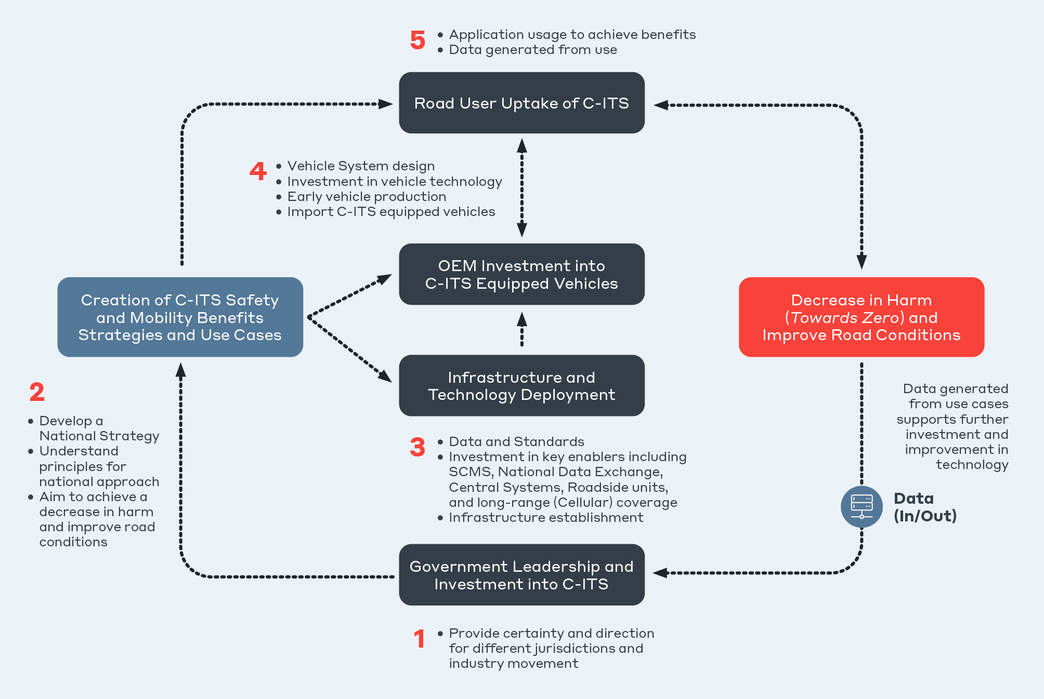

Figure 5.3 C‑ITS deployment considerations

The five steps outlined in Figure 5.3 may take place concurrently and iteratively to some extent. However, there is a need to address these issues to optimise the roll out of services and recognise key benefits.

* Step 1 shows **National Leadership and Investment into C‑ITS** as a starting point. This investment is not primarily financial. The certainty created by leadership, policy, and the development of a framework for implementation is more significant than strictly fiscal investment. Investment is being made in enabling the technology developed and paid for by private sector and end users.
* Step 2 outlines **Creation of C‐ITS Safety and Mobility Benefit Strategies and Use Cases** requires collaboration to help all parties identify benefits and opportunities before making investment decisions. Once use cases and functions are understood, data requirements can be identified.
* In step 3 **Infrastructure and Technology Deployment Data and Standards** can be identified and work initiated. This will require significant effort on behalf of road and transport agencies in particular.
* Once data is available from road and transport agencies Step 4 **ensures vehicle manufacturer investment into C‐ITS equipped vehicles and importation can be enabled**.
* Leading into **Step 5 Road User Uptake,** where the efficiency and safety benefits sought will be realised.

# Conclusion

C‑ITS is one mechanism available to contribute to improving Australia’s land transport issues. It is the only one built on a foundational principle that encourages information-sharing and better decision-making. A C‑ITS ecosystem maintained on this principle should be considered complementary to (and encourage) other technology initiatives to improve safety and efficiency.

This project and report unpacked the relevant priority issues for land transport (namely safety, efficiency, sustainability and accessibility), and assessed the capability of C-ITS to positively impact on these. It considered the technical, strategic and cost-benefit factors of C-ITS to determine if government intervention was needed. Key policy issues are identified and examined as part of this analysis, which found that on the balance of current state and land transport needs, leadership and direction is preferred to ensure vehicle manufacturers and technology providers have adequate certainty to consider future investment. This includes setting policy direction on standards suites and short-range communication that aligns to Europe. Some intervention is needed to create enabling infrastructure that establishes a minimum viable market for deployment.

The intention behind adopting C-ITS is to build an ecosystem that encourages information sharing between many vehicle types, road users and road infrastructure. When this information is safety-critical, for example from a broken-down vehicle ahead on the road, the vehicle manufacturer should not determine whether the information can be shared. If shared with everyone consistently (with trust), the safety and efficiency benefits are accessible to all. While other solutions exist (and will arise) for certain specific issues and markets, C-ITS is the only available solution that provides this open and harmonised ecosystem. National direction is needed through policy standards and guidelines to provide certainty and equal opportunity to deliver beneficial solutions within a known framework. The economic analysis found that positive Benefit-Cost Ratios between 1.4 and 2.9 exist when supporting infrastructure is available, highlighting the need for government-led initiatives that drive enabling technology and initial deployments. Given that vehicles imported to Australia are harmonised to European standards through WP.29, it is logical that Australia also harmonises C-ITS to the European deployment.

Principles for a national approach and a pathway through a road ahead are defined to provide near-term and long-term guidance for government and relevant stakeholders. A national framework that encourages collaboration, and agreement that moves to action a foundational ecosystem and scaled deployment, is a priority. Undertaking leadership and direction now (described in PA2), provides flexibility and will position government to determine the most appropriate future decisions, such as what to leave to industry to lead (similar to PA1), and what to regulate (as in PA3).

References

ACMA. (2017). Radiocommunications (Intelligent Transport Systems) Class Licence 2017. Retrieved from https://www.legislation.gov.au/Details/F2018L00026

ANCAP. (2016). ANCAP Submission: New Car Retailing Industry - a market study by the Australian Competition & Consumer Commission. Retrieved from https://s3.amazonaws.com/cdn.ancap.com.au/app/public/assets/5e1ccd77ae6bd1ad3a255ec2c8d9b559b49d5d58/original.pdf?1551158042

ANCAP. (2021). Submission to the joint select committee on road safety. Retrieved from https://s3.amazonaws.com/cdn.ancap.com.au/app/public/assets/c795cc9feb2a00f10e2fbfae0b8f7c2f7a2e1663/original.pdf?%201634173431

ATAP. (2021). Value of travel time for vehicle occupants. Retrieved from https://www.atap.gov.au/parameter-values/road-transport/3-travel-time

Australian Trade and Investment Commission. (2018). Intelligent Transport Systems. Retrieved from https://www.austrade.gov.au/future-transport/intelligent-transport-systems/

Austroads. (2015). Assessing Emerging C-ITS Standards for Local Adoption. (26). Retrieved from https://austroads.com.au/latest-news/assessing-emerging-c-its-standards-for-local-adoption

Austroads. (2021). Road Authority Data for Connected and Automated Vehicles: Guidance for Agency Data Provision to Connected and Automated Vehicles. Retrieved from https://austroads.com.au/publications/connected-and-automated-vehicles/ap-r662-21

Austroads. (2022). Upcoming and Active Projects. *FCA6314 Connected vehicle and road agency data exchange*. Retrieved from https://austroads.com.au/projects

BITRE. (2014). Freightline 1—Australia freight transport overview. Retrieved from https://www.bitre.gov.au/publications/2014/freightline_01

BITRE. (2015). Traffic and congestion cost trends for Australian capital cities. Retrieved from https://www.bitre.gov.au/publications/2015/is_074

BITRE. (2020). Australian Infrastructure Statistics Yearbook 2020. *Domestic freight by transport mode - total bulk and non-bulk - road 2019-20*. Retrieved from https://www.bitre.gov.au/sites/default/files/documents/bitre_aus_infrastructure_yearbook_2020.pdf

BITRE. (2021a). Safety Statistics. *Monthly Road Deaths Dashboard*. Retrieved from https://www.bitre.gov.au/statistics/safety

BITRE. (2021b). Road trauma Australia 2020 statistical summary. Retrieved from https://www.bitre.gov.au/sites/default/files/documents/road_trauma_australia_2020_statistical_summary.pdf

Bureau of Infrastructure, Transport and Regional Economics. (2020). Australian Infrastructure Statistics Yearbook. Canberra, Australia: Bureau of Infrastructure, Transport and Regional Economics. Retrieved from https://www.bitre.gov.au/sites/default/files/documents/bitre_aus_infrastructure_yearbook_2020.pdf

C2CCC. (2019). Guidance for day 2 and beyond roadmap. Retrieved from https://www.car-2-car.org/fileadmin/documents/General_Documents/C2CCC_WP_2072_RoadmapDay2AndBeyond.pdf

C2CCC. (2022). CAR 2 CAR Communication Consortium. Retrieved from https://www.car-2-car.org/about-us/

CCAM. (2021). Connected, Cooperative & Automated Mobility. Retrieved from https://www.ccam.eu/

Centre for Road Safety. (2021). Cooperative Intelligent Transport Initiative (CITI) Light Vehicle Study Driver Feedback Summary Report June 2021. TFNSW. Retrieved from https://roadsafety.transport.nsw.gov.au/downloads/citi-light-vehicle-driver-feedback.pdf

C-ITS Deployment Group. (2020a). C-ITS Deployment. Retrieved from https://c-its-deployment-group.eu/activities/c-its-deployments/

C-ITS Deployment Group. (2020b). ASFINAG connects roads with vehicles on a large scale in Europe. Retrieved from https://c-its-deployment-group.eu/activities/c-its-deployments/2020-10-09-asfinag-connects-roads-with-vehicles-on-a-large-scale-in-europe/

Commissioner for Privacy and Data Protection. (2015). Cloud Computing in the Victorian Public Sector. Retrieved from https://ovic.vic.gov.au/wp-content/uploads/2018/07/Cloud_Computing_in_the_Victorian_Public_sector.pdf

C-Roads. (2021). C-ITS in Europe is Reality Today. Retrieved from https://www.c-roads.eu/news/News/entry/show/c-its-in-europe-is-reality-today.html

C-Roads. (2021). The C-Roads Platform. *An overview of harmonised C-ITS deployment in Europe*. Retrieved from https://www.c-roads.eu/fileadmin/user_upload/media/Dokumente/C-Roads_Brochure_2021_final_2.pdf

Customer Service NSW. (2022). Cloud Strategy. Retrieved from https://www.digital.nsw.gov.au/policy/cloud-strategy-and-policy/cloud-strategy

Department of Communities, Housing and Digital Economy. (2022). Cloud Computing. Retrieved from https://www.qgcio.qld.gov.au/ict-strategy/cloud-computing

Department of the Prime Minister and Cabinet. (2021). Data and Digital Ministers' Meeting Communiqué 13 August 2021. Retrieved from https://www.pmc.gov.au/sites/default/files/publications/20210813-ddmm-communique.pdf

DITRDC. (2021). Infrastructure and Transport Ministers' Meeting FRIDAY, 28 May 2021. Retrieved from https://www.infrastructure.gov.au/sites/default/files/documents/15th-infrastructure-and-transport-ministers-meeting-communique-28-may-2021.pdf

DTA. (2017). Secure Cloud Strategy. Retrieved from https://dta-www-drupal-20180130215411153400000001.s3.ap-southeast-2.amazonaws.com/s3fs-public/files/cloud/secure-cloud-strategy.pdf

ERTRAC. (2019). Connected Automated Drivign Roadmap Version 8. Retrieved from https://www.ertrac.org/uploads/documentsearch/id57/ERTRAC-CAD-Roadmap-2019.pdf

ETSI. (2009). ETSI TR 102 638 V1.1.1. *Intelligent Transport Systems (ITS);Vehicular Communications; Basic Set of Applications; Definitions*. Retrieved from https://www.etsi.org/deliver/etsi_tr/102600_102699/102638/01.01.01_60/tr_102638v010101p.pdf

European Commission. (2021a). Intelligent transport systems (review of EU rules). Strasbourg. Retrieved March 1, 2021, from https://ec.europa.eu/info/law/better-regulation/have-your-say/initiatives/12534-Intelligent-transport-systems-review-of-EU-rules-_en

European Commission. (2021b). *Impact Assessment Report.* Strasbourg: European Commission. Retrieved March 1, 2022, from https://ec.europa.eu/info/law/better-regulation/

European Union. (2010). Directive 2010/40/EU of the European Parliament and of the Council of 7 July 2010 on the framework for the deployment of Intelligent Transport Systems in the field of road transport and for interfaces with other modes of transport Text with EEA relevance. Retrieved from http://data.europa.eu/eli/dir/2010/40/oj

FCAI. (2019). Federal Chamber of Automotive Industries. *Representing the Australian automotive industry*. Retrieved from https://www.fcai.com.au/about

FCAI. (2021). Cooperative ITS and associated spectrum considerations. *Internally available*.

FCC. (2020). FCC Modernizes 5.9 GHz Band to Improve Wi-Fi and Automotive Safety. Retrieved from https://www.fcc.gov/document/fcc-modernizes-59-ghz-band-improve-wi-fi-and-automotive-safety

Federal Chamber of Automotive Industries. (2021). Cooperative ITS and associated spectrum considerations. Retrieved from Internally available

Gettman, D. (2020). DSRC and C-V2X: Similarities, Differences, and the Future of Connected Vehicles. Retrieved from https://www.kimley-horn.com/dsrc-cv2x-comparison-future-connected-vehicles/#:~:text=Initial%20tests%20of%20C%2DV2X,for%20the%20key%20safety%20applications

GM. (2019). GM Outlines China Advanced Technology Roadmap for Accelerating “Drive to 2030”. Retrieved from https://media.gm.com/media/cn/en/gm/home.detail.html/content/Pages/news/cn/en/2020/Aug/0819-gm-tech-day.html

iMove Australia and Department of Transport and Main Roads. (2021). Ipswich Connected Vehicle Pilot. *C-ITS component of the Cooperative and Automated Vehicle Initiative: Preliminary Findings for Safety Evaluation and User Perception*. Retrieved from https://imoveaustralia.com/wp-content/uploads/2021/10/Ipswich-Connected-Vehicle-Pilot-C-ITS-Component-webinar-slide-deck-FINAL.pdf

Infrastructure and Transport Ministers. (2021). National Road Safety Strategy 2021-30. Retrieved from https://www.roadsafety.gov.au/sites/default/files/documents/National-Road-Safety-Strategy-2021-30.pdf

Intelligent Transportation Society of America and the American Association of State Highway and Transportation Officials. (2021). Notice of Appeal. *Use of the 5.850-5.925 GHz Band*. Retrieved from https://itsa.org/wp-content/uploads/2021/06/5.9-GHz-Notice-of-Appeal-Exhibit.pdf

ISO/TR21186-1. (2021). *Cooperative intelligent transport systems (C-ITS) — Guidelines on the usage of standards — Part 1: Standardization landscape and releases.* ISO.

ITS Standards. (2020). Cooperative intelligent transport systems (C-ITS). Retrieved from http://its-standards.info/Guidelines/IntroductionC-ITS.html

Korea Bizwire. (2021). Next-generation Intelligence Transport System to be Established Nationwide by 2027. Retrieved from http://koreabizwire.com/next-generation-intelligence-transport-system-to-be-established-nationwide-by-2027/202149

Levin, S., Skinner, I., & Nokes, T. (2019). European Commission, Directorate-General for Mobility and Transport. *Support study for impact assessment of cooperative intelligent transport systems : final report*. Publications Office. Retrieved from https://data.europa.eu/doi/10.2832/067308

Lexus Australia et al. (2021). Enabling Infrastructure to Vehicle Communication for Safety Applications of Connected Vehicles in Carlton, Victoria – Initial Test.

Makano, H. (2017). C-ITS and Connected Automated Driving in Japan. Retrieved from http://www.nilim.go.jp/lab/qcg/japanese/3paper/pdf/2017_13.pdf

Mauro, V. (2020). A national ecosystem for the delivery of C-ITS services. Retrieved from https://www.stradeeautostrade.it/en/smart-road-digital-transformation/a-national-ecosystem-for-the-delivery-of-c-its-services/

MDOT and CAR. (2017). International Scan of Connected and Automated Vehicle Technology Deployment Efforts. Retrieved from https://www.cargroup.org/wp-content/uploads/2017/04/CAV_International_Survey_2017_555402_7.pdf

Ministry of Land Infrastructure and Transport. (2017). Introduction of Korean ITS. Retrieved from https://www.unescap.org/sites/default/files/Country%20presentation%20-%20Korea.pdf

Ministry of Land, Infrastructure, Transport and Tourism. (2019). White Paper on Land, Infrastructure, Transport and Tourism in Japan. Retrieved from https://www.mlit.go.jp/common/001325161.pdf

MTA Queensland. (2021). Queensland's connected vehicle pilot wraps up. Retrieved from https://www.mtaq.com.au/queenslands-connected-vehicle-pilot-wraps-up/

National Road Safety Strategy. (2021). Fact sheet: Vision Zero and the Safe System. Retrieved from https://www.roadsafety.gov.au/nrss/fact-sheets/vision-zero-safe-system

NTC. (2020). Government access to vehicle-generated data. Retrieved from https://www.ntc.gov.au/transport-reform/ntc-projects/government-access-vehicle-generated-data

NXP. (2020). Choosing the right V2X Technology. *Straight talk on DSRC and 5G*. Retrieved from https://www.nxp.com/docs/en/supporting-information/CHOOSING-RIGHT-V2X-TECHNOLOGY.pdf

Omniair Consortium. (2021). Reservations for certification testing for C-V2X Devices and Dual-Use RSUS. Retrieved from https://omniair.org/reservations-for-c-v2x-and-dual-use-certification/

Qualcomm. (2020). C-V2X delivers outstanding performance for automotive safety. Retrieved from https://www.qualcomm.com/news/onq/2020/11/19/c-v2x-delivers-outstanding-performance-automotive-safety

Queensland Government. (2022a). CAVI components. Retrieved from https://www.qld.gov.au/transport/projects/cavi/cavi-components

Queensland Government. (2022b). Ipswich Connected Vehicle Pilot. Retrieved from https://www.qld.gov.au/transport/projects/cavi/ipswich-connected-vehicle-pilot

SAE International. (2022). About CAVSource. *See where CAV is heading*. Retrieved from https://www.sae.org/highlights/cav-source

TCA. (2018). Key decisions to progress Australian deployment of a security credential management system (SCMS). Retrieved from https://tca.gov.au/wp-content/uploads/2020/01/ExecutiveCompanion-SCMS-TCA.pdf

TfNSW. (2019). Cooperative Intelligent Transport Initiative (CITI). Retrieved from https://roadsafety.transport.nsw.gov.au/downloads/citi-overview.pdf

TfNSW. (2021). Smart-cities traffic management technology set for major upgrade. Retrieved from https://www.transport.nsw.gov.au/news-and-events/media-releases/smart-cities-traffic-management-technology-set-for-major-upgrade

The University of Melbourne. (2022). AIMES. Retrieved from http://www.aimes.com.au/

Transport and Infrastructure Council. (2019). National Land Transport Technology Action Plan 2020-2023. Canberra, ACT: DITRDC. Retrieved from https://www.infrastructure.gov.au/infrastructure-transport-vehicles/transport-strategy-policy/office-future-transport-technology/national-land-transport-technology-action-plan

UNECE. (2006). Regulation and Standard Setting in Australia. Retrieved from https://unece.org/DAM/trans/doc/2006/wp29/WP29-139-17e.pdf

UNECE. (2010). WP.29 - Introduction. *World Forum for Harmonization of Vehicle Regulations (WP.29)*. Retrieved from https://unece.org/wp29-introduction

UNECE. (2021). Working Party on Automated/Autonomous and Connected Vehicles - Introduction. Retrieved from https://unece.org/transport/vehicle-regulations/working-party-automatedautonomous-and-connected-vehicles-introduction

USDOT. (2020). The Safety Band at Work: Current Deployments. Retrieved from https://www.transportation.gov/sites/dot.gov/files/pictures/CV%20Deployment%20Map%201-2020.jpg

USDOT. (2021). Interactive Connected Vehicle Deployment Map. Retrieved from https://www.transportation.gov/research-and-technology/interactive-connected-vehicle-deployment-map

Zenzic. (2021). Roadmap. Retrieved from https://zenzic.io/roadmap/

|  |  |
| --- | --- |
| **About Us** | WSP is one of the world's leading professional services consulting firms. We are dedicated to our local communities and propelled by international brainpower. We are technical experts and strategic advisors including engineers, technicians, scientists, planners, surveyors and environmental specialists, as well as other design, program and construction management professionals. We design lasting solutions in the Transport & Water, Property & Buildings, Earth & Environment, and Mining & Power sector as well as offering strategic Advisory, Engagement & Digital services. With approximately 6,100 talented people in more than 50 offices in Australia and New Zealand, we engineer future ready projects that will help societies grow for lifetimes to come. www.wsp.com/en-au/. |
|  | |



1. Intelligent Transport Systems (ITS) have delivered important but incremental changes to Australia's transport systems. There have been significant benefits from deployments of dynamic speed zones and active lane management, ramp metering, traveller information systems, e-tolling and other well-established systems (Australian Trade and Investment Commission, 2018).
2. For more information on use cases, see ETSI Basic Set of Applications: Definitions (ETSI, 2009)
3. Information about CCAM and the future impact of C-ITS on automated vehicles can be found at <https://www.ccam.eu/>
4. Results to be publicly released in 2022
5. Note: Maps of Asia’s deployment were unable to be found
6. To be phased out and potentially redeployed
7. Statistics unable to be found
8. ACMA ITS Class licence (2017) aligns to ETSI EN 302 571 which requires ITS-G5(A,B,D) which is defined in ETSI EN 302 663
9. Current ITS-G5 uses IEEE 802.11p while an emerging (backwards compatible) version uses IEEE 802.11bd to extend performance
10. ETSI TR 103 667 and ETSI TR 103 766
11. Commission implementing decision of 7.10.2020 on the harmonised use of radio spectrum in the 5 875-5 935 MHz frequency band for safety-related applications of intelligent transport systems (ITS) and repealing Decision 2008/671/EC
12. ETSI Standard EN 302 571
13. ETSI Standard EN 302 571 references ITS-G5(A,B,D) which are defined in ETSI Standard EN 302 663
14. Data exchange is enabled using DATEXII and AMQP (Advanced Message Queuing Protocol)
15. C-ITS stations have architecture layers to process information as described in ETSI EN 302 665
16. EU VRU standards in development include ETSI TS 103 300 defining the VRU Awareness Message (VAM), and ETSI TR 103 562 defining the Cooperative Perception Message