Australian Government
Department of Infrastructure, Transport, Regional Development, Communications and the Arts

Advice on Strategies to Support C-ITS Deployment

Summary of findings and analysis

July 2022

# Introduction

This paper summarises the findings and analysis from the research report *Advice on Strategies to support Co‑operative Intelligent Transport Systems (C-ITS)*, prepared by WSP Australia and partners for the Department of Infrastructure, Transport, Regional Development and Communications and the Arts (DITRDCA), in conjunction with the Department of Transport and Main Roads Queensland, Transport for New South Wales, and Austroads.

A Co-operative Intelligent Transport System (C-ITS) is an interconnected system of technologies that allows road vehicles to communicate with other vehicles, road infrastructure, data services; and with vulnerable road users, such as pedestrians and cyclists. C-ITS has the potential to deliver benefits in road safety, road productivity, traffic congestion, journey times and environmental sustainability by helping drivers to make decisions based on the information provided. The National Land Transport Technology Action Plan 2020-23 and its predecessor (2016-2019) include key priorities to support the implementation of C-ITS in Australia. The work coming out of this report will build on these commitments.

The WSP report modelled various scenarios to test the economic viability of a nationally consistent C-ITS system. In most scenarios benefits were shown to outweigh the costs – with the Benefit to Cost Ratios (BCRs)[1] ranging between 1.4 to 2.9 over 10 years, depending on how C-ITS is implemented. The exception to this is a scenario involving Vehicle-to-Vehicle (V2V) communications only, without significant government investment in infrastructure such as roadside stations, which had a BCR of below 1.

The report found that a single standards and technology suite was necessary to support C-ITS optimal interoperability. The report also found that an Australian C-ITS system should align with European standards,[2] as current Australian regulations for vehicles align with those of the United Nations Economic Commission for Europe (UNECE) Working Party 29. Australian vehicle safety laws are also based on these European model laws, and therefore the design of Australian C-ITS systems should follow European standards.

Further, the WSP report found that C-ITS is crucial for the development of a smart and efficient Australian road network and should be supported by national and global standards alignment. It also noted that while current C-ITS applications focussed on information provided to human drivers, future applications may send messages to the vehicles themselves, acting as part of the communications system for emerging connected and automated vehicle technologies.

# C-ITS in Australia

## **What is C-ITS?**

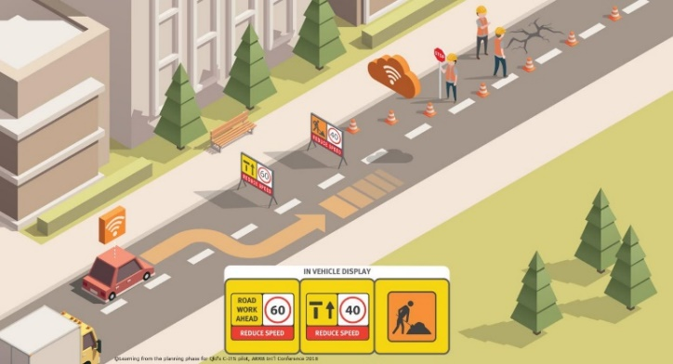Cooperative Intelligent Transport Systems – C-ITS – is an emerging suite of technologies for road users and operators to share real time safety and other traffic information, to make transport systems operate more cooperatively. Austroads has estimated that C-ITS can prevent between 25 to 35 percent of serious crashes[3]. C-ITS allows vehicles to communicate wirelessly with other vehicles, roadside infrastructure, road network management systems, cloud-based information, and personal mobile devices. Application of C-ITS is often referred to as ‘connected vehicles’, or Vehicle to Anything (V2X).

Not only is C-ITS able to alert drivers of road conditions or imminent safety issues, it is able to provide information about the movements of vehicles to road network operators. This would allow road operators to use this information to manage networks more effectively, such as changing traffic light timings. It would also allow road agencies to use the data for other purposes, such as to recognise segments of road that may be unsafe and in need of redesign or maintenance.

*Image: Transport and Main Roads Queensland*

Government involvement in C-ITS would provide authoritative data, and data that is not available from commercial sources, such as planned temporary traffic changes. It would also ensure that C-ITS use cases can continue to grow as technologies advance, and that we do not end up with siloed systems or systems that are not appropriately interoperable. This may deliver a system that is little better than the current cloud-connected road user-type services that simply mine available data, such as Android Auto, Apple CarPlay and Google live traffic information.

C-ITS use cases (i.e. the ways in which C-ITS can be applied or ‘used’) are classified into ‘days’, reflecting increasing complexity and sophistication into the future. Day 1 services focus on exchanging information to enhance foresighted driving. Early driver advisory use cases include messages alerting a driver that an “Emergency Vehicle is Approaching” or a “Traffic Jam Ahead Warning”. Day 2 services improve on this and include services where vehicles are sharing information they have gathered from around them – use cases would include things like protection/collision avoidance for vulnerable road users (like pedestrians) or other use cases involving cooperative awareness. Other examples of cooperative awareness are use cases where a vehicle notifies a second vehicle of a hazard that is out of the sight of the second vehicle. Day 3 adds further sophisticated services, and use cases would start to support vehicles cooperating with each other (for example, the ability for vehicles to drive closer together leading to more efficient use of roads) and may support higher levels of automated driving without human driver intervention.

C-ITS is an important element of the National Policy Framework for Land Transport Technology and its Action Plan where safety, efficiency and sustainability are of particular focus. C-ITS could address some of the key priorities by improving safety for road users, heavy vehicles, regional road users and vulnerable road users.

## **C-ITS Communications**

C-ITS is a technology ecosystem with many components working together to achieve optimum road safety and efficiency support. One of the threshold technical issues is the selection of technology for short range communications to vehicles. These communications systems are used where urgent messages are needed, such as in use cases seeking to avoid imminent collisions. There are two competing options for short range communications - Dedicated Short Range Communications (DSRC) or Cellular Vehicle to everything (C-V2X). This issue has caused delay to the deployment of C-ITS around the world.

Figure 1 is the hybrid model visualised using cartoon outlines for each of the stations connected by lines with arrows at both ends.C-ITS also usually includes a long-range communications system that would use the ordinary cellular network to connect vehicles to what are known as Central Stations, which receive, organise and distribute data in order to optimise road network operation. This includes data services supplied or managed by road agencies. This information would be advisory-type information that is less time-critical, such as traffic delays or options for car parking.

The pathways for short and long-range modes are set out in Figure 1.

DSRC uses existing WiFi based technology and at this time is more mature and therefore has been more widely used than C-V2X (except in the USA and China[4]). C-V2X communications uses cellular technology – 4G and later 5G – and is a technology comparatively still under development. Short-range communications are used between vehicles, roadside stations, and vulnerable road users for time-critical safety applications, such as to avoid collisions.

*Figure 1: The hybrid model of short and long-range communications*

Vehicles equipped with one of DSRC or C-V2X may be unable to inter-connect and share information with the other system. Further, if there are Australian jurisdictional differences in C-ITS standards, this could result in systems being unusable across borders.

This would mean, for example, a heavy vehicle operator who regularly crosses borders would not be able to receive key safety messages seamlessly across Australia. In 2017 the Australian Communications and Media Authority (ACMA) made available spectrum for ITS use in Australia through a class licence. Its specifications reference the ETSI standard [EN 302 571](https://www.etsi.org/deliver/etsi_en/302500_302599/302571/02.01.01_60/en_302571v020101p.pdf) which is based on the European DSRC system, known as ITS-G5.

There is a possible solution where vehicles or infrastructure could support both technologies and are able to switch between communications modes. This model may require additional measures to manage spectrum scarcity, signal interference and potential miscommunication where signals are unable to be appropriately prioritised. These types of equipment are already starting to become available.

## **Current State of C-ITS**

As shown internationally through many pilot programs and prototypes, C-ITS technology is viable for deployment. In Australia there have been C-ITS trials in Queensland, NSW and Victoria. The largest of these, the Ipswich Connected Vehicle Pilot in Queensland, investigated whether C-ITS is developed to a standard which warranted deployment in Australia. The program involved regular drivers in real world conditions to test a system of connected vehicles and infrastructure via Day 1 use cases. The outcomes were positive, including that the majority of trial participants reported a positive user experience and were willing to support a policy to require all vehicles to be fitted with C-ITS technology.

C-ITS trials and deployments have taken place internationally including in Europe, South Korea, the United States, China and Japan. Japan has had a simple system in place since 1996 with a major upgrade in 2014. The success of C-ITS pilot programs have led Europe to make decisions to move forward with C-ITS, with coordinated work being led by groups representing government road agencies, and automotive manufacturers and others[5]. Europe has adopted a continentally consistent approach that ensures that vehicles fitted with C-ITS technology would be able to travel between countries and still gain full access to C‑ITS data. Countries within Europe are variously in the process of actively deploying C-ITS technology for public use.

# Policy Impact Analysis

## **The** **Issue**

Australia has ongoing road network challenges – including safety, sustainability and efficiency – that C-ITS and other emerging technologies can help address. The National Road Safety Strategy 2021-2030 aims to reduce road deaths per annum by at least 50% by 2030 and 100% by 2050. Australia is not currently on track to meet these targets. Further, between 2013 and 2018, there has been an increase in congestion and an average speed decrease in all capital cities across Australia. C‑ITS could help alleviate these problems and put Australia on track to meet road safety goals.

C-ITS must be implemented with care so that agreed objectives are met and a system is deployed than can support a nationally seamless experience for road users. To maximise the benefits of C-ITS: all vehicles need to be able to communicate irrespective of make/model; information should be able to be transmitted to all C-ITS enabled vehicles and infrastructure regardless of where the data originates; and all road network agencies should be able to collect data for C‑ITS optimisation without impediments, such as state or territory borders. Achieving this will require cooperation between governments and industry in Australia.

## **Project Benefit to Cost Analysis**

The report by WSP modelled five scenarios to determine the Benefit to Cost Ratio (BCR) of C-ITS within a ten-year period. This was a rapid cost-benefit analysis (CBA) with only two benefits modelled: safety benefits of C-ITS from crash avoidance and travel time savings. The options started with a scenario involving minimal action by governments, and then built up from there in terms of the commitment (including investment) by government, the geographic range of C‑ITS coverage, and the types of use cases available in the expanding geographical range.

The first option involves minimal government involvement, with car manufacturers (known as original equipment manufacturers or OEMs) responsible for systems to support vehicle-to-vehicle services only. This option had a BCR of 0.57, indicating that the benefits of this option may not outweigh the costs.

The second option included vehicle-to-vehicle services and then added vehicle to infrastructure services on freight corridors connecting ports and intermodal hubs. This option committed governments to some base level services, such as a central data service, but limited roadside infrastructure investment to this relatively small geographical area. The BCR of 2.91 was the highest of those modelled as the limited infrastructure spend was well offset by the benefits in these key economic parts of the road network.

The third option built on option 2 and widened government investment to include roadside equipment across capital cities.

Like all the preceding options, the fourth option included the direct vehicle-to-vehicle use case from option 1, but it did not include vehicle-to-infrastructure use cases i.e. it did not include roadside equipment. It did include use cases that could be delivered by 4G cellular services across the cellular coverage area of Australia.

The fifth option involved a balanced hybrid of short-range vehicle-to-vehicle and roadside deployment, and long range cellular deployment across Australia.

The modelled scenarios show that after setting aside the first scenario with limited government involvement[6], the second, geographically limited scenario optimises the BCR results. All further BCRs are also above 1 (see Figure 2, below). Further, the quantum of economic return climbs as the level of government investment rises through the scenarios, with the quantum of benefits rising from just over $1B in scenario 2 to $11.8B in scenario 5 over 10 years. The economic return followed a similar climb, with option 5 having the greatest economic return at an estimated $3.757 billion over the modelled ten-year period.

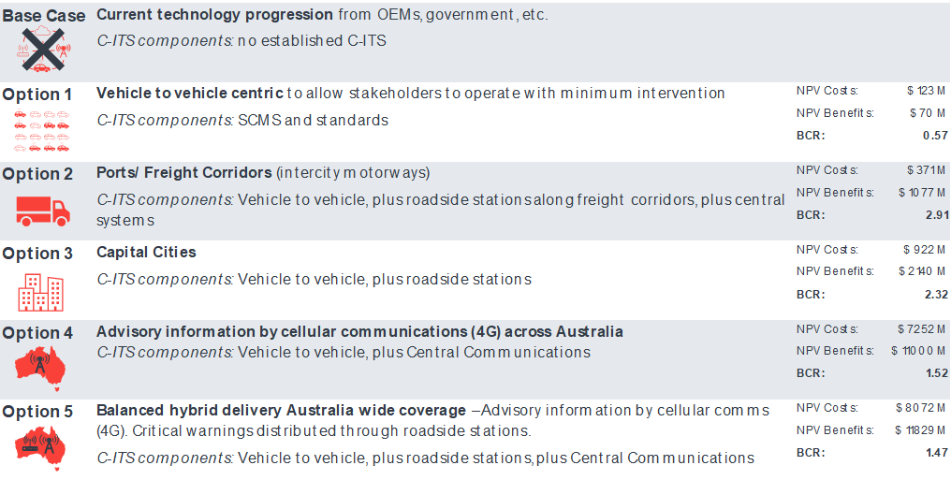

*Figure 2: Cost-benefit analysis options and results*

Beyond the figures generated, the modelled scenarios also provide evidence that C-ITS services do not need to be installed everywhere from the start. Option 2, which was limited to supporting services between ports and freight hubs in city areas, suggests that there are relatively low cost, no-regrets opportunities to create a minimum viable C-ITS market in Australia. To achieve this, governments would need to provide a base layer of support for C-ITS, like central services to distribute road data for a viable C-ITS. This then gives governments the capacity to prioritise the geographic spread of infrastructure, and to decide what suite of use cases should be supported in what areas, depending on policy priorities.

## **Policy Approaches**

Three Policy Approaches on how governments could support the rollout of C-ITS were considered:

1. **Leaving development of C-ITS to market forces.** A market led approach would involve minimal government intervention. Industries would coordinate their own approaches to C-ITS implementation and would likely use different technologies. Public C-ITS infrastructure would be delivered reactively with minimal future planning. Under this model vehicle to infrastructure communications benefits may not be seen in the near term.
2. **Government leadership and direction.** This approach would involve Australian governments working together to set policy direction for progressive, nationally-coordinated C-ITS implementation. Governments would establish a clear framework on how C-ITS would be deployed, such as specifying approaches for harmonisation and coordinated short-range communications technologies. This would provide stakeholders (including industry) with a clear path to follow and accelerate the delivery of wide-scale hybrid system of C-ITS technology. Under this model governments would undertake progressive infrastructure deployments including such elements as roadside stations, a security system, and central systems.
3. **Require by regulation.** This approach would align Australia with the EU plans to scale up C-ITS. It would mandate the fitment of C-ITS technology in all new vehicles from 2028 and would require OEMs to share vehicle data with road agencies to support services like road network management. This approach can be viewed as an extension of the second option, but more directive. It would ensure the most rapid deployment of nationally coordinated C-ITS in Australia. There are also options to regulate other matters, such as the communication channels used or data formats.

The consideration of these options found that the market led option has the highest risk of not being able to establish sufficiently to gain widespread C-ITS adoption. The report referred to this as the ‘chicken-and-egg dilemma’ where each party (government, industry, etc) will not move forward until the other also moves. This is likely to translate into reduced impact on national strategies, fewer socioeconomic benefits and less efficient benefits realisation.

The regulatory option would allow governments to move forward with strong national consistency. However, the process of developing nationally consistent law will take some time, which may delay early deployment and impact benefits realisation. Further, it may be better to consider what can be achieved without regulation in the first instance, given regulation would place a compliance burden on industry.

The analysis suggests that government leadership and direction to encourage deployment is the best option. This initially creates a proactive ecosystem that encourages vehicle manufacturers and other suppliers to deliver services and embrace innovation. It provides higher confidence to industry, is accessible to the community, is expected to deliver estimated socioeconomic benefits, and efficiently realises benefits. It also positions government to be able to make decisions to leave aspects to the market or reconsider regulation if required.

# Principles for a National Approach

The policy analysis found a nationally consistent approach is needed to ensure that industry is able to deploy C-ITS technology with certainty, and that defining common principles can help ensure an adequate foundation for C-ITS implementation is in place. Importantly, governments’ approach to C-ITS should complement other national transport strategies.

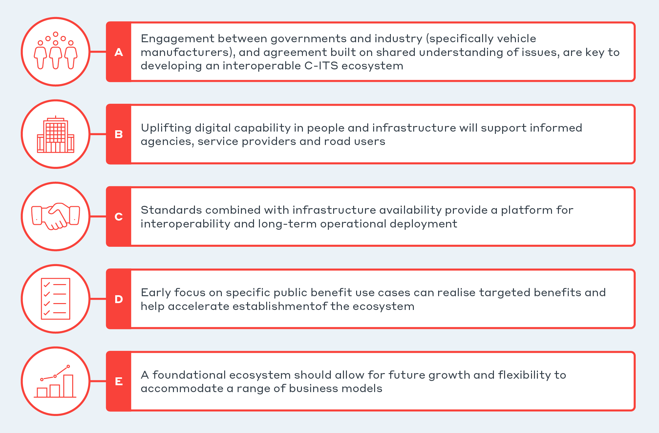From the findings, five principles were identified – summarised in Figure 3 below – as effective strategies to support national consistency. Further details on the rationale and justification for each principle are set out in the ‘Conclusion’ section below.

*Figure 3: Principles for a national approach*

# Key Findings

The key findings of the WSP report are grouped around three themes:

1. Government leadership and intervention is necessary for C-ITS to succeed in Australia;
2. To reduce the costs to OEMs in implementing C-ITS in the small Australian market, Australia should align itself to an international standards suite; and
3. To encourage uptake of C-ITS, Australia should decide which short-range communications technology approach it will favour.

The full table of WSP’s findings is at Appendix A.

In terms of the first group of findings, the report notes that, to achieve the maximum level of public interest benefits possible, government investment in infrastructure would likely total between 1‑7 percent of C-ITS costs. The remaining 93‑99 percent of costs would therefore be the responsibility of industry. Nationally coordinated leadership by government, and a moderate investment in data preparedness, infrastructure, and other matters, has the potential to make a strong return to the Australian community in terms of safety, road productivity and sustainability, and increasing the convenience of transport users (‘traveller comfort’).

The issue of alignment with international standards (the second group of findings) has two purposes – to reduce costs of implementing C-ITS in a relatively small market, and to ensure that C-ITS services are interoperable across Australia. Lack of interoperability will reduce productivity gains to heavy vehicle operators, in particular, if systems cannot operate across borders.

Most trials in Australia have been based on the EU’s C-ITS standards suite. An alternative standards suite is the suite that is being used in some parts of the United States.

Australian vehicle safety regulations are harmonised with those developed through the UNECE’s Global Forum for the Harmonisation of Vehicle Regulations (Working Party 29). A number of countries are contracting parties to these Regulations, including most European nations, the European Union, and Australia. The United States of America is not a contracting party to these Regulations.

The WSP report suggests that the link between the safety standards for vehicles entering the Australian market and the standards used by C-ITS systems is sufficient to recommend that Australia firm its commitment to EU C-ITS standards.

It is the Department’s view that links between safety Regulations and C-ITS standards will grow as C-ITS later day use cases require the vehicle (rather than the human driver) to receive and action safety messages received through C-ITS. This further suggests formalising alignment with EU C-ITS systems will ensure that implementation of C-ITS can move forward.

The third group of findings is related to the issue of selection of short-range communications technologies. The WSP report found that the DSRC/ITSG5 option is more technically mature at this time, but there appears to be a movement towards the C-V2X solutions. In 2019 the Council of the EU made the decision to take a technologically neutral approach (despite its overt support for ITSG5 before that) meaning that member states can select either option. In the US, a November 2020 decision by the Federal Communications Commission to reallocate around half of its ITS spectrum band to other uses and require the remaining 30 MHz be used for C-V2X effectively ruled out any prospect of further DSRC adoption.

The WSP report suggested that as most work undertaken in Australia had been in the ITS G5 environment, Australia should continue with that approach, and if or when the EU chooses a single communications method, move to align at that time.

A robust national framework aimed at ensuring maximum benefits from deploying C-ITS technology in Australia will help provide private industry and the public with clear direction on how C-ITS will be deployed and operated. WSP suggested the framework should include:

|  |
| --- |
| * A detailed roadmap of objectives, timelines and targets. * Consultation with experts and stakeholders such as the Federal Chamber of Automotive Industries (FCAI). * Agreement with manufacturers and between governments to ensure C-ITS interoperability. * Alignment with international standards such as those of Europe and Working Party 29. |

# Conclusion[7]

WSP found that standardisation is essential to achieve the level of interoperability required to realise the full benefits of C‑ITS in Australia. To this end, Australia should align itself to an international standards suite (WSP found the European suite to be preferred, due to the existing alignment for vehicle standards through WP.29) and consider which short range communications technology approach it will favour; and that government leadership and intervention is needed for C-ITS to succeed in Australia.

**Departmental analysis**

*International state of play*

China and the US have made decisions to adopt C-V2X for short range communications. China has made a unanimous decision to adopt only cellular technology for supporting V2X communication[8]. In the US, as a result of the 2020 FCC decision, the US is transitioning away from DSRC. The situation in the EU with respect to short-range technologies is uncertain. Since the 2019 decision of EU Ministers not to adopt ITS G5 and instead favour a more technology neutral approach, the EU has not adopted a clear position in its regulations (the [ITS Directive](https://www.europeansources.info/record/directive-2010-40-eu-on-the-framework-for-the-deployment-of-intelligent-transport-systems-in-the-field-of-road-transport-and-for-interfaces-with-other-modes-of-transport/)) or its spectrum arrangements. This means that in practice ITS G5 is the only short range technology currently able to be deployed in the EU outside of trials. However, this situation could change.

There is work underway to by the European Commission (EC) to [amend the ITS Directive](https://www.europeansources.info/record/proposal-for-a-directive-amending-directive-2010-40-eu-on-the-framework-for-the-deployment-of-intelligent-transport-systems-in-the-field-of-road-transport-and-for-interfaces-with-other-modes-of-transp/) (the outcome is yet to be determined) and also to develop [spectrum sharing](https://www.etsi.org/deliver/etsi_tr/103600_103699/103667/01.01.01_60/tr_103667v010101p.pdf) and/or [coexistence](https://www.etsi.org/deliver/etsi_tr/103700_103799/103766/01.01.01_60/tr_103766v010101p.pdf) arrangements to enable both C‑V2X and ITS G5 to operate in the 5.9 GHz spectrum in the EU (the spectrum work was to be complete by mid-2022 but is ongoing[9]). The [EU decisions](https://docdb.cept.org/document/related/412) on harmonised ITS spectrum use in the 5.9 GHz band[10] are also expected to be reviewed commencing later in 2022. Coexistence would not mean interoperability and a strategy would be needed to enable both these short range technologies to operate – it is not yet clear what this will be. As an example, one possible approach may be to continue the incumbent ITS G5 use cases for Day 1 applications, and then future use cases (such as those for higher levels of automation in vehicles) to be addressed by any of C-V2X, ITS G5 or a new technology, if it does not interfere with the existing Day 1 services (i.e. they would co-exist).

Some OEMs in the EU publicly support particular technologies. The main supporters of DSRC/ITS G5 globally have been Toyota (Japan), General Motors (GM) (US) and Volkswagen (VW) (EU) – GM’s position is likely to have changed following the US spectrum decision but VW continues to advocate for ITS G5 and it has deployed the technology in Golf MK8’s in the EU market since 2019. Others in the EU appear to favour C‑V2X[11] (e.g. BMW Group, Ford, Jaguar Land Rover, Groupe PSA, Audi and Mercedes-Benz Group (formerly Daimler AG)). In the recent (2020 and 2022) EC consultations on amending the ITS Directive, only [Volkswagen](https://ec.europa.eu/info/law/better-regulation/have-your-say/initiatives/12534-Intelligent-transport-systems-review-of-EU-rules-/F1265439_en) supported ITS G5. [BMW Group](https://ec.europa.eu/info/law/better-regulation/have-your-say/initiatives/12534-Intelligent-transport-systems-review-of-EU-rules-/F2936181_en) supported C-V2X and others ([Volvo](https://ec.europa.eu/info/law/better-regulation/have-your-say/initiatives/12534-Intelligent-transport-systems-review-of-EU-rules-/F1265245_en), the [European Automobile Manufacturers Association](https://ec.europa.eu/info/law/better-regulation/have-your-say/initiatives/12534-Intelligent-transport-systems-review-of-EU-rules-/F1267379_en) (ACEA, the EU equivalent of Australia’s FCAI) and the [5G Automotive Association](https://ec.europa.eu/info/law/better-regulation/have-your-say/initiatives/12534-Intelligent-transport-systems-review-of-EU-rules-/F2932956_en) (5GAA)) supported technology neutrality. Also, some OEMs have chosen to provide non safety-critical C-ITS information via cellular vehicle-to-network (V2N) services in the EU (e.g. Volvo and Mercedes).

Analysts[12] suggest that industry alignment globally is shifting towards C-V2X. Frost & Sullivan[13] indicates that OEMs in the US, China and EU are predominantly planning for LTE-V2X or 5G (i.e. NR-V2X). SBD[14] states that C‑V2X technology is currently leading much of the activity in terms of both trials and deployments by OEMs. In relation to the EU, SBD states that the longer the EU takes to clarify its position the more likely it is that OEMs will adopt C-V2X solutions; it anticipates that a mix of solutions is will co-exist in the short term but C-V2X will eventually dominate.

*Potential approaches*

If Australia follows the EU, then this would mean adopting ITS G5 for short range communications until the uncertainty resolves and then following the path the EU takes (including taking into account relevant transitional arrangements). There is a risk of stranded assets if deploying roadside infrastructure using ITS G5 in the current climate. Possible ways to manage this include keeping deployments small-scale to avoid significant equipment replacement costs[15]; moving forward with deployment in the knowledge that IT equipment is not generally a long-lived asset and managing any changes through asset replacement cycles; and/or using dual mode roadside units (i.e. units that enable road managers to switch between ITS G5 and C-V2X should circumstances change).

The alternative would be to look to another market (e.g. the US) for an approach on C-ITS standards and short range communications. There would be risks associated with this approach too. For example, with regard to the US, potential risks may include incompatibility with Australian vehicle regulations, the amount of spectrum for ITS (the US has allocated only 30 MHz but this is being challenged) and the requirement to replace any DSRC devices already deployed.

There are also other things Australia could do to prepare for C-ITS deployment without widely deploying roadside infrastructure to support short range communications. For example, agreeing national principles for C‑ITS deployment; developing management processes for a C-ITS; identifying data sources, and developing data standards and sharing arrangements; developing a central system to distribute road data; and developing a national security credential management system. The UK seems to be taking a similar approach in the absence of a clear EU position i.e. focussing on data requirements, cyber security and driver distraction.[16] Focusing efforts in areas like these would allow Australia to be ready to deploy short range C-ITS once the market resolves.

Australia could take this further, if governments were to agree, to provide consistent C-ITS messages to end users via third party providers or road manager traffic apps as a starting point – building on developments in heavy vehicle telematics systems, cellular-connected vehicles and driver’s personal devices via apps like Apple Car Play and Android Auto.

**Department position**

The Department considers that government leadership is necessary and that Australia should align with a larger market rather than taking a bespoke approach to C-ITS. Considering the above, it may well be that following the EU is the most viable option for Australia. However, we are not ready to take a definitive view until we have further evidence to support this. We agree that Australia should continue aligning itself to the EU standard suite for the time being, given our current regulations for vehicles align with those of the United Nations Economic Commission for Europe (UNECE) Working Party 29.

To assist in considering a way forward, the Department is commissioning work through the iMOVE Cooperative Research Centre, to undertake an objective and comprehensive assessment of possible standards options, including the EU and US suites, and consider issues associated with short-range communications.

While this work occurs, the Department intends to commence consultations with jurisdictions and other key players, including the National Transport Commission and Austroads, on national principles to support the deployment of C-ITS and on other measures that can be taken to prepare for C-ITS in light of the ongoing uncertainty in the EU on short range communications.

# Appendix A

# Key Findings

**The key findings of the WSP report:**

|  |  |
| --- | --- |
| **Number** | **Finding** |
|  | **Government Leadership and Intervention** |
| 1 | C-ITS is proven to be economically viable to implement, and benefits key features of the National Land Transport Technology Action – safety, efficiency, sustainability, and accessibility. |
| 2 | Only deployment models that were supported by public infrastructure were economically viable, highlighting the need for government involvement. |
| 3 | Government leadership should support a hybrid national model of C-ITS to encourage accessibility in both urban and rural settings. |
| 4 | Government investment in infrastructure will total between 1-7 percent of C-ITS costs in order to achieve the maximum level of public interest benefits possible. The remaining 93-99 percent of costs will be the responsibility of private industry. |
| 5 | Heavy vehicles were found to have the strongest benefit-cost ratio resulting from targeted deployment and low implementation costs. |
| 6 | Continued research is needed to surmount the economic and scalability challenges for use cases regarding vulnerable road users. |
|  | **Standardisation** |
| 7 | Standardisation is essential to achieve the level of interoperability required to realise the full benefits of C-ITS. |
| 8 | A consistent suite of standards (based on an international standards region) is needed to harmonise standards given that complexity increases with wide-scale deployment. |
| 9 | Europe has the most comprehensive set of standards through WP.29. It is now focusing on implementing standards across all manufacturers. |
| 10 | The ISO/CEN (C-ITS) guidelines provide the most comprehensive collation of a standards suite identified in the analysis. |
| 11 | Learnings from other markets outside of Europe are beneficial to C-ITS improvement. This should be considered when assessing the impacts of full harmonisation of Australian C-ITS standards to European standards. |
|  | **Short-Range Communications** |
| 12 | Prioritising support for a single short-range communications standard will encourage uptake and achieve maximum benefits given by interoperability. |
| 13 | Dedicated Short-Range Communications (DSRC) is the most mature and readily available technology. It has been used in all Australian pilot programs, and has been prioritised for European uptake of safety-related use cases. |
| 14 | The research and progress of C-V2X technology should be monitored for its potential to improve road safety and efficiency targets where the benefits of providing a shared and nationally interoperable grid are not degraded. |
| 15 | Full scale deployment delays have not been due to short-range communications technology but have rather been due to solving operational challenges (such as user acceptance and business models). |

1. A BCR equal to or greater than 1 indicates that the project has economic merit (i.e. the present value of benefits exceeds the present value of costs) and is used to rank projects in a budget constrained environment. The rapid analysis for this work was over a term of 10 years.
2. Note that in relation to the standard for short range communications, discussed further below, the EU has decided in 2019 to take a technology neutral position for the time being.
3. Austroads AP-R413-12 Cooperative ITS Strategic Plan
4. The US had been working with DSRC but a 2020 decision by the Federal Communications Commission changed the allowable use of radiofrequency spectrum in the 5.9 GHz (internationally harmonised for ITS use) spectrum band to C-V2X only. China is progressing with C‑ITS based on C-V2X.
5. These are known as [C-Roads](https://www.c-roads.eu/platform.html) and the [Car 2 Car Communication Consortium](https://www.car-2-car.org/) (C2C-CC).
6. For the purposes of this discussion, Scenario 1 is set aside because of the BCR of less than one and the doubt as to whether the automotive industry would invest in C-ITS in Australia without some commitment by road agencies, see “chicken and egg” discussion.
7. ***Note:* This section contains material from the following analyst reports which are licensed and must not be shared beyond your agencies:** Frost & Sullivan, *Strategic Analysis of the Global Vehicle-to-Everything Market, Forecast to 2025*, August 2020; and SBD, *V2X Deployment Worldwide*, June 2021
8. SBD, *V2X Deployment Worldwide*, June 2021, p. 11
9. European [Commission Implementing Decision (EU) 2020/1426](https://docdb.cept.org/document/18491) and [Minutes of the 25th ECC-ETSI meeting, 18 Feb 2022](https://www.cept.org/ecc/groups/ecc/ecc-sg/ecc-etsi/client/meeting-documents/file-history/?fid=69250)
10. European [Commission Implementing Decision (EU) 2020/1426](https://docdb.cept.org/document/18491) and CEPT [Electronic Communications Committee (ECC) Decision (08) 01](https://docdb.cept.org/download/1583) (Approved March 2008 and last amended 6 March 2020)
11. This is based on post-2018 trials and/or stated intentions.
12. As noted above, **material from the following reports is licensed and must not be shared beyond your agencies:** Frost & Sullivan, *Strategic Analysis of the Global Vehicle-to-Everything Market, Forecast to 2025*, August 2020; and SBD, *V2X Deployment Worldwide*, June 2021
13. Frost & Sullivan, *Strategic Analysis of the Global Vehicle-to-Everything Market, Forecast to 2025*, August 2020, p. 9
14. SBD, *V2X Deployment Worldwide*, June 2021, p. 11 and 84
15. [US DOT](https://www.ntia.doc.gov/files/ntia/publications/5.850-5.925_ghz_band_et_dkt_no._19-138.pdf) (see p.38) estimates, in the US context, $7.2 million (USD) for an average sized installation (more than 200 units but less than 1000), $4 million for less than 50 units and $360,000 for installations of 20 or fewer devices.
16. UK Department for Transport, presentation to [IWG on ITS 4th meeting](https://wiki.unece.org/display/trans/4th+session+of+the+IWG+on+ITS), Friday 17 June 2022, *Connected Vehicle Corridors*, p. 12