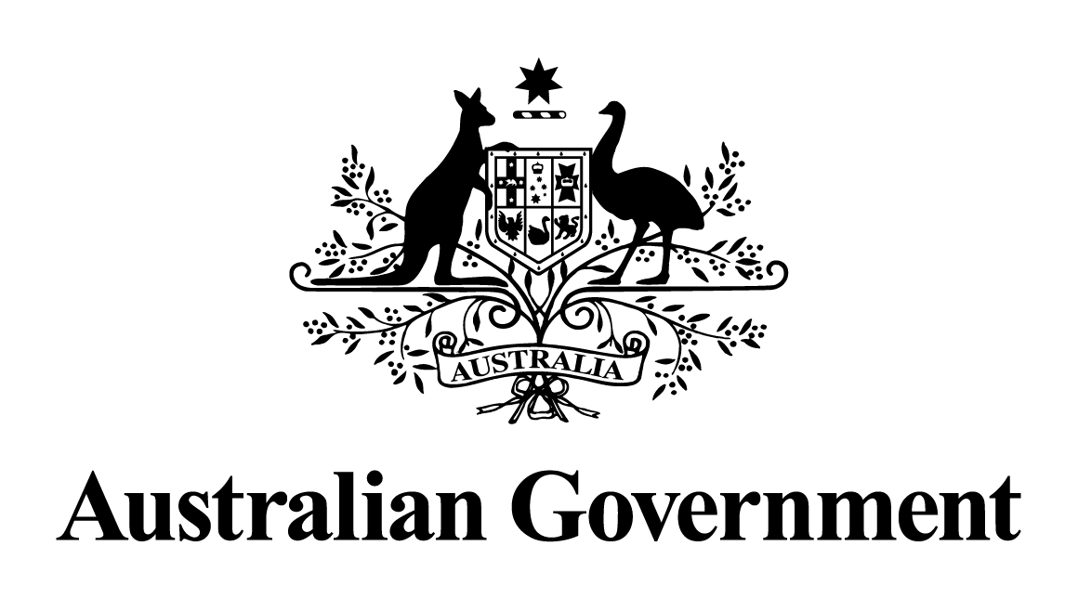

Australian Government response to the Parliamentary Joint Committee on Law Enforcement report:
Criminal Code Amendment (Sharing of Abhorrent Violent Material) Act 2019
May 2026

Contents
Australian Government response 3
Recommendation 1: 3

Australian Government response
The Australian Government’s response to the Criminal Code Amendment (Sharing of Abhorrent Violent Material) Act 2019 is set out below.

Recommendation 1:
2.149 The committee recommends that the Australian Government establish a stakeholder forum, consisting of relevant representatives, for regular engagement with industry to identify ways in which industry can be more effective in enacting the provisions of the AVM legislation.
The Government notes this recommendation.
Given the passage of time since this report was tabled, a substantive Government response is no longer appropriate.

