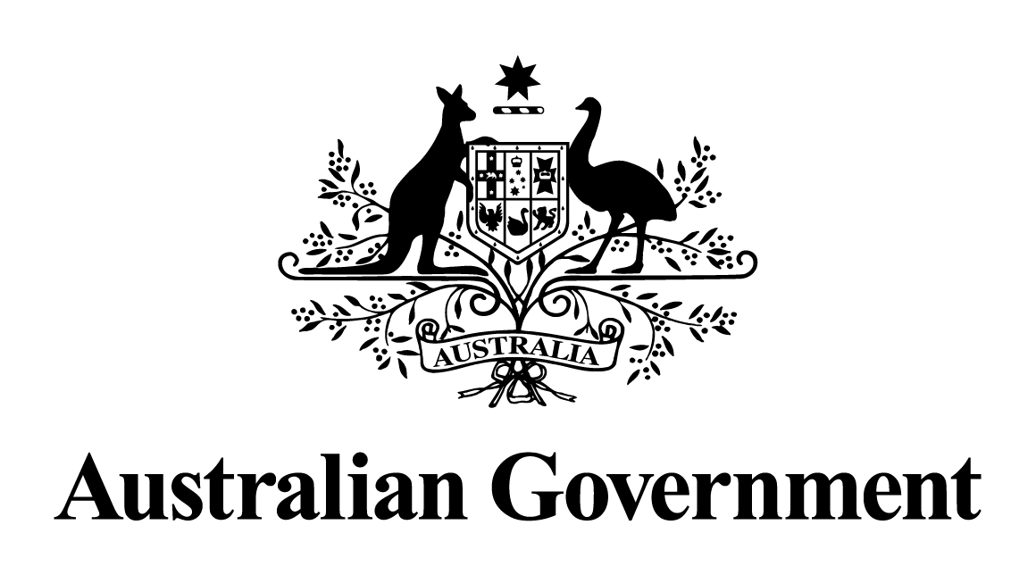

Australian Government response to the Environment and Communications References Committee report:
Middle Arm Industrial Precinct
March 2026

The Australian Government notes the report by the Environment and Communications References Committee (the Committee) into the Middle Arm Industrial Precinct, tabled in the Senate on 21 August 2024.
The Committee was not able to reach agreement on a unanimous set of recommendations, and presented a total of 31 individual recommendations from Committee members. With the exception of recommendations related to matters that are the responsibility of the Northern Territory (NT) Government, the Australian Government’s response to recommendations raised by Senators is contained below.
The Committee’s report reflects that planning for the project by the NT Government remains at an early stage. A range of the matters raised by the Committee will be considered through ongoing regulatory and assurance processes by respective governments.
The Australian Government remains committed to its $1.5 billion planned equity investment to support the development of common user infrastructure at the Middle Arm Sustainable Development Precinct (Middle Arm) in the NT. A final investment decision by the Australian Government will be made in due course, in accordance with the requirements of the Commonwealth Investment Framework, and informed by Infrastructure Australia’s evaluation of the business case.
The project is subject to the outcomes of Strategic Environmental Assessments being undertaken under the Environmental Protection Act 2019 (NT) (EP Act) and the Environment Protection and Biodiversity Conservation Act 1999 (Commonwealth) (EPBC Act).
Middle Arm is expected to deliver transformational impacts for Darwin, the NT and Australia.
The Australian Government’s investment will pave the way for Middle Arm to be a globally competitive, sustainable precinct, that takes advantage of new economic opportunities and delivers sustainable jobs for the future. Our funding will underpin infrastructure that supports industries critical to meet our commitment to Net Zero –including hydrogen and the manufacture and export of lithium batteries, and the project will be enabled by a growing renewable energy industry.
The Middle Arm Precinct is an investment in economic infrastructure that will also generate income for the NT Government, to support its ability to be self-sustaining, and the Australian Government through taxation revenues.
The Australian Government will continue to work with the NT Government to deliver the best possible outcomes for communities, industries and the environment.

