

Flying Considerately Guidance
  - Aviation White Paper Initiative #34
May 2026

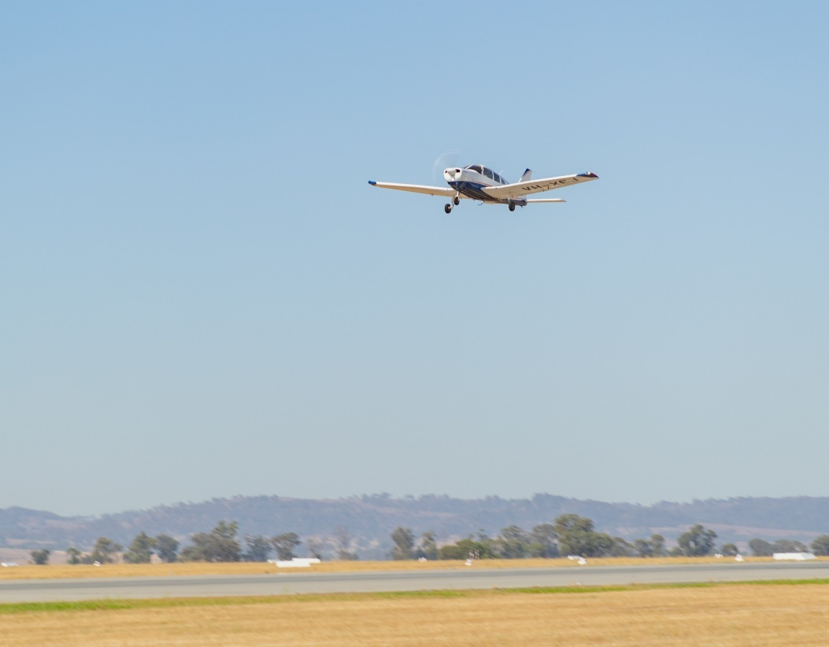

© Commonwealth of Australia 2026

Ownership of intellectual property rights in this publication
Unless otherwise noted, copyright (and any other intellectual property rights, if any) in this publication is owned by the Commonwealth of Australia (referred to below as the Commonwealth).

Disclaimer
The material contained in this publication is made available on the understanding that the Commonwealth is not providing professional advice, and that users exercise their own skill and care with respect to its use, and seek independent advice if necessary.
The Commonwealth makes no representations or warranties as to the contents or accuracy of the information contained in this publication. To the extent permitted by law, the Commonwealth disclaims liability to any person or organisation in respect of anything done, or omitted to be done, in reliance upon information contained in this publication.

Creative Commons licence

With the exception of (a) the Coat of Arms; (b) the Department of Infrastructure, Transport, Regional Development, Communications, Sport and the Arts photos and graphics; (c) content supplied by third parties; (d) content otherwise labelled; copyright in this publication is licensed under a Creative Commons BY Attribution 4.0 International Licence.

Use of the Coat of Arms
The Department of the Prime Minister and Cabinet (PM&C) sets the terms under which the Coat of Arms is used. Please refer to the Commonwealth Coat of Arms Information and Guidelines | PM&C.

Contact us
This publication is available in Word and PDF format All other rights are reserved, including in relation to any departmental logos or trademarks which may exist. For enquiries regarding the licence and any use of this publication, please contact:
Email: dap@infrastructure.gov.au
Website: www.infrastructure.gov.au/have-your-say/

Image credit
Cover image: Department of Infrastructure, Transport, Regional Development, Communications, Sport and the Arts.

1.1 Background
The Flying Considerately guidance provides a single, national reference for voluntary good practices that pilots and operators can adopt to minimise the impact of GA activity on local communities. It is designed to complement existing safety regulations while promoting consistent, practical approaches to considerate flying across Class G airspace in Australia.
Class G refers to airspace without an Air Traffic Control service. Pilots in uncontrolled airspace are not separated by ATC and have increased responsibility for being aware of surrounding aircraft and obstacles. A diagram of different airspace classes is provided at Figure 1.
Figure 1: Airspace classes – horizontal cross-section (Airservices Australia)
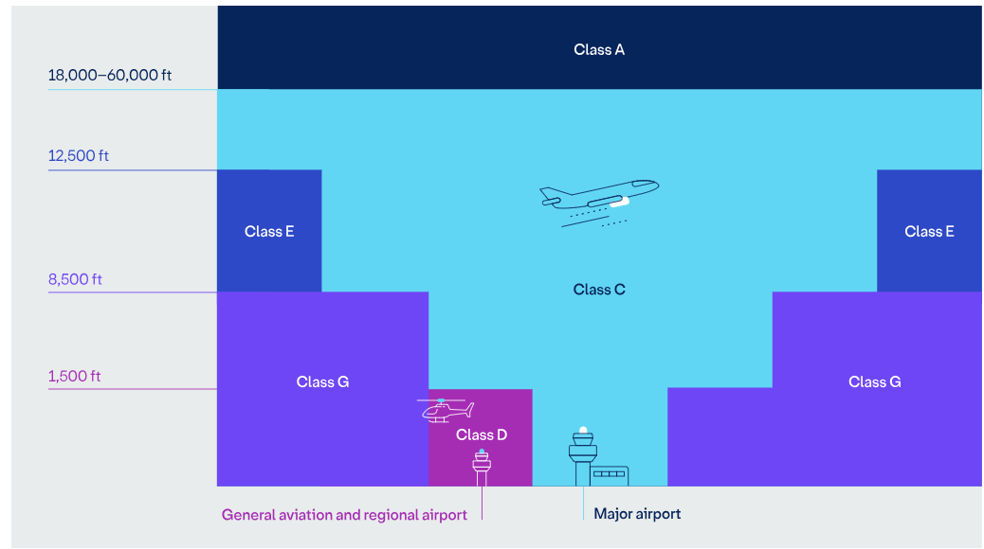
The guidance is designed to set clear, nationally consistent expectations that encourage considerate flying behaviours, while leaving pilots with the discretion to prioritise safety and adapt to local conditions. Its voluntary nature encourages innovation and collaboration, building on successful local initiatives without adding new regulatory burdens.

1.2 Guiding principles
Before using the guidance, pilots and operators should keep three key principles in mind. These principles ensure that flying considerately supports, not conflicts with, the broader goals of safety, regulatory compliance, and practical day-to-day flying.
- Safety First: Safety remains the paramount consideration. This ensures pilots will never take action that puts lives at risk, even when balancing noise concerns.
- Community awareness: General aviation operators are encouraged to be good neighbours by considering the impact of their operations on local communities.
- Practical Application: Recommendations from the guidance are designed to be applied where they are operationally feasible and consistent with regulations.
These principles give communities confidence that aviation activity in their area is shaped by an approach that balances safety, neighbourliness, and practicality. This approach can help reduce noise exposure, share noise impacts more fairly, and avoid particularly sensitive locations.

2. Flying Considerately Guidance for pilots operating in Class G airspace

2.1.1 Respect communities
- Noise awareness: Minimise repeated circuits over built-up areas. Where safe and practical, prioritise routes over waterways, major transport corridors and industrial areas in preference to residential overflight. Follow published noise abatement procedures and climb promptly after take-off to reduce the time spent at low altitudes.
- Be aware of operating hours: Observe published airport operating hours and avoid unnecessary early-morning or late-night operations, especially in noise-sensitive areas.
- Flight paths: Where guidance exists, stay on recommended tracks and avoid low overflights of sensitive sites like hospitals, schools, cultural landmarks, defence sites, or areas with livestock where safe and practical.
- Fly Neighbourly Agreements: Review local FNAs before flying and encourage fellow pilots, students and visiting crews to do the same. Using these agreements shows the community GA pilots are committed to responsible and considerate operations.
- Communication: Where possible, engage with local community groups and airfield neighbours to explain GA’s role and respond respectfully to concerns. Share the airspace.
- Separation and lookout: Maintain vigilant see-and-avoid practices. Broadcast your position and intentions on Common Traffic Advisory Frequency (CTAF) clearly and respond courteously to other pilots.
- Circuit discipline: Follow standard circuit patterns, avoid cutting in, and give way in accordance with the rules of the air.
- Respect controlled airspace: When transitioning through controlled airspace, follow ATC instructions precisely and plan ahead to avoid unnecessary frequency congestion or delays.

2.1.2 Support safety and professionalism
- Noise and safety are linked: Smooth, predictable flying typically creates less noise and fewer risks. Avoid aggressive manoeuvres or prolonged low-level operations near populated areas.
- Training with courtesy: Spread training activity across multiple practice areas where possible to avoid concentrating noise over a single area. Pilots and instructors are encouraged to rotate locations and vary routes to distribute impacts more evenly across the surrounding area. Instructors should explain FNAs and noise-sensitive areas during pre-flight briefings.
- Helicopter and aerial work operations: Helicopter and aerial work operators are encouraged to avoid extended hovering or repeated manoeuvres over residential areas, and to select transit routes over transport corridors, waterways, or industrial zones where feasible.
- Pre-flight preparation: Use flight planning tools to map altitudes and tracks that balance operational needs, airspace requirements, and community considerations.

2.1.3 Contextual awareness
- Wildlife sensitivity: Avoid low flying over marine parks, wetlands, nesting areas, and national parks where wildlife disturbance is likely.
- Be aware of local areas of cultural significance: Check FNAs or local sources for culturally significant sites and avoid overflying them at low altitudes.
- Efficient choices: Where possible, use quieter, more efficient aircraft or new technologies.

2.2 Supporting implementation of the guidance

2.2.1 Monitoring and continuous improvement
Aircraft and/or airport operators and pilots are encouraged to:
- Review flight tracks regularly using GPS logs, airport tools, or resources like Airservices’ WebTrak to identify opportunities for reduced noise or congestion. Where patterns of repeated overflight are identified, consider whether adjustments to routes or timing can aid in reducing cumulative exposure for affected communities
- Seek feedback from local communities and airport operators on noise concerns, and communicate what action, if any, can be taken in response
- Participate in airport or council-led noise monitoring programs where available
- Implement lessons learned from noise abatement initiatives and effective practices through pilot forums, aero clubs, or industry associations
- Support research into quieter operations, including flight path design, operational procedures, and technology adoption
- Collaborate with airports and communities on noise abatement initiatives.

2.2.2 Aviation regulations
This guidance complements existing safety and operational requirements. Pilots and aircraft and/or airport operators must continue to comply with:
- Civil Aviation Safety Regulations (CASR)
- Air Navigation (Aircraft Noise) Regulations
- Curfew Regulations
- ATC instructions
- Aeronautical Information Publications (AIP)
- Notices to Airmen (NOTAMs)
- Local airport operating procedures and requirements.

2.2.3 Resources and assistance
Aircraft and/or airport operators seeking to implement Flying Considerately practices can access:
- Airport noise abatement procedures on Airservices Australia or airport websites
- Curfew information (for Sydney, Adelaide, Gold Coast and Essendon Fields Airports) on the Department’s website
- Industry association guidance and training materials
- Community liaison programs and consultation opportunities at major GA airports, including Community Aviation Consultation Groups (CACGs)
- Technical advice on aircraft modifications that reduce noise impacts, accessible via aircraft manufacturers (OEM) websites, aviation maintenance providers, and relevant industry associations.

2.2.4 Training and education
Flight training organisations are encouraged to:
- Incorporate noise awareness and community engagement into initial and recurrent training
- Include noise abatement scenarios in flight simulator exercises where available
- Assess student knowledge of considerate flying practices during check flights
- Provide instructors with updated resources on noise-sensitive areas and FNAs
- Embed considerate flying principles into standard operating procedures and pre-flight briefing processes, so that community impact considerations are a routine part of flight planning and instructions.

Flying Considerately guidance is not intended for commercial air transport operations.
How airspace is managed - Airservices <https://www.airservicesaustralia.com/about-us/our-services/how-airtraffic-control-works/how-airspace-is-managed/>

