

Flying Considerately Consultation Paper
  - Aviation White Paper Initiative #34
February 2026
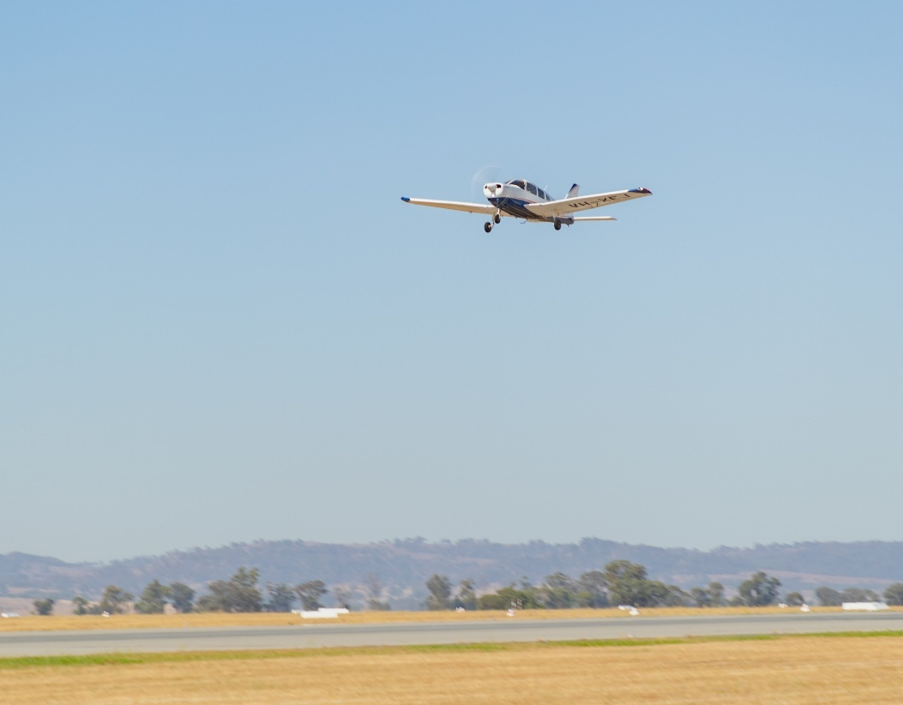

© Commonwealth of Australia 2026

Ownership of intellectual property rights in this publication
Unless otherwise noted, copyright (and any other intellectual property rights, if any) in this publication is owned by the Commonwealth of Australia (referred to below as the Commonwealth).

Disclaimer
The material contained in this publication is made available on the understanding that the Commonwealth is not providing professional advice, and that users exercise their own skill and care with respect to its use, and seek independent advice if necessary.
The Commonwealth makes no representations or warranties as to the contents or accuracy of the information contained in this publication. To the extent permitted by law, the Commonwealth disclaims liability to any person or organisation in respect of anything done, or omitted to be done, in reliance upon information contained in this publication.

Creative Commons licence

With the exception of (a) the Coat of Arms; (b) the Department of Infrastructure, Transport, Regional Development, Communications, Sport and the Arts photos and graphics; (c) content supplied by third parties; (d) content otherwise labelled; copyright in this publication is licensed under a Creative Commons BY Attribution 4.0 International Licence.

Use of the Coat of Arms
The Department of the Prime Minister and Cabinet (PM&C) sets the terms under which the Coat of Arms is used. Please refer to the Commonwealth Coat of Arms Information and Guidelines | PM&C.

Contact us
This publication is available in Word and PDF format All other rights are reserved, including in relation to any departmental logos or trademarks which may exist. For enquiries regarding the licence and any use of this publication, please contact:
Email: dap@infrastructure.gov.au
Website: www.infrastructure.gov.au/have-your-say/

Image credit
Cover image: Department of Infrastructure, Transport, Regional Development, Communications, Sport and the Arts.

Table of contents
Executive summary 4
Have your say 5
1. Development of Flying Considerately guidance 6
1.1 Background 6
1.2 Guiding principles 8
1.2.1 Safety first 8
1.2.2 Community awareness 8
1.2.3 Practical application 9
2. Flying Considerately: Guidelines for General Aviation 10
2.1 Guidance for pilots operating in Class G airspace 10
2.1.1 Respect communities 10
2.1.2 Support safety and professionalism 10
2.1.3 Contextual awareness 10
2.2 Supporting implementation of the guidance 11
2.2.1 Monitoring and continuous improvement 11
2.2.2 Aviation regulations 11
2.2.3 Resources and assistance 11
2.2.4 Training and education 11
3. Conclusion 12
A1—Fly Neighbourly Agreements 13
Voluntary participation 13
Agreed flight heights and preferred routes 13
Time of day consideration 13
Environmental and cultural sensitivity 13
Community engagement 14
Clear objectives 15
Optimal flight planning with defined flight paths and sensitive area avoidance 15
Noise and time management protocols 15
Community communication and feedback mechanisms 15
Monitoring and reporting: enabling shared accountability 16
Periodic review 16
A2—Consultation questions 17
A3—Glossary and acronyms 18

List of figures and tables
Figure 1: Airspace classes – horizontal cross-section (Airservices Australia) 6
Table 1: Key milestones for finalising and publishing the guidance 12

Executive summary
The introduction of Flying Considerately guidance is a key initiative under the Australian Government’s Aviation White Paper – Towards 2050 (AWP). The guidance will offer practical, voluntary measures for pilots and aircraft operators flying under Visual Flight Rules (VFR). VFR is a method of flying where conditions are suitable for a pilot to maintain visual reference to the ground or water to navigate their flight. The guidance will assist pilots to help reduce the noise impacts of GA on communities, while supporting the growth and long-term sustainability of the sector. The guidance will primarily apply to ‘Class G airspace’.
The guidance will be published through Airservices Australia’s En Route Supplement Australia (ERSA) as a companion to the Aeronautical Information Package (AIP). Aircraft operating in Class G airspace are typically permitted to operate anywhere within that airspace provided they meet the relevant regulatory requirements. However, the Government acknowledges many of the practices recommended in the guidance will also be relevant when GA aircraft operate under VFR in controlled airspace above 1, 500 feet, where communities continue to raise concerns about noise impacts. While the guidance does not override air traffic control instructions in controlled airspace, or the pilot’s responsibility to conduct safe operations in accordance with regulatory requirements, the underlying principles of considerate flying can still apply.
This guidance is being developed to promote nationally consistent actions that can improve the community experience of living and working alongside aviation businesses. The guidance will need to take account of existing noise minimisation schemes operating across Australia such as Fly Neighbourly Agreements (FNAs). The guidance also outlines practical steps for developing new FNAs that align with these recommendations and draws on international best practice.
The guidance will need to reinforce aviation’s primary commitment to safety while also delivering wider benefits. It will be designed on the principles of safety first, noise awareness, operational excellence, and transparency.
Specifically, the guidance will aim to:
- Promote consistency in how noise impacts are minimised across different regions
- Leverage emerging technologies to assist operators and communities with voluntary monitoring and improved flight planning
- Strengthen collaboration between government, operators, and communities, building mutual understanding and shared responsibility
- Work alongside existing regulatory frameworks without imposing unnecessary administrative burdens on pilots or operators.
We are seeking stakeholder views on the draft Flying Considerately guidance provided at Section 2 to ensure the final guidance is practical, reflects aviation realities, and aligns with the needs of both the aviation community and the public. An additional aim is to provide advice to enable improvement to existing tools such as FNAs, in line with best practice, drawing on Australian and international examples.

Have your say
Submissions in response to this consultation paper are due by 3 March 2026. To make a submission, visit the department’s website: www.infrastructure.gov.au/have-your-say.
To help you respond, we have provided consultation questions throughout the paper and summarised at A2 – Consultation questions. Your submission, including any personal information supplied, is being collected by the department in accordance with the Privacy Act 1988.
The department will make written submissions to this consultation paper publicly available in full on the department’s website unless you indicate you would like all or part of your submission to remain in confidence.
Any questions relating to the submission process can be directed to AVPOL@infrastructure.gov.au.

1. Development of Flying Considerately guidance

1.1 Background
GA plays a vital role in Australia’s transport, tourism, and emergency response networks. At the same time, the impacts of GA operations, particularly aircraft noise, must be managed so that the needs and values of the communities living near airports and airfields are respected.
The Flying Considerately guidance provides a single, national reference for voluntary good practices that pilots and operators can adopt to minimise the impact of GA activity on local communities. It is designed to complement existing safety regulations while promoting consistent, practical approaches to considerate flying across Class G airspace in Australia.
Class G refers to airspace without an air traffic control service. Pilots in uncontrolled airspace are not separated by air traffic control and have increased responsibility for being aware of surrounding aircraft and obstacles. A diagram of different airspace classes is provided at Figure 1.
Figure 1: Airspace classes – horizontal cross-section (Airservices Australia)
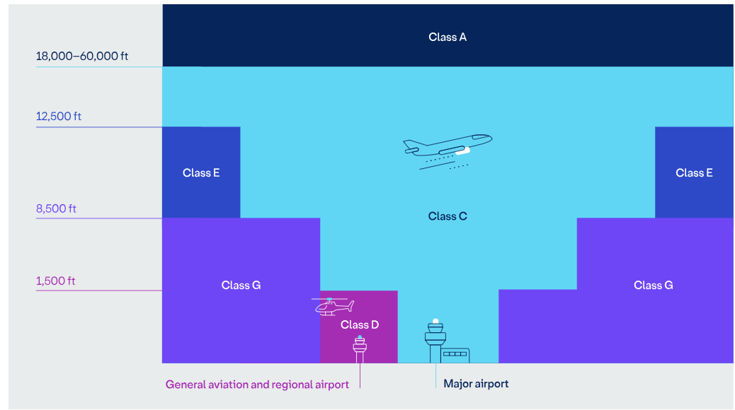
Currently, GA noise management relies on a mix of regulatory measures, airport noise abatement procedures, and local initiatives. The Civil Aviation Safety Authority (CASA), Airservices Australia, and individual airport operators each play a role. Airservices Australia also operates the Noise Complaints and Information Service (NCIS), which provides the public a central channel to raise concerns and access information about aircraft operations. However, as aircraft operating in Class G airspace are not subject to Air Traffic Control or procedures provided by Airservices, the NCIS has limited scope to investigate complaints in this airspace.
Feedback from the AWP consultation process demonstrated that residents, local councils, and advocacy bodies remain concerned about the cumulative impact of aviation noise on health, wellbeing, and the environment. GA operations take place across a wide range of contexts, with a concentration of activity in urban settings, particularly where flying schools operate, alongside the necessary access they provide in regional areas. Pilots already manage complex layers of aeronautical information.
This guidance aims to make it easier for pilots and operators to voluntarily adopt consistent, practical actions that reduce these impacts without compromising safety or operational needs.
The guidance is designed to set clear, nationally consistent expectations that encourage considerate flying behaviours, while leaving pilots with the discretion to prioritise safety and adapt to local conditions. Its voluntary nature encourages innovation and collaboration, building on successful local initiatives without adding new regulatory burdens.
Australia’s GA sector already has established local experience to draw on when it comes to flying considerately. In several regions, FNAs have been developed by local operators in partnership with local government authorities, communities, Traditional Owners, and land managers to address issues like aircraft noise, overflight of sensitive areas, and community impacts. The Flying Considerately guidance builds on these proven approaches, to aid aviators and operators in uncontrolled airspace, where air traffic services are not provided, and pilots coordinate directly with others to maintain safe separation, to work together more effectively. This provides greater predictability and transparency in voluntary noise minimisation and environmental stewardship.
FNAs should align with and reflect the principles of Flying Considerately guidance, incorporating best practice examples to deliver practical, locally tailored solutions. A1 - Fly Neighbourly Agreements provides examples of FNAs in practice, and the features that make them effective.

1.2 Guiding principles
Before using the guidance, pilots and operators should keep three key principles in mind. These principles ensure that flying considerately supports, not conflicts with, the broader goals of safety, regulatory compliance, and practical day-to-day flying.
- Safety First: Safety remains the paramount consideration. This ensures pilots will never take action that puts lives at risk, even when balancing noise concerns.
- Community awareness: General aviation operators are encouraged to be good neighbours by considering the impact of their operations on local communities.
- Practical Application: Recommendations from the guidance are designed to be applied where they are operationally feasible and consistent with regulations.
These principles give communities confidence that aviation activity in their area is shaped by an approach that balances safety, neighbourliness, and practicality.

1.2.1 Safety first
Safety should always remain the first priority in aviation. Pilots must retain full discretion to make decisions that prioritise safe flight operations, including when noise considerations cannot be prioritised due to weather, airspace limitations, or emergency situations.
International example: United States (US) Federal Aviation Administration (FAA) VFR Safety Emphasis. The FAA’s Noise Abatement Departure and Arrival Procedures advisory circular reminds pilots voluntary abatement routes are only recommended when they do not compromise safety. Pilots are explicitly advised to discontinue noise abatement procedures if weather, traffic, or aircraft performance make them impractical or unsafe.

Flights are conducted in the safest possible manner, reducing the risk of incidents while still prioritising noise considerations wherever conditions allow.

1.2.2 Community awareness
Pilots and operators are encouraged to consider the impacts of aircraft noise on the communities and environments beneath their flight paths. This includes being mindful of aircraft type, altitude, route choice, and time of day; particularly when operating near residential areas, cultural heritage sites, or sensitive environmental zones.
International example: Queenstown Airport ‘In, Out & Around’ VFR Guide, New Zealand. Queenstown Airport issues a VFR information guide aimed at GA pilots. It explicitly advises, “avoid directly overflying residential areas where possible…maintain as much altitude as you can, and reduce your power setting if practicable, in particular over Frankton Arm and the town.” This voluntary guidance, formally communicated to GA pilots reflects a community-aware approach to lessen noise impacts and promote noise awareness.

This approach can help reduce noise exposure, share noise impacts more fairly, and avoid particularly sensitive locations.

1.2.3 Practical application
The guidance should support practical decision-making for flight planning and execution. Pilots are encouraged to select routes and altitudes that reduce noise exposure where safe and practicable, avoid sensitive areas when possible, and consider the benefits of fuel-efficient techniques that reduce both noise and emissions.
International example study: Grenoble-Le Versoud Aerodrome, France. Following a government-commissioned review into light aircraft noise, voluntary measures were introduced to reduce noise impacts on surrounding villages. These include modified circuit patterns that prioritise faster climb-outs, avoidance of residential valleys, and the use of quieter power settings where possible. The procedures remain voluntary but are widely adopted by local pilots, reflecting a shared commitment to quieter and more considerate flying.

2. Flying Considerately: Guidelines for General Aviation

2.1 Guidance for pilots operating in Class G airspace

2.1.1 Respect communities
- Noise awareness: Minimise repeated circuits over built-up areas where practical. Follow published noise abatement procedures and climb promptly after take-off to reduce the time spent at low altitudes.
- Be aware of operating hours: Observe published airport operating hours and avoid unnecessary early-morning or late-night operations, especially in noise-sensitive areas.
- Flight paths: Where guidance exists, stay on recommended tracks and avoid low overflights of sensitive sites like hospitals, schools, cultural landmarks, or areas with livestock.
- Fly Neighbourly Agreements (FNA): Review local FNAs before flying and encourage fellow pilots, students and visiting crews to do the same. Using these agreements shows the community GA pilots are committed to responsible and considerate operations.
- Communication: Where possible, engage with local community groups and airfield neighbours to explain GA’s role and respond respectfully to concerns. Share the airspace.
- Separation and lookout: Maintain vigilant see-and-avoid practices. Broadcast your position and intentions on Common Traffic Advisory Frequency (CTAF) clearly and respond courteously to other pilots.
- Circuit discipline: Follow standard circuit patterns, avoid cutting in, and give way in accordance with the rules of the air.
- Respect controlled airspace: When transitioning through controlled airspace, follow Air Traffic Control (ATC) instructions precisely and plan ahead to avoid unnecessary frequency congestion or delays.

2.1.2 Support safety and professionalism
- Noise and safety are linked: Smooth, predictable flying typically creates less noise and fewer risks. Avoid aggressive manoeuvres or prolonged low-level operations near populated areas.
- Training with courtesy: Spread training activity across multiple practice areas where possible to avoid overloading one location with noise or traffic. Instructors should explain FNAs and noise-sensitive areas during pre-flight briefings.
- Pre-flight preparation: Use flight planning tools to map altitudes and tracks that balance operational needs, airspace requirements, and community considerations.

2.1.3 Contextual awareness
- Wildlife sensitivity: Avoid low flying over marine parks, wetlands, nesting areas, and national parks where wildlife disturbance is likely.
- Be aware of local areas of cultural significance: Check FNAs or local sources for culturally significant sites and avoid overflying them at low altitudes.
- Efficient choices: Where possible, use quieter, more efficient aircraft or new technologies.

2.2 Supporting implementation of the guidance

2.2.1 Monitoring and continuous improvement
Aircraft and/or airport operators and pilots are encouraged to:
- Review flight tracks regularly using GPS logs or airport tools to identify opportunities for reduced noise or congestion
- Seek feedback from local communities and airport operators on noise concerns
- Participate in airport or council-led noise monitoring programs where available
- Implement lessons learned from noise abatement initiatives and effective practices through pilot forums, aero clubs, or industry associations.
- Support research into quieter operations, including flight path design, operational procedures, and technology adoption.
- Collaborate with airports and communities on noise abatement initiatives.

2.2.2 Aviation regulations
This guidance complements existing safety and operational requirements. Pilots and aircraft and/or airport operators must continue to comply with:
- Civil Aviation Safety Regulations (CASR)
- ATC instructions
- Aeronautical Information Publications (AIP)
- Notices to Airmen (NOTAMs)
- Local airport operating procedures and requirements.

2.2.3 Resources and assistance
Aircraft and/or airport operators seeking to implement Flying Considerately practices can access:
- Airport noise abatement procedures on Airservices Australia or airport websites
- Industry association guidance and training materials
- Community liaison programs and consultation opportunities at major GA airports, including Community Aviation Consultation Groups (CACGs)
- Technical advice on aircraft modifications that reduce noise impacts, accessible via aircraft manufacturers (OEM) websites, aviation maintenance providers, and relevant industry associations.

2.2.4 Training and education
Flight training organisations are encouraged to:
- Incorporate noise awareness and community engagement into initial and recurrent training
- Include noise abatement scenarios in flight simulator exercises where available
- Assess student knowledge of considerate flying practices during check flights
- Provide instructors with updated resources on noise-sensitive areas and FNAs.

3. Conclusion
Flying Considerately represents a commitment to sustainable GA operations that respect community expectations while maintaining operational efficiency and safety. This guidance encourages all GA pilots and/or operators to adopt practices that demonstrate good neighbourhood citizenship while preserving access to Australia's airspace for legitimate aviation activities.
The guidance is designed to help pilots plan and fly in ways that minimise noise impacts and foster respectful community relationships. The success of this guidance depends on voluntary adoption by pilots and/or operators, ongoing dialogue with communities, and continuous improvement in noise management practices. By working together, the general aviation community can maintain its social licence to operate while contributing to Australia's aviation future.
To ensure the guidance is fit-for-purpose and responsive to stakeholder needs, the Government is committed to a thorough and inclusive consultation process. Consultation will shape the final guidance, which the Government plans to finalise and publish in line with the key milestones outlined in Table 1.
Table 1: Key milestones for finalising and publishing the guidance
Milestone
Consultation closes | 4 weeks
Review of submissions and stakeholder engagement | 4 weeks
Finalisation of the guidance by department | 4 weeks
Airservices to publish guidance via ERSA | Q3 2026
By participating in this consultation, all stakeholders can influence a guidance framework that is practical, aspirational, and grounded in collaboration rather than regulation. The Government looks forward to working closely with all parties to realise the full potential of Flying Considerately as a cornerstone of Australia’s aviation noise management.
Together, the guidance can ensure Australian skies remain safe, accessible, and considerate supporting aviation’s vital role in Australia today and into the future.

A1—Fly Neighbourly Agreements
This section is not intended as formal guidance on how to develop an FNA. Instead, it highlights the common features of successful agreements and shows how they have informed many of the customs of considerate flying in Australia. The purpose is to build understanding of their role, so pilots, operators and communities can better understand how voluntary approaches already work in practice and how they complement the new guidance.
Fly Neighbourly Agreements (FNAs) provide useful local information that can be used alongside Flying Considerately guidance to get the best outcome for local communities. FNAs vary between regions but share common features. By examining the features of Australian FNAs that work well, pilots, operators, and communities can work together to improve FNAs and ensure they work effectively with the new guidance.

Voluntary participation
FNAs are voluntary arrangements. They reflect a commitment by pilots and operators to reduce community impacts where safe and practicable. This voluntary structure encourages ownership and buy-in from the aviation sector, with arrangements more likely to succeed in the long term. For example, pilots and operators voluntarily comply with minimum altitudes and designated flight paths agreed with Traditional Owners and Parks Australia because of a collaborative understanding of cultural values.

Agreed flight heights and preferred routes
Several FNAs include guidance on minimum flight altitudes and preferred routes to help reduce noise over communities or sensitive environments. These measures are designed to assist pilots in avoiding residential areas, wildlife habitats, and culturally significant locations. For example, the Blue Mountains ERSA entry provides specific advice to pilots flying under VFR, encouraging higher altitudes and aircraft routing that minimise impacts on local communities and the natural environment. Except when operating on preferred scenic routes, pilots are requested to maintain a minimum altitude of 2000FT above the surface of the park, unless operation at this altitude would jeopardise the safe conduct of the flight. This minimises the risk of noise disturbance for both residents and wildlife.

Time of day consideration
FNAs often include recommendations about when flights should occur to minimise disturbance. These time-based considerations help reduce impacts during early mornings, evenings, or other noise-sensitive periods. At Parafield Airport, for instance, voluntary guidelines encourage GA pilots and/or operators to avoid circuit training over residential areas before 7:00am and after 10:00pm. These quiet hours provide local communities with greater certainty about when aircraft activity is most likely to occur.

Environmental and cultural sensitivity
Some FNAs include voluntary measures to protect environmentally and culturally sensitive areas. This may involve maintaining higher altitudes over protected zones, rerouting flights away from sacred sites, or avoiding flights during critical times such as wildlife breeding seasons or cultural ceremonies. The Western Australian Indigenous Tourism Operators Council is actively involved in supporting Indigenous tourism experiences in the Kimberley region, including those focused on aviation. Many of these tours are developed and run in partnership with Traditional Owners, like the Bunuba people.

Community engagement
Genuine community consultation in the design of FNAs ensures agreements reflect local values and concerns, builds trust and creates lasting partnerships between aviation operators and those surrounding them. At Hobart Airport, the Community Aviation Consultation Group (CACG) provides a structured forum where residents, local councils, and airport users meet regularly to discuss noise issues and flight procedures. This process allows for two-way communication, giving communities a voice in how local aviation operates. Where CACGs are not established, community engagement on the guidance should be led through targeted outreach to local councils, resident associations, and other relevant community forums.
By looking closely at Kakadu, and other FNAs, the Government has identified the features that make FNAs strong, credible, and enduring. By understanding what makes FNAs strong, pilots and airport operators can see how voluntary, community-driven approaches have shaped considerate flying in Australia. FNAs are not required everywhere, nor are they being mandated. Where they exist, or where communities and operators wish to create them, they offer a tested way to translate considerate flying principles into practice.
Case study
One of the most comprehensive examples is the Kakadu National Park FNA, which is widely regarded as a benchmark for voluntary aviation practice. The Kakadu model shows how considerate flying can protect cultural heritage, reduce environmental impacts, and support sustainable tourism while still allowing aviation businesses to thrive. It demonstrates how voluntary, community-driven solutions can work in practice, offering a blueprint for other regions to adapt.
The Kakadu FNA was developed jointly by Parks Australia, Traditional Owners, and aviation operators, recognising the need to balance scenic flight operations with the protection of cultural and environmental values. The agreement sets a minimum recommended altitude of 2,500 feet above sea level over sensitive areas, with specific flight paths designed to avoid sacred sites and cultural landscapes, unless weather or safety concerns require deviation. Seasonal changes to flight paths are also implemented to protect critical wildlife breeding habits, particularly during the wet season. Monitoring is a shared responsibility, with Parks Australia working alongside Traditional Owners to review data and community feedback throughout the year. Park staff are also encouraged to observe aircraft movement above the Park, and report breaches. The agreement is also reviewed periodically, allowing for adjustments as tourism patters shift or new cultural and environmental considerations emerge.

Clear objectives
A strong FNA begins with shared, well-defined objectives. These are not just formalities, they provide the foundation for trust, clarity, and mutual accountability. Without clear objectives, agreements risk becoming vague or symbolic, with little practical impact.
Setting out objectives ensures that operators, communities, Traditional Owners, and government agencies understand why the agreement exists and what it seeks to achieve. This common ground helps prevent misunderstanding and provides a framework for evaluating success.
The guidance will recommend that every voluntary agreement starts with clearly stated goals, ensuring focus and credibility from the outset of each agreement.

Optimal flight planning with defined flight paths and sensitive area avoidance
For an FNA to be robust, it must go beyond general statements of intent and provide practical, operational guidance. Defining flight paths and minimum altitudes translates community expectations into actionable aviation protocols.
Strong agreements specify:
- preferred routes to avoid sensitive areas where safe and practicable
- minimum altitudes over cultural and environmental sites
- seasonal adjustments, responding to wildlife breeding cycles or ceremonial periods
- safety-first clauses, reinforcing pilot’s overriding safety responsibilities, such as during adverse weather or emergencies.
The guidance will recommend that voluntary agreements include operationally relevant flight planning criteria, turning broad principles into day-to-day aviation practice.

Noise and time management protocols
Noise and timing protocols are central to strong FNAs because they directly address the lived experiences of communities and visitors. Managing when and how flights occur reduces disturbance without requiring a reduction in aviation activity.
Strong agreements include:
- voluntary quiet times
- noise-sensitive circuit training guidelines, avoiding repetitive overflight of residential or visitor zones
- encouragement to adopt noise-minimising flight techniques.
The guidance will recommend practical noise and time management protocols, helping operators reduce local impacts without compromising business viability.

Community communication and feedback mechanisms
Successful FNAs are based on relationships, not just procedures. Open communication and feedback mechanisms build social license, giving communities confidence that aviation operators are listening and responsive.
Effective agreements include:
- consultation during development, ensuring local voices shape the outcomes
- ongoing communication, through regular meetings or established contact points
- transparent response processes, so feedback leads to constructive action.
The guidance will recommend agreements include clear engagement processes, ensuring local knowledge and concerns are reflected in ongoing aviation operations.

Monitoring and reporting: enabling shared accountability
A voluntary agreement is only as strong as its ability to demonstrate whether it’s working. Monitoring and reporting support transparency, learning, and shared responsibility for improvement. This collaborative approach builds trust and encourages everyone involved to stay committed to the agreement’s outcomes.
Shared monitoring usually involves:
- Operator self-monitoring: aviation operators voluntarily record flight tracks, altitudes, and timing, using onboard systems or flight planning data. Operators then report back regularly to local stakeholder groups or park managers on how they’ve followed the agreed protocols.
- Community input: local communities and Traditional Owners contribute by raising concerns, identifying patterns, or flagging changes in on-ground impacts. At federally leased airports, these contributions are typically coordinated through CACGs, ensuring feedback is captured systematically alongside technical data. This input is essential because not all impacts can be captured by technical data alone.
- Formal reporting pathways: feedback from communities is often channelled through national services like Airservices Australia’s NCIS, which provides a consistent mechanism for logging concerns in controlled airspace. For operations outside controlled airspace, community members and operators may use local airport reporting channels to capture noise incidents and patterns. While these mechanisms do not involve a formal investigation of voluntary agreements, they help identify trends and inform broader noise management initiatives.
- Collaborative reviews: stakeholders meet regularly to review data, discuss trends, and agree on any adjustments. These reviews create opportunities to fine-tune agreements, address emerging issues, and celebrate successes.
The guidance will recommend similar shared monitoring approaches. By involving multiple parties in tracking progress, agreements become more credible, transparent, and adaptable, ensuring that improvements are both realistic and sustainable over time.

Periodic review
Even the best agreements can become outdated if they aren’t reviewed. A strong FNA includes regular review cycles to keep pace with:
- new technology, like improved navigation tools
- changes in tourism patterns, land use, or environmental conditions
- updated cultural protocols from Traditional Owners.
The guidance will recommend that all voluntary agreements include regular review processes, ensuring continuous relevance and community confidence.

A2—Consultation questions
The following questions are provided to support focused and constructive feedback on the guidance. They cover the key themes and proposals outlined in this consultation paper, including the core principles, draft framework proposal, and monitoring approaches.
Respondents are encouraged to address as many questions as they wish and to provide any additional comments or suggestions that may assist in refining the guidance. Input is invaluable to ensuring the final guidance is practical, effective, and responsive to the diverse needs of Australia’s aviation community and affected stakeholders.
Consultation Questions
About the introduction
  - Is the purpose of the guidance, and who it applies to, clear?
  - Are the proposed principles relevant and sufficient to inform how pilots and/or operators should apply the guidance?

About the core flying considerately practices
  - Are the practical examples relevant and realistic?
  - Can you suggest any other examples that could be added to assist users of the guidance?
  - Are there any gaps or missing elements that should be addressed?

About supporting implementation
  - Does the supporting implementation section provide sufficient advice for GA operators?
  - Is it clear how the guidance will work with existing FNAs?
  - Do you agree with the analysis of the key features that make FNAs affective in A1 - Fly Neighbourly Agreements?
  - What additional features or approaches could improve the strength and durability of FNAs?
  - How can the guidance build on and support existing FNAs?

A3—Glossary and acronyms
Acronym | Description
AIP | Aeronautical Information Package
ANO | Aircraft Noise Ombudsman
ATC | Air Traffic Control
AWP | Aviation White Paper
CAA | Civil Aviation Authority
CACG | Community Aviation Consultation Group
CASA | Civil Aviation Safety Authority
CASR | Civil Aviation Safety Regulations
CDO | Continuous descent operations
CTAF | Common Traffic Advisory Frequency
ERSA | En Route Supplement Australia
eVTOL | Electric vertical take-off and landing
FAA | Federal Aviation Administration of the United States of America
FNA | Fly Neighbourly Agreements
GA | General aviation
GPS | Global Positioning System
IFR | Instrument Flight Rules
NAPs | Noise abatement procedures
NATS | National Air Traffic Services
NOTAM | Notices to Airmen
PBN | Performance-based navigation
VAI | Vertical Aviation International
VFR | Visual Flight Rules
IFR | Instrument Flight Rules
NAPs | Noise abatement procedures
NATS | National Air Traffic Services
NCIS | Noise Complaints and Information Service
PBN | Performance-based navigation

A definition of ‘Class G’ airspace is provided in Section 1.1
Federal Aviation Administration, Noise Abatement Departure and Arrival Procedures, Advisory Circular AC 91-36D, FAA, Washington D.C., available at: AC 91-36D - Visual Flight Rules (VFR) Flight Near Noise-Sensitive Areas [ Accessed 17 Jul. 25].
Queenstown Airport, In, Out & Around Queenstown: A VFR Guide for GA Pilots, Queenstown Airport Corporation, 2024, available at: In, out, and around Queenstown [ Accessed 17 Jul. 25].
Sénat, Question de Mme DAVID Annie (Isère - CRC) publiée le 25/11/2004, 22 November 2004, available at: Nuisances occasionnées par les activités de l'aérodrome de Grenoble - Le Versoud [ Accessed 17 Jul. 25].
Director of National Parks, ‘Uluru-Kata Tjuta National Park Management Plan 2010-2020’, Australian Government, Canberra, 2010, available at: management-plan.pdf [ Accessed 18 Jul. 25].
Airservices Australia, ‘Special Procedures (Not Associated with an Aerodrome)’, Airservices Australia, Canberra, 2025, available at: ERSA.book [Accessed 21 Aug. 25].
Parafield Airport, ‘Aircraft Noise, South Australia, available at: Section-13.pdf [ Accessed 21 Aug. 25].
Western Australian Indigenous Tourism Operators Council (WAITOC), Kimberly County (Fitzroy Tours), WAITOC, Perth, available at: Kimberley Country (Fitzroy Tours) :: WAITOC [ Accessed 18 Jul. 25].
Airservices Australia, ‘Hobart Airport community aviation consultation group’, Airservices Australia, Canberra 2025, available at: Hobart Airport community aviation consultation group – AsA National Insightfull [ Accessed 18 Jul. 25].
Parks Australia, ‘Airspace Management above Kakadu National Park’, Parks Australia, Canberra, 2010, available at: Fly Neighbourly Agreement, Kakadu National Park [ Accessed 18 Jul. 25].
Parks Australia, ‘Kakadu National Park Plan of Management 2016-2026’, Parks Australia, Canberra, 2016, available at: Kakadu National Park Management Plan 2016-2026 [ Accessed 18 Jul. 25].
Parks Australia, ‘Airspace Management above Kakadu National Park’, Parks Australia, Canberra, 2010, available at: Fly Neighbourly Agreement, Kakadu National Park [ Accessed 18 Jul. 25].
Parks Australia, ‘Airspace Management above Kakadu National Park’, Parks Australia, Canberra, 2010, available at: Fly Neighbourly Agreement, Kakadu National Park [ Accessed 18 Jul. 25].
Airservices Australia, ‘Aircraft Noise Complaints and Information Service’, Airservices Australia, Canberra, 2025, available at: Making a complaint - Airservices [ Accessed 18 Jul. 25].

