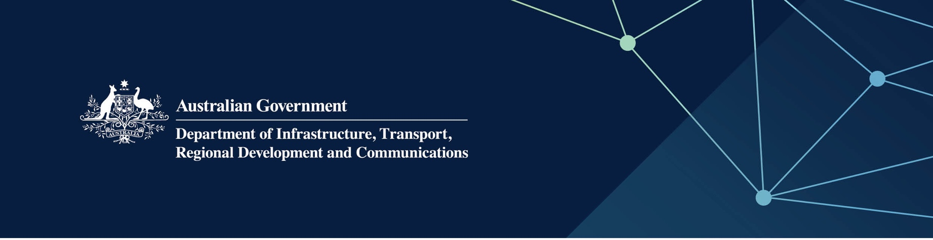

TERRITORIES division / IOT branch / IOT GOVERNMENT ARRANGEMENTS

Frequently asked questions

Water and wastewater treatment infrastructure upgrades on the Cocos (Keeling) Islands West Island

February 2022

# 

## What are the water and wastewater treatment projects?

The Department of Infrastructure, Transport, Regional Development and Communications (the Department) has contracted Water Corporation to undertake the following water and wastewater projects on the Cocos (Keeling) Islands (CKI) West Island:

* construct a new 200 kilolitre per day (kL/day) Seawater Reverse Osmosis (SWRO) Plant, including water source drilling and testing activities for the SWRO production bores
* upgrade the capacity of the existing Wastewater Treatment Plant (WWTP) from 50kL/day to 80kL/day.

## How much are the projects costing?

In 2021-22, the Australian Government provided $17.4 million over two years to complete the projects. The Department of Defence is also making a funding contribution of $2 million to the SWRO through their Integrated Investment Program.

## Why are the projects being undertaken?

The CKI West Island water supply is sourced from freshwater lenses located below the airfield runway. To ensure water security for the community into the future, the construction of a SWRO will replace reliance on the freshwater lenses which are susceptible to contamination from metals, hydrocarbons or other chemicals which may render the water source unusable for safe drinking water.

The WWTP is operating at maximum capacity at 50kL/day. The proposed project will increase capacity by an additional 30kL/day to a total of 80kL.day. This increase will allow for future economic development of the Island. Without this WWTP upgrade project, further economic development on West Island is not possible.

## What will the SWRO look like?

The SWRO will be a sister plant to the water plant already in place on Home Island. The Water Corporation has more than five years’ experience in operating and maintaining the Home Island water plant. As the water plants will be the same, operational spares can be used for either plant.

## Where will the SWRO be located?

The new SWRO will be located on land adjacent to the existing WWTP on Lot 100 Sydney Highway, CKI West Island.  
This area is away from the main settlement on the island, and will not cause any visual or noise disturbances to the community through the construction period or during ongoing operations.

## Who will be doing the projects?

Water Corporation will deliver these infrastructure projects through their Indian Ocean Territories Service Delivery Arrangement with the Australian Government, through the Department. Water Corporation has been providing water and wastewater services to the CKI communities since 2001.

## When will the work start?

In February 2022, Parliamentary Standing Committee on Public Works (PWC) approval was received to undertake the water source and bore drilling program. This drilling program will provide information on water quality and help inform the design of the SWRO.

All other works will commence following PWC approval, with construction works on-island to commence in August 2023. The projects will be completed early 2024.

## How will the community be consulted?

The Department and Water Corporation are working together to ensure the community is kept informed at every stage of the projects. It is important that residents and visitors to the islands have access to safe drinking water, and effective management of wastewater treatment.

Information and updates on the projects will be made available to the community through media releases, community bulletins, fact sheets and the Department’s website. At times, members of the project team will be on CKI to talk directly to key stakeholders and community members about the projects.

## How can I get further information?

If you require any further information regarding the works, please contact the project team at [IOTSDA@infrastructure.gov.au](mailto:IOTSDA@infrastructure.gov.au)