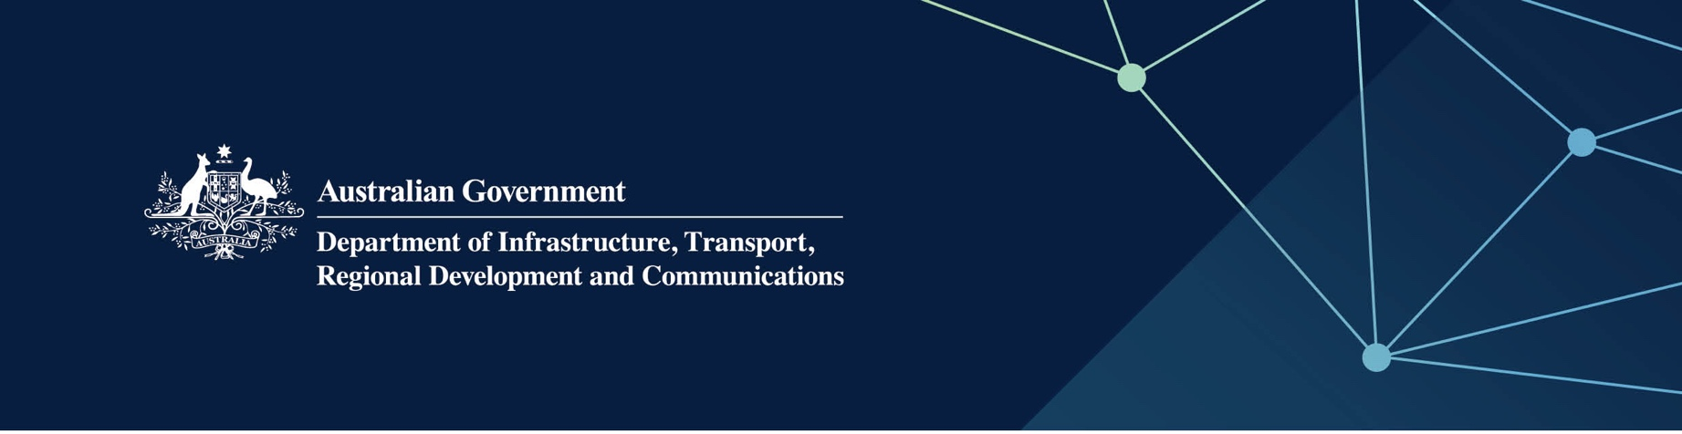

TERRITORIES division / IOT branch / IOT GOVERNMENT ARRANGEMENTS

Fact Sheet

Water and wastewater treatment infrastructure upgrades on the Cocos (Keeling) Islands, West Island

February 2022

# 

## The project

The Department of Infrastructure, Transport, Regional Development and Communications (the Department) has contracted Water Corporation to undertake the following water and wastewater projects on the Cocos (Keeling) Islands (CKI) West Island:

* construct a new 200 kilolitre per day (kL/day) Seawater Reverse Osmosis (SWRO) Plant, including water source drilling and testing activities for the SWRO production bores
* upgrade the capacity of the existing Wastewater Treatment Plant (WWTP) from 50kL/day to 80kL/day.

In February 2022, the Department referred the projects to the Parliamentary Standing Committee on Public Works for Parliamentary approval to proceed. The projects can commence following Parliamentary Works Committee approval.

Water Corporation will deliver these infrastructure projects through their Indian Ocean Territories Service Delivery Arrangement with the Department. Water Corporation has been providing water and wastewater services to CKI communities since 2001.

The new SWRO will be located on Part Lot 100 Sydney Highway, CKI West Island, adjacent to the existing WWTP. This area is away from the main settlement on the island, and will not cause any visual or noise disturbances to the community through the construction period or during ongoing operations.

These projects will ensure a secure water source into the future, with increased capacity of the WWTP to support future economic development on West Island.

For the community’s safety, access is likely to be restricted around these areas and surrounding locations while works are under way.

The Department and Water Corporation are working together to ensure the community is kept informed at every stage of the projects. It is critical that residents and visitors to the islands have access to safe drinking water, and effective management of wastewater treatment.

## Background

Water for the CKI West Island community is currently sourced from freshwater lenses located below the operational airfield. Should there be any contamination of the freshwater lenses from metals, hydrocarbons or other chemicals, this may render the water source unusable for safe drinking water.

To address this risk, the Department, through Water Corporation, proposes to construct a new 200kL/day SWRO on   
CKI West Island to provide a secure water source for the community. This SWRO will be a sister plant to the SWRO already operating on Home Island. Water Corporation has more than five years’ experience and technical expertise in operating and maintaining the Home Island plant.

The existing WWTP needs to have its capacity increased by 30kL/day to support future economic development of   
CKI West Island.

In 2021-22, the Australian Government provided $17.4 million over two years to complete the projects. The Department of Defence is also providing funding of $2 million to the SWRO through their Integrated Investment Program.

The main elements of the projects include:

* water source drilling and testing activities for the SWRO production bores
* construction of a 200kL/day SWRO on the mainland which will be transported to CKI West Island for installation
* a modular upgrade to the WWTP to increase capacity by 30kL/day which will be transported to CKI West Island for installation.

Following Parliamentary approval, construction works on-island will commence in August 2023 and are expected to be completed early 2024.

## Community and stakeholder engagement

Residents and community members more affected by the works will receive further direct communications. Residents in the area will be notified before any work is undertaken.

If you require any further information regarding the works, please contact the project team at [IOTSDA@infrastructure.gov.au](mailto:IOTSDA@infrastructure.gov.au)