Australian Government
Department of Infrastructure, Transport, Regional Development, Communications and the Arts

Fact sheet—Replacement of Summit tank to Drumsite tank water main, Christmas Island

Replacement of Summit tank to Drumsite tank water main, Christmas Island

May 2023

## The project

The Department of Infrastructure, Transport, Regional Development, Communications and the Arts   
(the Department) has contracted Water Corporation to undertake replacement of a 3.5km section of the Summit tank to Drumsite tank water main on Christmas Island (CI).

The Australian Government has provided funding over two years to complete the project. Project works   
are expected to commence in late May 2023, with expected completion in November 2023.

Water Corporation will deliver this infrastructure project through their Indian Ocean Territories Service Delivery Arrangement with the Department. Water Corporation has been providing water and wastewater services to the CI community since 2000.

To meet Australian Government requirements, it was necessary for Water Corporation to engage a contractor accredited with the Office of the Federal Safety Commissioner. As the water main is classified as a Major Works contract by Water Corporation, it was also necessary for their successful contractor to have Tier 1 Health Safety and Environment accreditation due to the complex design and construction, in accordance with the relevant standards. Civcon Civil & Project Management Pty Ltd met all these requirements.

This project will ensure a secure water source into the future, with leaks in this section of water main currently resulting in loss of community water supply.

The water main replacement works will commence from the Summit tank in the National Park and progress towards the Drumsite tank. This section of the water main is the most difficult for Water Corporation to access to undertake repairs during the wet season and annual crab migration, and is also exposed to heavy vehicle movement.

For the community’s safety, access is likely to be restricted around these areas and surrounding locations while works are under way. Traffic management plans will be put in place on Murray Road when necessary.

On 17 February 2022, the Department received Parliamentary Standing Committee on Public Works Medium Works approval for the project to proceed.

The Department and Water Corporation are working together to ensure the community is kept informed at every stage of the project. It is critical that residents and visitors to the islands have access to safe drinking water.

## Background

Christmas Island relies solely on rainwater infiltration into the groundwater system. The water accumulates in naturally formed caves and sinkholes. The principal water supply for the Island is sourced from Jedda Cave and Jane-up Well, producing 80 per cent of the Island’s water supply. A secondary source at Waterfall Spring supplements the town water.

The pipeline was originally installed in the Murray Road verge. Over time, road maintenance has resulted in widening of the road. The widening of the road surface has escalated the leakage rate due to the vibration and impact of heavy traffic above and near the pipeline – this is evidenced by the reduction in leak repairs when this section of road is closed due to the annual crab migration.

A diagram of the proposed works is provided below.

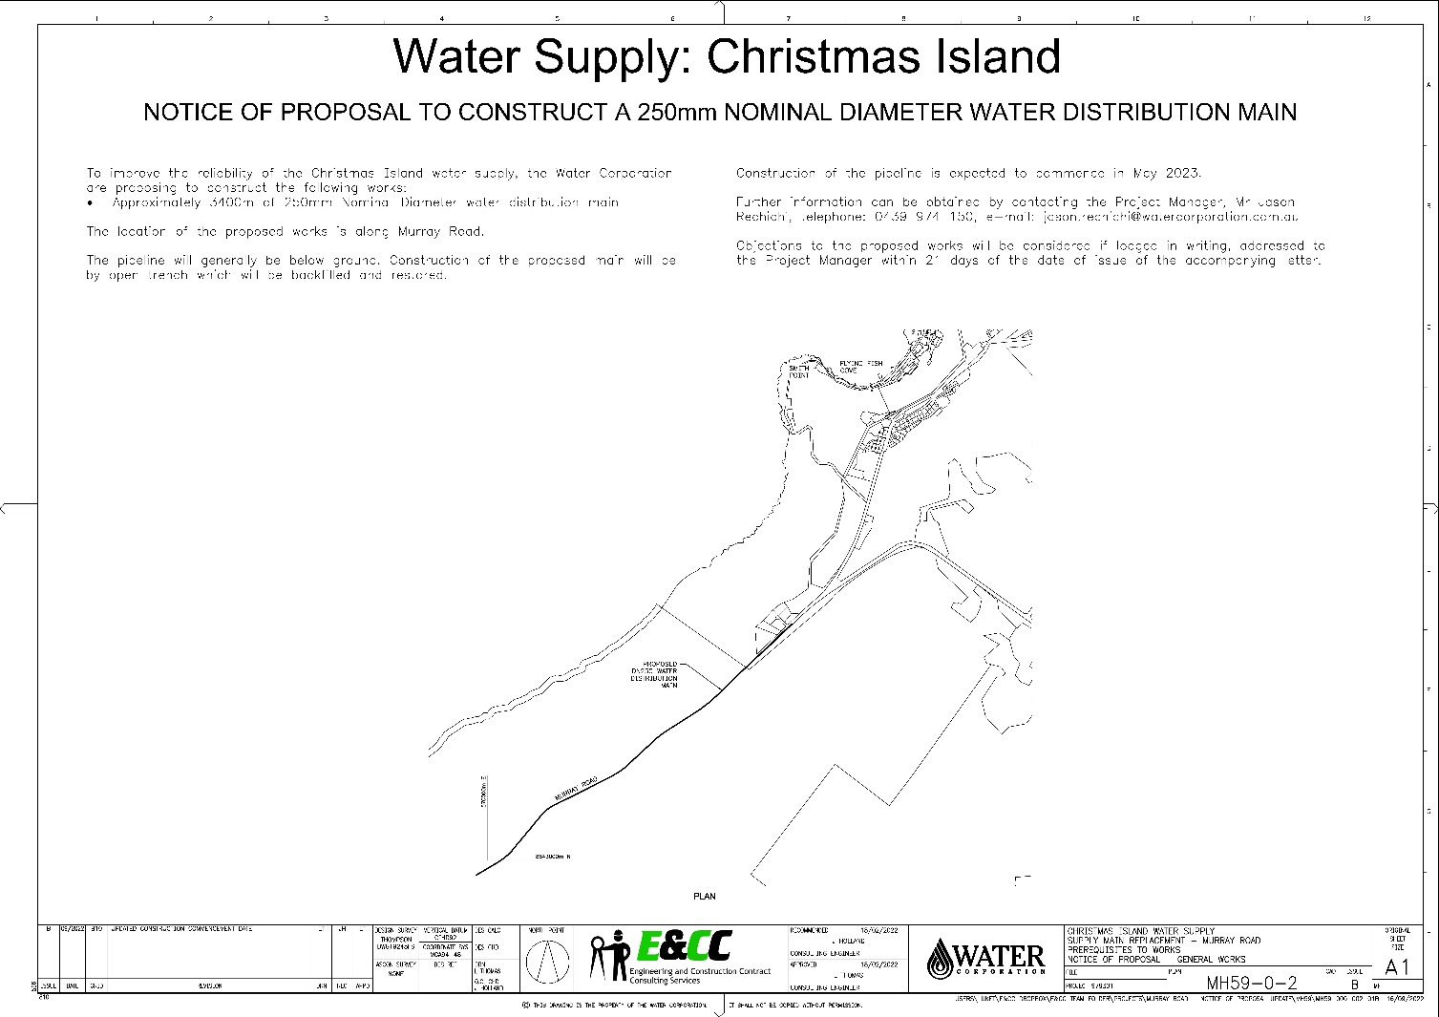

## Community and stakeholder engagement

Residents and community members more affected by the works will receive further direct communications from Civcon. Residents in the area will be notified before any work is undertaken.

If you require any further information regarding the works, please contact the project team at [IOTSDA@infrastructure.gov.au](mailto:IOTSDA@infrastructure.gov.au).