

Fact sheet—Proposed changes to exemptions from the New Vehicle Efficiency Standard (NVES)
May 2026

Why are vehicles over 3.5 tonnes currently exempt from the NVES?
- Vehicles with a gross vehicle mass (GVM) over 3.5t are currently exempt from the NVES, as Australia had not yet mandated a CO₂ test procedure for vehicles over 3.5t.
- On 20 April 2026, the Australian Government adopted a new legislative instrument called Australian Design Rule (ADR) 114. This will require new cars, SUVs and utes supplied from 30 June 2027 with a GVM between 3.5 and 3.855 tonnes to have their CO₂ emissions tested in accordance with an international standard before they can be sold in Australia.
- Equivalent CO₂ testing requirements already apply in the United States, Canada and the European Union. The 3.855t threshold aligns with the US definition of a light vehicle (8,500 pounds).
- This ADR will enable manufacturers to report a valid CO₂ emissions number for vehicles with a GVM up to 3.855t. This will enable these vehicles to be counted in the assessment of a manufacturer’s compliance with the New Vehicle Efficiency Standard Act 2024 (NVES Act) from 1 July 2027.
- A one-year lead time is required to enable manufacturers to complete any additional testing for Australian models and submit this information to the Department of Infrastructure, Transport, Regional Development, Communications, Sport and the Arts by 30 June 2027.

Why do the new testing requirements only apply to vehicles up to 3.855t?
- ADR 114/00 only applies to vehicles with a GVM up to 3.855t, as the current UN Regulations for CO₂ emissions testing do not enable heavier vehicles to be tested.
- This also aligns with the US definition of a light duty vehicle for its CO₂ testing requirements, which apply to vehicles with a GVM up to 8,500 pounds.
- Vehicles with a GVM under 3.855t account for over 70% of cars, SUVs and utes with a GVM over 3.5t. These vehicles also compete with similar sized vehicles with a GVM under 3.5t.
- The next series of UN Regulations adopting Euro 7 are being updated in 2026 and will enable heavier vehicles to be tested.
- Once this occurs, the government will consider further changes to CO₂ testing requirements to cover cars, SUVs and utes between 3.855 and 4.5t. This would enable these vehicles to be covered by the NVES from 2030.

What vehicles will lose their exemption from the NVES?
- The proposed amendment to the New Efficiency Standard Determination 2024 will remove the current exemption for vehicles supplied from 1 July 2027 with a GVM over 3.5t, if they are required to comply with ADR 81/03 or ADR 114/00.
- ADR 81/03 applies to vehicles with a GVM over 3.5t, if the vehicle is fitted with a label providing information on the vehicle’s fuel consumption, CO₂ emissions, energy consumption or battery range. This type of label is not mandated for vehicles over 3.5t.
- ADR 114/00 applies to vehicles with a GVM between 3.5 and 3.855t, unless the vehicle is a ‘work truck’ or ‘work van’. These vehicles are defined by the length of the tray/body/cargo area behind the seats.
- A work van is a vehicle with an integrated and enclosed space designed for the carriage of passengers and goods, with an area designed for the carriage of goods exceeding 50% of the vehicle’s ‘Total Length’.
- A work truck is a vehicle fitted, or designed to be fitted, with a body to carry goods and/or equipment. The length of this body must exceed:
- 60% of the vehicle’s ‘Total Length’, if the vehicle has one row of seats, or
- 50% of the vehicle’s ‘Total Length’, if the vehicle has 2 or more rows of seats.

Examples of vehicles required to comply with ADR 114.
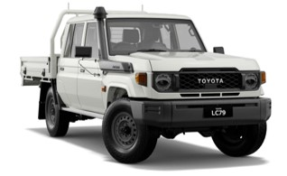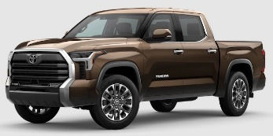
Examples of work trucks and vans over 3.5t.
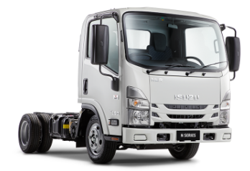

When will these changes be implemented?
- An amendment is required to the New Efficiency Standard Determination 2024 to remove the exemption for these vehicles from 1 July 2027.
- If this amendment is not adopted, these vehicles will remain exempt until the end of 2027.
- Section 36 of the New Vehicle Efficiency Standard Act (NVES Act) requires a 60-day public consultation process to be undertaken before this amendment can be adopted.
- Once this consultation process completed, the government intends to adopt the required amendments to remove this exemption for cars, SUVs and utes between 3.5 and 3.855t from 1 July 2027. This is expected to occur in the third quarter of 2026.

When will vehicles over 3.855t be included in the NVES?
- A longer transition period is required to enable a suitable test procedure to be adopted for vehicles over 3.855t. This is because UN vehicle regulations that underpin our CO₂ testing requirements do not currently enable vehicles over 3.855t to be tested.
- The UN Regulations are currently being updated to enable heavier vehicles to be tested. This amendment is expected to enter into force under the UN 1958 Agreement on vehicle regulations in late 2026.
- Once the new UN Regulations enter into force, the government plans to consult on a new ADR that will mandate these testing requirements for cars, SUVs and utes up to 4.5t, to enable the exemption for these vehicles to be phased out by 2030.
- Work trucks and vans over 3.5t are intended to remain exempt, as these vehicles are not used as substitutes for passenger vehicles and are used by emergency and public interest services.
- Emissions from these vehicles will be addressed through other measures to decarbonise the heavy vehicle sector (such as low carbon liquid fuels and regulatory reforms to support the uptake of zero emission heavy vehicles).

Can vehicles over 3.5t ‘opt-in’ to the NVES before 1 July 2027?
- No, all vehicles with a GVM over 3.5t entered on Register of Approved Vehicles (RAV) before 1 July 2027 must be entered as an exempt vehicle, even if they comply with ADR 81/03 or 114/00.
- These vehicles will not be counted in the calculation of a manufacturer’s ‘interim emissions value’, even if the RAV entry is amended to report NVES data after 1 July 2027.
- Only vehicles that are required to report NVES data from 1 July 2027 will be counted.

If you have any other questions about the ADRs for CO₂ emissions testing or the proposed changes to exemptions from the NVES, you can contact the Light Vehicle Emissions Policy team at: cleanercars@infrastructure.gov.au.

