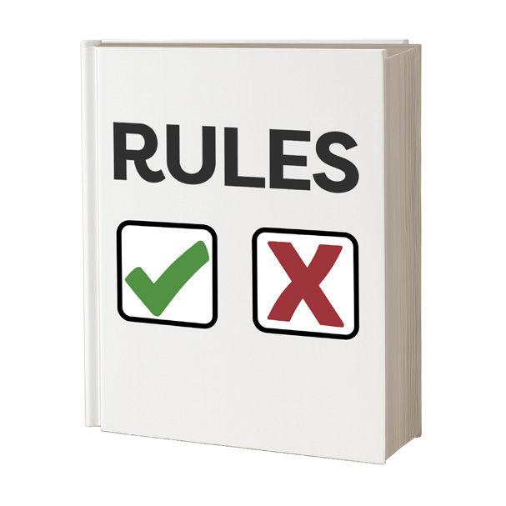
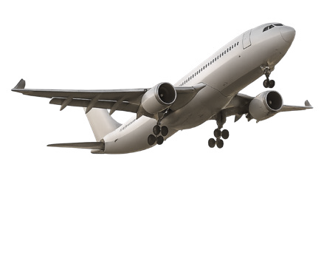
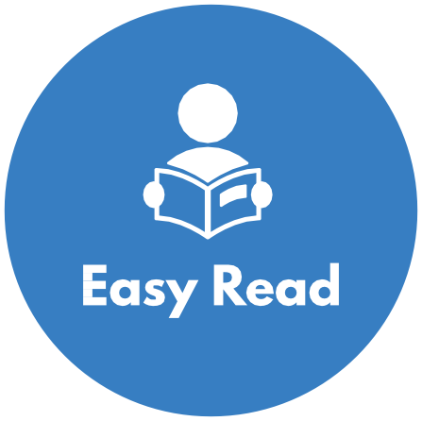
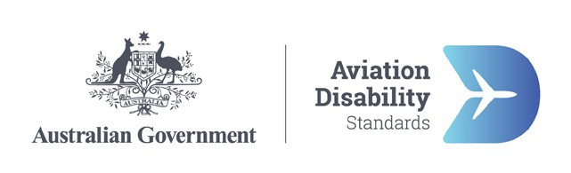

Better plane travel for people with disability—Why we need new rules

About this information
This information is about new air travel rules to support people with disability.
Air travel is when people
- Book plane tickets
- Go through airports
- Get on and off planes
- Fly on planes.
Air travel is important for lots of people.
It helps people see their friends and family.
Air travel can be a way for people to get to services for the support they need.
But air travel can be hard for people with disability.
Sometimes they do not get the support they need to travel in a safe and fair way.
Lots of things can be hard for people with disability when they use air travel like when they
- Book a flight
- Get on and off the plane
- Are on the plane
- Check in at the airport.
Check in means when you let the airline know you are coming for the flight.
Some people check in online before they get to the airport.
Airlines are businesses that own and fly planes.
This information says why we need new rules to make air travel easy for people with disability.

What the law says now
There is a law that says people with disability must be treated the same as everyone else.
This law is a rule that everyone must follow.
It is called the Disability Discrimination Act.
You must not be treated different because of your disability.
This law says services must make reasonable adjustments for people with disability.
Reasonable adjustments are changes so that a person with disability can use a service.
There are also rules that all kinds of public transport must follow.
Public transport means ways people get around like using a
- Train or bus
- Taxi
- Ferry
- Plane.
The rules are called the transport standards.
The transport standards say what public transport services must do to support people with disability.
They say airlines and airports must also follow these rules.
But people with disability still have problems with air travel even with these laws and rules.

Making new rules for air travel
In 2024 the government made a plan called the Aviation White Paper.
We will say paper for short.
In this paper the government said they will make new rules for air travel.
They said they will work together with people with disability to make the new rules.
This is called co design.
The new rules should
- Support people with disability to get their rights when they use air travel
- Say what airlines and airports must do better.
The government did 3 co design workshops in 2025.
In the workshops we heard from lots of different people. We heard from
- People with disability
- People with disability groups.
People at the workshops shared ideas to make air travel better for people with disability.
We put ideas people shared with us in a consultation paper.
The consultation paper has ideas for how to make each step of air travel better like
- Booking and planning your trip
- Being at the airport
- Being on the plane.
To read these you can go to www.infrastructure.gov.au/Aviation-Disability-Standards
The consultation paper is not in Easy Read.

Easy Read information about other ideas
You can also read other Easy Read information about ideas to make air travel easier for people with disability.
You can read about ideas for
- The plane trip from start to finish
- Planning and booking a plane trip
- At the airport
- Flying on a plane.
To read these you can go to www.infrastructure.gov.au/Aviation-Disability-Standards

Have your say
You can have your say on the ideas for new air travel rules.
To have your say you can
- Send us an email to
AviationAccessibility@infrastructure.gov.au
- Call us on 1800 621 372
Go to our Have Your Say website at
www.infrastructure.gov.au/Aviation-Disability-Standards
The Have Your Say website is not in Easy Read.

Who did this Easy Read
CID made this information for the Australian Government.
The pictures we use are copyright.
Copyright means you need to ask CID if you want to use the pictures. You can email CID at business@cid.org.au
To read more about how we do Easy Read at CID you can go to our website at www.cid.org.au/inclusion-services

