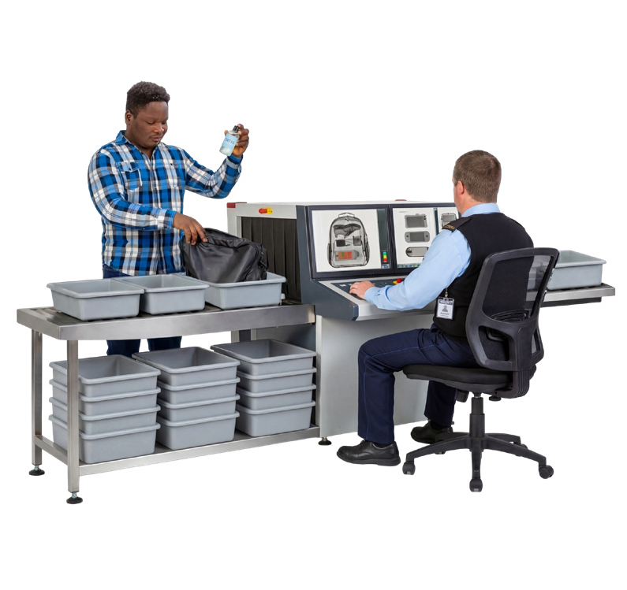
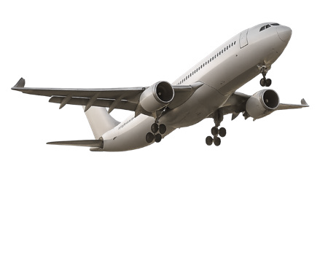



Better air travel for people with disability—3. At the airport

About this information
This information is about new air travel rules to support people with disability.
Air travel is when people
- Book plane tickets
- Go through airports
- Get on and off planes
- Fly on planes.
The government wants to make new rules so air travel is better for people with disability.
This information has ideas for how air travel could be better for people with disability at the airport.
The government wants to hear what you think of the ideas.

What people told us
People with disability told us airports
- Are busy
- Are loud
- Have changes that can be confusing.
Some people are told they need to get out of their own mobility device when they check in.
A mobility device is something like a wheelchair that supports you to move around the airport.
When this happens it stops people from moving around the airport on their own.
People said security checks can make some people feel not safe.
Security checks are when airport staff check you and your bags before you go to the plane.
Sometimes staff do not respect your choice and rights.
Next we will look at the ideas to make air travel better at the airport.

Idea 1

Let people with disability stay with their mobility device as long as they can
People with disability said they want to stay with their mobility device as long as they can.
This would be before they move into an airline wheelchair or get on a plane.
You would only hand it over if it is really needed.
If you have to hand it over staff must not leave you alone for a long time.

Idea 2

Make check in easy to use
People with disability said airlines must make sure check in is easy for everyone.
Check in is the place where you tell the airline you are at the airport and ready to fly.
Self service kiosks must be easy for you to use.
A self service kiosk is a machine where you can
- Check in for your flight
- Print your boarding pass
- Print the tag for your bag.

Idea 3

Have support points at the airport
People with disability said airports with a lots of passengers each year must have support points.
A support point is a place that has either
- A staff member to help you
- A call button you can press for help.
Support points must also have seats where people with disability can sit and wait.

Idea 4

Have clear signs around the airport
People with disability said there should be rules about having clear signs at the airport.
The rules should be made together with
- The government
- Airports and airlines
- People with disability.
Each airport could also have a group of people with disability that tell airports if their signs are clear or not.

Idea 5

Make information about your trip easy to understand
People with disability say airports should share information about their trip in ways that are easy to understand and use.
This might be information about
- Changes to your flight
- Where to go in the airport
- When to board the plane.
Easy ways could be
- Information in Easy Read
- Messages that work with screen readers.
A screen reader is a tool that reads the words on a screen out loud.

Idea 6

Make it easier to get to and from the airport
People with disability said they must have free parking near the airport terminal.
A terminal is the main airport building where you check in and get on the plane.
Parking near the terminal must be easy for people with disability to use.
Airports must have drop off and pick up areas near the terminal for people with disability.
Other ways to get to and from the airport must also be close to the terminal and easy for people with disability to use like
- Public transport
- Taxis
- Rideshare.
Rideshare is when you book a car to take you somewhere like Uber.
You should be able to ask for support at
- Parking areas
- Drop off areas.

Idea 7

Have a security lane for people with disability
Some airports have more than one security lane.
People with disability said these airports must have a lane for people with disability to use.
People with disability can then choose to use that lane if they want.
Security staff must give clear information about the security lane.
Security staff must have good training about disability.
Staff should learn how to talk with people with disability in a helpful way.
Staff should use things like
- Their words
- Pictures or signs.

Idea 8

Keep disability aids safe and let people track them
People with disability said airlines must make sure disability aids do not get broken.
A disability aid means things you use for daily life like a walker or computer to talk.
Airlines must give you a way to track your disability aid.
Track means you can use an app to see where your disability aid is.

Idea 9

Talk to people with disability
People with disability said airlines and airports should ask people with disability how to make airports easy to get to and use.
They must also talk with people with disability when they make big changes at airports.

Idea 10

Let people choose how they move between airline wheelchairs and seats
Airlines must let people with disability choose how they move between their mobility device and airline wheelchairs and seats.
Airline staff must have training and the right equipment to help people move safely between them.

Easy Read information about other ideas
You can also read other Easy Read information about ideas to make air travel easier for people with disability. You can read about ideas for
- Why we need new rules for air travel
- Planning and booking a plane trip
- The plane trip from start to finish
- Flying on a plane.
To read these you can go to
www.infrastructure.gov.au/Aviation-Disability-Standards.

Have your say
You can have your say on the ideas for new air travel rules.
To have your say you can
- Send us an email to AviationAccessibility@infrastructure.gov.au
- Call us on 1800 621 372
- Go to our Have Your Say website at
www.infrastructure.gov.au/Aviation-Disability-Standards
The Have Your Say website is not in Easy Read.

Who did this Easy Read
CID made this information for the Australian Government.
The pictures we use are copyright. Copyright means you need to ask CID if you want to use the pictures.
You can email CID at business@cid.org.au
To read more about how we do Easy Read at CID you can go to our website at www.cid.org.au/inclusion-services

