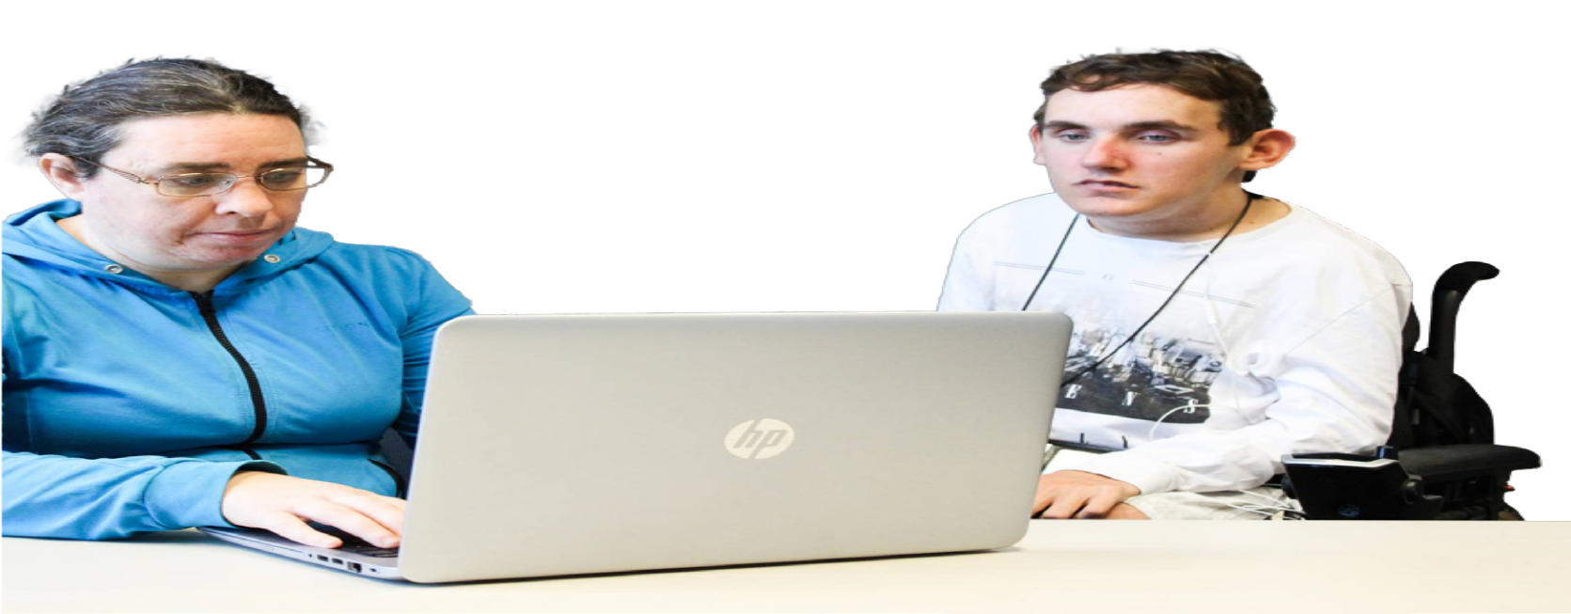
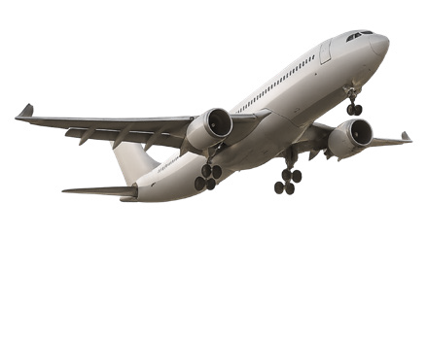




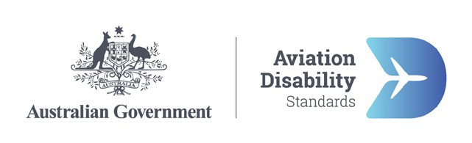

Better air travel for people with disability—2. Planning and booking

About this information
This information is about new air travel rules to support people with disability.
Air travel is when people
- Book plane tickets
- Go through airports
- Get on and off planes
- Fly on planes.
The government wants to make new rules so air travel is better for people with disability.
This information has ideas for how air travel could be better for people with disability at the airport.
The government wants to hear what you think of the ideas.

What people told us
Air travel can be hard and stressful for people with disability.
People with disability might need information before they can book like
- How to take a wheelchair on the plane
- Travelling with a carer.
Sometimes this information can be hard to find.
Next we will look at the ideas to make planning and booking easier for people with disability.

Idea 1

Set up passenger assistance profiles
People with disability say that airlines could have a passenger assistance profile for people who need support for air travel.
We will say profile for short.
The profile could have information about what support you need when you travel by plane.
An airline can keep this information but only if you say yes to it.
Airlines are businesses that own and fly planes.
The profile could save you time when you book another flight. This is because the airline already has your information.

Idea 2

Limit wheelchairs only sometimes
Sometimes airlines have a limit for how many people can have wheelchair support.
A limit means how many people who need support with a wheelchair can get on a plane.
One idea is that airlines should only have a limit if having more people could
- Make the plane not safe
- Make problems for flying the plane.

Idea 3

Airlines must give support if they are told early
People with disability say airline staff should give you support if you tell them 2 days before your flight.
The airline must tell you in writing what support they will give you.

Idea 4

Pay the same price no matter how you book
People with disability say booking over the phone should not be the only way to book.
They should also be able to book in other ways like
- Online
- In person.
People with disability should pay the same price no matter how they book.

Idea 5

Be clear about how to travel with assistance animals
Some people with disability have an assistance animal.
Assistance animals are animals with special training to support people with disability.
People with disability say they want airlines to give the rules about assistance animals in a clear way.
When you ask the airline if you can bring an assistance animal, they must tell you in a set time like in 2 days.
The answer must be in a way that you can understand like
- Easy Read
- Using large letters
- By email or on the phone.
The rule right now is that you must check in at the airport if you have an assistance animal.
Check in means you let the airline know you are coming for the flight.
People with disability say that you should be able to check in online even if you have an assistance animal.
It must always be ok for your assistance animal to travel in the cabin with you.
The cabin is the inside part of the plane where people sit.
On long flights you may have to bring things like poo bags for your assistance animal.
The airline must give you a way to throw them away.

Idea 6

Be clear about how to travel with dangerous goods
People with disability say all airlines should ask the same questions about disability aids that could be dangerous goods.
Disability aids are things that support you with your disability like a wheelchair.
Dangerous goods are things that might not be safe on planes.
This can be things like wheelchair batteries that might catch fire on a plane.
The rules now say that you must ask an airline before you travel if you can take something that might be a dangerous good.
People with disability want airlines to tell you in 2 days if you can take it on the plane or not.

Idea 7

Make it free to travel with disability aids
People with disability say it should be free to take disability aids and medical equipment on the plane.
They should not count these things as part of your baggage. Airlines must tell you in a clear way
- Which disability aids you can bring
- How big and heavy things can be to go in the cabin
What things you need to ask the airline about before you bring them on the plane.

Idea 8

Be clear about how to travel with carers
People with disability say that airlines should not make you travel with a carer, unless you cannot travel on your own.
If you travel with a carer your carer must be able to sit next to you.
Airlines must let you change information about your carer for free.
This might be their name in case a different carer travels with you.

Idea 9

Be clear about when you can be asked for a medical certificate
Sometimes airlines might ask you for a medical certificate.
A medical certificate is a letter from your doctor about your disability or health issue.
People with disability say that airlines should only ask you for a medical certificate if you
- Need medical support to fly in a safe way
- Need medical oxygen during the flight
- Travel using things like a stretcher or incubator.
Medical oxygen is extra air that helps you breathe. You might get it from the airline or bring it in a small machine.
A stretcher is a bed used to carry someone who can not sit up.
An incubator is a special clear box that keeps a baby warm and safe.

Idea 10

Give clear information about accessibility before booking
People with disability say that airlines and airports should give clear information about accessibility.
Accessibility means how easy it is for everyone to get around or use something.
Information about accessibility will help people with disability plan before they book.
The information should have things like
- How big and heavy disability aids can be on each plane
- How many wheelchairs are safe to have on a plane
- How to find your way at the airport
- Disability aids or parts of them that are dangerous goods
- Booking rules like who can sit in an exit row.

Idea 11

Give booking information in different ways
People with disability say that airlines and airports should give booking information in different ways like
- Auslan videos
- Easy Read
- Braille
- Social stories
Auslan is sign language used by people who are deaf or have trouble hearing.
Braille is writing with small bumps that you read with your fingers.
Social stories are short stories with pictures that help you know what to do.
Booking websites could also have a button to make them easy to use.

Idea 12

Share flight changes in different ways
Airlines should tell you about flight changes in ways that are easy to read and use.
This also means information like
- If the new plane can take you and your disability aids
- How to get support to change your booking.

Idea 13

When an airline says no to travel
People with disability say airlines should tell you why you or your disability aids cannot travel on their plane.
The airline must tell you about other planes you can take to the same place.
They must offer to
- Book you on a new plane for the same price or less
- Give you your money back if another plane cannot take you.

Idea 14

You choose the best seats for your needs
When you tell the airline about your disability they should tell you
- Which seats might be best for what you need
- Which of these seats you can still get for the price you paid.

Easy Read information about other ideas
You can also read other Easy Read information about ideas to make air travel easier for people with disability.
You can read about ideas for
- Why we need new rules for air travel
- The plane trip from start to finish
- At the airport
- Flying on a plane.
To read these you can go to
www.infrastructure.gov.au/Aviation-Disability-Standards.

Have your say
You can have your say on the ideas for new air travel rules. To have your say you can
- Send us an email to AviationAccessibility@infrastructure.gov.au
- Call us on 1800 621 372
- Go to our Have Your Say website at
www.infrastructure.gov.au/Aviation-Disability-Standards
The Have Your Say website is not in Easy Read.

Who did this Easy Read
CID made this information for the Australian Government.
The pictures we use are copyright. Copyright means you need to ask CID if you want to use the pictures.
You can email CID at business@cid.org.au
To read more about how we do Easy Read at CID you can go to our website at www.cid.org.au/inclusion-services

