


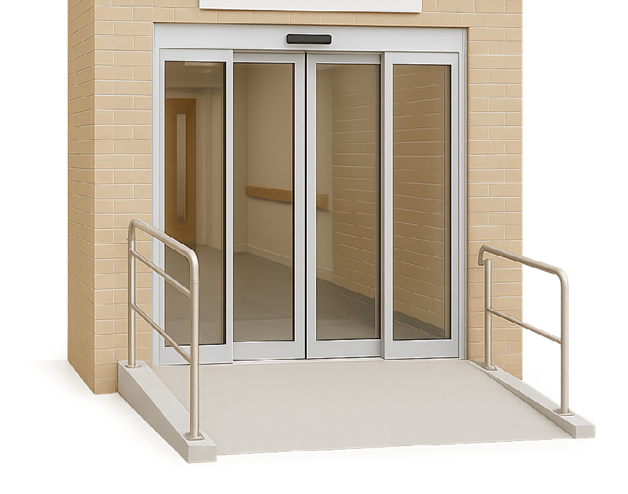
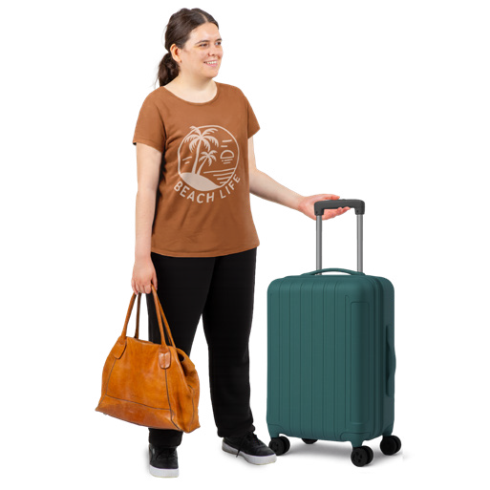

Better air travel for people with disability—
1. The whole trip

About this information
This information is about new air travel rules to support people with disability.
Air travel is when people
- Book plane tickets
- Go through airports
- Get on and off planes
- Fly on planes.
The government wants to make new rules so air travel is better for people with disability.
This information has ideas for how air travel could be better for people with disability from
- When they book their trip
- To the end of their trip.
The government wants to hear what you think of the ideas.

What people told us
People with disability told us there are lots of hard things when they use air travel.
They said there are hard things
- When they book their trip
- At the airport
- When they are on the plane.
People with disability want airport terminals and planes to be easy to get to and use.
People with disability want information about what will happen when they use air travel.
They want airline and airport staff to learn how to support them.
Airlines are businesses that own and fly planes.
Next we will look at the ideas to make air travel better from the start to the end.

Idea 1

Make it clear who gives support
It is not clear if the airport or airline should give support to people with disability.
The government has ideas to make this more clear.
One idea is for airlines and airports to agree which parts of the trip they will support people with disability.
This means airports would support people with disability from when they get to the airport to when they check in for their flight.
Check in is the place where you tell the airline you are at the airport and ready to fly.
Airlines would then support people with disability from check in to the end of the trip when they pick up their bags.
Another idea is for just the airline staff or just the airport staff to give all the support.

Idea 2

Make sure staff know how to support people with disability
People with disability said more airline and airport staff should have training to support people with disability.
One example is that staff must learn how to move a person with a mobility aid in a safe and kind way.
A mobility aid is something you use to support you to move around like a wheelchair or walking frame.
People with disability say that staff need to learn how to take apart and put together mobility aids.
Airports and airlines should also share information about their training if you ask.

Idea 3

Set up a group of people with disability
People with disability say that airlines and airports should set up a group of people with disability.
The group would be called a reference group.
Airports and airlines would ask the reference group about big changes they want to make.
The people with disability would say what they think about the changes.

Idea 4

Share information
People with disability say that airlines should share information every year like
- How many mobility aids were broken or lost
- How many staff got training and what they learned
- How many times people with disability were told they can not get on the plane
- How many support animals they do not let on the plane
- How many complaints they got from people with disability.
Complaints are when you tell the airline you are not happy with something.
Airlines and airports should say how they are following the new air travel rules.

Easy Read information about other ideas
You can also read other Easy Read information about ideas to make air travel easier for people with disability. You can read about ideas for
- Why we need new rules for air travel
- Planning and booking a plane trip
- At the airport
- Flying on a plane.
To read these you can go to
www.infrastructure.gov.au/Aviation-Disability-Standards

Have your say
You can have your say on the ideas for new air travel rules.
To have your say you can
- Send us an email to AviationAccessibility@infrastructure.gov.au
- Call us on 1800 621 372
- Go to our Have Your Say website at
www.infrastructure.gov.au/Aviation-Disability-Standards
The Have Your Say website is not in Easy Read.

Who did this Easy Read
CID made this information for the Australian Government.
The pictures we use are copyright. Copyright means you need to ask CID if you want to use the pictures.
You can email CID at business@cid.org.au
To read more about how we do Easy Read at CID you can go to our website at www.cid.org.au/inclusion-services

