

Emissions Reduction Plan 2025
October 2025

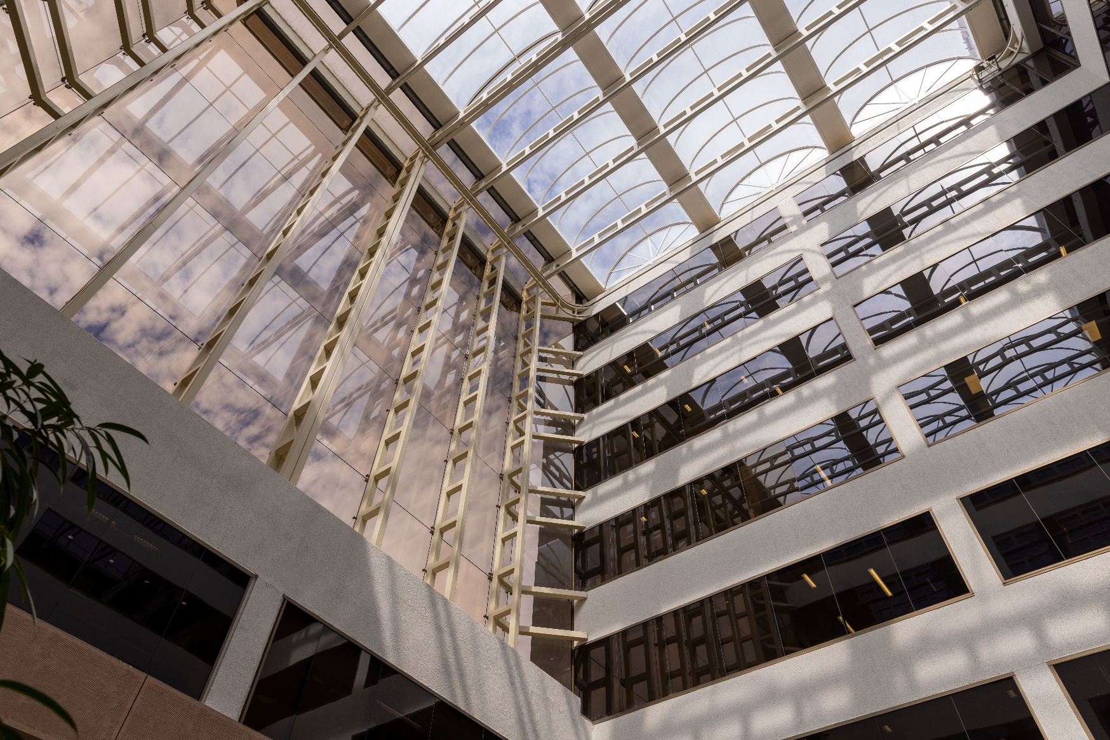

Acknowledgement of Country
We acknowledge the Traditional Custodians of the lands where we work and live. From the desert to the high Country, connecting to our beaches and sand, through the snow, the rivers and saltwaters, in our cities, the bush and islands, we reflect, respect, and celebrate the unique and diverse communities we serve. We walk with Aboriginal and Torres Strait Islander peoples, celebrating the oldest continuing living cultures in the world — listening, learning, and yarning, to understand the past and work as one towards an inclusive future. We pay our respects to all Elders past and present. We are committed to creating positive change and promoting meaningful reconciliation.

Table of Contents
Acknowledgement of Country 2
Accountable Authority Sign Off 4
Emissions Reduction Plan 5
Purpose 5
Net zero greenhouse gas emissions 5
Governance and reporting 5
DITRDCSA Operational context 6
Baseline emissions 7
Engagement 7
Emissions reduction targets 7
Priorities and actions 8
Buildings 9
Electricity 11
Fleet and Travel 12
Territories 13

Accountable Authority Sign Off
The Australian Government released the Net Zero in Government Operations Strategy in November 2023, setting out the overall approach and action required by Commonwealth entities to achieve the APS Net Zero 2030 target.
The Net Zero in Government Operations Strategy represents a strong commitment by the Australian Government to lead by example on emissions reduction and contribute to the decarbonisation of Australia’s economy.
The Department of Infrastructure, Transport, Regional Development, Communications, Sport and the Arts is committed to the achievement of the Government’s APS Net Zero 2030 target. The Department of Infrastructure, Transport, Regional Development, Communications, Sport and the Arts is following the APS Net Zero 2030 target in full, as per the Net Zero in Government Operations Strategy.
This Emissions Reduction Plan describes the priorities and actions Department of Infrastructure, Transport, Regional Development, Communications, Sport and the Arts is taking to reduce our operational emissions and contribute to the APS Net Zero 2030 target.



SIGNED BY ACCOUNTABLE AUTHORITY

Emissions Reduction Plan

Purpose
The Department of Infrastructure, Transport, Regional Development, Communications, Sport and the Arts (DITRDCSA) has a strong commitment to managing and implementing emissions reduction initiatives set by the Australian Government’s Net Zero in Government Operations Strategy (the Strategy). The Strategy sets out the Australian Government’s approach to achieving net zero greenhouse gas emissions from its operations by 2030 and the reinstatement of public emissions reporting.
The Emissions Reduction Plan (ERP) provides a pathway for the department to contribute to the achievement of the APS Net Zero 2030 target through emissions reduction activities.
This ERP has been completed in accordance with the Strategy, associated guidance and reporting standards for annual emissions reporting.

Net zero greenhouse gas emissions
APS Net Zero 2030 is the target set by the Australian Government to achieve net zero greenhouse gas emissions from government operations by 2030. It includes scope 1 (direct emissions that the department burns directly, e.g. fuel and gas for its facilities and fleet) and scope 2 (indirect emissions - electricity) emissions from activities in Australia and its territories, as described in the Strategy. The APS Net Zero 2030 target applies at the aggregate level to non-corporate Commonwealth entities and generally covers the entirety of the entity’s organisation. From an organisational perspective, this means minimising the greenhouse gas emissions that are within our control.

Governance and reporting
After initially reporting in September 2024, the department will undertake an annual revision that outlines the progress against actions identified, and encompasses existing and new priorities and actions within the department that aims to reduce emissions. Key updates to the Plan will be included in the department’s Commonwealth Climate Disclosure (CCD) statements as part of the annual reports. Both the ERP and the annual emissions reporting, will be used as a measure of the department’s progress towards reducing emissions and contributing to the APS Net Zero 2030 target.
As part of the Net Zero in Government Operations Annual Progress Report, the Department of Finance will aggregate these measures to provide whole-of-Australian Government (WoAG) emissions reporting.

DITRDCSA Operational context
The department impacts the economic and social wellbeing of Australia. With its diverse portfolio, the department works with partners to enable connected, productive, safe, sustainable and culturally vibrant communities in our cities, regions and territories to improve the lives of Australians.
More information about the department can be found in our Corporate Plan.
People
The department’s workforce of 2,356 staff (as of 30 June 2025) is predominantly based in Canberra, however our footprint across Australia continues to grow with over 22% of our staff now working in other capital cities, regional areas, and non-self-governing territories.
Buildings and facilities
Currently, the department operates nationally with its built facilities (excluding the non-self-governing external territories) including 15 commercially leased office spaces, two combined office/warehouses, one warehouse, and two storage leases with a total net lettable area (NLA) of 48,407m². Excluded sites include six commercial offices and six sub-leased work-points which are all under MoU hosting agreements.
The department is undertaking an office consolidation project, working towards the four Canberra offices relocating into an office precinct of two buildings in 2026–27. This is intended to optimise site operations, reduce emissions resulting from activities including energy consumption, water consumption, waste generation, and reduce work point redundancy. At the time of finalising this Plan, the department has secured the first building for the Canberra precinct, and is currently negotiating the lease for the second building.
Energy
Our mainland office sites use multiple sources of energy. Electricity is obtained through direct arrangements with suppliers, supply through landlords, and participation in WoAG electricity supply arrangements.
Vehicle fleet and travel
The department has a small fleet (excluding territories operations) consisting of three electric vehicles, one hybrid, a transit van and one combustion engine passenger vehicle in a remote area.
All of the department’s travel is undertaken in line with the whole of Australian Government (WoAG) travel arrangements administered by the Department of Finance. Official travel must only be undertaken where other communication tools, such as teleconferencing and videoconferencing are not an effective option.
Territories
The department provides governance and essential services to Australia’s non-self-governing territories. This includes providing essential infrastructure, and funding and delivering services through direct service provision and service delivery arrangements with state, local and private partners to residents of the external territories (Norfolk Island and the Indian Ocean Territories) and the Jervis Bay Territory.
The department owns a varied portfolio of assets across the territories and oversees complex governance arrangements over infrastructure and operations. For these reasons, the department’s sphere of influence over emissions reductions is dependent upon its level of operational control and funding limitations.

Baseline emissions
Baseline emissions are a record of greenhouse gases that have been produced in the past and were produced prior to the introduction of any strategies to reduce emissions. The baseline emissions from financial year 2022–23 are the reference point against which emissions reduction actions can be measured.
The baseline emissions for this plan focus on scope 1 and scope 2 emissions, consistent with the APS Net Zero 2030 target. Electricity-related emissions were calculated using the location-based method. The 2022–23 greenhouse gas emissions inventory tables for the department’s mainland operations are presented in our 2022–23 annual report.
Baseline year | Financial year 2022–23
Scope 1 emissions | 11 tCO₂e
Scope 2 emissions | 2,229 tCO₂e
Scope 3 emissions (transmission and distribution losses for electricity and fuels) | 187 tCO₂e
Total emissions | 2,427 tCO₂e

The department’s current emissions reporting does not include emissions from the non-self-governing territories due to the limited data available. However, steps have been undertaken to establish the baseline emissions from the territories’ operations.

Engagement
In the development of this plan through its annual review, the department has engaged with both internal and external stakeholders. This is to ensure that the updated list of actions has been confirmed in consultation with relevant business areas across the department, and the plan aligns with the Net Zero in Government Operations Strategy.

Emissions reduction targets
The department is committed to achieving the APS Net Zero 2030 target as per the Net Zero in Government Operations Strategy. Over the next 12 months, the department will continue building on its priorities and actions identified in this plan to drive emissions reduction across operations. As the department matures in its actions and data, it will develop more robust emissions estimations which, in turn, will inform our reporting in future iterations of the ERP.
In alignment with the Australian Government Emissions Reporting Framework, the department has made progress toward integrating our external territories in the APS Net Zero target. The department will work towards reducing emissions in external territories operations while acknowledging significant challenges facing it in achieving net zero by 2030. Complexities include data limitations, technology constraints, unique logistical and operational environments, and significant budget requirements. Recognising that emissions reduction measures can potentially deliver co-benefits for adaptation and resilience building, the department will aim to identify cost-effective and impactful action opportunities to address our territories emissions and synergise approaches to mitigation and adaptation where possible.

Priorities and actions
While the department anticipates that offsets may need to be mobilised to address hard-to-abate emissions, our primary focus is to maximise emissions reduction through both WoAG and the department-led measures. For the department to contribute to the achievement of the APS Net Zero 2030 target, targeted actions on existing emissions reduction measures and the introduction of further or new measures is required.
In alignment with the Net Zero in Government Operations Strategy, the department’s priority action themes target both the areas of greatest emissions and the areas offering the biggest opportunities to improve our performance:
- Buildings
- Energy
- Travel and fleet
- Territories.
Acknowledging the importance of creating a climate conscious culture in our organisation to sustain impactful climate action, the department will be also focused on:
- supporting and empowering our staff to embed climate action and sustainability into their work
- continuously improving our data availability and quality to ensure more accurate reporting and monitoring of our progress and evidence-based decision making.
The detailed actions for this ERP are listed in the table below.

Buildings
Action No. | Action description | Action lead and support | Timeframe | Delivery status | Progress Summary
1.1 | Establish and run an Emissions Reduction Plan Working Group that comprises business units across the department responsible for leading and/or supporting ERP actions to coordinate delivery, share knowledge, and grow collective capability. | Climate and Sustainability, Integrated Services Branch | 2025-2029 | In progress | Established working group that meets bi-monthly
1.2 | Undertake annual tenancy NABERS Energy ratings for leased office properties with a net lettable area (NLA) of >1,000m² and implement improvement measures where needed, achieving a minimum 5.5-star rating for metropolitan sites and 4.5-star rating for regional sites. | Lead: Property, Integrated Services Branch  Support: Future Workplace Canberra | 2024-2029 | In progress | Undertook NABERS assessments for 3 sites with one achieving 5 star, one 5.5 star, and one 6 star  Included a positive obligation in the new leases of the Canberra precinct for the landlord to ensure achievement of 5.5 NABERs rating for the base building 15 months following the occupancy
1.3 | Implement Green Lease Schedules (GLS) for all new leased office properties with an NLA of >1,000m² and minimum 4-year lease term. | Lead: Property, Integrated Services Branch  Support: Future Workplace Canberra | 2025-2029 | In planning | Ensured inclusion of a GLS for the new leases of the Melbourne building and the Canberra precinct
1.4 | Prefer all-electric building options for new leases, and ensure transition plans in place where needed, to achieve all-electric building portfolio. | Lead: Property, Integrated Services Branch  Support: Future Workplace Canberra | 2024-2029 | Completed and ongoing | Embedded the requirement into the departmental leasing processes  Entered two new leases for Townsville and Perth with all electric tenancy energy  Made arrangements with the landlord to transition the Perth office to all-electric base building prior to 2030  Building 1 of the Canberra precinct will be able to achieve the required all-electric target by 2037. This timeline is rationalised due to the newly installed gas boiler at the building and it is not the best practice for reducing emissions to dispose of it before reaching its economic life cycle  Building 2 of the Canberra precinct is currently a fully electrified building
1.5 | Investigate and ensure all new office spaces >1,000m² purchased, leased, constructed, or refurbished have separate electricity metering (where practical) or implement separate digital revenue metering where the department occupies 50% or more of the total building. | Lead: Property, Integrated Services Branch  Support: Future Workplace Canberra | 2024-2029 | Completed and ongoing | Embedded the requirement to the departmental leasing processes  Ensured the two new leases for Townsville and Perth have separate metering  Ensured both buildings of the Canberra precinct have separate metering
1.6 | Implement EV charging in accordance with the department’s EV Plan 2024. | Lead: Property, Integrated Services Branch  Support: Future Workplace Canberra | 2025-2029 | In progress | Applied preference for new leased premises to include EV charging where the department has fleet vehicles  Ensure EV charging points to be installed at both new Canberra office buildings
Action No. | Action description | Action lead and support | Timeframe | Delivery status | Progress Summary
1.7 | Undertake Type-2 Energy Audits at sites identified as having high energy intensity or not meeting the required NABERS Energy rating and use the audits to identify energy efficiency solutions for consideration. | Property, Integrated Services Branch | 2025-2029 | Not started | N/A
1.8 | New office fit-outs are to include high efficiency LED, coupled with lighting control sensors such as daylight sensors and occupancy sensors (where applicable). Consideration should be given to upgrading existing lighting at lighting end of life upgrades. | Lead: Property, Integrated Services Branch  Support: Future Workplace Canberra | 2025-2029 | Not started | New LED lighting installed at both buildings of the Canberra precinct with sensor controls in place for the offices and meeting rooms. Sensory areas with low light to be included in the new fit-out
1.9 | Maintain existing end of journey facilities for cyclists and investigate opportunities to improve end of journey facilities in new builds to support low/no emissions staff commute. | Lead: Property, Integrated Services Branch  Support: Future Workplace Canberra | 2024-2029 | Completed and ongoing | Maintained and enhanced existing end of trip facilities in current buildings  Incorporated end of trip requirements as part of the Request for Proposal for new leases
1.10 | Implement best practice waste management systems across the whole property portfolio by:  1.10a Integrate best practice waste management systems where possible in new leases. | Lead: Property, Integrated Services Branch  Support: Future Workplace Canberra | 2024-2029 | In planning | Engaging removalist for the Canberra Precinct relocation process such as waste disposal and taking the consideration of the requirements
1.10 | 1.10b Implement recommendations of the 2023 waste audit report on the department’s two major sites. | Property, Integrated Services Branch | 2024-2029 | Not started | No major progress
1.11 | Consider, promote, and implement waste reduction measures where feasible within the department’s property portfolio by:  1.11a Adopting sustainability principles and practices in managing office fit-out waste. | Property, Integrated Services Branch | 2024-2029 | In progress | No major progress
1.11 | 1.11b Considering and implementing organics collections, single use coffee cup recycling systems, small battery recycling, and partnership with local charities for ad-hoc collection services of donatable items. | Property, Integrated Services Branch | 2024-2029 | In progress | Installed coffee cup recycling facility in the Brisbane office
1.11 | 1.11c Adopting good waste management practices in the Canberra office consolidation project, including reducing office shredding machines, ensuring sustainable disposal of confidential paper and redundant furniture and equipment. | Future Workplace Canberra, Integrated Services Branch | 2024-2027 | In progress | Planned to reduce the shredding machines at the Canberra precinct buildings as a result of footprint reduction
1.11 | 1.11d Promoting waste minimisation such as encouraging staff to reduce printing. | Climate and Sustainability, Integrated Services Branch | 2025-2029 | Not started | N/A
1.12 | 1.12a Implement office consolidation and optimisation planning in the Canberra sites to reduce redundant, unused office facilities. | Future Workplace Canberra, Integrated Services Branch | 2024-2027 | In progress | This is one of the project goals for Future Workplace Canberra and will be achieved through the fit-out
 | 1.12b Investigate optimisation options in other sites across the property portfolio based on work point occupancy rates. | Property, Integrated Services Branch | 2025-2029 | Not started | N/A

Electricity
Action No. | Action description | Action lead and support | Timeframe | Delivery status | Progress Summary
2.1 | Participate in the WoAG Green Power purchase scheme to procure renewable sources for the department’s properties. | Property, Integrated Services Branch | 2024-2029 | In progress | No major progress

Fleet and Travel
Action No. | Action description | Action lead and support | Timeframe | Delivery status | Progress Summary
3.1 | Set a target of 75% of all new passenger fleet vehicles procured by 1 Jul 2025 to be low emissions vehicles.  Apply fuel efficiency criteria to the purchase and lease of new vehicles where electric or hybrid options are not commercially or operationally viable. | Financial Operations, Financial Management Branch | 2025-2025 | Completed and ongoing | Achieved 100% of the department’s new passenger vehicles ordered being LEVs since the release of the Net Zero in Government Operations Strategy in November 2023
3.2 | Promote, encourage, and support staff to adopt sustainable and active transport modes for both work commute and business travel through induction programs for new staff, internal communications, and possible employee incentive options. | Climate and Sustainability, Integrated Services Branch | 2024-2029 | In progress | Provided information to staff to support sustainability behaviour, including transport information about salary sacrifice for e-bikes and the green vehicle guide
3.3 | Ensure a continued transition of all the departmental fleet to low/zero emissions fleet as they are retired. | Financial Operations, Financial Management Branch | 2024-2029 | Completed and ongoing | Changed the composition of the department’s fleet to a more emission friendly profile as new LEV orders replaced retiring fleet
3.4 | Prepare sites to include required EV charging infrastructure to enable the transition to an electric fleet, and enable installations of EV charging infrastructure in accordance with the Electric Vehicle Charging Plan 2024. | Property, Integrated Services Branch | 2025-2029 | Not started | Applied preference for any new leased premises to include EV charging where the department has fleet vehicles
3.5 | Explore fleet optimisation opportunities by reviewing and monitoring vehicle utilisation, fuel consumption and emissions data. | Lead: Climate and Sustainability, Integrated Services Branch  Support: Financial Operations, Financial Management Branch | 2025-2029 | In planning | No major updates
3.6 | Identify and implement measures to encourage sustainability in corporate travel, and continue implementing rationalisation and guidelines to reduce needs for air travel, accommodation, and car hire. | Lead: Financial Operations, Financial Management Branch  Support: Climate and Sustainability, Integrated Services Branch | 2025-2029 | In progress | Implemented measures including limiting travel to only essential purposes, and requiring division head endorsement on interstate travel prior to booking  The department is bound by the WoAG travel arrangements. These are currently being reviewed and any measures relating to sustainability will be implemented
3.7 | Investigate options to offset the department’s emissions from corporate flights | Lead: Climate and Sustainability, Integrated Services Branch  Support: Financial Operations, Financial Management Branch | 2026-2027 | Not started | N/A

Territories
Action No. | Action description | Action lead and support | Timeframe | Delivery status | Progress Summary
4.1 | Determine and verify the operational control for Territories emissions on an asset-by-asset basis. | Lead: Climate and Sustainability, Integrated Services Branch  Support: Governance and Finance, Territories Enabling Service Branch | 2025-2027 | In progress | Collected and cleaned the asset data of the external territories
4.2 | Establish an emissions inventory for the operations within the Territories to inform a targeted approach to emissions reduction. | Lead: Climate and Sustainability, Integrated Services Branch  Support: Governance and Finance, Territories Enabling Service Branch | 2026-2027 | Not started | N/A

