

Norfolk Island Ports Strategy
  - Draft for public consultation - does not represent government policy
June 2026

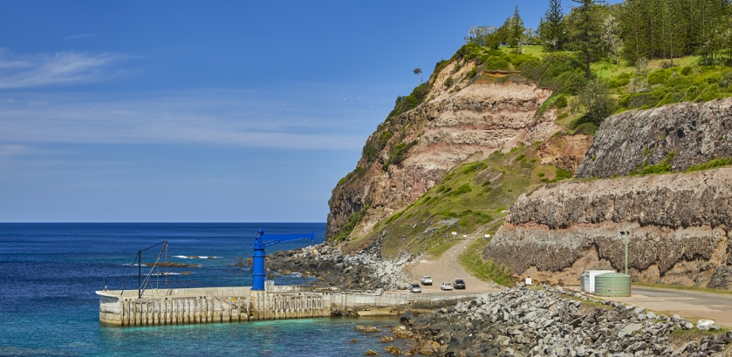

© Commonwealth of Australia 2026
Ownership of intellectual property rights in this publication
Unless otherwise noted, copyright (and any other intellectual property rights, if any) in this publication is owned by the Commonwealth of Australia (referred to below as the Commonwealth).
Disclaimer
The material contained in this publication is made available on the understanding that the Commonwealth is not providing professional advice, and that users exercise their own skill and care with respect to its use, and seek independent advice if necessary.
The Commonwealth makes no representations or warranties as to the contents or accuracy of the information contained in this publication. To the extent permitted by law, the Commonwealth disclaims liability to any person or organisation in respect of anything done, or omitted to be done, in reliance upon information contained in this publication.
Creative Commons licence

With the exception of (a) the Coat of Arms; (b) the Department of Infrastructure, Transport, Regional Development, Communications, Sport and the Arts photos and graphics; (c) content supplied by third parties; (d) content otherwise labelled; copyright in this publication is licensed under a Creative Commons BY Attribution 4.0 International Licence.
Use of the Coat of Arms
The Department of the Prime Minister and Cabinet (PM&C) sets the terms under which the Coat of Arms is used. Please refer to the Commonwealth Coat of Arms Information and Guidelines | PM&C.
Contact us
This publication is available in PDF format. All other rights are reserved, including in relation to any departmental logos or trademarks which may exist. For enquiries regarding the licence and any use of this publication, please contact:
Email: ni.shipping@infrastructure.gov.au
Website: https://www.infrastructure.gov.au/have-your-say/draft-norfolk-island-port-strategy

Table of Contents
1. Purpose and status of this strategy 5
2. Strategic context and problem definition 5
2.1 Overview 5
2.2 Background 6
2.3 Existing ports and shipping arrangements 6
2.4 Sustainable infrastructure 8
2.5 Port management 9
3. Vision and long-term outcomes 10
4. Operating environment and constraints 12
4.1 Cascade Reserve 12
4.2 Marine Parks 12
4.3 Biosecurity 13
4.4 Search and rescue 14
4.5 Work Health and Safety 14
5. Scope and strategic assumptions 16
6. Strategic principles and investment logic 17
6.1 Strategic principles 17
6.2 Investment logic 17
6.3 Application of principles to infrastructure and operations 18
7. Preferred port system, roles, and settings 19
7.1 Existing infrastructure and assets 19
7.2 Shipping operations 23
8. Demand and Freight task 25
8.1 Containerised freight task 25
8.2 Tourism 28
9. Governance, management and regulatory framework 29
9.1 Port management 29
9.2 Biosecurity 31
10. Phased investment framework 33
10.1 Phase 1: Enabling foundations (short term actions) 37
10.2 Phase 2: Capacity and efficiency uplift (mid-term actions) 38
10.3 Phase 3: End-state port capability (aspirational, long-term actions) 40
11. Strategy outputs and next steps 42
Document Control 42
Appendix A – History of Norfolk Island Ports 43

List of Figures and Tables
Table 1 Recognised port facilities at Norfolk Island 6
Figure 1 Three existing port locations, Norfolk Island (Imagery Source: ESRI World Imagery) 8
Figure 2: Photo of Cascade Pier in the background including the fisherman’s crane on the left and blue crane and infrastructure in the foreground including the desalination plant, historic whaling station and PTV (2025) 19
Figure 3: The Fisherman’s Crane (left) and the Blue Crane (right) located on Cascade Pier at Norfolk Island 20
Figure 4: Cascade Reserve Boundary (Source: ERM (Environmental Resource Management)) 21
Figure 5: Extent of works under the Cascade Apron raising project 22
Figure 6: location map of Kingston Pier at Norfolk Island (Source: Google Earth 2020) 22
Table 2: Freight volumes over the last 5 years, proved by provided by NIRC (April 2025) 25
Table 3: Summary of port operational aspects based on mode of handling 27
Table 4: Total of passengers to visit Norfolk Island from Cruise suites over the last 5 years, provided by Norfolk Island Regional Council 28
Table 5: Summary of Phased Strategy Outcomes 41

Purpose and status of this strategy
The Norfolk Island Ports Strategy sets out the long-term strategic direction for ports and sea freight servicing Norfolk Island. It establishes a clear vision for how port infrastructure, freight handling and governance arrangements must evolve over time to support safety, reliability, economic sustainability and supply chain resilience for the island community.
Achieving this vision will require a sustained, long-term commitment to staged and complementary improvements. The strategy builds on existing port infrastructure and projects already underway, while identifying additional enabling actions required to progressively lift Norfolk Island’s port capability to contemporary standards. This approach recognises the island’s unique operational, environmental and heritage constraints and the need to sequence investment carefully over time.
To support this, the strategy adopts a phased delivery framework aligned to short-, medium- and aspirational long-term outcomes. The phased approach will assist decision-making, prioritisation and sequencing of future investment, rather than commit government to specific projects or timeframes. Detailed scope, cost and delivery arrangements for individual initiatives will be developed through subsequent business cases and project planning processes, subject to funding approval.
A key function of this strategy is to provide the strategic rationale and supporting evidence to inform future government investment decisions. It identifies priority areas for investment to upgrade port infrastructure, strengthen port governance and management arrangements, and ensure compliance with Australian legislative and regulatory requirements, including biosecurity, safety and security standards. In doing so, the strategy establishes a clear and credible foundation for future funding bids and detailed project development.
This strategy was prepared by the Commonwealth and was subsequently subject to technical review by GHD who provided specialist civil ports management advice to ensure the strategy is robust, technically, and legally sound, and appropriately addresses matters such as border functions, security, work health and safety, and other regulatory requirements.

Strategic context and problem definition
This section provides a short summary of the baseline situation at Norfolk Island. Further detail on the site settings, constraints and operational situation is found in Section 4 and Section 7.

2.1 Overview
Norfolk Island’s remote location and exposure to a challenging marine environment means that maritime access is inherently constrained and reliability is dependent on weather, sea state and the available port infrastructure.
The Island’s current port system does not provide a sheltered harbour or consistent access, resulting in an operating model that relies on offshore anchorage and ship-to-shore transfer using Cargo Transfer Vessels (CTVs). This strategy responds to long-standing concerns raised by the Norfolk Island community, including through the 2022 Have Your Say consultation, and sets an aspirational, long-term direction for how port infrastructure, freight handling arrangements and governance must evolve to lift safety, improve reliability, strengthen supply chain resilience and support the Island’s economic sustainability.
This strategy seeks to address two fundamental issues:
- Ensuring a safe and efficient port facility through effective governance and security arrangements
- Constraints on shipping and cargo handling that Norfolk Island faces, mainly due to low volumes and basic port infrastructure.

2.2 Background
As an island, shipping, transport, safe and efficient movement of freight and suitable port infrastructure are important to Norfolk Island. Port infrastructure facilitates the delivery of essential goods and services to the Norfolk Island community. Over the last 20 years there have been many studies and reviews undertaken and some port infrastructure upgrade works completed.
In November 2022, the Minister for Regional Development, Local Government and Territories, the Hon Kristy McBain MP, held a town hall meeting on Norfolk Island, supported by a Have Your Say process to seek community advice on sea freight. Community consultation identified Cascade as the most practical location for long-term port development. This strategy recognises Cascade as the preferred long-term port solution due to its location, existing infrastructure, favourable landside conditions and reasonable road access but recognises that Kingston, Ball Bay and inland facilities will continue to play their part in the near and medium term.

2.3 Existing ports and shipping arrangements
Currently there are three port locations identified on Norfolk Island – see Figure 1 and Table 1:
Table 1 Recognised port facilities at Norfolk Island
Port | Features | Role / function | Ownership | Constraints | Comment
Kingston | 180-year-old, ~150m long pier ~10m minimum width. Incorporates a 60T fixed crane | Preferred location for passenger arrivals. | DITRDSCA | Heritage controls, highly exposed to southerly / westerly weather patterns | Planned channel deepening and pier remediation works
Cascade | Narrow pier of ~ 40m length x 10m wide. 0.36Ha landside area used for stowage of CTV’s / barges. Incorporates a 35T Crane | Primary location for cargo exchange | DITRDSCA | Shallow berth pocket, highly exposed to easterly and northerly weather patterns | Pier extended in 2018.
Ball Bay | No berth – vessels anchor and transfer via flexible pipeline | Import of bulk fuels (incl. LPG) | NIRC | Steep road access, no berth structures, shallow nearshore area. Environmental values | Has been used for a temporary RoRo ramp in past
All three ports operate within the Norfolk Commonwealth Marine Park.
All maritime operations at Norfolk Island are highly constrained due to the high energy marine environment and vulnerability in certain weather conditions. The current settings require all vessels to operate offshore and interface with shore via lighterage, passenger transfer vessels, or pipelines.

Shipping
Cargo shipping is currently undertaken by the MV Norfolk which is an 80m length overall (LOA) landing craft fitted with a bow landing ramp and two small cranes (4 tonne capacity). The vessel is operated by NPDL with the service currently being exempt from Australian domestic shipping regulations meaning that it is legally permitted to carry cargo and passengers between the island and Australian mainland states or territories without requiring a temporary coastal trading license.
Although the use of shipping containers is now the default method of packaging and transporting goods by sea, Norfolk Island, using the MV Norfolk, is limited in its ability to handle containers. The vessel does not have crane capacity to lift 20-foot (20 ft) containers into the CTV (barges) and Norfolk Island’s basic port infrastructure does not allow the vessel to come directly alongside or dock to use its bow ramp. Consequently, cargo is moved in breakbulk form (refer Sections 4 and 7 for further information).
The two new lighterage cargo transfer vessels (CTVs), were procured with funding from the Australian Government. They have the capability to each carry an ISO 20 ft shipping container. The lighter vessels, built in Vietnam, became operational in early 2026.
Cruise arrivals involve small to mid-sized cruise ships that call as part of a regional calling itinerary. The ships anchor offshore, and transfer passengers using the ships own tenders or passenger transfer vessels (PTV’s) that are based on the Island.
Bulk fuel is delivered using small tankers. Fuel is transferred via a floating pipeline to onshore storage facilities.
The timeliness and reliability of shipping services to Norfolk Island are also critical to the island’s economic and social wellbeing. However, maintaining consistent scheduling remains challenging due to the difficulty of safely accessing port facilities during periods of inclement weather.
In parallel with reliability, service frequency is a key concern for the Norfolk Island community. Regular shipping services are essential to support the timely delivery of goods, as well as enabling local businesses to maintain adequate stock levels—particularly in preparation for peak periods. However, increasing service frequency typically comes at a higher cost, leading to an inherent trade-off between frequency and freight affordability.
Achieving an appropriate balance of port infrastructure that supports shipping service choice, reliability, and cost will therefore be central to developing a sustainable and effective strategy for Norfolk Island.

Operations
At Cascade, ships anchor a short distance from the pier and transfer cargo from containers that are retained on the vessels deck to the CTV’s (lighter barges) using the ship’s deck gear. The barges then shuttle cargo to the pier. The barges are unloaded using a mobile crane that is positioned on the pier during ship calls and operated by NIRC. In bad weather there are often delays to the start of the cargo unloading operations.
At Kingston, infrastructure supports smaller-scale and more variable maritime activity, including predominant access for tourism vessels, fishing vessels and government patrol craft (e.g. Australian Federal Police and other agency vessels) (though these vessels could also be serviced at Cascade in appropriate conditions). These vessels typically undertake alongside berthing where conditions permit or operate in a similar offshore transfer mode us during rough conditions.
At both port locations, cargo is handled using forklift trucks which move the cargo through designated bio-security check points prior to collection by public.
Across both locations, vessel–wharf interaction is rare and weather-dependent, with constrained craneage, limited deck space and manual handling processes shaping operational efficiency and safety. The lightering mode, and lack of unitized cargo reflects the lack of berthing options, driven by challenging meteorological and oceanographic conditions, lack of sheltered sites, and limited cargo handling capabilities on the MV Norfolk.
Cruise ship tenders, passenger transfer vessels (PTVs) and cargo transfer vessels (CTVs) further rely on favourable sea states to conduct safe embarkation via the limited interface points available at both Cascade and Kingston.
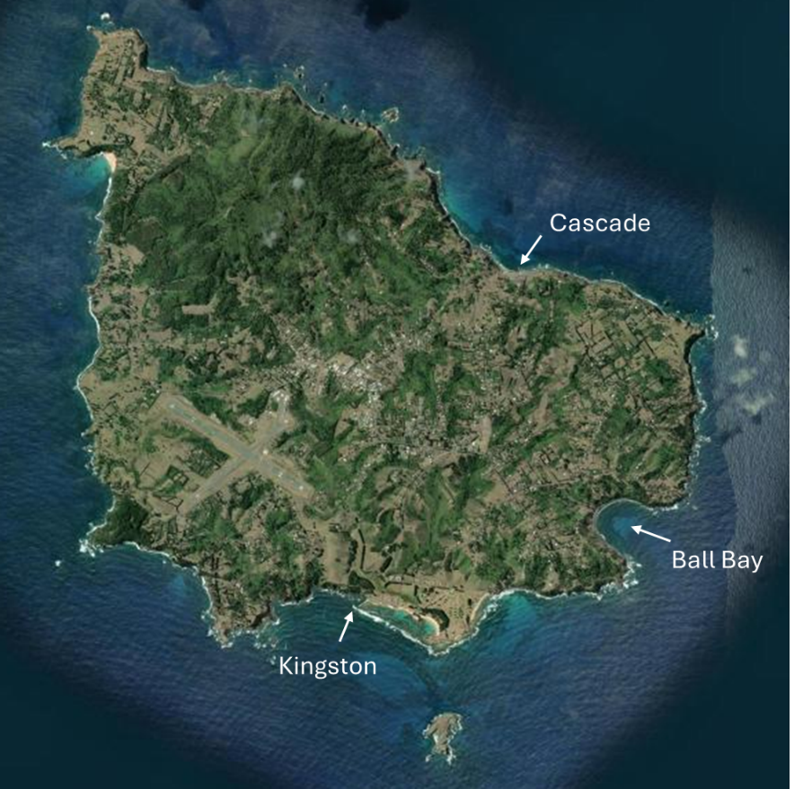
Figure 1 Three existing port locations, Norfolk Island (Imagery Source: ESRI World Imagery)

2.4 Sustainable infrastructure
Investment in port infrastructure at Norfolk Island is vital to the future of a reliable and cost-effective shipping service. The extent and sequencing of investment must be guided by:
- Sustainable solutions that support safer and more efficient marine and landside operations;
- the need to satisfy biosecurity and border requirements associated with FPOE status;
- the environmental and heritage settings, particularly at Cascade Reserve and Kingston and Arthur’s Vale Historic Area (KAVHA);
- adaptability to shipping systems, and cargo demand (for example, RoRo functionality and container handling arrangements as well as effective solutions for special projects);
- the need to preserve community and recreational access to port facilities when appropriate.
Future port and logistics planning for Norfolk Island should address both routine freight requirements and infrequent, high-impact events. A key example is the anticipated resurfacing of Norfolk Island International Airport’s runway between 2032 and 2035. This project will require the importation of heavy civil construction plant, specialised equipment, and large volumes of materials that cannot be safely or efficiently managed through existing freight handling arrangements.
Provision for heavy-lift vessel access—particularly via roll-on/roll-off (RoRo) systems—may play an important role in enabling such activities. A weather-protected rampway could further improve operational reliability, supporting both major project delivery and more regular freight movements through faster and more efficient container transfer. Considering these capabilities within the port strategy at an early stage will help reduce delivery risks, minimise potential project delays, and ensure the island’s infrastructure can support essential capital works when required.
However, development must remain flexible and proportionate. One-off heavy lift projects may also be delivered using temporary or alternative landing solutions, avoiding the risk that a permanent, high-cost ramp becomes underutilised or obsolete due to changes in shipping logistics or service models in the longer term.
Equally, because of the lack of established industry on the Island there are few exports. Waste removal therefore becomes a key issue that would benefit from a containerised solution as it has to be removed from Norfolk Island (including asbestos waste) on special sailings currently that add significant cost.
A clear and staged implementation roadmap is therefore critical. Near-term investments should be planned and designed to integrate with potential future upgrades, ensuring infrastructure outcomes are economically sustainable, safety-led, and appropriately scaled to Norfolk Island’s long-term needs.

2.5 Port management
On Norfolk Island, some basic port management functions are undertaken by Norfolk Island Regional Council (NIRC) as part of its Service Delivery Agreement (SDA) with the Australian Government, while other regulatory matters fall to the Minister appointed under the Norfolk Island Act 1979 Cth (the Minister) under the Norfolk Island Marine Safety Act 2013 (the Act) as there is no Port Authority or Harbour Master.
Council has a primarily operational role including; managing the use of the maritime ports; the loading and unloading of ships; and the use of the ports for commercial and recreational purposes but lacks system-wide marine safety oversight and enforcement capabilities. The absence of a dedicated Port Authority limits regulatory capability, revenue collection and consistent compliance with modern port management standards.
Port facilities on Norfolk Island are also not permanently secured, given the infrequency of sea freight deliveries, and are ordinarily open for community and tourist use at other times. On cruise and cargo days, the required port is closed off for traffic, and the operations are staffed by contractors or casual workers employed by the council.

Vision and long-term outcomes
Vision: Norfolk Island’s ports infrastructure and management enhances the islands economy, improves safety, reduces supply chain vulnerability and supports population needs sustainably to support long-term regional development and enhance emergency response capability.
The Norfolk Island Ports Strategy offers a clear framework for delivering on the vision for sea freight to the island. It is underpinned by short, medium and aspirational long-term outcomes, that are supported by staged and cost-effective investments.
The proposed investments are designed to achieve both immediate and incremental improvements that collectively provide longer-term gains for shipping on Norfolk Island including sustainable shippings costs, improved security, safety, and reliability.
This strategy builds on early work and incorporates stakeholder views, with actions being logical, and evidence based. Section 10 provides more information on how the actions identified throughout this strategy deliver on the vision and outcomes.
Short term
Norfolk Island will have enhanced maritime infrastructure and governance to support safer operations, regulatory compliance, and more efficient freight handling.
• Governance, planning and legislative framework supports long-term outcome
• Infrastructure upgrades lead to safer vessel movement on water and safer operations on land
As a priority, the Cascade Reserve Master Plan, along with a comprehensive Heritage Management Plan, and supporting port development studies will be completed. Supporting studies will confirm options and investment triggers (See Section 10 for list of recommended additional studies). The Cascade Reserve Master Plan will clearly map out current state, define allowable uses, zoning and what changes are required, identify best utilisation of the space and allocated resources.
The Kingston Pier Channel Construction Project will be delivered to enable safer vessel movement, launch and retrieval at Kingston Pier; while the Cascade Pier Apron Raising project will be completed to improve safety and improve freight handling capabilities.
In parallel, essential reforms and capability uplifts in governance and work, health and safety across infrastructure and ports management will improve worker safety and regulatory compliance to ensure that Norfolk Island’s ports shift closer to align with contemporary safety standards.

Mid-term
Outcome: The majority of freight to and from Norfolk Island will be containerised supported by appropriate container handling systems and a cost-effective solution will exist for the airport runway project and waste exports.
• Infrastructure upgrades lead to improved launch and recovery of vessels
• Infrastructure upgrades lead to more efficient and safer movement of large freight and equipment, including containers
Projects in this phase will see the Island further improve freight efficiency, reduce manual handling and reduce freight costs, improve workplace, health and safety, enhance the reliability and resilience of essential supply chains for the island and ensure sustainable and secure long-term shipping.
The findings from the supporting studies, regulatory reform, and mid-term interventions will facilitate greater consistency in containerised cargo handling, more reliable shipping connections, enhanced resilience in supply chains, and better define the forward investment pathway.
Mid-term interventions will also support the planned resurfacing of the Norfolk Island International Airport expected between 2032 and 2035. This will require the importation of heavy civil construction equipment that cannot be managed through containerised freight alone. The identification of a roll-on/roll-off mode solution in this mid-term stage will be critical to support the airport works while preserving options for future freight efficiency and supply chain resilience.
Aspirational Position
Outcome: Norfolk Island will be serviced by modernised port infrastructure supporting lift-on-lift-off wharf operations, that will enable safe, efficient, and resilient maritime freight and passenger services.
Subject to agreed funding and/or ongoing limitations in operations Norfolk Island will aim to be serviced by modernised port infrastructure that allows vessels to berth pull up alongside, capable of supporting lift-on-lift-off wharf operations, that will enable safe, efficient, and resilient maritime freight and passenger services.
• Infrastructure upgrades lead to safe, efficient and productive movement of freight to and from Norfolk Island
• Infrastructure upgrades lead to the safe and efficient movement of people through the port areas
Projects in the final phase will enhance the island’s economic sustainability, reduce supply chain vulnerability, support population needs, and provide vital infrastructure to enable long-term regional development and emergency response capability.

4. Operating environment and constraints

4.1 Cascade Reserve
Cascade Pier and port facilities are located within Cascade Reserve, which is a Commonwealth site. The reserve currently accommodates several industrial uses, including port operations, an operational desalination plant (with large tanks and a standpipe), a quarry and parking for Passenger Transfer Vessels (PTVs). These uses are inconsistent with the current zoning of the reserve under the Norfolk Island Plan. Parts of the reserve around the port are zoned as Conservation and Open Space, which does not align with port activities. This strategy proposes changes to address these inconsistencies including recommendations to rezone the area around the port as Special Use including the pier and the area east of the pier in the reserve.
In addition to its economic importance, Cascade Reserve has significant heritage and environmental values and is listed on the Commonwealth Heritage List. The reserve contains identified historical artefacts and sites and supports a range of marine and migratory species, including birds, marine mammals and fish species.
These factors add complexity to the management and operations of the site, and it should also be noted that under the Environment Protection and Biodiversity Conservation Act 1999 (EPBC Act), DITRDCSA is required to prepare a Heritage Management Plan for Cascade Reserve as part of the forward planning process for the reserve. For any anticipated future development, the management plan will identify in detail the heritage values and the conservation policies to be followed. All existing and proposed uses must be considered when developing Plans of Management and the Operational Plan.

4.2 Marine Parks
Norfolk Island is located within the Norfolk Marine Park, one of eight Australian Marine Parks that make up the Temperate East Marine Parks Network and is managed by Parks Australia for the Director of National Parks. The network was established in 2012 for the purpose of protecting and maintaining marine biodiversity, while allowing for the sustainable use of natural resources in appropriate areas. Active management commenced on 1 July 2018. The marine park is recognised primarily for its commercial and conservation values with Commonwealth waters extending to the high-water mark.
The Temperate East Marine Parks Network Management Plan 2018 outlines zoning which provides for certain activities to occur in the reserve, including ports facilities. These zones and the provisions within the Management Plan are important consideration in any ports planning and development on Norfolk Island, including the potential of any changes that could introduce invasive marine species. A review of the Temperate East Marine Parks Network Management Plan 2018 is scheduled to commence in 2026.
Currently, the use of lightering operations provides an added level of protection to the sensitive marine environment, as ballasting/de-ballasting is undertaken offshore at anchorage if required. Shifting to different means of operations (roll-on / roll-off, or lift-on / lift-off) will create increased risks due to potential invasive marine species in ballast waters, and increased periods of hull contact which will need to be considered in greater detail in the medium to long term in support of the proposed infrastructure upgrades.

4.3 Biosecurity
All three designated ports on Norfolk Island are declared First Points of Entry (FPOE) to Australia. Port area limits and designated wharf locations were determined initially for each port in 2016 based on existing infrastructure. New FPOE determinations commenced 16 March 2022 for Port of Norfolk Island, replacing three separate determinations with a single determination listing the whole Island as a Biosecurity Entry Point (BEP).
The FPOE determination recognizes luggage, general cargo, and waste but does not allow shipping containers to be discharged to these ports currently. Accordingly (and in line with current shipping limitations), freight is shipped to Norfolk Island in containers, then devanned on the delivery ship, where the loose cargo is transferred to the CTVs on pallets (using nets). The CTV’s then deliver the freight as breakbulk (General Cargo), where it is unloaded using a mobile crane and handled by forklift trucks operating at either location. The containers are retained on the deck of the vessel. The mobile crane is brought to the port for the port days and operated by NIRC.
The import cargo is inspected and checked at the port prior to collection by customers using road vehicles. The port also includes a recognised area for holding cargo if required.
Looking forward, the strategy focuses on leveraging the containerised aspects of freight flows. Unitising cargo offers improvements in safety, general security, biosecurity, and productivity, and subsequently supports the view for Norfolk Island to progressively support a shift to container handling, subject to operational feasibility, biosecurity and First Point of Entry requirements.
The current vessel (MV Norfolk) does however prevent an immediate transition due to the capacity limitations of its vessel cranes combined with an inability for the vessel to come alongside a discharge via another means. Since the new CTV’s have the capacity to handle containers, pathways include modifications to shipping and/or infrastructure on the landside to support alongside discharge as described below.
Ship modification pathways include:
- Use of an alternative vessel / shipping arrangement that has capacity to handle 20-foot containers allowing them to be transferred using the CTVs. Containers then being handled by the Blue Crane at Cascade.
- Modification of the existing vessel to upgrade its crane capacity to handle 20-foot containers (min 25 tonne crane capacity) with containers transferred using the CTV’s - as above.
- Modification of the existing vessel with adjustment of the choice in container size to optimise the upgrade in crane capacity on the existing vessel. An example would be 10-foot containers and a crane capacity of say 10 tonne – 15 tonne. Containers transferred as above.
Each of the above have challenges linked to the cost of shipping, modification capex, and buy-in from the owners of the vessel and containers (utilised on the service). Upgrades to crane capacity on landing craft can result in a permanent loss of cargo carrying capacity suggesting that an optimised pathway may be preferred.
Infrastructure modification pathways include:
- Provision of a RoRo capable solution allowing the existing vessel (or other landing craft) to be able to discharge containers using a bow or stern ramp
- Provision of an alongside berthing solution that facilitates a LoLo mode of container exchange.
Challenges with the above relate to the technical and commercial feasibility of the options – which is discussed further in Section 10.
In summary, it is recognised that the development of a full container handling system may take time, and there may be several transitions on the journey relating to shipping arrangements and port infrastructure which will influence control measures for the safe and secure handling of goods including containers.
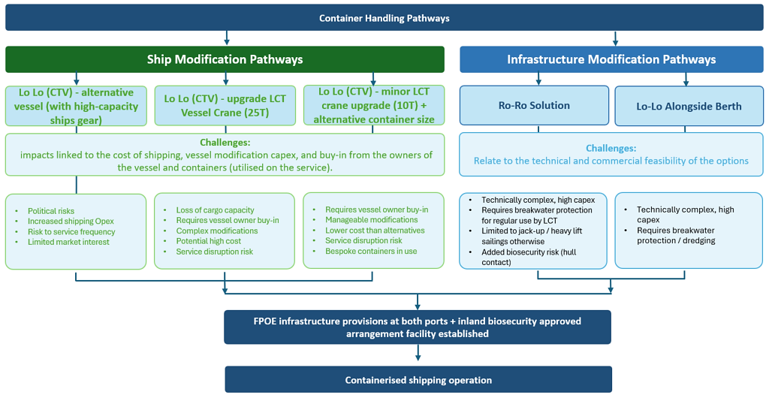

4.4 Search and rescue
Norfolk Island Police Force (AFP) is responsible for marine search and rescue. AFP with Australian Government funding, procured a new search and rescue vessel in October 2023. The vessel is fully equipped to perform modern sea search and rescue operations including night searches if required, including infra-red equipment.
The AFP vessel is currently stored in the firefighter shed at the airport which does delay response times due to having to transport the vessel down to Cascade Pier. To launch and retrieve the AFP vessel, the blue dock crane at Cascade is currently used or a mobile crane. Kingston Pier is not used due to the shallow water.

4.5 Work Health and Safety
Existing port infrastructure provides limited space for cargo handling, vehicle movements, and pedestrian access. As a result, port operations often occur in tightly confined areas where workers, contractors, mobile plant, cranes, fishermen, and visitors may be operating in proximity. These spatial limitations restrict the ability to fully separate activities or establish optimal exclusion zones, increasing reliance on supervision, coordination, and procedural controls to maintain safety.
Cascade Bay is also affected by the need to maintain access to the adjacent quarry.
Crane operations are a critical component of Norfolk Island port activities due to the reliance on lifting equipment for cargo handling, vessel launching and retrieval, and lighterage support. The current infrastructure means crane operations are frequently undertaken in a constrained environment, close to the wharf edge, around fixed assets, and near other port users. This heightens the need for strict adherence to safe lifting practices, clear exclusion zones, competent operators, and effective oversight to manage the risks associated with suspended loads, load stability, and interaction with nearby workers and vehicles.
A key consideration at both piers is the clearance and manoeuvring space available around the fixed crane infrastructure. At Cascade for example, the dimension between the wave wall and the Blue Crane mounting plinth is narrower than a 20-foot container – meaning that the current Mobile Harbour Crane (MHC) system of works would not be workable.
The limitations of the existing port infrastructure are further compounded by exposure to variable and often challenging weather and sea conditions. The piers are affected by wind gusts, spray, wave overtopping, and strong currents. Changes in visibility, wind, swell, and sea state can influence the safety and timing of lighterage and crane operations, narrow operational safety margins, and increase the risk associated with working near water and lifting heavy or awkward loads.
These factors together materially influence the scale of infrastructure required and decisions on investments.

5. Scope and strategic assumptions
In scope
Future investment and upgrades of ports facilities on Norfolk Island will focus on:
- Cascade Pier
- Kingston Pier
Cascade is the best site for a long-term permanent port, given it has existing infrastructure and favourable landside attributes supporting port and logistics development. This includes space for short term container storage, biosecurity checks, and reasonable road access to support near term goals and options for berth and breakwater expansion to support the longer-term goals.
Cascade already features the largest pier and fixed crane capacity on the island, supporting a range of port operations. These operations include cargo handling, launching fishing boats, receiving cruise ship passengers, and accommodating Passenger Transport Vehicles (PTVs).
Cascade Pier is used for cargo handling most of the time, however due to the unpredictable weather patterns, energetic Southern Ocean swell, and seasonal cyclonic swells result in difficult sea conditions sometimes sees Kingston Pier used as an alternative to load and unload cargo or passengers.
The development of Cascade Pier cannot be done in isolation to upgrade work at Kingston Pier, and the Island needs to maintain redundancy in port landing options.
Out of scope
- Ball Bay
Although currently used as a port for the delivery of fuel and gas, Ball Bay has been identified through various option studies as not preferred for further port development at this stage. Previous studies and costings indicate that construction of a harbour at this location may be cost prohibitive, road access is challenging, and the Bay is considered to be a marine environment sensitive to disturbance.
Assumptions
This Strategy is framed around Neptune Pacific Direct Line (NPDL) continuing as the current provider of cargo shipping services to Norfolk Island), with services expected to be provided using the MV Norfolk (landing craft) over the period outlined in this Strategy.
Infrastructure improvements identified in the strategy are subsequently tested against this setting but are also examined to make sure they would not be unnecessarily restrictive to other (future) shipping arrangements. The Strategy also assumes that the following will be satisfied in order to handle containers.
- Completion of the Cascade Pier Apron Raising project (capacity / biosecurity drivers)
- First Point of Entry (FPOE) requirements for containerised cargo are met (see Section 8)
- A Biosecurity approved arrangement facility is established to support container operations*.
Note* It is assumed that the port area will be unable to satisfy full FPOE biosecurity arrangements due its size / configuration, and a supporting biosecurity approved arrangement facility will be needed elsewhere on the Island in order to satisfy the requirements of the legislation. The requirements for this are set out in Section 8. It is assumed this facility will be able to serve both Kingston and Cascade equally.
This sea-based transfer would be initiated either by completing upgrades to the existing vessel (MV Norfolk) related to increased crane capacity (currently limited to 4t HIAB cranes) or by providing a suitable docking solution at Cascade Pier. These pathways are set out further in Section 10.

6. Strategic principles and investment logic
The approach for achieving the vision and aspirational, long-term outcomes for Norfolk Island ports is guided by a set of strategic principles that recognise the Island’s unique operational environment, constrained infrastructure base and reliance on safe, reliable maritime supply chains.
These principles provide the foundation for identifying, sequencing, and prioritising investments across the life of the strategy.

6.1 Strategic principles
The following core principles underpin the strategy:
- Incremental capability uplift – Investment is financially sustainable and staged to deliver progressive improvements in safety, operability and efficiency, recognising that large-scale infrastructure interventions must be carefully sequenced and justified. Early actions focus on enabling safe and compliant operations, with later phases contingent on demonstrated need, technical feasibility and regulatory alignment.
- Operational fit and practicality – Infrastructure and operational solutions must reflect Norfolk Island’s remote and constrained context. This includes consideration of limited footprint, exposure to wave and weather conditions, current reliance on lighterage and cranes, and the need for equipment and systems that offer redundancy and which can also be maintained and operated locally without reliance on highly specialised resources.
- Complementary system development – Improvements should be coordinated across marine, landside and governance systems to ensure each initiative contributes to overall system performance. Port infrastructure, cargo handling arrangements, regulatory approvals and governance capability must operate as an integrated system rather than as stand-alone elements.
- Evidence-based decision making – Major capital investments, particularly those relating to vessel interface (e.g. roll-on/roll-off capability or alongside berthing), should be supported by documented demand, operational requirements and technical assessment. This includes evaluation of alternatives, safety, operability, environmental and biosecurity considerations.
- Alignment with regulatory and environmental requirements – All development must be consistent with biosecurity, maritime safety, environmental and heritage obligations. Particular attention is required to ensure that planned changes to operations or infrastructure do not introduce unacceptable biosecurity risks or conflict with marine park and heritage site requirements.
- Flexibility and adaptability – The strategy must accommodate uncertainty in freight demand, shipping services and future operational requirements. Infrastructure and operational arrangements should be adaptable to support a range of scenarios, including changes in vessel types, freight composition and seasonal demand patterns.

6.2 Investment logic
The investment logic for Norfolk Island ports is structured around three interrelated objectives:
- Safety and compliance – Improvements must prioritise safety across all port users, including workers, passengers and the community. This includes reducing exposure to high-risk crane operations, improving spatial separation of activities, strengthening safety systems and ensuring alignment with legislative and regulatory requirements.
- Reliability and resilience – Investment should improve the predictability and continuity of freight and passenger services by reducing weather-related disruption, improving operational windows and strengthening system redundancy between port locations.
- Efficiency and cost effectiveness – Actions should reduce unnecessary handling, minimise congestion at port locations and support more efficient freight transfer arrangements, contributing to lower overall costs for the Island community.

6.3 Application of principles to infrastructure and operations
The application of the strategic principles to the Norfolk Island context results in the following approach:
- The prioritisation of upgrades to existing infrastructure (Cascade and Kingston piers) before consideration of major new works;
- Adoption of a staged and financially sustainable transition toward containerisation that is consistent with FPOE requirements and realistic operational constraints;
- Use of a split-function logistics model, where port locations are focused on vessel interface and short-duration handling, while the inland biosecurity approved arrangement facility supports detailed inspection, storage, treatment, and distribution (see Section 8);
- Careful evaluation of higher-capital infrastructure options, including roll-on/roll-off facilities and longer-term protection or berthing solutions, to ensure these are supported by a clear operational need and are technically and environmentally viable.
These principles collectively ensure that investment decisions are transparent, coordinated and aligned with the long-term objectives of safety, reliability and resilience.

7. Preferred port system, roles, and settings

7.1 Existing infrastructure and assets

Cascade Pier
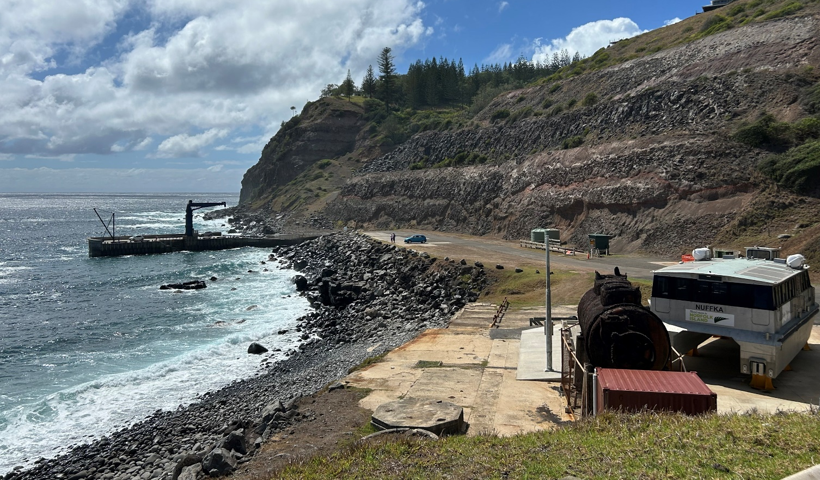
Figure 2: Photo of Cascade Pier in the background including the fisherman’s crane on the left and blue crane and infrastructure in the foreground including the desalination plant, historic whaling station and PTV (2025)
Cascade Pier is located along the northern coast of Norfolk Island.
As a result of its northward facing aspect, Cascade Pier has more favourable sea conditions than Kingston Pier and consequently, it is used approximately 70% of the time compared to 30% for Kingston Pier.

Features
The pier is around 40m long and 10m wide with a minimum alongside water depth of around 1.5m which is sufficient for the CTV’s and other small craft that use the pier. Depths offshore are much greater. The pier is formed using precast concrete caissons that are fixed to the seabed with ground anchors with the units filled with rock and then grouted to form a gravity structure. The concrete is reinforced with stainless steel reinforcement.
The pier incorporates a 1m perimeter wave wall to the northern and eastern edges as well as pedestrian (tidal) access stairs that are cutout of the pier footprint on the western (berth) face to support passenger transfers. A 35-tonne (static) “Blue” crane is mounted on a concrete plinth on the southern side of the stairs and a smaller fisherman’s crane is located at the outer end. The cranes are used for unloading break-bulk cargo from lighterage vessels, launching and retrieving PTVs, CTVs, fishing vessels and government craft, and supporting general port tasks.
The landside port footprint encompasses an area of ~3,600 square metres at a uniform level, measuring around 175m long x 20m wide. The area incorporates a weighbridge, grassed areas, and through route for vehicles accessing the jetty and adjacent quarry. The area is used for the storage of the CTV’s and PTV’s as well as cargo operations on port days. Access to the jetty and port zone is via Cascade Road which is sealed and has a moderate gradient.
The port area also houses a public toilet at the location of a former Whaling Station site at the western extents. The Whaling site foundations have not been preserved. Some lower levels of the structure are at risk of collapsing into the sea.
Elevated areas above the port zone include the Cockpit Picnic area and a former fish factory site.
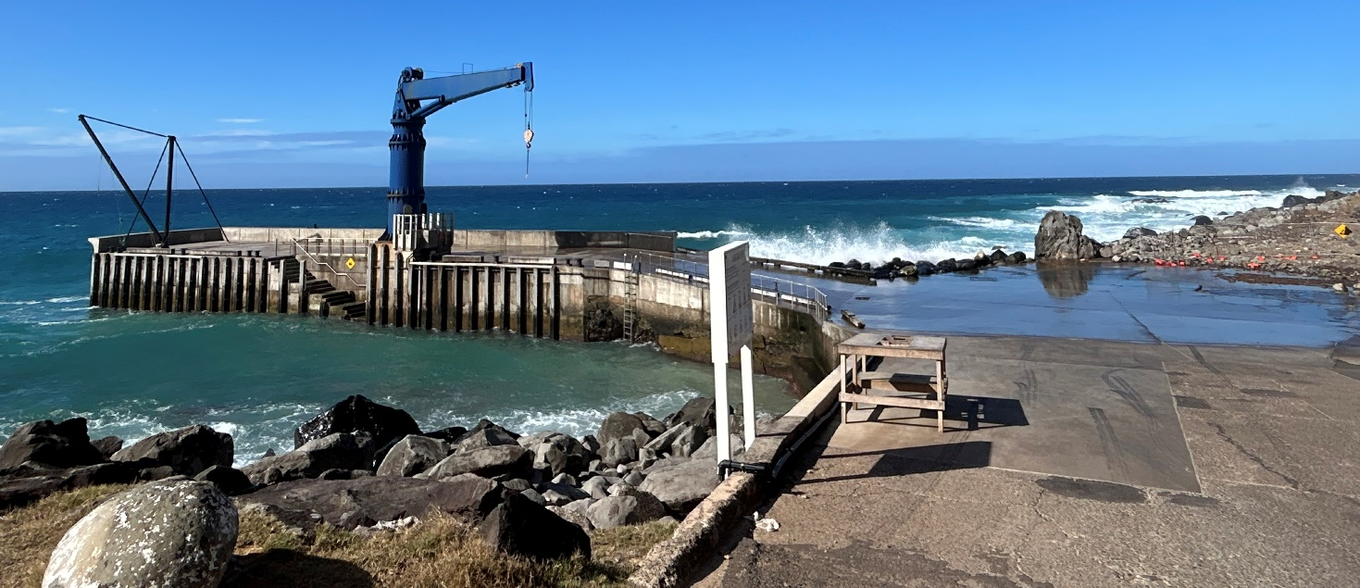
Figure 3: The Fisherman’s Crane (left) and the Blue Crane (right) located on Cascade Pier at Norfolk Island

Constraints
Navigational access to the pier is constrained by shallow rock outcroppings with a known hazard being an existing rock outcrop (Bombora) located approximately 25.7m from the outer end of the pier. Other constraints relate to the narrow berth pocket and challenges linked to navigation into the facility.
Cascade is highly constrained by the exposed coastal setting, with frequent swell and wave overtopping directly affecting safety and operability. Wave run-up onto the pier apron and working areas can reduce effective working windows, disrupt lifting operations, and increase risks associated with suspended loads and moving vessels. As a result, operations are tightly governed by prevailing sea state and weather conditions, with operations often paused or deferred to maintain safe lifting conditions and personnel safety.
With crane operations at Cascade being fundamental to all maritime activities, the reliance on a single primary fixed crane (with finite lift capacity, reach and duty cycle) is an ongoing concern. Despite the capacity of the “Blue Crane” being sufficient for container operations, its location and arrangement pose restrictions. The crane is 25m from the outer end of the pier, and ~10m from where the berth pocket shallows. The clearance between the wave wall and plinth is <5m. Operational constraints are further compounded by limited apron space, restricted laydown areas, and the need to share crane access across freight, passenger and vessel handling tasks, resulting in sequential rather than parallel operations and reduced overall productivity.
The associated landside operational area available at Cascade is also a limitation in terms of footprint and because the pier and area serve community and tourism uses outside of port days. The area must remain open and cannot be adequately secured on a permanent basis. Access for the public, occasional cruise passengers, fishing, and ongoing access to the quarry must also be maintained. This public access requirement poses a conflict for future container operations and plans for longer term equipment storage, specifically because local container storage at the site on an ongoing basis will not be feasible.
From a footprint perspective the available land areas are fully utilised for operational purposes on port days, as set out in the traffic management plans (TMPs), but will pose restrictions for container handling. The existing surface (ramp) gradients, surfacing, and dimensions currently prevent containers from being handled and stored at the site. Some of these limits will however be resolved through the planned Cascade apron raising works (see below).
Regarding land use settings, there are also several issues regarding land zoning of Cascade Reserve, the main issue being, part of the reserve around the port is currently zoned as Conservation and Open Space, however, these areas have several special uses such as quarry, desalination plant, and port. Also, the coast stretch east of the pier, and the pier itself, are currently outside of the Reserve boundary.
Each of these constraints and limitations must be adequately considered when selecting improvement options to implement, to best align with the strategic development principals.
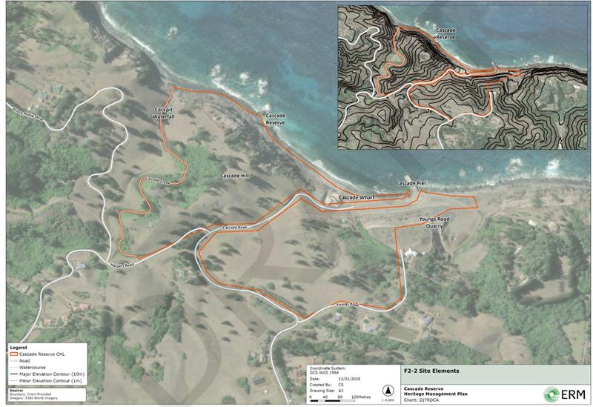
Figure 4: Cascade Reserve Boundary (Source: ERM (Environmental Resource Management))

Planned interventions
There are plans to implement changes to the land use zoning within Cascade to remedy the barriers that restrict the handling of containers due to the arrangement of existing apron areas.
Changes to the land use settings will see the area around the port recognised as Special Use with the boundary extent adjusted to include the pier and the area east of the pier in the reserve, also as Special Use.
The Cascade apron raising project involves the provision of around 1,700 sqm of new flat apron behind the pier that will be around 1m higher in vertical elevation. The area is highlighted in the Figure below. The area increases manoeuvring space for equipment and will facilitate the temporary storage of containers.
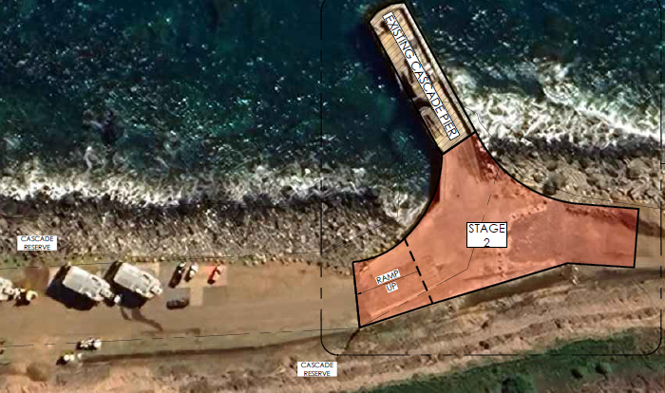
Figure 5: Extent of works under the Cascade Apron raising project

Kingston Pier
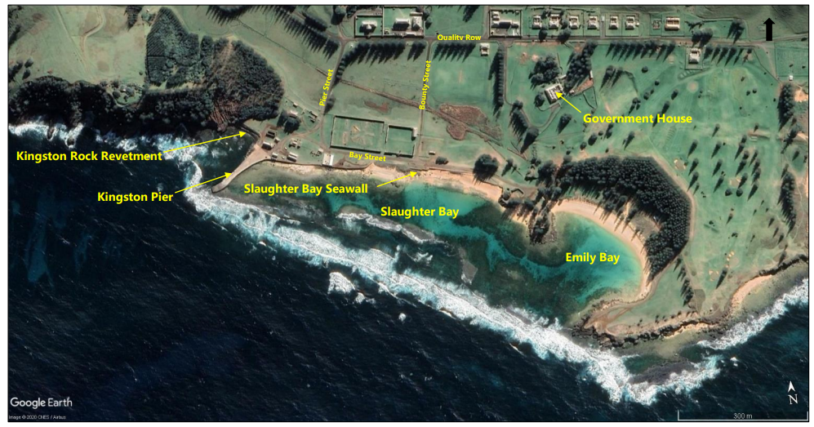
Figure 6: location map of Kingston Pier at Norfolk Island (Source: Google Earth 2020)
Kingston Pier is located on the south side of the Island. Kingston Pier is the oldest continuously operating pier in the South Pacific, built by convicts in 1839. Located in the UNESCO World Heritage-listed Kingston and Arthur's Vale Historic Area, it serves as the island's vital lifeline for cargo, emergency services, and local fishing operations.
The waters around Norfolk Island are considered Commonwealth waters under the jurisdiction of the Australian government and are in the Norfolk Marine Park

Features
The pier is approximately 150m in length, with varying width along its length (minimum width of approximately 10m). Kingston Pier was constructed from 1839 to 1847. It is currently comprised of external stonework, steel sheet piles, a concrete surface and rubble fill. The structure was refurbished in 2007.
The sheet pile wall system includes the combination of an old wall built in 1953 and a new wall built in 2006 but is showing signs of degradation with evidence of backfill loss from behind the new wall. The result of these findings indicates a significant reduction in pier capacity.
The pier is used by various vessel operators such as commercial charters, fishing vessels and emergency responders as well as by NIRC for break-bulk cargo deliveries when Cascade is inoperable. The cargo is lifted out of the lighters at Kingston Pier using either a shore-mounted crane or mobile crane.
Road access to Kingston Pier is provided from Pier Street via the junction of Quality Row, Country Road and Middlegate Road. It is also accessible from Bay Street via Bounty Street.

Constraints
The sea conditions at Kingston Pier are quite challenging and require a high degree of local knowledge, familiarity and experience. The existing entrance and interior channel dimensions of the harbour adjacent to Kingston Pier are inadequate for safe navigation during all tides and does not meet required navigation standards and guidelines. In addition, the existing limited water depth adjacent to Kingston Pier at lower tides is a safety risk for users due to inadequate under keel clearance. This limits the use of Kingston Pier by many vessels.
At Kingston, the available operational area is similarly constrained to Cascade and must accommodate a mix of port, community and heritage uses within a highly protected World Heritage setting. The pier forms part of the Kingston and Arthur’s Vale Historic Area, which places strict limitations on physical modification, expansion and operational intensification, requiring ongoing public access and preservation of heritage values alongside maritime use.
As a result, cargo handling and vessel operations are undertaken within a tightly constrained footprint using basic crane infrastructure and mobile equipment, with limited ability to establish dedicated storage, segregation or modern operational zones. These constraints, combined with shallow water and channel limitations, restrict the types of vessels and operations that can be safely accommodated and reduce overall operational flexibility and efficiency.

Planned interventions
The Kingston Pier channel deepening project aims to make navigational access to the safer. It involves deepening and widening with dredging of up to 6,000 m³ of sediment to be removed from the site and taken to the opposite side of the island and deposited at the Cascade Quarry.

7.2 Shipping operations
Shipping operations comprise regular cargo services, cruise ship calls, local fishing operations and other ad-hoc events such as Navy visits, ocean racing and general yacht arrivals. This strategy is focused on improvements related to the regular cargo services.
Cargo operations involve lightering using the CTVs as described earlier. Cruise ship passengers are transferred to shore using cruise ships own tenders or purpose-built passenger transfer vessels (PTV’s) kept on the Island.
Cargo shipping services are currently provided by Neptune Pacific Direct Line (NPDL) who utilise an 80m LOA landing craft vessel (the MV Norfolk) that was built and launched in July 2023. The vessel provides a dedicated freight service to Norfolk Island that runs on an eight-week schedule, alternating supply stops in Brisbane and Auckland and making deliveries to Norfolk Island at least every three to four weeks. This service operates without financial support from the Commonwealth.
Cruise ship visits to the island are variable with up to around 10 calls per year that are concentrated through November to April. Itineraries include Australia, NZ, and nearby Pacific Islands. Vessel sizes range from 500 to 2,500 passengers.
Weather conditions determine when cargo and passenger transfers operations can occur, and it is not unusual for the MV Norfolk to wait offshore for several days for conditions to improve before unloading cargo.

Coastal Trading to external territories exemptions
Norfolk Island, as an external territory is considerably further away from the Australian mainland than other Australian islands and ships must cross international waters to reach it. Norfolk Island is currently subject to an exemption to the Coastal Trading (Revitalising Australian Shipping) Act 2012. This means the service does not have to operate under a temporary coastal trading licence or permits, provided they do not take on or discharge additional cargo/passengers at other intermediate ports.

8. Demand and Freight task

8.1 Containerised freight task
Norfolk Island relies heavily on sea transport for the supply of most day-to-day necessities including basic food supplies, building and construction materials, retail items, stock-feed, fertiliser, all gas, fuel and significant volumes of general cargo.
General goods are shipped in containers and handled as described earlier. Fuel and LPG is handled in liquid bulk form, with products landed at Ball Bay via a floating pipeline which transfers the product direct from the tanker to a storage facility located permanently in Ball Bay.

Volume of containerised cargo
The volume of cargo in containers is small by shipping standards, which is reflected by the single service provider, small vessel, and low frequency of calls. This situation creates market challenges and adds additional layers of cost and complexity to those that live on Norfolk Island.
Freight volumes for the period 2020 to 2024 are shown in Table 2. These show a large variability in annual volumes with the high being 18,000 m³, the low being 3,300 m³ and average being ~9,400 m³. It should be noted that these records span the Covid affected period, and the high year likely reflects a ‘catch-up’ response to the disruptions.
Looking forward, the advice from Transam indicates that a typical annual volume would be ~12k m³ (revenue tonnes) p.a. with almost all of it being import cargo. In terms of volumes per call, the flow of cargo on each sailing leg (Auckland / NI and Brisbane / NI) has been described as well balanced and the handling task per call would translate to something like 25-35 TEU.
From a port planning perspective, the terminal needs to be able to accommodate the regular flows and have some surplus capacity to deal with seasonal peaks / regular imbalances that may occur.
A move to a containerised flow of goods would also see a similar number of containers flow back on each call. This means each call may involve the exchange of 50 to 70 TEU which needs to be accommodated via the port and landside logistics.
Table 2: Freight volumes over the last 5 years, proved by provided by NIRC (April 2025)
Year | Voyages | Sum of Volume M³
2020 | 7 | 8539.2220
2021 | 3 | 3585.8373
2022 | 4 | 3275.2677
2023 | 10 | 17919.1810
2024 | 12 | 12240.3400
Grand Total | 36 | 45559.848
The ability to increase the frequency / number of shipping calls is considered low as the schedule is defined by the sailing speeds and travel distance. One way sailing durations are around 5 days from Auckland to NI, and 6 days for Brisbane to NI. Return journeys then involve ~22 days sailing within a 28–30-day shipping schedule.
Freight allocations and tariff rates for sea freight are managed by NPDL’s subsidiary, Transam Argosy. The allocations and rates are managed through commercial agreements with importers and freight agents. Importers and freight agents then sell portions of their wholesale allocations to retail customers. Due to demand, there can be a wait list of 1-2 ships for booking sea freight.

Port and logistic requirements
Based on the above insights, the port system will need to accommodate an exchange of 50-70 TEU on each call and provide the supporting facilities required by Customs and Biosecurity officers to match the task.
The requirements for customs and biosecurity will apply to both the port area, the supporting (inland) biosecurity approved arrangement facility, and road corridors in between. The need for an inland biosecurity approved arrangement is a core assumption.
Envisaged requirements for the port area are set out below. Requirements for the inland biosecurity approved arrangement facility are discussed in the following section.
Port facility requirements:
The Norfolk Island port facilities will need to provide the following:
- container exchange area (crane drop / equipment pick up)
- container biosecurity clearance inspection area (rack for 360-degree container visual check) sized to accommodate containers awaiting clearance
- container wash down facility (to include controls on water run-off)
- container storage area for cleared import containers awaiting collection to transfer to the biosecurity approved arrangement facility – area size based on container numbers and collection rates
- container storage area for MT containers scheduled to be exported from the Island.
- shelter, office and amenities for ABF and DAFF officers
- designated parking for ABF and DAFF officers
- waste holding facilities
- adjacent areas that are free from vegetation
The container storage requirements will also be influenced by the mode of handling, checking processes, and rate of transfers off the port to the biosecurity approved arrangement facility. Table 3 provides an overview of how the expected features may vary based on the possible operations. This assumes exchange of 50-70 TEU.
Table 3: Summary of port operational aspects based on mode of handling
Mode | Handling | Productivity | Storage capacity | Logistics
LoLo (CTV) | Dock crane and container handler / side lifter truck | 3-4 moves / hour  (6-8 TEU) | 20 TEU (FCL)  20 TEU (MT) | 1-2 trucks shuttling containers from port to depot (10-minute travel)
RoRo (vessel) | Vessel based handling equipment and side lifter truck | 10 moves per hour  (10 TEU) | 35 TEU (FCL)  20 TEU (MT) | Truck shuttles from port to depot
LoLo (vessel) | Dock crane / ships gear, container handler and side lifter truck. | 10 moves per hour (10 TEU) | 35 TEU (FCL)  20 TEU (MT) | Truck shuttles from port to depot
It should be noted that the above information is provided as an initial guide based on information made available at the time of reporting. To strengthen future decision-making, a more structured demand outlook is recommended that links freight and passenger demand to infrastructure triggers, including anticipated changes in freight composition, seasonality and peaks, major project demand (including airport pavement works), and realistic container throughput assumptions. This understanding will help verify the planned infrastructure and/or justify investment and future shipping solutions.
It is also noted that the planned Cascade Pier Apron raising project will help to address some of the FPOE requirements and provide sufficient capacity for the inspection activities and envisaged storage of containers at Cascade. Further enhancements may however be needed regarding provision of an approved wash down area (likely 16m x 5m) that needs a water collection system and water supply.

Biosecurity approved arrangement facility
Ports traditionally have approved biosecurity arrangement facilities at the first point of entry, to minimise biosecurity risks and to reduce the time taken to move containers on and off vessels. Given the limited land area at both port locations, the strategy has adopted a model where time-critical handling occurs at the pier, and a centralised inland biosecurity approved arrangement facility is established to provide the primary location for examination, devanning, temporary storage and release under biosecurity and border control processes. The facility will be connected by a road corridor that also meets biosecurity performance requirements.
This approach reduces the need for extended container dwell time within publicly accessible port areas and provides a more controlled environment for compliance and operational management.
The strategy recognises that a location for the inland biosecurity approved arrangement facility needs to be secured and arrangements agreed on how the facility will be run (Industry, Council, commercial etc.). The location should be selected to minimise impacts on community users of the ports, and such that it would equally be able to service any of the port locations.
The facility will need to incorporate all facilities and amenities required of bio-security officers, the resident operational support staff and potentially Australian Border Force staff. This will include impervious pavements, container stacking areas, secure and weather protected inspection areas, lighting, stores, offices, amenities, parking, fencing, approved wash bays, appropriate services & utilities, waste storage / destruction capabilities, and fumigation systems.
An area of between 0.6 Ha and 1.0 Ha is estimated to be required – but this will need to be verified through further study.

8.2 Tourism
Tourism is crucial to Norfolk Island’s economy with tourism income dominating Norfolk Island’s Gross Territorial Product (GTP), contributing $48.8 million in FY2024, or 35.1 per cent of the Norfolk economy. In the same year, jobs in tourism (accommodation and food, wholesale and retail trade and transport) made up 36 per cent of Norfolk Island’s employment. Historically, air services have catered for the tourism sector, however over recent years there has been a growth in cruise ship calls to Norfolk.
DITRDCSA procured three passenger transfer vessels (PTVs) in 2019 to transfer passengers from cruise ships to Norfolk Island aiming to increase the number of passengers aboard cruise ships who disembark onto Norfolk Island. The PTVs currently use both Cascade and Kingston piers.
The cruise ship industry in Australia is experiencing a steady growth in the number of ports visited and the number of passenger days at port. Passengers contribute to the local economy by taking tours, eating at local restaurants and cafes and buying in local shops. As Norfolk Island’s economy is highly dependent on tourism, an increase in the number of cruise ship visits could have a positive impact on the tourism industry and the island’s economy as a whole. Improved port facilities, even if only partially contributing to increased passenger traffic, could have clear benefits for the island.

Passengers count to visit Norfolk Island from cruise ships
Table 4: Total of passengers to visit Norfolk Island from Cruise suites over the last 5 years, provided by Norfolk Island Regional Council
Year | Pax Count
2020 | 600
2022 | 5993
2023 | 20033
2024 | 15928
Grand Total | 42554
In 2024, 14 cruise ships visited Norfolk Island, 7 large and 7 boutique ships, attracting approximately 16,000 visitors to the island on day trips. The total expenditure attributed to tourists arriving via cruise ships is estimated at $1,577,800
An increase in cruise ship visitors may create demand for greater capability and infrastructure at both piers. As it stands, port assets have basic capacity in the following areas:
- Basic and dated toilet facilities at either pier;
- No covered passenger holding areas at either pier
- No suitable harbor to unload cargo directly from ships.
Aspirational, long-term infrastructure planning on Norfolk Island needs to consider the safe and effective movement of cruise ship passengers. This includes consideration of safe passenger circulation and segregation from freight operations; improved amenity and weather protection; waste collection facilities, and accessibility considerations for older visitors and those with reduced mobility.

9. Governance, management and regulatory framework

9.1 Port management
The Marine Safety Act 2013 (NI) established an authority called the Norfolk Island Marine and Harbour Authority (NIMAHA). Despite this establishment, no such authority exists. As such, the appointment of a Port Manager to manage the day-to-day operations of the ports has not occurred. This impacts enforcement of port bylaws, working and safety conditions and escalation capabilities.
Under current arrangements:
- Port operations, including loading and unloading of vessels and management of port use, are coordinated locally;
- Port facilities are generally accessible to the public outside of operational periods, requiring temporary access controls on cargo and cruise days;
- A dedicated harbour master function is not established on a full-time basis, with port management responsibilities undertaken alongside other infrastructure roles.
Currently basic port operations are primarily managed by NIRC as part of its Service Delivery Agreement (SDA) with the Australian Government, and with individual contracts. There is no designated Harbour Master. In its absence, the person occupying the position of NIRC Manager Infrastructure Services is the default Harbour Master. In particular, the absence of a dedicated port authority or full-time harbour master function limits:
- The consistent application of regulatory and safety requirements;
- Operational oversight of vessel movements and port safety;
- Coordination with external agencies responsible for biosecurity, customs and maritime safety;
- Implementation of a cohesive, system-wide regulatory framework.
As well as being insufficiently resourced, NIRC is also not skilled at delivering a full port management service. While statutory requirements (such as maritime security plan) are being fulfilled, they lack the support of an organisation that understands the full regulatory framework affecting port operations. There are currently significant risks / gaps around biosecurity (particularly FPOE), and a lack of a cohesive approach means funding (including potential income) is not managed effectively.
As a FPOE, a port must have suitably approved facilities, arrangements and systems in place to effectively manage biosecurity risks associated with port and passenger arrival operations. Management of the Norfolk Island FPOE at Kingston and Cascade must be in accordance with the regulatory requirements of the Biosecurity Act 2015 as outlined in the FPOE Biosecurity Standards for ports and landing places.
The standards ensure all operators facilitating international arrivals at the port have the procedures and infrastructure in place to:
- Manage the biosecurity risks associated with arriving vessels, travellers and cargo
- Respond to and report biosecurity or human biosecurity risks
- Manage biosecurity waste appropriately
- Support biosecurity officers to safely and effectively assess, inspect and treat goods under biosecurity control
- Manage the environment around the port of entry to reduce its receptivity to pests and diseases of biosecurity concern.
The Biosecurity (First Point of Entry – Port of Norfolk Island) Determination 2022 identifies commercial vessels, passenger vessels, and non-commercial vessels are approved for baggage other than passenger vessel baggage, general goods, non-commercial vessel waste.
Due to the sea conditions around the island, there is no safe area for the mooring of vessels. Hence, boats at both Kingston and Cascade piers are launched and retrieved using a range of different cranes, dependent on the user and the vessels. Policies and processes on access, use and required training and inductions for the safe use and operations of the cranes need to be included in development of a Norfolk Island Port management plan.
When launching and retrieving vessels using any of the cranes at Cascade or Kingston an open hook is used because of the nature of the operations. It was explained by experienced locals that a closed hook takes too long to hook and unhook cargo net rings due to the independent movements between lighters/ship/cargo.
Shipping within Norfolk Island raises some workplace health and safety concerns. Due to the nature of the unique environment and constraints, Norfolk Island lighterage and stevedore workers are highly skilled and experienced to perform what is high risk work in conditions that do not occur on mainland Australia, however Australian work health and safety standards are not consistently applied. The safety of all stakeholders involved in port operations on Norfolk Island is paramount as is the security of the piers, cargo and vessels.
In a November 2024 workplace health and safety audit it was recommended that a Norfolk Island port management plan be developed that captures topics such as but not limited to – roles and responsibilities, emergency management plans, traffic management, consultation and communication, incident reporting and investigation, risk register PPE, lifting gear, unloading/loading processes, vehicle and mobile plan and vessels, and meets all legislative and regulatory requirements, which includes but is not limited to the Maritime Transport and Offshore Facilities Security Act (2003) and WHS Act 2011 (Cth.).
Operations today, are now covered by the following suite of documents:
- The NI Maritime Safety Act 2013 (MSA), overseen by the Minister
- The Service Delivery Agreement (SDA) under the control of DITRDCA
- Maritime Security Plan (MSP)
- Port Safety and Operations Manual (PSOM)
- Traffic management Plans (TMPs)
The PSOM provides the primary operational framework, explicitly integrating biosecurity and customs processes within cargo handling workflows and defining roles for agencies such as ABF and DAFF. The SDA establishes NIRC’s role in coordinating port operations and interfacing with Commonwealth agencies. The MSP supports these functions indirectly through access control, security measures, and coordination mechanisms. Together, the documents create a functional, process-driven system that enables general compliance with external regulatory requirements.
Noted gaps do however remain, these include:
- The SDA positions NIRC as both operator and quasi-regulator, whereas best practice port governance separates these roles to avoid conflicts of interest, ensure independent oversight, and enable efficient service delivery. Compliance relies on external agencies being present and engaged.
- While Section 8 of the NIRC 24_25 SDA assigns operational port management and some regulatory functions to NIRC, it does not fully establish a coastal State governance framework. There are gaps in:
- No mention of aids to navigation (AtoN’s)
- Incident investigation and safety assurance (SAR)
- Environmental and system-level governance functions (pollution response)
- A key misalignment relates to the fact that the Minister retains regulatory authority, NIRC delivers operations via SDA, but the Harbour Master / port authority layer is not fully replicated, creating a gap in operational maritime control and system integration
- Key Harbour Master functions—including pilotage, channel maintenance, wreck removal, and formal marine directions—are either absent, or only implicitly addressed through informal operational arrangements. While the Ports Manager performs a role functionally analogous to a Harbour Master, this role lacks statutory authority and clear jurisdictional powers.
- SDA and/or MSA do not recognise international shipping conventions (e.g. SOLAS, MARPOL, STCW).
The gap analysis supports the view that the Norfolk Island should establish the Authority and appoint a Harbour Master as a means of ensuring independent oversight.
The planned upgrades at Cascade and Kingston will assist in ensuring that infrastructure supports safe environments for workers, passengers and community.

9.2 Biosecurity
The Biosecurity Act 2015 is the primary legislation for the management of the risk of diseases and pests that may cause harm to human, animal or plant health, the environment and the economy. Australia’s non-self-governing territories, including Norfolk Island, each have unique animal and plant health biosecurity statuses that are different to each other and the Australian mainland. Biosecurity arrangements on the territories are designed to maintain the unique biosecurity statuses of each place.
Under the Biosecurity Act, the movements of vessels, goods and people into and between these external territories, including from the Australian mainland are managed like international movements, rather than interstate movements. Therefore, all vessels and aircrafts that arrive at the territories and all goods that are brought or imported into these external territories must comply with biosecurity legislation.
The strategy establishes a pathway toward enabling container handling that is consistent with biosecurity requirements. A key component of this approach is the adoption of a split-function model, where:
- Both port locations provide basic FPOE functions, including vessel inspection, initial control of cargo and short-term staging;
- A centralised inland biosecurity approved arrangement facility provides the primary location for inspection, devanning, quarantine and release of goods.
- Connecting road corridors satisfy the biosecurity requirements.
This approach reflects the physical constraints of port locations, reduces exposure to biosecurity risks associated with extended dwell time at the port, and supports more controlled and consistent application of regulatory requirements.
Any transition to container handling will require:
- Appropriate approvals and variation to existing FPOE determinations;
- Development of secure and compliant infrastructure for inspection, storage and handling;
- Implementation of operational procedures to maintain control of goods between port and inland facilities.
- Agreement on commercial and contractual arrangements for the establishment and operation of the biosecurity approved arrangement facility.

9.3 Work Health and Safety
Work health and safety (WHS) risks at Norfolk Island ports are strongly influenced by the combined effects of infrastructure constraints, operational practices and environmental conditions. Key risk factors include:
- Limited space for cargo handling and vehicle movements;
- interaction between workers, mobile plant, cranes, vessels and members of the public;
- reliance on crane-based operations near the water’s edge;
- exposure to variable wind, swell and sea state, which can affect timing and safety of operations;
- reliance on lighterage operations, which involve dynamic interfaces between vessels, cargo and lifting equipment.
Existing safety arrangements rely heavily on procedural controls, supervision and operator experience. While these controls are critical, the strategy recognises that infrastructure and system-level improvements are required to support safer operations over the long term. The strategy therefore includes measures to:
- continually review and updated the operational plans and procedures
- improve spatial separation between operational activities where practicable;
- enhance infrastructure to reduce exposure to high-risk conditions (for example, through improvements to apron areas and staging zones);
- strengthen safety management systems and documentation to reflect current and future operations;
- ensure that new operational elements, including additional lighterage vessels and any transition to container handling, are fully integrated into safety procedures and risk management frameworks.
The existing suite of operational and management plans will require updates to reflect all changes in arrangements, including:
- Systems for handling and clearing containers at both ports.
- Use of the new CTV’s
- Fixed Crane operations
- Road corridor surveys and inspections
- Appointments of the Authority and Harbour Master
These measures support a transition toward a safer, more structured and more resilient operating environment for Norfolk Island ports.

10. Phased investment framework
Vision: Norfolk Island’s ports infrastructure and management enhances the islands economy, improves safety, reduces supply chain vulnerability and supports population needs sustainably to support long-term regional development and enhance emergency response capability.
This strategy adopts a staged delivery framework aligned to short-, medium- and aspirational, long-term outcomes. The phased approach is intended to guide prioritisation and sequencing of investment, with detailed scope, cost and delivery arrangements to be developed through subsequent planning and business case processes, subject to funding approval.
A summary of the phased outcomes is provided in Table 5.

Uplifting ports infrastructure and assets
Improving the capabilities of ports infrastructure on Norfolk Island is critical to deliver on the vision and outcomes. In addition to projects underway at the time of preparing this strategy, there are nine outputs or projects which have been identified under the strategy, and these are phased over the life of the strategy.
One option (RoRo solutions) has two variants depending on whether containers are to be handled on the RoRo facility – as follows:
- A RoRo facility to be used for container exchange will require breakwater protection and appropriate transition gradients to operate,
- A RoRo facility established just for ‘special’ project cargo deliveries (e.g. Runway renewal) could be developed without breakwater protection and of lesser scale.
Under option 2, the scale of the solution could be reduced from that required under (1). Connectivity for unloading could be achieved through a spud leg barge shipping solution and/or temporary floating linkspan solution interfacing with a simple bankseat on the landside.
Under option 2, container handling operations could still be achieved by way of the ship modification pathway.
Further, all outputs deliver on both the security improvements (with purple edges) and reliability improvements (with red edges) identified through community feedback.
Short term output: Kingston Pier Channel Construction Project completed
Short term output: Cascade Pier Apron Raising Project + FPOE interfaces
Medium term: Crane modifications and construction for commercial and recreational uses
Medium term: Container Ro-Ro solution identified and constructed at Cascade with breakwater
Aspirational Position: Breakwater extension for alongside berthing
Aspirational Position: Cascade Pier upgraded to enable container ships to pull alongside to load and unload
Aspirational Position: Wharf facilities upgraded to support commercial and recreational fishers
Optional medium term: Special projects Ro-Ro solution identified and constructed at Cascade
Short / med term: Inland biosecurity approved arrangement facility established + FPOE at Kingston / Cascade

Uplifting vessel, freight and cargo handling facilities
Improving the facilities to support container handling on Norfolk Island is critical to deliver on the vision and outcomes. Three outputs or projects have been identified for consideration under the strategy. These outputs deliver on both safety, cost and reliability improvements identified through community feedback.
Medium term output: Facility investments to satisfy FPOE requirements at both ports (inspection stands, wash down, waste collection)
Medium term output: Vessel crane modifications to enable container handling via the CTVs + onshore equipment procured
Medium term output: Biosecurity approved arrangement facility handling facility established + FPOE modifications completed at Kingston

A staged delivery of infrastructure upgrades including the completion of current planned projects - the Cascade Pier apron raising project (with FPOE modifications) and the Kingston Pier channel construction project will greatly assist to improve safety, resilience and freight efficiency.
Further infrastructure improvements aligned to satisfying the biosecurity approved arrangement facility requirements over the mid-to-long-term will also reduce risks and support freight efficiency.
Cost effective solutions that allow the cargo to be unitised will help to reduce costs to receive freight on the Island and support more sustainable shipping by enabling safer cargo handling loading and unloading on shore, along with reducing delays that affect service reliability. An optimised ship modification pathway (early on) has potential to be a catalyst to test the benefits of containerising the cargo task.
The government has a role in developing infrastructure that can help with cargo handling efficiency, with an aspirational, long-term goal to improve vessel berthing facilities and support the transition to containerisation.
Permanent infrastructure to accommodate roll-on, roll-off transport of vehicles, including large and heavy machinery is important to the long-term growth, development and further progress on Norfolk Island. Such improvements will help to reduce overhead costs, such as the cost of delays caused by weather, and higher insurance premiums incurred by shipping freight by breakbulk.
Upgraded infrastructure will also attract cruise ships currently or proposing to operate in the Pacific Ocean to consider Norfolk Island as an intendent stop over location.

Clarifying and uplifting ports management and governance
Improving and clarifying arrangements around ports management is critical to deliver on the vision and outcomes. Two outputs or projects have been identified as a priority under the strategy. These outputs deliver on both the cost improvements (with orange edges) and security improvements (with purple edges) identified through community feedback.
Short term outputs: Cascade Reserve Master Plan developed
Short term outputs: Norfolk Island Marine and Harbour Authority established + HM appointed
Establishing a clear and coordinated planning framework is critical to unlocking the full potential of Norfolk Island’s maritime infrastructure. The Cascade Reserve Master Plan will provide the foundation for future development by setting out clear zoning, allowable uses, and will be complemented by a Heritage Management Plan. It will also define governance arrangements, clarify roles and responsibility, and ensure resources are aligned with regulatory requirements – creating the certainty needed for informed decision-making, investment and compliance with Australian Standards.
The establishment of the Norfolk Island Marine and Harbour Authority will ensure appropriate maritime oversight and safety compliance. At a minimum, Norfolk Island needs a qualified harbour master who can manage operations centrally and ensure that all incoming arrivals are properly managed, including freight and cruise ships. This would ideally involve NIRC establishing the NIMAHA as a business unit and employing a dedicated harbour master.
Port authority services may be delivered by an existing entity that already provides those services at another port; for example, Queensland has four Government Business Enterprises (GBEs) that deliver port management services in Qld, and one of these entities may agree, under commercial terms, to extend port management services to Norfolk Island. If the GBEs aren’t in a position to deliver services, those may instead be delivered by a private company, similar to arrangements in the Indian Ocean Territories or a hybrid model.

10.1 Phase 1: Enabling foundations (short term actions)
Norfolk Island will have enhanced maritime infrastructure and governance to support safer operations, regulatory compliance, and more efficient freight handling.
  - Governance, planning and legislative framework supports long-term outcome
  - Infrastructure upgrades lead to safer vessel movement on water and safer operations on land
Project 1: Cascade Reserve Master Plan
A master plan for the site will ensure multiple users/uses occur while maintaining WHS standards and conserving heritage and environmental values. Specific activities which need to occur as part of the master planning exercise include:
- Review land zoning within Cascade to best meet the future needs of Norfolk Island community
- Prepare a Heritage Management Plan for Cascade Reserve in line with legislative requirements for Commonwealth Heritage listed sites
- Develop a quarry master plan
- Review current usage and infrastructure within Cascade Reserve and develop master plan for next 20 years to support cohesive and effective utilisation of the site
- Identify road corridor treatments required as part of the biosecurity approved arrangement facility.
Project 2: Norfolk Island Marine and Harbour Authority
The Marine Safety Act 2013 (NI) established the Norfolk Island Marine and Harbour Authority (NIMAHA) and the Harbour Master position. However, the NIMAHA has not been established, and the Harbour Master position is currently filled by the NIRC Manager of Infrastructure Services, with port operations primarily managed by the NIRC through the Service Delivery Agreement (SDA).
- Establish the NIMAHA in line with legislative requirements.
- Resource a full time Harbour Master position.
- DITRDCSA to engage with NIRC to design an arrangement that would provide greater rigor to port operations to complement modern port facilities and container handling.
Project 3: Kingston Pier Channel Construction Project (existing, funded project)
The project will increase the Kingston Pier channel bed's depth and width to improve access and safety and ensure it meets required standards.
- Remediation works to the Kingston Pier structure will be undertaken prior to the channel augmentation works (dredging).
  - The Kingston Pier Rock Revetment, located at the base of Flagstaff Hill to the west of Kingston Pier, needs repair and upgrading, to protect the integrity of the masonry and sheet-pile wall behind it and repair erosion that has occurred adjacent to the structure.
  - Kingston Pier requires repairs to address structural integrity concerns with the overall pier structure.
- Provision of a deeper and wider approach channel for commercial and recreational vessels.
  - Removing up to 6,000 m³ of seabed material.
  - The material will be transported to the Old Cascade Quarry site, on the northern side of the island, for disposal.
- Increasing the availability of Kingston Pier for berthing of vessels by providing a safer berthing approach.
- Enhancing port operations once completed by providing an augmented channel for larger vessels in the future.

Project 4: Cascade Pier Apron Raising - Stage 2 (existing, funded project)
The project includes investigation, design and documentation of port development at Cascade Pier. What will be part of a staged project, involves the initial raising of the apron area and landward part of the pier to improve forklift container handling safety, while ensuring compatibility for future development at Cascade including consideration of integration with a future Ro-Ro ramp. Stage 2 of the Cascade Pier Apron Raising Project includes:
- Improve the safety and amenity of loading/unloading operations at Cascade Pier with the following alterations:
  - Eliminate the existing ramp up to the pier, which impinges on lift truck stability and operational efficiency.
  - Improve sight lines by eliminating the existing dogleg and ramp.
  - Reduce the current exposure to frequent wave overtopping for the apron area to the rear of the pier; and
  - Increase the plan dimensions of the apron area to the extent possible.
- Improve the safety of pedestrians by considering appropriate pathways and access arrangements that separate personnel and vehicles as far as reasonably practical.
- Ensure the design facilitates future potential port uses without significant additional rework and associated cost (i.e. future proofing for FPOE status).
Project 5: Supporting studies to evaluate optimal containerisation pathway for Norfolk Island (unfunded projects)
Potential projects to be considered (depending on preferred development pathway) include demand, trade and shipping studies (freight demand, vessel and shipping analysis based on observed constraints, Infrastructure triggers), detailed metocean assessment (wave climate characterisation at the site, specific operability thresholds and exceedance, downtime analysis), bathymetric survey, breakwater and berthing options feasibility studies (options development, assessment of conditions wave diffraction, overtopping, tranquillity, constructability assessment, cost-benefit analysis), RORO function and alternatives studies (demand validation, interface analysis, alternative concepts, safety and biosecurity risk assessment), container handling and terminal configuration studies (detailed assessment and design), FPOE network study (operational model, flow on effects, commensurate works), detailed navigation safety and risk assessment, and an economic and investment case study.

10.2 Phase 2: Capacity and efficiency uplift (mid-term actions)
Outcome: The majority of freight to and from Norfolk Island will be containerised supported by appropriate container handling systems and a cost-effective solution will exist for the airport runway project and waste exports.
  - Infrastructure upgrades lead to improved launch and recovery of vessels
  - Infrastructure upgrades lead to more efficient and safer movement of large freight and equipment, including containers
Project 1: Stage 2A and Stage 2B upgrades to Cascade Pier and Kingston
Construction of additional upgrades to Cascade Pier and Kingston Pier infrastructure to meet First Point of Entry requirements.
- Secure container inspection areas.
- Wash down facility and managed run-off system – that enables effective cleaning and biosecurity control if soil, pests or organic material are detected on containers
- Quarantine and container capability – that ensure high-risk cargo can be isolated until it is cleared or treated
- Lighting, safety barriers and edge protection to support safer operations in all conditions.
- Improve on-shore storage and staging areas to streamline cargo transfer and reduce double-handling.
Project 2: First Point of Entry (FPOE), border and biosecurity approval
To support the safe movement of containers to Norfolk Island that are free from pests and disease.
- Formal designation as a FPOE by relevant Australian authorities – to ensure containers can legally enter Australia through Norfolk Island without needing diversion elsewhere.
- Border and biosecurity approvals – requirements of Australian Border Force (ABF) and Department of Agriculture, Fisheries and Forestry (DAFF) are met.
Project 3: Central biosecurity approved arrangement facility
At Norfolk Island, none of the port locations have sufficient land area to satisfy full biosecurity requirements. To overcome this, a central biosecurity approved arrangement facility is required. This central location would be complemented by basic point of entry measures at each port location (including hard stand and washdown bay) so that containers can be treated before being transported to the central facility.
- Road corridor upgrades from port to facility to address biosecurity risks and to allow safe container movements to and from the port as well as safe movement of the PTVs and CTVs
- Development of a sealed, load-rated hardstand capable of supporting container weights and handling equipment.
- Clearly defined container set-down, stacking and circulation areas to improve efficiency and safety.
- Secure perimeter fencing, controlled access points and lighting to meet security and customs requirements.
- Dedicated biosecurity inspection and quarantine areas with cleanable surfaces and drainage.
- Improved road access and internal traffic management for trucks and service vehicles.
- On-site services including power, communications and water to support operations and inspections.
- Offices, amenities, parking, landscaping
- Fumigation, waste handling facilities
- Formal operating procedures, safety systems and trained personnel to support consistent, compliant operations.
Project 4a: Vessel crane modifications (optimised 10T) (lowest cost enabling pathway)
- Replace / upgrade the vessel cranes to 10T capacity and procure a smaller inventory of containers for the freight service at Norfolk Island.
- MV Norfolk, cranes and containers used in conjunction with the CTVs to bring containerised cargo ashore
Project 4b: Cargo Equipment procurement
- Procure container handling equipment, spreader, forklifts and lifting frames suited to varied cargo types.
- Procure side lifter trucks or alt equipment systems for handling containers at the biosecurity approved arrangement facility
Project 5a: Cascade Pier Stage 3 Roll-on-Roll-off ramp construction for container operations
- Construction of an engineered rampway (1:8 transition) to facilitate roll-on roll-off (RoRo) freight transfer, including the installation of a ro-ro ramp designed to interface with the folding ramps of suitable ro-ro vessels.
- Integrated breakwater protection and berthing systems to allow year-round operations. Local dredging as required.
Project 5b: Cascade Pier Roll-on-Roll-off ramp construction for special project cargo
- Bankseat construction at cascade Pier to support use by spud leg barge and/or floating linkspan connectivity for (one off) special project cargo and equipment transfers
- These works may include local channel / berth pocket deepening.
Project 6: Cargo handling and crane upgrades at Kingston Pier
- Further upgrade works at Kingston Pier to upgrade crane facilities for cargo, passenger, emergency services and recreational fishers’ usage to improve efficiency and safety

10.3 Phase 3: End-state port capability (aspirational, long-term actions)
Outcome: Norfolk Island will be serviced by modernised port infrastructure supporting lift-on-lift-off wharf operations, that will enable safe, efficient, and resilient maritime freight and passenger services.
Subject to agreed funding and/or ongoing limitations in operations Norfolk Island will aim to be serviced by modernised port infrastructure that allows vessels to berth pull up alongside, capable of supporting lift-on-lift-off wharf operations, that will enable safe, efficient, and resilient maritime freight and passenger services.
  - Infrastructure upgrades lead to safe, efficient and productive movement of freight to and from Norfolk Island
  - Infrastructure upgrades lead to the safe and efficient movement of people through the port areas
Project 1: Development of a safe harbour for vessel berthing at Cascade Pier
Large scale construction for Cascade Pier, include provisions for:
- Extending Cascade Pier to create a berthing platform capable of lift-on-lift-off wharf operations, allowing vessels to berth alongside for loading and unloading. This would support year-round access to Norfolk Island and help secure shipping services to Norfolk Island over the long-term.
- Dredging to establish a deep-water channel closer to the pier.
- Breakwater extensions to provide a safe harbour offering full protection from all prevailing sea conditions.

Table 5: Summary of Phased Strategy Outcomes
Phase | Primary driver | Key interventions | Outcomes (what changes) | Dependencies / notes
Phase 1 – Enabling foundations | Safety gaps, governance gaps, constrained operations | - Cascade Reserve Master Plan and Heritage Plan  - Establish Marine & Harbour Authority = Harbour Master  - Kingston Pier channel deepening and remediation  - Cascade Pier apron raising + initial FPOE capability  - Supporting studies (container pathway, metocean, options) | - Safer vessel access and cargo handling  - Improved WHS and operational control  - Governance and regulatory uplift  - Increased usable landside capacity at Cascade  - Clear investment pathway defined | - Enables all future phases  - Required for FPOE and container pathway  - Studies to inform Phase 2 decisions
Phase 2 – Capacity & efficiency uplift | Inefficient breakbulk handling, high costs, low productivity | - FPOE-compliant upgrades at Cascade and Kingston (inspection, washdown, quarantine)  - Central biosecurity approved arrangement facility + road corridor upgrades  - Vessel crane modification pathway (CTV-based container handling)  - Cargo handling equipment (forklifts, side lifters, spreaders)  - Optional RoRo solutions:  - Container RoRo (with breakwater)  - Special-project RoRo (reduced scale, no breakwater)  - Kingston crane and handling upgrades | - Transition toward containerised freight  - Reduced double handling and manual lifting  - Improved freight efficiency and safety  - Increased system capacity and reliability  - Capability to support major projects (e.g. runway works) | - Requires Phase 1 infrastructure and governance  - Dependent on FPOE approvals and biosecurity arrangements  - RoRo solutions contingent on demand validation and operability  - Vessel modification provides lower-cost early pathway
Phase 3 – End-state (aspirational) | Long-term reliability constraints (weather exposure, no berthing) | - Breakwater / harbor protection at Cascade  - Pier extension / Lo-Lo wharf capability  - Channel deepening for larger vessels  - Potential expanded berthing / second interface | - Direct vessel berthing capability  - Year-round operability (reduced weather downtime)  - Full container handling (Lo-Lo)  - Improved passenger and freight interface | - High capital and technical complexity  - Requires demonstrated demand and Business Case  - Dependent on earlier phases and shipping model evolution

11. Strategy outputs and next steps
This strategy adopts a staged, incremental and cost-effective approach to improving Norfolk Island’s port system as the basis for future funding requests. It prioritises practical interventions that can deliver immediate improvements in safety, efficiency and reliability, while progressively building toward a more capable and resilient long-term operating model. Collectively, these measures are intended to lift Norfolk Island’s shipping arrangements to better align with contemporary standards for vessel operations and cargo handling. Over time, this is expected to enable more efficient freight movements, reduce handling constraints, and create the conditions for new and more competitive shipping services and modern freight handling practices.
Importantly, the strategy is designed to move beyond single-project solutions and instead supports a coordinated transition toward a more integrated port and logistics system, shoring up safety, security and economic benefits. This includes strengthening the interface between marine operations, landside infrastructure and governance arrangements, and progressively enabling containerised freight handling where feasible. The phased investment framework outlined in this strategy provides a clear pathway for sequencing decisions, managing risk and ensuring that early investments are compatible with, and supportive of, future upgrades.
A key outcome of this strategy is the consolidation of a significant body of work undertaken over many years into a single, coherent evidence base. Previous consultation, studies, technical reviews and stakeholder feedback have been drawn together to provide a comprehensive and consistent view of the challenges, opportunities and feasible pathways for Norfolk Island’s ports. While the scale of any future investment is a matter for Government, this consolidated approach supports more informed and proactive decision-making by Government and establishes a clear strategic narrative to guide future investment, prioritisation and policy development.
The next steps following consultation will focus on refining the strategy based on stakeholder and community feedback, confirming preferred delivery pathways, and advancing priority actions identified for the short term. This includes progressing enabling studies, governance reforms and funded infrastructure projects, as well as developing more detailed business cases for medium- and long-term interventions and requests for funding. Together, these next steps will ensure that future investment is targeted, evidence-based and aligned with the long-term objective of delivering safe, reliable and sustainable maritime access for Norfolk Island.

Document Control
Refer to the following table for the approver and latest version of this document.
Version | Release date | Approver | Reason for update
1.0 | June 2026 |  | Technical review completed by GHD and ready for public consultation

- History of Norfolk Island Ports

Cascade Pier
Cascade Pier has been used as a landing place for the transfer from ship to shore of people and goods since 1788. A wooden pier was constructed at the site around 1792 which was destroyed in a storm a few years later. The pier has been rebuilt several times, including a replacement in 1796. The present concrete pier structure was established around 1920 with steps and parapets. This has had subsequent upgrades occurring through the twentieth and twenty-first century and most recently was upgraded in 2018. Modifications and upgrades have been undertaken on top of the pre-existing pier, the edge of which can still be seen on the eastern side.
The 2018 project to improve usability and structural integrity was designed to be done in stages. Stage one was the pier extension and structural upgrades. The pier was extended by 25 metres and raised, a wave deflector wall constructed, and the 35-tonne dock crane installed.
Cascade Pier is located within Cascade Reserve and managed by the Commonwealth. The purpose of Cascade reserve is defined in the Public Reserves Act 1997 (NI) to:
- promote the conservation of the natural environment and landscape beauty of Norfolk Island.
- promote the conservation of the heritage of Norfolk Island; and
- preserve the way of life and the quality of life of the people of Norfolk Island.
Cascade Reserve, a total area of approximately 23 hectares, was added to the Commonwealth Heritage List in February 2022, as recognition for its significance in Australia’s early history and its strong association with travel, transport and recreation for Norfolk Islanders. The reserve’s coastal boundary extends to the high-water mark and surrounds Cascade Pier; however, the pier itself is not included in the heritage listing.
Located within Cascade Reserve is existing infrastructure, some of which is still in operation, including:
- Containerised desalination plant, owned by NIRC
- Canvas water tank, to hold water after being treated by the desalination plant, owned by the Commonwealth
- Standpipe for water carters to access water from the water tank and desalination plant, owned by NIRC
- Weighbridge, owned by NIRC
- Passenger Transfer Vessels (PTVs) temporary hardstand, where the three PTVs are currently parked when not in use
- Cascade whaling station site, historically significant
- Cascade Pier
- Fisherman’s crane located on the Cascade Pier, owned by the Fishers Association
- Blue Crane, a fixed 35-tonne dock crane, owned by the Commonwealth
- Toilet block
- Young’s Quarry
Cascade Pier apron raising project
On 3 March 2025, the Hon Kristy McBain MP, Minister for Regional Development, Local Government and Territories announced that the Australian Government is investing $10 million to repair and raise the Cascade Pier apron, stage two of the Cascade Pier improvements.
The Cascade Pier apron raising project will incorporate a new reinforced concrete hardstand, raised by approx. 1 metre to eliminate the existing ramps. The raising of the apron and the continuation of the concrete wave deflector on the eastern side of the pier into the shoreline will eliminate the ocean swell that breaches onto the area at high tide.
New pavement either flexible bitumen or concrete that will incorporate discrete concrete hardstand areas to facilitate cargo container placement for First Point of Entry (FPOE) operational purposes. FPOE determination will allow for containerised cargo handling, which is currently not available at either pier on Norfolk.
The designs will make allowances for the future development of an additional ‘roll on roll off’ (Ro-Ro) ramp facility that will enable more efficient cargo receivals by eliminating the ship to shore transfers of cargo that are the current operational requirements for sea freight on Norfolk Island.
Geotechnical preliminary work and wave monitoring activities were scheduled to start mid-2025 to support the detailed designs that are expected to be completed by early 2026. Development application submission and request for tender activities are scheduled for mid-2026 with construction scheduled for 2027.
Space at the pier is limited. This is further restricted by the current storage of the three Commonwealth owned passenger transfer vessels (PTVs) on a temporary handstand area above the pier. The longer-term storage and movement of the PTVs and the two new Cargo Transfer Vessels (CTVs) from Cascade Pier has been identified as a potential risk. The road network leading to Cascade Pier has been cited as inadequate for safe transportation of the vessels, as parts of Cascade Road have tight curves that make the safe movement of the vessels difficult. The identification and construction of permanent storage facilities to house the vessels along with confirmation of required road widening may be required.
As it stands, Cascade Pier is the only location on Norfolk Island where the PTVs can be deployed and received, using the Dock Crane. This is due to a lack of resources at Kingston Pier, and concerns about the safe operations of the PTVs due to Kingston channel requiring deepening.
Blue Crane planned maintenance
Used to launch and retrieve vessels at Cascade Pier is the steel fixed 35-tonne boom crane, referred to as Blue Crane. Blue Crane was installed in 2018. Major maintenance works on the crane, in accordance with the manufacture’s specifications, is planned within the next 2 years of the preparation of this strategy. The crane is owned and maintained by the Commonwealth.

Kingston Pier
is the site of the landing of the first European settlement on Norfolk Island in 1788. The pier was originally constructed by convicts over the top of an existing reef. It is approximately 150m long from the outer end to the inner end and it curves to provide protection from incoming waves over the reef. Its construction signified a major engineering and infrastructure achievement for the island, and its 20th century history is rich and varied. Over the centuries, the pier has been subject to major changes to improve access and safety.
The pier was rehabilitated in 2006 to strengthen the pier and replace the timber fendering and wharf furniture. There is a timber kerb around the pier on the non-operational sides. The land at Kingston Pier is owned and managed by the Australian government and is located within the Kingston and Arthur’s Vale Historic Area (KAVHA). KAVHA is listed on the UNESCO World Heritage List as one of the 11 places that make up the Australian Convict Sites World Heritage serial listing and is also listed on the National and Commonwealth Heritage Lists.
The shipwreck site of HMS Sirius, located on the outer reef at Slaughter Bay, off the coast of Norfolk Island, is listed on the National Heritage and Commonwealth Heritage Lists.
Today, Kingston Pier is considered critical infrastructure for both minor freight operations and cruise ship passengers to access Norfolk Island. Break-bulk cargo is transhipped from cargo ships moored offshore using the launches and lighters. Cargo is lifted out of lighters at the pier using either a shore mounted crane or mobile crane. There is a Fisherman’s Crane on Kingston Pier at the outer end that is used for launching and retrieving fishing and charter boats and recreational outrigger canoes. This crane is owned and maintained by Norfolk Island Fishing Association.
Kingston Pier channel construction project
DITRDCSA are coordinating a project to locally deepen and widen the channel approach and berthing area adjacent to Kingston Pier to provide safer access to vessels at all tides. Remediation works to the Kingston Pier structure will also be done as part of the project, prior to undertaking the channel augmentation works.
An EPBC Act Referral for the project was deemed a ‘Controlled Action’ in April 2022. As a result, a Public Environment Report (PER) was commissioned and finalised on 2 May 2023.

Cargo Transfer Vessels (CTVs) are small barges used to lighter the cargo to shore.
Towards a long-term shipping solution for Norfolk Island, February 2023, Summary of community feedback from the Have your Say and community forum consultation process
The MV Norfolk has two 4 tonne capacity HIAB cranes that are in a fixed location.
ARUP, Interim Landing at Cascade Port, Norfolk Island Environmental Assessment, November 2021
DCCEEW, Working Together: Managing Commonwealth Heritage Places (2019)
Australian Marine Parks Atlas, Norfolk Marine Park
Temperate East Marine Parks Network – Management Plan 2018
Norfolk Marine Park Invasive Species (IMS) Survey – Final Report (August 2022)
Department of Agriculture, Fisheries and Forestry, (April 2022), 56-2022: New biosecurity first point of entry determinations for Christmas Island and Norfolk Island ports
The MV Norfolk cranes do not have capacity to lift a 20’ container and the vessel is also unable to land / dock and transfer containers in either RoRo mode or LoLo mode at either port location.
NIRC statistics
ACIL Tasman, Norfolk Island Economic Development Report, March 2012
RDA Mid North Coast, Norfolk Folk Island Regional Plan 2024-26, February 2024
Engagement with Transam in May 2026.
Based on 6 knot sailing speed, advised by Transam
Gross Territorial Product Estimate 2023-24 Norfolk Island, 1 November 2024
DITRDCA, Assets Management Plan, Norfolk Island Ports, June 2020
DAFF, First Points of Entry – Seaport operator requirements
Australian Government, Biosecurity (First Point of Entry – Port of Norfolk Island) Determination 2022
Grosvenor, Norfolk Island Ports Management current state report, 3 July 2019s
PR Risk Management Pty Ltd, Norfolk Island Regional Council Work Health and Safety Management System Audit Report, November 2024
Varman, R.V.J., 1998, Archaeological zoning plan: Phillipsburgh/Cockpit Historic Site, Part 2 Inventory
ARUP, Interim Landing at Cascade Port, Norfolk Island Environmental Assessment, November 2021
Norfolk Island Legislative Assembly, (May 2003),Plan of Management Part B Section Four, Cascade Reserve.
Department of Climate Change, Energy, the Environment and Water, Commonwealth Heritage List, Cascade Reserve, February 2022
Project update from Territories Capital and Major Projects (TCMP). March 2025
Grosvenor, 2019, Norfolk Island Ports Management Review Current State
Advisian WorleyParksons Group, (July 2017), Norfolk Island Port Management Case Study
DITRDCA, Kingston Pier Channel Construction Project

